Report on “Reel to Real: Exploring Earth’s Challenges through Film and Qui”

Event Type: Movie and Quiz
Venue: C303, KRMU
Mode of Activity: Offline
Coordinator: Dr. Sapna Rana (NSS Member)

Organized by: NSS KRMU

Date: 22-04-2025
Participants: 40 NSS Volunteer
Student Coordinator: Srishty Singh (B.Tech), and Prakhar (B.Tech) (NSS Volunteers)
SDG:

Introduction:

World Earth Day, celebrated globally on April 22nd, is a powerful reminder of our collective responsibility toward preserving and nurturing the planet we call home. It provides an opportunity to reflect on the environmental challenges we face and to renew our commitment to sustainable living. In alignment with this global movement, the National Service Scheme (NSS) Unit of K.R. Mangalam University organized a unique and educational event titled "Reel to Real: Exploring Earth’s Challenges through Film and Quiz". Held in Room C303, the event aimed to raise awareness about critical environmental issues through multimedia and interactive engagement. The event attracted the participation of 40 students, representing diverse academic backgrounds, all united by a common cause: environmental stewardship.
Objectives of the Event
The primary objectives of the event were:
- To commemorate World Earth Day by fostering awareness of current environmental crises.
- To sensitize students to the importance of sustainable development and environmental responsibility.
- To use audio-visual media (film) as an effective tool for environmental education.
- To engage students in a quiz activity that reinforces their learning and promotes critical thinking about environmental challenges.
- To encourage active participation of youth in the global mission to protect Earth’s ecosystems.
Content of the Event
On the occasion of World Earth Day, the NSS unit of K.R. Mangalam University organized an awareness-driven and thought-provoking event titled "Reel to Real: Exploring Earth’s Challenges through Film and Quiz" on April 22, 2025. The event aimed to sensitize students about pressing environmental issues and to encourage them to become more conscious and responsible citizens of the planet. It was conducted in Room C303 and was attended by 40 enthusiastic students from various departments of the university.
The event commenced with a motivational speech by an NSS volunteer, who highlighted the origin, importance, and significance of Earth Day. The speaker emphasized the impact of human activities on the environment, such as pollution, climate change, deforestation, and excessive consumption of resources. The speech also focused on how youth can become agents of change by adopting sustainable practices in daily life and spreading environmental awareness in their communities.
Following the address, the audience was shown a documentary film that explored real-world environmental challenges including plastic pollution, global warming, and biodiversity loss. To engage the participants further and to assess their understanding of the environmental issues presented, a quiz competition was conducted at the end of the session
The film showcased the devastating effects of human negligence on nature and encouraged the viewers to reflect on the consequences of unsustainable development. It effectively connected emotional storytelling with environmental facts, making the audience aware of the urgent need to preserve and protect natural resources. The screening served as a powerful visual tool to educate and inspire action.
The quiz included multiple-choice questions related to Earth Day, environmental awareness, and facts showcased in the film. Students actively participated in the quiz, demonstrating both attentiveness and eagerness to learn. The interactive format not only tested their knowledge but also reinforced key takeaways from the session.
The event was efficiently coordinated by Dr. Sapna Rana, NSS Member at K.R. Mangalam University, who ensured smooth execution from planning to completion. Dr. Rana expressed her appreciation for the student volunteers and participants, emphasizing that events like these play a vital role in building environmental consciousness among the youth. She also urged students to go beyond symbolic celebrations and make a tangible difference through small, consistent actions like reducing plastic use, conserving water and energy, and promoting tree plantation.
Overall, the event was both educational and inspiring, aligning with the global mission of World Earth Day to “Invest in Our Planet.” It served as a meaningful platform to foster dialogue, reflection, and commitment toward environmental protection. Through film and quiz, the event successfully bridged awareness and action — taking the students from reel understanding to real responsibility. The NSS unit reaffirmed its dedication to promoting environmental sustainability and will continue to organize such initiatives in the future.
Outcomes of event:

On the occasion of World Earth Day, students participated in a special event where they watched an educational movie highlighting the importance of protecting our planet. The film focused on environmental challenges such as climate change, pollution, deforestation, and the urgent need for sustainable practices.

After the movie screening, students engaged in an interactive discussion where they shared their thoughts, reflections, and ideas on how individuals and communities can contribute to saving the Earth. The discussion helped raise awareness about current environmental issues and encouraged students to adopt eco-friendly habits in their daily lives.

Overall, the event successfully inspired students to think critically about their role in preserving the environment and motivated them to take meaningful actions towards a greener and healthier planet.

Conclusion

The celebration of World Earth Day at K.R. Mangalam University through the event "Reel to Real" proved to be both informative and inspirational. By blending education with interaction, the NSS team effectively created a platform for young minds to engage deeply with environmental concerns. The combination of film and quiz transformed the observance from a symbolic event into a meaningful learning experience. It encouraged students to think critically, act responsibly, and emerge as change-makers for a greener future.

Events like these are essential to instill a sense of eco-consciousness among youth and to promote community engagement in sustainable practices. As Earth continues to face serious threats, such initiatives remind us that the journey from awareness to action begins with informed, inspired, and involved individuals. The NSS unit reaffirmed its commitment to continue organizing such impactful events in its mission to serve the community and protect the planet.
Images:
Pic 1: Student giving speech on world earth day
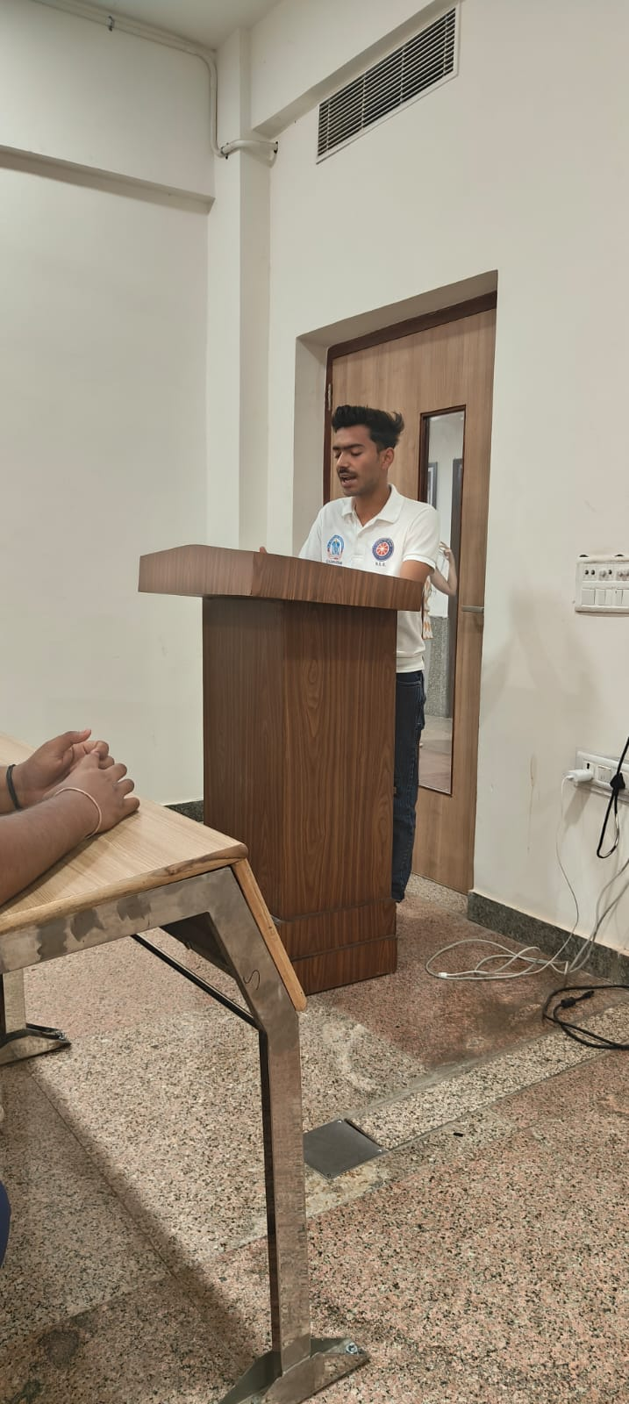

Pic 2: Students watching movie
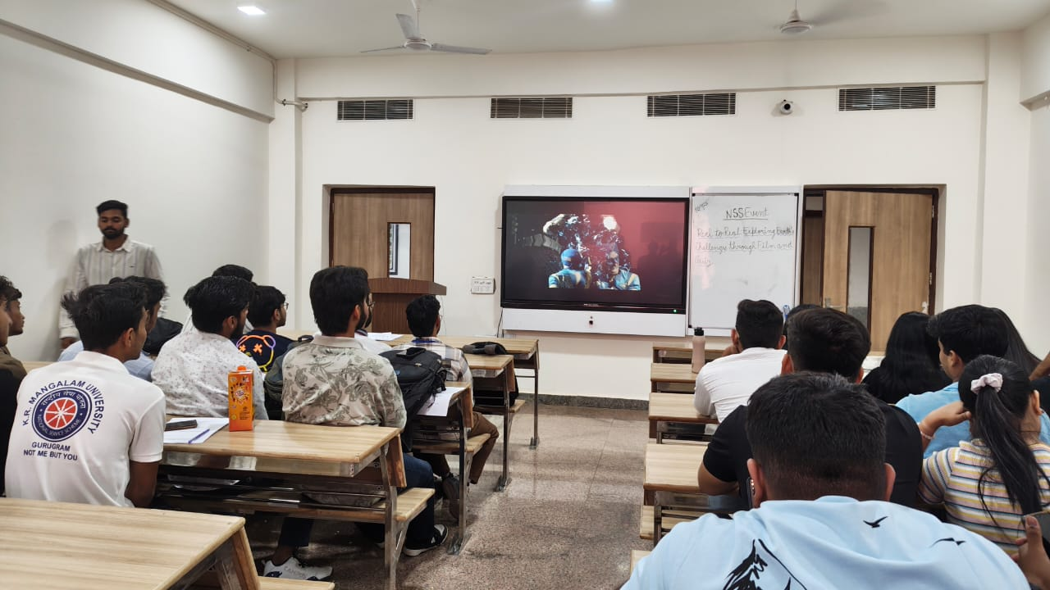

Pic 3: Students watching movie
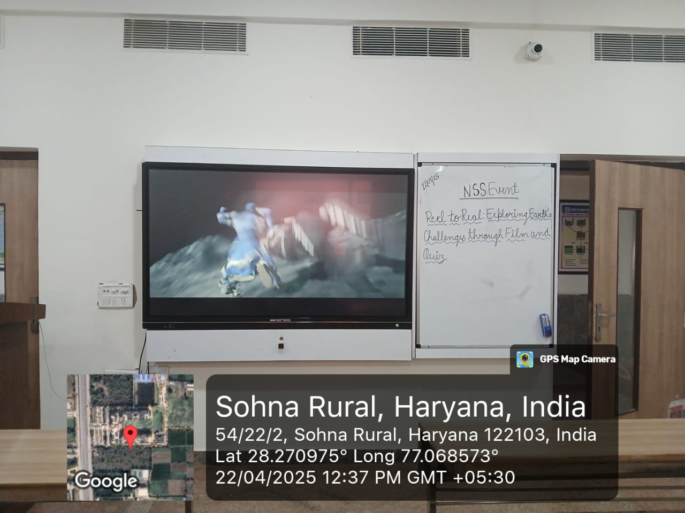

Pic 4: Geotagged photo with Poster
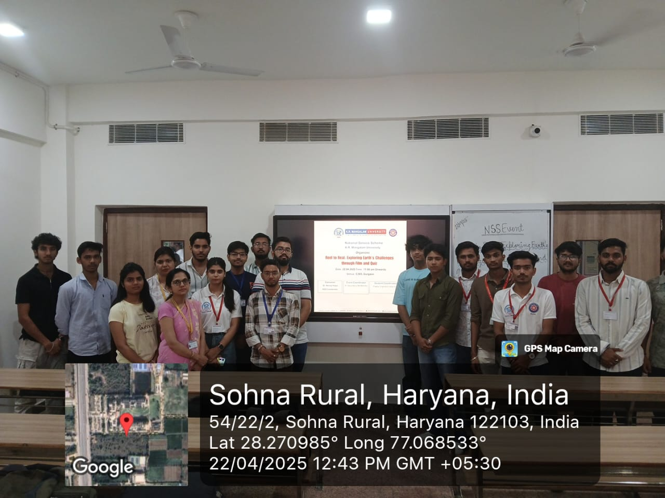

Report Prepared by  Report Verified by | Dr. Sapna Rana (NSS Member)  Dr. Neeraj Kumari (NSS Program Coordinator)
Report Verified by IQAC Coordinator | Dr Shikha Dutt Sharma

