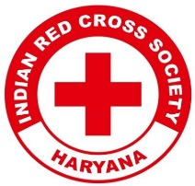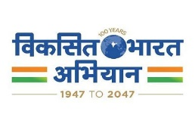
Report on
Talent Show Competition – Women’s Day Celebration
Date: 12th March 2025
Venue: Garhi Bajidpur, Sohna
Event Type: Talent Show Competition
Mode of Activity: Offline
Target Group: Women of the Local Community
Attendees: Local Women, Faculty, and Youth Red Cross Volunteers
Organized by: Youth Red Cross Committee, K.R. Mangalam University
Number of Participants: 40+ local women and 14 YRC volunteers

Introduction:
On the occasion of International Women’s Day, the Youth Red Cross Committee of K.R. Mangalam University organized a Talent Show Competition on 12th March 2025 at Garhi Bajidpur, Sohna. The event was dedicated to celebrating the strength, creativity, and voice of women, offering them a platform to express themselves through various cultural performances. The program aimed to empower local women and raise awareness about gender equality through engaging and inclusive activities.

Objectives:
Objectives are as follows:

- To celebrate International Women’s Day by recognizing the talent and contributions of women.
- To provide a platform for local women and students to express themselves through cultural performances.
- To promote community engagement and gender sensitivity.
- To encourage youth participation in social outreach and inclusive development.

Content:
The celebration commenced with a warm welcome to the Chief Guest, Prof. (Dr.) Anshika Prakash, Professor at the School of Management & Commerce, K.R. Mangalam University. Dr. Monika Yadav, the Program Coordinator of the Youth Red Cross Committee, addressed the audience and shared the significance of Women’s Day and the importance of gender equality.
The talent show included vibrant dance performances, soulful songs, and powerful slogan-writing activities by women from the local community. Participants showcased their creativity and enthusiasm, reflecting themes of empowerment, unity, and cultural pride. The event was filled with joy and appreciation, as every performance was met with enthusiastic applause and encouragement.
Student coordinators—Jatin, Sanjiv, and Amar Mittal—played a crucial role in organizing the event and coordinating the participants. The event successfully brought together the university’s volunteers and the rural community in a celebration of talent, respect, and empowerment.

Outcome:
- Over 40 local women and students actively participated in the talent show.
- Women showcased talent through song, dance, and slogan-writing performances.
- The event fostered a sense of confidence and empowerment among participants.
- Strengthened community-university collaboration.
- Promoted awareness of gender equality and women’s rights.
Conclusion:
The Talent Show Competition held on 12th March 2025 at Garhi Bajidpur, Sohna, on the occasion of Women’s Day, was a vibrant celebration of womanhood and community spirit. The Youth Red Cross Committee successfully provided a platform for women and students to express their creativity and thoughts. The participation of the local community and the enthusiastic involvement of the university team made the event impactful and memorable. Such initiatives are essential in promoting inclusivity, cultural expression, and gender sensitivity, especially in rural settings.

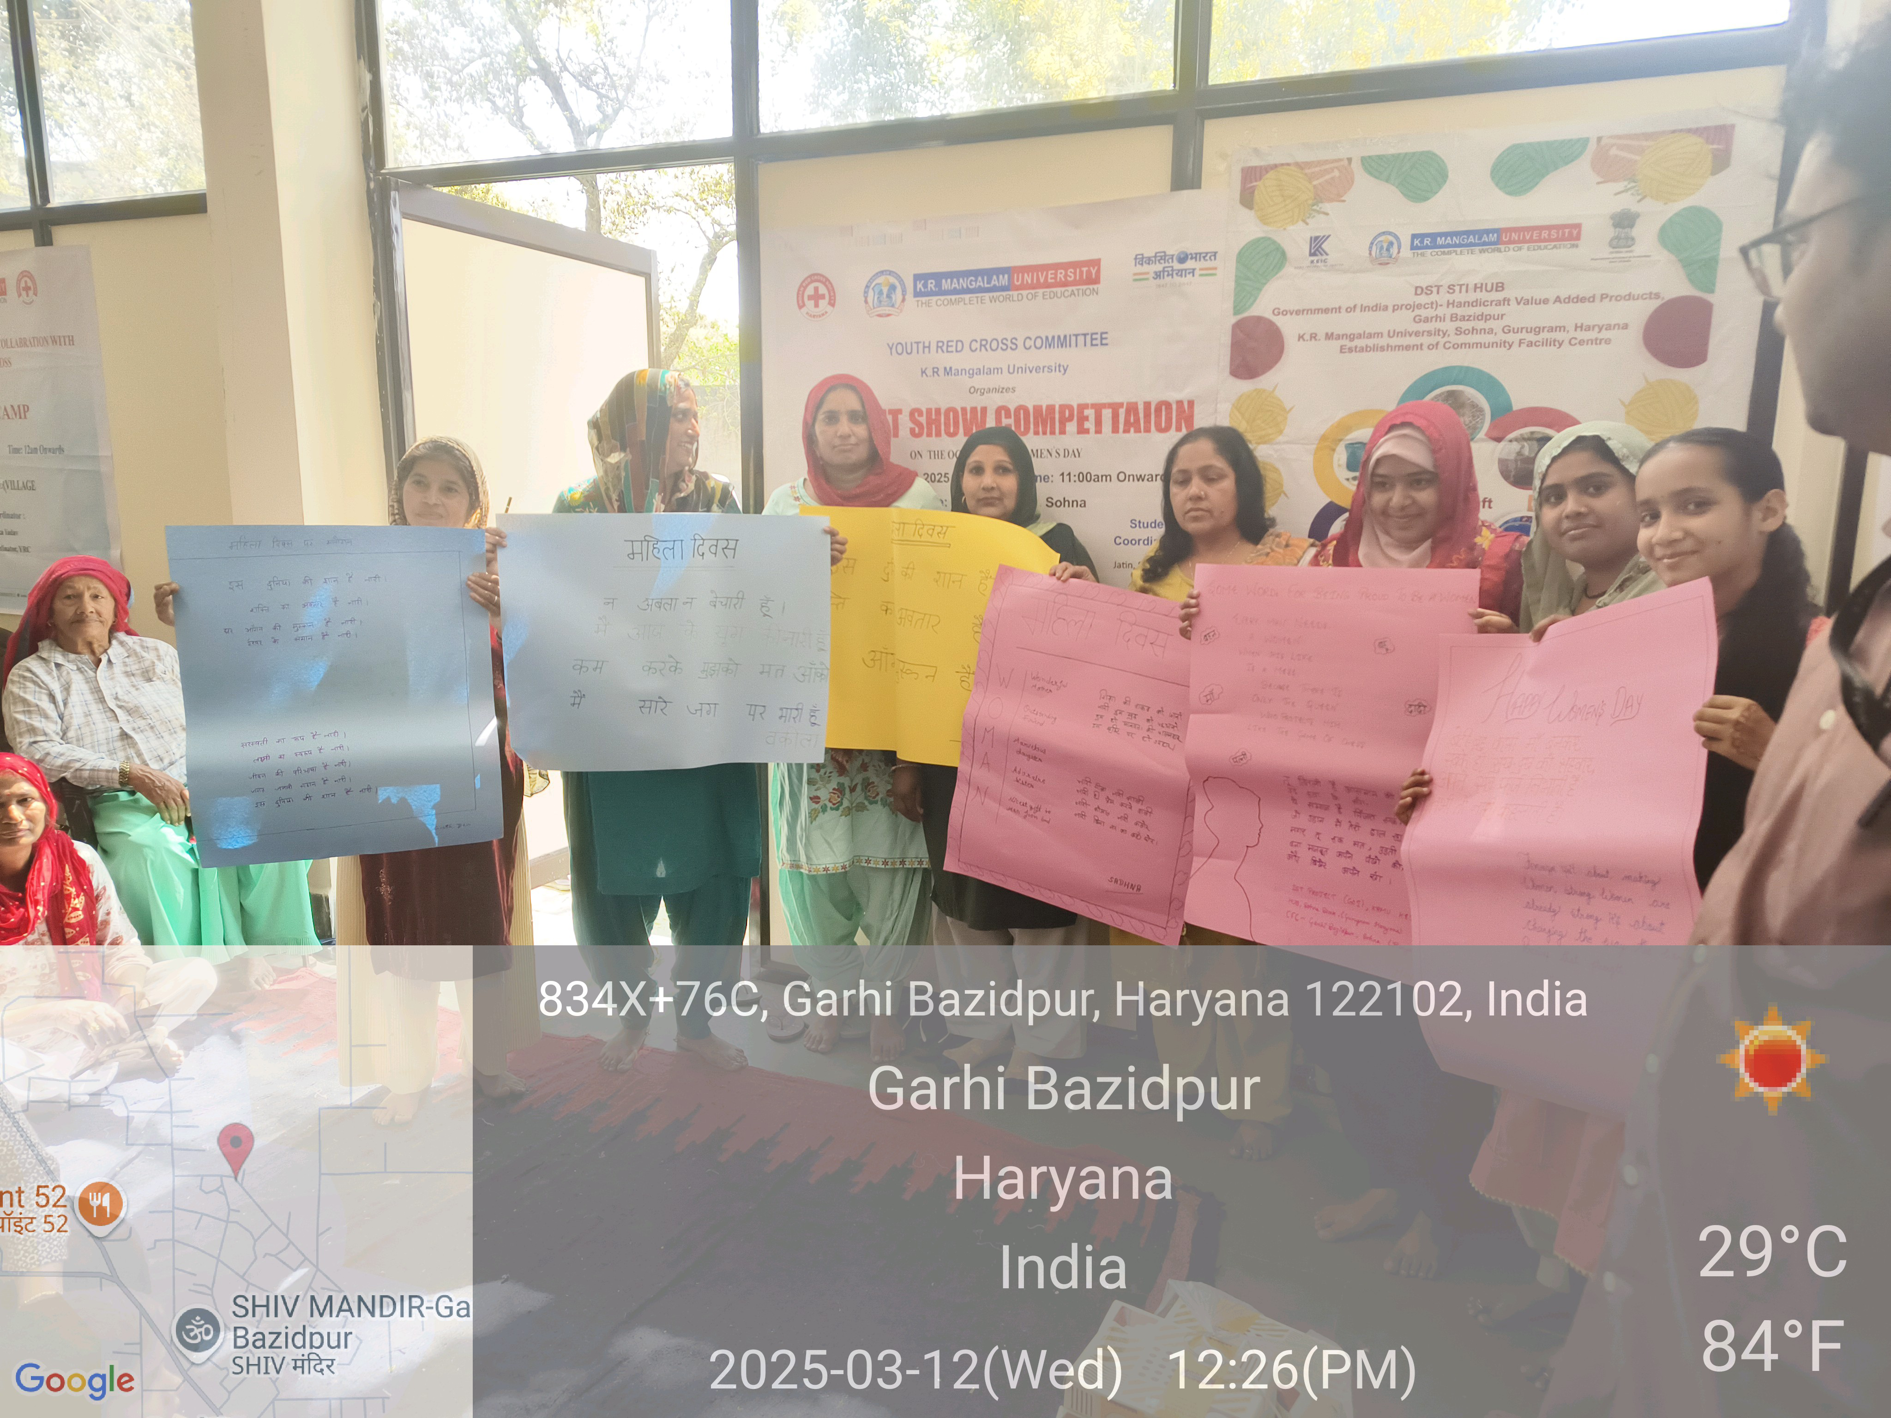

Local women proudly displaying their creative slogan posters during the Talent Show Competition on Women’s Day at Garhi Bazidpur, organized by KR Mangalam University on 12th March 2025.

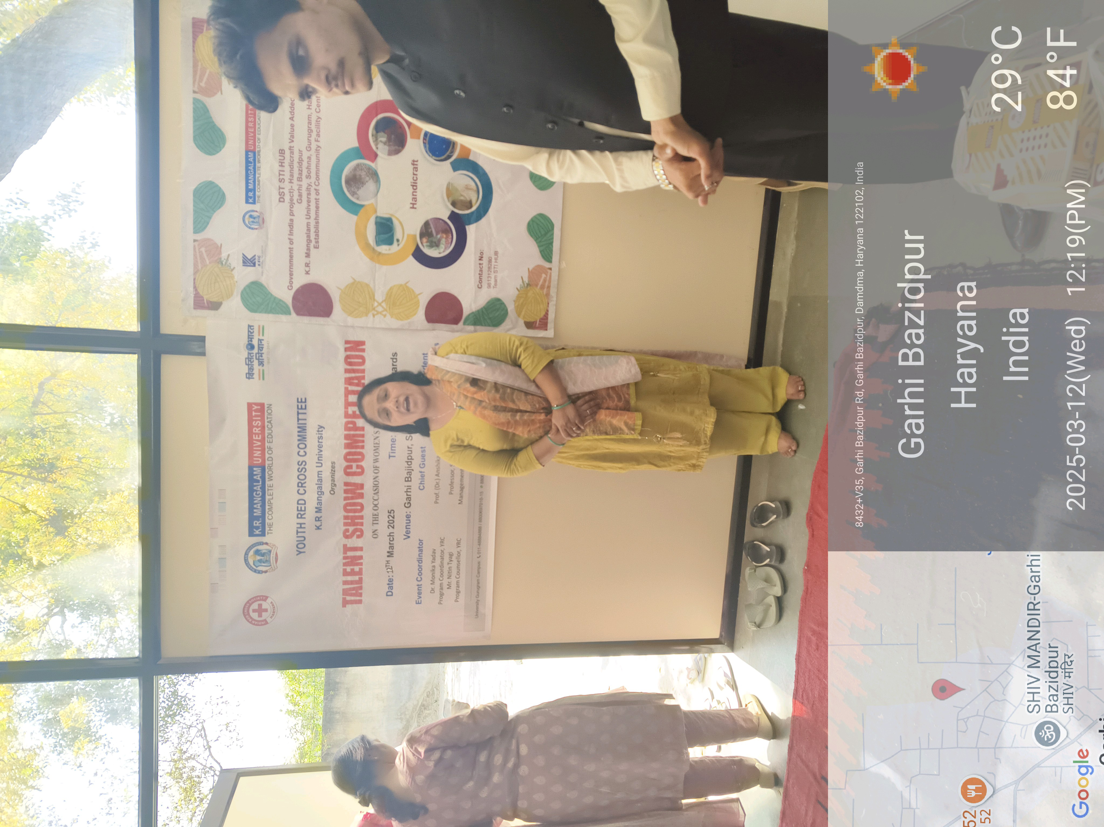

A participant passionately performing a song during the Talent Show Competition held on Women’s Day, 12th March 2025, at Garhi Bazidpur, organized by KR Mangalam University.

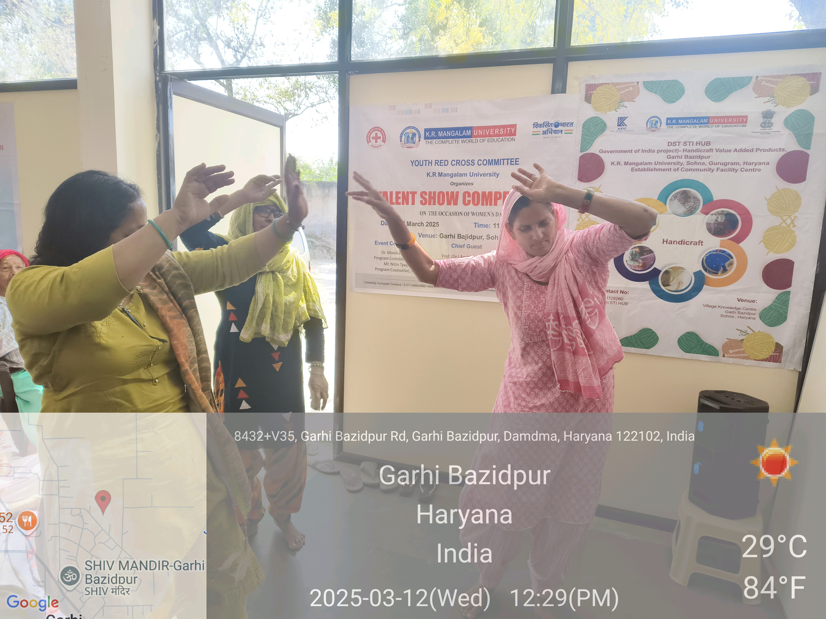

Women showcasing energetic and graceful dance performances during the Talent Show Competition on Women’s Day, 12th March 2025, at Garhi Bazidpur.

Report prepared by | Dr. Monika Yadav
Report seen by IQAC Coordinator | Dr. Shikha Dutta Sharma

