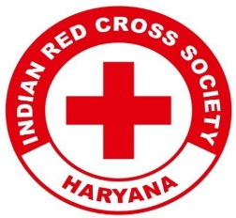
Report on
"Save a Life: First Aid Awareness” Training Session on World First Aid Day

Date: 14th September 2024

Venue: Lakhuwas Village
Event Type: Training Session
Mode of Activity: Offline
Target Group: Residents of Village Lakhwas

Attendees: Villagers, Youth Red Cross Volunteers

Organized by: Youth Red Cross, KRMU, in collaboration with the Indian Red Cross Society

Number of Participants:

Introduction:
The Training Session on World First Aid Day, held on 14th September 2024, was organized to raise awareness about the importance of first aid and equip the residents of Lakhuwas Village with life-saving skills. The event addressed the community’s emergency preparedness need by providing hands-on training on basic first-aid procedures. This initiative is part of a broader effort to foster a safer and healthier community.

Objectives:
Objectives are as follows:
- To educate villagers on the critical importance of first aid and its role in preventing injuries from becoming fatal.
- To provide practical training on essential first aid skills, enabling villagers to act promptly in emergencies.
- To build confidence within the community, encouraging swift and effective responses to accidents and health crises.
- To motivate community members to take ownership of their health and safety responsibilities, fostering a culture of care and support.

Content:

A training session was conducted to introduce participants to the fundamental principles of first aid, emphasizing its critical role in everyday life and the importance of timely intervention in mitigating harm in emergencies. The workshop included practical demonstrations and hands-on training in essential first aid techniques, such as Cardiopulmonary Resuscitation (CPR), handling fractures, treating burns, and managing bleeding. These sessions were led by Mr. Jitin Kaushik, District Training Officer, Gurugram, who provided expert instruction, ensuring each participant could practice these life-saving techniques effectively.
In addition to the practical training, real-life emergency scenarios were simulated, including choking, fainting, and shock. These simulations allowed participants to observe and perform first-aid interventions in a controlled environment under the close supervision of Mr. Kaushik.
The Training Session also featured interactive discussions, where participants were encouraged to ask questions, share personal experiences, and discuss the challenges of providing first aid. Mr. Kaushik offered valuable insights, addressed participants' concerns, and ensured that everyone left with a thorough understanding of the procedures discussed.

Outcome:

- Villagers learned about the vital role of first aid and the importance of immediate care in accident scenarios. They also enhanced their awareness about the availability of local healthcare support.
.
- Participants acquired practical first aid skills, which can be utilized to prevent accidents from escalating into life-threatening situations. The hands-on experience boosted their confidence in handling medical emergencies.

- Villagers felt empowered and more responsible for ensuring safety within their community. Learning first aid made them more self-reliant in handling emergencies until professional help arrived.

Conclusion:

The Training Session on World First Aid Day was a resounding success in raising awareness and equipping the villagers of Lakhuwas with vital first aid skills. Under the expert guidance of Mr. Jitin Kaushik, the hands-on training provided participants with the confidence and knowledge required to act swiftly during emergencies. The initiative has not only contributed to improving community safety but also inspired ongoing efforts to maintain health and well-being in the village. Such programs pave the way for building a more resilient and proactive society, capable of taking prompt and effective action in critical situations.

Photos of the Orientation Workshop:

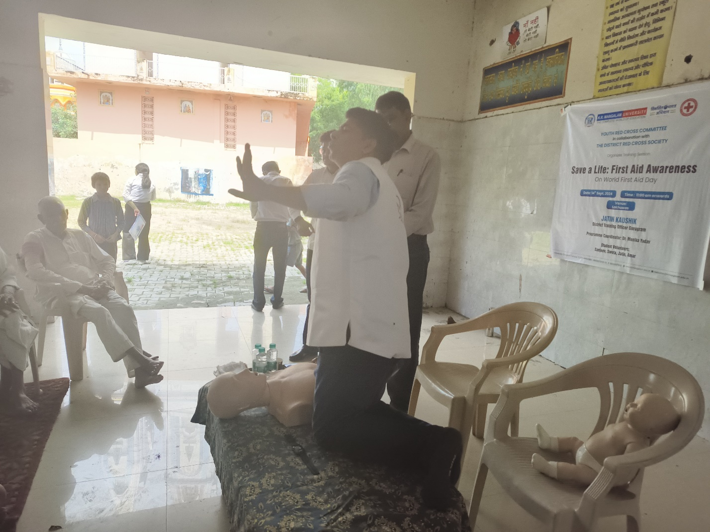Image 1: Mr. Jatin Kaushik, District Training Officer, Gurugram, conducting a live demonstration on CPR techniques during the "Save a Life: First Aid Awareness” Training Session.

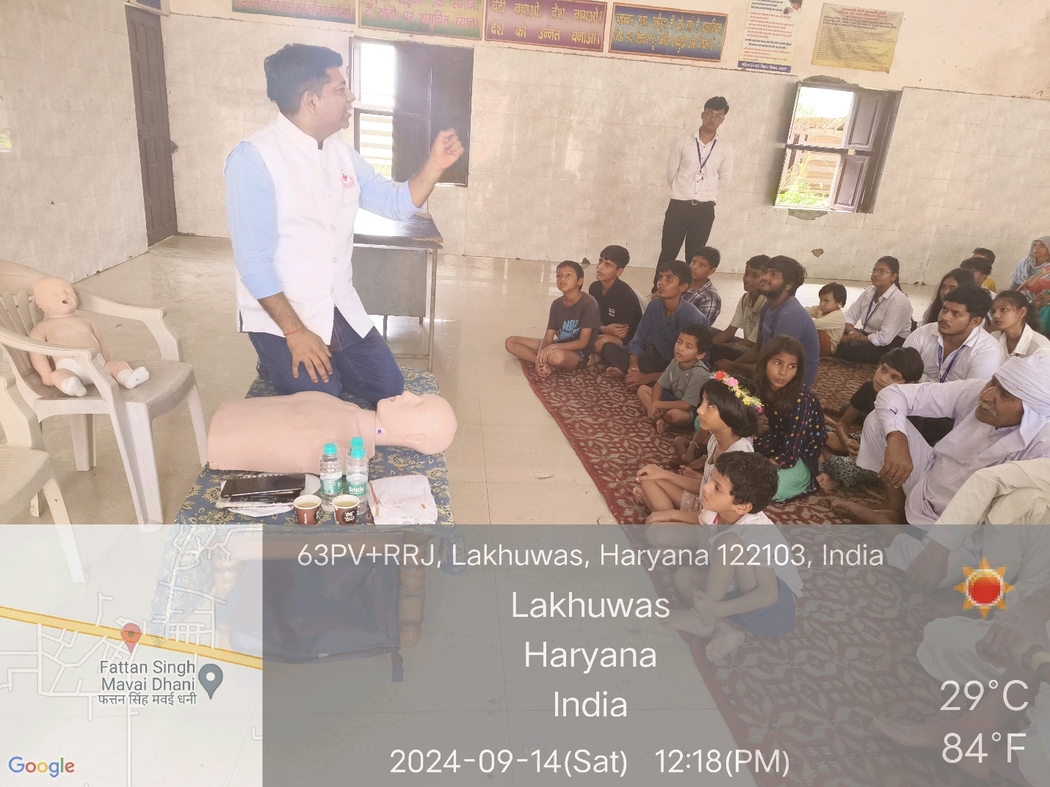
Image 2: Mr. Jatin Kaushik, District Training Officer, Gurugram, explaining CPR techniques to participants during the First Aid Awareness Training Session.
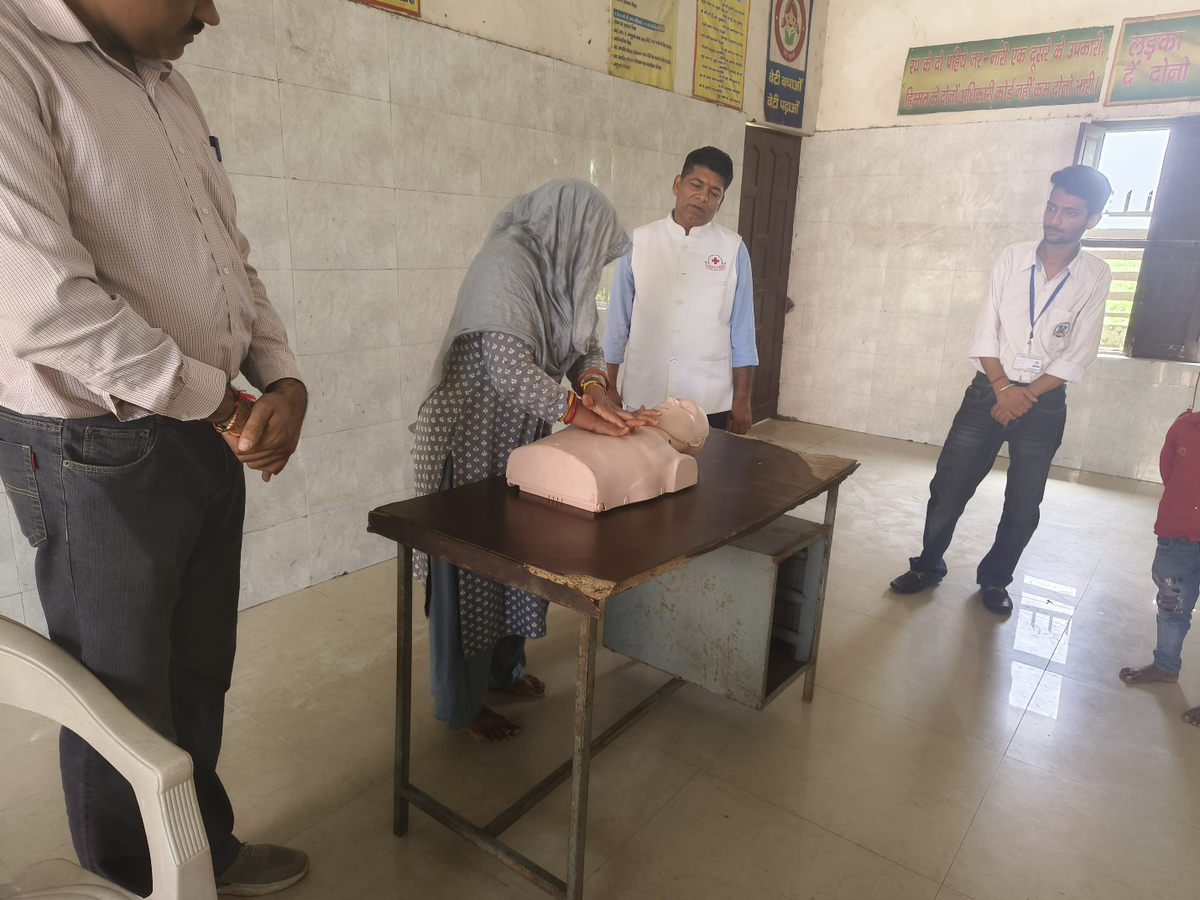
Image 3: A participant practicing CPR on a dummy under the supervision of Mr. Jatin Kaushik, District Training Officer, Gurugram.

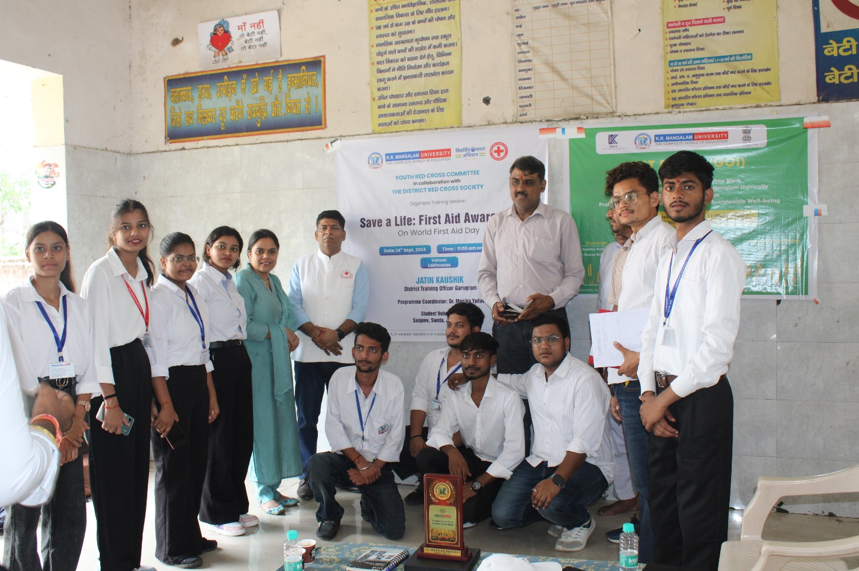
Image 4: Group photo of participants and organizers during the "Save a Life: First Aid Awareness" event.

Report prepared by ( Youth Red Cross Programme coordinator) | Dr. Monika Yadav
Report Seen By IQAC Coordinator | Dr. Shikha Dutt Sharma

