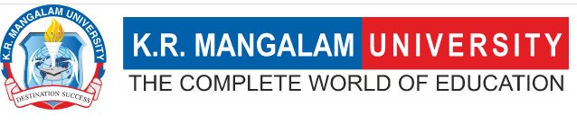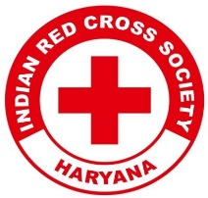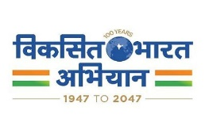
Report on
Drawing Competition on Save the Water for New Generation

Date: 23rd December 2024
Venue: Government Senior Secondary School, Daula Village
Total No. of Participants: 24 School students & 14 YRC volunteers
Event Type: Drawing Competition
Mode of Activity: Offline
Target Group: Students of Government Senior Secondary School, Daula
Organized by: Youth Red Cross Committee, K.R. Mangalam University
Event Coordinator: Dr. Monika Yadav, Programme Coordinator, YRC
Student Coordinators: Mr. Sanjiv, Mr. Shivang, Mr. Jatin

Introduction:
Youth Red Cross Committee, K.R. Mangalam University Organized a Drawing Competition on “Save the Water for New Generation." The drawing competition was conducted on 23rd December 2024 at Government Senior Secondary School, Daula Village. The event aimed to raise awareness about water conservation through the creative expression of young minds. It aligned with the institution's commitment to fostering sustainability and environmental consciousness.

Objectives:
- To create awareness about the importance of water conservation among students.
- To encourage students to express their thoughts on saving water creatively.
- To foster environmental responsibility among the youth.
- To strengthen community engagement through participation in meaningful activities.

Content:
The competition started at 10:00 AM with a brief introduction by Dr. Monika Yadav, Program Coordinator, YRC. The students were then given an hour to showcase their artistic skills on the theme "Save the Water for New Generation." Participants created diverse and impactful drawings that reflected their understanding of the importance of water conservation. The event concluded with the announcement of the winners, who were felicitated with certificates and tokens of appreciation.

Outcome:
- Increased awareness among participants about the significance of water conservation.
- Encouraged students to think creatively about sustainable practices.
- Strengthened the bond between K.R. Mangalam University and the local community.
- Identified talented individuals with exceptional artistic abilities.

Conclusion:
The "Save the Water for New Generation" drawing competition successfully engaged students in meaningful dialogue about water conservation. It fostered creativity and environmental responsibility, leaving a lasting impression on all participants. The collaboration between the Youth Red Cross Committee, the school, and the community was highly commendable. Such initiatives are crucial for building a sustainable future and promoting awareness among the younger generation.

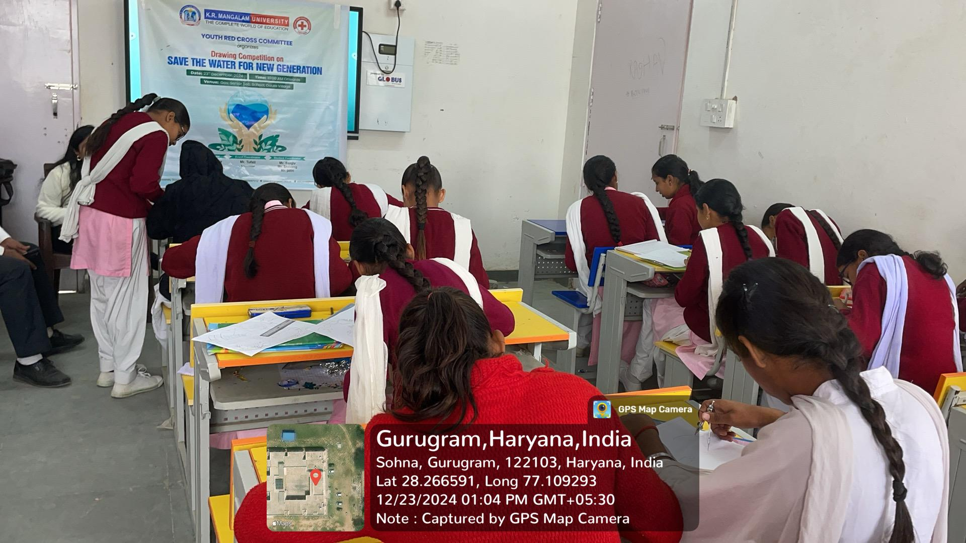

Students participate in a Youth Red Cross drawing competition on "Save the Water for New Generation."
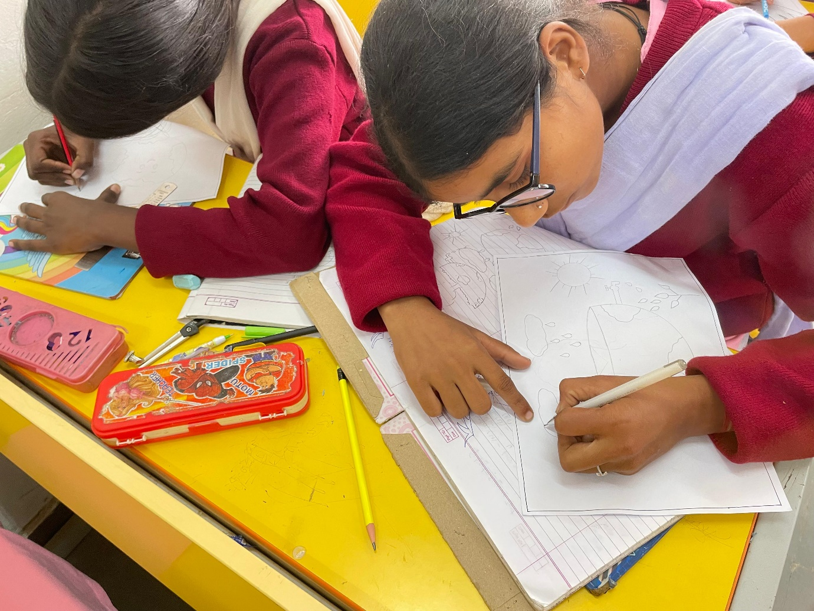

Students participate in a Youth Red Cross drawing competition on "Save the Water for New Generation."

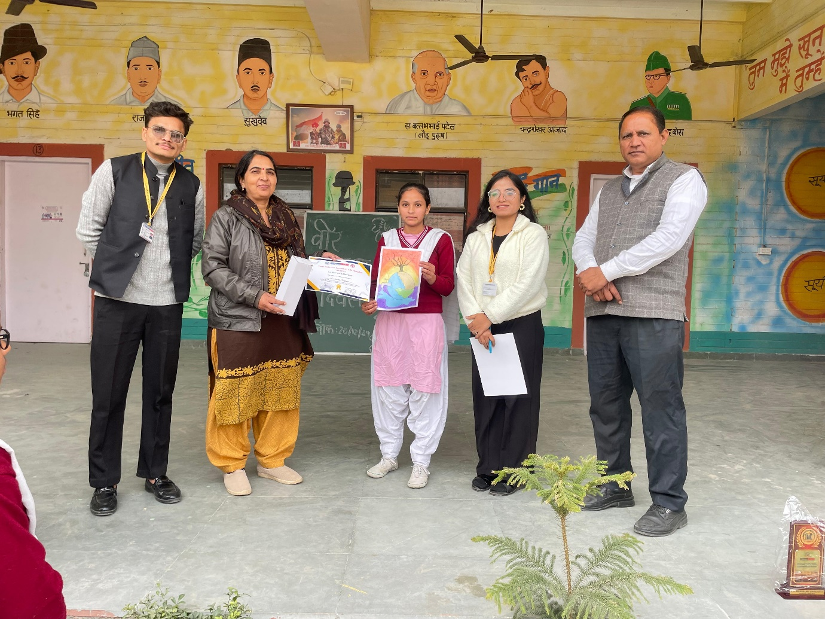

A student is awarded for her artwork on "Save the Water for New Generation" during a Youth Red Cross event in Gurugram, Haryana.

Report prepared by YRC Program Coordinator | Dr. Monika Yadav
Report seen by IQAC Coordinator | Dr. Shikha Dutta Sharma

