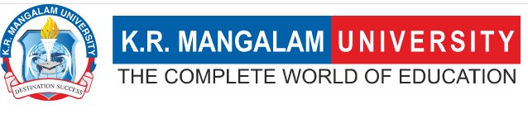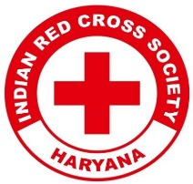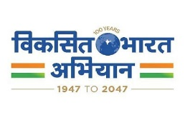
Report on
Declamation Contest on Drug Abuse: Its Social, Psychological and Health Consequences
Date: Monday, 21st October, 2024
Venue: Multipurpose Hall, 4th Floor, K.R Mangalam University
Total No. of Attendees: 85 students of KRMU
Total No. of Participants: 20 Participants
Event Type: Declamation Contest
Mode of Activity: Offline
Target Group: Students of K.R Mangalam University
Organized by: Youth Red Cross Committee & Environment Club, KR Mangalam University in Collaboration with Rotary Club New Gurgaon.
Resource Persons: Rtn Ashok Malik, Former President Rotary Club New Gurgaon
Rtn Mini Agarwal, Treasurer Rotary Club New Gurgaon
Rtn Dr Ram Kumar Yadav, President Rotary Club New Gurgaon
Event Coordinator: Dr Monika Yadav, Program Coordinator YRC, Dr Joginder Yadav, Chairperson Environment Club.
Student Coordinators: Mr. Jatin & Mr. Amar Mittal

Introduction:
The Youth Red Cross Committee and the Environment Club of KR Mangalam University, in collaboration with Rotary Club New Gurgaon, organized a declamation Contest on the topic “Drug Abuse: Its Social, Psychological and Health Consequences” to raise awareness about the harmful, lethal, and life-spoiling effects of drug abuse among the young generation. The event was held on Monday, 21st October 2024, at the university campus.

Objectives:
Objectives are as follows:
- To educate students about the social, psychological, and health consequences of drug abuse.
- To create awareness and encourage students to avoid drug use and resist peer pressure.
- To foster collaboration between educational institutions and community organizations for social causes.

Content:

The program began with a meeting between the Rotary Club team and Vice-Chancellor Prof. Raghbir Singh, who was introduced to Rotary's activities and initiatives for society. Impressed by the objectives of the declamation contest, Prof. Singh agreed to become an honorary member of Rotary Club New Gurgaon and was pinned by the President, Past President, and Treasurer of the club.
The contest featured speeches in both English and Hindi. The topic was “Drug Abuse: Its Social, Psychological and Health Consequences” Students enthusiastically participated, displaying comprehensive knowledge and declamation skills. The event was judged by representatives of the Rotary Club, including Rtn Ashok Malik, Rtn Mini Agarwal (Treasurer), and Rtn Dr. Ram Kumar Yadav (President).
Dr. Monika Yadav addressed the students, advising them to avoid succumbing to peer pressure and to say "no" to drugs. Dr. Joginder Yadav congratulated the participants for their impressive presentations and emphasized the need for more collaborative projects to spread awareness.

Prize Winners:
English Category:
- 1st Prize: Tanvi Vashisht
- 2nd Prize : Nitish Kumar Minz & Hilminthang
- 3rd Prize: Ms. Payal Shokhanda
Hindi Category:
- 1st Prize: Nitu Sharma

Rtn Mini Agarwal, one of the judges, also led the students in making a pledge to be patient, think before taking any steps, resist peer pressure, and commit to a drug-free life.

Outcome:

- Increased awareness among students regarding the dangers of drug abuse and its adverse impacts on life.
- Students were encouraged to resist peer pressure and make informed, healthy choices.
- Strengthened collaboration between KR Mangalam University and Rotary Club New Gurgaon for future initiatives.

Conclusion:

The Declamation Contest on Drug Abuse was a successful initiative aimed at educating and empowering students to avoid drug use. The event fostered a collaborative spirit between the Environment Club, Youth Red Cross, and Rotary Club New Gurgaon, laying the foundation for future projects focused on social awareness. Dr. Joginder Yadav thanked the guests and emphasized the need for continued joint efforts to address social issues.

Glimpse of the Declamation Contest

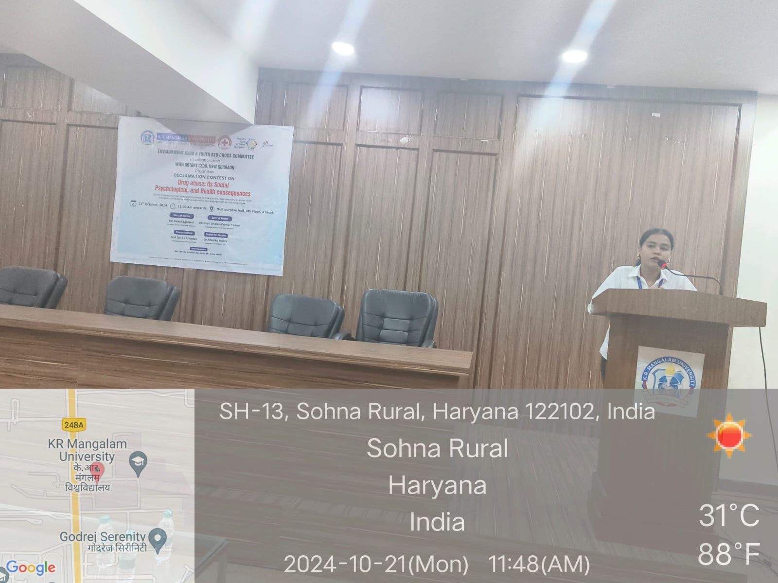

Image 1: student presenting at the Declamation Contest on "Drug Abuse: Social, Psychological, and Health Consequences," hosted by KR Mangalam University and Rotary Club New Gurgaon.

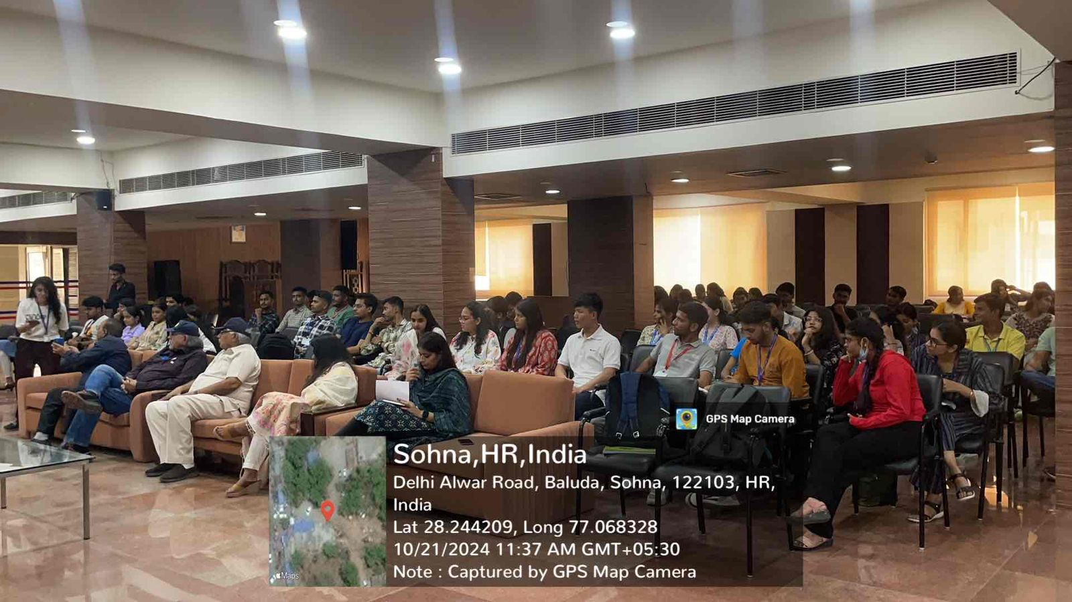

Image 2: Audience attending the Declamation Contest

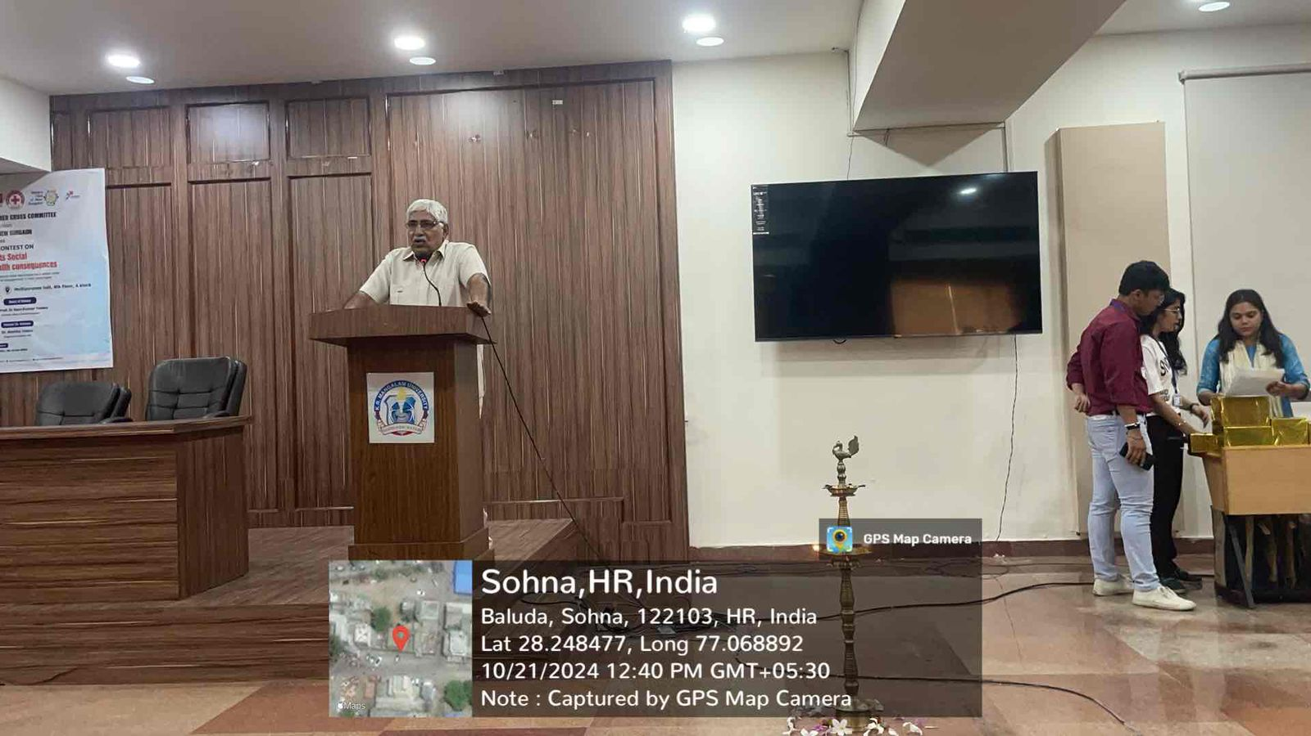

Image3: Rtn Dr Ram Kumar Yadav, President Rotary Club New Gurgaon, addresses the audience during the Declamation Contest

Report prepared by | Dr. Monika Yadav
Report verified by Event Coordinator | Dr. Monika Yadav
Report Seen by Red Cross Coordinator | Dr. Monika Yadav
Report seen by IQAC Coordinator | Dr. Shikha Dutta Sharma

