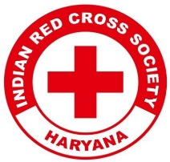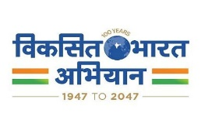
Report on
Awareness Session on Child Safety and Protection

Date: 13th May 2025
Venue: Government Senior Secondary School, Daula
Total No. of Participants: school students & 14 YRC volunteers
Event Type: Awareness Session
Mode of Activity: Offline
Target Group: School Students (Government Senior Secondary School, Daula)
Organized by: Youth Red Cross Committee, K.R. Mangalam University
Event Coordinator:
Dr. Monika Yadav, Program Coordinator, YRC
Mr. Nitin Tyagi, Program Counsellor, YRC
Student Coordinators: Jatin, Sanjiv, Amar Mittal
Resource Person: Ms. Gargi Singh, Assistant Professor, School of Legal Studies

Introduction:
The Youth Red Cross Committee, K.R. Mangalam University organized an impactful awareness session on "Child Safety and Protection" on 13th May 2025 at Government Senior Secondary School, Daula. The session aimed to sensitize school students about their rights, responsibilities, and the importance of personal safety in various environments.

Objectives:

Objectives are as follows:
- To spread awareness about child rights and legal provisions for child protection.
- To educate students about recognizing, resisting, and reporting unsafe situations.
- To build self-confidence and awareness among children regarding personal safety.

Content:
The session was conducted by Ms. Gargi Singh, Assistant Professor, School of Legal Studies, who addressed vital topics related to child safety laws, identifying abuse, and the legal rights of minors. The discussion included real-life examples, legal perspectives, and interactive activities to keep the students engaged. Students actively participated by asking questions and sharing their thoughts.

Outcome:
- Students gained awareness of key safety concerns and legal rights.
- The session empowered students to communicate and report inappropriate behaviours confidently.
- Created a more informed and sensitive student community regarding child safety issues.

Conclusion:
The awareness session on Child Safety and Protection was a resounding success. It helped foster a safe and informed environment for students by addressing their doubts, educating them on important safety aspects, and making them aware of the support systems in place. The Youth Red Cross Committee plans to conduct more such sessions in various schools to further this mission.
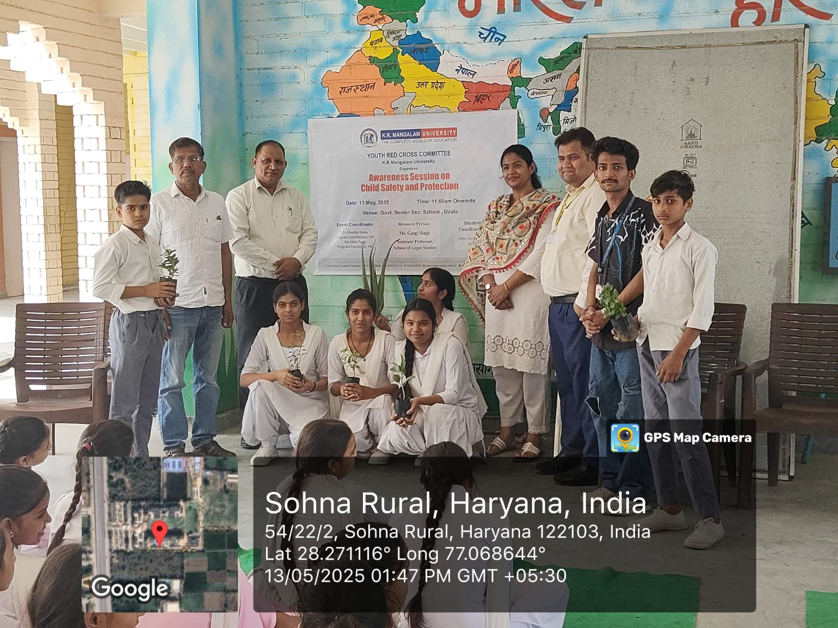

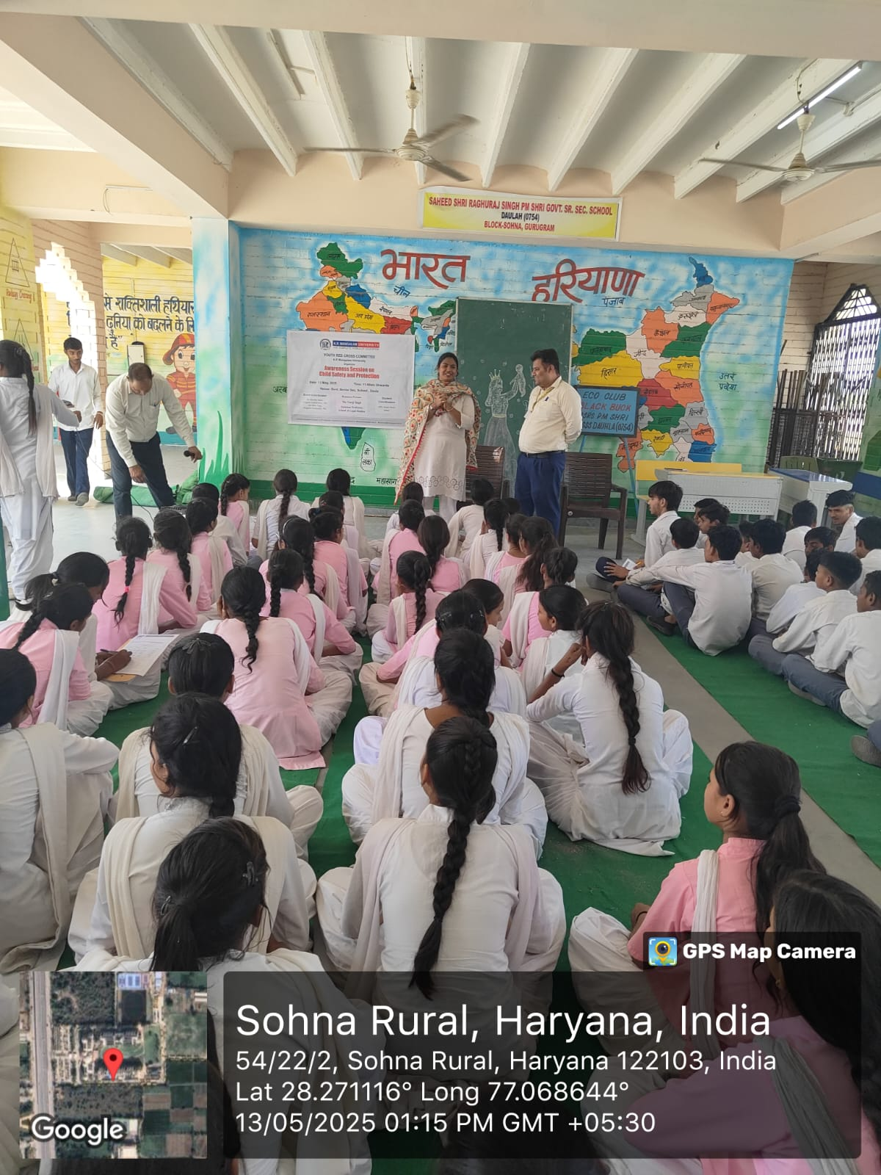
Dr. Gargi Singh addressing students during the awareness session on adolescent health and well-being at Shaheed Shri Raghubir Singh Govt. Sr. Sec. School, Sohna Rural, Haryana.

Report Seen by Red Cross Coordinator | Dr. Monika Yadav
Report seen by IQAC Coordinator | Dr. Shikha Dutta Sharma

