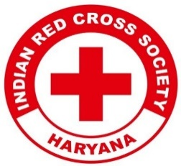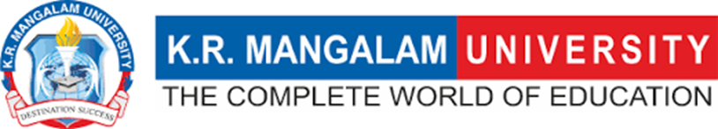
Report on
Blood Donation Camp "Give Blood, Give Life"

Date: 24th Sep.2024
Venue: Physiotherapy OPD, A Block, KR Mangalam University
Event Type: Blood Donation Camp
Mode of Activity: Offline
Target Group: Students & Faculty of KR Mangalam University
Attendees: Students & Faculty Members of KR Mangalam University
Organized by: Youth Red Cross committee in collaboration with District Red Cross Society
Number of Participants: 80 students donated blood

Introduction:
A blood donation camp was organized at KR Mangalam University's Physiotherapy OPD on 24th Sep.2024. The event was held in collaboration with the District Red Cross Society to encourage voluntary blood donation among students and raise awareness about the importance of blood donation in saving lives. The camp was met with enthusiastic participation from the university community, with 80 students donating blood.

Objectives:
Objectives are as follows:
- To promote the spirit of voluntary blood donation among students.
- To raise awareness of the importance of donating blood and how it can save lives.
- To support the local blood banks with safe, healthy blood supplies.
- To involve students in humanitarian activities and social responsibility initiatives.

Content:

The camp was managed by a team of healthcare professionals from the Indian Red Cross Society, who ensured that the donation process was smooth, safe, and efficient. The key individuals involved in the operation of the camp included:
- Ananta Kumar Saha – Team Incharge & Technical Supervisor
- Yojna – Technical Officer
- Dr. Saif – Medical Officer
- Sunita – Counsellor
- Neha – Nursing Sister
- Ravi – Lab Technician
- Vicky – Helper
The camp was set up at the Physiotherapy OPD of KR Mangalam University, with proper seating, screening, and donation areas. The donors were given an initial health check-up to ensure their eligibility to donate. Post-donation, each donor was provided with refreshments to help them recover quickly.

Outcome:

The camp was a great success, with 80 students volunteering to donate blood. The event helped foster a sense of social responsibility among the university students and contributed to the local blood banks. All participants were acknowledged for their contributions and encouraged to continue participating in such life-saving activities in the future.
The Red Cross Society team ensured the camp was conducted smoothly and safely. Both the university and the donors greatly appreciated their professionalism and dedication.

Conclusion:

The blood donation camp held at KR Mangalam University's Physiotherapy OPD was a commendable initiative highlighting the university's commitment to social responsibility and humanitarian causes. With the support of the Red Cross Society and the enthusiastic participation of 80 students, the camp successfully contributed to local blood banks, potentially saving many lives. The event also served as a platform to educate and encourage students on the significance of blood donation. The dedicated efforts of the medical team, led by Ananta Kumar Saha, ensured the smooth execution of the camp.
Such initiatives reinforce the importance of giving back to the community. They will continue to inspire future participation in similar events, fostering a culture of empathy and social contribution among students.

Photos of the Blood Donation Camp:

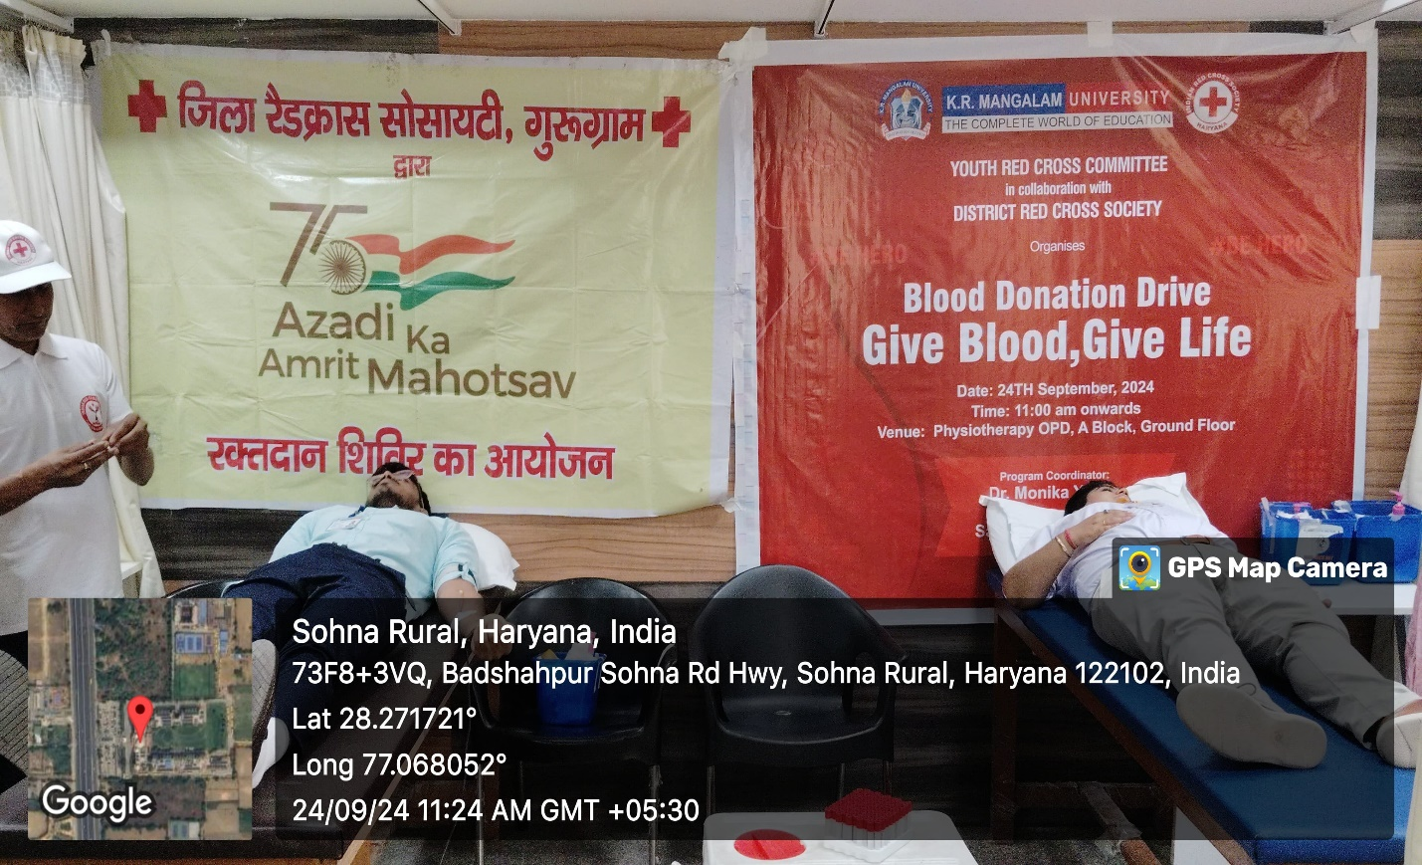
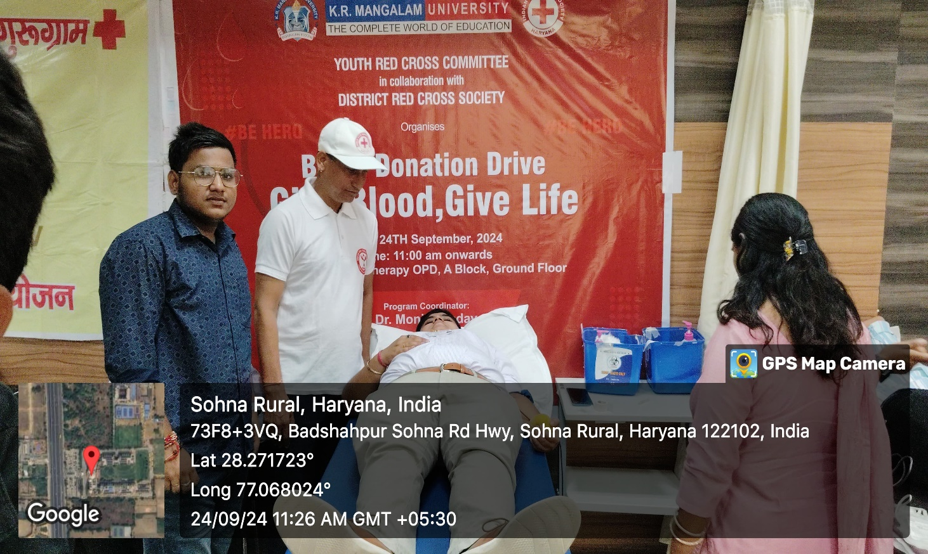

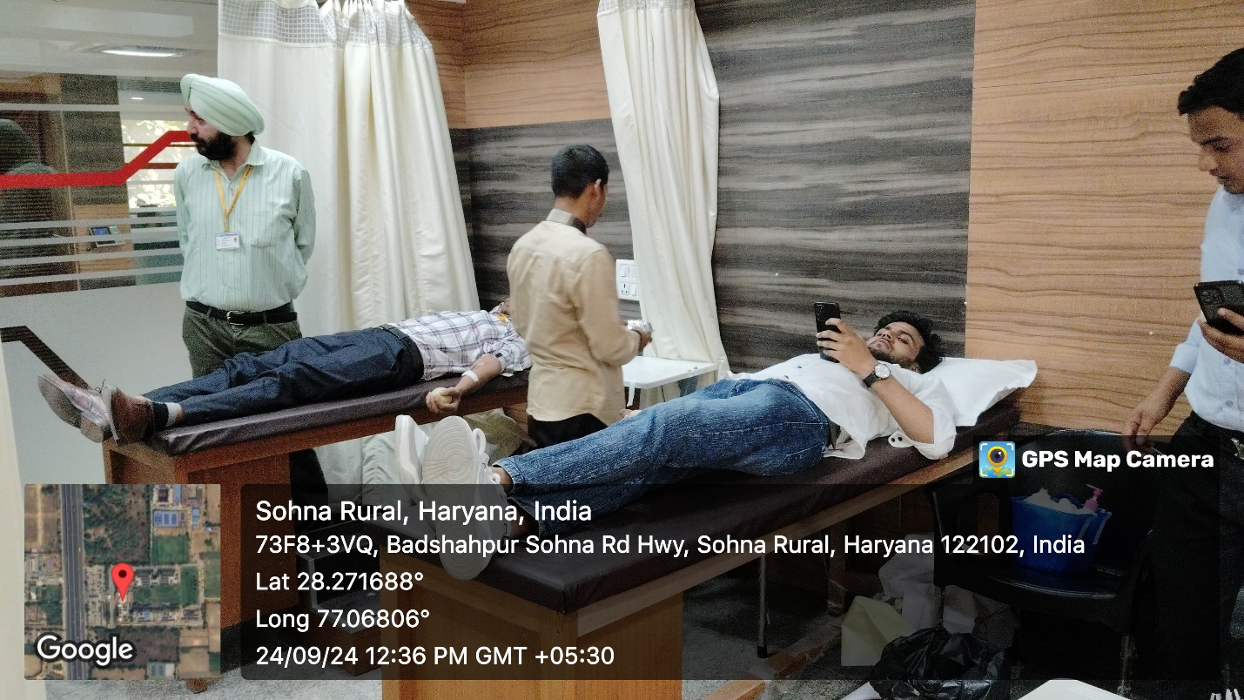

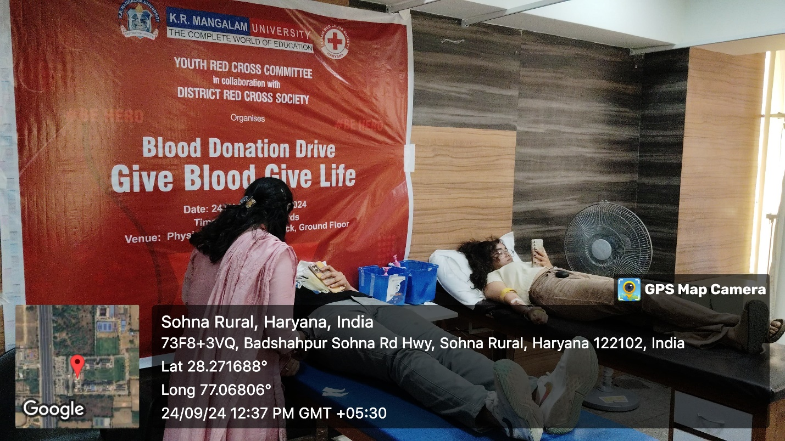

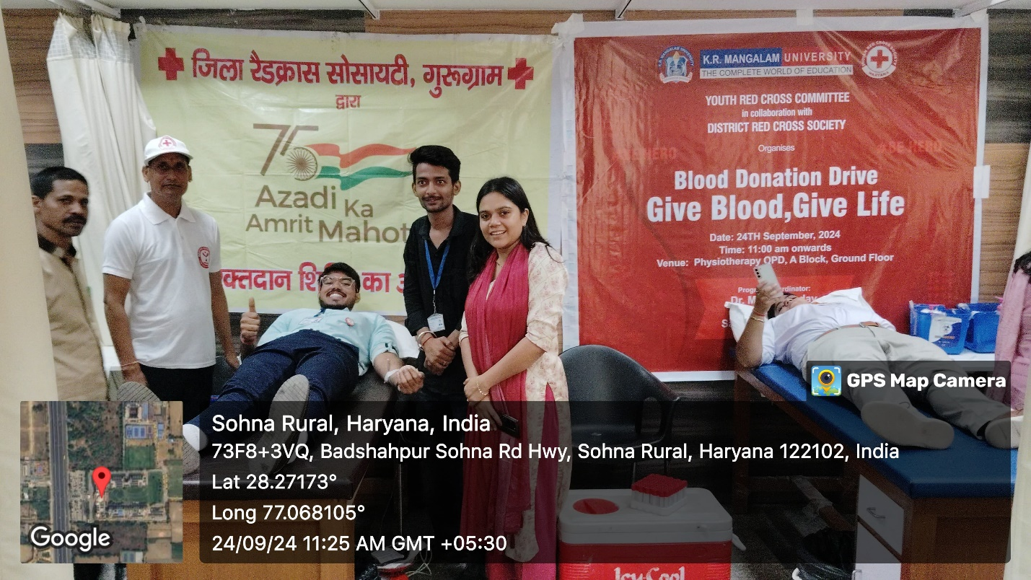

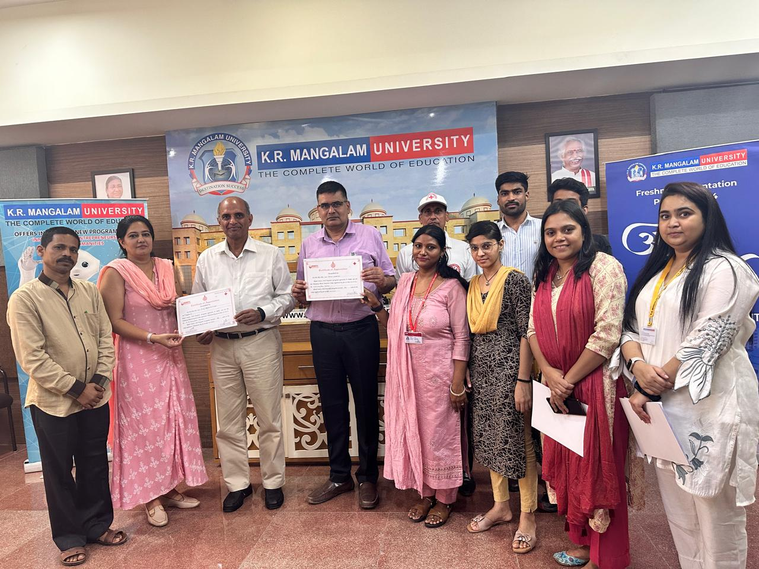

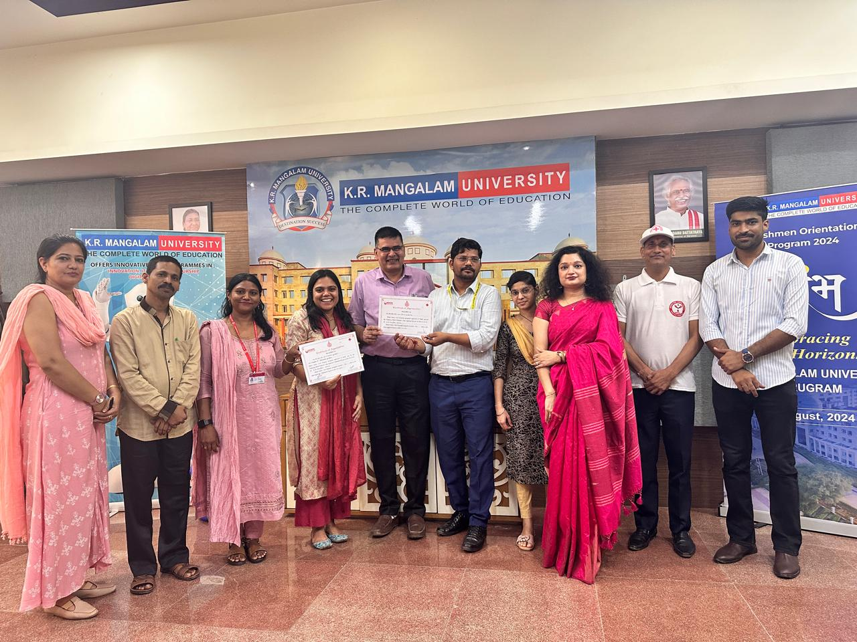

Report prepared by ( Youth Red Cross Programme coordinator) | Dr. Monika Yadav

