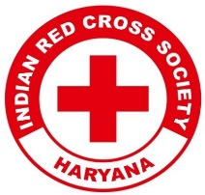
Report on
Nourish & Flourish: A Path to Balanced Nutrition and Health

Date: 20th December, 2024
Venue: Gov. Senior Sec. School, Daula
Total No. of Participants:
Event Type: Lecture Session
Mode of Activity: Offline
Target Group: Students of Gov. Senior Sec. School, Daula & YRC Volunteers
Organized by: Youth Red Cross Committee, K.R. Mangalam University
Resource Person: Dr. J.S. Yadav, Dean, School of Agriculture & Science
Event Coordinator: Dr. Monika Yadav, Program Coordinator, YRC
Student Coordinators: Mr. Sanjiv, Mr. Shivang, Mr. Jatin

Introduction:
The Youth Red Cross Committee of K.R. Mangalam University organized a lecture session titled "Nourish & Flourish: A Path to Balanced Nutrition and Health." This session aimed to educate the community about the importance of balanced nutrition for maintaining good health and overall well-being.

Objectives:
- To create awareness about the role of balanced nutrition in leading a healthy life.
- To promote healthy eating habits among local communities and students.
- To address practical strategies for adopting nutritional practices in daily life.
- To highlight the significance of balanced diets in preventing lifestyle diseases.

Content:

The session commenced with a warm welcome to the participants, followed by an insightful address by the resource person, Dr. J.S. Yadav, Dean of the School of Agriculture & Science. Dr. Yadav explained the concept of balanced nutrition, emphasizing the importance of consuming the right proportions of carbohydrates, proteins, fats, vitamins, and minerals to maintain overall health. He highlighted the critical role of a nutritious diet in preventing lifestyle-related diseases, such as obesity, diabetes, and heart ailments.
He encouraged the participants to focus on locally available and affordable foods rich in essential nutrients. He also provided simple meal-planning tips and emphasized the importance of hydration and mindful eating practices. Dr. Yadav addressed common misconceptions about nutrition and clarified doubts raised by the participants, ensuring an interactive and engaging session.
The participants actively interacted throughout the session, sharing their perspectives and health concerns. Dr Yadav’s approachable style and relatable content made it easier for attendees to grasp the importance of nutrition and apply it in their daily routines.

Outcome:

- Participants gained a better understanding of balanced nutrition and its impact on health.
- The local community and students became more aware of simple, practical steps for incorporating nutritious food into their daily lives.
- The event fostered a stronger connection between the university and the local community, promoting health education.
- Positive feedback was received, with participants expressing enthusiasm to implement the learnings in their daily routines.

Conclusion:

The "Nourish & Flourish" lecture session was a significant step in promoting health and nutrition awareness. Dr. J.S. Yadav’s expertise and practical insights made the session highly impactful and engaging. The event fulfilled its objectives, leaving a lasting impression on participants and encouraging them to make informed choices for a healthier lifestyle. The success of this event reflects the commitment of the Youth Red Cross Committee to community development and education.

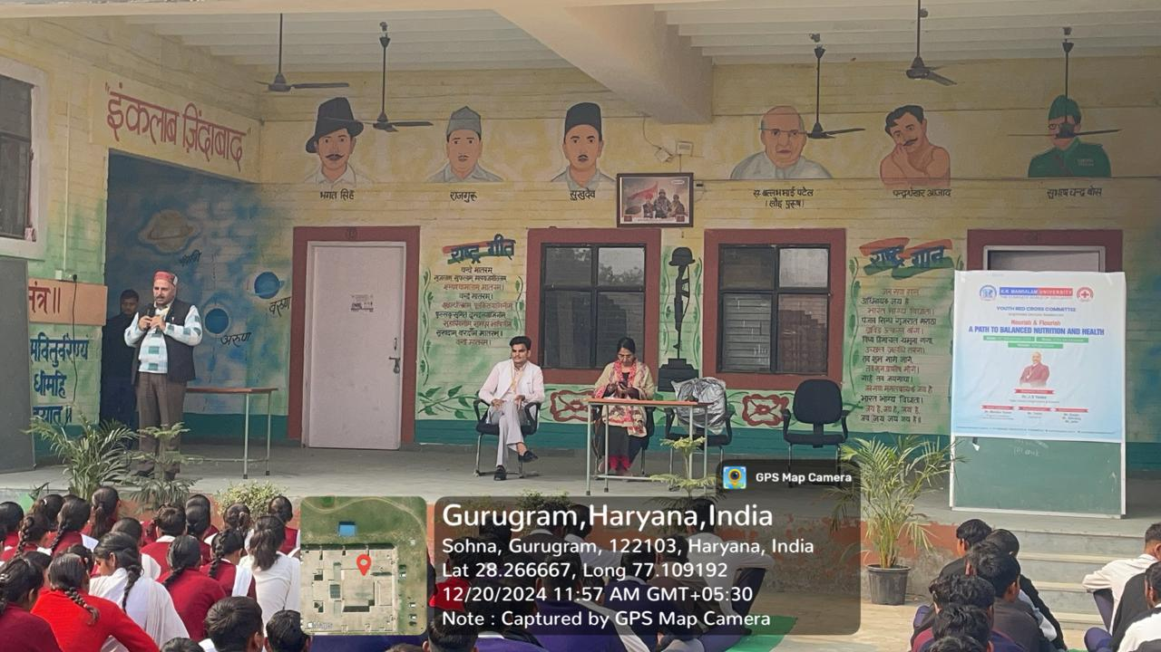

Dr. Yadav explaining the concept of balanced nutrition.

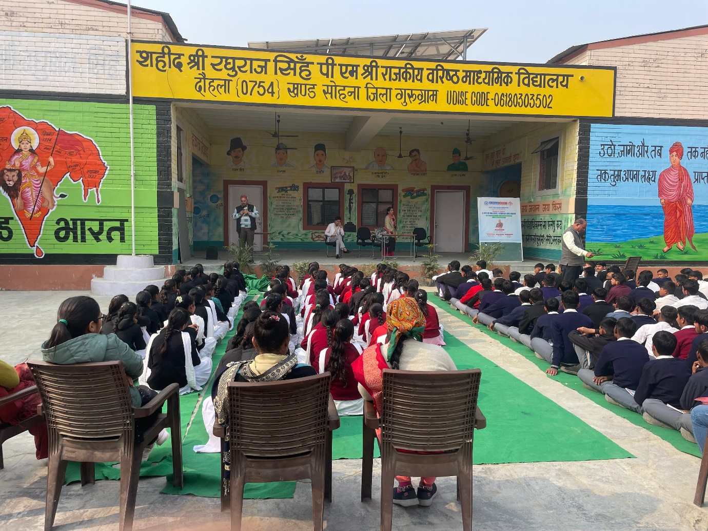

Students engaged in a health awareness program on balanced nutrition.

Report prepared by | Dr. Monika Yadav
Report verified by Event Coordinator | Dr. Monika Yadav
Report Seen by Red Cross Coordinator | Dr. Monika Yadav
Report seen by IQAC Coordinator | Dr. Shikha Dutta Sharma

