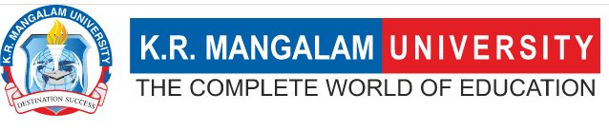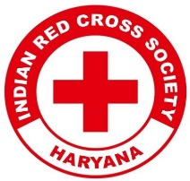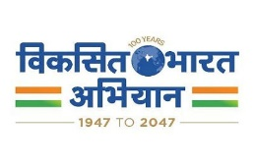
Report on
Republic Day Celebration

Date: 26th January 2025
Venue: Govt. School, Dhaula Village
Total No. of Participants: 116 School Students & 10 YRC Volunteers
Event Type: Community Engagement & Celebration ( Extension)
Mode of Activity: Offline
Target Group: School Students, Village Community & University Volunteers
Organized by: Youth Red Cross Committee, K.R. Mangalam University
Event Coordinator: Dr. Monika Yadav (Program Coordinator, YRC)
Student Coordinators: Mr. Sanjiv, Mr. Shivang, Mr. Jatin

Introduction:
The Youth Red Cross Committee of K.R. Mangalam University organized a Republic Day Celebration at Govt. School, Dhaula Village, to instill patriotism and promote community engagement. The event aimed to inspire students and the community with the values of unity, democracy, and national pride.

Objectives:

Objectives are as follows:
- To celebrate the 76th Republic Day with students and the local community.
- To promote social awareness and the importance of democracy among school children.
- To engage youth volunteers in community-building activities.
- To highlight the significance of service and social responsibility through the Red Cross movement.

Content:
The event began with the flag hoisting ceremony, followed by the national anthem and a cultural program presented by school students. Several activities, including patriotic speeches and interactive sessions, were conducted to educate the children about the importance of Republic Day. Volunteers from K.R. Mangalam University’s Youth Red Cross Committee actively engaged with the students, sharing insights about national values and the role of youth in shaping the country’s future.
Additionally, a community interaction session was conducted where discussions on health, hygiene, and social responsibility were held, emphasizing the role of education in national development.
Outcome:
- Enhanced awareness among students about the significance of Republic Day and the Indian Constitution.
- Encouraged youth participation in social service and community welfare.
- Strengthened the university’s outreach and engagement with rural communities.
- Inspired school students to take an active interest in civic responsibilities.

Conclusion:

The Republic Day celebration by the Youth Red Cross Committee was a successful event that brought together students, faculty, and community members in a spirit of patriotism and service. The event not only strengthened the bond between K.R. Mangalam University and the local community but also reinforced the importance of nation-building through education and social responsibility.

Photos of the event:
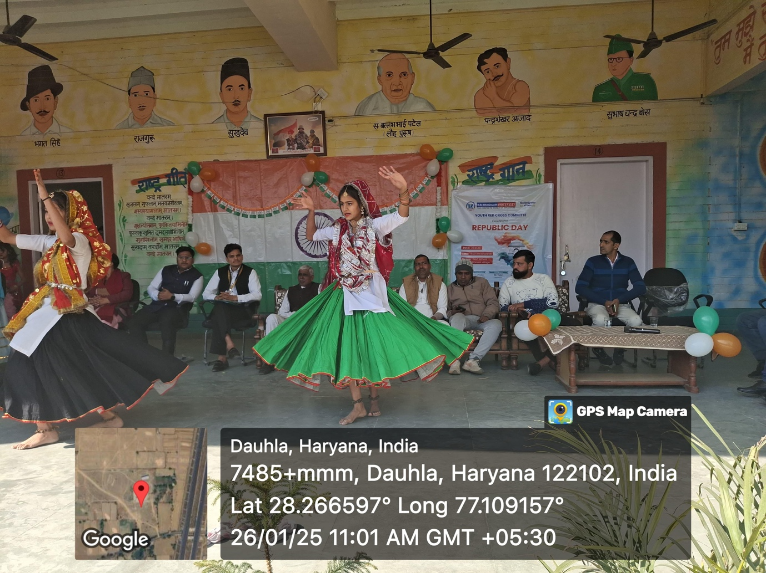

Republic Day 2025 celebrated by Youth Red Cross Committee at Dhaula Village with vibrant cultural performances and community engagement.

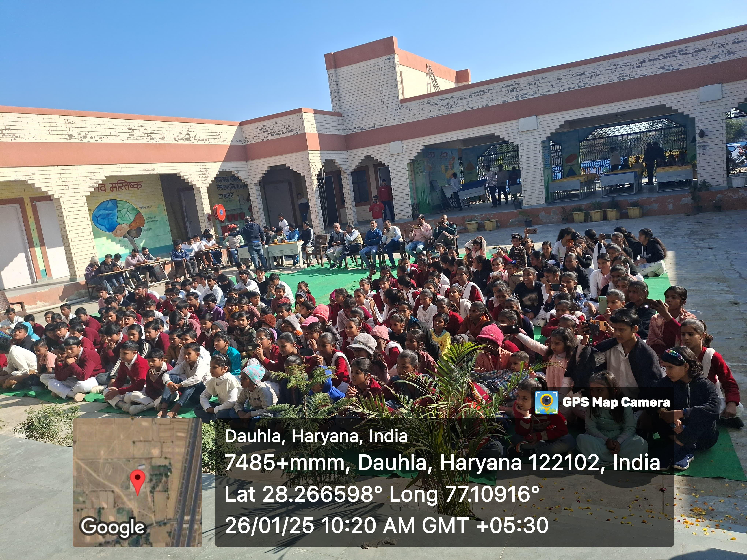

The Youth Red Cross Committee of K.R. Mangalam University engaged students and the local community in a patriotic celebration filled with enthusiasm, unity, and learning.

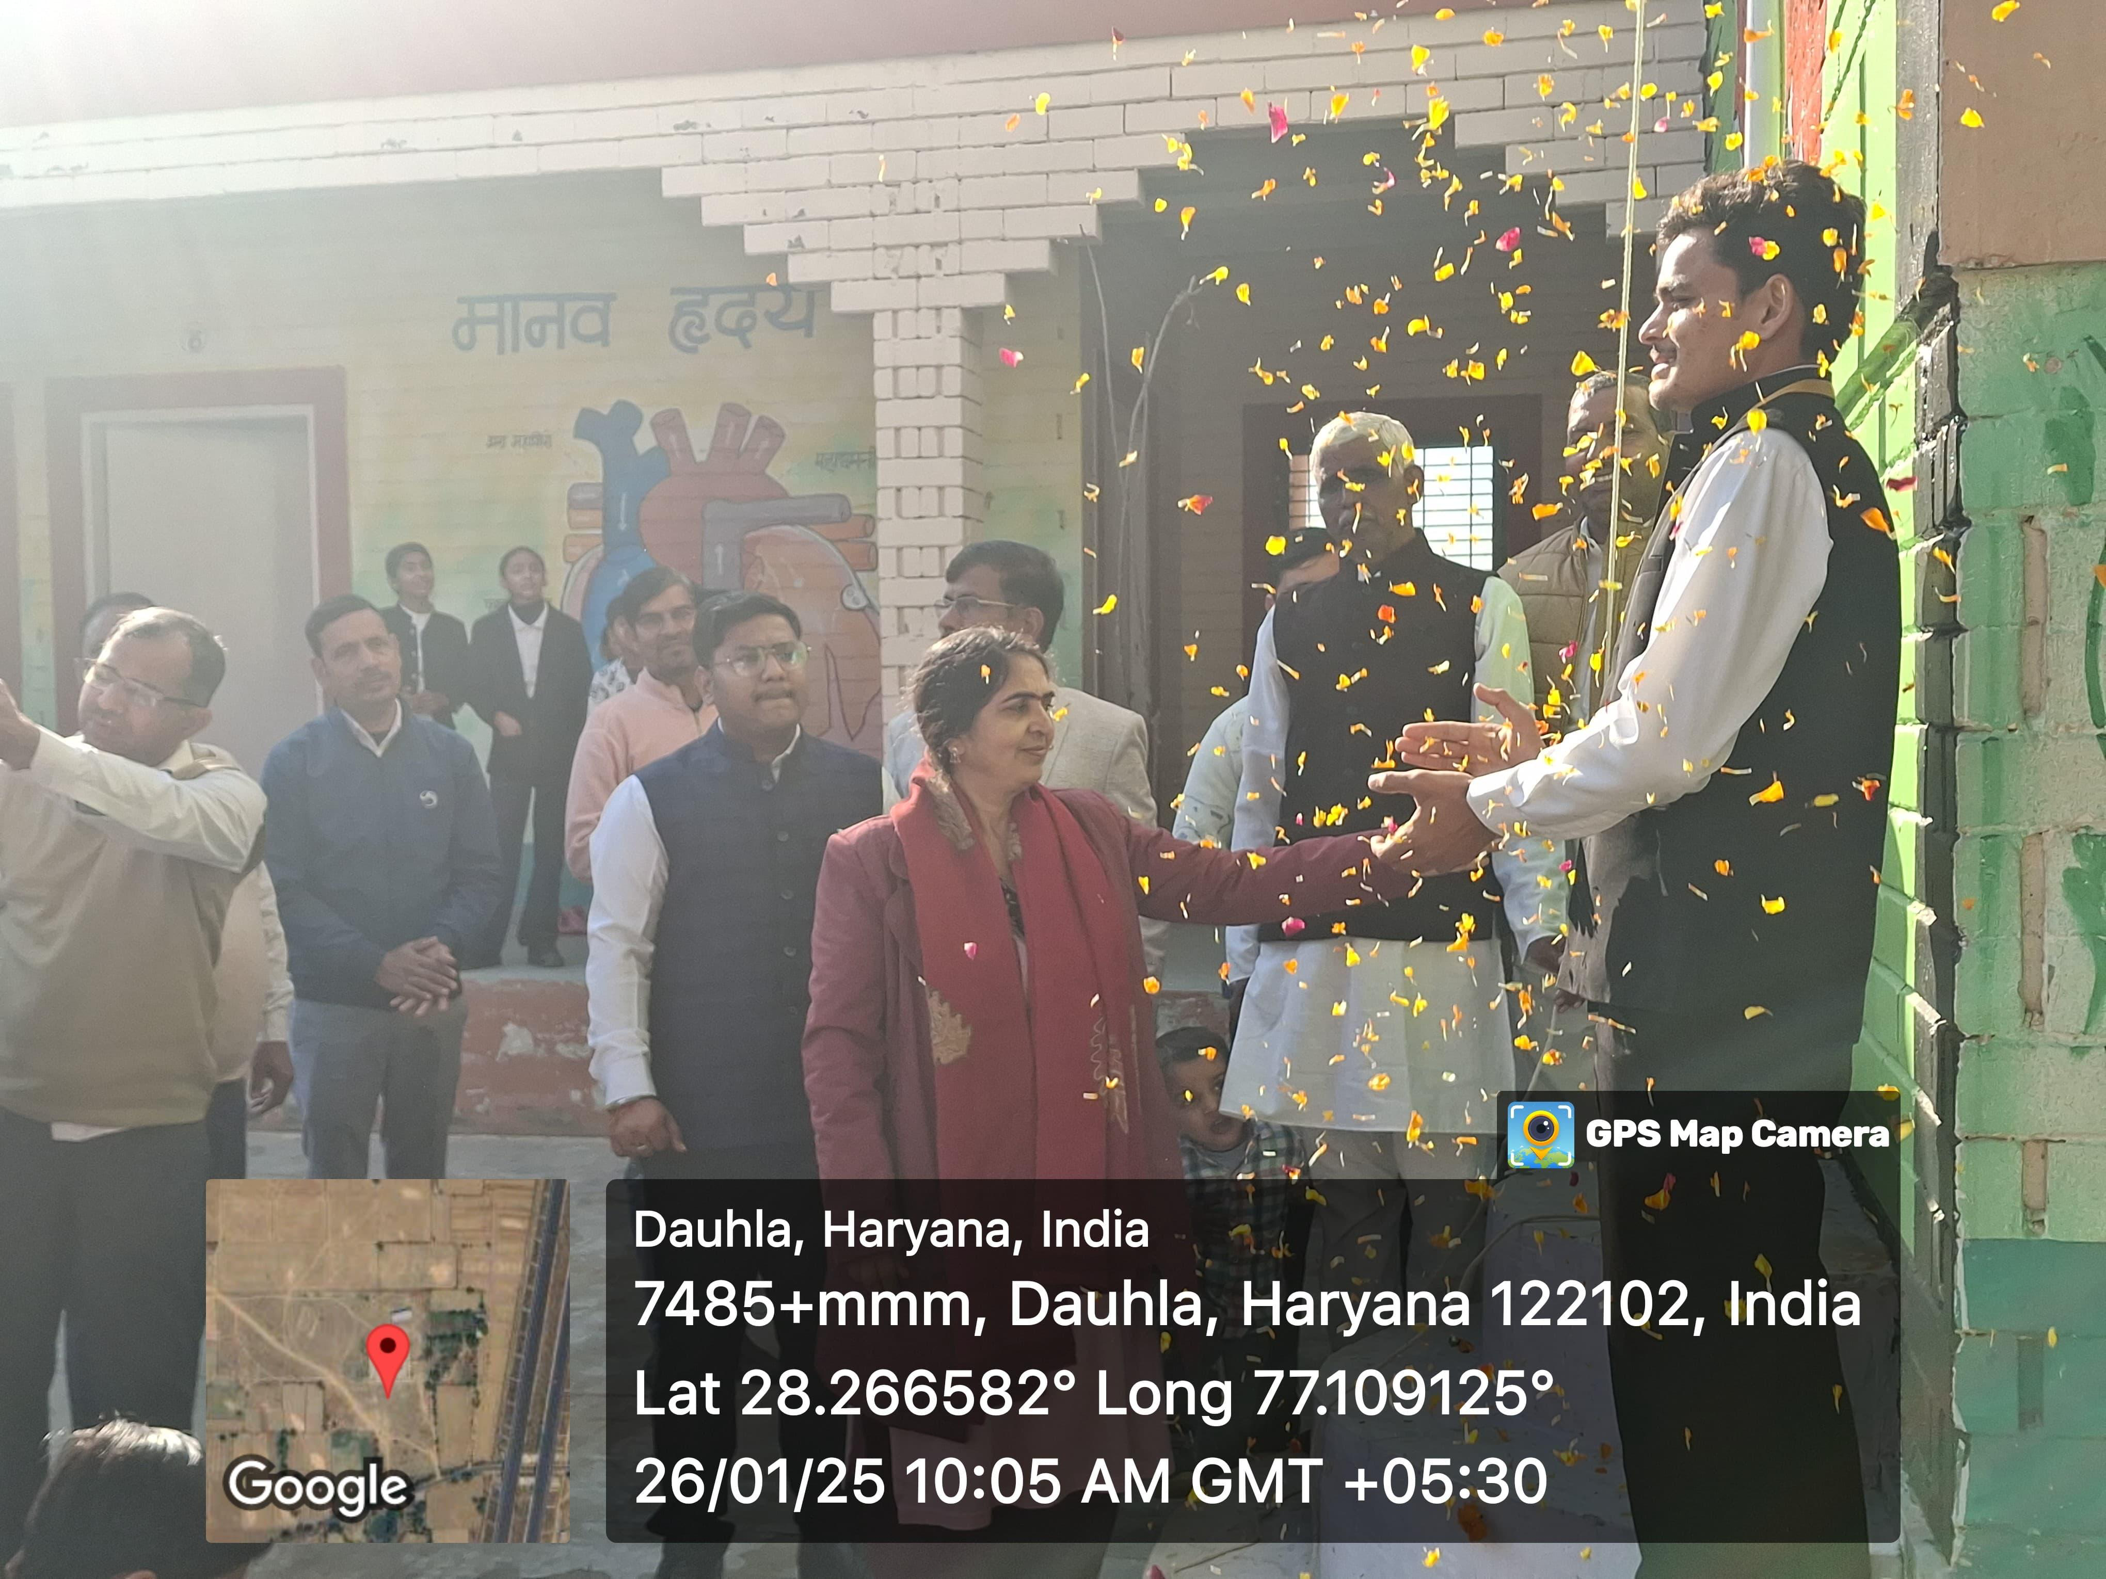
Republic Day 2025 celebrated with enthusiasm at Dhaula Village, honoring patriotism and community spirit with the Youth Red Cross Committee

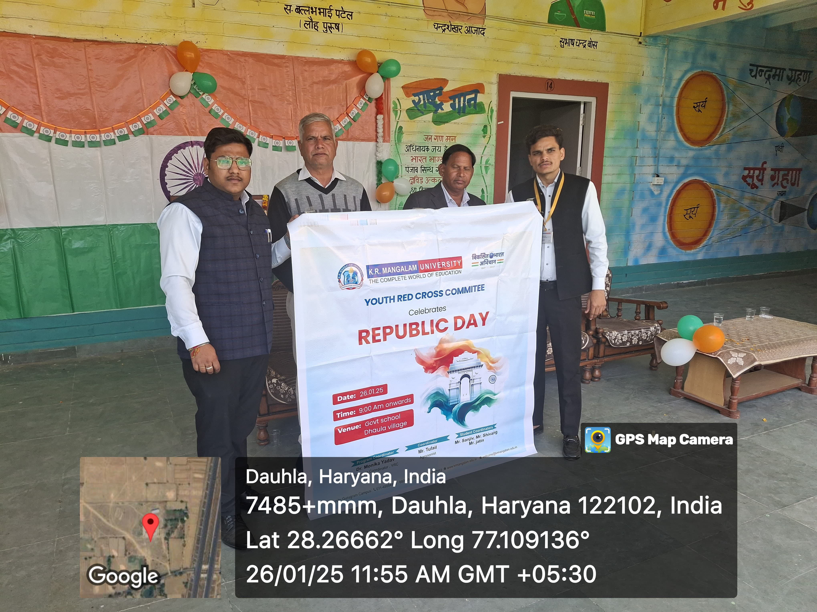

Youth Red Cross Committee of K.R. Mangalam University proudly celebrates Republic Day 2025 at Dhaula Village, fostering patriotism and community engagement

Report verified by | Dr. Monika Yadav
Report seen by IQAC Coordinator | Dr. Shikha Dutta Sharma

