REPORT ON POSTER MAKING COMPETION ON "SAY NO TO DRUGS "

Event Type: Poster making competition
Venue: Multi-Purpose Hall, KRMU
Mode of Activity: Offline
Coordinator: Dr. Thomas Monteiro (NSS Program officer), Dr. Sapna Rana, NSS Member

Organized by: NSS KRMU

Date: 04-02-2025
Participants: 60 students from different schools of University
Judges: Dr. Shikha Dutt, IQAC Coordinator KRMU, Dr. Thomas Monteiro (NSS Program officer) KRMU

Introduction:
On February 4, 2025, the National Service Scheme (NSS) organized an impactful Poster Making Competition on the theme "Say No to Drugs" at the Multi-Purpose Hall. The event was aimed at raising awareness about the devastating effects of drug abuse and encouraging students to advocate for a drug-free society. This initiative sought to engage students in a creative and thought-provoking manner, reinforcing the importance of making informed life choices.
Objective:
The primary objectives of the competition were:

- To raise awareness about the harmful effects of drug abuse.

- To encourage students to creatively express their perspectives on a drug-free society.

- To foster a sense of responsibility among youth in combating drug addiction.

- To enhance students’ artistic and communicative abilities by using visual storytelling.

Content:
The competition attracted enthusiastic participation from 60 students across various students from all disciplines in KRMU. Each participant utilized their artistic skills to create vibrant and impactful posters that highlighted the dangers of substance abuse and the benefits of a drug-free lifestyle. The posters effectively conveyed strong messages about informed decision-making, health, and social well-being. The competition also provided students with an opportunity to visually articulate their understanding of the theme, while advocating for a crucial social cause.
The event was coordinated by Dr. Thomas Monteiro (NSS Program Officer) and Dr. Sapna Rana (NSS Member), whose guidance and meticulous planning ensured the smooth execution of the competition. The posters were evaluated by the esteemed judge, Dr. Shikha Dutt, who assessed the entries based on the following criteria:

- Creativity and originality

- Relevance to the theme

- Clarity of message

- Overall presentation and visual appeal

Outcomes of Session: The event successfully provided students with a platform to creatively express their thoughts while spreading a crucial social message. It reinforced the importance of standing against drug abuse and making informed life choices. Competitions like these not only nurture creativity but also inspire the younger generation to actively contribute to societal well-being. By engaging in such awareness programs, students develop a stronger sense of responsibility towards building a healthier and more informed community. Cash prizes were given to winners, the first prize winner was rewarded with 1000 Rs, 700 Rs were given to second position holder and finally Rs 300 were given to Third position holder. The competition concluded on a high note with the announcement of winners:
First Prize: Riya Goswami (B.A. Psychology)- Rs. 1000
Second Prize: Somiya (B. Des UI & UX)- Rs. 700
Third Prize: Nishtha Yadav (B. Sc Chemistry)- Rs. 300

Conclusion

The "Say No to Drugs" Poster Making Competition was an enlightening and engaging event that highlighted the power of creativity in addressing critical social issues. By participating in this competition, students not only showcased their artistic talents but also demonstrated a deep understanding of the detrimental effects of drug abuse. The event successfully instilled in students the importance of making informed choices and advocating for a healthier society free from substance abuse.

Through visually compelling posters, students effectively conveyed messages that underscored the need for awareness, education, and collective action in tackling drug addiction. The competition served as a reminder that combating social evils requires a multi-faceted approach that involves education, advocacy, and community engagement. It also emphasized the role of youth in leading positive societal change, reinforcing the idea that they can be influential agents in the fight against drug abuse. Moreover, the event fostered a sense of teamwork and mutual encouragement among participants. By coming together under a shared cause, students cultivated an environment of support and motivation, strengthening their resolve to stand against social vices. The meticulous organization and seamless execution of the competition by the NSS team, under the guidance of dedicated faculty members, ensured that the event was both impactful and inspiring. The success of the competition underscores the significance of integrating awareness programs within academic institutions to nurture responsible, socially aware individuals. It is through such initiatives that students are empowered to voice their concerns, promote healthy lifestyles, and contribute to the betterment of society. Moving forward, similar events should continue to be encouraged to sustain momentum in raising awareness about pressing social issues and inspiring proactive participation in social causes.

In conclusion, the "Say No to Drugs" Poster Making Competition was not just an artistic endeavor but a movement towards creating a more informed and responsible generation. By combining creativity with advocacy, the event left a lasting impact on participants and the audience alike, reinforcing the collective commitment towards a drug-free future.

Images: 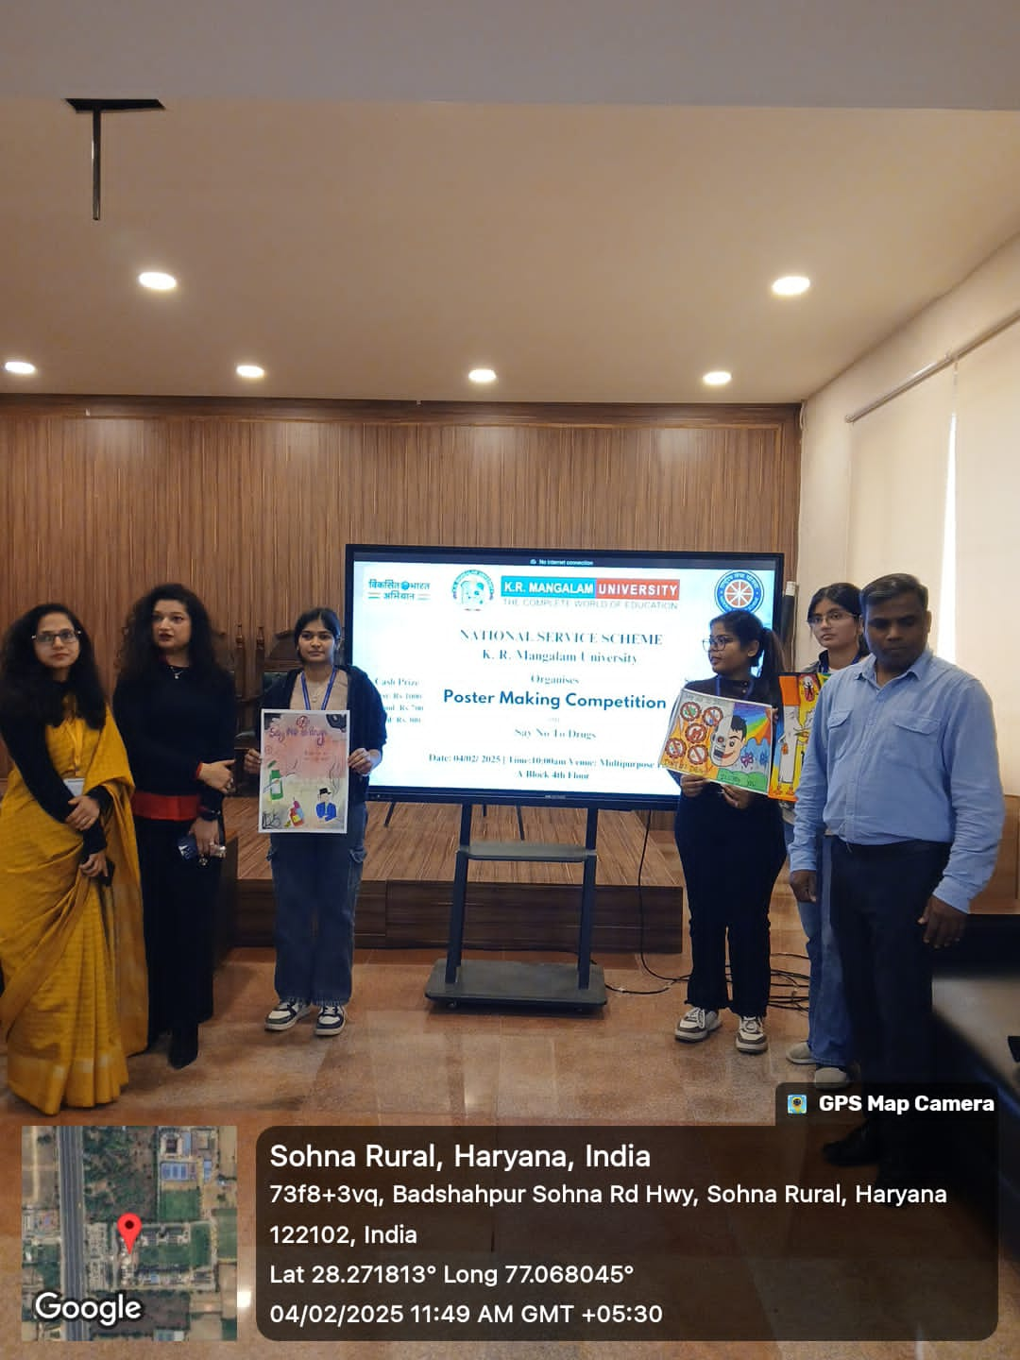

Pic 1: E banner on Poster making competion

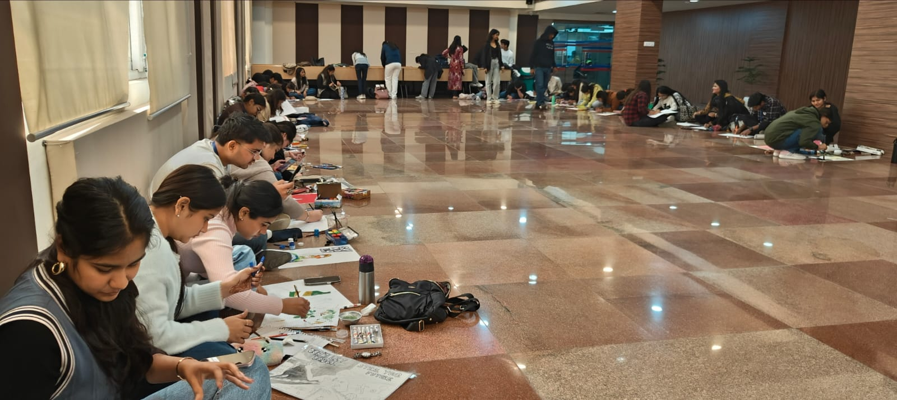
Pic 2: Students enthusiastically making posters
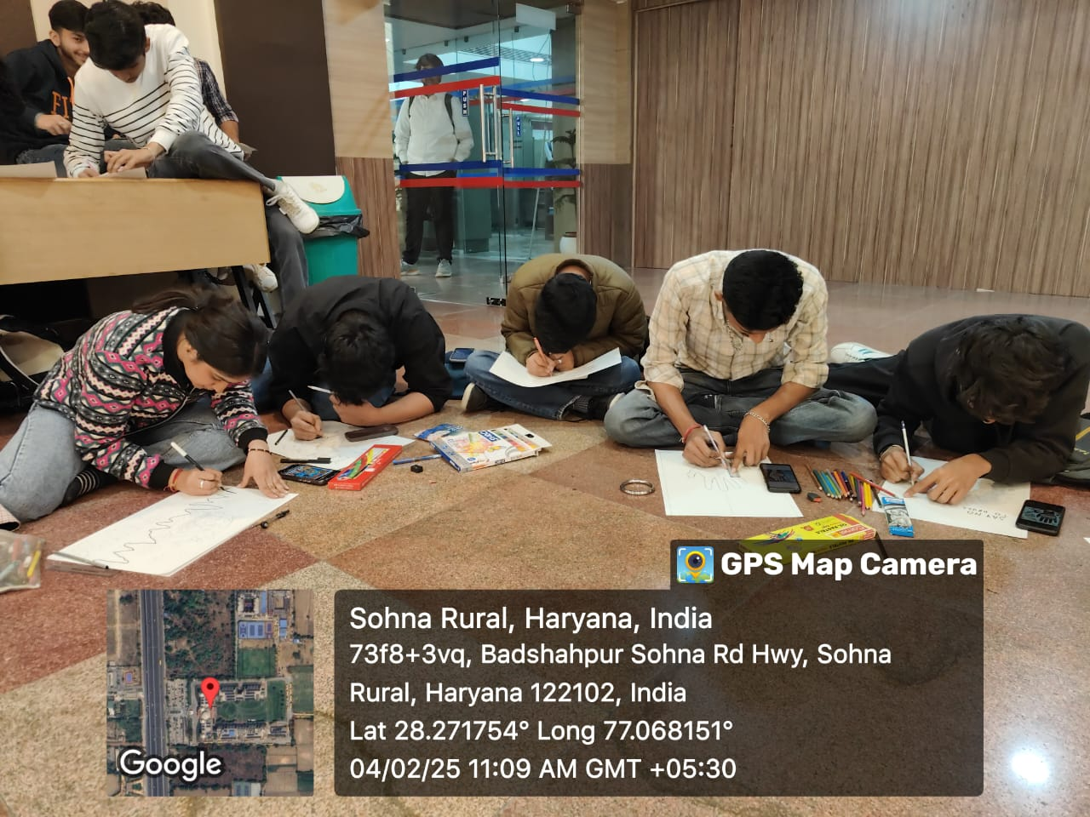
Pic 3: Putting their creativity
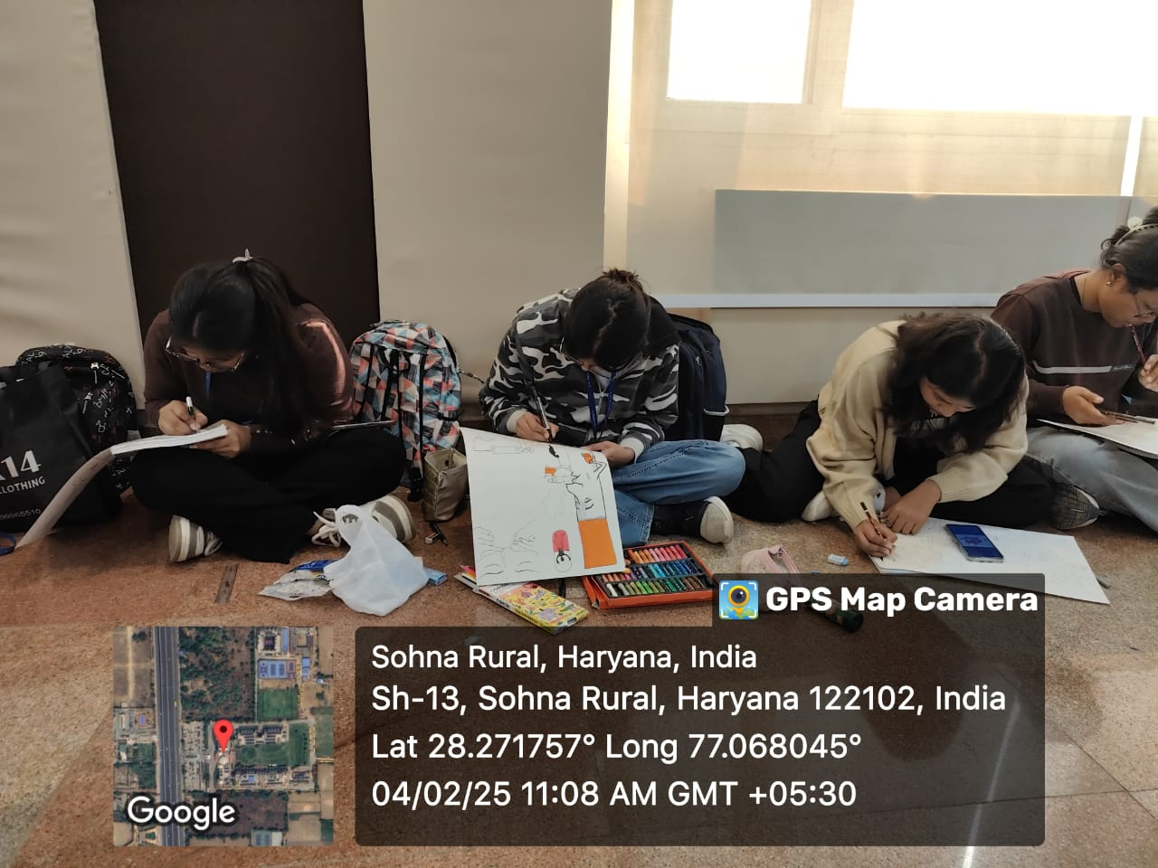
Pic 4: Students showcasing their talent
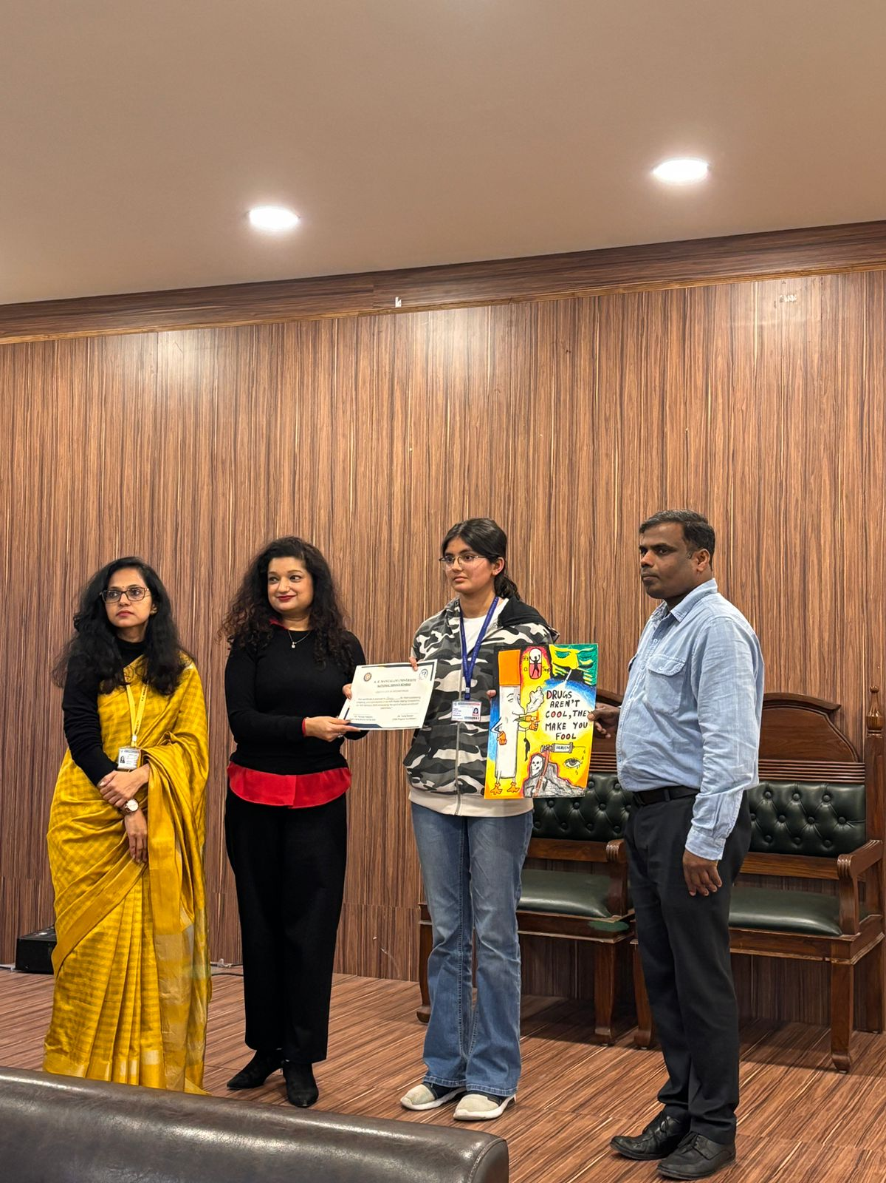
Pic 5: Prize winners
Report Prepared by  Report Verified by | Dr Sapna Rana (NSS Member)  Dr Neeraj Kumari (NSS Program Coordinator)
Report Verified by IQAC Coordinator | Dr Shikha Dutt Sharma

