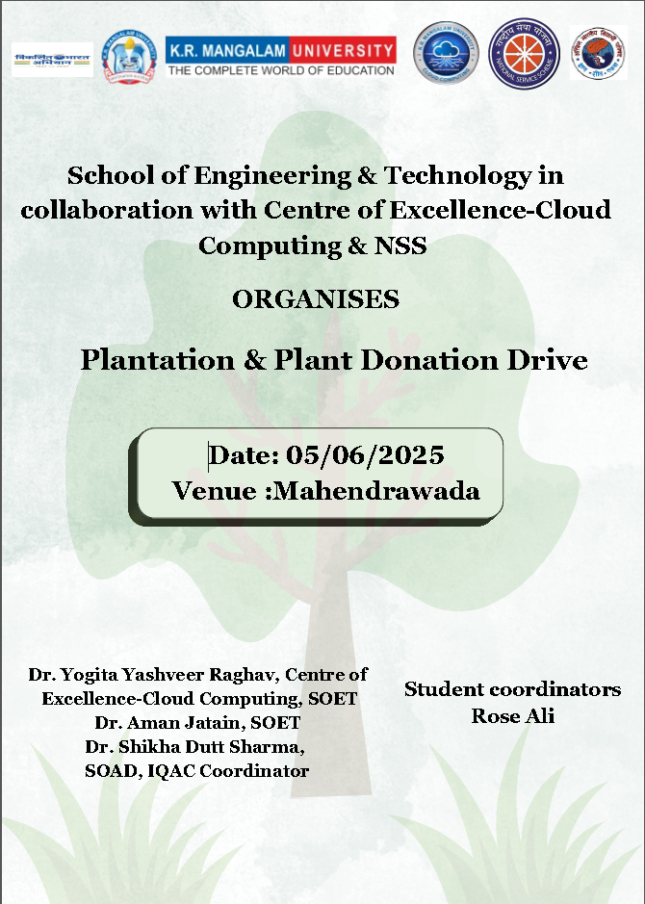

Report on
Plantation & Plant Donation Drive

Date: 06/06/2025

Venue: Govt. Sr. Sec. School, Teekli, Gurugram & Mahendrawara
Event Type: Plantation & Plant Donation Drive
Mode of Activity: Offline
Target Group: Secondary School Students, faculty and villagers from surrounding areas

Coordinators: Dr. Yogita Yashveer Raghav, Dr. Aman Jatain, Dr. Shikha Dutt Sharma

Organized by: School of Engineering and Technology in collaboration with Centre of Excellence – Cloud Computing, Akhil Bhartiya Vidyarthi Parishad (ABVP), Gurugram Mahanagar &NSS

Number of Participants: 33 Govt. Sr. Sec. School Students and Villagers 3 Faculty members and 2 NSS Volunteers 2 ABVP Volunteers (35 External Internal 5)

Introduction
To commemorate World Environment Day on 5th June 2025, the School of Engineering & Technology (SOET) at K.R. Mangalam University, in collaboration with the Centre of Excellence – Cloud Computing and Akhil Bharatiya Vidyarthi Parishad (ABVP), Gurugram Mahanagar, organized a large-scale Plantation and Plant Distribution Drive at Government Senior Secondary School, Teekli, Gurugram. The initiative was aimed at spreading awareness about environmental conservation, promoting green practices, and encouraging active participation from school children and the local rural community. This event directly contributed to the following United Nations Sustainable Development Goals (SDGs):
- SDG 13: Climate Action – by reducing carbon footprint through increased green cover.
- SDG 15: Life on Land – by enhancing biodiversity and ecological balance through tree plantation.
- SDG 11: Sustainable Cities and Communities – by engaging the local population in building greener and more sustainable environments.

Objectives
The event aimed to promote environmental awareness and encourage students and the rural community to contribute to a greener and healthier planet. The key focus was on planting fruit-bearing and flowering trees and distributing them to schools and nearby villages.

Methodology
- Massive Plantation Drive: Over 100 saplings, including fruit-bearing and flowering plants, were planted and distributed.
- Plant Distribution: Plants were distributed to villagers and school authorities to ensure long-term environmental impact.
- Awareness Campaign: A brief awareness session on the importance of tree plantation and environmental sustainability was conducted.
Key Highlights:
- Plants were planted in the school premises and nearby villages including Mahendrawad and Badshahpur.
- Students, school staff, and locals actively participated in the drive, enhancing community engagement.
- Special emphasis was laid on the role of students in preserving environmental balance for a sustainable future.
Outcome
- Plants were planted in the school premises and nearby villages including Mahendrawad and Badshahpur.
- Students, school staff, and locals actively participated in the drive, enhancing community engagement.
- Special emphasis was laid on the role of students in preserving environmental balance for a sustainable future.

Conclusion
The plantation drive on World Environment Day was a resounding success, fostering environmental responsibility and active community participation. The joint initiative by the School of Engineering, CoE Cloud Computing, and ABVP highlighted the importance of collaborative efforts in creating a greener tomorrow.

Future Scope
Building on the success of the plantation drive, the School of Engineering & Technology, along with the Centre of Excellence – Cloud Computing and ABVP Gurugram, plans to initiate an “Adopt-a-Plant” campaign to ensure sapling survival and encourage long-term community involvement. Future activities include greening more school campuses, conducting environmental awareness workshops, and using technology to monitor plant growth—aligning with SDG 4, SDG 9, SDG 13, SDG 15, and SDG 17. These efforts aim to strengthen environmental consciousness and foster sustainable practices across rural and academic communities. across rural and academic communities.
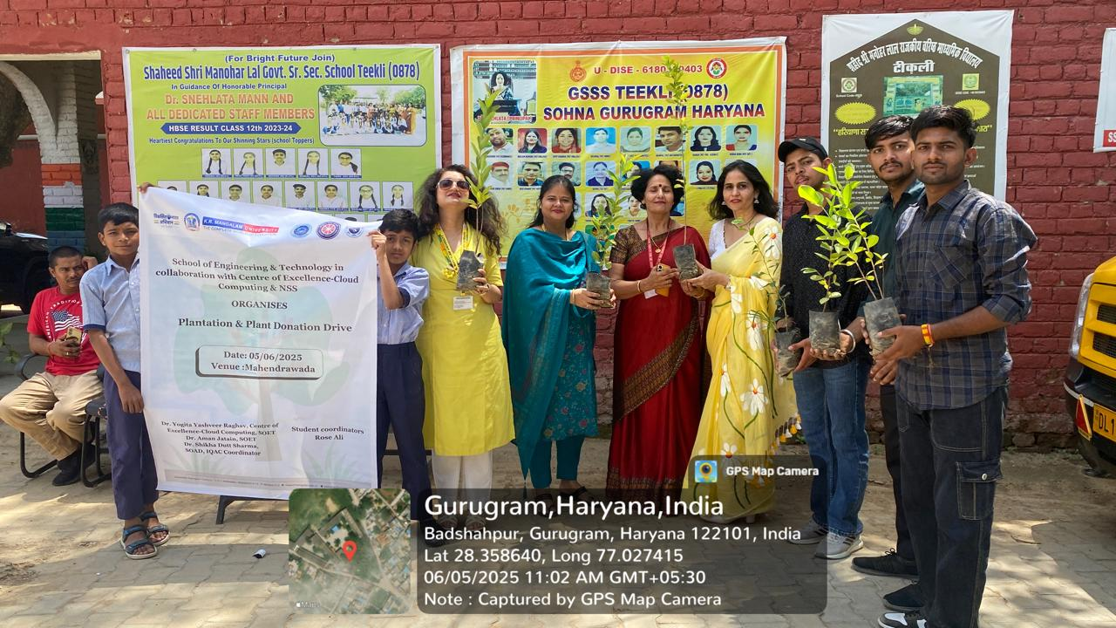
Photo 1: Welcoming the Principal of Govt. Sr. Sec. School, Teekli, to inaugurate the World Environment Day Plantation Drive
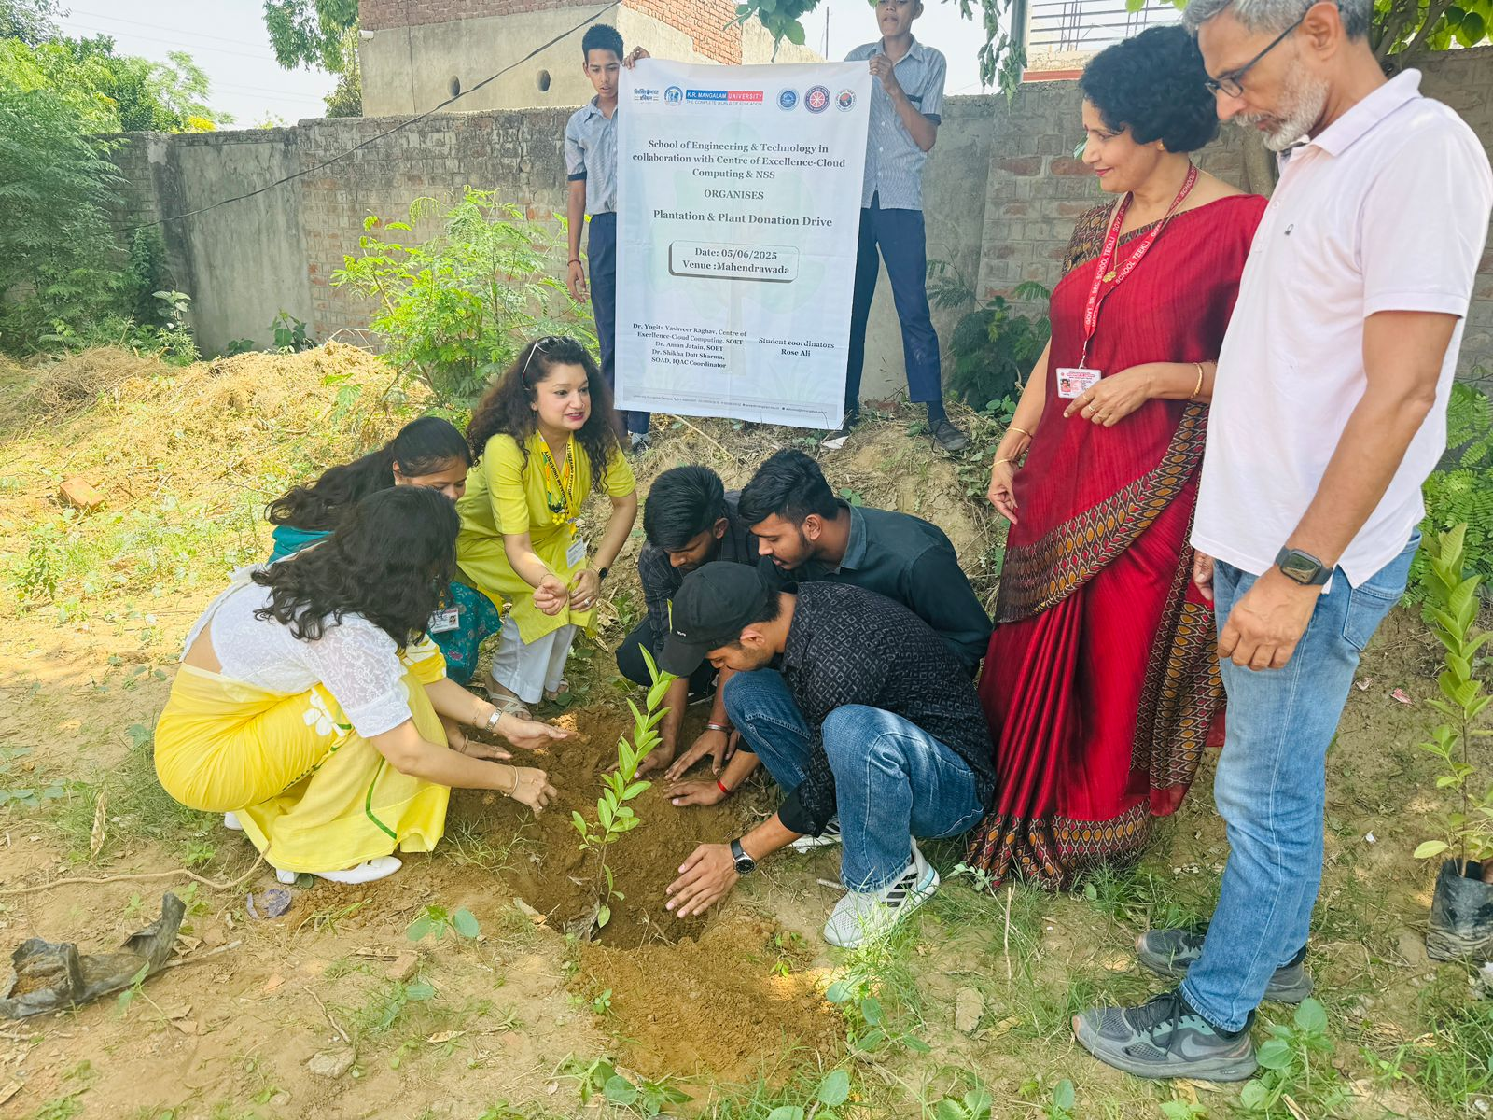
Photo 2: Planting with the ABVP volunteers and School Staff

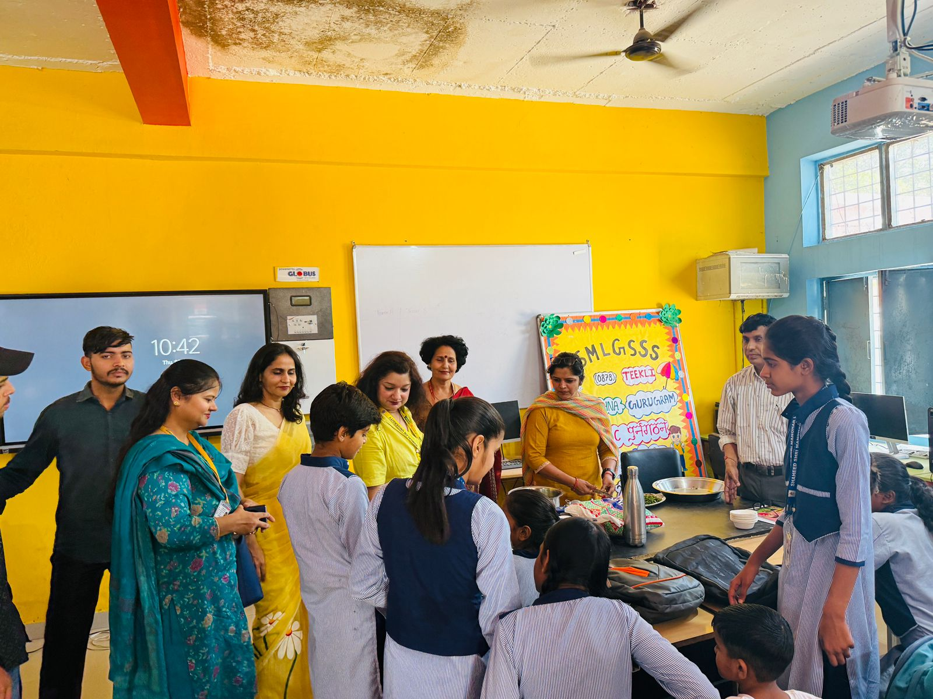

Photo 3: Awareness session on the importance of tree plantation and environmental sustainability

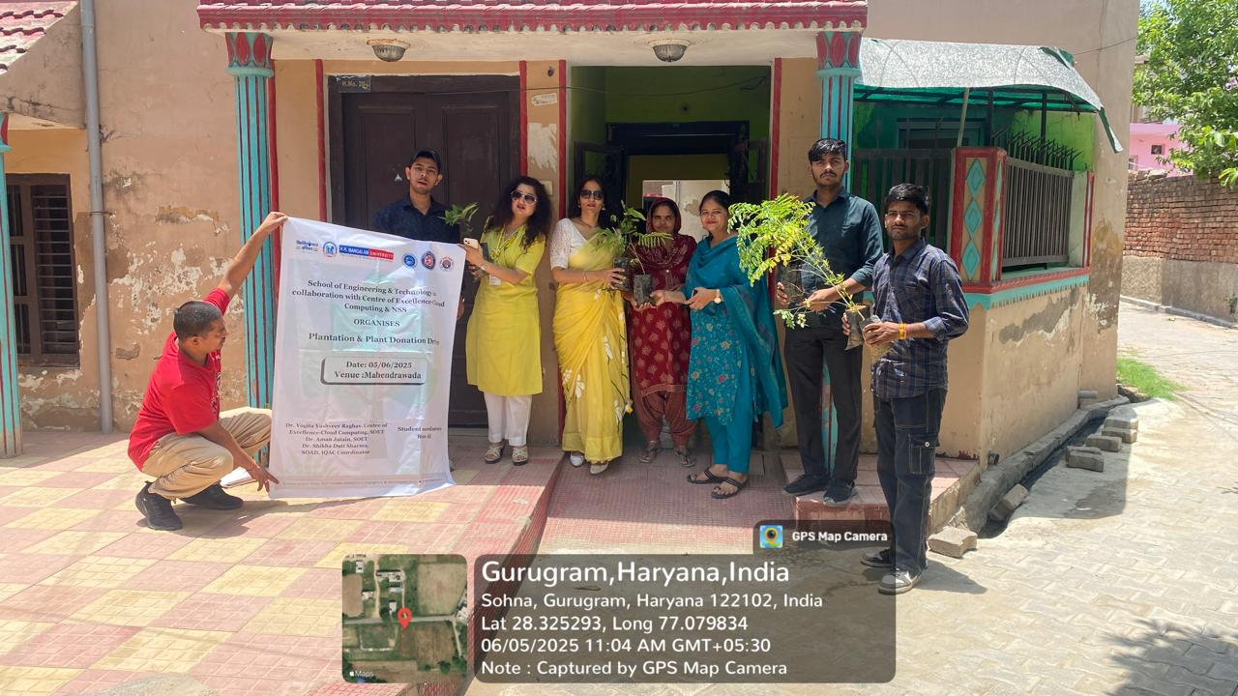
Photo 4: Donating plants to the villagers
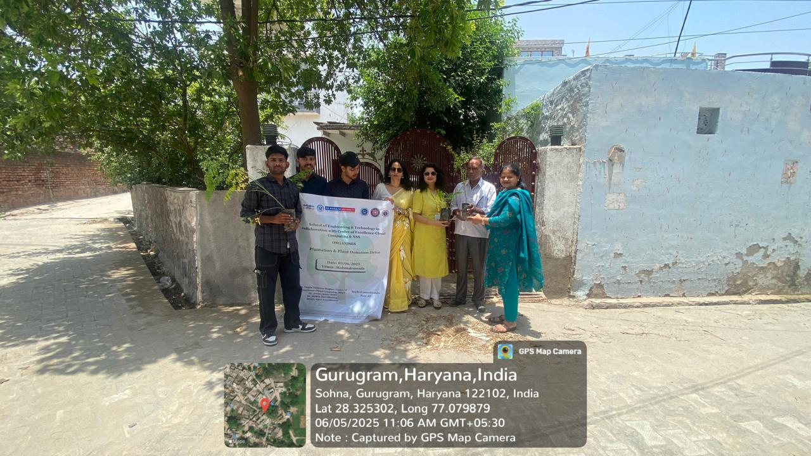
Photo 5: Donating plants to the villagers

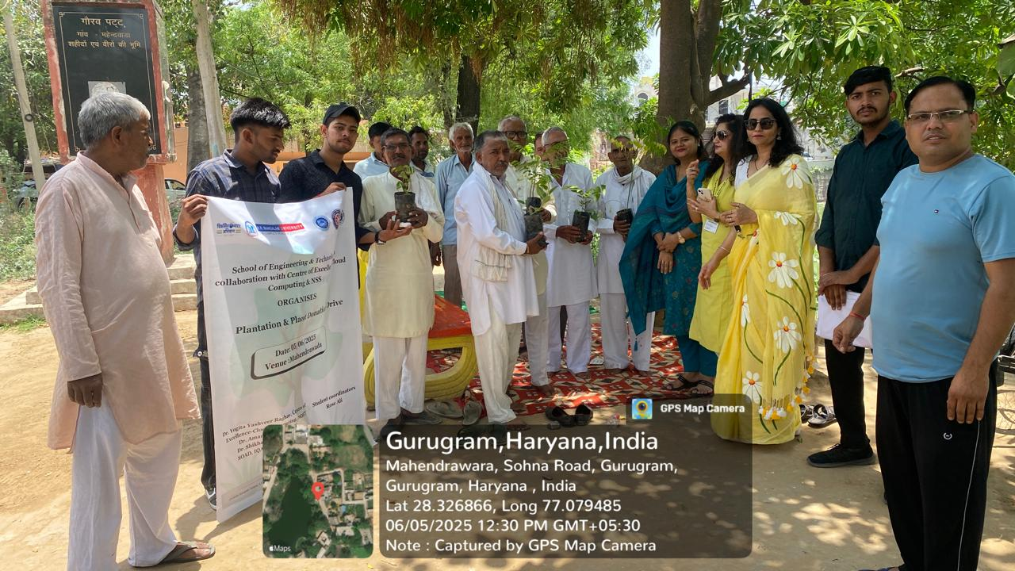
Photo 6: Donating plants to the group of people.

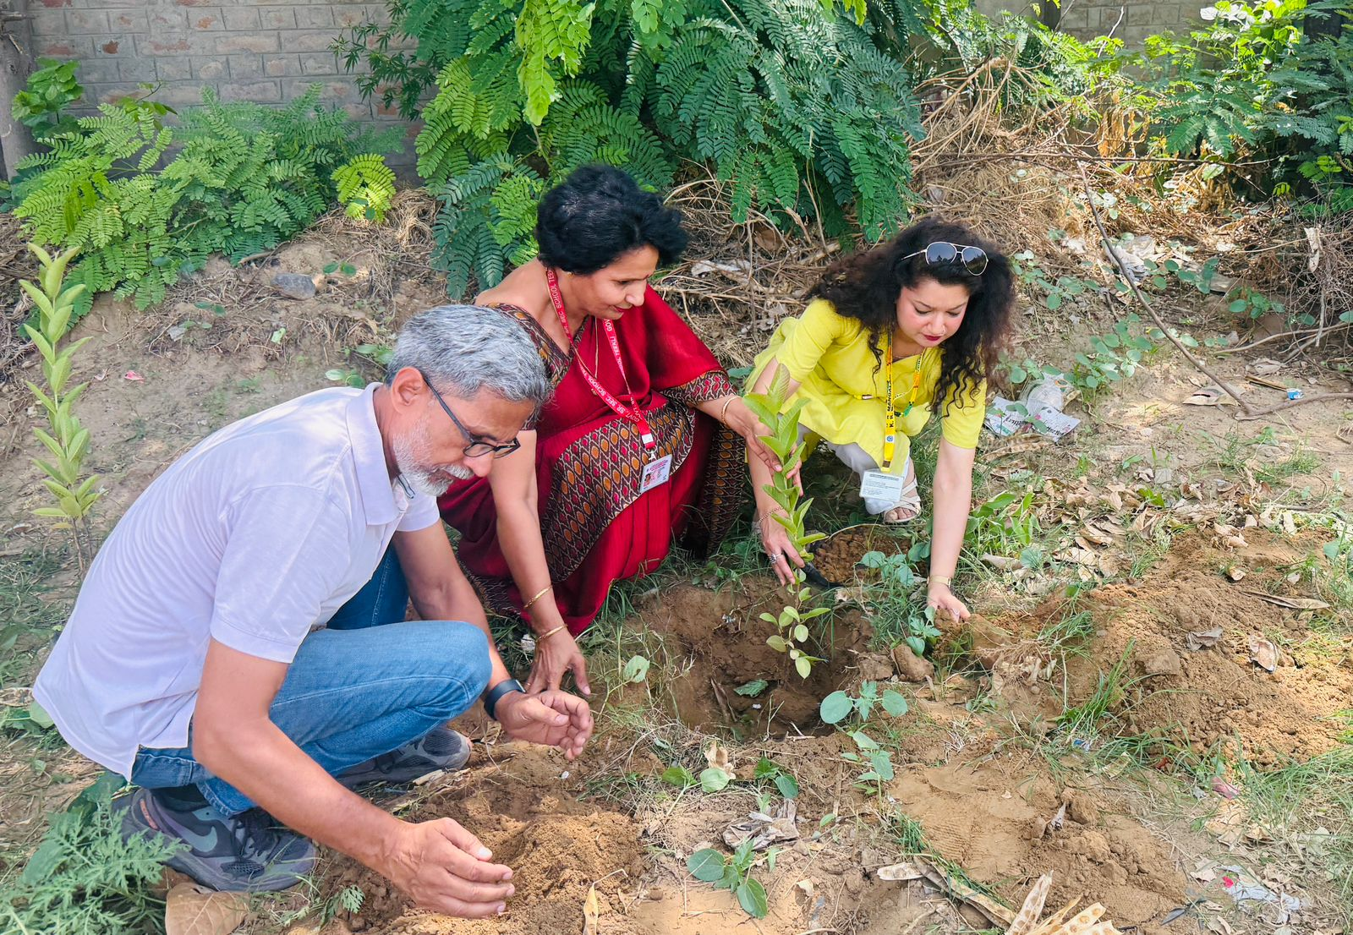
Photo 7: Planting plants with school Authorities
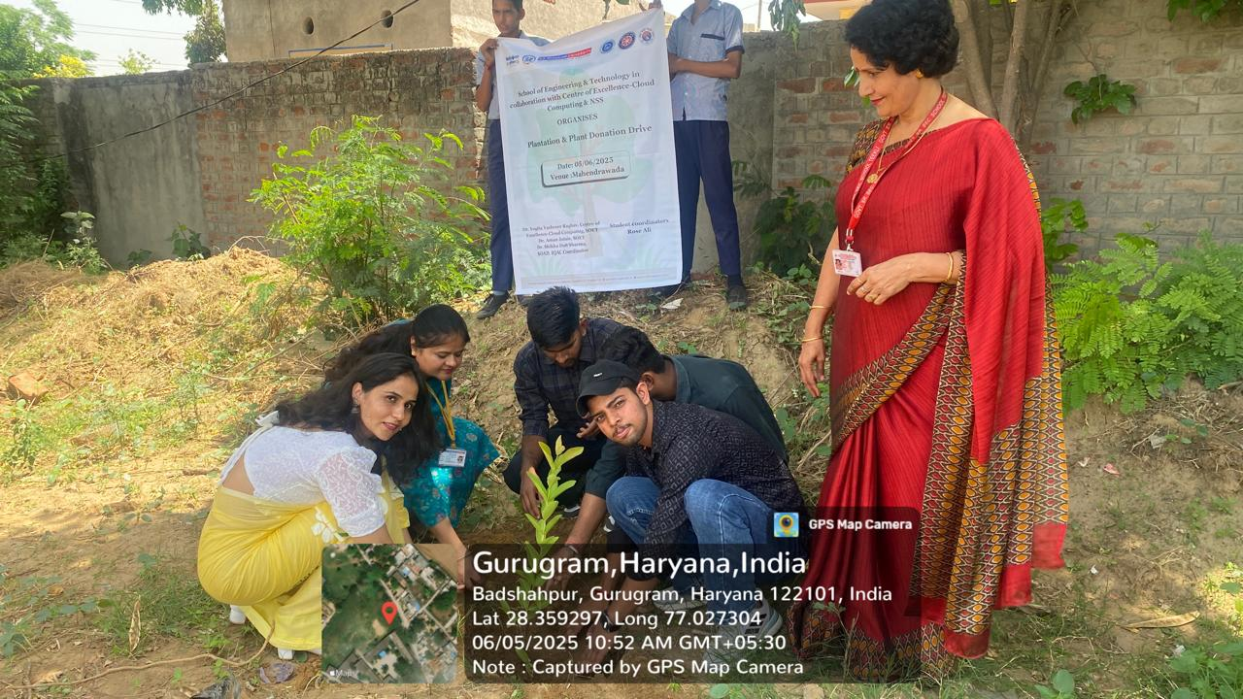
Photo 7: Planting plants with ABVP Volunteers

Report Prepared By | Dr. Yogita Yashveer Raghav
The report verified by the NSS Coordinator  (Event Coordinator) | Dr. Yogita Yashveer Raghav ,Neeraj Kumari
Dean SOET | Prof. Dr. Pankaj Agarwal
IQAC Coordinator | Dr. Shikha Dutt Sharma

