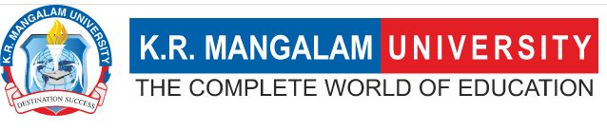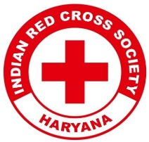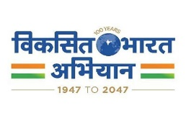
Report on
Synergy: Wellness and Development Program

Date: 18th October 2024
Venue: A 213, A Block, K.R. Mangalam University
Total No. of Participants: 107 students of KRMU
Event Type: Live Seminar
Mode of Activity: Offline
Target Group: Students of K.R. Mangalam University
Organized by: Youth Red Cross Committee, K.R. Mangalam University, in collaboration with The Kailasa Foundation
Resource Person: Mr. Varun Sharma, Founder of the Kailasa Foundation,
Event Coordinator: Dr. Monika Yadav
Student Coordinators: Mr. Jatin & Mr. Amar
Introduction:
The Youth Red Cross Committee of K.R. Mangalam University organized a live seminar titled "Synergy: Wellness and Development Program," focusing on physical, digital, and mental well-being. The event was held in collaboration with The Kailasa Foundation, aiming to introduce an overall development program for the participants. The session was conducted by Mr Varun Sharma, the Founder of The Kailasa Foundation, who shared insights on holistic development strategies.

Objectives:
Objectives are as follows:
- To educate participants about the importance of physical, digital, and mental well-being.
- To provide an overview of wellness practices that contribute to overall personal development.
- To engage the university community in discussions around maintaining balance in different aspects of life.
- To foster collaboration between educational institutions and wellness organizations.

Content:

The seminar commenced with an introduction by Dr. Monika Yadav, the Program Coordinator of the Youth Red Cross Committee. She emphasized the importance of maintaining a balanced lifestyle in today’s fast-paced and digitally driven world. She set the stage for the event by highlighting the need for holistic well-being, integrating physical, digital, and mental health. Following her introduction, the session was led by Mr. Varun Sharma, the Founder of The Kailasa Foundation.
Mr. Sharma began by discussing the importance of physical well-being, stressing the need for a healthy lifestyle through regular exercise, proper nutrition, and adequate rest. He emphasized how these fundamental aspects of physical health form the foundation for overall well-being. Transitioning to digital wellness, Mr. Varun Sharma underlined the significance of managing screen time effectively and creating a balanced relationship with digital devices. He explained how digital overuse could affect mental health, urging participants to adopt mindful practices in their digital lives.

Outcome:

- Participants comprehensively understood the interconnectedness of physical, digital, and mental health.
- The seminar raised awareness on achieving a balanced lifestyle by adopting simple yet effective wellness practices.
- Attendees learned techniques that can be implemented in their daily routines to improve overall well-being.
- Strengthened the collaboration between the Youth Red Cross Committee and external wellness organizations, setting the stage for future events.

Conclusion:

The seminar "Synergy: Wellness and Development Program" successfully educated and empowered the participants to prioritize their well-being in all aspects. The engaging session led by Mr. Varun Sharma highlighted practical strategies to maintain a balanced and healthy lifestyle. The collaboration with The Kailasa Foundation added significant value to the program, and the event received positive feedback from all participants, reflecting the importance of such initiatives within the university community.

Photos of the Seminar:
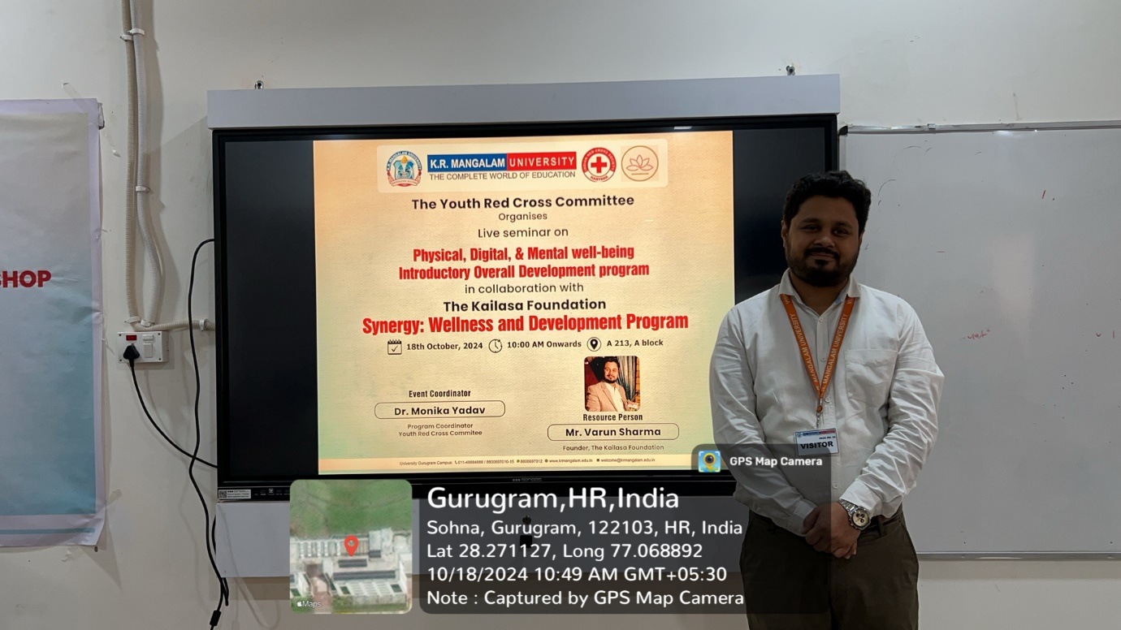

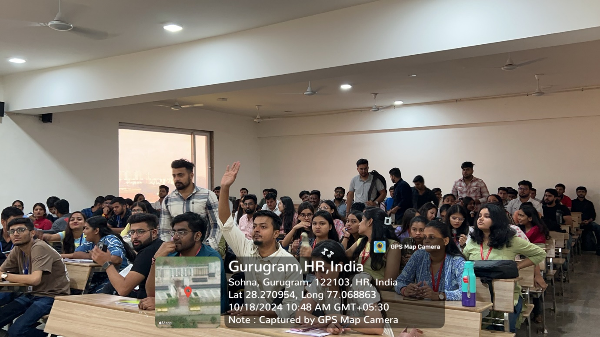

Report prepared by | Dr. Monika Yadav
Report verified by Event Coordinator | Dr. Monika Yadav
Report Seen by Red Cross Coordinator | Dr. Monika Yadav
Report seen by IQAC Coordinator | Dr. Shikha Dutta Sharma

