Report on "Empower Her: Celebrating Strength and Spirit through Performance"

Event Type: Nukkad Natak (Extension Activity)
Venue: Abheypur Village
Mode of Activity: Offline
Coordinator: Dr. Sapna Rana & Dr. Vicky Kapoor (NSS Member)

Organized by: NSS KRMU

Date: 05-03-2025
Participants: 30 NSS Volunteer & More than 30 Villagers
Student Coordinator: Ansh (B.Tech), Pihu (BBA) and Anushri (BA Psychology) (NSS Volunteers)
SDG: 5 "Achieve gender equality and empower all women and girls

Introduction:
The National Service Scheme (NSS) unit organized a meaningful celebration of International Women’s Day on 5th March 2025 at Abheypur Village. The event aimed to honor the strength, resilience, and achievements of women, while also creating awareness about gender equality and women’s empowerment in rural communities. The program was successfully coordinated by Dr. Sapna Rana and Dr. Vicky Kapoor (NSS Members), with the enthusiastic participation of NSS volunteers, local women, and men.
Objective:
The primary objectives of the event were:

- To celebrate the contributions and achievements of women in all spheres of life.

- To promote awareness about gender equality, women's rights, and empowerment.

- To engage with women in the village and discuss their challenges and aspirations.

- To encourage active participation of NSS volunteers in social responsibility initiatives.

Content:
The event comprised a series of informative and interactive activities aimed at empowering the local community. It began with a warm welcome by the NSS team, followed by an insightful introduction about the significance of International Women’s Day. NSS Volunteer delivered a speech on the importance of women's education and financial independence. A major highlight of the day was a powerful Nukkad Natak (street play) presented by NSS volunteer students on the theme "Empower Her: Celebrating Strength and Spirit through Performance". The play was performed in the village square and witnessed by both women and men of Abheypur. It depicted real-life challenges faced by women and promoted messages of empowerment, resilience, and equality. The performance resonated deeply with the audience and successfully encouraged open discussions among community members. Following the performance, NSS volunteers distributed awareness materials and facilitated an interaction session, where women shared their experiences and ideas for collective growth.
Outcomes of Session:
The event successfully provided students with a platform to creatively express their thoughts while spreading a crucial social message. The event comprised a series of informative and interactive activities aimed at empowering the local community like Nukkad Natak and speech by NSS volunteers. Increased awareness was observed among villagers about health, education, and legal rights of women. Several young girls expressed interest in continuing their education and joining vocational training. Strengthened community bonding between NSS volunteers and villagers.

Conclusion

The International Women’s Day Celebration organized by NSS at Abheypur Village was a successful and impactful event that promoted awareness, empowerment, and unity. The event fulfilled its purpose of honoring women and inspiring change through community engagement. Coordinators Dr. Sapna Rana and Dr. Vicky Kapoor played a vital role in making the event informative and inspiring. The NSS team remains committed to continuing such outreach initiatives to support rural development and women’s empowerment.

This event not only created a space for dialogue on important gender-related issues but also served as a reminder of the power of collective action in transforming communities. The strong participation from both women and men highlighted a growing awareness and willingness to challenge traditional norms. The enthusiasm shown by the youth, especially the NSS volunteers, demonstrated their readiness to lead social change. Going forward, the NSS unit aims to organize follow-up programs, including health camps, vocational workshops for women, and educational support sessions to sustain the momentum generated by this celebration. Together, these efforts will help lay the foundation for a more inclusive and empowered society.
Images:
Pic 1: Students Performing Nukkad Natak
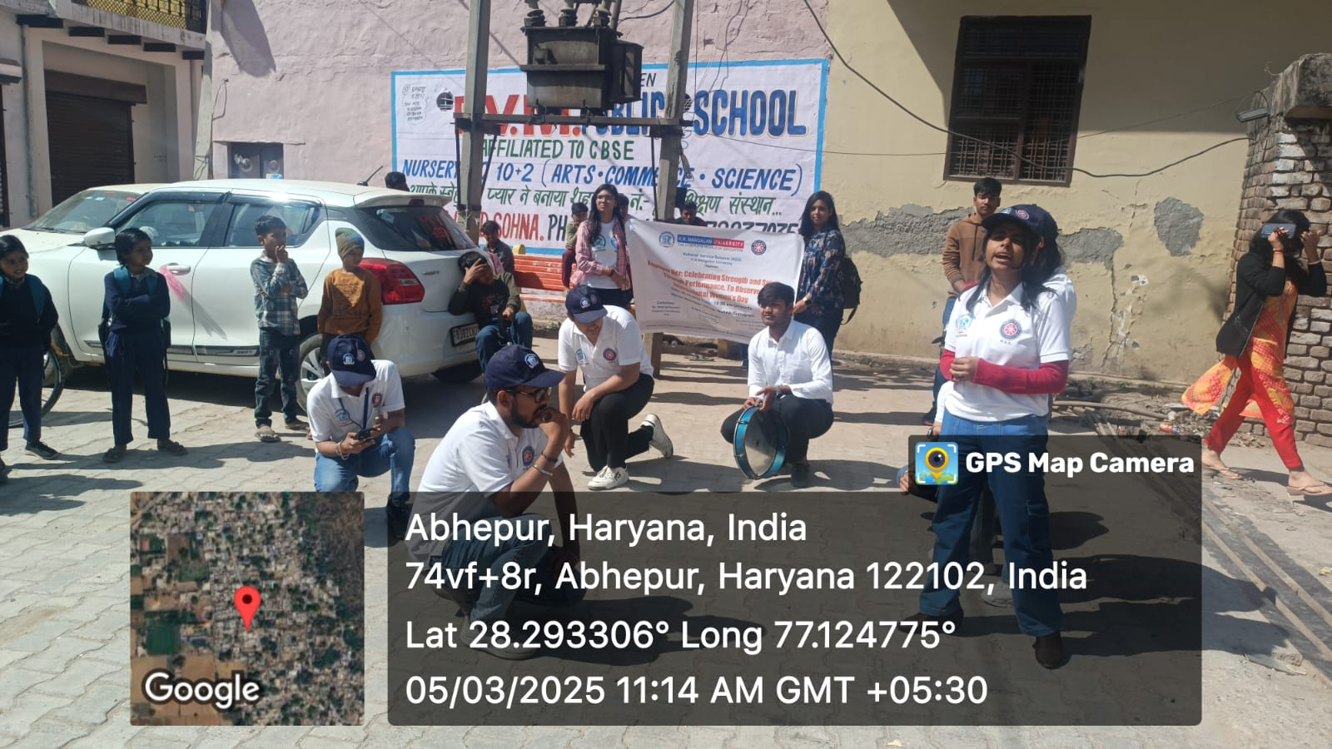
Pic 2: Students enthusiastically making posters
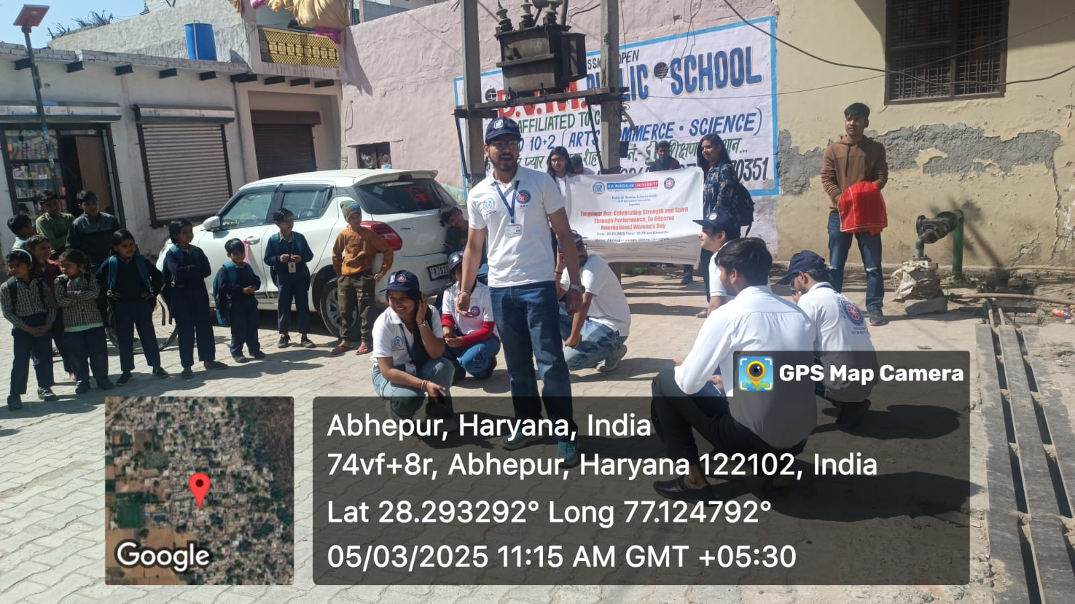
Pic 3: Students giving speech on gender equality
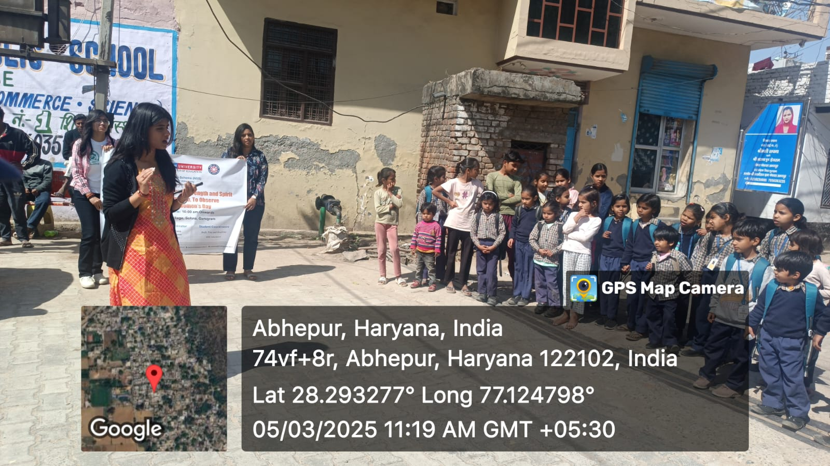
Pic 4: Student giving speech on legal rights of women
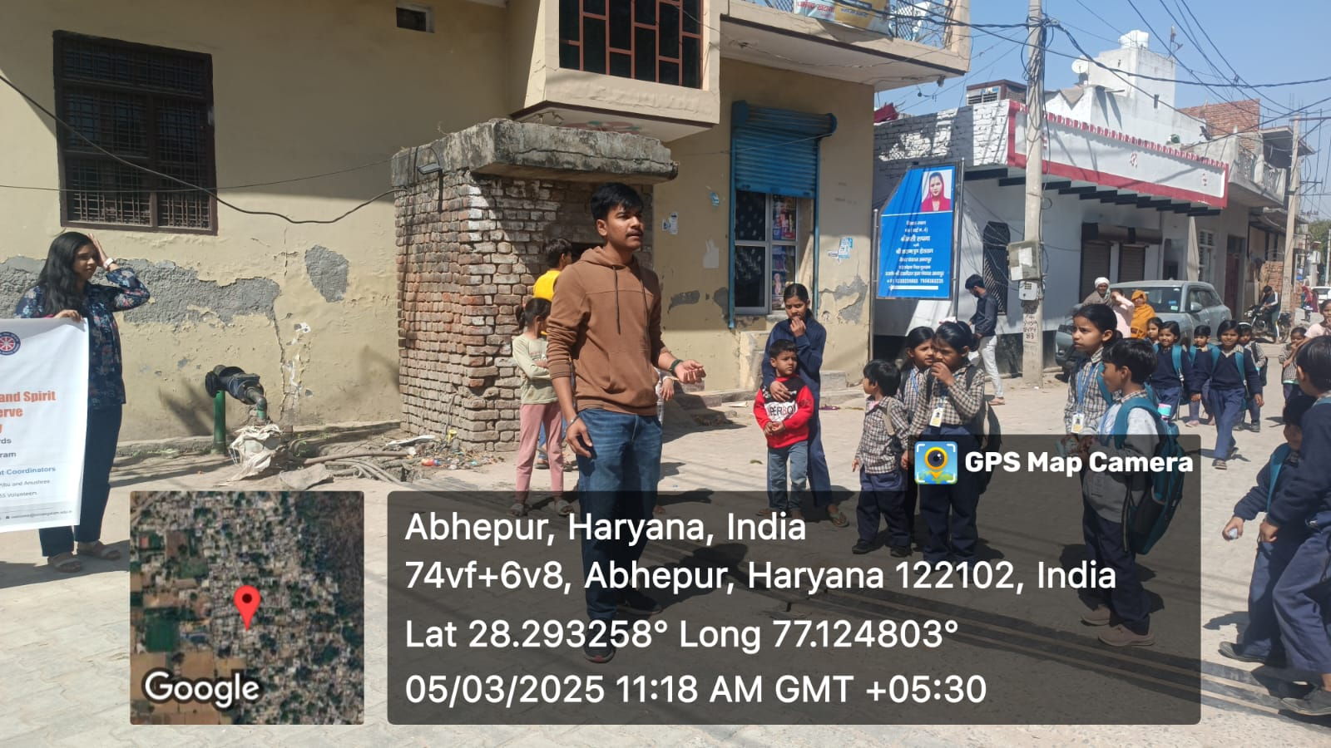
Pic 5: Geotagged photo with Poster
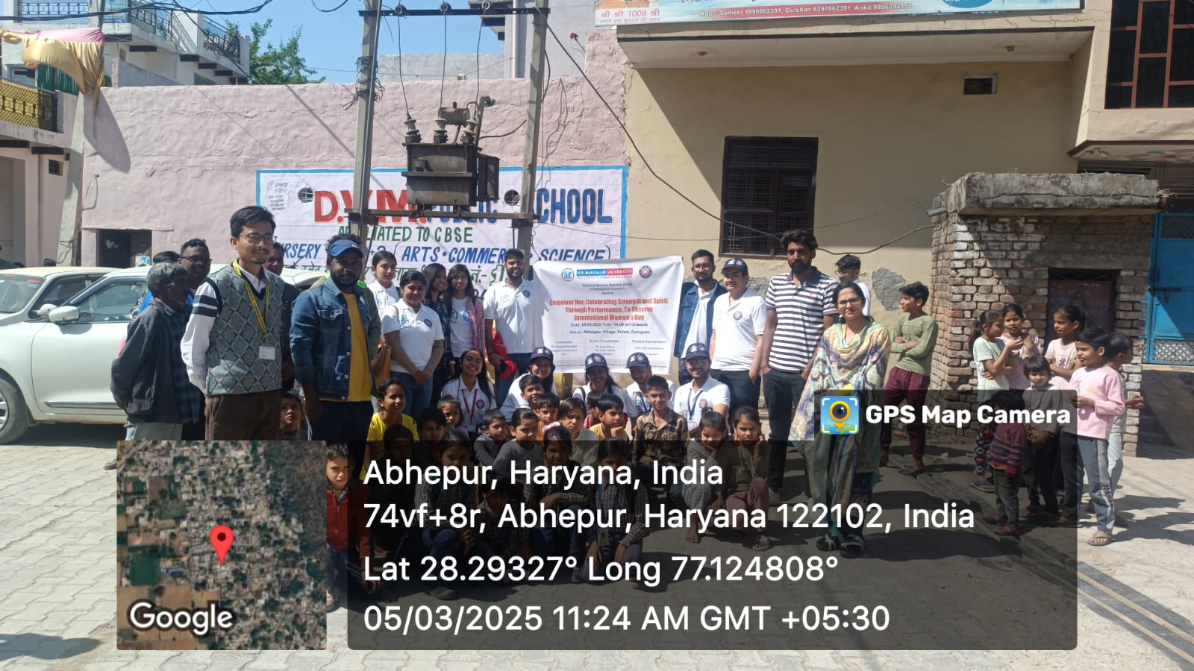

Report Prepared by  Report Verified by | Dr. Sapna Rana (NSS Member)  Dr. Neeraj Kumari (NSS Program Coordinator)
Report Verified by IQAC Coordinator | Dr Shikha Dutt Sharma

