



Gender Audit Report 2023-24

Gender Audit Report 2023-24

Table of Contents
- About KRMU 2
- Introduction 2
- Objectives 3
- Gender Sensitization at K.R. Mangalam University 4
  - Safety and Security 5
  - Facilities available to women employees and students 6
- Gender Sensitization and Safety Committee 7
- Methodology 7
- Gender Balance Across University Statutory Bodies 8
- Data Finding: Gender Ratio across Teachers/Students/Staff Body 9
  - Gender Balance In Enrollment at Graduation 9
  - Gender Balance among Teaching Faculty 10
  - Gender Balance among Non-Teaching Staff 10
- Gender Ratio in various Committees of University 11
- Salient Findings and Recommendations 13
12 Conclusion 14

K.R. Mangalam University, a pioneering Institution of higher education established in 2013 under the Haryana Private University Act, is spread over 26 acres of lush green campus with ultra-modern amenities. It has an Industry-Integrated curriculum with international exposure and Tie-ups with various foreign universities and institutions of higher repute. The university offers 60+ UG and PG programs with full-time faculty with rich industry experience.
- About KRMU
The campus is fully furnished with fully functional high-end laboratories across various disciplines. The University offers multiple programs at UG and PG levels in Engineering, Management, Law, Humanities, Education, Journalism, Sciences, Hotel Management, Physiotherapy, Agriculture, Architecture, and Pharmacy. Various councils recognise the University and have approximately 3200 students on campus.
- Introduction
K.R. Mangalam University is dedicated to fostering and maintaining a community where students, teaching staff, and non-teaching staff can collaborate in an atmosphere where women have a work environment equally with men. The University ensures gender equity and gender sensitivity and provides equal opportunities by giving prominent responsibilities to manage the day-to-day operations of the University.
To maintain equal representation of men and women, gender sensitivity is used in all recruitment, promotions, and opportunities for leadership. The female staff supervises most club exercises. Also, our understudy ratio supports the institution's gender sensitivity. The University collectively works towards and analyses ways to create a gender-sensitive environment that respects gender diversity and the intersectionality of other marginalities. The ICC coordinates different projects to reinforce the spirit of women and illuminate

them about the significance of gender balance and t h e anticipation of brutality against ladies. To show the students the importance of tolerating sexual minorities and other individuals with different gender orientations towards the production of a more equitable society, diverse classes have been organised. Various skill development programs were likewise coordinated, and girls were given special training in equipping themselves with self-employment. Seminars and invited lectures on women and law were organised by the various clubs and societies at university.
- Objectives
- To uphold the country's commitment to gender equality by encouraging gender sensitization in all facets of University Campus life and among the University community.
- To stop violations of national laws that forbid gender inequities, endeavor to remedy any infringements on gender-based rights and promote women's empowerment in all University-related activities.
- To foster an atmosphere that recognizes both gender diversity and the intersectionality of other marginalized groups.
- To ensure that no personnel faces prejudice and that all women receive equal opportunities.
- To develop methods for stopping gender-based violence and discrimination, including sexual harassment, and to make sure that these methods are put into practice in both letter and spirit.

- Gender Sensitization at K.R. Mangalam University

A Committee on Gender Sensitisation at KR Mangalam university is a crucial committee which aims to bring extremely gender equitable and gender sensitive academic space and follows zero tolerance to sexual harassment towards women. The committee is responsible for developing and implementing policies and training programs aimed at raising awareness and promoting respectful behavior among students, faculty, and staff. By organizing workshops, seminars, and support services, the committee helps to create a safer and more supportive space for all members of the university community. Its work not only enhances the overall educational experience but also contributes to the broader goal of gender equality and social justice. The Gender Sensitization Committee is constituted:
--with aim to create awareness amongst students about the need for gender equality, and the various forms of gender-based discrimination, so that they are better equipped to deal with such cases in their personal lives as well to make their voices heard in public- speaking in unison for the rights of women
-- and committed to not only creating a gender sensitive and women friendly academic space but also spread awareness in the institution and amongst communities at large about tenets and principles of gender equality.
--and is dedicated to spread awareness, with support and cooperation of students and faculty members, by conducting workshops and seminars for all on various topics, with specific focus on laws for women’s empowerment, safety and gender equality. These workshops and seminars will bring together as panellist eminent legal experts from Bench and Bar: distinguished academicians as subject experts, and our interested students which will give usa chance to listen to different perspectives and engross with subject experts.
--to work towards a gender-just and gender-equal campus.
The Gender Sensitization Committee is committed towards making a safe and discrimination free campus for all stakeholders and zero tolerance zone.

  - Safety and Security

  - All students and other hostel employees are required to use the Biometric Attendance System, which is implemented in the ladies' hostel.
  - Creating meetings, seminars, workshops, and social activities that offer a forum for equal opportunity and coexistence in order to improve student profiles through inclusive practices involving gender and social sensitization.
  - Campus security guards provide 24-hour defense against external threats. Upon enrollment, each student is given a university identity card. The security guard at the campus gates ensures that only approved students are allowed entry by appropriately confirming the student and their identity card.
  - To promote women's safety and security, the Internal Complaints Committee hosts a number of awareness campaigns. The female grievance cell does not require a name in order for a female faculty member, staff member, or student to file a complaint. A committee is then established by the cell to look into the issue and make sure the complainant is satisfied with the resolution. j) After considering their parents, the mentor grants leave to the female students. Before departing the campus, the student also checks in at the guard room.
  - To promote women's safety and security, the Internal Complaints Committee hosts a number of awareness campaigns. The female grievance cell does not require a name in order for a female faculty member, staff member, or student to file a complaint. A committee is then established by the cell to look into the issue and make sure the complainant is satisfied with the resolution. j) After considering their parents, the mentor grants leave to the female students. Before departing the campus, the student also checks in at the guard room.
  - SHE boxes are placed in every location for problems where students might be afraid to reveal their identities.
  - Proctor Office/Female Security guards are available on campus.
  - In the event of an emergency, instructors, students, and staff have access to a 24-hour ambulance service.
  - Male and female faculty members are in responsible of maintaining order on all university buses.

  - After expressing worry for their parents, the mentor grants leave to the female pupils. Before departing the campus, the student also checks in at the guard room.
  - All notice boards and prominent locations on campus publicly show information about the availability of support networks addressing various gender equity concerns for students to easily access.
  - Facilities available to women employees and students at the University

    - Common Room: The institution offers lodging facilities to female students who reside in distant places. The rooms are fully furnished and have adequate facilities to accommodate a good number of students. An ideal study room, which is quiet and spacious, with lots of fresh air and natural light, is also available.
    - Sanitary Vending Machine: The institution provides sanitary vending machines in all three blocks of the University. Female staff or students can use these machines free of cost for napkins.
    - Girl’s Hostel: The institution offers lodging facilities to female students residing in distant places. The rooms are fully furnished, with adequate facilities, to accommodate many students. An ideal room for study, which is quiet and spacious, with lots of fresh air and natural light, is also available. Due importance is given to the well-being of the students by offering decent meals, in addition to water purifiers and coolers.
    - Cameras: Hi-Tech Surveillance system: E- Surveillance with high-resolution cameras through day and night. A facility for distributed recording in the control room has been set up on campus; these cameras monitor the entry of unwanted elements.
    - She Boxes: The institution offers a she boxes where an aggrieved female at the campus can put her complaint. This box can only be opened by a female who is specifically designated to deal with complaints.
    - Washrooms for Special Challenged Women: In each block of the University, separate

washrooms are available for girls and boys and also for specially challenged girls. 24-hour water is available with proper ventilation in the bathroom.
    - Counseling: Students are counselled on many essential academic, personal, career- related or psycho-social issues. Counselling services are available online for anyone experiencing psychological distress due to reasons like anxiety, depression, loss, trauma, relationship conflicts, confusion and crises around identity and life transitions, academic stress, social anxiety, etc.
5. Gender Sensitization and Safety Committee
The university has constituted a Gender Sensitization and Safety Committee. GSSC conducts an Annual Gender Audit and collects data from various Schools and departments to present in this report.
- Dr. Shobhna Jeet, Associate Professor, SOLS
- Dr. Kanchan Khatreja, Assistant Professor, SOED
- Dr. Monica Yadav, SOMC
- Dr. Vineet Dahiya, SOET
- Dr. Khalid Bashir Mir, SMAS

- Dr. Megha Garg, Assistant Professor, SOLS
- Prerna BALLB(Hons).
- Krishna Sindhwani BBALLB(Hons).

6. Audit Methodology
The methodology for analyzing the gender ratio comprised collecting relevant data on the gender composition of the organization and gender distribution across different bodies, cells, committees, departments, and functions. This data was collected through employee records and other relevant sources.
Statistical tools and techniques were used to analyze the collected data to determine whether

there are any significant differences in the representation of men and women across various bodies and committees.
Statistical tools and techniques were used to analyze the gender-wise composition of the organization and identify any significant differences in the representation of men and women across faculties, staff, and students.
7. Gender Balance Across University Statutory Bodies
(Academic Board of Management/Governing Body and Board of Advisors)
Gender Balance Across University Statutory Bodies
23%
77%
Male
Female
S.No. Member Gender
1 | Prof. Dinesh Singh, Chancellor | Male
2 | Prof. Raghuvir Singh, Vice Chancellor | Male
3 | Dr. Pradeep Kulshrestha | Male
4 | Sh. Abhishek Gupta | Male
5 | Sh. Rohit Gupta | Male
6 | Sh. Siddartha Gupta | Male
7 | Sh. Manish Jindal | Male
8 | Prof. Kavi Arya | Male
9 | Prof. Umesh Rai | Male
10 | Sh. Pranav Roach | Male
11 | Sh. Sunil Sethi | Male
12 | Sh. Arun Kapur | Male
13 | Ms. Suman | Female
14 | Ms. Malashri | Female
15 | Mr. Vinod | Male
16 | Mr. Badrinath | Male
17 | Ms. Pallavi Sinha | Female
18 | Prof. Madan M Chaturvedi | Male
19 | Ms. Anita Sharma | Female
20 | Prof. Jack Copeland | Male
21 | Ms. Pooja Sharma | Female

8. Data Findings Gender ratio Across Students/ Teachers/ Staff
  - Gender Balance In Enrollment at Graduation
Student Strength 2023-24

Total Number of Full-time Students on Rolls | UG |  | PG |  | Ph.D. |  | UG Diploma
Total Number of Full-time Students on Rolls | 4975 |  | 475 |  |  |  | 114
Total Number of Full-time Students on Rolls | M | F | M | F | M | F | M | F
Total Number of Full-time Students on Rolls | 3284 | 1691 | 288 | 187 | 162 | 72 | 98 | 16

Male Female Other
Gender Balance In Enrollment at Post Graduation

Male Female
Gender Balanced Enrollment in UG Diploma

Male Female
Gender Balanced Enrollment in PhD

Male Female







Gender Balance among Teaching Faculty

23%

77%
Male
Female
  - Gender Balance among Teaching Faculty

Recruited FullTime | Professor |  |  |  | Associate Professor |  |  |  | Assistant Professor
Recruited FullTime | M | F | Others | Total | M | F | Others | Total | M | F | Others | Total
Recruited FullTime | 12 | 13 | 0 | 25 | 8 | 18 | 0 | 26 | 47 | 188 | 0 | 187
8.3 Gender Balance among Non-Teaching Staff







Gender Balance among Non-Teaching Staff

28%

72%
Male
Female

9. Gender Ratio in various Committees of the University

S.No. | Committees | Name Of Chairperson Of  Committee (S) | Member Secretary
1 | University Research  Committee | Dr. Seema Raj (Dean Research) | Registrar/ Associate Dean-  Research
2 | Student Discipline Committee | Dr. Diwakar Padalia  (Officiating Proctor) | Dr. Imran Siraj
3 | Admission Committee | Dy. Director- Admission | Registrar
4 | Anti-Ragging Committee | Vice Chancellor | Registrar
5 | Anti- Discrimination/ Minority  Committee | Prof. Joginder Singh Yadav | Registrar (Ex-Officio)
6 | Gender Sensitisation & Safety  Committee | Dr. Shobhna Jeet | Dr. Megha
7 | Examination Committee | Prof. Meena Bhandari | Controller Of  Examinations
8 | Internal Complaints  Committee | Prof. Varuna Tyagi | Dr. Shobhna Jeet
9 | Cultural Committee | Prof. Anjana Singh (Dsw) | Dr. Anshul Saluja
10 | Sports Committee | Mr. Puneet Kumar | Mr. Sanjeev Kumar
11 | Library Committee | Dr. Prakash Chand Jena | Librarian
12 | Grievance Redressal Cell (Students/ Teachers/ Non-  Teaching) | Dr. Kamini Chauhan Tanwar | Dr. Anshul Saluja
13 | Purchase Coordination  Committee | Dr. Vineet Dahiya | Mr. S.K. Yadav
14 | Equivalence Committee | Dr. Vineet Dahiya | Dr. Diwakar Padalia
15 | Environment Compliance  Committee | Dr. Vineet Dahiya | Dr. Dilraj Preet Kaur
16 | St/ Sc/ Obc Cell | Dr. Diwakar Padalia | Registrar (Ex-Officio)
17 | Asset Management Committee | Registrar | Ao
18 | Corporate Development | Mr. Rajesh Kumar Srivastava | Mr. Neeraj Kumar

 | Committee |  | (Director- Training)
19 | Research And Development  Committee | Dean Research (Ex Officio) | Dr. Pawan
20 | K.R. Mangalam Entrepreneurship And  Incubation Center (Keic) | Dr. Anshika Prakash | Dr. Monica Yadav
21 | Lms And E-Learning  Committee | Prof. Tania Gupta | Vidhi Gaur
22 | National Service Scheme (Nss) | Dr. Neeraj Kumari  (Nss Programme Coordinator) | -
23 | Committee For Implementation Of Nep | Prof. Varuna Tyagi (Dean, Academic Affairs) | Dr. Dilraj Preet Kaur (Associate Dean Academic Affairs)
24 | Seed Grant Committee | Dean Research | Associate Dean Research
25 | Website Development  Committee | Dr. Pankaj Agarwal | Dr. Neeraj Khattri
26 | Code Of Conduct Committee | Prof. Varuna Tyagi (Dean,  Academic Affairs) | Dr. Vineet Dahiya
27 | Ipr Committee | Dr. Inderpreet | Ms. Gargi Singh
28 | Red Cross Committee | Vice- Chancellor | Dr. Monica Yadav
29 | Hostel Committee | Dr. Kaushal Kumar | Mr. Sukesh (Warden Boys  Hostel)
30 | Maintenance Committee (It &  Transport Committee) | Registrar | Administrative Officer  (A.O.)
31 | Internal Quality Assurance  Cell | Vice Chancellor | Director Iqac
32 | Student Council | Dr. Anjana Singh | Dr. Anshul Saluja
33 | University Research Ethics  Committee | Dean, Rdc | Dr. Pawan

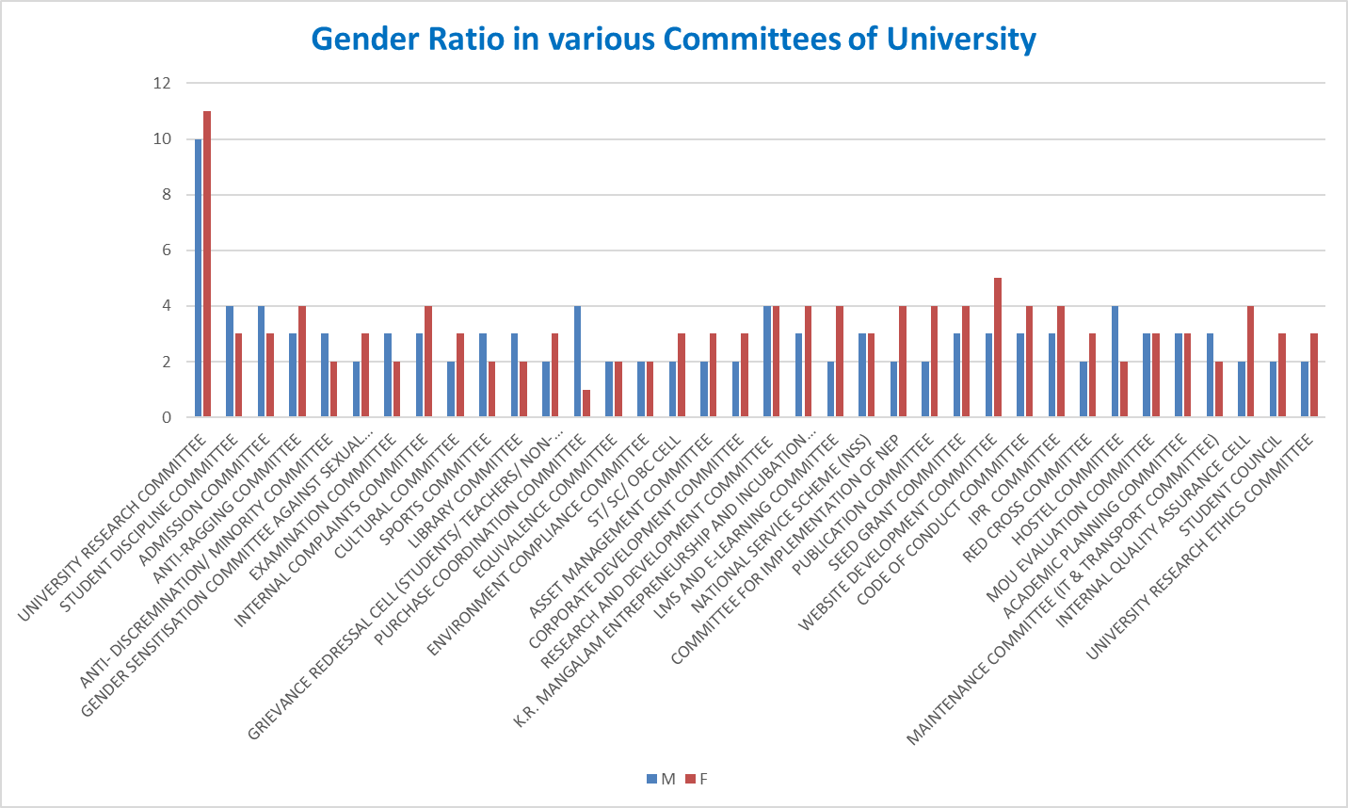

Initiatives taken by the university to promote Gender Sentisation:

10. Salient Findings and Recommendations

University has attained gender balance in most aspects of its system and gives equal opportunities to everyone. Some unique features include:
- Students' strengths, particularly girls’, are high in arts and science UG and PG

programs.

- Even in category-wise distribution, female students seem to outnumber male students.

- In both regular teaching staff and guest faculties, the strength of female staff is higher than male.

- The diverse committees and cells in the university conduct diverse

- programs to inculcate gender consciousness among students.
11. Conclusion

The Gender Audit of the University, after an exhaustive examination of all the aspects of gender sensitivity and adequacy of facilities for both men and women, indicates a positive and eminently satisfactory situation. The University has always been known for providing a safe and encouraging atmosphere for women's education. In all these years, rarely has any untoward incident involving women occurred. The University maintains an atmosphere of healthy interaction among boys and girls. Under the present KRMU leadership and gender-balanced staff, the University maintains its tradition of gender sensitivity.

