Report on Workshop on Recycling Waste and Conservation of Water
Date: 22nd March 2025
Venue: Govt. Sr. Sec. School, Ghanghola, Sohna
Event Type: Workshop (Extension Activity)
Mode of Activity: Offline
Target Group: School students
Coordinators: Mr. Amit Kumar (NSS Program Officer)
Organized by: NSS Unit, K.R. Mangalam University, Gurugram
Participants during the event: 19 NSS volunteers and 39 School students
Introduction:
In observance of World Water Day on 22nd March 2025, the NSS, K.R. Mangalam University organized a Workshop on Recycling Waste and Conservation of Water to promote sustainable environmental practices among students and community members. This initiative was in alignment with the United Nations Sustainable Development Goals (SDGs) 6 (Clean water and sanitation) to ensure the availability and sustainable management of water and sanitation for all and SDGs 13 (climate action) by raising awareness on conserving natural resources to mitigate climate change.
Objectives:
- To educate participants on the importance of water conservation and waste management.
- To promote behavioral change toward recycling and sustainable use of water.
- To engage NSS volunteers in community-based environmental action.
- To celebrate World Water Day with a call for responsible environmental practices.

Contents:
The workshop featured interactive sessions, expert talks, and demonstrations focusing on sustainable waste recycling methods and water conservation techniques. The event was started by Mr. Amit Kumar where he explained the importance of water in life and the motive behind the celebration of World Water Day. He discussed the urgent need to protect water resources, highlighting issues such as water pollution, scarcity, and the impact of climate change on freshwater ecosystems.
Demonstrations included simple home-based recycling techniques, and eco-friendly disposal of solid waste. NSS volunteers also conducted role-plays to educate the students about everyday practices that can significantly reduce water wastage and environmental harm.
In the last, the poster making session was conducted for the participants. All the posters were related to the practices related to conservation of water.
Conclusion:
This World Water Day workshop served as a platform for environmental learning, community engagement, and youth leadership in sustainability. Through insightful discussions and practical demonstrations, the event highlighted the role of informed students in addressing water and waste management challenges. The NSS Unit’s effort was a step forward in empowering students and the community to practice and promote eco-conscious behaviors in line with the Sustainable Development Goals.
Event Outcomes:
The workshop successfully generated awareness about the significance of water conservation and waste recycling in combating global environmental challenges. It inspired participants to take proactive steps towards sustainable living and resource conservation.
Future Prospects:
Building on the success of this workshop, the NSS Unit plans to organize regular awareness drives, hands-on training sessions, and community outreach programs focused on environmental sustainability.

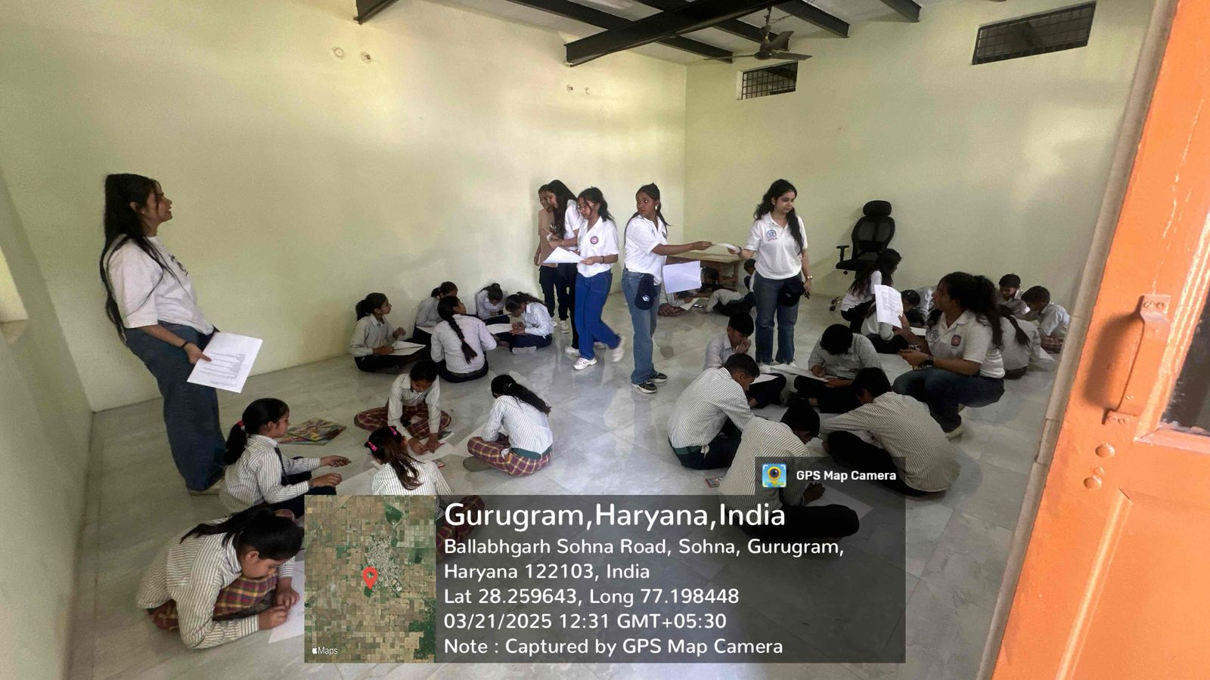

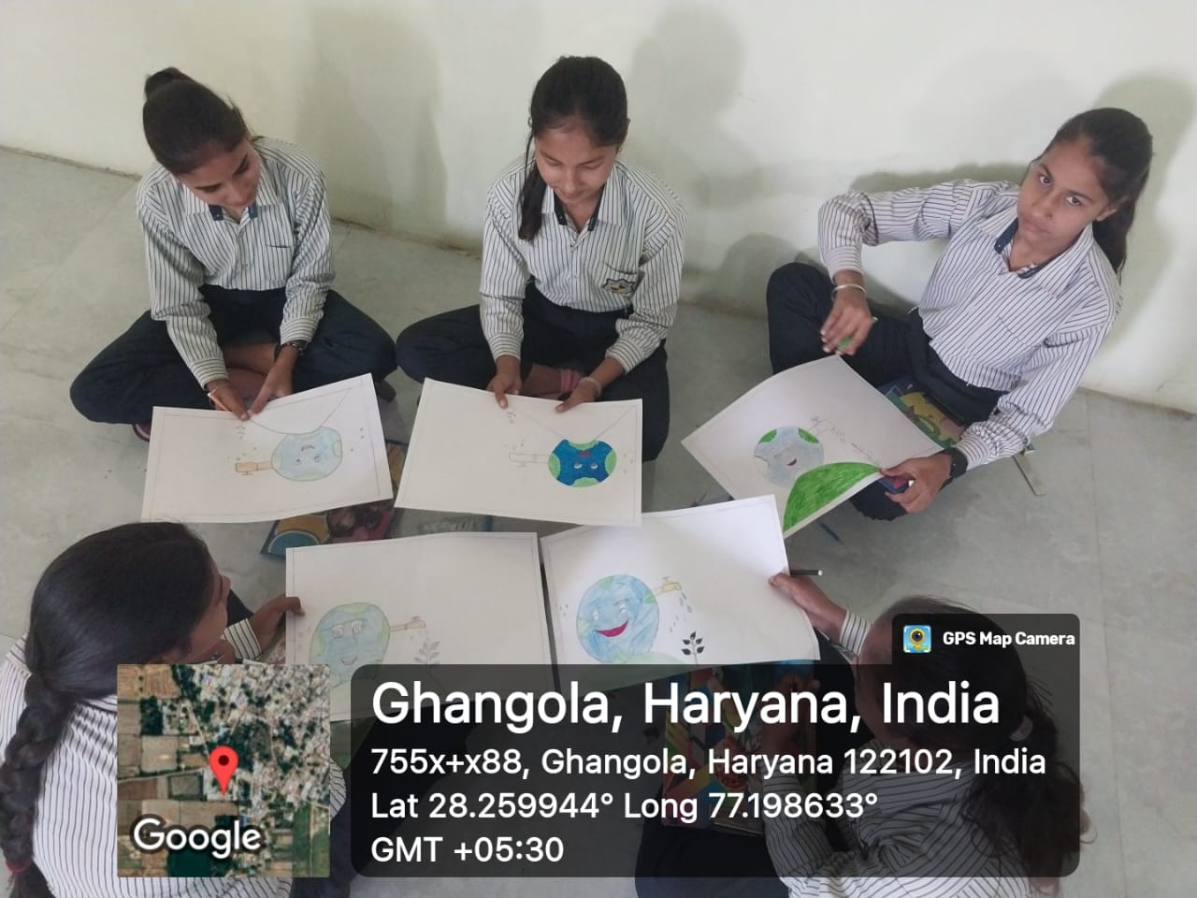
Photo 1: NSs volunteers helping the students for making paper bags from wastepaper

Photo 2: School students during poster making competition
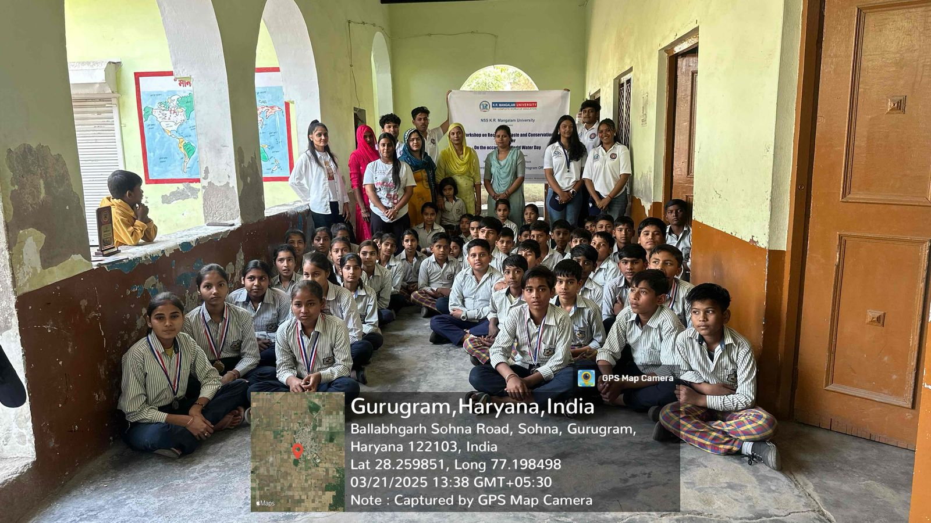

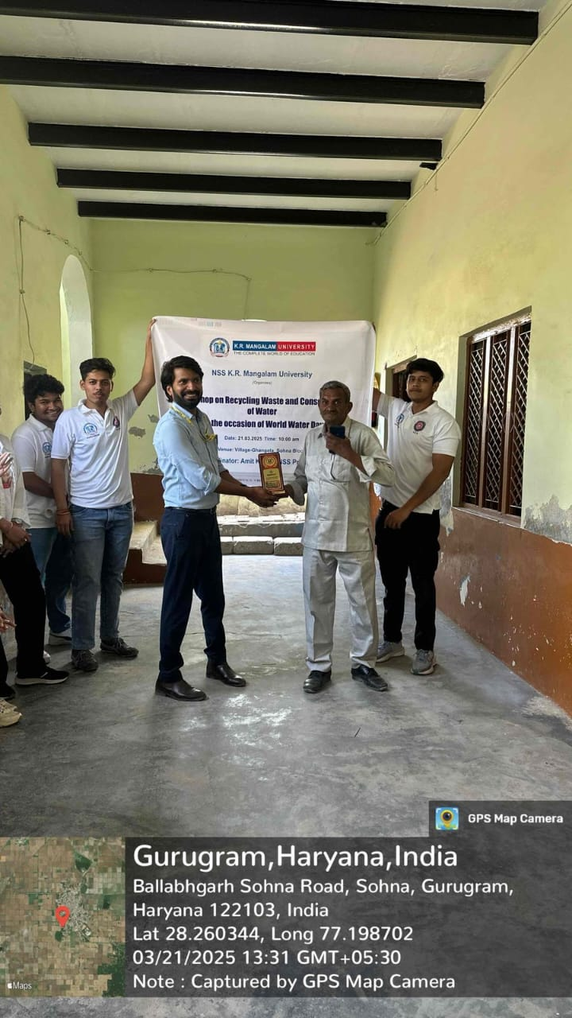
Photo 3: A group photograph of school students, staff and NSS volunteers

Mr Amit Kumar NSS Program Officer Felicitating the School Staff
Report Prepared by | Dr Neeraj Kumari, NSS Program Coordinator
Report Verified by IQAC Coordinator | Dr Shikha Dutt Sharma

