EXPERT SESSION: THE POWER AND POTENTIAL OF SOLAR CELLS IN DAILY LIFE

Date: 11th April 2025
Venue: Room B018, Bhaskaracharya Block, K. R. Mangalam University, Gurugram, Haryana
Event Type: Expert Session
Mode of activity: Offline
Target group: NSS and KRMU students
Organized by: NSS Unit, K. R. Mangalam University, Gurugram, Harayana
Resource Person: Dr. Ankit Kumar Rao, Head of R & D at P3C Technology Pvt. Ltd., Gurugram, Haryana
Event Coordinators: Dr. Vicky Kapoor, Assistant Professor, SBAS
Participants: NSS and KRMU students

Introduction:
The NSS Unit of K. R. Mangalam University successfully organized an expert session titled "The Power and Potential of Solar Cells in Daily Life" on April 11, 2025, at Bhaskaracharya Block, KRMU Campus. The event brought together students, faculty, and energy enthusiasts to engage in a stimulating discussion on the role of solar energy in creating a sustainable future.
We had the honor of welcoming Dr. Ankit Kumar Rao, Head of the Research and Development Cell at P3C Technology and Solutions Pvt. Ltd., Gurugram, a leading organization in the field of perovskite solar cell manufacturing. Dr. Rao offered a comprehensive and insightful perspective on the advancements and applications of solar cell technology, particularly focusing on the groundbreaking potential of perovskite solar cells in revolutionizing the renewable energy sector.

Objectives:
- To raise awareness about the growing relevance of solar energy in addressing climate change.
- To introduce students to the working mechanism and emerging innovations in solar cell technologies.
- To explore the transformative applications of perovskite solar cells in day-to-day life.
- To encourage youth participation in sustainable energy practices and research.
- To create a platform for interaction with industry experts in the field of clean energy.
Content:
The event commenced with a warm welcome by Dr. Vicky Kapoor, Faculty Coordinator, followed by a brief introduction of the guest speaker.
In his session, Dr. Ankit Kumar Rao took the audience on an enlightening journey through:
- The Fundamentals of Solar Technology: Including photovoltaic principles and the evolution of solar panels.
- Perovskite Solar Cells: Their structure, functionality, and how they outperform traditional silicon-based cells in certain conditions.
- Commercial Viability and Industry Trends: How perovskite solar cells are shaping the future of clean, efficient, and affordable energy.
- Real-World Applications: Examples of solar technology integration in homes, transportation, and public infrastructure.
- Interactive Q&A Session: Where students asked insightful questions and discussed project ideas related to solar energy.
Dr. Rao emphasized the urgency of transitioning toward renewable energy sources and how innovations in materials science are unlocking new potentials for solar power usage.

Conclusion:
The expert session was a remarkable success and proved to be a powerful platform for learning and exchange. The knowledge shared by Dr. Ankit Kumar Rao not only broadened the participants' understanding of solar technologies but also ignited a passion for contributing to sustainable development goals.
The session highlighted the importance of industry-academia collaboration in addressing global energy challenges, and it left attendees feeling inspired and informed.
Event Outcome:
- Increased awareness among students and faculty about perovskite solar cells and their benefits.
- Participants gained a clearer understanding of the career and research opportunities in the renewable energy sector.
- Several students expressed interest in initiating green energy projects on campus.
- The session strengthened KRMU’s commitment toward sustainability and innovation in science and technology.
Future Prospect:
- Plans to conduct hands-on workshops on solar panel design and application.
- Potential collaboration with P3C Technology and Solutions Pvt. Ltd. for student internships and research projects.
- Introduction of a Green Campus Initiative led by NSS, focusing on clean energy adoption and awareness drives.
- Organizing more such expert talks and awareness campaigns on renewable energy and environmental issues.

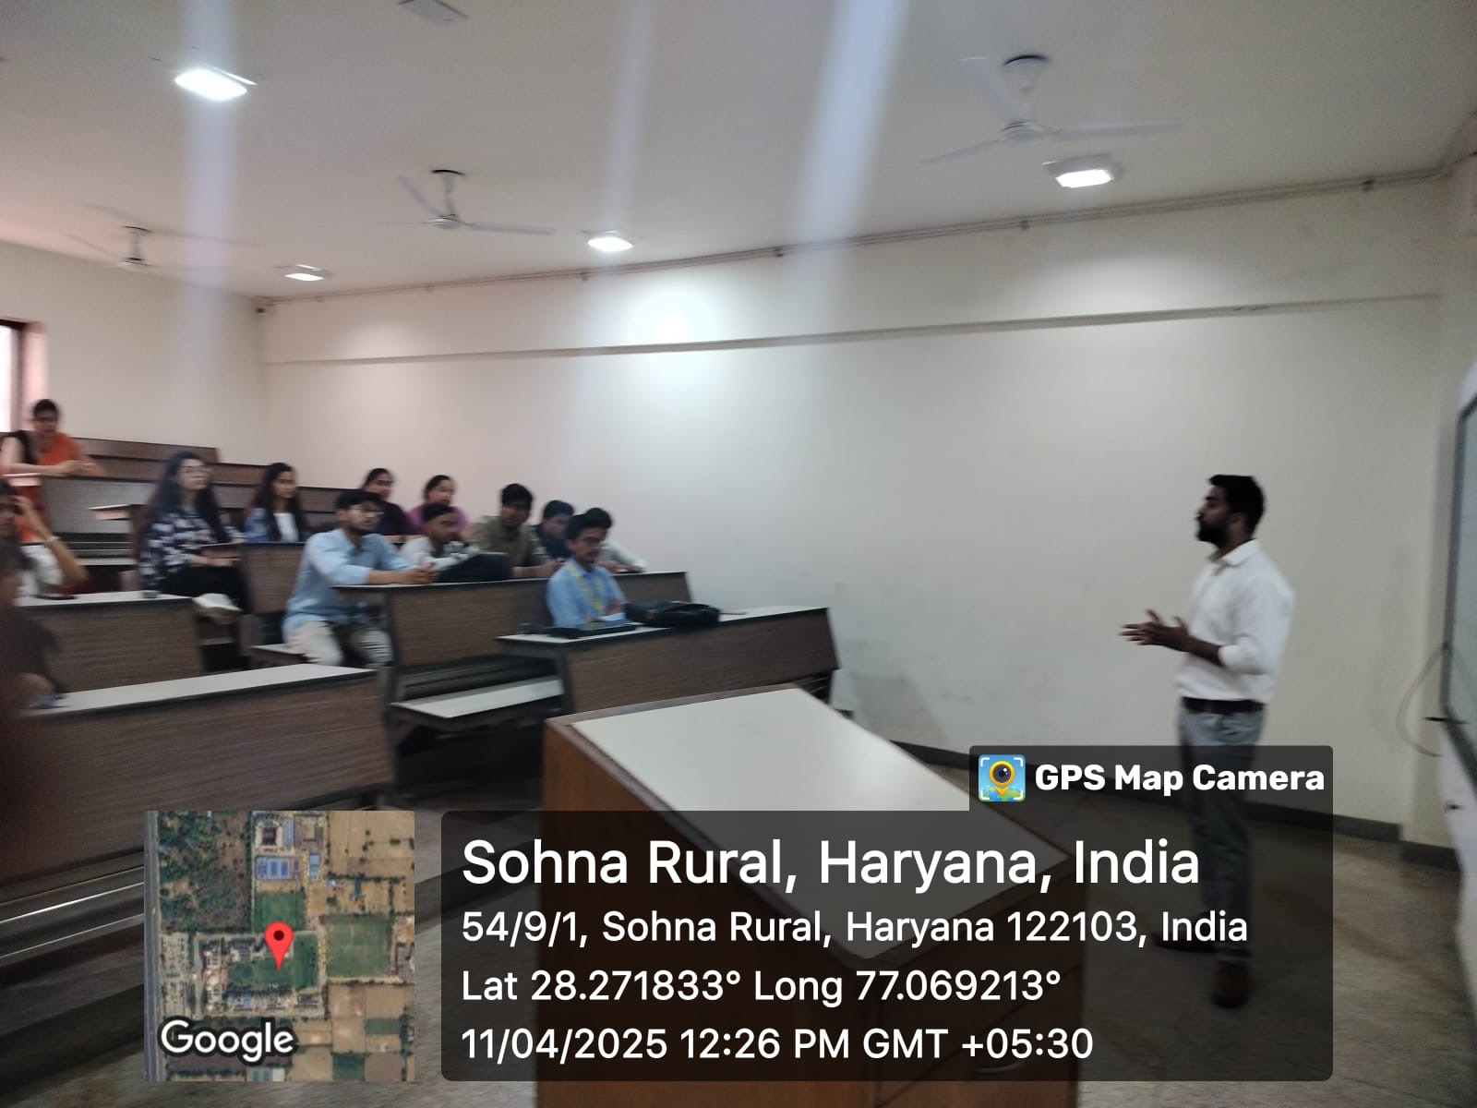

Pic 1: Dr. Ankit Kumar Rao addressing the audience – A moment from the expert session.

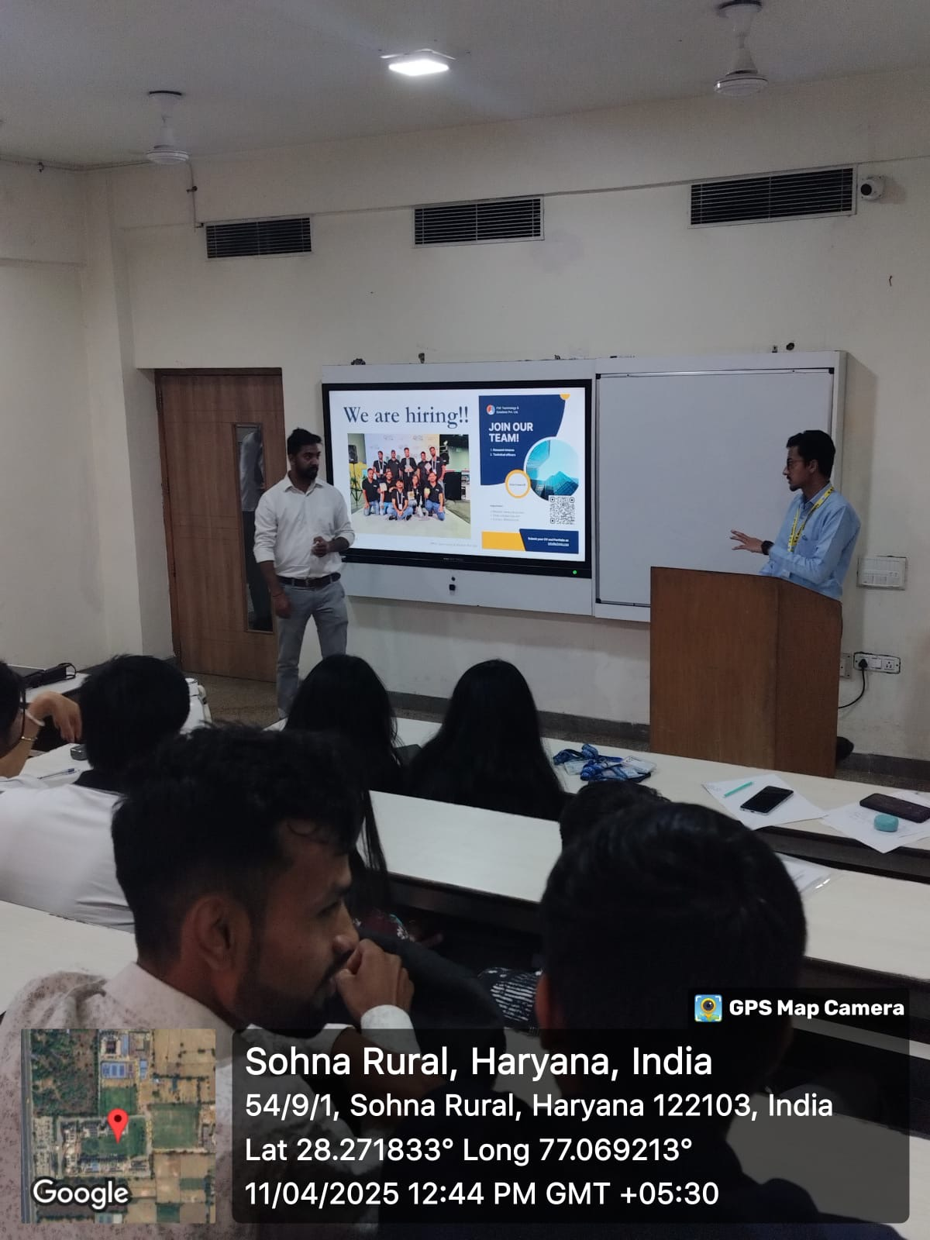

Pic 2: Interactive Q&A with students – Students engaging with the speaker.

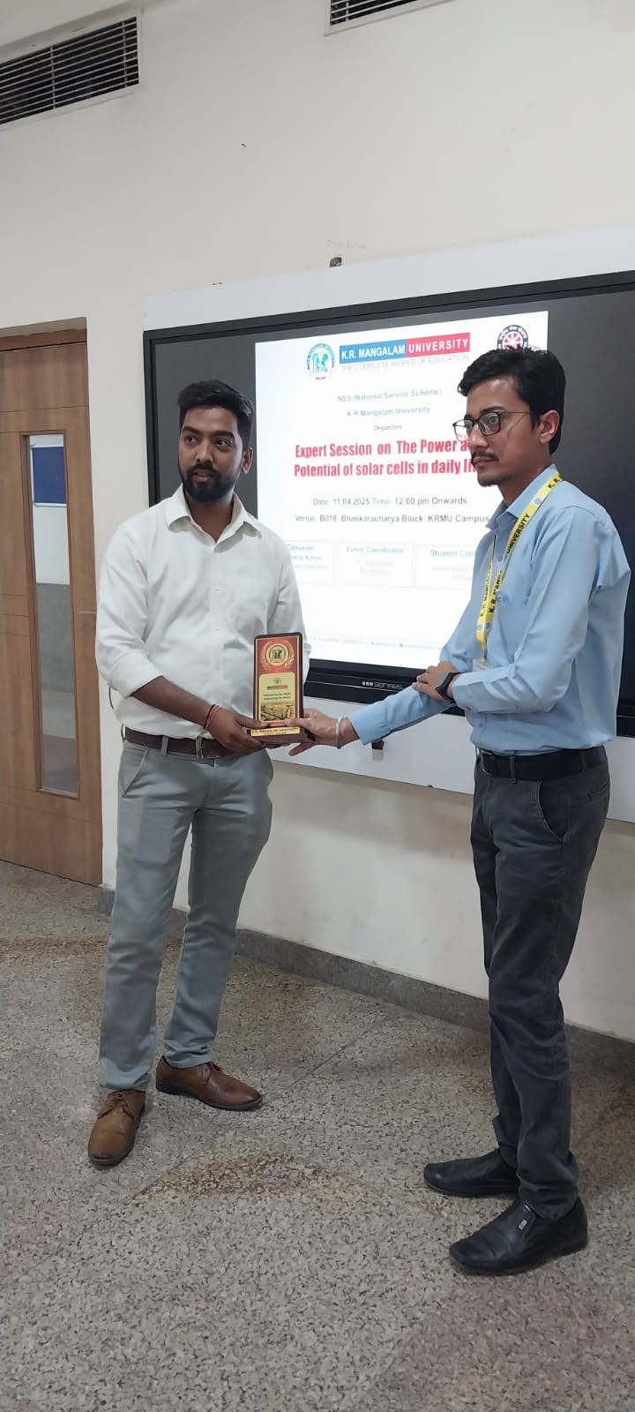

Pic 3: Memento presented to Dr. Ankit Kumar Rao as a token of appreciation for their esteemed presence

Report Prepared by  Event Coordinator | Dr. Vicky Kapoor  Event Coordinator, NSS Unit  Assistant Professor, Physics  K. R. Mangalam University
Report Verified by
Dean, SBAS

Report Verified by
IQAC Coordinator

