Report on
Event: Importance of Oxygen in Living Bodies in Collaboration with NSS
Date: Wednesday 3rd May, 2023.
Venue: Government School, Garhi Bazidpur Village
Mode of Activity: Offline
Target Group: Students of government school
Resource Person (if any): NA
Coordinators: Ms. Ragini Pandey and Dr. Rupali
Organized by: School of Basic and Applied Sciences in collaboration with NSS
Number of Attendees (Attach Attendance as Annexure): 21 (Govt School Students) and 05 (Student of SBAS and NSS Volunteers)

Objective:

The aim of this event was to promote awareness about the importance of oxygen in living beings. It helped students to acquire basic knowledge of the role of oxygen for existence and survival of living being. The proposed event imparted knowledge on how oxygen helps organisms to grow, breathe, reproduce and turn food into energy among the students of different ages.

Introduction:
School of Basic and Applied Sciences (SBAS), K.R. Mangalam University, Sohna Road (Gurugram) in collaboration with NSS organized an event for students at government school in Garhi, Bazidpur on 3rd May 2023, entitled “Importance of Oxygen in Living Bodies” where students volunteers of NSS Unit of K.R. Mangalam University shared their ideas on significance of oxygen for the survival of living bodies.
Two student volunteer speakers, Ms. Anuvanshika and Mr. Rahul, first year B.Sc. Mathematics, delivered the lecture informing the students about how oxygen is important for a living body to live. During the lecture, they explained the importance of oxygen in the human body, how the human body uses oxygen, and the effects of oxygen deprivation on the body. They also provided tips on how to maintain proper breathing habits. Both of them used different live and easy examples to help students understand the concept better. They showed diagrams of the human body and how oxygen enters and circulates in the body.
The audience was highly engaged and interested in the lecture. They asked several questions and provided their feedback on the lecture content and delivery. School students were curious to know how to maintain proper breathing habits and how it can benefit them.
The event was managed by faculty coordinators named Ms. Ragini Pandey and Dr. Rupali. It was an amazing learning experience for both the organizers and the students.

Outcome:
One of the main outcomes of the lecture on the Importance of Oxygen in the Living Body was that the students gained a better understanding of how vital oxygen is to their health and wellbeing. They learned about the different functions of oxygen in the body, including respiration, energy production, and maintaining healthy cells and tissues. They also learned about the potential consequences of not getting enough oxygen, such as fatigue, shortness of breath, and even more serious health problems.
Moreover, the lecture inspired the students to take better care of their health and to appreciate the importance of healthy habits such as regular exercise, proper nutrition, and getting enough sleep. They were encouraged to prioritize their health and make healthy choices in their daily lives, which will not only benefit them in the short term but also in the long term.
Overall, the lecture was a great success in terms of educating the students about the importance of oxygen in the living body and inspiring them to prioritize their health and wellbeing. It is hoped that the lessons learned will have a lasting impact on the students and motivate them to make positive changes in their lives.

Conclusion:
In conclusion, the lecture was a great success in spreading awareness about the importance of oxygen in the human body. The students learned about the effects of oxygen deprivation and how proper breathing techniques can help them maintain a healthy life. It is important to educate students about the importance of physiology and how it affects human life.
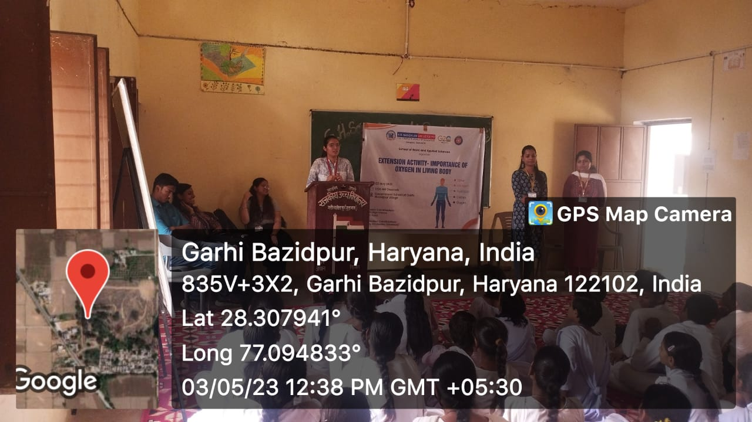

Photo 1: Student volunteer giving lecture to students of government school

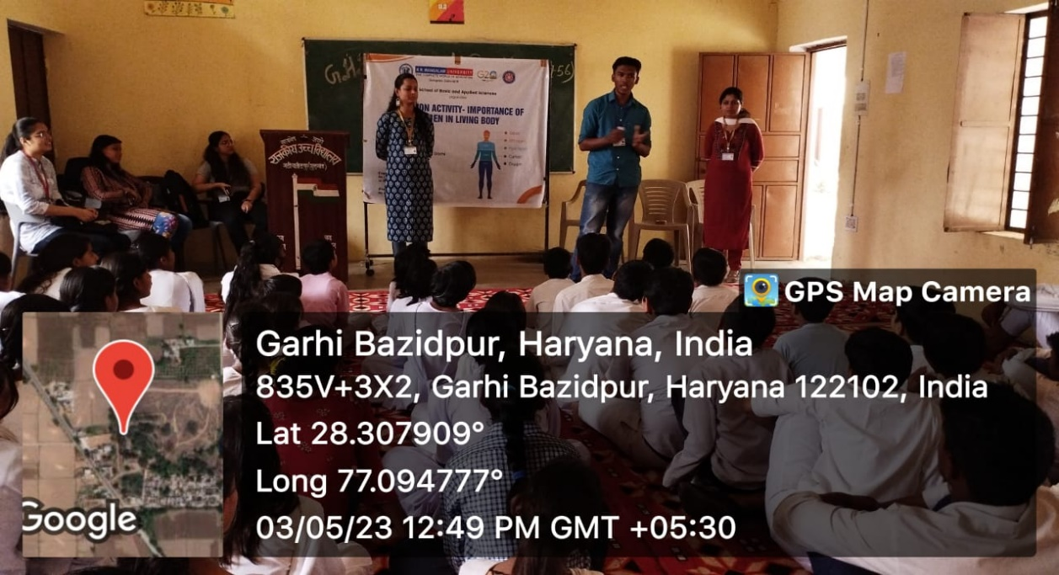

Photo 2: Participants listening the lecture

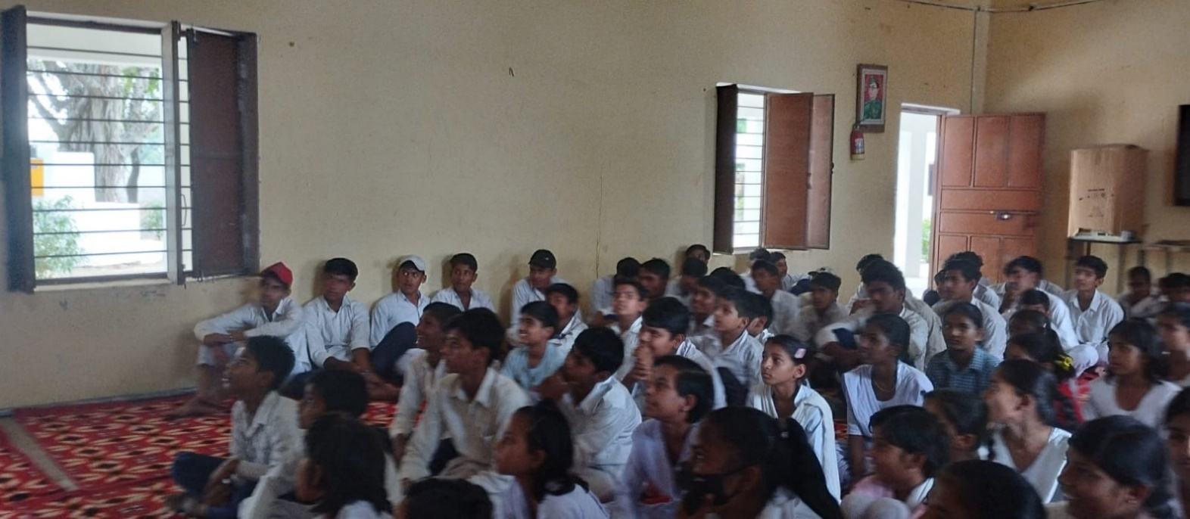

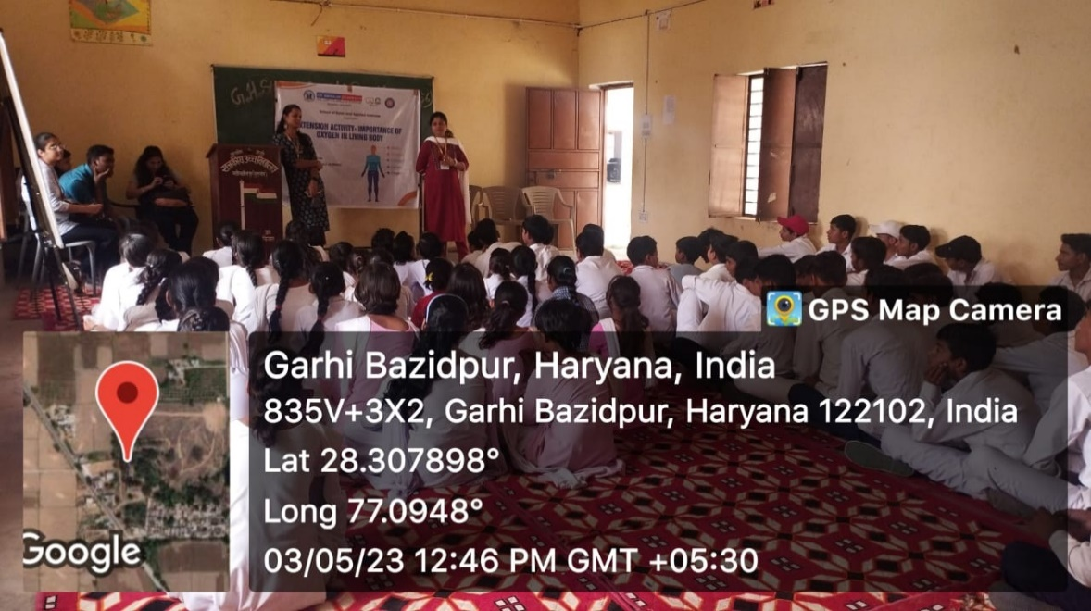

Photo 3: A photo of faculty giving lecture

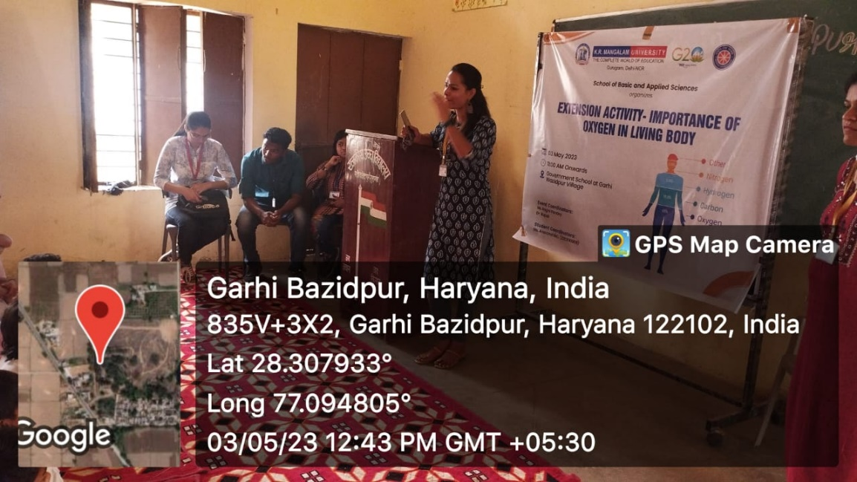

Photo 4:
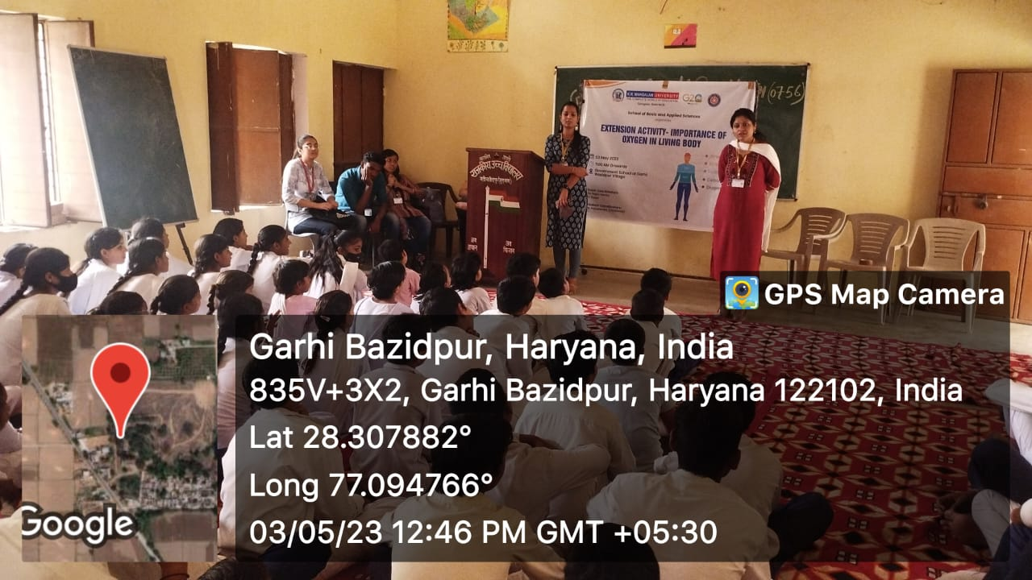

Photo 4: A group photo of students of government school with the organizers

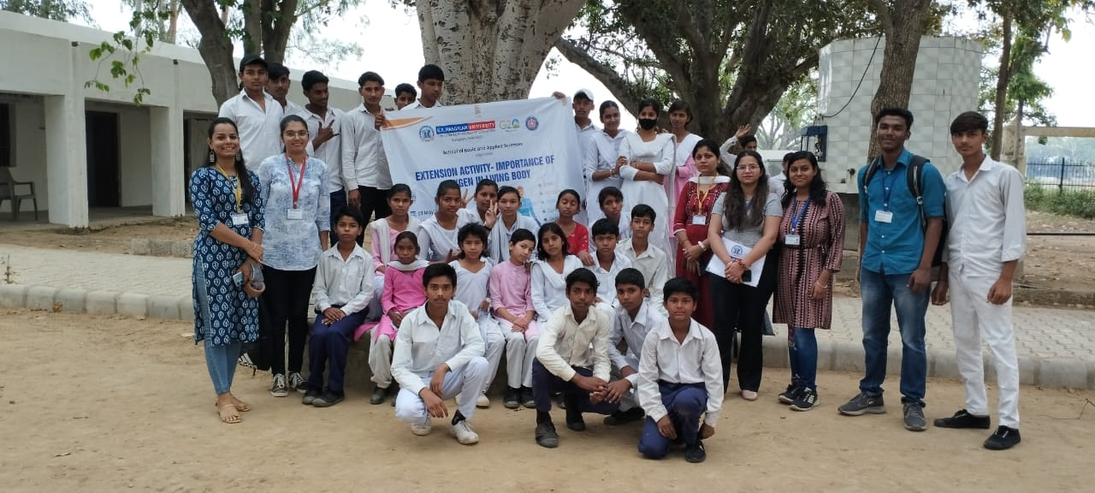

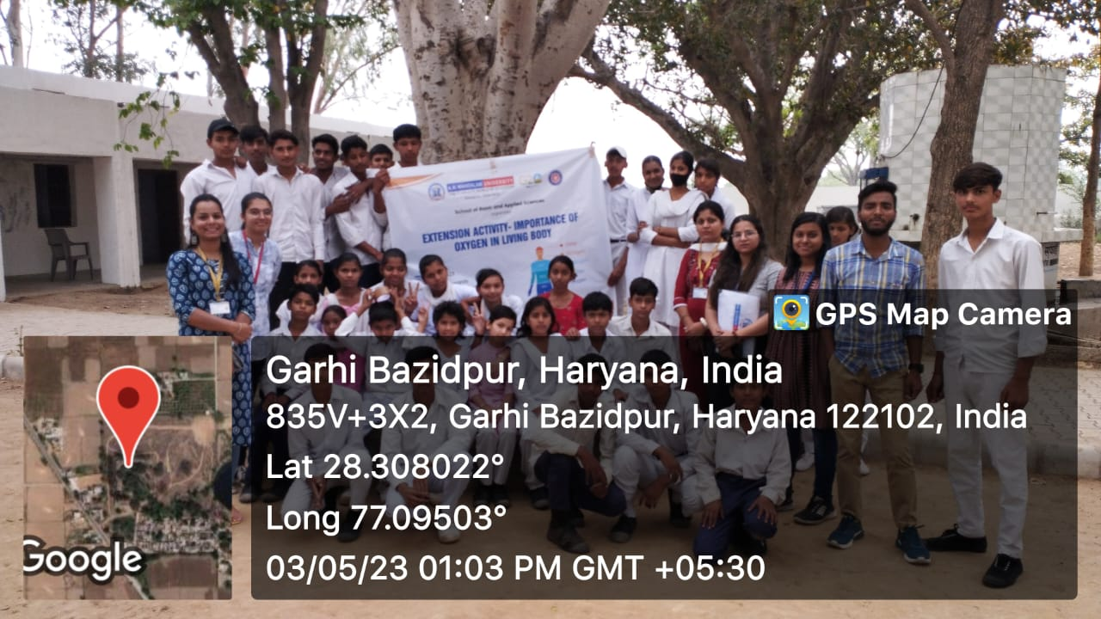

Feedback Analysis

Faculty and student members inspired more than 100% of the students to take part in the activity. Below is the student's feedback analysis report.

- The atmosphere contains __ of Oxygen ?
Response:
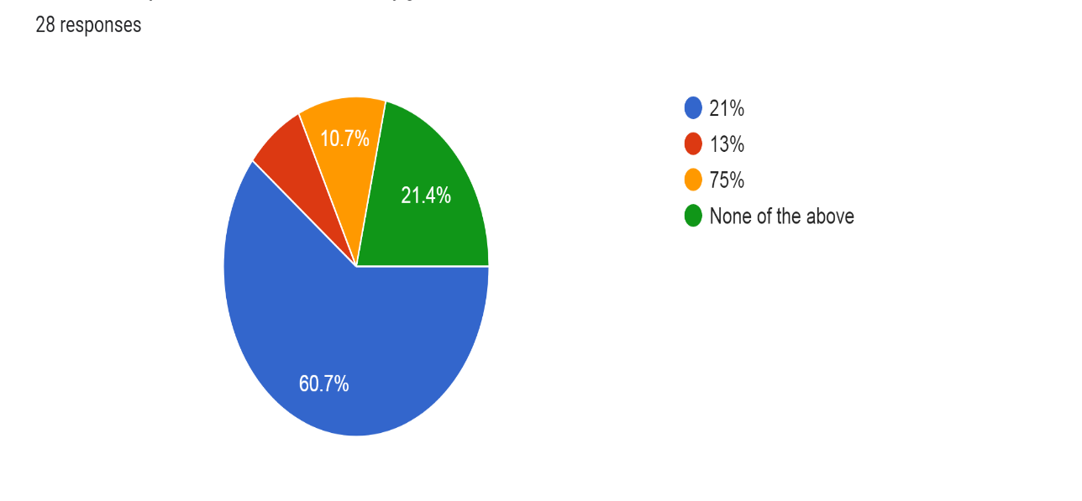

2. Which gas does human inhale?
Response:

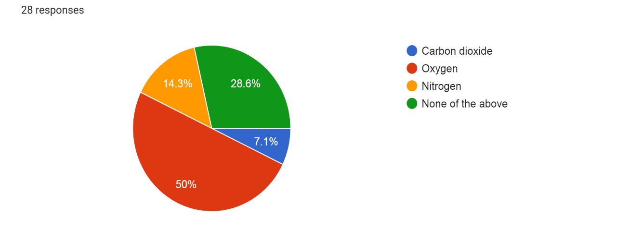

3. In which state of matter does oxygen exist in the atmosphere?

Response:

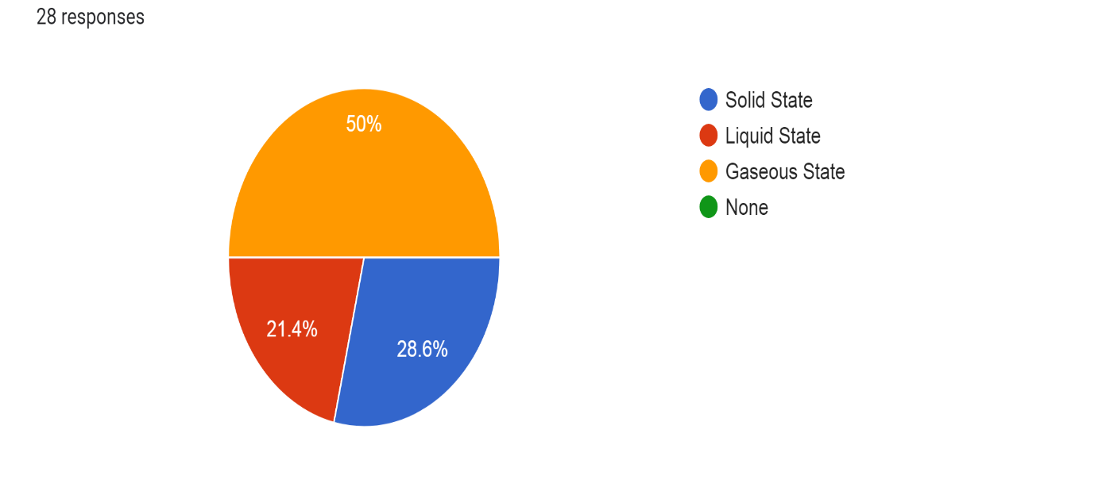

4. For which of the following might cylinders of compressed oxygen be used?
Response:

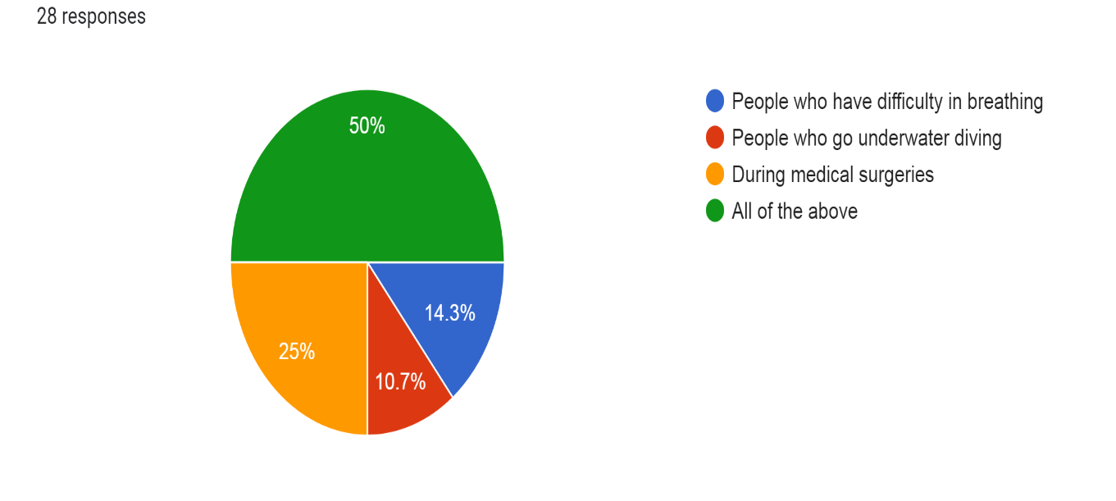

5. What is the percentage of Oxygen in a Human body?
Response:
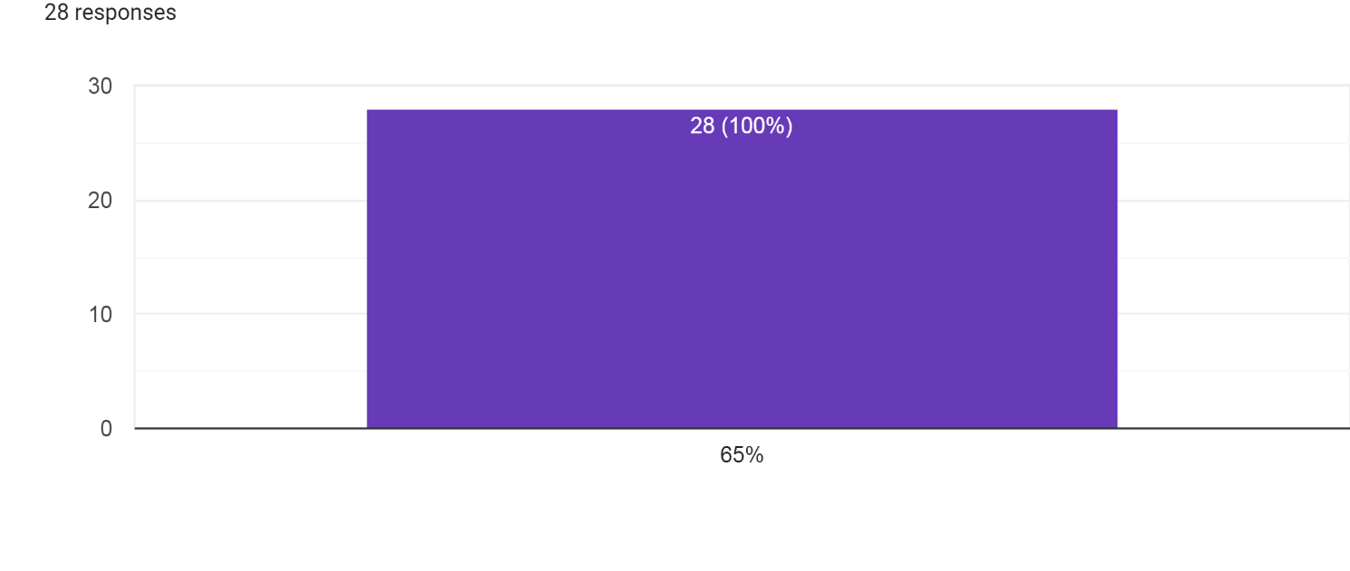
6. How satisfied are you with the content of the session?
Response:

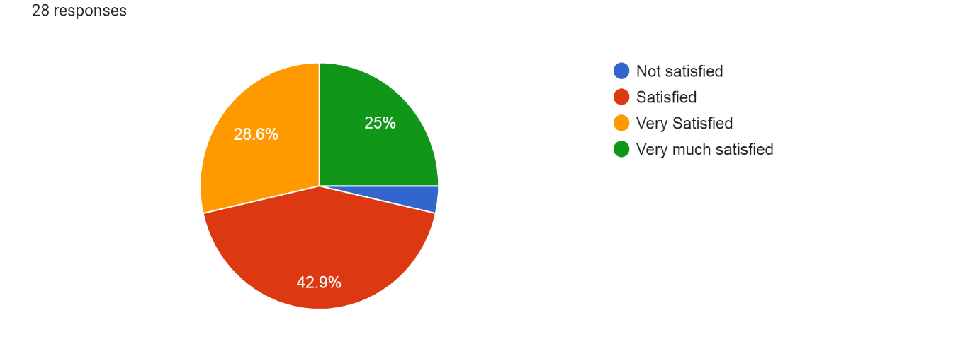

Report prepared by | Ms. Ragini and Dr. Rupali
Report verified by Event Coordinator | Ms. Ragini and Dr. Rupali
Report Seen by Dean /Activity Coordinator Director | Dr. Meena Bhandari
Report Seen by IQAC Coordinator | Dr. Shikha Dutt Sharma

