

Report on
Essay Writing Competition on Environmental Sustainability

Organized by: Youth Red Cross Committee, K.R. Mangalam University
Date: 26th March 2025
Time: 10:00 AM onwards
Venue: Government Senior Secondary School, Daula
Total No. of Participants: 24 School Students &12 YRC Volunteers
Event Type: Competition
Mode of Activity: offline
Target Group: School Students
Organized by: Youth Red Cross committee, KRMU
Event Coordinator: Dr. Monika Yadav
Student Coordinators: Mr. Sanjeev
Introduction:
The Youth Red Cross Committee of K.R. Mangalam University organized an Essay Writing Competition focused on the theme Environmental Sustainability to commemorate the auspicious occasion of Basant Panchami. The event aimed to spread awareness about environmental issues and inspire young minds to contribute positively towards sustainability efforts. The enthusiastic participation of students from Government Senior Secondary School, Daula, reflected their interest in environmental conservation.
Objectives:
Objectives are as follows:
- To spread awareness among students about environmental sustainability and its importance.
- To encourage youth engagement in environmental conservation activities.
- To promote critical thinking and writing skills among school students.
- To build a sense of responsibility towards nature and sustainable living.
- To commemorate Basant Panchami by linking cultural celebration with social awareness.

Content:
The Essay Writing Competition on the theme "Environmental Sustainability" was conducted on 26th March 2025 at Govt. Senior Secondary School, Daula, by the Youth Red Cross Committee of K.R. Mangalam University. The competition aimed to enhance awareness and critical thinking on pressing environmental issues among school students. Participants were given time to prepare and write essays expressing their understanding, concerns, and solutions related to sustainability, climate change, pollution, and conservation practices.
The event began with a brief orientation by the coordinators, emphasizing the relevance of environmental sustainability in the current global context. Students were then guided through the rules of the competition and encouraged to reflect deeply on their personal and community-level contributions toward protecting the environment.
The activity was smoothly coordinated by faculty and student members, ensuring a fair and encouraging environment for all participants. All essays were later reviewed by the jury panel based on criteria such as creativity, depth of knowledge, clarity of thought, and originality.
Outcome:
Outcomes are as follows:
- Enhanced Awareness: Students gained a deeper understanding of environmental sustainability and the urgent need for action at all levels.
- Skill Development: Participants improved their writing, articulation, and critical thinking skills through the essay writing exercise.
- Student Engagement: The competition fostered active participation and engagement of school students in a socially relevant topic.
- Social Responsibility: The event instilled a sense of environmental responsibility and encouraged students to adopt eco-friendly habits.
- Institutional Collaboration: Strengthened the bond between K.R. Mangalam University and the local community through meaningful educational outreach.

Conclusion:
The event concluded on a high note, with participants demonstrating awareness, creativity, and dedication to the cause of environmental sustainability. Certificates of participation were distributed, and appreciation was extended to all the coordinators and students involved.

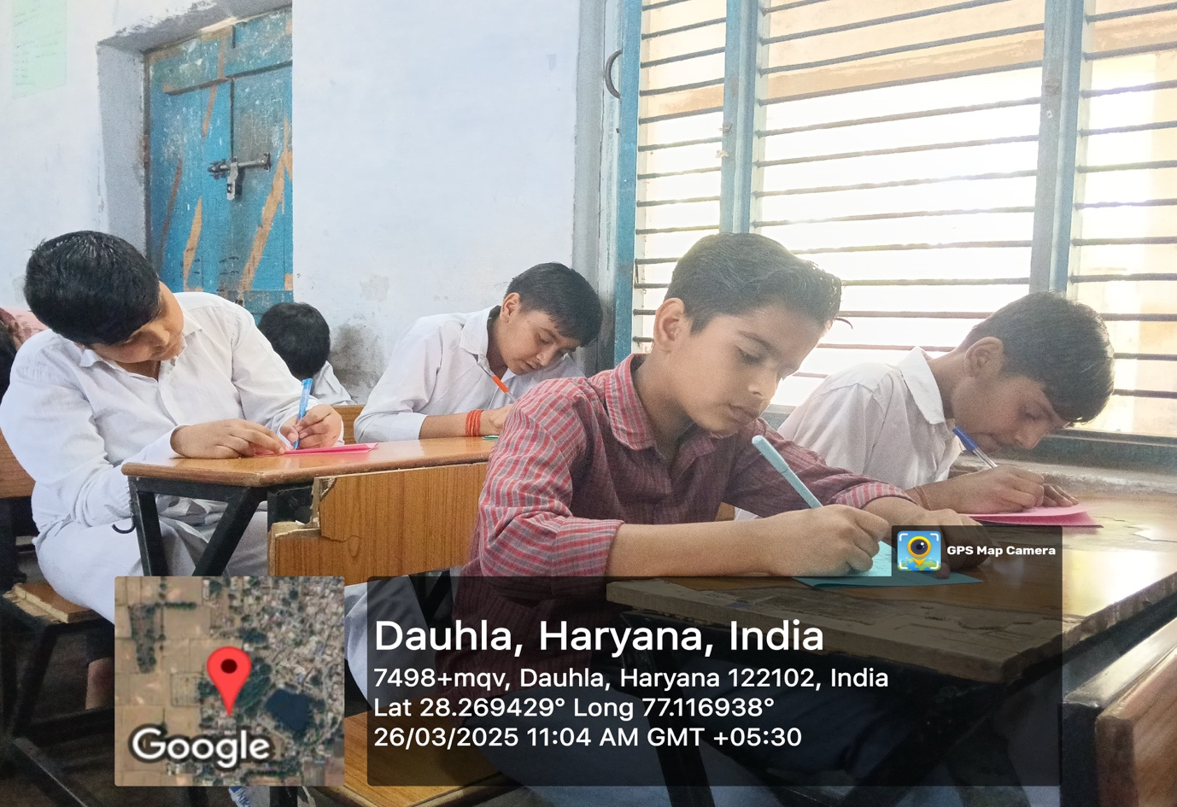

Students actively participating in the essay writing competition held at Dauthla, Haryana, showcasing their creativity and writing skills.

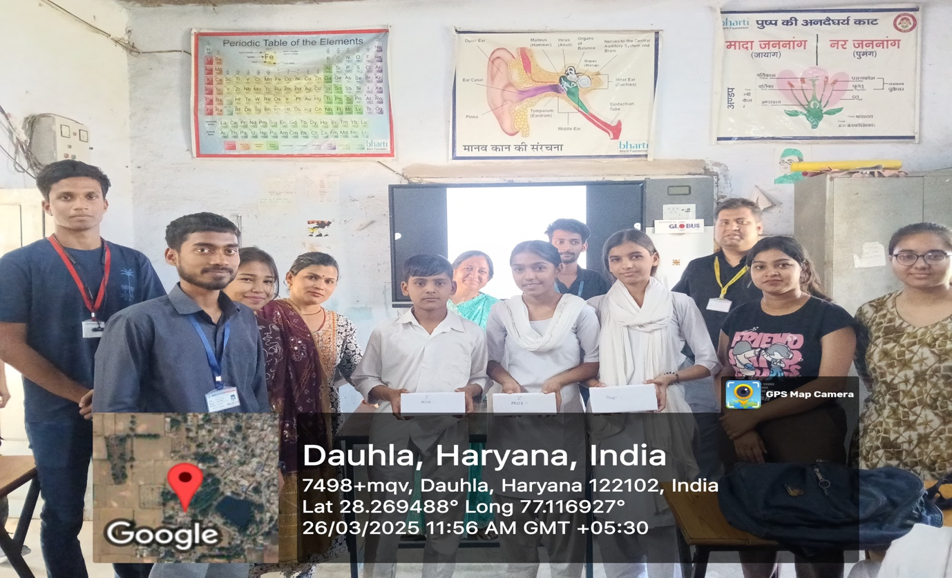

Winners of the essay writing competition being felicitated by the organizing team at Dauthla, Haryana, in recognition of their outstanding performance and creativity.

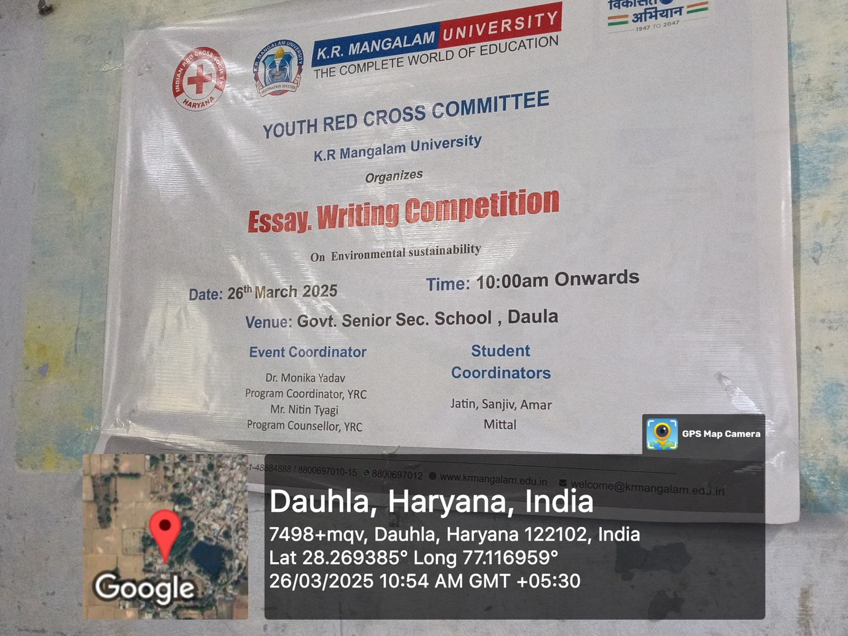

Poster highlighting the Essay Writing Competition on Environmental Sustainability organized by the Youth Red Cross Committee of K.R. Mangalam University at Govt. Senior Sec. School, Daula on 26th March 2025.

