Two-days International Conference
On
2nd International Conference
on
Advanced Materials for Green Chemistry and Sustainable Environment

(March 20-21, 2025)
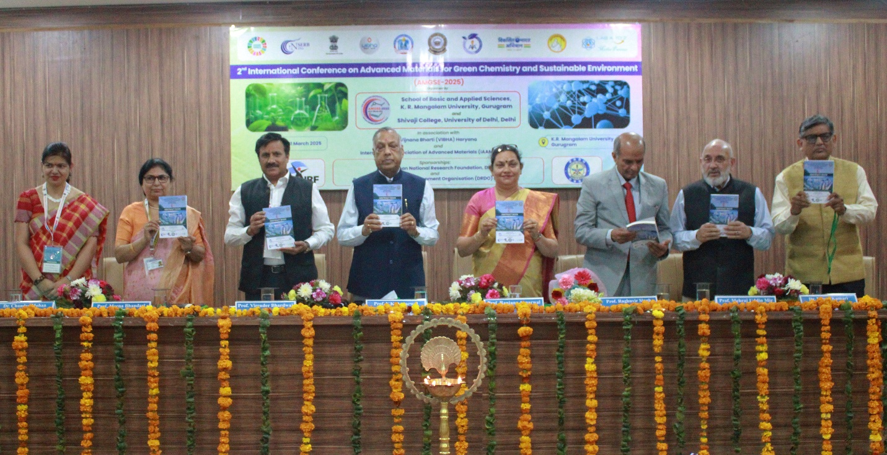

A Brief Report
On
2nd International Conference
Advanced Materials for Green Chemistry and Sustainable Environment (AMGSE-2025)

Jointly Organized by
School of Basic and Applied Sciences
K.R. Mangalam University
&
Shivaji College, University of Delhi

Venue : Moot Court, 4th Floor, Aryabhatt Block
K.R MANGALAM University
Gurugram, India

Contents

Preface and Acknowledgements
Title and Objective of the Conference
Themes and Sub-Themes of the Conference
Inaugural Function
Address of the Invited Speakers
Session wise & Track wise Report
Valedictory Function
Feedback from the Participants

Preface
We are delighted to present the preface of the 2nd International Conference on Advanced Materials for Green Chemistry and Sustainable Environment (AMGSE-2025), organized by the School of Basic and Applied Sciences, K.R. Mangalam University, in association with Shivaji College, University of Delhi. This conference is held in collaboration with Vijnana Bharti (Haryana) and the International Association of Advanced Materials (IAAM), Sweden, and is graciously sponsored by Anusandhan National Research Foundation (ANRF), Department of Science and Technology (DST), and Defence Research and Development Organisation (DRDO), Delhi.
Building on the success of the inaugural edition, AMGSE-2025 aims to bring together leading researchers, academicians, scientists, and industry experts from across the globe to deliberate on the recent advancements and innovations in the domain of green chemistry and sustainable materials. The objective is to foster interdisciplinary research and collaborations that address global environmental challenges and contribute towards a greener and more sustainable future.
This conference provides a vibrant platform for presenting cutting-edge research, exchanging ideas, and exploring collaborative opportunities in emerging areas such as eco-friendly materials, nanotechnology, renewable energy, waste management, sustainable polymers, and green synthesis. Through keynote lectures, oral and poster presentations, and interactive sessions, the conference endeavors to ignite discussions that shape future directions in sustainable science and technology.
We extend our heartfelt gratitude to our collaborators and sponsors for their unwavering support, and to all the contributors whose valuable research and insights have enriched this conference. We hope that AMGSE-2025 will serve as a meaningful step forward in the journey towards sustainability, innovation, and global scientific cooperation.

Organizing Committee
AMGSE-2025

Acknowledgements

We would like to express our sincere gratitude to all those who contributed to the success of the 2nd International Conference on Advanced Materials for Green Chemistry and Sustainable Materials (AMGSE-2025), jointly organized by the School of Basic and Applied Sciences, K.R. Mangalam University and Shivaji College, University of Delhi, in collaboration with Vijnana Bharti (Haryana) and the International Association of Advanced Materials (IAAM), Sweden.
We extend our heartfelt thanks to our esteemed sponsors — the ANRF, Department of Science and Technology (DST), and Defence Research and Development Organisation (DRDO), Delhi — for their generous support and encouragement, which played a pivotal role in the successful organization of this conference.
We are especially grateful to Prof. Raghuvir Singh, Hon’ble Vice Chancellor, K.R. Mangalam University, for his visionary leadership and constant encouragement. Our deep appreciation goes to Prof. Virender Bhardwaj, Principal of Shivaji College, University of Delhi, for his unwavering support and cooperation throughout the planning and execution of the event.
We would also like to acknowledge the valuable contributions and guidance of Prof. Meena Bhandari, Dean, School of Basic and Applied Sciences, K.R. Mangalam University, whose dedication and commitment ensured the academic excellence of this conference.
Our sincere thanks to all the invited speakers, delegates, researchers, organizing committee members, volunteers, and participants for their active involvement, insightful contributions, and enthusiastic participation, which made AMGSE-2025 a grand success.

Together, we are catalyzing positive change and paving the way towards a more sustainable future.

Title of the conference: 2nd International Conference on Advanced Materials for Green Chemistry and Sustainable Environment (AMGSE-2025)
Objective of the Conference: The objectives of the 2nd International Conference on Advanced Materials for Green Chemistry and Sustainable Materials is multi-faceted and encompasses several key aims:
- To promote awareness and development of eco-friendly materials and green technologies.
- To foster collaborative research and innovation among national and international scientific communities.
- To encourage young researchers and students to explore sustainable solutions for real-world environmental and industrial challenges.
- To highlight the role of materials science in achieving sustainable development goals (SDGs).
- To bridge the gap between academic research and industrial applications in green chemistry and sustainable technologies.

Overall, the conference aimed to serve as a catalyst for accelerating the transition towards a more sustainable future by promoting the development and adoption of advanced materials and green chemistry principles across various sectors, ultimately contributing to the preservation of natural resources, reduction of environmental pollution, and enhancement of global well-being.

Themes and Sub-Themes of the Conference
The conference topics include, but are not limited to:
Advanced Materials for Green Chemistry
- Development of eco-friendly and biodegradable materials and their applications
- Sustainable polymers and composites.
- Nanomaterials for green catalytic processes.
- Bio-based and renewable feedstock materials.
- Materials for waste management and resource recovery
Sustainable Environmental Technologies
- Materials for water and air purification systems.
- Innovations in renewable energy materials (solar, wind, bioenergy).
- Carbon capture, utilization, and storage (CCUS) materials.
- Sensors for environmental monitoring.
- Sustainable construction materials.
- Indian Knowledge System for achieving Environmental Sustainability
Green Chemistry Approaches
- Atom economy and waste minimization in chemical processes.
- Green solvents and reaction media.
- Photocatalysis and electrocatalysis for environmental applications.
- Mechanochemistry and alternative energy sources for green synthesis.
- Green technologies for chemical manufacturing.
- Forensic toxicology and environmental forensic
Applications of Advanced Materials in Sustainability
- Advanced materials in sustainable agriculture.
- Energy-efficient materials for buildings and infrastructure.
- Materials for sustainable transportation (e.g., lightweight composites).
- Advanced batteries and energy storage systems.
- Functional materials for environmental sensors and remediation.
Analytics for Sustainable Development through Optimization and Modelling
- Green Logistics and Sustainable Inventory/ production Management

- Multi-Objective Optimization for Sustainable Manufacturing Systems
- Fuzzy and Stochastic Models for Uncertain Demand and Sustainability
- Waste to energy nexus, technology for future industries
- Additive manufacturing IOT and Information and Communications Technology (ICT)
in Industries
Policy, Education, and Innovation for Sustainable Development
- Role of advanced materials in achieving the UN Sustainable Development Goals
(SDGs).
- Strategies for implementing green chemistry in academia and industry.
- Environmental impact and regulatory frameworks for advanced materials.
- Public-private partnerships for innovation in sustainable materials.
- Innovation with Sustainable Development goals for quality education

Inaugural Function
The 2nd International Conference on Advanced Materials for Green Chemistry and Sustainable Materials (AMGSE-2025) was inaugurated with great enthusiasm at K.R. Mangalam University, organized jointly by the School of Basic and Applied Sciences, K.R. Mangalam University, and Shivaji College, University of Delhi, in collaboration with Vijnana Bharti (Haryana) and the International Association of Advanced Materials (IAAM), Sweden. The event is sponsored by the Advanced Natural Research Foundation (ANRF), the Department of Science and Technology (DST), and the Defence Research and Development Organisation (DRDO), Delhi.
The inaugural session began on an auspicious note with the lighting of the ceremonial lamp and the soulful recitation of the Saraswati Vandana, invoking the blessings of the Goddess of Knowledge.
The session was graced by several eminent dignitaries. Prof. Raghuvir Singh, Hon’ble Vice Chancellor of K.R. Mangalam University, warmly welcomed the guests and highlighted the university’s commitment to promoting research and innovation in green chemistry and sustainable technologies.
Prof. Virender Bhardwaj, Principal, Shivaji College, extended his heartfelt gratitude to the organizing partners and emphasized the importance of such international platforms in bridging research across borders.
The Chief Guest, Prof. Ranjana Aggarwal, Director, CSIR-National Institute of Science Communication and Policy Research (NIScPR), delivered an inspiring address, emphasizing the need for environmentally sustainable materials and the role of interdisciplinary research in shaping a green future.
The Guest of Honour, Prof. V. K. Aggarwal, Pro-Chancellor, Jagannath University, appreciated the efforts of the organizers and encouraged young researchers to take forward the mission of sustainability through innovation.
Prof. Meena Bhandari, Dean, School of Basic and Applied Sciences, expressed her pride in being part of such a globally significant event and encouraged continued collaboration between institutions.
Dr. Chandra Mohan, Organizing Secretary & Convenor, AMGSE-2025, shared the objectives and themes of the conference, setting the tone for the sessions to follow.

The conference witnessed participation from several distinguished international speakers, including Prof. Dominic C. Y. Foo from Malaysia and Dr. Ahmed Kareem Hussein Alatafi from Iraq, who graced the event with their in-person presence and delivered brief introductory remarks during the inaugural session.
The inaugural function was a perfect blend of academic excellence and cultural heritage, setting a vibrant tone for the multi-day conference that aims to foster international collaboration and address pressing environmental challenges through advanced materials and green chemistry.
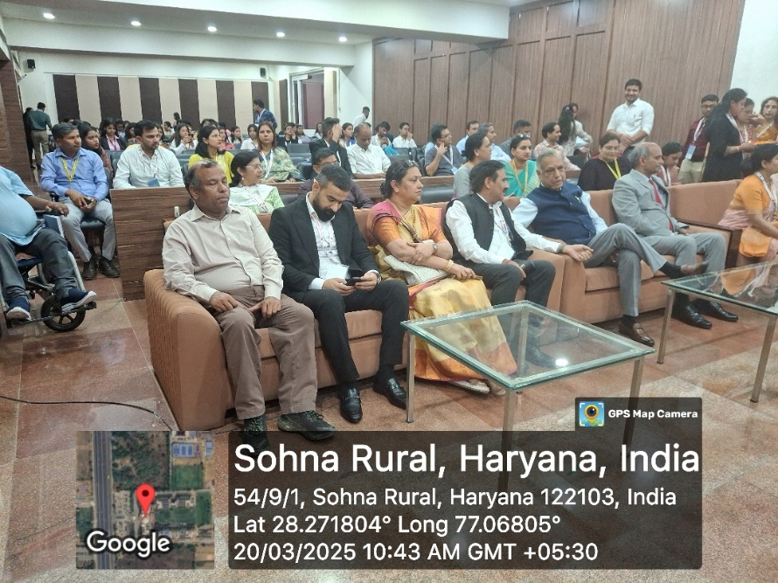

Photo 1: Participants and guests during inauguration session
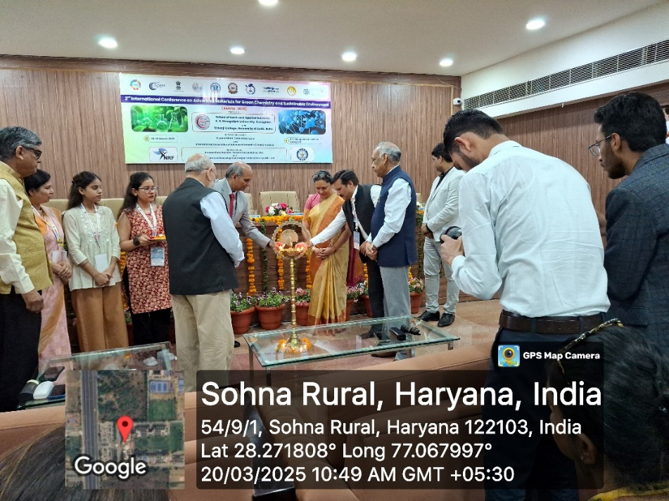

Photo 2: Lamp lighting ceremony during inauguration session

Photo 3: Conference delegates and convenors during release of abstract book

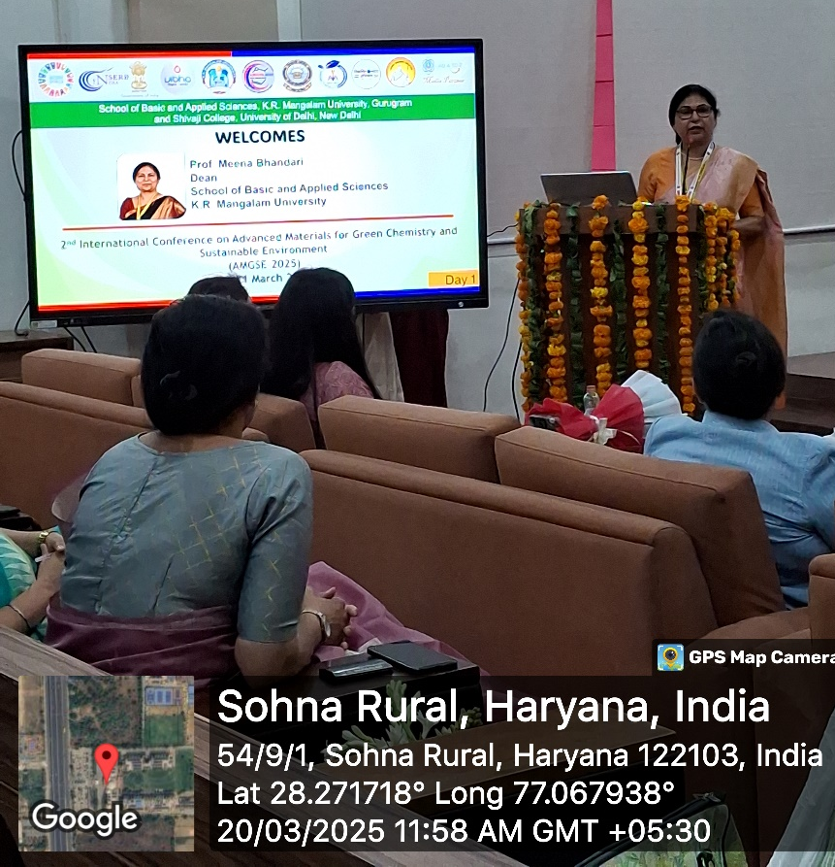

Photo 4: Dr Meena Bhandari welcomed all the guests

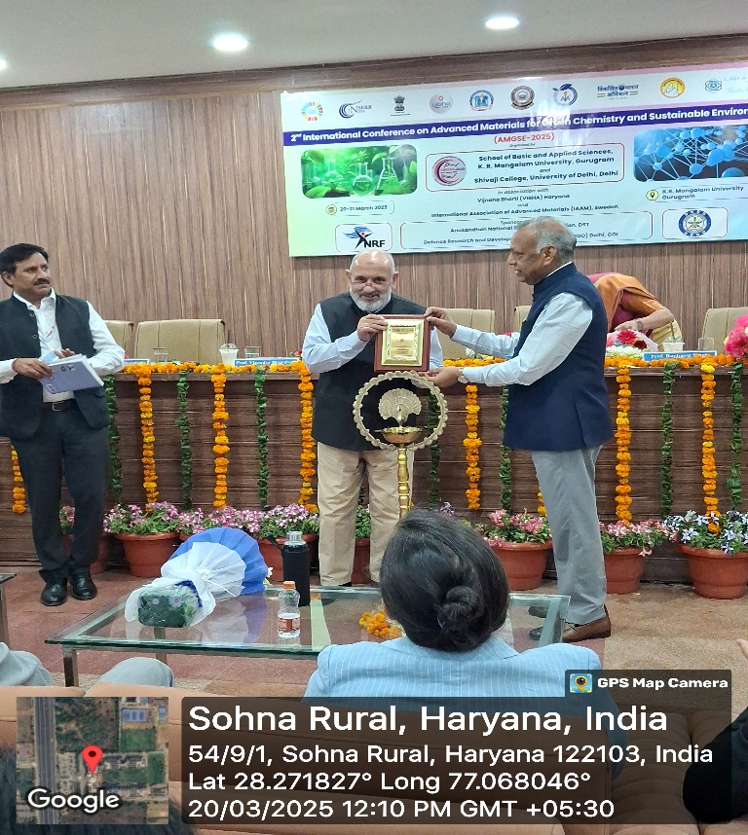

Photo 5: Prof. Mehraj Uddin Mir presented token of gratitude to Prof. V K Agarwal

Invited lectures:
As part of the 2nd International Conference on Advanced Materials for Green Chemistry and Sustainable Materials (AMGSE-2025), a series of insightful invited lectures were delivered by renowned experts from India and abroad, enriching the academic discourse with their cutting-edge research and valuable perspectives.
Prof. Sabu Thomas, Former Vice Chancellor and Director, Centre for Nanoscience and Nanotechnology, Mahatma Gandhi University, Kottayam, Kerala, India, delivered a highly engaging lecture on the emerging trends in nanomaterials and their applications in sustainable development. His talk inspired young researchers to explore interdisciplinary approaches in material science.
Prof. (Dr.) Rajendra Sarin, expert in Forensic Chemistry, National Forensic Sciences University, New Delhi, shared insights into the latest advancements in forensic applications of green materials, emphasizing the integration of science and justice.
Dr. Ahmed Kareem Hussein Alatafi, from the College of Science, Diyala University, Iraq, provided an international perspective on innovative research in environmental chemistry, showcasing collaborative efforts for global sustainability.
Dr. Gaurav Khandelwal, from ENTEG, University of Groningen, Netherlands, presented his work on sustainable energy materials and highlighted the role of advanced materials in the transition to cleaner energy systems.
Prof. Harish Kumar, Central University of Haryana, Mahendergarh, discussed the synthesis and characterization of novel green catalysts, underlining their potential industrial and environmental impact.
Dr. Pooja Srivastava, Scientist E, INMAS, DRDO, New Delhi, elaborated on biomedical applications of sustainable materials in defense research, focusing on innovations in drug delivery and biosensing technologies.
The session provided a rich platform for knowledge exchange, fostering collaboration and inspiring future research in the field of green chemistry and sustainable materials.
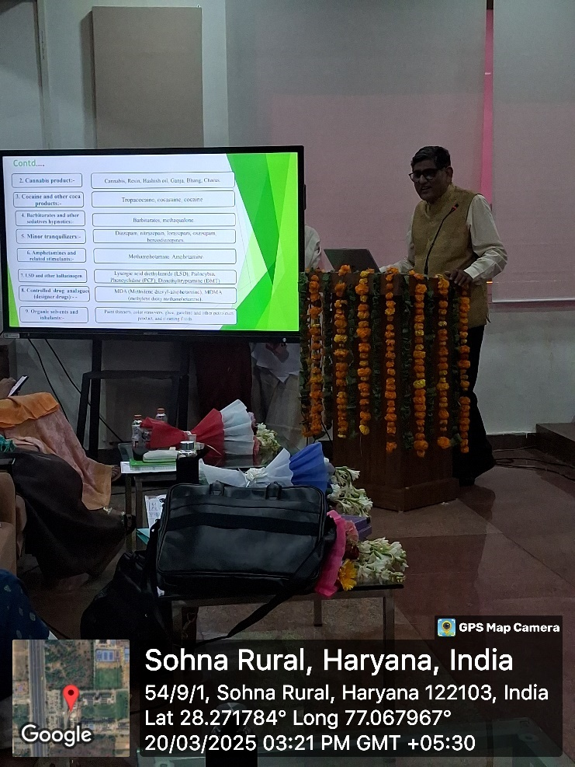

Photo 6: Prof. Rajendra Sarin during his talk

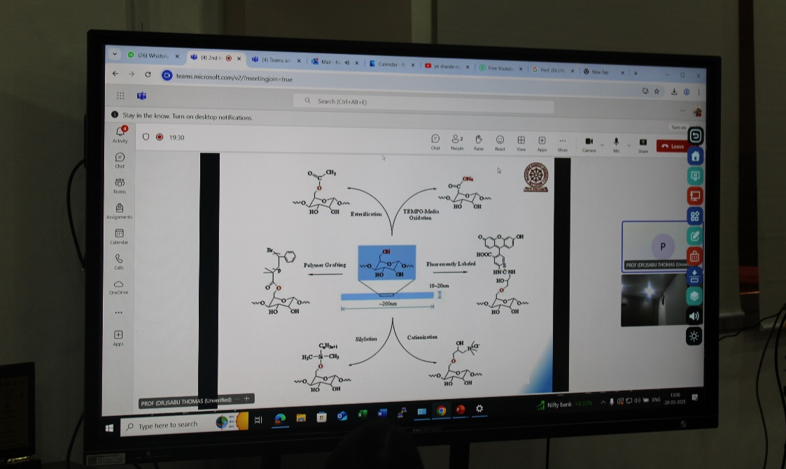

Photo 7: Prof. Sabu Thomas during his talk

The poster session was held in the multipurpose hall, 4th floor, Aryabhatt block, where 28 poster on various theme of the conference were presented by the participants from different institutes. The evaluation of these posters was conducted by our esteemed guests, Professor Dominic C. Y. Foo, Head, Centre for Green Technologies, University of Nottingham Malaysia, Dr. Ahmed Kareem, Hussein Alatafi, College of Science, Diyala University, Iraq, and Prof. Harish Kumar, Central University of Haryana, Mahendergarh. Details of poster presentation are given as:

S N | Name of the author and affiliation | Tile of the poster and Paper id
01 | Preeti Chauhan, Shivaji College, University of Delhi | Growth of Copper Oxide using Electrospinning technique. AMG_011(PP)
02 | Sakshi Kumari, Amity Institute of Biotechnology, Amity University Uttar Pradesh, Noida | Converting “Mandi” Waste into Bioplastics: An Eco-Friendly Approach to Green Chemistry AMG_037(PP)
03 | Dr. Kanchan Khatreja, K R Mangalam University | Environmental Sustainability through Indian Knowledge System: A Holistic Approach AMG_051(PP)
04 | Aasma Rahangdalea, Meghna Chaudhary,  Shivaji College, University of Delhi | GREENCHRONOS: Organic Approach Towards Preservation of Cosmetics AMG-052(PP)
05 | Aryan Pachauria,  Department of Chemistry, Shivaji College, University of Delhi | Unlocking Forensic Insights: Drug Detection in Hair, Blood, Saliva and Urine AMG_053(PP)
06 | Apurva Dabasa,  Department of Chemistry, Shivaji College, University of Delhi | Analytical Methods for Identifying CWA (Chemical Warfare Agents) Agents in Human Samples  AMG_055(PP)
07 | Abhishek Kumar Saroja,  Department of Electronics Engineering, IIT-(BHU) Varanasi, UP, 221005, India | Role of RF Energy and Cu Material Based RF Sensor Passive Antenna for Biomedical Applications  AMG_056(PP)
08 | Karanbeer Kaur,  Peptide Chemistry Laboratory, School of Physical Sciences, Jawaharlal Nehru University, New Delhi | PREPARATION OF CuFexOy NANOCOMPOSITE FOR ADSORPTION OF AZO DYES FROM INDUSTRIAL CONTAMINATED WATER AMG_059(PP)
09 | Priyanshu Singh  Shivaji College, University of Delhi | Nanotechnology for Sustainable Energy Solutions Under Sustainable Environmental Technologies  AMG_063(PP)
10 | Khushal  Shivaji College, University of Delhi | Eco-friendly chemical traits of green materials  AMG_066(PP)
11 | Pratyaksha Tiwari  Organic Synthesis Laboratory, School of Physical Sciences, Jawaharlal Nehru University, New Delhi | Synthesis of 2-Aryl /benzimidazole/benzothiazole in Water with Reusable Photocatalyst Cu/Cu2O@g-C3N4 under visible light, AMG_067(PP)
12 | Anamika Kumari,  Department of Applied Chemistry, Delhi Technological University, Delhi | Aloevera, Pectin, Citric acid, Essential oil based Biodegradable Film for Food Packaging, AMG_071(PP)
13 | Ashi Singh  Shivaji College, University of Delhi | Sustainable Construction Materials: A Pathway to Reduce Carbon Emissions AMG_076(PP)
14 | Neelam Anand,  Department of Chemistry, SGT Khalsa College, University of Delhi | Sustainable Greener Nanoparticles for Biomedical Applications AMG_078(PP)
15 | Sneha  Shivaji College, University of Delhi | Green Chemistry: A Sustainable Approach to Chemical Manufacturing AMG_080(PP)
16 | Kashish Mann  Sri Venkateswara College, Department of Chemistry, University of Delhi | A Simple, Green Synthesis of Biologically Potent Pyrimidinethiones Using DES as a New Green Solvent  AMG_081(PP)
17 | Shivani  Centre for Biotechnology, MD University, Rohtak, (Haryana), India | Synthesis of Nanoparticles from Natural Resources: Approaches, Applications and Limitations  AMG_082(PP)
18 | Sweeti  Vertox laboratory, Defence Research &amp; Development Establishment (DRDE), Jhansi Road, Gwalior | Iodine Mediated Facile One-Pot Synthesis of O,O’-Dialkyl-N,N-Dialkylphosphoramidates from Trialkyl Phosphites  AMG_083(PP)
19 | Devangi Rawat, Anshika, Khushi Dubey  Shivaji College, University of Delhi | Sustainable approach to Mitigating Plastic Pollution  AMG_085(PP)
20 | Gyanesh Kumar Mishra  Vertox Laboratory, Defence Research &amp; Development Establishment, Gwalior | A Sustainable Single Drop Micro-extraction of A-series Nerve Agents from Aqueous Samples AMG_086(PP)

21 | Aryan Bajaj  School of Basic and Applied Sciences, K.R. Mangalam University, Sohna Road,  Gurugram, Haryana | PCB-Based Wireless Air Quality Monitor with Temperature, Humidity, CO, VOC, and Ozone Sensing  AMG_088(PP)
22 | Md. Muktasir Rohman  University School of Biotechnology, Guru Gobind Singh Indrarastha University, New Delhi | Embracing Sustainability: The Impact of Environmental Social Governance (ESG) on the Growth of Manufacturing Industries in India AMG_090(PP)
23 | Sonia Singh  Department of Environmental Studies, Central University of Haryana, Mahendergarh | Bioconversion of Malt industry sludge amended with Paddy straw Biochar to enhance vermicomposting efficiency using Eisenia fetida-AMG_101(PP)
24 | Shivani Dhalla  Department of Physics, D. A. V. College, Jalandhar, Punjab, India | Analytical Comparative Study for Synthesis of Electron Transport Layer using TiO2 and TiO2 Graphene (Graphene Doped) Using Different Deposition Techniques-AMG_106(PP)
25 | Srijan Pushkarna  Department of Physics, D.A.V. College Jalandhar, Punjab, India | Sustainable Fabrication of Carbon Dots via Citric Acid from Lemon Juice-AMG_107(PP)
26 | Srishti Mishra  K. R. Mangalam University, Gurugram | E-Cigarette Toxicology in Forensic Investigations: Challenges, Evidence, and Future Directions AMG_135(PP)
27 | Prithvi Singh Chohan  Computational Quantum Materials Design (CQMD) Lab, Department of Applied Physics,  Delhi Technological University, Delhi | A Machine Learning assisted study of feature importance for Anomalous Hall Effect-AMG_137(PP)
28 | Akansha Gupta  K. R. Mangalam University, Gurugram, Haryana, 122103, India | Advancements in Sustainable Degradation of Organic Contaminants Using Metal Oxide Composites Prepared by Green Methods AMG_140(OP)

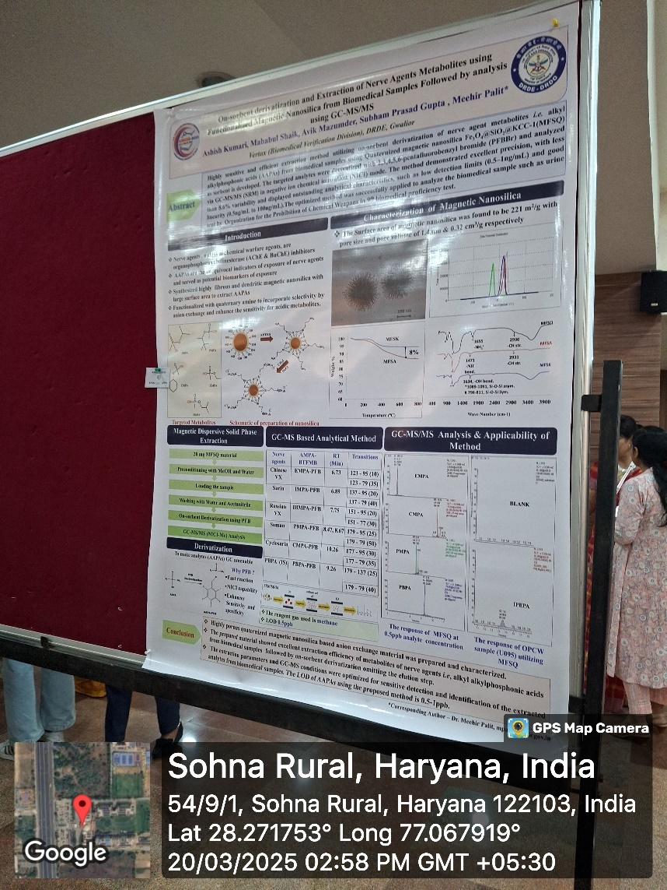

Photo 8: One of the poster during poster presentation

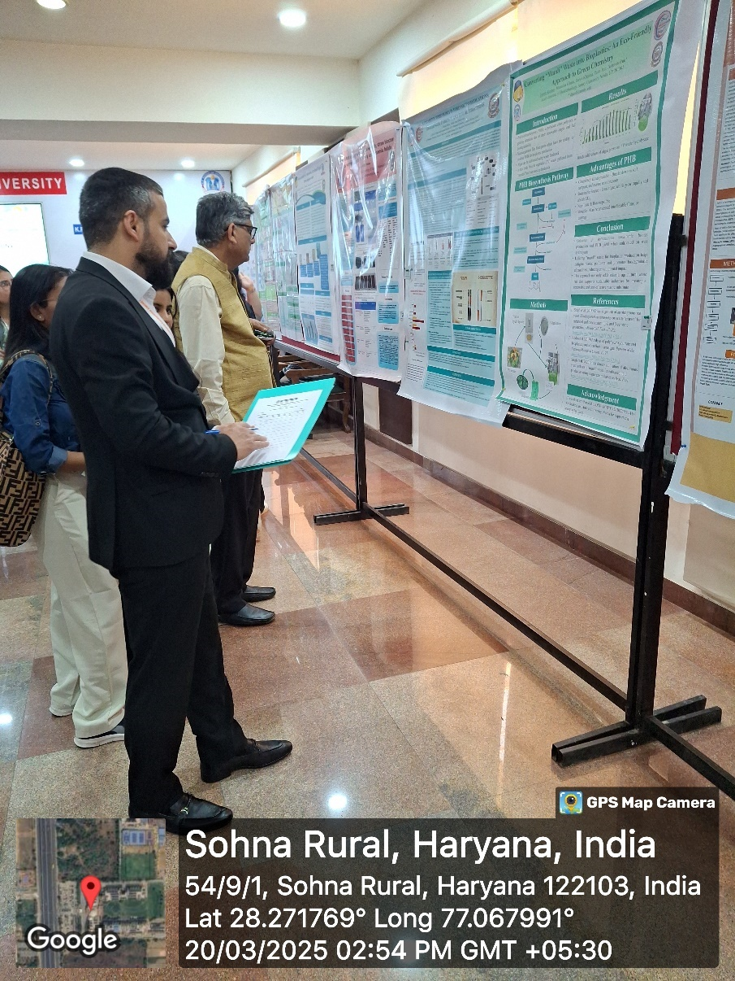

Photo 9: The experts during the evaluation of poster

On the first day of the conference, three parallel sessions of oral presentations were held at various locations: B018, B011, Bhaskracharya block and the Moot Court, Aryabhatt block from 3:00 pm to 5:00 pm. The three technical sessions encompassed the following themes:
- Green Chemistry Approaches, Biochemistry & Forensic toxicology
- Advanced Materials for Green Chemistry & Sustainable Agriculture
- Indian Knowledge System for achieving Environmental Sustainability

The session in Moot court, Aryabhatt block was chaired by Dr. Jyoti Sinha, Principal & Associate Dean, Pharmacy, Sushant University, Gurugram and Co-Chaired by Dr. Anoop Yadav, Associate Professor, Dept. of Environmental Studies, Central University of Haryana under the theme ‘Green Chemistry Approaches, Biochemistry & Forensic toxicology’. The moderators for this session were Dr. Divyanshi from K. R. Mangalam University and Dr. Reeta from Shivaji college. During the session, participants highlighted green synthesis methods, environmentally-friendly biochemical processes, and novel forensic toxicology tools contributing to safer scientific practices.

S N | Name of the author and affiliation | Tile of the poster and Paper id
01 | Anjusha A.J.  Department of Physics, Annamalai University, India | Solvent-Assisted Mechanochemical Ligand Exchange Method: An Eco-Friendly Approach for Surface Modification of Upconversion Nanoparticles - AMG_031(OP)
02 | Blesson Tom Mathew  Department of Textile and Fiber Engineering, Indian Institute of Technology Delhi | Development of Sustainable Thermoregulatory  Cellulosic Fibers from Textile Waste Using Green Chemistry Approaches-AMG_046(OP)

In B018, Dr. Anu Singh, ICMR-Scientist, School of Biotechnology, Jawaharlal Nehru University, New Delhi was the session chair and Dr. Chhagan Lal, Assistant Professor, Department of Chemistry - Swami Shraddhanand College, Delhi was the session-co-chair. Both the experts chaired the session under the theme ‘Advanced Materials for Green Chemistry & Sustainable Agriculture’ The session was moderated by Dr. Divyanshi from K.R. Mangalam University and Mr. Deepesh from Shivaji College
Prior to the commencement of the technical sessions at the 2nd International Conference on Advanced Materials for Green Chemistry and Sustainable Materials (AMGSE-2025), a series of impactful keynote lectures were delivered by eminent international scientists, setting a strong academic foundation for the sessions that followed.
Dr. Avtar Singh, Research Scientist, Research and Development, Molekule Inc., USA, delivered an engaging talk focused on air purification technologies and the role of nanomaterials in environmental remediation. His insights into industry-driven innovations aligned seamlessly with the conference’s theme of sustainable materials and green technologies.
Dr. Sonia A. C. Carabineiro, from Nova University of Lisbon, Portugal, shared her expertise on catalysis and green chemistry, highlighting the significance of sustainable catalytic processes in achieving energy-efficient and eco-friendly chemical transformations.
The participants focused on the development and application of smart materials, biodegradable polymers, and eco-friendly agro-technologies to support sustainable farming practices.

S N | Name of the author and affiliation | Tile of the poster and Paper id
01 | Vishal Sharma  School of Physics and Material Sciences, Shoolini University, Solan, India, 173229 | Interfacial Polarization and Dielectric Properties of LaFeO3 and LaFeO3/rGO Composites - AMG_001(OP)
02 | Neha Kumari  School of Physics and Materials Science, Shoolini University of Biotechnology and Management Sciences, Solan | Synthesis of Reduced Graphene Oxide via Electrospinning method: A Modified Approach in calcination process-AMG_003(OP)
03 | Yogita Basnal  Amity Institute of Nanotechnology, Amity University, Manesar, Gurugram, Haryana INDIA | Carbon quantum dots loaded 4 Dimensional synthetic hydrogels for brain extracellular matrix (ECM) mimicking- AMG_017(OP)
04 | Preety Poswal  Department of Mathematics, NBGSM college, Sohna, Gurugram ,122103, Haryana, India | A Fuzzy EOQ Model for Inventory Management: An Efficient Approach with Numerical and Sensitivity Analysis- AMG_042(OP)
05 | Barkha Sharma  K. R. Mangalam University, Gurgaon | Advancing Sustainability: Green Chemistry Applications in Heterocyclic Compounds-AMG_068(OP)

A keynote lecture by Dr. Ajeet Kaushik, Florida Polytechnic University, USA, held from 16:00 to 16:20, in room no. B011, Bhaskaracharya block under the theme ‘Indian Knowledge System for achieving Environmental Sustainability’. He emphasized nano-enabled sensing platforms for environmental and biomedical applications. His lecture provided a futuristic view of how nanotechnology can be leveraged for real-time monitoring and sustainable health solutions.
This keynote address offered valuable perspectives from academia and industry, stimulating thought-provoking discussions and encouraging collaborative research for addressing global sustainability challenges.
Dr. Vishal Baloria, Assistant Professor, School of Engineering & Technology, BML Munjal University with co-chair Dr. Vinod Kumar, Associate Professor, School of Healthcare and Allied Sciences, G. D. Goenka University, Gurugram evaluated the session in B011, Bhaskracharya block along with Dr. Prabhakar Bhandari and Dr. Nidhi, moderators for this session. The presentations reflected on traditional Indian ecological wisdom, integrating ancient knowledge with modern scientific advancements to address today’s environmental challenges.
S N | Name of the author and affiliation | Tile of the poster and Paper id
01 | Aditya Raj,  K. R. Mangalam University, Gurgaon | Integrating Indian Knowledge Systems in the Modern World: Education, Health, and Sustainability - AMG_038(OP)
02 | Dr. Kanchan Khatreja  K. R. Mangalam University, Gurgaon | Environmental Sustainability through Indian Knowledge System: A Holistic Approach-AMG_051(OP)

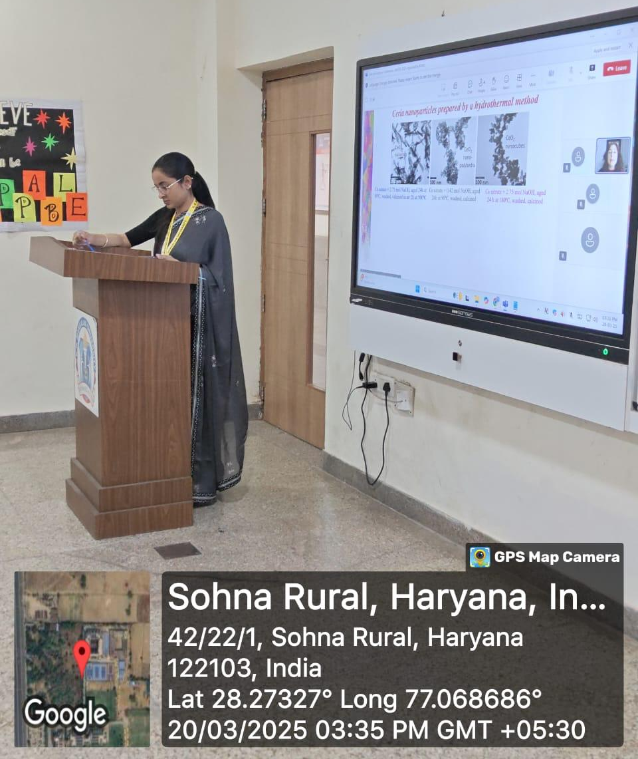

Photo 10: Dr Divyanshi during the technical session
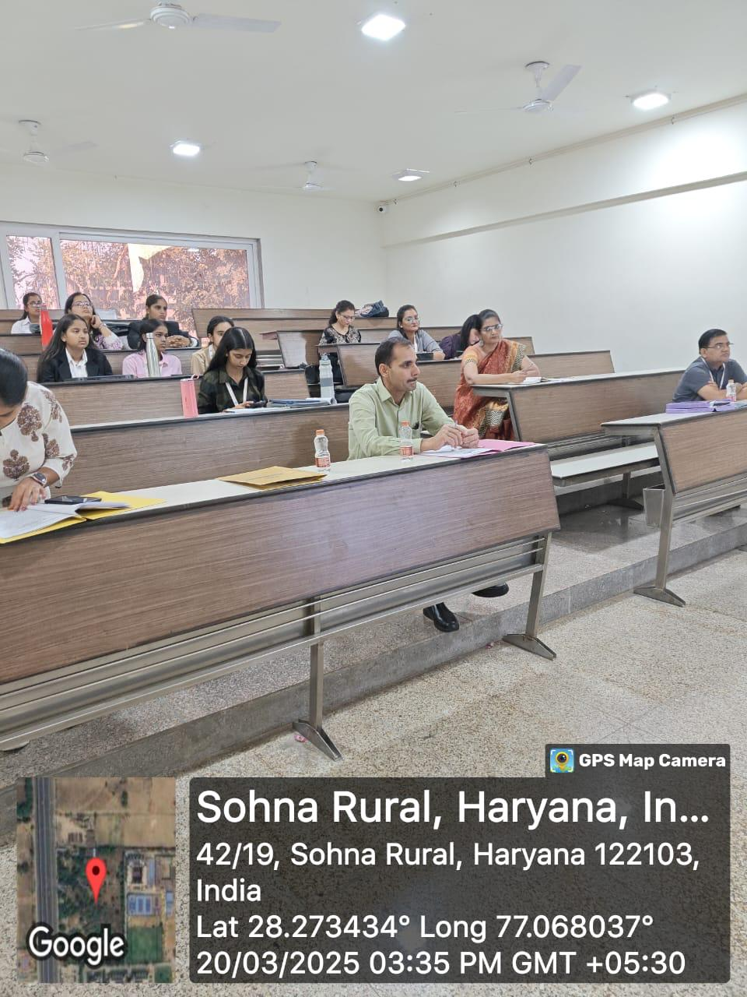

Photo 11: Participants and Session chair, co-chair during the technical session
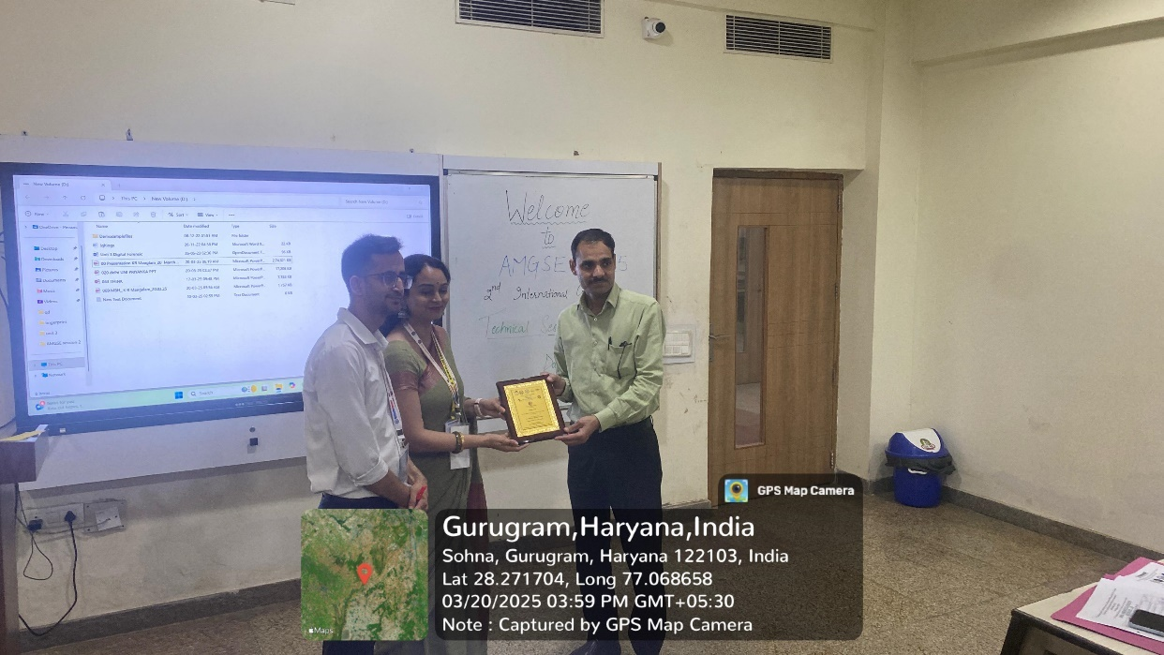

Photo 12: Dr. Pratibha and Dr. Pawan Kumar facilitated the session chair

Throughout the sessions, the role of advanced materials in mitigating environmental pollution, incorporating green chemistry principles in industrial systems, and promoting circular economy models were key discussion points.
To recognize the significant contribution of session moderators, all session chairs and co-chairs were presented with mementos and certificates by faculty members of K.R. Mangalam University, acknowledging their time, insights, and efforts in evaluating the presentations.
These sessions not only fostered academic exchange but also inspired collaborative thinking for a greener, more sustainable future.

2ND DAY OF THE CONFERENCE

The academic proceedings of the 2nd International Conference on Advanced Materials for Green Chemistry and Sustainable Materials (AMGSE-2025) began with a powerful lineup of keynote and invited lectures delivered by eminent national and international experts in the field of sustainable science and green technologies.
The session commenced with an invited lecture by Prof. Dominic C. Y. Foo, Head of the Centre for Green Technologies, University of Nottingham, Malaysia, who provided deep insights into the integration of process systems engineering with green technologies to achieve sustainable industrial practices.
The next keynote lecture was delivered by Dr. Sandeep Kumar Lal, ICAR-IARI, New Delhi, who shared advancements in sustainable agricultural systems, bioresource utilization, and green innovation strategies in farming.
Dr. Jaspal Singh, Post-Doctoral Fellow at the University of Quebec, Canada, delivered a keynote lecture focusing on nanomaterial development and their applications in environmental remediation, energy storage, and biomedical sciences.
The session continued with an invited lecture by Prof. Ponnadurai Ramasami from the University of Mauritius, who discussed quantum chemical approaches and computational methods in green material design.
Dr. Suman Singh, Senior Principal Scientist and Head at CSIR-CSIO, Chandigarh, gave an impactful keynote address on the development of scientific instruments and technologies with a green and sustainable focus, aiding both research and industrial sectors.
Concluding the pre-session lectures, Dr. Yogendra Kumar Mishra, from the University of Southern Denmark, presented an engaging keynote lecture on functional nanostructures and their pivotal roles in environmental protection, sustainable energy solutions, and next-generation material applications.
This lecture series laid a strong foundation for the conference, stimulating intellectual curiosity and setting the tone for the subsequent technical sessions.
Following the impactful invited and keynote lectures, the poster presentation session was conducted as part of the ongoing academic activities at the 2nd International Conference on Advanced Materials for Green Chemistry and Sustainable Materials (AMGSE-2025). The session
provided a dynamic platform for interactive knowledge sharing and visual communication of research innovations.
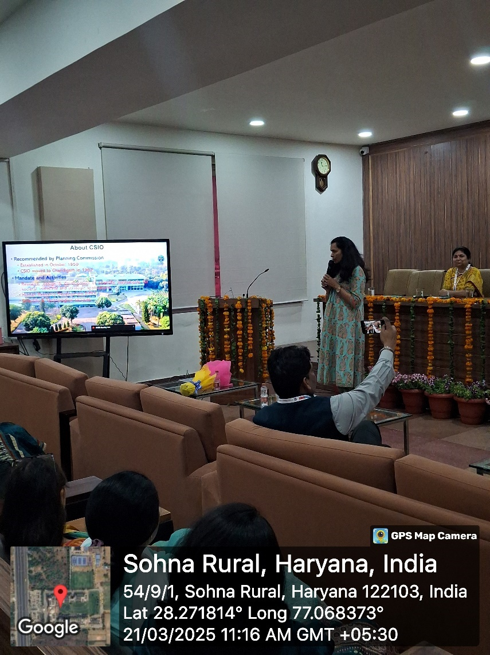

Photo 13: Dr. Suman Singh during her talk

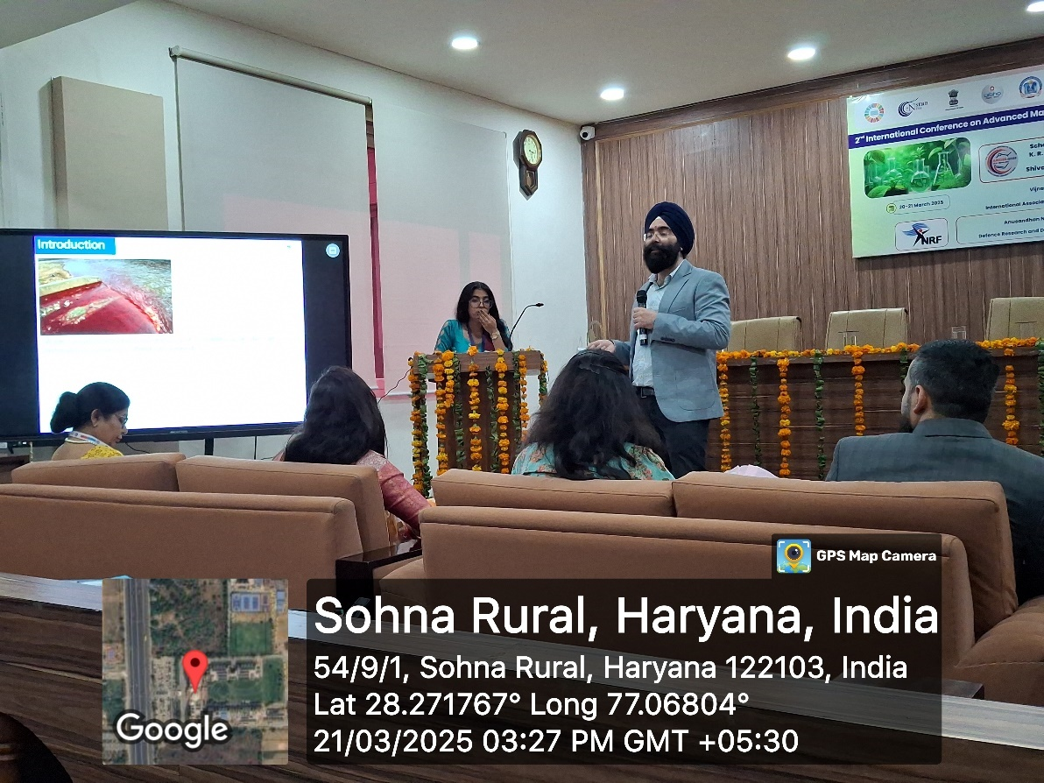

Photo 14: Dr. Jaspal during his talk

More than 25 participants from various academic institutions enthusiastically presented their research work, showcasing experimental findings, novel concepts, and practical applications aligned with the themes of green chemistry, sustainable development, and advanced materials.
The posters reflected a wide range of interdisciplinary topics, and participants engaged in thoughtful discussions with peers and evaluators. The session fostered networking and idea exchange among budding researchers and seasoned experts.
The posters were evaluated by a panel of esteemed experts, including:
- Dr. Jaspal Singh, Postdoctoral Fellow, University of Quebec, Canada
- Dr. Ahmed Kareem Hussein Alatafi, College of Science, Diyala University, Iraq

S N | Name of the author and affiliation | Tile of the poster and Paper id
01 | Nisha Bagotia  Chaudhary Charan Singh Haryana Agriculture University, College of Agriculture Bawal, Rewari | Cellulosed based hydrogel for soil conditioning: Resent advances and future prospective-AMG_091(PP)
02 | Ruchika Mehta  ruchika.mehta@jaipur.manipal.edu | A Multidisciplinary Approach in Assessing the Impact of Climate Change on Alpine Ecosystems: A Review-AMG_092(PP)
03 | Dr. Rajni Gautam  K. R. Mangalam University, Gurugram | Detection of Oral habits by Oral cavity examination-AMG_041(PP)
04 | Preeti  Shivaji College, University of Delhi | Tbuxphos Phosphine Ligand-Supported Palladium-Catalysed Cross-Coupling Reactions in Organic Synthesis-AMG_095(PP)
05 | Bhavana Arora  K. R. Mangalam University, Gurugram | Photodegradation of Dyes Using Metal Oxides: A Sustainable Approach for Environmental Remediation-AMG_096(PP)
06 | Pooja Sharma  K. R. Mangalam University, Gurugram | Graphene Oxide-Based Ternary Nano Composites: A Comprehensive Study on Synthesis, Properties, and Emerging Applications-AMG_097(PP)
07 | Aprajita Singh  Amity School of Natural Resources & Sustainable Development, Amity University, Noida | Evaluating the effectiveness of vernacular design strategies in achieving sustainable interior spaces: A quantitative study-AMG_100(PP)
08 | Sonia Singh  Department of Environmental Studies, Central University of Haryana, Mahendergarh | Bioconversion of Malt industry sludge amended with Paddy straw Biochar to enhance vermicomposting efficiency using Eisenia fetida -AMG_101(PP)
09 | Kalpna  K. R. Mangalam University, Gurugram | Study of transformational practices among human resources with reference to faculty of educational institutions of faridabad-AMG_102(PP)
10 | Sanjay Kumar  Department of Chemistry, Deshbandhu College, University of Delhi, Delhi | Fluoride Removal via Wheat Straw-Derived Dialdehyde Nanocellulose-UIO-66-NH₂ cellum of Nanocomposite: Adsorption Kinetics and Mechanistic Insights. -AMG_108(PP)
11 | Shobha  Department of Physics, Shivaji College,  University of Delhi | Multiwalled Carbon Nanotubes Ternary Composite for Supercapacitor-AMG_110(PP)
12 | Mayank Nautiyal  K. R. Mangalam University, Gurugram | HHO Gas: A Sustainable Energy Solution for the Future—A Review of Its Applications and Opportunities-AMG_111(PP)
13 | Chhavi Pathania  Department of Biotechnology, IILM University, Greater Noida, Uttar Pradesh, India | Neem (Azadirachta indica) Assisted Green Synthesis of Copper Nanoparticles and its Application in Water Treatment-AMG_112(PP)
14 | Dr. Priyanka Kumari,  Shivaji College, University of Delhi | The Role of Green Chemistry in Advancing Sustainability Goals-AMG_119(PP)
15 | Aakrishi Sinha  K. R. Mangalam University, Gurugram | Sustainable latent fingerprint development: Forensic analysis of pulse, rice and alum powder on non-porous surface-AMG_120(PP)
16 | Abhishek Maurya  Shivaji College, University of Delhi | Biodegradable Polymers: An Eco-Friendly Solution to Plastic Pollution-AMG_121(PP)
17 | Amal George  Vels Institute of Science, Technology and Advanced Studies, Chennai | Kerala's Green Warriors: Empowering Community-Led Sustainable Development through Haritha Karma Sena-AMG_123(PP)
18 | Dr. Vineet Verma  School of Engineering and Technology, Vivekanand Institute of Professional Studies- Pitampura, Delhi. | Green Chemistry and its practical applications-AMG_127(PP)
19 | Richa Jain  Department of Physics, Motilal Nehru College, Benito Juarez Road, New Delhi | Green synthesis of Nanoparticles to Treat the Wastewater-AMG_128(PP)
20 | Manoj Ojha  Shivaji College, University of Delhi | Sustainable polymers and composites-AMG_145(PP)
21 | Lavish  Shivaji College, University of Delhi | Sustainable Technologies, Carbon Capturing AMG_149(PP)
22 | Dr. J. Josepha  Noorul Islam Centre for Higher Education Kumaracoil Kanyakumari Dist Tamilnadu India | Sustainable Phenanthroline-Based Metal Complexes for Hydrogen Evolution: Synthesis, Characterization, and Electrocatalytic Performance Toward Viksit Bharat AMG_131(PP)
28 | Akshat  Amity School of Design, Amity University | Theatre view: an art solution to booking movie tickets online AMG_126(PP)
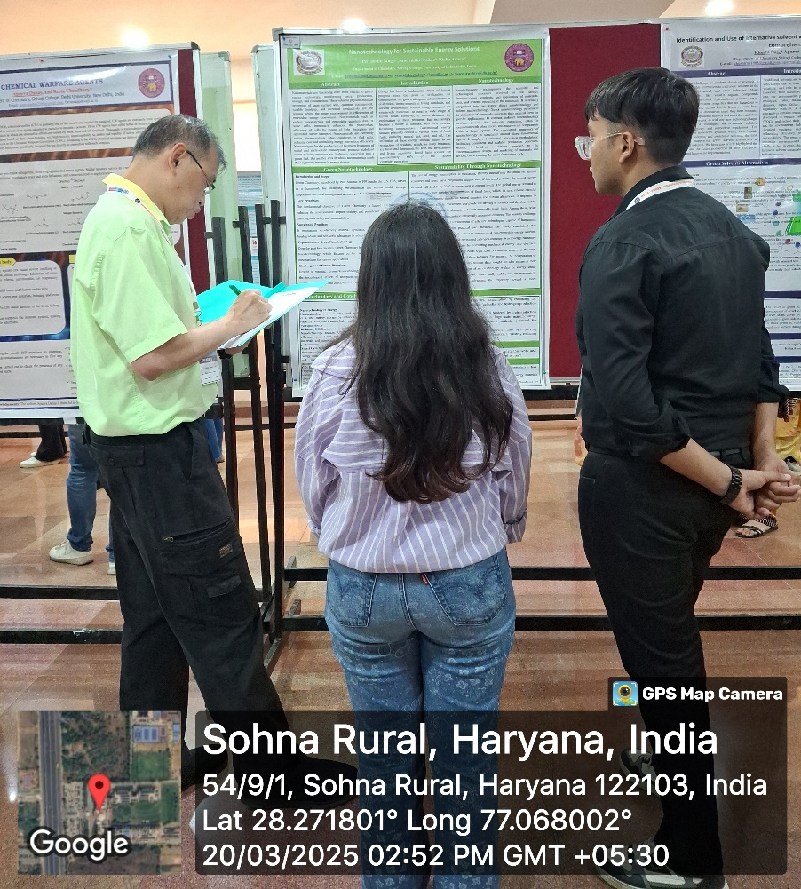

Photo 15: Prof. Dominic during the evaluation of poster

The evaluators appreciated the quality of research and provided constructive feedback to the participants. Some of the outstanding posters were shortlisted for special recognition, encouraging young researchers to further pursue excellence in their academic pursuits.
The poster session was a vibrant and engaging component of the conference, promoting dialogue, critical thinking, and collaborative spirit among the scientific community.
After the poster session, 3 parallel sessions of oral presentations and one online session were held at various locations. The theme of the sessions was
- Sustainable Environmental Technologies & Analytics for Sustainable development through Optimization and Modelling
- Innovation of Advanced Materials with Sustainable Development goals for quality Education -b018
The session in moot court was chaired by Dr. Chandra Mouli Pandey, Assistant Professor Chemistry & Deputy Dean Research, SGT University, Gurugram under the theme ‘Sustainable Environmental Technologies & Analytics for Sustainable development through Optimization and Modelling’. The moderators of the session were Dr. Divyanshi from K R Mangalam University and Dr. Reeta from Shivaji college.

S N | Name of the author and affiliation | Tile of the poster and Paper id
01 | Dinkal V. Kasundra  Tarsadia Institute of Chemical Science (TICS), Uka Tarsadia University, Bardoli | Biphenyl based photo luminescent sensor for real time hydrazine detection: Design, synthesis, DFT and single crystal XRD studies - AMG_004(OP)
02 | Gurpinder Singh  Department of Chemistry, Lovely Professional University, Punjab | Synthesis and Biological Evaluation of Triazole Linked Chromone Derivatives -AMG_005(OP)
03 | Y. Premkumar Singh  Physics Department, Motilal Nehru College, University of Delhi | Dielectric nanoparticle coating for light absorption enhancement in thin film silicon solar cells-AMG_035(OP)
04 | Priyanka Negi  Department of Chemistry, Graphic Era (Deemed to be) University, Dehradun | Sustainable graphene oxide intercalated bentonite composite for the effective removal of imidacloprid from water: Adsorption performance, isotherm and kinetics -AMG_072(OP)
05 | Y. Premkumar Singh  Physics Department, Motilal Nehru College, University of Delhi | Dielectric nanoparticle coating for light absorption enhancement in thin film silicon solar cells-AMG_085(OP)
06 | Priyanshu  Shivaji College, University of Delhi | Nanotechnology for Sustainable Energy Solutions-AMG_133(OP)
07 | M. Premkumar  Department of Mathematics, Sathyabama Institute of Science and Technology (Deemed to Be University) Chennai-600119, Tamilnadu, India | Algebraic Characteristics of ȶ -Norms under the 𝑸−Fuzzy PS-Sub Algebra and Ideals in PS-Algebra-AMG_135(OP)

In B018, Bhaskracharya block, the sessions were held under the theme ‘Innovation of Advanced Materials with Sustainable Development goals for quality Education’. The session was chaired by Dr. Vinod Kumar, Deputy COE & Assistant Professor, J. C. Bose University of Science & Technology, YMCA Faridabad and moderated by Dr. Pratibha Sharma from K R Mangalam University and Dr. Seema Lal from Shivaji college.
S N | Name of the author and affiliation | Tile of the poster and Paper id
01 | Kumari Ruchi  Department of Chemistry, Dayalbagh Educational Institute, Dayalbagh – 282005, India | A Study of Enhanced Photoelectrochemical Water Splitting in Metal-Incorporated Bismuth Ferrite Photoanode- AMG_008(OP)
02 | Aarti Malyan  Department of Electronic Science, University of Delhi, South Campus, Delhi | Synthesis of Silver nanoparticles and study its impact on the efficiency of Microbial Fuel Cell-AMG_009(OP)
03 | Mohit Deswal  Department of Zoology, Maharshi Dayanand University, Rohtak, Haryana - 124001 | Nanoplastics: an upcoming challenge to ecological health-AMG_024(OP)
04 | Nitin Kishore Rawat  Department of Physics, UPES (University of Petroleum and Energy Studies), Dehradun | Structural insights into compressive deformation behavior of Cu-Ni alloy with faceted grain boundary: A molecular dynamics investigation-AMG_039(OP)
05 | Ashima Sharma  Delhi Skill and Entrepreneurship University (DSEU), Dwarka Campus, Sector 9, Delhi | A transformative solution for Sustainable Construction: The Potential of Bamboo -AMG_130(OP)

An online session was also conducted for the participants and evaluated by Dr. Prabhakar Bhandari, Assistant Professor, School of Engineering and Technology, K R Mangalam University and Ms. Neetu, Assistant Professor, Department of Chemistry, Shivaji collage, University of Delhi.

S N | Name of the author and affiliation | Tile of the poster and Paper id
01 | Gurumurthy Ramaiah  Department of Textile Technology, Federal Technical and Vocational Training Institute, Addis Ababa, Ethiopia | Sustainable Briquette Production from Textile Waste and Sawdust: A Route to Renewable Energy and the Circular Economy- AMG_036(OP)
02 | Anjali Maurya  Department of Chemistry, SS Khanna Girl’s Degree College  (A Constituent College of University of Allahabad), Prayagraj, UP | Ancient Indian Nanomaterials: Properties and Applications of Bhasma-AMG_115(OP)
03 | Rachana Gaur  K. R. Mangalam University, Gurgaon | Theoretical analysis of optically active vibrational modes of Columbite NiV2O6-AMG_010(OP)
04 | Anurag Mudgal  2Pandit Deendayal Petroleum 1University, Gandhinagar, Gujarat-382426, India | Design, Manufacturing and Feasibility study of a thermal- energy driven Reverse Osmosis system for brackish and water contamination areas in India-AMG_040(OP)
05 | Akshima Soni  Department of Chemistry, Amity School of Applied Sciences, Gurugram, Haryana, India | Green Synthesis of Hybrid Nanocomposites for Environmental Remediation-AMG_012(OP)

Participants shared insightful presentations and case studies highlighting how innovative materials and technologies can address environmental challenges while supporting global sustainability targets. Emphasis was placed on integrating advanced analytics and modeling techniques to optimize processes for resource efficiency and cleaner production. The session also included online participation, enabling global academic engagement and knowledge exchange. Participants collectively reinforced the importance of interdisciplinary collaboration and education in driving sustainable innovation forward.

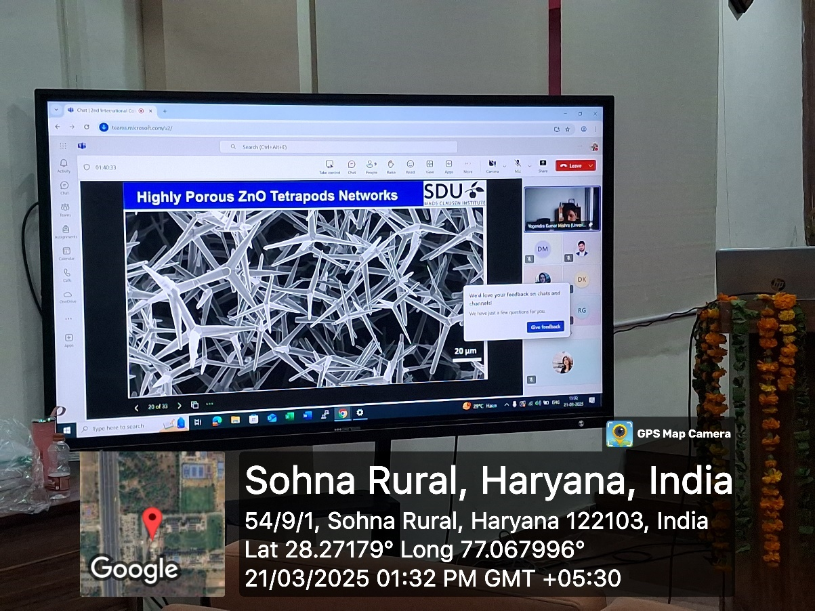

Photo 16: Prof. Yogendra Kumar Mishra during his talk
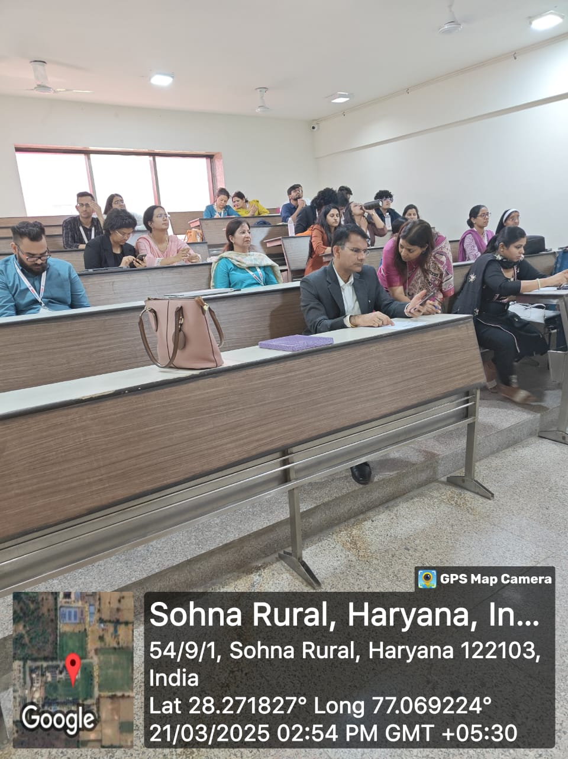

Photo 17: Participants during the technical session

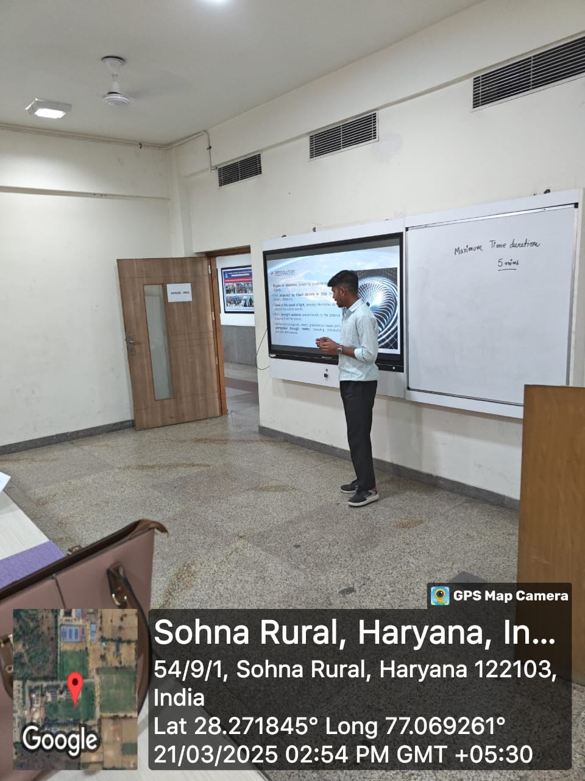

Photo 18: Participant during his presentation

VALEDICTORY CEREMONY
The 2nd International Conference on Advanced Materials for Green Chemistry and Sustainable Materials (AMGSE-2025) concluded with a meaningful and engaging valedictory session, marking the successful end of two days of academic enrichment and global collaboration. The session was led by Dr. Ahmed Kareem Hussein Alatafi (Iraq), who delivered a comprehensive summary of the key discussions, research contributions, and collaborative outcomes of the conference.
Prof. Meena Bhandari, the Organizing Head, and Prof. Mehraj Uddin Mir, Motilal Chair, K.R. Mangalam University, addressed the gathering, commending the enthusiasm of participants and the excellence of the sessions conducted. The event also featured a formal award distribution ceremony, recognizing exceptional contributions. Awards were presented for Best Oral Presentation, Best Poster Presentation, and the prestigious Young Scientist Award, honoring promising researchers in the field.
The session also included reflections from participants, who appreciated the platform for its diverse and high-quality academic exchange. Dr. Chandra Mohan and Dr. Neeraj Kumari, Convenors of AMGSE-2025, extended heartfelt acknowledgments to all dignitaries, speakers, participants, sponsors, and organizing team members for their support and active participation.
The valedictory session concluded on a high note, celebrating the conference’s role as a vibrant hub for international collaboration, scientific dialogue, and advancement of sustainable practices in green chemistry and environmental sciences.
Best oral/poster presentation awards
The jury of the session chair and co-chair have selected overall four best oral presentation, and four poster presentation awards based on relevance of their work to the conference theme.

S N | Title of talk | Presenter | Affiliation | Award
01 | Development of Sustainable Thermoregulatory Cellulosic Fibers from Textile Waste Using Green Chemistry Approaches | Blesson Tom Mathew | Department of Textile and Fiber Engineering, Indian Institute of Technology Delhi | Young Scientist (Oral Presentation)
02 | Biodegradable Polymers: An Eco-Friendly Solution to Plastic Pollution | Abhishek Maurya | Biodegradable Polymers: An Eco-Friendly Solution to Plastic Pollution | Young Scientist (Poster presentation)
03 | Biphenyl based photo luminescent sensor for real time hydrazine detection: Design, synthesis, DFT and single crystal XRD studies | Ms. Dinkal V. Kasundra | Tarsadia Institute of Chemical Science (TICS), Uka Tarsadia University, Bardoli – 394 350, Gujarat, India | Oral Presentation (1st Position)
04 | Next-Generation Recycling for Photovoltaics: APOLLO’s Strategic Approach | Deepa Oberoi | PDRA, Centre for Sustainable Materials Processing, University of Leicester | Oral Presentation (2nd Position)
05 | Role of RF Energy and Cu Material Based RF Sensor Passive Antenna for Biomedical Applications | Abhishek Kumar Saroj | Department of Electronics Engineering, IIT-(BHU) Varanasi, UP, 221005, India | Oral Presentation (3rd Position)
06 | Embracing Sustainability: The Impact of Environmental Social Governance (ESG) on the Growth of Manufacturing Industries in India | Md. Muktasir Rohman | University School of Biotechnology, Guru Gobind Singh Indrarastha University, New Delhi | Poster Presentation (1st Position)
07 | Preparation of CuFexoy Nanocomposite for Adsorption of Azo Dyes From Industrial Contaminated Water | Karanbeer Kaur | Peptide Chemistry Laboratory, School of Physical Sciences, Jawaharlal Nehru University, New Delhi | Poster Presentation (2nd Position)
08 | Photodegradation of Dyes Using Metal Oxides: A Sustainable Approach for Environmental Remediation | Ms. Bhawna Arora | SBAS, K R Mangalam University | Poster Presentation 3rd Position)

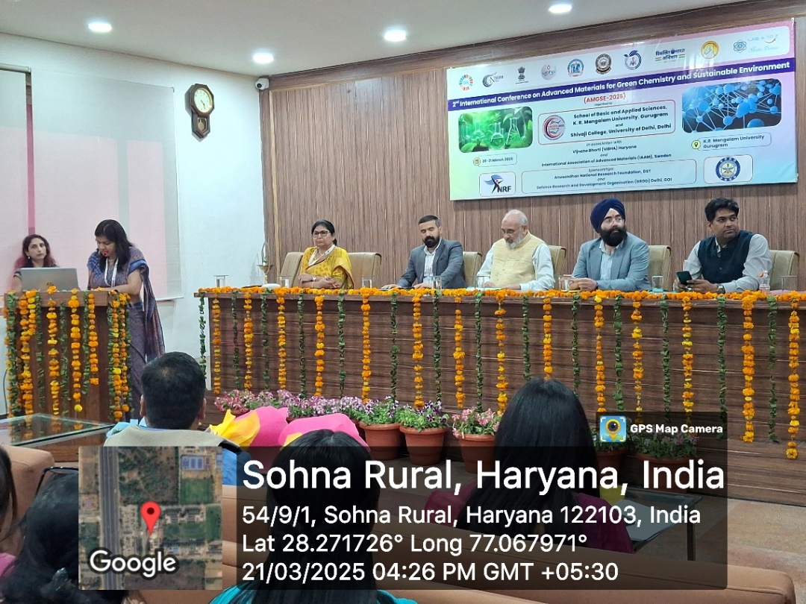

Photo 19: Dr Neeraj Kumari gave vote of thanks in the conference

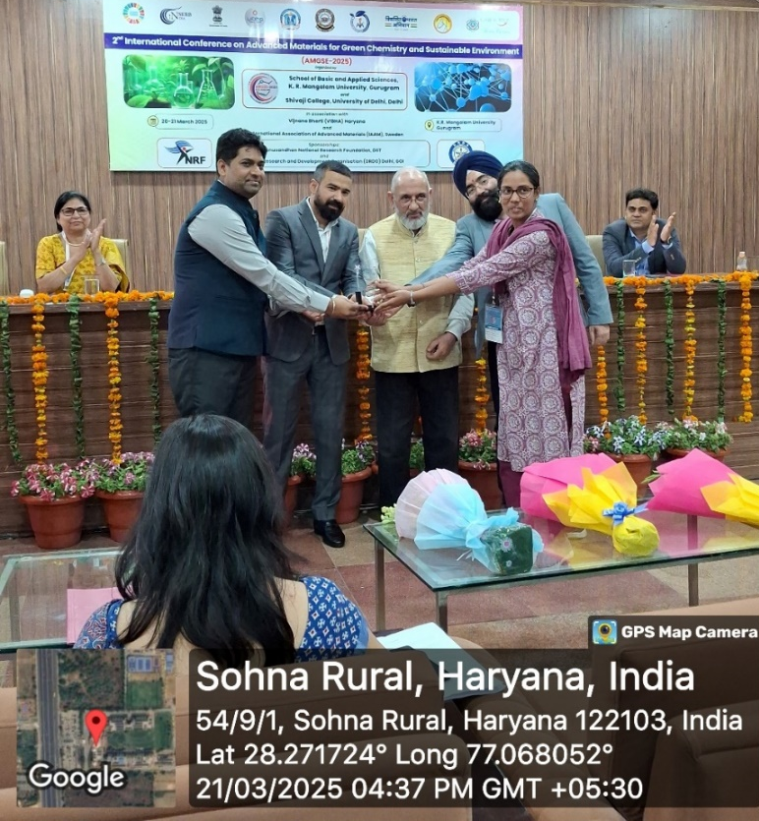

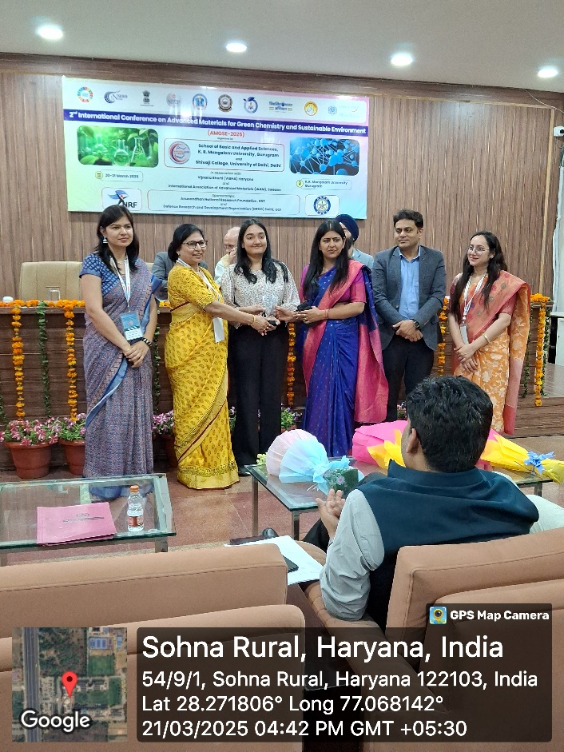
Photo 20: Conference chair and convenor with guests awarded the participants for best oral presentation

Photo 21: Conference chair and convenor with guests awarded the participants for best oral presentation
Report prepared by | Dr Neeraj Kumari
Report seen by | Prof. Meena Bhandari  Dean, SBAS
Report verified by | Dr Shikha Dutt Sharma, IQAC Coordinator

