3-Day International Conference
On
Connect 360
Sustainability and Innovation Incorporating Indian Knowledge System
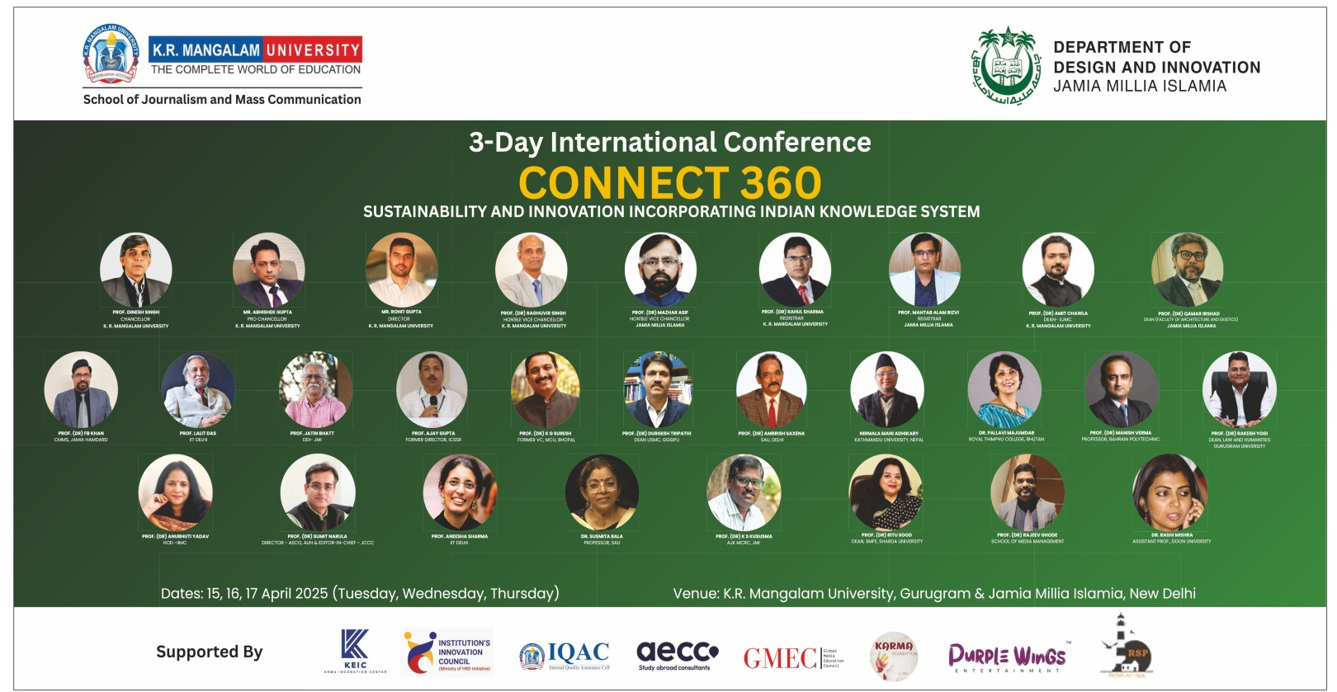
(April 15–17, 2025)

A Brief Report on
3-Day International Conference
On
Connect 360: Sustainability and Innovation Incorporating Indian Knowledge System

Organized by
School of Journalism and Mass Communication, K.R. Mangalam University, Sohna Road, Gurugram

In collaboration with
Department of Design and Innovation (DDI),
Jamia Millia Islamia, New Delhi

Venues:
Multipurpose hall and SOHMCT Conference Room
K.R. Mangalam University, Gurugram (Haryana)
&
Ho Chi Minh Conference Hall, Jamia Millia Islamia
New Delhi
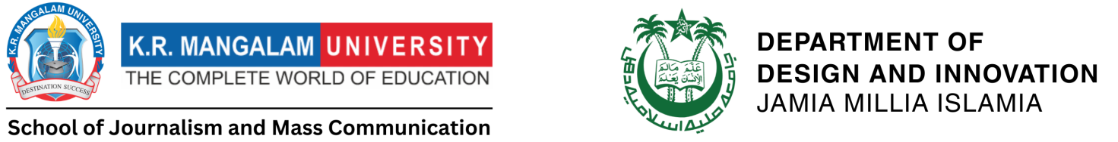

Contents
- Preface
- Acknowledgements
- Title and Objective of the Conference
- Themes and Sub-Themes of the Conference
- Inaugural Function
- Address of the Invited Speakers
- Session wise & Track wise Report
- Valedictory Function
- Feedback from the Participants

Preface
The Connect 360 International Conference, held over three enriching days, brought together a diverse group of scholars, researchers, media professionals, and students from around the world. Organized jointly by K.R. Mangalam University and Jamia Millia Islamia, this conference served as a dynamic platform for meaningful dialogue on the vital themes of sustainability, innovation, and the enduring relevance of Indian Knowledge Systems (IKS) in today’s rapidly changing world.
In a time when the world faces unprecedented challenges in the realms of environmental sustainability, technological innovation, and cultural preservation, the Connect 360 conference sought to bridge traditional wisdom with modern scientific research. By engaging a multidisciplinary audience, the event highlighted how ancient Indian Knowledge Systems can provide essential insights and solutions to contemporary global issues.
With over 130 delegates participating from India and various international locations, the conference provided a robust exchange of ideas and research. A total of 68 paper presentations were delivered across six technical sessions, which were held in a hybrid format, allowing for both in-person and virtual participation. The conference included scholars from a wide range of disciplines, including journalism, design, digital media, environmental studies, communication, and indigenous knowledge, demonstrating the broad relevance of IKS across different sectors.
The participation of keynote speakers, panellists, and session chairs from over 10 esteemed academic institutions enhanced the quality of discussions and presentations. Each session fostered collaboration and encouraged cross-disciplinary thinking, ensuring that the conference was not just an academic exercise, but a collective endeavors to forge new paths in research, practice, and policy-making.

Acknowledgements
We begin by expressing our profound gratitude to our esteemed Chancellor, Prof. Dr. Dinesh Singh, whose visionary leadership and unwavering commitment to excellence in education have been pivotal in shaping this conference. Our heartfelt appreciation also goes to Pro-Chancellor Shri Abhishek Gupta ji, whose steadfast support and strategic direction played a critical role in bringing this conference to life. His leadership ensured its smooth execution and wide-reaching impact, and for this, we are truly grateful.
We extend our sincere thanks to Vice-Chancellor Prof. Dr. Raghuvir Singh and Registrar Dr. Rahul Sharma for their constant encouragement and instrumental facilitation. We would also like to express our sincere gratitude to Prof. Mazhar Asif, Vice Chancellor of Jamia Millia Islamia, New Delhi, Prof. Md. Mahtab Alam Rizvi, Registrar, and Prof. Qamar Irshad, HOD, DDI and Dean FAE of Jamia Millia Islamia, for their continuous support and contribution to the success of this conference.
Our deepest thanks go to IQAC Director Prof. Tania Gupta and IQAC Coordinator for exceptional coordination and leadership, which ensured the smooth and efficient running of the conference. We are also grateful to Prof. Varuna Tyagi, Dean of Academics, for her continuous academic guidance, which provided the solid foundation for the success of this event. Additionally, we extend our sincere appreciation to Dr. Seema Raj, Dean of Research, for her invaluable contributions in advancing the research agenda and enhancing the academic rigor of the conference.
A special note of gratitude goes to the organizing team, whose hard work, dedication, and exemplary coordination were crucial to the event’s success. Their tireless commitment ensured the seamless execution of this conference.
Finally, we would like to express our heartfelt thanks to our students, whose enthusiasm, energy, and unwavering commitment were integral to the success of this conference. Their tireless efforts, positive attitude, and support were essential in making this event a reality, and we look forward to their continued involvement in future academic endeavors.
This conference stands as a testament to the collective effort of all involved, reflecting our shared commitment to advancing academic excellence and fostering interdisciplinary engagement. We are excited for the continued success of this initiative and look forward to its further growth and the development of future academic initiatives.

Title and Objective of the Conference

Title of the Conference: Connect 360: Sustainability and Innovation Incorporating Indian Knowledge System
Objectives:
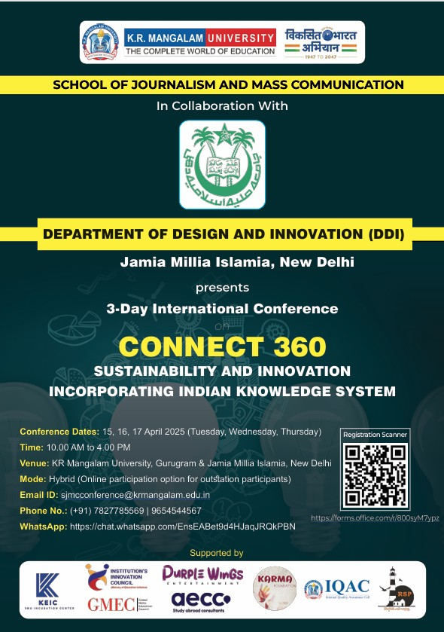
1. To elaborate on the discourse around the crucial role of communication and design research in interpreting, preserving, and promoting the principles of Indian Knowledge Systems (IKS) through innovative and engaging storytelling, design thinking, and immersive experiences.
2. To explore the relevance of Indian Knowledge Systems in addressing sustainability challenges in contemporary contexts.
3. To engage design thinking and communication strategies to amplify the global relevance of Indian Knowledge Systems.
4. To foster interdisciplinary collaboration that bridges ancient wisdom with modern sustainable, innovative, and scientific advances through design-driven research, co-creation, and knowledge exchange.
5. To develop actionable recommendations on how to better represent and promote Indian Knowledge Systems through innovative storytelling, design-led approaches, and ethical considerations.

Themes and Sub- Theme
Media, IKS, and the Power of Visual Storytelling: Designing Engaging Narratives
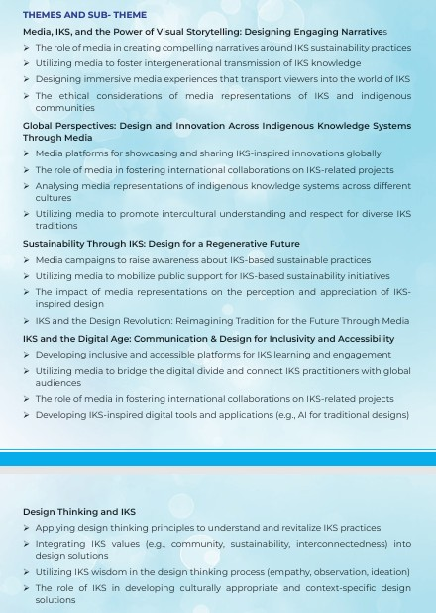
- The role of media in creating compelling narratives around IKS sustainability practices
- Utilizing media to foster intergenerational transmission of IKS knowledge
- Designing immersive media experiences that transport viewers into the world of IKS
- The ethical considerations of media representations of IKS and indigenous Communities.
Global Perspectives: Design and Innovation Across Indigenous Knowledge Systems Through Media
- Media platforms for showcasing and sharing IKS-inspired innovations globally.
- The role of media in fostering international collaborations on IKS-related projects.
- Analyzing media representations of indigenous knowledge systems across different cultures.
- Utilizing media to promote intercultural understanding and respect for diverse IKS traditions.
Sustainability through IKS: Design for a Regenerative Future
- Media campaigns to raise awareness about IKS-based sustainable practices.
- Utilizing media to mobilize public support for IKS-based sustainability initiatives.
- The impact of media representations on the perception and appreciation of IKS inspired design.
- IKS and the Design Revolution: Reimagining Tradition for the Future Through Media.
IKS and the Digital Age: Communication & Design for Inclusivity and Accessibility
- Developing inclusive and accessible platforms for IKS learning and engagement
- Utilizing media to bridge the digital divide and connect IKS practitioners with global audiences.
- The role of media in fostering international collaborations on IKS-related projects.

- Developing IKS-inspired digital tools and applications (e.g., AI for traditional designs).

Design Thinking and IKS

- Applying design thinking principles to understand and revitalize IKS practices.
- Integrating IKS values (e.g., community, sustainability, interconnectedness) into design solutions.
- Utilizing IKS wisdom in the design thinking process (empathy, observation, ideation)

- The role of IKS in developing culturally appropriate and context-specific design solutions.

Inaugural Function
The conference commenced with a traditional lamp-lighting ceremony, a symbolic gesture marking the beginning of an academic journey dedicated to sustainability, innovation, and the integration of Indian Knowledge Systems (IKS) into contemporary research practices. This ceremonial start reflected the spirit of enlightenment and collective commitment toward addressing global challenges through indigenous wisdom and modern innovation.
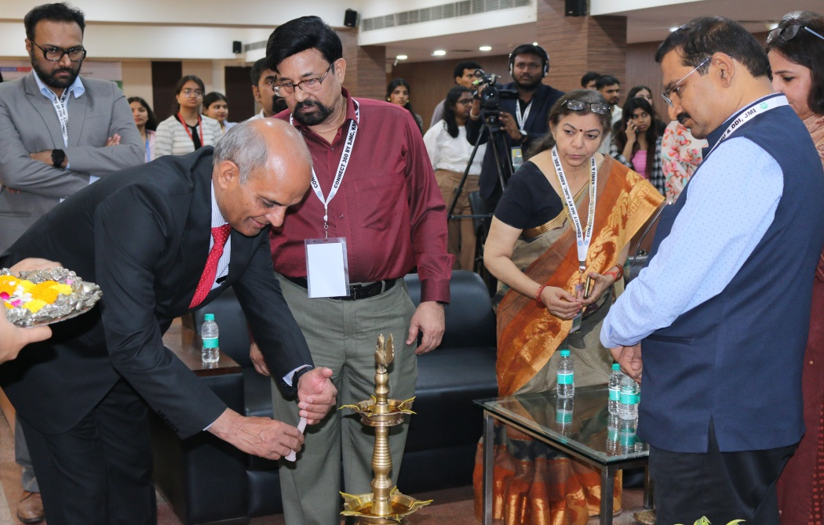
(Connect 360- 3 days International Conference lamp-lighting ceremony at Multipurpose Hall, KRMU)

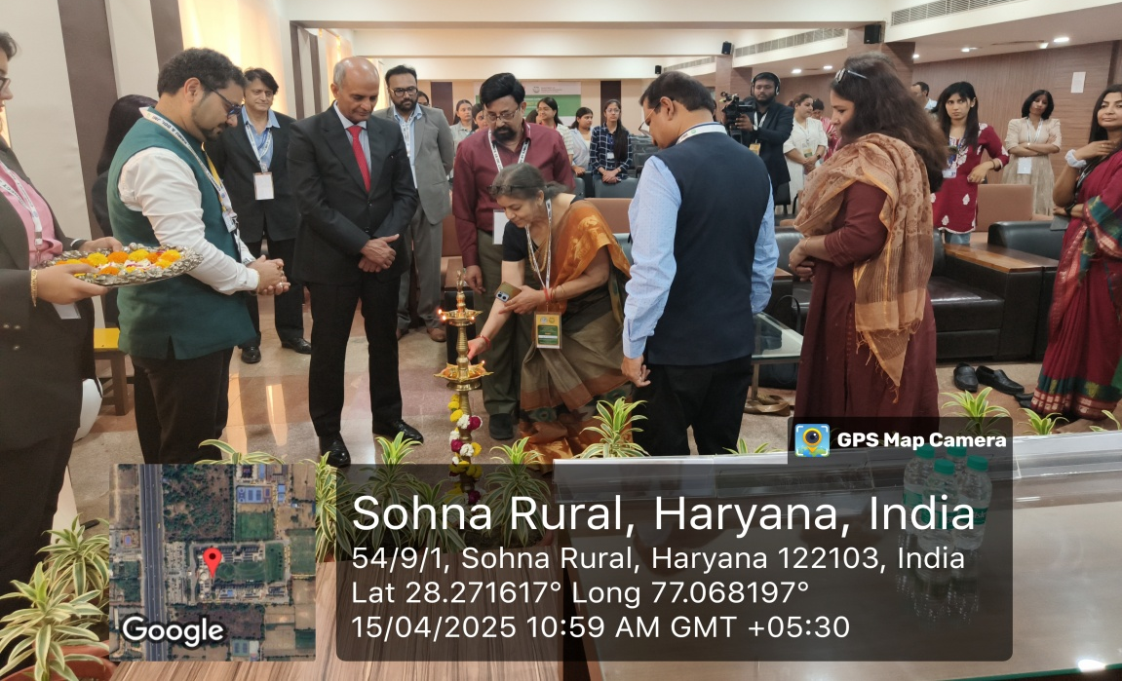

The inaugural session was led by Prof. (Dr.) Raghuvir Singh, Vice Chancellor of K.R. Mangalam University, who set the tone for the event with his insightful address. He emphasized the need for adopting a “360-degree perspective” when tackling the complex and interconnected issues of sustainability. Prof. Singh highlighted that solutions to today’s pressing global problems require a holistic, interdisciplinary approach that bridges traditional knowledge with cutting-edge scientific research. He also underscored the importance of fostering innovation and collaboration across different fields to create meaningful, sustainable change.
The objectives of the conference closely aligned with key Sustainable Development Goals (SDGs). SDG 4.4 focuses on enhancing relevant skills for employment, decent jobs, and entrepreneurship, encouraging individuals to be better equipped for the demands of a changing world. SDG 11.4 emphasizes the protection and safeguarding of the world's cultural and natural heritage, a principle deeply embedded in the integration of Indian Knowledge Systems. Meanwhile, SDG 17.8 highlights the significance of strengthening global partnerships, particularly through improving access to technology and promoting knowledge sharing, especially among developing nations. Together, these SDGs illustrate the conference’s commitment to fostering a more sustainable, inclusive, and innovative future. By blending ancient wisdom with contemporary research, the event sought to build bridges between the past and the future, creating pathways for collective progress on a global scale.

Address of the Invited Speakers: Day 1, Venue: K. R. Mangalam University, Gurugram
The conference featured compelling keynote addresses from distinguished scholars, each offering unique perspectives on the intersection of sustainability, indigenous knowledge, and ethical communication.
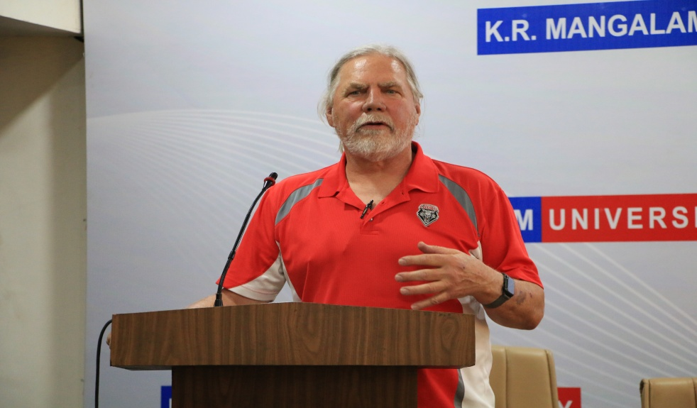
Prof. William L. Gannon, University of New Mexico delivered an insightful address emphasizing the critical need for cross-border academic collaborations. He pointed out that in today's increasingly interconnected world, challenges such as sustainability cannot be effectively tackled in isolation. Prof. Gannon argued that knowledge frameworks must transcend geographical, cultural, and political boundaries to foster a truly global exchange of ideas and innovations. He highlighted that the collective sharing of research, resources, and expertise among nations is essential for developing comprehensive solutions to the complex issues confronting humanity. By promoting collaborative knowledge networks, he suggested, the global academic community can make significant strides toward achieving sustainable development goals.

(Guest of Honour-Prof. William L. Gannon, University of New Mexico shares his views at the SJMC Connect 360 International Conference, K.R. Mangalam University)
Prof. F.B. Khan Founder Professor – DDI and Professor - CMMS, Jamia Hamdard University, Delhi focused his keynote on the vital role of indigenous knowledge systems in modern sustainability practices. He underscored the richness and relevance of traditional wisdom, particularly in areas such as agriculture, healthcare, and environmental conservation.

Prof. Khan advocated for the integration of indigenous knowledge with scientific research, arguing that such a synthesis can lead to more resilient and locally adapted solutions.
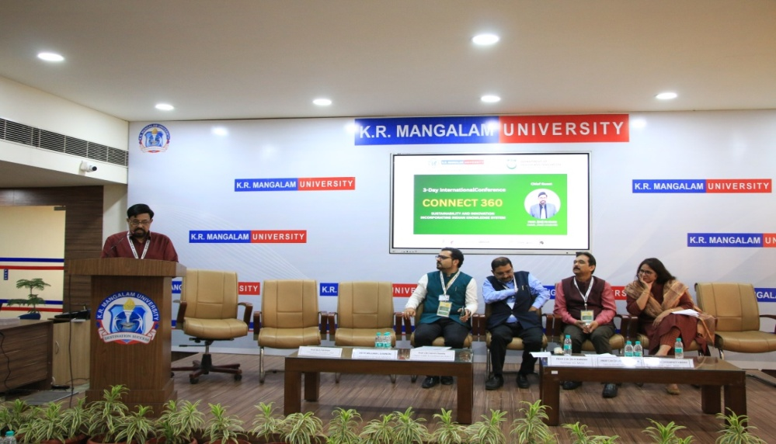
He stressed that indigenous communities possess centuries-old insights into living sustainably within their environments, and modern science stands to benefit greatly from these traditional practices. Recognizing and valuing the contributions of local communities, he suggested, is key to crafting sustainable models that are both innovative and respectful of cultural heritage.
(Chief Guest Prof. (Dr.) F.B. Khan shares his insights at the SJMC Connect 360 International Conference.)
(Dr.) K G Suresh, Former VC, MCU, Bhopal; Former DG, IIMC, New Delhi addressed the ethical dimensions of journalism, bringing attention to the media's critical role in shaping public discourse on sustainability. He emphasized that responsible and ethical storytelling is fundamental to raising awareness, influencing public opinion, and mobilizing action. Dr. Suresh warned that without adherence to ethical principles, journalism risks spreading misinformation or fostering apathy. He advocated for journalism that informs, educates, and empowers citizens, highlighting the necessity of truthful reporting to drive societal engagement with sustainability issues. Ethical journalism, he concluded, serves not just to inform, but also to inspire communities to participate actively in building a sustainable future.

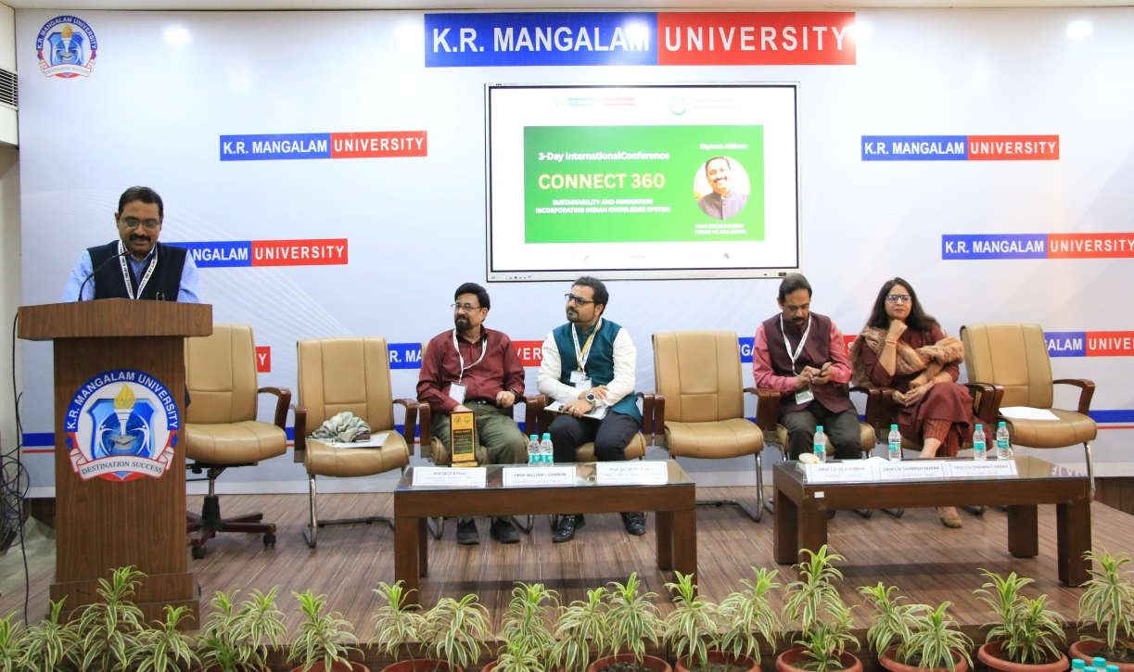
(Prof. (Dr.) K G Suresh, Former VC, MCU, Bhopal; Former DG, IIMC, New Delhi addressing the session)
Prof. (Dr.) Ambrish Saxena, Professor at SAU and Secretary of GMEC, delivered a thought-provoking session on the pivotal role of media education in fostering critical thinking. He emphasized the importance of equipping students with the tools to analyze, evaluate, and interpret media content in today’s information-driven world. Prof. Saxena discussed how media education can cultivate a deeper understanding of societal issues and encourage students to approach information critically. By focusing on critical thought, he highlighted that media education plays a central role in empowering individuals to engage meaningfully with the world around them.
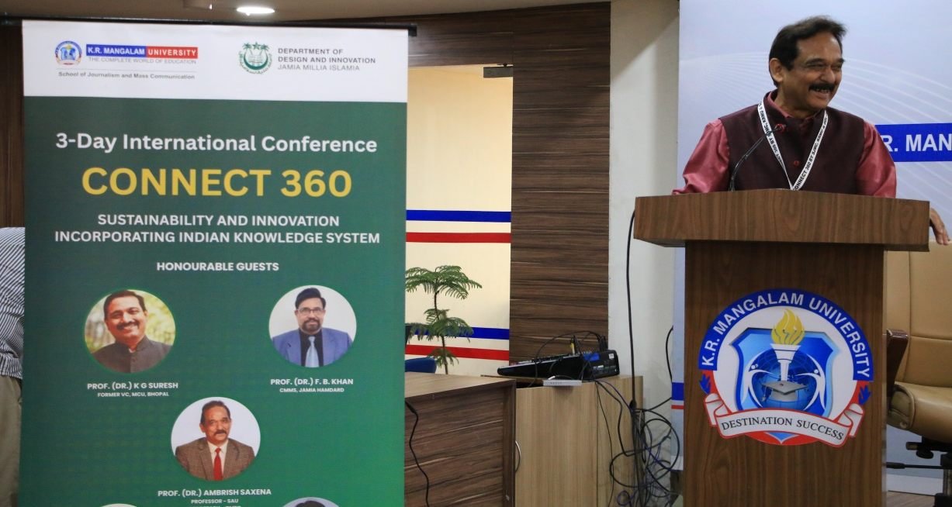

(Prof. (Dr.) Ambrish Saxena speaks at the CONNECT 360 conference at K.R. Mangalam University.)

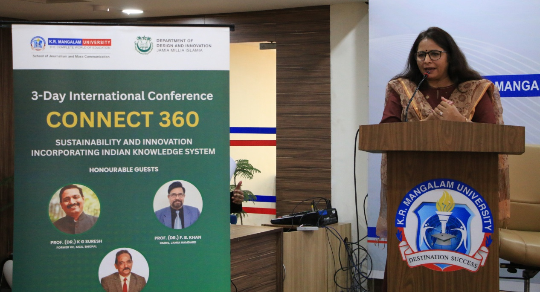
Prof. (Dr.) Anubhuti Yadav, Professor and Head of the Department at IIMC, Delhi, focused her address on the ethics of digital innovation. Dr. Yadav underscored the significance of ethical considerations in the rapidly evolving field of digital technology. She stressed that as digital platforms grow, ethical issues such as data privacy, misinformation, and algorithmic biases must be prioritized. Dr. Yadav called for a balanced approach, where innovation is aligned with ethical standards to ensure that technology benefits society responsibly and equitably.

(Prof. (Dr.) Anubhuti Yadav addresses the audience at the CONNECT 360 conference at K.R. Mangalam University.)
Both speakers contributed significantly to the conference discussions, providing valuable perspectives on the intersection of education, media, and ethics in an increasingly digital world. Their insights not only sparked deep reflections but also encouraged the audience to consider how these critical issues shape the future of society. The keynote speeches set a thoughtful and visionary tone for the conference, emphasizing collaboration, respect for indigenous knowledge, and the ethical responsibilities of communication in addressing global challenges.
Launch of the Book of Abstracts and Paper Presentations:
Another significant highlight of the conference was the launch of the official Book of Abstracts, a comprehensive compilation featuring the summaries of all the research papers presented during the event. This publication not only served as a valuable academic resource but also symbolized the collaborative spirit and intellectual rigor that the conference aimed to foster.

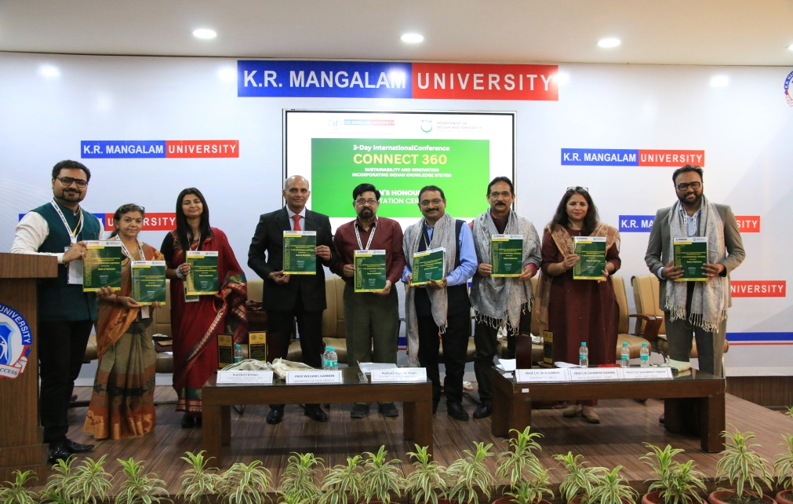
The Book of Abstracts captured the diversity of ideas and research efforts contributed by participants from various disciplines, offering a snapshot of contemporary scholarly engagement with critical global issues.

(Book of Abstracts released during the 3-day Connect 360 International Conference at K.R. Mangalam University)
Following the launch, the first round of paper presentations was conducted, featuring the work of 22 promising student researchers. These young scholars presented on a wide range of topics, reflecting the conference’s overarching themes of sustainability, innovation, and ethical communication. Many of the presentations delved into critical areas such as media education, highlighting how media literacy is becoming increasingly essential in a digital world dominated by rapid technological advancements and information overload. Other papers explored ethics in digital innovation, emphasizing the need for responsible technological development that prioritizes human rights, inclusivity, and environmental sustainability.
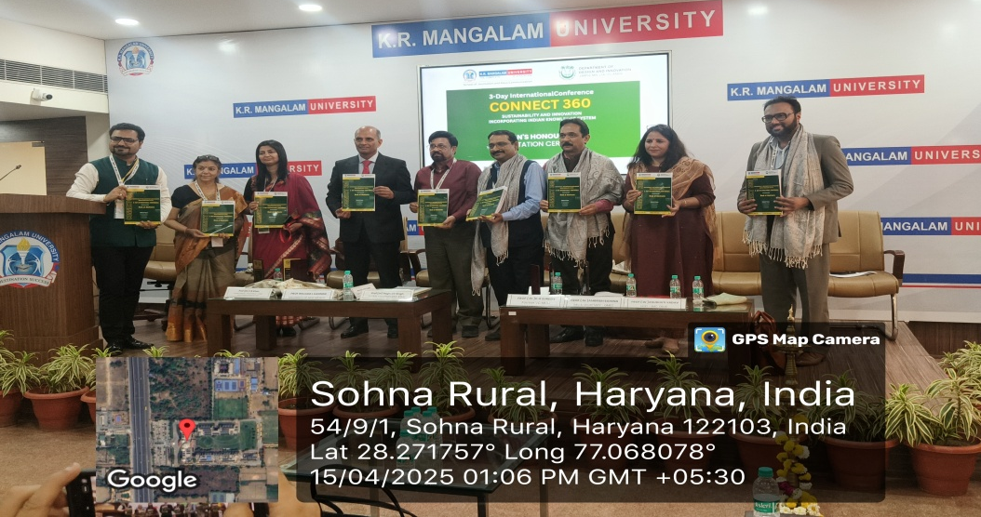

Additionally, several presentations examined the evolving role of journalism in society, particularly in fostering critical thinking and civic engagement. Students highlighted how ethical journalism can empower communities, challenge misinformation, and contribute meaningfully to democratic processes. The diversity of topics and the depth of research presented showcased the students’ commitment to addressing real-world challenges through academic inquiry. The session not only provided a platform for students to share their research but also encouraged constructive dialogue and feedback from peers and experts, contributing to their academic and professional growth. Overall, the paper presentations set an inspiring tone for the rest of the conference, underscoring the importance of youth engagement in shaping a more informed, ethical, and sustainable future.

Session Wise & Track Wise Report: Day 1

Date: April 15, 2025 (Tuesday), Venue: K.R. Mangalam University, Gurugram

Technical Session Inauguration and Keynote Address:

The first day of the conference was Technical Session inaugurated at 1:30 PM at K.R. Mangalam University. The event began with a formal welcome and the lighting of the ceremonial lamp, marking the auspicious start of the technical sessions. The Keynote Address was delivered by Prof. (Dr.) Pallavi Majumdar, Professor of Mass Communication at Royal Thimphu College, Bhutan. Dr. Majumdar spoke eloquently on the significance of Indian Knowledge Systems in today's globalized and digitized world. She emphasized how traditional wisdom, if effectively communicated through modern media and technology, could play a pivotal role in addressing contemporary challenges, ranging from sustainability to mental health. Her address set the tone for the day, inspiring participants to view IKS as an evolving body of wisdom rather than a static repository.
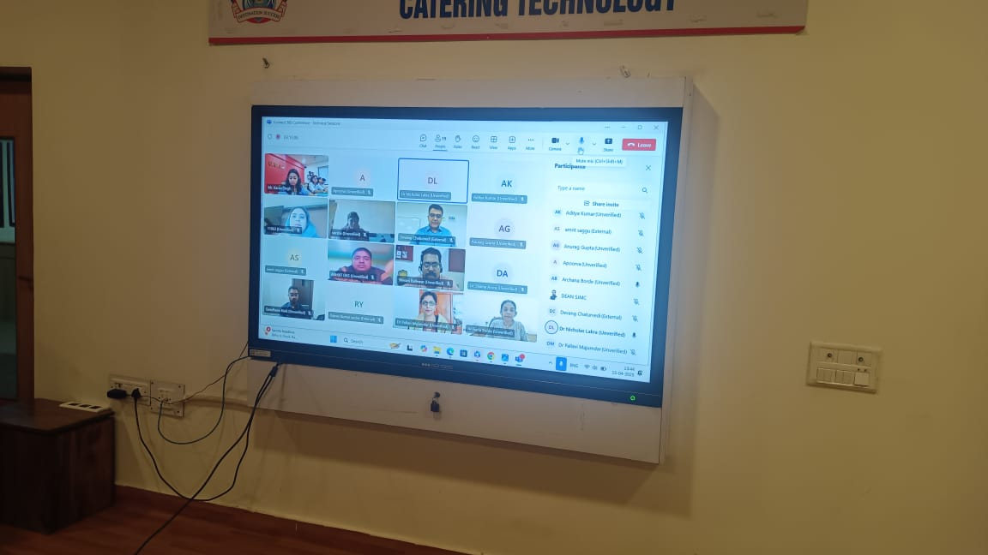

(Prof. (Dr.) Pallavi Majumdar, Professor of Mass Communication at Royal Thimphu College, Bhutan addressing the online session)

Technical Session 1 (Offline), Time: 1:30 PM – 3:30 PM

Venue: MPH Conference Room, A Block, 4th Floor, K.R. Mangalam University

Session Chairs: Dr. Ambrish Saxena, Senior Academic and Media Expert, Dr. Susmita Bala, Professor, Mass Communication

Moderator: Dr. Aaqib A. Butt, Assistant Professor, SJMC, KRMU
Conference Dates: 15-17 April 2025 (Tuesday, Wednesday and Thursday)
DAY 1
April 15, 2025 (Tuesday) | Venue: K.R. Mangalam University, Gurugram
Technical Sessions Inauguration at 1:30 PM
Keynote Address by Prof (Dr) Pallavi Majumdar
Professor - Mass Communication, Royal Thimphu College, Bhutan
Technical Session 1 (OFFLINE)
15-04-2025 (Tuesday) | 1:30 PM - 3:30 PM | Off Line / MPH Conference Room, A Block 4th Floor, KRMU
Session Chair 1 - Dr. Ambrish Saxena |  | Session Chair 2 - Dr. Susmita Bala
Moderator – Dr. Aaqib A. Butt
Presenter Name | Affiliation | Paper Title
Lakshita Pant | Sharda University | Reviving Menstrual Health Through IKS: The Role of Ritu Viḍyā: as a Medium for Visual Storytelling and Intergenerational Knowledge Transmission
Suman Lata | Sangam University Bhilwara | Beyond Borders: Media as a Bridge for Indian Knowledge Systems (IKS)
Prof (Dr) Subhra Das | Amity Education Valley Gurugram | Reimagining Agriculture: Technology, Tradition, and a Sustainable Future for India
Trilok Kumar Singh | K. R. MANGALAM UNIVERSITY | Indian Knowledge Systems in the Age of Digital Media: Preservation, Transformation, and Worldwide Reach
Dr. Mohd Adil | KR Mangalam University | Driving the Future: How Financial Incentives Shape Indian Consumers’ EV Adoption Intentions – An Extended TPB Approach
Archika Arya | Research Scholar/Student (offline) | "From Tradition to Technology: How Media Bridges Indian Knowledge Systems and Modern Fertility Treatments for Better Psychological Outcomes"
Dr. Parul Malhotra | Professor, Jagannath University, NCR | From Spoken Word to Digital Narratives: The Evolution of Communication and Media’s Role in Preserving Indigenous Knowledge Systems
Vandana | KR Mangalam University | The Role of Community Radio in Preserving and Promoting Indigenous Knowledge:  A case study of FM 24, Bhiwadi, Alwar,
Adiboina Uma Maheshwari | KR Mangalam University | From Local to Global: IKS perspectives
Dr. Yasmin Begum S Nadaf | Govt. First Grade College for Women, Belagavi, Karnataka, India | Bridging Ancient Wisdom and Modern Management: The Role of Indian Knowledge System in Sustainable Business Education
Closing Remarks by Session Chair. Announcement of 'Best Paper Award'. Award of Certificates.

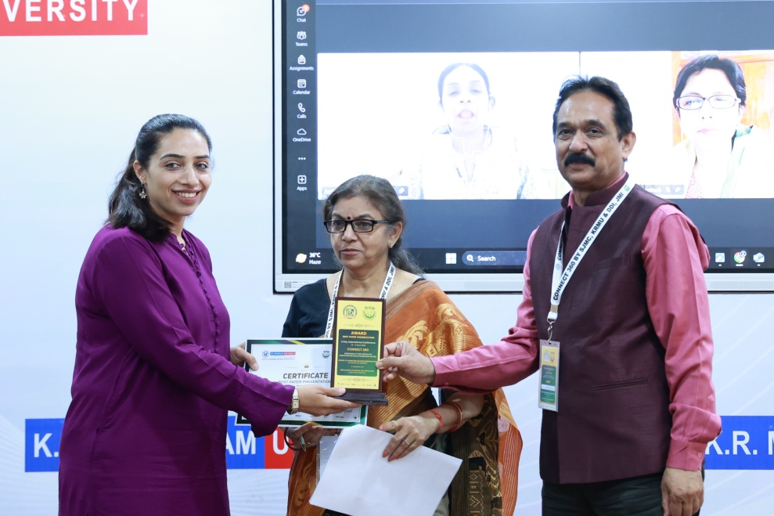

(Ms.Archika Arya, Research Scholar, KRMU, Receiving best paper award)

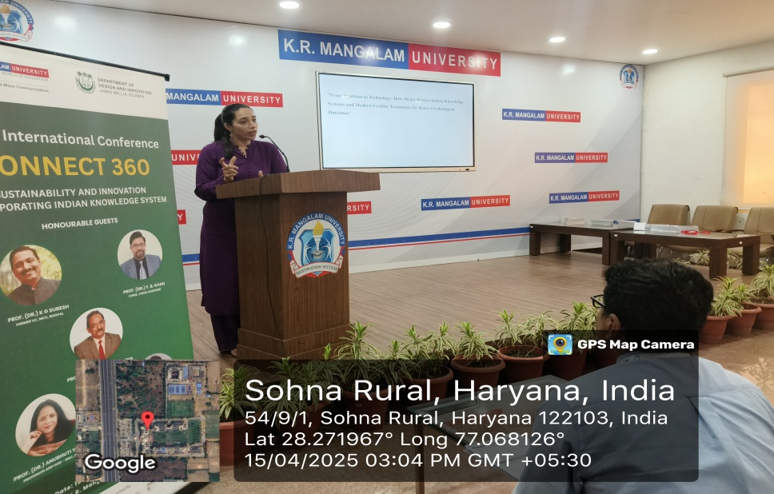

The offline session saw enthusiastic participation with presentations from esteemed researchers and scholars across various institutions. The session revolved around how media,

technology, and community initiatives are reshaping and revitalizing the transmission of Indian Knowledge Systems (IKS).

After all the insightful presentations, the Best Paper Award (Offline) was announced and conferred to Ms. Archika Arya, Research Scholar, KRMU, Paper Title: "From Tradition to Technology: How Media Bridges Indian Knowledge Systems and Modern Fertility Treatments for Better Psychological Outcomes." All participants were honored with Certificates of Presentation, and the session chairs commended the diversity and depth of the research presented.

Technical Session 2 (Online), Time: 1:30 PM – 3:30 PM

Venue: Conference Room, SOHMCT, C Block, K.R. Mangalam University

Session Chairs: Dr. Pallavi Majumdar, Royal Thimphu College, Bhutan, Dr. Rajeev Godhe, Academic Expert

Moderators: Ms. Aditi Aggarwal/Mr. Karan Singh

Online Team Link: Connect 360 - Online (MS-Teams) meeting link- Meeting ID: 461588491285, Passcode: Gv9Cy9CA

The online technical session witnessed active participation from scholars across India and abroad, reflecting on how traditional Indian Knowledge Systems are being adapted and communicated through emerging technologies such as Artificial Intelligence, digital media, and interactive platforms.
Technical Session 2 (ONLINE)
15-04-2025 (Tuesday) | 1:30 PM - 3:30 PM | Conference Room, SOHMCT, C Block, KRMU
Session Chair 1 – Dr. Pallavi Majumdar |  | Session Chair 2 – Dr. Rajeev Godhe
Moderator - Ms. Aditi Aggarwal / Karan Singh
Presenter Name | Affiliation | Paper Title
Varsha A | Maharaja Institute of technology Mysore | Paper on Tribal Knowledge System- A Comprehensive Study from Indian Perspective.
Amrit Kaur Saggu | Christ University, Delhi-NCR | From Manuscripts to Machine Learning: Role of Artificial Intelligence in the Global Expansion of IKS
Swadheen Naik | University of Hyderabad | Digital Narratives of Ayurveda: Framing Mental Health in the Wellness Media Landscape
Anurag Gupta | VIPS, New Delhi | Rethinking Communication: A Comparative Study of Sadharanikaran.
Anjani kumar singh | KRMU | From Manuscripts to Machine Learning: Role of Artificial Intelligence in the Global Expansion of IKS
Priyanka Singh | SJMC, K.R. Mangalam University | A Study on "The Role of Memes in Advertising”
ABHIJIT DAS | West Bengal State University | IKS Trends in Digital Media: Connecting Global Audience.
Rajeev Kumar Yadav | Amity University Rajasthan | The Guru-Shishya Tradition in Indian Sports Biopics: A Reflection of the Indian Knowledge System
Maahi.A.Mehta | Andhra University | Transferring IKS to the future -Role of Media in transference of IKS knowledge
Dr Iram Rizvi | ISOMES | Timeless Stories on Screen: Mythological Adaptations in Indian Cinema
Himesh Baboolall | Department of Applied Arts, BHU | Bridging generations: Using interactive media to educate youth on IKS-based sustainability
Nitin Bhatt | K R Mangalam University Gurugram Haryana | Role of AI in TV News Room - A Study of Indian TV News Channel (Delhi NCR)
Closing Remarks by Session Chair. Announcement of 'Best Paper Award'. Award of Certificates.

The Best Paper Award (Online) was conferred to Mr. Anurag Gupta, VIPS, New Delhi, Paper Title: "Rethinking Communication: A Comparative Study of Sadharanikaran." The session concluded with remarks from the chairs, highlighting the innovative approaches to integrating traditional wisdom with modern communication technologies.

Day 1 of the International Conference on Connect 360: Sustainability and Innovation Incorporating Indian Knowledge System (IKS) at K.R. Mangalam University concluded on a vibrant and intellectually fulfilling note. The day's proceedings commenced with the Registration and Networking Session, followed by a formal inauguration ceremony that brought together esteemed academicians, industry leaders, and student researchers.

Day 2 – April 16, 2025, Venue: Ho Chi Minh Conference Hall, Dept. of Design and Innovation, JMI, Jamia Millia Islamia, New Delhi

The second day of the collaborative conference between K.R. Mangalam University and Jamia Millia Islamia (JMI) was held on April 16, 2025, at the Department of Design and Innovation (DDI), JMI, New Delhi. Focused on the theme “Inclusive Design & Communication Strategies for Indian Knowledge Systems (IKS) in the Digital Era,” the day offered a rich blend of scholarly discussions, keynote addresses, and an engaging panel conversation that underscored the intersections of tradition, innovation, and modern communication tools.

The day commenced with registration at the DDI Foyer from 9:30 AM onwards, where participants received conference kits and were welcomed by the organizing committee. The formal program began at 10:00 AM in the Ho Chi Minh Conference Hall with a serene Quranic recitation by Minhajur Rahman Khan, setting a reflective tone for the day. This was followed by a warm welcome and introduction to JMI, the Department of Design and Innovation (DDI), and the broader vision of the Connect 360 initiative—an interdisciplinary academic platform aimed at integrating Indian Knowledge Systems with modern-day media and communication practices.

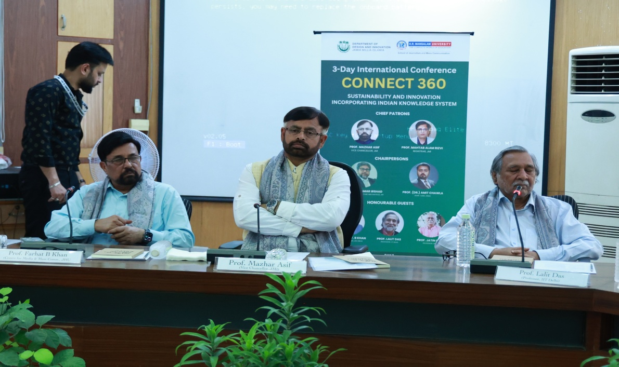

(Chief Guest, Prof. Mazhar Asif, Hon’ble Vice Chancellor of Jamia Millia Islamia, delivered an inspiring speech encouraging students and researchers)

Prof. Qamar Irshad, Head of DDI and Dean of the Faculty of Architecture and Ekistics, delivered the welcome address and felicitated all dignitaries. He emphasized the department’s commitment to blending traditional Indian design values with cutting-edge global innovation. This was followed by Prof. (Dr.) Amit Chawla, Dean of the School of Journalism and Mass Communication (SJMC), K.R. Mangalam University, who introduced the Connect 360 initiative and highlighted the collaborative academic objectives between the two institutions.

The inaugural session featured a distinguished lineup of eminent speakers. Prof. F.B. Khan from Jamia Hamdard University provided insights into the philosophical foundations and cultural depth of IKS, particularly in relation to media and communication studies. Prof. Lalit Das, Professor at IIT Delhi and Distinguished Visiting Professor at DDI, JMI, spoke about the importance of reconnecting design education with indigenous Indian systems of knowledge, sustainability, and functionality. This was followed by Prof. Jatin Bhatt, another Distinguished Visiting Professor at DDI, JMI, who elaborated on the aesthetic and ethical responsibilities of designers when representing traditional knowledge in modern contexts.

The Guest of Honour, Prof. Mohd Mahtab Alam Rizvi, Registrar of JMI, addressed the gathering and emphasized the role of interdisciplinary collaboration in higher education. The Chief Guest, Prof. Mazhar Asif, Hon’ble Vice Chancellor of Jamia Millia Islamia, delivered an inspiring speech encouraging students and researchers to become cultural bridges—preserving the past while innovating for the future.

Following this, all dignitaries collectively released the Book of Abstracts, showcasing the contributions from both online and offline presenters across institutions. Dr. Deepshikha concluded the session with a formal Vote of Thanks, expressing gratitude to faculty members, student volunteers, speakers, and participants for making the event a success. A networking tea session was held thereafter in the DDI Foyer.

The post-tea session featured a panel discussion titled “Inclusive Design & Communication Strategies for IKS in the Digital Era” which brought together thought leaders and academics from diverse fields. Moderated by Mr. Saniuddin Khan, Assistant Professor at JMI, the panel included prominent figures such as Prof. (Dr.) F.B. Khan, Prof. (Dr.) K.S. Kusuma from AJK Mass Communication Research Centre, JMI; Prof. Lalit Das from IIT Delhi; Prof. Jatin Bhatt; and Prof. (Dr.) Amit Chawla from K.R. Mangalam University.

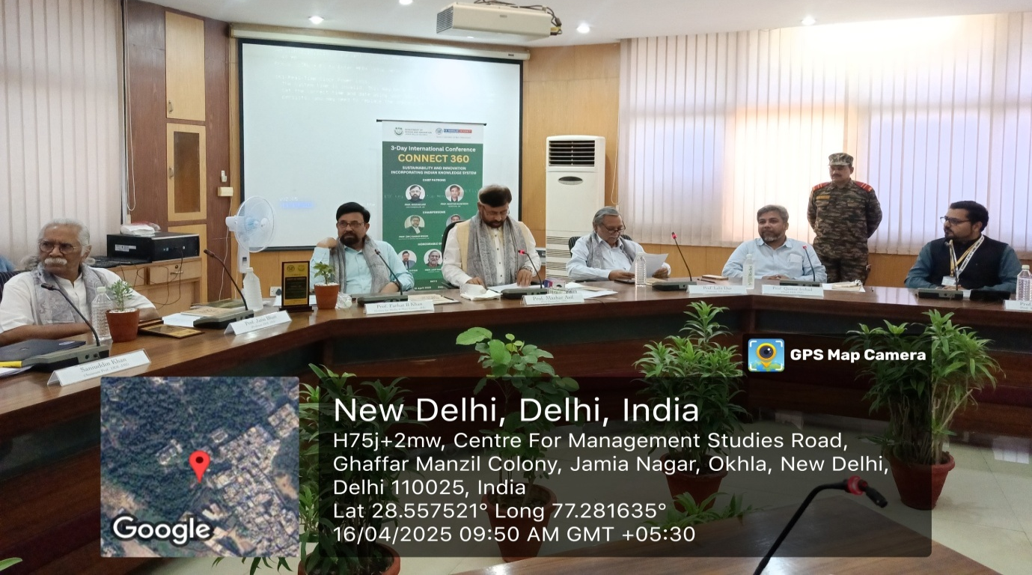
The discussion delved into how traditional Indian knowledge systems can be preserved, interpreted, and recontextualized through the lenses of design thinking, emerging technologies, and media narratives. Panelists highlighted real-world examples of indigenous design solutions, inclusive storytelling, and participatory research as effective tools for promoting IKS in the digital space.

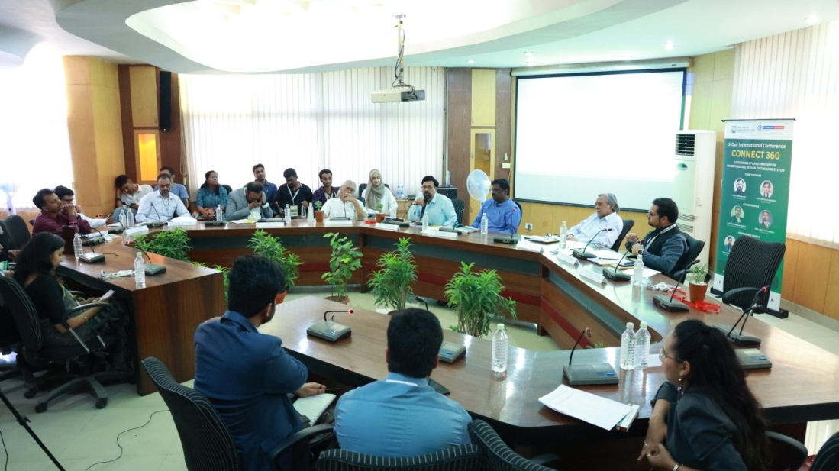

(Speaker share their views- Panel discussion titled “Inclusive Design & Communication Strategies for IKS in the Digital Era)

The discussion emphasized the importance of combining interdisciplinary research with digital storytelling, user-cantered design, and inclusive media strategies to ensure the preservation and evolution of traditional Indian knowledge systems. The panel also received thoughtful questions from the audience, which enriched the dialogue and underlined the relevance of the theme to contemporary academia and practice.

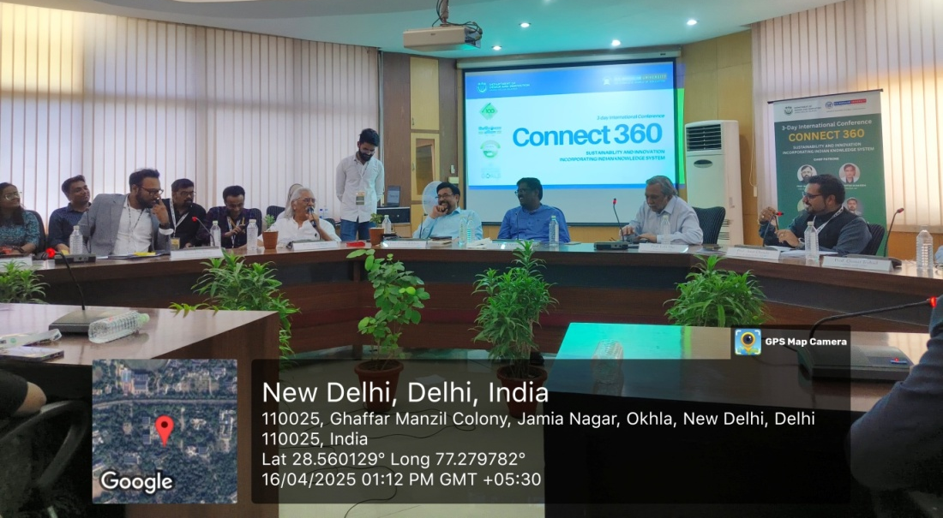
The event concluded with a lunch session in the DDI Foyer where participants, speakers, and faculty had the opportunity to interact, exchange ideas, and build potential collaborations. Day 2 of the conference not only strengthened the academic partnership between K.R. Mangalam University and Jamia Millia Islamia but also provided a valuable platform for reflecting on how India's cultural and knowledge heritage can be revitalized through innovative and inclusive communication strategies in the digital era.

Session Wise & Track Wise Report: Day 2

Technical Session 3 (Offline), Time: 1:30 PM – 3:30 PM

Date: April 16, 2025 (Wednesday), Venue: Ho Chi Minh Conference Hall, DDI, JMI

Day 2 of the Connect 360 conference witnessed a compelling and intellectually stimulating Technical Session 3 (Offline), held at the Ho Chi Minh Conference Hall, DDI, Jamia Millia Islamia. Chaired by Dr. K.S. Kusuma, Professor at AJK Mass Communication Research Centre (AJK MCRC), JMI, and Dr. Amit Chawla, Dean of the School of Journalism and Mass Communication, K.R. Mangalam University, the session was moderated by Prof. Tauheed Mehtab, adding depth and structure to the discussions.

This session focused on the broad theme of “Indian Knowledge Systems (IKS), Design, and Media Narratives,” and brought together a diverse range of research scholars and faculty members from premier institutions. The presentations explored how traditional Indian concepts and indigenous knowledge intersect with modern-day visual storytelling, sustainable development, media, and digital documentation.
Technical Session 3 (OFFLINE)
16-04-2025 (Wednesday) | 1:30 PM - 3:30 PM | Ho Chi Minh Conference Hall, DDI, JMI
Session Chair 1 - Dr. KS Kusuma Session Chair 2 - Dr. Amit Chawla
Moderator – Prof. Tauheed Mehtab
Presenter Name | Affiliation | Paper Title
Vishesh Azad | Assoc Professor, NIFT & Research Scholar, JMI | Once Upon a Vlog: Archiving the Indian  Knowledge Systems through Travel Vlogging
Dr. Rashi Mishra | Assistant professor Doon University, Dehradun | Message and Messenger: Exploring Product  Semantics as a Tool for Environmental  Sustainability Discourse — Could Rahul Gandhi’s White T-shirt Reflect an Eco-friendly Approach?
Tarab Khan | Guest faculty, AJK  MCRC, JMI | The Faces of Indian Advertising: A Study of Mascot Design and Cultural Connection
Rukhsana Khatoon | M Des, JMI | Digital Repository for folk arts of India
Manaswani Singhal Tushar | Research Scholar JMI | Cradle to Cradle
Saqib Bhatt | Research Scholar, AMU | Cross-Community Counter-Memorialisation and  Resistance in the Contemporary Kashmiri Art of Veer Munshi and Ehtisham Azhar
Dr. Deepshikha | Assistant professor, DDI, JMI | Relevance of Sustainable Development Goals and IKS in Design Education
Dr. Ritu S. Sood/ Danish | Dean, SMFE and  Research scholar Sharda University | Indian Knowledge System and the Influence of Natya Shastra on Hindi Cinema
Mohammad Danish  Siddiqui | Jamia Millia Islamia | Sustainable Development Goals and IKS in Design Education
Pratibha Tiwari | Amity Institute of English Studies | Discerning Indian Knowledge System Through Visual Storytelling: Analysing Lootera as a Crosscultural Adaptation of The Last Leaf
Closing Remarks by Session Chair. Announcement of 'Best Paper Award'. Award of Certificates.
After all the insightful presentations concluded, the session chairs announced the Best Paper Awards (Offline), recognizing exceptional research and impactful contributions to the field of Indian Knowledge Systems.
The award was jointly conferred to Vishesh Azad, Associate Professor at NIFT and Research Scholar at Jamia Millia Islamia, for his paper titled “Once Upon a Vlog: Archiving the Indian Knowledge Systems through Travel Vlogging”, and Pratibha Tiwari from the Amity Institute of English Studies, for her paper “Discerning Indian Knowledge System Through Visual Storytelling: Analysing Lootera as a Cross-cultural Adaptation of The Last Leaf.”
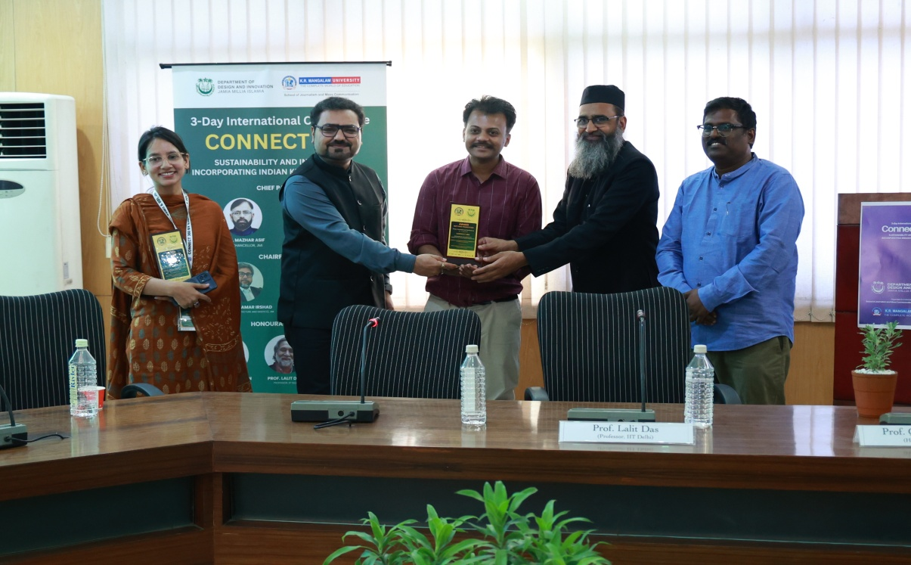
(Day -2: Best Paper Award (Offline) presented to Dr. Vishesh Azad and Pratibha Tiwari at the Connect 360 International Conference, JMI.)

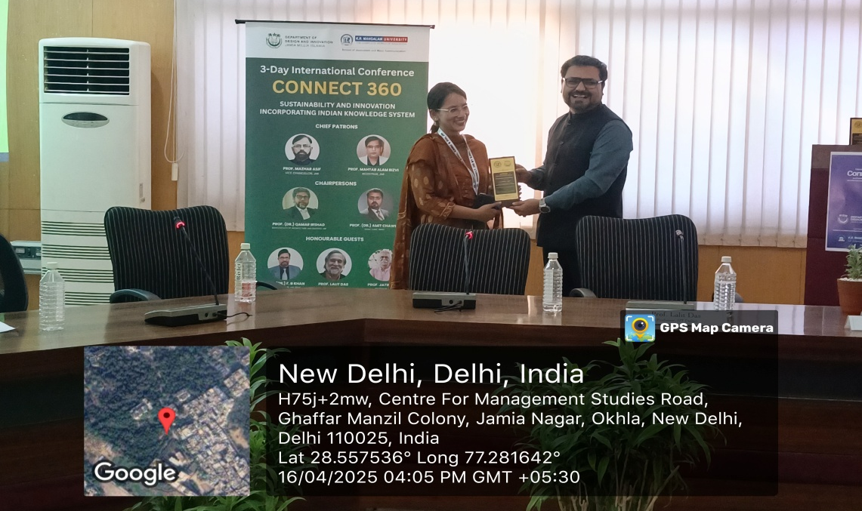

Both papers stood out for their originality, depth of analysis, and innovative engagement with the theme of the conference. Azad's exploration of travel vlogging as a digital archive for cultural transmission opened new pathways for media-based preservation of IKS, while Tiwari's nuanced literary-cinematic analysis highlighted how Indian narratives reinterpret global texts through indigenous lenses. Their recognition marked a fitting conclusion to an intellectually enriching session.

Technical Session 4 (Online), Time: 1:30 PM – 3:30 PM

Date: April 16, 2025 (Wednesday), Venue: ONLINE / DDI Conference Room

Online Team Link: Connect 360 - Online (MS-Teams) meeting link- Meeting ID: 461588491285, Passcode: Gv9Cy9CA
Introduction to the Conference Tracks by Dr. Ritwik Ghosh and Dr. Aaqib Butt
Connect 360
Technical Session 4 (ONLINE)
16-04-2025 (Wednesday) | 1:30 PM - 3:30 PM | ONLINE / DDI Conference Room
Session Chair 1 - Dr. Aaqib Anwaar Butt Session Chair 2 - Dr. Ritwik Ghosh
Moderator – Dr. Tawseef Majeed
Presenter Name | Affiliation | Paper Title
Dr Kriti Singh | Amity University, Noida  & Manipur International  University, Manipur | Countering Radicalization through Media: A Design  Thinking Approach Rooted in Indian Knowledge Systems (IKS)
Dr. Sagarika Dash | Amity School of Comm., Amity Univ. Chhattisgarh | Nature, Technology, and Emotional Harmony in Ghibli Animation and Indian Ecological Thought
Jigyasa Goswami | Amity University Madhya Pradesh | Role of IKS in addressing the ethical challenges related to AI
Shiksha | Doon University, Dehradun | Promoting Sustainability: Role of Social Media Influencers in Reviving Indian Ecological Wisdom in Context of Uttarakhand
Arshiya Khan, Abdul Kalam | DIT University | How Navarasa Affects Typeface and Enhances the User Experience for Digital Typography
Sucharita Purkait | Amity University Gwalior | Reimagining Tradition for Sustainable Futures and  Using AI, AR, and VR in Indian IKS: The Media's Role in Activating Public Support
Vijay S. Jodha | SJMC, K R Mangalam  University | Leveraging mass comm. tools for promoting traditional knowledge & grassroots innovations in India
Dr.Vidhya J | M.O.P. Vaishnav College for Women, Chennai | The application of Sthāyi Bhāvas from Nātyasāstra in modern-day advertisements: fostering emotional resonance through aesthetic storytelling
Chinmoyee Das | Central University Haryana | Cyber Narratives Through the Lens of Indian TechNoir
Mrs. Komal Verma | Guru Gobind Singh  Indraprastha University | The Story telling of IKS with Shadow Puppetry as an interactive pedagogy
Closing Remarks by Session Chair. Announcement of 'Best Paper Award'. Award of Certificates.

The Technical Session 4 (Online) of the Connect 360 Conference was held on April 16, 2025, from 1:30 PM to 3:30 PM, hosted virtually from the DDI Conference Room, Jamia Millia Islamia. The session was chaired by Dr. Aaqib Anwaar Butt and Dr. Ritwik Ghosh, with Dr. Tawseef Majeed serving as moderator. This intellectually vibrant session featured a diverse lineup of scholars and practitioners whose research explored the intersection of Indian Knowledge Systems (IKS), digital media, emerging technologies, and sustainable design.

The session began with a brief introduction to the conference tracks by Dr. Ritwik Ghosh and Dr. Aaqib Butt, who outlined the objectives of Connect 360—emphasizing the need to bridge tradition and innovation through interdisciplinary discourse, especially in the realms of communication, design, and indigenous knowledge.

Day 3, Date: April 17, 2025 (Thursday)

Venue: K.R. Mangalam University, Gurugram

The third and final day of the Connect 360 International Conference on Sustainability and Indian Knowledge Systems (IKS) took place at K.R. Mangalam University (KRMU), Gurugram, on April 17, 2025. With enthusiastic participation from scholars, faculty members, and students, the day was marked by two parallel technical sessions — one conducted offline and the other online — both showcasing a wide range of interdisciplinary research linked to IKS, sustainability, communication, and digital innovation.

Technical Session 5 (Offline)

Time: 9:30 AM – 12:30 PM, Venue: MPH, A Block, 4th Floor, KRMU

Session Chairs: Prof. Dr. Ruhi Lal and Prof. Seema Raj, Moderator: Dr. Ujjval Das

This offline session featured dynamic presentations by scholars and academicians from across India. Dr. Shalini Prasad set the tone with a thought-provoking study on how OTT platforms can be leveraged to share Indian mythology, making IKS more accessible to younger generations.
Technical Session 5 (OFFLINE)
17-04-2025 (Thursday) | 9:30 AM - 12:30 PM | Conference Room, MPH, A Block, 4th Floor, KRMU
Session Chair 1 - Prof. Dr. Ritu Sood |  | Session Chair 2 - Prof. Dr. Ruhi Lal
Moderator - Dr. Ujjval Das
Presenter Name | Affiliation | Paper Title
Dr. Shalini Prasad | Assistant Professor, Jamshedpur university | Analysis of Ott platform for showcasing and sharing the Indian knowledge system through mythology to inspire future generations
Suchivrat Arya | Assistant Professor, Bennett University | Exploring the impact of social media on Public Perception and Discourse: A critical Analysis of Media trends
Sahil Dhall | IITM GGSIPU | Colour psychology in Design: A political Communication Perspectives
Arshia Goswami | Academician/Professionals’/ scholars | Impact of pornography on youth
Nitin Bhatt | K R Mangalam University Gurugram Haryana | Role of AI in TV News Room - A Study of Indian TV News Channel ( Delhi NCR)
Dr. Rahul Kumar | IITM GGSIPU | A study of Political Advertisement affecting Political Awareness and participation of Voters.
Dr. Mudasir Hamid | Assistant professor, KRMU | Bridging the Digital divide: Analysis of NEP
Aditi Agarwal | Academician/Professionals, KR Mangalam | The Digital Prescription: How Social Media Shapes Self Medication Choices
Mohammad Ashraf | Sharda | Role of Cinema in Promoting IKS
Mohd. Javed Jamaal | Banasthali Vidyapeeth, Rajasthan | Study on Digital Class Rooms
Neeraj Singh Mehta | KRMU | Impact of Video editing techniques on Audience engagement
All on-spot registrations, internal students & faculty members of KRMU to present their papers in this slot.
Closing Remarks by Session Chair.

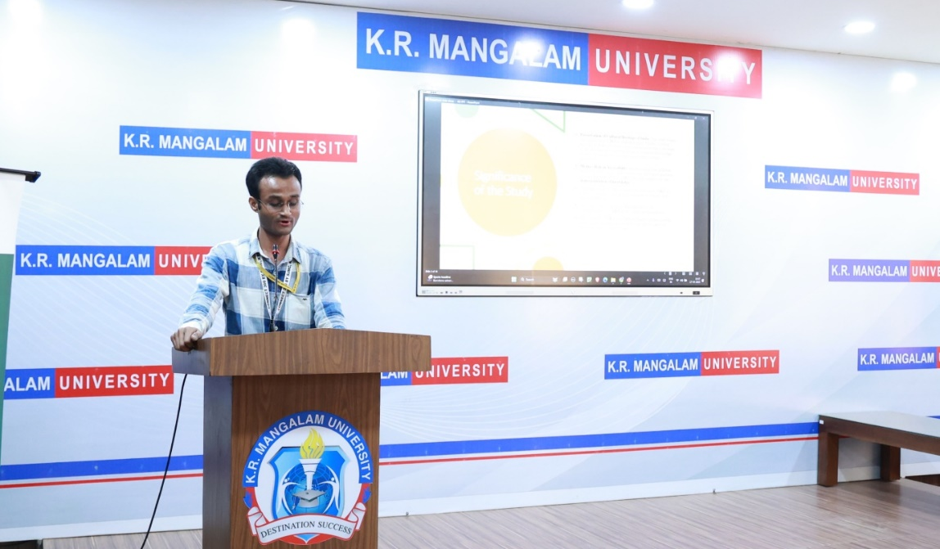

(Participant presenting his paper at Connect 360 conference)

Dr. Mudasir Hamid (KRMU) received the Best Paper Award for his work on "Bridging the Digital Divide: Analysis of NEP", highlighting how the National Education Policy supports equitable digital access and promotes Indian Knowledge Systems (IKS). Trilok Kumar Singh (KRMU) was also awarded for his paper "Indian Knowledge Systems in the Age of Digital Media", showcasing how digital platforms aid in preserving and globalizing IKS.

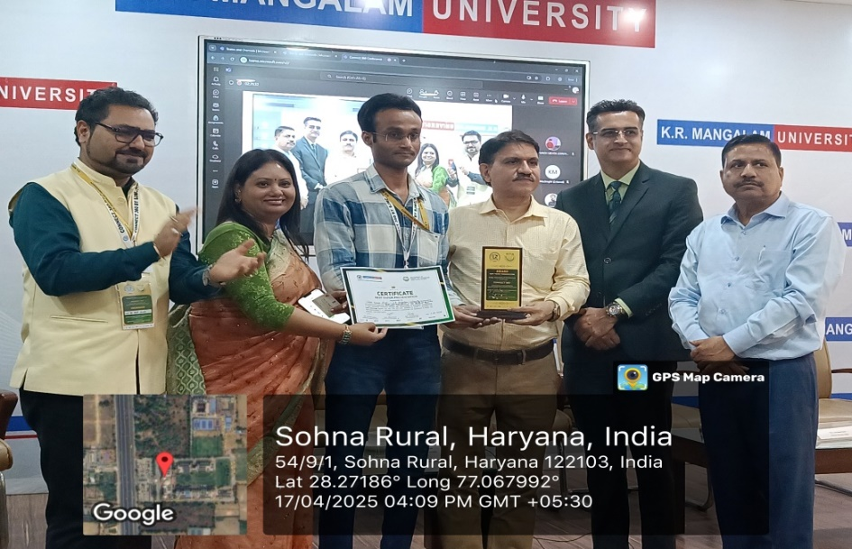

Technical Session 6 (Online)

Time: 9:30 AM – 12:30 PM, Venue: MPH, A Block, 4th Floor, KRMU

Session Chairs: Prof. Dr. Ruhi Lal and Prof. Seema Raj, Moderator: Dr. Ujjval Das

Online Team Link: Connect 360 - Online (MS-Teams) meeting link- Meeting ID: 461588491285, Passcode: Gv9Cy9CA

The Technical Session 6, held online, provided an intellectual platform for in-depth discussions on various topics relating to media, philosophy, communication, and technology. The session, conducted from 9:30 AM to 12:30 PM, was chaired by Dr. Nirmala Mani Adhikary and Dr. Rashi Mishra, with Dr. Deepshikha moderating the session.
Technical Session 6 (ONLINE)
17-04-2025 (Thursday) | 9:30 AM - 12:30 PM | Conference Room, MPH, A Block, 4th Floor, KRMU
Session Chair 1 - Dr. Nirmala Mani Adhikary |  | Session Chair 2 - Dr. Rashi Mishra
Moderator - Dr. Deepshikha
Presenter Name | Affiliation | Paper Title
Shivam Suryakant Ballewar | Amity University Rajasthan | The Evolution of Queer Representation in Hindi Cinema Post-Section 377 Decriminalization
Somendra Prajapat | Amity University Rajasthan | Maya, Illusion, and Nolan’s Exploration of Reality: A Philosophical Analysis of Inception and The Prestige
Pinky Kharata | K. R. Mangalam University | Exploring the Relationship Between Media Representation and Social Activism Sustainability: A #MeToo Movement Case Study
Md Danish Rahman | Sharda University, Greater Noida | Augmented Reality (AR) in Heritage Journalism: Reviving Lost Indian Knowledge
Dr. Anwesha Sen Majumdar | IMS UNISON UNIVERSITY | The Role of PR and Advertising in globalizing Ayurveda
Arjita Singh | CSJM University, Kanpur | Green Pedagogy: A Study on the Integration of Sustainability in Indian Design Curriculums
Sakshi Pundir | Doon University Dehradun | From Oral Tradition to OTT: A Study on the Transformation of Mythological Storytelling in Indian Cinema
Ms Apoorva Nawaz | PhD Scholar Sharda University, | Sustainable Information Flow: The Role of Independent Digital News Broadcasters in shaping Political participation
Devang Chaturvedi | Department of African Studies, University of Delhi | Rethinking Communication: A Comparative Study of Sadharanikaran, Dominant Western Theories, and the NWICO Debate in the Global North-South Media Flow
Dr. Kanta Kaveri Sonowal | Dibrugarh University | Artificial intelligence Vs Human Intelligence: A case study based on Ancient Indian Wisdom
Dr Nicholas Lakra | DCMS, Central University of Rajasthan | Representation of indigenous knowledge for sustainable future: A critical analysis of mainstream media in India
Dr. Kanta Kaveri Sonowal | CSJMC, Dibrugarh University | Artificial Intelligence Vs Human Intelligence: a case study based on Ancient Indian Wisdom.
Ms. Tulika | ASCO, AUMP & PhD Scholar, Sharda University | Storytelling, Sustainability and Social Change: A Contemporary Study of Bhojpuri Folk Songs of UP
Dr. Julia Oinam | Christ University, Bengaluru | Hashtag Heritage: The Virality of Indian Knowledge System in the Contemporary Social Media Landscape
Closing Remarks by Session Chair.

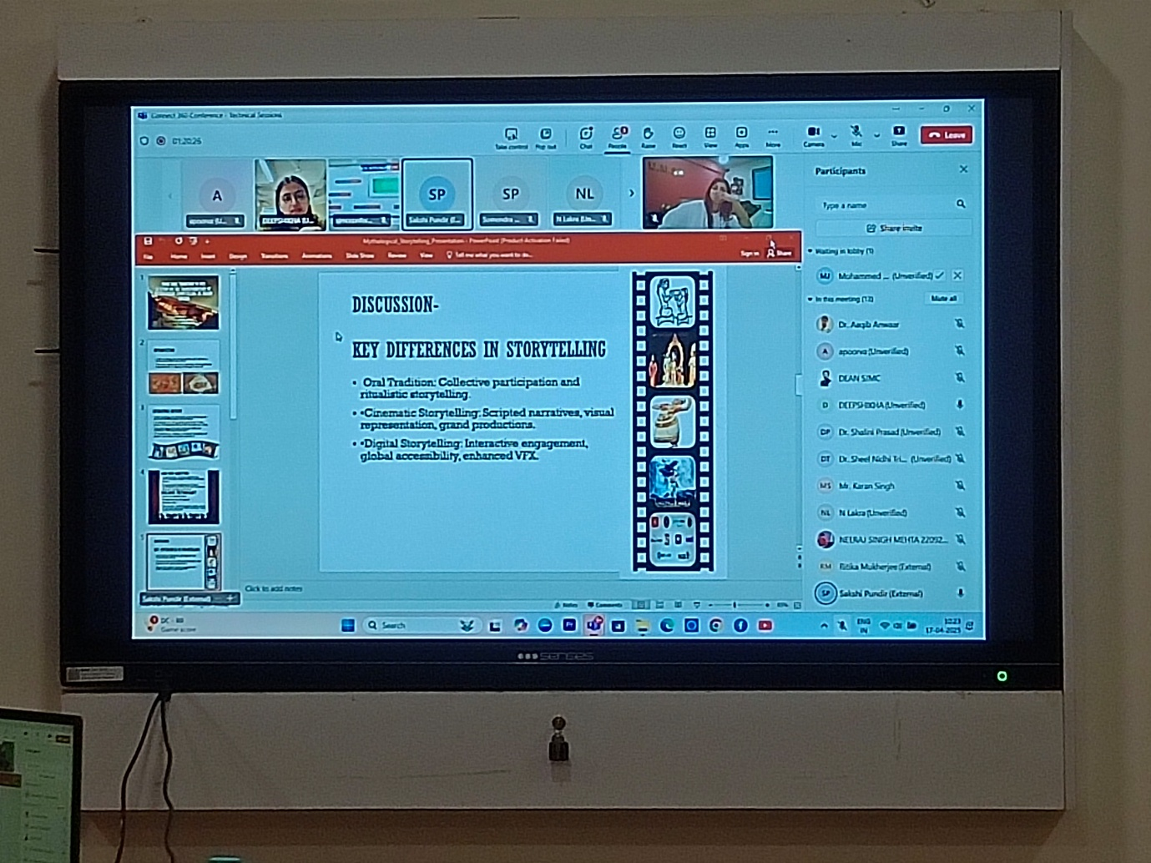

(Participants presenting their paper online at Connect 360)

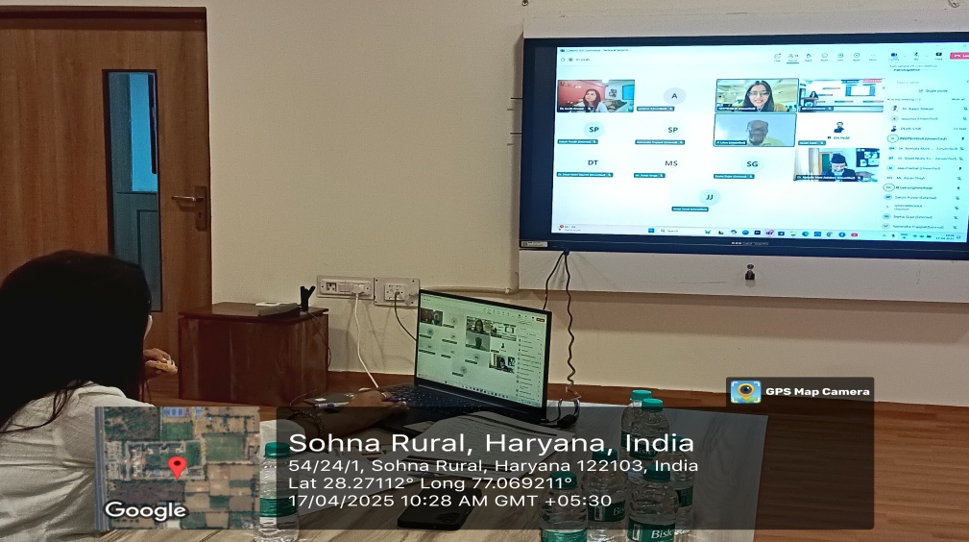

Best Paper Presentation Award: The Best Paper Presentation Award in the online category was presented to Somendra Prajapat from Amity University Rajasthan for his paper titled "Maya, Illusion, and Nolan’s Exploration of Reality: A Philosophical Analysis of Inception and The Prestige."

The Panel Discussion titled "Designing the Future with Tradition: Reimagining Sustainability through Indigenous Wisdom" was held on 17th April 2025 from 2:40 PM to 3:20 PM at the Multi-purpose Hall (MPH), A Block, 4th Floor of the KRMU Campus. The session featured esteemed guests, including Prof. Ajay Gupta, Former Director of ICSSR, Prof. (Dr.) Durgesh Tripathi, Professor & Dean of USMC, GGSIPU, New Delhi, Prof. (Dr.) Sumit Narula, Director of ASCO, AUH & Editor-in-Chief of JCCC. The discussion was moderated by Dr. Ritwik Ghosh, Assistant Professor at SJMC, along with Mr. Saniuddin Khan, Assistant Professor at DDI, JMI.
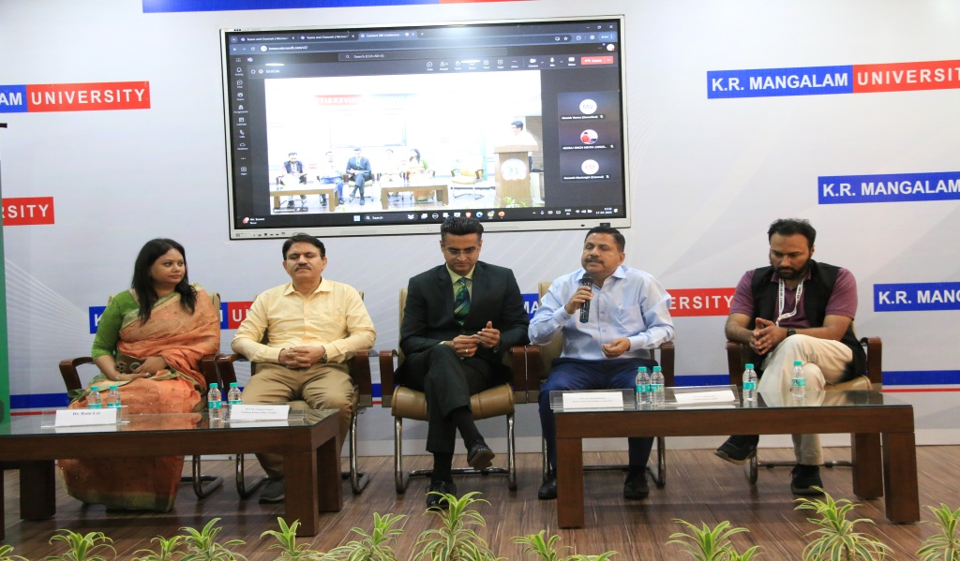

(Panellist Discussion on "Designing the Future with Tradition: Reimagining Sustainability through Indigenous Wisdom”)

The panel delved into the intersection of traditional indigenous knowledge and contemporary sustainability practices, exploring how ancient wisdom can provide valuable insights into solving modern challenges related to environmental sustainability and social progress.

The conversation emphasized the need for integrating indigenous traditions and values into modern practices, highlighting their relevance in fostering a more sustainable and equitable future. The speakers shared their diverse perspectives on how indigenous wisdom, often overlooked in modern discourse, holds the key to designing a future that balances development with environmental stewardship.

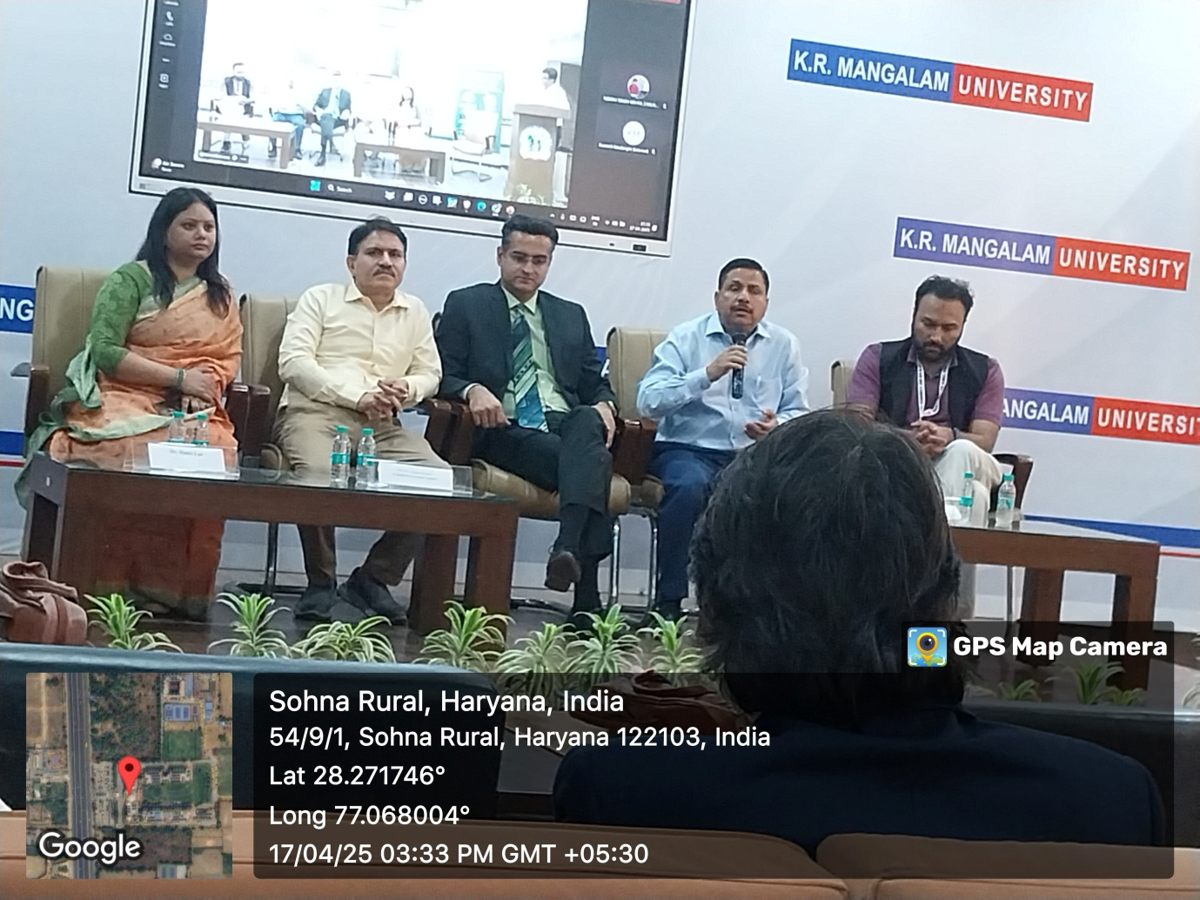

Each guest contributed a unique viewpoint, enriching the discussion. Prof. Gupta focused on the role of social sciences in understanding traditional ecological knowledge, while Prof. Tripathi emphasized the importance of academic research in reviving and preserving indigenous practices. Prof. Narula discussed how media and communication can play a pivotal role in spreading awareness about these traditions. Prof. Yogi highlighted the role of law and policy in supporting the integration of indigenous wisdom into modern systems. The discussion was both thought-provoking and inspiring, leaving the audience with a deeper appreciation of how indigenous knowledge can help guide future generations toward a sustainable and harmonious existence.

Valedictory Function:

The Concluding Ceremony of the conference, held on 17th April 2025 (Thursday) at K.R. Mangalam University, Gurugram, brought a successful end to the three-day event. The ceremony commenced with the seating of participants and attendees in the Multi-purpose Hall (MPH), A Block, 4th Floor of the KRMU Campus, followed by the traditional lamp lighting and the Saraswati Vandana, which symbolized the beginning of the closing proceedings. Prof. (Dr.) Amit Chawla, Dean of the School of Journalism and Mass Communication (SJMC) and Conference Chair, then presented the Conference Report, offering an overview of the event’s highlights and expressing gratitude to the speakers, presenters, and participants for their contributions.

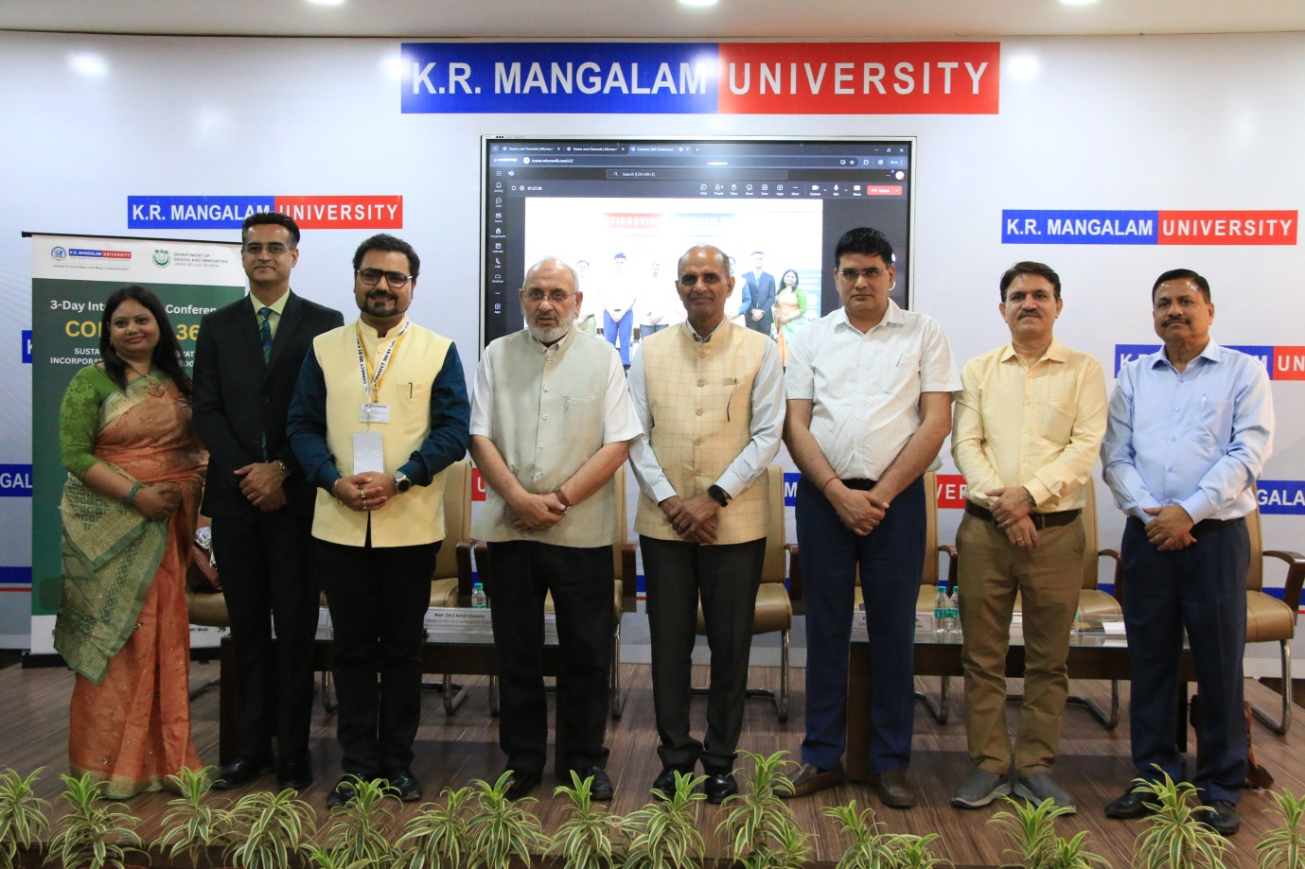
(Dignitaries members at the Concluding Ceremony of the 3-Day International Conference "Connect 360)

The Closing Address was delivered by Prof. (Dr.) Raghuvir Singh, Hon'ble Vice Chancellor of K.R. Mangalam University. He emphasized the importance of academic collaboration and intellectual exchange, acknowledging the success of the conference. Following his address, the distinguished guests were felicitated with tokens of appreciation for their contributions.

The final part of the ceremony featured a Keynote Address by Prof. Ajay Gupta, Former Director of the Indian Council of Social Science Research (ICSSR), who discussed the evolving role of social science research and the interdisciplinary nature of contemporary challenges. His insights served as an inspiration for further academic inquiry and reflection. The Concluding Ceremony marked a positive closure to the conference, leaving attendees with valuable knowledge and a sense of accomplishment. It successfully encapsulated the essence of the event, fostering intellectual growth and setting the stage for future academic collaborations.

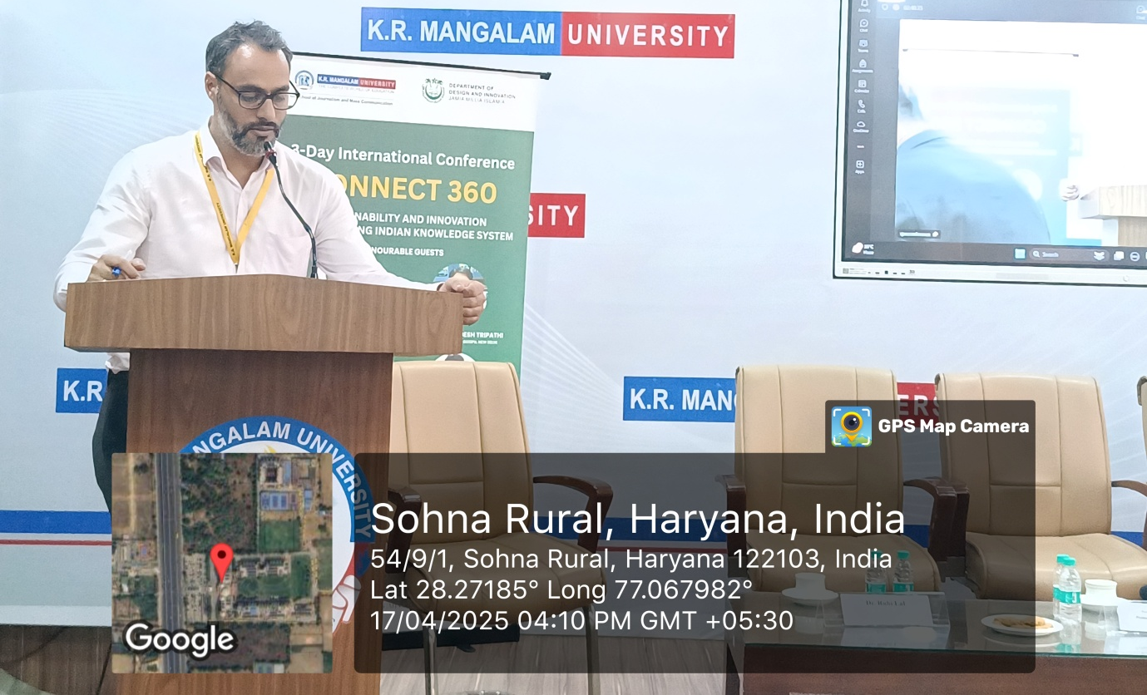

The Vote of Thanks was delivered by Dr. Aaqib A. Butt, Convenor of the conference, who expressed heartfelt appreciation to all those who contributed to the success of the event. He extended his gratitude to the university leadership, organizing committee, speakers, participants, volunteers, and technical teams for their unwavering support and commitment. Dr. Butt acknowledged the collaborative efforts that made the conference a meaningful and enriching experience for all and emphasized the importance of continuing such academic engagements in the future.

Conclusion:
The Connect 360 conference was a ground breaking event that transcended the typical academic framework, serving as a vibrant platform for the fusion of ideas, disciplines, and generations. By integrating Indian Knowledge Systems with contemporary global challenges, the conference created a space for innovative collaborations grounded in cultural integrity.

This synergy between traditional wisdom and modern science highlighted the potential to address global sustainability issues in a holistic way. Through multidisciplinary exchanges, the event demonstrated how Indian knowledge could inform modern advancements in science, technology, and sustainability, providing a unique perspective on how these fields can intersect to create impactful solutions.

The conference was deeply aligned with the Sustainable Development Goals (SDGs), particularly Target 4.4 (skills for employment and entrepreneurship), Target 11.4 (safeguarding cultural heritage), and Target 17.8 (enhancing science, technology, and innovation through international collaboration). By promoting international cooperation and fostering a deep respect for cultural heritage, Connect 360 aimed to contribute to global efforts in these areas. It was a demonstration of how blending ancient knowledge with modern innovations can lay the foundation for sustainable and inclusive futures.

Glimpses of the Conference:

Day-1

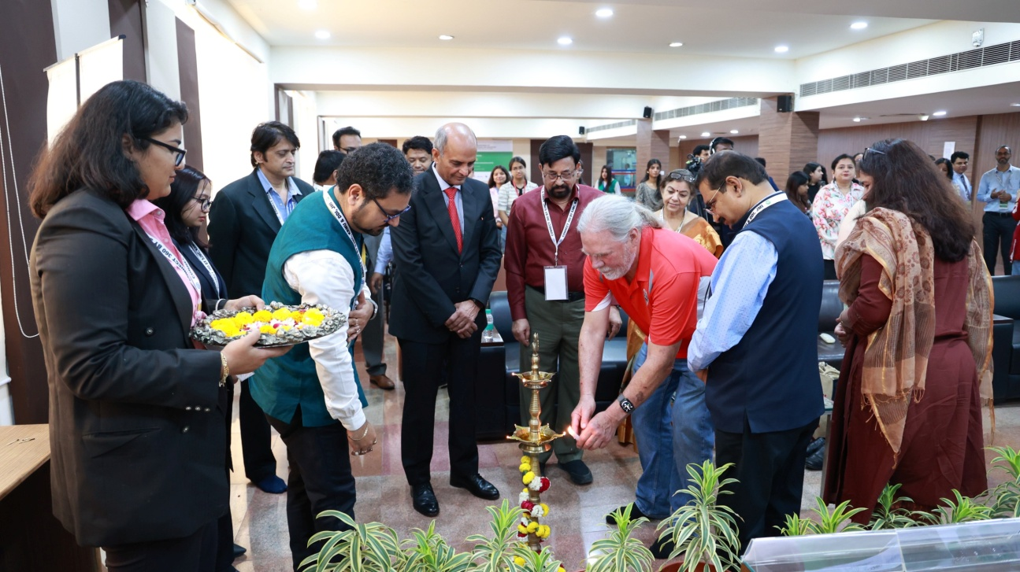
(Photo-1: Inauguration of the CONNECT 360 International Conference with lamp lighting by dignitaries and international delegates at K.R. Mangalam University)

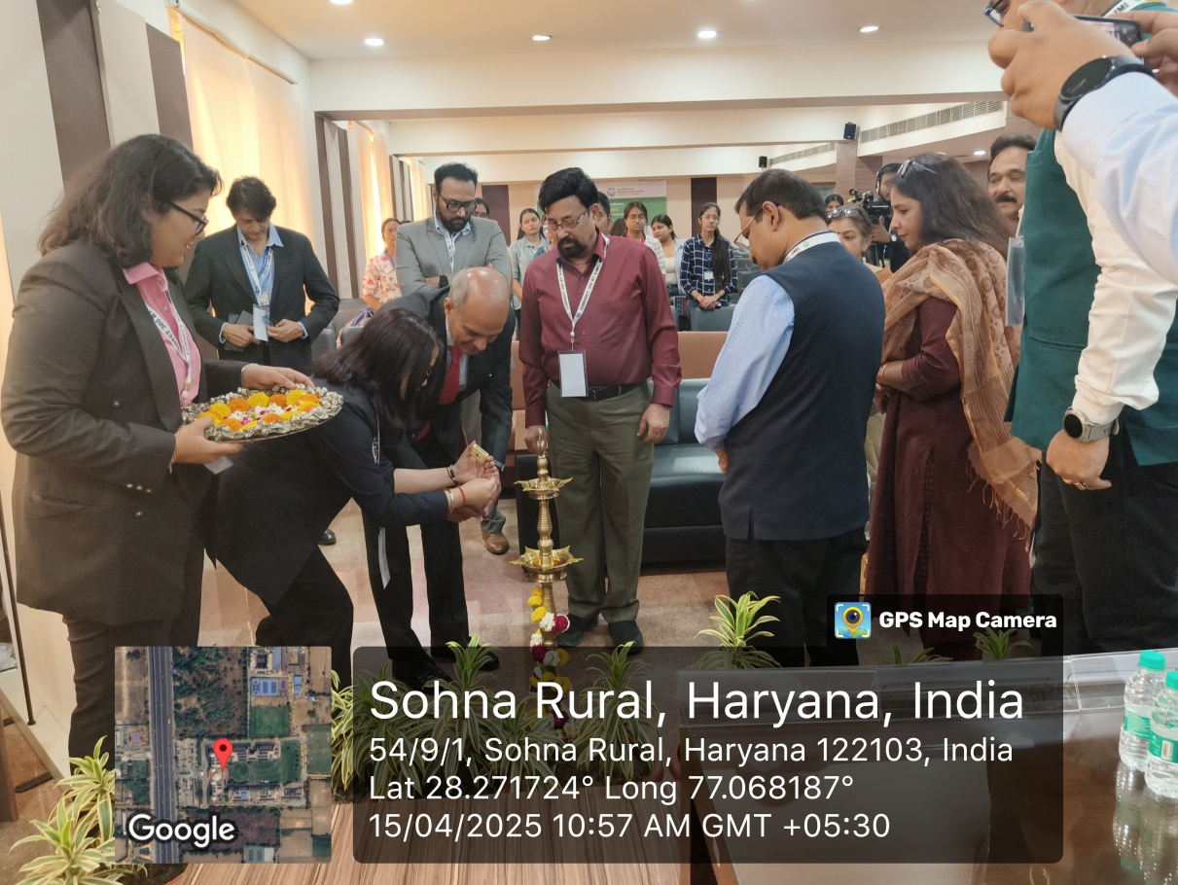
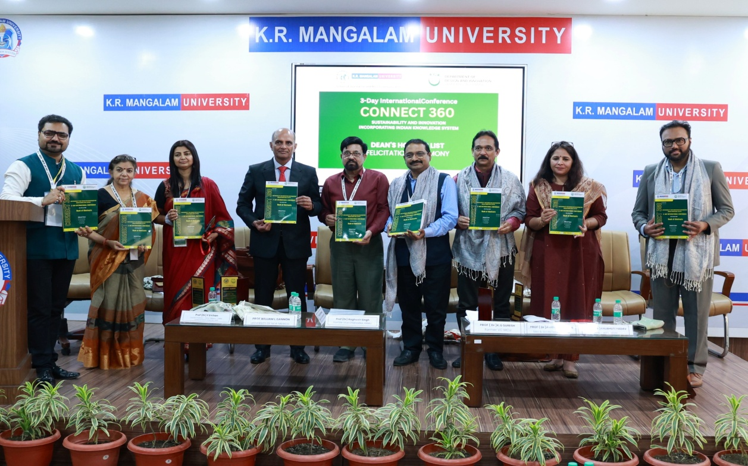
(Photo-2: Dignitaries unveil the CONNECT 360 Book of Abstracts during Felicitation Ceremony at K.R. Mangalam University.)

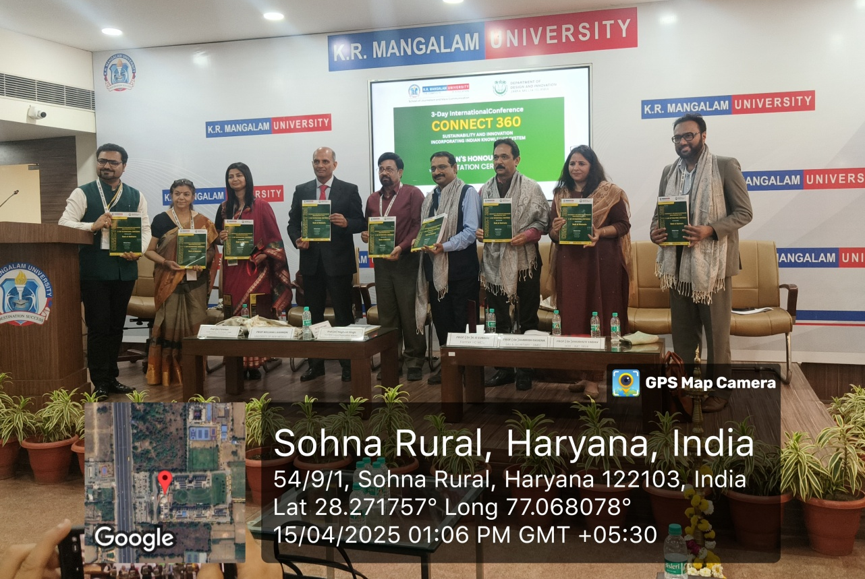

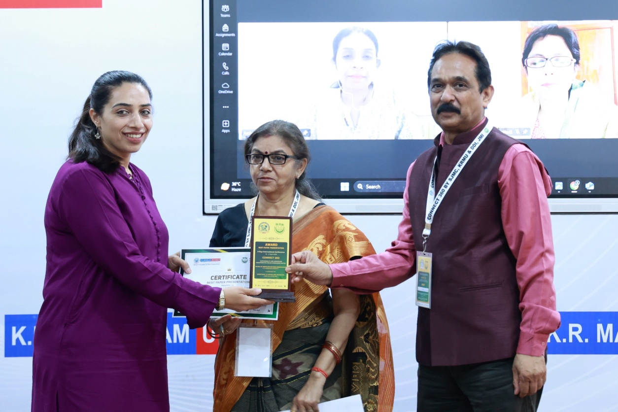
(Photo-3: Participant receives the Best Paper Award at CONNECT 360 for her paper “From Tradition to Technology.”)

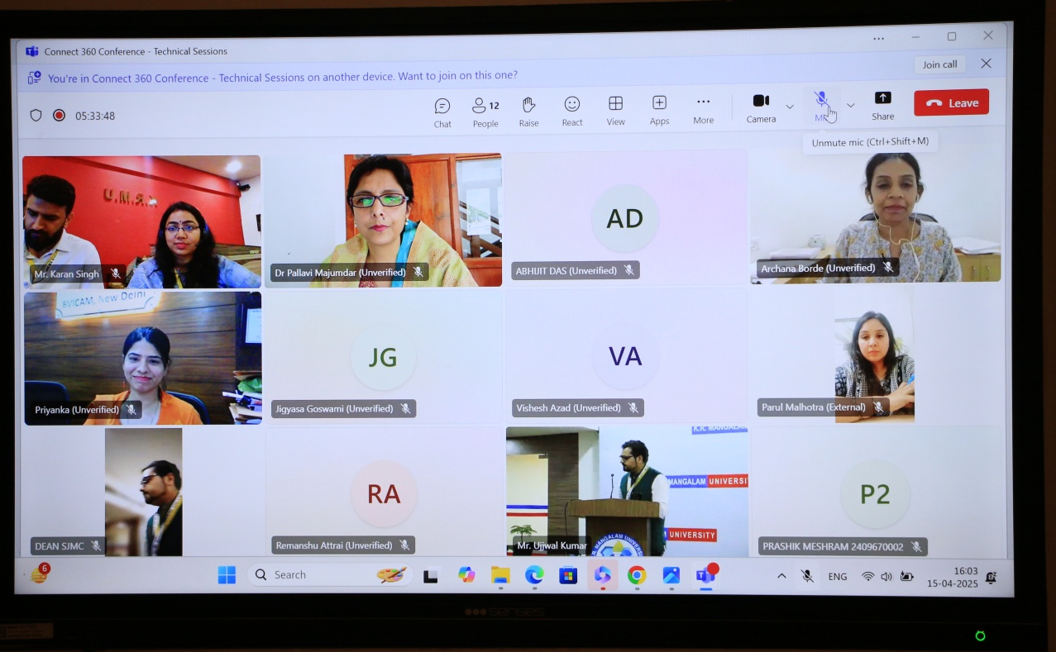
(Photo-4: Participants engage in a virtual technical session during the CONNECT 360 International Conference.)

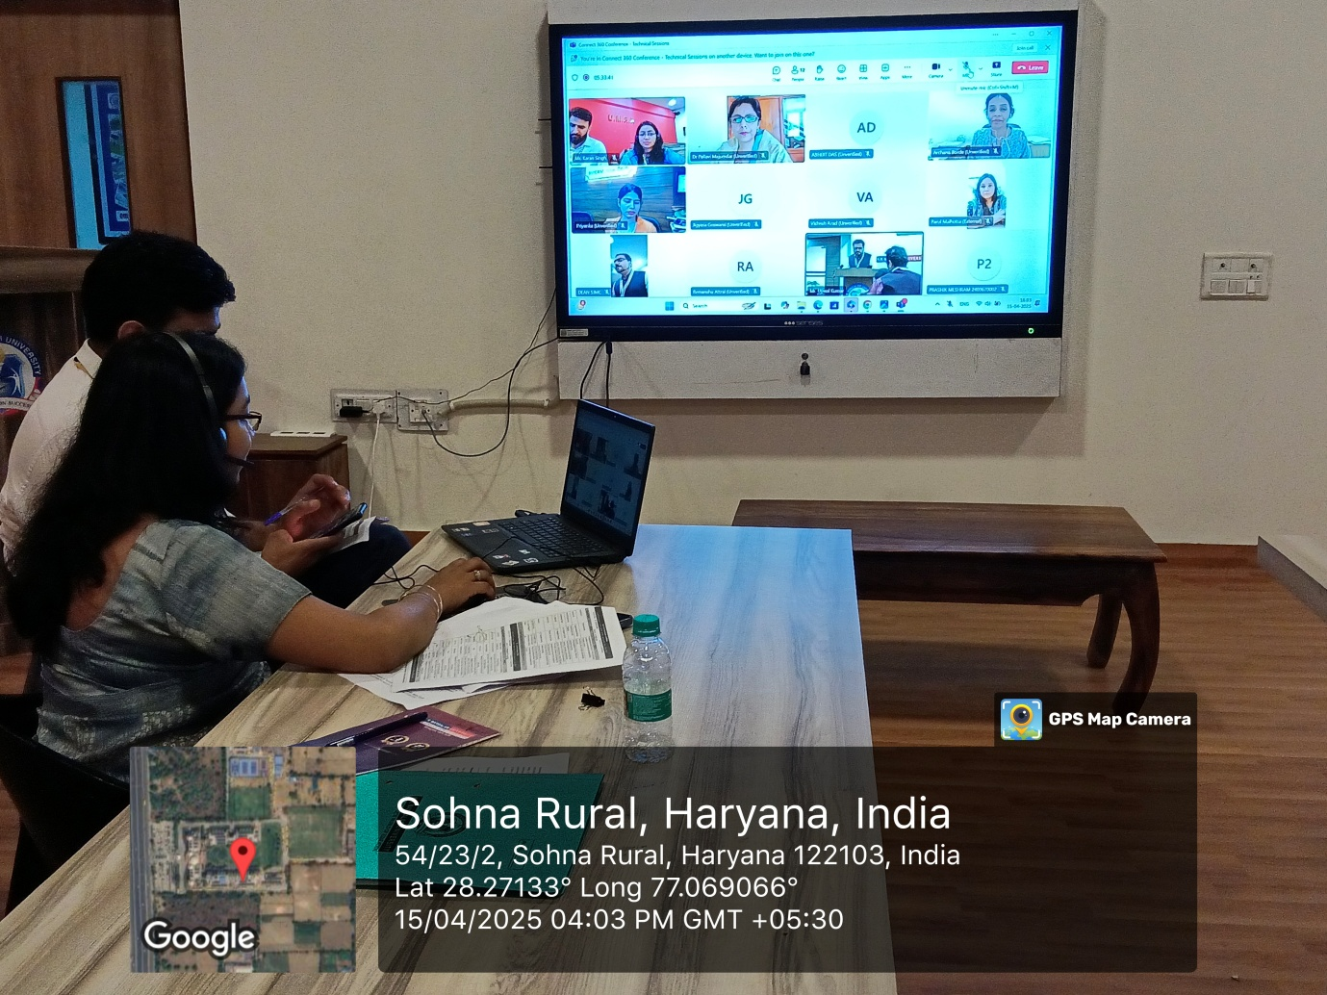

Day-2

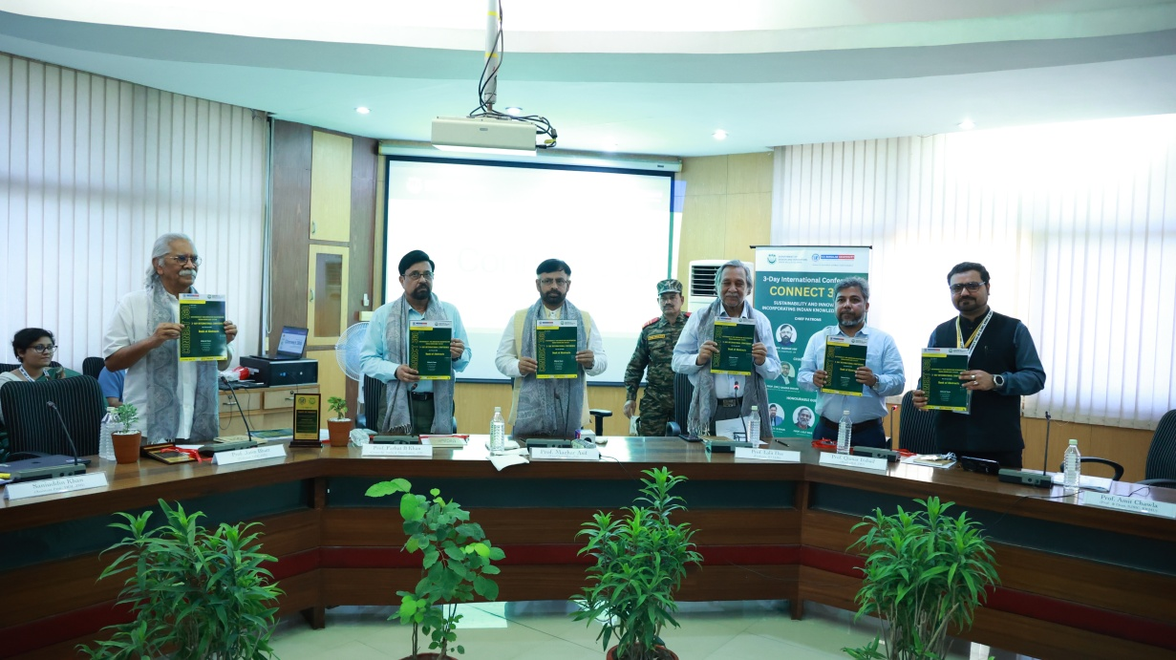
(Photo-5: Dignitaries unveil the CONNECT 360 Book of Abstracts during the inaugural ceremony at Jamia Millia Islamia University, New Delhi).
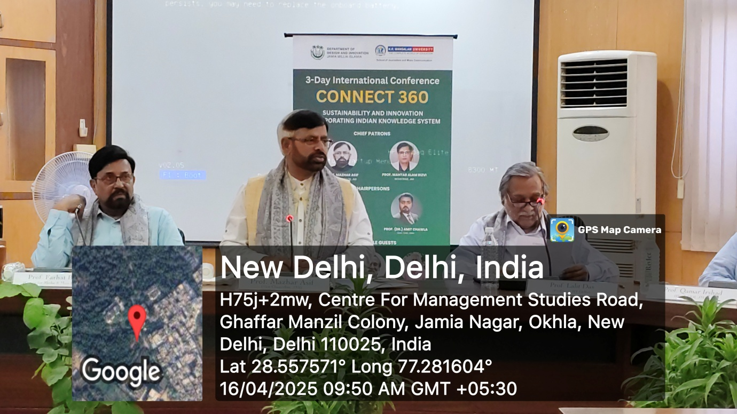

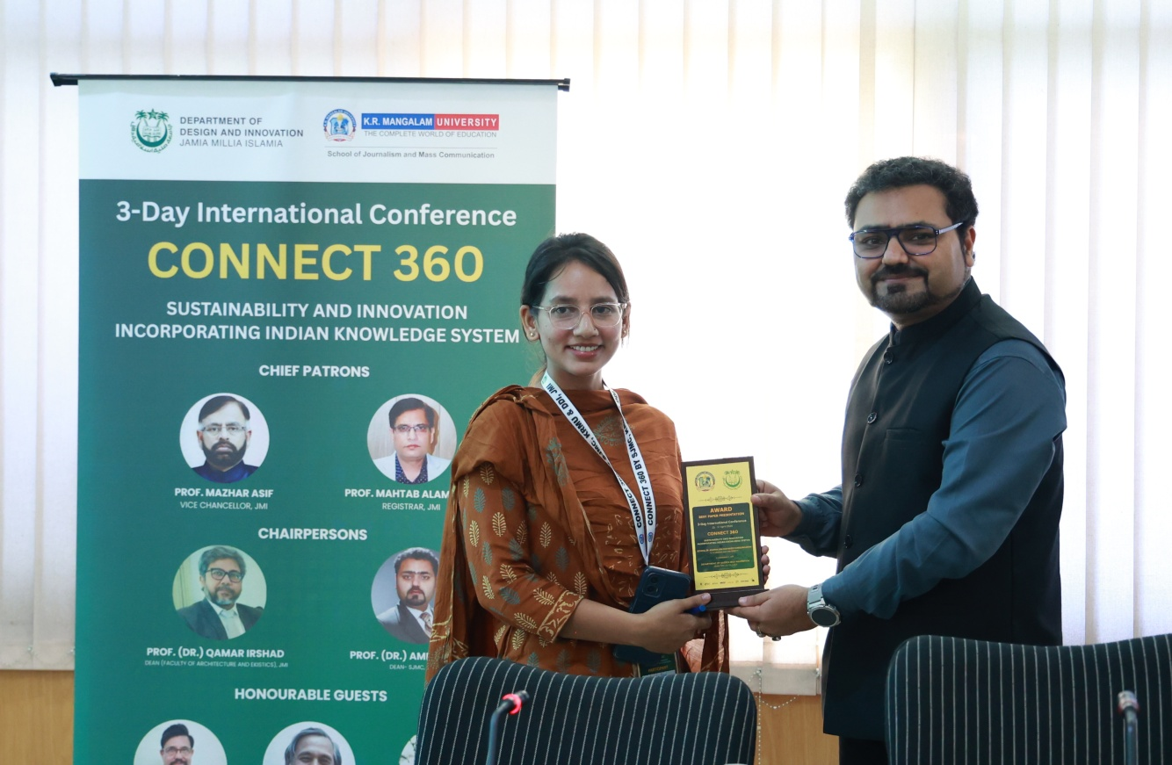
(Photo-6: Participant awarded Best Paper at CONNECT 360 for "Discerning Indian Knowledge System Through Visual Storytelling: Analysing Lootera as a Cross-cultural Adaptation of The Last Leaf.")

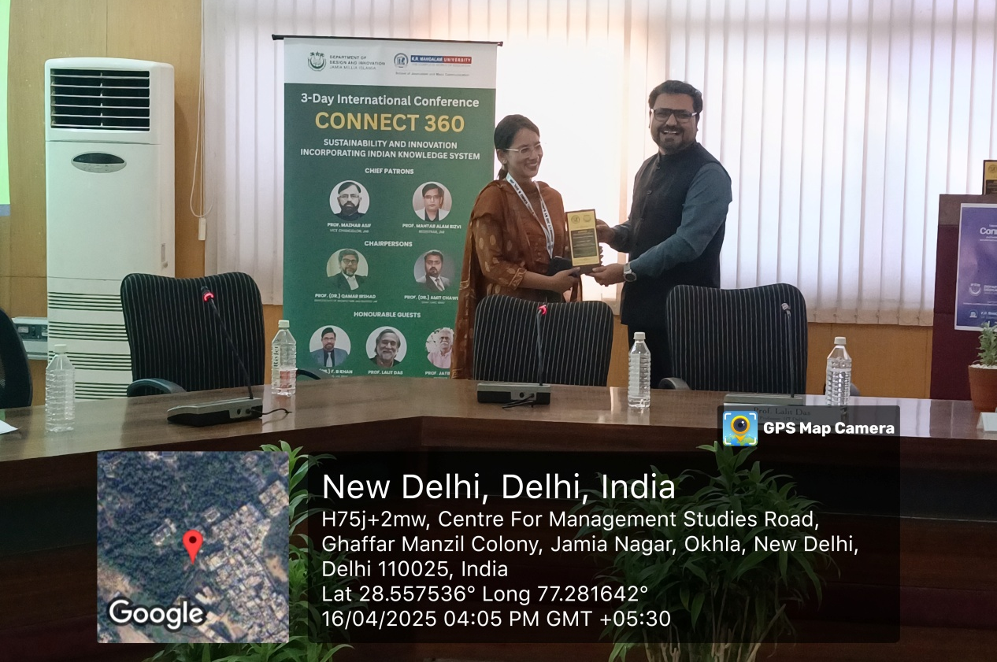

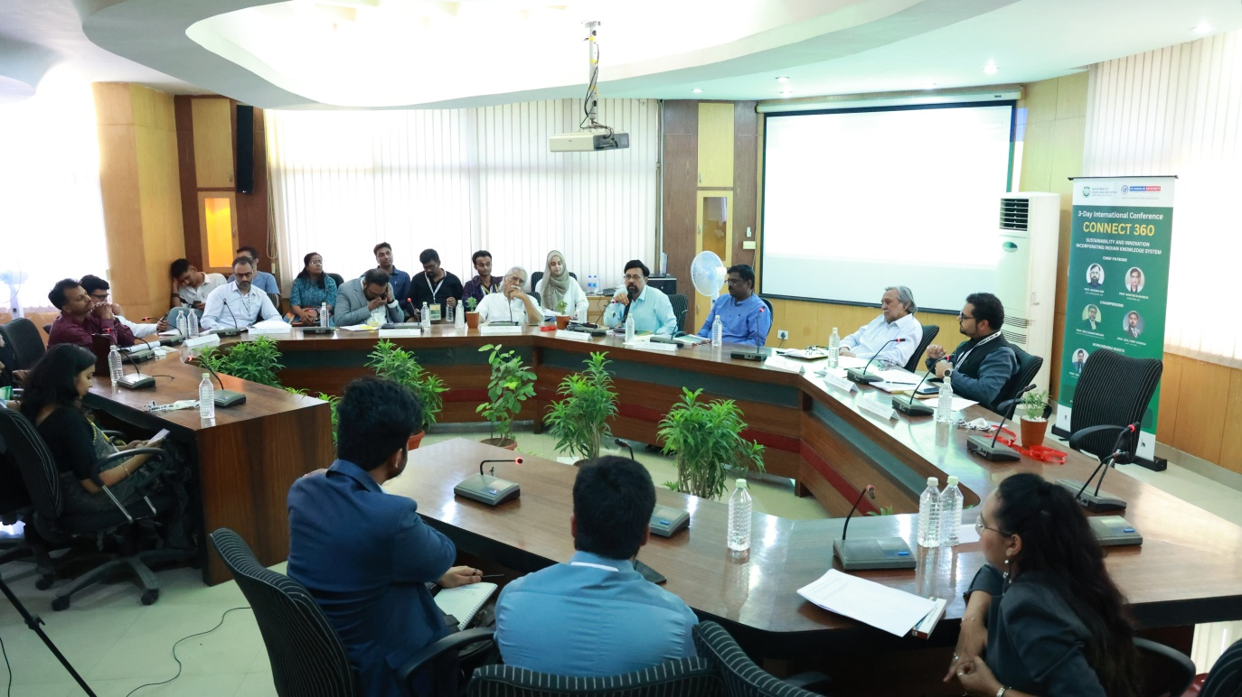
(Photo-7: Panel discussion in progress during CONNECT 360 Conference at Jamia Millia)

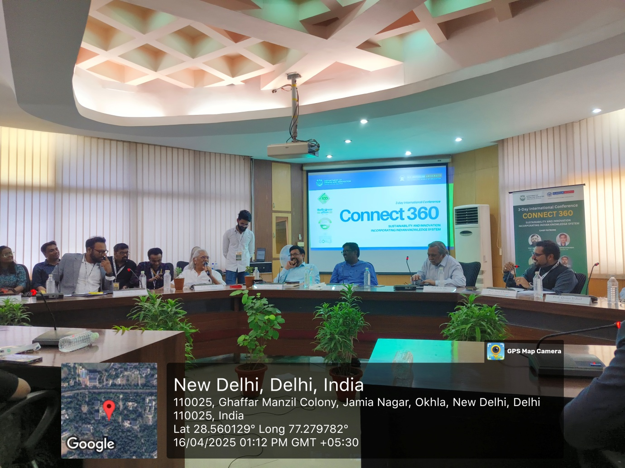

Day -3
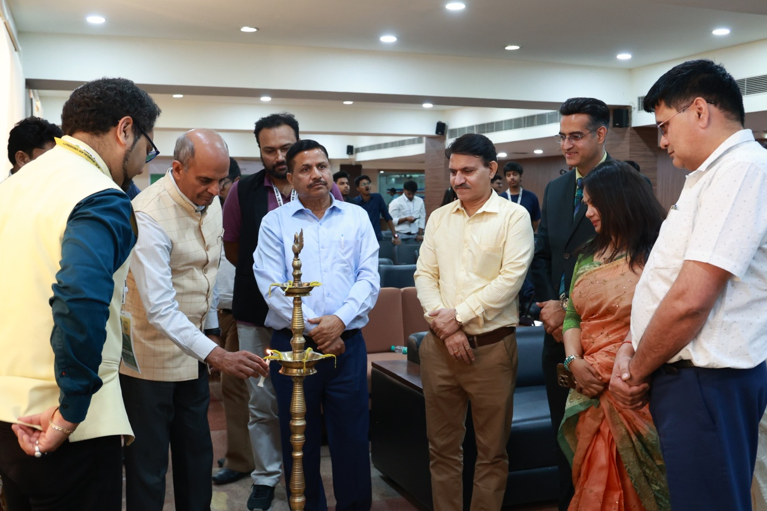
(Photo-8: Dignitaries lighting the lamp during the Valedictory Function of CONNECT 360 Conference.)
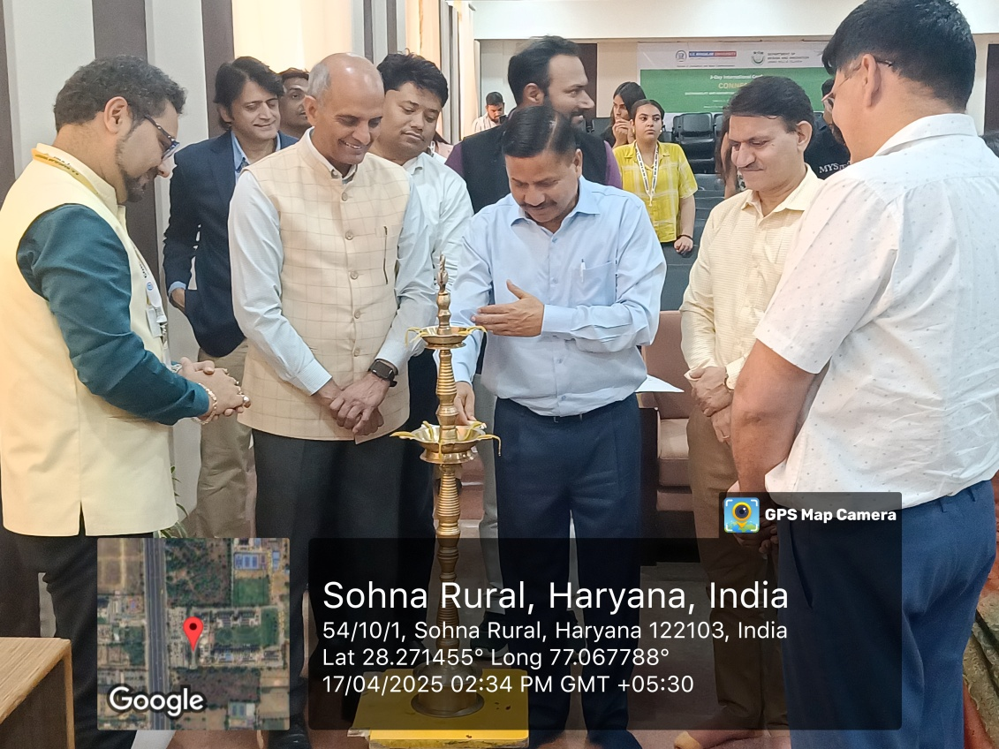

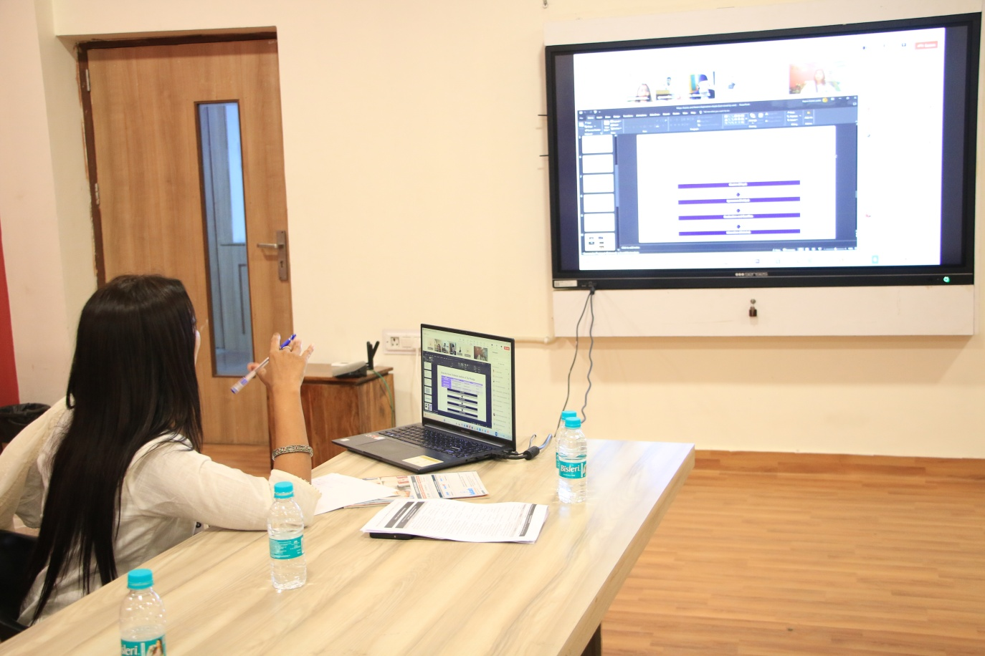
(Photo-10: Participant delivering an online presentation during CONNECT 360 Conference.)
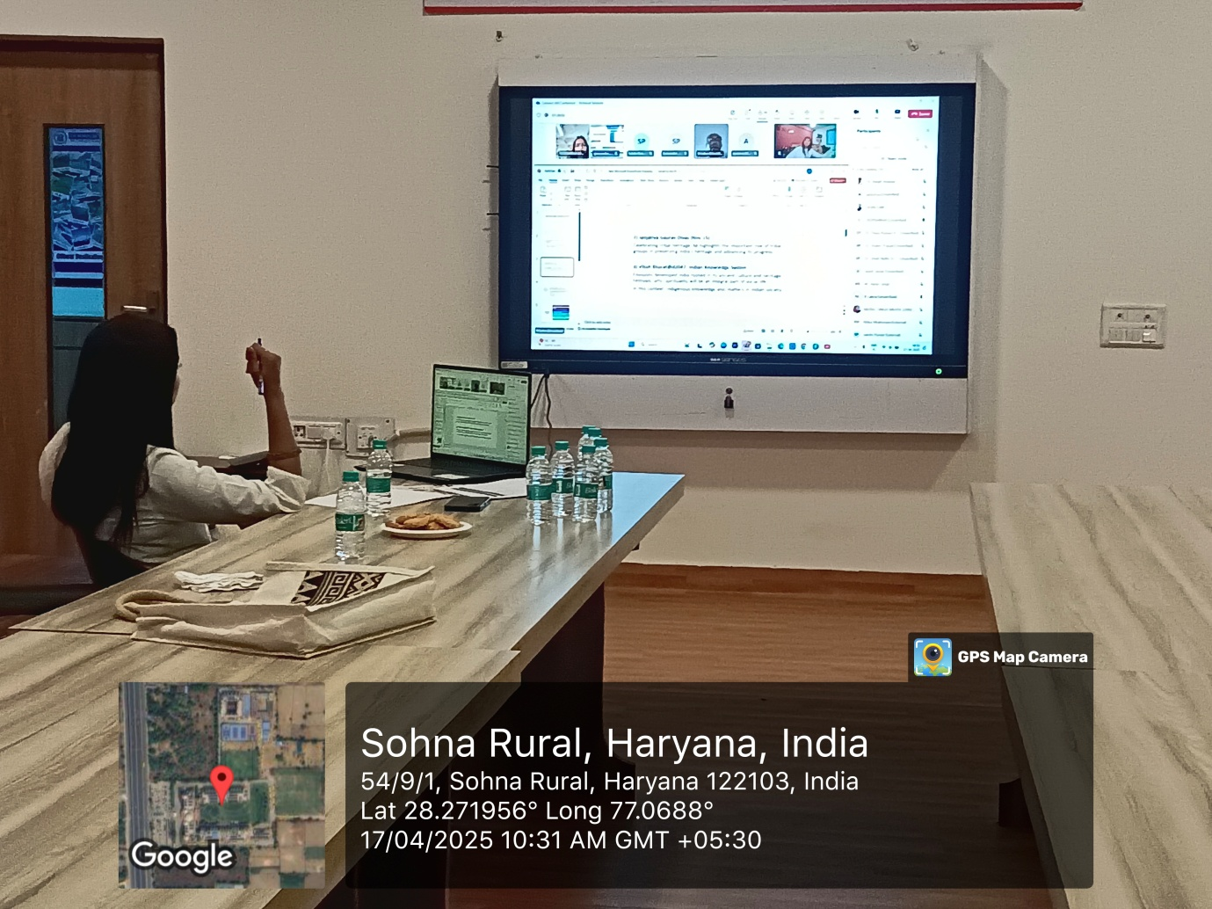

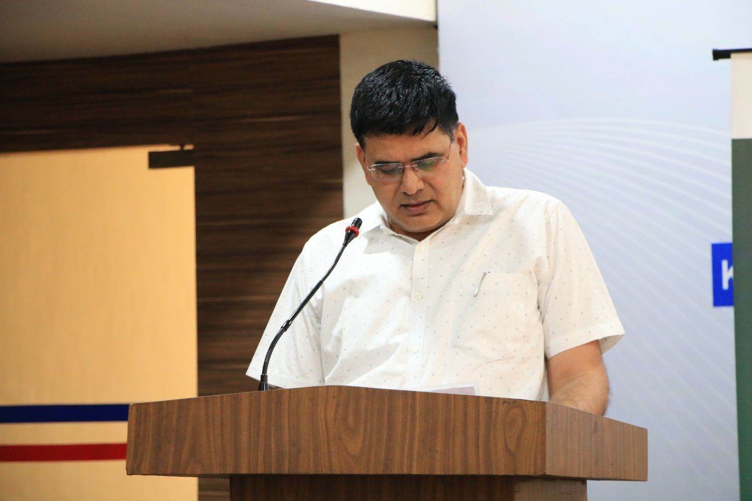
(Photo-11: KRMU Registrar addressing the audience during CONNECT 360 Conference.)
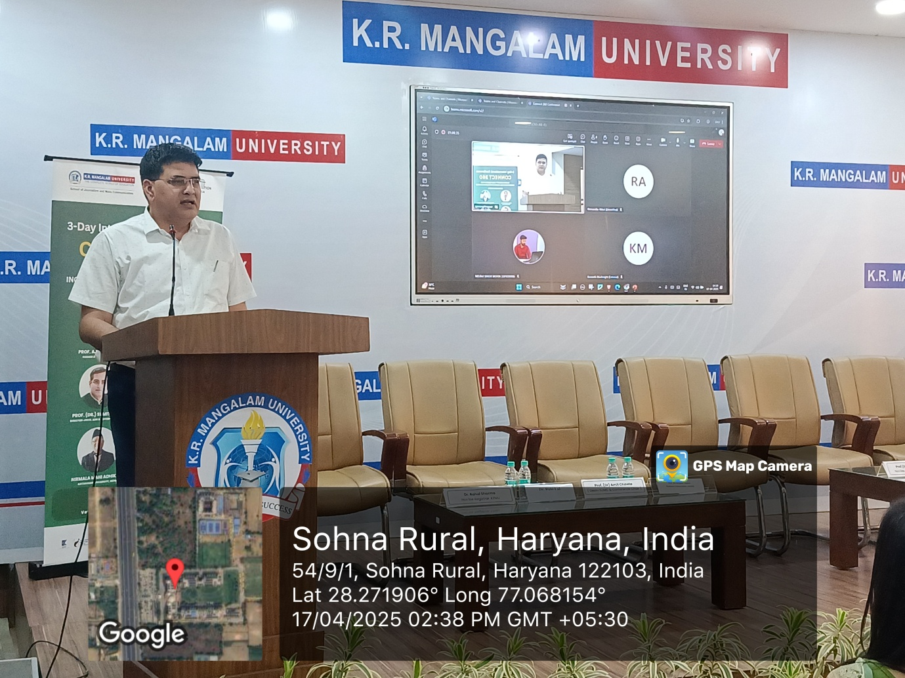

Report prepared by | Mr. Karan Singh
Report verified by Coordinator | Mr. Karan Singh
Report verified by Dean | Prof. Dr. Amit Chawla  Dean, SJMC
Report verified by IQAC Coordinator | Dr. Shikha Dutt Sharma

