2-day International Multidisciplinary Conference
on
DESIGN 2030 - Developing Efficient and Sustainable Innovations for Global Needs

(March 21st – 22nd, 2025)
In collaboration with
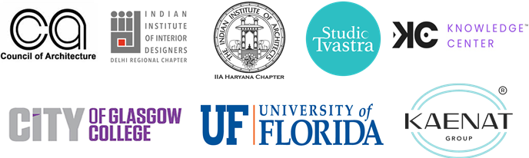

A Brief Report

Organized by
School of Architecture and Design
K.R. MANGALAM UNIVERSITY
Sohna Road, Gurugram

Venue : Knowledge Center, M3M Broadway
Gurugram, India

Contents

- Preface
- Acknowledgements
- Title and Objective of the Conference
- Themes and Sub-Themes of the Conference
- Inaugural Function
- Address of the Invited Speakers
- Session wise & Track wise Report
- Valedictory Function
- Feedback from the Participants
- Media Coverage
- Recommandations

- PREFACE
The Design 2030 Conference, organized by the School of Architecture and Design at KR Mangalam University, stands as a confluence of ideas, innovation, and interdisciplinary dialogue in the realm of design. As we navigate the evolving landscape of architecture, urban planning, product innovation, and digital transformation, this conference aims to explore the future of design in a rapidly changing world.
With the year 2030 marking a pivotal juncture in global developmental goals and sustainability initiatives, this conference delves into emerging technologies, material advancements, human-centered design strategies, and the role of designers in shaping a more resilient, inclusive, and aesthetically enriched environment. Bringing together academics, professionals, students, and industry leaders, Design 2030 fosters meaningful discussions, critical reflections, and forward-thinking solutions that address the complexities of contemporary design challenges.
The diverse range of presentations, panel discussions, and workshops featured in this conference provide a platform for intellectual engagement and knowledge exchange, ensuring that design remains at the forefront of global progress.

Overview: About the Conference
By 2030, two-thirds of the world population (5 billion people) is expected to live in cities. Rapid urbanization has brought enormous challenges, including growing numbers of slum dwellers, increased air pollution, inadequate basic services and infrastructure, and unplanned urban sprawl, which also make cities more vulnerable to disasters. Making cities safe and sustainable means ensuring access to safe and affordable housing, investment in public transport, creating green public spaces, and improving urban planning and management in a participatory and inclusive manner.
The DESIGN 2030 conference brings academics, activists, artists, and professionals to engage in a dialogue on resiliency and sustainability. It will investigate how interdisciplinary built-environment studies, including but not limited to Architecture, Architectural History, Landscape Architecture, Landscape History, Construction Management, Engineering, History of Technology, Urban Planning, Urban History, Urban Sociology, Urban Public Health, Justice Studies, Fine Arts, Environmental Studies, Environmental History, Disaster Studies, and Interior Design, can address global needs to build resilient communities.

About School of Architecture and Design (SOAD)
At the School of Architecture & Design, students pursue architecture and design-related courses to construct sensitive habitable spaces. The programmes equip the students with knowledge, skills, and attitudes to attain capabilities required to understand current scenarios and address future challenges in this field. The curriculum balances creativity, aesthetic understanding, and skills along with ethical practices.
Convenor:
Dr. Tanaya Verma
Professor and Dean,
School of Architecture and Design, KR Mangalam University, Gurugram
Co-Convenors:
Ar. Tulika Pahwa, Assistant Professor
Ar. Mehak Arora, Assistant Professor
School of Architecture and Design, KR Mangalam University, Gurugram
- ACKNOWLEDGEMENTS
We extend our sincere thanks to the esteemed leadership of KR Mangalam University—our Honorable Chairman, Honorable Vice-Chancellor, Registrar Sir, AO sir—for their unwavering support and visionary guidance. Our heartfelt appreciation goes to Ar. Vivek Logani, Chairman of IIA Haryana, for his encouragement and invaluable contributions. We are deeply indebted to the Council of Architecture for their academic support and to the IIID Delhi Regional Chapter for their continued motivation.
We are privileged to have collaborated with esteemed international institutions—the University of Florida and the City College of Glasgow—whose engagement has enriched our discourse. Our deepest gratitude goes to our sponsors, the Knowledge Center for hosting this event, Kaenat and all other sponsors, whose dedication was instrumental in bringing this vision to life.
A special note of gratitude to our Convenor, Prof. Dr. Tanaya Verma, whose vision and leadership have been instrumental in making DESIGN 2030 a success. To our esteemed faculty, distinguished speakers, session chairs, and enthusiastic participants—your contributions have elevated this event to new heights.

- TITLE AND OBJECTIVE OF THE CONFERENCE
Title: DESIGN 2030 - Developing Efficient and Sustainable Innovations for Global Needs
Aim:
To foster a global platform for interdisciplinary collaboration and knowledge
exchange to advance efficient and sustainable innovations that address pressing global needs, aligning with the vision of a sustainable future by 2030.

Objectives:
- Promote Sustainable Design Practices:
Explore and highlight innovative practices in sustainable architecture, urban design, and renewable energy technologies to drive global efforts toward ecological balance and resource efficiency.
- Advance Climate Resilience and Disaster Management:
Facilitate the sharing of insights, technologies, and strategies for building climate-resilient urban environments and effective disaster management solutions to mitigate the impacts of climate change.
- Encourage Integration of Policy and Governance:
Discuss the role of policy frameworks, governance models, and public-private partnerships in fostering sustainable urban development and implementing smart city initiatives.
- Enhance Education and Capacity Building:
Support the development of educational programs and research initiatives that equip professionals, educators, and students with the tools and knowledge to address sustainability challenges effectively.
- Explore Contemporary Art and Design Practices:
Investigate the impact of emerging technologies, digital art, and craftsmanship on contemporary design and their potential to inspire sustainability in creative fields.

- THEMES AND SUB-THEMES OF THE CONFERENCE
Track 1: Sustainable Architecture and Urban Design
- Green Building Practices
- Smart Cities and Sustainable Infrastructure
- Cultural and Social Sustainability in Urban Design
- Urban Green Spaces and Biodiversity
- Innovative Case Studies and Best Practices
Track 2: Renewable Energy and Environmental Technologies
-Smart Building Technologies and Energy Management Systems
-Challenges and Solutions for Renewable Energy Integration
-Waste-to-Energy Solutions in Building Design
-Advanced Water and Wastewater Treatment in Sustainable Architecture
-Climate-Responsive Building Design
-Sustainable Agricultural Practices
Track 3: Climate Resilience and Disaster Management
-Urban Resilience and Climate Adaptation
-Role of Green Infrastructure in Disaster Management
-Digital Tools and Technologies for Disaster Preparedness
-Case Studies in Climate-Resilient Urban Development
-Design Strategies for Post-Disaster Recovery
-Harnessing Nature-Based Solutions for Disaster Risk Reduction
Track 4: Policy, Governance, and Social Innovation
-Policy Frameworks for Sustainable Urban Development
-Public-Private Partnerships in Urban Planning and Development
-Smart Cities and the Role of Technology in Governance

Track 5: Education and Capacity Building for Sustainability
-Education and Capacity Building for Sustainable Development
-Role of Research and Innovation in Advancing Sustainability Education

Track 6: Contemporary Art & Design Practice
-Digital Art and Emerging Technologies in Design
-Art and Design in the Age of Artificial Intelligence
-The Impact of Digital Media on Contemporary Art
-Art and Design in Urban Spaces
-The Role of Craftsmanship in Modern Design
-Contemporary Approaches to Traditional Art Forms

- INAUGURAL FUNCTION
The Inaugural Ceremony of the Design 2030 Conference, , commenced with great enthusiasm and reverence. The event began with the ceremonial lighting of the lamp, a tradition symbolizing enlightenment, wisdom, and the transformative power of knowledge. To mark this auspicious beginning, distinguished guests Ar. Gajanad Ram, Ar. Vivek Logani, Mr. Rishu Anand, Dr. Varuna Tyagi, and Dr. Tanaya Verma were invited to the stage to perform the ceremonial lamp lighting.
In his opening remarks, Ar. Gajanad Ram, Vice President, Council of Architecture welcomed the esteemed guests, faculty members, and participants, highlighting the significance of the conference in fostering innovation and shaping the future of design. He emphasized the role of design in addressing contemporary challenges and the importance of collaborative efforts in pushing the boundaries of architectural and design excellence.
Following the ceremonial proceedings, the audience was captivated by a Saraswati Vandana, a traditional invocation performed by the talented students of the School of Architecture and Design. The soulful rendition paid homage to the goddess of wisdom and creativity, setting a harmonious and inspiring tone for the sessions ahead.
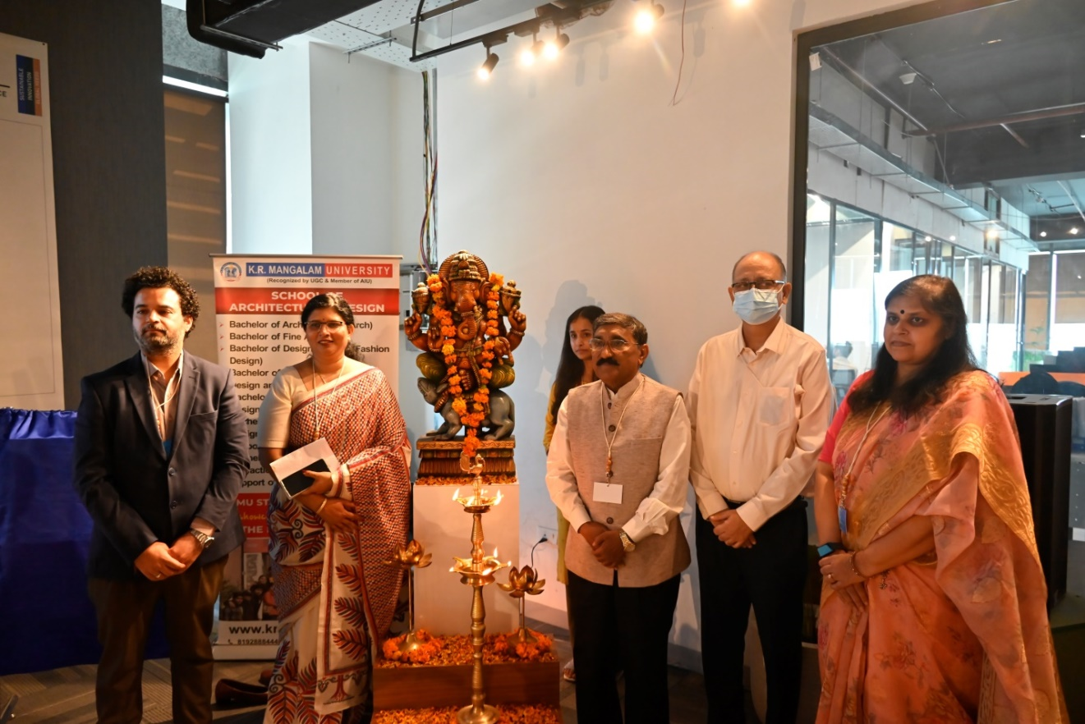
Figure 1: Lamp Lighting in Inauguration Ceremony
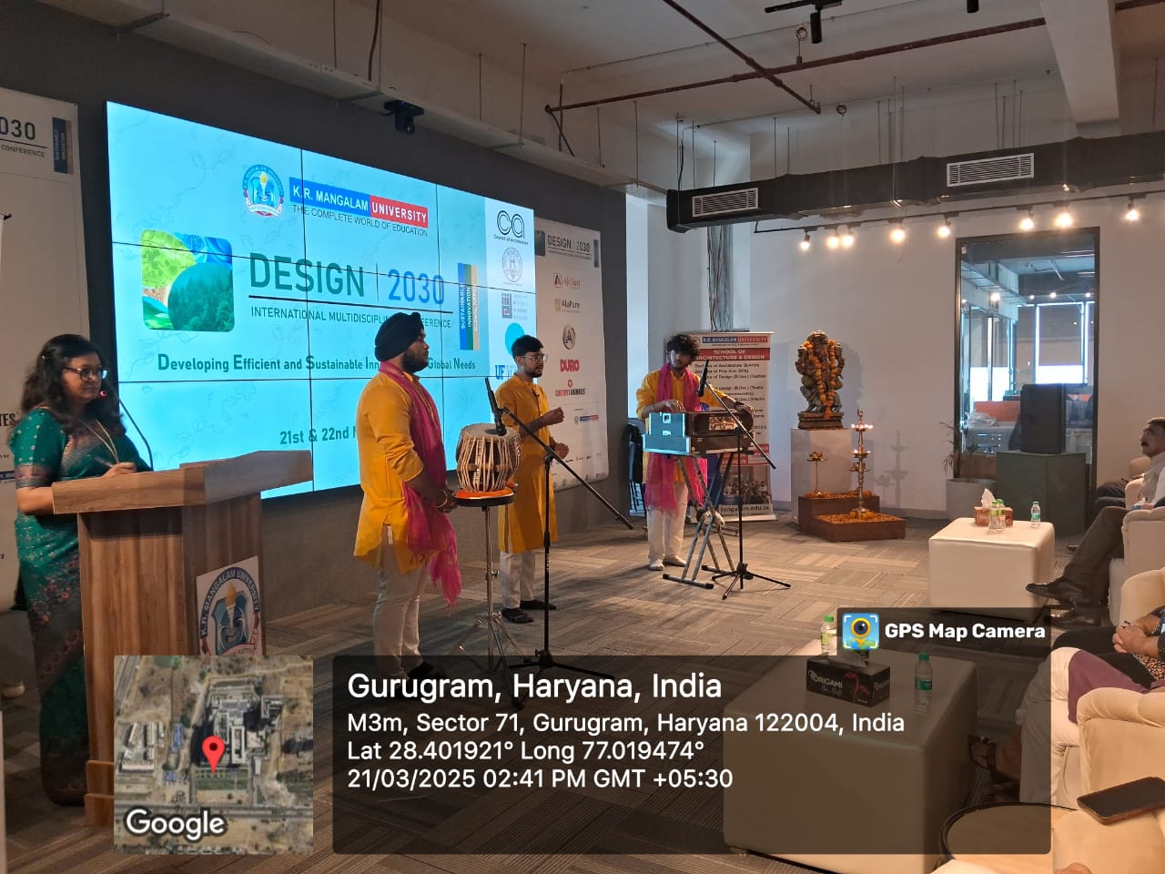
Figure 2: Saraswati Vandana in Inauguration Ceremony
- ADDRESS OF THE INVITED SPEAKERS
The segment featured insightful addresses from esteemed invited speakers, who shared their perspectives on the evolving landscape of design and its impact on academia and the profession. The session was graced by Ar. Gajanad Ram, Vice President, Council of Architecture; Ar. Vivek Logani, Chairman, IIA Haryana Chapter; and Mr. Rishu Anand, Chairman, IIID Delhi Regional Chapter.
Ar. Gajanad Ram delivered an enlightening address on the role of the profession in academia. He emphasized the need for a stronger synergy between architectural practice and education, highlighting how professional expertise can enrich academic learning. He stressed the importance of integrating real-world challenges into the curriculum to prepare students for the dynamic demands of the industry.
Ar. Vivek Logani spoke on the role of the Indian Institute of Architects (IIA) and the importance of bridging the gap between industry and academia. He underscored the significance of professional organizations in shaping architectural education and fostering collaboration between institutions and industry stakeholders. His address called for a more practice-oriented approach in academics to enhance students’ preparedness for professional challenges.
Mr. Rishu Anand addressed the audience on the role of the Institute of Indian Interior Designers (IIID) and the need for professionals and students to associate with it. He highlighted how IIID serves as a platform for knowledge exchange, networking, and industry engagement, encouraging young designers and architects to become active members to stay updated with industry trends and best practices.
The session provided valuable insights into the intersections of academia and professional practice, reinforcing the importance of collaboration between institutions, industry bodies, and aspiring designers. The speakers’ addresses set a strong foundation for the discussions and learning experiences that followed in the conference.
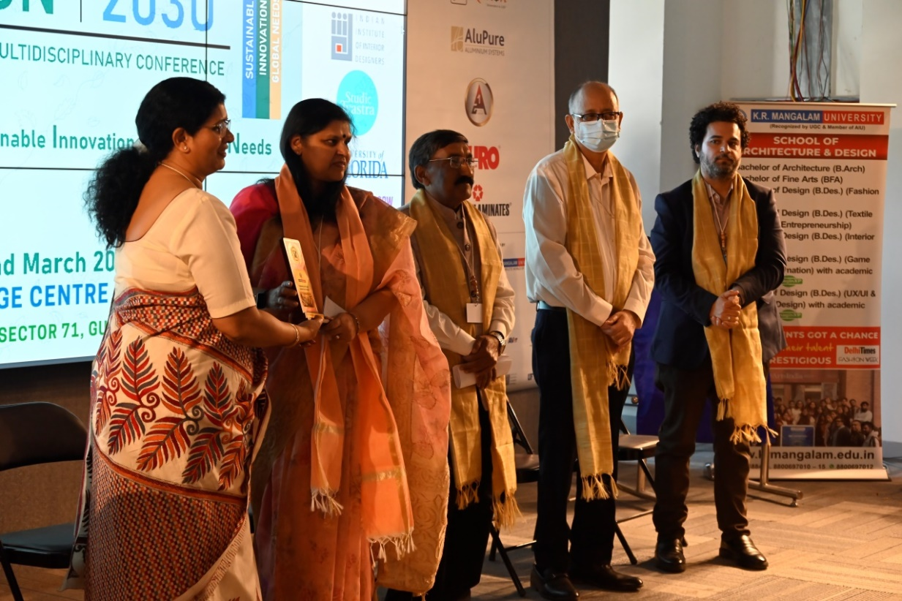
Figure 3: Felicitation of Eminent Guests
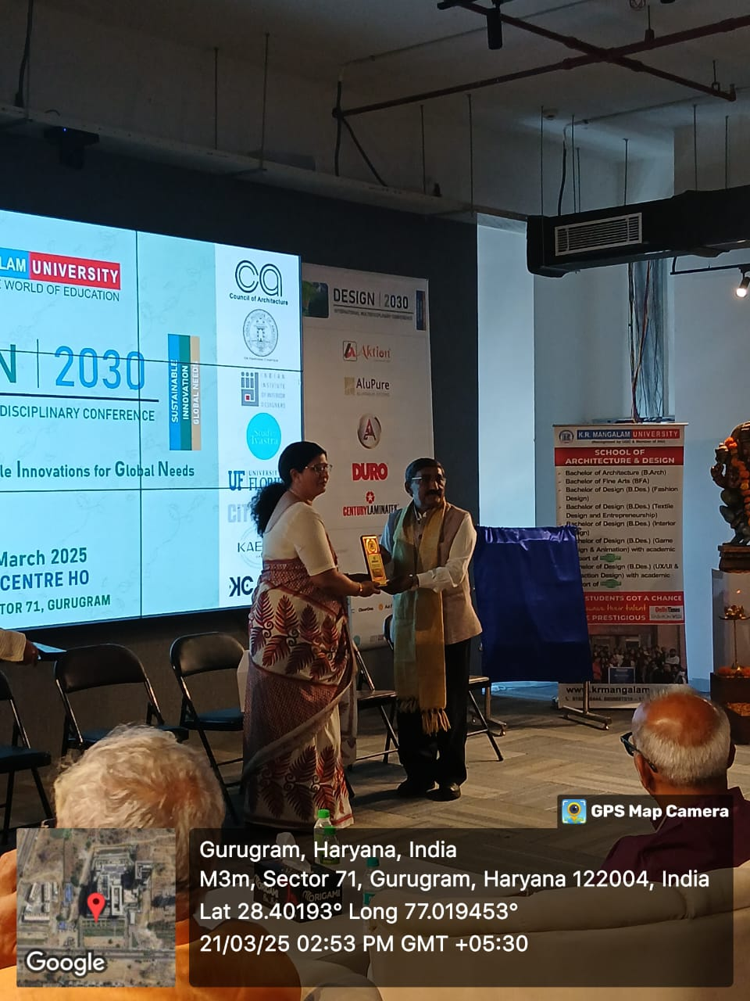
Figure 4: Felicitation of Eminent Guests
- SESSION WISE & TRACK WISE REPORT
DAY 1: 21st March 2025
DAY 1: 21st March 2025
The Conference commenced with an engaging and insightful first day, setting the stage for thought-provoking discussions, expert talks, and vibrant cultural performances.

Registrations and Opening Ceremony (10:00 - 10:45 AM)
The day began with the registration and high tea, providing an excellent opportunity for networking among attendees, faculty members, and esteemed guests. The welcome address introduced the overarching themes of the conference, emphasizing sustainability and the conference’s efforts to minimize environmental impact. The two-day schedule was outlined, and attendees were encouraged to connect via WhatsApp QR codes, hashtags, and mentions. The conference tracks and technical session venues were introduced before welcoming Tulika Pahwa, the Co-Convener of Design 2030, to share a few words. Following her address, Dr. Tanaya Verma, Dean of SOAD and Convener of the Conference, was invited to deliver her remarks, after which attendees dispersed for the technical sessions.
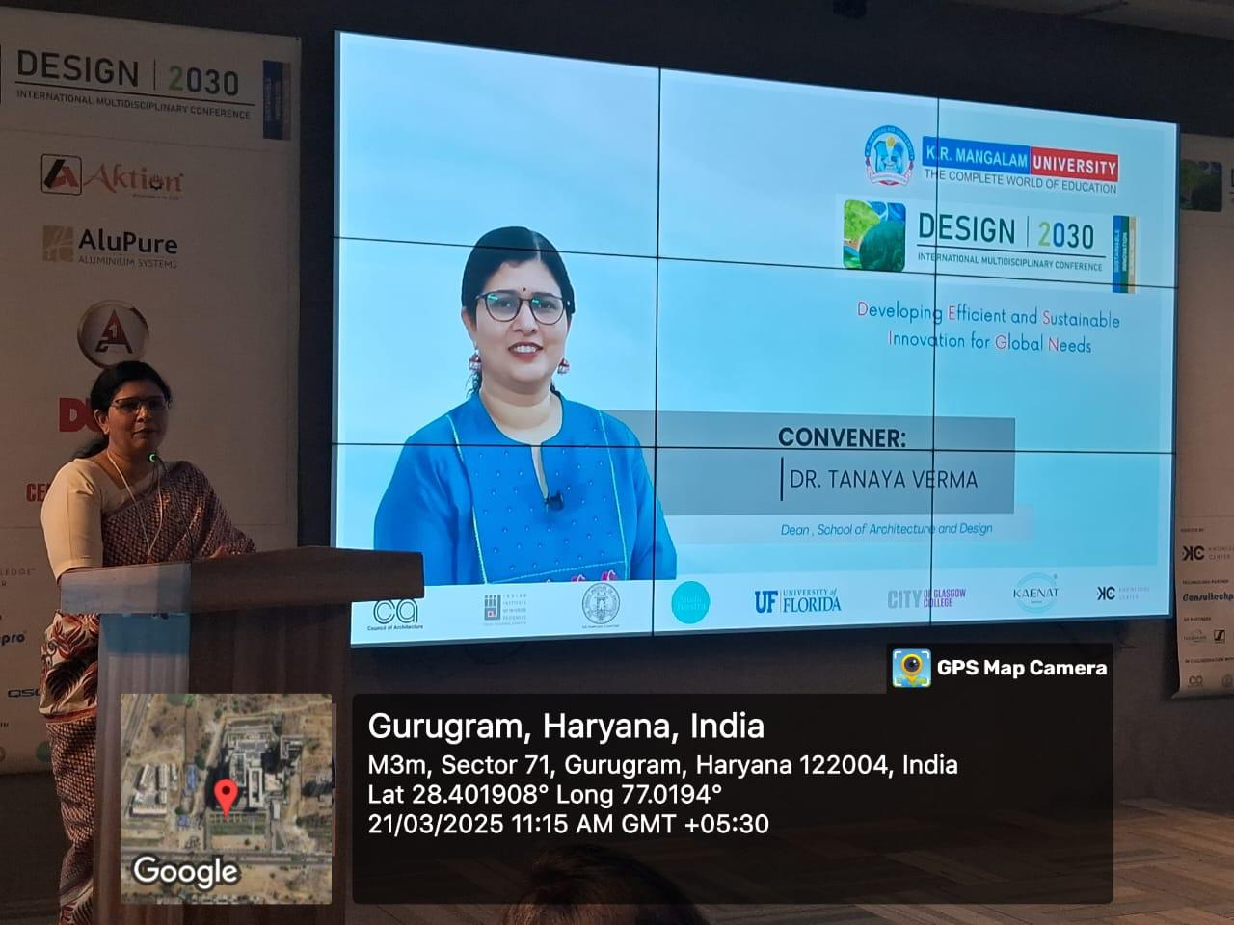
Figure 5: Welcome Address by Ar. Tulika Pahwa

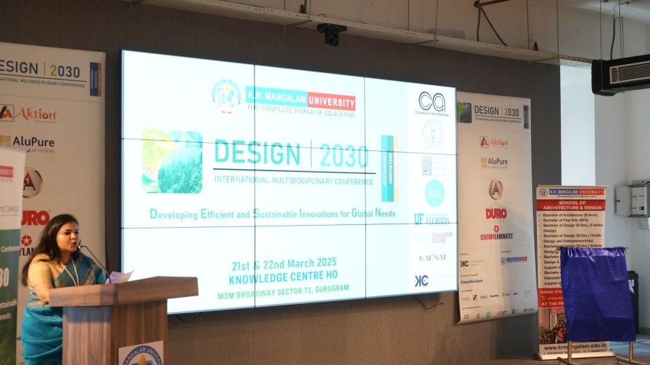
Figure 6: Welcome Address by Ar. Tulika Pahwa

Technical Session (11:00 AM Onwards)
Following the inaugural events, the technical sessions commenced across three venues- 2 venues in offline presentation and 1 venue in online presentation, each featuring insightful presentations and discussions on contemporary design challenges and innovations:
- Track 1 (Venue 1, 2): Sustainable Architecture and Urban Design: This track explores innovative approaches to sustainable urban development, emphasizing green building practices, smart city infrastructure, and the integration of social and cultural sustainability in urban planning.
- Track 4 (Venue 1,2): Policy, Governance, and Social Innovation: This track delves into policy frameworks, governance mechanisms, and social innovation strategies crucial for sustainable urban development. Key discussions included the role of technology in governance, public-private partnerships, and adaptive reuse in urban environments.
- Track 1 to 6 (Venue 3): Online
The following papers were presented in offline mode at Venue 1:
The session was chaired by Dr. Ila Gupta, Director at Amity University Manesar and Ms. Anjali Goel, Founder Studio Tvastra. The session was co-chaired by Dr. Sagar Paruthi, Assistant Professor, SOAD.
Dr. Ila Gupta, Director of the Amity School of Architecture and Planning at Amity University Haryana, brought her vast experience in urban planning and earthquake disaster management to the discussion. She has contributed significantly to research on sustainable infrastructure and was recognized as one of the ‘10 Must Watch Influential Women Leaders in Indian Education.’
Ms. Anjali has embarked on a journey of self-discovery and artistic exploration, she traversed diverse landscapes - from the nascent beginnings as part of the inaugural batch at Kurukshetra College to the creative haven of Baroda Fine Arts College for her Master's. The shift from a structured environment to one of liberation, allowed her to unfurl her artistic expression and personal growth.
- Strengthening Climate Resilience: A Synergistic Approach to Disaster Risk Reduction – Lipi Shrivastava
- Analysing the Dimensions of Sustainable Urban Neighbourhood: Case of Gurugram – Md Shahroz Alam
- Transforming Urban Voids: The Role of Thaltej Lake – Muskan Kaushal
- Impact of Public Art in Creating a Dynamic and Inclusive Urban Environment – Anju Mani Kalita
- Inclusive Architecture: A Review of Regulations and Policies for Autism-Friendly Design – Nandini Bhandari Sharma
- Formulating a Framework for Assessing Lonar Crater India as a Potential Geopark: A Literature-Based Approach to Social Innovation and Sustainable Development – Shruti Hippalgaonkar
- Effects of Urban Sprawl in Hilltown – A Study of Shimla – Tanya Verma
- Inclusive Heritage Spaces: Assessing Women's Accessibility and Mobility at the Qutub Minar Complex – Aarjavi Jain
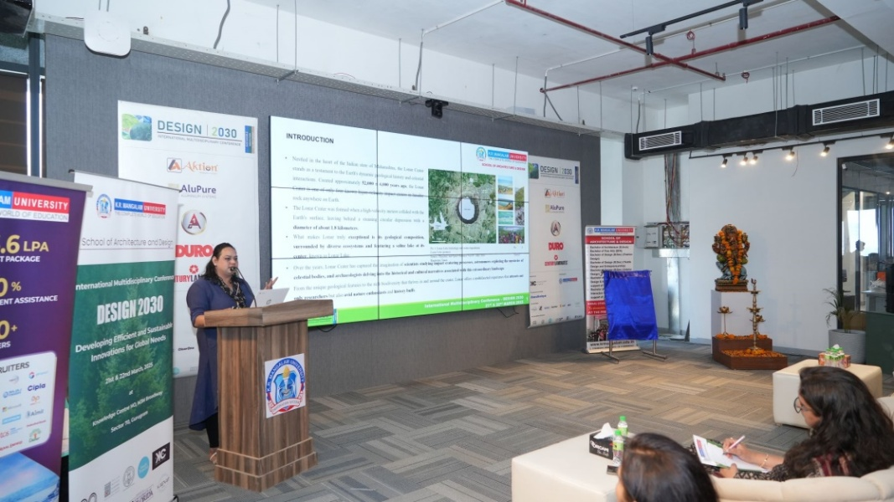
Figure 7: Paper Presentation Ar. Shruti in Venue 1
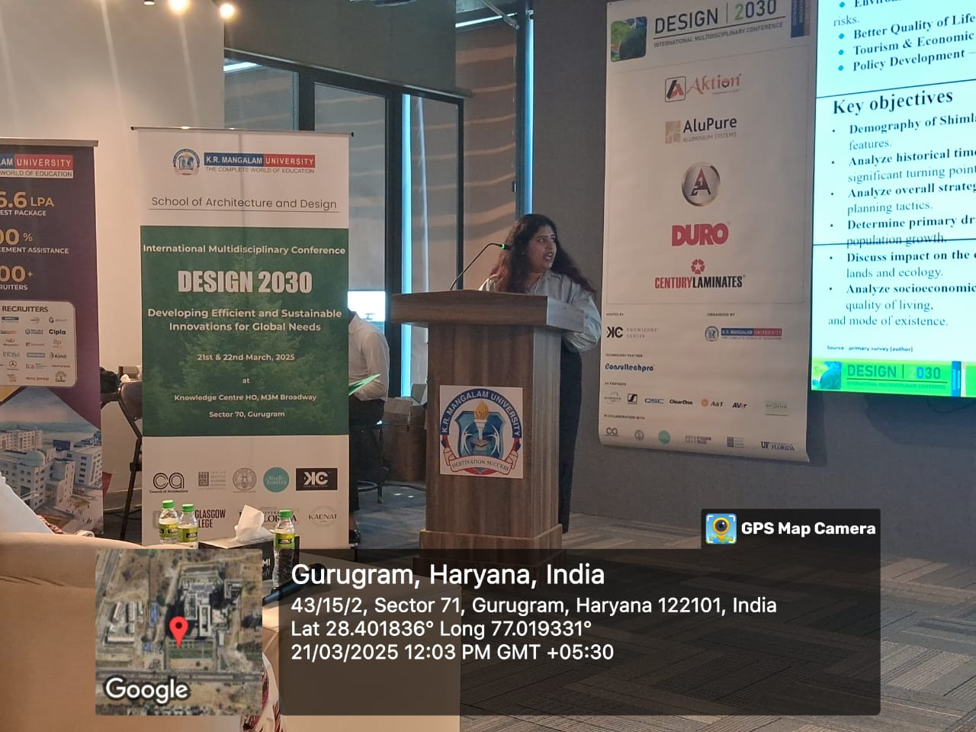
Figure 8: Paper Presentation by Ms. Tanya Verma in Venue 1
The following papers were presented in offline mode at Venue 2:
The session was chaired by Prof. Hemani Singh. The session was co-chaired by Ar. Praveen Gupta, Associate Professor, SOAD.
Hemani Singh is a professor of Architecture and former Dean at School of Architecture and Design at K R Mangalam University in India. She has a Master of Science degree in Architecture, Building and Planning from Eindhoven University of Technology (TU/e), The Netherlands and B. Arch from School of Planning and Architecture, New Delhi. She has lived, worked, and studied in Netherlands, Dubai and India. The experience of diverse cultures and contexts have been instrumental in her educational, professional and personal development. She has consolidated her interest in pedagogical innovation and ecological urbanism.
- ANN Approach to Forecasting the Strength of Nano Silica Incorporated Geopolymer Composite – Dr. Sagar Paruthi
- Karmuka Planning: Revitalizing Urban Spaces Through Ancient Wisdom - A Case Study of Ganj Golai – Pooja Sahoo
- Chandigarh: Navigating the Path to Environmental Sustainability in Smart Urban Development – Varnan Gupta
- Bridging the Divide: Reconciling Architectural Intentions and Public Perceptions in Compact City Planning – Kaira Arora
- Ramgarh Shekhawati – An Analytical Study of Prastara Settlement – Pragati Singh
- Sacred Spaces and Psychological Well-Being – Vanshika Kalia
- The Art of City Planning: Swastika Patterns from Mohenjodaro to Beyond – Drishti Grover
- Community Involvement in Heritage Conservation – Ar. Akanksha Singh
- Breathing New Life into Dead Malls: A Study of Adaptive Reuse in Metro Cities – Disha Shah
- Shantipath: Redefining its Identity as a Green Corridor – Ar. Mehak Arora
- Module Design Strategies for Residential Satisfaction in Row Housing: Case of Central India – Nandit Pastariya
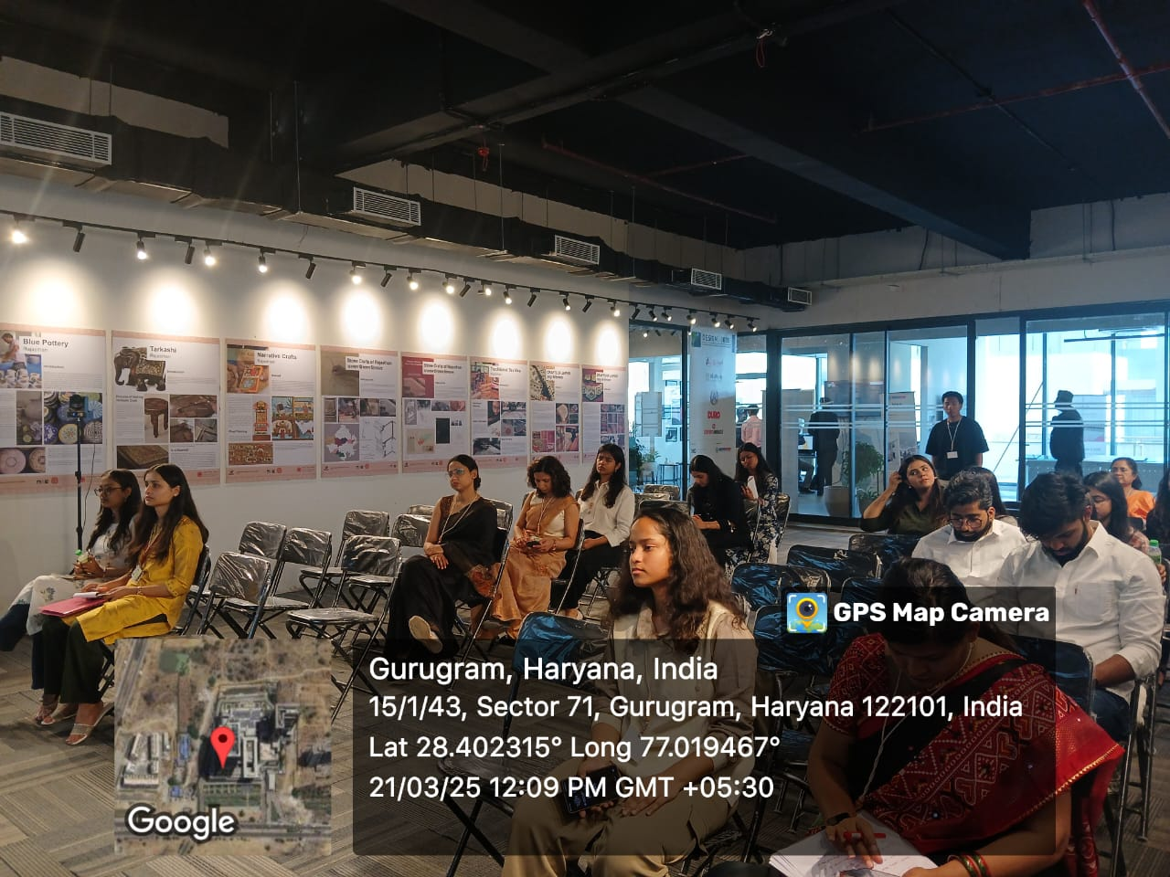
Figure 9: Research Session in Venue 2
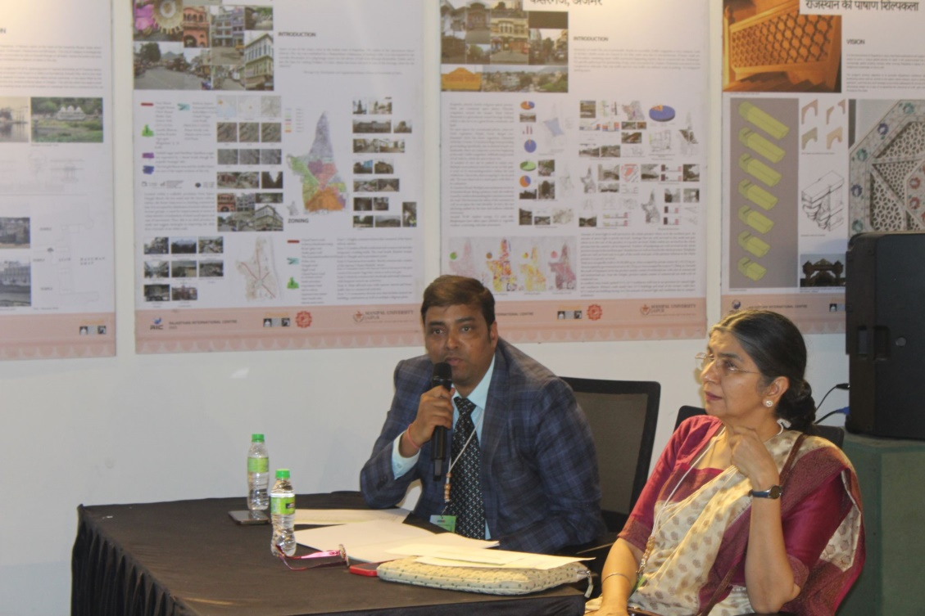
Figure 10: Session Chairs Prof. Hemani Singh and Ar. Praveen Gupta at Venue 2
The following papers were presented in online mode at Venue 3:
- The Role of Shrine in Understanding the Physical Characteristics and Cultural Connotations of the Spiritual City – Sehba Saleem
- Beyond Foot Traffic: Leveraging Neuroscience to Design Brand Spaces that Spark Engagement and Sales – Nachiket Jaywant Ahiwale
- Impact of Informal Housing on Livelihoods and Social Mobility: Case of Gurgaon – Poorva Priyadarshini
- A Review: Integrating Solar Energy as a Solution to Reduce CO2 Emissions in Buildings within Composite Climate – Baishali Pradhan
- Exploring Local Craft Identity: A Study on the Perception and Awareness of Batik Print in Ujjain – Divya Solanki
- Assessments in Collaborative Studio – Payal Taneja
- Exploring the Theoretical Framework and Practical Applications of Adaptive Reuse in Contemporary Architecture – Kanchan Atnurkar
- Reinventing Indian Tribal Art Practices for Design and Spaces – Alpa Jain
- Game Mechanics as the Foundation of Engagement: Understanding Their Impact on Player Experience – Yogindra Ashok Vaidya
- Enhancing Daylighting and Energy Efficiency in Institutional Buildings Through Jaalis: A Review of the Literature - Ar. Ajaybahu Joshi
- Empowering Adolescents: The Role of Sustainable Urban Design in Fostering Spatial Independence – Ar. Sapna Dhiman
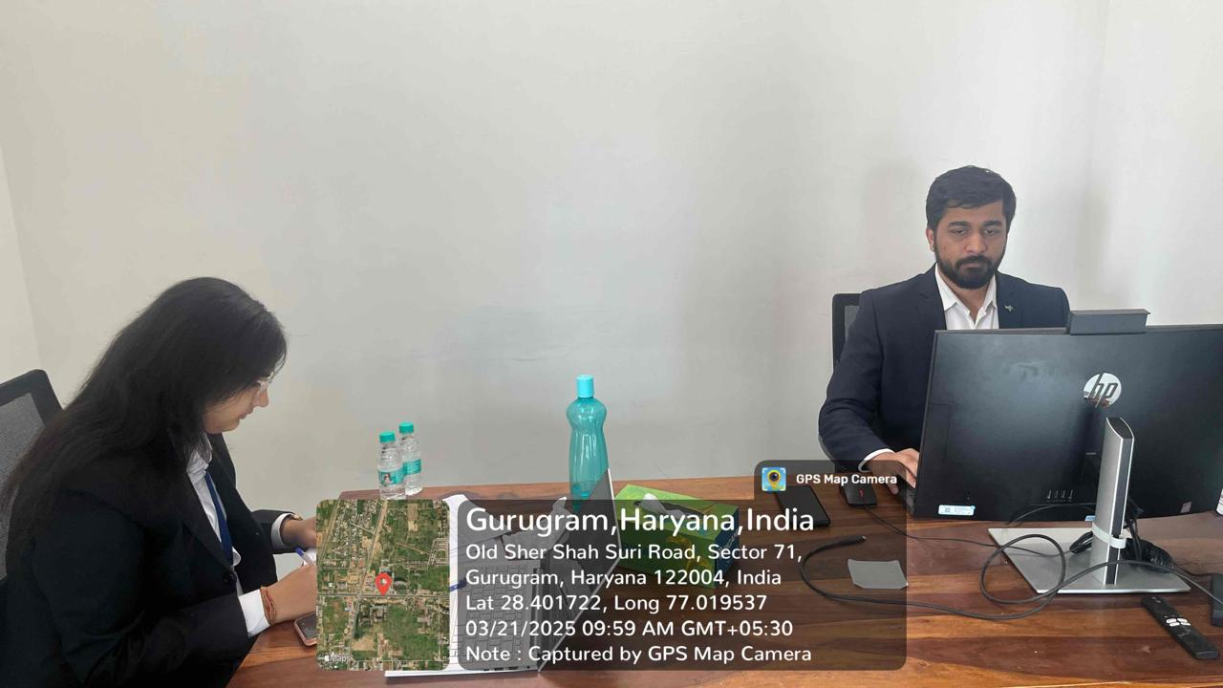
Figure 11: Research Session at Venue 3by Co-session Chair Ar. Nandit Prastariya
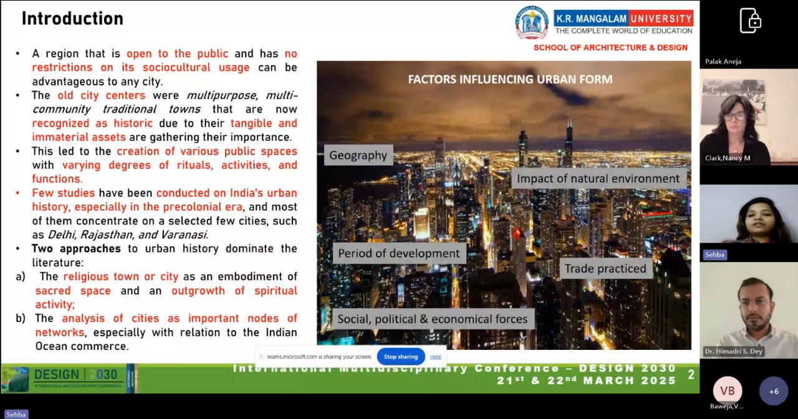
Figure 12: Online Research Session in Venue 3 chaired by Dr. nancy Clark, University of Florida, USA
Each venue featured engaging discussions, expert feedback, and interactive Q&A sessions, allowing participants to gain deeper insights into the future of design.

Knowledge Session (2:00 PM Onwards)
The knowledge session started with a warm welcome extended to invited guests of honor, including Leadership from COA, IIA, IIID, eminent speakers, faculty, and students. The session commenced with the ceremonial lamp lighting, led by Ar. Gajanad Ram, Ar. Vivek Logani, Mr. Rishu Anand, and Dr. Tanaya Verma, followed by a Saraswati Vandana performed by students.
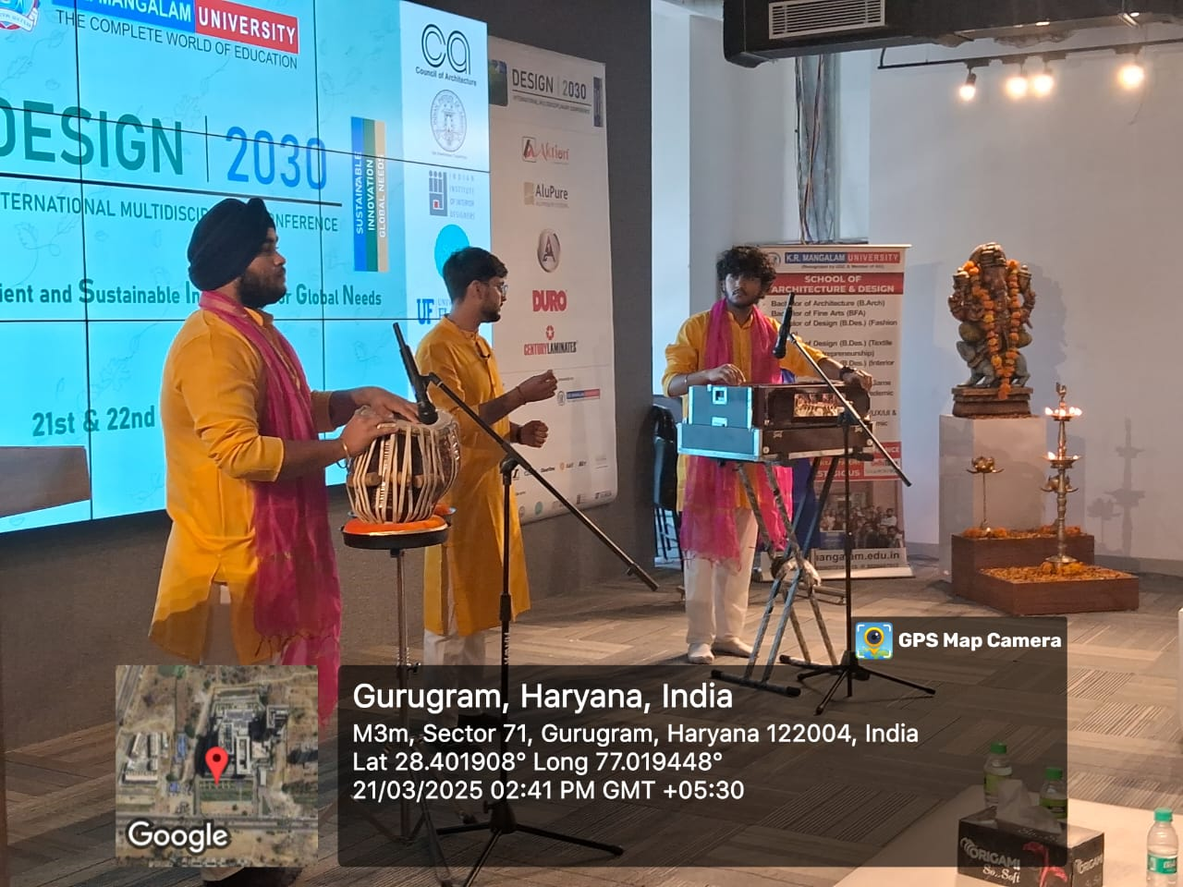
Figure 13: Saraswati Vandana in Inaugration
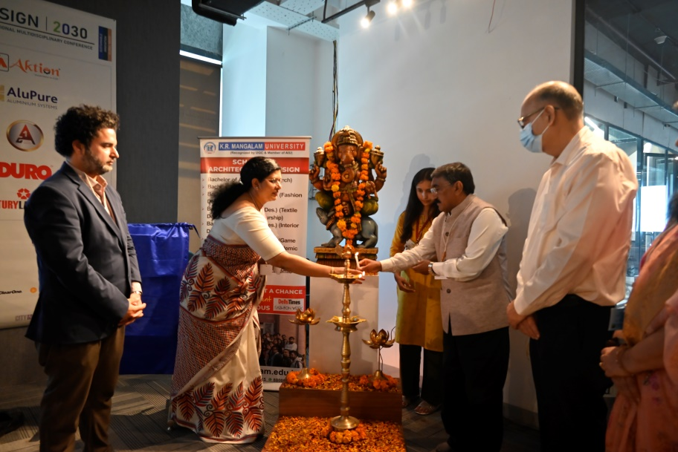
Figure 14: Lamp Lighting in Inaugration

Felicitation and Addresses: Dr. Tanaya Verma delivered a speech, emphasizing the role of design in shaping a sustainable future.
This was followed by addresses from Ar. Gajanad Ram (COA VP), who spoke on the role of the profession in academia; Ar. Vivek Logani (IIA Haryana Chapter Chairman), who highlighted IIA’s role in bridging the gap between academia and industry; Mr. Rishu Anand (IIID Delhi Regional Chapter Chairman), who emphasized the importance of associating with IIID. After their addresses, the dignitaries proceeded to unveil the SOAD Newsletter and the Book of Abstracts.
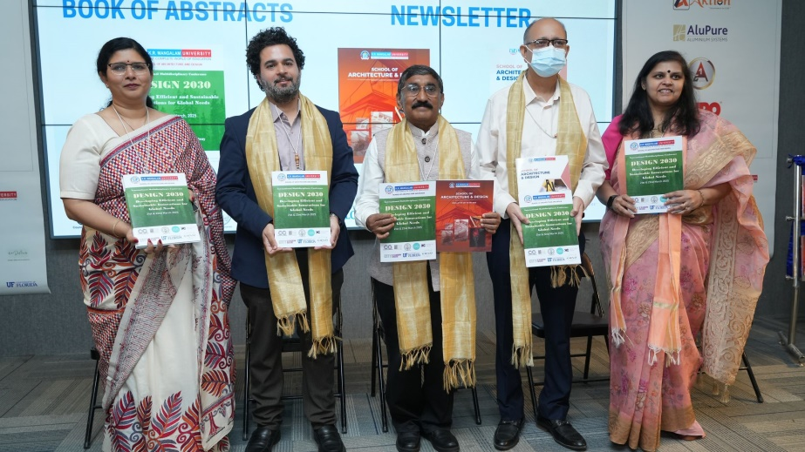
Figure 15: Book of Abstract and Newsletter unveiling
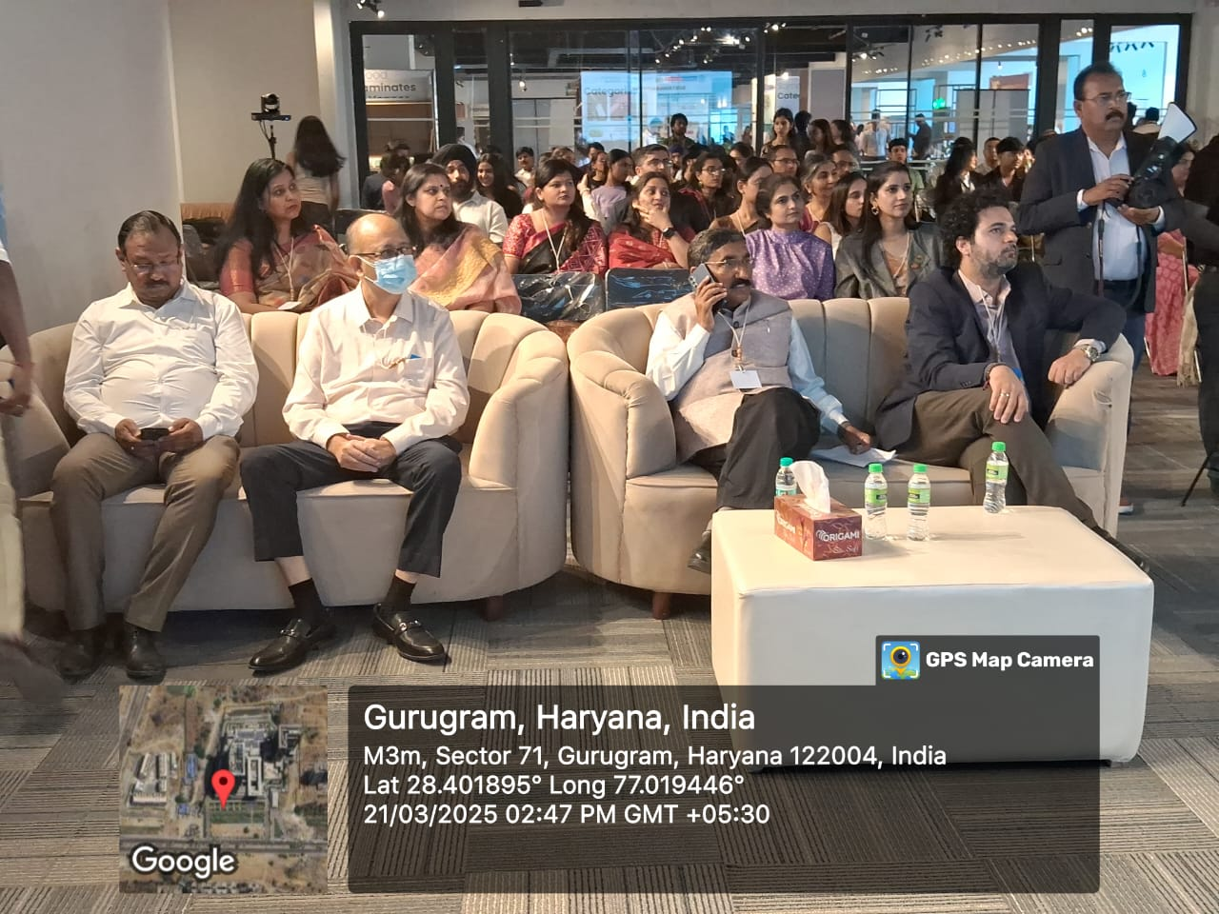
Figure 16: Eminent Guests of DESIGN 2030

Expert Talks
The expert talks provided an in-depth exploration of architecture and design through the insights of leading professionals:
Ar. Ankon Mitra: He is an architect, sculptor, and pioneer in folding techniques and spatial geometry. Ar. Ankon Mitra has built an international reputation through his innovative approach to blending origami and architecture, which he calls ‘Oritecture’. His work spans across India, Italy, France, the UK, the USA, Japan, the Netherlands, Brazil, and China, and has been showcased at the Shanghai Biennale, Arte Laguna in Venice, and the CODA Museum in the Netherlands. A recipient of the All-India Gold Medal for Sculpture (2018) and the Lexus Design Award (2020), his sculptures and installations are now part of public developments and private collections worldwide. He is also a TEDx speaker and a strong advocate for cross-disciplinary design thinking. He delivered a session on parametric design and origami in architecture, followed by his felicitation by Ar. Gajanad Ram.
Ar. Sanjay Soni: a seasoned architect and designer with over 35 years of experience. A graduate of SPA, New Delhi, he has dedicated his career to curating ‘Brand Architecture’—a fusion of architecture, exhibition, and meeting design across India and the globe. His journey began as a shy architecture student, but a pivotal moment during his internship in Russia changed everything. From then on, he pursued a path that combined innovation, storytelling, and experiential design, leading him to win multiple international awards. His work redefines architecture as installation, where spaces become immersive and interactive, challenging the way we perceive design. He shared perspectives on sustainable design.
Mr. Gopal Namjoshi: known for transforming industrial waste into monumental art installations, creating pieces that are both visually stunning and deeply thought-provoking. His work is not just about aesthetics; it serves as a powerful intervention in communities, sparking conversations about coexistence, sustainability, and shared spaces. He believes that art should provoke dialogue, invite curiosity, and engage the public in meaningful ways. Through his large-scale installations, he seeks to redefine placemaking, turning ordinary spaces into dynamic cultural experiences. His projects encourage us to reflect on the future of our cities and our role in shaping them. He gave an engaging talk on art and architecture.
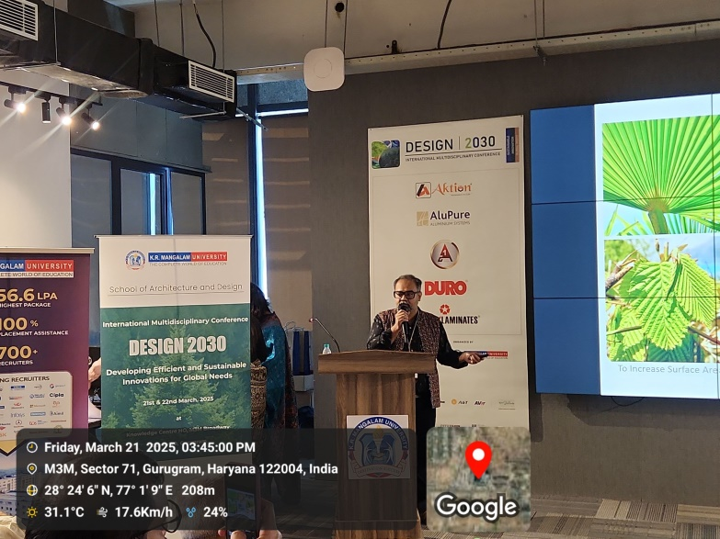
Figure 17: Expert Talk by Ar. Ankon Mitra
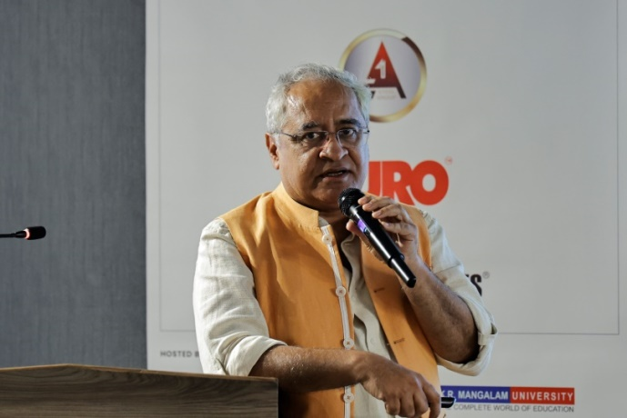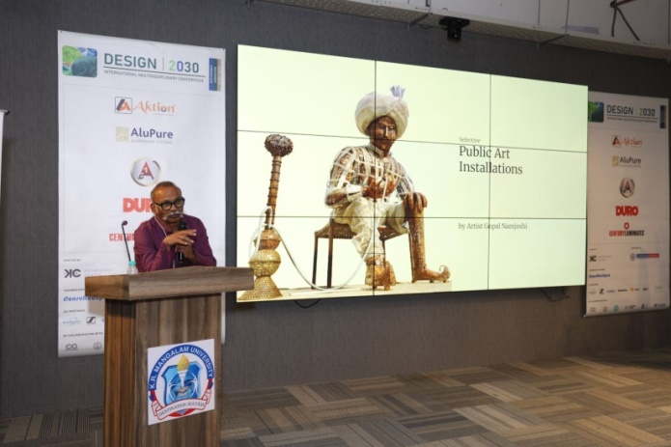
Figure 18 & 19: Expert Talk by Ar. Sanjay Soni and Artist Gopal Namjoshi
The discussions have took everyone on a journey across disciplines—from folding structures and architectural innovation to urban resilience and sustainability in art. These conversations challenged to think differently, build boldly, and design with intention.

Insta Talk Segment
DESIGN 2030 witnessed incredible architects and interior designers who are not just creating spaces but also creating trends online! Their posts, reels, and ideas are shaping the way we experience design. Some of the most influential voices in architecture and interior design participated to talk about their journey so far.
- Ankur Ahuja: founder of Marque Interiors Pvt. Ltd. A distinguished interior designer from New Delhi, he specializes in architecture, interior design, and construction management. With over a decade of experience, Ankur has worked on diverse projects across India and globally, blending innovation, functionality, and aesthetics to create impactful spaces.
- Suneet Zishan Langar: a writer, editor, and curator with a deep passion for design, architecture, and urbanism. As the Director of Editorial & Brand Strategy at Epistle Communications, he brings stories of architecture to life, bridging design and discourse in unique ways.
- Pallak Kakkar Khanna: An award-winning NIFT topper and Swiss Textile College, Zurich alumnus, she has mentored over 68,000+ design aspirants through her YouTube community. As a jury member for international design weeks and fashion shows, she continues to inspire and guide young designers, blending academic excellence with real-world insights.
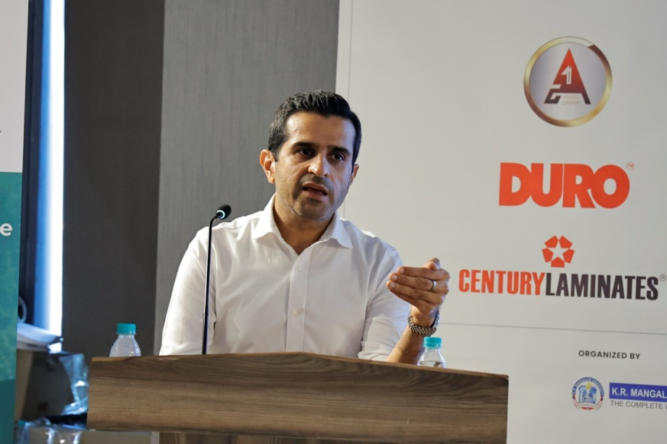
Figure 20: Insta Talk by Ar.Ankur Ahuja
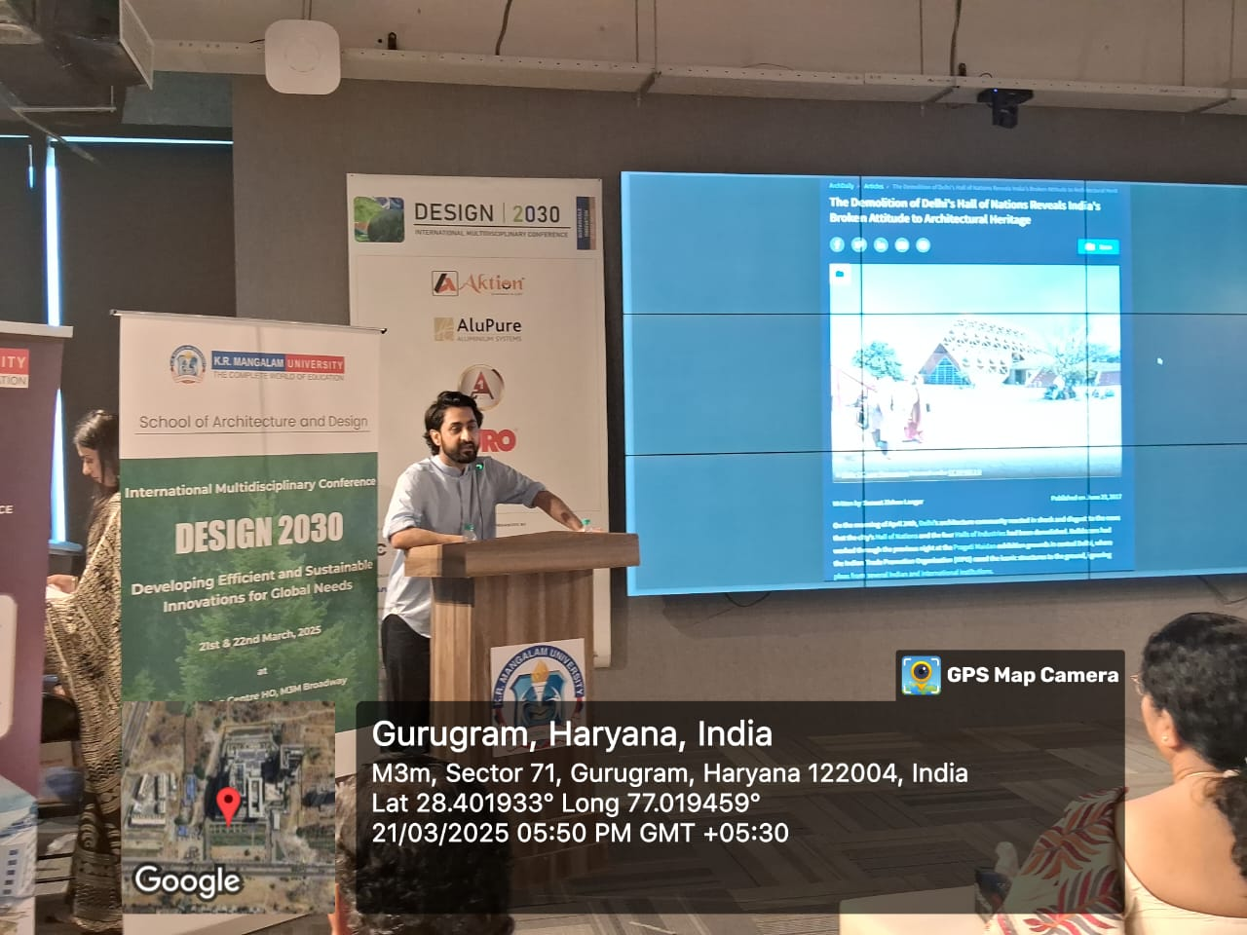
Figure 21: Insta Talk by Ar.Sunnet Zishan langar
All these renowned designers brought fresh ideas and inspiration to the participants. Their insights and experiences were truly enriching.

Sponsor Presentations & Exhibition Inauguration
A dedicated segment was reserved for sponsor presentations, where representatives from Aktion, A One Steel Group, AluPure, and Duro shared insights into their contributions to the industry. Each sponsor was individually welcomed and thanked for their support.
The exhibition (RASA) inauguration was also held, showcasing cutting-edge student projects.
RASA – Remembrance: Art, Space & Architecture Art has long been a vessel for emotions, bridging the tangible with the ephemeral, the physical with the abstract. RASA, a Sanskrit term that embodies aesthetic essence and emotional experience, forms the foundation of this exhibition. It explores how memory, space, and artistic expression converge to shape our perceptions and interactions. Showcasing the innovative works of students from Architecture, Interior Design, Fine Arts, Game Design, and Fashion, this exhibition fosters an interdisciplinary dialogue on design and culture. Through art, space manipulation, and architectural narratives, students reinterpret remembrance—invoking the past while envisioning new creative possibilities. RASA challenges conventional narratives, highlighting materiality, storytelling, and the transformative power of design. It serves as a dynamic platform for critical engagement, inviting visitors to reflect on the intersections of art, space, and cultural expression.
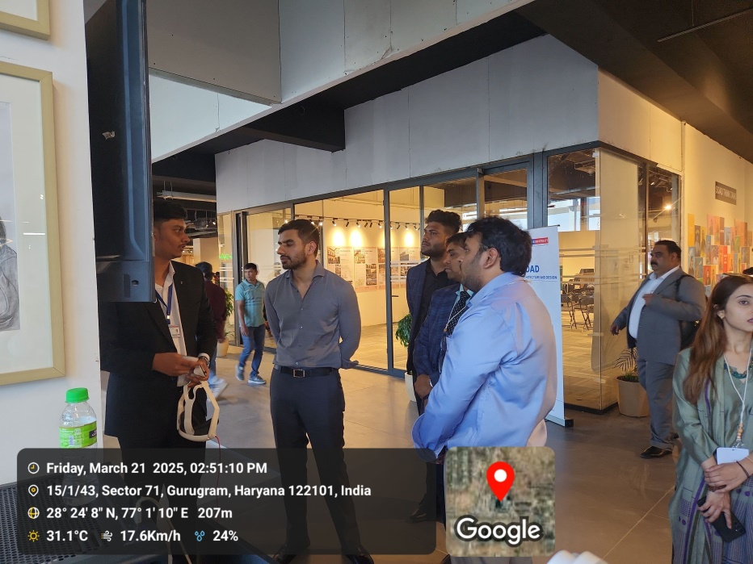
Figure 22: Student explaining Game design project in exhibition

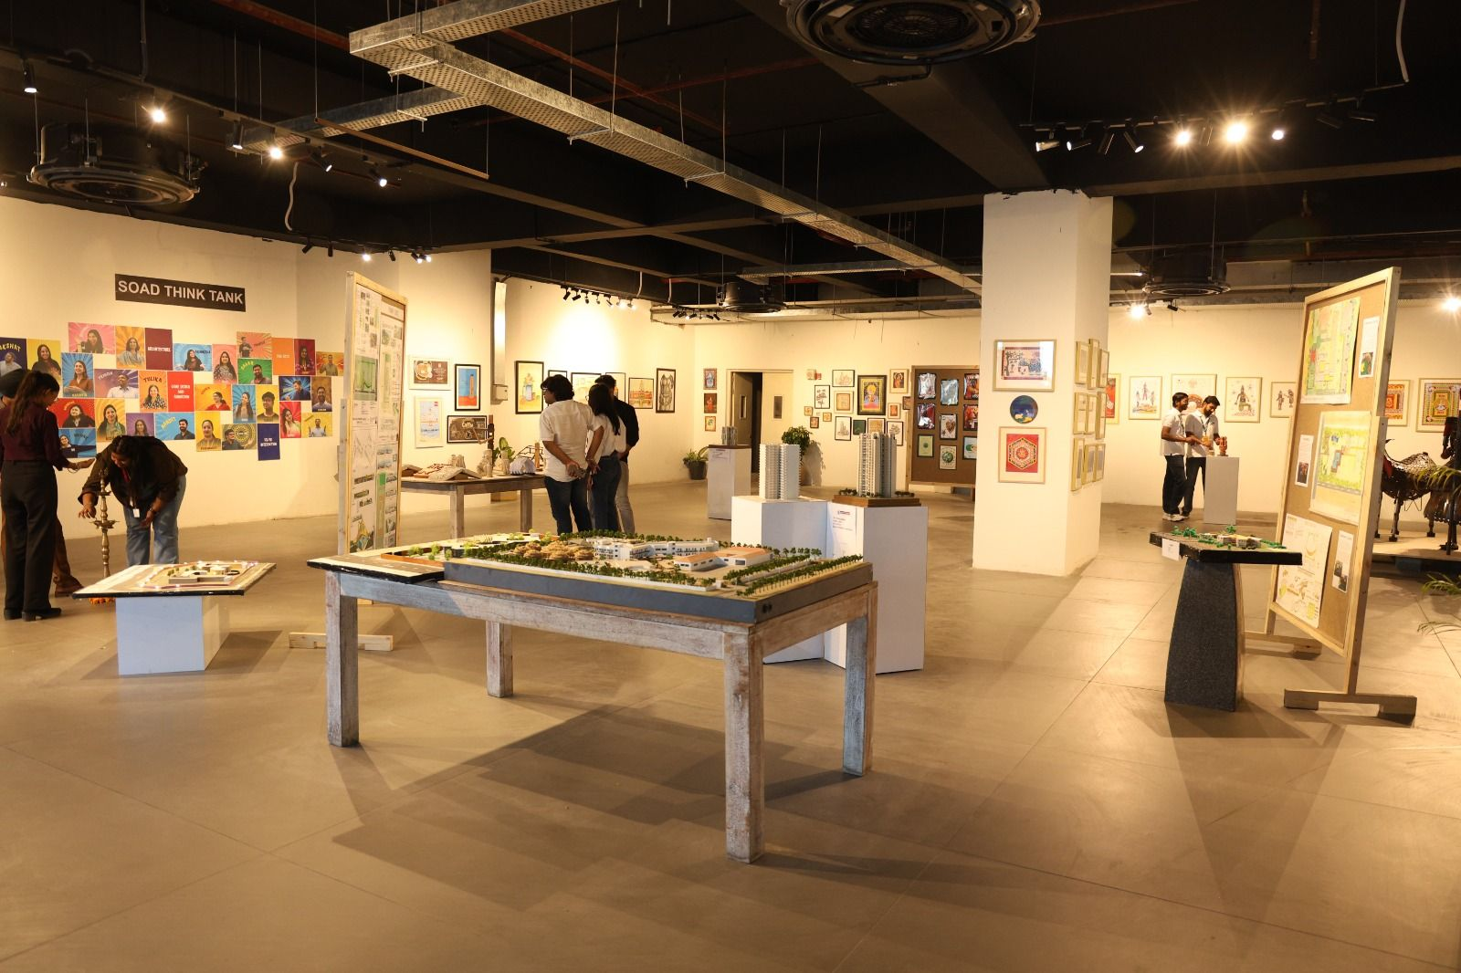
Figure 23: RASA exhibition view

Cultural Event (5:30 PM Onwards)
The cultural evening was a vibrant celebration of artistic expression and diversity. It began with a captivating folk dance performance, setting the stage for an immersive cultural experience. The energy continued with a fashion show featuring Punja Durries, showcasing traditional craftsmanship in a modern light. A mesmerizing contemporary dance performance then held the audience spellbound, blending movement and storytelling with grace. Adding to the evening's vibrancy, another fashion show themed Indie Fusion brought together eclectic styles, creating a perfect fusion of tradition and innovation.The event ended with a closing note, after which attendees dispersed for a gala dinner.
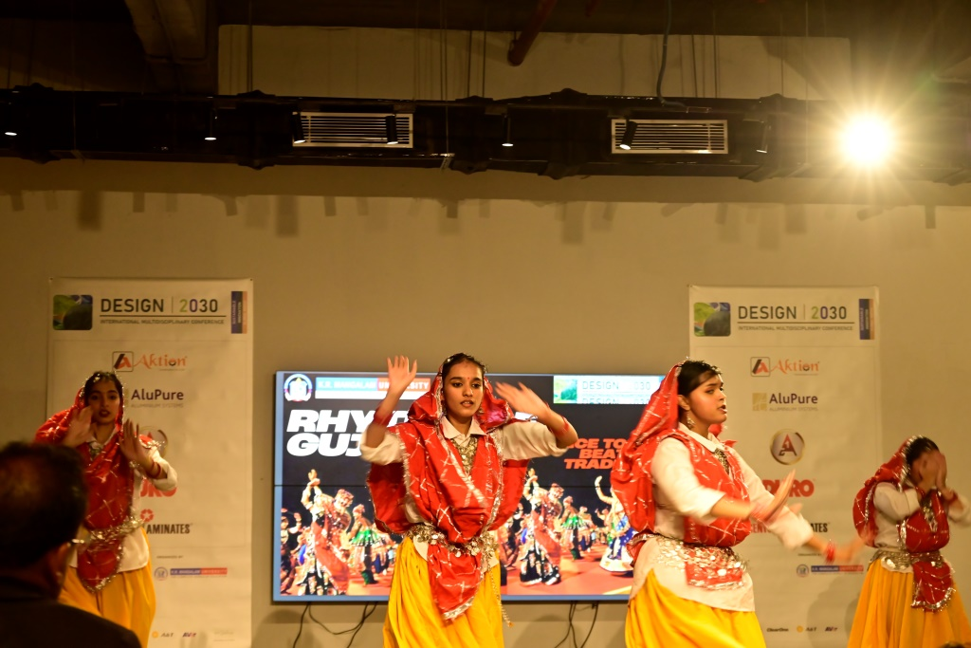
Figure 24: Cultural Dance Performance

Figure 25: Fashion show at DESIGN 2030

Conclusion : Day 1 of the Design 2030 Conference was a resounding success, bringing together experts, students, and professionals in a dynamic exchange of ideas. The sessions set the stage for continued discussions and innovations in design and sustainability, promising an equally engaging second day of the conference.
DAY 2: 22nd March 2025
The second day of the DESIGN2030 conference commenced with the registration process starting at 10:00 AM, where participants, speakers, and attendees gathered to engage in discussions about sustainability, architecture, and design. The day was divided into multiple sessions across two venues, featuring insightful paper presentations, knowledge-sharing discussions, and thought-provoking interactions among experts in the field.
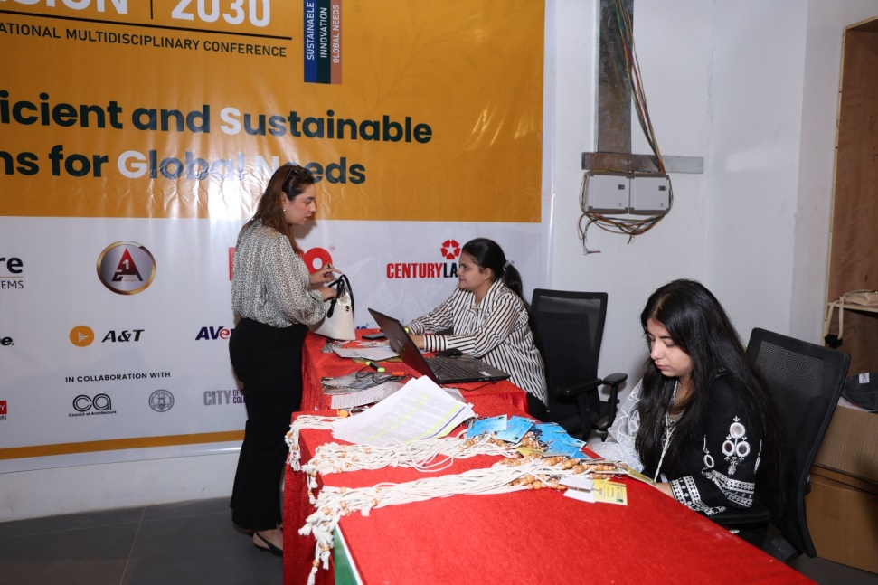
Figure 26: Registration Desk

Paper Presentations (10:15 AM - 11:30 AM)

Venue 1 - Tracks: Climate Resilience and Disaster Management & Contemporary Art & Design Practice
The sessions at Venue 1 were chaired by Dr. Hina Zia and Ms. Anjali Goel. Dr. Hina Zia is a distinguished academic and professional in urban planning and sustainable development. She is currently the Professor and Head of the Department of Planning at Jamia Millia Islamia, with extensive experience in green building projects, climate resilience strategies, and sustainable urban development. Her expertise was crucial in guiding discussions on climate resilience and disaster management during this session. Alongside her, Ms. Anjali Goel, a practicing artist known for her work in art therapy and contemporary design, co-chaired the sessions. Her deep understanding of contemporary artistic expressions added a unique perspective to discussions on art and design practices.
The session featured the following papers:
- Mohd Arqam Khan presented Hospital Disaster Management: Tackling Internal Disasters Through Resilient Architecture, discussing the role of resilient design in medical facilities.
- Sachin Datt introduced A New Approach for Defining Learning Outcomes in Design Programs, addressing the limitations of Bloom’s Taxonomy in design education.
- Praguni Mathur showcased her research on Contemporary Art Pieces: Preserving Natural and Non-Sustainable Articles with the Medium of Art Resin.
- Indrajeet Kumar presented The Revival and Innovation of Punja Durries: A Contemporary Art and Design Perspective.
- Annu Yadav discussed A Study on Inclusive Size Clothing: A Way to Understand Plus Size Fashion.
- Hemani Singh delivered insights on Ecological Urbanism.
- Dr. Koustav Nag concluded the session with a presentation on The Influence of Socialist Thought on Contemporary Indian Artists.
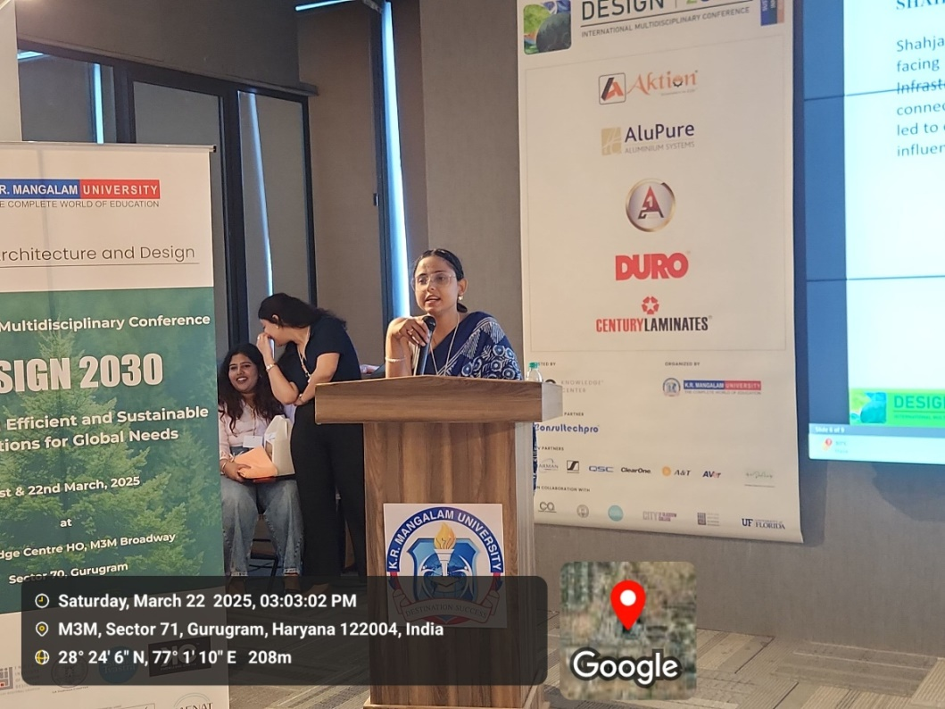
Figure 27: Presentations by authors at Venue 1
Venue 2 - Tracks: Renewable Energy & Environmental Technologies and Education & Capacity Building for Sustainability
The sessions at Venue 2 were chaired by Dr. Ila Gupta and Dr. Kushal Matai. Dr. Ila Gupta, Director of the Amity School of Architecture and Planning at Amity University Haryana, brought her vast experience in urban planning and earthquake disaster management to the discussion. She has contributed significantly to research on sustainable infrastructure and was recognized as one of the ‘10 Must Watch Influential Women Leaders in Indian Education.’ Co-chairing the session was Dr. Kushal Matai, an expert in sustainability and education development, who emphasized the role of research and innovation in advancing sustainability education.
The session included the following papers:
- Kiran G Singh presented Energy Neutral Approach Towards Residential Sector in India, offering solutions for sustainable housing.
- Avitesh Vaishnavi Nayak explored the Life Cycle Assessment of Solar Panels: Environmental Impacts from Production to Disposal.
- Nisha Sharma discussed Energy Efficient Passive Strategies for Residential Buildings in Composite Climate: Insights from Literature.
- Deepika Shukla examined Beyond Energy Efficiency: A Comprehensive Approach to Sustainable Cities.
- Yashika Manglani analyzed A Comparative Analysis of Generational Shifts in Mental Health Stigma: From Silent Suffering to Social Acceptance?.
- Mohd. Anees presented Integrating Rural Education and School Infrastructure for Holistic Village Development.
- Kesar Khurana conducted an Assessment of Lux Levels in Various Spaces of Campus Buildings: A Case Study of K.R. Mangalam University.
- Aayushi Srivastava measured Ethical Orientation in Architects: Idealism versus Relativism.
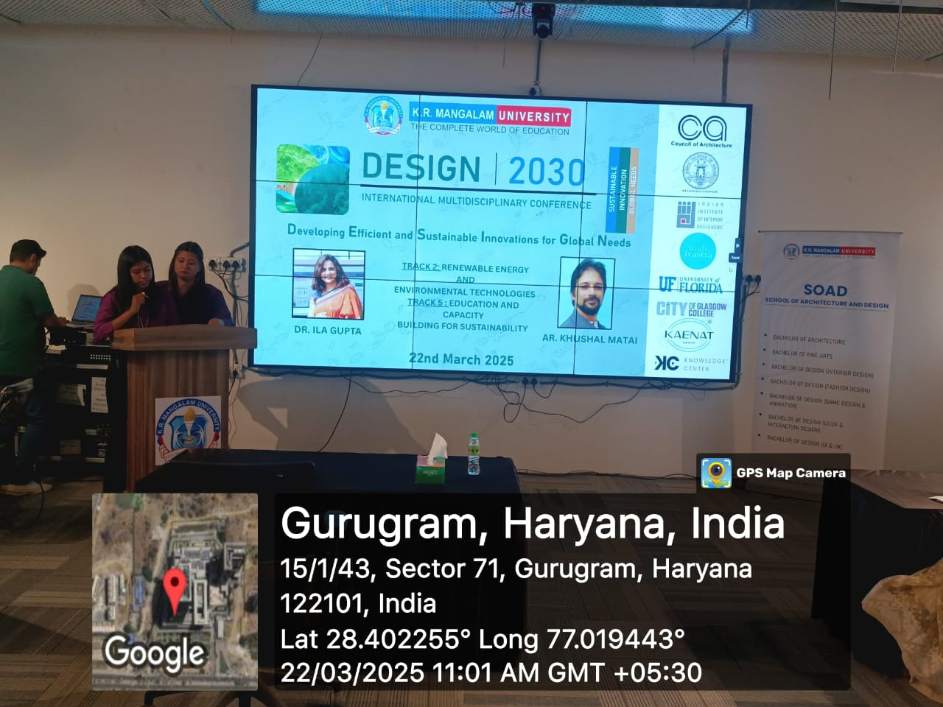
Figure 28: Research Session at Venue 2
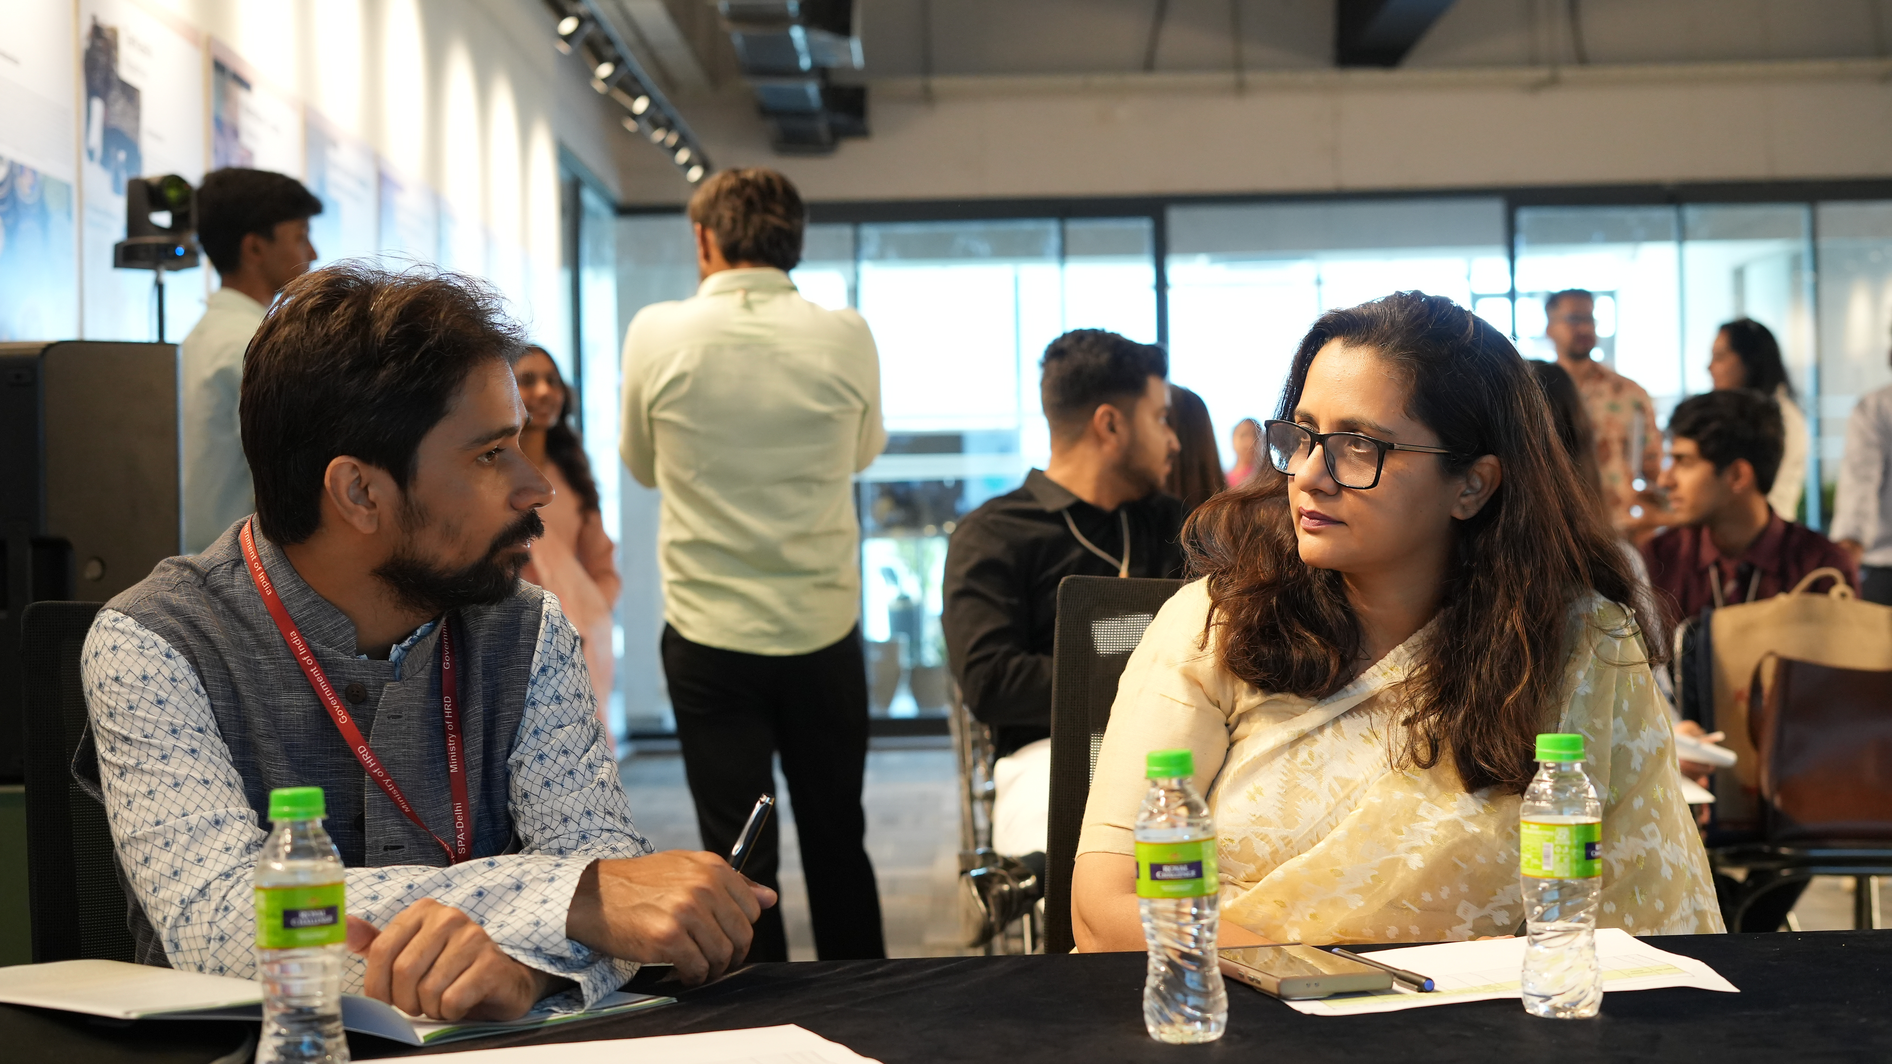
Figure 29: Session Chairs at Venue 2: Dr. Ila Gupta, Director at Amity University Gurugram and Dr. Kushal matai, Associate Professor at SPA New Delhi

Knowledge Sessions (11:30 AM - 12:30 PM)
The highlight of the morning was the panel discussion on Architectural Toolkit for 2050: Designing Sustainable and Service-Intensive Built Environments, featuring distinguished architects and industry leaders. The panel included an introduction video from Ar. Sanjay Prakash, a sustainability expert and Principal Consultant at SHiFt: Studio for Habitat Futures, Ar. Tanmay Tathagat, Director of Environmental Design Solutions and a key advocate for energy-efficient urban development, and Ar. Gajanand Ram is the Vice President of the Council of Architecture (CoA) and has also served as the Chief Town Planner of Jharkhand.. Also contributing were Ar. Vivek Gupta, Principal Architect at Arvind Vivek & Associates, specializing in eco-friendly designs, Ar. Vijay Garg, Chairman of SEAC Delhi and former Acting President of the Council of Architecture, bringing expertise in policy and governance, and Prof. Dr. Tanaya Verma, Dean of the School of Architecture & Design at K.R. Mangalam University, with extensive research in urban resilience. The discussion delved into the future of sustainable architecture, exploring innovations in design, smart infrastructure, policy frameworks, and strategies to create resilient and service-intensive urban environments.
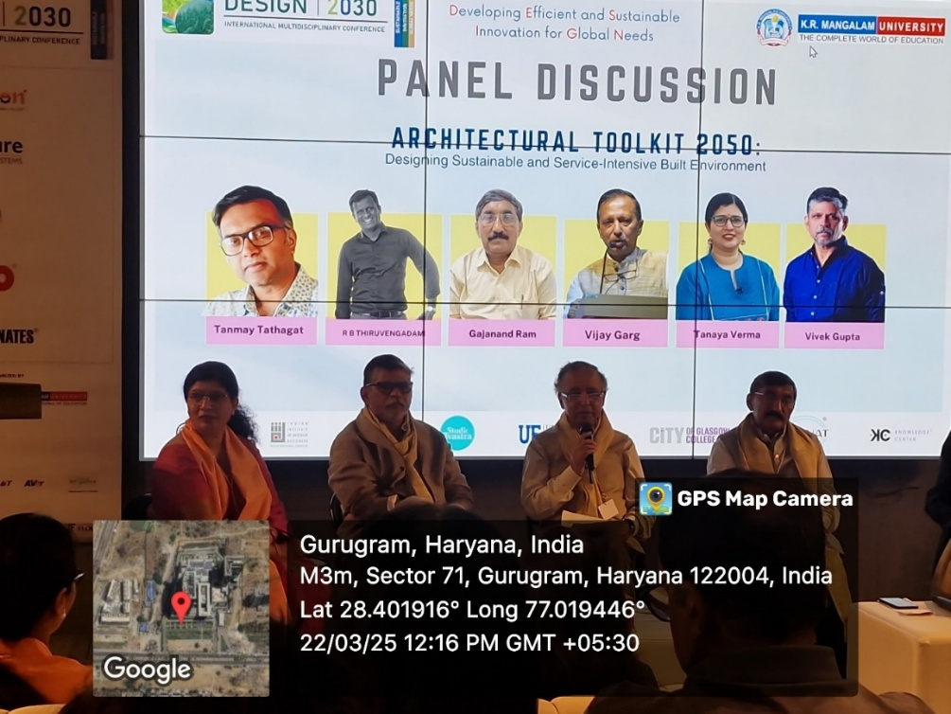
Figure 30: Panellists delivering the session
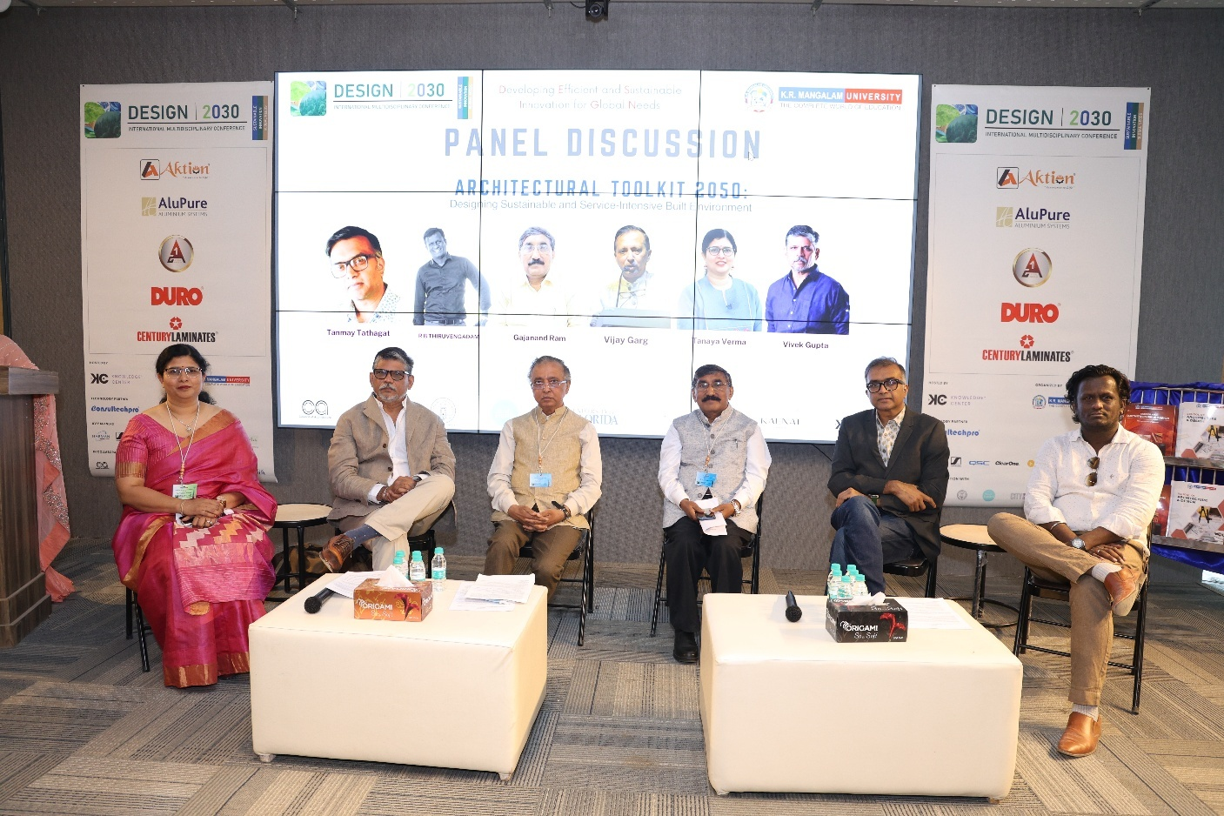

Figure 31: Panellists delivering the session

IIA Haryana Chapter Handbook Launch (12:30 PM - 01:00 PM)
Following the panel discussion, the IIA Haryana Chapter Handbook was officially launched. The session was inaugurated by IIA Chairman Ar. Vivek Logani, alongside members of the Indian Institute of Architects (IIA). This handbook serves as a comprehensive guide for architects and urban planners in the region, detailing best practices and emerging trends in sustainable design.
The launch event was graced by eminent architects, urban planners, policymakers, and students, all eager to explore the wealth of knowledge encapsulated in the handbook. Ar. Vivek Logani, in his inaugural address, emphasized the role of architects in shaping Haryana’s urban landscape and how the handbook serves as a roadmap for future-ready, sustainable developments.
The event concluded with a collective acknowledgment of the efforts made by the IIA Haryana Chapter in compiling this invaluable resource. Attendees expressed their appreciation for the handbook’s potential to elevate architectural standards and foster innovation in the industry.
The launch of this handbook not only signifies a new era of architectural excellence in Haryana but also reinforces IIA’s commitment to knowledge-sharing and professional growth in the field of architecture.
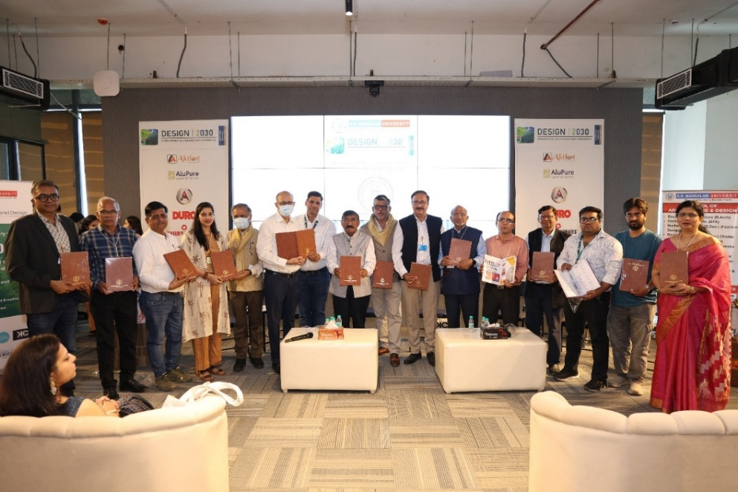
Figure 32: Ar. Vivek Logani, and members of IIA with handbook

Insta Talk by Design Influencers (01:45 PM – 02:15 PM)
The afternoon sessions began with an Insta Talk featuring prominent design influencers. First we had Sagar Saoji, Anjari Ganguli followed by Sonika Khurana and Siddharth Bhayani. Each one of these incredible speakers brings something unique to the table. They shared insights on the evolving role of digital media in architecture and design, highlighting how social media is shaping contemporary design narratives.
Our first speaker was Sagar Saoji. Architect and content creator known for making architectural education engaging and accessible. He is the founder of f.y.i.arch, a platform dedicated to simplifying architectural concepts through various media, including podcasts, courses, and newsletters and a massive following of 183K followers.
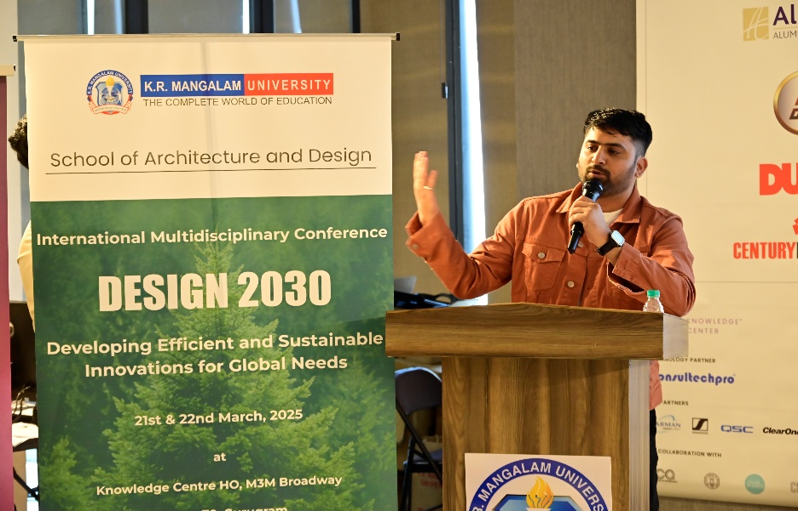
Figure 33: Design Influence Sagar Saoji addressing the audience
Next, we had Anjari Ganguli. A New Delhi-based architect, interior designer, and content creator known for her engaging DIY projects and home décor transformations. She shares her creative journey on Instagram (@thatyellowtrunk), where she has amassed a following of more than 2 lakhs.
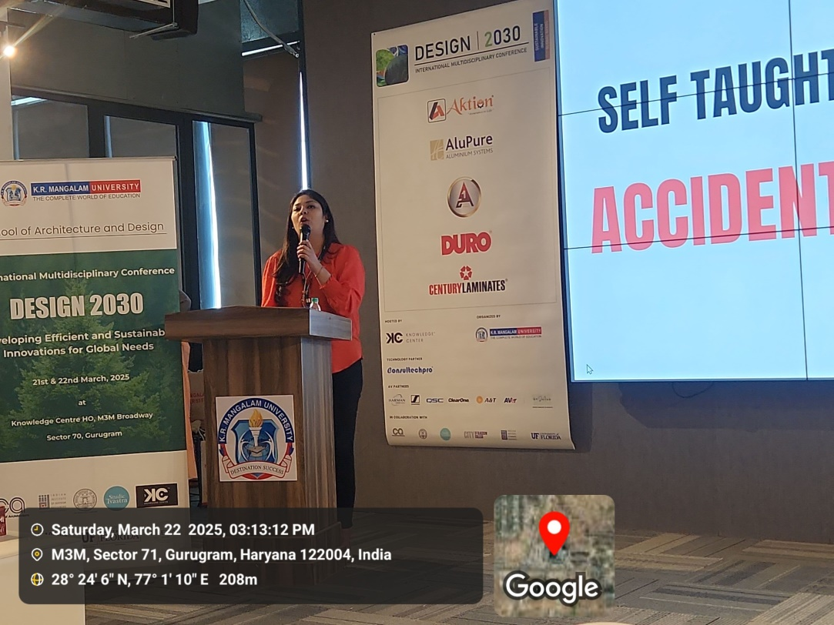
Figure 34: Sonika Khurana addressing the audience

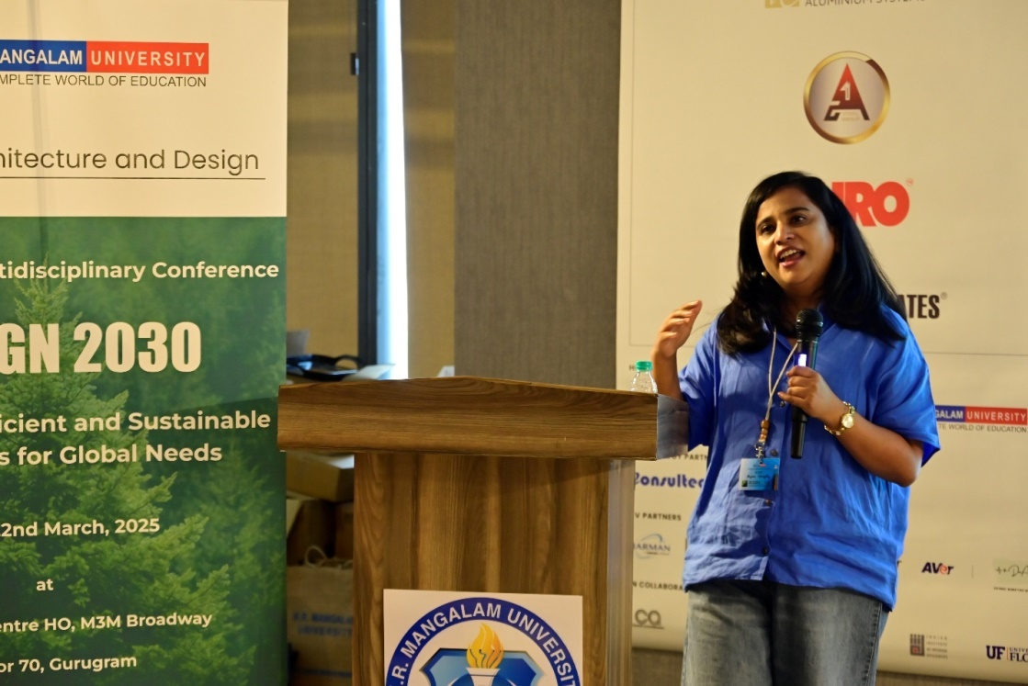
Figure 35: Design Influence Anjari Ganguli addressing the audience
Then we welcomed Sonika Khurana. A seasoned interior designer, educator, and content creator with over 13 years of experience. She is the founder of Coloraza Design, an interior design firm, and Coloraza Design School, where she mentors aspiring designers. Let’s welcome her on stage!
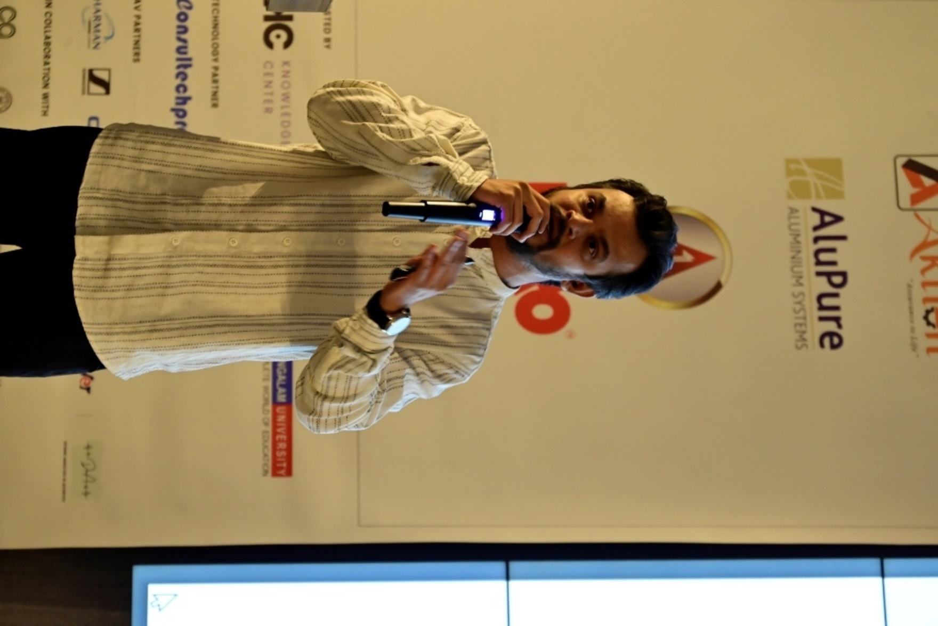
Figure 36: Siddharth Bhayani addressing the audience
Finally Mr. Siddharth Bhayani. Architect, entrepreneur, and founder of The Architects Diary, a platform that showcases architectural designs and promotes ideas related to architecture and interior design. He is also involved with Elev8 India, Archioo India, and the lIDA Summit.

Sponsor Presentation – Kaenat Glass and Other Key Sponsors (02:15 PM - 02:45 PM)
Key sponsors, including Kaenat Glass, took the stage to present innovative products and solutions that support sustainable architecture. The names of the sponsors who presented include A One Steel Group, Aktion, Alupure and Duro. Their presentation focused on advancements in glass technology and its applications in energy-efficient buildings.
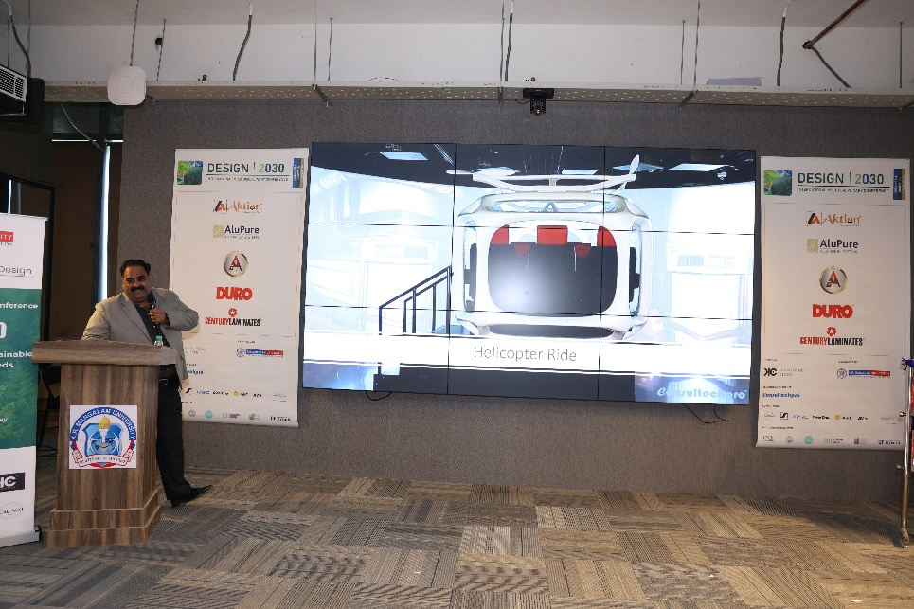
Figure 37: Sponsors showcasing their work
- VALEDICTORY CEREMONY (02:45 PM - 04:00 PM)
The Valedictory Ceremony marked the grand conclusion of the conference, serving as a moment of reflection, recognition, and gratitude. This final session was dedicated to acknowledging the invaluable contributions of speakers, session chairs, panelists, and participants, all of whom played a crucial role in making the event a resounding success.
Awards and Recognitions
A key highlight of the Valedictory Ceremony was the distribution of awards and certificates, celebrating academic excellence and active engagement:
Best Paper Awards: Recognizing outstanding research contributions, the Best Paper Award was presented for each track, honoring authors whose work demonstrated originality, innovation, and a significant impact on the field of architecture and sustainable design.
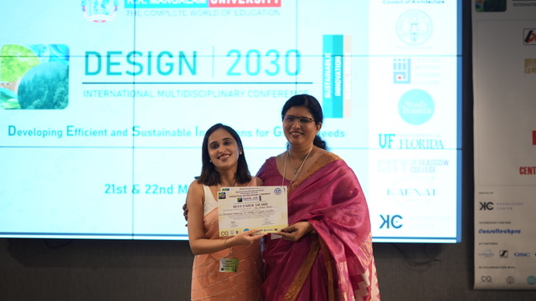
Figure 37: Dr. Tanaya Verma presenting Best Paper Award to the author
Dean’s Honour List: Students who achieved a CGPA of 8.5 and above were felicitated, acknowledging their dedication to academic excellence and commitment to professional growth.

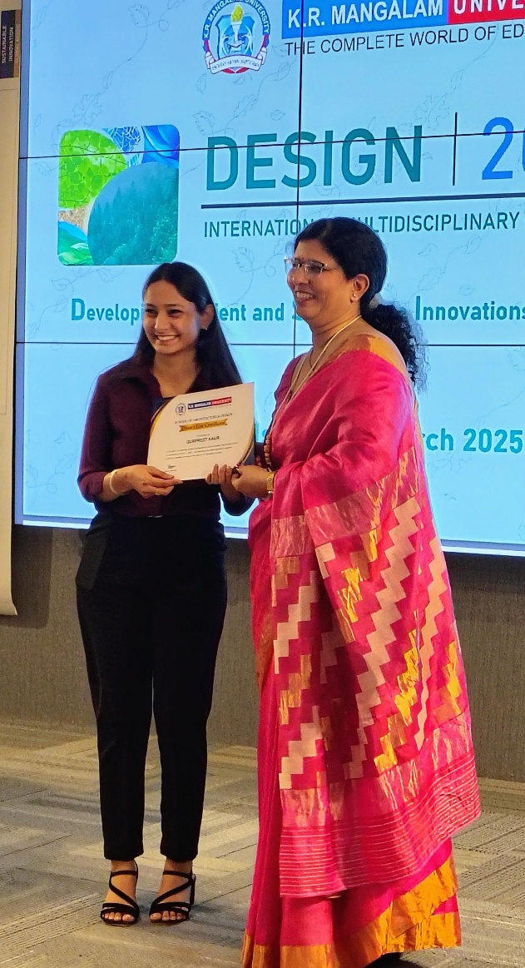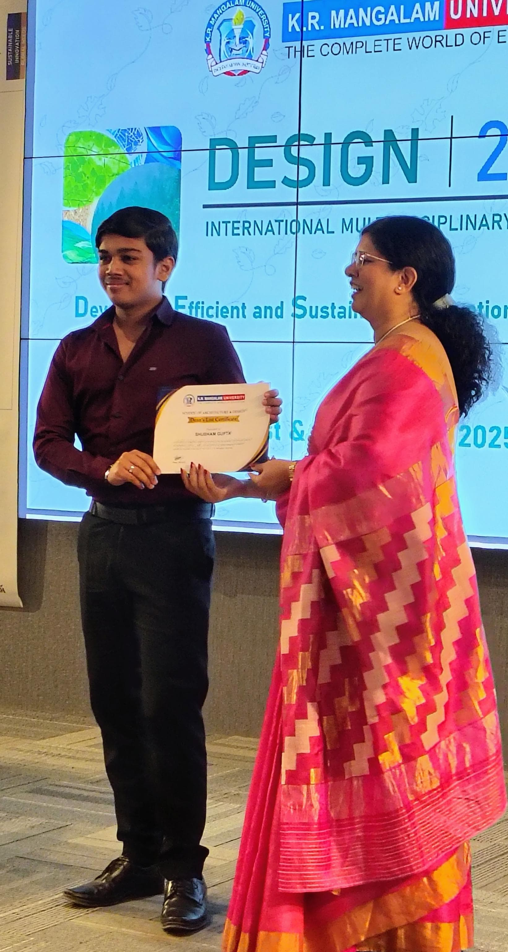
Figure 38: Dr. Tanaya Verma rewarding students from Dean’s Honour List
Certificates: All attendees, including researchers, academicians, students, and industry professionals, received certificates of participation, commemorating their role in making the conference an intellectually enriching experience.
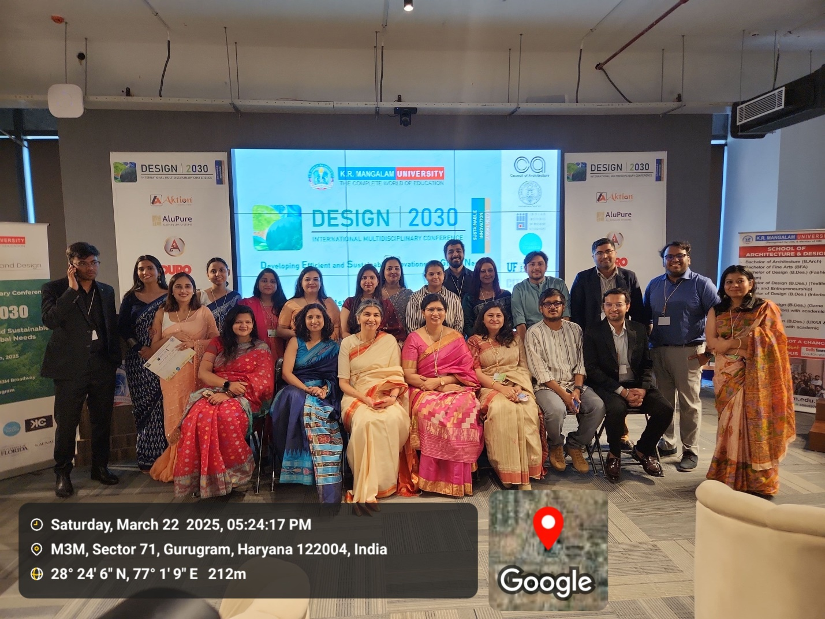
Figure 39: Group Photograph at valedictory

- FEEDBACK FROM THE PARTICIPANTS
The feedback from attendees of the Design Conference indicates an overall positive response.
- Display Area Satisfaction: A majority of respondents rated the display area as either Good or Excellent, with very few indicating the need for improvement.
- Conference Management: While most attendees were satisfied with the conference management, a small portion suggested improvements.
- Paper Presentations: The presentations were generally well-received, with Good and Excellent ratings dominating the feedback.
- Panel Discussion: The panel discussion was widely appreciated, with the majority of responses marking it as Excellent.
- Session and Discussion Quality: Attendees found the sessions engaging and of high quality, with very few critical responses.
- Event Organization and Coordination: The organization was well-executed, receiving predominantly Excellent and Good ratings.
Overall, the conference was a success, with only minor areas where improvement could be made.
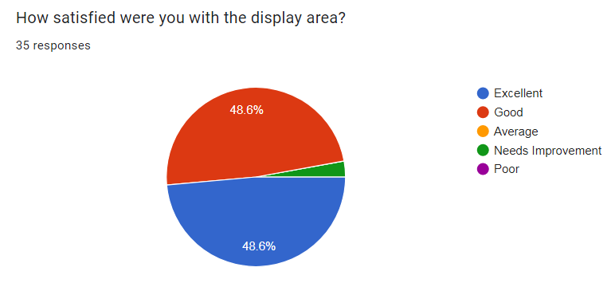
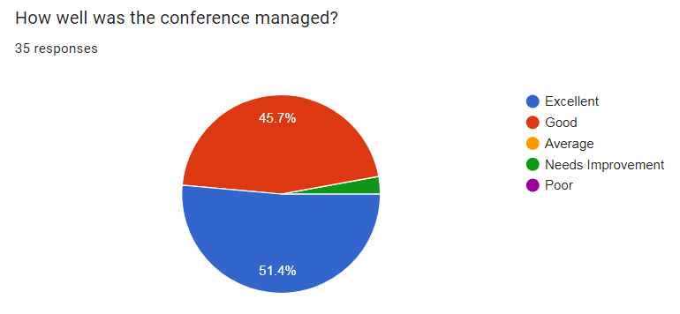
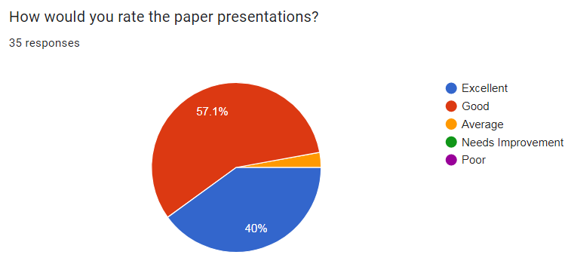
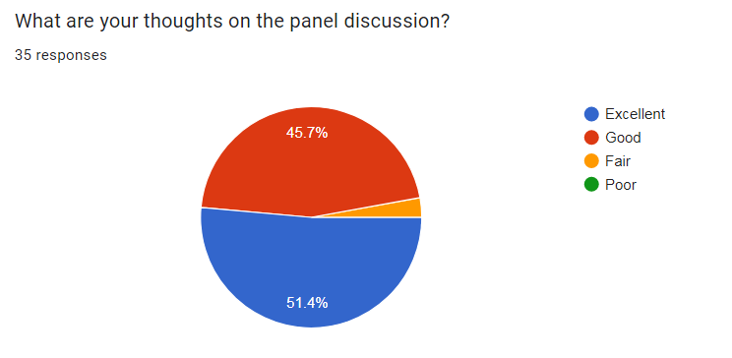
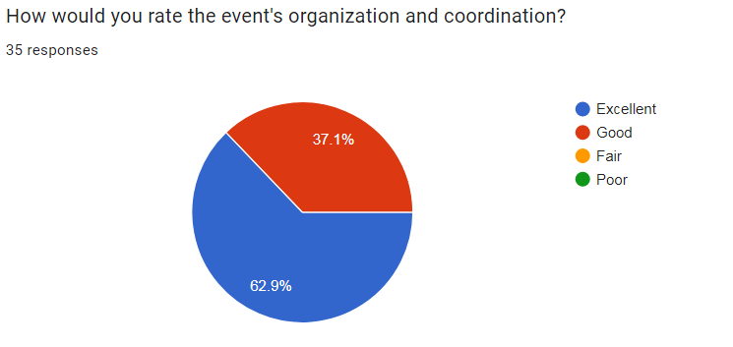

- MEDIA COVERAGE
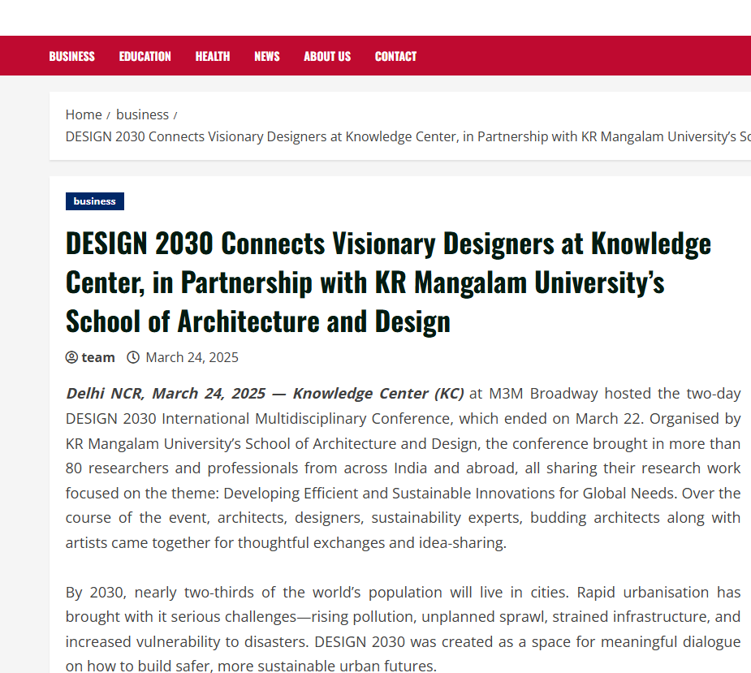
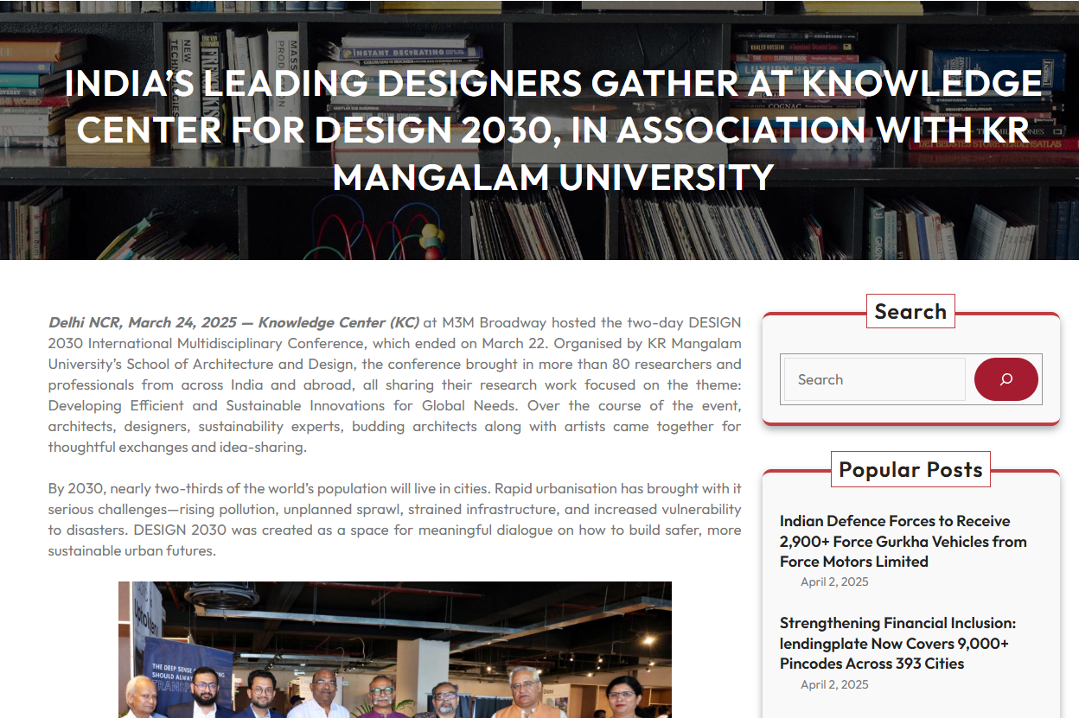
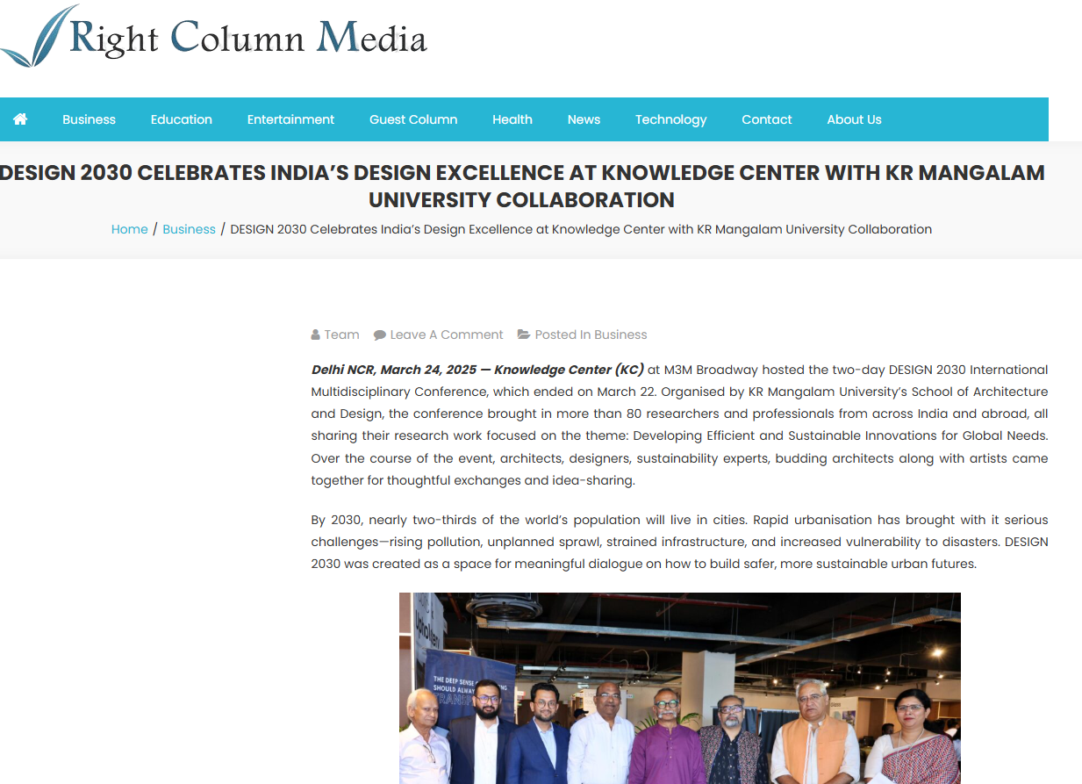
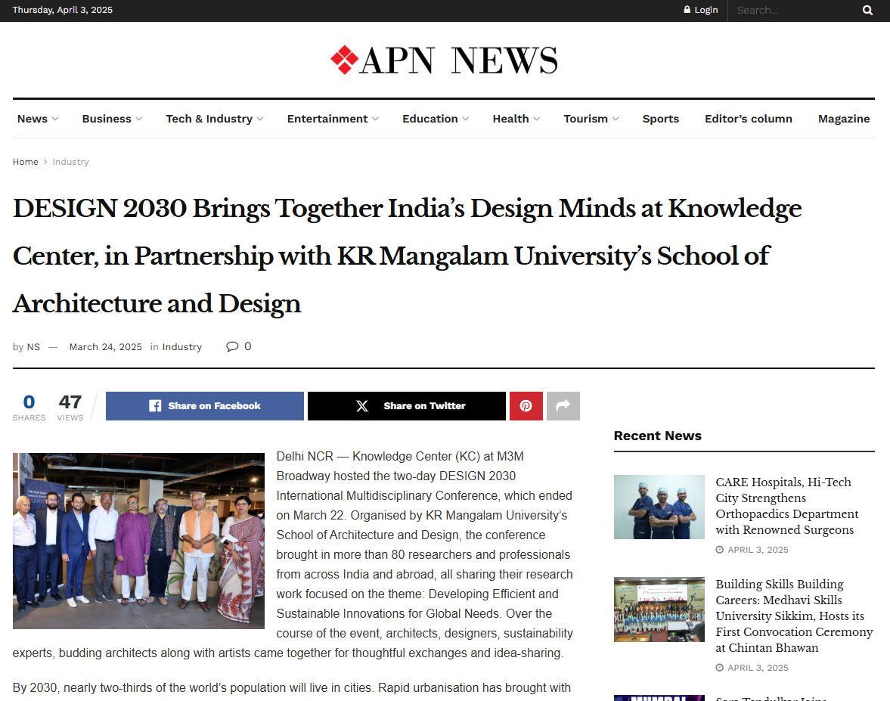

ANNEXURE – III
LIST OF INVITED SPEAKERS & SESSION CHAIRS

Sr. No. | Invited Speakers & Session Chairs Name | Designation | Affiliation | Contact Details (email, phone) | Session Day and Time | Topic
1 | Gajanand Ram | Vice President | Council of Architecture | gajanandram@gmail.com | DAY1 2:00 PM ONWARDS | Key Note Address and Panel Discussion
2 | Vivek Logani | Chairman | IIA Haryana chapter | vlogani@yahoo.com | DAY1 2:00 PM ONWARDS | Key Note Address and IIA Haryana Handbook Launch
3 | Surender s Chaudhary | Vice Chairman | IIA Haryana chapter | suren_archcon@yahoo.co.in | DAY1 2:00 PM ONWARDS | IIA Haryana Handbook Launch
4 | Rishu Anand | Chairperson | IIID Delhi Regional Chapter | rishu@twentynorth.in | DAY1 2:00 PM ONWARDS | Keynote Address
8 | ANKON MITRA | Director (Landscape + Art Projects) | HEXAGRAMM INFRASTRUCTURE PRIVATE LIMITED | ankon.mitra@hexagramm.in | DAY1 2:00 PM ONWARDS | Expert talk
9 | SANJAY SONI | Chief Knowledge Director | Incredible Design | sanjay@sanjaysoni.in | DAY1 2:00 PM ONWARDS | Expert talk
10 | GOPAL NAM JOSHI | Artist | Gopal Namjoshi Studio | studiogopal@gmail.com ; namjoshigopal@gmail.com | DAY1 2:00 PM ONWARDS | Expert talk
11 | TANMAY TATHAGAT | Director | Environmental Design Solutions | tanmay@edsglobal.com | DAY 2 11:30 AM ONWARDS | Panel Discussion on Architectural Toolkit 2050
12 | SANJAY PRAKASH | Principal Consultant | SHiFt: Studio for Habitat Futures | sp@sanjayprakash.co.in | DAY 2 11:30 AM ONWARDS | Panel Discussion on Architectural Toolkit 2050
13 | VIVEK GUPTA | Principal Architect | Arvind Vivek And Associates | vivek@architectsava.com | DAY 2 11:30 AM ONWARDS | Panel Discussion on Architectural Toolkit 2050
14 | DR. TANAYA VERMA | Dean | School of Architecture and Design, Kr Mangalam University | dean.soad@krmangalam.edu.in | DAY 2 11:30 AM ONWARDS | Panel Discussion on Architectural Toolkit 2050
15 | VIJAY GARG | Chairman | SEAC Delhi  Deptt of Environment, Govt of NCT Delhi (2021-24)  Former Acting President CoA ( 2018-19) And Vice President COA (2016-2019) | gargvijay31@gmail.com | DAY 2 11:30 AM ONWARDS | Panel Discussion on Architectural Toolkit 2050
16 | Ila Gupta | Director | Architecture & Planning Amity University | igupta@ggn.amity.edu | DAY1 10:00 AM ONWARDS and DAY 2 10:15 AM ONWARDS | Session Chair
17 | Anjali Goel | Founder | Studio Tvastra | Anjali.studiotvastra@gmail.com | DAY 2 10:15 AM ONWARDS | Session Chair
18 | Dr. Vandana Baweja | Associate Professor | School of Architecture; University of Florida Gainesville | vbaweja@ufl.edu | DAY1 10:00 AM ONWARDS | Session Chair
19 | Nancy Clark | Assistant Director Graduate Programs and Associate Professor | School of Architecture; University of Florida Gainesville | nmclark@ufl.edu | DAY1 10:00 AM ONWARDS | Session Chair
20 | Hina Zia | Head | Department of Planning,  Jamia Millia Islamia (Central University) | hzia@jmi.ac.in | DAY 2 10:15 AM ONWARDS | Session Chair
21 | Khushal Matai | Assistant Professor | School of Planning and Architecture, New Delhi | arkhushal@live.com | DAY 2 10:15 AM ONWARDS | Session Chair
22 | Hemani Singh | Professor | KR Mangalam University | hemanisingh8@gmail.com | DAY1 10:00 | Session Chair
ANNEXURE – V
CERTIFICATES
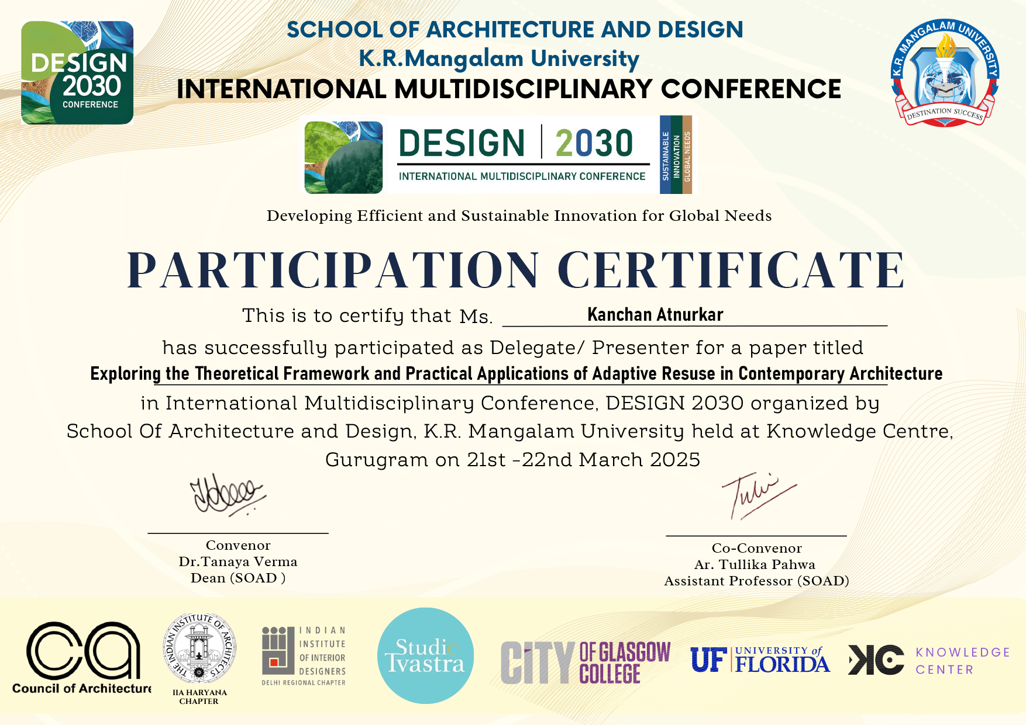
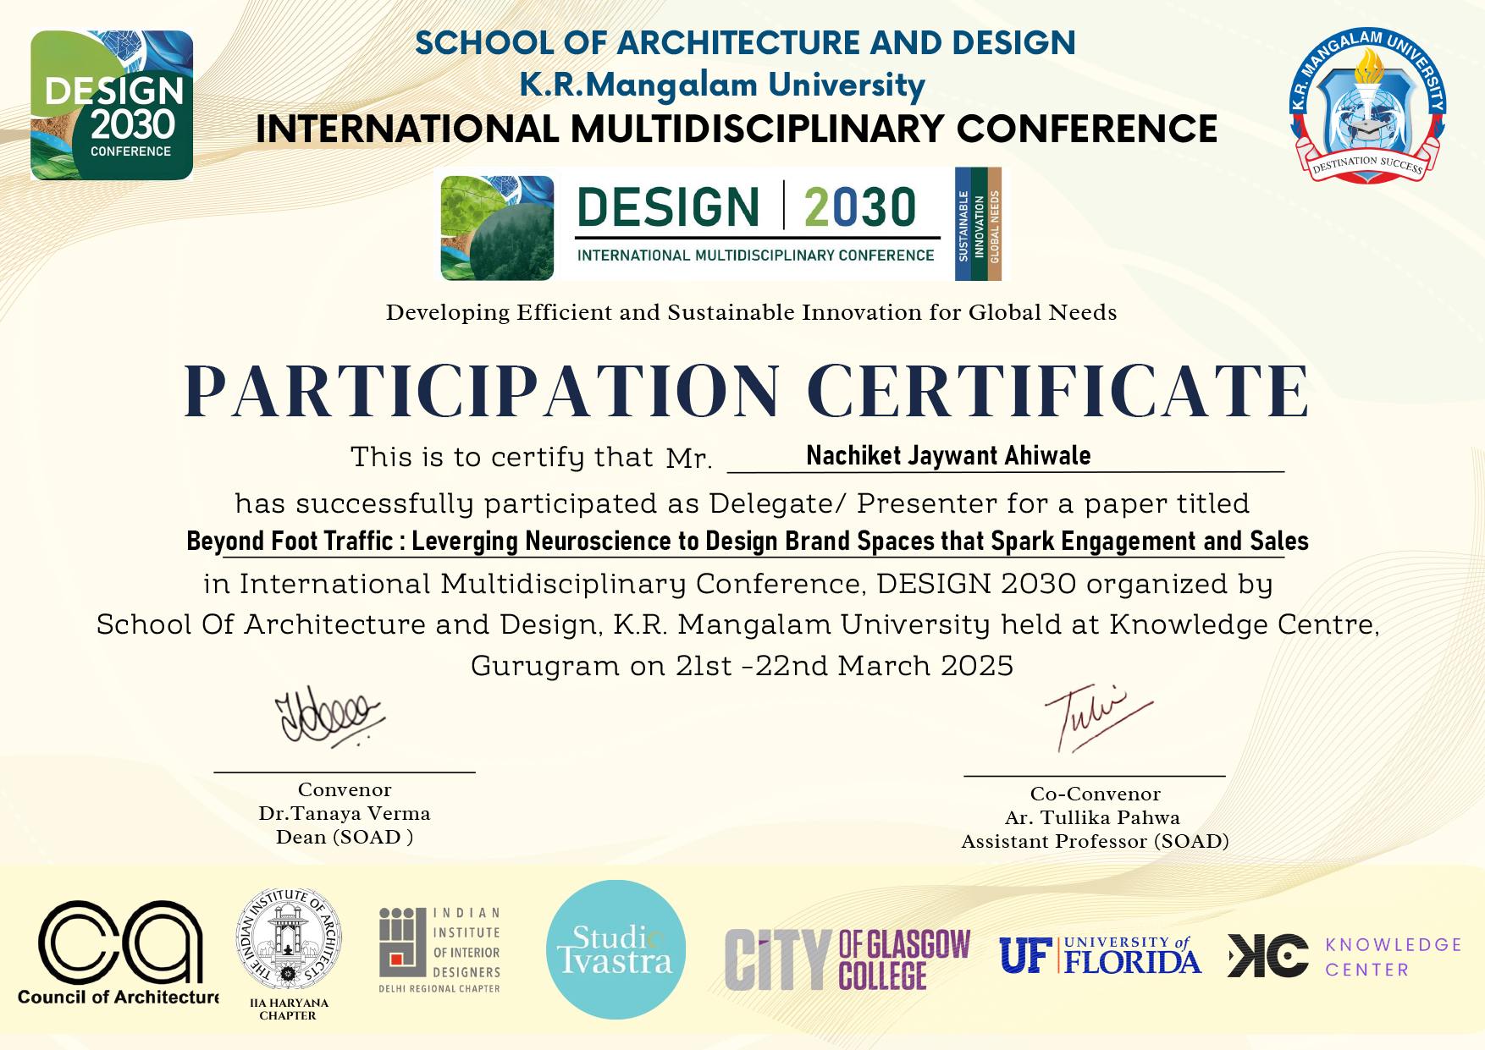
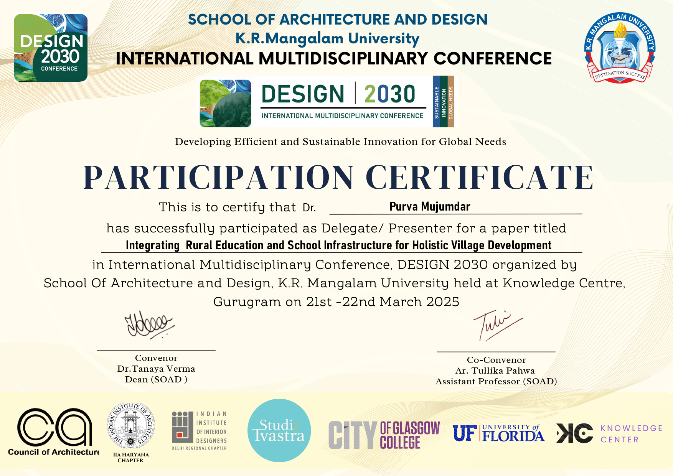
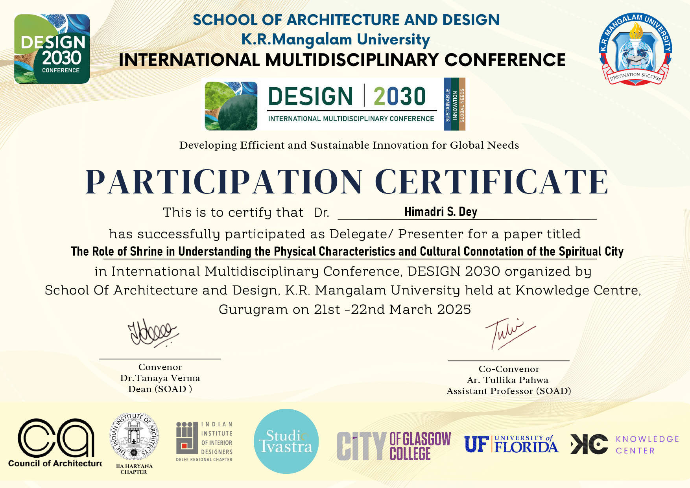

ANNEXURE – VI
GEO-TAGGED PHOTOGRAPHS
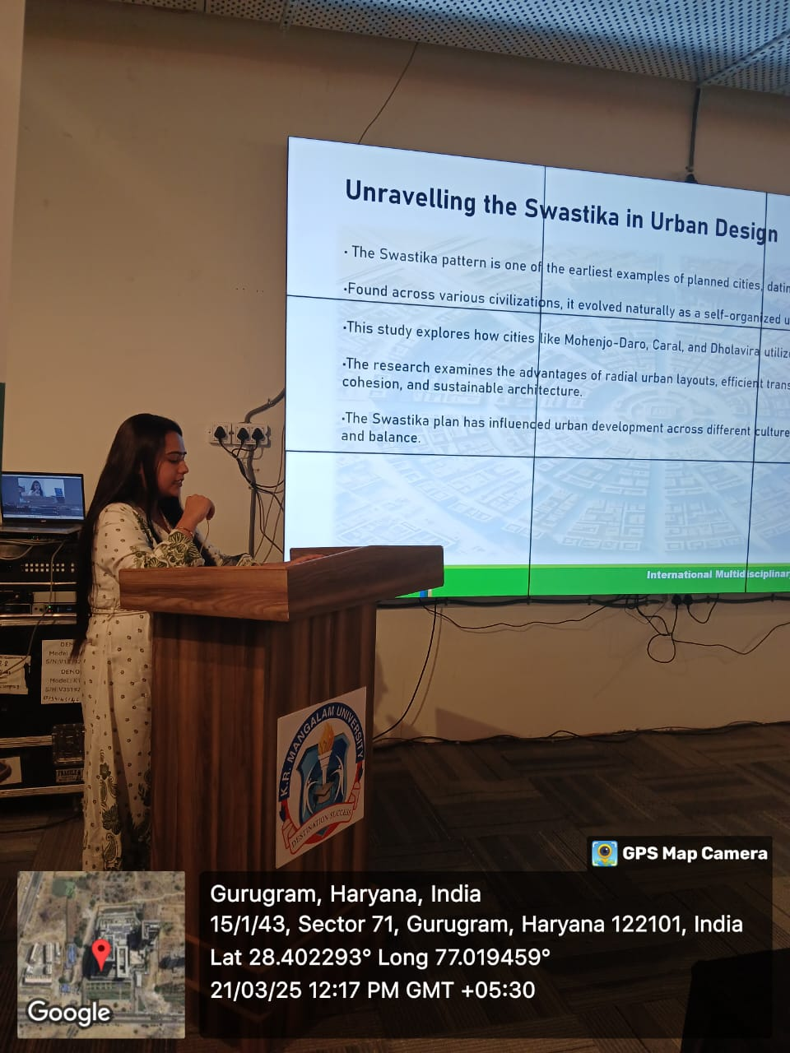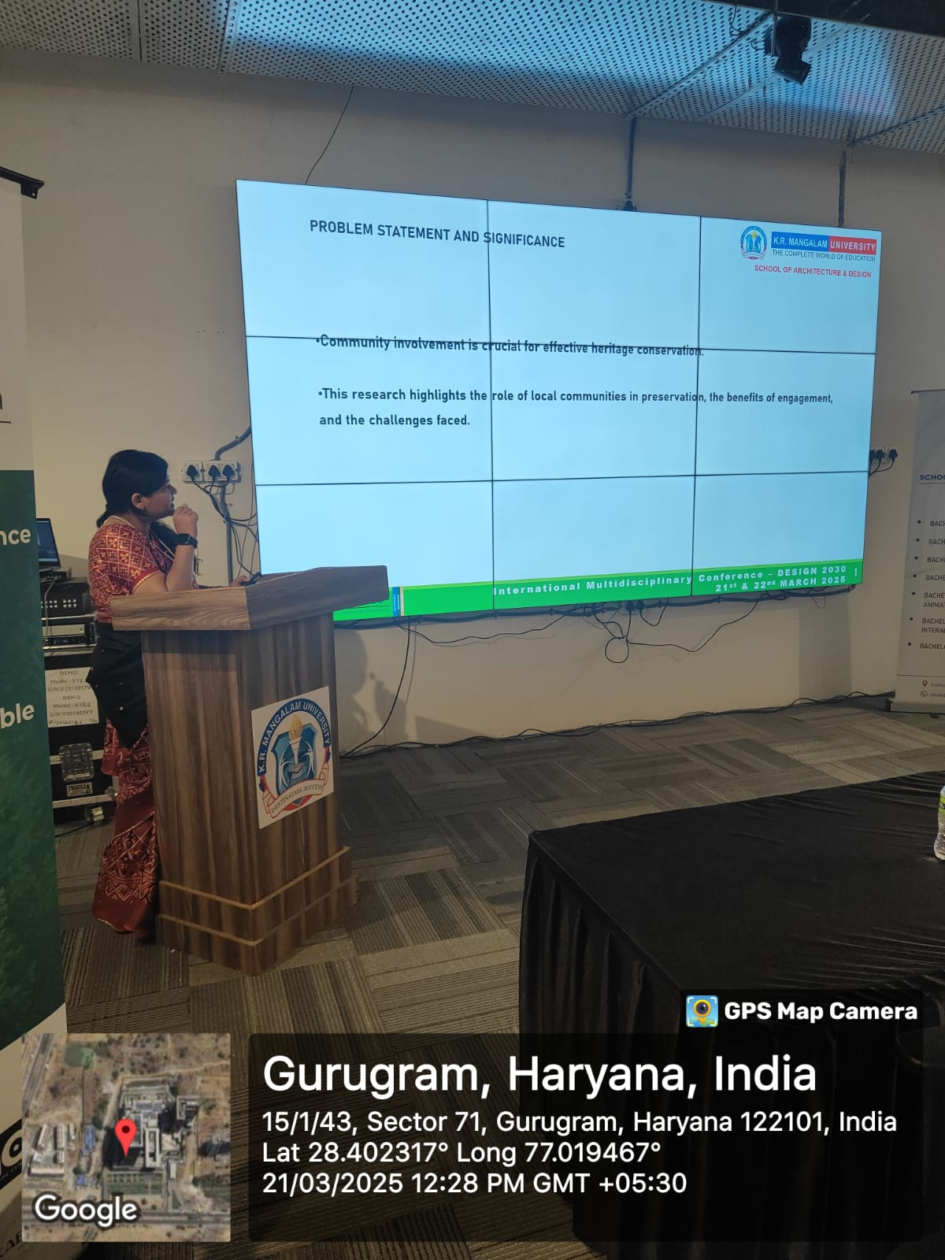
Paper presentations by authors on Day 1
Eminent Guests in Inauguration ceremony

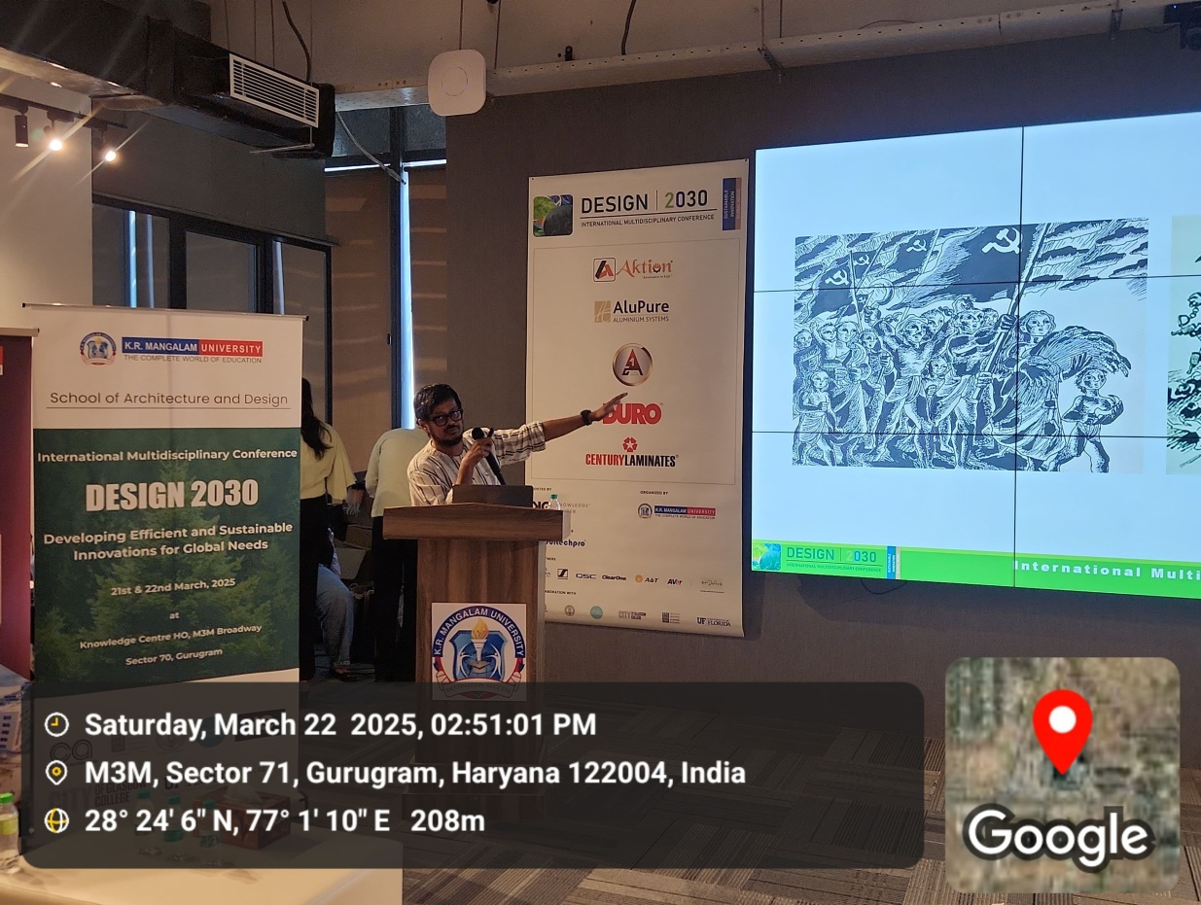
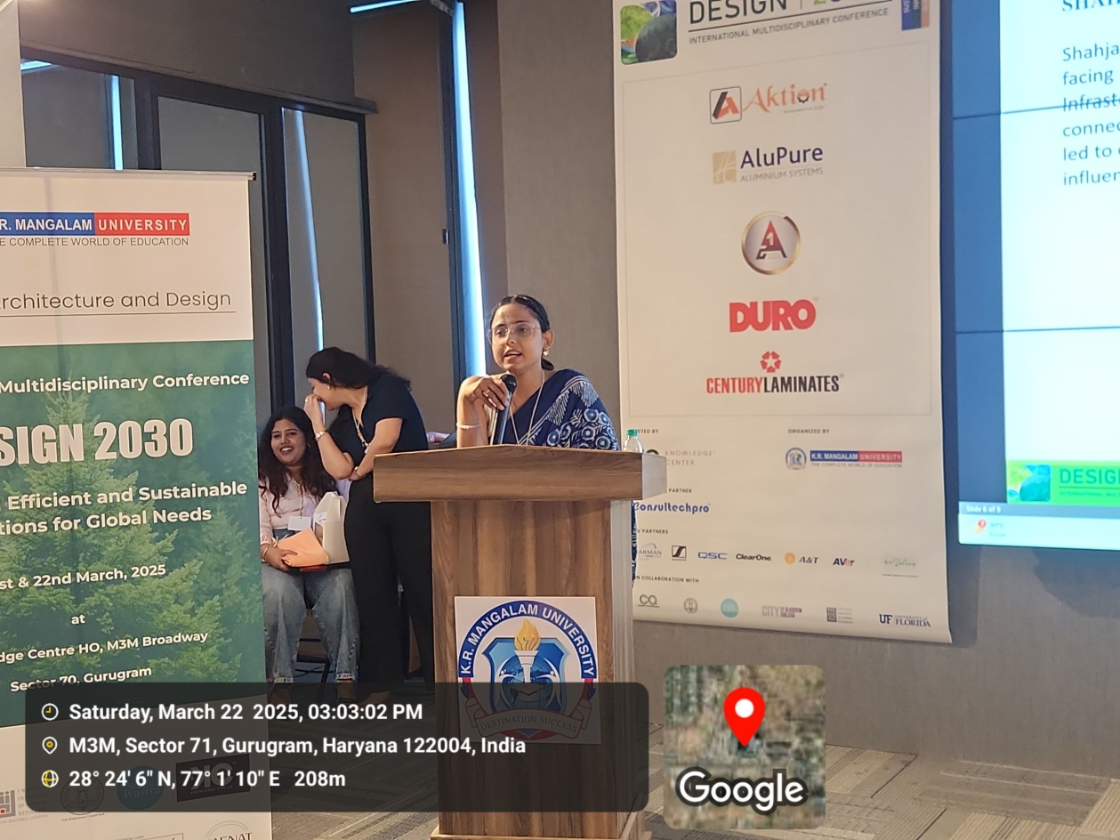
Paper presentations by authors on Day 2

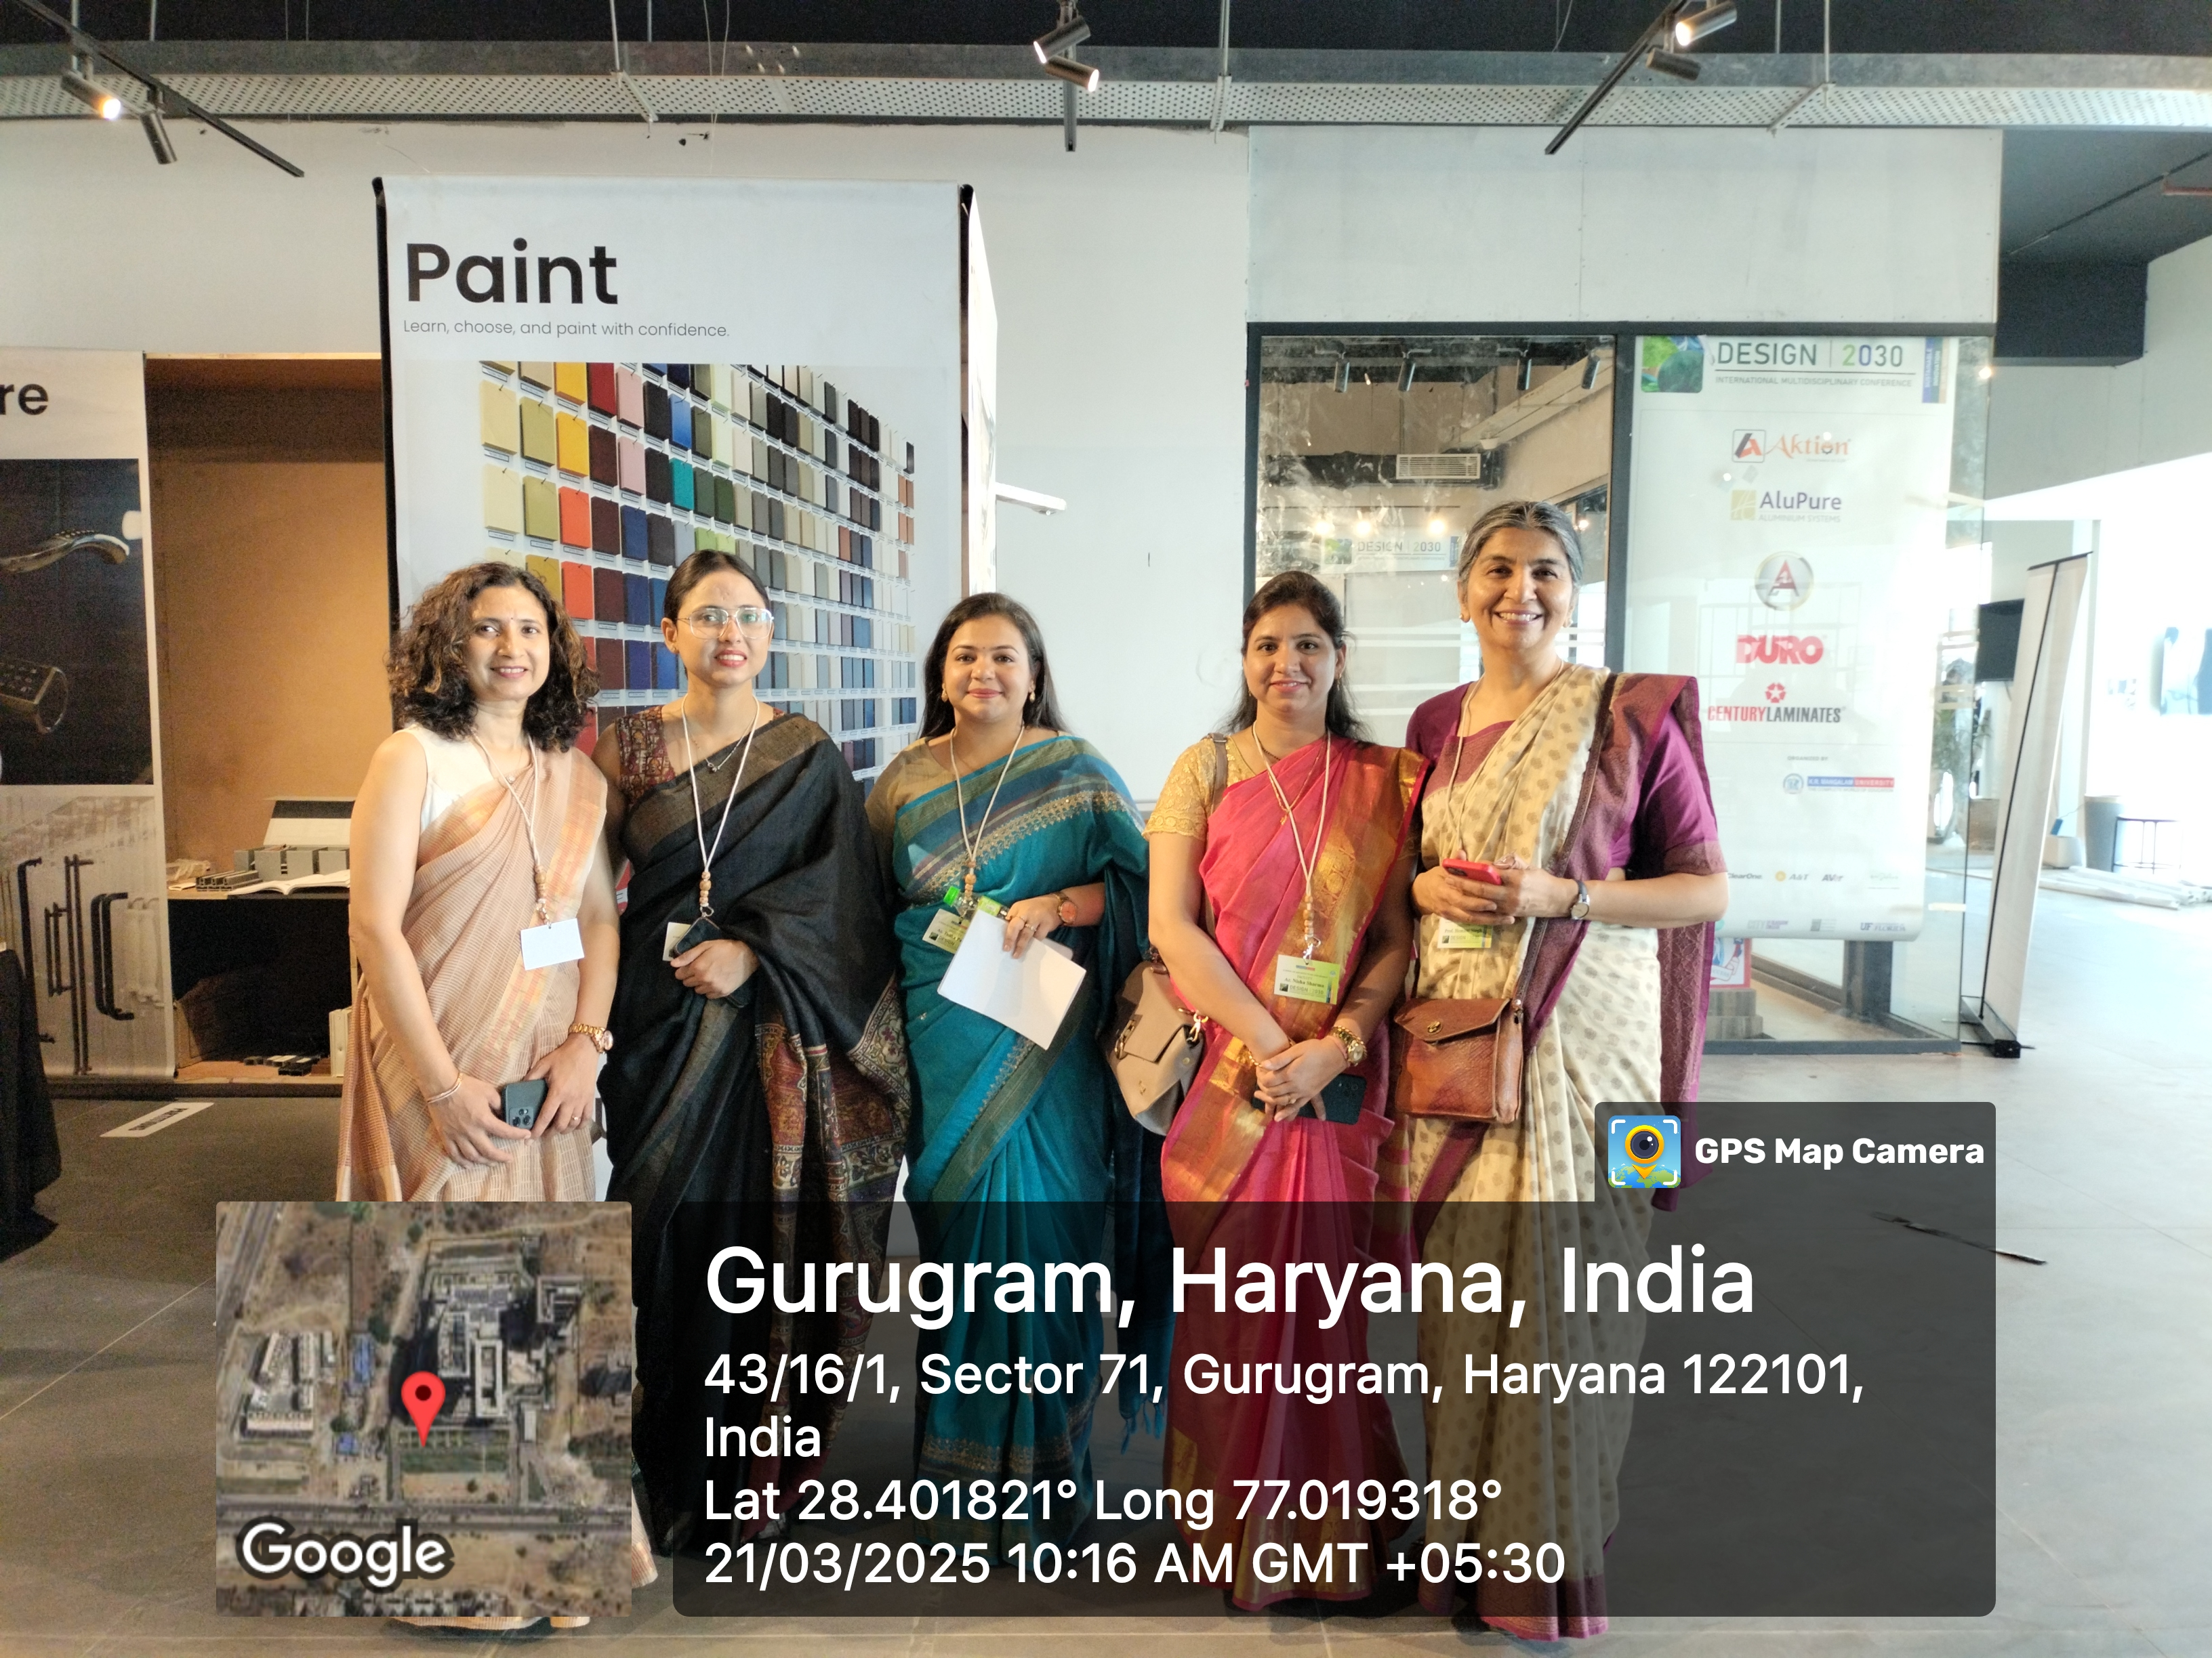
SOAD Faculties at DESIGN 2030
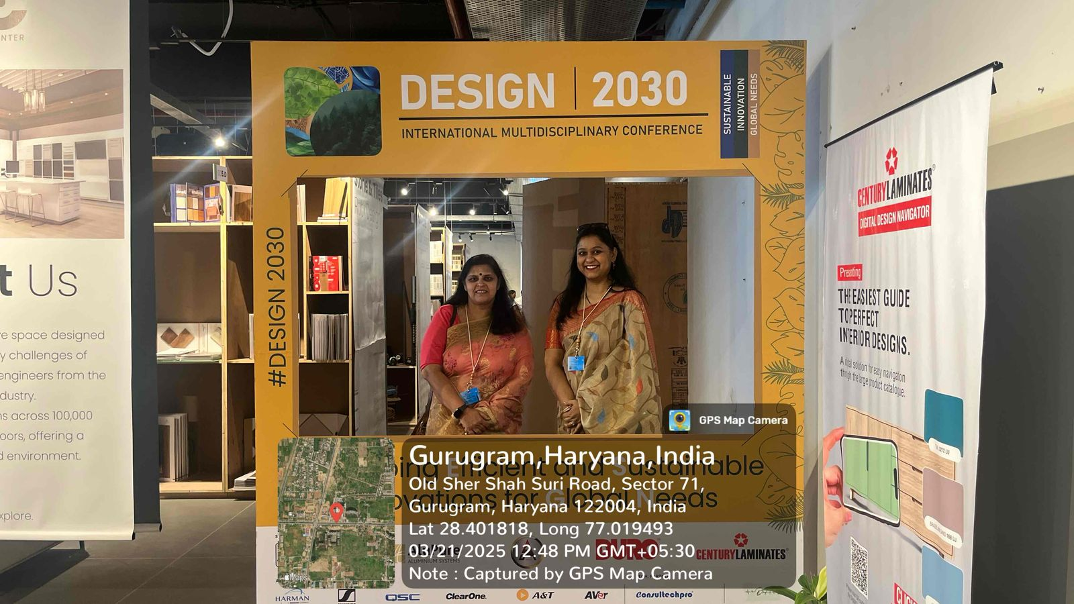
Dr. Varuna Tyagi, Dean Academics, KRMU and Dr. Anjana Singh, Dean Student Welfare, KRMU at DESIGN 2030

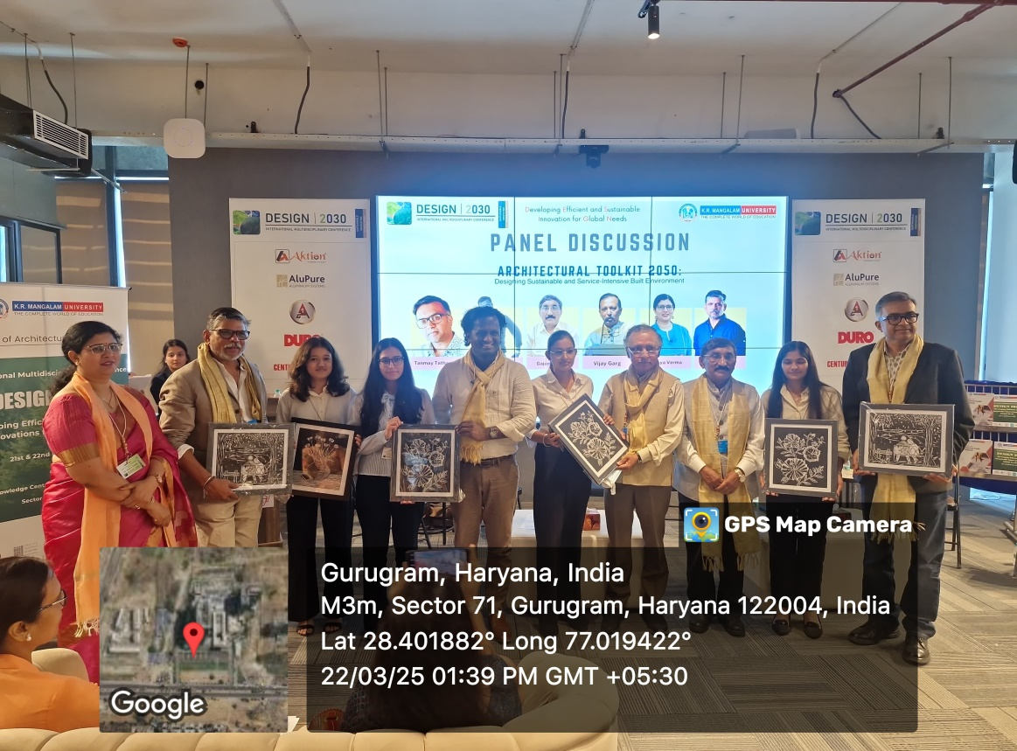
Student Appreciation at Panel Discussion
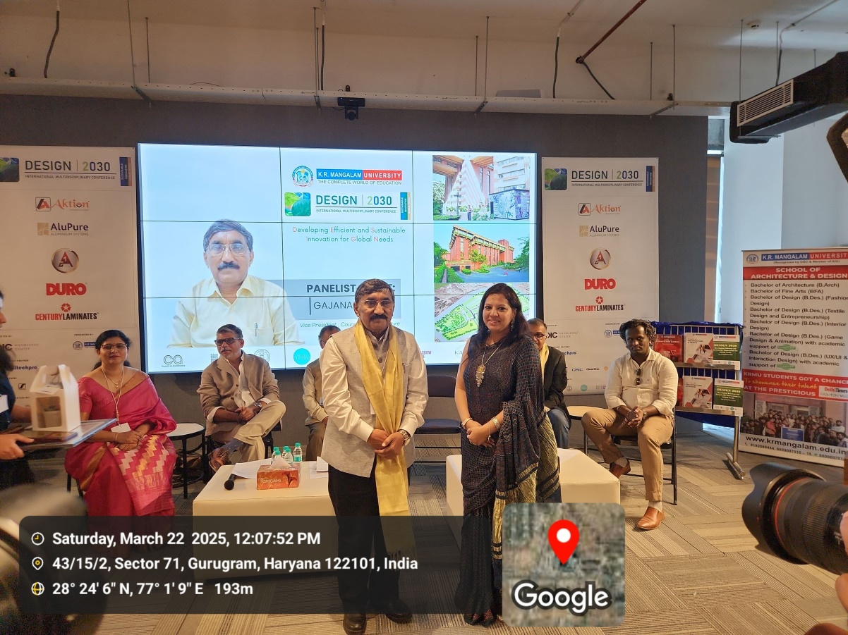
Artist Anjali Goel, Founder, Studio Tvastra felicitating Ar. Gajanand Ram, Vice President, COA Delhi

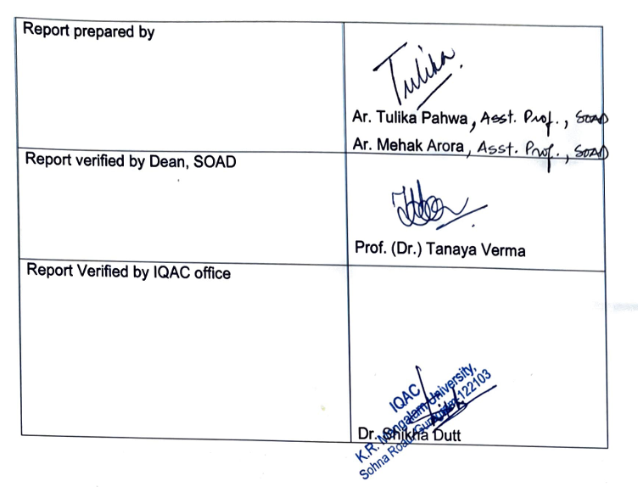

Report prepared by | Ar. Tulika Pahwa  Ar. Mehak Arora
Report verified by Dean, SOAD | Prof. (Dr.) Tanaya Verma
Report Verified by IQAC office | Dr. Shikha Dutt

