National Conference
On
Innovation, Entrepreneurship and Sustainable Solution (IESS 2025)

(24th March- 25th March, 2025)

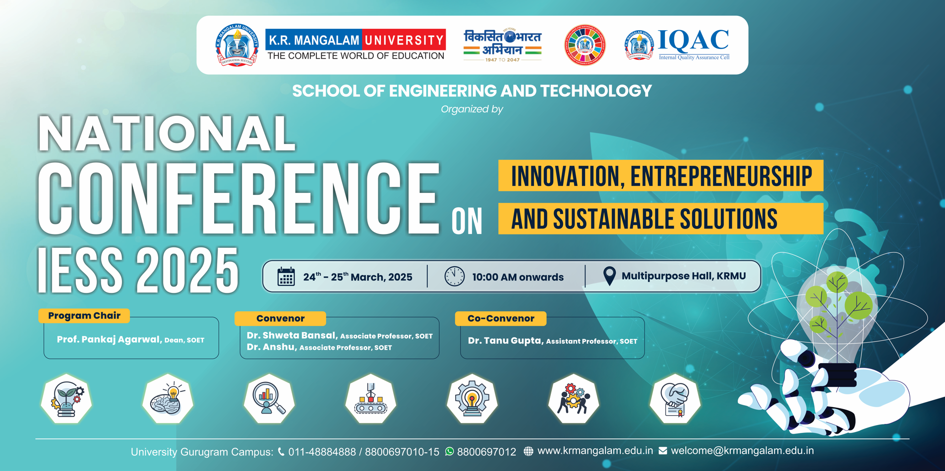

Organized by
School of Engineering and Technology
K.R. MANGALAM UNIVERSITY
Sohna Road, Gurugram

Venue : Multi- Purpose Hall, 4th Floor, Block A

K.R MANGALAM University
Gurugram, India

Contents

- Preface and acknowledgements
- Title and objective of the conference
- Themes and sub-themes of the conference
- Inaugural function
- Address of the invited speakers
- Session wise & track wise report
- Valedictory function
- Annexure – i: Brochure
- Annexure – ii: Minute-To-Minute Conference Schedule
- Annexure – iii: List of Invited Speakers & Session Chairs
- Annexure – iv: List of Attendees
- Annexure – v: Certificates
- Annexure – vi: Glimpses of Conference

PREFACE

We are pleased to present the proceedings of the National Conference on Innovation, Entrepreneurship, and Sustainable Solutions (IESS2025), held on 24th–25th March 2025 at the School of Engineering and Technology (SOET), K.R. Mangalam University with IQAC Cell.
In an era where innovation and sustainability are the twin engines of economic and societal progress, IESS2025 served as a timely and significant platform for the convergence of ideas, research, and best practices. Hosted by the School of Engineering and Technology, this two-day national conference aimed to foster interdisciplinary dialogue among researchers, academicians, industry professionals, and entrepreneurs.
The conference featured thought-provoking keynote speeches, technical paper presentations, and interactive discussions across various domains including Artificial Intelligence, Blockchain, IoT, and sustainable technologies. It offered a unique opportunity for participants to exchange knowledge, build collaborations, and reflect on the strategies required to achieve a sustainable and technologically empowered future.

ACKNOWLEDGEMENT

We extend our heartfelt gratitude to all those who contributed to the successful organization and execution of the National Conference on Innovation, Entrepreneurship, and Sustainable Solutions (IESS2025).
Our sincere thanks to the Hon’ble Vice Chancellor, Prof. Raghuvir Singh, for his visionary guidance and inspiring address, which set a strong foundation for the conference. We are deeply grateful for his continued encouragement and steadfast commitment to fostering a culture of academic excellence and innovation.
We also extend our sincere appreciation to the university leadership and management team for their invaluable support in enabling this prestigious event. Their strategic vision and encouragement played a pivotal role in facilitating interdisciplinary collaboration and thought leadership throughout the conference. We are grateful to our keynote speakers Prof. B. Chandra, Adjunct Professor, IIT Delhi, and Mr. Sanjay Kumar, Director, Lepton Projects Pvt Ltd, for sharing their profound insights and experiences, which significantly enriched the learning experience for all participants.
We express our appreciation to Dr. Pankaj Agarwal, Dean, SOET, for his unwavering support, and to the Conference Convenors Dr. Shweta Bansal and Dr. Anshu, along with Co-Convenor Dr. Tanu Gupta, for their dedicated efforts in curating a dynamic and impactful conference agenda. A special note of thanks to Dr. Yogita Raghav for her warm and motivating inaugural address, and to all faculty members, technical staff, researchers, student volunteers, and participants whose enthusiastic involvement made IESS2025 a resounding success.

National Conference on Innovation, Entrepreneurship, and Sustainable Solutions (IESS2025)

Objectives:
The primary objective of IESS2025 was to foster interdisciplinary collaboration and knowledge exchange on emerging trends in innovation, entrepreneurship, and sustainability. The conference aimed at:
- Encourage discussions on advancements in technology and sustainable business practices.
- Provide insights into entrepreneurial strategies for economic development.
- Bridge the gap between academia and industry through collaborative engagements.
- Promote research and development in sustainable solutions for contemporary challenges.

THEMES AND SUB-THEMES OF THE CONFERENCE

The National Conference on Innovation, Entrepreneurship, and Sustainable Solutions (IESS2025) centered around the exploration and discussion of innovative ideas, disruptive technologies, and sustainable solutions to address modern-day challenges. The conference embraced a multidisciplinary approach, inviting contributions from academia, industry, and entrepreneurs across the following key themes and sub-themes:
Theme 1: Artificial Intelligence, Machine Learning, and Data-Driven Innovations
Sub-Themes:
- Deep Learning and Neural Networks
- Predictive Analytics and Decision-Making Systems
- Natural Language Processing (NLP)
Theme 2: Human-Centred Computing and User Experience
Sub-Themes:
- Human-Computer Interaction (HCI)
- Usability Engineering and UX Design
- Adaptive Interfaces and Accessibility
Theme 3: Smart and Sustainable Solutions
Sub-Themes:
- Green Technologies and Smart Cities
- Sustainable Energy Systems and Resource Management
- Environmental Monitoring and Smart Agriculture
Theme 4: Blockchain, Cybersecurity, and Distributed Systems
Sub-Themes:
- Blockchain Protocols and Applications
- Smart Contracts and FinTech Solutions
- Cyber Threat Detection and Prevention
Theme 5: Internet of Things (IoT) and Edge Intelligence
Sub-Themes:
- IoT Architectures and Frameworks
- Edge and Fog Computing Solutions

INAUGURAL
IESS2025 began with an inspiring inaugural session Dr. Yogita Raghav, Assistant Professor, SOET. extended a warm welcome to all attendees, emphasizing the conference’s vision to unite researchers, entrepreneurs, investors, policymakers, and academia to drive impactful innovations and sustainability solutions. The inaugural session was marked by the traditional Lamp Lighting Ceremony, signifying the triumph of knowledge over ignorance. Esteemed dignitaries, including Hon’ble Vice Chancellor Prof. Raghuvir Singh, Keynote Speaker Prof. B. Chandra (Adjunct Professor, IIT Delhi), Special Guest Mr. Sanjay Kumar (Director, Lepton Projects Pvt Ltd), Dean SOET Dr. Pankaj Agarwal, Conference Convenor Dr. Shweta Bansal (School Coordinator, SOET) & Dr. Anshu (Associate Professor, SOET), and Co-Convenor Dr. Tanu Gupta (Assistant Professor, SOET), participated in this auspicious ceremony, symbolizing the enlightenment of minds and the guiding vision for the conference.

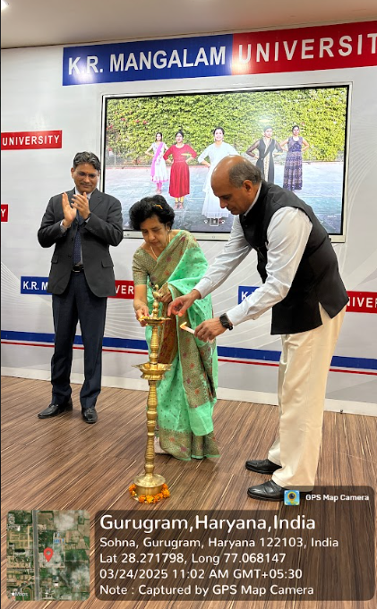 | 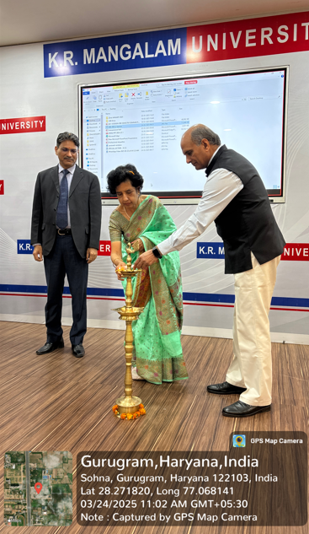

ADDRESS OF THE INVITED SPEAKERS

The inaugural session was further enriched by the Hon’ble Vice Chancellor, Prof. Raghuvir Singh, whose inspiring words set the tone for the conference. Prof. Singh emphasized the critical role of innovation, entrepreneurship, and sustainable solutions in shaping a self-reliant and technologically empowered society. Then, Dr. Pankaj Agarwal, Dean of the School of Engineering & Technology, took the stage to introduce the esteemed guests. His address underscored the significance of the conference in nurturing young innovators and entrepreneurs. The conference also featured thought-provoking keynote sessions delivered by distinguished speakers who shared their expertise and insights on cutting-edge technologies and entrepreneurial advancements. Prof. B. Chandra (Adjunct Professor, IIT Delhi) – A pioneer in Artificial Intelligence and Machine Learning, Prof. Chandra provided deep insights into AI-driven innovations, the evolving landscape of neural networks, and the future of intelligent automation. Mr. Sanjay Kumar (Engineering Leader & Innovator) – With over 30 years of experience in industrial infrastructure and power transmission, Mr. Kumar delivered an engaging session on technological innovations and sustainability in engineering.
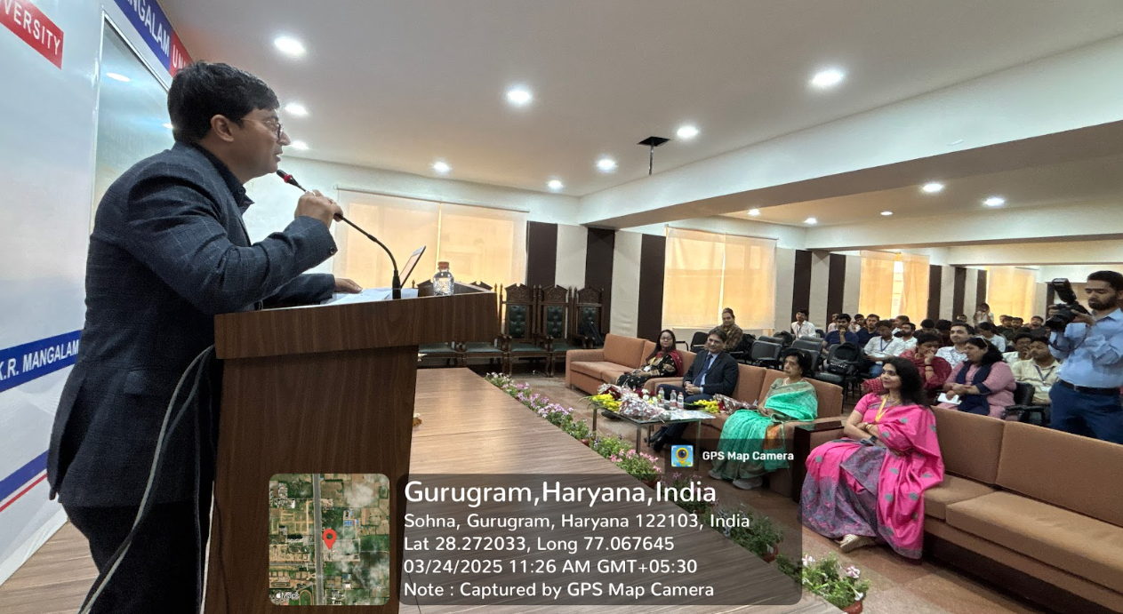
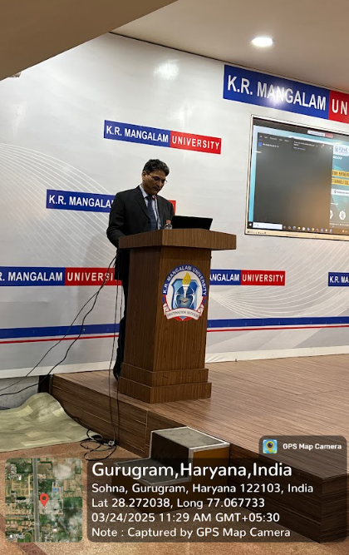

SESSION WISE REPORT

Session 1:
Session 1 of IESS2025 showcased a dynamic and thought-provoking lineup of research presentations, focusing on contemporary challenges and innovative solutions in corporate digital responsibility, advertising psychology, deep learning, cybersecurity, and blockchain applications. The session encouraged interdisciplinary dialogue and received active participation from attendees across academia and industry.
Session 1 set the stage for the IESS2025 conference with a diverse mix of impactful research presentations and discussions. It reflected the conference’s core vision of bridging technology, social responsibility, and innovation. The audience actively engaged in Q&A sessions, appreciating the relevance and quality of the presented works.

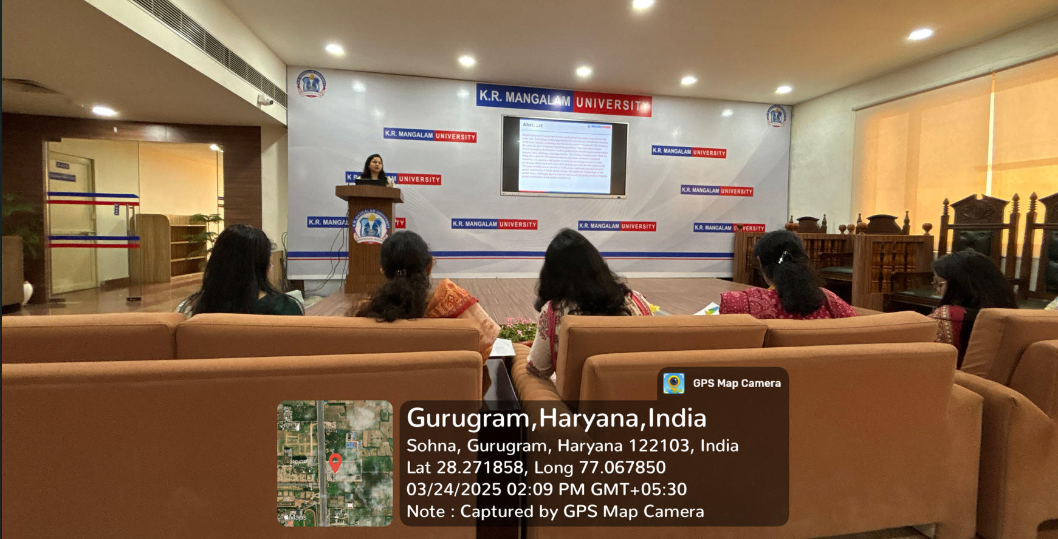
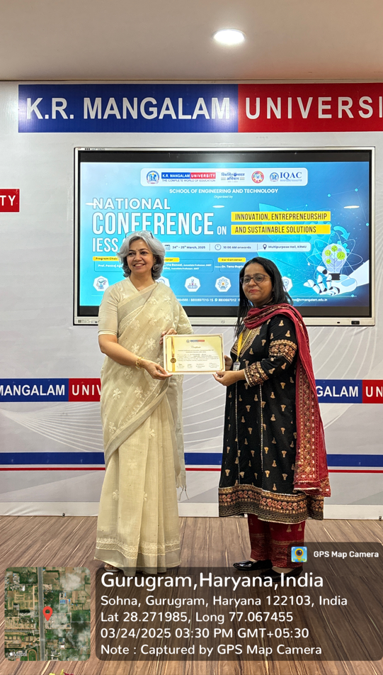 | 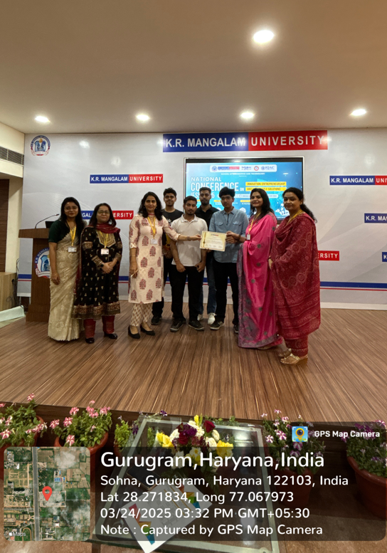
Glimpse of Session 1

Session 2:
Session 2 of the IESS2025 conference was conducted in hybrid mode, allowing participation from both in-person and remote attendees. The session was thematically focused on emerging innovations in Artificial Intelligence, Cybersecurity, IoT, and Predictive Analytics. A total of six high-quality research papers were presented by scholars and practitioners, highlighting the application of modern technologies in real-world scenarios. Overall, Session 2 was a highly informative and engaging segment of IESS2025. The diversity of research topics reflected the conference’s vision of fostering innovation and interdisciplinary dialogue. The hybrid format allowed for vibrant discussions, questions, and networking, further reinforcing the collaborative spirit of the event.

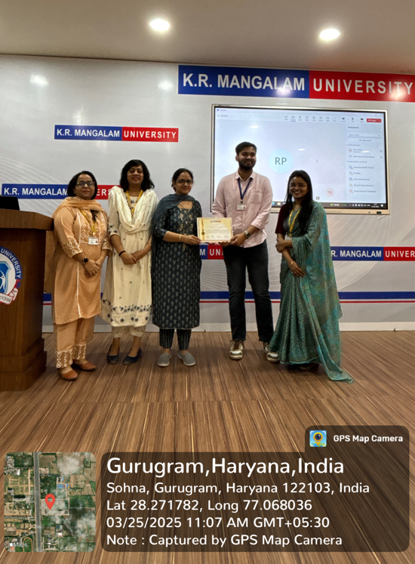 | 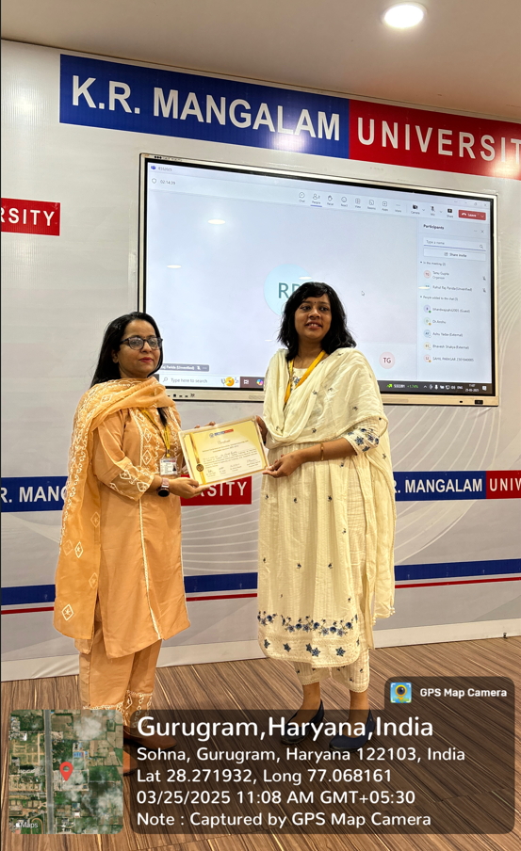
Glimpse of Session 2

Session 3:
Session 3 of IESS2025 was conducted in a hybrid mode, enabling a broad spectrum of participants to join both on-site and remotely. This session showcased six impactful research papers centered around the integration of Machine Learning, Deep Learning, Natural Language Processing, and Environmental Studies. The session highlighted the innovative application of technology in societal, urban, and environmental domains.
Overall, Session 3 successfully provided a platform for exchanging diverse and forward-looking research that applies data science, AI, and sustainability principles to solve real-world problems. The engaging Q&A segments and hybrid participation enriched the discussions and opened avenues for collaborative research

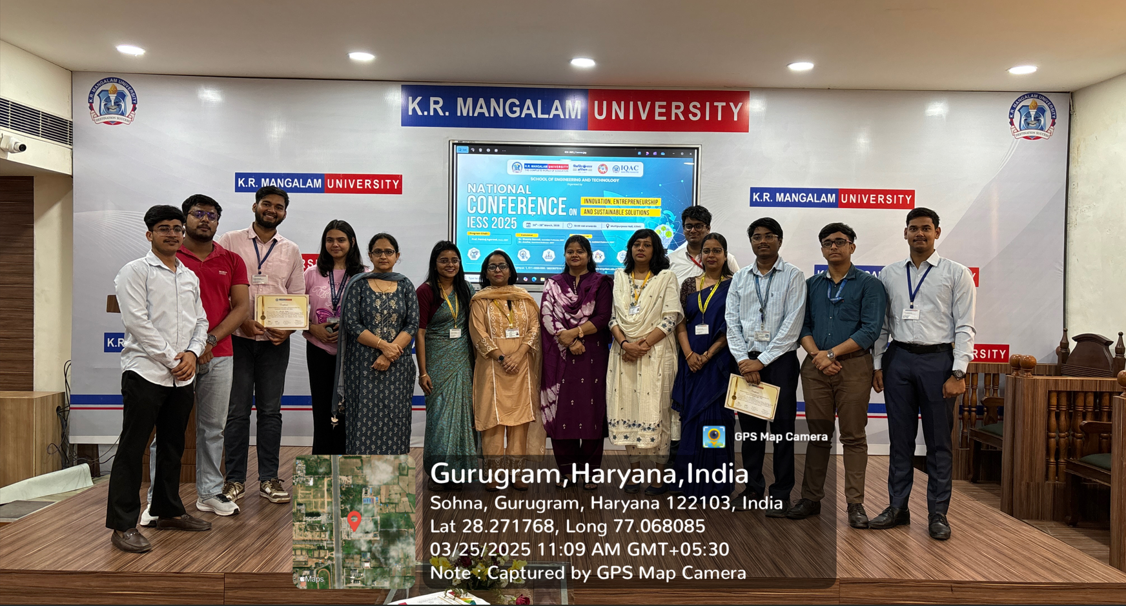
Glimpse of Session 3

VALEDICTORY FUNCTION
The valedictory function of the National Conference on Innovation, Entrepreneurship, and Sustainable Solutions (IESS2025) was held on the afternoon of 25th March 2025, marking the successful conclusion of the two-day academic event organized by the Department of Computer Science and Engineering, SOET, K.R. Mangalam University, with IQAC Cell.
The session commenced with a warm welcome address by Dr. Shweta Bansal, Conference Convenor, who expressed heartfelt gratitude to all the participants, keynote speakers, session chairs, and organizing committee members for their active involvement and valuable contributions. She summarized the conference highlights and acknowledged the high level of enthusiasm shown by researchers and academicians throughout the event.
Dean SOET, Dr. Pankaj Agarwal, shared insights into the importance of innovation and entrepreneurship in addressing real-world challenges and commended the participants for presenting relevant and impactful research. He appreciated the efforts of the organizing team and emphasized the role of interdisciplinary collaboration for sustainable development.
The event was graced by the presence of Hon’ble Vice Chancellor, Prof. Raghuvir Singh, who delivered the valedictory address. Prof. Singh praised the diversity of research topics covered during the conference, ranging from AI and Blockchain to environmental impact and urban planning. He congratulated the participants and highlighted the significance of platforms like IESS2025 in bridging academia and industry. He also encouraged students and young researchers to continue pursuing innovation-driven solutions that align with the UN Sustainable Development Goals (SDGs).
The function also included the announcement of Best Paper Awards, selected by the session chairs based on originality, presentation, and relevance. Winners were acknowledged for their outstanding contributions, and certificates of appreciation were distributed to all presenters.
The vote of thanks was delivered by Dr. Tanu Gupta, Co-Convenor of IESS2025, she expressed gratitude to the management, technical team, volunteers, and sponsors for their support and commitment. She also thanked all the attendees—offline and online—for making the conference a grand success.
The valedictory function concluded with a group photo session and a renewed spirit of collaboration, innovation, and academic excellence. Participants departed with new ideas, connections, and inspiration to contribute meaningfully to the world of technology and sustainable development.

ANNEXXURE – I
BROCHURE

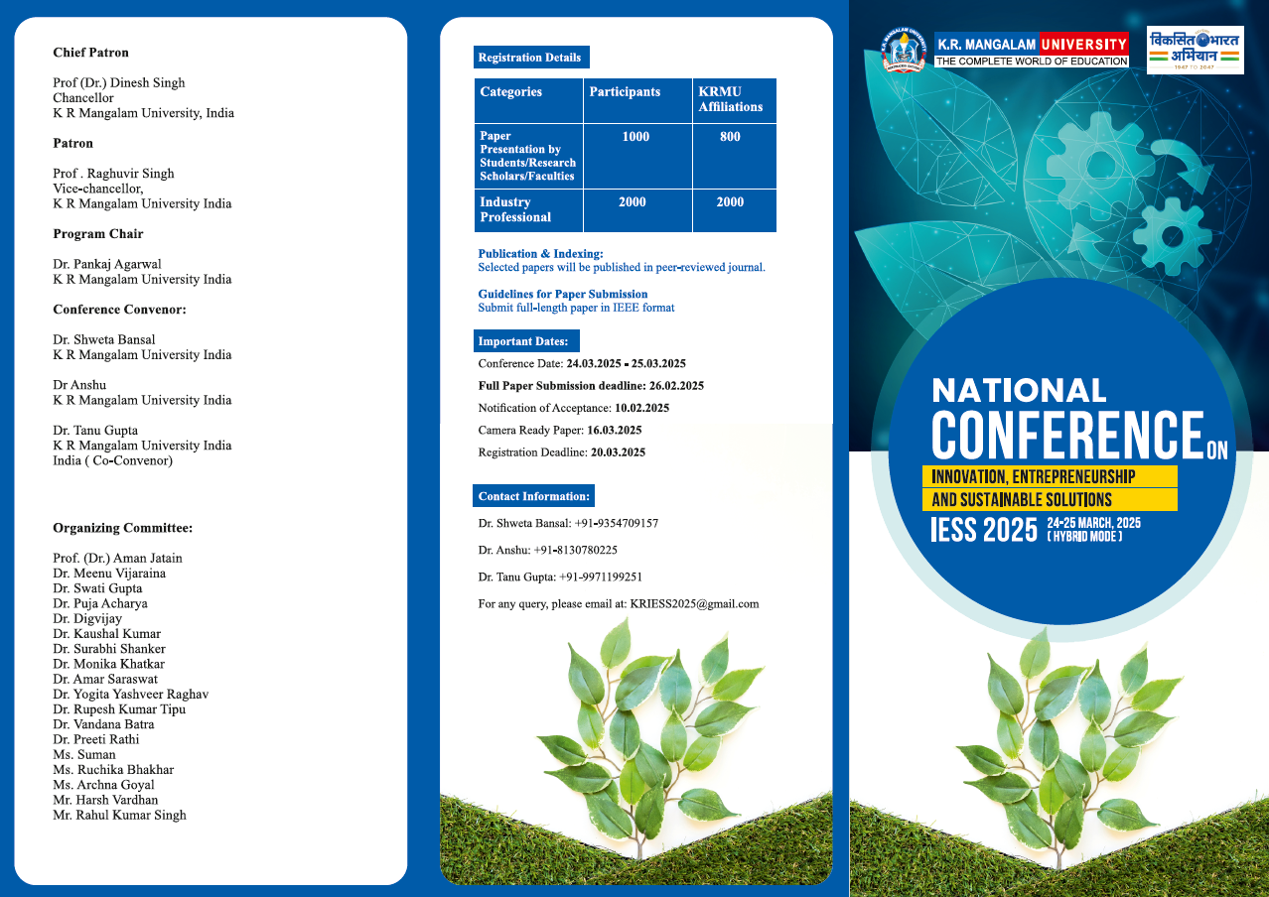
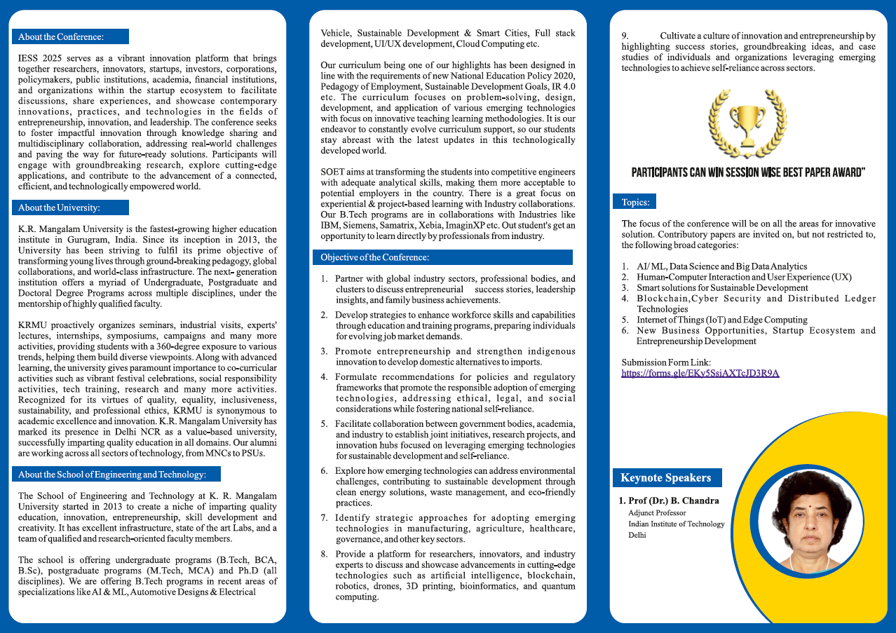

ANNEXURE – II
MINUTE-TO-MINUTE CONFERENCE SCHEDULE

Day & Date | Day 1: 24 March 2025, Monday
9:30-10:30 AM | Registration
10:30-10:35 AM | Welcome Address
10:35-10:40 AM | Lightning of Lamp
10:40-10:45 AM | Saraswati Vandana
10:45-10:50 AM | Address by Dean SOET
10:50-11:00 AM | Address by Vice Chancellor
11:00-01:00 PM | Keynote Session
01:00-02:00 PM | Lunch break
02:00-03:30 PM | Paper Presentations – Session 1
Day & Date | Day 2: 25 March 2025, Tuesday
9:30-11:00 AM | Paper Presentations – Session 2
11:00-11:30 AM | High Tea
11:30-1:00 PM | Paper Presentations – Session 3
01:00-02:00 PM | Lunch break
02:00-03:30 PM | Valedictory Session & Vote of Thanks

Detailed Schedule

Time | Activity | Online Links | Presenter
10:00 AM – 1:00 PM | Address by Dignitaries | https://msteams.link/2RES | Prof. Raghuvir Singh (Vice Chancellor), Prof. Pankaj Agrawal (Dean SOET), Prof. B Chandra and Mr. Sanjay Kumar Malik (Keynote Speakers)
Paper Presentation Schedule
Time | Activity | Online Links | Session Chair | Paper IDs
2:00 PM – 3:30 PM  Day 1 (24th March, 2025) | Paper Presentation (Each Paper 15 Minutes) | https://msteams.link/2RES | Dr. Aman Jatain, Dr. Monika Khatkar  (Session 1) | IESS033, IESS023, IESS026, IESS032, IESS029, IESS035,  IESS044
9:30 AM – 11:00 AM  Day 2  (25th March, 2025) | Paper Presentation (Each Paper 15 Minutes) | https://msteams.link/2RES | Dr. Swati Gupta, Dr. Meenu  (Session 2) | IESS022, IESS024, IESS027, IESS034, IESS043, IESS036
11:30 AM – 1:00 PM  Day 2  (25th March, 2025) | Paper Presentation (Each Paper 15 Minutes) | https://msteams.link/2RES | Dr. Surabhi Shanker, Dr. Yogita Raghav  (Session 3) | IESS028, IESS037, IESS038, IESS039, IESS040, IESS042

ANNEXURE – III
LIST OF INVITED SPEAKERS & SESSION CHAIRS

Sr. No. | Invited Speakers & Session Chairs Name | Organization | Contact Details (email, phone) | Session  Day and Time | Topic
1. | Prof. B. Chandra | IIT Delhi | bchandra104@yahoo.co.in | Day 1, 11:00-1:00 pm | Deep insights into AI-driven innovations
2. | Mr. Sanjay Kumar | Director, Lepton Projects Pvt Ltd | skumar@lepton.co.in | Day 1, 11:00-1:00 pm | Technological innovations and sustainability

ANNEXURE – IV
LIST of ATEENDEES

Sr. No. | Name of the attendee | Organization | Title of the Paper | Duration(from-to) (DD-MM-YYYY)
1 | Dr Neha Chaudhary | Gurugram University | Role of Corporate Digital Responsibility (CDR) For Gender Sensitization | 24th March, 2025
2 | Meenakshi Siwach | Banasthali Vidyapeeth | Corporate Communication - Effectivity vs spontaneity study if the tools are changed in corporate communication | 24th March, 2025
3 | Seema Yogi | Banasthali Vidyapeeth | Influence of Celebrity endowment in Advertising on Young Children Perception for Indian Festivals and Sweets | 24th March, 2025
4 | Sahil Bhardwaj | K. R. Mangalam University | A Comprehensive Review of Deep Learning Architectures  for Task specific Analysis | 24th March, 2025
5 | Vanshika Sharma | K. R. Mangalam University | Phishing detecting in email using deep learning | 25th March, 2025
6 | Yugal Lohani | K. R. Mangalam University | TokenUp: A Decentralized Blockchain and AI Framework for Reward-Based Learning via Automated Token Incentives and Tamper-Proof Certificate | 24th March, 2025
7 | Vaduguru Venkata Ramya | Sri Balaji University, Pune, India | Forecasting Stock Market Trends: A Comparative Study of StockNet and Traditional Predictive Algorithms | 25th March, 2025
8 | Vipin Yadav | Northcap University | Secure cryptographic Scheme based on Dual of Generalized Reed-Muller (GRM) codes for image encryption. | 25th March, 2025
9 | Ashu Yadav | J.S.S. Academy of Technical Education, Noida | Leveraging CNN-BiLSTM for Multi-Class Cyberbullying Detection in Hindi Text | 25th March, 2025
10 | Survesh | K. R. Mangalam University | Enhancing AI Decision-Making: Sensitivity Analysis, Hyperparameter Optimization, Multi-Agent Collaboration, and AI-Human Comparisons | 25th March, 2025
11 | Dheeraj Tiger | Northcap University | Leveraging Blockchain and AI for secure and Scalable Edge computing in IoT | 25th March, 2025
12 | Aadya Mishra | K. R. Mangalam University | News Article Sentiment Analysis using NLP | 25th March, 2025
13 | Devesh Kumar | K. R. Mangalam University | Leveraging Machine Learning for Predicting Mental Health Outcomes: A Data-Driven Approach | 25th March, 2025
14 | Rahul Raj | K. R. Mangalam University | Enhanced Urban Layout Generation Using  WGGAN: A Study on Gurugram and California  Dataset | 25th March, 2025
15 | Aprajita Kumari | K. R. Mangalam University | Detecting phishing in text messages | 24th March, 2025
16 | Mansi Mishra | K. R. Mangalam University | Enhancing NFT Discovery with Sentence Transformers and Cosine Similarity: A Deep Learning Approach | 25th March, 2025
17 | Aryan Dabas | K. R. Mangalam University | Topic Modelling using NLP for Student Feedback | 25th March, 2025
18 | Tushar Pant | K. R. Mangalam University | Impact of fuel economy on environment | 25th March, 2025
19 | Kartik Rathi | K. R. Mangalam University | The Efficacy of Specialized Language Models in Advancing Educational Outcomes | 25th March, 2025

ANNEXURE – V
CERTIFICATES

Program Chair
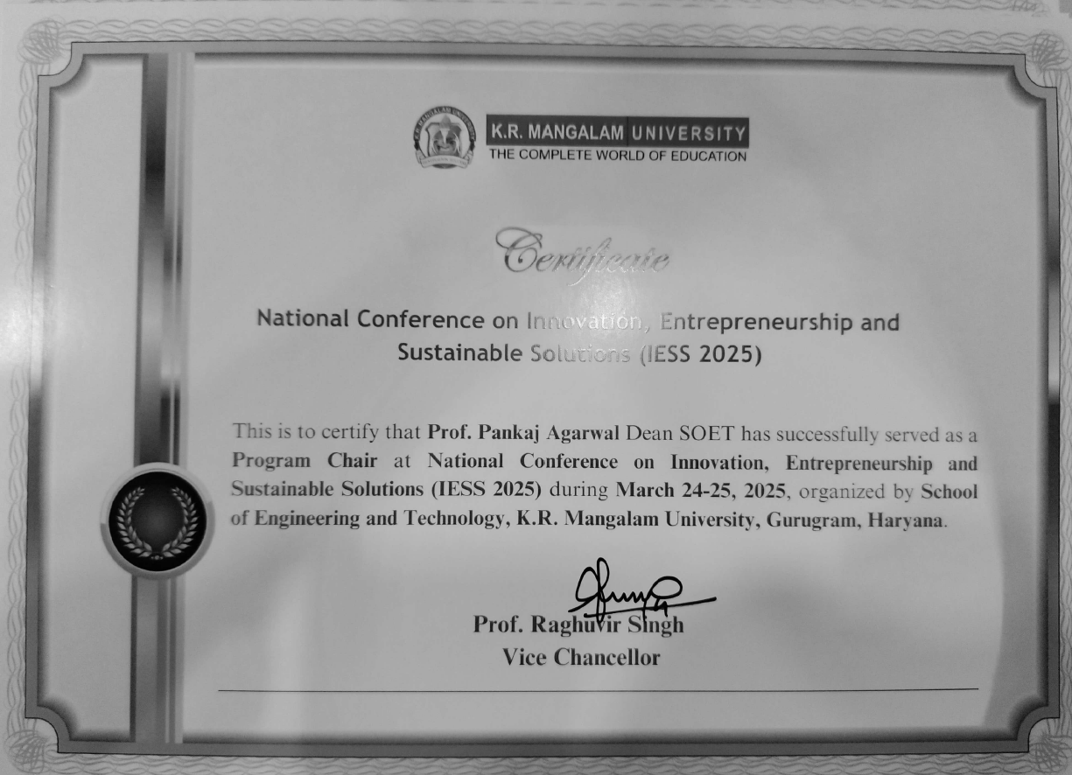
Convener Certificate
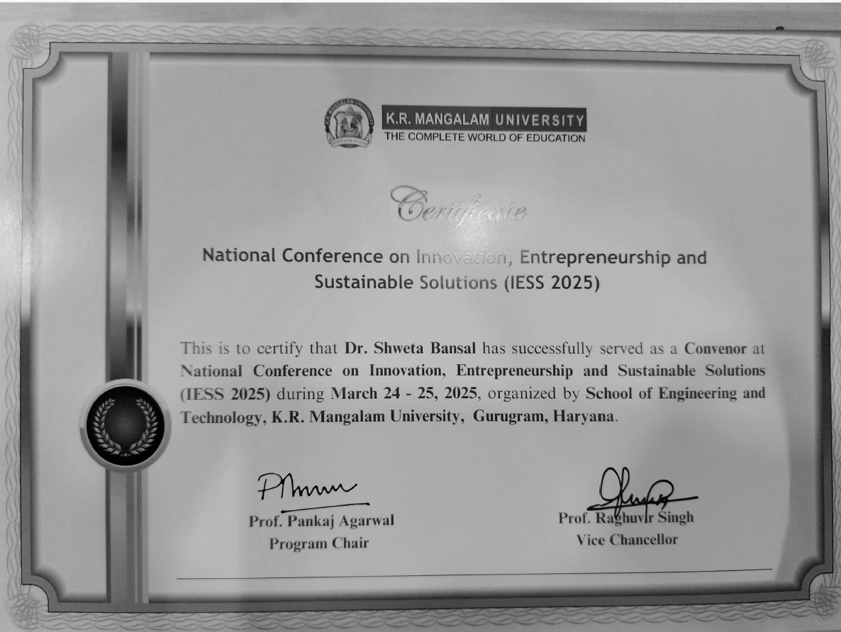
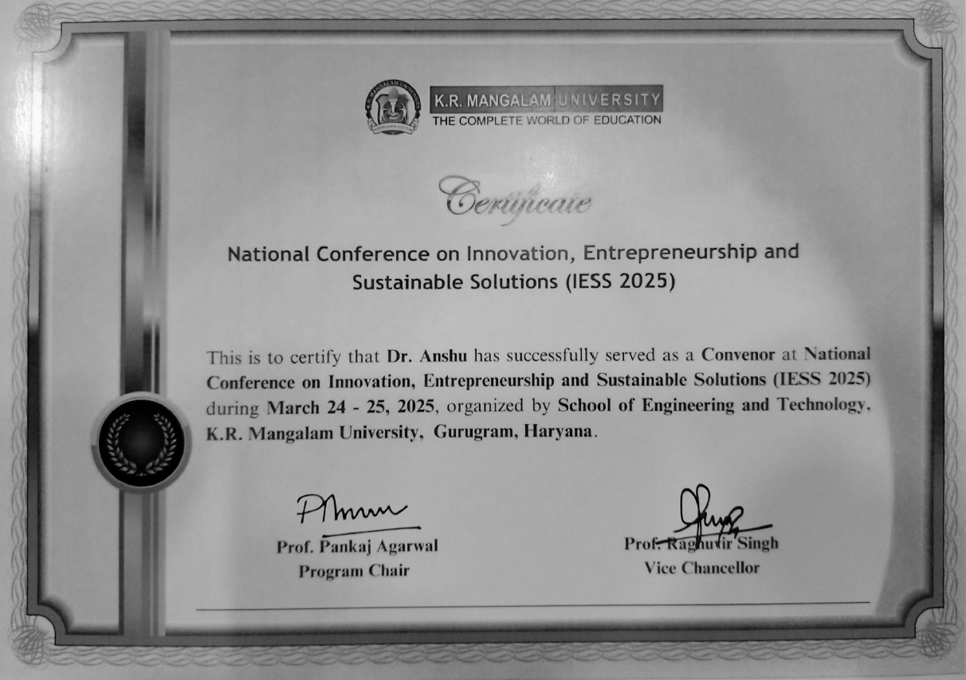

Co-Convener Certificate
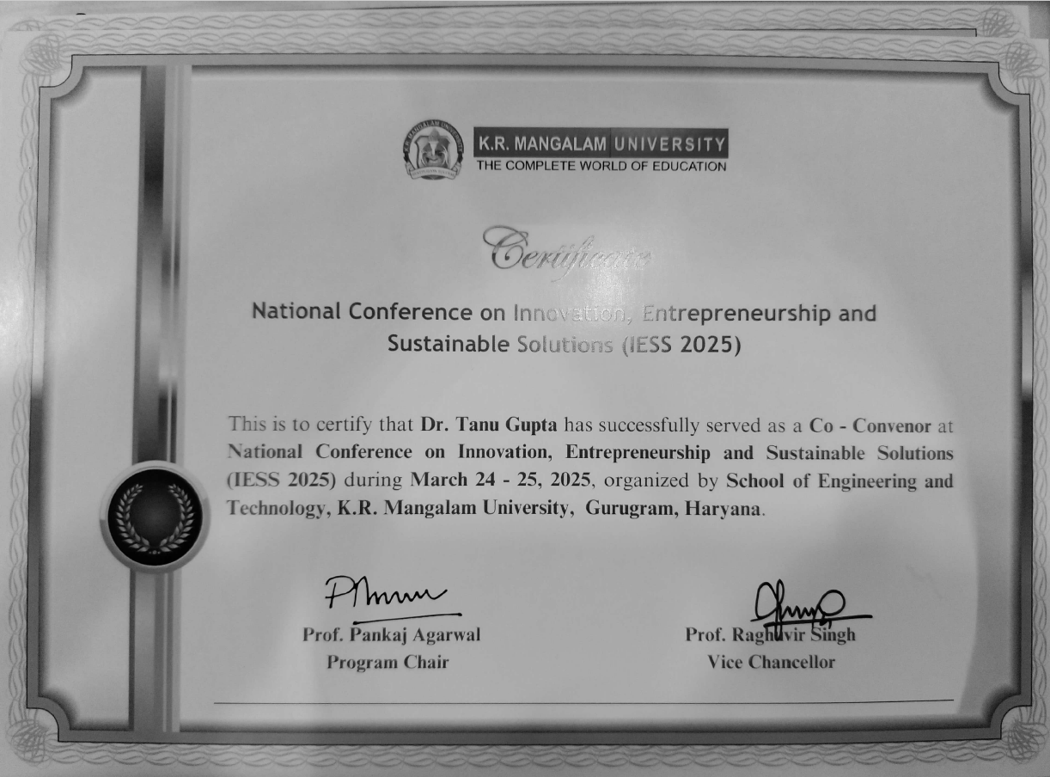

Best Paper Certificate
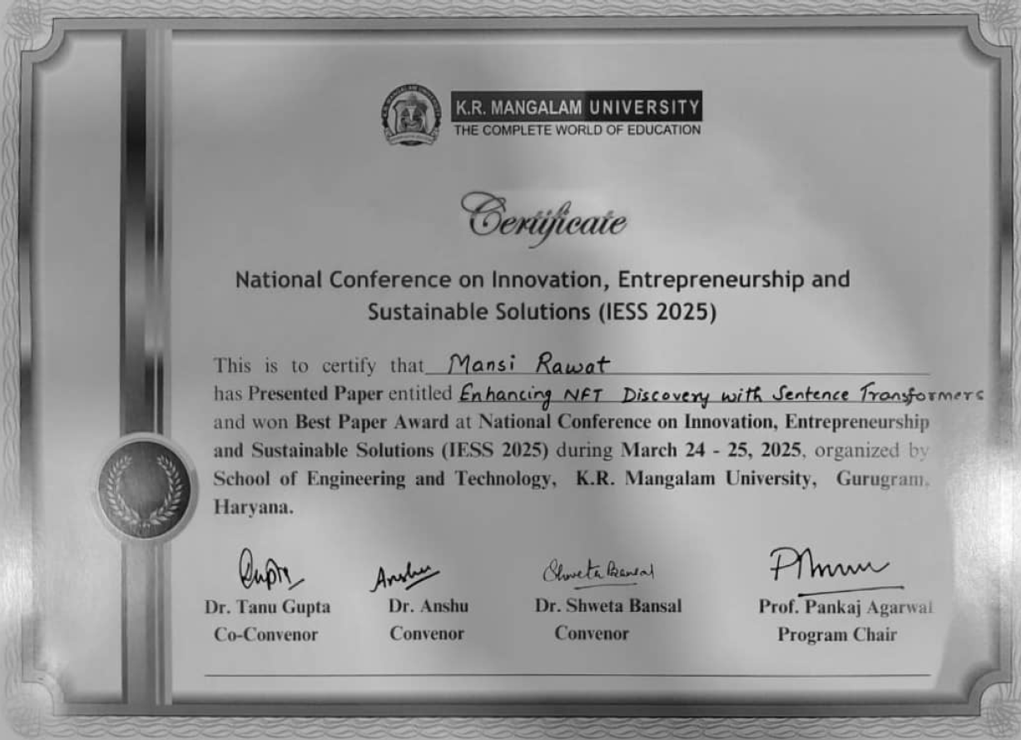

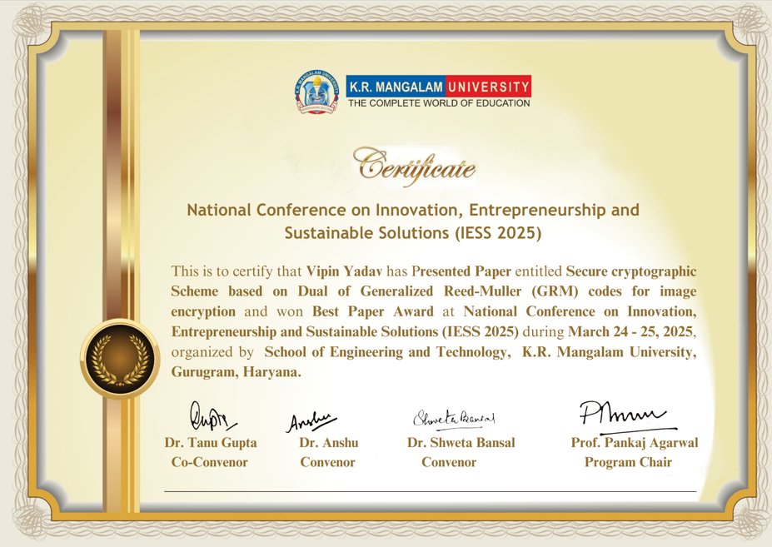

Presenter Certificate
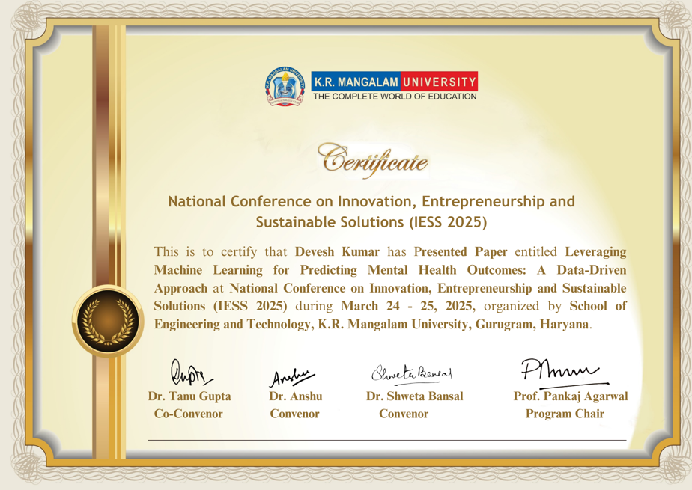

ANNEXURE – VI
GLIMPSES OF CONFERENCE
 | 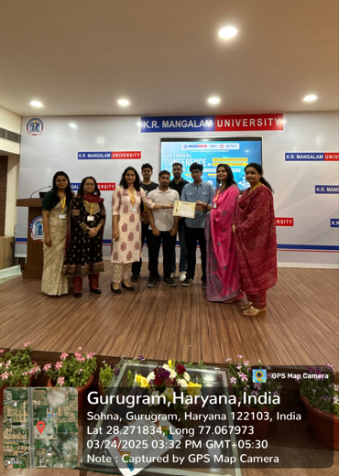
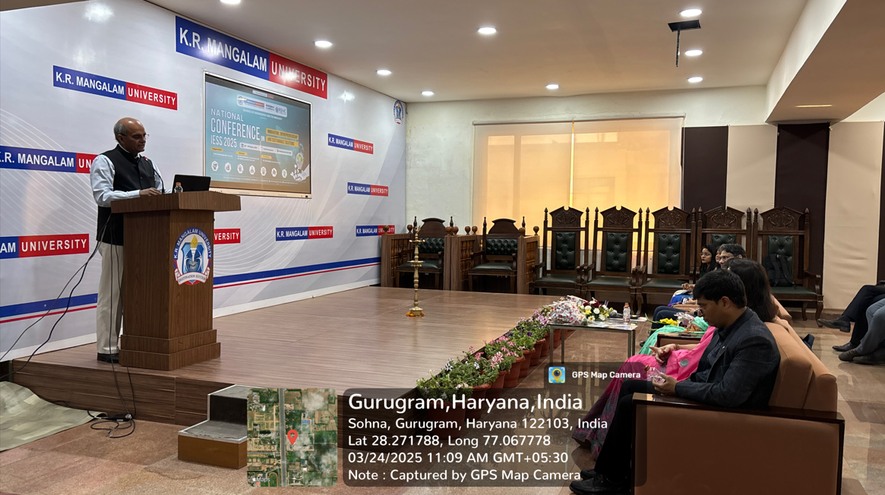
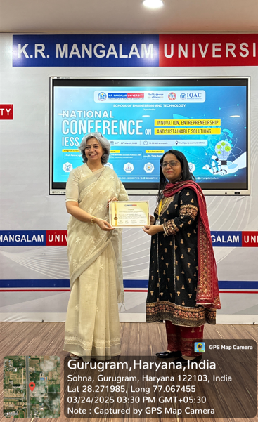 | 