SESSION: "EAT RIGHT, MOVE MORE"- WELLNESS WORKSHOP FOR CHILDREN

Date: 21st April 2025
Venue: Government Senior Secondary School, Daulah, Gurugram
Event Type: Wellness Workshop
Mode of activity: Offline
Target group: Government School Students and NSS Volunteers
Organized by: NSS Unit, K. R. Mangalam University, Gurugram, Harayana
Participants: 30 School Students and 48 NSS Volunteers
Event Coordinators: Dr. Vicky Kapoor, NSS member
Introduction:
The NSS Unit of K. R. Mangalam University successfully organized a one-day wellness workshop titled "Eat Right, Move More" on April 21, 2025, at the Government Senior Secondary School, Daulah, Gurugram. The initiative aimed at fostering healthier lifestyles among children, with a focus on promoting balanced nutrition and the importance of physical activity. The event brought together students, teachers, and volunteers, engaging them in a series of fun and educational activities designed to encourage lifelong habits of wellness. The event also aligned with several Sustainable Development Goals (SDGs), particularly those focused on health, well-being, and education.
Objectives:
- To educate school students on the significance of balanced nutrition and healthy eating.
- To encourage regular physical activity as part of a healthy lifestyle.
- To engage students in interactive activities that promote fitness and wellness.
- To raise awareness among teachers and volunteers about the role of wellness in academic and personal development.
- To motivate children to adopt sustainable, health-conscious habits in their daily lives.

SDG Alignment: This workshop directly contributed to the achievement of the following SDGs:
- SDG 3: Good Health and Well-being – The event focused on promoting physical activity, healthy eating, and general well-being among children, ensuring that they can lead healthier lives.
- SDG 4: Quality Education – By integrating wellness and health education into the curriculum, the workshop contributed to a holistic approach to learning, improving students' overall academic and personal growth.
- SDG 12: Responsible Consumption and Production – Educating children on balanced nutrition fosters awareness about responsible consumption of food and the importance of sustainability in dietary habits.
Content:
The workshop commenced at 11:00 AM with a warm welcome and a brief introduction by Dr. Vicky Kapoor, NSS Member. The sessions were carefully structured to make the topic engaging and accessible for young minds:
- Session 1: Importance of Healthy Eating: Dr. Vicky Kapoor provided an informative presentation on the benefits of balanced nutrition, explaining the various food groups and their role in overall health. The session highlighted how children could make smarter food choices that support their growth and energy needs.
- Session 2: Fun Fitness Activities: The students participated in a series of interactive physical activities, including light exercises and games that promoted movement and fitness. These activities were designed to be fun and encourage the students to incorporate physical activity into their daily routines.
- Interactive Q&A Session: The workshop concluded with an interactive Q&A session where students had the opportunity to ask questions about wellness, nutrition, and fitness. Many students showed keen interest in learning more about how they could stay healthy and active.
Conclusion:
The "Eat Right, Move More" wellness workshop proved to be an engaging and impactful event, successfully reaching its goal of raising awareness about the importance of healthy living among young minds. By providing students with knowledge about nutrition and fitness in an enjoyable and interactive format, the workshop encouraged them to embrace healthier lifestyles. The event also underscored the importance of community and peer support in promoting long-term wellness habits.

SDG Contribution:
This workshop made a significant contribution to the achievement of SDG 3 (Good Health and Well-being), SDG 4 (Quality Education), and SDG 12 (Responsible Consumption and Production) by educating students on health and wellness, promoting sustainable habits, and improving access to quality health education.
Event Outcome:
- Enhanced awareness about the importance of nutrition and physical activity among school students.
- Students gained practical knowledge on how to incorporate healthy habits into their daily lives.
- Increased participation in wellness-related activities among the students.
Future Prospect:
- Plans to extend similar wellness workshops to other schools in Gurugram to further promote healthy living.
- Introduction of a "Wellness Challenge" program, where students can track their progress in adopting healthier routines.
- Potential for creating a partnership with local health experts to continue guiding students in their wellness journey.

Geotag photos with captions:

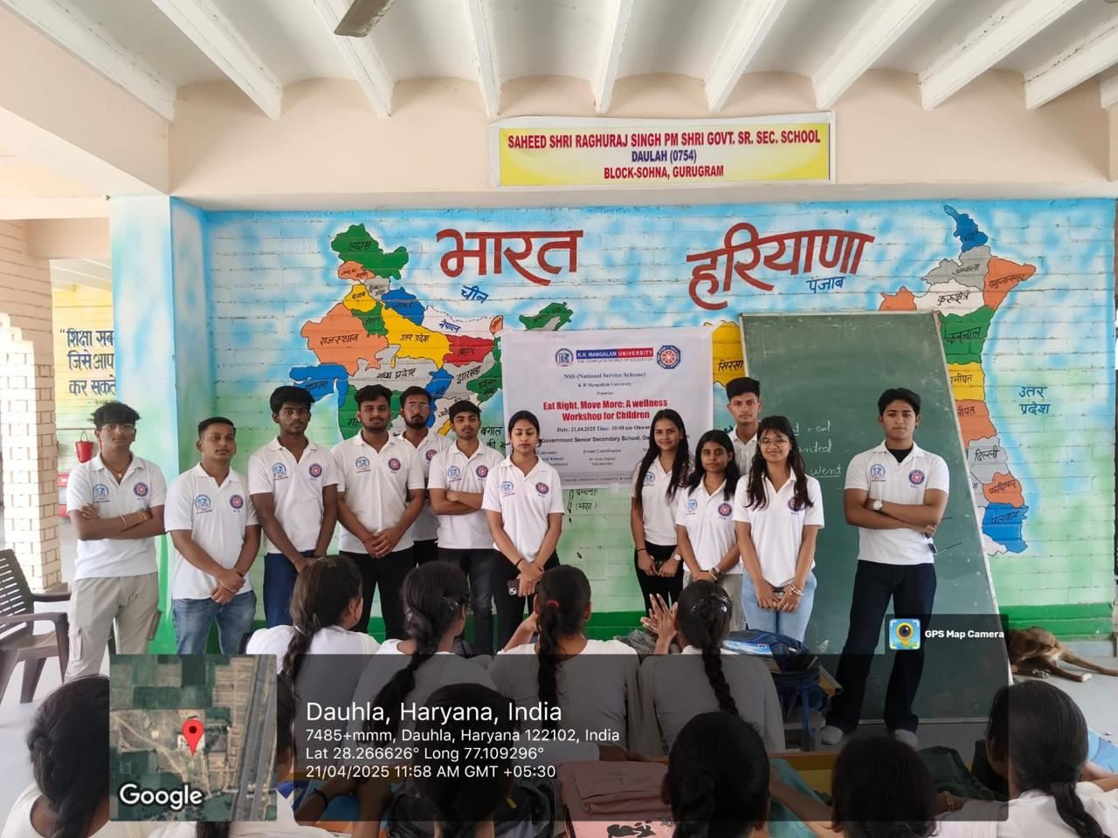

Pic 1: NSS volunteers group picture

\

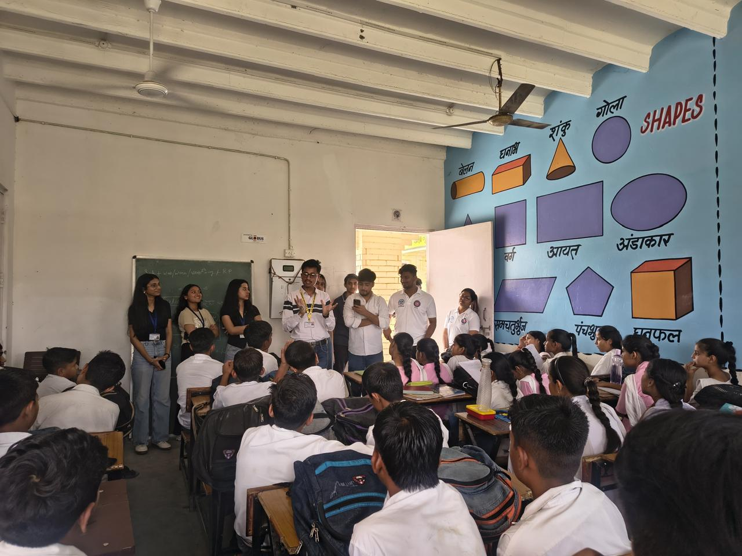

Pic 2: Interactive Q&A with students.

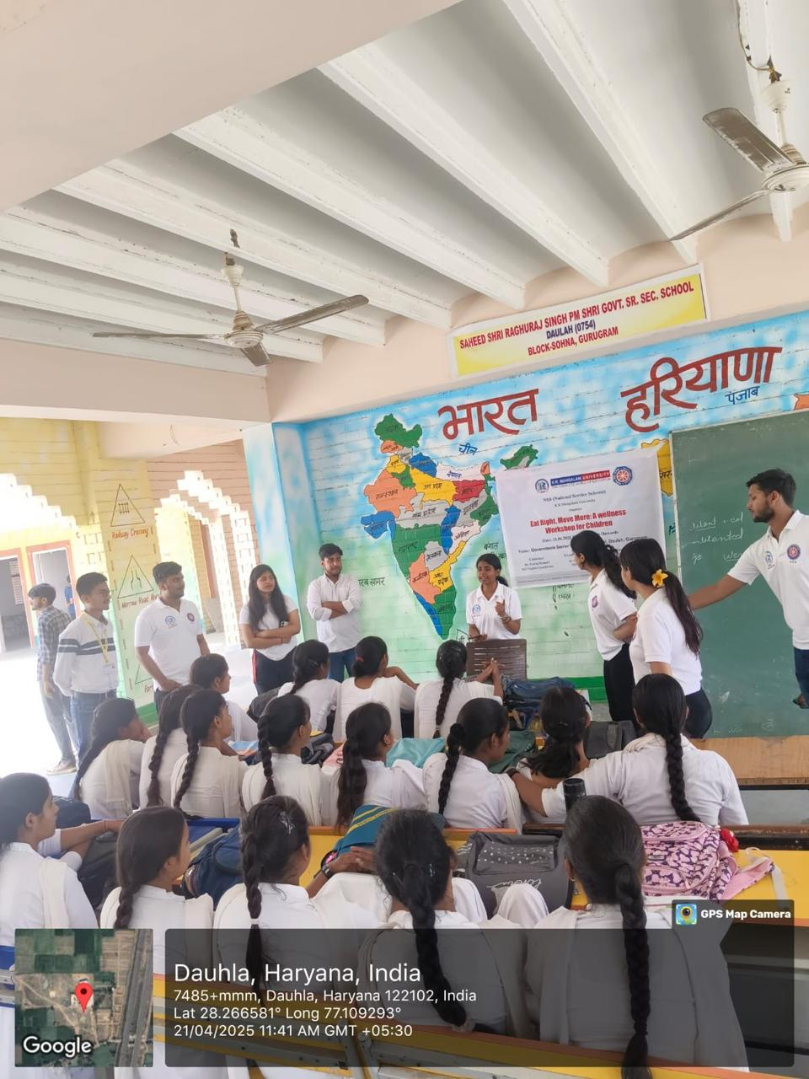

Pic 3: NSS volunteers during interactions with students.

Report Prepared by  Event Coordinator | Dr. Vicky Kapoor  Event Coordinator, NSS Unit  Assistant Professor, Physics  K. R. Mangalam University
Report Verified by
Dr. Neeraj Kumari
NSS, Program Coordinator

Report Verified by
IQAC Coordinator

