REPORT

Mortuary Visit

Date: 29th Nov 2024
Venue: Deen Dayal Upadhyay Hospital, Delhi
Type of activity: Educational Visit
Mode of Activity: Offline
Target Group: B.Sc. (Hons.) Forensic Science Students of 1st and 2nd year
Coordinator: Mr. Nitin Tyagi and Ms. Anuradha Mangla, Assistant Professor, Forensic Science, SBAS
Target Group: UG and PG Students (SBAS)
Organized by: School of Basic and Applied Sciences(Forensic Sciences )
No. of Participants: 40 students

Introduction
On 29th November 2024 40 students from the B.Sc. and M.Sc. Forensic Science programs Department of Forensic Science (SBAS) were taken for visit of Mortuary at Deen Dayal Upadhyay Hospital, Delhi. The visit was coordinated under the mentorship of Mr. Nitin Tyagi and Ms. Nitin Tyagi (Assistant Professors, Forensic Science).
Dr. Jatin Assistant Professor, Department of Forensic Medicine and Toxicology, Deen Dayal Upadhayay Hospital, Delhi demonstrated about the importance of forensic medicine to the students of B.Sc. Forensic Science and M.Sc. Forensic Science. Post Mortem was demonstrated to students describing procedures and protocols of Autopsy by Dr. Komal

Objectives of the Visit:

1. Practical Exposure to Forensic Procedures: The primary objective of the mortuary visit was to provide students with hands-on experience in forensic procedures. By witnessing post-mortem examinations first hand, students were expected to gain a deeper understanding of the techniques and processes involved in forensic investigations.

2. Application of Classroom Learning: Another key objective was to bridge the gap between theoretical knowledge acquired in the classroom and its real-world application. By observing and participating in autopsy procedures, students were encouraged to apply their academic knowledge to practical scenarios, thereby enhancing their comprehension and retention of forensic science concepts.

3. Understanding Post-Mortem Examination Protocols: The visit aimed to familiarize students with the protocols and standards followed during post-mortem examinations. By observing the systematic approach taken by forensic professionals in documenting injuries, collecting evidence, and determining cause of death, students were expected to develop a comprehensive understanding of forensic examination procedures.

4. Enhancement of Critical Thinking and Analytical Skills: Through discussions and interactions with faculty members and forensic experts, students were encouraged to critically analyse autopsy findings, identify patterns of injury, and draw conclusions based on forensic evidence. The visit aimed to foster the development of analytical skills essential for forensic science professionals.

5. Experiential Learning Opportunities: The event sought to provide students with practical exposure to the challenges and complexities encountered in real-world forensic investigations. By actively participating in the mortuary visit, students were expected to gain insights into the multifaceted nature of forensic science and develop the skills necessary to address diverse forensic challenges effectively.

Conclusion:

The mortuary visit to Mortuary at Deen Dayal Upadhyay Hospital, Delhi provided students of the Department of Forensic Science at K.R. Mangalam University with invaluable hands-on experience and practical exposure to forensic procedures. By achieving the objectives outlined above, the visit contributed significantly to the academic and professional development of the students, reinforcing the Department's commitment to excellence in forensic education and research. Moving forward, it is recommended that similar experiential learning opportunities be organized regularly to further enhance students' practical skills and prepare them for successful careers in forensic science.
Overall, the participation in visit of Mortuary was an enriching experience, offering valuable insights to the students and Faculty members.

Glimpse of Visit :

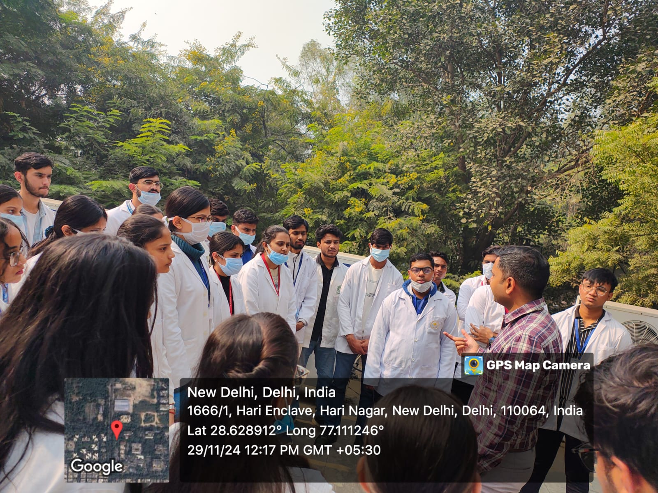
Picture 1: Dr. Jatin Demonstrating students about Forensic Medicine

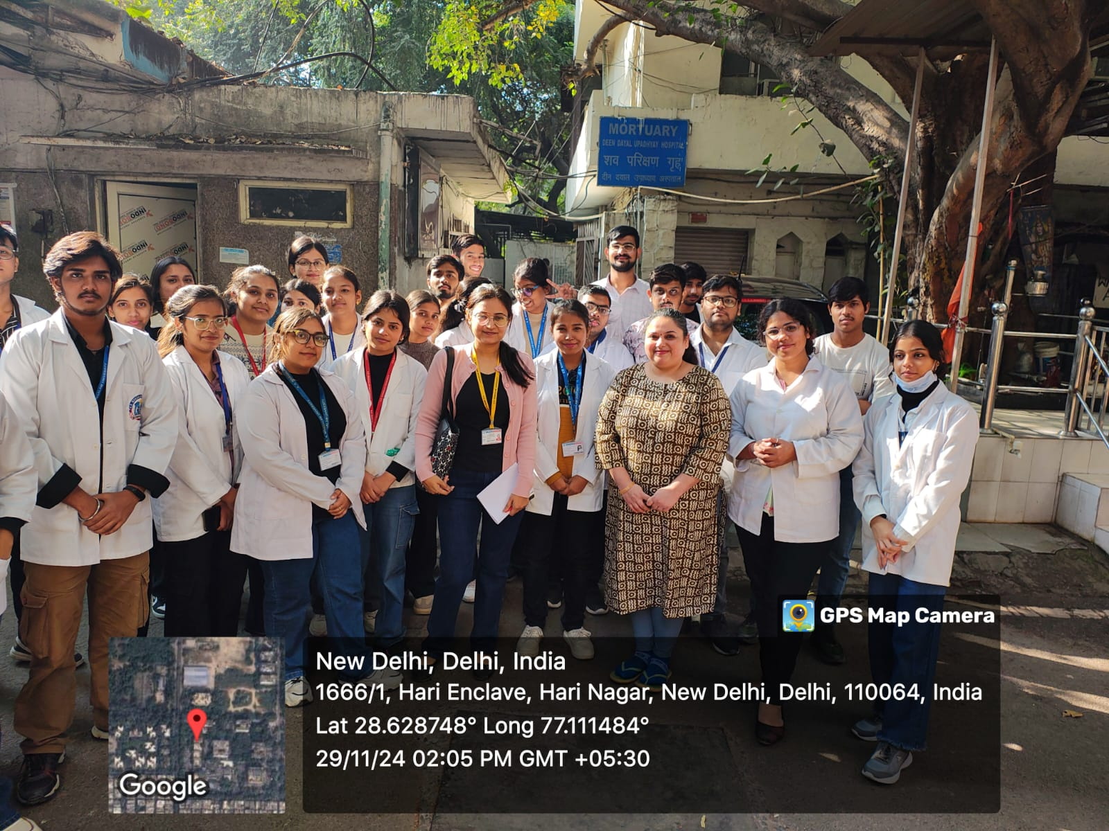
Picture 2: Dr. Komal with students

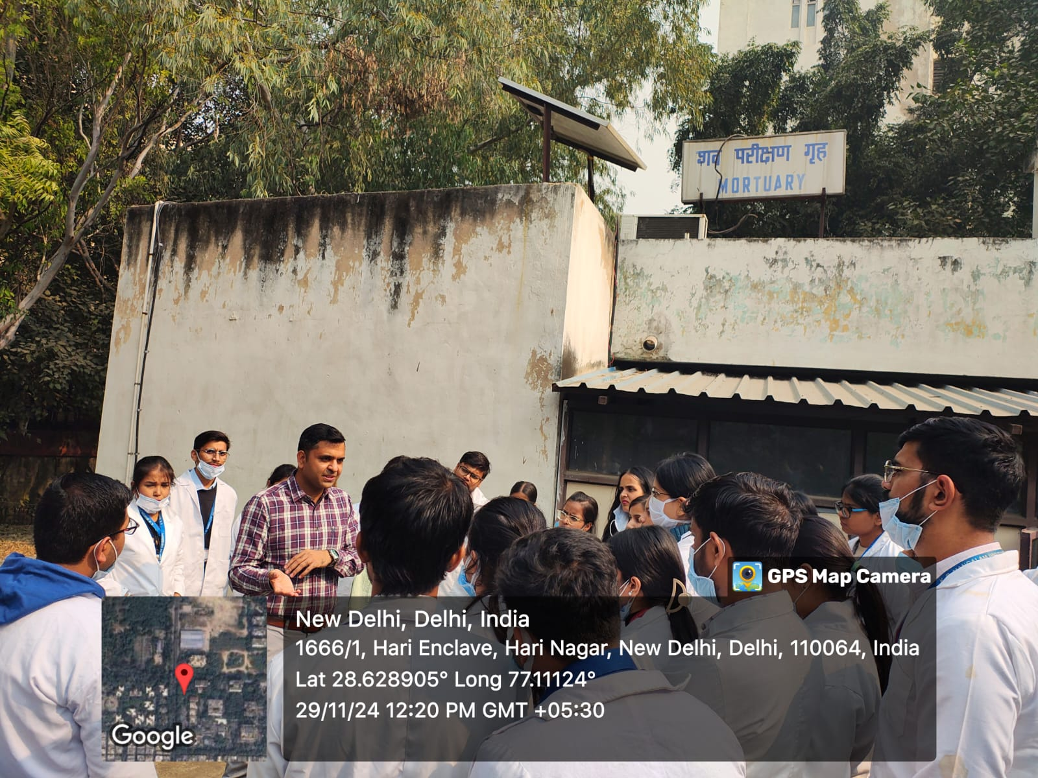
Picture 3: Dr. Jatin Demonstrating students about Forensic Medicine

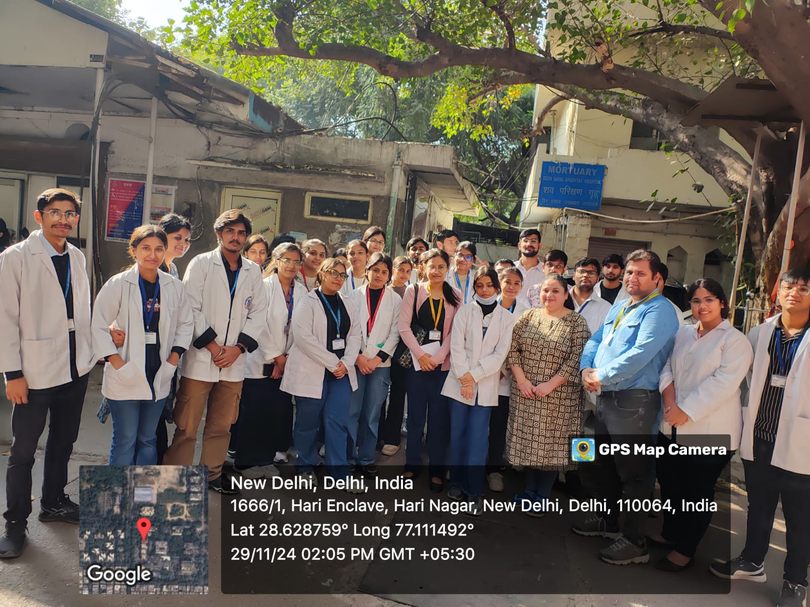
Mr. Nitin Tyagi and Dr. Komal with students

