REPORT

Expert Session

On

Teaching with Integrity: Professional Ethics Training for Educators

30th August, 2024
Date: 30 August, 2024
Venue: Room No. A306, A Block, K.R. Mangalam University
Event Type: Expert Session
Mode of Activity: Offline
Organized by: School of Education, K. R. Mangalam University, Gurugram, Haryana

Resource Person: Dr. Niradhar Dey, Associate Professor, School of Education, Indira Gandhi National Open University, New Delhi
Target group: Faculty members of SOED, K. R. Mangalam University
Number of Participants: 08
Faculty Coordinators Prof. (Dr.) P.C. Jena, Professor, School of Education (SOED), K.R Mangalam University, Gurugram, Haryana
Dr. Kanchan Khatreja, Assistant Professor, School of Education (SOED), K.R Mangalam University, Gurugram, Haryana
School of Education, K R Mangalam University was organized an expert talk entitled Teaching with Integrity: Professional Ethics Training for Educators on 30th August 2024 by inviting Dr. Niradhar Dey, Associate Professor, School of Education, Indira Gandhi National Open University, New Delhi, as a resource person. It was a momentous occasion dedicated to fostering professional ethics in the teaching profession. Dr. Niradhar Dey highlighted on key principles such as commitment to students' well-being, integrity, and respect for diversity, professional development, the role of School Management Committees, and the significance of professions in shaping mankind's destiny.
The primary objectives of this event were to improve educators' understanding of ethical issues in teaching and learning, enhance educators' ability to create inclusive, respectful, and fair learning environments, equip educators with strategies to handle ethical dilemmas in teaching effectively and to foster a commitment to lifelong learning and continuous improvement in ethical practices. Dr. Niradhar Dey’s talk not only achieved these objectives but also resonated deeply with the attendees, reaffirming the importance of honesty, integrity, accountability, respectfulness, and adherence to the law in the realm of education. The session was expertly introduced by Dr. Kanchan Khatreja, Assistant Professor, School of Education and warmly welcomed by Prof. P. C. Jena, Coordinator of the School of Education.
As a result of this event, participants gained a renewed understanding of the ethical responsibilities that come with teaching, Increased awareness and adherence to professional codes of conduct and ethical guidelines. They adopt ethical teaching practices that promote academic honesty, fairness in assessment, and respect for diversity. Dr. Niradhar Dey’s expertise and dedication to the field left a lasting impression on all participants. The event was a resounding success, emphasizing the critical role of professional ethics in the education sector and reaffirming the commitment of K R Mangalam University's School of Education to promoting ethical excellence among educators. All the faculty members of the School of Education attended the lecture.
Glimpses of the Training Programme:
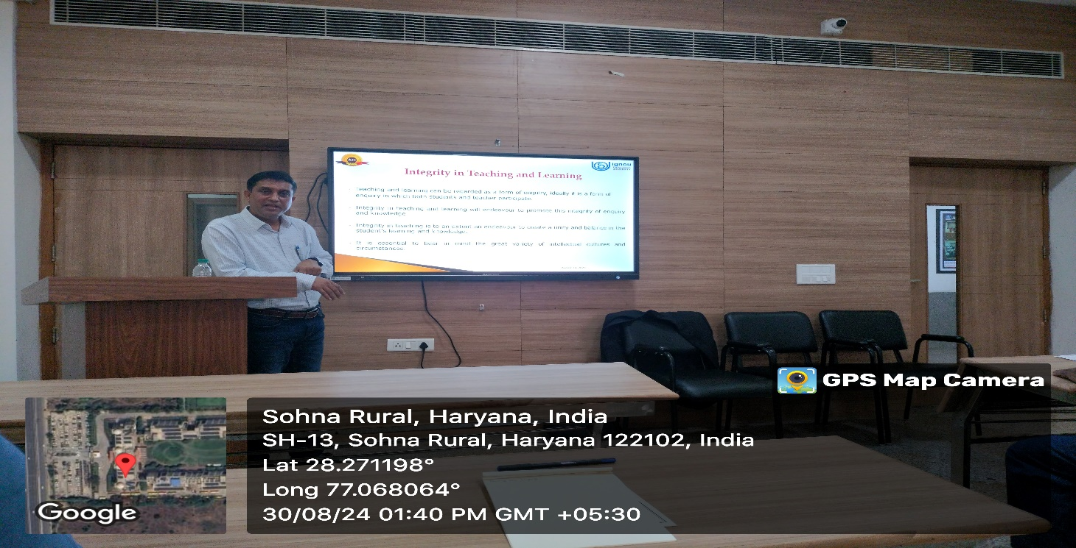
Upholding integrity in teaching and learning: Building a foundation of honesty, fairness, and respect to inspire academic excellence and ethical growth
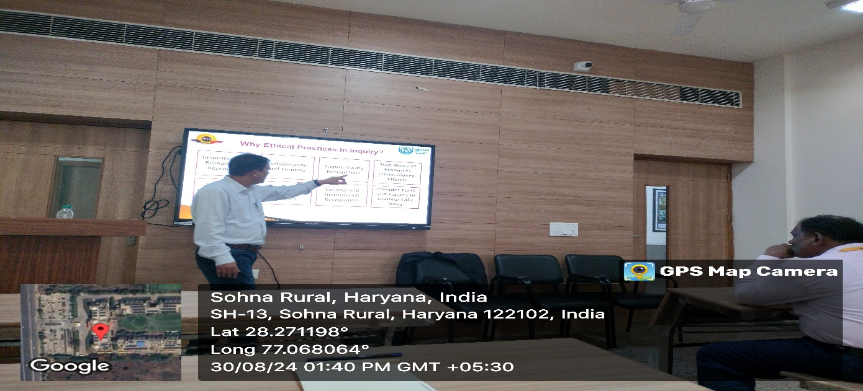
Dr. Niradhar Dey, Guest speaker shed light on the importance of ethical practices, emphasizing integrity, transparency, and responsibility as the foundation of sustainable success
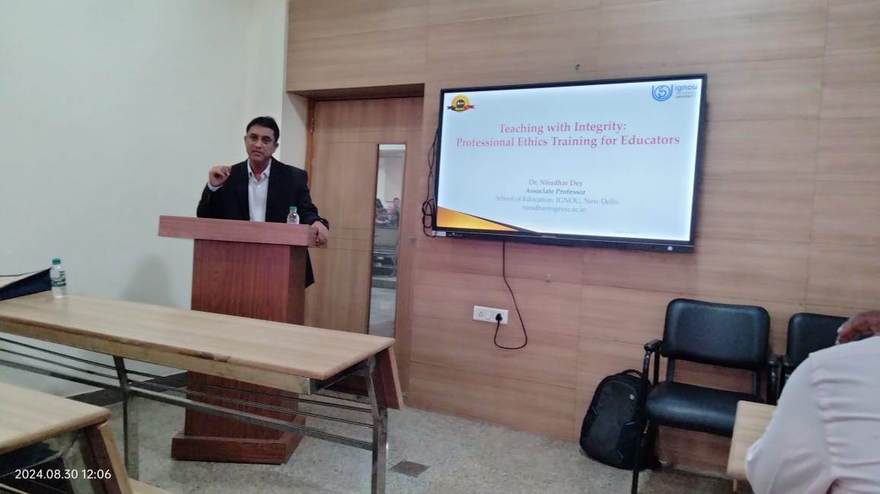
Empowering educators with the principles of professional ethics: Our speaker leads an engaging session on 'Teaching with Integrity,' fostering a culture of trust, fairness, and responsibility in education

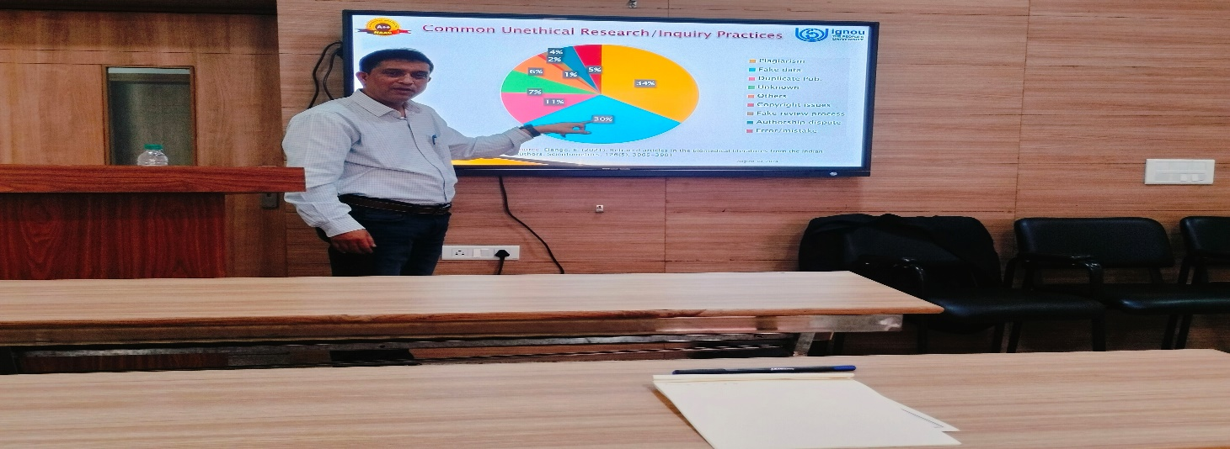
Highlighting the dangers of unethical research practices: data manipulation, plagiarism, and lack of transparency compromise the integrity of scientific inquiry
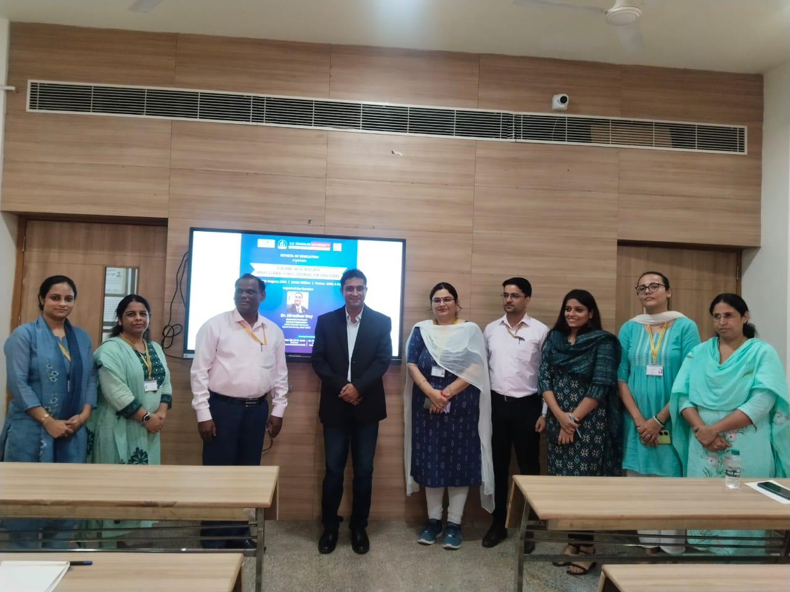

Faculty members of the School of Education with expert Dr. Niradhar Dey

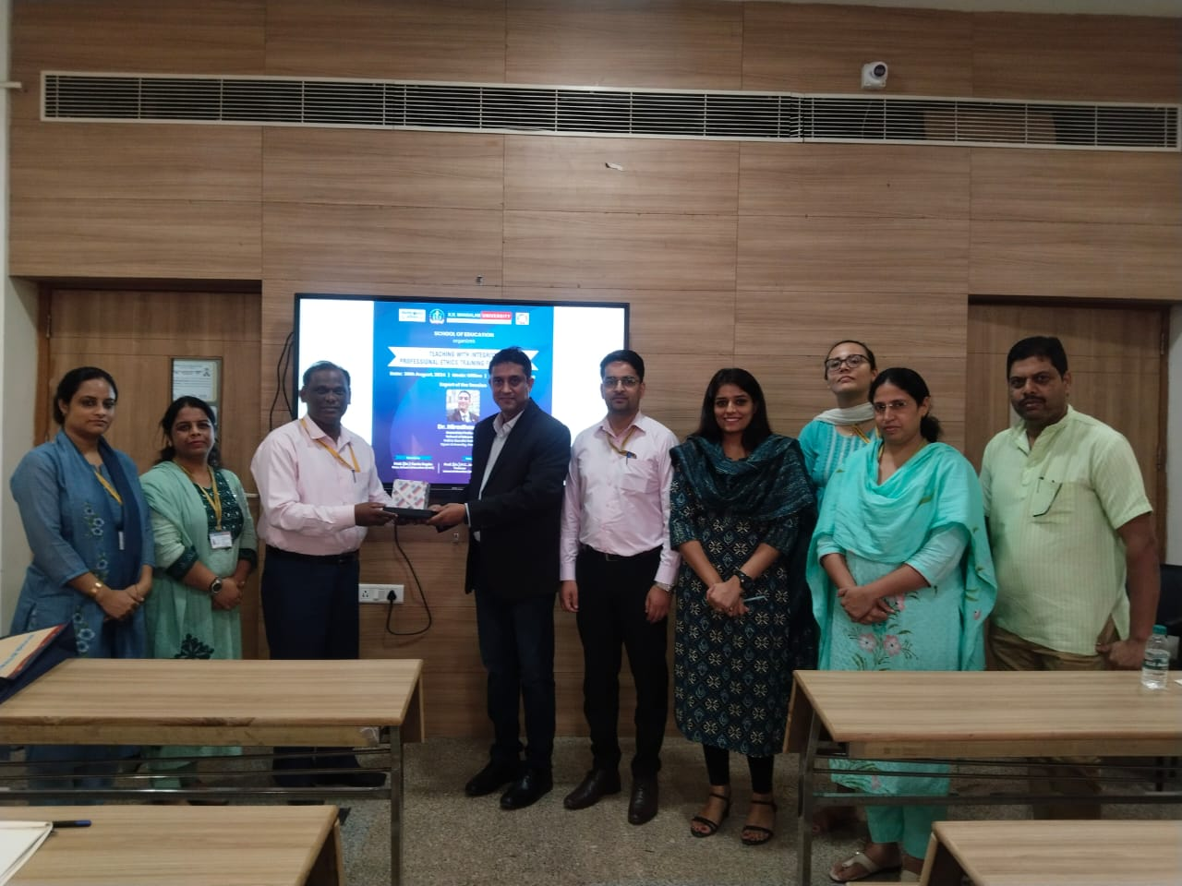
Honoring our esteemed speaker with a token of appreciation for their inspiring insights and valuable contributions

Report prepared by: | Dr. Kanchan Khatreja Assistant Professor, SOED
Report checked & verified by: | Prof. Tania Gupta  Dean, SOED
IQAC Coordinator: | Dr. Shikha Dutt Sharma

