Lecture on “Soft Skills: Strategies for Success”
Date: 25th September 2024
Venue: Multi-Purpose Hall
Event Type: Lecture
Mode of activity: offline
Target group: Students of SBAS
Organized by: School of Basic and Applied Sciences, K R Mangalam University, Sohna Road, Gurugram (Haryana).
Participants: 168
Resource Person: Ms. Tuhina Ray, Head of the Career Development Cell, K R Mangalam University, Sohna Road, Gurugram (Haryana).
Event Coordinators: Dr. Pooja Vats and Dr. Ritika Khatri
Introduction: On 25th September 2024, the School of Basic and Applied Sciences at K R Mangalam University organized a highly enriching lecture titled “Soft Skills: Strategies for Success.” The lecture, delivered by Ms. Tuhina Ray, the Head of the Career Development Cell at K R Mangalam University, Sohna, aimed at underscoring the importance of soft skills in achieving success in both academic and professional arenas. The event was held in the Multi-Purpose Hall from 10:30 am onwards and saw a participation of 168 students. The session was an excellent opportunity for students to understand how the development of soft skills can play a significant role in shaping their career prospects.
Objectives: The primary objective of the lecture was to create awareness among students about the vital role of soft skills in personal and professional growth. Soft skills, such as communication, teamwork, adaptability, problem-solving, and emotional intelligence, are essential in the modern workplace and academic settings. The lecture aimed to:
1. Highlight the significance of soft skills in enhancing employability.
2. Provide students with strategies to develop and refine their soft skills.

3. Encourage students to understand how these skills contribute to overall success.
4. Equip students with the tools to confidently approach their academic and professional goals.
Content: The lecture was marked by its interactive and insightful content. Ms. Tuhina Ray began by introducing the concept of soft skills and discussing their increasing relevance in today’s competitive world. She provided a detailed analysis of various soft skills, including communication, leadership, problem-solving, time management, and emotional intelligence, emphasizing their importance in professional environments. Through real-world examples and engaging stories, Ms. Ray demonstrated how these skills are often the differentiators in hiring decisions and career advancements.
One of the key highlights of the lecture was the practical approach Ms. Ray adopted while discussing strategies for soft skills development. She encouraged students to actively participate in workshops, internships, and extracurricular activities to develop these competencies. Additionally, Ms. Ray emphasized the role of self-awareness and continuous learning in mastering soft skills.
The session was designed to be interactive, with Ms. Ray engaging the students through thought-provoking questions and group discussions. The attendees were encouraged to share their thoughts on soft skills they believe are important for their future success. This interaction fostered a collaborative learning environment, where students could reflect on their own abilities and areas for improvement.
Conclusion: In conclusion, the lecture on "Soft Skills: Strategies for Success" proved to be an invaluable session for the students of the School of Basic and Applied Sciences. Ms. Tuhina Ray’s insights provided clarity on the importance of soft skills and how they are indispensable in today’s academic and professional spheres. The session highlighted that while technical knowledge is crucial, soft skills complement and enhance one's ability to thrive in real-world environments.
Event Outcome: The lecture successfully met its objectives, leaving the students with a deeper understanding of the significance of soft skills in their academic and professional growth. Some key outcomes of the event include:
- Increased Awareness: Students gained a clearer perspective on the importance of soft skills in shaping their future careers.
- Motivation to Improve Soft Skills: Many students expressed their intention to focus on honing their soft skills through self-improvement techniques and participation in various activities.
3.

3. Enhanced Engagement: The interactive format of the lecture fostered increased student engagement and participation, encouraging them to take an active role in their personal and professional development.
4. Positive Feedback: The event received positive feedback from the participants, who found the session both informative and inspiring.
Overall, the lecture was a significant contribution to the development of students’ soft skills, equipping them with valuable strategies to excel in their academic pursuits and future professional endeavours.
Future Prospect:
- Enhanced Employability: Soft skills like communication, teamwork, and problem-solving are highly valued by employers, boosting career opportunities and growth.
- Leadership Development: Builds essential skills for leading teams, resolving conflicts, and making decisions in professional settings.
- Workplace Efficiency: Promotes effective collaboration and adaptability, fostering a productive and harmonious work environment.
- Personal Branding: Strengthens professional image through confidence, communication, and etiquette, aiding in networking and career advancement.
- Global Competence: Prepares individuals for multicultural work environments by enhancing cultural sensitivity and adaptability.
Geotag photos with captions:
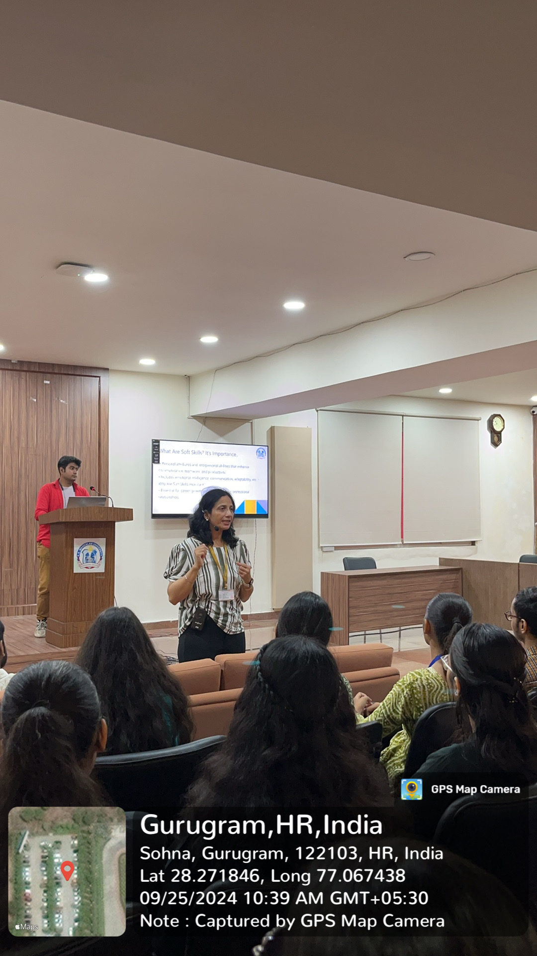
Photo1: Lecture delivered by Ms. Tuhina Ray

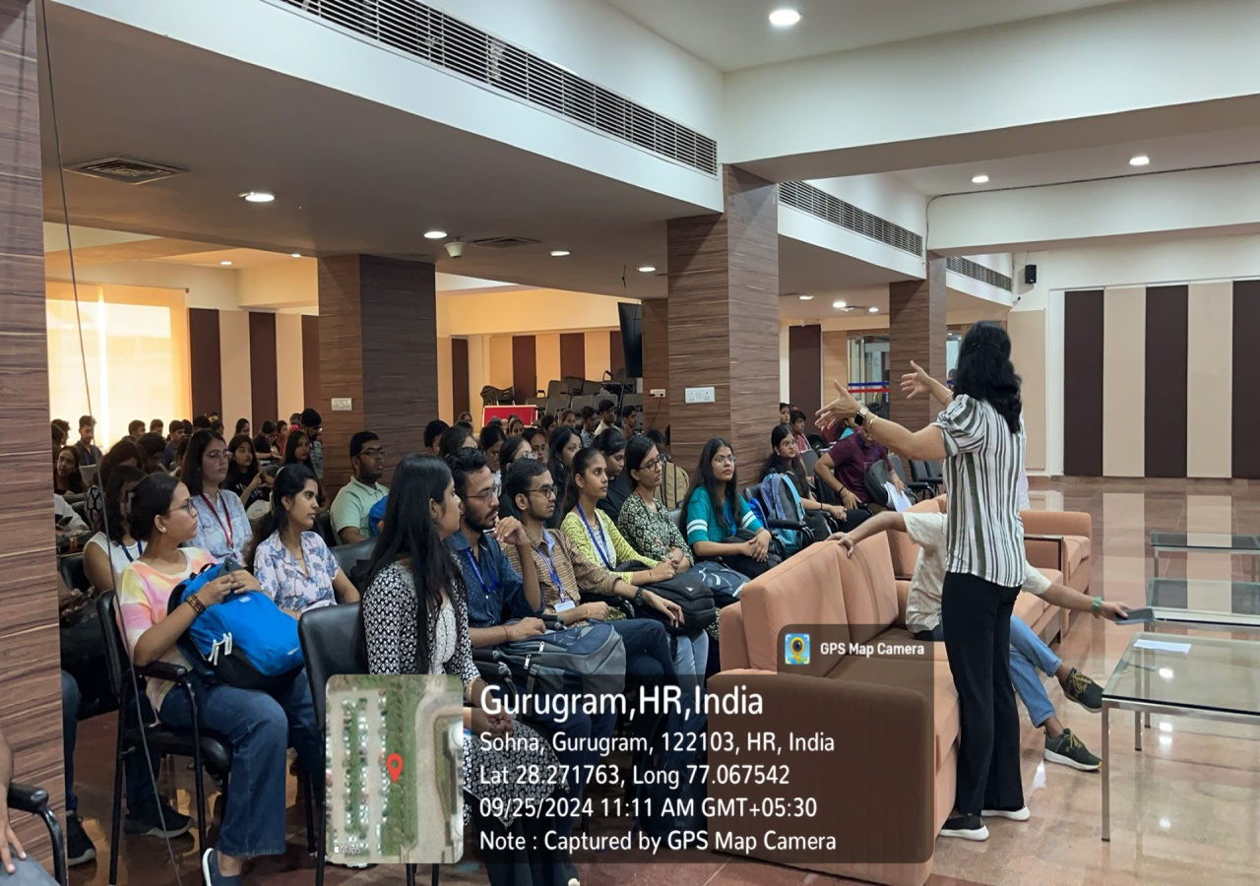
Photo2: Students listening to the speaker
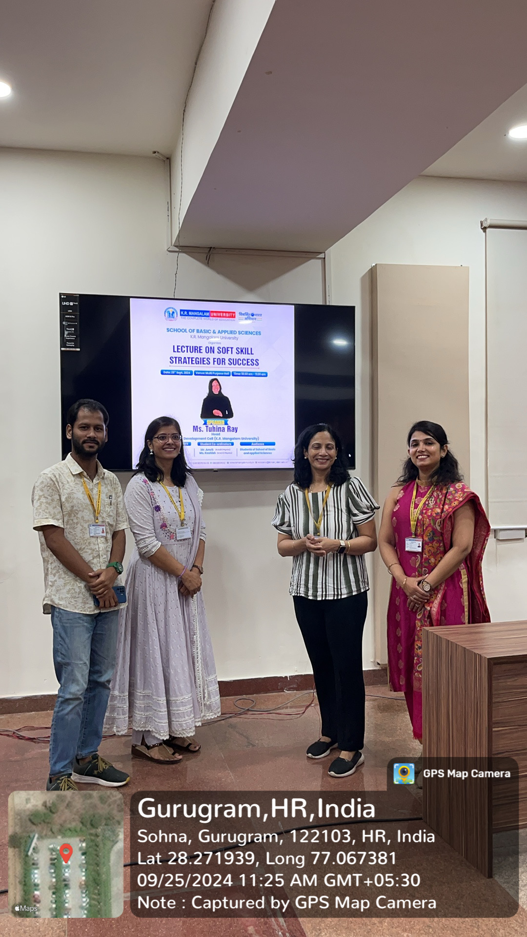
Photo3: Successful Completion of event

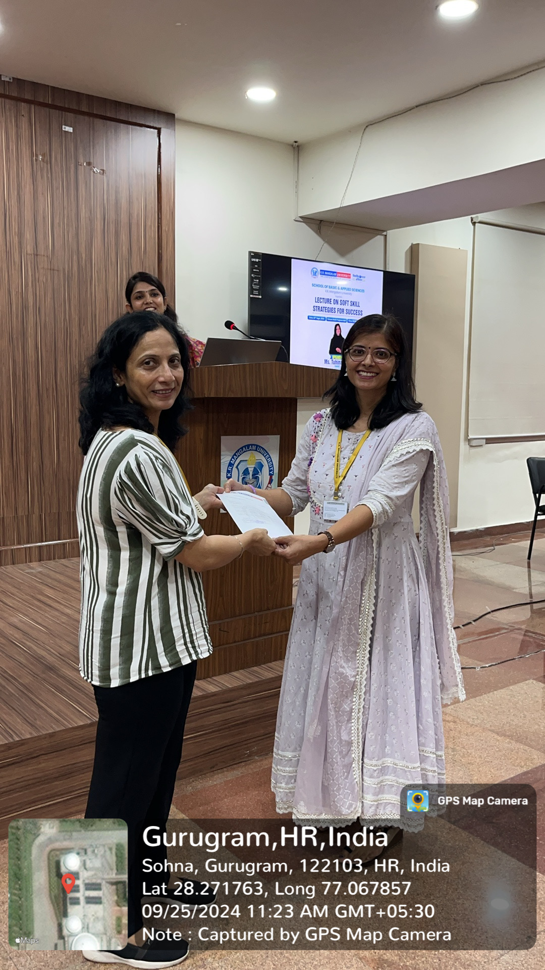
Photo4: Expression of Gratitude

