SOCIAL IMPACT, EQUALITY, KNOWLEDGE EXCHANGE
AND HEALTH & WELLBEING REPORT
2022-23, 2023-24, 2024-25
K.R. Mangalam University (KRMU)

INDEX
A. Support for Persons with Disabilities (Divyangjan) – EQ7 / SDG 10
A1. Introduction and Institutional Commitment
A1.1 Alignment with RPwD Act, 2016
A1.2 Alignment with UGC Accessibility Guidelines
A1.3 Alignment with UN SDGs (SDG 10: Reduced Inequalities)

A2. Existence of Disability Support Office (Divyangjan Cell)
A2.1 Establishment and Mandate of the Divyangjan Cell
A2.2 Composition and Participatory Governance (administration, faculty, students, HR, PwD representation)
A2.3 Functions: policy implementation, record maintenance, surveys, grievance redressal
A2.4 Evidence (EQ7.1)
- Revised Divyangjan Policy (2024)
- Divyangjan Policy (2017)
- SDG 10 Report 2023–24

A3. Campus Accessibility for Persons with Disabilities
A3.1 Barrier-Free Campus Framework (Harmonised Guidelines for Universal Accessibility, 2021)
A3.2 Physical Accessibility Measures
- Ramps with handrails
- Elevators and wheelchair-friendly corridors
- Tactile paths
- Accessible classrooms, laboratories, library and auditoriums
- Accessible restrooms, designated parking, wheelchair facilities
A3.3 Evidence (EQ7.2)
- Revised Divyangjan Policy
- SDG 10 Report 2023–24 (Section 10.6.7: Accessible Facilities)
- Divyangjan Policy (Sections 7.3 and 7.4: Barrier-Free Infrastructure & Hostel Support)

A4. Access Schemes and Support Services
A4.1 Faculty Mentoring System for Divyangjan Students
A4.2 Academic Accommodations
- Accessible learning materials
- Assistive technologies
- Note-takers / scribes
- Flexible deadlines and alternative assessment modes
- Extended examination time
A4.3 Central Assistive Technology Hub
- Screen readers (NVDA), magnifiers, speech-to-text tools
- WCAG 2.1 AA compliant digital platforms
A4.4 Counselling and Psychosocial Support (WE-DOST Counselling Cell)
A4.5 Evidence (EQ7.3)
- Revised Divyangjan Policy (Sections 6.1, 6.4, 6.8)
- SDG 10 Report 2023–24 (Sections 10.6.6 and 10.6.9)
- Divyangjan Policy (Sections 7.1 and 7.5)

A5. On-Campus Accommodation for Persons with Disabilities
A5.1 Inclusive Hostel Infrastructure
- Ground-floor rooms
- Wheelchair-accessible entrances
- Accessible washrooms
- Emergency alarm systems
- Priority assistance protocols
A5.2 Evidence (EQ7.4)
- Revised Divyangjan Policy (Hostel accommodation provisions)
- Divyangjan Policy (Section 7.4)

A6. Policy on Reasonable Adjustments and Funding
A6.1 Reasonable Accommodation Framework
A6.2 Financial and Institutional Support Measures
- Fee concessions and financial assistance
- Procurement of assistive devices and software
- Medical and wellness support
- Facilitation of scholarships (e.g., NFPwD)
- Annual budget provisions for accessibility infrastructure and training
A6.3 Evidence (EQ7.4 / EQ7.5 as applicable)
- Revised Divyangjan Policy (Sections 6.7 and 6.8)
- Divyangjan Policy (Section 7.4)
- SDG 10 Report 2023–24 (Sections 10.6.10 and 10.6.8)
A7. Additional Institutional Commitments
A7.1 Zero-Tolerance Anti-Discrimination Policy (Disability)
A7.2 Mandatory Annual Sensitisation Programmes
A7.3 Dedicated Grievance Redressal Committee for Divyangjan
A7.4 Periodic Accessibility Audits and Annual Reporting to IQAC
A7.5 Evidence
- Revised Anti-Discrimination Policy (2024)
- Anti-Discrimination Policy (2018)

A8. Conclusion
A8.1 Summary of Institutional Mechanisms and Support
A8.2 Alignment with QS / SDG Outcomes and Measurable Impact

B. Health & Wellbeing – HW2
B1. HW2.1 Provision of Healthy and Affordable Food Options on Campus
B1.1 Introduction and Rationale (food security, wellbeing, affordability)
B1.2 On-Campus Food Facilities (cafeterias, hostel messes)
B1.3 Pricing, Quality Monitoring and Transparency (menus and rate charts)
B1.4 Food Waste Reduction and Responsible Consumption
B1.4.1 Behavioural Interventions and Awareness Campaigns
- Signboards and digital displays (e.g., “Serve What You Can Eat”)
B1.4.2 Portion control and serving-size options
B1.5 Utilisation of Food Waste through Biogas Plant
B1.5.1 Waste-to-energy system and circular food economy
B1.5.2 Outputs: renewable energy, organic manure
B1.6 Composting and Vermicomposting
B1.6.1 Segregation of waste (organic/inorganic)
B1.6.2 Compost application in campus gardens and farms
B1.7 Food Access and Support Mechanisms
B1.7.1 Student Welfare Support
- Subsidised meal plans
- Free meal coupons
- Community kitchens / redistribution
- Nutritional awareness programmes
B1.7.2 Staff Welfare Support
- Subsidised staff meals (e.g., ₹50)
- Free meal coupons/allowances (Employee Welfare Scheme)
- “KRMU Ann Seva” initiatives
- Emergency food support mechanism
B1.8 Sustainable Food Choices
B1.8.1 Plant-based and balanced diet options
B1.8.2 Local/seasonal procurement practices
B1.8.3 Ban on single-use plastics in dining
B1.8.4 Hydration and refill stations
B1.9 Conclusion (HW2.1 outcome statement)
B1.10 Evidence / URLs / Photographs Index (to be annexed)

B2. HW2.2 Access to Physical Healthcare Services on Campus
B2.1 Introduction (medical access and campus safety)
B2.2 On-Campus Medical & Health Centre (services and operating mechanism)
B2.3 Academic Strengthening through Health Schools
- School of Medical and Allied Sciences (SMAS)
- School of Physiotherapy and Rehabilitation Sciences (SPRS)
B2.4 Institutional Healthcare Linkages and Emergency Referral Support
B2.5 Preventive Care Measures and Regular Health Camps
- BP, sugar, BMI, eye check-ups etc.
B2.6 Health Education and Awareness Initiatives (NSS/Health Society/Red Cross)
B2.7 Conclusion (HW2.2 outcome statement)
B2.8 Evidence / URLs and Required Reports
- Health check-up camp reports
- Blood donation camp reports

B3. HW2.3 Sexual and Reproductive Health-Care Services (Including Information & Education)
B3.1 Introduction and Institutional Commitment
B3.2 Policies and Institutional Mechanisms
- Gender Equity and Sensitivity Policy
- Gender Sensitization and Safety Committee
- Internal Complaints Committee (ICC)
B3.3 Infrastructure and Facilities for Women
- Sanitary napkin vending machines and incinerators
- Medical rooms (resident nurses and on-call doctors)
- She Boxes for confidential reporting
B3.4 Awareness and Education Initiatives (monthly sessions and campaigns)
B3.5 Conclusion (HW2.3 outcome statement)
B3.6 Evidence / URLs / Screenshots Index (to be annexed)

B4. HW2.4 Access to Mental Health Support for Students and Staff
B4.1 Introduction (holistic wellbeing and safe campus environment)
B4.2 WE-DOST Counselling Centre – Structure and Services
B4.3 Confidential Counselling Services (students and staff)
B4.4 Workshops and Group Sessions (NSS/Health Committee/student clubs)
B4.5 Conclusion (HW2.4 outcome statement)
B4.6 Evidence / URL (Counselling & Mental Wellbeing Centre page)

- Support for Persons with Disabilities (Divyangjan) – EQ7 / SDG 10
A1. Introduction and Institutional Commitment
The institution has a current and comprehensive Equality, Diversity and Inclusion (EDI) Policy that reflects its commitment to fostering an inclusive, equitable, and non-discriminatory academic environment. The policy applies to all stakeholders, including students, faculty, staff, and visitors, and is integrated into institutional governance and operational practices.
The Equity, diversity, Inclusion (EDI) Policy is formally approved by competent authority and serves as an official guiding document for promoting equal opportunities, preventing discrimination, and ensuring dignity and respect across the campus. Implementation is supported through institutional mechanisms, awareness initiatives, and grievance redressal systems to ensure effective enforcement and accountability.
The policy explicitly addresses a wide range of protected characteristics, including:
- Age
- Gender and gender reassignment
- Disability
- Race and ethnicity
- Religion or belief
- Sexual orientation
- Marriage and civil partnership
- Refugees and asylum seekers
- Pregnancy and maternity
Link for Policy
By covering these protected characteristics, the institution demonstrates alignment with global best practices in equality and inclusion. The policy strengthens institutional culture, enhances stakeholder well-being, and supports diversity as a core value contributing to academic excellence and social responsibility.

A2. Institutional Support for Persons with Disabilities (Divyangjan)
K.R. Mangalam University (KRMU) is firmly committed to building an inclusive, accessible, and equitable academic environment for persons with disabilities (Divyangjan). The University aligns its policies and practices with the Rights of Persons with Disabilities (RPwD) Act, 2016, UGC Accessibility Guidelines, and the UN Sustainable Development Goals, particularly SDG 10: Reduced Inequalities.

A2.1 Existence of Disability Support Office / Divyangjan Cell

K.R. Mangalam University has a formally established Divyangjan Cell, which functions as the nodal body for disability inclusion, support services, and grievance redressal. The Cell is responsible for:

Implementation of disability-related policies

Maintenance of records and documentation

Conducting need-based surveys and audits

Facilitating academic and infrastructural accommodations

Addressing grievances of Divyangjan students and staff

The Divyangjan Cell comprises senior administrators (Dean Students Welfare), faculty representatives, student representatives, HR officials, and representation from persons with disabilities, ensuring participatory and inclusive governance.

This institutional mechanism ensures that disability inclusion is systematically integrated into academic, administrative, and infrastructural decision-making.

Evidence
- Link Revised Divyangjan Policy (2024)
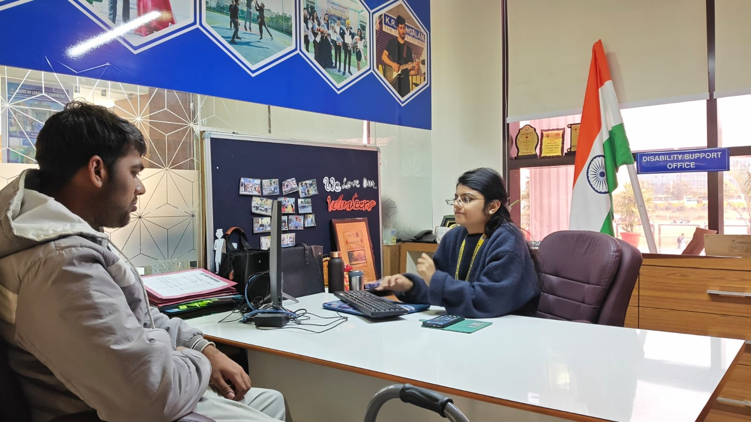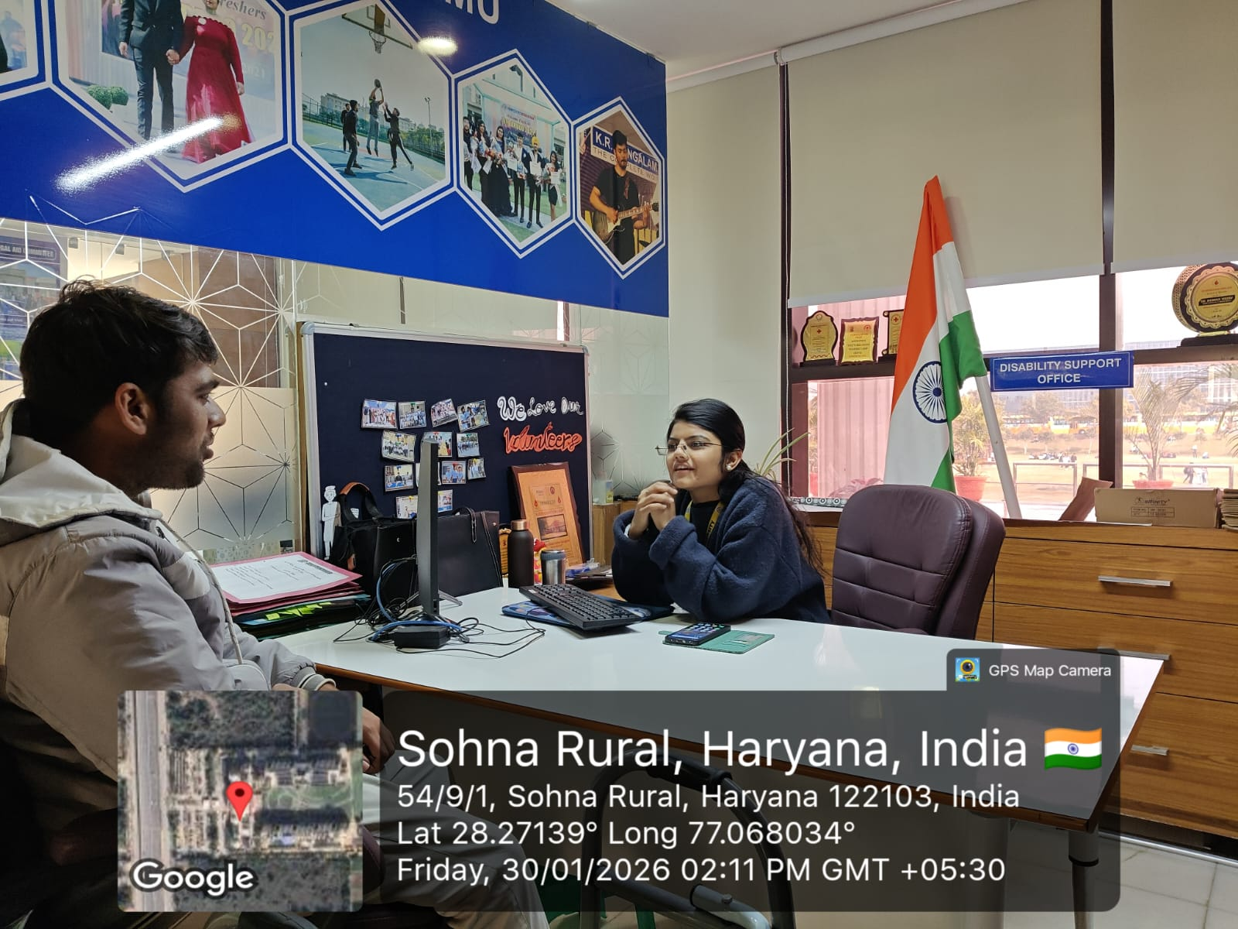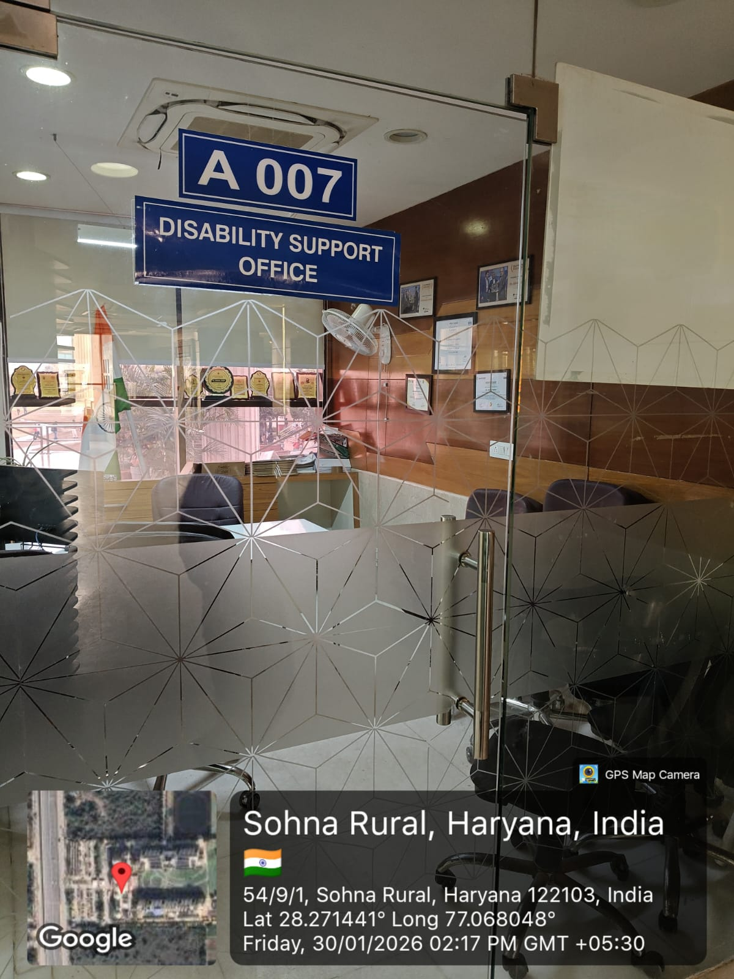
A3. Accessible Campus Infrastructure
K.R. Mangalam University maintains a barrier-free campus, developed in accordance with the Harmonised Guidelines and Standards for Universal Accessibility (2021). The University has implemented extensive physical accessibility measures to ensure safe and independent mobility for persons with disabilities.
Key accessibility features include:
- Ramps with handrails
- Elevators and wheelchair-friendly corridors
- Tactile pathways for visually impaired persons
- Accessible classrooms, laboratories, libraries, and auditoriums
- Accessible restrooms with grab bars
- Designated parking spaces
- Wheelchair facilities across academic and residential blocks
These measures ensure universal access to learning spaces, residential facilities, and common areas.
Evidence
- Revised Divyangjan Policy

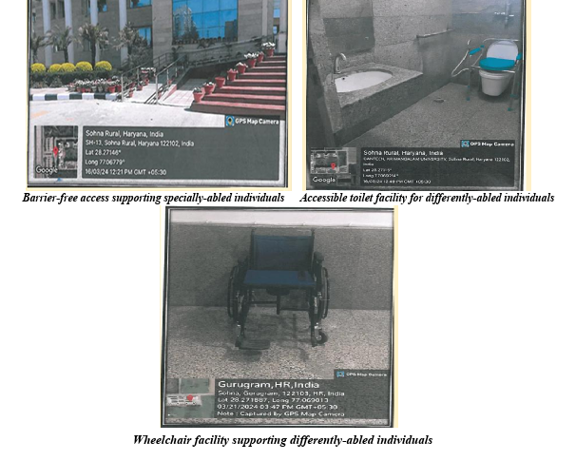

A4. Access Schemes and Academic Support for Persons with Disabilities

KRMU provides structured academic, mentoring, and psychosocial support schemes for students with disabilities to ensure equity in learning outcomes and campus participation.

Key support mechanisms include:

Allocation of a faculty mentor to each Divyangjan student

Accessible learning materials and digital resources

Assistive technologies and software

Provision of note-takers, scribes, and readers

Flexible deadlines and alternative assessment modes

Extended examination time, as per need

The University operates a Central Assistive Technology Hub, equipped with:

Screen readers (NVDA)

Screen magnifiers

Speech-to-text tools

Accessible digital platforms compliant with WCAG 2.1 AA standards

Psychological and emotional support is provided through the WE-DOST Counselling Cell, ensuring mental well-being, continuity of education, and holistic development.

Evidence
- Revised Divyangjan Policy, Sections 6.1, 6.4, and 6.8: Learning Support, Mentoring, and A5. On-Campus Accommodation for Persons with Disabilities
K.R. Mangalam University offers inclusive on-campus accommodation for students with disabilities. Hostel facilities include ground-floor rooms, wheelchair-accessible entrances, attached accessible washrooms, emergency alarm systems, and priority assistance during medical or mobility-related needs. Residential arrangements are designed to ensure safety, comfort, and independence for Divyangjan students.
A6. Policy on Reasonable Adjustments and Institutional Funding
The University has a clearly articulated policy framework for reasonable accommodations, supported by institutional funding. Provisions include financial assistance, fee concessions, procurement of assistive devices and software, medical and wellness support, and facilitation of government scholarships such as the National Fellowship for Persons with Disabilities (NFPwD). Annual budgetary provisions are made for accessibility infrastructure, digital inclusion, and training programs.

Evidence
- Revised Divyangjan Policy, Sections 6.7 and 6.8: Hostel Accommodation and Financial Support
Revised-Divyangjan-Policy
A7. Additional Institutional Commitments (Public Information)
- A Zero-Tolerance Anti-Discrimination Policy explicitly prohibits discrimination on the basis of disability across admissions, academics, employment, and campus life.
- Mandatory awareness and sensitization programs are conducted annually for students, faculty, and staff.
- A dedicated Grievance Redressal Committee for Divyangjan ensures time-bound resolution of complaints.
- Periodic accessibility audits and annual reporting to IQAC reinforce accountability and continuous improvement.
Evidence:
- Link Revised Policy
- Link Policy

Through robust institutional mechanisms, inclusive infrastructure, targeted academic and mentoring support, accessible accommodation, and comprehensive policy frameworks, K.R. Mangalam University demonstrably provides strong and measurable support to persons with disabilities.
Through robust policy frameworks, institutional mechanisms, accessible infrastructure, targeted academic and mentoring support, inclusive accommodation, and sustained financial commitment, K.R. Mangalam University provides strong, systematic, and measurable support to persons with disabilities, reflecting its deep commitment to equity, dignity, and inclusive excellence.
EQ* - Equality
Introduction — Mandatory Annual Training on Social Aspects of Sustainability
At K.R. Mangalam University (KRMU), we are committed to fostering a culture of sustainability that goes beyond environmental stewardship to include social responsibility, equity, inclusiveness, and ethical engagement. As part of this commitment, the University provides mandatory annual dedicated training on the social aspects of sustainability for all staff members, including faculty and professional/support staff.
This initiative is designed to build awareness, develop competencies, and embed sustainability principles into everyday academic and administrative practices. The training covers key thematic areas including:
- Sustainable development goals (SDGs) with emphasis on social dimensions
- Diversity, equity and inclusion in the workplace
- Ethical conduct and responsible behavior
- Community engagement and social impact
- Human rights, gender sensitization and workplace safety
- Well-being and mental health in university settings
Training Design and Monitoring
The programmes are delivered through a blended learning approach, including expert-led workshops, faculty development programmes, seminars, alumni talks, field visits, and reflective learning activities. Participation in these trainings is centrally monitored, and completion records are maintained by the University through HR and academic quality assurance mechanisms, ensuring systematic integration into continuous professional development.

Serial No | Name of Event | Organised By | Date of Event | Link
1 | Capacity Development of Govt. School Teachers on the Use of Educational Technology in Pedagogy and Assessment | School of Education, K.R. Mangalam University | 02–17 May 2024 | Report
2 | Communicate to Lead: Capacity Development Programme on Interpersonal Communication and Team Building Soft Skills | School of Education & Career Development Centre, KRMU | 27 Oct – 17 Nov 2025 | Report
3 | Two-Day International E-Conference CTPDCON ERA 2023 on Educational Reforms & Advancements | School of Education, KRMU & CTPD | 14–15 Oct 2023 | Report
4 | Dealing with Change and Uncertainty: Capacity Development Training Program on Soft Skills | School of Education, KRMU | 21 Jan 2025 | Report
5 | Workshop on Pitching and Communication Skills for Entrepreneurs | School of Education & KEIC | 09 Dec 2024 | Report
6 | Session on Work Life Balance and Well Being (Alumni Talk) | School of Education, KRMU | 16 Oct 2024 | Report
7 | Teaching with Integrity: Professional Ethics Training for Educators | School of Education, KRMU | 30 Aug 2024 | Report
8 | Educational Autopsy Visit to AIIMS, New Delhi | School of Basic and Applied Sciences, KRMU | 27 Mar 2025 | Report
9 | Educational Visit to All India Forensic Science Summit 2025 | School of Basic and Applied Sciences, KRMU & NFSU | 14–15 Apr 2025 | Report
10 | Alumni Lecture: Fostering Future Minds – Evolving Role of Science in Education | School of Basic and Applied Sciences, KRMU | 29 Nov 2024 | Report
11 | Code of Conduct for Students Training Programme | School of Basic and Applied Sciences, KRMU | 28 Aug 2024 | Report
12 | Journey Beyond Campus: Alumni Insight Session | School of Basic and Applied Sciences, KRMU | 04 Apr 2025 | Report
13 | Mastering Communication Skills for Personal and Professional Growth | School of Basic and Applied Sciences, KRMU | 22 Apr 2025 | Report
14 | Professional Ethics for Teachers Seminar | School of Basic and Applied Sciences, KRMU | 24 Apr 2025 | Report
15 | Visit to Centre for Advanced Materials and Devices, BML Munjal University | School of Basic and Applied Sciences, KRMU | 04 Dec 2024 | Report
16 | Training Programme on Professional Ethics | School of Basic and Applied Sciences, KRMU | 28 Aug 2024 | Report
17 | Quality Assurance in Higher Education Seminar | School of Basic and Applied Sciences & IQAC, KRMU | 10 Apr 2025 | Report
18 | Faculty Development Programme on Imperatives of Indian Knowledge System | School of Basic and Applied Sciences, KRMU | 19–24 May 2025 | Report
19 | Educational Visit by Gargi College (Delhi University) under MoU | School of Basic and Applied Sciences, KRMU | 04 Sep 2024 | Report
20 | Lecture on Soft Skills: Strategies for Success | School of Basic and Applied Sciences, KRMU | 25 Sep 2024 | Report
21 | Educational Mortuary Visit to Deen Dayal Upadhyay Hospital, Delhi | School of Basic and Applied Sciences, KRMU | 29 Nov 2024 | Report

Capacity Development of Govt. School Teachers on the Use of Educational Technology in Pedagogy and Assessment in Ghamroj and Alipur Villages
This case study focuses on the capacity development of government school teachers in the rural villages of Ghamroj and Alipur, Gurugram, with respect to the use of educational technology in pedagogy and assessment. The study highlights the growing importance of educational technology in improving teaching–learning processes, particularly in rural areas where access to quality educational resources remains limited. A mixed-method research design was adopted, involving pre-test and post-test assessments, hands-on training sessions, focus group discussions, and classroom observations.
The baseline assessment revealed that the majority of teachers had limited technological competence, especially in using basic digital tools such as Gmail, Google Forms, Canva, PowerPoint, Learning Management Systems, and online teaching platforms. To address these gaps, a structured intervention program was conducted between May 2 and May 17, 2024, focusing on practical, hands-on training for integrating technology into teaching, learning, and assessment.
Post-test results indicated a significant improvement in teachers’ technological skills and confidence, with notable gains in digital lesson planning, online assessments, and classroom engagement. However, challenges such as inadequate infrastructure, unreliable internet connectivity, resistance to change, and the need for continuous professional development were also identified. The study concludes that targeted capacity-building initiatives, supported by sustained training and improved infrastructure, are essential for bridging the digital divide and enhancing educational quality in rural schools.
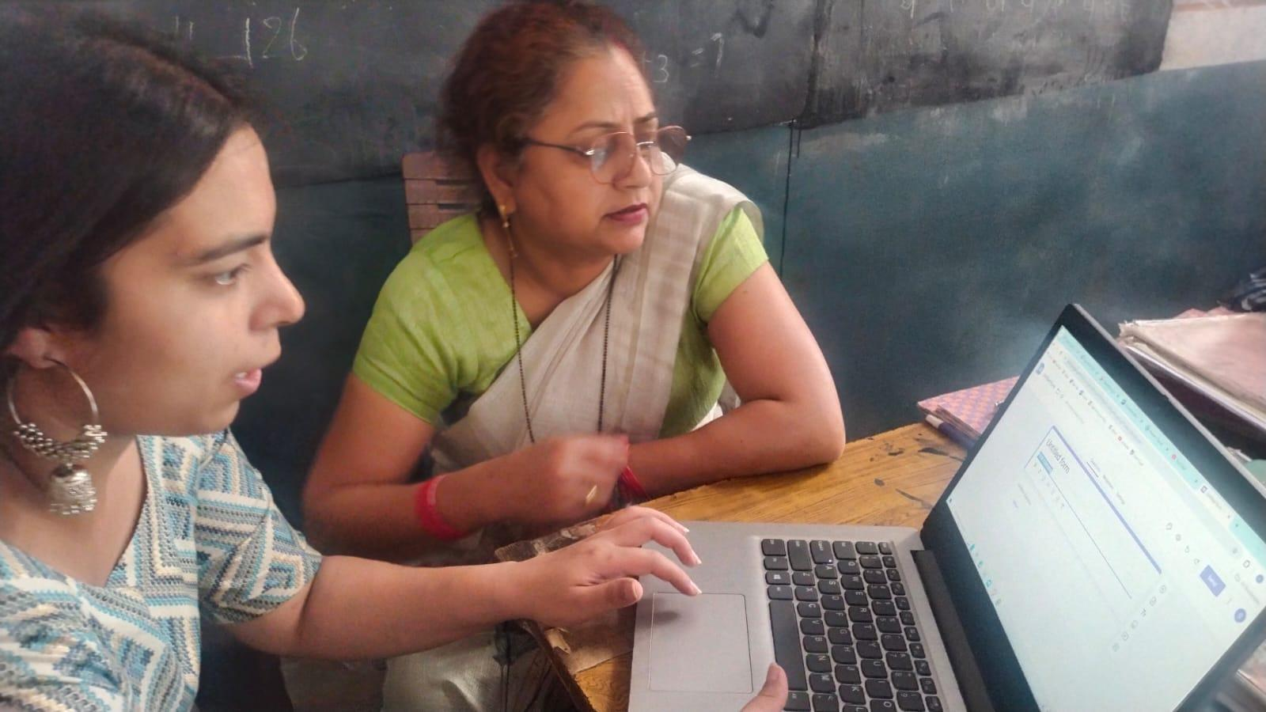

Teachers Engaged in Pre-Test Assessment: Evaluating Technological Competence.
Capacity Development Programme on Interpersonal Communication and Team Building Soft Skills For Teacher in Collaboration with Career Development Centre (CDC K.R.M.U)
The School of Education, in collaboration with the Career Development Centre (CDC), K.R. Mangalam University, organized a Capacity Development Programme titled “Communicate to Lead” from 27 October to 17 November 2025. The programme focused on enhancing interpersonal communication, team building, public speaking, time management, and professional skills among B.Ed. Semester I students. Expert sessions included practical activities, public speaking strategies, and exposure to AI-enabled resume building and LinkedIn networking. The programme contributed to SDG 4 (Quality Education) and SDG 8 (Decent Work), strengthening participants’ confidence, employability, and classroom readiness.
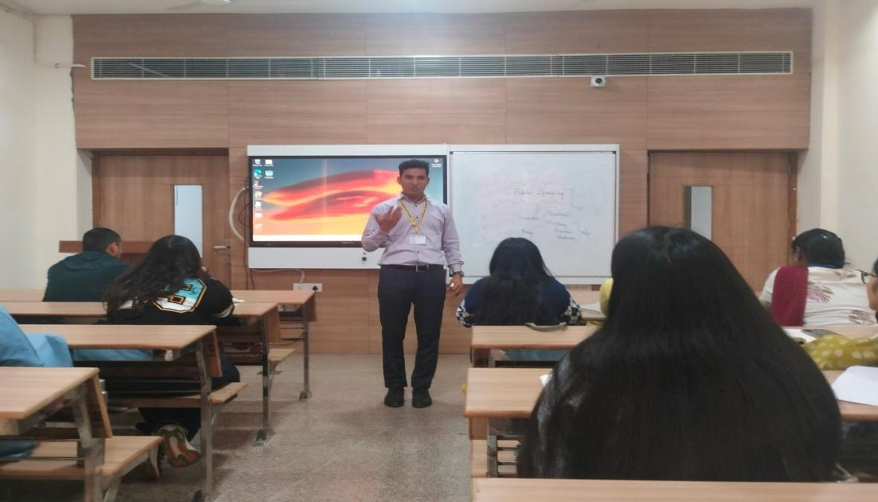

Unlocking the power of communication empowers individuals to lead with clarity, influence positive change, and inspire collective action. Effective communication strengthens leadership by fostering trust, collaboration, and shared purpose.
Two-days International E-Conference CTPDCO ERA 2023 On ‘Educational Reforms & Advancements’ (October 14 – 15, 2023)
The Two-Day International E-Conference CTPDCON ERA 2023 on “Educational Reforms & Advancements” was organized by the School of Education, K.R. Mangalam University, Gurugram, in collaboration with the Council for Teachers Professional Development (CTPD), and held virtually on 14–15 October 2023. The conference provided a global platform for educators, researchers, policymakers, and practitioners to deliberate on emerging challenges and innovations in education, with special reference to India.
The conference was structured around four major thematic tracks: Indian Knowledge Systems (IKS), Sustainable Development, Digital Transformation and Online Education, and Equitable and Inclusive Higher Education. Eminent national and international speakers, including academicians, education leaders, and policymakers, delivered keynote addresses and chaired plenary sessions. The deliberations highlighted the relevance of NEP 2020, integration of IKS, digital pedagogy, artificial intelligence in education, sustainable development goals, and inclusive educational practices.
The conference concluded with a valedictory session featuring award ceremonies and policy-oriented recommendations. Overall, CTPDCON ERA 2023 significantly contributed to academic discourse, professional development, and policy dialogue, reinforcing the need for continuous educational reforms aligned with global and national priorities.
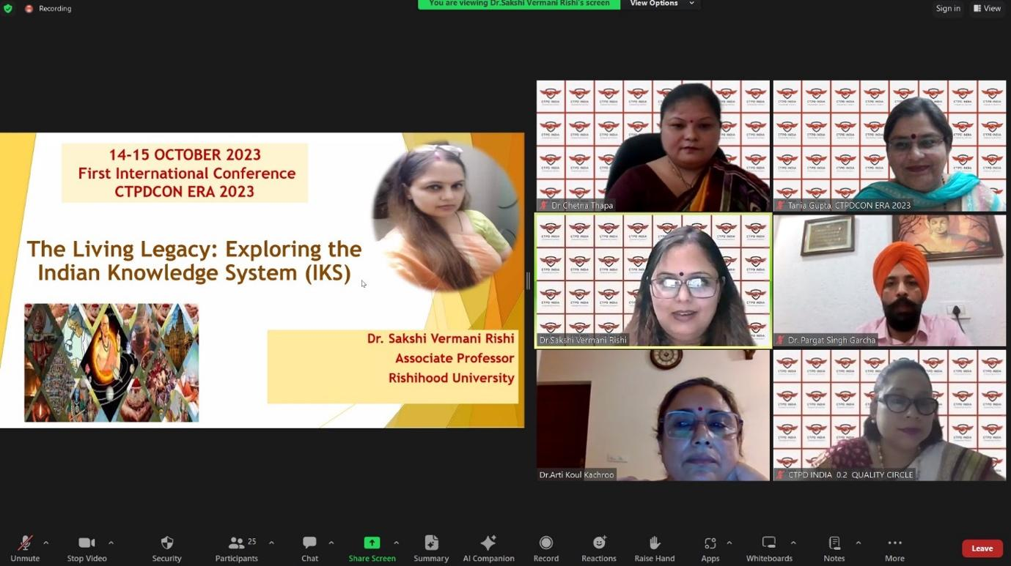
On “Educational Reforms & Advancements,” bringing together academicians and experts to explore innovative practices and transformative trends in education.
Dealing with Change and Uncertainty: Capacity Development Training Program on Soft Skills
The School of Education, K.R. Mangalam University organized a Capacity Development Training Program titled “Dealing with Change and Uncertainty” on 21 January 2025. The program was conducted in offline mode for student-teachers of the School of Education and SOHS, with participation from 40 students. The session was facilitated by Dr. Sakshi Vermani Rishi, Associate Professor, School of Psychology and Education, Rishihood University, Sonipat.
The training aimed to strengthen participants’ soft skills, particularly in understanding ethical principles, analyzing ethical issues, and enhancing ethical decision-making in professional contexts. An interactive workshop methodology was adopted, encouraging active participation and discussion.
The program resulted in improved adaptability, resilience, stress management, and problem-solving abilities among participants. Students developed a more positive and proactive approach towards change and uncertainty, along with an appreciation for continuous learning and self-improvement. The session concluded with a vote of thanks by Prof. (Dr.) Tania Gupta, Dean, School of Education, acknowledging the resource person and organizing team. Overall, the program successfully met its objectives and contributed to the holistic professional development of future educators.
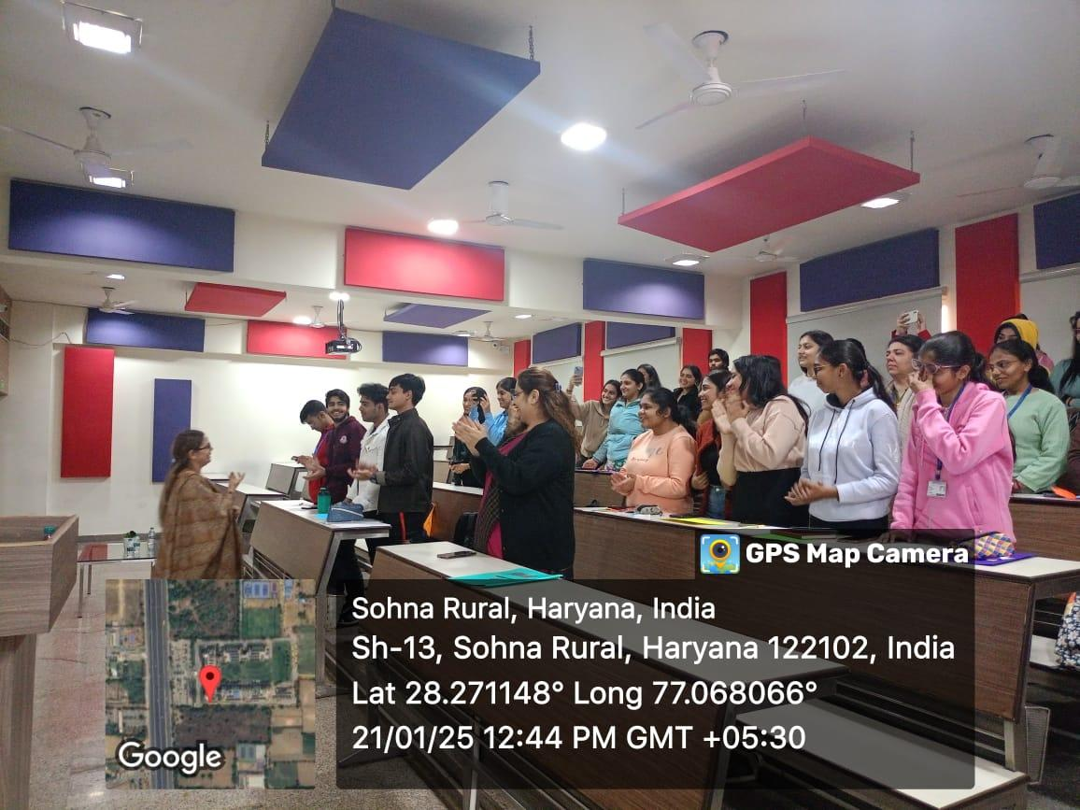

Student Participation in Activities Active involvement of students in discussions and interactive sessions.

Workshop on "Pitching and Communication Skills for Entrepreneurs “in Collaboration with KEIC
The School of Education, K.R. Mangalam University, organized a workshop titled “Pitching and Communication Skills for Entrepreneurs” in collaboration with KEIC on 9 December 2024 at A210, A Block, K.R. Mangalam University. The workshop was conducted in offline mode for faculty members of the School of Education, with participation from 13 faculty members. The session was led by Dr. Sonam Bansal, Associate Professor, Department of Education, Gurugram University.
The workshop focused on enhancing participants’ pitching and communication skills essential for entrepreneurship. It included brainstorming activities, discussions on the characteristics of successful entrepreneurs, and case studies related to startup pitching, Startup India initiatives, and government support for entrepreneurship. The interactive format encouraged active engagement and knowledge sharing among participants.
The event was coordinated by Dr. Kanchan Khatreja, Assistant Professor, School of Education. Prof. (Dr.) Tania Gupta, Dean, School of Education, presented a token of appreciation to the resource person, and the session concluded with a vote of thanks. Overall, the workshop was enriching and successfully strengthened participants’ communication and entrepreneurial pitching competencies.

Session on Work Life Balance and Well Being
The School of Education (SOED), K.R. Mangalam University, Gurugram organized an alumni talk on “Work Life Balance and Well Being” for students of SOED on 16 October 2024 from 11:00 AM to 12:00 PM. The session was conducted by Dr. Amita Bhati, Assistant Professor, School of Liberal Education, Sanskaram University, Jhajjar, Haryana. She is a proud alumnus of School of Education, K.R Mangalam University, Gurugram. Prof. (Dr.) Tania Gupta, Dean, School of Education extended Dr. Bhati a warm welcome.
Dr. Bhati delivered an insightful lecture on the significance of Work-Life Balance for students. She shared practical strategies for time management and stress reduction, encouraging attendees to prioritize self-care. She highlighted the significance of flexibility and adaptability in maintaining a healthy work-life balance. She also spoke about the value of seeking support from peers and mentors. Lastly, she underscored the long-term benefits of work-life harmony for both career success and personal well-being.
The event was meticulously coordinated by Dr. Shikha and Ms. Shalvi Kumari, Assistant Professors, School of Education, who ensured the seamless execution of the programme. The session was further supported by the efforts of the student coordinators, Sulakhani and Chetna, fifth-semester B.El.Ed. students, who skillfully moderated the proceedings. The programme concluded with a vote of thanks delivered by Chetna. She expressed her gratitude to Dr. Amita Bhati for her enlightening session, the faculty and student coordinators for their dedicated efforts, and all the participants for their active engagement.
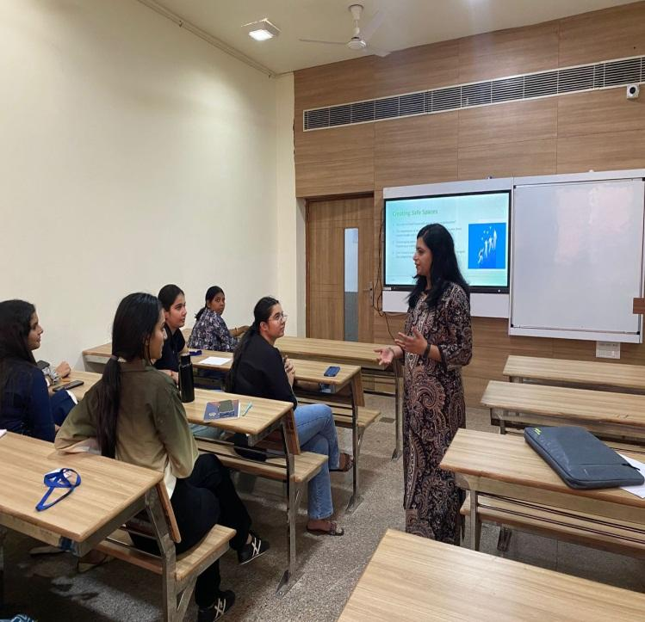

An interactive discussion focusing on stress management, personal well-being, and achieving a healthy balance between professional and personal life.

Teaching with Integrity: Professional Ethics Training for Educators 30th August, 2024
The School of Education, K.R. Mangalam University, organized an expert session titled “Teaching with Integrity: Professional Ethics Training for Educators” on 30 August 2024 in offline mode. The session was conducted for faculty members of the School of Education, with participation from eight faculty members. Dr. Niradhar Dey, Associate Professor, School of Education, Indira Gandhi National Open University (IGNOU), New Delhi, served as the resource person.
The session focused on strengthening professional ethics in teaching, highlighting key principles such as integrity, accountability, respect for diversity, commitment to students’ well-being, and adherence to professional codes of conduct. The objectives included enhancing educators’ understanding of ethical issues, promoting inclusive and fair learning environments, and equipping faculty with strategies to address ethical dilemmas in teaching and research.
The session resulted in increased awareness of ethical responsibilities among educators and reinforced ethical teaching practices such as academic honesty, fairness in assessment, and respect for diversity. The event successfully emphasized the critical role of professional ethics in education and reaffirmed the institution’s commitment to ethical excellence in teaching and learning.

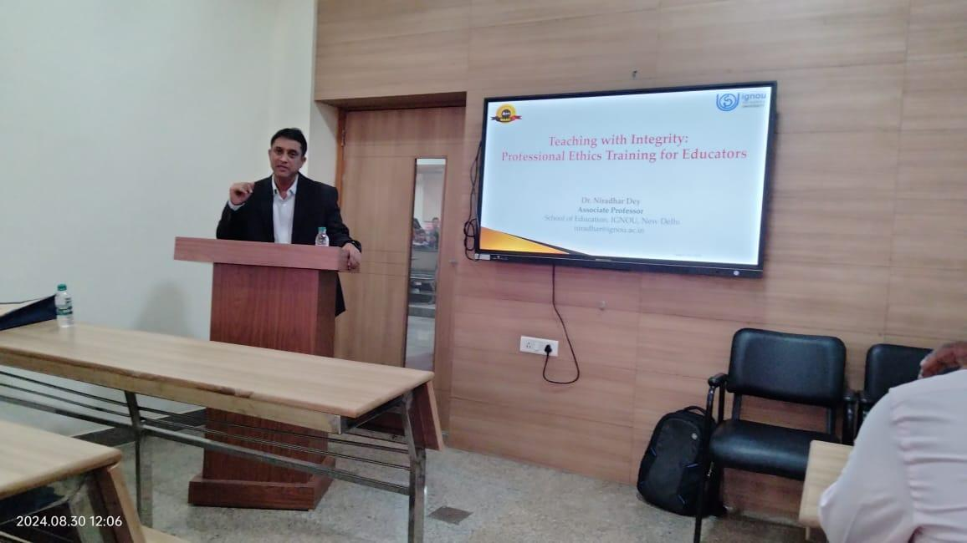

Held on 30th August 2024, the session emphasized ethical practices, professional responsibility, and integrity in teaching and academic leadership.
Report on Autopsy Visit to AIIMS
The School of Basic and Applied Sciences, K.R. Mangalam University, organized an autopsy visit to the All-India Institute of Medical Sciences (AIIMS), New Delhi, on 27 March 2025 for 48 B.Sc. (H) Forensic Science Semester-II students. The visit was conducted under the guidance of faculty members Dr. Baljeet Yadav, Dr. Sourabh Kumar Singh, and Ms. Saloni Arora as part of an experiential learning initiative aligned with SDG 4: Quality Education.
The visit aimed to provide students with firsthand exposure to medico-legal autopsy procedures, forensic pathology practices, and evidence documentation processes. Students observed three autopsy cases, including one burn-related death and two cases of death by hanging, enabling them to correlate theoretical knowledge with real-world forensic applications. The sessions were facilitated with the support of Dr. Ashok Kumar Jaiswal, Senior Chemist P.S.O., AIIMS.
The visit significantly enhanced students’ understanding of forensic medicine, highlighted the critical role of autopsies in the justice system, and strengthened their professional competence and career orientation in forensic science. Overall, the visit proved to be an impactful and enriching learning experience.

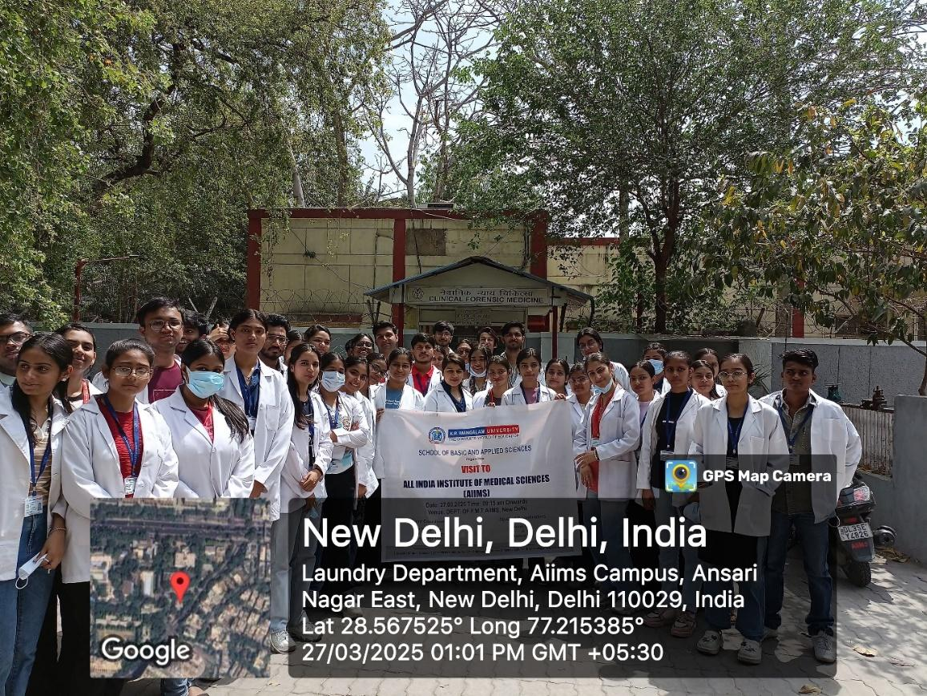

All students of B.Sc 2nd semester & M.Sc. 1st semester Forensic Science at FMT, A.I.I.M.S

Report on Educational Visit to All India Forensic Science Summit 2025
The School of Basic and Applied Sciences, K.R. Mangalam University, organized an educational visit to the All India Forensic Science Summit 2025, held on 14–15 April 2025 at Vigyan Bhawan, New Delhi, and hosted by the National Forensic Sciences University (NFSU). The visit involved 60 B.Sc. (H) Forensic Science students, coordinated by faculty members Ms. Kritika Singh, Ms. Saloni Arora, and Dr. Shivani Sehgal. The visit aimed to expose students to recent advancements and real-time applications in forensic science, encourage participation in national-level academic forums, and promote interaction with experts from academia, law enforcement, and research institutions. Students actively contributed through five oral presentations and four poster presentations, with five abstracts published.
The summit featured keynote lectures, technical sessions, and panel discussions on emerging areas such as digital forensics, toxicology, forensic psychology, crime scene investigation, and forensic technologies aligned with national initiatives. The experience enhanced students’ scientific communication skills, broadened their understanding of national forensic trends, strengthened professional networking, and reinforced career orientation in forensic science. Overall, the visit served as an effective extension of classroom learning and significantly enriched students’ academic and professional development.

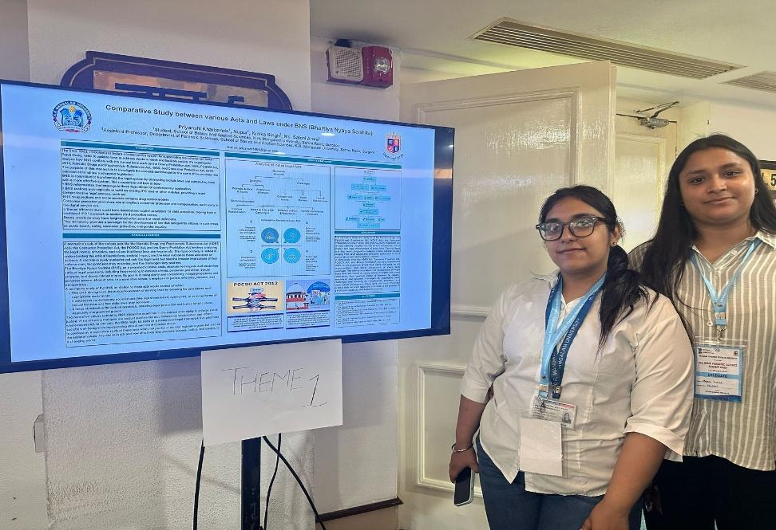

Poster Presented by Priyanshi and Nupur (B.Sc. Forensic Science) of K.R. Mangalam University on 14/04/2025 at Vigyan Bhawan in AIFSS
Lecture on Fostering Future Minds: Alumni Perspectives on the Evolving Role of Science in Education
The School of Basic and Applied Sciences (SBAS), K.R. Mangalam University, organized a lecture titled “Fostering Future Minds: Alumni Perspectives on the Evolving Role of Science in Education” on 29 November 2024 in offline mode. The session was conducted for SBAS students, with participation from 25 students. The resource person was Mr. Agnivesh Tiwari, an alumnus of B.Sc. (H) Mathematics and currently working as Operations Manager at Retina India. The lecture aimed to provide students with real-world insights into the evolving role of science education and its relevance to professional careers. Mr. Tiwari shared his academic-to-industry journey and highlighted the importance of critical thinking, interdisciplinary learning, and innovation in science-based careers. The session emphasized the integration of emerging technologies such as Artificial Intelligence, Data Science, and Biotechnology into science education and encouraged students to adopt lifelong learning.
The interactive session enhanced students’ understanding of career pathways, strengthened alumni–student engagement, and reinforced the practical application of scientific knowledge in addressing contemporary challenges. Overall, the lecture successfully aligned academic learning with industry expectations and future career readiness.

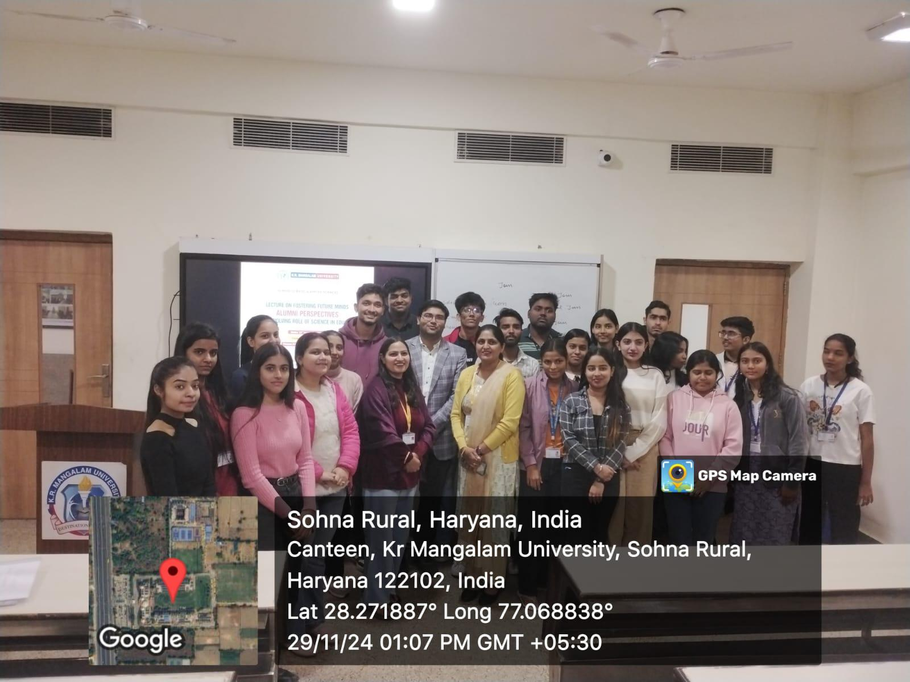

A group photograph with students, alumni, and event coordinators
A Training Session on Code of Conduct for Students
The School of Basic and Applied Sciences, K.R. Mangalam University, organized a training program on the Code of Conduct for Students on 28 August 2024 in offline mode at C005, C Block. The program was conducted for students of SBAS, with participation from 54 students. The session was led by Dr. Seema Raj, Associate Professor, and Dr. Pawan Kumar, Professor, SBAS. The training aimed to familiarize students with institutional rules, behavioral expectations, and ethical standards to maintain a disciplined, safe, and inclusive campus environment. Key aspects covered included punctuality, campus discipline, prohibition of ragging, substance abuse, bullying, and use of offensive language, along with adherence to academic integrity. Students were informed about mandatory participation in academic activities, proper use of university facilities, and restrictions on mobile phone and laptop usage during classes.
The session also highlighted violations of the code of conduct and corresponding disciplinary actions. Overall, the program successfully enhanced students’ awareness of responsible behavior, ethical conduct, and institutional values, contributing to a harmonious and productive academic environment.

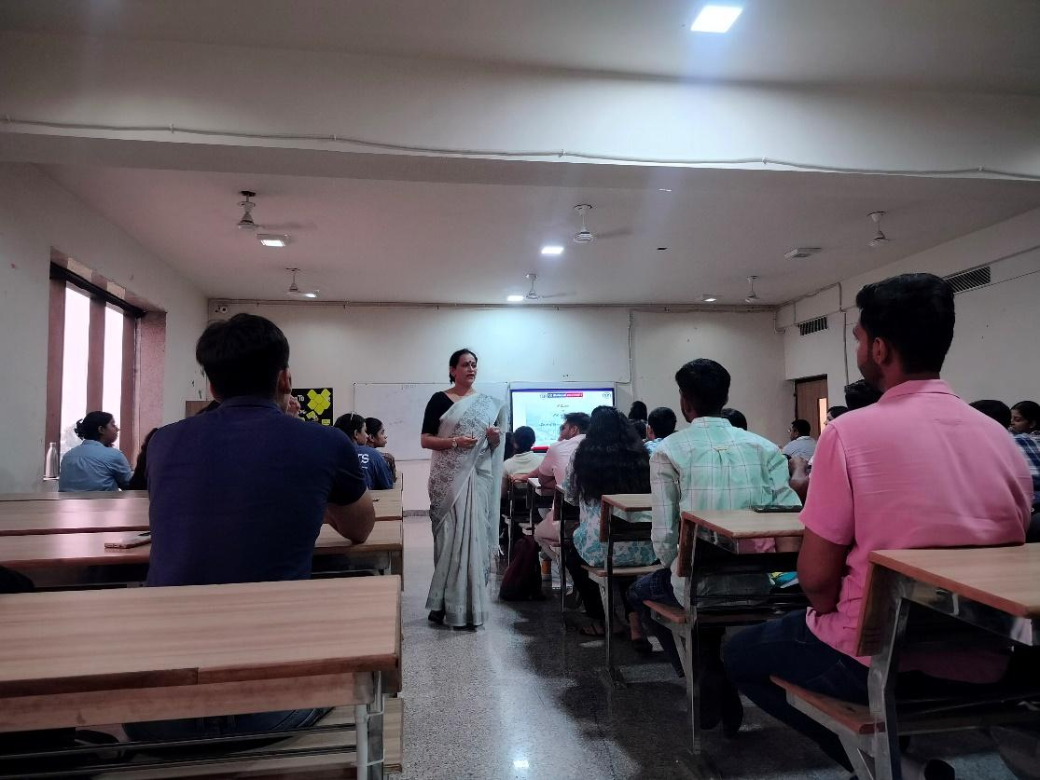

Dr. Seema addressed the students on the importance of the Code of Conduct, emphasizing ethical behavior, professional responsibility, and integrity in academic and institutional practices.
Alumni Insight Session: Journey Beyond Campus: Alumni Insight
The School of Basic and Applied Sciences, K.R. Mangalam University, organized an Alumni Insight Session titled “Journey Beyond Campus: Alumni Insight” on 4 April 2025 at B013, K.R. Mangalam University. The resource person was Ms. Aarti Gangadhar Shinde, an alumna currently pursuing an MBA at SOIL School of Business Design. The session aimed to bridge the gap between academic learning and professional life by providing students with practical career guidance and industry insights. Discussions focused on the transition from campus to career, the importance of technical and soft skill development, emerging industry trends, entrepreneurship, and strategies for maintaining work–life balance. An interactive Q&A session enabled students to seek personalized advice on career planning and professional growth. The session enhanced students’ understanding of industry expectations, motivated them toward skill development and lifelong learning, and strengthened alumni–student engagement. Overall, the event contributed meaningfully to career readiness and mentorship-oriented learning, aligning with SDG 4: Quality Education.

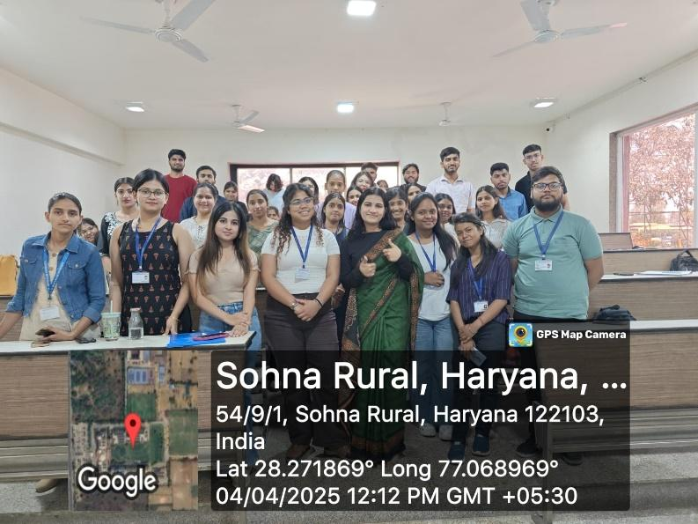

Ms. Aarti Gangadhar Sinde, distinguished alumna, interacted with students and shared her professional journey, career insights, and real-world experiences, motivating learners to pursue their goals with confidence and clarity.
Mastering on Communication skills for Personal and Professional Growth
The School of Basic and Applied Sciences, K.R. Mangalam University, organized a seminar titled “Mastering Communication Skills for Personal and Professional Growth” on 22 April 2025 at B007. The seminar was conducted in offline mode for undergraduate students of SBAS, with participation from 26 students. The session was delivered by Dr. Tuhina Ray, Career Development Cell, K.R. Mangalam University, and aligned with SDG 4: Quality Education.
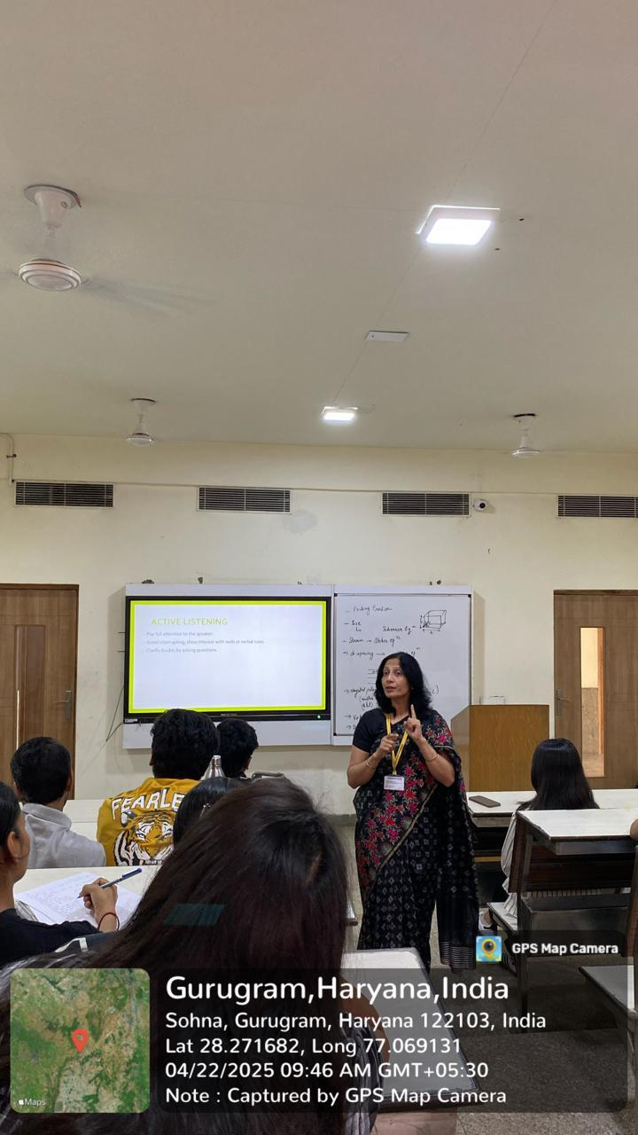
The seminar focused on enhancing students’ communication competencies essential for academic success and professional growth. Key areas covered included spoken and non-verbal communication, active listening, emotional awareness, workplace communication (emails, presentations, meetings), and overcoming common communication barriers. The session emphasized clarity, confidence, empathy, and effective interpersonal interaction. Through interactive discussions and practical insights, students gained improved understanding of communication skills and their role in building relationships, confidence, and career readiness. The seminar successfully motivated participants to refine their communication abilities for personal development and future professional opportunities.

Dr. Tuhina explained the importance of clear and concise expression, highlighting how effective communication enhances confidence, professional competence, and overall personal development.
A Seminar on Professional Ethics for Teachers
The School of Basic and Applied Sciences, K.R. Mangalam University, organized a seminar on “Professional Ethics for Teachers” on 24 April 2025 at Aryabhatta Block, KRMU. The seminar was conducted in offline mode for faculty members, with participation from 20 faculty members. Prof. (Dr.) Mehraj Uddin Mir, Motilal Nehru Chair, K.R. Mangalam University, served as the resource person. The seminar aimed to enhance awareness of personal and professional ethics among educators. The speaker emphasized that professional ethics are an extension of personal ethics and vary across contexts and professions. Key discussions included professional codes of ethics, ethical decision-making, and research ethics covering responsible conduct of research, use of resources, and prevention of scientific misconduct.
The session enabled participants to clearly distinguish between personal and professional ethics and understand the application of ethical codes in academic and research settings. The seminar concluded with a vote of thanks and felicitation of the resource person. Overall, the program was insightful and strengthened ethical awareness and critical thinking among faculty members.
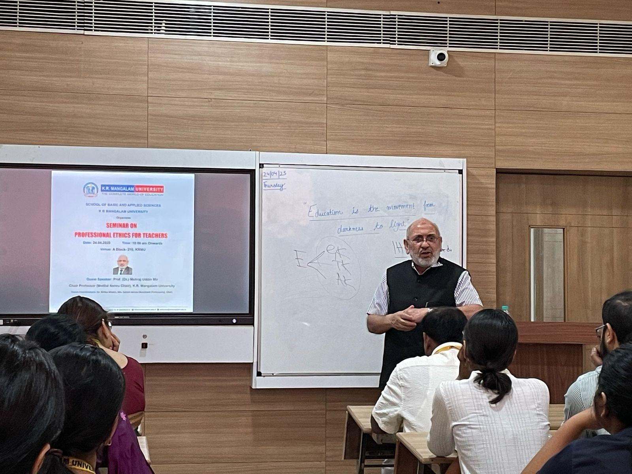

Prof. (Dr.) Mehraj Uddin Mir, Motilal Nehru Chair, K. R. Mangalam University giving insights into "Professional Ethics for Teachers"

Visit to Centre for Advanced Materials and Devices, BML Munjal University
The School of Basic and Applied Sciences (SBAS), K.R. Mangalam University, organized an industrial/lab visit to the Centre for Advanced Materials and Devices, BML Munjal University, Gurugram, on 4 December 2024 for Applied Science students. The visit was conducted in offline mode with participation from 14 students, under the coordination of faculty members Dr. Rishi Ranjan Kumar, Dr. Aina Gupta, and Dr. Deepak Yadav. Dr. Vishal Baloria, Assistant Professor, BML Munjal University, served as the resource person.
The visit aimed to expose students to advanced research in materials science, nanotechnology, and device fabrication. Students received an overview of ongoing research, toured state-of-the-art laboratory facilities, and observed advanced instruments such as scanning electron microscopes (SEM) and atomic force microscopes (AFM). Faculty presentations highlighted research methodologies, real-world applications, and career pathways in applied sciences.
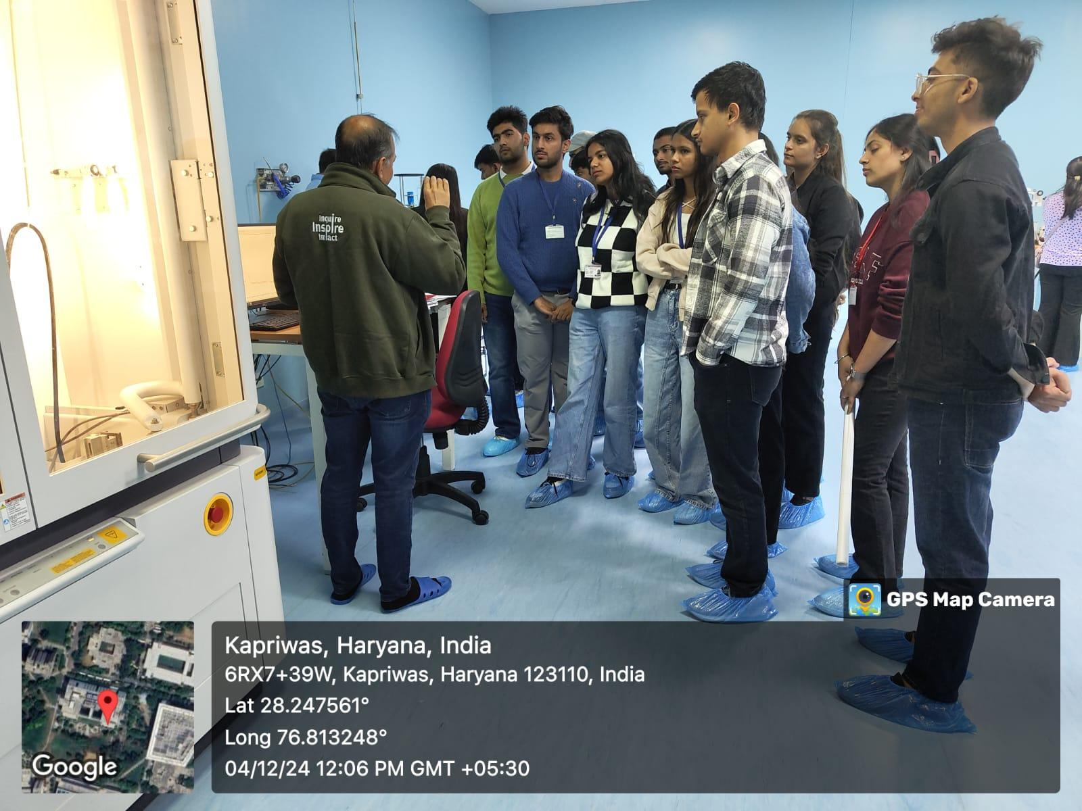
The visit enhanced students’ understanding of the practical application of theoretical concepts, encouraged interest in research and higher studies, and strengthened industry–academia exposure. Overall, the visit was an enriching experiential learning opportunity contributing to students’ academic and professional development.

Students gained hands-on exposure to advanced research facilities and instrumentation, enhancing their understanding of material science applications and cutting-edge technological innovations.
Training Programme on Professional Ethics
The School of Basic and Applied Sciences (SBAS), K.R. Mangalam University, organized a Training Programme on Professional Ethics on 28 August 2024 at C005, C Block, in offline mode. The programme was conducted for SBAS students, with participation from 60 students, and was led by Prof. Pawan Kumar, Professor, SBAS.
The primary objective of the training was to instill a strong ethical foundation among future science professionals by addressing ethical challenges specific to scientific research and professional practice. The session emphasized core ethical principles such as integrity, accountability, transparency, responsibility, and respect for intellectual property. Through interactive lectures and real-life examples, students were introduced to common ethical dilemmas encountered in scientific fields and effective strategies for ethical decision-making.
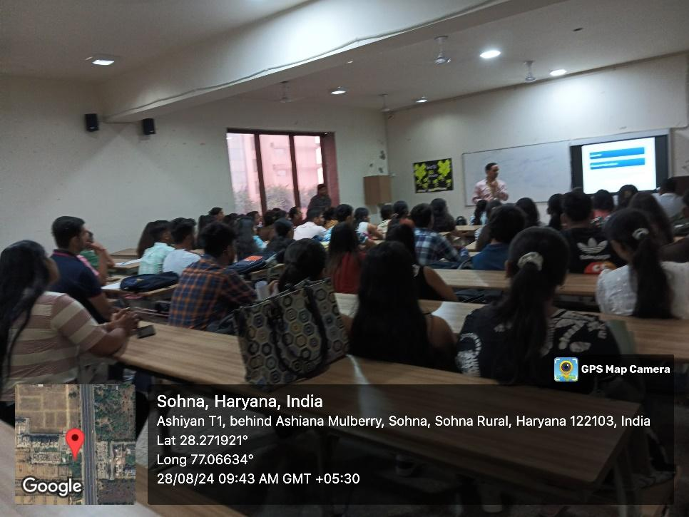
The programme also included group discussions and case-based learning, enabling students to critically analyze ethical issues and exchange perspectives. Overall, the training enhanced students’ ethical awareness, critical thinking, and understanding of professional responsibility, contributing meaningfully to their academic and professional development.

An engaging session emphasizing ethical values, integrity, and responsible conduct, guiding students toward ethical decision-making in academic and professional environments.
A Seminar on Quality Assurance in Higher Education
The School of Basic and Applied Sciences (SBAS), in collaboration with IQAC, organized a seminar titled “Quality Assurance in Higher Education” on 10 April 2025 at K.R. Mangalam University. The seminar was conducted in offline mode for faculty members, with participation from 24 faculty members. Prof. (Dr.) Tania Gupta, Dean, School of Education, served as the resource person. The seminar aimed to strengthen awareness of quality assurance mechanisms in higher education. Key areas discussed included the concept and importance of quality assurance, student-centered learning, accountability, stakeholder engagement, and continuous improvement. The session provided detailed insights into national accreditation frameworks such as NAAC and NBA, the role of faculty and leadership in fostering a quality culture, and the relevance of global benchmarks and rankings. Challenges in implementing quality assurance processes and possible solutions were also deliberated.
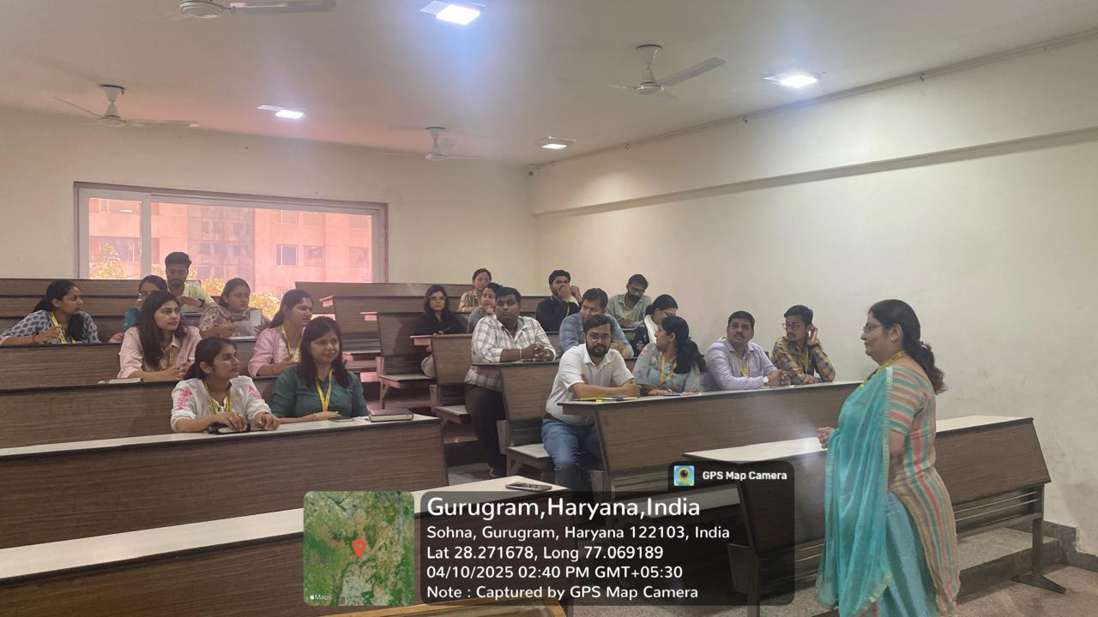
The seminar enhanced participants’ understanding of institutional quality systems, motivated faculty to actively contribute to accreditation and quality initiatives, and laid the groundwork for future capacity-building programs related to quality assurance and accreditation processes.

Prof. Tania Gupta delivered an insightful lecture on quality assurance, highlighting best practices, standards, and continuous improvement strategies essential for academic and professional excellence.
Faculty Development Program on Imperatives of Indian Knowledge System
The School of Basic and Applied Sciences, K.R. Mangalam University, organized a One-Week Faculty Development Programme (FDP) on “Imperatives of Indian Knowledge System” from 19 to 24 May 2025 in hybrid mode (online sessions with an offline valedictory). The FDP aimed to deepen understanding of India’s rich intellectual heritage and explore its relevance in contemporary education, research, and professional practice. The programme witnessed participation from around 58 faculty members and researchers from various institutions and featured 18 eminent resource persons. The FDP covered a wide range of interdisciplinary themes, including Indian Knowledge Systems (IKS), Nitishastra, ancient mathematics, Vedic mathematics, Indian medicinal plants, Ramayan and leadership, Bharatiya Darshana, Natyashastra, digital detox through Vedic principles, and the role of IKS in global education. Through expert lectures, discussions, and interactive sessions, participants explored philosophical, scientific, mathematical, and cultural dimensions of traditional Indian wisdom.
The programme successfully bridged ancient knowledge with modern academic applications, enhanced interdisciplinary perspectives, and encouraged participants to integrate IKS principles into teaching, research, and professional practices. Overall, the FDP significantly contributed to academic enrichment, cultural awareness, and capacity building in higher education.
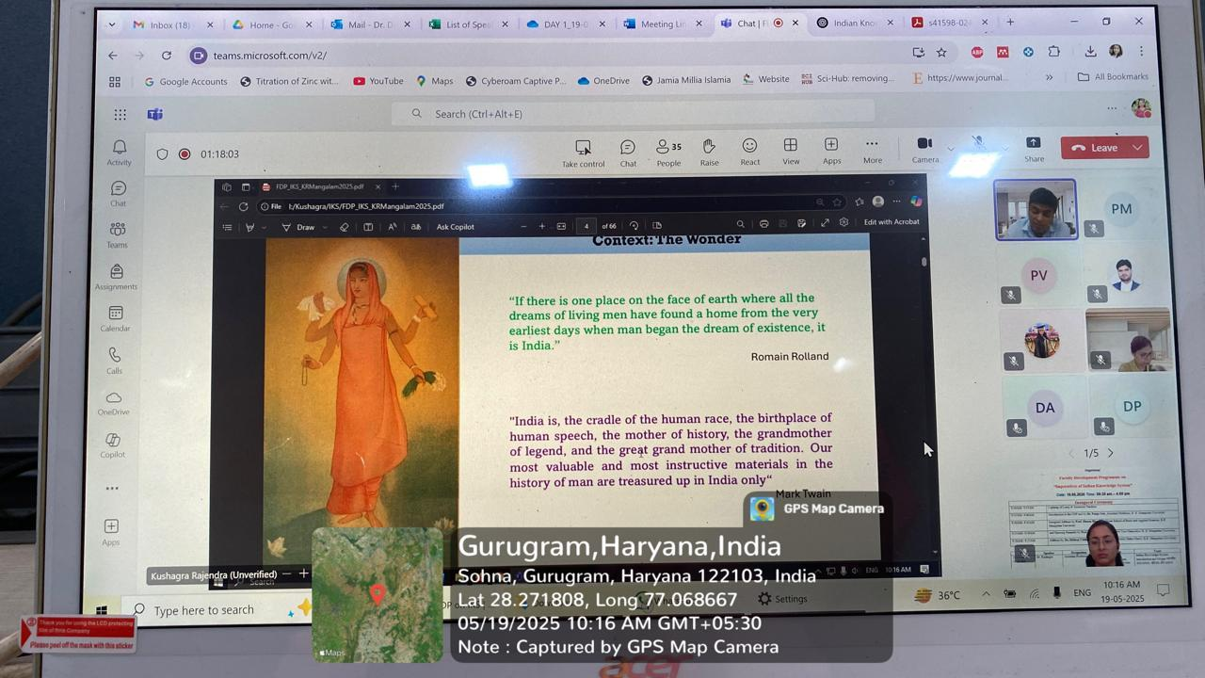

Dr. Kushagra engaged the participants highlighting the philosophical foundations, cultural heritage, and interdisciplinary relevance of Indian Knowledge Systems in contemporary education.

Lecture on “Soft Skills: Strategies for Success
The School of Basic and Applied Sciences, K.R. Mangalam University, organized a lecture titled “Soft Skills: Strategies for Success” on 25 September 2024 at the Multi-Purpose Hall. The session was conducted in offline mode for students of SBAS, with participation from 168 students. The lecture was delivered by Ms. Tuhina Ray, Head of the Career Development Cell, K.R. Mangalam University.
The lecture aimed to highlight the importance of soft skills in academic achievement and professional success. Key areas discussed included communication, teamwork, leadership, problem-solving, adaptability, time management, and emotional intelligence. The resource person emphasized practical strategies for developing soft skills through self-awareness, continuous learning, internships, workshops, and extracurricular activities. The interactive format encouraged student participation through discussions and real-life examples.
The session enhanced students’ awareness of employability skills, motivated them to improve personal and professional competencies, and reinforced the role of soft skills in career readiness. Overall, the lecture was impactful and contributed significantly to students’ holistic development and future employability.
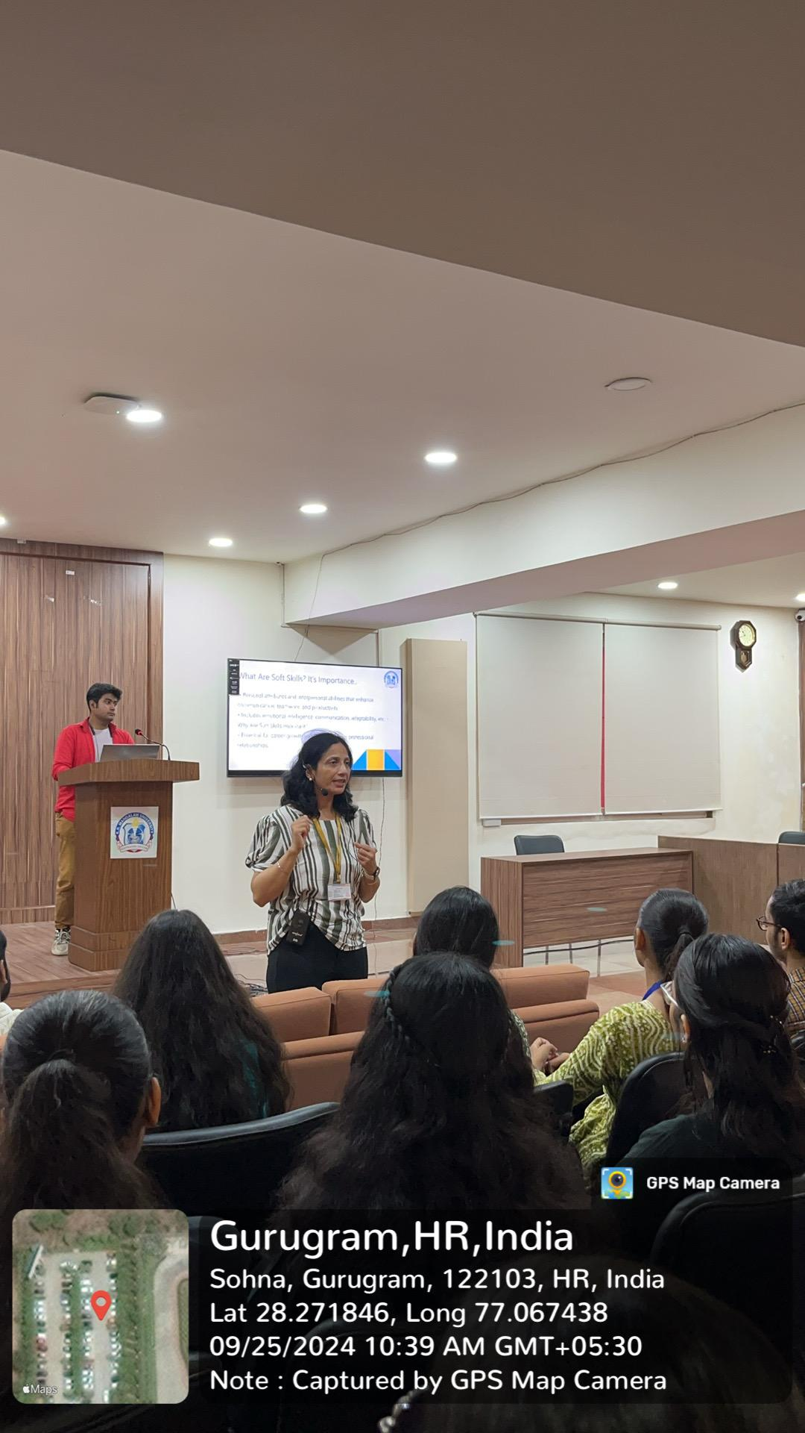

An engaging and participative session focusing on communication, confidence building, and leadership skills, encouraging active interaction and experiential learning among participants.

Mortuary Visit to Deen Dayal Upadhyay Hospital, Delhi
The School of Basic and Applied Sciences (Forensic Science), K.R. Mangalam University, organized an educational mortuary visit to Deen Dayal Upadhyay Hospital, Delhi, on 29 November 2024 for 40 undergraduate and postgraduate Forensic Science students. The visit was coordinated by Mr. Nitin Tyagi and Ms. Anuradha Mangla, Assistant Professors, SBAS. The visit aimed to provide students with practical exposure to forensic medicine and post-mortem examination procedures. Dr. Jatin, Assistant Professor, Department of Forensic Medicine and Toxicology, and Dr. Komal demonstrated autopsy procedures, protocols, evidence documentation, and determination of cause of death. Students observed systematic forensic practices and engaged in discussions to enhance analytical and critical thinking skills.
The visit effectively bridged the gap between theoretical learning and real-world forensic application, offering experiential learning in medico-legal investigations. Overall, the activity significantly contributed to students’ academic understanding, practical competence, and professional orientation in forensic science, reinforcing the department’s commitment to experiential and skill-based education.
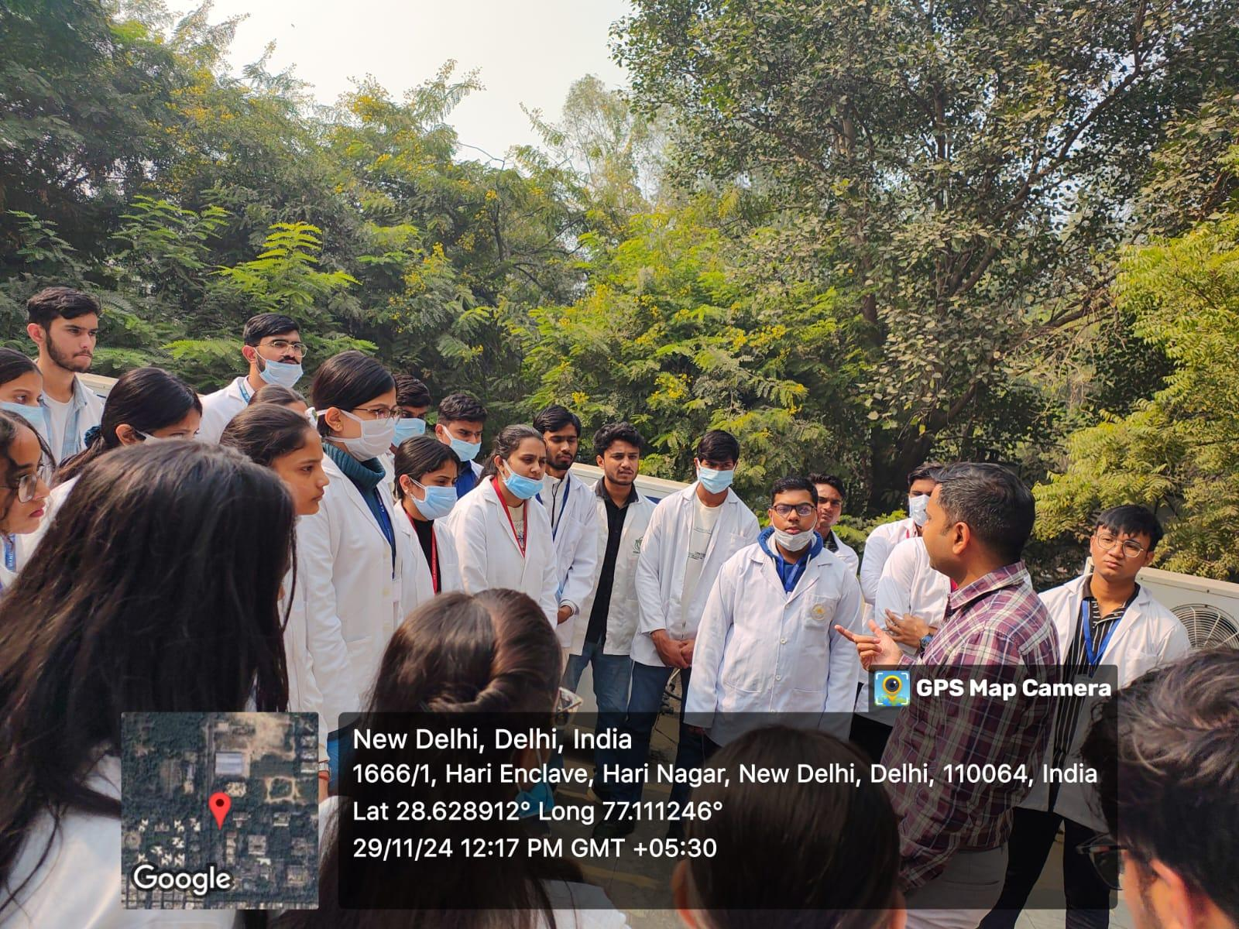
Dr. Jatin provided an in-depth practical demonstration to students, explaining key concepts of forensic medicine, medico-legal procedures, and real-life applications in crime investigation and justice delivery.
Conclusion
Through mandatory annual training on the social aspects of sustainability, K.R. Mangalam University ensures that principles of equality, diversity, ethics, and well-being are deeply embedded within institutional culture. By systematically equipping faculty and staff with inclusive competencies and ethical awareness, the University reinforces its commitment to equitable education, responsible governance, and sustainable social impact, in line with national priorities and global best practices.
KE2 - Knowledge Exchange
K.R. Mangalam University (KRMU) actively offers, manages, and delivers structured outreach projects across education, health, information services, community engagement, and capacity-building initiatives for the local and regional community. These projects are an integral part of the University’s mission to promote social responsibility, inclusivity, and sustainable development through knowledge exchange.
The University undertakes community outreach primarily through its National Service Scheme (NSS), academic departments, research centers, and institutional committees, ensuring systematic planning, execution, and impact assessment.
Key Outreach Areas
Education & Capacity Building
- Community-based literacy programs, tutorials, and academic mentoring for school students
- Career guidance, skill development, and awareness sessions for youth
- Workshops on communication skills, leadership, and ethical values
Health & Well-being
- Health awareness campaigns on hygiene, nutrition, mental well-being, and lifestyle diseases
- First-aid training, self-defense workshops, and wellness programs
- Sessions on work–life balance, stress management, and gender sensitization
Information & Awareness Services
- Legal awareness programs (constitutional rights, women’s rights, cyber safety)
- Environmental awareness initiatives (cleanliness drives, sustainability education)
- Awareness sessions on road safety, disaster preparedness, and public health
Community Engagement
- Outreach activities in adopted villages and nearby communities
- Collaboration with schools, NGOs, government departments, and local institutions
- Interactive programmes such as street plays (Nukkad Natak), quizzes, and exhibitions to promote social change
Management and Delivery Mechanism
- Outreach projects are planned annually, aligned with institutional goals and national priorities such as the Sustainable Development Goals (SDGs).
- Faculty members provide academic leadership, while students actively participate under supervision.
- Activities are documented, monitored, and evaluated, with outcomes recorded for institutional review and reporting.
Impact
- Strengthened university–community partnerships
- Enhanced access to education, health awareness, and essential information
- Development of socially responsible graduates with real-world engagement experience
Through these sustained outreach efforts, K.R. Mangalam University ensures that knowledge generated within the institution directly benefits society, reinforcing its commitment to inclusive growth and community empowerment.

Serial No | Name of Event | Organised By | Date of Event
1. | Case Study to National Crafts Museum & Hastkala Academy, New Delhi | 26th September 2024 | Case study to National Craft Museum
2. | A Visit to the Aravalli Biodiversity Park and Field Project on “Exploring Biodiversity Conservation Strategies at Aravalli Biodiversity Park: A Study on Ecological Sustainability and Community Engagement” | 29 November 2024 | A Visit to the Aravalli Biodiversity Park
3. | Secure Your Digital World: Key Cybersecurity Tips for Everyday Safety | 19 December 2024 | Secure Your Digital World
4. | Green Strokes: Draw to Preserve (Drawing Competition) | 28 May 2025 | Green Strokes
5. | Synergy: Wellness and Development Program | 18 October 2024 | Synergy: Wellness and Development Program
6. | Nourish & Flourish: A Path to Balanced Nutrition and Health | 20 December 2024 | Nourish & Flourish: A Path to Balanced Nutrition and Health
7. | Child Safety and Protection | 13 May 2025 | Child Safety and Protection
8. | Declamation Contest on Drug Abuse: Its Social, Psychological and Health Consequences | 21 October 2024 | Declamation Contest on Drug Abuse
9. | Drawing Competition on Save the Water for New Generation | 23 December 2024 | Drawing Competition on Save the Water for New Generation
10. | Save a Life: First Aid Awareness” Training Session on World First Aid Day | 14 September 2024 | Save a Life: First Aid Awareness
11. | Cleanliness Drive and Rally under ‘Swachhata Hi Seva’ Campaign | 27th September 2024 | Cleanliness Drive
12. | Session on ‘Constitutional Rights and Duties’ | 26th November 2024 | Constitutional Day
13. | Nukkad Natak: ‘Shakti Ki Udaan – Betiyan Banayein Mahaan’ | 29th November 2024 | Shakti Ki Udaan
14. | Seven-Day Special Camp under the Theme 'Yuva for My Bharat and Yuva for Digital Literacy' | 2nd to 8th January 2025 | Report
15. | Road Safety Awareness Campaign | 28th January 2025 | Road Safety
16. | Donation Drive and Visit to Old Age Home | 11th February 2025 | Donation Drive
17. | Shiksha Uday: A One-Day Literacy Camp | 4thMarch, 2025 | Literacy Campaign
18. | Empower Her: Celebrating Strength and Spirit through Performance” | 5th March 2025 | Empower Her
19. | Health Checkup Camp | 15th April 2025 | Health Camp
20. | Eat Right, Move More’- Wellness Workshop for Children | 21st April 2025 | Report

Case Study to National Crafts Museum & Hastkala Academy, New Delhi
The case study visit to the National Crafts Museum & Hastkala Academy, New Delhi, was conducted on Thursday, 26th September 2024, from 10:00 AM onwards, as an offline academic activity organized by the School of Architecture and Design, K R Mangalam University. The event was coordinated by Ar. Nandit Pastariya, Assistant Professor, SOAD, and was attended by 17 third-year architecture students. The visit aimed to enhance students’ understanding of the integration of traditional Indian crafts with architectural design. Through direct observation of textiles, folk art, and handcrafted materials such as wood and metal, students explored the relationship between cultural heritage, sustainability, and architectural aesthetics. The activity provided experiential learning through on-site sketching, material discussions, and spatial analysis. The case study was further complemented by a site visit to Bhairon Marg, Pragati Maidan, enriching students’ practical exposure to contextual design and traditional craftsmanship in contemporary architectural practice.
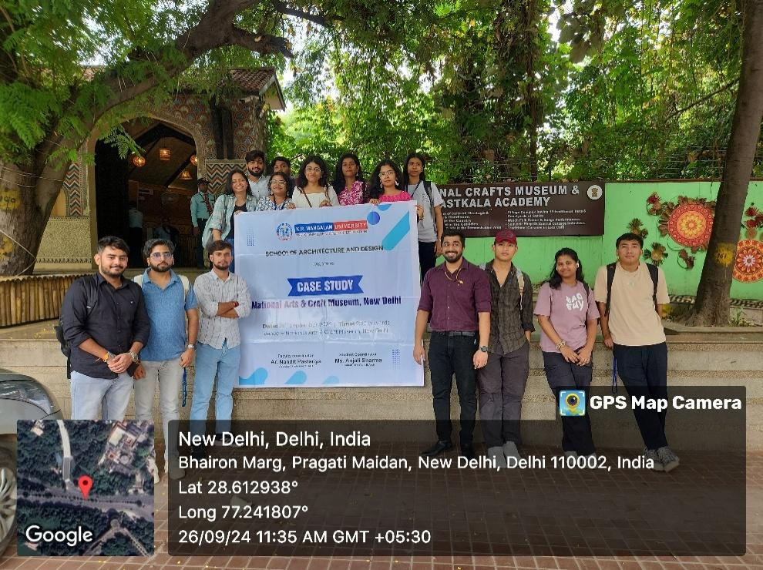

Students of the School of Architecture and Design participated in an academic case study visit, gaining firsthand exposure to India’s rich craft traditions, vernacular design principles, and cultural heritage, thereby bridging classroom learning with real-world architectural and design practices.

A Visit to the Aravalli Biodiversity Park and Field Project on “Exploring Biodiversity Conservation Strategies at Aravalli Biodiversity Park: A Study on Ecological Sustainability and Community Engagement”
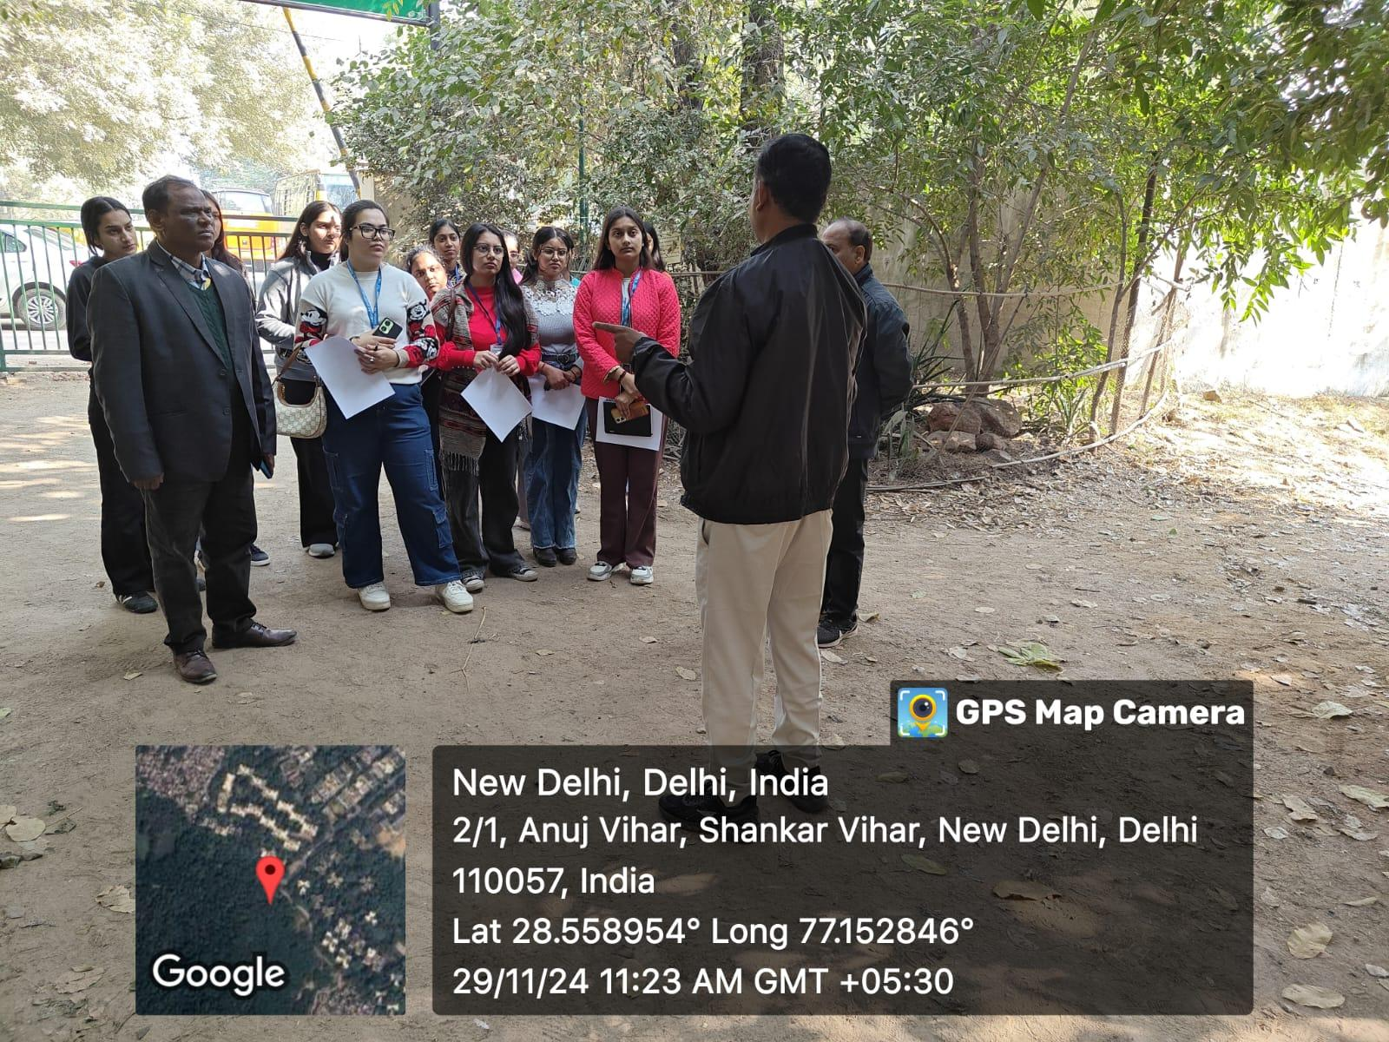
The field visit and case study to the Aravalli Biodiversity Park, Vasant Vihar, New Delhi, was conducted on 29 November 2024 as an offline academic activity organized by the School of Education, K. R. Mangalam University. The visit involved student-teachers of B.El.Ed. Semester 3 and 5, with a total participation of 48 student-teachers, and was coordinated by Prof. P. C. Jena, Professor, School of Education, and Dr. Anshul Saluja, Assistant Professor, School of Education. The activity focused on exploring biodiversity conservation strategies, ecological sustainability, and community engagement, in alignment with Sustainable Development Goal (SDG) 15: Life on Land. During the visit, participants observed conservation practices related to native flora and fauna, ecological restoration, and habitat sustainability, guided by park officials, reflecting effective collaboration with the Aravalli Biodiversity Park authorities. The visit enhanced experiential learning by integrating theoretical knowledge with real-world ecological practices and highlighted the role of education and community participation in promoting environmental stewardship and sustainable development.

Student-teachers receiving the instructions from the park officials before visit to the park
Secure Your Digital World: Key Cybersecurity Tips for Everyday Safety
The lecture session titled “Secure Your Digital World: Key Cybersecurity Tips for Everyday Safety” was organized on 19 December 2024 at Garhi Bazidpur Village as an offline community outreach initiative by the Youth Red Cross Committee, K.R. Mangalam University. The programme targeted villagers of Garhi Bazidpur and Youth Red Cross (YRC) volunteers, with the objective of enhancing awareness about cybersecurity and safe digital practices. The session was delivered by Ms. Kritika Singh, Assistant Professor of Cyber Forensics, and coordinated by Dr. Monika Yadav, Program Coordinator, Youth Red Cross Committee, with support from student coordinators. The lecture focused on common cyber threats such as phishing, malware, and hacking, and emphasized practical measures including strong passwords, two-factor authentication, safe browsing habits, and protection of personal data on social media and email platforms. The interactive discussion enabled participants to clarify doubts through real-life examples of cyber fraud. Overall, the initiative successfully strengthened digital awareness, encouraged safer online behavior, and promoted community empowerment in the digital domain.

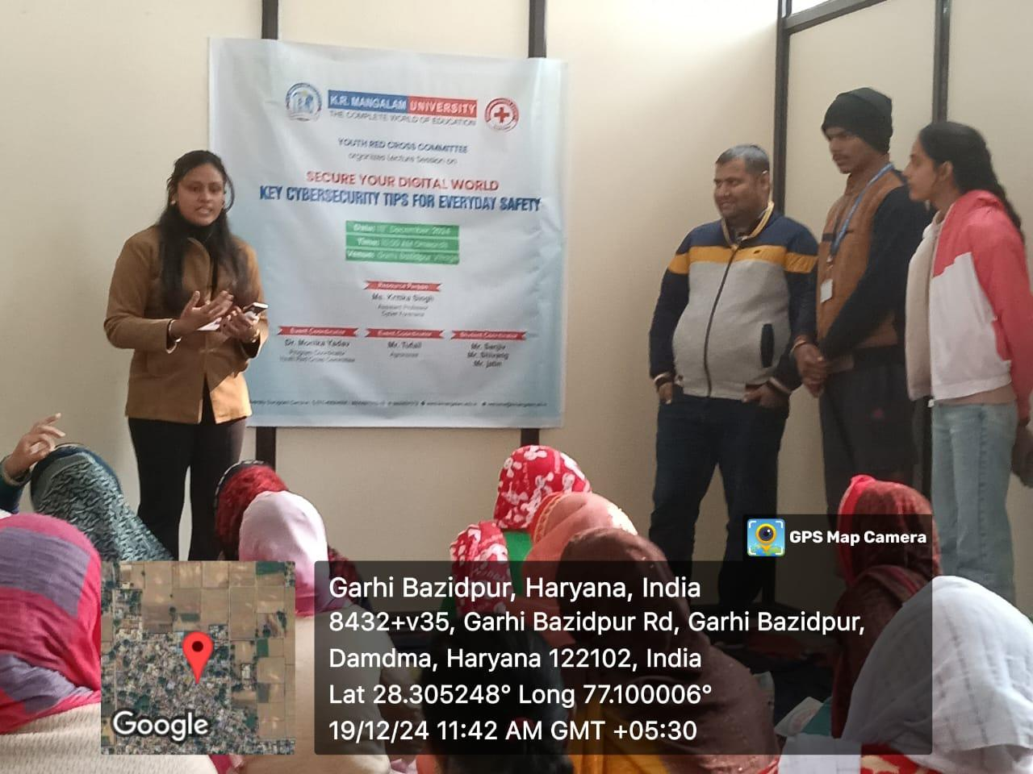

Ms. Kritika Singh delivers a lecture on "Key Cybersecurity Tips for Everyday Safety" at Garhi Bazidpur Village, organized by the Youth Red Cross Committee on 19th December 2024.

Green Strokes: Draw to Preserve (Drawing Competition)
The drawing competition titled “Green Strokes: Draw to Preserve” was organized on 28 May 2025 at Government Primary School, Daula, as an offline outreach activity by the Youth Red Cross Committee, K. R. Mangalam University. The event was conducted to commemorate Earth Day and to promote environmental awareness among school children. School students of Daula actively participated along with 14 Youth Red Cross volunteers from KRMU, under the coordination of Dr. Monika Yadav, Program Coordinator, YRC, with support from student coordinators. The activity focused on encouraging creative expression on themes such as environmental conservation, sustainability, water conservation, and protection of natural resources. Through art-based learning and guided interaction, the competition successfully sensitized young participants toward eco-friendly practices. The initiative also strengthened community engagement and reinforced the role of educational institutions in fostering environmental responsibility and sustainable values among future generations.

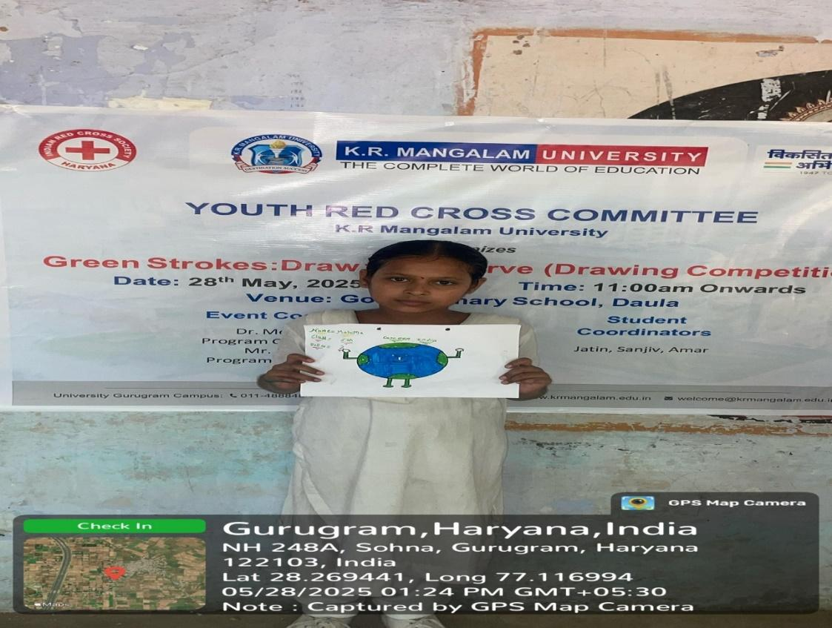

A young participant proudly showcasing her artwork during the environmental awareness drawing competition organized by the Youth Red Cross Committee, K.R. Mangalam University, promoting sustainability and conservation through creative expression.

Synergy: Wellness and Development Program
The live seminar titled “Synergy: Wellness and Development Program” was organized on 18 October 2024 at Room A-213, A Block, K.R. Mangalam University as an offline academic and wellness initiative. The programme was conducted by the Youth Red Cross Committee, K.R. Mangalam University, in collaboration with The Kailasa Foundation, reflecting effective institutional–external partnership. A total of 107 university students participated in the seminar, which was coordinated by Dr. Monika Yadav, with student coordinators providing organizational support. The session was led by Mr. Varun Sharma, Founder of The Kailasa Foundation, who delivered an insightful discourse on the interrelationship between physical, digital, and mental well-being. The seminar emphasized practical strategies such as healthy lifestyle practices, responsible digital usage, and mental balance in a fast-paced environment. Overall, the event enhanced awareness of holistic wellness, encouraged balanced living among students, and strengthened collaboration between educational institutions and wellness organizations.

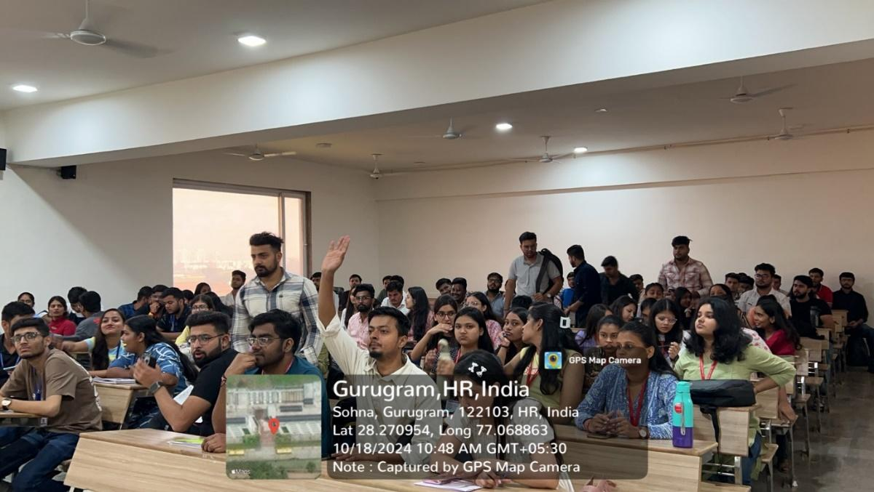

An interactive session fostering holistic well-being and personal development, with active student participation and discussions aimed at enhancing mental resilience, self-awareness, and overall growth.

Nourish & Flourish: A Path to Balanced Nutrition and Health
The lecture session titled “Nourish & Flourish: A Path to Balanced Nutrition and Health” was organized on 20 December 2024 at Government Senior Secondary School, Daula, as an offline community outreach initiative by the Youth Red Cross Committee, K.R. Mangalam University. The programme targeted school students of Daula along with Youth Red Cross volunteers and was coordinated by Dr. Monika Yadav, Program Coordinator, YRC. The session was delivered by Dr. J. S. Yadav, Dean, School of Agriculture & Science, who emphasized the importance of balanced nutrition for overall health and prevention of lifestyle-related diseases. The lecture highlighted practical dietary practices, including the consumption of locally available nutritious foods, meal planning, hydration, and mindful eating. Through interactive discussions and clarification of common nutritional misconceptions, the session enhanced health awareness among participants. The initiative also strengthened university–community engagement and encouraged the adoption of healthy dietary habits for sustainable well-being.

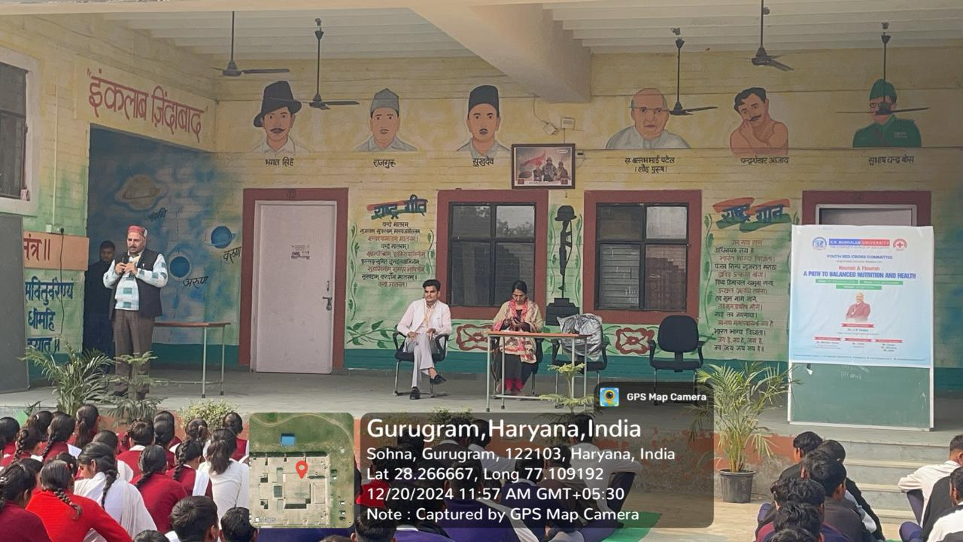

An informative outreach programme conducted for school students, focusing on the importance of balanced nutrition, healthy lifestyle practices, and overall well-being, fostering awareness and positive health habits at an early age.

Awareness Session on Child Safety and Protection
The awareness session on “Child Safety and Protection” was conducted on 13 May 2025 at Government Senior Secondary School, Daula, as an offline outreach initiative organized by the Youth Red Cross Committee, K.R. Mangalam University. The programme targeted school students and involved 14 Youth Red Cross volunteers, aiming to enhance awareness of child rights, personal safety, and legal protection mechanisms. The session was coordinated by Dr. Monika Yadav and Mr. Nitin Tyagi, and delivered by Ms. Gargi Singh, Assistant Professor, School of Legal Studies. Through interactive discussions and real-life examples, students were educated on recognizing unsafe situations, understanding legal provisions, and reporting inappropriate behaviour. The session effectively empowered students, strengthened safety awareness, and contributed to building a more informed and confident school community.
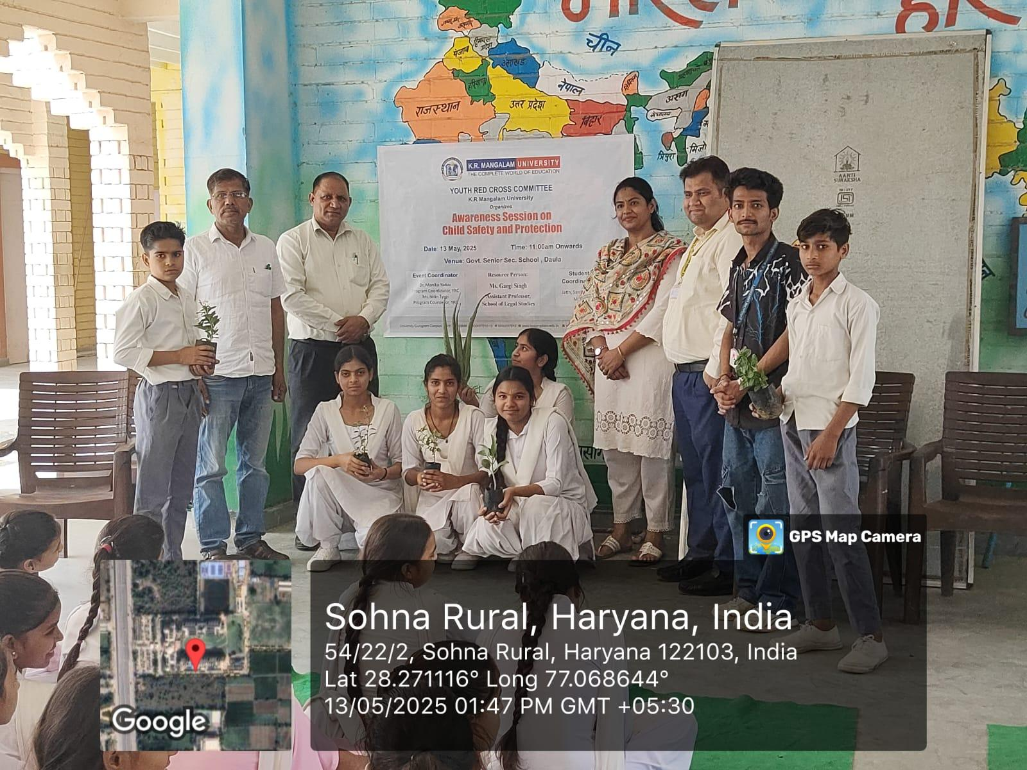

Dr. Gargi Singh addressing students during the awareness session on adolescent health and well-being at Shaheed Shri Raghubir Singh Govt. Sr. Sec. School, Sohna Rural, Haryana.

Declamation Contest on Drug Abuse: Its Social, Psychological and Health Consequences
The declamation contest titled “Drug Abuse: Its Social, Psychological and Health Consequences” was organized on 21 October 2024 at the Multipurpose Hall, 4th Floor, K.R. Mangalam University, as an offline awareness initiative. The event was jointly organized by the Youth Red Cross Committee and the Environment Club of K.R. Mangalam University, in collaboration with the Rotary Club New Gurgaon, reflecting strong institutional–community partnership. A total of 85 students attended the programme, with 20 students actively participating in English and Hindi categories. The contest was evaluated by Rotary Club representatives, including Rtn. Ashok Malik, Rtn. Mini Agarwal, and Rtn. Dr. Ram Kumar Yadav. The activity aimed to sensitize students to the social, psychological, and health impacts of drug abuse and to encourage resistance to peer pressure. The initiative significantly enhanced awareness, promoted responsible decision-making, and strengthened collaboration for future social awareness programmes.
- 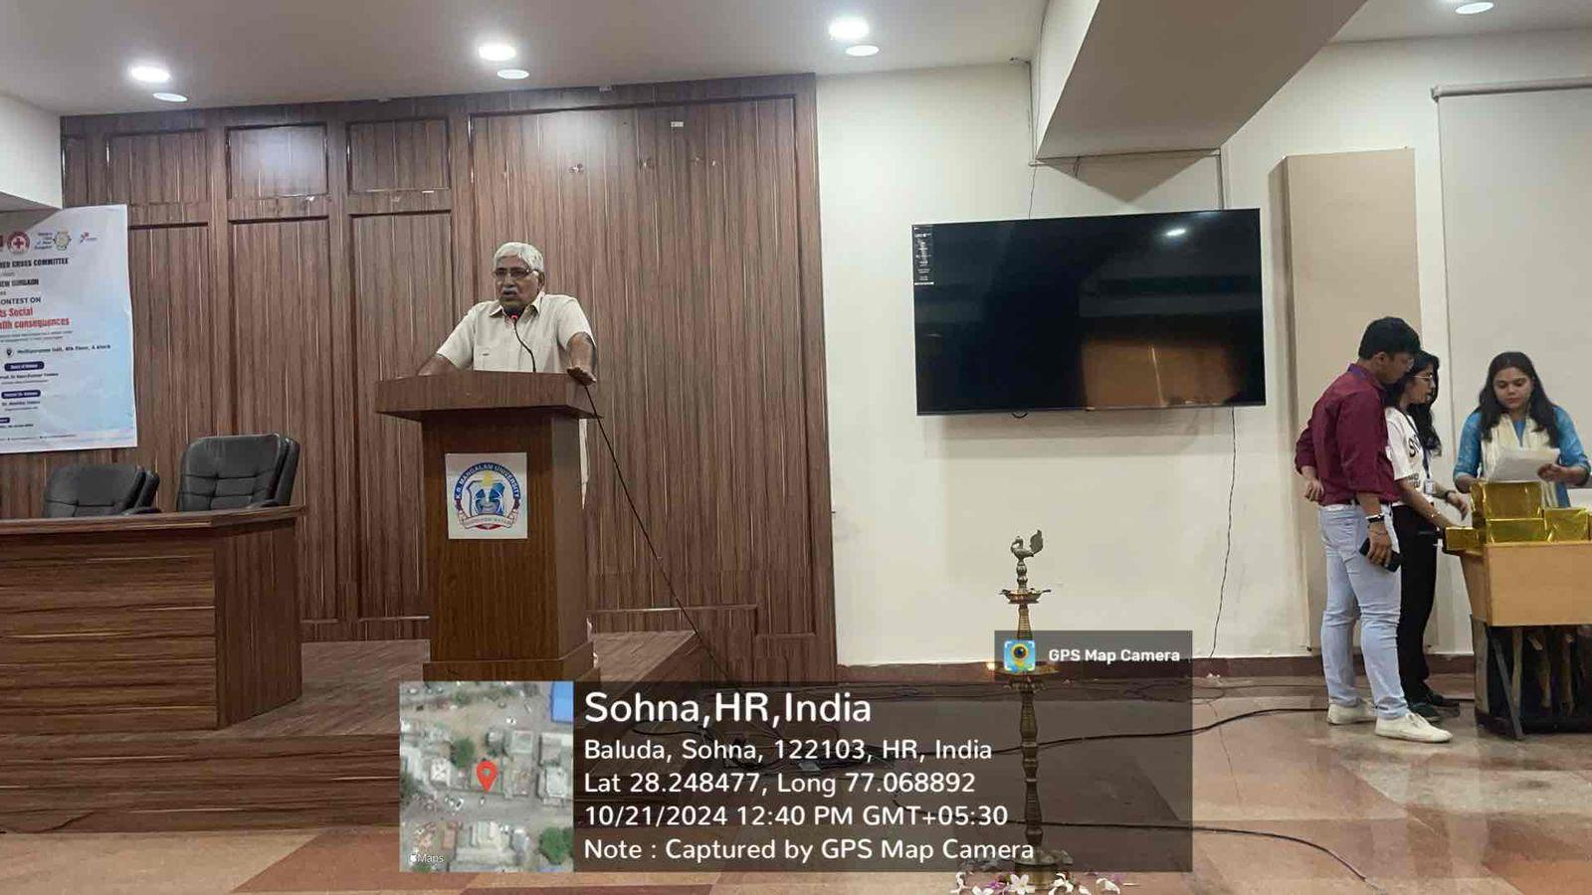
Rtn Dr Ram Kumar Yadav, President Rotary Club New Gurgaon, addresses the audience during the Declamation Contest

Drawing Competition on Save the Water for New Generation
The drawing competition titled “Save the Water for New Generation” was organized on 23 December 2024 at Government Senior Secondary School, Daula Village, as an offline awareness activity by the Youth Red Cross Committee, K.R. Mangalam University. The programme targeted school students and witnessed the participation of 24 students along with 14 Youth Red Cross volunteers, aiming to promote environmental consciousness through creative engagement. The event was coordinated by Dr. Monika Yadav, Programme Coordinator, YRC, with support from student coordinators. The primary objective was to sensitize young learners to the importance of water conservation and to encourage creative expression on sustainable practices. Students produced insightful artworks reflecting the need to preserve water resources for future generations. The competition concluded with the recognition of outstanding entries through certificates and appreciation tokens. Overall, the initiative enhanced environmental awareness, fostered creativity, and strengthened collaboration between the university and the local school community toward sustainable development goals.
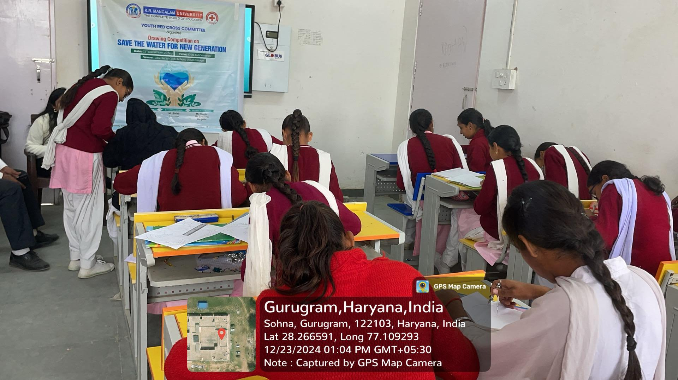
Students participate in a Youth Red Cross drawing competition on "Save the Water for New Generation."

Save a Life: First Aid Awareness” Training Session on World First Aid Day
The training session titled “Save a Life: First Aid Awareness” was conducted on 14 September 2024 at Lakhuwas Village to mark World First Aid Day. The programme was organized by the Youth Red Cross, K.R. Mangalam University, in collaboration with the Indian Red Cross Society, reflecting a strong partnership between academic and humanitarian organizations. Conducted in offline mode, the session targeted residents of Lakhuwas Village along with Youth Red Cross volunteers. The training was led by Mr. Jitin Kaushik, District Training Officer, Gurugram, who provided hands-on demonstrations on essential first aid skills, including CPR, fracture management, burn treatment, and bleeding control. Simulated emergency scenarios further enhanced practical learning and community preparedness. The session significantly improved participants’ knowledge, confidence, and ability to respond effectively to medical emergencies. Overall, the initiative strengthened community resilience and promoted a culture of safety, responsibility, and proactive health care at the grassroots level.
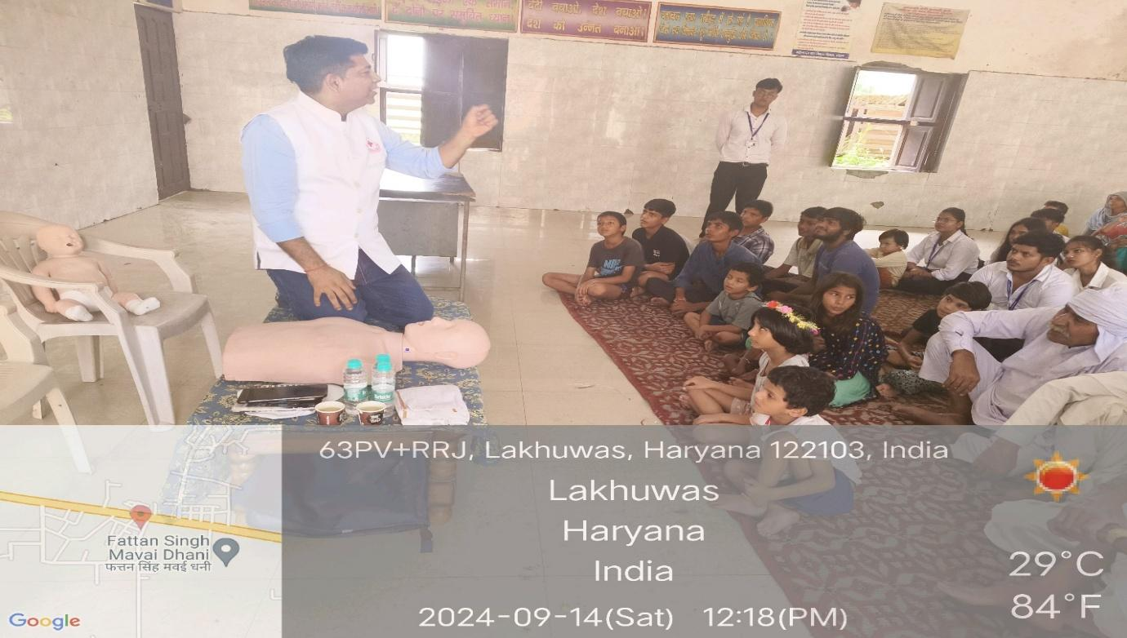
Mr. Jatin Kaushik, District Training Officer, Gurugram, explaining CPR techniques to participants during the First Aid Awareness Training Session
Cleanliness Drive and Rally under ‘Swachhata Hi Seva’ Campaign
As part of the nationwide ‘Swachhata Hi Seva’ (SHS) campaign, NSS K.R. Mangalam University organized a two-day cleanliness drive and awareness rally at Govt. Sr. Sec. School and Ghanghola village. This campaign, under the Ministry of Youth Affairs and Sports, promotes community participation in maintaining cleanliness and environmental health. The event aimed to encourage hygienic practices among locals and foster civic responsibility.
The initiative began with a briefing by the coordinators, highlighting the significance of cleanliness in improving community well-being. On 25th September, volunteers collected litter, cleaned school premises, and cleared surroundings, visibly transforming the area and promoting hygiene. More than 60 volunteers actively participated that day.
On 27th September, an awareness rally was conducted in Ghanghola village where volunteers marched through the streets chanting slogans like:
- "स्वच्छता ही सेवा है, इसे अपनाएं, जीवन को सुंदर बनाएं।"
- "आओ मिलकर कसम ये खाएं, स्वच्छ भारत हम बनाएंगे।"
- "स्वच्छ रहना, स्वस्थ रहना – यह है हमारा कहना।"
- "स्वच्छ भारत का यही नारा, गंदगी को दूर भगाना हमारा।"
The rally attracted the attention of villagers, promoting awareness on sustainable cleanliness practices. The event concluded with reflections on the importance of collective action for a cleaner India.
- 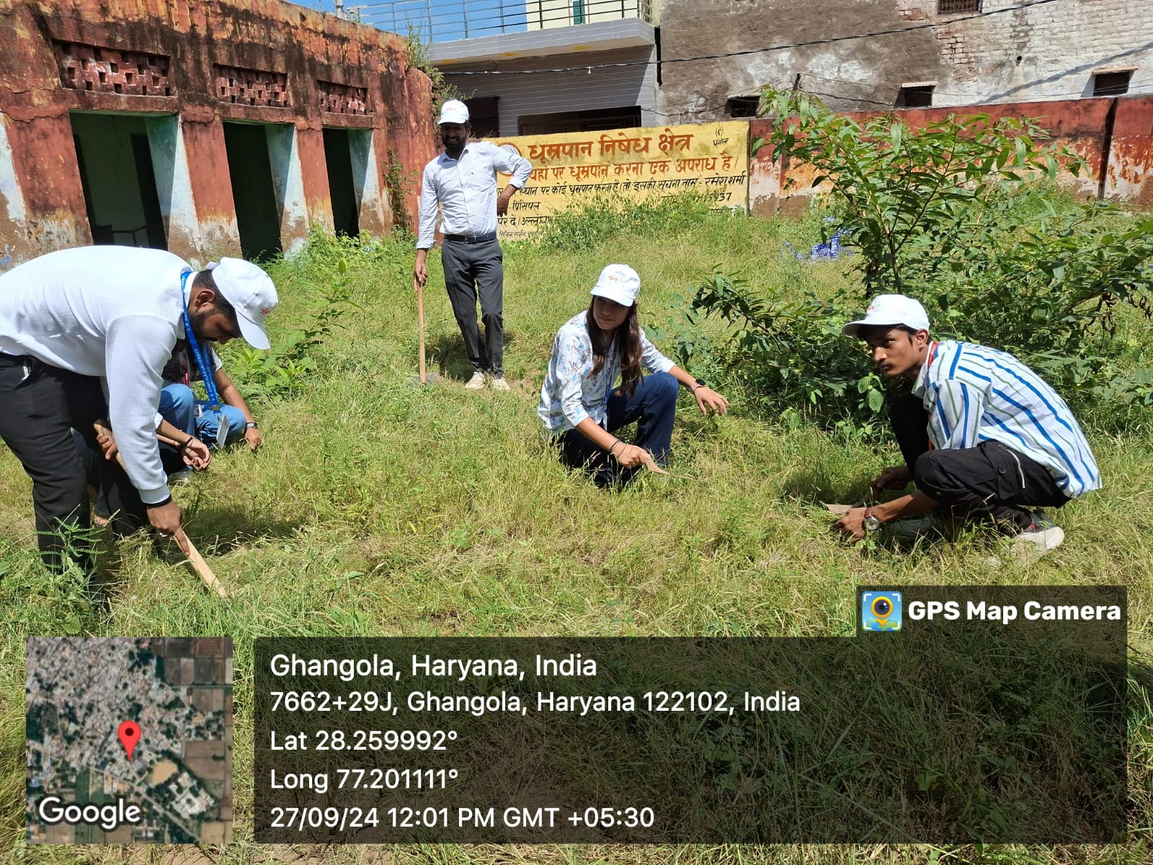
Volunteers actively participate in the Swachhata Hi Seva campaign by removing weeds and cleaning the surroundings to promote cleanliness and environmental responsibility.”
Session on ‘Constitutional Rights and Duties’
On the occasion of Constitution Day, NSS, K.R. Mangalam University, in collaboration with the Legal Aid Committee, organized a session on ‘Constitutional Rights and Duties’ at Government Senior Secondary School, Abheypur on 26th November 2024. The session aimed to raise awareness about the Indian Constitution, especially the Fundamental Rights and Duties. Dr. Sapna Rana, NSS member, welcomed the gathering and introduced the expert speaker, Dr. Arti Sharma, Assistant Professor, School of Legal Studies, KRMU. Dr. Sharma explained the historical importance of Constitution Day and elaborated on the constitutional provisions that ensure equality, justice, and responsibility. The session saw active participation from students and teachers. An oath-taking ceremony was conducted to pledge allegiance to constitutional values. The program concluded with a vote of thanks by the school principal, who appreciated NSS KRMU's efforts.

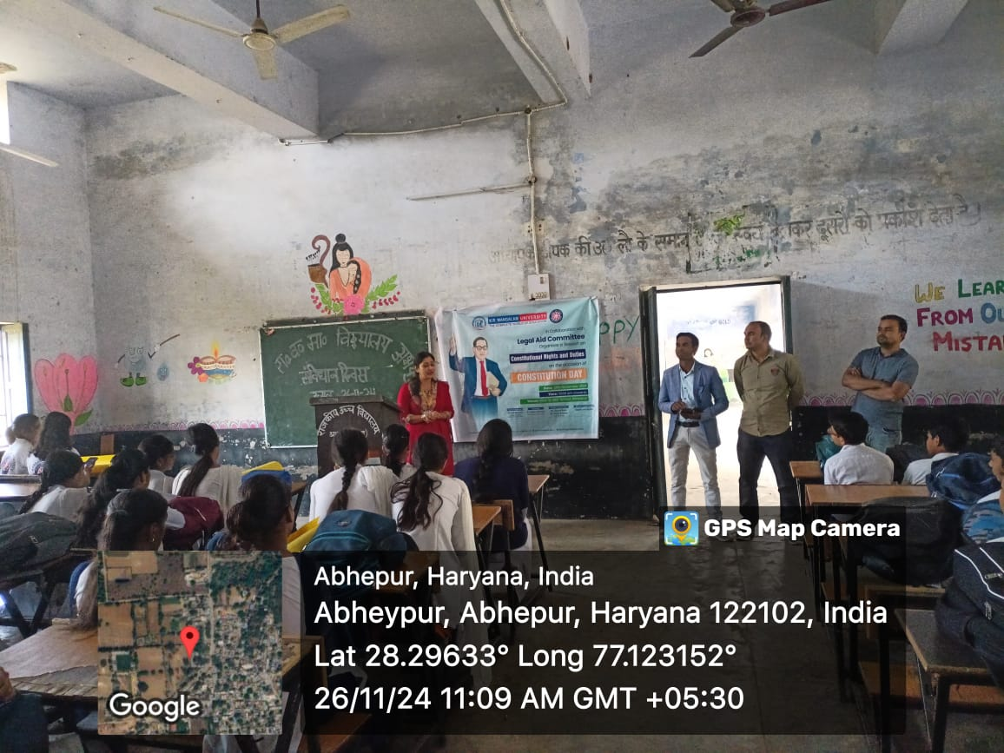
An awareness session on Constitutional values conducted at Government School, Abhepur, Haryana, engaging students in understanding their rights and duties on the occasion of Constitution Day
Nukkad Natak: ‘Shakti Ki Udaan – Betiyan Banayein Mahaan’
On 29th November 2024, NSS K.R. Mangalam University organized a Nukkad Natak titled "Shakti Ki Udaan: Betiyan Banayein Mahaan" at Berka Village to promote gender equality and girl empowerment. The play, performed by 20 NSS volunteers, depicted real-life situations highlighting the importance of girls’ education, freedom, and societal participation. Coordinated by Dr. Vicky Kapoor along with student leaders Shubhi and Aditi Gairi, the event engaged over 30 villagers in thought-provoking dialogue. The interactive format encouraged reflection on traditional gender roles and the need for change. The community appreciated the performance, and the event successfully inspired awareness and support for women's empowerment at the grassroots level.

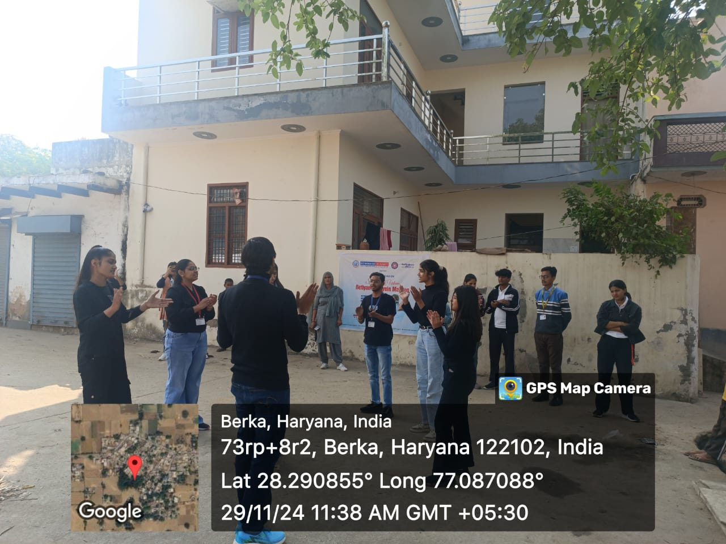
Volunteers engaging in nukkad natak to spread social awareness and promote collective responsibility
Seven-Day Special Camp under the Theme 'Yuva for My Bharat and Yuva for Digital Literacy'
Under the theme 'Yuva for My Bharat and Yuva for Digital Literacy,' the NSS Unit of K.R. Mangalam University organized a seven-day special camp in Lakhuwas village, Sohna from 2nd to 8th January 2025. The camp was conducted under the guidance of Dr. Neeraj Kumari (NSS Program Coordinator), Mr. Amit Kumar Yadav, Mr. Thomas Monteiro (NSS Program Officers), Dr. Sapna Rana, and Dr. Vicky Kapoor (NSS Members). The objective of the camp was to spread awareness among youth about digital literacy and community service. Various activities and sessions were conducted to empower the youth and benefit the rural community, including digital literacy training, cyber security awareness, anti-drug awareness, and entrepreneurship development sessions. Additionally, the camp featured a rangoli competition on cleanliness, a speech competition on the importance of Swadeshi, and a poster-making competition on the role of youth, fostering creativity and social responsibility. A health camp and first-aid training were also organized, benefiting over 100 villagers.
NSS volunteers actively participated in nukkad natak (street plays), cultural programs, and sports competitions, promoting community engagement and teamwork. The camp concluded with a valedictory ceremony, where Dr. Rajendra Kumar Yadav, NSS Program Coordinator from Sushant University, distributed prizes to the volunteers and winners. This camp was a remarkable example of youth capacity building and the promotion of digital literacy, significantly contributing to social welfare and nation-building.

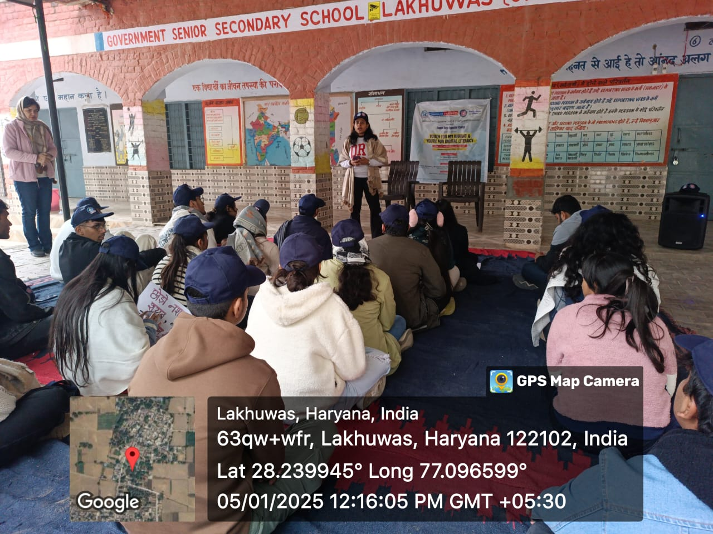

Volunteers attentively participating in an orientation and awareness session during the NSS Seven-Day Special Camp
Road Safety Awareness Campaign
On 28th January 2025, NSS K.R. Mangalam University successfully conducted an outreach activity on "Road Safety Awareness" under the National Road Safety Month (NRSM) 2025, an initiative of the Government of India. The event was organized in collaboration with the students of Government Senior Secondary School, Ghangola, Block Sohna, with the aim of spreading awareness about road safety and responsible driving. The activity featured an Awareness Rally through the village, where students and volunteers held placards and chanted slogans to emphasize the importance of traffic rules and safe driving practices. Additionally, a Poster Making Competition and an Essay Writing Competition were conducted among school students to encourage creative expression and critical thinking on road safety issues. The winners were honored with medals and certificates for their outstanding contributions. The event concluded with a felicitation ceremony, where the Principal, Sh. Satish Kumar, appreciated the efforts of NSS Programme Officer Mr. Amit Kumar Yadav, the winners, and all the NSS volunteers for their dedication to this social cause. The initiative successfully engaged the local community, reinforcing the need for responsible road behavior and adherence to traffic regulations to ensure safety for all.

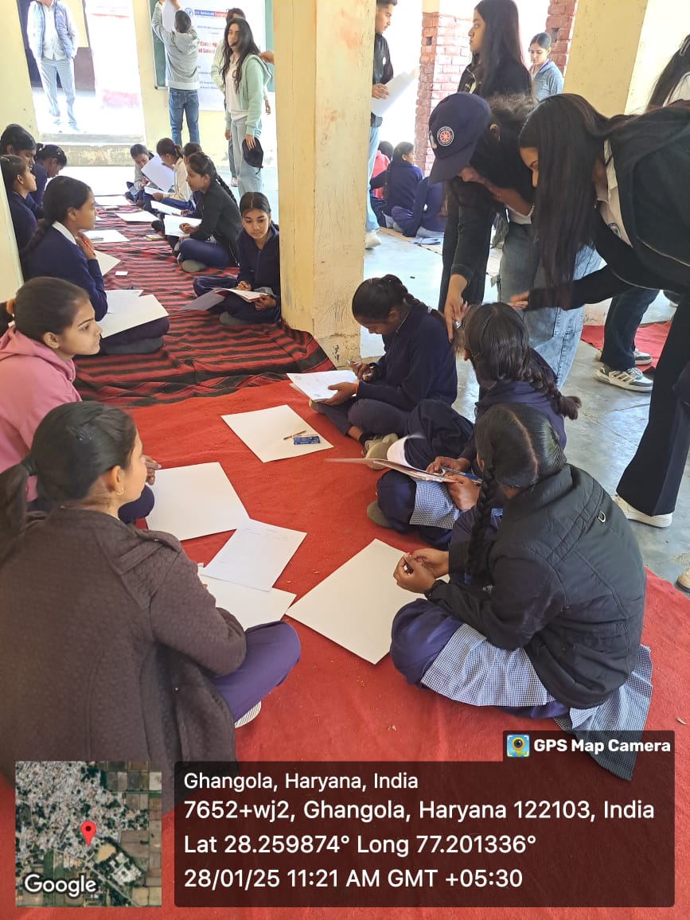
School students actively participating in a poster-making activity on Road Safety, guided by NSS volunteers to spread awareness about traffic rules and safe practices
Donation Drive and Visit to Old Age Home
The NSS Unit of K.R. Mangalam University organized a donation drive and visit to the Earth Saviours Foundation, Bandhwari, on 11th February 2025. Coordinated by Dr. Neeraj Kumari and Dr. Sapna Rana, the initiative aimed to promote compassion, service, and social responsibility among students. Donation boxes were placed across campus to collect clothes, food, and daily essentials, which were later sorted by NSS volunteers. A team of 44 NSS volunteers visited the foundation and distributed the collected items to over 31 residents. Volunteers personally served lunch and engaged in meaningful conversations with the elderly, learning about their lives and challenges. The experience created a warm atmosphere filled with mutual respect and empathy.
The visit not only brought joy to the residents but also deeply impacted the students, reinforcing the value of selfless service. The success of the drive was reflected in the enthusiastic participation of the university community and the heartfelt gratitude expressed by the foundation’s residents.

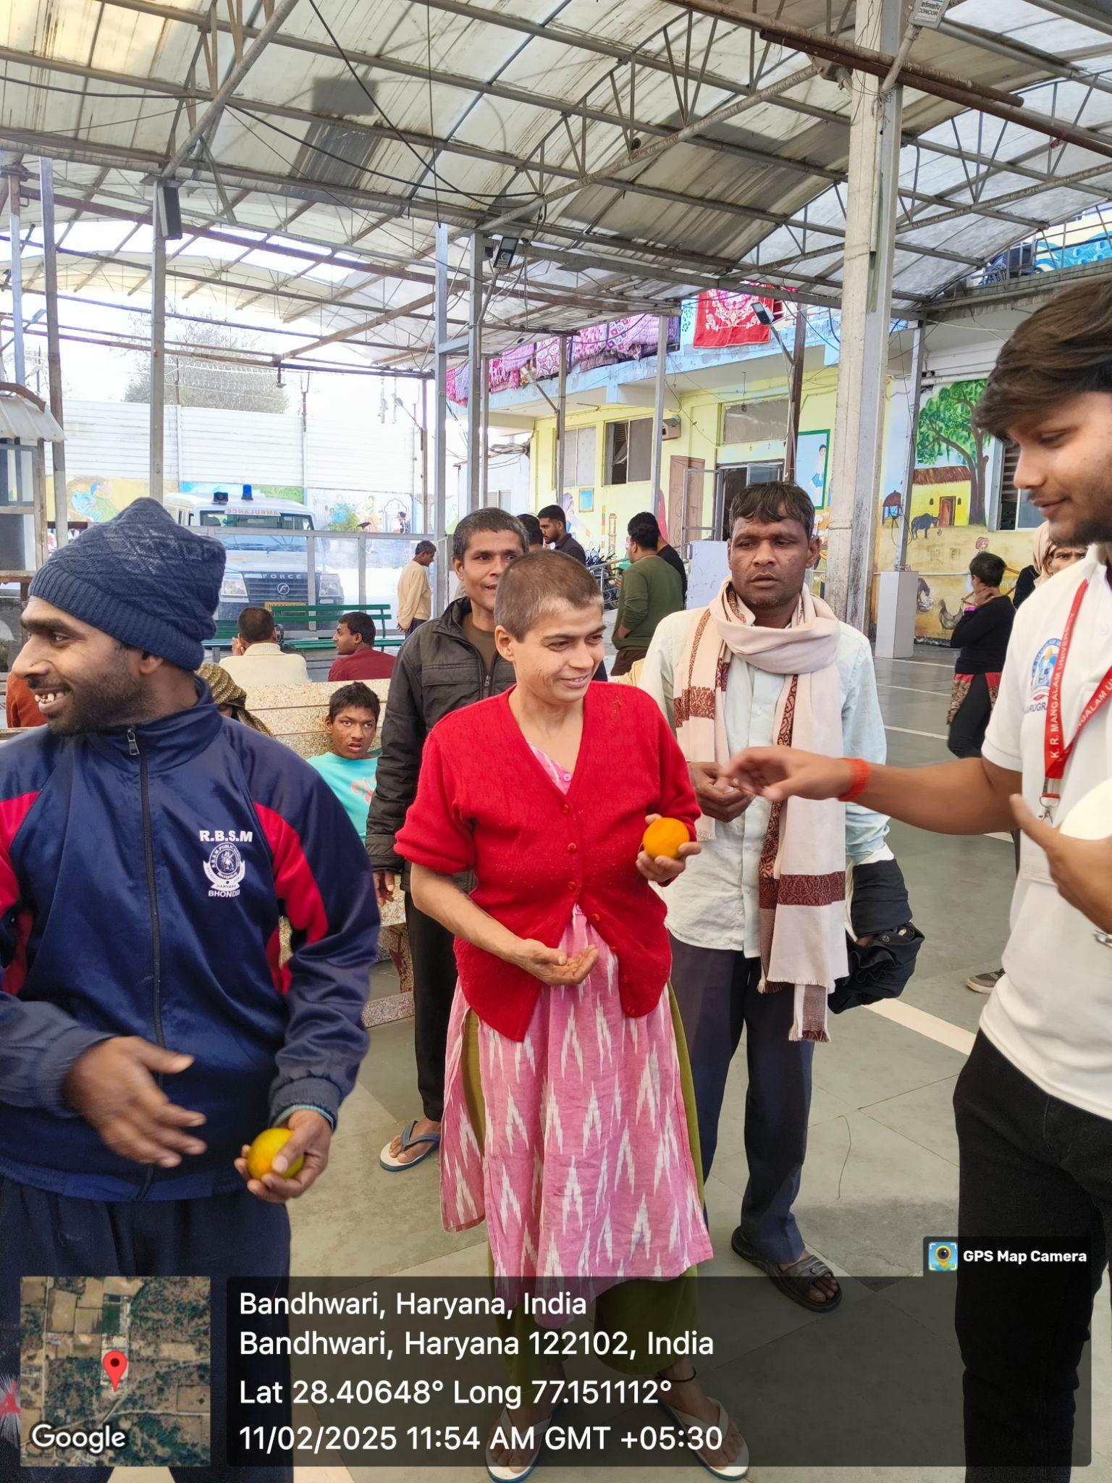
NSS volunteers distributing fruit to the residents of foundation
Shiksha Uday: A One-Day Literacy Camp
NSS Unit of K.R. Mangalam University, Gurugram, organized "Shiksha Uday: A One-Day Literacy Camp" on March 4, 2025, at Dream Girls Foundation, Sector-9, Gurugram, under the guidance of Dr. Neeraj Kumari (NSS Program Coordinator) and Mr. Thomas Monteiro (NSS Program Officer). The camp aimed to educate and inspire underprivileged children (ages 1 to 10) from labor-class backgrounds through engaging activities. NSS volunteers interacted with the children, teaching them basic literacy skills, numbers, and rhymes in a fun and interactive way. Various educational games, storytelling sessions, drawing, and craft activities were conducted to enhance their learning experience. The children also participated in recreational games, songs, and dance activities, making the day lively and joyful. Volunteers distributed stationery, books, and refreshments, ensuring that the children had a memorable and enriching experience. The event successfully created a positive impact, fostering a love for learning among the children while reinforcing the spirit of social responsibility in NSS volunteers.
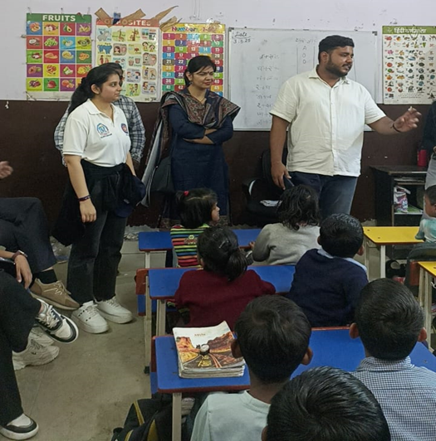
NSS volunteers during teaching the students during literacy campaign
“Empower Her: Celebrating Strength and Spirit through Performance”
On 5th March 2025, the NSS unit of K.R. Mangalam University organized a Nukkad Natak titled “Empower Her: Celebrating Strength and Spirit through Performance” at Abheypur Village to mark International Women’s Day. The event aimed to spread awareness about gender equality and women’s empowerment under SDG 5. Coordinated by Dr. Sapna Rana and Dr. Vicky Kapoor, the program saw the active participation of 30 NSS volunteers and over 30 villagers. The highlight was a compelling street play showcasing women’s struggles and inspiring messages of strength, resilience, and equality. Speeches on women's education and rights further enriched the program. Student coordinators Ansh, Pihu, and Anushri led the event with enthusiasm. The play sparked meaningful discussions among villagers, especially women, who shared their aspirations and challenges. Many young girls expressed interest in further education and skill training. The event successfully fostered awareness, community bonding, and dialogue for positive social change.
- 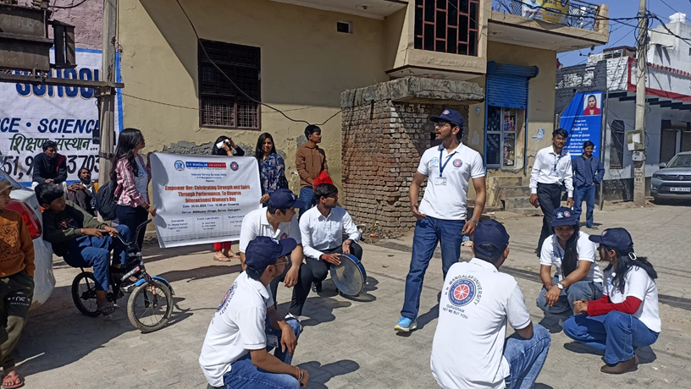
NSS volunteers performing nukkad natak at Abheypur village
Health Checkup Camp
On 15th April 2025, K.R. Mangalam University’s NSS Unit, in collaboration with the School of Physiotherapy and Rehabilitation Sciences, organized a one-day Health Checkup Camp at Daulah Village, Sohna Block. The camp aimed to provide free physiotherapy and healthcare services to over 34 villagers, addressing common issues like joint pain and mobility problems. Under the guidance of experts Dr. Ankita Samuel and Dr. Hemant Kumar, 31 NSS and SPRS student volunteers conducted check-ups, treatments, and health awareness sessions. The event focused on promoting good health, hygiene, and preventive care in line with SDG 3. Local authorities, including the village Sarpanch, supported the initiative, making it well-received in the community. The camp also provided practical learning opportunities for students, enhancing their clinical skills and social responsibility. It successfully met immediate health needs while educating villagers on healthy lifestyle habits. The collaboration strengthened community ties and inspired plans for future health camps and follow-up care. This outreach reflects the university’s ongoing commitment to nation-building through service.

- 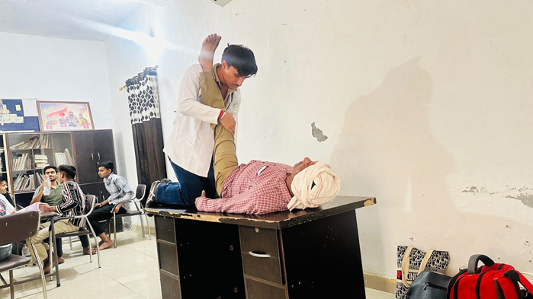
Student from physiotherpy department during the session with villager
‘Eat Right, Move More’- Wellness Workshop for Children
The NSS Unit of K.R. Mangalam University organized a one-day wellness workshop titled "Eat Right, Move More" on 21st April 2025. The event aimed to promote healthy eating habits and physical activity among school students. Coordinated by Dr. Vicky Kapoor, the session engaged 30 school students and 48 NSS volunteers through informative discussions and fun fitness activities.
The workshop included a session on the importance of balanced nutrition, followed by interactive physical games to encourage daily exercise. An open Q&A session allowed students to explore wellness topics further. The event aligned with SDG 3 (Good Health and Well-being), SDG 4 (Quality Education), and SDG 12 (Responsible Consumption and Production).
The workshop successfully raised awareness about the benefits of a healthy lifestyle and inspired students to adopt sustainable wellness habits. Plans are in place to replicate the program in more schools and introduce a student-led “Wellness Challenge” in the future.

- 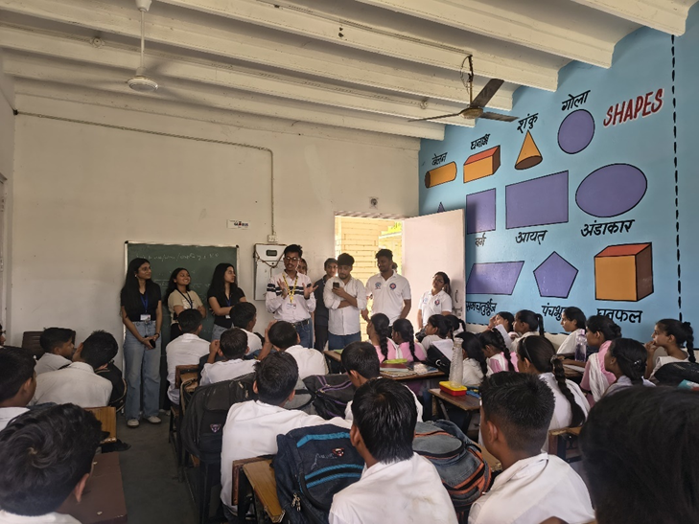
Dr. Vicky Kapoor explaining about the healthy habits
Conclusion:
Through sustained and structured outreach initiatives, K.R. Mangalam University ensures that knowledge generated within the institution directly benefits society. By integrating academic expertise with community needs, the University reinforces its commitment to inclusive growth, social empowerment, and sustainable development, in line with national priorities and the Sustainable Development Goals.
HW2.1 – Provision of Healthy and Affordable Food Options on Campus
Introduction
K.R. Mangalam University is committed to ensuring the health, well-being, and food security of its students and staff by providing healthy, hygienic, and affordable food options within the campus. The University recognizes that consistent access to nutritious food is essential for academic performance, physical health, and overall campus well-being.
To ensure that students and staff do not need to leave the campus for meals or refreshments during academic hours, the University operates multiple on-campus food facilities, including cafeterias and hostel messes. These facilities provide balanced vegetarian and non-vegetarian meals at subsidized and regulated prices, making food economically accessible to individuals from diverse socio-economic backgrounds.
Food pricing and quality are monitored and regulated by the University administration, with transparent mess menus and published rate charts displayed across dining facilities. This ensures affordability in comparison to nearby private food outlets while maintaining consistent nutritional standards.
In addition to food provision, the University adopts a responsible food management approach that integrates food waste reduction and resource optimization, thereby enhancing food availability, efficiency, and sustainability without compromising affordability. This comprehensive model strongly aligns with the QS Sustainability Ranking – Health & Wellbeing (HW2.1) criteria.
On-Campus Food Provision and Waste Utilization
The University ensures uninterrupted access to food throughout academic hours by operating on-campus dining facilities across academic blocks, hostels, and common areas. Students and staff have continuous access to meals, snacks, beverages, and drinking water without reliance on off-campus vendors. Meal pricing across all on-campus dining facilities is regulated by the University administration through subsidized meal plans, transparent mess menus, and published rate charts, ensuring economic accessibility for students and staff.
The pricing of meals across all on-campus food outlets is regulated by the University and remains lower than comparable food options available at nearby private and commercial outlets.

Awareness and Behavioural Interventions for Responsible Consumption
Through menu design, quantity management, and promoting conscious student consumption, dining establishments and cafeterias are actively attempting to reduce waste. The institution seeks to reduce food waste by providing a range of serving sizes and encouraging a balanced diet.
Digital displays, posters, and signboards in cafeterias and eating rooms act as a continual reminder to staff and students to treat food with respect as a valuable resource and to avoid overserving. Phrases like "Zero Food Waste, Food Mantra" and "Serve What You Can Eat" encourage conscious eating and social responsibility.
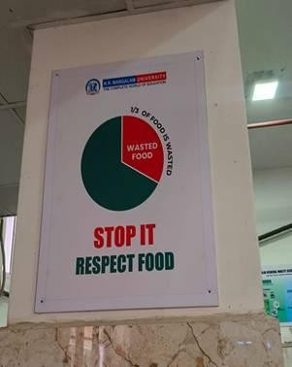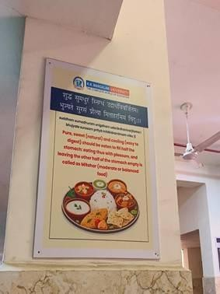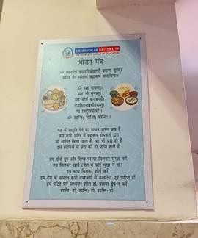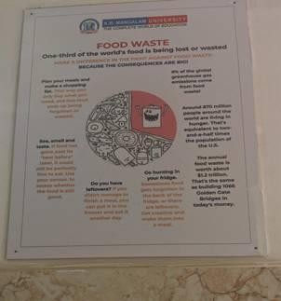

Awareness signboards and digital displays placed across campus cafeterias remind students and staff to avoid food wastage. Messages such as “Serve What You Can Eat” and “Zero Food Waste, Food Mantra” foster mindful eating habits and social responsibility within the campus community.

Integrated Report on Utilization of Food Waste through Biogas Plant
The University has also implemented an integrated system to optimize food resources and minimize wastage, thereby supporting long-term affordability and responsible food management. Through careful menu planning, portion control, and multiple serving-size options, campus dining facilities actively reduce food waste while ensuring adequate food availability.
Organic food waste generated from cafeterias and hostels is utilized through an on-campus biogas plant, converting waste into renewable energy and organic manure. This system supports uninterrupted campus food services by reducing operational costs and contributing to a circular campus food economy.

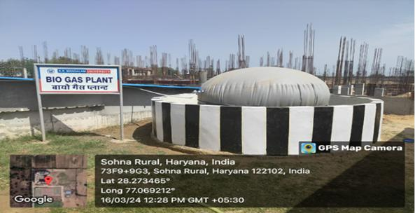

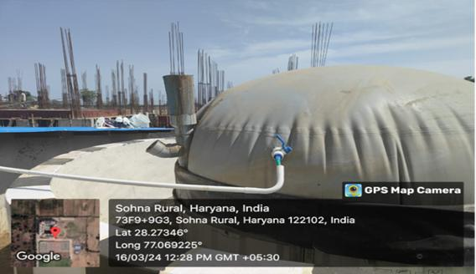
Campus biogas plant converting food waste into clean energy, replacing LPG & generating organic fertiliser

Food waste inlet chamber demonstrating closed-loop waste-to-energy system

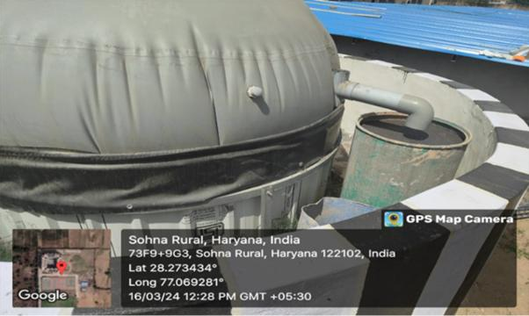

Biogas outlet & slurry discharge used as organic manure for campus horticulture sustainability
Waste Management Systems

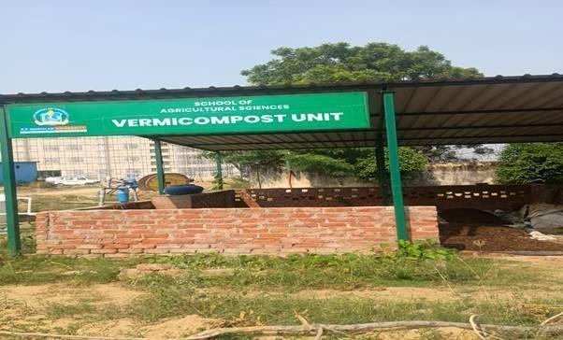
The separation of organic and inorganic trash is part of the university's integrated waste management systems. Dining establishments collect and handle their organic waste using composting techniques. The compost produced is frequently put to use in campus gardens, supporting sustainable practices on campus and fostering a circular economy.

The University implements a structured food waste management system that segregates organic and inorganic waste. Organic waste is collected from dining facilities and converted into compost, which is then used in campus gardens—promoting circular economy and sustainable resource use.
The scientific process of creating compost with earthworms is called vermicomposting. They typically live in soil, consume biomass, then expel it after digesting it

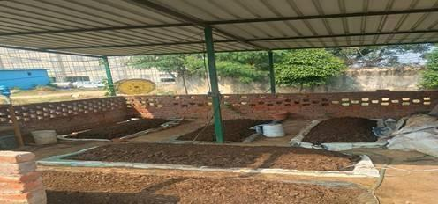

Nutrient-rich organic fertilizer produced through the university’s vermicomposting process. The compost, used in the university’s gardens and farms, enhances soil fertility and reduces dependence on chemical fertilizers, advancing sustainable agricultural practices.
Student Food Access, Affordability, and Support Mechanisms

K.R. Mangalam University ensures that no student faces food insecurity during their academic journey through structured welfare and support mechanisms.
Key Initiatives (2024):
Subsidized Meal Plans: Nutritious meals are provided at subsidized rates in cafeterias and hostels, ensuring regular access to balanced food for all students, particularly those from low-income backgrounds.
Free Meal Coupons: Economically weaker students receive free meal coupons under the Student Welfare Fund, redeemable at designated on-campus food outlets.
Community Kitchens and Food Redistribution: Surplus food is redistributed through controlled and hygienic systems, supporting students in need while minimizing waste.
Nutritional Awareness Programmes: Workshops and seminars on healthy eating, food hygiene, and nutrition promote informed food choices and well-being.

These interventions ensure continuous on-campus access to affordable meals, aligning directly with QS HW2.1 expectations.

Food Access and Affordability for Staff

The University extends food security initiatives to faculty, non-teaching, and support staff, ensuring inclusive access to nutritious meals on campus.

Staff-Centric Food Initiatives (2024):

Subsidized Staff Meals: Nutritious meals are provided at highly subsidized rates (e.g., ₹50) for non-teaching and support staff.

Free Meal Support: Economically weaker staff members receive free meal coupons under the Employee Welfare Scheme.

Community Meal Programmes (“KRMU Ann Seva”): Regular shared meals promote inclusivity and ensure food access during times of need.

Emergency Food Support: A confidential mechanism allows students or staff facing urgent food needs to request immediate assistance.

These measures ensure equitable food access across the campus community, strengthening the University’s claim under HW2.1.
Healthy, Affordable, and Sustainable Food Choices on Campus
The University promotes healthy and affordable food choices through transparent dining systems and responsible procurement.
Key Practices:
- Display of mess menus and rate charts to ensure transparency
- Availability of vegetarian, vegan, and balanced meal options
- Use of locally sourced and seasonal ingredients where feasible
- Installation of filtered water refill stations to support safe hydration
These practices ensure that students and staff have consistent access to nutritious food without financial burden, while maintaining quality and sustainability.

Students staff hunger interventions

K. R. Mangalam University(KRMU) is deeply committed to promoting food security, nutritional well-being, and social equity across its campus community. Recognizing that both students and staff may occasionally face food-related challenges, the University has instituted comprehensive hunger intervention programmes to ensure that no member of the KRMU family experiences food scarcity or nutritional deprivation.

Initiatives and Interventions (2024):

- Campus Food Assistance Programme: The University operates a structured food assistance system that provides free or subsidized meals to students and staff in need, supported by the Student Welfare Fund and the Employee Support Cell.
- Community Meal Initiative (“KRMU Ann Seva”): Under this initiative, faculty, staff, and student volunteers organize periodic community meals on campus and in nearby areas. The programme promotes inclusivity and compassion while ensuring that nutritious meals reach those facing temporary food insecurity.
- Zero Food Waste Campaign: Partnering with local NGOs and student clubs, KRMU has implemented a zero food waste policy in hostels and cafeterias. Surplus food from the campus dining facilities is systematically collected, repackaged hygienically, and distributed to students and staff members who may require assistance.
- Nutritional and Well-being Drives: The University regularly conducts nutrition awareness, health check-ups, and dietary guidance sessions for both students and staff, promoting healthy lifestyles and preventing malnutrition-related concerns.
- Emergency Food Support System: A confidential emergency food support mechanism has been set up under the Dean Student Welfare Office, where any student or staff member facing urgent food needs can request assistance without stigma or administrative delay.
The university made sure that students always had access to reasonably priced, healthful food on campus in order to prevent and reduce hunger. Breakfast and meals were made available for all students at reasonable rates, while additional measures were taken to support lower-income groups. For instance, guards, sweepers, and other support staff could access breakfast at a nominal charge of less than 5 US dollars per month. Such initiatives reflected the University’s inclusive approach to eradicating hunger within its community.
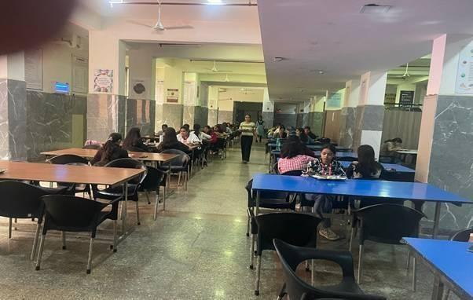

Students dining in the KRMU hostel mess, where healthy and affordable meal plans promote balanced nutrition. The university ensures food quality through sustainable sourcing and transparent menus, reinforcing its commitment to food security and well- being for all students.

Sustainable Food Choices on Campus

K. R. Mangalam University is strongly committed to promoting sustainable, healthy, and environmentally responsible food practices across its campus. Recognizing the importance of sustainability in food systems, the University has implemented multiple initiatives to encourage eco-friendly dining, waste reduction, and conscious consumption among students, faculty, and staff.

Sustainable Food Initiatives (2024):

- Promotion of Plant-Based and Balanced Diets: The University cafeteria and hostel mess menus include a wide range of plant-based and vegetarian options to reduce the carbon footprint associated with food production while ensuring balanced nutrition for all.
- Locally Sourced and Seasonal Produce: KRMU promotes the use of locally grown and seasonal food items procured from nearby farms and suppliers, reducing transportation emissions and supporting local agricultural communities.
- Ban on Single-Use Plastics: The University has completely banned single-use plastic packaging, bottles, and cutlery in food outlets and dining facilities, replacing them with eco-friendly and biodegradable alternatives.
- Composting and Food Waste Management: A campus composting unit has been established to convert organic food waste from cafeterias and hostels into compost, which is then used in the University’s gardens and green zones, promoting a circular waste management system.
- Awareness and Behavioural Change Campaigns: Regular workshops, poster campaigns, and awareness drives are organized by the School of Agricultural Sciences and Environmental Club to educate the campus community on sustainable eating habits, mindful consumption, and food waste minimization.

- Hydration and Refill Stations: To reduce plastic waste, the University has installed filtered water refill stations across the campus, encouraging the use of reusable water bottles and sustainable hydration practices.
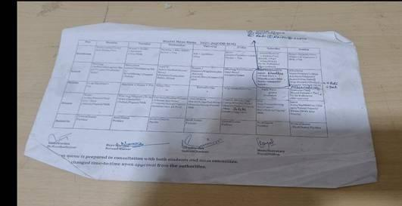
The University actively promotes sustainable and ethical food choices. Menus in hostels and canteens include vegetarian, vegan, and balanced meal options. Sustainable procurement practices ensure food quality and ethical sourcing.

Mess Menu Chart Displayed

Healthy and Affordable Food Choices

The University ensures healthy and affordable meal options for all through transparent hostel dining plans and published rate charts.
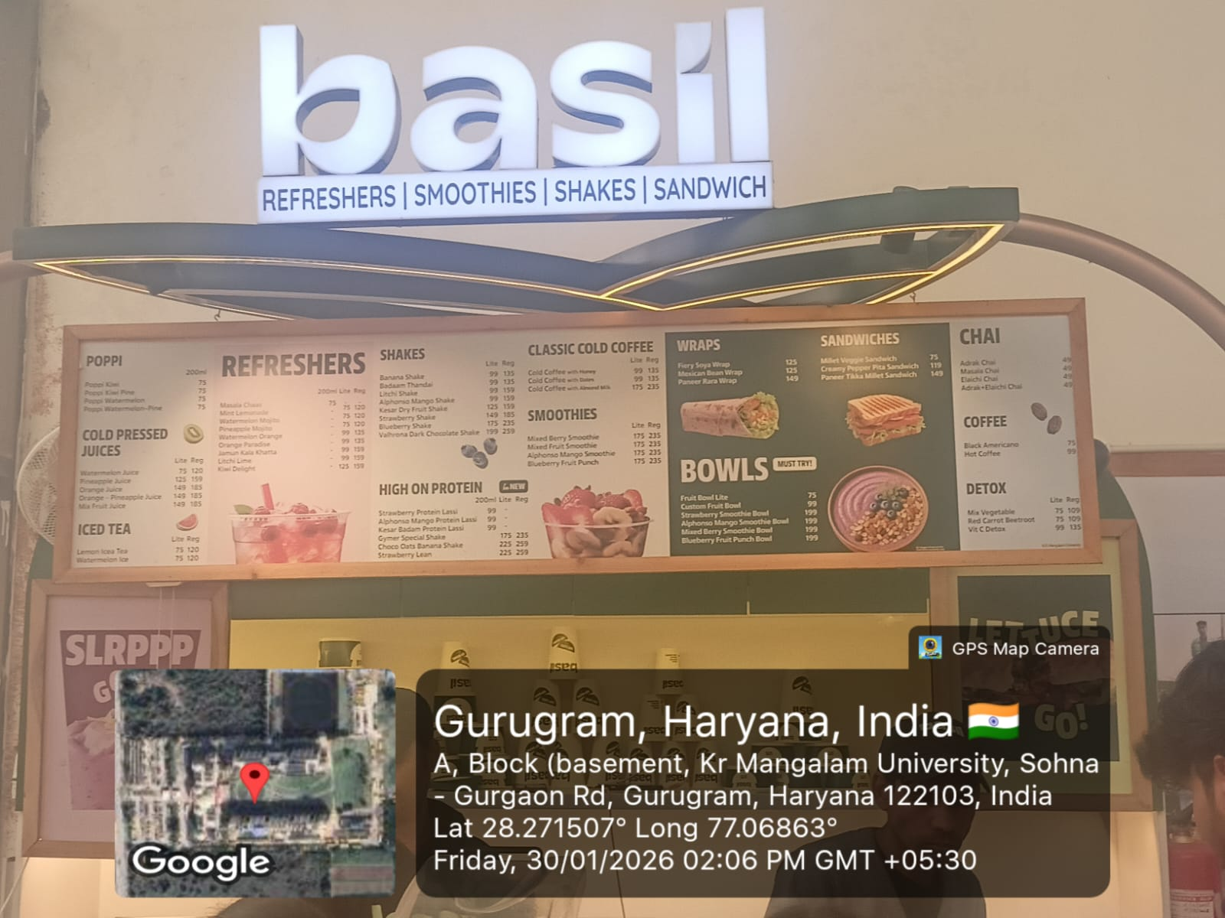
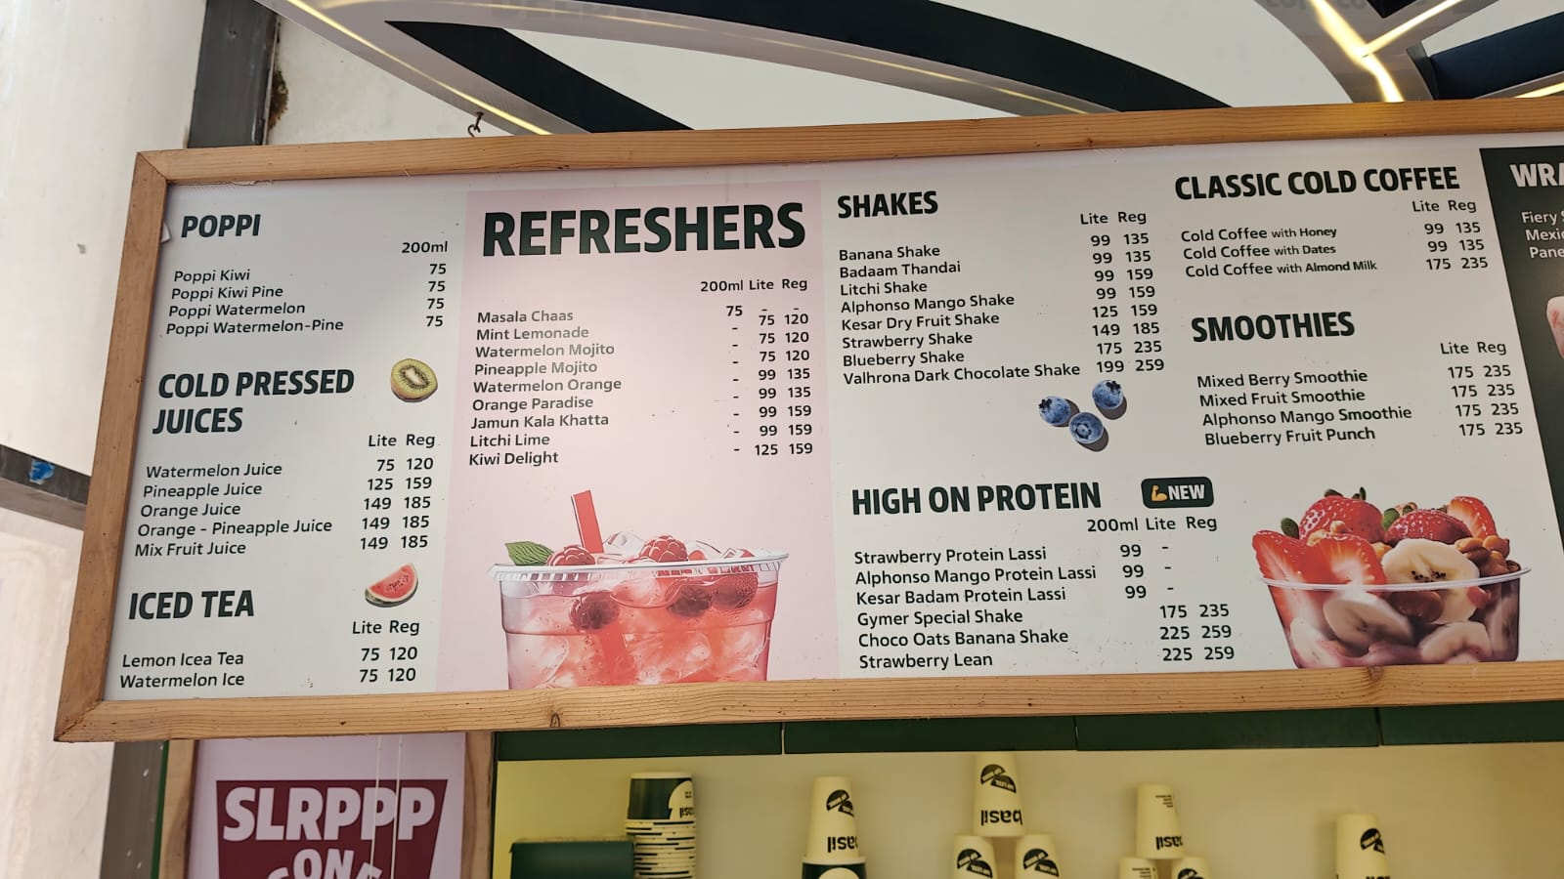

The KRMU hostel menu showcases a diverse range of nutritious vegetarian and vegan meal options, reflecting the university’s commitment to offering healthy, affordable, and ethically sourced food choices to all students.

Staff hunger interventions

The University is committed to fostering a supportive and equitable campus environment that prioritizes the welfare of its faculty and staff. Recognizing that access to nutritious food is essential for employee health, well-being, and productivity, the University has introduced a range of staff-centric hunger intervention initiatives to ensure that every member of the KRMU community has access to affordable and healthy meals without financial or social barriers.

Initiatives and Interventions (2024):

      - Subsidized Meal Program for Staff: The University offers nutritious and subsidized meals just Rupees 50 at its cafeterias and dining facilities for all non-teaching and support staff.
      - Free Meal Support for Economically Weaker Staff: Under the Employee Welfare Scheme, KRMU provides free meal coupons or meal allowances for staff members from lower income groups, ensuring that no employee experiences food insecurity.
      - Community Kitchen and Shared Meals: The “KRMU Ann Seva” programme extends beyond students to include staff participation. Regular community meal events are organized to foster unity, respect, and mutual care among all employees.
      - Health and Nutrition Awareness for Staff: The University Health Centre, in collaboration with the Human Resource Department, conducts awareness sessions on
balanced diets, food safety, and nutrition, promoting long-term health and reducing lifestyle-related health risks.
      - Zero Food Waste Collaboration: Leftover food from dining halls and events is safely redistributed to staff members in need through a controlled and hygienic redistribution system, aligning with the University’s Zero Food Waste Policy.
Through its integrated approach to on-campus food provision, affordability regulation, food security interventions, and responsible food management, K.R. Mangalam University ensures that students and staff have continuous access to healthy and affordable food without the need to leave campus.
University Facilities – Cafeteria & Dining Services
Campus Facilities at K.R. Mangalam University

HW2.2 – Access to Physical Healthcare Services on Campus
Introduction
K.R. Mangalam University ensures accessible, inclusive, and institutionally supported on-campus physical healthcare services for both students and staff through a dedicated Medical & Health Centre, supported by its academic healthcare schools. The University recognizes that timely access to physical healthcare is essential for academic continuity, workplace well-being, and a safe campus environment.
The University’s healthcare ecosystem is strengthened by the presence of the School of Medical and Allied Sciences (SMAS) and the School of Physiotherapy and Rehabilitation Sciences (SPRS), which collectively enhance healthcare education, clinical exposure, preventive care, and community health services on campus. These schools contribute to healthcare delivery through trained faculty, students, clinical infrastructure, and outreach programmes, thereby reinforcing the University’s capacity to provide primary, preventive, and rehabilitative healthcare support.
School of Medical and Allied Sciences
https://www.krmangalam.edu.in/school-of-medical-and-allied-sciences/
The School of Medical and Allied Sciences (SMAS) at K.R. Mangalam University offers a wide range of undergraduate, postgraduate, doctoral, and diploma programmes aimed at preparing skilled and compassionate healthcare professionals. With the motto “Healing Hands, Advancing Health—Shaping Future Healthcare Leaders,” SMAS provides a holistic education that integrates strong academic foundations with hands-on clinical experience. Its innovative curriculum combines theoretical knowledge, research-based learning, and practical training using advanced diagnostic technologies. Students benefit from modern laboratories, clinical exposure, and expert mentorship, enabling them to meet the evolving demands of the healthcare industry. Through strong industry collaborations and experiential learning, SMAS nurtures future-ready professionals dedicated to excellence, innovation, and patient-centred care.
SMAS plays a key role in advancing healthcare education and service delivery. The school offers a comprehensive range of programmes, including:
● Diploma in Pharmacy (D.Pharm)
● Bachelor of Pharmacy (B.Pharm)
● Master of Pharmacy (M.Pharm.)
● Bachelor of Physiotherapy (BPT)
● B.Sc. (Hons.) Respiratory Technology (with academic and industry support from Emversity) ● B.Sc. (Hons.) Cardiovascular Technology (with academic and industry support from Emversity)
● Ph.D. in Pharmacy and Allied Health Sciences
Key Highlights:
● Comprehensive Training: Students learn through advanced simulation labs, hospital tie ups, and clinical internships that provide real-world exposure.
● Community Health Outreach: Regular free medical and wellness camps are organized in nearby villages under the University’s Social Responsibility (USR) initiatives.
● Research & Innovation: Faculty and students actively engage in projects focusing on non-communicable diseases, nutrition, physiotherapy, and drug development.
● Skill Development: Emphasis on empathy, ethics, communication, and patient care prepares students to be compassionate healthcare professionals.
School of Physiotherapy and Rehabilitation Sciences https://www.krmangalam.edu.in/schools/school-of-physiotherapy-and-rehabilitation-sciences/
The School of Physiotherapy and Rehabilitation Sciences (SPRS) at K.R. Mangalam University is a centre of excellence dedicated to developing skilled and compassionate healthcare professionals who contribute to a healthier society through effective, evidence-based, and accessible care. The undergraduate programme blends clinical instruction, ethical healthcare practices, and experiential learning through internships, simulation training, and research exposure. With state-of-the-art laboratories, high-tech physiotherapy equipment, and experienced faculty mentors, SPRS provides a dynamic learning environment that nurtures clinical expertise and diagnostic skills. Through collaborations with leading hospitals and rehabilitation centres, students gain valuable real-world experience, shaping them into empathetic, research-driven professionals ready to excel in the healthcare sector.
Institutional Healthcare Linkages and Emergency Referral Support
To further strengthen on-campus physical healthcare access, K.R. Mangalam University has established formal institutional linkages with leading hospitals, healthcare institutions, and professional bodies through Memoranda of Understanding (MoUs). These collaborations enhance the University’s capacity to provide timely referrals, specialized medical support, clinical exposure, and emergency healthcare services, thereby reinforcing the effectiveness of the on-campus Medical & Health Centre.
The University has entered into over 20 active MoUs with reputed hospitals and healthcare institutions, including multi-specialty and super-specialty hospitals in Gurugram and surrounding regions. These partnerships support:
- Emergency medical referrals for cases requiring advanced or specialized care
- Clinical consultation and diagnostic support beyond primary healthcare
- Hands-on training and internships for students of Physiotherapy, Pharmacy, and Allied Health Sciences
- Joint health camps, workshops, and preventive health initiatives for campus and community
Key hospital collaborations with institutions such as Polaris Hospital, Medox Hospital, Ektaa Hospital, Akropolis Super Specialty Hospital, Kasturba Institute of Psychology & Behavioural Medicine, Hawk Eye, Al-Ameen College of Pharmacy, Bangalore, Karnataka, Dayanand Dinanath College, Institute of Pharmacy, Kanpur, International Center for Stem Cells, Cancer & Biotechnology (ICSCCB). New Delhi, Biotic Waste limited, BLDEA's SSM College of Pharmacy and Research Centre, BLDE (Deemed) University Campus, Karnataka Fortis Hospitals, C.K. Birla Hospital, Physio-Expert and Sarvodaya Hospital strengthen the University’s emergency response network and referral mechanisms, ensuring that students and staff receive prompt and appropriate medical attention when required.
Sr. No. | Year | School / Programme | MoU Partner Organization | Link
 | 2021 | School of Physiotherapy and Rehabilitation Sciences (SPRS) | Polaris Hospital (Polaris Medicare Services Ltd.), Gurugram, Haryana | Polaris Hospital
 | 2022 | School of Physiotherapy and Rehabilitation Sciences (SPRS) | Medox Hospital, Gurugram, Haryana | Medox Hospital
 | 2022 | School of Physiotherapy and Rehabilitation Sciences (SPRS) | Ektaa Hospital, Gurugram, Haryana | Ektaa Hospital
 | 2022 | School of Medical and Allied Sciences (SMAS) | Fortis Memorial Research Institute (Hospital), Gurugram, Haryana | Fortis Memorial Research Institute
 | 2023 | School of Medical and Allied Sciences (SMAS) | Sarvodaya Hospital, Faridabad, Haryana | Sarvodaya Hospital
 | 2023 | School of Physiotherapy and Rehabilitation Sciences (SPRS) | C K Birla Hospital, Gurugram, Haryana | C K Birla Hospital
 | 2024 | School of Medical and Allied Sciences (SMAS) | Akropolis Super-Speciality Hospital, Gurugram, Haryana | Akropolis Super-Speciality Hospital
 | 2023 | School of Physiotherapy and Rehabilitation Sciences (SPRS) | Physio Experts, Gurugram, Haryana | Physio Experts
 | 2022 | School of Humanities (SOHS) | Kasturba Institute of Psychiatry & Behavioural Medicine, Greater Noida, Uttar Pradesh | Kasturba Institute of Psychiatry & Behavioural Medicine
 | 2023 | School of Medical and Allied Sciences (SMAS) | Al-Ameen College of Pharmacy, Bangalore, Karnataka | Al-Ameen College of Pharmacy
 | 2023 | School of Medical and Allied Sciences (SMAS) | Dayanand Dinanath College, Institute of Pharmacy, Kanpur, Uttar Pradesh | Dayanand Dinanath College, Institute of Pharmacy
 | 2022 | School of Medical and Allied Sciences (SMAS) | Indian Pharmacy Graduates Association, Delhi | Indian Pharmacy Graduates Association
 | 2024 | K.R. Mangalam University | Medowsgreen, New Delhi | Medowsgreen
 | 2024 | School of Medical and Allied Sciences (SMAS) | International Center for Stem Cells, Cancer & Biotechnology (ICSCCB), New Delhi | International Center for Stem Cells, Cancer & Biotechnology
 | 2024 | School of Medical and Allied Sciences (SMAS) | Biotic Waste Limited, Gurugram, Haryana | Biotic Waste Limited
 | 2022 | School of Basic and Applied Sciences (SBAS) | BLDEA's SSM College of Pharmacy & Research Centre, BLDE (Deemed) University, Karnatka | BLDEA's SSM College of Pharmacy & Research Centre

In addition, collaborations with professional bodies and industry partners in pharmacy, physiotherapy, forensic sciences, and behavioural health further enhance health service delivery, skill development, and preventive healthcare awareness on campus.
Through these structured healthcare linkages, the University ensures that its on-campus physical healthcare services are seamlessly integrated with external medical expertise, fully aligning with the QS Sustainability Ranking – Health & Wellbeing (HW2.2) requirements.
On-Campus Medical & Health Centre
The University operates a dedicated Medical & Health Centre that provides essential physical healthcare services during working hours. The facility is equipped to address routine medical concerns, provide first-line treatment, and coordinate emergency responses when required.
Key Features of Physical Healthcare Services
- Qualified Medical Professionals: Trained and qualified medical professionals are available during working hours to provide primary healthcare consultation and treatment to students and staff.
- First-Aid Facilities: Fully equipped first-aid kits are available across academic blocks, hostels, laboratories, sports facilities, and administrative offices to ensure immediate medical assistance.
- Emergency Medical Support: The University has an established emergency response and referral system to nearby hospitals and healthcare facilities for cases requiring advanced medical care.
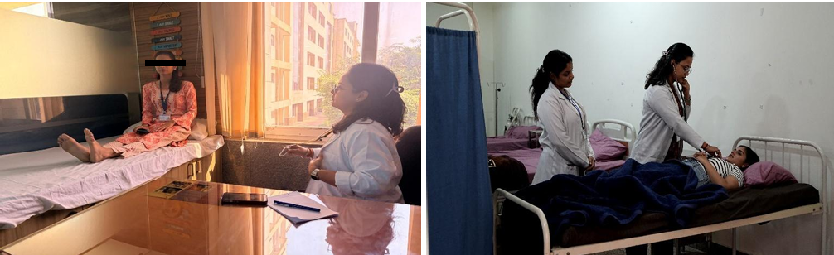
Medical Consultation in University Health Care
- Regular Health Check-Up Camps: Periodic health screening camps are organized on campus, including:
  - Blood Pressure (BP) monitoring
  - Blood sugar testing
  - Body Mass Index (BMI) assessment
  - Eye check-ups
These camps promote early detection and preventive healthcare among students and staff.
Preventive and Curative Care: Basic treatment, medical advice, and referrals are provided to support physical well-being and reduce absenteeism due to health issues.
Health Education and Awareness Initiatives
In addition to clinical services, the University emphasizes health education and preventive awareness to promote healthy lifestyles and informed health choices.
Modes of Health Information Dissemination
- Orientation Programs: Health-related information, medical facilities, and emergency protocols are introduced to students during induction and orientation programmes.
- NSS-Led Health Awareness Drives: The National Service Scheme (NSS), Health Society and Red Cross Society actively organizes health awareness sessions focusing on hygiene, nutrition, lifestyle diseases, and preventive healthcare.

S N | Name of the event | Date | Organized by | Link
1 | Awareness of Social Issues (Women's Health and Hygiene_Young Age Challenges | Case Study | SOET | Report
2 | Save a Life First Aid Awareness Training Session on World First Aid Day | 14-09-2024 | Red Cross | report word First Aid Day
3 | Nourish & Flourish A Path to Balanced Nutrition and Heaith | 20-12-2024 | Red Cross | report Balanced Nutrition and Health.docx - Google Docs
4 | Blood Donation Camp Give Blood Give Life | 24-09-2024 | Red Cross | Blood Donation Camp
5 | Wellness and Development Program | 18-10-2024 | Red Cross | kailasha foundation.docx - Google Docs
6 | Declamation Contest on Drug Abuse Its Social Psychological and Health Consequences | 21-10-2024 | Red Cross | report drug addiction
7 | Visit to Ayushman Hospital | 22-10-2024 | NSS | Ayushman Hospital
8 | KRMU PHYSIOCON 2.0, 2025 THEME- TOWARDS HEALTHCARE: INTEGRATING INDIAN KNOWLEDGE SYSTEM | 27th-29th March, 2025 | SPRS
9 | Menstrual Health Awareness Session | 07-04-2025 | NSS | Menstrual Health
10 | Health Checkup Camp | 15-04-2025 | NSS | Health Check Up Camp
11 | SESSION: "Eat Right, Move More"- Wellness Workshop for Children | 21-04-2025 | NSS | Eat Right
12 | Guest Session on Quality Control and Audit on Hygiene and Health in Commercial Kitchens in Collaboration with IQAC KRMU | 28-04-2025 | SOHMCT | Guest Session on Quality Control and Audit on Hygiene and Health in Commercial Kitchens in Collaboration with IQAC KRMU.pdf - Google Drive
13 | Outreach Activity Clean Living Healthy Life A Life Skill Drive | 01-05-2025 | SMAS | clean living report.pdf - Google Drive

A case study on “Awareness of Social Issues: Women’s Health and Hygiene – Young Age Challenges
A case study on “Awareness of Social Issues: Women’s Health and Hygiene – Young Age Challenges” was conducted by the School of Engineering & Technology, K.R. Mangalam University, during the academic year 2024–25 to address critical gaps in menstrual health awareness among adolescent girls and young women in villages Ghamroj and Bhondsi. The initiative focused on identifying prevailing myths, hygiene practices, and health challenges through surveys, interviews, and community interactions. Phase I involved baseline surveys to assess awareness levels, while Phase II included interactive awareness programs, open discussions, and one-to-one counselling sessions. Faculty members and student volunteers played an active role in educating participants about menstrual hygiene, nutrition, and safe sanitary practices. Sanitary napkins were distributed along with demonstrations on proper use and disposal. The program successfully reduced stigma, improved health literacy, and empowered young girls with confidence and knowledge. Overall, the case study contributed significantly to community health awareness and aligned with Sustainable Development Goals related to health and gender equality
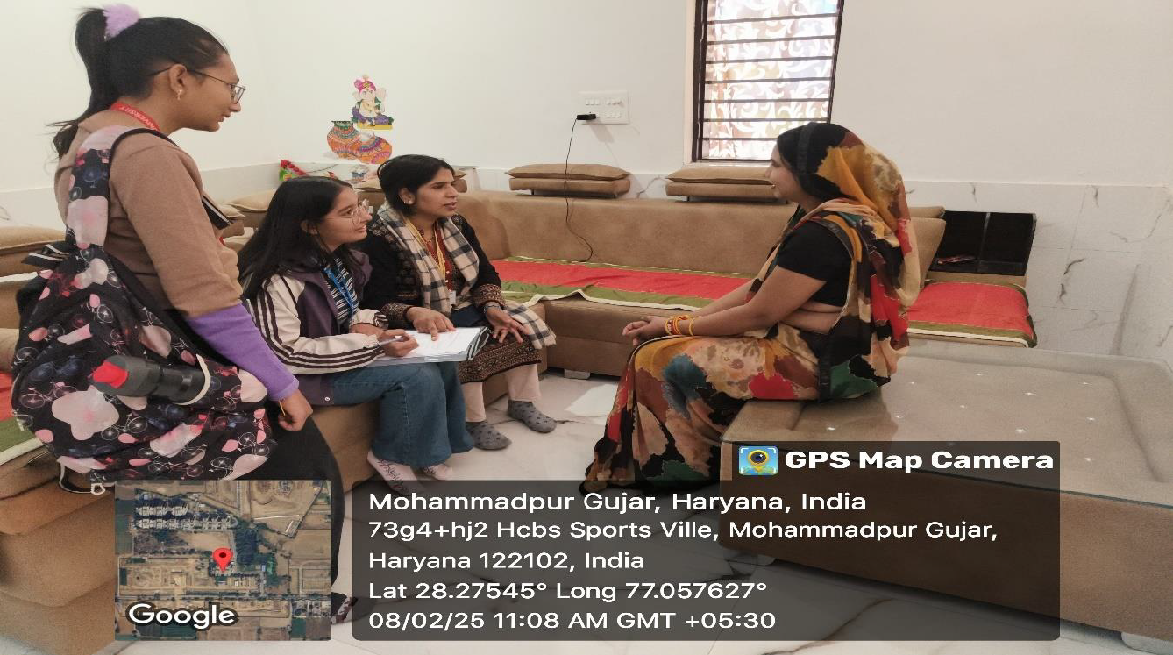

University students engaging in a one-to-one interaction with a local woman during a community outreach program at Mohammadpur Gujar village, conducting a survey and discussion on women’s health, hygiene practices, and daily challenges.
Training Session on “Save a Life: First Aid Awareness”
The Youth Red Cross of K.R. Mangalam University, in collaboration with the Indian Red Cross Society, organized a “Save a Life: First Aid Awareness” training session on World First Aid Day, 14th September 2024, at Lakhuwas Village. The program aimed to equip villagers with essential first-aid knowledge and practical life-saving skills. The session, led by Mr. Jitin Kaushik, District Training Officer, included hands-on training in CPR, management of burns, fractures, bleeding, and simulated emergency situations. Villagers actively participated and gained confidence in responding effectively to medical emergencies. The initiative successfully enhanced community preparedness and fostered a sense of responsibility towards health and safety.

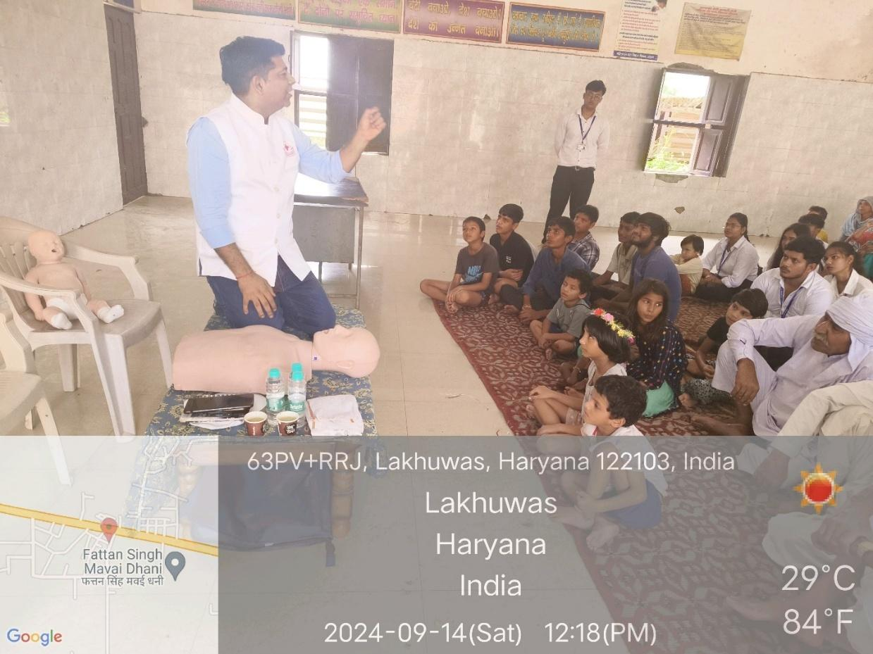

Hands-on first aid training session conducted on World First Aid Day at Lakhuwas Village, where participants attentively learned life-saving techniques under expert guidance as part of the “Save a Life: First Aid Awareness” program organized by the Youth Red Cross, K.R. Mangalam University.
A Session on “Nourish & Flourish: A Path to Balanced Nutrition and Health”
The Youth Red Cross Committee of K.R. Mangalam University organized a lecture session titled “Nourish & Flourish: A Path to Balanced Nutrition and Health” on 20th December 2024 at Government Senior Secondary School, Daula. The session was delivered by Dr. J.S. Yadav, Dean, School of Agriculture & Science, who highlighted the importance of balanced nutrition and healthy eating habits for overall well-being. He discussed the role of essential nutrients, prevention of lifestyle diseases, and the benefits of consuming locally available, nutritious foods. The interactive session helped students and community members understand practical ways to adopt healthy dietary practices in daily life. The program successfully raised awareness about nutrition and strengthened the university’s outreach and health education initiatives.

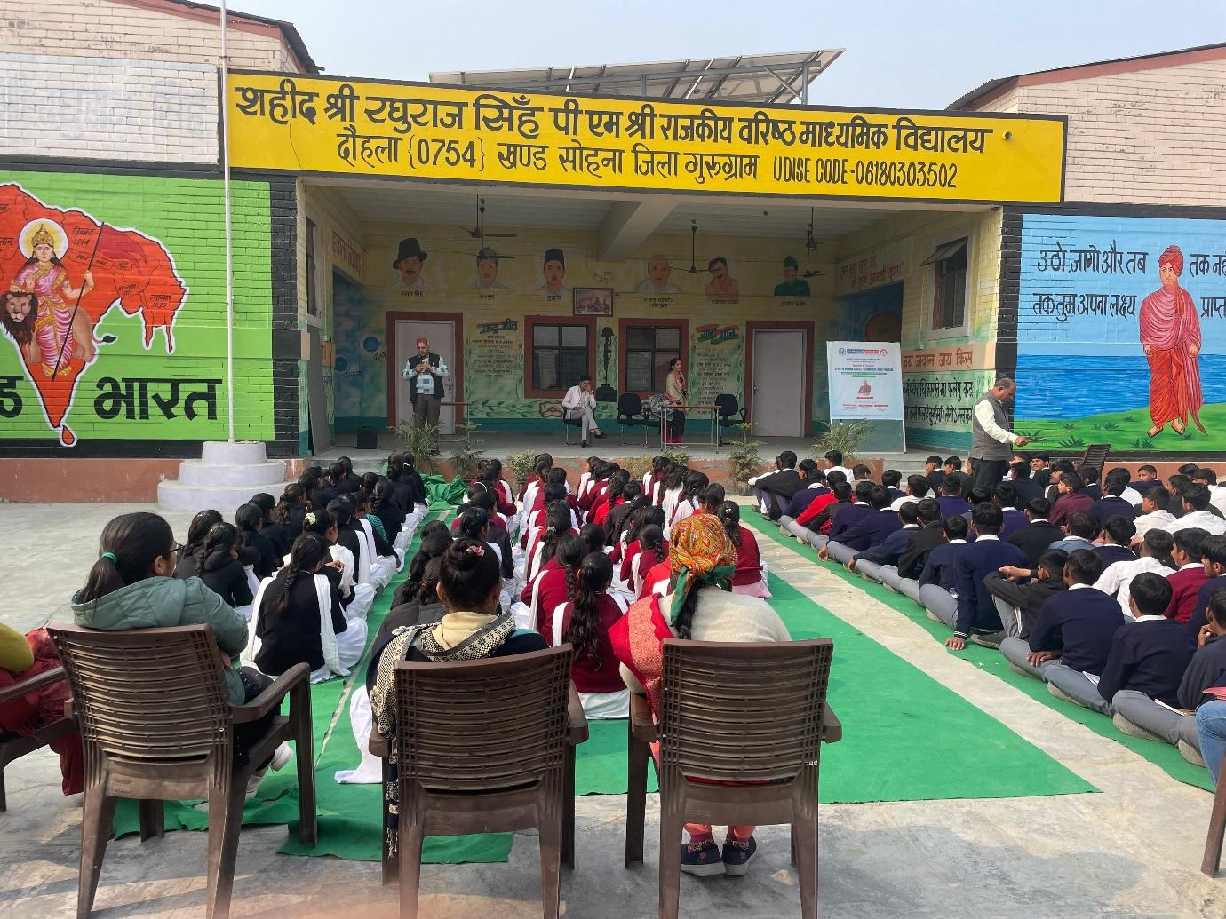

Students attentively participating in the session “Nourish & Flourish: A Path to Balanced Nutrition and Health” organized by the Youth Red Cross Committee of K.R. Mangalam University at Government Senior Secondary School, Daulah, aimed at promoting awareness on balanced nutrition and healthy living.
Blood Donation Camp "Give Blood, Give Life"
A blood donation camp was successfully organized at the Physiotherapy OPD of K.R. Mangalam University on 24th September 2024 in collaboration with the District Red Cross Society. The initiative aimed to promote voluntary blood donation and raise awareness about its life-saving importance among students. The camp witnessed enthusiastic participation, with 80 students donating blood after proper health screening and under the supervision of a professional medical team. The event was conducted smoothly, ensuring donor safety and comfort, followed by post-donation care and refreshments. This humanitarian initiative strengthened students’ sense of social responsibility and contributed significantly to local blood banks, reflecting the university’s strong commitment to community service.
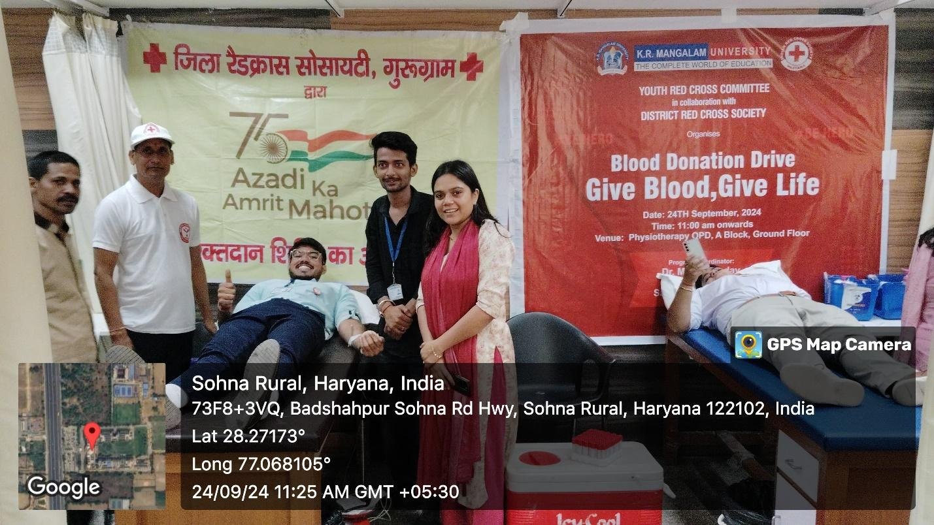

Students and volunteers participating in the Blood Donation Drive “Give Blood, Give Life” organized by the Youth Red Cross Committee of K.R. Mangalam University in collaboration with the District Red Cross Society at the Physiotherapy OPD, showcasing the spirit of voluntary blood donation and social responsibility.
Live Seminar - Synergy: Wellness and Development Program
The Youth Red Cross Committee of K.R. Mangalam University successfully organized a live seminar titled “Synergy: Wellness and Development Program” in collaboration with The Kailasa Foundation, focusing on physical, digital, and mental well-being. The session was introduced by Dr. Monika Yadav, who highlighted the importance of holistic wellness in today’s fast-paced, technology-driven lifestyle. The seminar was conducted by Mr. Varun Sharma, Founder of The Kailasa Foundation, who shared practical insights on maintaining physical health, managing digital exposure, and nurturing mental well-being. Participants gained a clear understanding of the interconnected nature of wellness and learned simple strategies to incorporate balance into their daily lives. The program was well-received and strengthened collaboration between the university and external wellness organizations, paving the way for future initiatives.
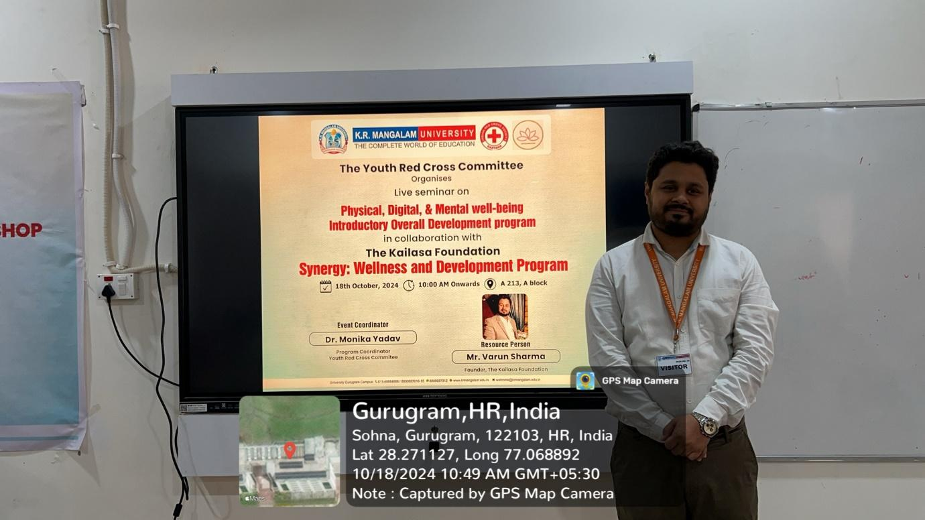

Mr. Varun Sharma, Founder of The Kailasa Foundation, during the live seminar “Synergy: Wellness and Development Program” organized by the Youth Red Cross Committee of K.R. Mangalam University, focusing on physical, digital, and mental well-being.
Declamation Contest on Drug Abuse: Its Social, Psychological and Health Consequences
The Youth Red Cross Committee and Environment Club of K.R. Mangalam University, in collaboration with Rotary Club New Gurgaon, organized a declamation contest on “Drug Abuse: Its Social, Psychological and Health Consequences” on 21st October 2024. The event witnessed active participation from 20 student speakers and an audience of 85 students, with speeches delivered in both English and Hindi. Distinguished members of the Rotary Club served as judges and emphasized the need for a drug-free lifestyle, while students showcased strong awareness and oratory skills. The program also included a pledge encouraging students to resist peer pressure and make healthy life choices. Overall, the contest effectively raised awareness about the harmful effects of drug abuse and strengthened collaboration between the university and community organizations.

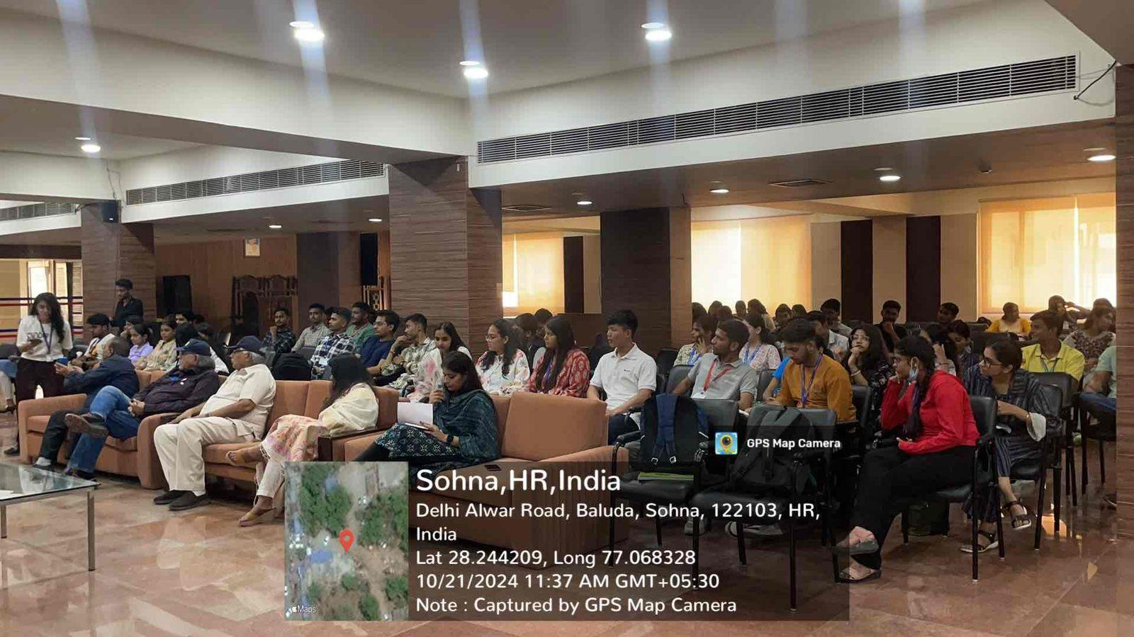

Students attentively participating in the Declamation Contest on “Drug Abuse: Its Social, Psychological and Health Consequences”
Visit to Ayushman Hospital

On 22nd October 2024, 24 NSS volunteers from K.R. Mangalam University visited Ayushman Hospital, C-2, Palam Vihar, Gurugram, under the guidance of Dr. Neeraj Kumari and Mr. Thomas Monteiro. The visit aimed to provide exposure to traditional systems of medicine under the Ayushman Bharat scheme (PM-JAY). The volunteers were warmly welcomed by experts including Mr. Bhudev (Yoga), Dr. Anupriya (Ayurveda), and Dr. Geetanjli (Panchakarma). They learned about Panchakarma therapy, its detoxification processes, and its benefits in balancing the body and mind. A yoga session introduced them to various asanas and breathing techniques. The interaction offered valuable insights into natural healing, preventive care, and lifestyle management. The session concluded with a discussion on empathy and ethics in healthcare. The visit proved enriching and educational, encouraging volunteers to consider future roles in healthcare and wellness sectors.

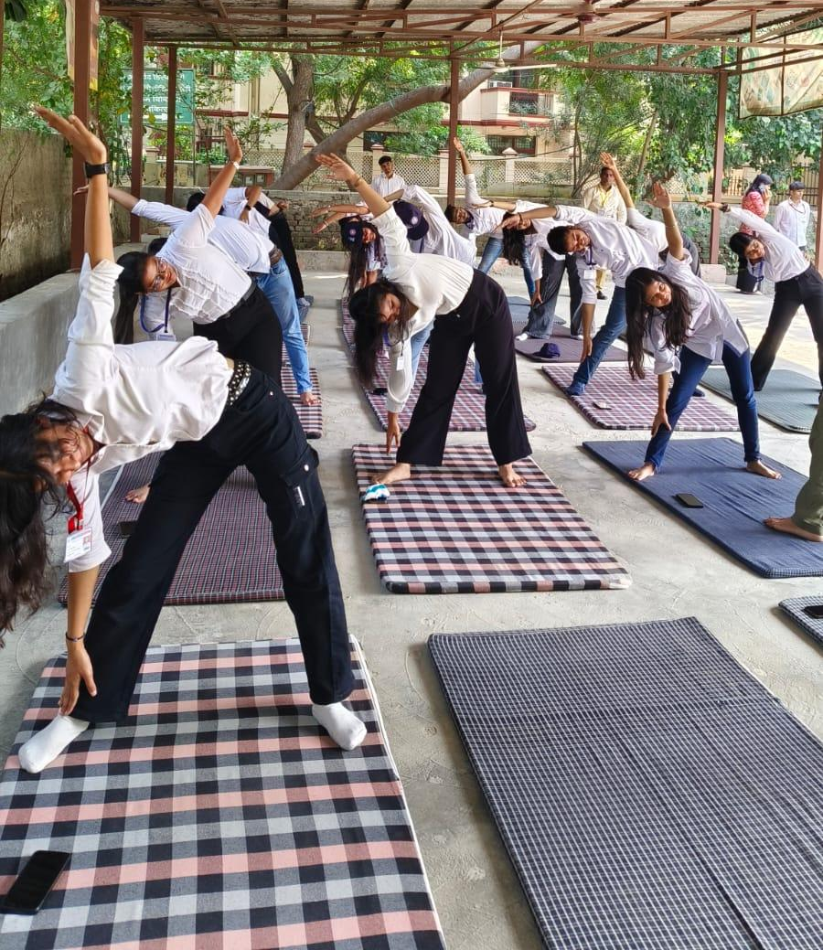

NSS volunteers actively participating in a yoga session at the AYUSH Hospital, practicing various asanas and breathing exercises under expert guidance.
PHYSIOCON 2.0
KRMU PHYSIOCON 2.0 was a three-day collaborative event organized by the School of Physiotherapy and Rehabilitation Sciences in association with the Ayush Department, Haryana, centered on the theme “Towards Holistic Healthcare: Integrating Indian Knowledge Systems.” Day 1 featured hands-on workshops, including a Pilates session by Ms. Taru Chaddha, Founder of Red Mat Pilates, focusing on core strength and posture, and a virtual reality–based rehabilitation workshop conducted by Dr. Harpreet Singh and Dr. Zubina Khan (AIIMS). Day 2 included research paper and poster presentations highlighting the integration of Ayush practices with modern physiotherapy, followed by a cultural program showcasing dance, singing, rangoli, and reel making. Academic sessions comprised a symposium on “Integrative Approaches to Chronic Diseases,” a panel discussion on “Ethical Practices in Integrative Medicine” moderated by Dr. Gurjeet Kaur Chawla, and an expert talk on holistic nutrition by Dr. Pooja Anand (SGT University). The event concluded with a valedictory ceremony and a vote of thanks by Dr. Mamta Shankar, marking a successful interdisciplinary exchange promoting holistic healthcare.
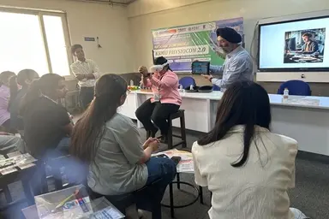

An engaging hands-on demonstration session during PHYSIOCON KRMU-2 Conference, where experts interacted with participants to demonstrate advanced physiotherapy techniques, fostering experiential learning, clinical skill enhancement, and academic exchange among students and professionals at K.R. Mangalam University.

Awareness about Menstrual Health on the occasion of World Health Day

On the occasion of World Health Day, an awareness session on Menstrual Health was organized by NSS K R Mangalam University on 07th April 2025 in Berka Village, Gurgaon, with the objective of educating rural women about menstrual hygiene and breaking the stigma surrounding it. The event was initiated by Dr. Neeraj Kumari, NSS Program Coordinator, who shared insights into the history of sanitary pads and explained the biological reason behind the monthly menstrual cycle. The session was further led by Ms. Anushri and Ms. Riya, dedicated NSS volunteers, who emphasized the importance of using sanitary pads, the recommended frequency of changing them, managing period pain, and necessary precautions to be taken during menstruation. The event concluded with a heartfelt vote of thanks by Dr. Sapna Rana, event coordiantor followed by the distribution of sanitary pads to women in the village, promoting health, hygiene, and dignity for all.

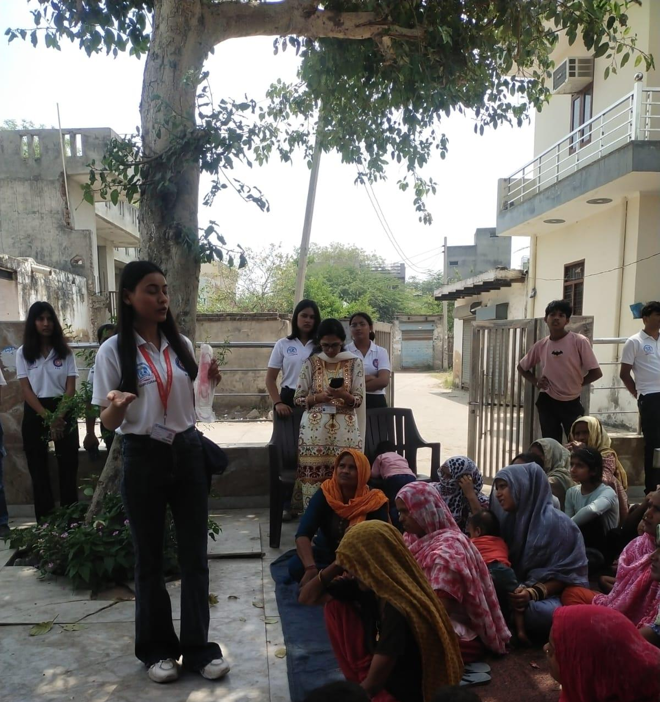

Ms. Riya addressing rural women during a health awareness session, explaining the correct use of sanitary pads and emphasizing the importance of menstrual hygiene management.
Health Checkup Camp
On 15th April 2025, K.R. Mangalam University’s NSS Unit, in collaboration with the School of Physiotherapy and Rehabilitation Sciences, organized a one-day Health Checkup Camp at Daulah Village, Sohna Block. The camp aimed to provide free physiotherapy and healthcare services to over 34 villagers, addressing common issues like joint pain and mobility problems. Under the guidance of experts Dr. Ankita Samuel and Dr. Hemant Kumar, 31 NSS and SPRS student volunteers conducted check-ups, treatments, and health awareness sessions. The event focused on promoting good health, hygiene, and preventive care in line with SDG 3. Local authorities, including the village Sarpanch, supported the initiative, making it well-received in the community. The camp also provided practical learning opportunities for students, enhancing their clinical skills and social responsibility. It successfully met immediate health needs while educating villagers on healthy lifestyle habits. The collaboration strengthened community ties and inspired plans for future health camps and follow-up care. This outreach reflects the university’s ongoing commitment to nation-building through service.
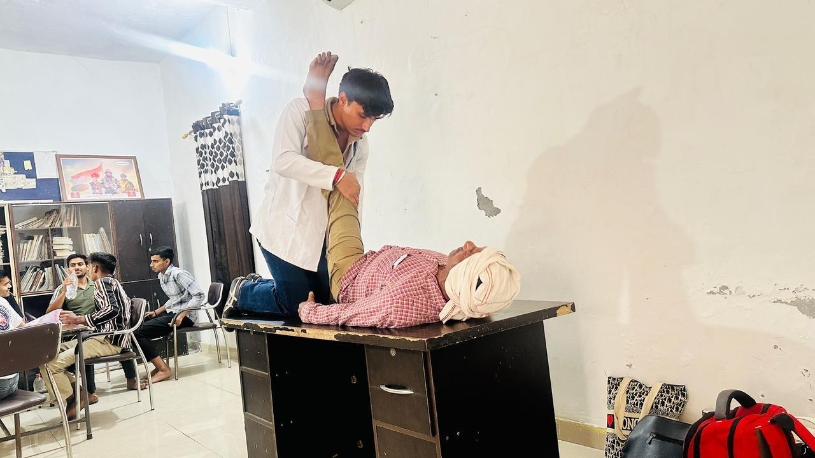

A student from the Department of Physiotherapy demonstrating basic therapeutic techniques during the first aid and health awareness session, providing hands-on assistance to a villager.
‘Eat Right, Move More’- Wellness Workshop for Children
The NSS Unit of K.R. Mangalam University organized a one-day wellness workshop titled "Eat Right, Move More" on 21st April 2025. The event aimed to promote healthy eating habits and physical activity among school students. Coordinated by Dr. Vicky Kapoor, the session engaged 30 school students and 48 NSS volunteers through informative discussions and fun fitness activities.
The workshop included a session on the importance of balanced nutrition, followed by interactive physical games to encourage daily exercise. An open Q&A session allowed students to explore wellness topics further. The event aligned with SDG 3 (Good Health and Well-being), SDG 4 (Quality Education), and SDG 12 (Responsible Consumption and Production).
The workshop successfully raised awareness about the benefits of a healthy lifestyle and inspired students to adopt sustainable wellness habits. Plans are in place to replicate the program in more schools and introduce a student-led “Wellness Challenge” in the future.

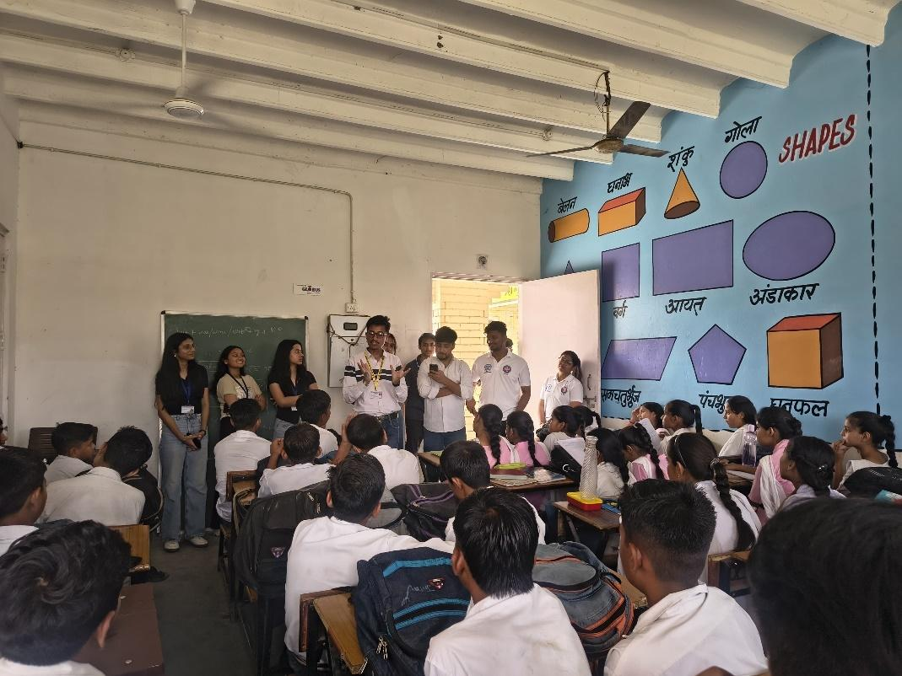

Dr. Vicky Kapoor interacting with school students and explaining the importance of healthy habits during an awareness session, encouraging children to adopt good health practices for a better and active lifestyle.
Guest session on Quality Control and Audit on Hygiene and Health in Commercial Kitchens
A guest session on “Quality Control and Audit on Hygiene and Health in Commercial Kitchens” was organized on 28th April 2025 by the School of Hotel Management and Catering Technology in collaboration with IQAC, K.R. Mangalam University. The session was conducted by Chef Vikas, Chef de Cuisine at The Roseate, New Delhi, for BHMCT 4th and 6th semester students. He shared practical insights on hygiene standards, quality audits, food safety protocols, and FSSAI compliance in commercial kitchens. Real-life case studies and audit procedures were discussed to bridge the gap between theory and industry practices. The interactive session enhanced students’ understanding of professional kitchen operations and reinforced the importance of discipline, cleanliness, and compliance in the hospitality industry.

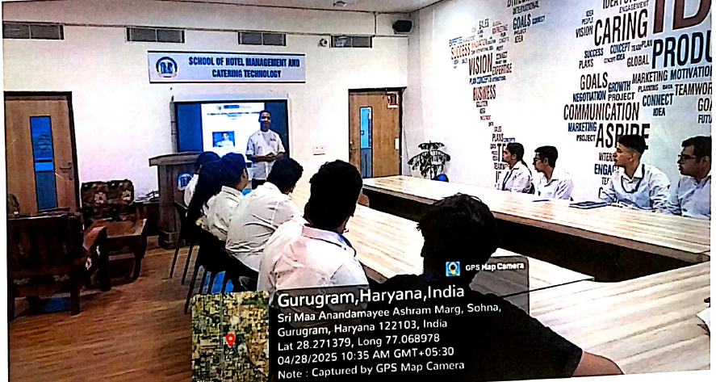

Students attentively participating in the guest session on “Quality Control and Audit on Hygiene and Health in Commercial Kitchens” organized by the School of Hotel Management and Catering Technology in collaboration with IQAC, K.R. Mangalam University, gaining practical insights into professional kitchen hygiene standards and audit practices.
“Clean Living, Healthy Life: A Life Skill Drive”
The School of Medical and Allied Sciences, K.R. Mangalam University, in collaboration with NSS and the Centre of Excellence for Sustainable Development Goals (SDGs), organized an outreach activity titled “Clean Living, Healthy Life: A Life Skill Drive” on 1st May 2025 at Village Abheypur. The initiative focused on promoting personal hygiene, dental care, and menstrual health awareness among villagers and school students. Free dental check-ups and oral health consultations were provided, along with interactive sessions on menstrual hygiene management for adolescent girls and women. NSS volunteers actively participated in community mobilization and awareness activities. The program successfully empowered the rural community with essential life skills and promoted preventive healthcare practices.

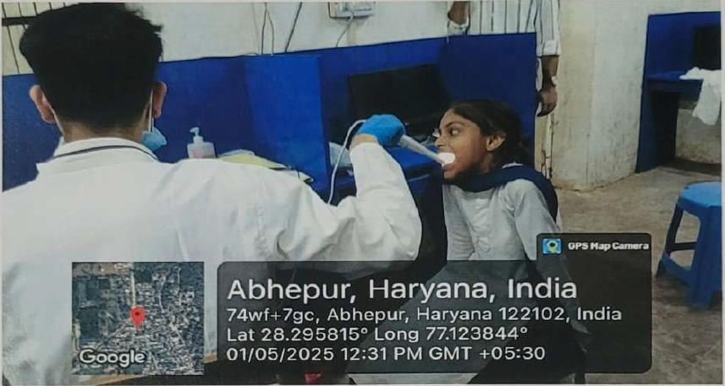

A dental health screening in progress during the “Clean Living, Healthy Life: A Life Skill Drive” organized at Abheypur Village, where a healthcare professional conducts an oral examination of a school student.
- University Circulars and Notices: Regular health advisories, awareness messages, and information related to medical services are disseminated through official circulars, notices, and digital communication platforms.
Conclusion
Through its dedicated Medical & Health Centre, trained medical personnel, emergency response mechanisms, regular health check-up camps, and structured health awareness initiatives, K.R. Mangalam University ensures comprehensive access to physical healthcare services on campus. These measures reflect the University’s strong commitment to health, safety, and well-being, fully aligning with the QS Sustainability Ranking – Health & Wellbeing (HW2.2) requirements.

HW2.3 – Access to Sexual and Reproductive Health-Care Services (Including Information & Education)
Introduction
K.R. Mangalam University has a serious commitment towards women's health by rationalization of services related to Sexual and Reproductive Health in an integrated infrastructure, policies and reach. The University has established crucial mechanisms like the Internal Complaints Committee (ICC), Gender Sensitization and Safety Committee, as well as the ‘WE DOST’ counselling portal to provide psychosocial support, preventive education and grievance redressal confidentially, keeping in line with its Gender Equity and Sensitivity Policy. K.R. Mangalam University provides a range of well-being facilities that ensure the holistic health and safety of its campus community. These include dedicated counselling services, sanitary napkin vending machines and incinerators, and fully equipped medical rooms staffed with three resident nurses and two on-call doctors. In addition, ‘She Boxes’ are installed across campus for both students and staff to confidentially report any grievances related to safety or harassment. With the collaborative support of various University clubs, academic schools, and the NSS unit, monthly Health Awareness Sessions are organized on critical themes such as family planning, nutrition, prevention of cancer, menstrual hygiene, and mental health.
Institutional Mechanisms for Sexual and Reproductive Health Care Services
    - Gender Equity and Sensitivity Policy:
The Gender Equity and Sensitivity Policy provide the foundation for inclusivity, equal opportunity, and gender-responsive practices at the University. It emphasises equitable access to healthcare, menstrual hygiene, and psychosocial support while promoting gender sensitisation and awareness among all stakeholders.
Link: https://www.krmangalam.edu.in/policies-on-good-health-and-well-being/
    - Gender Sensitization and Safety Committee:
The Gender Sensitization and Safety Committee functions as a proactive body to create a respectful, inclusive, and gender-sensitive campus environment. It organizes sensitization workshops, awareness programmes, and capacity-building initiatives to prevent bias, discrimination, and harassment. The Committee works closely with the Internal Complaints Committee to ensure a culture of prevention and responsible conduct.
Evidence Link on website: https://www.krmangalam.edu.in/K. R. Mangalam University-committee/

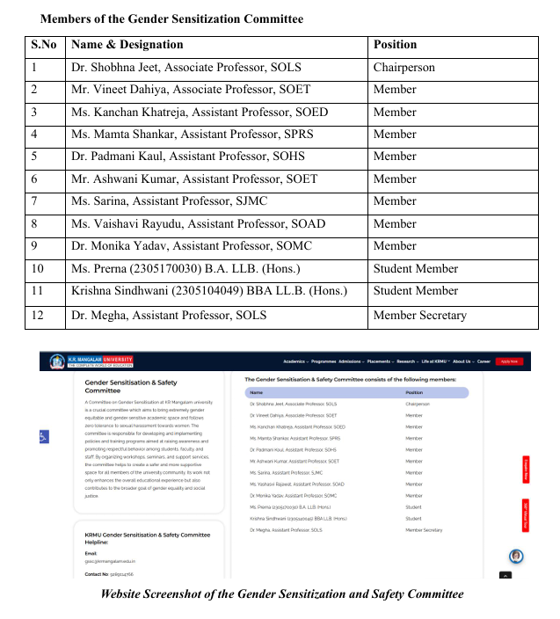

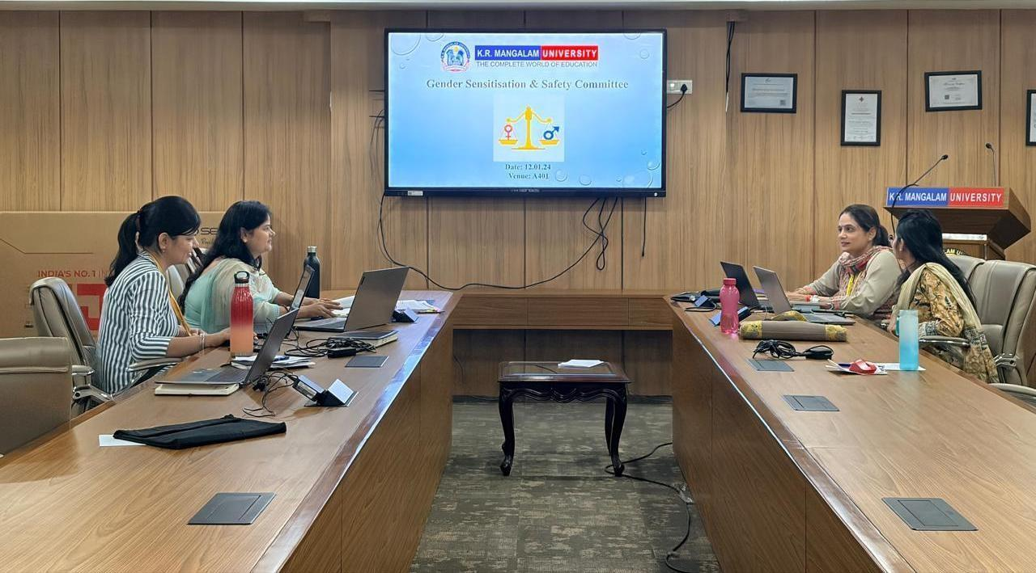

The Gender Sensitization and Safety Committee convene to review and assess the effective implementation of gender equity and safety initiatives at K.R. Mangalam University
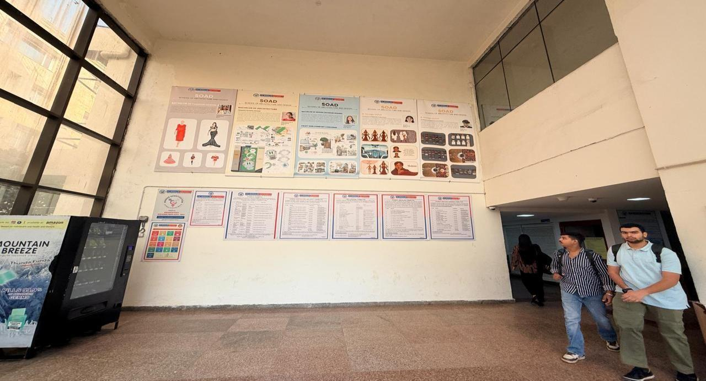
Details to contact the members of the Gender Sensitisation and Safety Committee are displayed in various strategic locations around the University campus

Details to contact the members of the Gender Sensitization and Safety Committee are displayed on campus

Internal Complaints Committee (ICC)
In accordance with the Gender Equity and Sensitivity Policy and the Prevention of Sexual Harassment Act, 2013, the Internal Complaints Committee serves as the statutory body responsible for addressing grievances related to harassment or violation of dignity. The Committee provides a confidential, fair, and legally accountable platform for resolution and undertakes awareness programmes on gender sensitization, women’s rights, and workplace safety. The ommittee is also responsible for undertaking the awareness programmes on gender sensitization, women's rights and women's empowerment in the university campus.

Evidence Link on website:
https://www.krmangalam.edu.in/K. R. Mangalam University-committee/

Details of Members of the Internal Complaints Committee (ICC)

S.No. | Name of the Member | Designation | Position
1 | Prof. Varuna Tyagi | Professor, SOMC | Chairperson
2 | Dr. Shobhna Jeet | Associate Professor (SOLS) | Vice Chairperson
3 | Dr. Inderpreet Kaur | Associate Professor (SOLS) | Member
4 | Prof. Prakash Chandra Jena | Professor (SOED) | Member
5 | Dr. Shivani Wadhwa | Assistant Professor (SOHS) | Member
6 | Dr. Kaushal Kumar | Associate Professor (SOET) | Member
7 | Prof. Vageshwari Deswal | Professor (Delhi University) | External Member
8 | Advocate Kanchan Khatana | NGO Member | External Member
9 | HR Manager | HR | Member Secretary
10 | Archisha Asthana | LL.B. (Hons.) | Student Member
11 | Mihir Srivastava | B.Arch. | Student Member

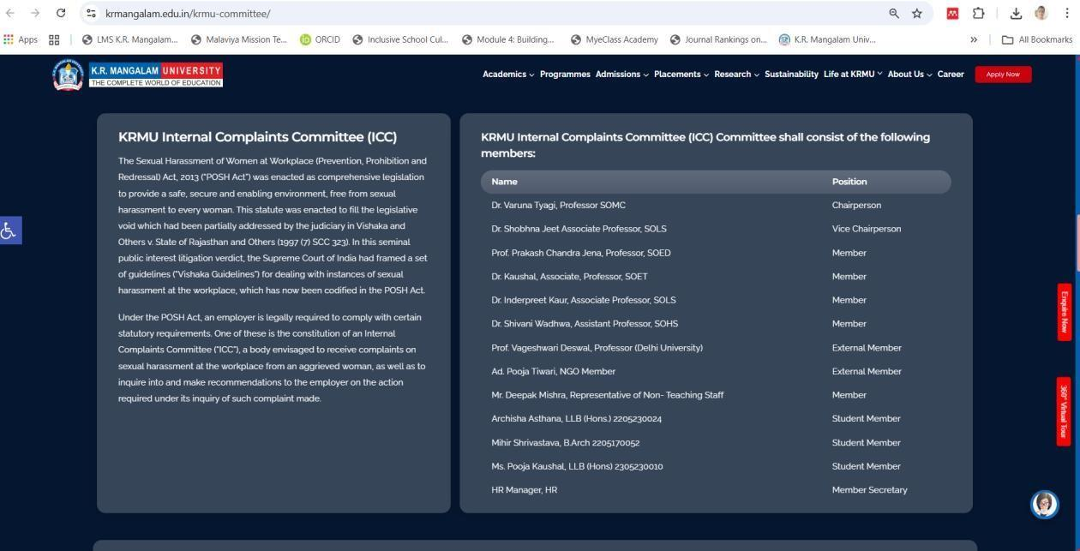
Website Screenshot of the Internal Complaints Committee (ICC)
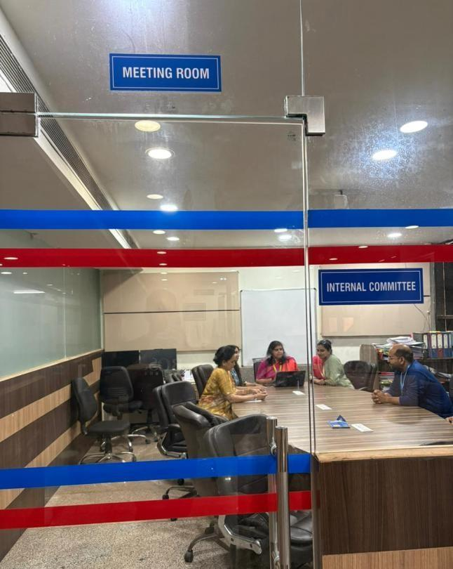
A Dedicated Meeting Room Has Been Provided on Campus for ICC Committee Members to Convene, Deliberate and Address Matters Related to Grievances and Gender Well-being in a Confidential and Professional Environment

Provision of Medical Rooms and Health Check-up Centres
K.R. Mangalam University prioritizes the health, safety, and well-being of its students, faculty, and staff through well-equipped Medical Rooms and Health Check-up Centres located within the campus. The University’s medical facility operates under the supervision of three qualified resident nurses and two on-call doctors, ensuring the availability of immediate medical attention, emergency care, and routine consultations. The centre provides first aid, general health assessments, minor treatments, and medical guidance, fostering a secure and health-conscious campus environment.

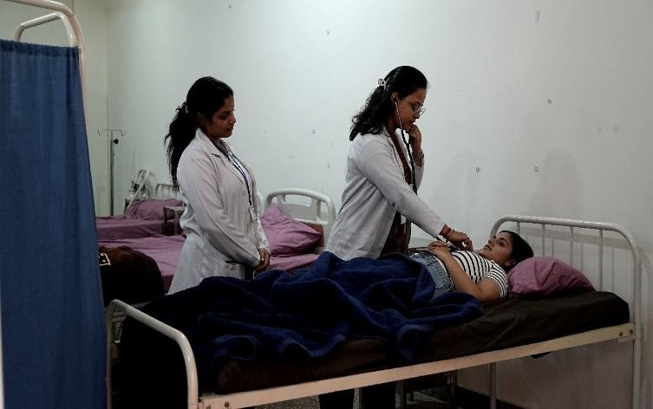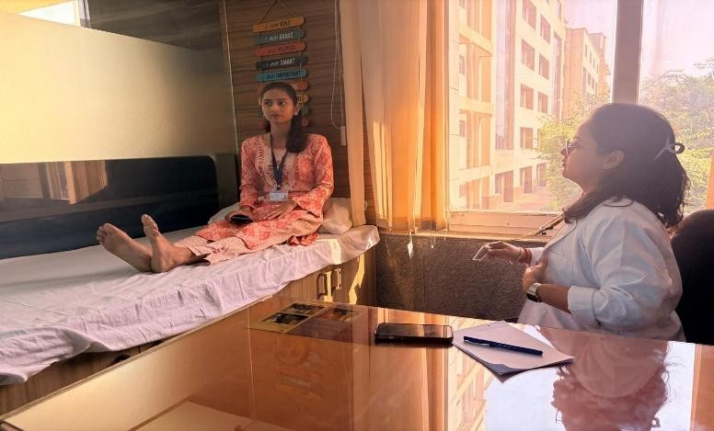

Medical Consultation in University Health Centre

To promote a culture of preventive healthcare, the University regularly conducts comprehensive health check-up camps and wellness screening sessions in collaboration with reputed hospitals and healthcare partners.

These initiatives enable early diagnosis of common ailments, lifestyle-related issues, and other health concerns, ensuring timely medical intervention and follow-up care. In alignment with SDG 3: Good Health and Well-Being, K.R. Mangalam University also organizes awareness

programs, health talks, and fitness workshops focusing on nutrition, hygiene, stress management, and holistic wellness.
Through its proactive health services and infrastructure, the University ensures that every member of its community enjoys a safe, healthy, and supportive environment conducive to learning and personal growth.

Facilities Available to Women Employees and Students
Sanitary Napkin Vending Machines and Incinerators: Sanitary vending machines are installed in the female washrooms of all academic blocks to provide free and easy access to sanitary napkins. Each machine is paired with an incinerator to ensure hygienic disposal and environmental responsibility.

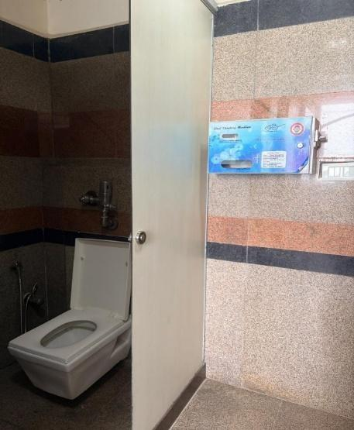
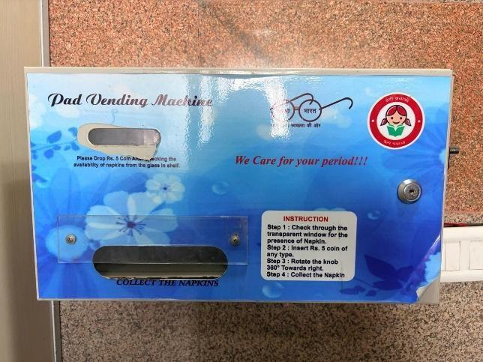

Sanitary napkin vending machines installed in female washrooms to promote menstrual hygiene and ensure safe, eco-friendly disposal
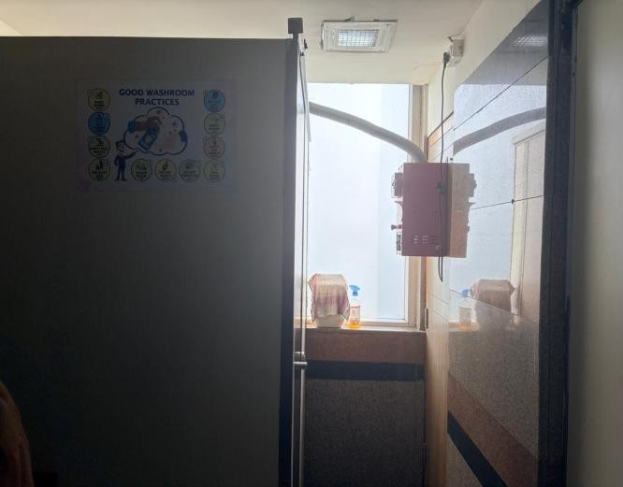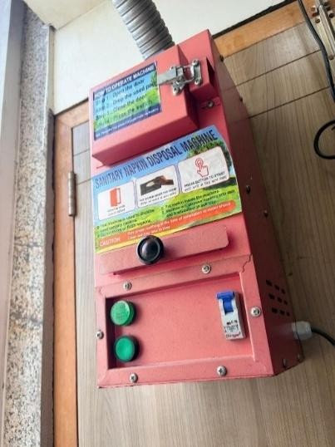

Sanitary Napkin Vending Machines and Incinerators installed in female washrooms to promote menstrual hygiene and sustainable waste management
She Boxes: She Boxes are placed in various locations on campus to allow women to submit complaints confidentially. The boxes can be accessed only by authorised female members of the Gender Sensitisation Committee, ensuring privacy and prompt action.
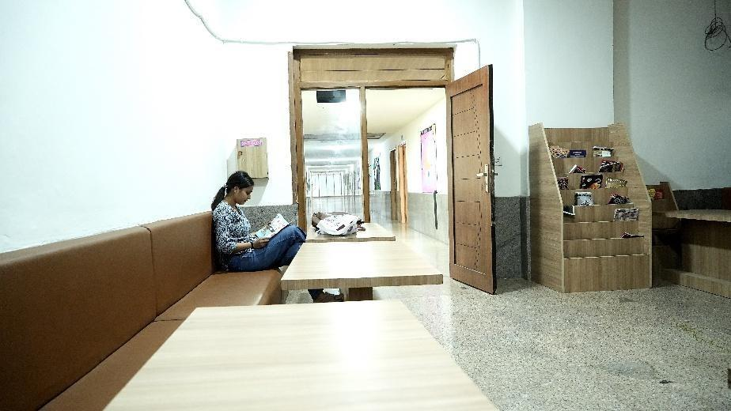
‘She Box’ installed in the Girls’ Common Room to ensure a safe, supportive, and gender- sensitive campus environment

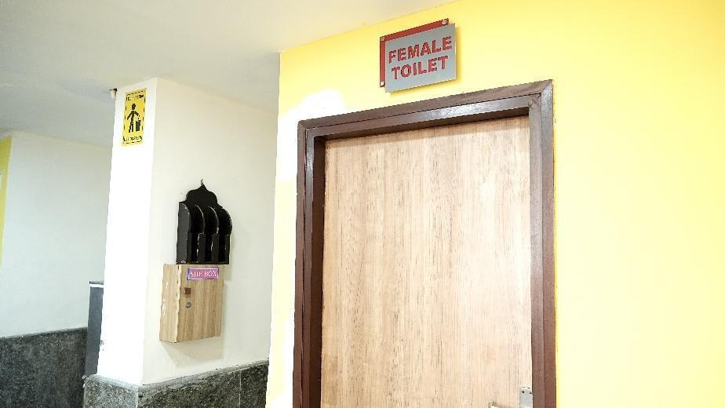
‘She Box’ installed near female washrooms to provide a secure and confidential space for reporting gender-related concerns and ensuring campus safety

Evidence / URL
- Gender Sensitization / Health Awareness / NSS Activities Page
👉 (Insert official university webpage URL here)

HW2.4 – Access to Mental Health Support for Students and Staff
Introduction:
K.R. Mangalam University is deeply committed to promoting holistic wellness and fostering a safe, inclusive environment that prioritizes the physical, emotional, and psychological well-being of its community. Through its dedicated ‘WE DOST – Counselling Centre’, the University provides confidential and empathetic counselling services addressing a broad spectrum of issues related to sexual and reproductive health, menstrual hygiene, family planning, stress management, and emotional balance.
Qualified and trained counsellors offer personalized support to students and staff, ensuring that every individual feels heard, respected, and guided with compassion. Counselling sessions are conducted both in-person and on a confidential basis, providing a safe space to discuss sensitive matters without fear of stigma or judgment.
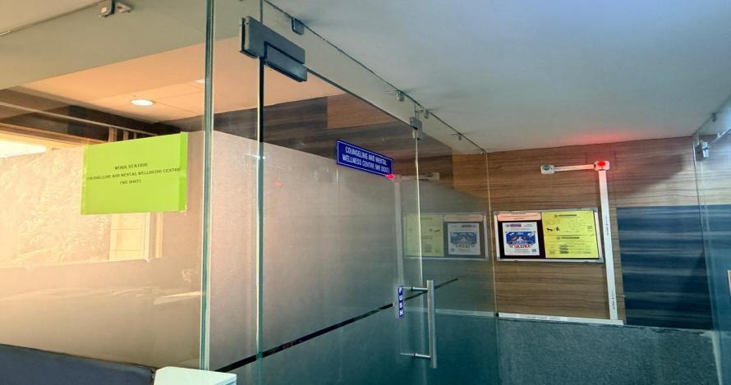
We Dost- Mental Well- Being and Counselling Centre
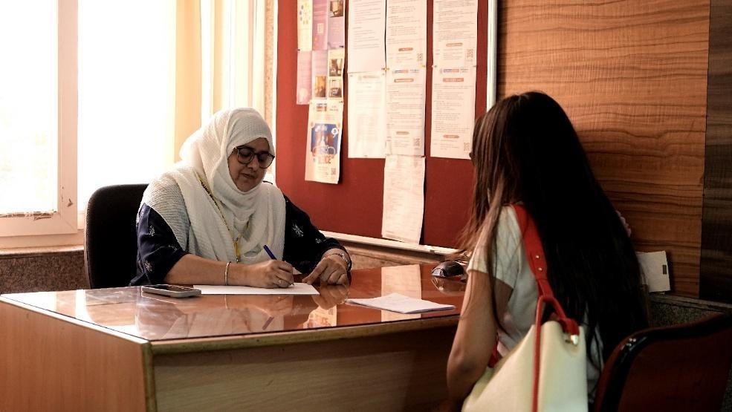
Promoting Mental Well-Being — A Qualified Counsellor Conducts a Guidance Session to Support Students’ Emotional Health and Resilience

In addition to one-on-one sessions, the WE DOST Centre frequently organizes awareness workshops and interactive group discussions in collaboration with the University’s Health Committee, NSS, and student clubs, focusing on topics such as reproductive rights, mental wellness, self-care practices, and relationship awareness.
Evidence / URL
- Counseling & Wellness Centre Page
Counselling & Mental Wellbeing Centre (We Dost) - krmangalam

