REPORT ON
SEVEN DAYS SPECIAL DAY-NIGHT CAMP
UNDER THE THEME
YOUTH FOR MY BHARAT & YOUTH FOR DIGITAL LITERACY

Date: 2nd – 8th January 2025
Venue: Lakhuwas Village, Sohna, Haryana
Event Type: Seven Days Camp
Mode of Activity: Offline
Target Group: Villagers of Lakhuwas & NSS Volunteers
Coordinators: Dr. Neeraj kumari(NSS Program Coordinator) Mr Thomas Monteiro (NSS Program Officer), Mr. Amit Kumar Yadav (NSS Program Officer), Dr. Sapna Rana(NSS Member) and Dr Vicky Kapoor (NSS Member)
Organized By: NSS, KR Mangalam University, Gurugram
Resource Persons: Dr. Sunil Chahar, Associate Professor, Department of Pharmacy, Sushant University, Mr. Rajkumar & Mr. Mahesh Soni, Traffic Police Officer, Sohna, Mr. Satyajeet, Tehsildar, Sohna, Mr. Nikhil Tiwari, Founder, Inferno Guardians, Dr. Rajendra Kumar Yadav, NSS Program Coordinator, Sushant University, Mr. Rohtash Singh, Lecturer, GSSS, Daulah and Coordinator of Red Cross Society
Participants: 51 NSS volunteers and more than 100 villagers
Introduction
Special Camping is an essential component of the National Service Scheme, holding a particular appeal for young individuals. This aspect offers students distinctive opportunities for communal living, sharing collective experiences, and engaging in continuous interaction with the community. NSS volunteers engaged in different NSS initiatives, collaborate with members of the community to contribute to societal well-being, environmental conservation, healthcare, and sanitation efforts. With the same motive, NSS, K R Mangalam University organized seven days special camp from 2nd – 8th January 2025 in Lakhuwas village under the theme “Youth for MY Bharat & Youth for Digital Literacy”. The camp was conducted under the supervision of Dr Neeraj Kumari (NSS Program Coordinator), Mr. Thomas Monteiro and Mr. Amit Kumar Yadav (NSS Program Officer), Dr Sapna Rana and Dr Vicky Kapoor (NSS Members).

Objectives

The main objective to conduct the camp is to foster self-reliance and empowerment among participants. Through various activities and initiatives, the camp aims to encourage the
individuals to contribute positively for the development of communities. The camp seeks to promote skills development, community engagement, and sustainable practices that align with the vision of a self-reliant and resilient India.

Content

During the camp, various awareness sessions, nukkad natak, cleanliness drive and many other activities had been organized.

First Day (02.01.2025): The first day of the camp commenced with the official opening ceremony. The ceremony began with the singing of the NSS Geet and the NSS clap, marking the formal initiation of the camp. The participants were then divided into five groups, each led by a designated leader. To facilitate ice-breaking and foster interaction among the members, they were given time to engage with each other and decide on a name for their respective groups. Following this, the volunteers were introduced by Dr. Neeraj Kumari to the National Service Scheme (NSS) and briefed on their roles and responsibilities. In the evening, a lecture on the topic of drug abuse was conducted. The expert of the session was Mr. Sunil Chahar, Associate Professor of Pharmaceutical, Sushant University, who provided valuable insights to the participants. To further enhance interaction and teamwork, friendly sports activities like badminton were organized, promoting unity among the volunteers. The day culminated with an enthusiastic dance session, providing a lively and enjoyable conclusion to the first day of the camp.

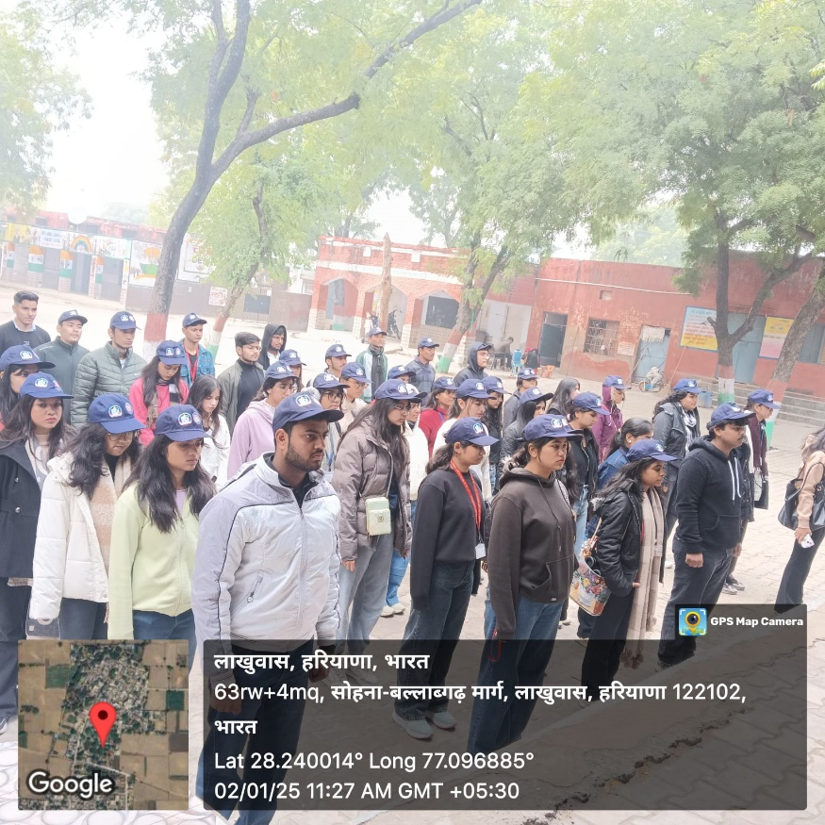

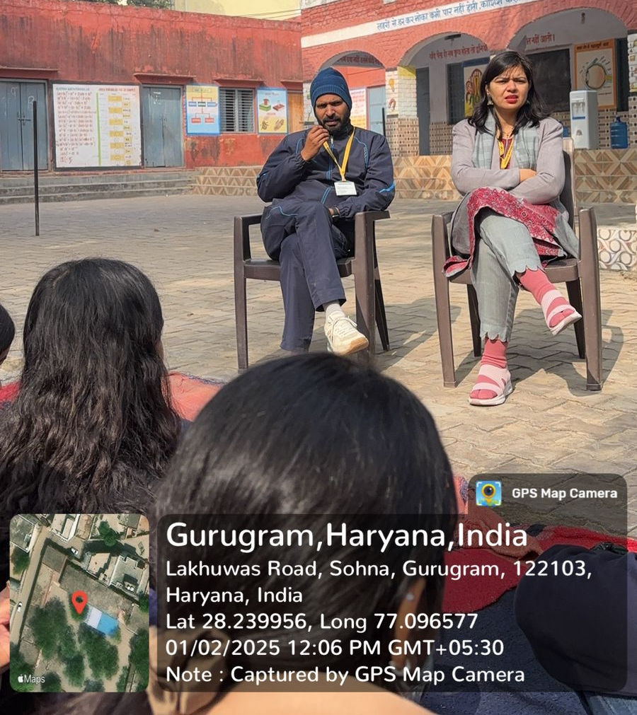
Photo 1: NSS volunteers during NSS Geet and NSS clap

Photo 2: Dr. Neeraj and Mr Amit informed the volunteers about their role in the development of society

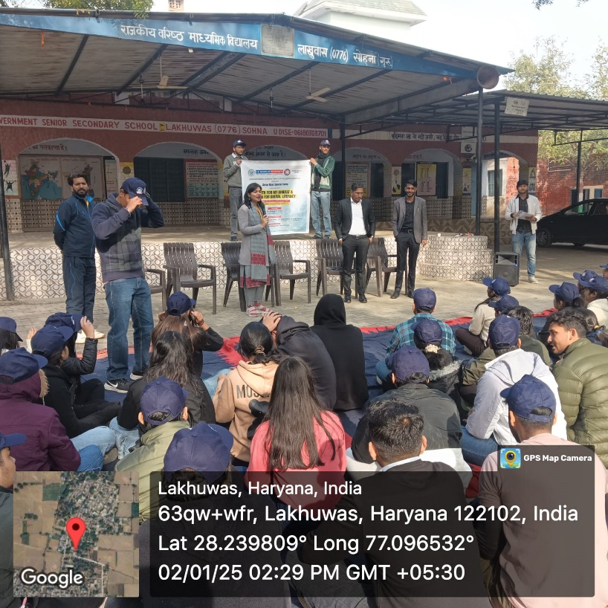

Photo 3: Dr. Neeraj Kumari introduced the expert in front of volunteers

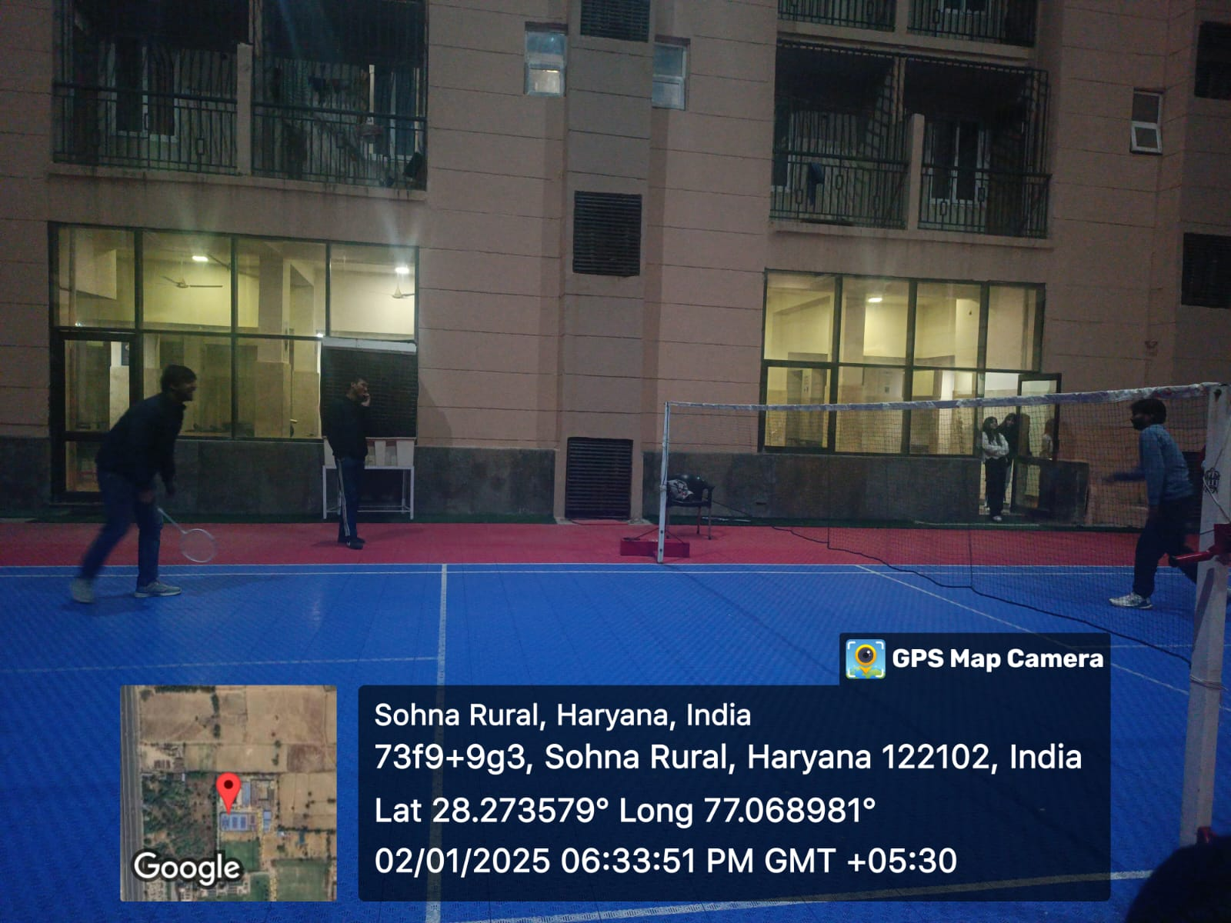

Photo 4: NSS volunteers during their sports time

Second Day (03.01.2025): The second day of the camp started with a rejuvenating yoga session. The group then proceeded officially with the NSS Geet and NSS clap. The volunteers moved for a Nukkad Natak in the village addressing various societal issues, including the harmful effects of alcohol consumption, the importance of gender equality, and the issue of malnutrition. The performance aimed to raise awareness and encourage the community to take proactive measures for societal betterment. A session on HIV/AIDS was conducted by Mr. Amit Kumar Yadav, who discussed common taboos and provided an overview of the basics of the disease. The session concluded with guidance on preventive measures to reduce the risk of transmission. A poster-making competition was held on the theme ‘Role of Youth in Shaping the Future of India’. Three participants from each group participated and expressed their views on above mentioned theme through their artwork. The creative event encouraged participants to think critically and visually represent their perspectives. The day officially concluded with an informative session on ‘Road Safety’ organized by the traffic police officer, Sohna, which proved to be both enlightening and interactive. The session focused on traffic regulations, raising awareness on the importance of responsible behaviour on the roads. The evening featured the highly anticipated inter-group badminton competition, with four volunteers from each group participating. The spirited competition provided an energetic and engaging end to Day 2 of the camp.
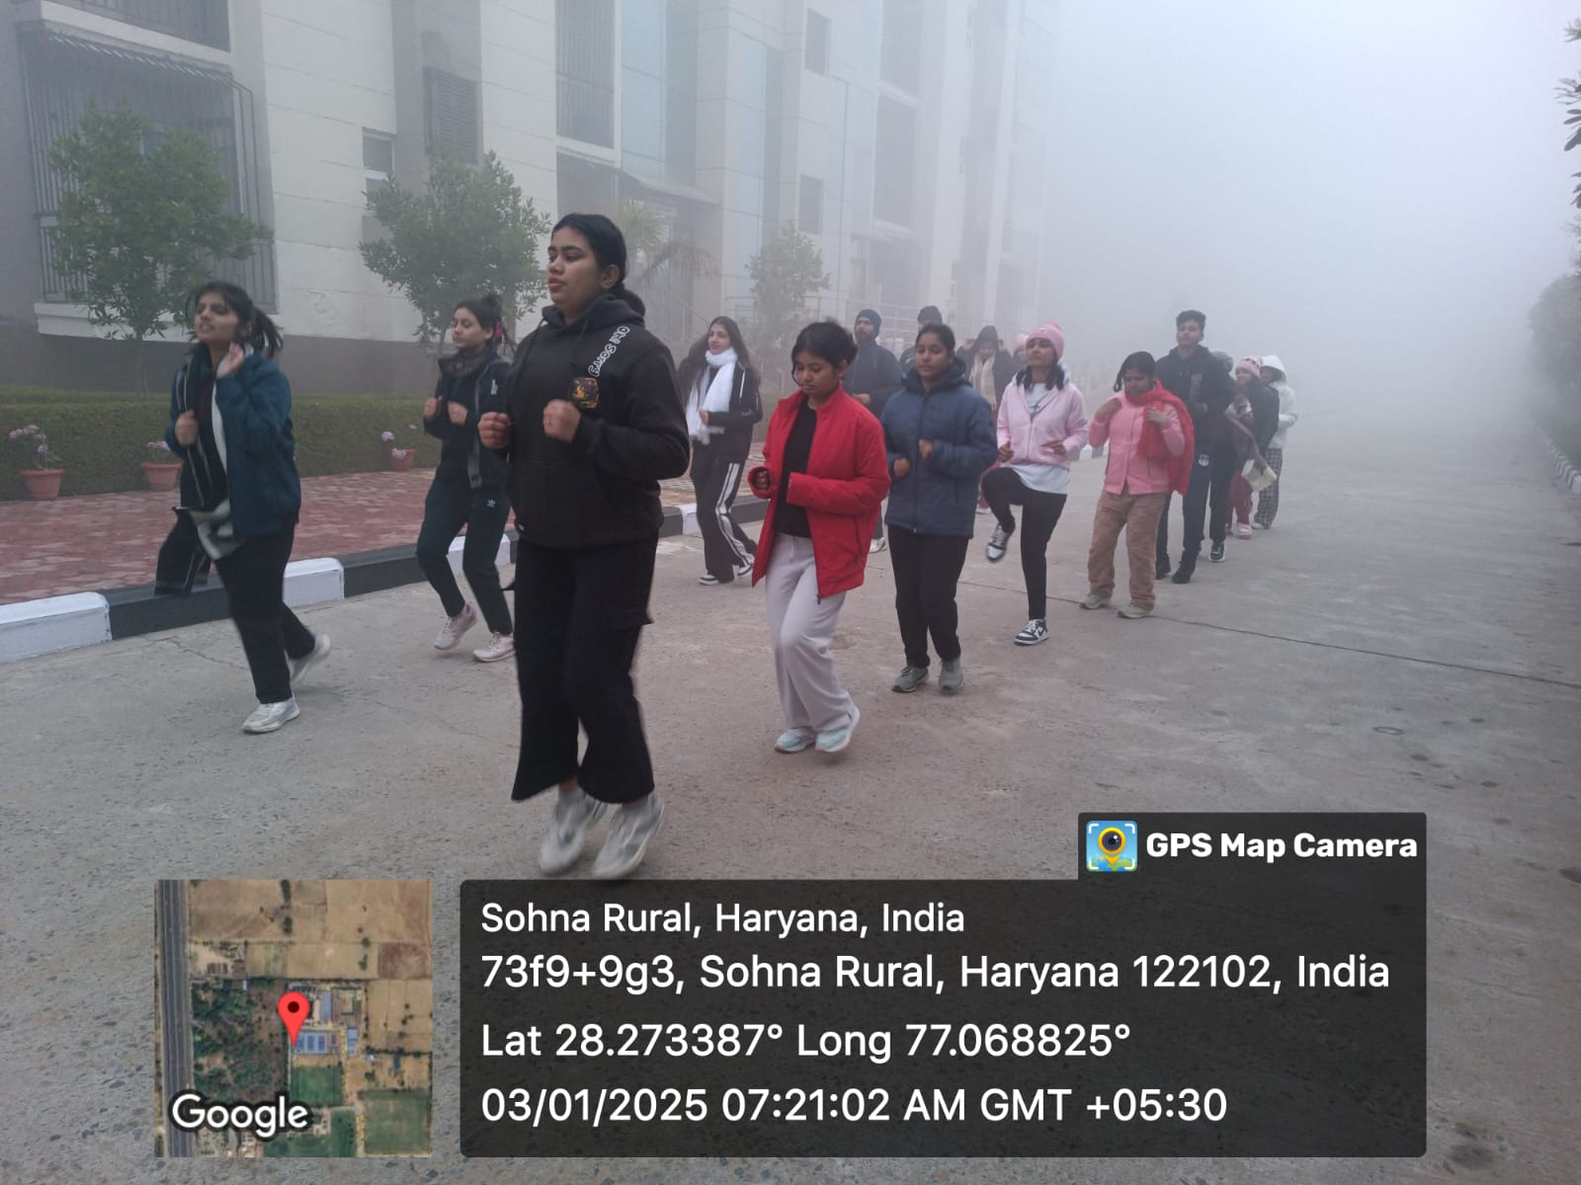

Photo 5: NSS volunteers during Yoga session and Physical Exercise session in the morning

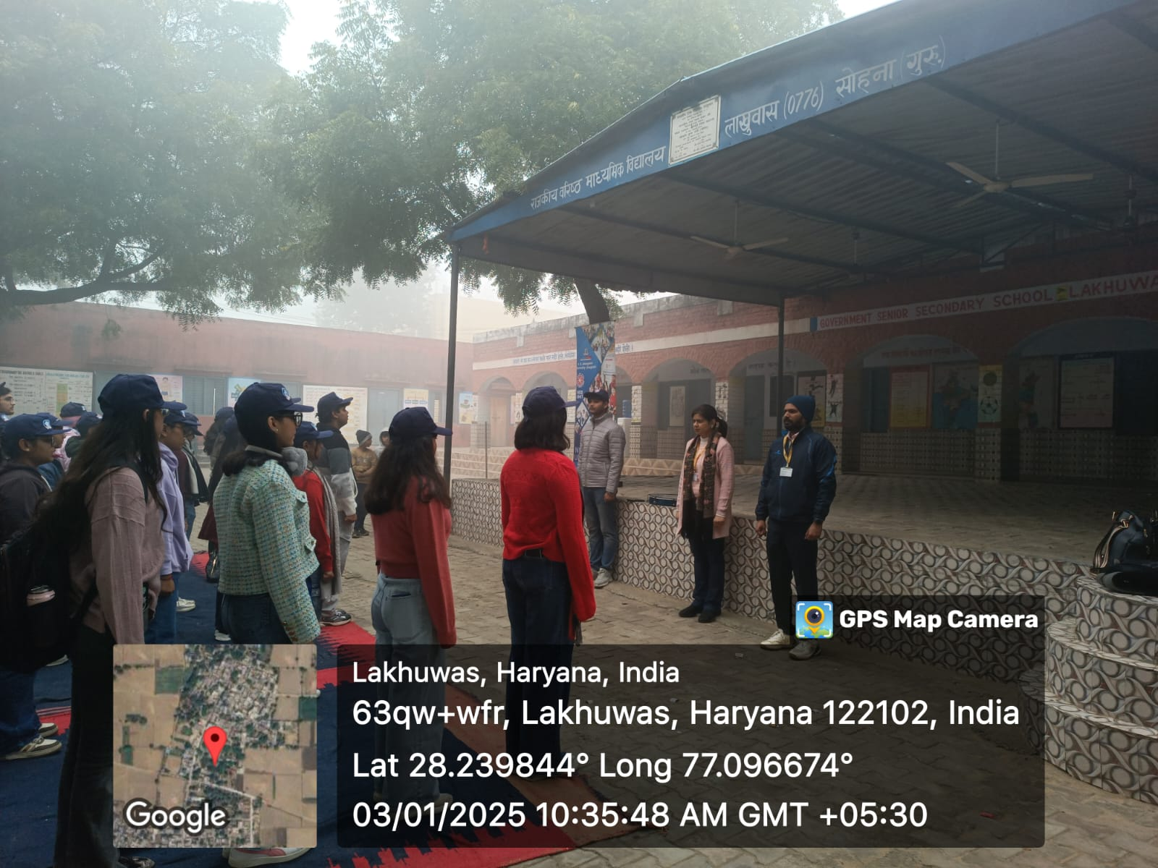

Photo 6: NSS volunteers and NSS officials during NSS geet in the morning

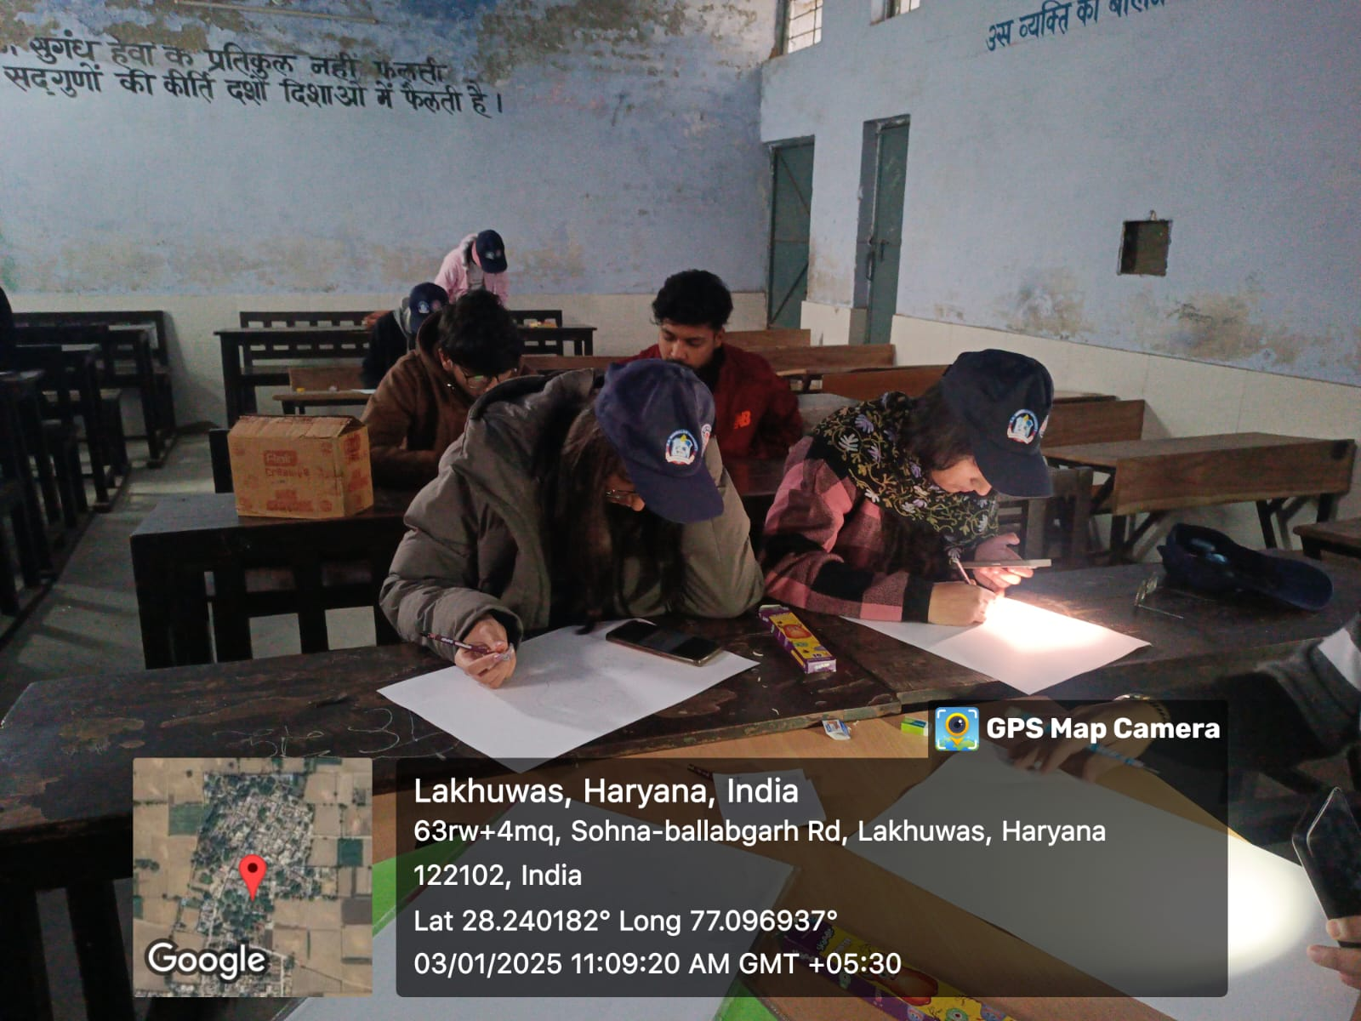

Photo 7: NSS volunteers during poster making competition
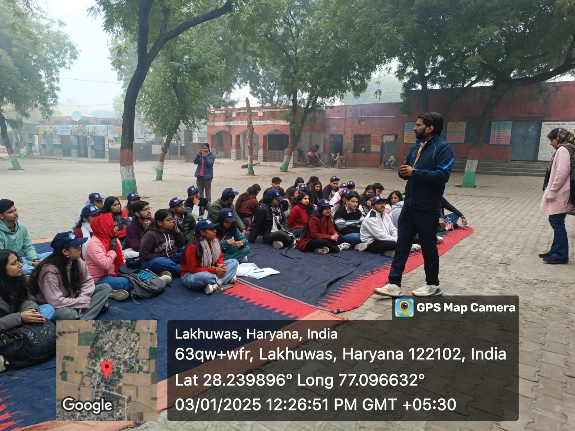

Photo 8: Mr Amit Kumar briefed about the history of HIV-AIDS to volunteers
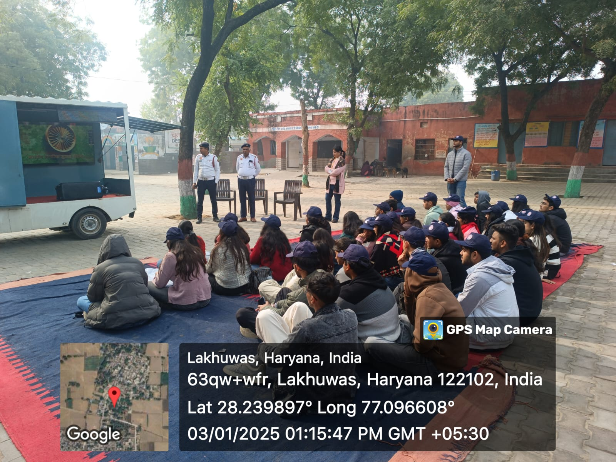

Photo 9: NSS volunteers and Traffic Police Officer during Road Safety Awareness Program

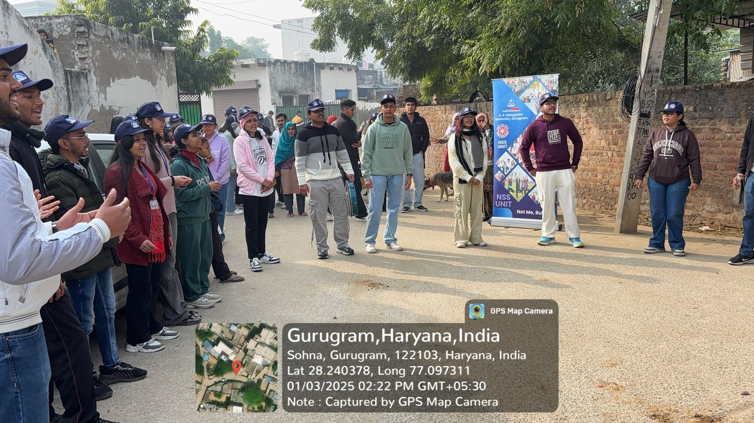

Photo 10: NSS volunteers during their Nukkad Natak performance
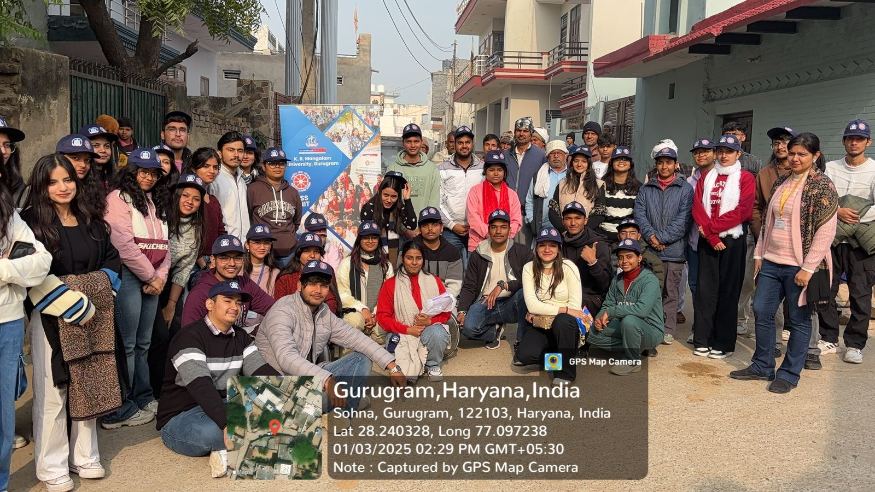

Photo 11: NSS team with villagers after performing Nukkad Natak on Current Issues of the Society
Third Day (04.01.2025): The third day of the camp continued with a refreshing yoga session. The group then preceded as per their schedule. The day officially commenced with the NSS Geet and NSS clap. On 3rd day, the NSS-KRMU organized a health check-up camp for the villagers. Physicians from the AYUSH Hospital, specializing in homeopathy and Ayurveda,
provided free medical consultations and distributed necessary medications to the villagers. Over more than 100 villagers benefitted the free health check-up facility. In afternoon, Mr.

Rohtash Singh from the Red Cross Society conducted a detailed session on first aid training. The session was interactive, informative, and practical, allowing volunteers to engage actively. Participants found the training valuable, gaining essential knowledge and skills in first aid. In the evening, volunteers participated in badminton matches for recreation, along with practice sessions for other events, concluding the day with a communal dinner.
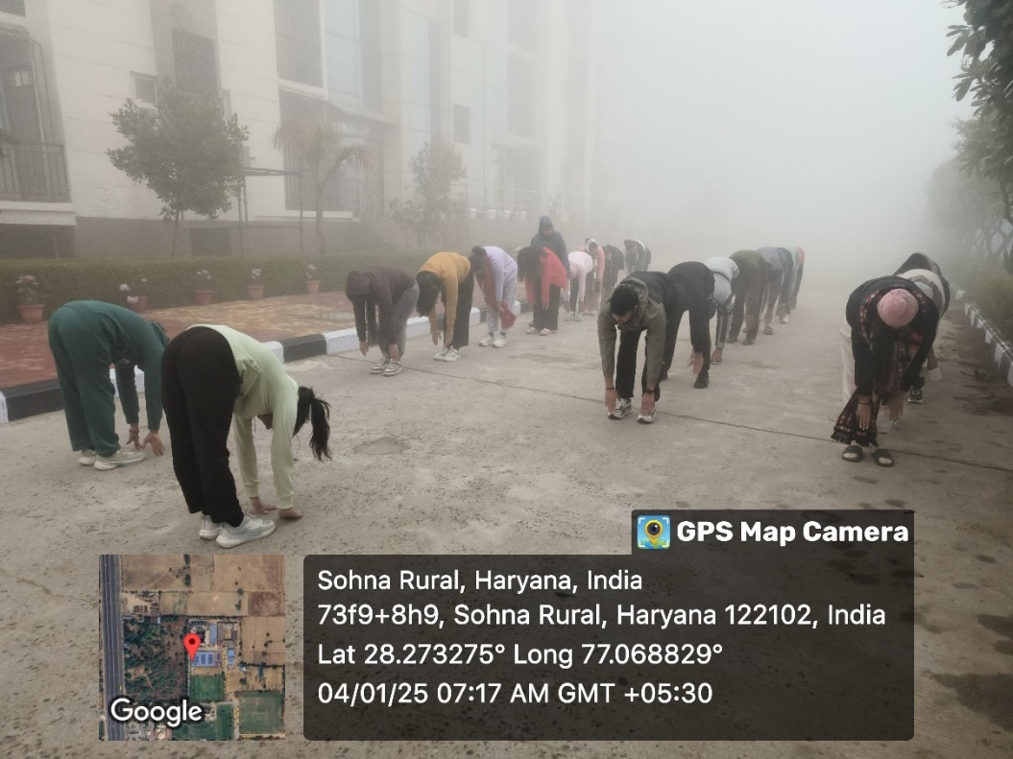

Photo 12: NSS volunteers during yoga session in the morning
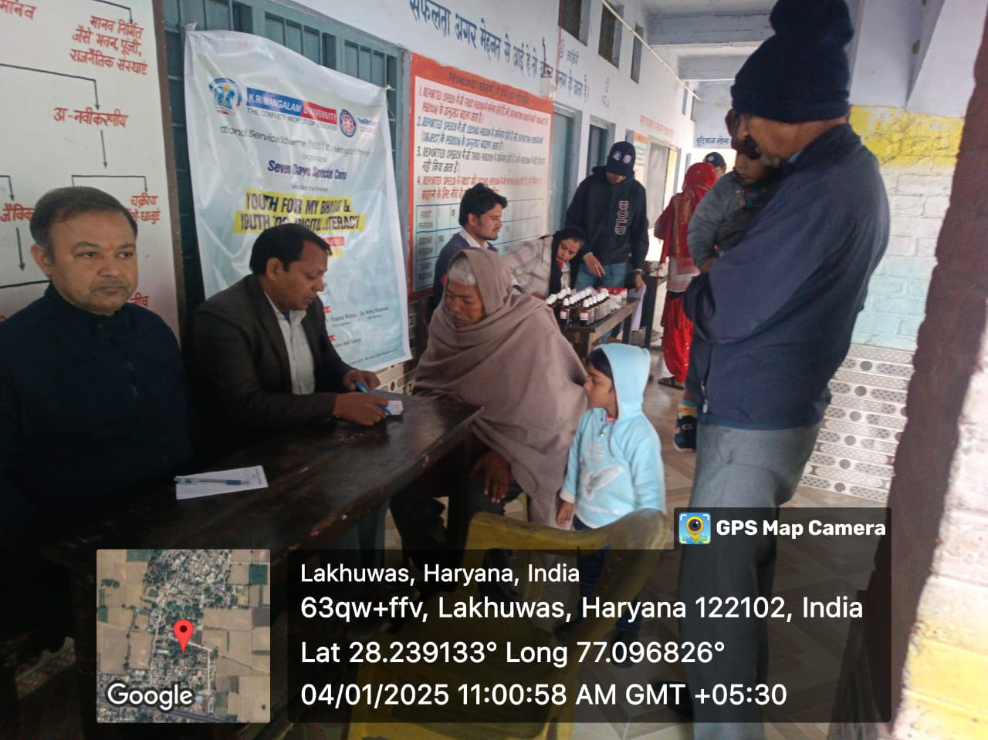

Photo 13: Villagers during Health Check Up Camp

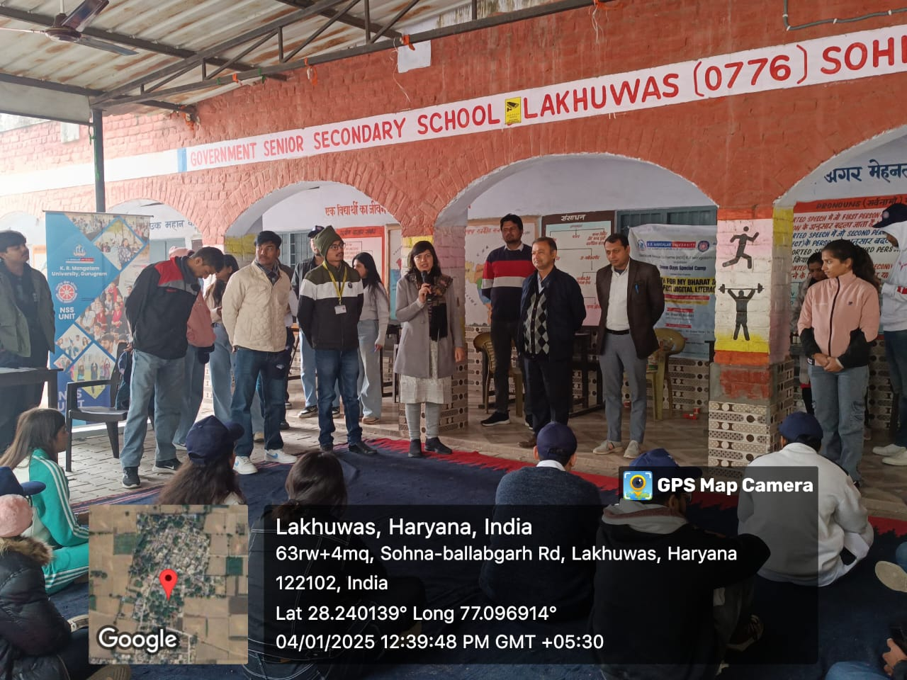

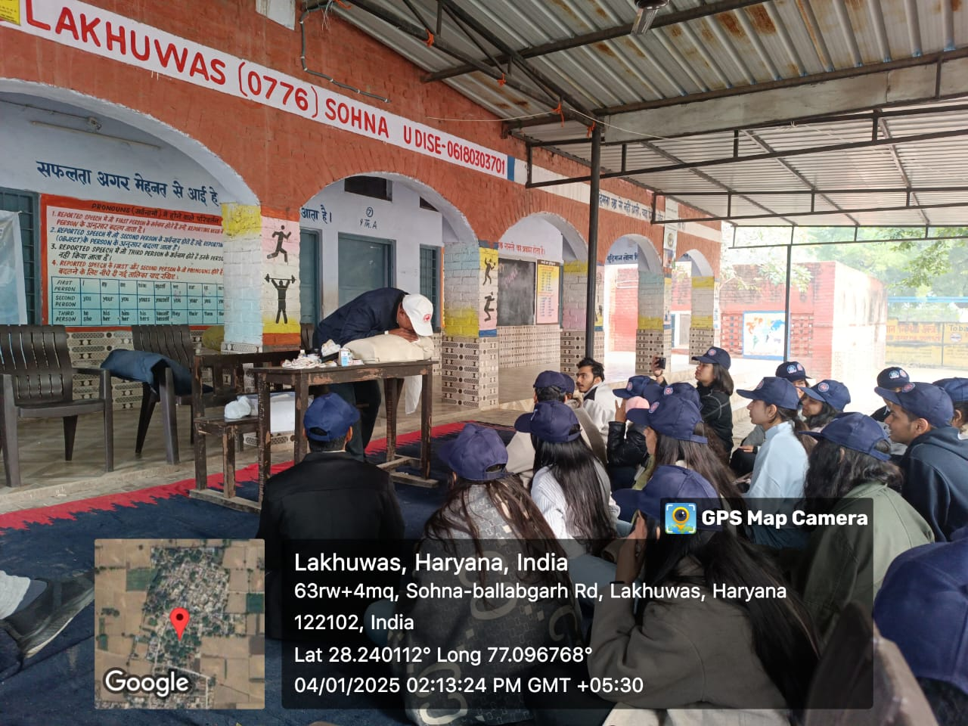
Photo 14: Dr. Neeraj Kumari during vote of thanks to the team of Doctors

Photo 15: Th expert explained the procedure of CPR

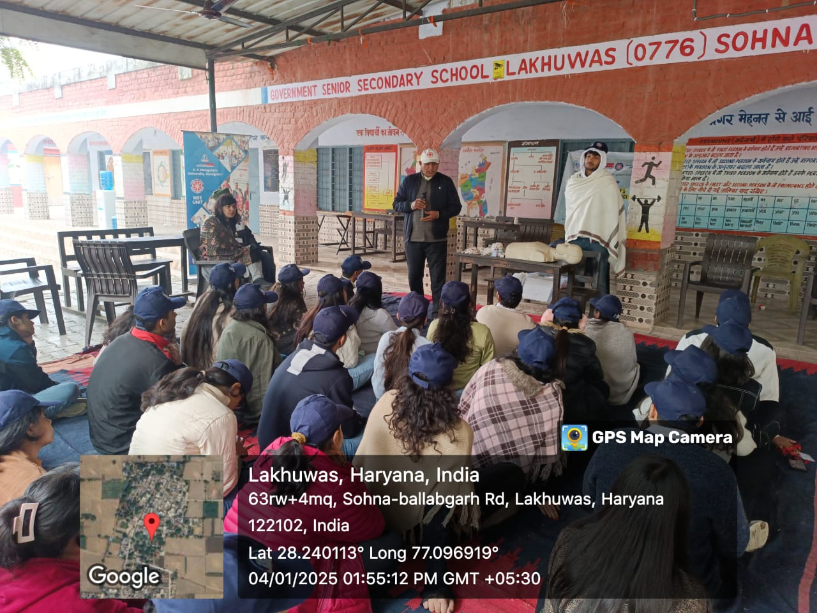

Photo 16: Mr. Rohtash Singh from Red Cross Society giving First Aid training to volunteers

Fourth Day (05.01.2025): On the fourth day of the camp, the day began with the NSS song and a round of NSS applause. A session on cybersecurity was conducted, highlighting practical examples of emerging cybercrimes and providing measures to protect oneself from them. The expert of the session was Mr Satyajeet, an expert of digital literacy. Following this, one volunteer from each group delivered a speech on "The Role of MY Bharat in the Capacity Development of Youth."
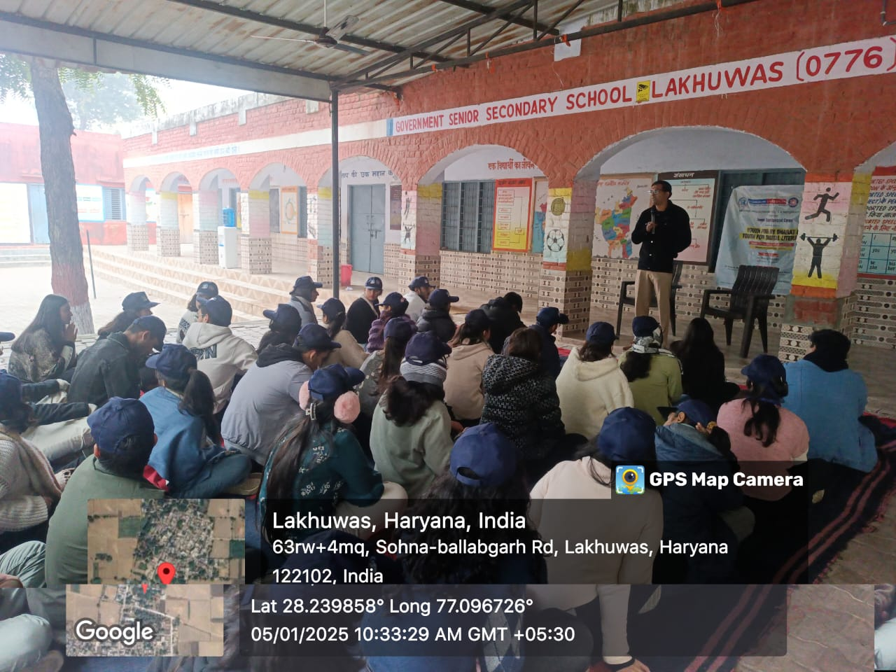

Photo 17: Mr Satayjeet enlightened NSS volunteers on Digital Literacy

The speech covered various aspects of the MY Bharat portal and its benefits for the youth. Subsequently, a rally was organized to promote the message of "Say No to Drugs," followed by a session on digital literacy. In the evening, friendly football match was organised amongst the teams to encourage interaction and lighten the mood followed by the preparation of cultural performances.
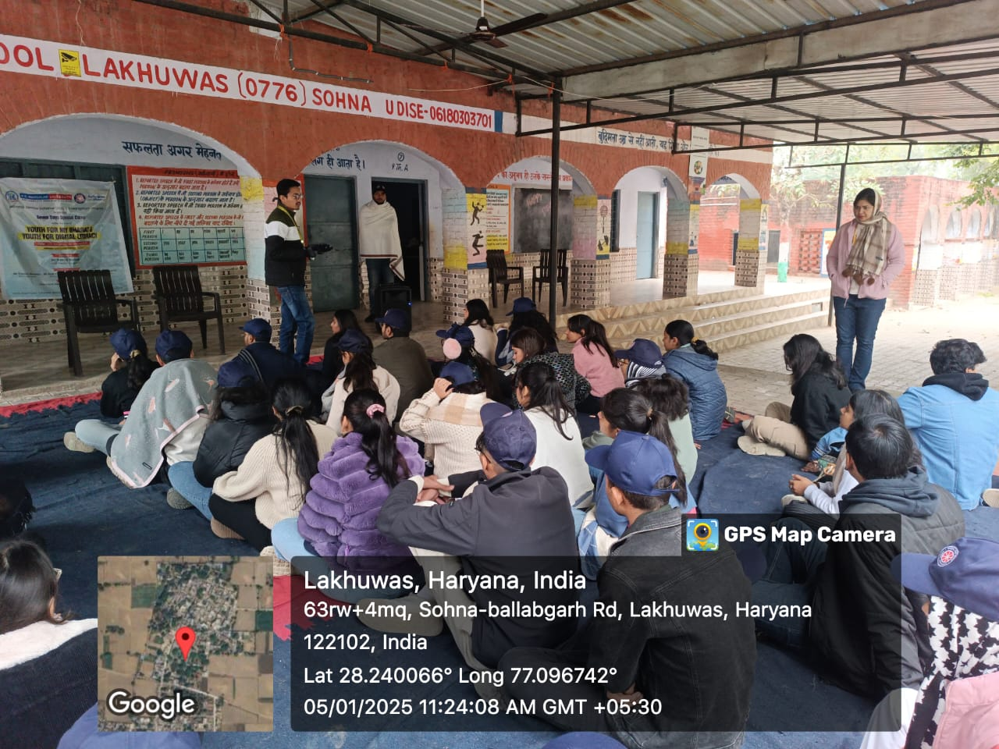

Photo 18: Dr Vicky Kapoor explained various preventive measure while using social media

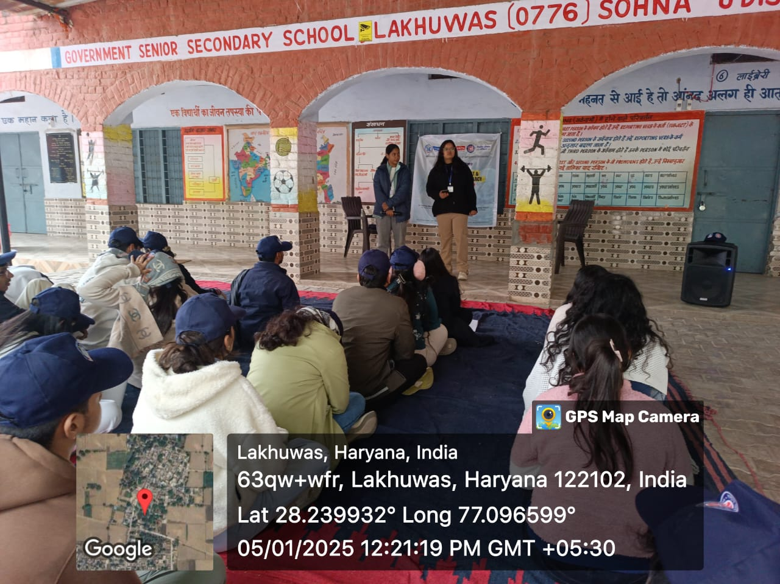

Photo 19: NSS volunteers during expressing their views on The Role of MY Bharat in the Capacity Development of Youth

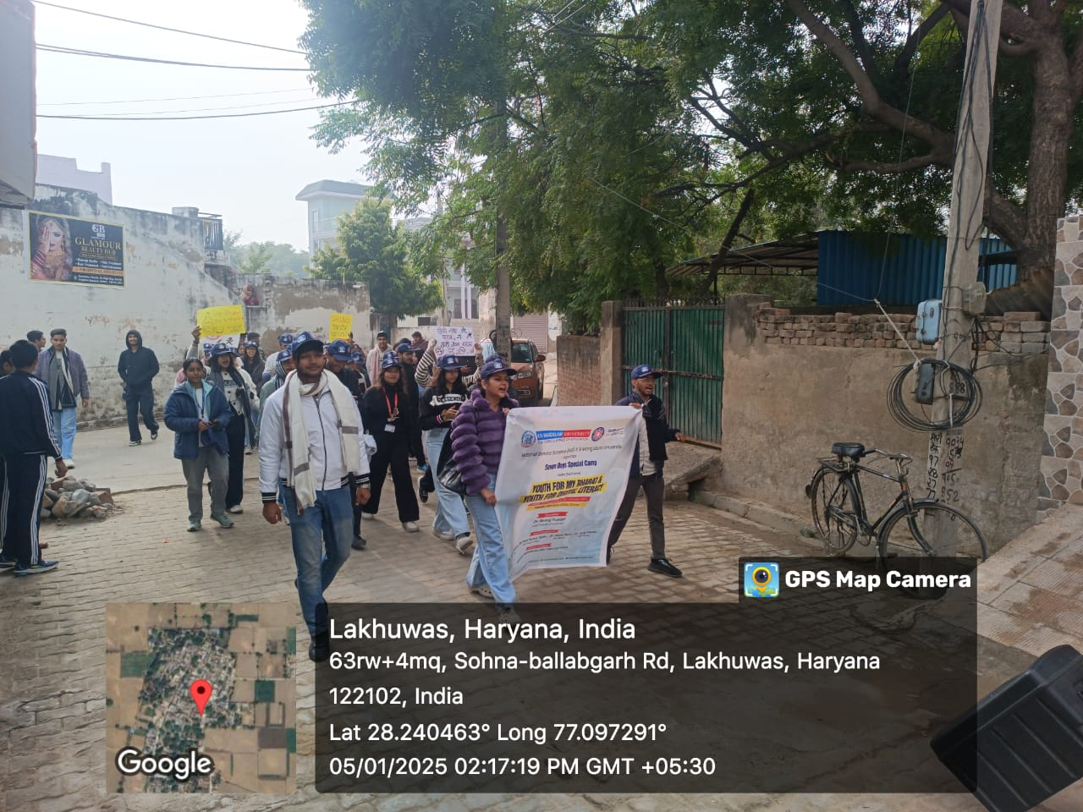

Photo 20: Rally by NSS volunteers in village on Say NO to Drugs
Fifth Day (06.01.2025): On the fifth day of the camp, the day commenced with a rejuvenating yoga session, followed by a cleanliness drive. The camp area was divided into different sections, with each group of volunteers diligently working to clean and maintain the surroundings. Their concerted efforts made a visible difference in the environment. The rangoli competition was also organized among NSS volunteers. The theme of the Rangoli competition was ‘Swachhata Abhiyaan’. More than 30 volunteers participated in the competition with 5 to 6 volunteers among each group. In the afternoon, a plantation drive was organized, during which more than 50 saplings were planted across the village and Govt. Sr. Sec. School, Lakhuwas. This initiative not only contributed to the beautification of the area but also symbolized a step towards enhancing the environment by providing vital oxygen-producing plants. The evening, however, was the most eagerly anticipated part of the day—the cultural program. This event, the highlight of the day showcased a vibrant display of creative expressions. Volunteers presented poetry in various languages, including Hindi, English, and Punjabi, as well as beautiful Shayaris, creating a rich and reflective atmosphere. The event served as the perfect moment for a metaphoric and emotional experience, allowing the

participants to connect deeply with the art of words. As the evening drew to a close, the day ended on a beautiful and harmonious note, leaving everyone with lasting memories.
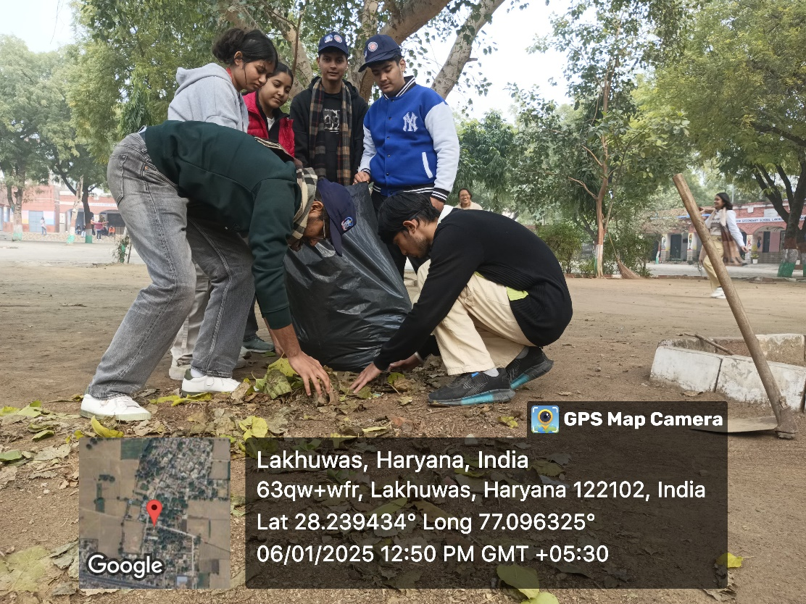

Photo 21: NSS volunteers during cleanliness drive

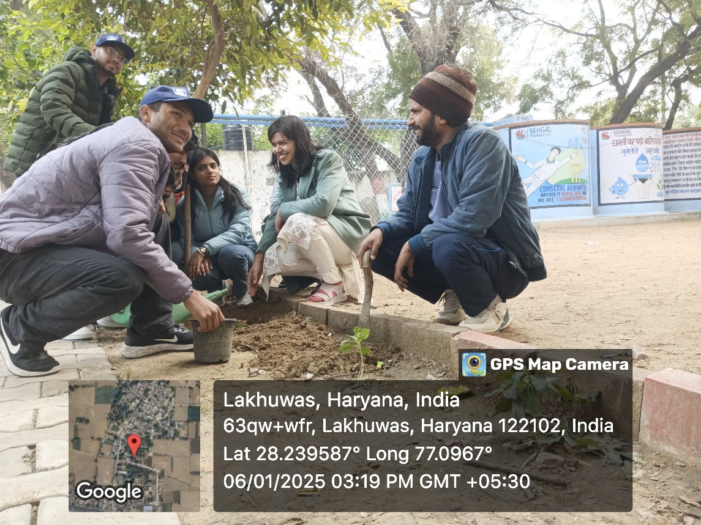

Photo 22: NSS volunteers and officials during plantation drive

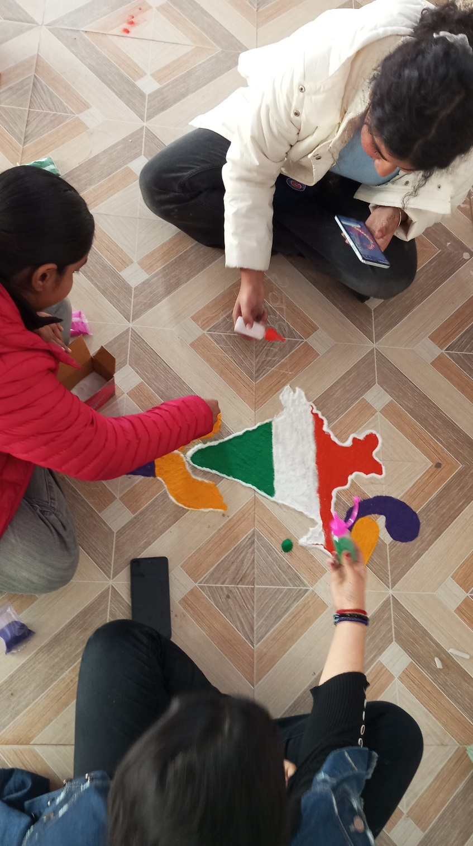

Photo 23: NSS volunteers during Rangoli making competition

Sixth Day (07.01.2025): Day six began with a refreshing physical exercise of NSS volunteers. The day continued with an insightful session on the role of MSMEs in startups, coupled with an awareness drive about government schemes. The session provided a reality check on the current market scenario, encouraging participants to assess their own position, recognize their potential, and understand their value. It emphasized the importance of starting from Day 1 and continuously working on self-improvement. In the afternoon, a visit to local area nearby village was organized, where students participated experienced the life of village, offering them a relaxing and enjoyable break from the schedule. The evening, however, was the highlight of the day, as all the groups had prepared cultural performances. From traditional state dances to soulful singing, the performances created a memorable experience, leaving a lasting mark in the history of the camp.
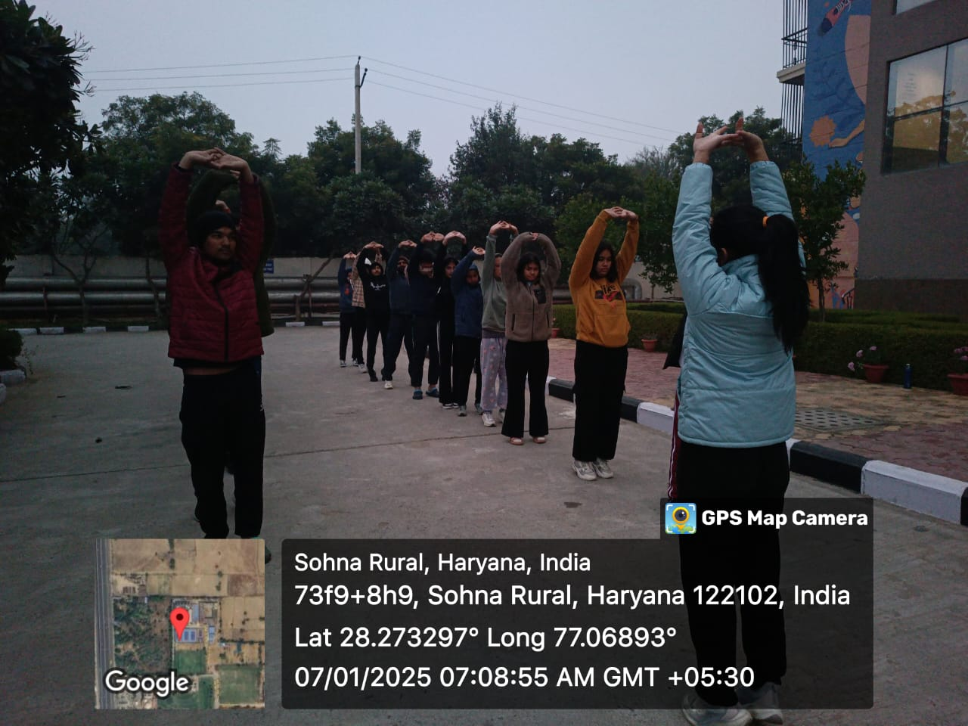

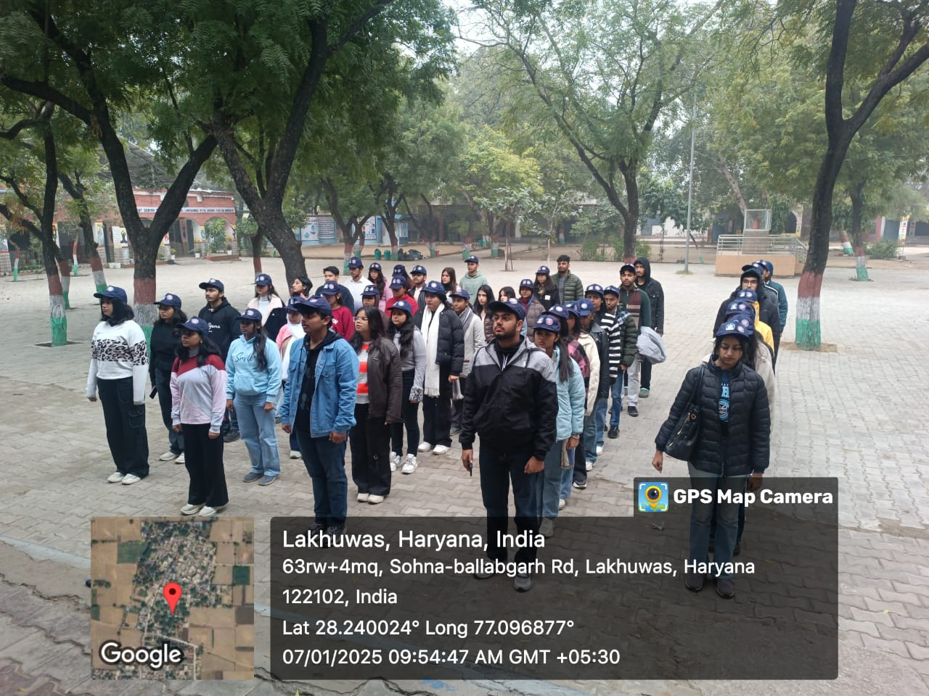
Photo 24: NSS volunteers during yoga session

Photo 25: NSS volunteers during NSS geet

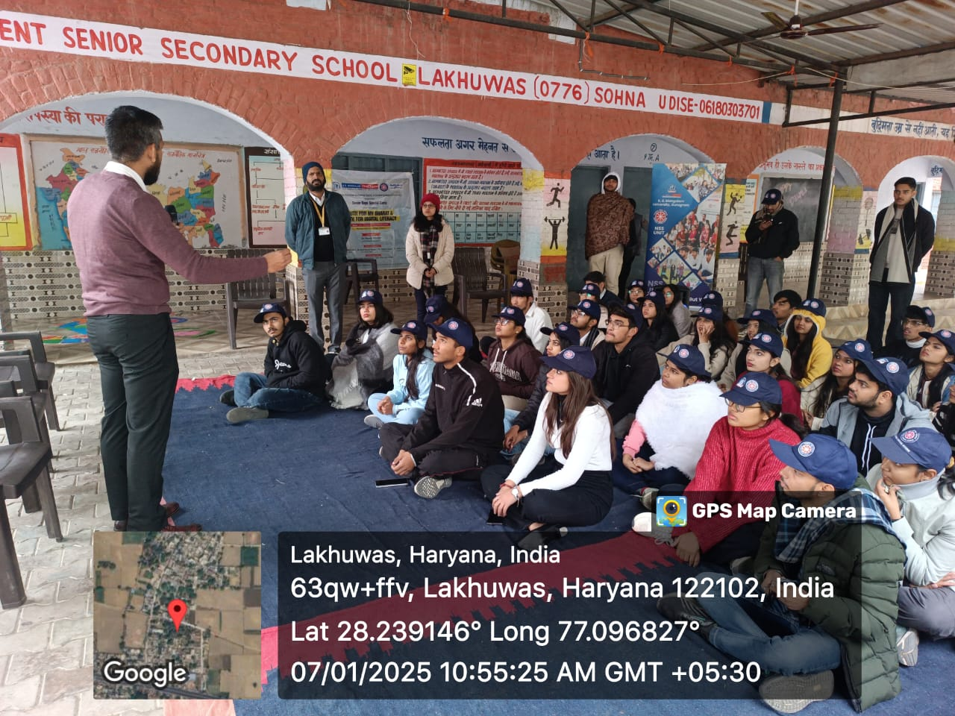

Photo 26: Mr Nikhil Tiwari explained about the Govt. Scheme for entrepreneurship
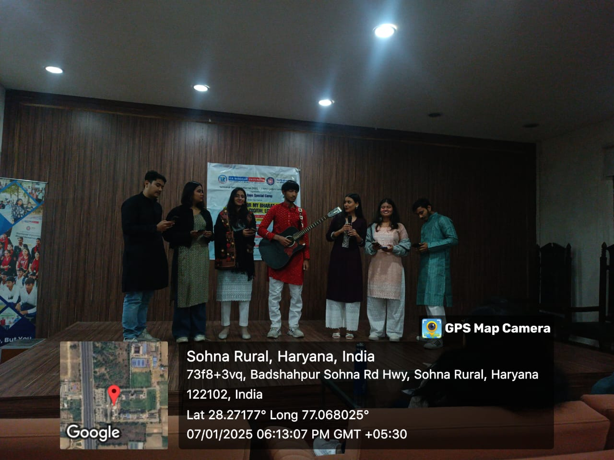

Photo 27: NSS volunteers during cultural performance

Seventh Day (08.01.2025): The morning of Day 7 began with a rejuvenating with physical exercise, after which the group departed for the venue. The official proceedings commenced with the NSS Geet and a song, marking the start of the day’s activities. The volunteers then gathered the villagers to present a Nukkad Natak (street play) addressing the issue of drug abuse, emphasizing its harmful and potentially fatal effects. The performance aimed to raise awareness and inspire action against drug misuse in the community. The day was further honoured by the distinguished presence of Dr. Rajendra Kumar Yadav, NSS Program Coordinator, Sushant University, who delivered an insightful address, adding immense value to the occasion. The valedictory ceremony followed, recognizing the outstanding contributions of various individuals and groups. Awards were presented to the best performers, the best group, as well as the best male and female volunteers. Special acknowledgments were also made to the former NSS President and the Cultural Head for their exceptional leadership. The ceremony concluded with a heartfelt vote of thanks by Dr. Neeraj Kumari, NSS Program Coordinator, expressing gratitude to all who contributed to the success of the camp.
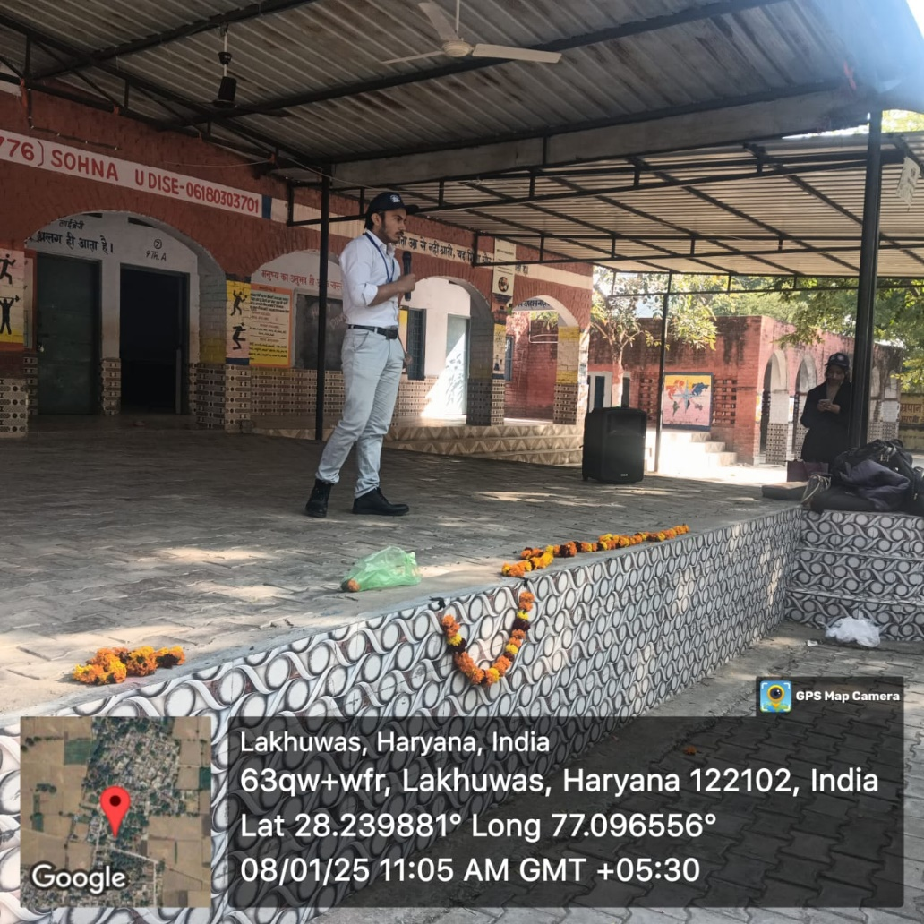

Photo 28: NSS volunteers put their views on importance of Swedeshi

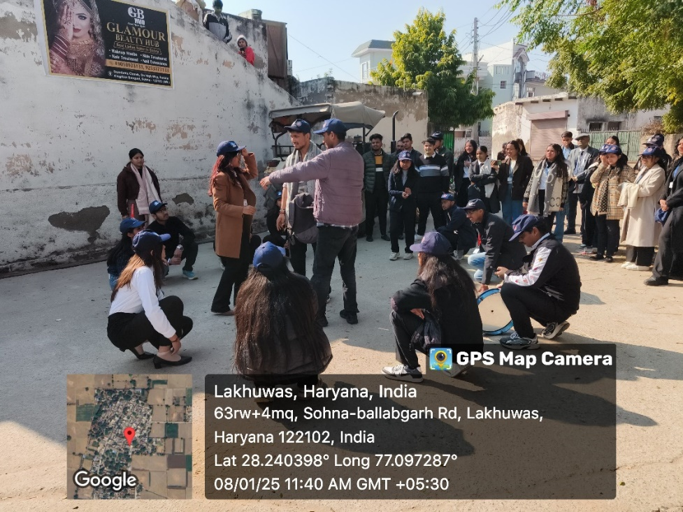

Photo 29: NSS volunteers during Nukkad Natak
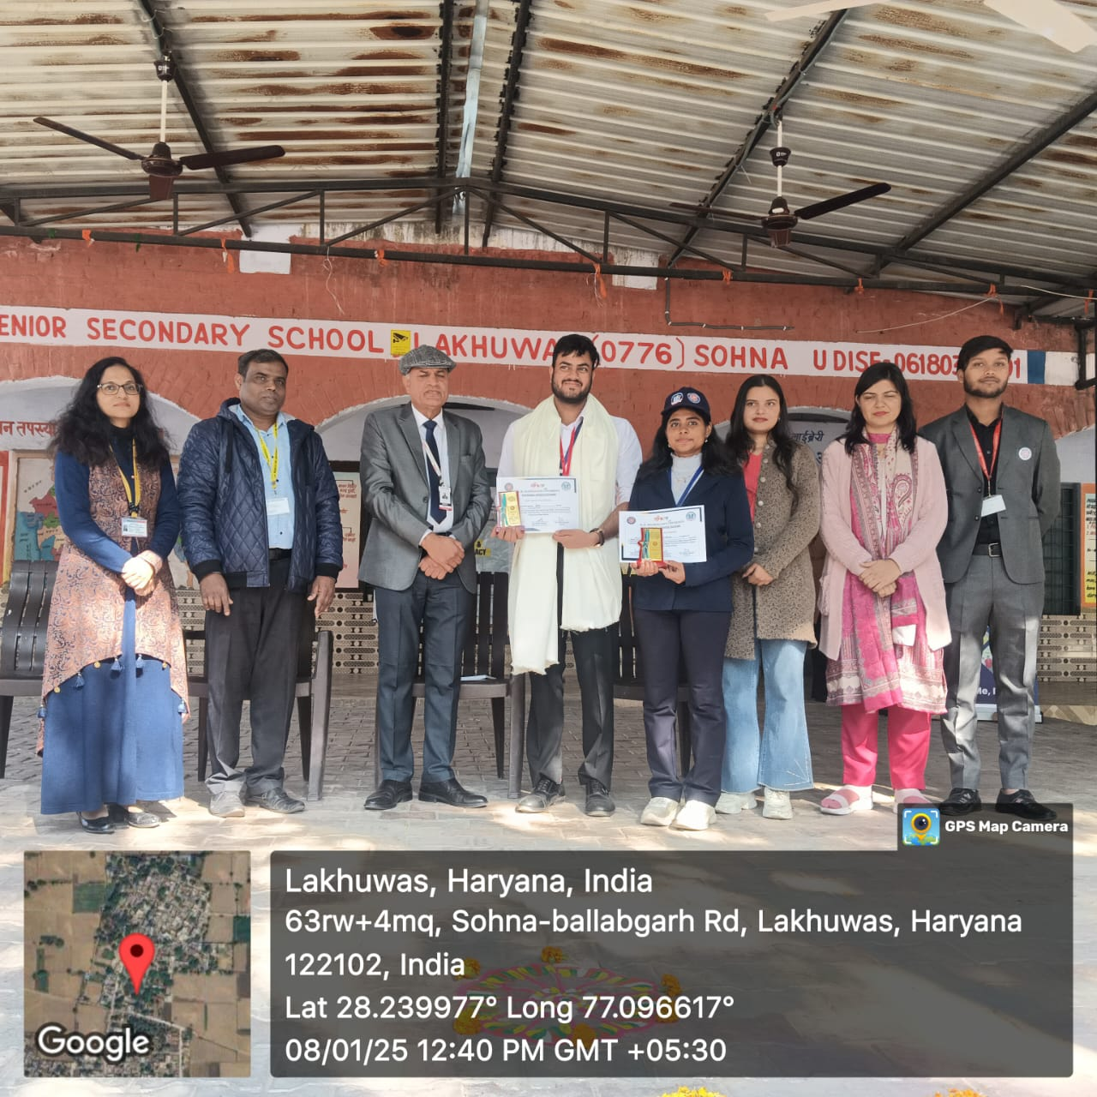

Photo 30: Dr Rajendra Kumar and NSS key officials during award ceremony

