REPORT ON
Road Safety Campaign on the Occasion of National Road Safety Month (NRSM) 2025

Date: 28th January 2025
Venue: Govt. Sr. Secondary School, Ghangola, Sohna, Haryana
Event Type: Road Safety Campaign on the Occasion of National Road Safety Month (NRSM) 2025
Mode of Activity: Offline
Target Group: Students of Govt. Sr. Secondary School, Ghangola & NSS Volunteers
Coordinators: Mr. Amit Kumar
Organized By: NSS, KR Mangalam University, Gurugram
Resource Persons: Dr. Satish Kumar, Principal (Govt. Sr. Secondary School, Ghangola)
Participants: 20 NSS volunteers and more than 50 Students

Introduction:
National Road Safety Month is an annual event aimed at raising awareness about road safety, reducing accidents, and promoting safer driving habits among the public. The "Road Safety Campaign" conducted during this month is a nationwide initiative that involves various activities aimed at educating people of all age groups about the importance of road safety, traffic rules, and safe driving practices. The campaign was held from February 1 to February 28, 2025, and included multiple events, workshops, and awareness programs across schools, colleges, public spaces, and local communities.

Objectives
• To raise awareness about the importance of road safety and traffic rules.
• To educate the general public, especially students and young drivers, on safe driving practices.
• To reduce road accidents by encouraging responsible road behavior.
• To promote the use of seat belts, helmets, and other safety gear.
• To highlight the role of traffic authorities in maintaining road safety and ensuring discipline on the roads.

.

Content
NSS KR Mangalam University conducted outreach activity “Road Safety Awareness” under National Road Safety Month ( NRSM) 2025 an initiative of Government of India, along with students of Government Senior Secondary School Ghangola, Block Sohna on 28th January, 2025.

The event included Awareness Rally, Poster Making Competition, and Essay writting competition to spread awareness about Raod Safety.

The winners were awarded with medals and certificates. The Principal Sh. Satish Kumar facilitated NSS Programme Coordinator Dr. Neeraj Kumari and NSS Programme Officer Mr Amit Kumar Yadav, winners and NSS Volunteers
• Road Safety Posters and Banners:
- Posters, banners, and digital media were displayed in strategic locations like schools, public parks, and busy intersections. The visuals emphasized critical aspects of road safety, such as wearing helmets, seat belts, adhering to speed limits, and avoiding distractions while driving.
• Public Awareness Drive:
- Volunteers, including students, took to the streets, distributing leaflets and speaking to pedestrians, cyclists, and motorists about road safety measures. They also used social media platforms to share tips and facts related to road safety.
- Key safety tips included:
  - Avoiding the use of mobile phones while driving.
  - The importance of wearing seat belts and helmets.
  - Encouraging public transportation or carpooling to reduce road congestion.

Key Outcomes:
- Increased Awareness: The campaign successfully reached a large audience, especially students and young drivers, raising awareness about safe road behaviors.
- Community Engagement: Active participation from local authorities, traffic police, and volunteers contributed to creating a stronger community bond focused on road safety.
- Positive Public Feedback: Many participants expressed gratitude for the information shared during the workshops and events, with several promising to adopt safer driving practices.

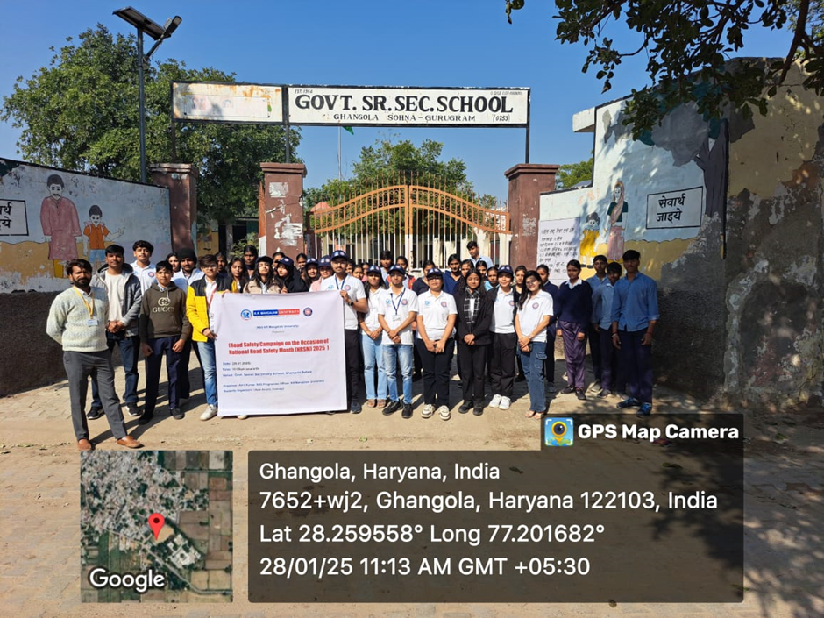

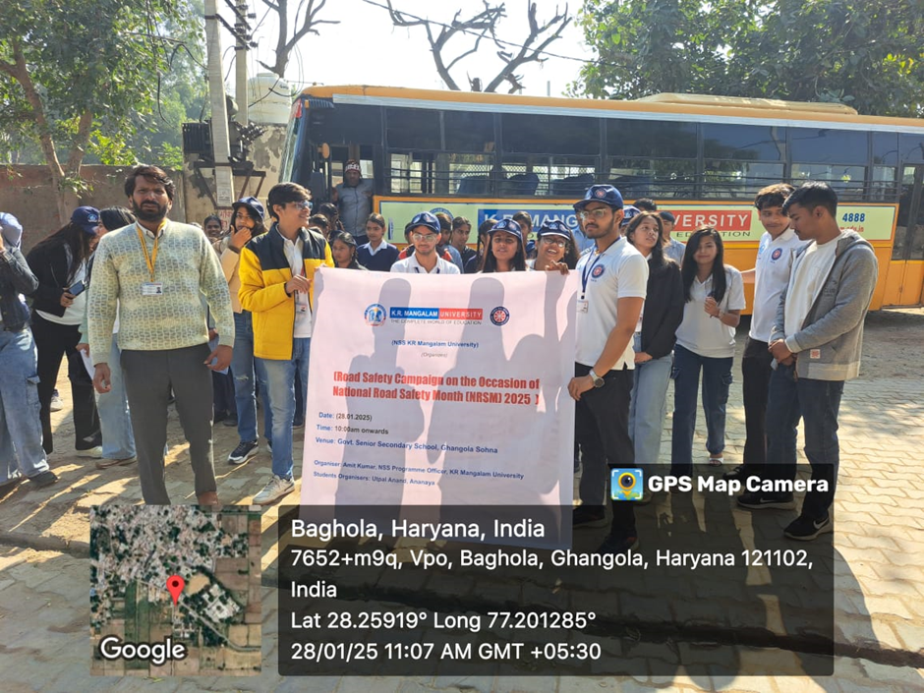

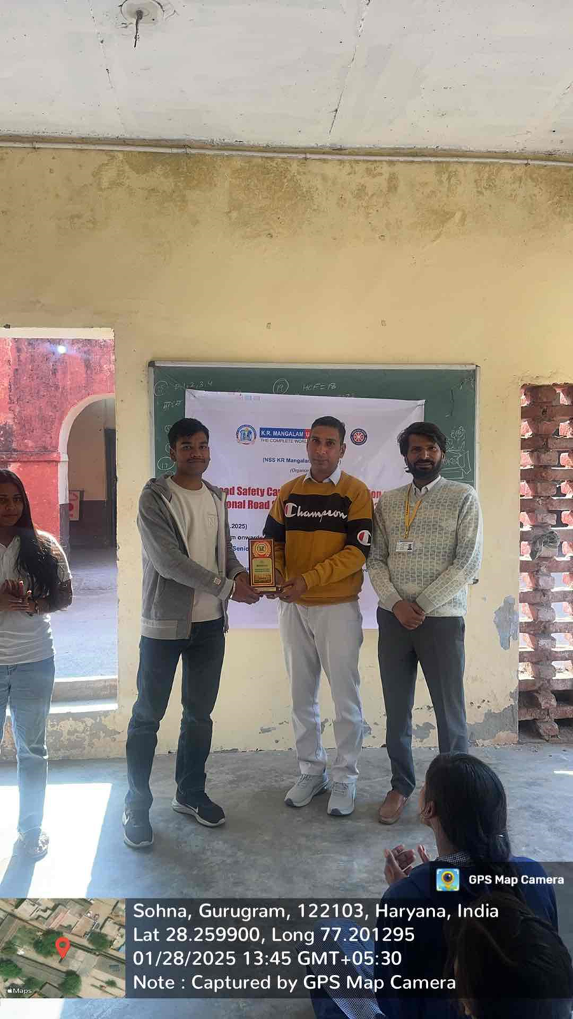

Report prepared by Event Coordinator | Mr. Amit Kumar
Report Verified by NSS Program Coordinator | Dr. Neeraj Kumari
Report Verified by IQAC | Dr. Shikha Dutt Sharma

