Report on the Educational Visit by Faculty and Students from Gargi College (Delhi University) under MOU

Date: September 4th, 2024
Venue: KRMU Campus
Event Type: Visit
Mode of Activity: Offline
Target Group: Students and Faculty members of Gargi College
Coordinators: Dr Ruby Jindal

Organized by: School of Basic and Applied Sciences, K R Mangalam University, Gurugram
Participants: 45 Students and 6 Faculty Members of Gargi College

Introduction:
On September 4th, 2024, KRMU had the pleasure of hosting a delegation of faculty and students from Gargi College (Delhi University) as part of our ongoing collaboration under the existing Memorandum of Understanding (MoU). The visit was aimed at acquainting the students with our research facilities and fostering potential research collaborations between faculty members.
Welcome and Orientation:
The event commenced with a warm welcome extended to all faculty and students of Gargi College by Dr. Ruby Jindal (Associate Professor) and Prof. Meena Bhandari (Dean, School of Basic and Applied Sciences). The Dean initiated the program with an insightful presentation, introducing the visitors to the various research areas pursued by our faculty members and the advanced facilities available at KRMU.
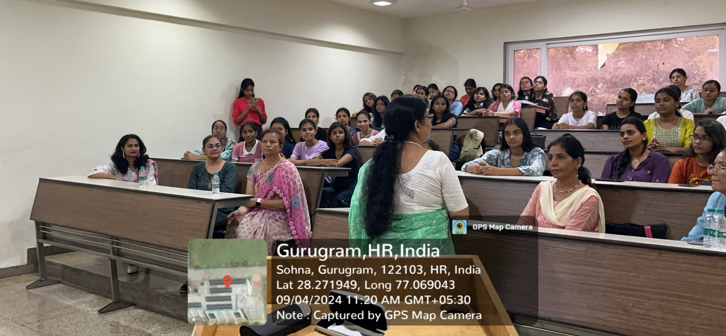
Fig 1: Orientation session

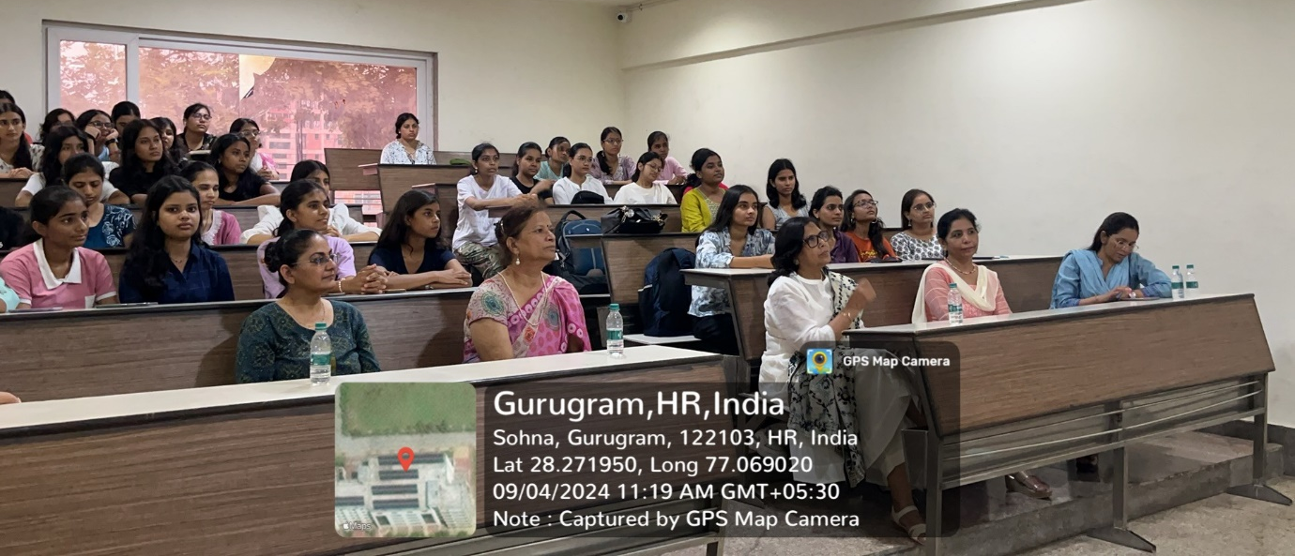
Fig 2: Students of Gargi college and Faculty members attentively attending the orientation session

Acquainting Students with Research Facilities:
Following the presentation, the B.Sc. students of Gargi College were oriented to our research facilities. They were provided with an overview of the cutting-edge research being conducted at KRMU, highlighting key projects and the interdisciplinary nature of our work. The students showed great interest in understanding the practical applications of the research and how they align with their academic curriculum.
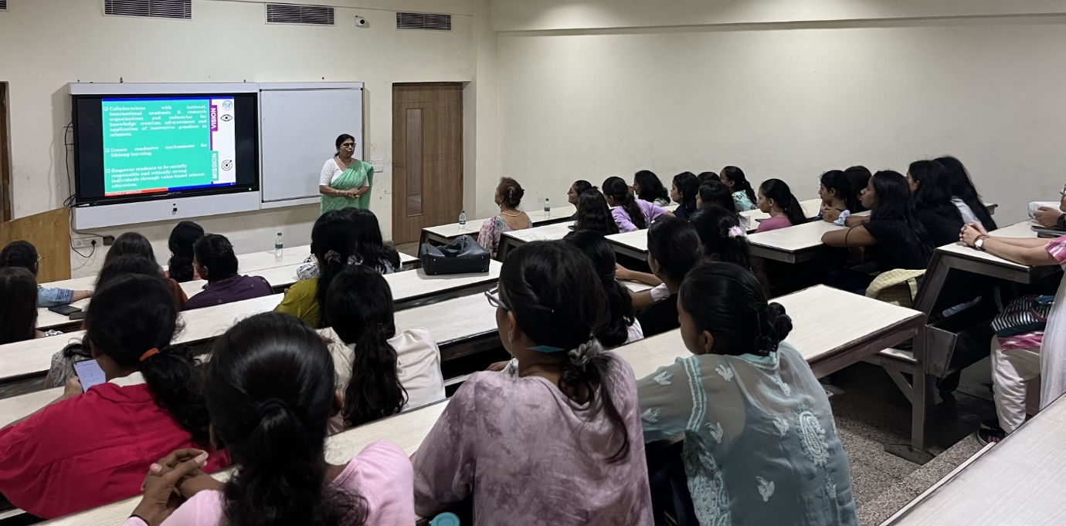
Fig 3: Prof Meena Bhandari acquainting Students with Research Facilities using smart interactive panel
Lab Visits:
The visitors were then guided on a tour of our campus, which included visits to various laboratories:
Physics Lab: Students and faculty were introduced to the experimental setups and ongoing research in physics.

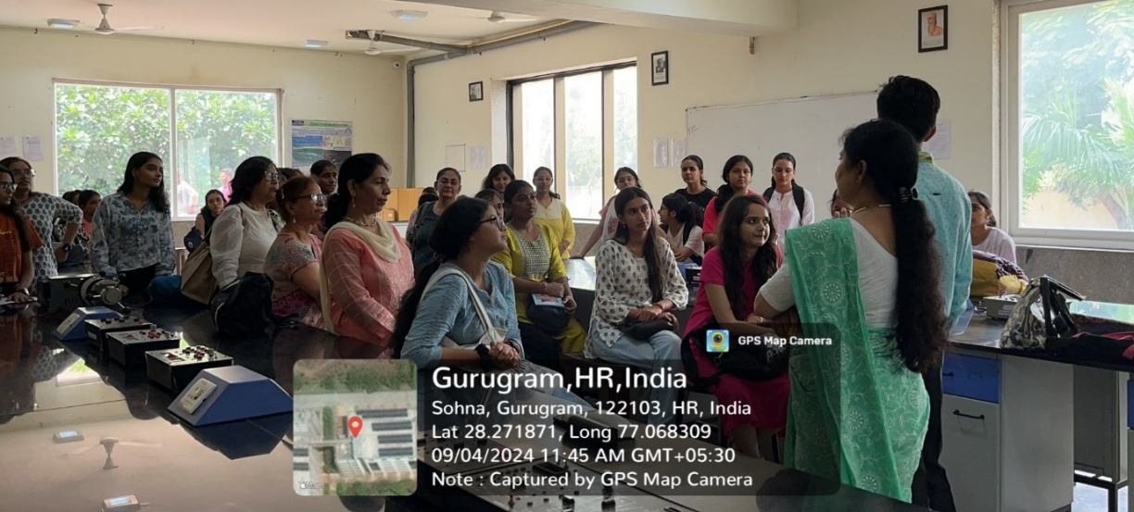
Fig 4: Dr. Vicky Kapoor (Physics Department, SBAS) demonstrating the procedure for operating the instrument to students in the physics lab.

Chemistry Lab: They explored the chemical research tools and methodologies employed by our researchers.
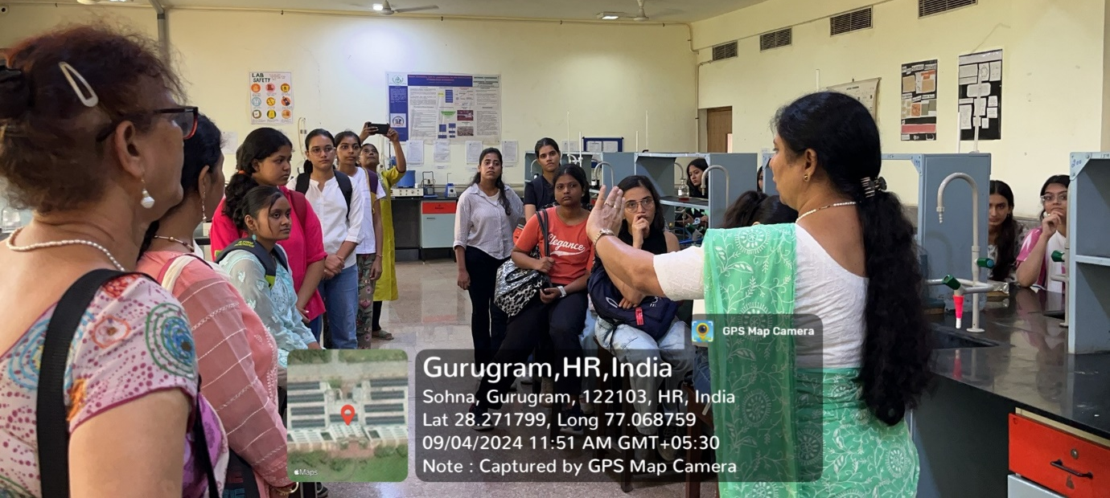
Fig 5: Prof. Meena Bhandari (Dean, SBAS) explaining the procedure for using the instrument to students in the CIF lab.

Forensic Lab: The delegation was briefed on forensic science techniques and the lab's role in real-world investigations.
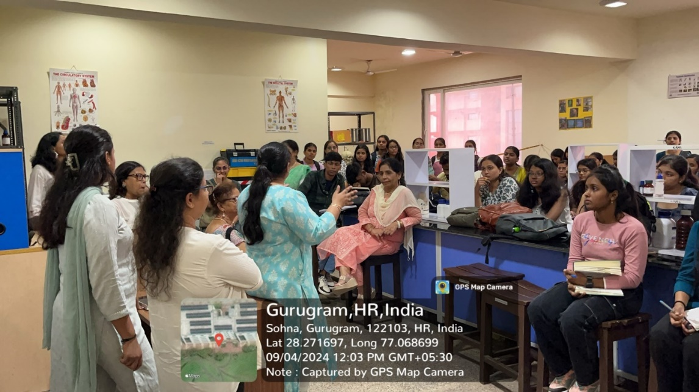

Fig 6: Dr. Mandeep Kaur (Assistant Professor) from Forensic Department explaining the students about Forensic Laboratory experiments

CIF Lab: A detailed demonstration of the Central Instrumentation Facility (CIF) showcased the sophisticated instruments available for advanced research.
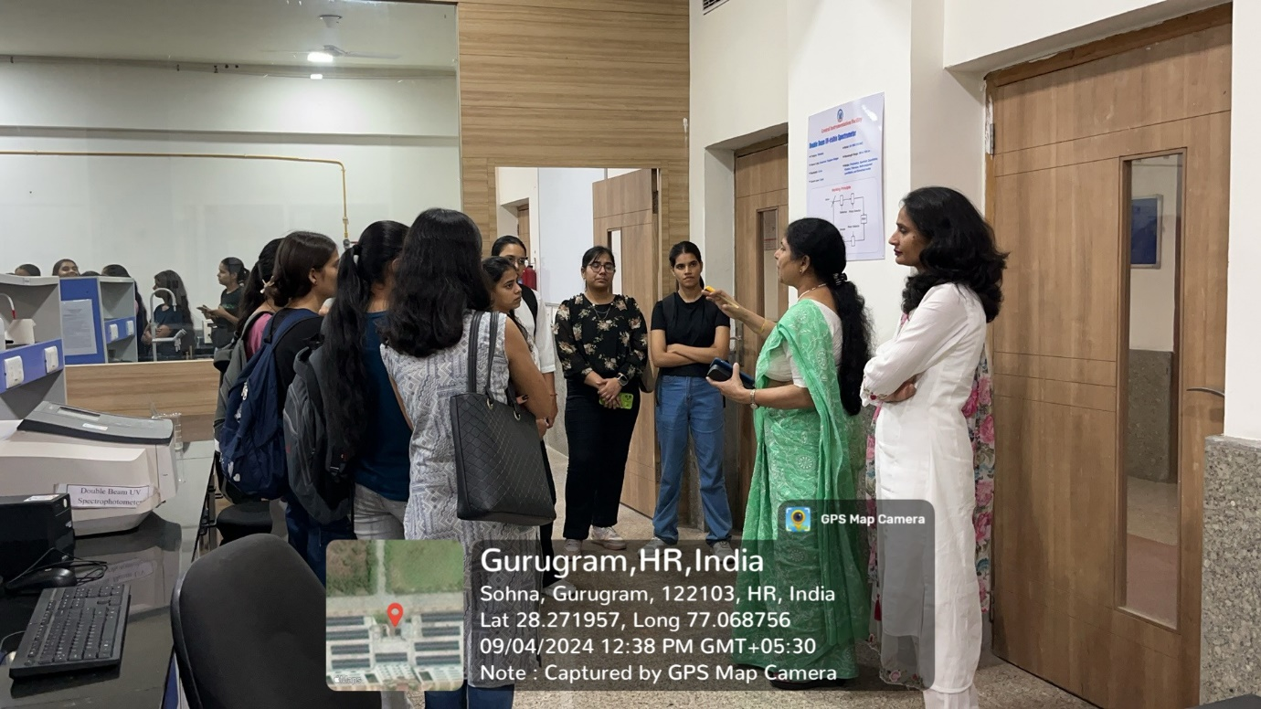
Fig 7: Prof. Meena Bhandari (Dean, SBAS) explaining the procedure for using the instrument to students in the CIF lab.
Discussion on Research Collaboration:
The visit culminated in a healthy discussion among faculty members from both institutions. The conversation focused on exploring avenues for collaborative research projects, exchange programs, and potential joint publications. The faculty from Gargi College expressed keen interest in leveraging the resources and expertise available at KRMU for future collaborations.

Conclusion:
The visit was mutually beneficial, providing students with valuable exposure to advanced research environments and opening doors for enhanced academic and research partnerships between Gargi College and KRMU. We look forward to continuing our collaboration and expanding the scope of our shared academic pursuits.

