


School of Education
Report on
‘Orientation Session on Professional Ethics for Students’

Date: 29th August, 2025

Venue: Room No. 204A, KRMU Campus

Time: 9:30 onwards

Event Type: Orientation Session

Mode of Activity: Offline
Target Group: Student- Teachers of School of Education
Resource Person: Prof. (Dr.) Tania Gupta, Dean, School of Education & Director-IQAC, K.R. Mangalam University
Coordinator: Dr. Monika Bishnoi, Assistant Professor, K.R. Mangalam University, Gurugram.

Organized by: School of Education, K.R. Mangalam University, Gurugram

Number of Participants: 18

Introduction

On 29th August, 2025, the Training Programme on Professional Ethics for New Students was organized by the School of Education to sensitize the freshmen towards the ethical values, principles, and professional conduct required in academic and professional life. As the students step into the teaching profession, they need to cultivate habits of responsibility, honesty, and ethical decision-making, aligning with SDG 4 (Quality Education), which emphasizes the promotion of ethical, value-based, and responsible learning environments.
The session was conducted by Prof. (Dr.) Tania Gupta, Dean, School of Education & Director-IQAC, who emphasized that professional ethics are the foundation of the teaching profession. She highlighted how values such as integrity, respect, fairness, and accountability are not only desirable but necessary qualities for educators to uphold in every aspect of their work.

Objectives

Introduce freshmen to the concept and importance of professional ethics in the teaching profession.

Highlight ethical responsibilities of student-teachers towards themselves, peers, faculty, and the institution.

Instill values of honesty, respect, and fairness in academic and social interactions.

Develop awareness about ethical challenges in modern education and strategies to address them.

Encourage students to embrace professional ethics as guiding principles for lifelong practice.

Methodology

Interaction with Speaker, Role Playing, Group Discussions, Ethical Dilemmas.

Content

Prof. (Dr.) Tania Gupta delivered an insightful session, covering multiple aspects of professional ethics, including:

Integrity and Honesty: The importance of maintaining honesty in academics, classroom engagement, and relationships with peers and teachers.

Respect and Dignity: Treating all individuals with respect, avoiding discrimination, and maintaining a positive classroom environment.

Responsibility and Accountability: Understanding one’s duties as a student-teacher and taking responsibility for actions and decisions.

Confidentiality and Trust: The ethical responsibility of educators to handle information with sensitivity and confidentiality.

Commitment to Excellence: Striving for quality in academic work, discipline in daily conduct, and dedication to continuous learning.

Professional Behavior in the Digital Era: Ethical use of digital resources, avoiding plagiarism, responsible communication on social media, and respecting digital boundaries.

Outcomes

Students gained a clear understanding of professional ethics and their significance in the teaching profession.

The session encouraged participants to integrate values such as honesty, fairness, and accountability in their academic journey.

Student-teachers recognized their future role as ethical leaders and role models in society.

The training inspired self-reflection, helping participants commit to ethical decision-making in academic and personal life.

The interactive format provided clarity on handling ethical dilemmas, equipping students with strategies for professional growth.

Glimpses of the event

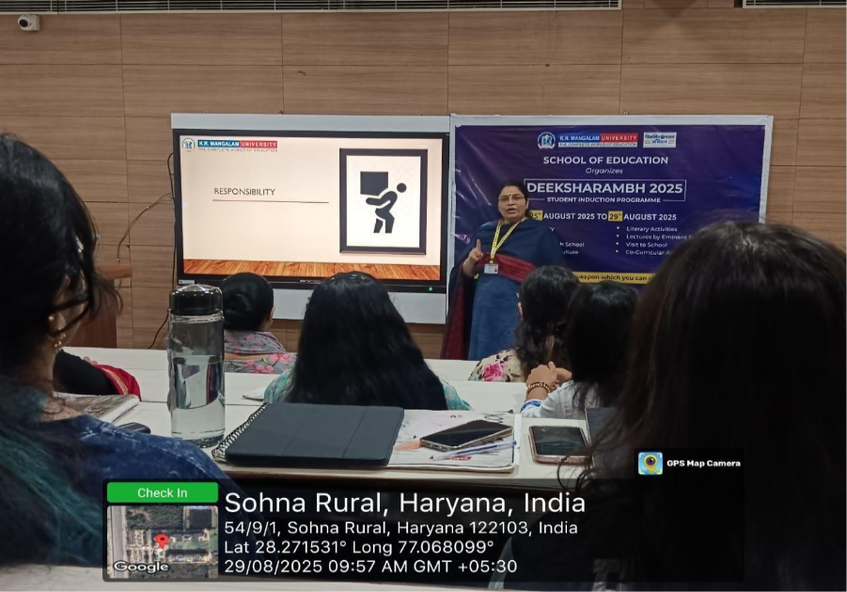Photo 1: Expert Speaker Prof. (Dr.) Tania Gupta Addressing Students on Professional Ethics

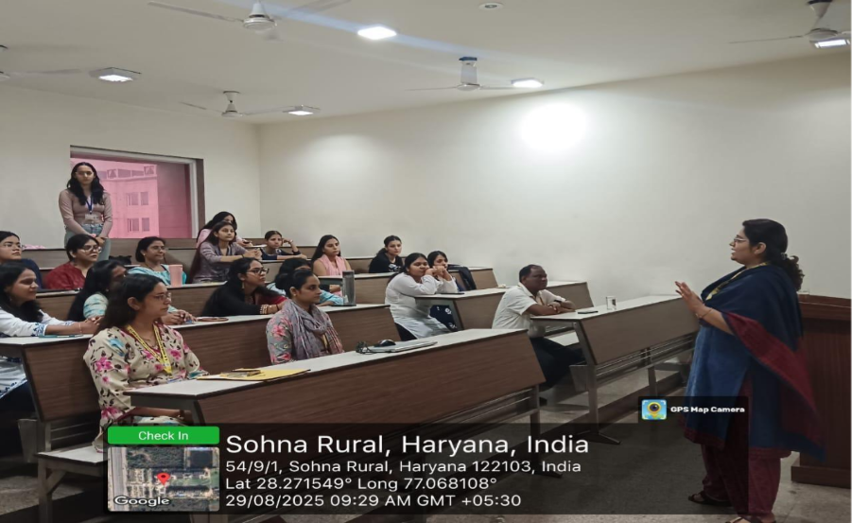Photo 2: Interactive Discussion on Ethical Conduct with SOED Students

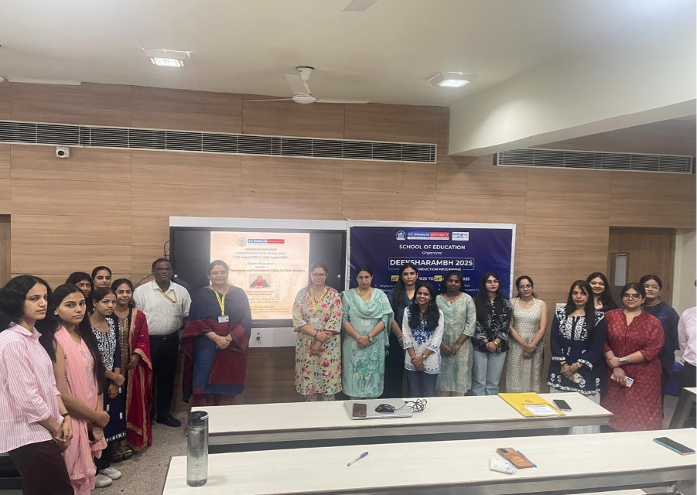Photo 3: SOED School Coordinator Prof. P.C. Jena and Expert Speaker Prof. Tania Gupta with faculty members and students

Conclusion
The Orientation Session on Professional Ethics for New Students successfully provide foundational understanding of values and ethical principles essential for the teaching profession. Through guidance, discussion, and reflection, the freshmen of the School of Education developed awareness of the expectations placed upon them as future educators.
The session set the stage for their holistic development, ensuring that student-teachers internalize professional ethics as guiding principles for both their academic journey and professional careers.

Report prepared by: | Dr. Monika Bishnoi
Report checked & verified by: | Prof. (Dr.) Tania Gupta
Report verified by IQAC Office | Dr. Shikha Dutt Sharma

