Kisan Gosthi on “Promotion of Quality Practices of Natural Farming and Agriculture Diversification” under the aegis of IQAC
Date | : | 19th February, 2025
Venue | : | Multipurpose Hall, K.R. Mangalam University
Event Type | : | Kisan Gosthi
Mode of Activity | : | Offline
Resource Person | : | Dr. Ravinder Singh Chauhan (CEO, Haryana Kisan Kalyan Pradhikaran, Panchkula)
Faculty organizer | : | Dr. Anjali Tomar, Dr. Neha Sharma, Dr. Ambika Bhandari
Target Group | : | Farmers, Students of B.Sc. (Hons.) Agriculture and Faculty of SOAS, KRMU.
Convenor | : | Dr. Joginder Singh Yadav (Dean, SOAS)
Number of Participants | : | 40 Farmers + 9 Students
Organized by | : | School of Agricultural Sciences (SOAS)

Brief Report:-
The School of Agricultural Sciences, KRMU in collaboration with Haryana Kisan Kalyan Pradhikaran, Panchkula, organized a Kisan Gosthi on Promotion of Quality Practices of Natural Farming and Agriculture Diversification at K.R. Mangalam University, Haryana on 19th February 2025. The event aimed to provide farmers and students with valuable insights into the promotion of quality practices of natural farming and diversification of agriculture. This event served as an important platform to explore the impact of sustainable farming on both soil health and farmers' income, while emphasizing the need for diversification to reduce risks and increase sustainability..
The objectives of this kisan gosthi were:
- To promote awareness about natural farming and its environmental benefits.
- To highlight the role of crop diversification in achieving sustainable agricultural practices.
- To provide practical insights from farmers and experts on overcoming challenges related to adopting natural farming.
- To educate students about the latest advancements in agricultural science that support sustainable practices
- To contribute to SDG 2 by promoting sustainable agricultural practices that enhance food security, improve soil health, and increase farmers' income, thereby working toward ending hunger and ensuring access to sufficient and nutritious food.
The Kisan Gosthi focused on various key aspects:
The Kisan gosthi began with a welcome address by Dr. Anjali Tomar, who extended a warm welcome to all guests, resource persons, and participants. She emphasized the importance of sustainable farming practices in addressing the current agricultural challenges and expressed her gratitude to the speakers and attendees for their participation. The event was also graced by Prof. Raghuvir Singh, Vice Chancellor, KRMU, He shared his experience about natural farming practice and the role of education in transforming agriculture.
Dr. J.S. Yadav, Dean of the School of Agricultural Sciences (SOAS), opened the session by stressing the significance of natural farming and crop diversification as strategies to improve agricultural productivity and ensure long-term sustainability. He discussed how diversified farming helps farmers manage risks related to pests, diseases, and market fluctuations while contributing to the overall health of the ecosystem.
Following this, Prof. Baljeet Saharan (Professor of Microbiology, CCSHAU, Hisar) presented on the principles of natural farming and the benefits of sustainable practices. He highlighted the impact of these practices on soil health, and how natural farming can reduce dependency on chemical fertilizers and pesticides, contributing to long-term agricultural sustainability.
Rao Mansingh, President of the Kisan Club, Gurugram, shared his personal experiences regarding the adoption of natural farming and crop diversification. He spoke about the challenges farmers face in transitioning to natural methods and the rewards of maintaining an eco-friendly approach to farming.
Mr. Sanjay Yadav, the founder of Dharuhera Agro Organic Farm, provided valuable insights into organic farming, discussing the marketability of organic products and the importance of maintaining high-quality standards. He also shared strategies for connecting organic farmers with consumers and improving sales.
Dr. Ravinder Singh Chauhan, CEO of the Haryana Kisan Kalyan Pradhikaran, Panchkula, discussed the government initiatives that support farmers in adopting sustainable agricultural practices. His presentation covered various programs aimed at improving the welfare of farmers and promoting the adoption of eco-friendly farming practices in Haryana.
Dr. Bhagendra Singh, a representative from the DDA, elaborated on the scientific advancements that support natural farming. He discussed how technology and research are contributing to the development of sustainable agricultural practices, thus ensuring that natural farming is both productive and efficient.
Kisan Gosthi Highlights:
- Interactive Discussions: The Kisan gosthi allowed participants to ask questions and engage in interactive discussions with experts on the challenges and solutions for adopting natural farming.
- Real-Life Experiences: Farmers shared their firsthand experiences, creating an open forum for knowledge exchange and collaboration.
- Networking Opportunities: The Kisan gosthi provided an excellent opportunity for farmers, students, and experts to network and explore potential collaborations in the field of sustainable agriculture.
Significance of the Event:
The Kisan Gosthi was a crucial initiative in promoting sustainable farming practices among farmers, students, and other agricultural stakeholders. By emphasizing the importance of natural farming and crop diversification, the event aimed to equip participants with the knowledge and tools necessary for improving agricultural practices, enhancing farm income, and contributing to environmental sustainability. This also aligns with SDG 2, which focuses on achieving food security, improving nutrition, and promoting sustainable agriculture to help end hunger and promote sustainable farming practices worldwide.
Conclusion:
The Kisan Gosthi successfully brought together farmers, experts, and agricultural stakeholders to discuss the importance of sustainable farming practices. The Kisan gosthi highlighted the significance of natural farming and crop diversification in ensuring a resilient agricultural future. The Kisan gosthi was an important step towards building awareness and fostering collaboration for sustainable agriculture in the region. Dr. Anjali Tomar, Dr. Neha Sharma, Dr. Ambika Bhandari, and the organizing team are to be commended for successfully executing this important event.
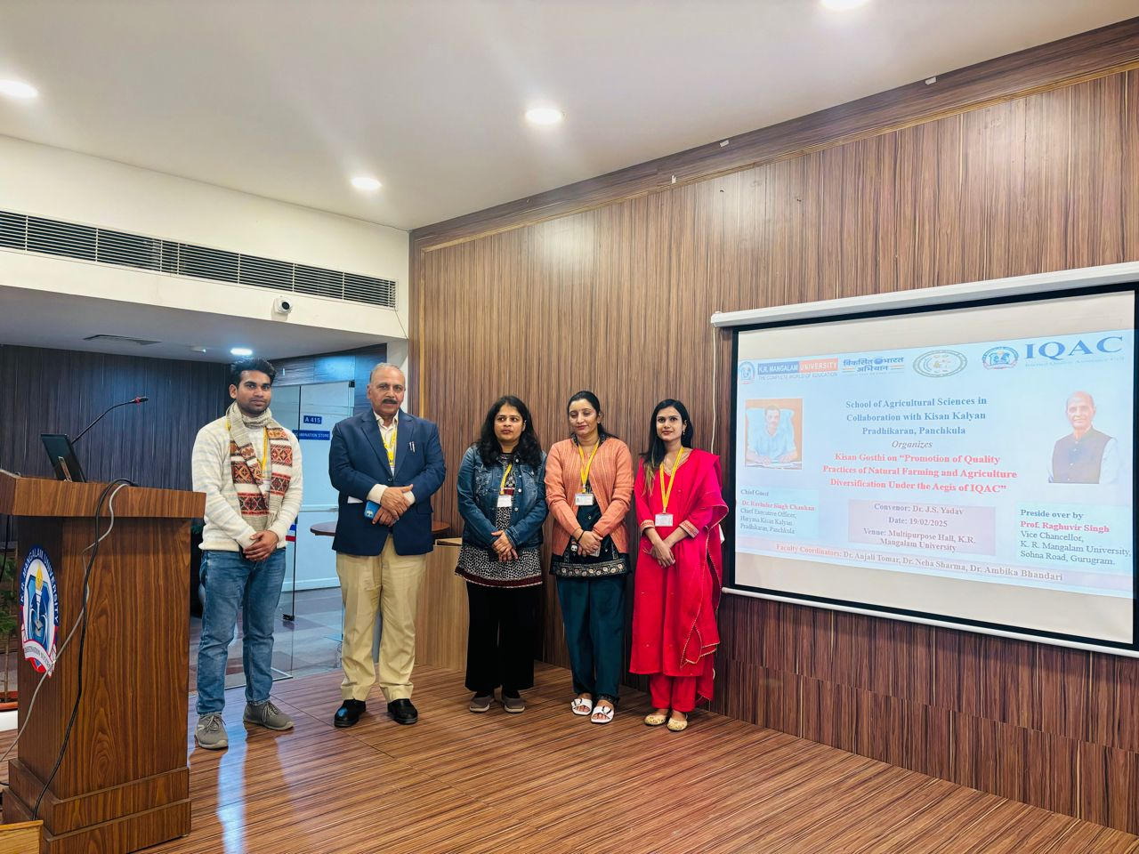
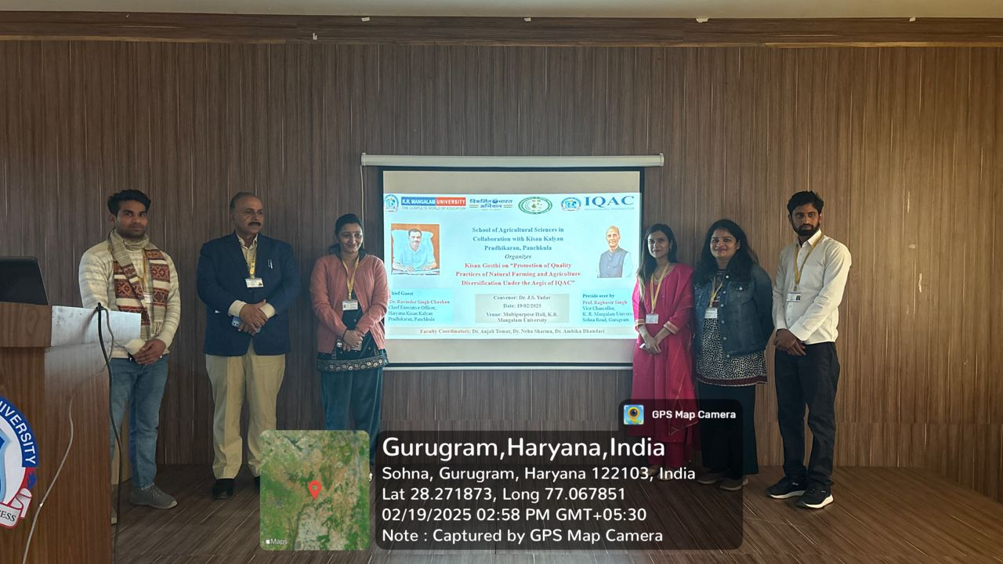
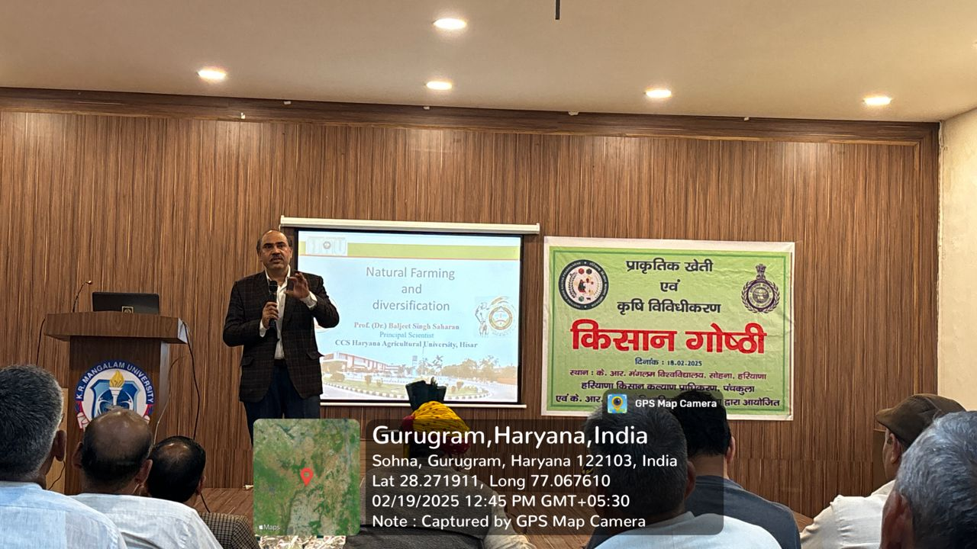

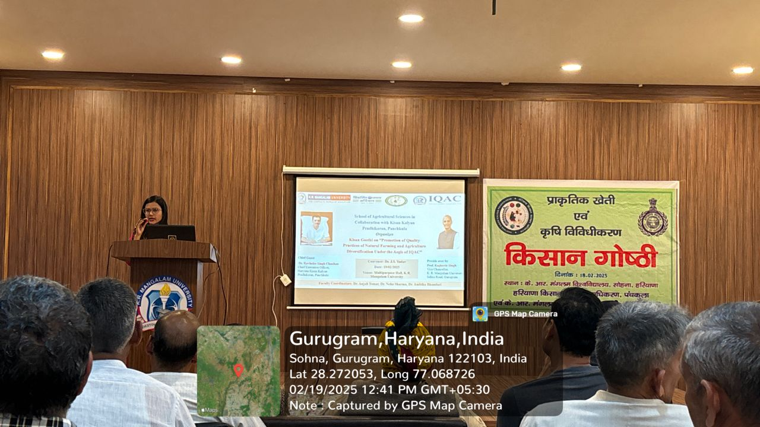

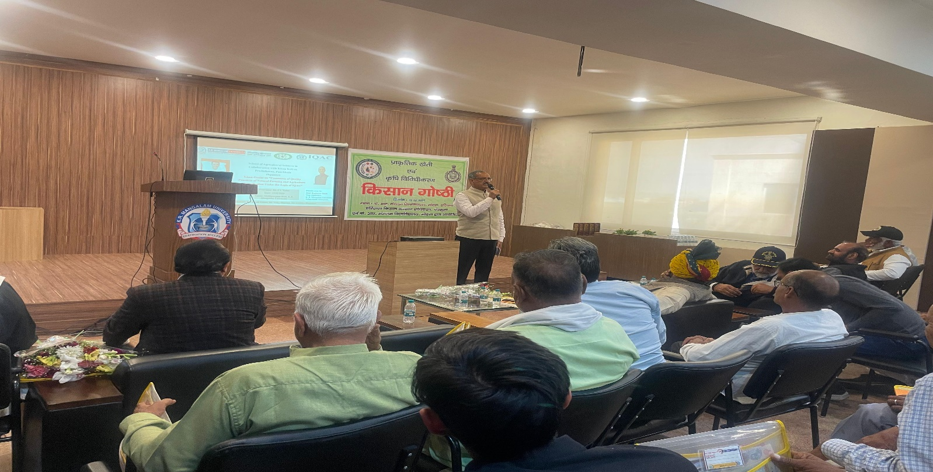
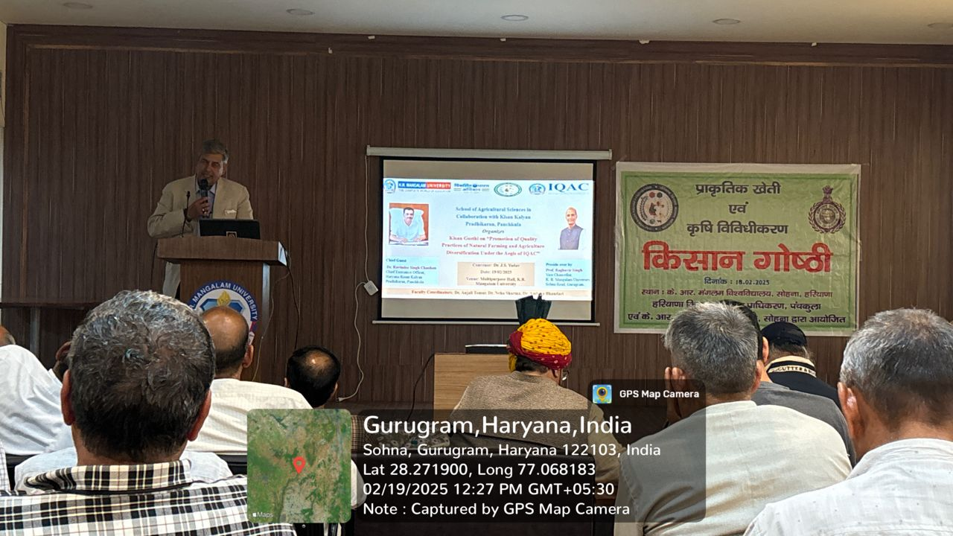

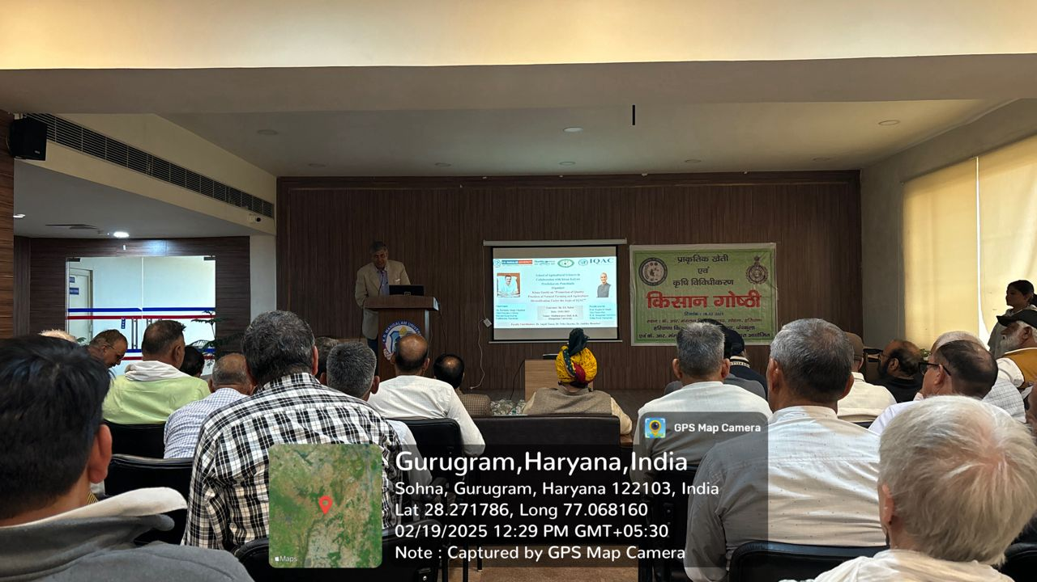
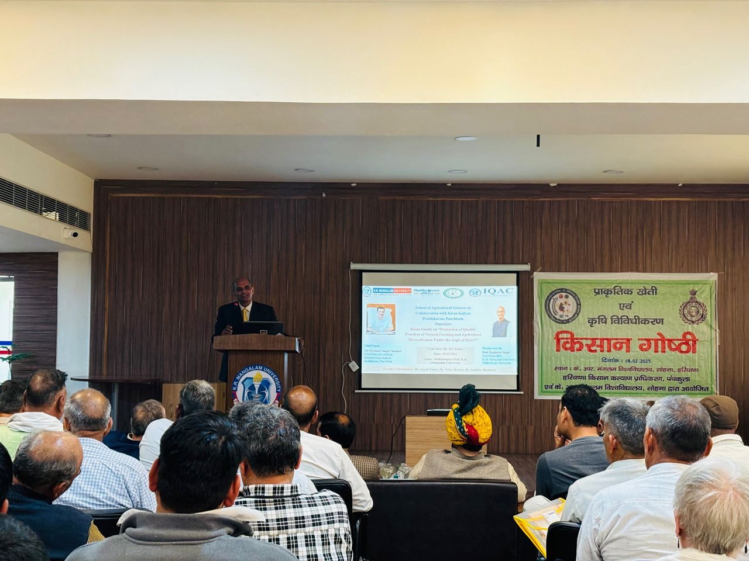

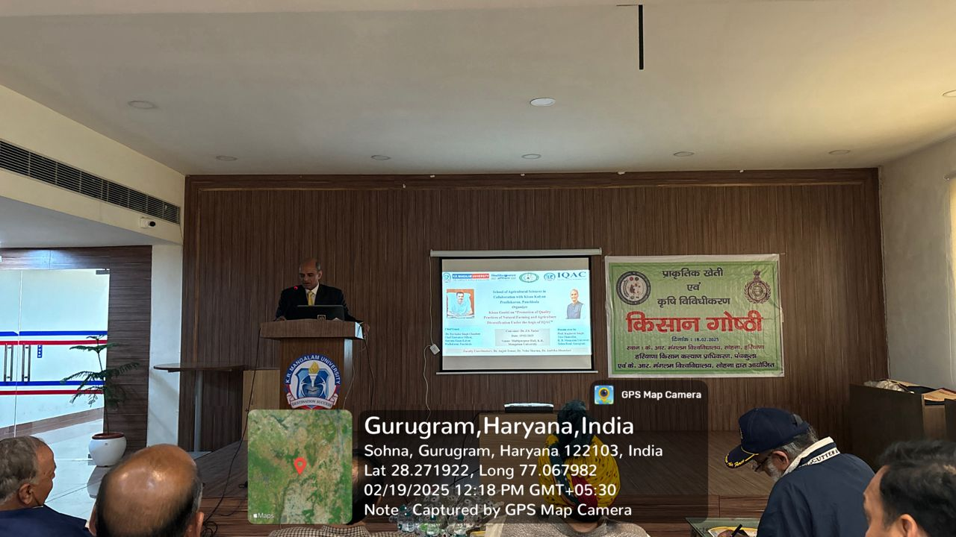
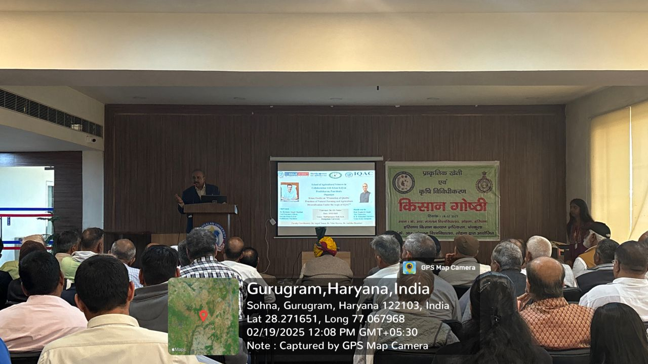

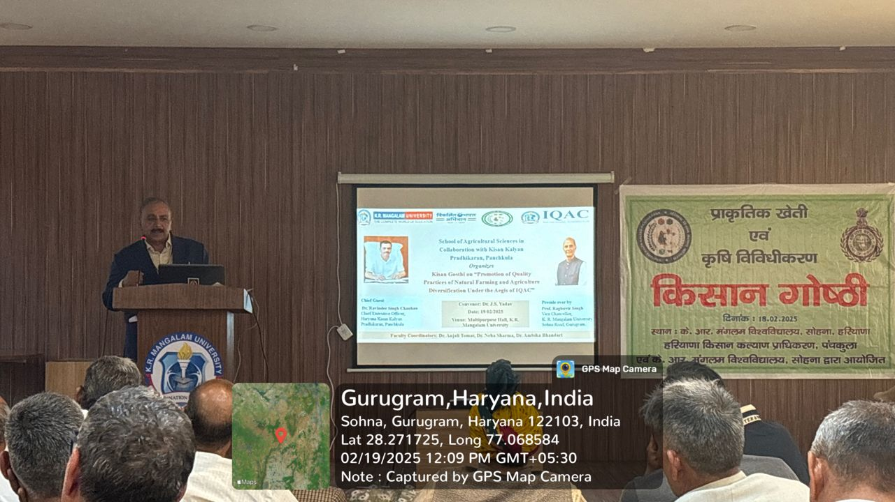
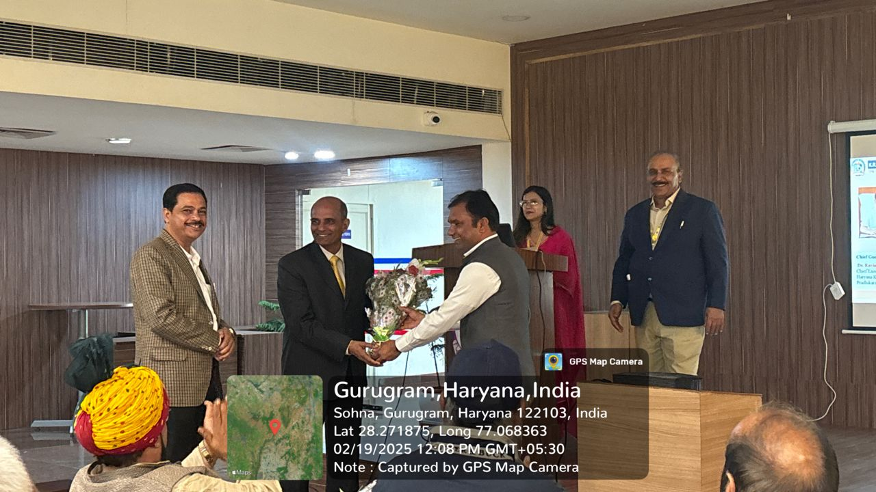

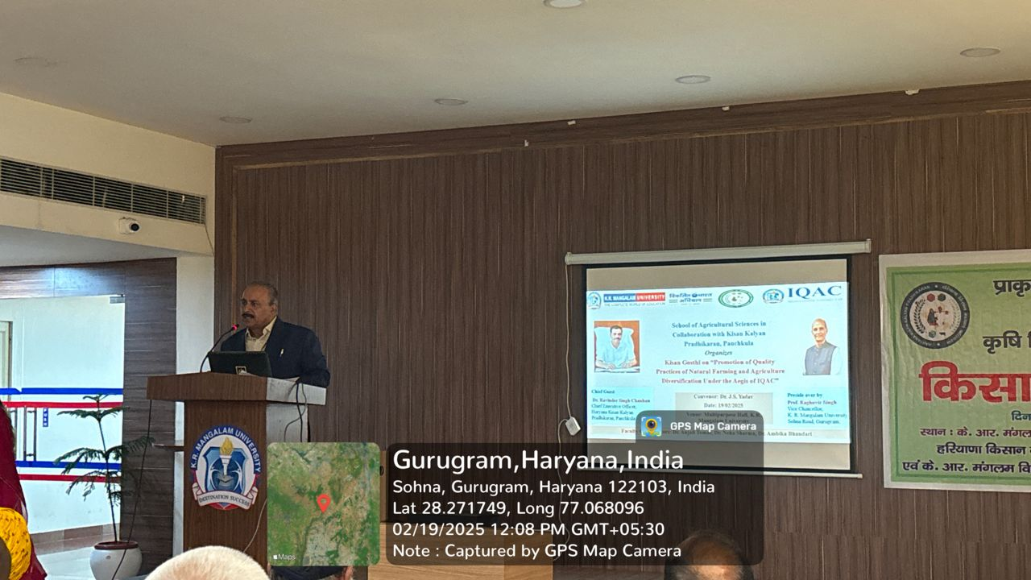
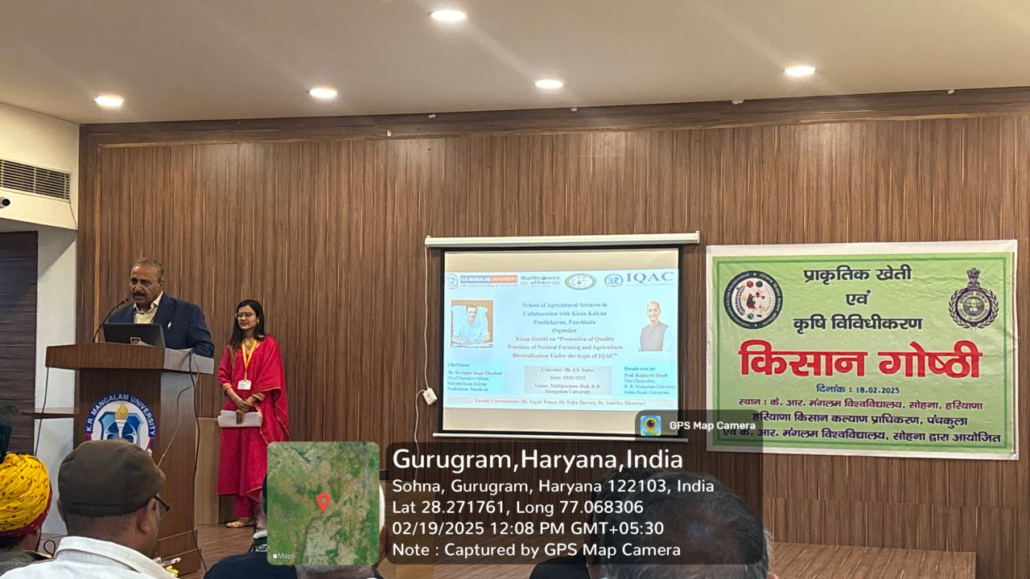

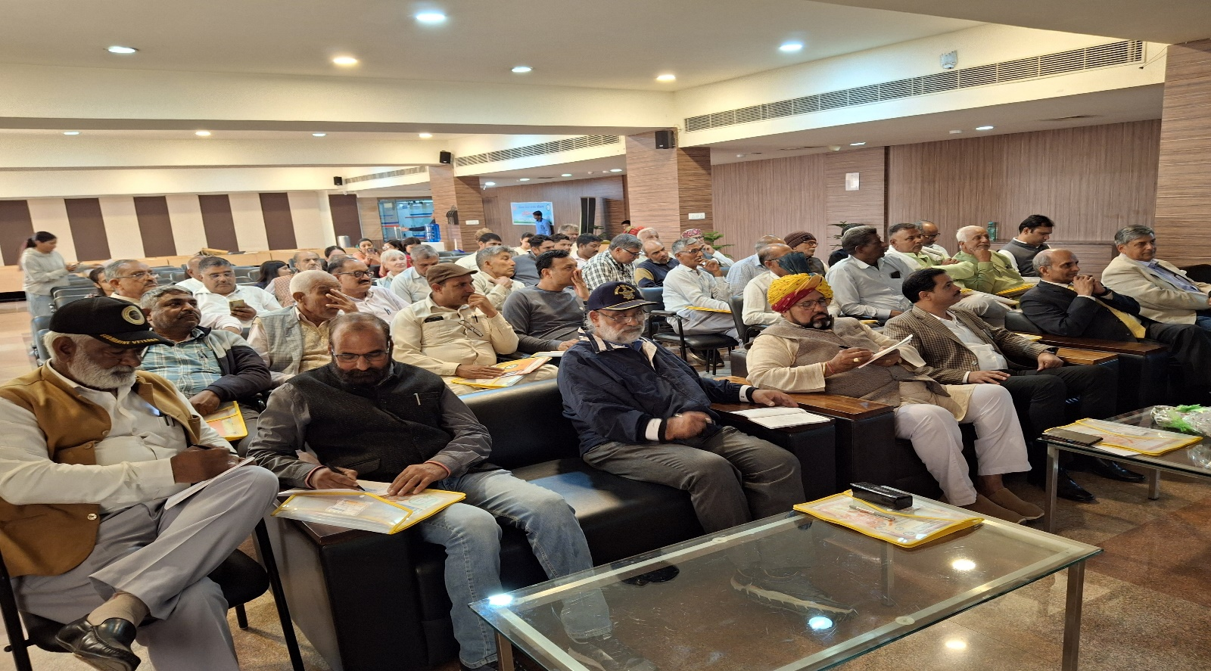
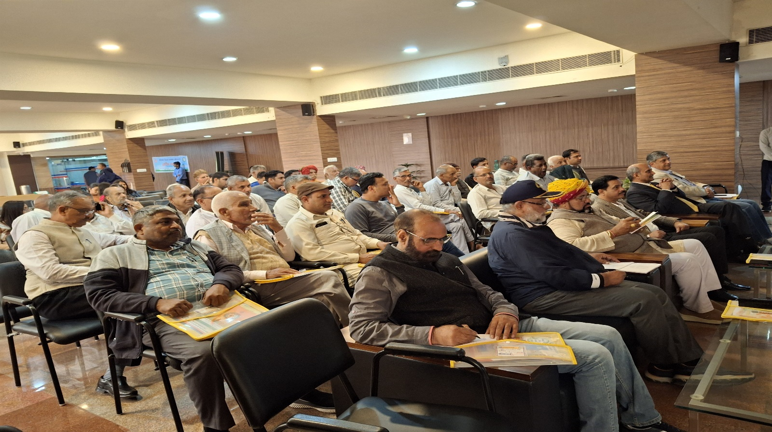

Report prepared by | Dr. Anjali Tomar  Assistant Professor,  SOAS, KRMU
Report seen & verified by Dean | Dr. J.S. Yadav  Dean,  SOAS, KRMU
Report verified by IQAC Office | Dr. Sikha Dutt  Coordinator,  IQAC, KRMU

