REPORT
on
Faculty Development Program
on
“Imperatives of Indian Knowledge System”
(19th May 2025 to 24th May 2025)
Organised By School of Basic and
Applied Sciences
K.R. MANGALAM UNIVERSITY, GURUGRAM

TABLE OF CONTENTS
Sr. No. | Contents
1 | Introduction including topic
2 | Report of the Session Conducted (Session wise - Day wise)
3 | Faculty Feedback
4 | Annexure I – Information Leaflet including collaborators (if any), Preamble, About the FDP, Registration Links and Important Dates)
5 | Annexure II - List of Resource Persons and Organizers
6 | Annexure III – Minute-to-Minute FDP Schedule
7 | Annexure IV – Registration Form
8 | Annexure V – List of Attendees
9 | Annexure VI – Evaluation Details / Questionaries/ etc
10 | Annexure VII – FDP Certificates
11 | Annexure VIII – Geotagged Photographs
12 | Annexure IX - Media Coverage

1. Introduction

The One-Week Faculty Development Programme (FDP) on Imperatives of Indian Knowledge System is designed to provide participants with a profound understanding of India’s rich intellectual heritage and its relevance in contemporary academia and research.
This comprehensive programme will explore diverse domains including Understanding Indian Knowledge System: identity, Sources and Attitude, Nitishashtra, Indian Medicinal Plants with Antioxidant and Anti-Inflammatory Properties, राष्ट्र निर्माण में चार्वाक दर्शन की भूमिका ,Measures of space,Mathematics and Natyashastra . Structured in a hybrid mode, the FDP will feature six days of online sessions followed by an offline valedictory session, offering participants flexibility while ensuring an immersive learning experience. Through a combination of expert lectures, interactive discussions, and practical demonstrations, the programme aims to bridge the gap between ancient wisdom and modern applications, fostering interdisciplinary insights. Designed for faculty members, researchers, and professionals, this FDP will equip participants with a deeper appreciation of the Indian Knowledge System, enabling them to integrate its principles into their teaching, research, and professional pursuits. Upon completion, attendees will gain a well-rounded perspective on India’s scientific, mathematical, and philosophical traditions, empowering them to contribute to academic and intellectual discourse in meaningful ways.
The objectives were to:
- Understand the fundamental principles of the Indian Knowledge System and its relevance in modern education.
- Explore the core concepts of Ramayan, Mathematics, and Ayurveda as described in ancient Indian texts.
- Analyze the principles of Nitishastra and astronomical calculations in the Indian Knowledge System.
- Discuss the interdisciplinary applications of ancient Indian knowledge in contemporary research and practice.
- Examine the philosophical and scientific aspects of traditional Indian wisdom and its impact on holistic well-being.

There were 18 speakers and around 58 participants from different universities, colleges and institutes.
The sessions of the FDP were planned to meet the desired objectives. Schedule of the FDP has been enclosed
Day 1: 19/05/2025 (Monday)
Inaugural Ceremony

9:30AM– 9:35AM | Lighting of Lamp & Saraswati Vandana
9:35AM– 9:40AM | Introduction to the FDP and by Dr. Pooja Vats, Assistant Professor, K. R. Mangalam University
9:40AM– 9:45AM | Inaugural Address by Prof. Meena Bhandari, Dean School of Basic and Applied Sciences, K.R. Mangalam University
9:45AM– 9:50AM | and Opening Remarks by Prof. Raghuvir Singh, Hon’ble Vice Chancellor, K. R. Mangalam University
9:50AM– 9:55AM | Address by, Dr. Mehraj Uddin Mir, Chair Professor (Motilal Nehru Chair), K.R. Mangalam University
Day 1: 19/05/2025 (Monday)

Time | Name |  | Designation | Affiliation | Topic
10:00 AM – 11:30 AM | Dr. Kushagra |  | Associate Professorand Head | School of Earth and Environmental Sciences, Amity University, Haryana | Indian Knowledge System: Introduction and Design भारतीय जान परंपरा: परिचय और प्रारूप
11:30 AM – 1:30 PM | Dr. Shivani Sharma |  | Professor | Dept of Philosophy, Panjab University Chandigarh | Understanding Indian Knowledge System: identity, Sources and Attitude
Break
2:00 PM – 4:00 PM | Dr. Bharat Bhushan | Dy. Director |  | Centre for Indian Knowledge Systems, Sri Sri University | An introduction to Nitishashtra
Day 2: 20/05/2025 (Tuesday)

Time | Name | Designation |  | Affiliation | Topic
9:30 AM – 11:30 AM | Dr. Rachna Sharma | Associate Professor |  | Department of Education, KIIT College of Education, Gurugram | Contribution of IKS to various disciplines
11:30 AM – 1:30 PM | Dr. Md Imtaiyaz Hassan | Professor |  | Center for Interdisciplinary Research in Basic Sciences,  Jamia Millia Islamia,  Jamia Nagar,  New Delhi-110025 | Indian Medicinal Plants with Antioxidant and Anti-Inflammatory Properties
Break
2:00 PM – 4:00 PM | Dr. Akshay Chaitanya | Hindu Monk and Spritual & Scriptural Guide |  | Ashram in Uttarkashi | राष्ट्र निर्माण में चार्वाक दर्शन की भूमिका
Day 3: 21/05/2025 (Wednesday)

Time | Name | Designation |  | Affiliation | Topic
9:30 AM – 11:30 AM | Dr. Mouna Gupta | Assistant Professor |  | Department of Education, KIIT College of Education, Gurugram | Ancient Mathematics: Unveiling the legacy
11:30 AM – 1:30 PM | Dr. Mala Kapadia | Director |  | Centre for Indigenous Knowledge System,Anaadi Foundation | Bharteeya Gyan Parampara-U Turn or Way Forward?
Break
2:00 PM – 4:00 PM | Dr. Sudip Majumder | Scientific Officer |  | International Institute of Innovation and Technology, Kolkata (I3TK) | Evolution of Science in Ancient India and looking back into it from Today's perspective
Day 4: 22/05/2025 (Thursday)

Time | Name | Designation |  | Affiliation | Topic
9:30 AM – 11:30 AM | Dr. Ashutosh | Professor |  | Institute of Applied Sanskrit Shaastriya Knowledge, Chandigarh | Application Utility & Relevance of Sanskrit Shaastriya Knowledge to Decolonize Social Sciences & Management Studies
11:30 AM – 1:30 PM | Dr Rahul Misra | Board of advisors |  | Austin University  Member Innovation council Pt Ravi Shanker Shukla university Raipur  Ramayan and its relevance in management and leadership | Ramayan and its relevance in management and leadership
Break
2:00 PM – 4:00 PM | Dr. Naeem Ahmad Pundeer | Guest Faculty |  | SRCC, DU | Vedic Mathematics and its Applications
Day 5: 23/05/2025 (Friday)

Time | Name | Designation |  | Affiliation | Topic
9:30 AM – 11:30 AM | Dr. Arun | IPS |  | AIFC, C/47, Palaspalli (near airport), Bhubaneswar-751020 | Measures of space in ancient India
11:30 AM – 1:30 PM | Dr. Ramesh Verma | Adjunct Professor |  | Chitkara University, Baddi | Bharatiya Darshana: Why and What can we learn about Science?  And Space, Time, Matter, and Causality in Ancient Indian Thought
Break
2:00 PM – 4:00 PM | Prof. (Dr.) Tania Gupta | Dean and Director, IQAC |  | K. R. Mangalam University | Role of IKS in Global Education
Day 6: 24/05/2025 (Saturday)

Time | Name | Designation |  | Affiliation | Topic
9:30 AM – 11:30 AM | Ms. Upasana Tendulkar | Visiting Faculty |  | Founder, Dancing Tales.  Resource person, Brhat  Atlas University | Natyashastra
11:30 AM – 1:30 PM | Prof. (Dr.) Gyanendra Nath Tiwari | Head of the Department |  | Department of Teacher Education, Ngaland University | Sources of Indian Knowledge System
Break
2:00 PM – 3:30 PM | Mr. Neeraj Gupta | Associate Director |  | Kyndryl global IT services | From Instagram to Inner Calm: Digital Detox the Vedic Way
Valedictory Session (Room No. B005/Link will be provided to online participants)

3:30 PM – 3:40 PM | Welcome Address and a brief summary on the various sessions held as a part of FDP by Dr. Pooja Vats, Assistant Professor, K. R. Mangalam University
3:40 PM – 3:45 PM | Address by Prof. Meena Bhandari,Dean, School of Basic and Applied Sciences, K. R. Mangalam University
3:45 PM -3:55 PM | Vote of Thanks By Dr. Pratibha Sharma , Assistant Professor of Chemistry, K. R. Mangalam University

2. Day-wise Report of the Sessions Conducted

- Monday 19th May 2025

- Inaugural Session:

The inaugural day of the Online Faculty Development Programme, organized by the School of Basic and Applied Sciences, K.R. Mangalam University in collaboration with the Internal Quality Assurance Cell (IQAC), K.R. Mangalam University, Gurugram,was successfully conducted on Monday, 19 May 2025.

The day commenced at 9:30 AM with the Lighting of the Lamp & Saraswati Vandana, led by Dr. Pooja, setting an auspicious and traditional tone for the academic proceedings. This was followed by an introduction to the FDP by Dr. Pooja Vats, Assistant Professor, K.R. Mangalam University, who outlined the vision and structure of the program.

The Inaugural Address was delivered by Prof. Meena Bhandari, Dean, School of Basic and Applied Sciences, K.R. Mangalam University, who emphasized the importance of interdisciplinary knowledge systems in contemporary education. The inaugural session concluded with a keynote by Dr. Mehraj Uddin Mir, Chair Professor (Motilal Nehru Chair), K.R. Mangalam University, who shared his insights on the transformative role of knowledge systems in national development.

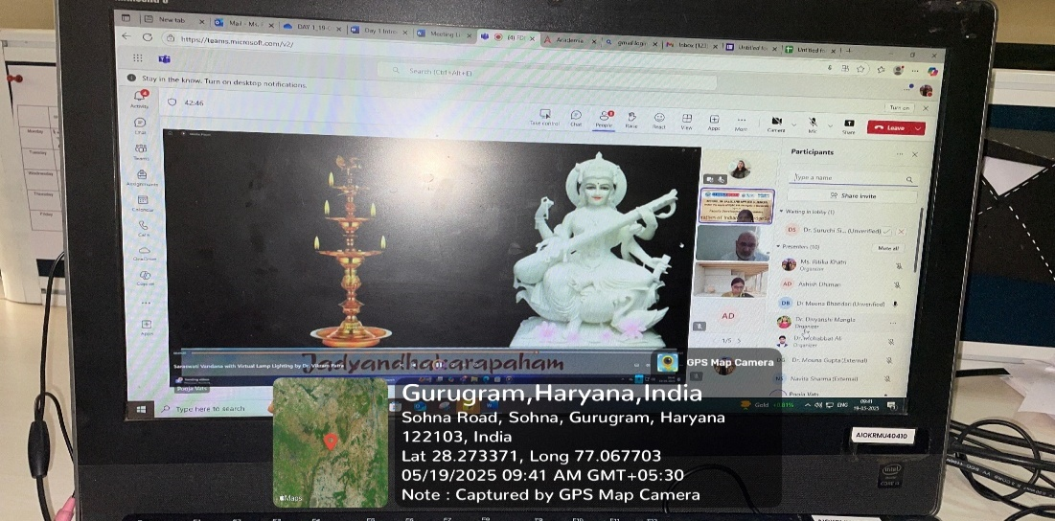

Photo 1: The inaugural session commences with Saraswati Vandana

Photo 2: Address by, Dr. Mehraj Uddin Mir, Chair Professor

i. Session on Indian Knowledge System: Introduction and Design भारतीय जान परंपरा: परिचय और प्रारूप (10:00 AM to 11:30 AM )
Following the inaugural ceremony, the academic sessions began with a lecture by Dr. Kushagra, Assistant Professor, School of Earth and Environmental Sciences, Amity University, Haryana. He delivered an enlightening session on "Indian Knowledge System: Introduction and Design" (भारतीय ज्ञान परंपरा: परिचय और प्रारूप), offering a foundational perspective on indigenous epistemologies. The session was introduced by Dr. Ritika and concluded with a vote of thanks by Dr. Divyanshi.
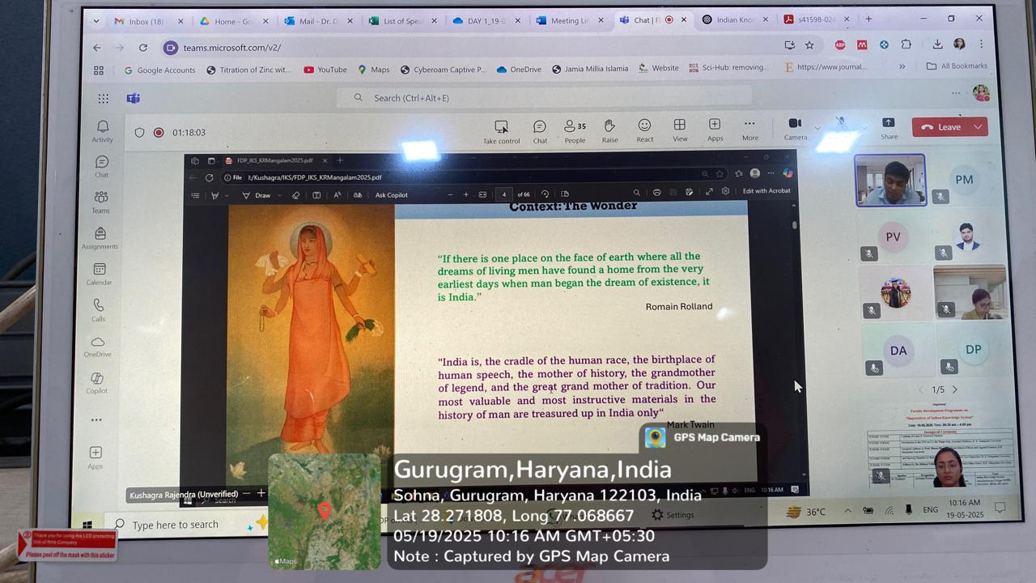

Photo 3: Dr. Kushagra delivering an insightful session on Indian epistemology

ii. Session on Understanding Indian Knowledge System: identity, Sources and Attitude (11:30 AM to 1:30 PM)
The second session, from 11:30 AM to 1:30 PM, featured Dr. Shivani Sharma, Professor, Department of Philosophy, Panjab University, Chandigarh. Her talk titled "Understanding Indian Knowledge System: Identity, Sources and Attitude" provided a deep philosophical insight into the essence and epistemic roots of Indian traditions. Dr. Divyanshi facilitated the session with an introduction and concluding vote of thanks.

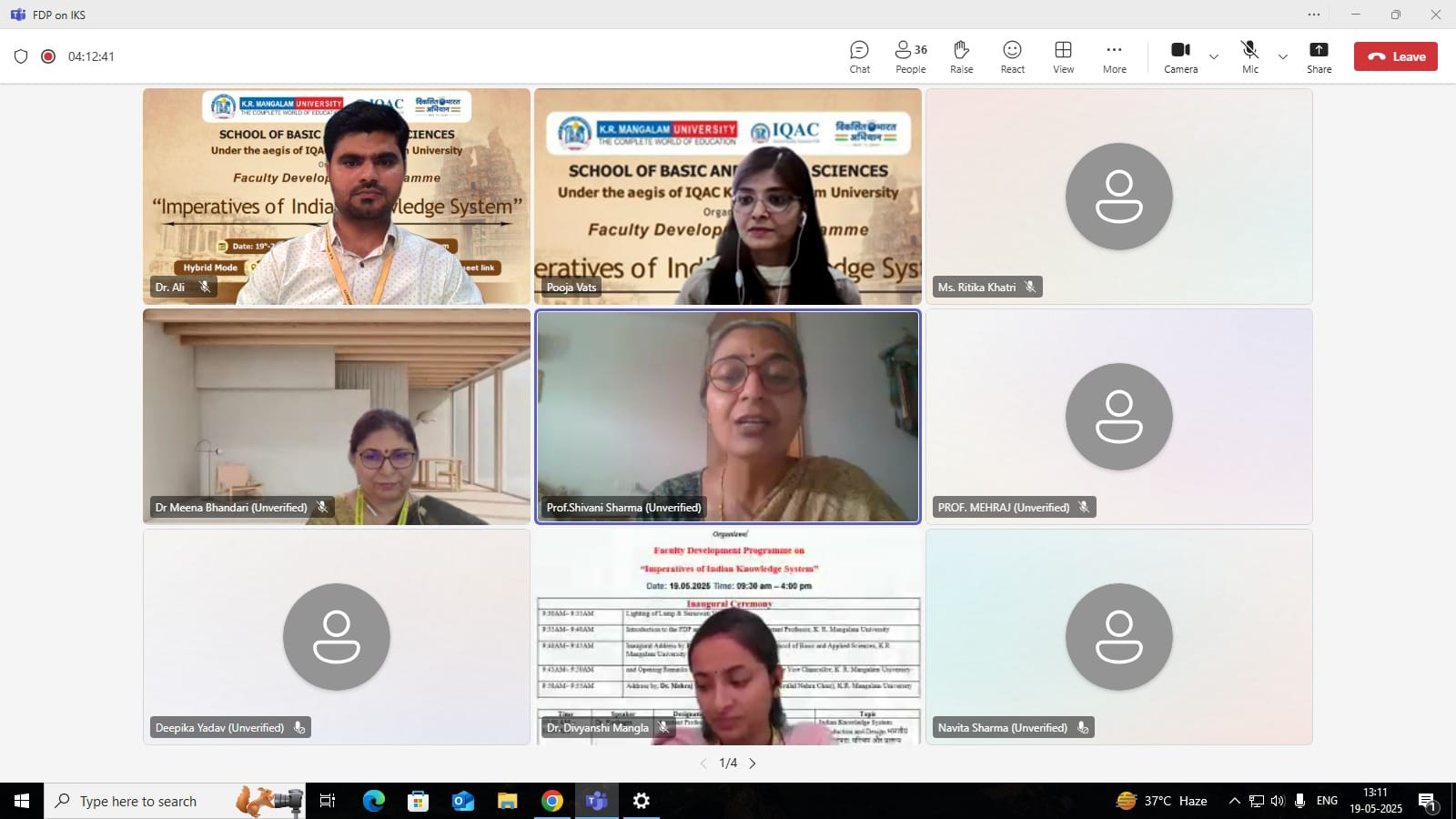

Photo 4: Engaging talk by Dr. Shivani Sharma

iii. Session on An introduction to Nitishashtra (2:00 PM – 4:00 PM)
After a short break, the final session of the day took place from 2:00 PM to 4:00 PM and was led by Dr. Bharat Bhushan, Dy. Director, Centre for Indian Knowledge Systems, Sri Sri University. He delivered an engaging session titled "An Introduction to Nitishashtra", which delved into the classical Indian discourse on ethics, leadership, and governance. Dr. Divyanshi introduced the speaker, and Dr. Ali offered the formal vote of thanks.
The day concluded on a high note with active participation and intellectual engagement from attendees. The meticulous coordination and moderation by the organising team ensured the smooth execution of all sessions.
Participant feedback was collected to assess the impact and improve the structure of upcoming sessions.
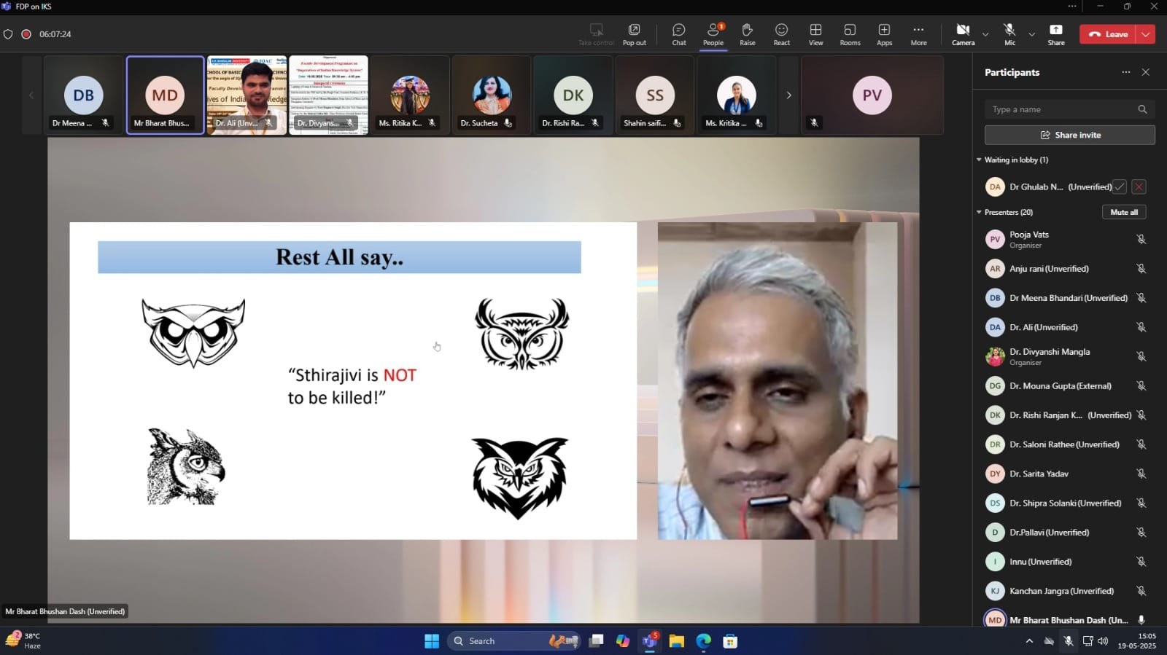

Photo 5: Address by Dr. Bharat Bhushan

- Tuesday 20th May 2025

The second day of the Online Faculty Development Programme, organized by the School of Basic and Applied Sciences, K.R. Mangalam University in collaboration with the Internal Quality Assurance Cell (IQAC), K.R. Mangalam University, Gurugram, continued to build on the intellectual momentum initiated on the inaugural day.

- Session on Contribution of IKS to various disciplines (9:30 AM to 11:30 AM)
The day's proceedings commenced at 9:30 AM with an insightful session by Dr. Rachna Sharma, Associate Professor, Department of Education, KIIT College of Education, Gurugram. Her talk titled "Contribution of Indian Knowledge Systems (IKS) to Various Disciplines" explored the expansive relevance of indigenous knowledge frameworks across academic fields. The session was introduced by Dr. Divyanshi and concluded with a vote of thanks by Dr. Pratibha.
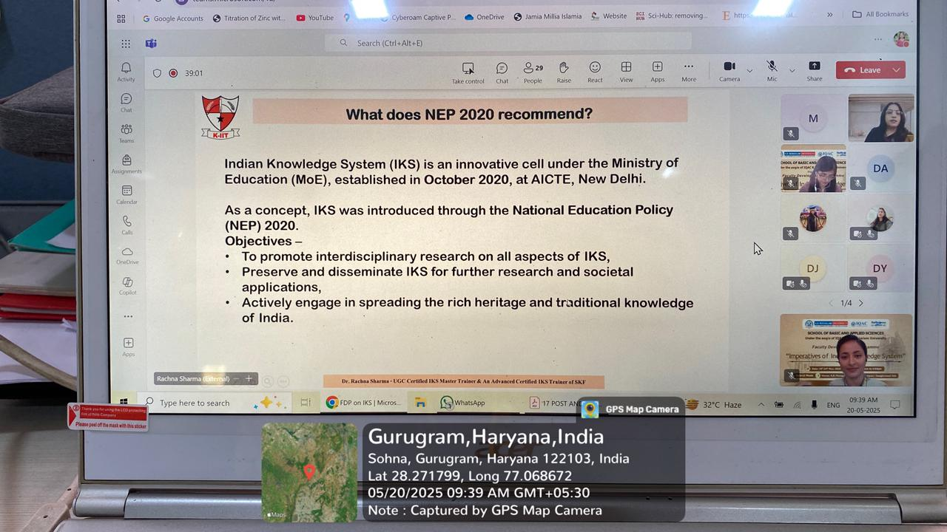
Photo 6: Dr. Rachna Sharma’s talk sheds light on Indian Knowledge Systems
- Session on Indian Medicinal Plants with Antioxidant and Anti-Inflammatory Properties (11:30 AM to 1:30 PM)
The second session, from 11:30 AM to 1:30 PM, featured Dr. Md Imtaiyaz Hassan, Professor, Center for Interdisciplinary Research in Basic Sciences, Jamia Millia Islamia, New Delhi. He delivered an engaging lecture on "Indian Medicinal Plants with Antioxidant and Anti-Inflammatory Properties", bridging traditional knowledge with modern scientific research. This session was also facilitated by Dr. Divyanshi, who delivered both the introduction and the vote of thanks, alongside Dr. Pooja.
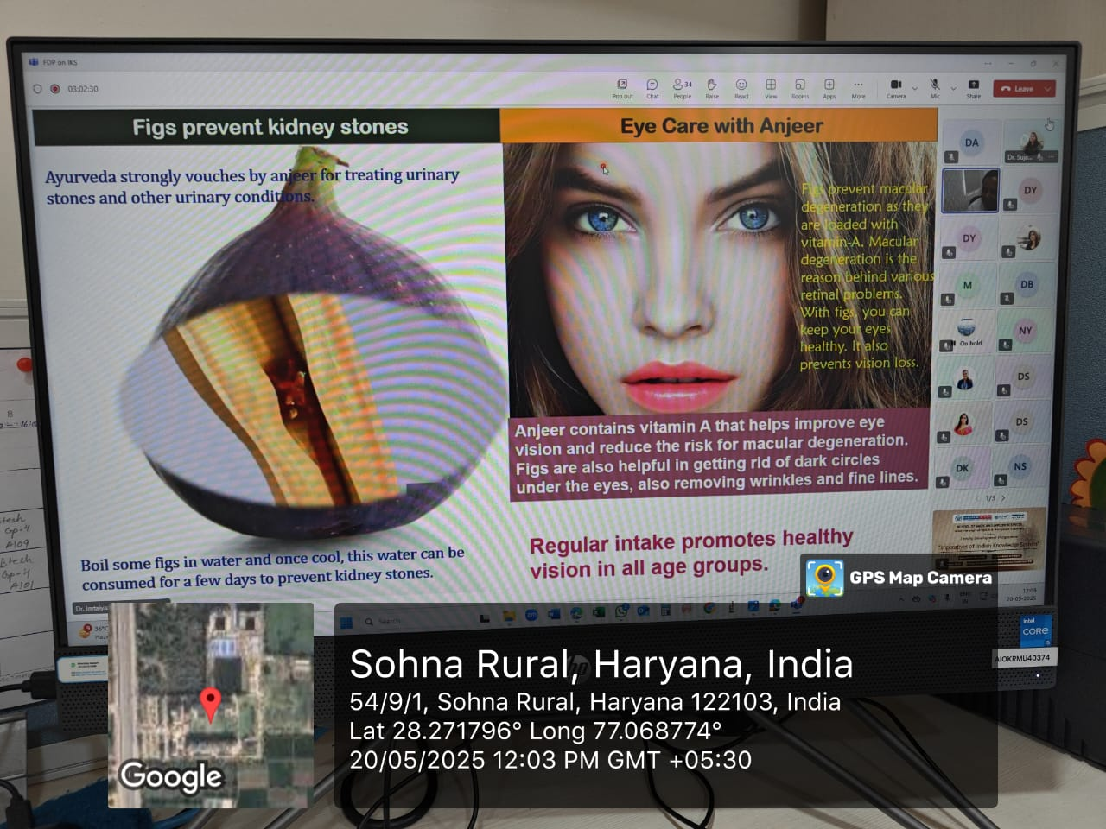
Photo 7: Dr. Md Imtaiyaz Hassan delivers a lecture on Indian Medicinal Plants
- Session on राष्ट्र निर्माण में चार्वाक दर्शन की भूमिका (2:00 PM – 4:00 PM)
Following a lunch break, the afternoon session resumed at 2:00 PM with a unique perspective brought in by Dr. Akshay Chaitanya, from a Hindu Monastic and Scriptural background, currently based at an Ashram in Uttarkashi. His talk, titled "राष्ट्र निर्माण में चार्वाक दर्शन की भूमिका" (The Role of Charvaka Philosophy in Nation Building), delved into alternative Indian philosophical viewpoints and their implications in socio-political contexts. The session was introduced by Dr. Ritika and concluded with a vote of thanks by Dr. Divyanshi.
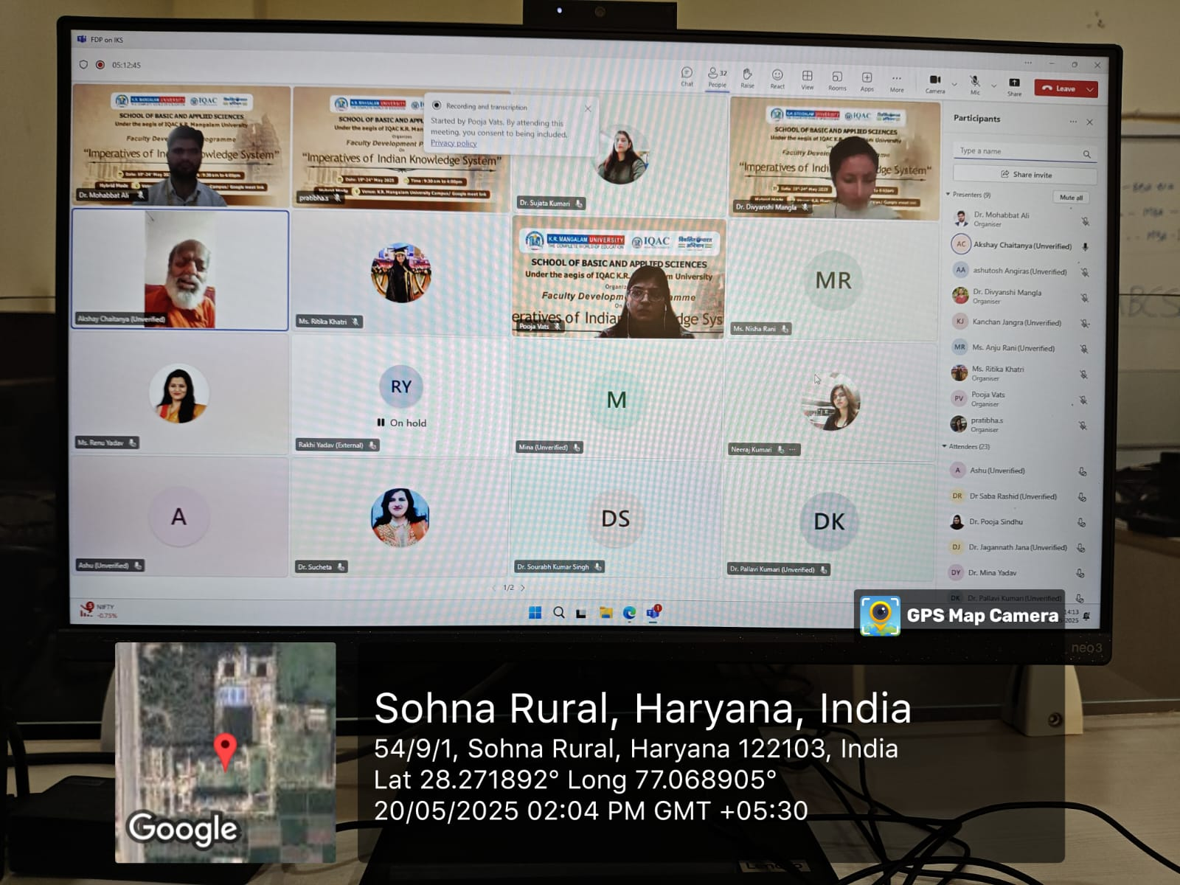
Photo 8: Dr. Akshay Chaitanya explores Charvaka philosophy’s role in nation building.
All three sessions on Day 2 were marked by active engagement and critical inquiry from the participants, highlighting the multidisciplinary and inclusive nature of the FDP. The organizing team once again ensured seamless coordination and effective moderation, making the day another resounding success.
Feedback from participants was collected to evaluate the sessions and guide future improvements in the programme delivery.
- Wednesday 21st May 2025

The third day of the Faculty Development Programme, organized by the School of Basic and Applied Sciences, K.R. Mangalam University in collaboration with the Internal Quality Assurance Cell (IQAC), K.R. Mangalam University, Gurugram, was successfully conducted on Wednesday, 21 May 2025.

The day commenced with a welcome note delivered by Dr. Pooja Vats, setting a thoughtful and engaging tone for the sessions ahead.
- Session on Ancient Mathematics: Unveiling the Legacy (9:30 AM to 11:30 AM )
At 9:30 AM, the first session began with Dr. Mouna Gupta, Assistant Professor, Department of Education, KIIT College of Education, Gurugram. She presented a thought-provoking talk on "Ancient Mathematics: Unveiling the Legacy" The session explored the relevance and resurgence of Indian knowledge traditions in modern times. The speaker was introduced by Dr. Divyanshi, and the session concluded with a vote of thanks by Dr. Ritika.
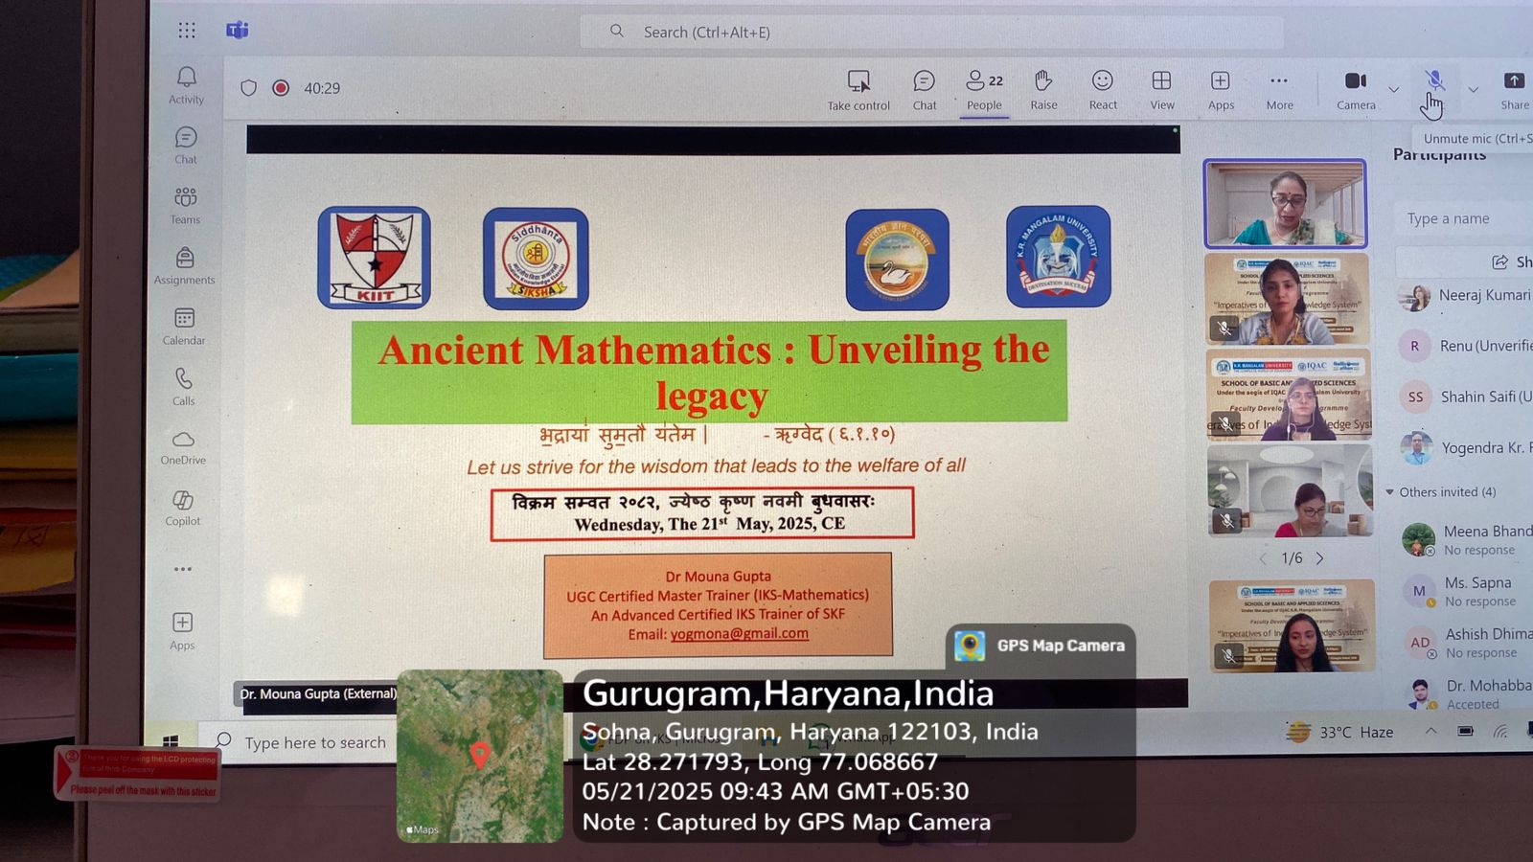
Photo 9: Dr. Mouna Gupta unravels the legacy of Ancient Mathematics in a captivating session.
- Session on Bharteeya Gyan Parampara – U Turn or Way Forward? (11:30 AM to 1:30 PM)
From 11:30 AM to 1:30 PM, the second session was conducted by Dr. Mala Kapadia, Director, Centre for Indigenous Knowledge System, Anaadi Foundation. Her session titled "Bharteeya Gyan Parampara – U Turn or Way Forward?" delved into the rich historical contributions of Indian scholars to the field of mathematics. Dr. Ritika provided the introduction and also offered the thank-you note, along with Dr. Divyanshi. 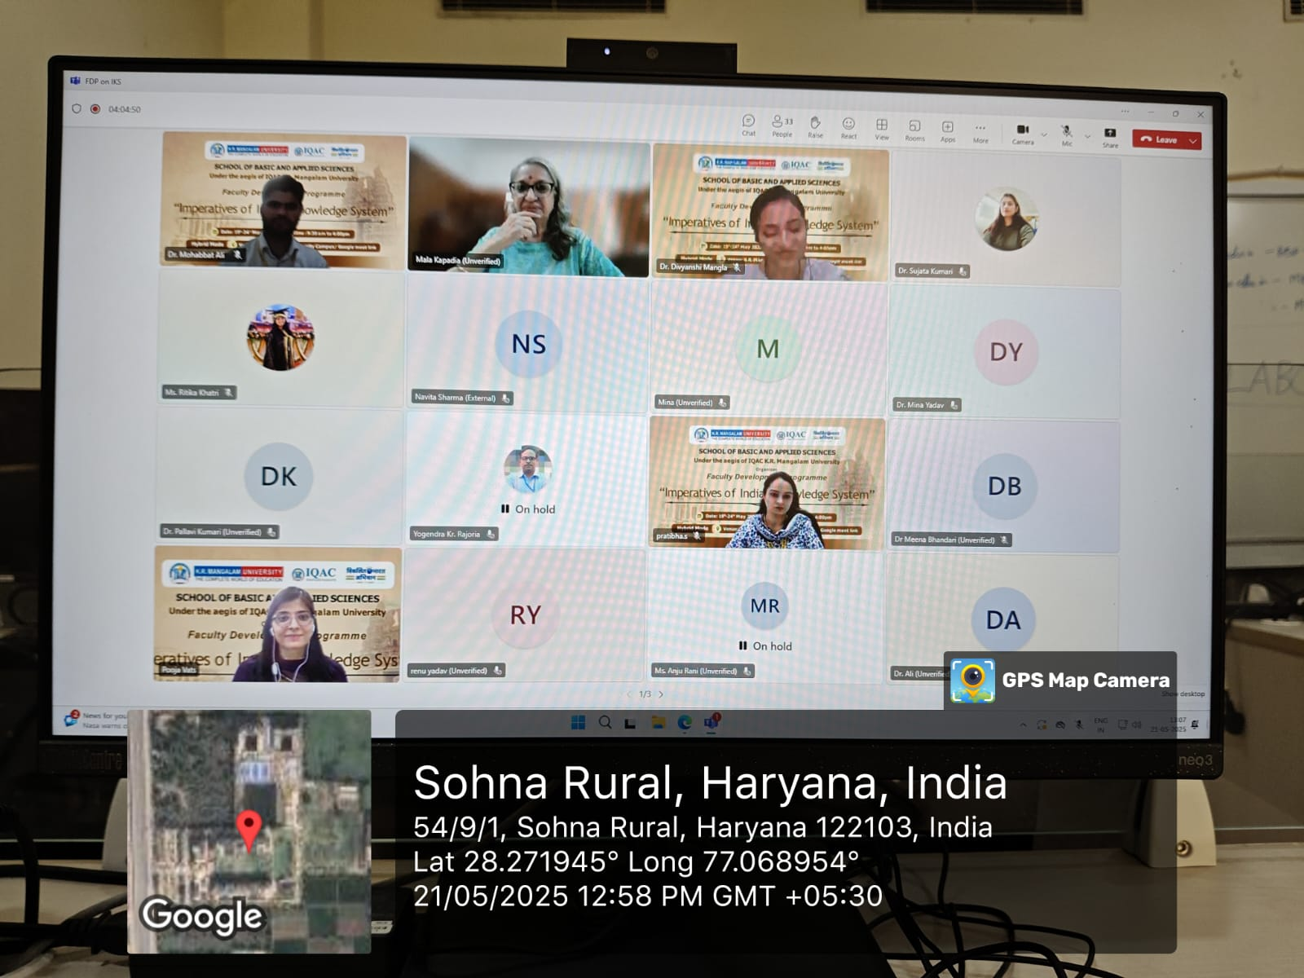
Photo 10: Dr. Mala Kapadia discusses ‘Bharteeya Gyan Parampara’ and India’s mathematical heritage.
- Session on Evolution of Science in Ancient India and Looking Back into it from Today’s Perspective (2:00 PM – 4:00 PM)

Following a break, the final session of the day was held from 2:00 PM to 4:00 PM. Dr. Sudip Majumder, Scientific Officer, International Institute of Innovation and Technology, Kolkata (I3TK), delivered a comprehensive session on "Evolution of Science in Ancient India and Looking Back into it from Today’s Perspective." His session highlighted the scientific advancements rooted in ancient Indian traditions and their implications in the present-day context. Dr. Ali introduced the speaker, and Dr. Divyanshi presented the vote of thanks.
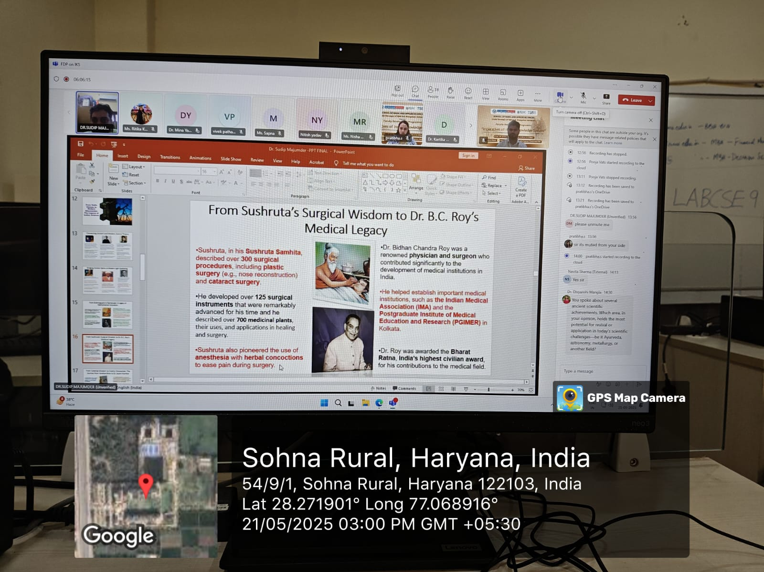
Photo 11: Dr. Sudip Majumder on ancient Indian scientific traditions and their modern-day relevance
The day concluded with enthusiastic participation from attendees, marked by insightful discussions and valuable interactions. The organizing team ensured the seamless conduct of all sessions with effective coordination and moderation.
A concluding note was delivered by Dr. Divyanshi, encapsulating the essence of the day's learnings and extending appreciation to all speakers and participants.
Participant feedback was collected to further refine the upcoming sessions of the programme.
- Thursday 22nd May 2025

The fourth day of the Online Faculty Development Programme was successfully held on 22 May 2025. The day featured three intellectually stimulating sessions that bridged traditional Indian knowledge systems with modern academic and professional practices.
- Session on Application Utility & Relevance of Sanskrit Shaastriya Knowledge to Decolonize Social Sciences & Management Studies (9:30 AM to 11:30 AM)
The proceedings began at 9:30 AM with an insightful lecture by Dr. Ashutosh, Professor at the Institute of Applied Sanskrit Shaastriya Knowledge, Chandigarh. His session, titled "Application Utility & Relevance of Sanskrit Shaastriya Knowledge to Decolonize Social Sciences & Management Studies," explored how ancient Indian intellectual traditions can redefine and enrich contemporary academic disciplines. Dr. Pratibha introduced the esteemed speaker, and Dr. Divyanshi extended the vote of thanks.
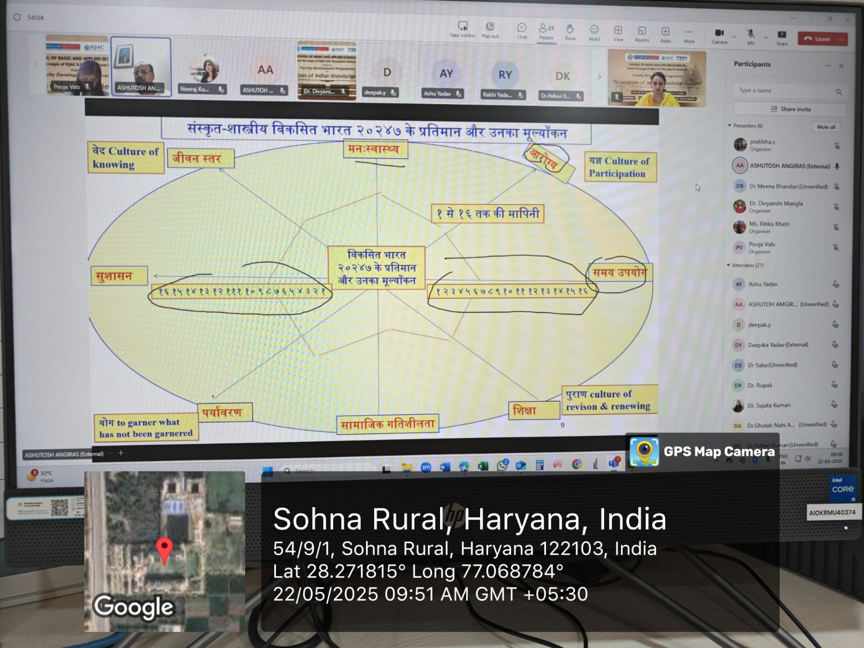 Photo 12: Dr. Ashutosh on the relevance of Sanskrit Shaastriya Knowledge in decolonizing social sciences and management
- Session on Ramayan and its Relevance in Management and Leadership (11:30 AM to 1:30 PM)
From 11:30 AM to 1:30 PM, Dr. Rahul Misra, Member of the Board of Advisors at Austin University and Innovation Council Member at Pt Ravi Shanker Shukla University, Raipur, delivered a thought-provoking talk on "Ramayan and its Relevance in Management and Leadership." Dr. Misra highlighted leadership principles and ethical governance models embedded in ancient Indian epics. This session was also moderated by Dr. Pratibha, with a joint vote of thanks offered by Dr. Pratibha and Dr. Pooja.
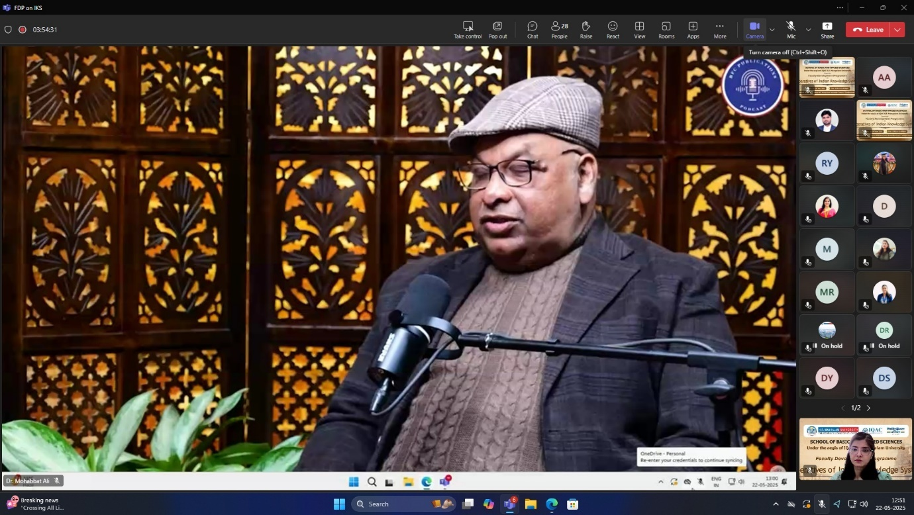
Photo13: Dr. Rahul Misra discusses leadership and ethics from the Ramayan in management.
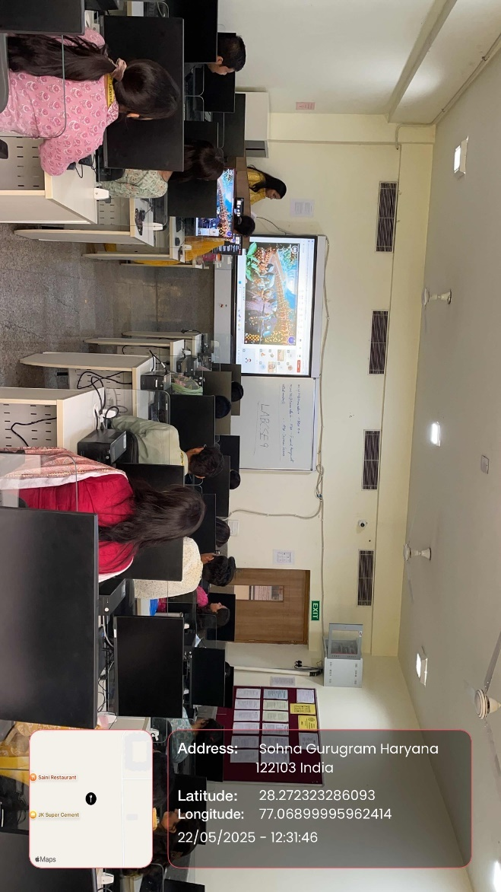
Photo14: Participants engaged in Dr. Rahul Mishra’s session
- Session on Vedic Mathematics and its Applications (2:00 PM – 4:00 PM)
Post-lunch, at 2:00 PM, Dr. Naeem Ahmad Pundeer, Guest Faculty at Shri Ram College of Commerce (SRCC), University of Delhi, took the virtual stage to present a lecture on "Vedic Mathematics and its Applications." His session illustrated the efficiency and elegance of Vedic mathematical techniques and their relevance to modern pedagogy and problem-solving. Dr. Pratibha introduced the speaker, and the session concluded with a formal thank you note by Dr. Ritika.
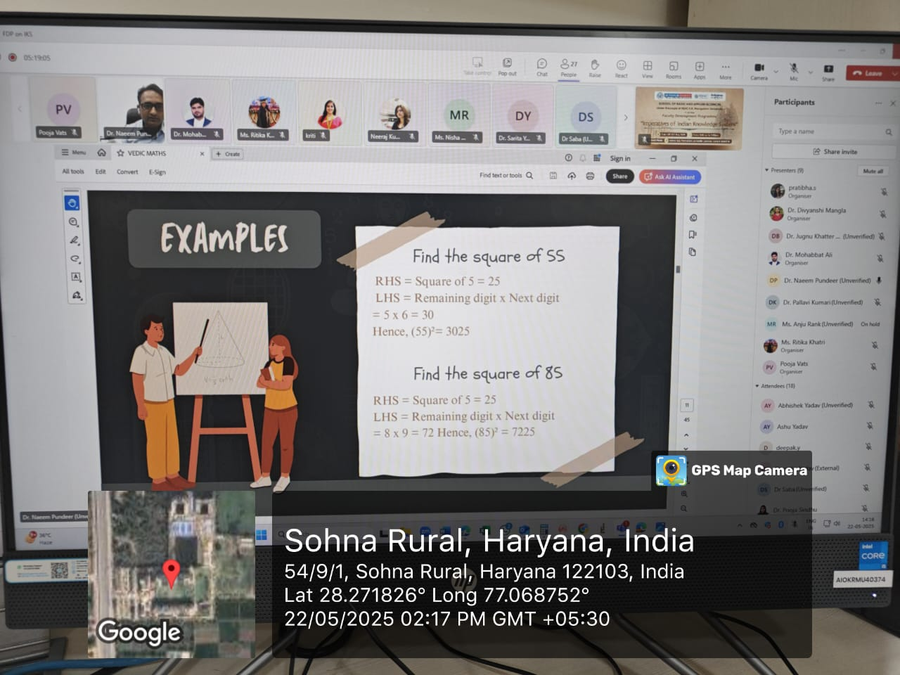
Photo15: Dr. Naeem Ahmad Pundeer presents on the applications of Vedic Mathematics in modern education.
The day was characterized by robust academic discourse and active participant engagement. The seamless execution of all sessions reflected the commendable efforts of the organizing team. Feedback from participants was collected to assess the quality of the sessions and to guide improvements for the remaining days of the programme.

- Friday 23rd May 2025
The fifth day of the Faculty Development Programme, organized by the School of Basic and Applied Sciences in collaboration with the Internal Quality Assurance Cell (IQAC), K.R. Mangalam University, continued with enriching academic deliberations on Friday, 23 May 2025.
- Session on Measures of Space in Ancient India" delved into the historical perspectives and methodologies of spatial understanding in Indian tradition (9:30 AM to 11:30 AM)

The day commenced at 9:30 AM with an insightful session by Dr. Arun, IPS, from AIFC, Bhubaneswar. His lecture on "Measures of Space in Ancient India" delved into the historical perspectives and methodologies of spatial understanding in Indian tradition”. The session was introduced by Dr. Ritika, and a formal vote of thanks was delivered by Dr. Pratibha.
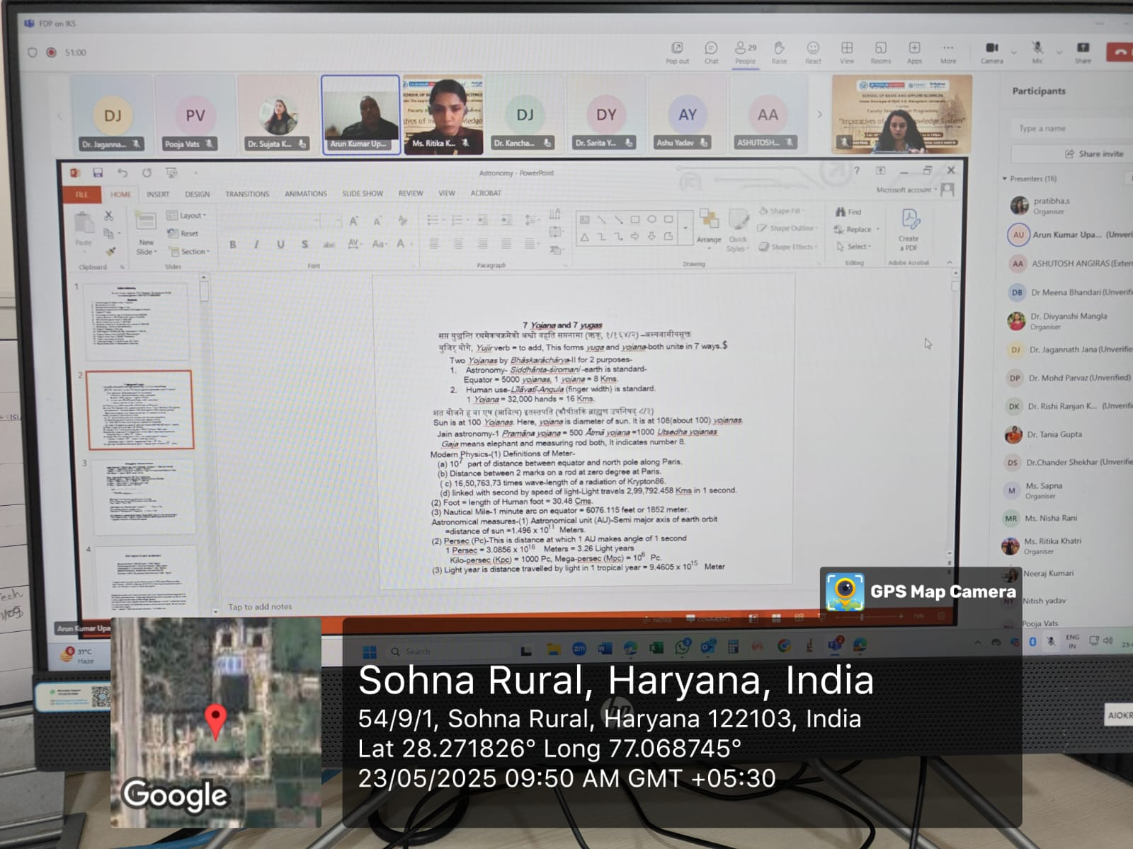Photo16: Dr. Arun, IPS, discusses the ancient Indian methodologies of spatial understanding.
- Session on Bharatiya Darshana: Why and What Can We Learn About Science? And Space, Time, Matter, and Causality (11:30 AM to 1:30 PM)
The second session, held from 11:30 AM to 1:30 PM, featured Dr. Ramesh Verma, Adjunct Professor, Chitkara University, Baddi. His talk titled "Bharatiya Darshana: Why and What Can We Learn About Science? And Space, Time, Matter, and Causality" provided a multidimensional exploration of scientific thought rooted in Indian philosophy. Dr. Pratibha introduced the session and also delivered the vote of thanks, along with support from Dr. Pooja.
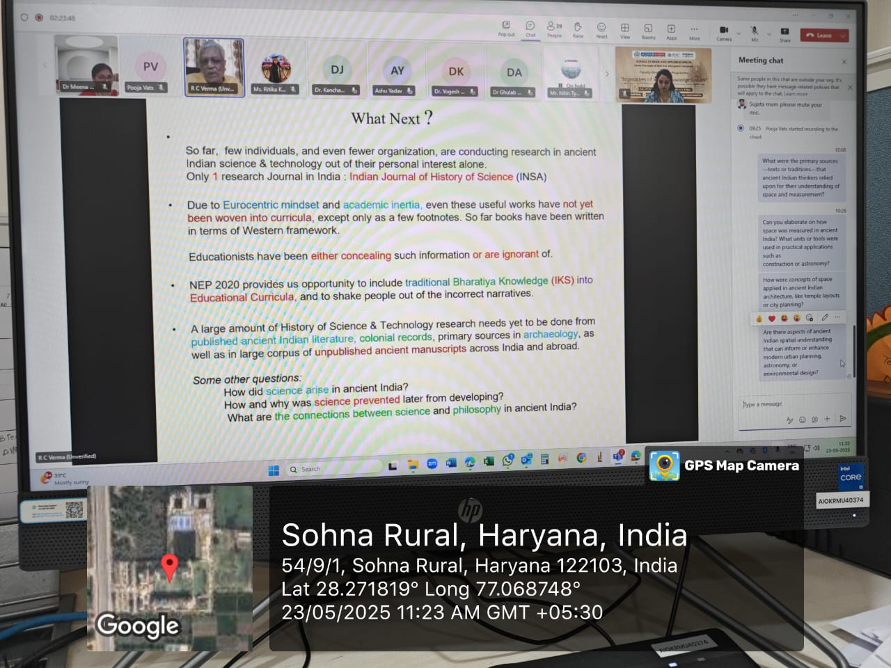 Photo17: Dr. Ramesh Verma explores science and philosophy through Bharatiya Darshana.
- Session on Role of IKS in Global Education (2:00 PM to 4:00PM)
Following a brief break, the final session of the day was conducted from 2:00 PM to 4:00 PM. Prof. (Dr.) Tania Gupta, Dean and Director, IQAC, K.R. Mangalam University, presented a comprehensive lecture on "Role of IKS in Global Education" under the theme of Ancient Indian Thought. The session highlighted the contemporary relevance of the Indian Knowledge System in global academic and educational landscapes. The session was introduced by Dr. Ali and concluded with a formal thank-you note by Dr. Pratibha.
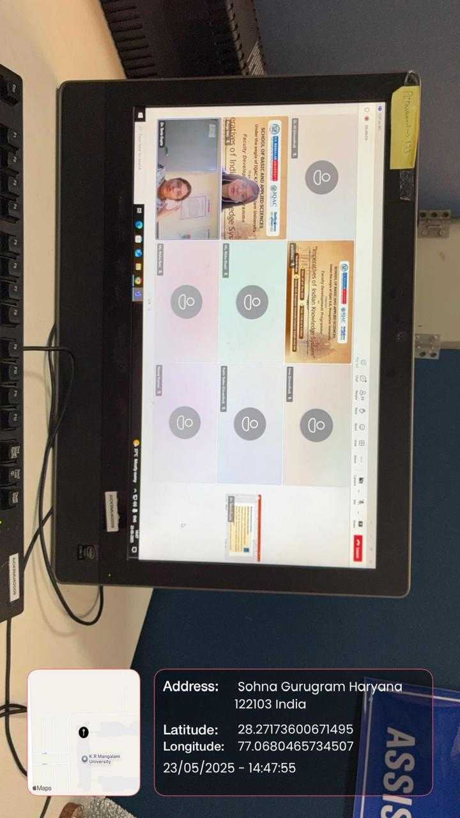
Photo18: Prof. (Dr.) Tania Gupta discusses the global relevance of Indian Knowledge Systems.
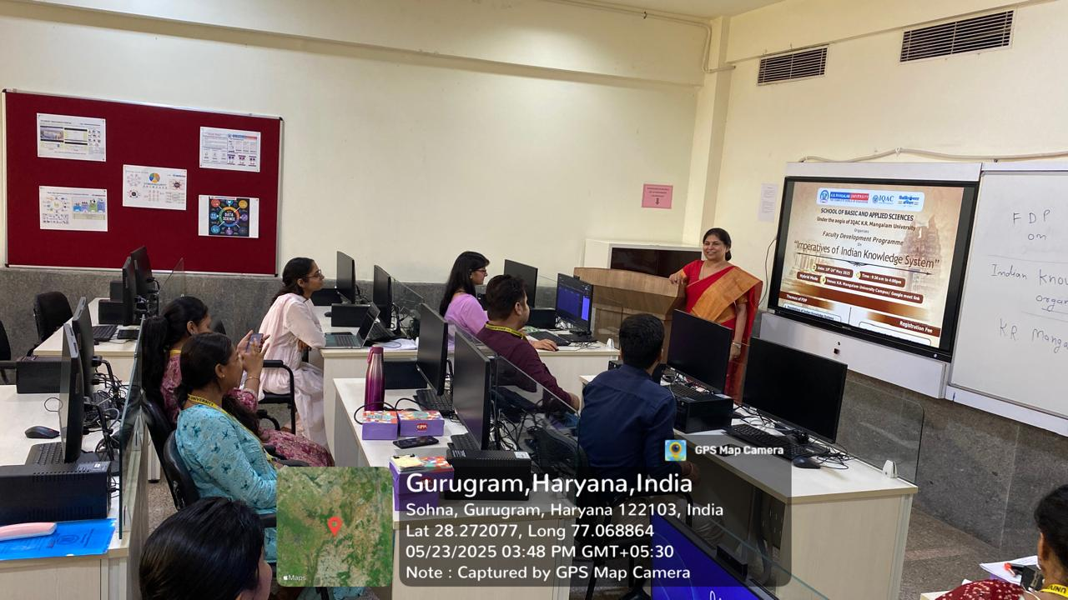Photo19: Participants engaged in session.
In addition to the lectures, a quiz based on the day's sessions was conducted to reinforce key learnings and actively engage participants in assessing their understanding of the topics discussed.

The day concluded successfully, marked by vibrant discussions and meaningful engagement among participants. The organizing team once again ensured the smooth and timely conduct of the sessions, maintaining the academic rigor and collaborative spirit of the programme.
Feedback from participants was collected to continuously enhance the programme's structure and delivery in the upcoming sessions.
- Saturday 24th May 2025
The sixth and final day of the Faculty Development Programme, organized by the School of Basic and Applied Sciences, K.R. Mangalam University in collaboration with the Internal Quality Assurance Cell (IQAC), K.R. Mangalam University, Gurugram, was successfully conducted on Saturday, 24 May 2025.
- Session on Natyashastra (9:30 AM to 11:30 AM)
The day began with an insightful session at 9:30 AM by Ms. Upasana Tendulkar, Visiting Faculty and Founder of Dancing Tales, and a resource person at Brhat, Atlas University. Her talk on Natyashastra captivated the participants by delving into the classical Indian treatise on performing arts. The session was introduced by Dr. Pratibha, and a thank-you note was delivered by Dr. Ali.
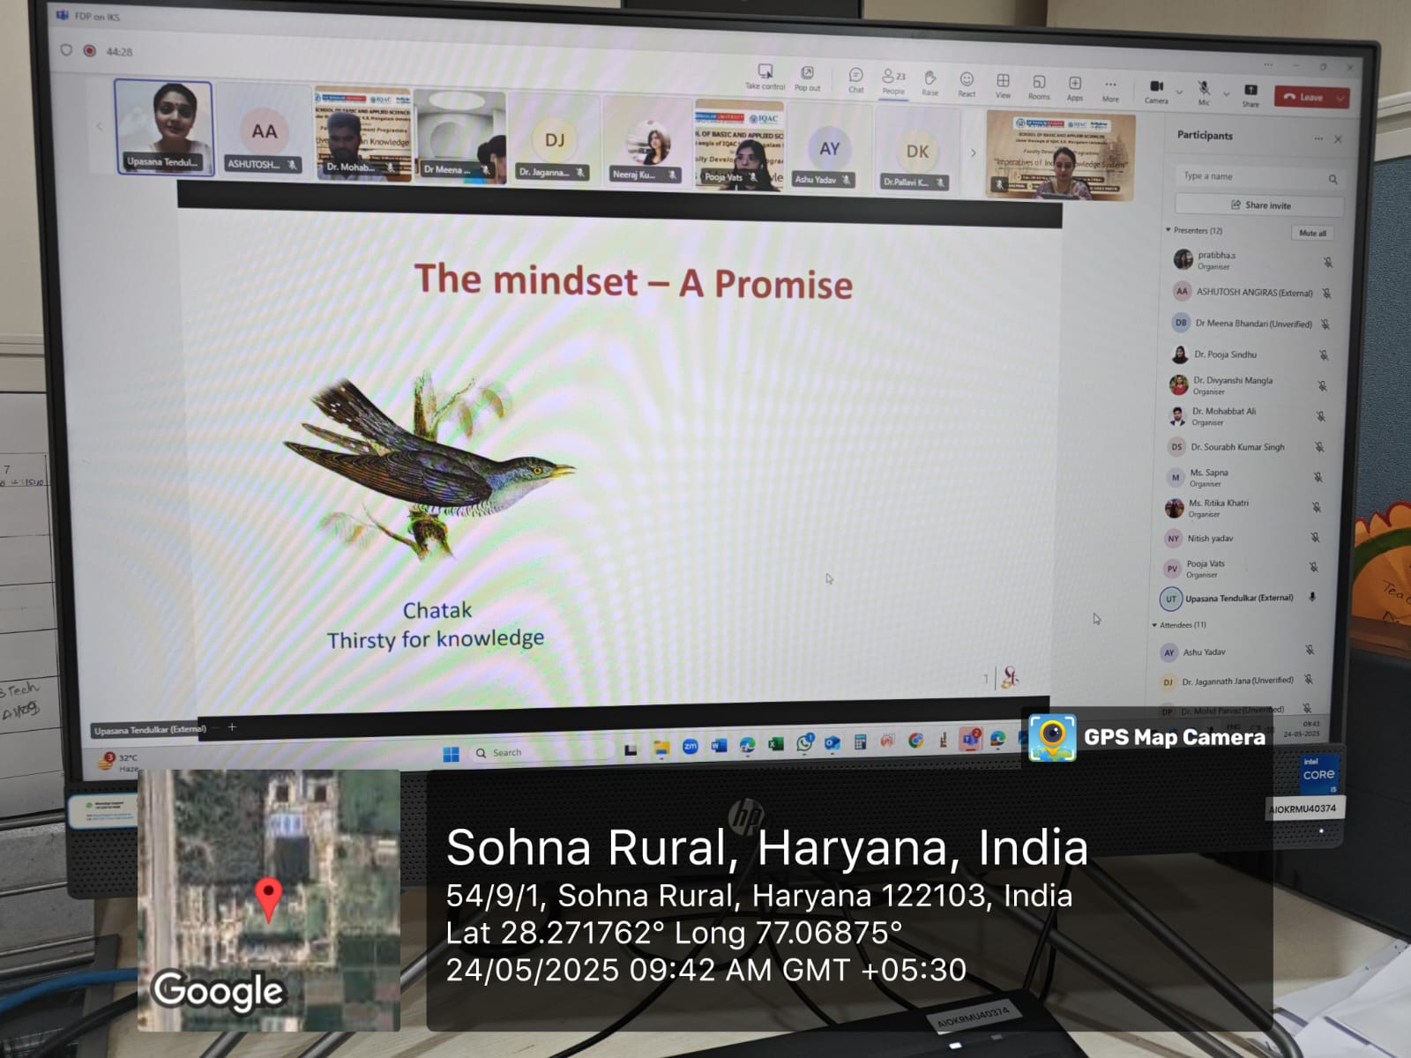
Photo 20: Ms. Upasana Tendulkar captivates participants with insights on Natyashastra.
- Session on Sources of Indian Knowledge System (11:30 AM to 1:30 PM)

At 11:30 AM, the second session featured Prof. (Dr.) Gyanendra Nath Tiwari, Head of the Department of Teacher Education at Nagaland University. His lecture focused on Sources of Indian Knowledge System, offering a comprehensive overview of the foundations and development of Indian intellectual traditions. Dr. Pratibha introduced the speaker and also extended a thank-you note, along with Dr. Pooja.
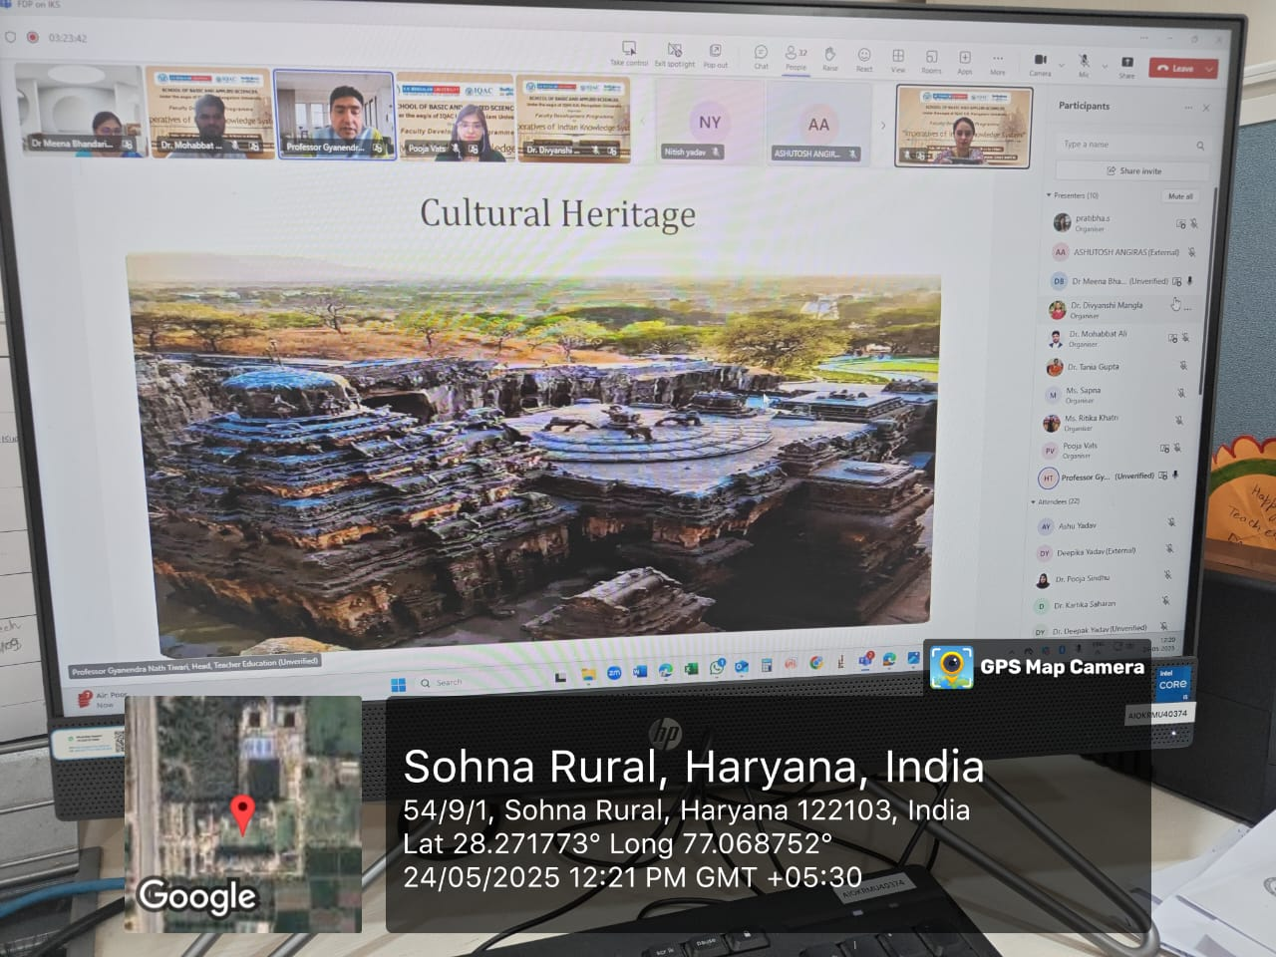
Photo 21: Prof. (Dr.) Gyanendra Nath Tiwari presents on the Sources of Indian Knowledge System.
- Session on From Instagram to Inner Calm: Digital Detox the Vedic Way (2:00 PM to 4:00PM)
Following a lunch break, the third session commenced at 2:00 PM, led by Mr. Neeraj Gupta, Associate Director at Kyndryl Global IT Services. His session titled From Instagram to Inner Calm: Digital Detox the Vedic Way explored the intersection of modern digital lifestyles and ancient Indian wellness philosophies. Dr. Ali provided the introduction, and Dr. Pratibha delivered the thank-you note.
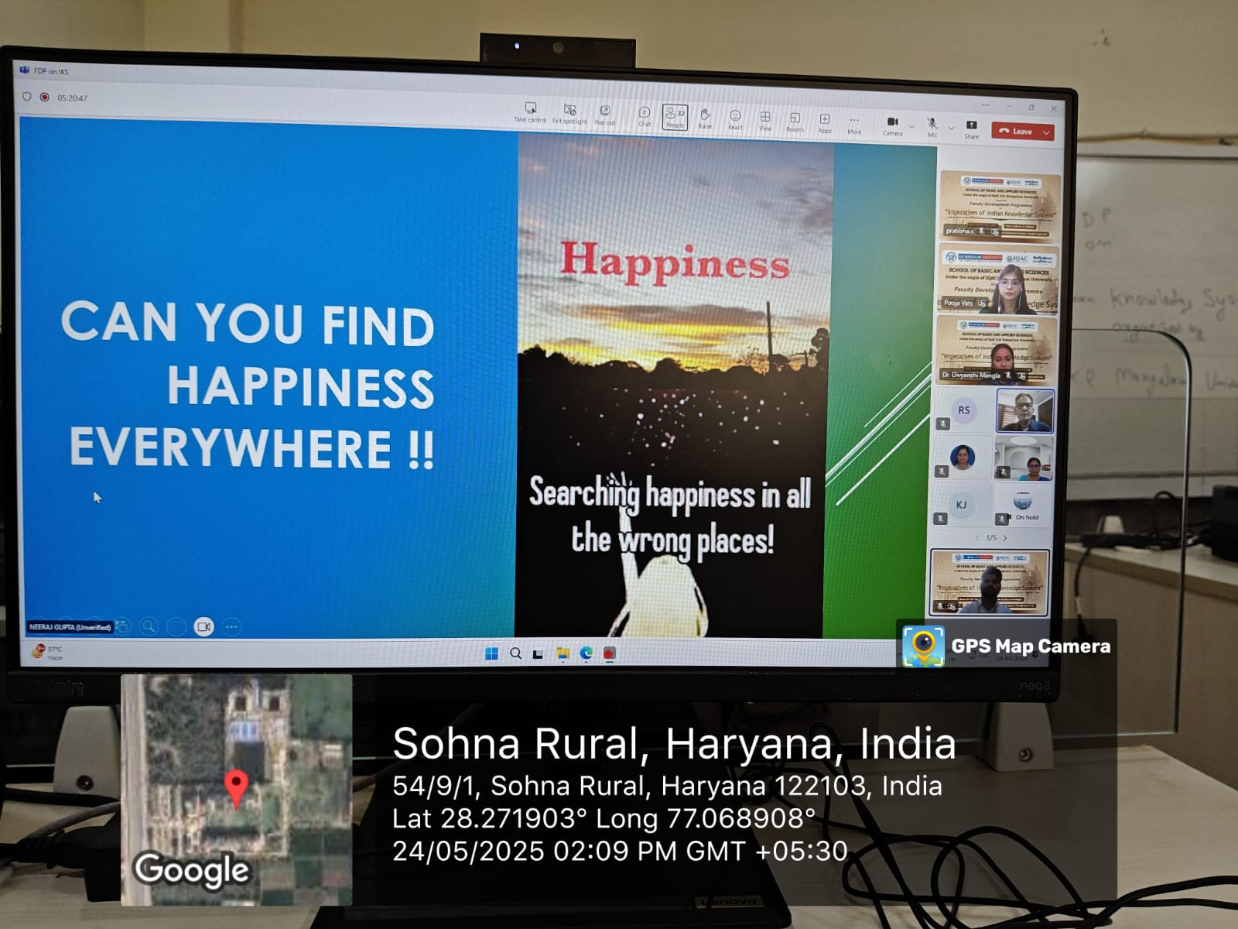
Photo22: Mr. Neeraj Gupta shares insights on digital detox through ancient Indian wellness philosophies.

The day concluded with the Valedictory Session, held in Room No. B005 and also accessible to online participants via provided link.
Valedictory Session
The valedictory segment began at 3:30 PM with a welcome address and a brief summary of the FDP sessions, presented by Dr. Pooja Vats, Assistant Professor, K.R. Mangalam University. This was followed by an address from Prof. Meena Bhandari, Dean, School of Basic and Applied Sciences, K.R. Mangalam University, who acknowledged the efforts of all organizers, speakers, and participants. The session concluded with a Vote of Thanks by Dr. Pratibha, Assistant Professor of Chemistry, K.R. Mangalam University.
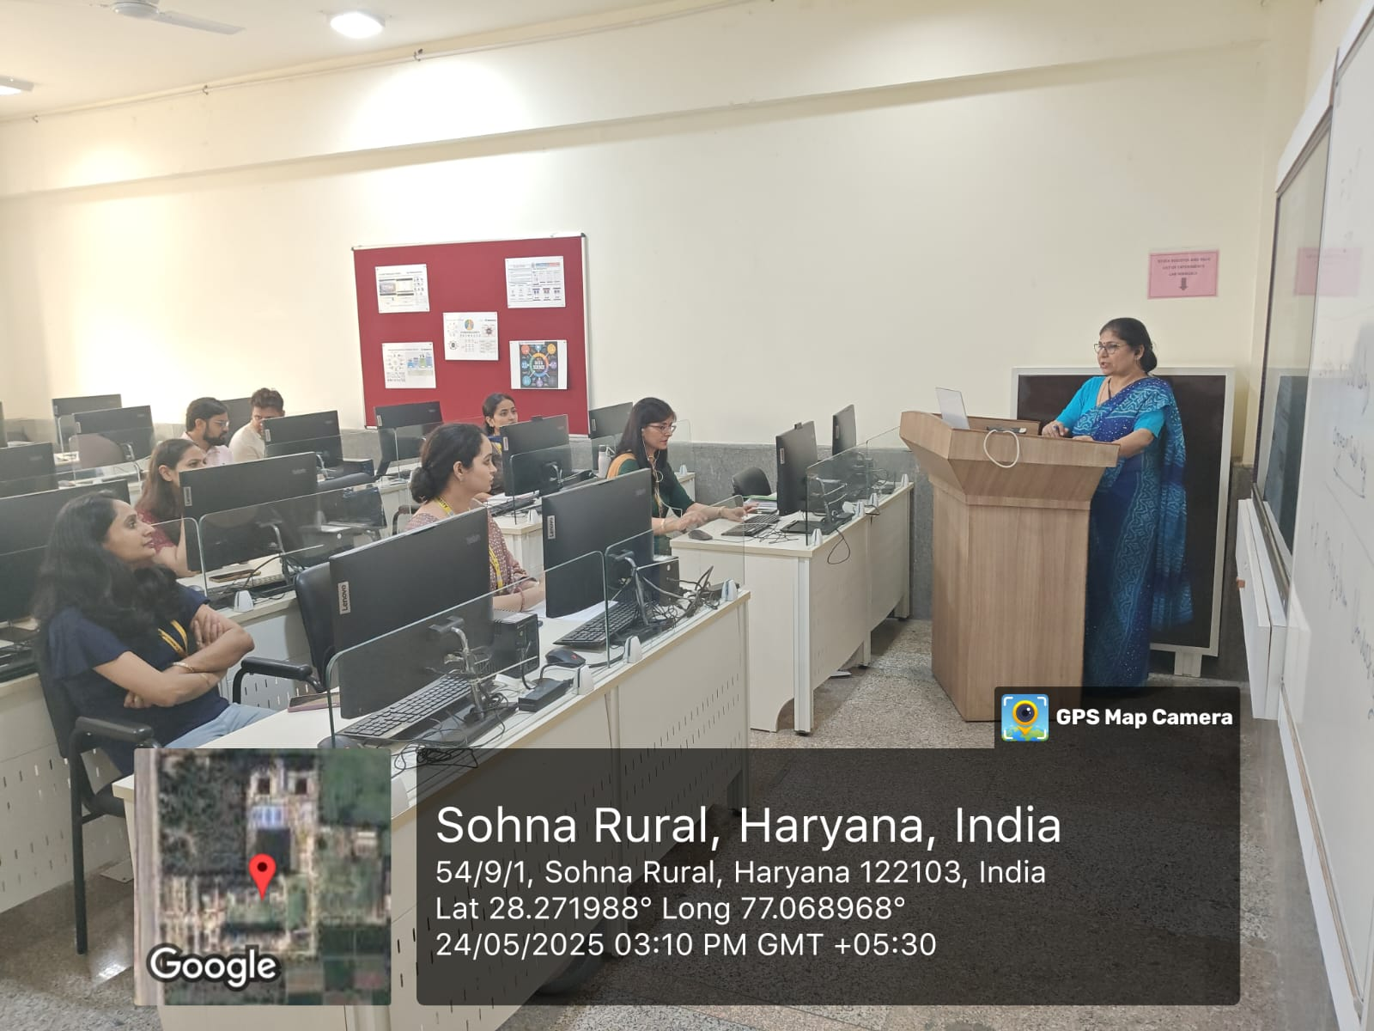
Photo23: Valedictory Session
The final day witnessed enthusiastic participation and rich academic discourse. The sessions were well-coordinated, and the organizing committee ensured smooth execution. Feedback was collected from participants to enhance the effectiveness of future programs.

Report prepared by

Report verified by Event Coordinator

Report Seen by Dean / Club Coordinator / Activity Coordinator/ IQAC Director / Registrar

FACULTY FEEDBACK:

Participants - A total of 58 participants from various disciplines were attended FDP and give feedback.

• How would you rate the overall organization of the FDP?

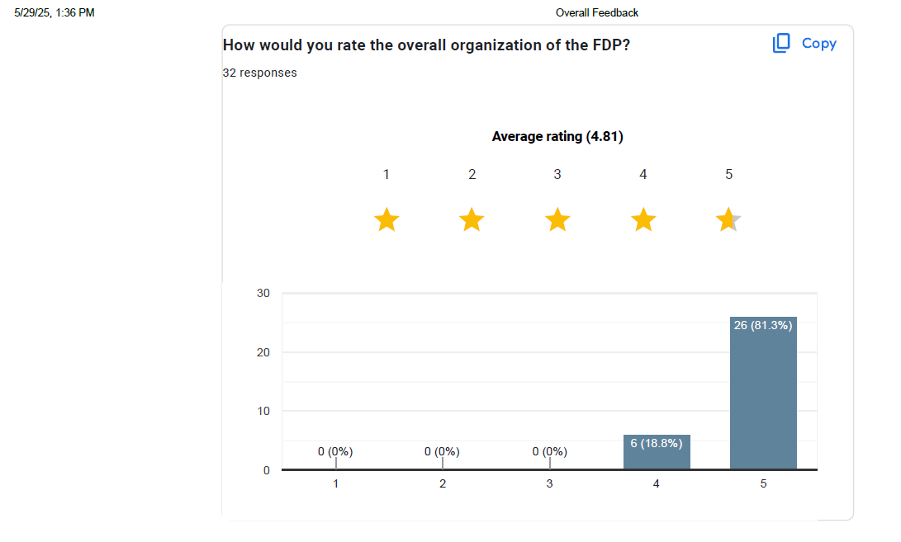

- How relevant was the content of the FDP to your professional development?

