


REPORT
COMMEMORATION OF AMBEDKAR JAYANTI: “RELEVANCE OF AMBEDKAR'S VISION IN THE INDIAN CONSTITUTION”
April 11, 2025

Date: 11 April 2025
Venue: Lecture Hall No B018, B Block, K.R Mangalam University
Event Type: Discussion
Mode of Activity: Offline
Target Group: NSS Volunteers
Faculty Coordinators: Mr. Thomas Monteiro, NSS P.O
Resource Person: Dr. Kriti Singh, Assistant Professor, SOLS, K.R. Mangalam University
Organized By: National Service Scheme, K.R Mangalam University
Participants: 35 Students

National Service Scheme, K.R. Mangalam University on the occasion of commemoration of Ambedkar Jayanti organized a discussion on the “Relevance of Ambedkar's Vision in the Indian Constitution” on 11 April 2025 in the lecture hall 018 in B Block, K.R. Mangalam University. Dr. Kriti Singh -Assistant Professor from School of Legal Studies moderated the discussion.

The objectives of the discussion were
1. To apply the Ambedkar's Vision in the constitution to contemporary issues and critically analyze them.
2. to encourage students to participate in the democratic decision-making processes.
35 students and 4 Faculty members participated in the discussion. Dr. Kriti Singh started with a brief presentation on Ambedkar’s vision in the constitution of India and opened the floor for the discussions on relevance of reservation and Ambedkar’s vision and one nation one election and Ambedkar’s vision. All the students and faculty members enthusiastically participated in the discussion gave innovative suggestions for better implementation of various policies to make Ambedkar’s vision in constitution relevant for contemporary India. Everybody agreed that Ambedkar’s visions were ideal for Indian context and policies related to reservation and elections need to have better implementation so that democratic ideals of equal participation and equal opportunities are safeguarded.
The discussion ended with pledge taking ceremony on Preamble of the Constitution and final, vote of thanks delivered by Mr. Thomas Monteiro – NSS Program Officer.

Glimpses of the Event

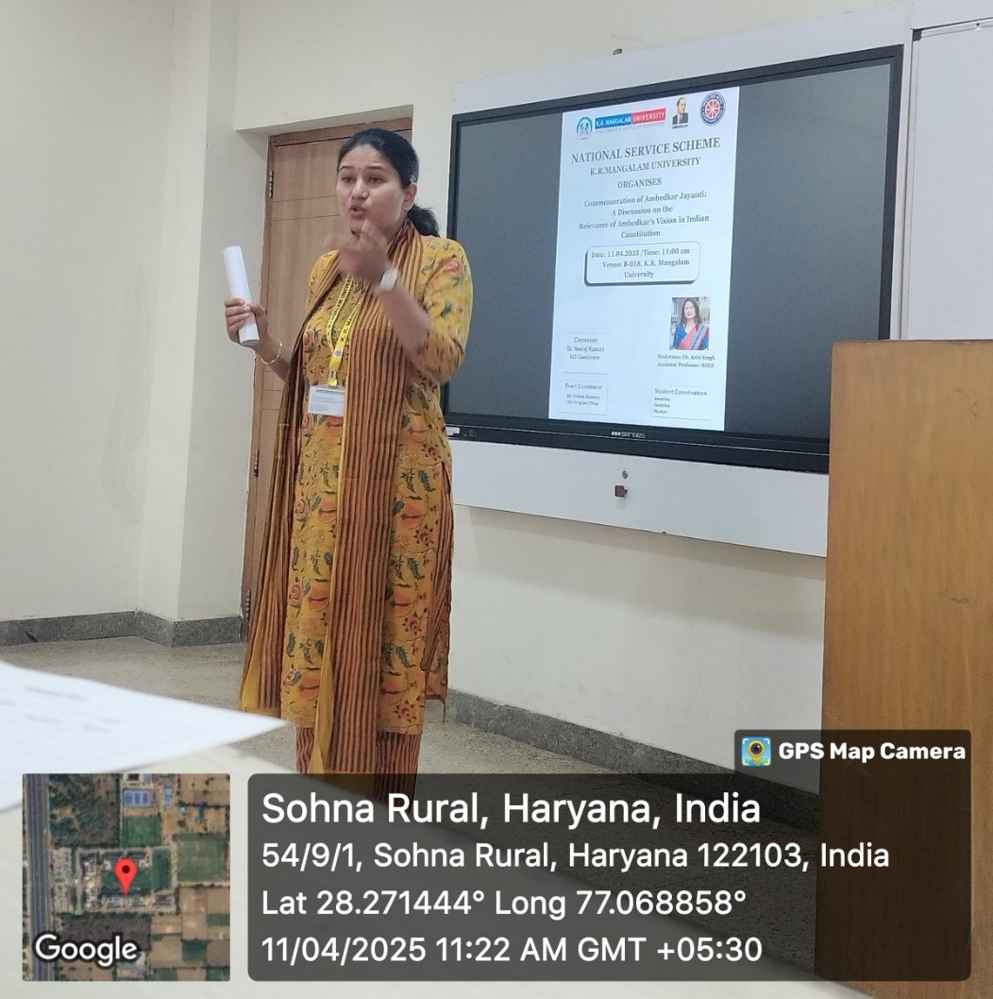
Image 1: Dr. Kriti Singh Initiating the discussion on the vision of Ambedkar in the constitution

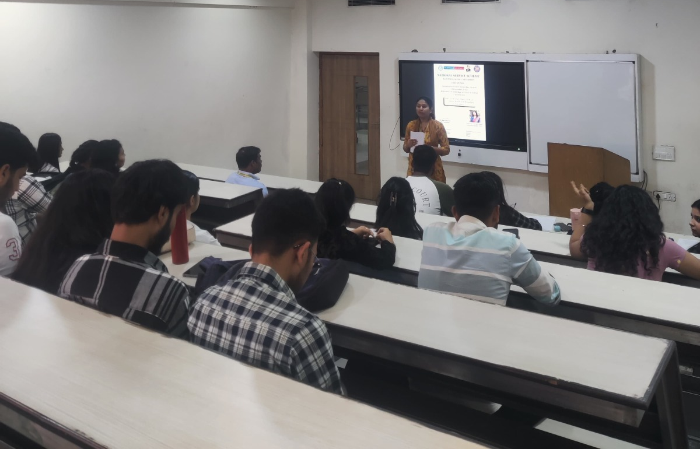
Image 2: Students participating in the discussion

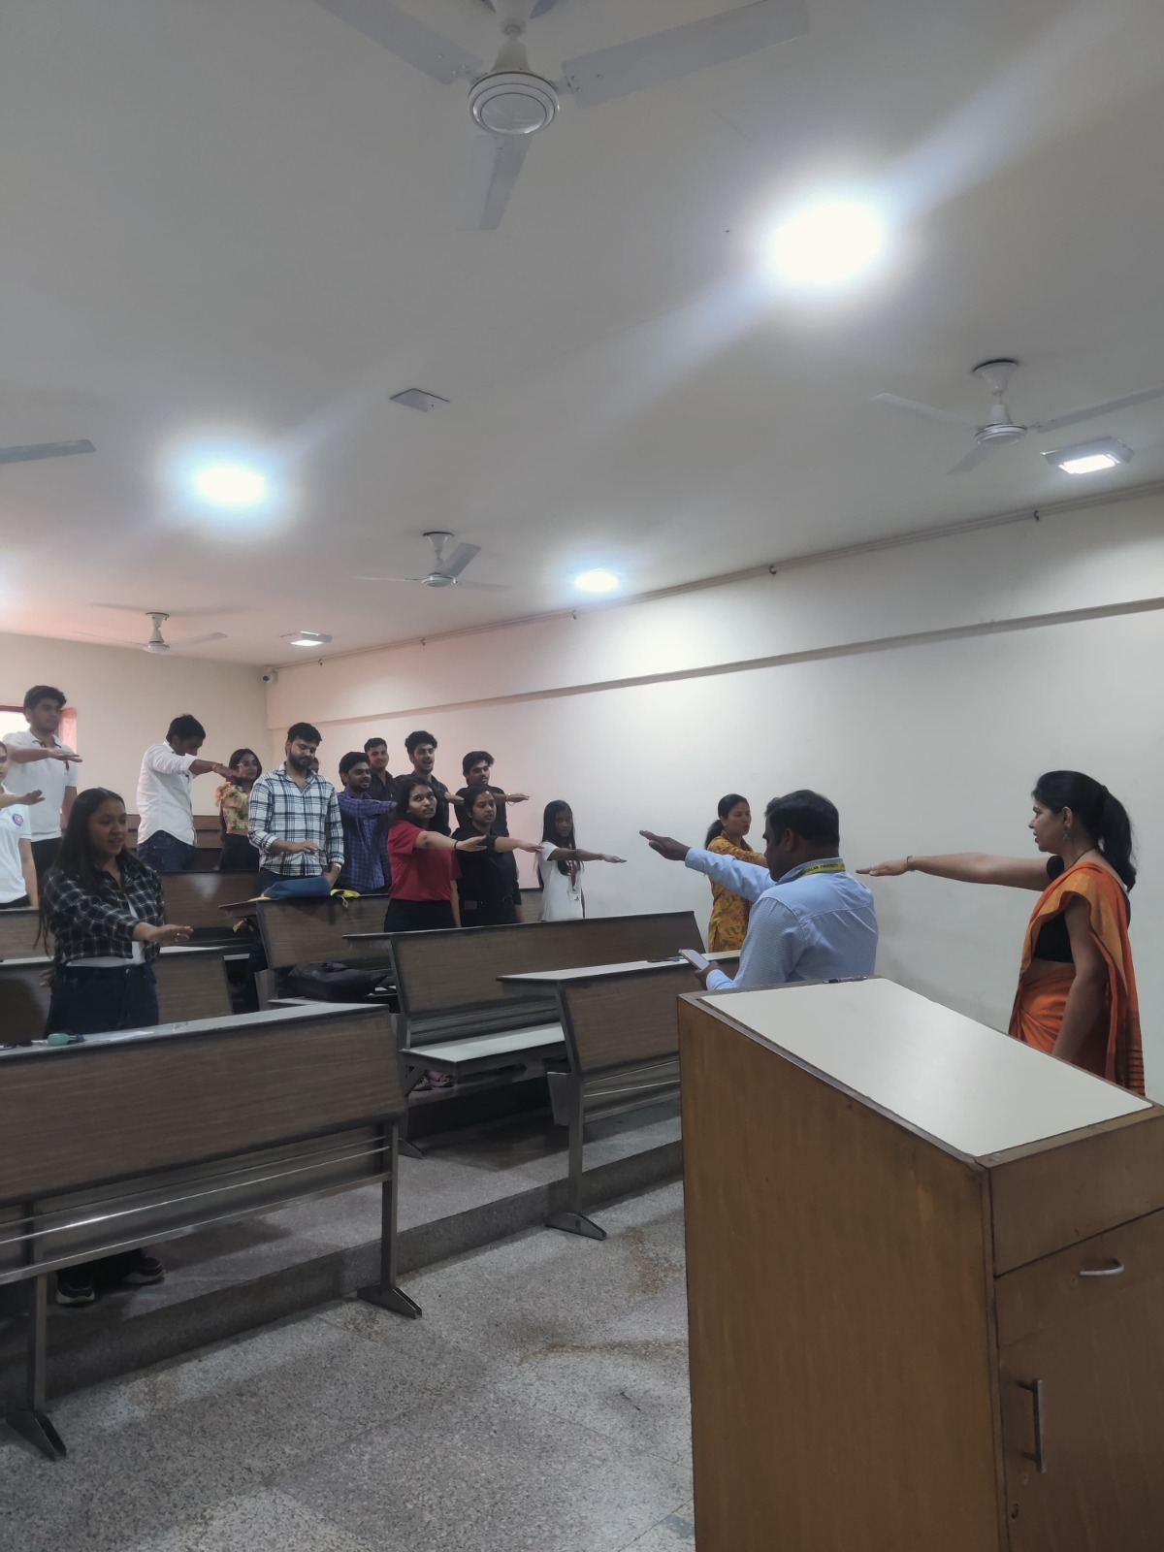
Image 3: Oath Taking Ceremony to uphold the vision of Ambedkar in the constitution

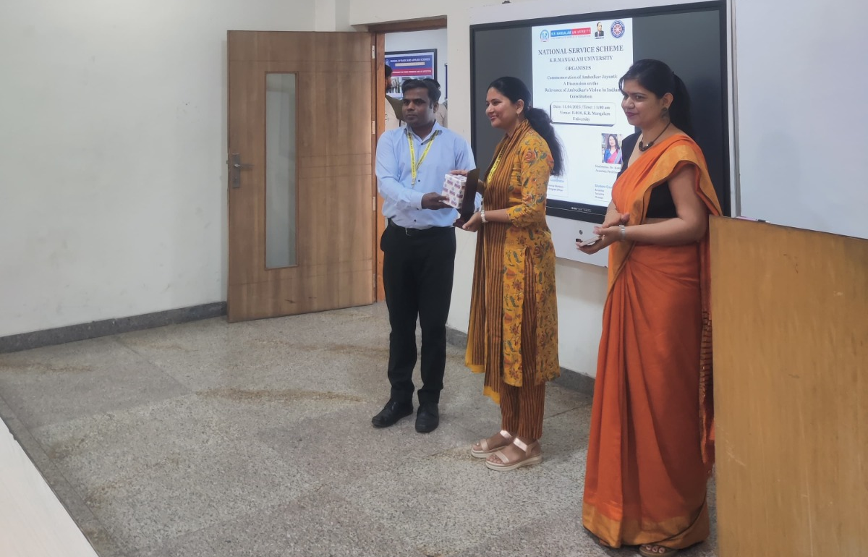
Image 4: Mr. Thomas felicitating Dr. Kriti with a memento and a gift.

Annexure 1: Summary of Feedback Form
Annexure 2: Attendance

Category | Name | Signature with Date
Report prepared by | Mr. Thomas Monteiro  NSS Program Officer
Report verified by NSS Coordinator | Dr. Neeraj Kumari  NSS Coordinator
Report verified by IQAC Coordinator | Dr. Shikha Dutt Sharma

