

REPORT
Life Skills Training Programme
On
“Boosting Immunity: Simple Daily Habits for a Healthier Life”
Date: 23 January 2025
Time: 11:00 a.m. onwards
Venue: A-210, KRMU Campus, Gurugram, Haryana
Event Type: Training Program
Mode of Activity: Offline
Target Group: Students of the School of Education, K.R. Mangalam University
SDG 3: Promoting mental health and well-being by focusing on stress management and relaxation techniques.
SDG 4: Integrating life skills, including health literacy, into educational frameworks to ensure holistic learning.
SDG 12: Promoting sustainable lifestyles, including healthy eating and natural health practices.
Coordinator: Dr. Kanchan Khatreja, Assistant Professor, School of Education
Organized by: School of Education, K. R. Mangalam University, Gurugram
Session Expert: Prof. Harish Tyagi, Head, Faculty of Education and Head AIBAS, Head ASPESS, Chairman Faculty Research Committee- Education, Amity University, Delhi
Number of Participants: 29
The School of Education organized a workshop on- Boosting Immunity: simple daily habits for a healthier life on 23rd January 2025. Prof. (Dr.) Harish Tyagi, Head Faculty of Education, Head -Amity Institute of Behavioural and Allied Sciences and Amity School of Physical Education and Sports Sciences, Amity University Uttar Pradesh, Noida was the resource person for the event. The objective of the event was to educate participants on the role of immunity in overall health and well-being and to provide practical strategies for strengthening the immune system through lifestyle changes, nutrition, exercise, and mental health practices. The Session begin with welcome note by Prof. Tania Gupta, Dean, School of Education and was followed by the discussion on need of immunity boosting and life skills, characteristics of healthy lifestyle, discussed case study on successful personalities. The event was successfully conducted by Dr. Kanchan Khatreja, Assistant Professor SOED. Prof. Dr. Tania Gupta, Dean SOED presented a memento to the resource person. All faculty members and students interacted throughout the session. Prof. Dr. P.C. Jena presented Vote of Thanks. Ritika and Tanushri, B.El.Ed. students coordinated the event. The training program was coordinated by Dr. Kanchan Khatreja, Assistant Professor, School of Education. Students also gave the Feedback of the training session. It was really an enriching session.

Glimpses of Life Skills Training Programme on Boosting Immunity: Simple Daily Habits for a Healthier Life on 23 January 2025

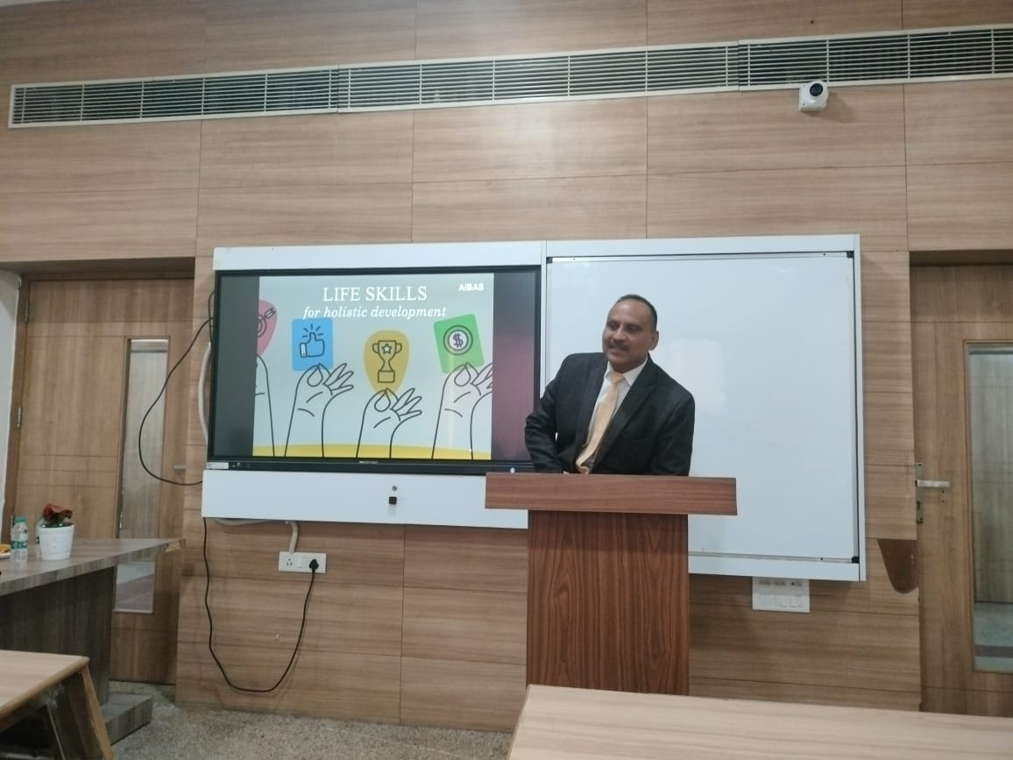

Photo 1: Guest speaker interacting with participants during Life Skills Training Programme On Boosting Immunity: Simple Daily Habits for a Healthier Life

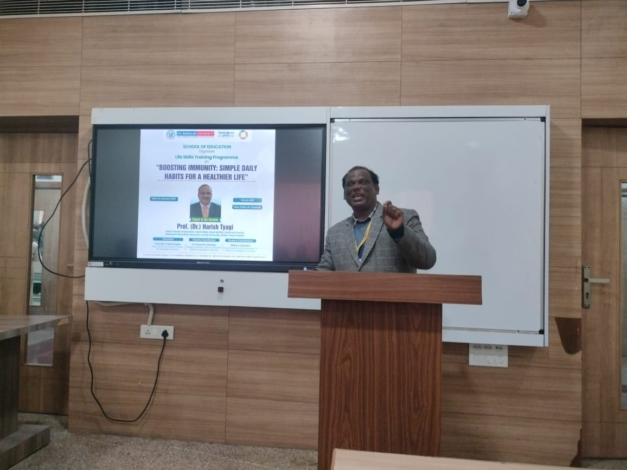

Photo 2: Vote of Thanks of Prof. (Dr.) Harish Tyagi, Head Faculty of Education, Head -Amity Institute of Behavioural and Allied Sciences and Amity School of Physical Education and Sports Sciences, Amity University Uttar Pradesh, Noida by School Coordinator Prof. P.C Jena

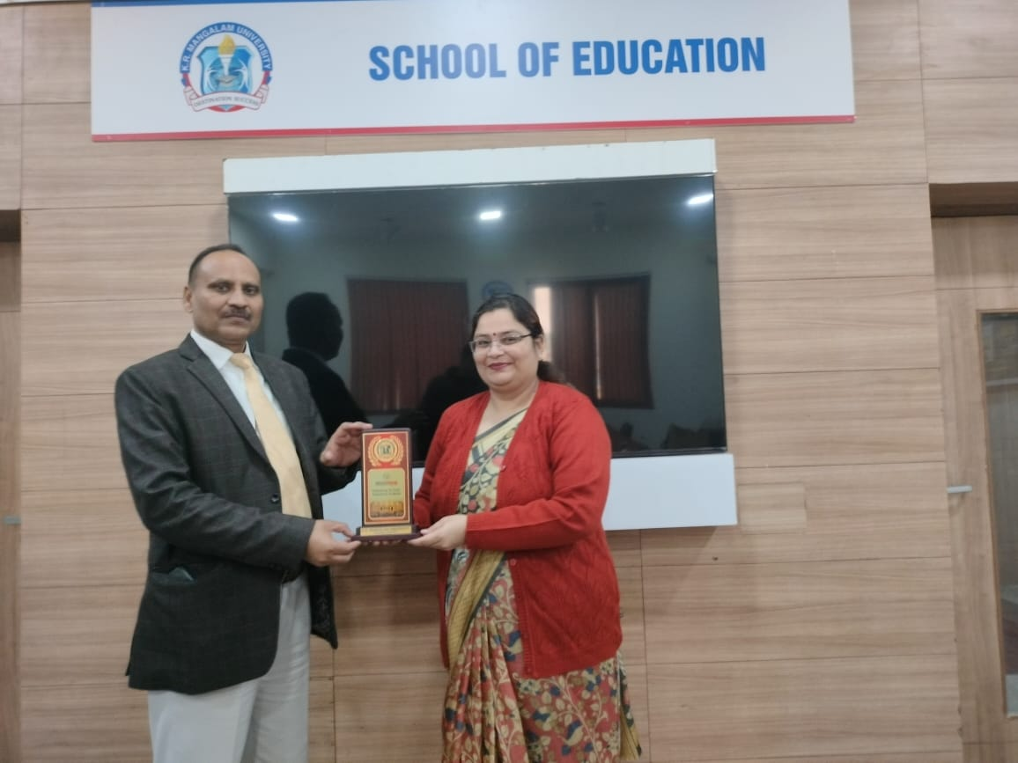

Photo 3: Memento presentation to guest speaker by Prof. Tania Gupta, Dean School of Education

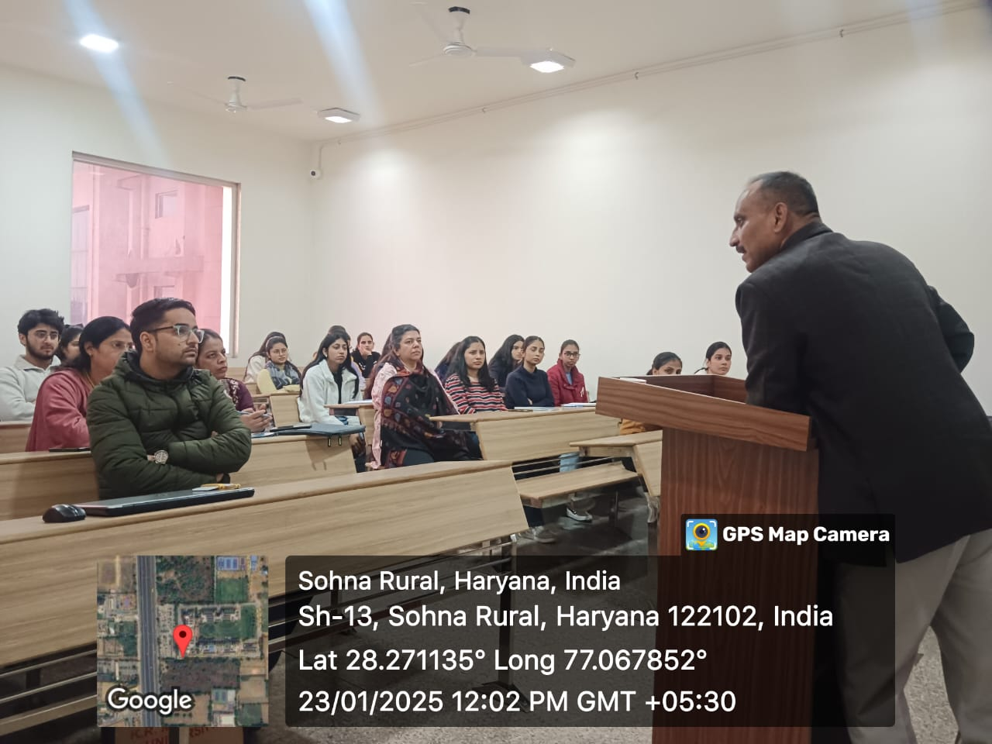

Photo 4: Prof. (Dr.) Harish Tyagi, discussing On Boosting Immunity: Simple Daily Habits for a Healthier Life with daily life examples

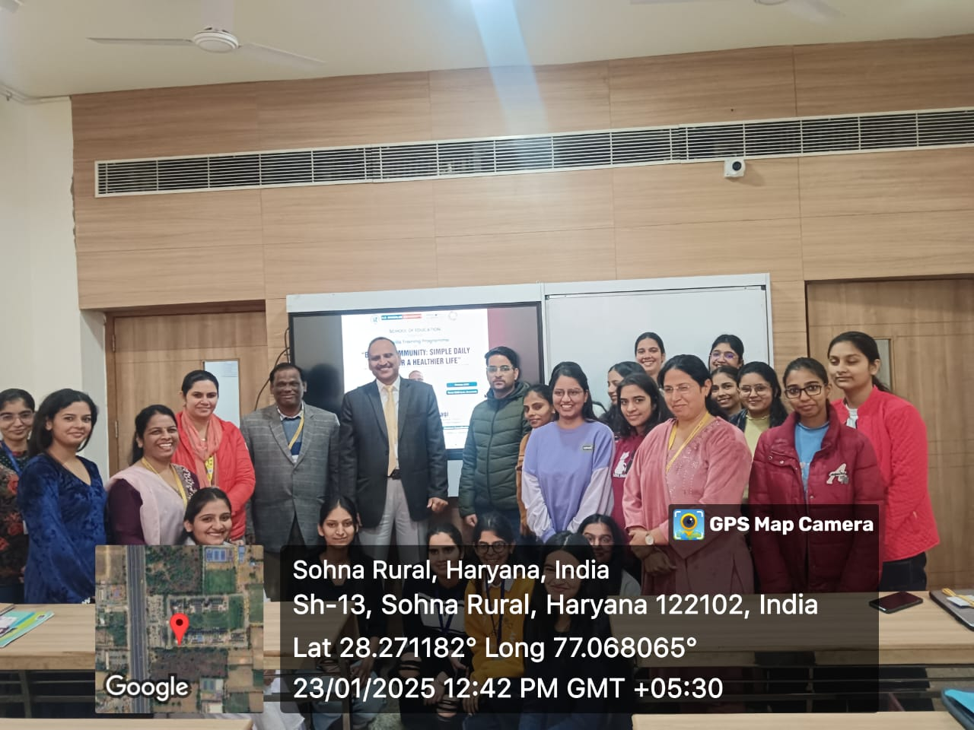

Photo 5: Participants of Life Skills Training Programme On Boosting Immunity: Simple Daily Habits for a Healthier Life

Report prepared by | Dr. Kanchan Khatreja
Report verified by Event Coordinator | Dr. Kanchan Khatreja
Report Seen by Dean / Club Coordinator / Activity Coordinator | Prof. (Dr.) Tania Gupta
Report Verified by IQAC Office | Dr. Shikha Dutt Sharma

