
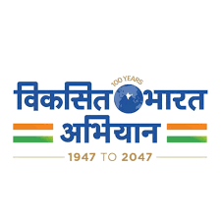

REPORT
School of Education
Organizes

Dealing with Change and Uncertainty: Capacity Development Training Program on Soft Skills

Date: 21/01/2025

Venue: Room 213A

Time: 11:00 Onwards

Mode of Activity: Offline
Target Group: Student- Teachers of School of Education & SOHS
Resource Person: Dr. Sakshi Vermani Rishi, Associate Professor, School of Psychology and Education, Rishi hood University, Sonipat, Haryana.
Coordinator: Dr. Shikha, Assistant Professor, School of Education.

Organized by: School of Education, K.R. Mangalam University, Gurugram

Number of Participants: 40

Introduction

The School of Education, K.R. Mangalam University, organized a Capacity Development Training Program on Soft Skills titled “Dealing with Change and Uncertainty.” Date 25 Jan 2025 The event aimed to equip student teachers and faculty members with essential soft skills to navigate ethical dilemmas and make informed decisions in professional settings. The session was conducted by Dr. Sakshi Vermani Rishi, Associate Professor, School of Psychology and Education, Rishihood University, Sonipat, Haryana. The program was well-received, with enthusiastic participation from both students and faculty members.

Objectives
- To understand ethical principles and their importance in professional settings.
- To develop students' ability to recognize and analyse ethical issues.
- To enhance decision-making skills based on ethical considerations

Methodology

Interactive Training workshop with Invited Expert.

Outcomes

Participants will demonstrate greater flexibility and adaptability in response to changes and new challenges.

Participants will exhibit improved resilience, showing better stress management and quicker recovery from setbacks.

Participants will develop stronger problem-solving skills, enabling them to approach uncertain situations with creativity and confidence.

Participants will adopt a more positive and proactive mindset towards change, viewing it as an opportunity for growth.

Participants will embrace the concept of continuous learning and self-improvement as essential tools for dealing with change and uncertainty.

Conclusion

The program concluded with a formal vote of thanks delivered by Prof. (Dr.) Tania Gupta, Dean, School of Education, K.R. Mangalam University. Dr. Gupta expressed gratitude to Dr. Sakshi Vermani Rishi for her valuable insights and acknowledged the efforts of the organizing team, moderators, and participants. The session provided an enriching learning experience, emphasizing the significance of ethical decision-making and soft skills development. Participants found the discussions and case studies highly beneficial, and the event successfully met its objectives. Future programs focusing on different aspects of professional ethics and capacity development are recommended to continue this initiative.

Glimpses of the event
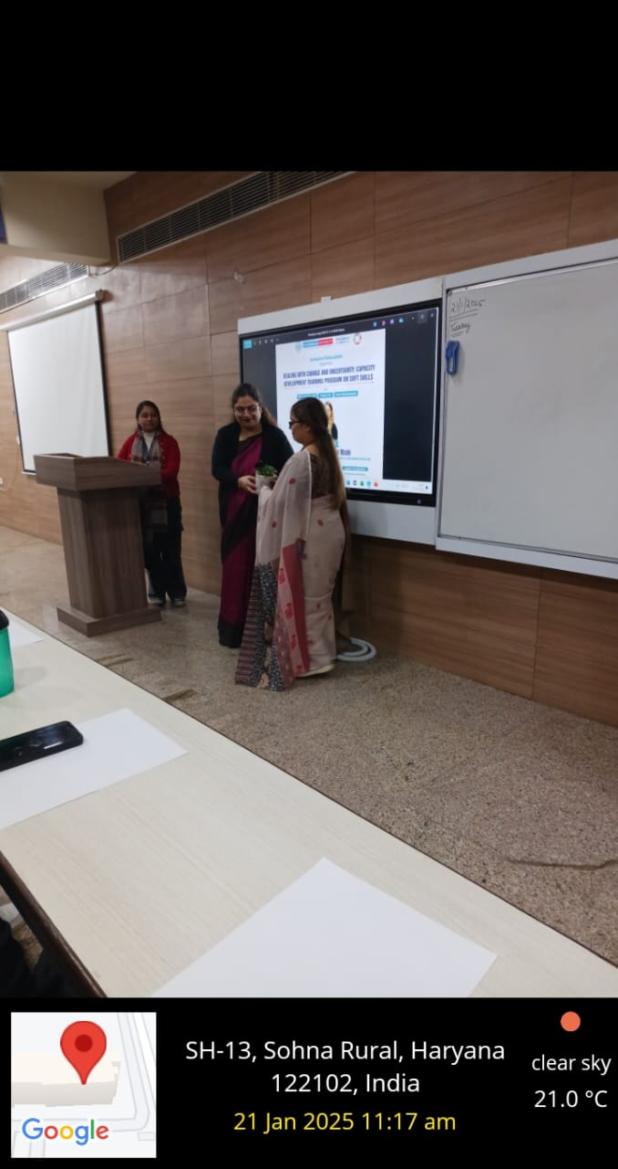

Photo 1: Prof. (Dr.) Tania Gupta presenting a token of honour to the guest speaker.
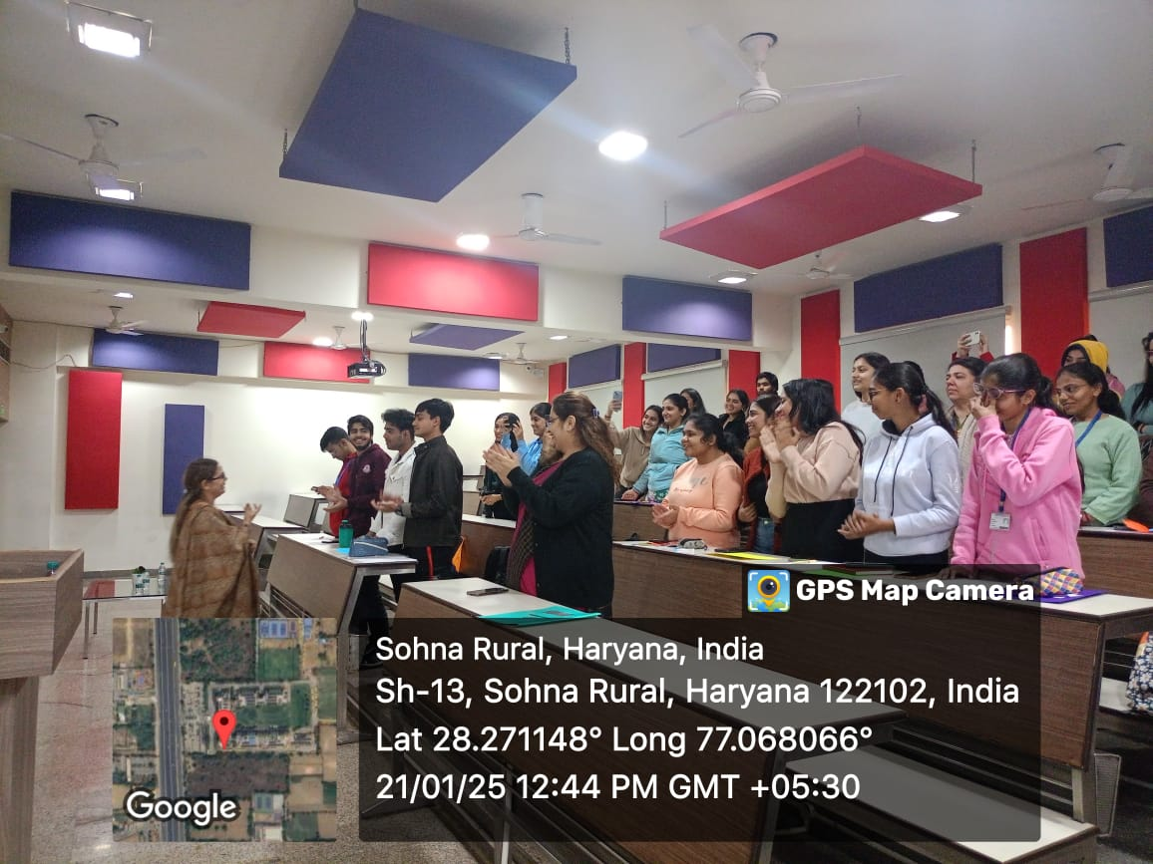

Photo 2: Student Participation in Activities Active involvement of students in discussions and interactive sessions.

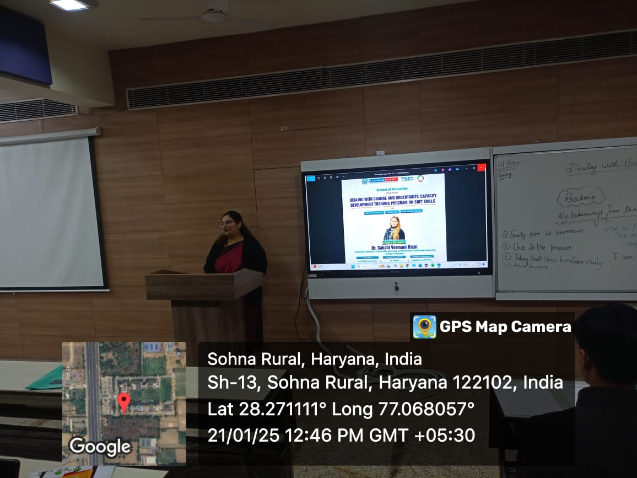
Photo 3: Prof. (Dr.) Tania Gupta delivering the vote of thanks.

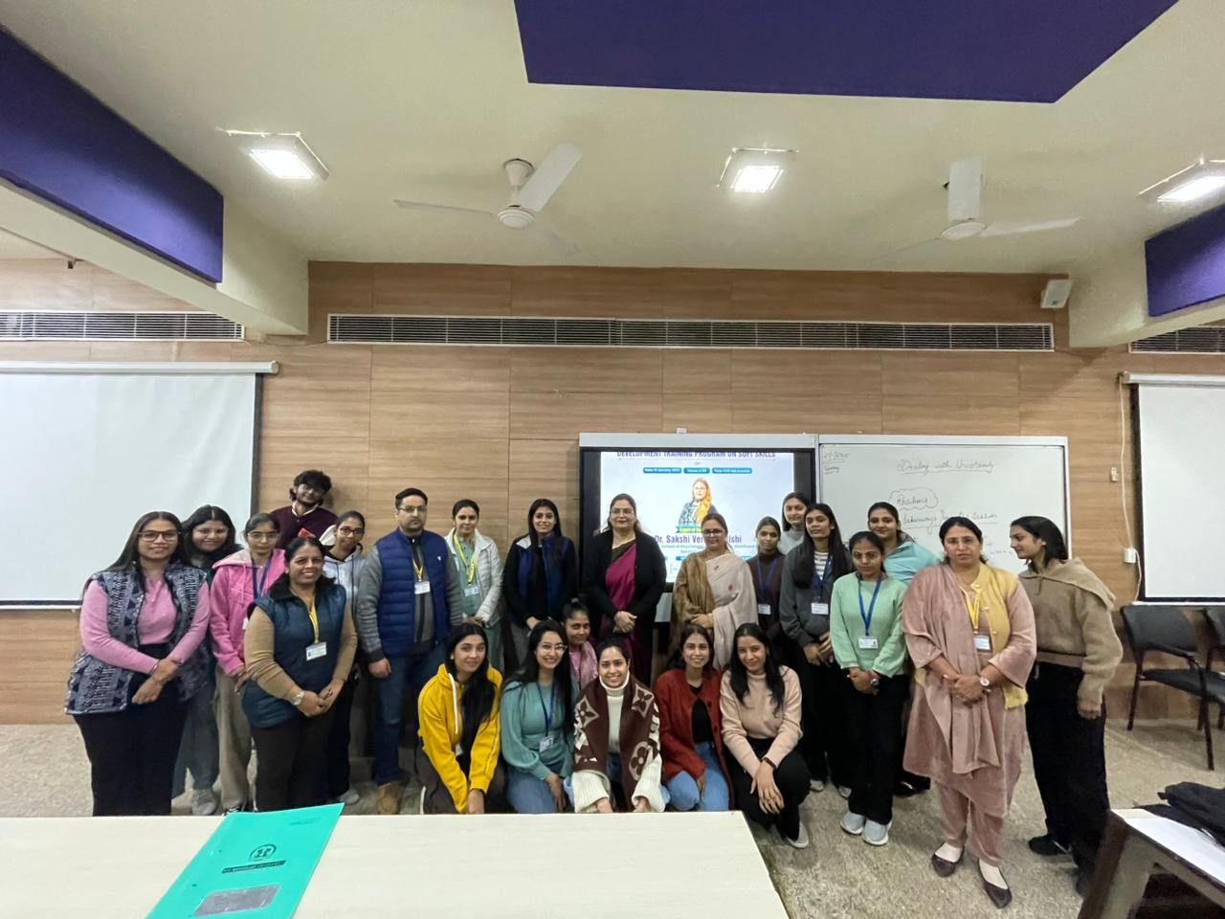
Photo 4: A group photo capturing faculty, students, and the guest speaker.

Report prepared by: | Dr. Shikha  Assistant Professor, SOED
Report checked & verified by: | Prof. (Dr.) Tania Gupta  Dean, SOED
IQAC Coordinator: | Dr. Shikha Dutt Sharma

