Seminar on

Quality Assurance in Higher Education
Date: 10.04.2025
Venue: B016, Ground Floor, Bhaskaracharya Block, KRMU
Event Type: Seminar
Mode of Activity: Offline
Target Group: Faculty Members
Organized by: School of Basic and Applied Sciences (SBAS), in collaboration with IQAC
Resource Person: Prof. (Dr.) Tania Gupta, Dean, School of Education
Event Coordinators:
- Dr. Ruby Jindal, Associate Professor, SBAS
- Dr. Deepak Yadav, Assistant Professor, SBAS
Participants: 24
Introduction
The School of Basic and Applied Sciences, in collaboration with IQAC, organized a seminar titled “Quality Assurance in Higher Education” on April 10, 2025. The seminar aimed to enhance awareness among academic stakeholders about maintaining and improving standards in higher education through structured quality assurance mechanisms.
Objectives
- To introduce the concept and need for quality assurance in higher education.
- To explore key principles and frameworks that guide quality assurance.
- To discuss the role of faculty, leadership, and global standards in shaping quality education.
- To identify challenges and possible solutions in implementing quality assurance processes.

Content
In seminar Prof. (Dr.) Tania Gupta, Dean of the School of Education, was the keynote speaker. She initiated the seminar with an overview of what constitutes quality assurance and why it is crucial in the context of rapidly evolving academic environments.
Key topics discussed included:
- Definition and Need for Quality Assurance: Ensuring educational excellence, accountability, and continuous improvement.
- Key Principles of Quality Assurance: Student-centered learning, transparency, accountability, and stakeholder engagement.
- Frameworks and Models: Detailed insight into quality assurance mechanisms such as NAAC (National Assessment and Accreditation Council) and NBA (National Board of Accreditation), their criteria, and relevance.
- Role of Teachers and Leadership: The importance of active faculty involvement, institutional leadership, and a culture of quality.
- Global Benchmarks and Rankings: How international ranking systems and best practices influence Indian higher education.
- Challenges in Implementation: Limited resources, resistance to change, lack of awareness, and aligning institutional goals with accreditation standards.
The session encouraged discussion and questions, with participants sharing perspectives on institutional practices and areas for improvement.
Conclusion
The seminar concluded with a Vote of Thanks delivered by Prof. Meena Bhandari, Dean, School of Basic and Applied Sciences. She emphasized the importance of such initiatives in fostering a quality-centric culture and commended the speaker for her in-depth insights.

Event Outcome
- Participants gained a thorough understanding of quality assurance systems and their applicability.
- The seminar encouraged institutions to benchmark against national and international standards.
- Faculty members were motivated to contribute proactively to institutional quality processes.
Future Prospects
The seminar laid the foundation for future training sessions and workshops focusing on capacity building for NAAC/NBA preparation, policy formulation, and quality culture enhancement within the University.

Photo 1: Speaker Prof. (Dr.) Tania Gupta addressing the participants.

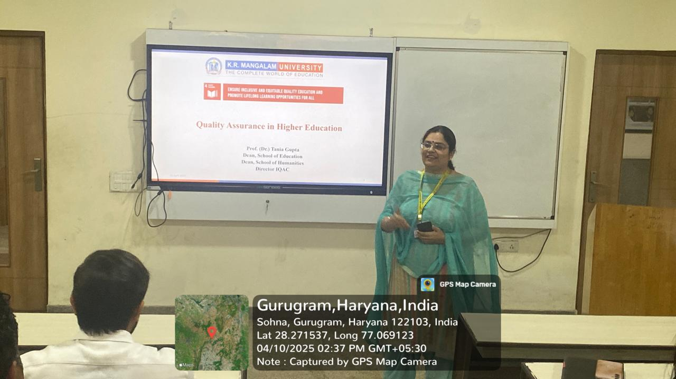

Photo 2:
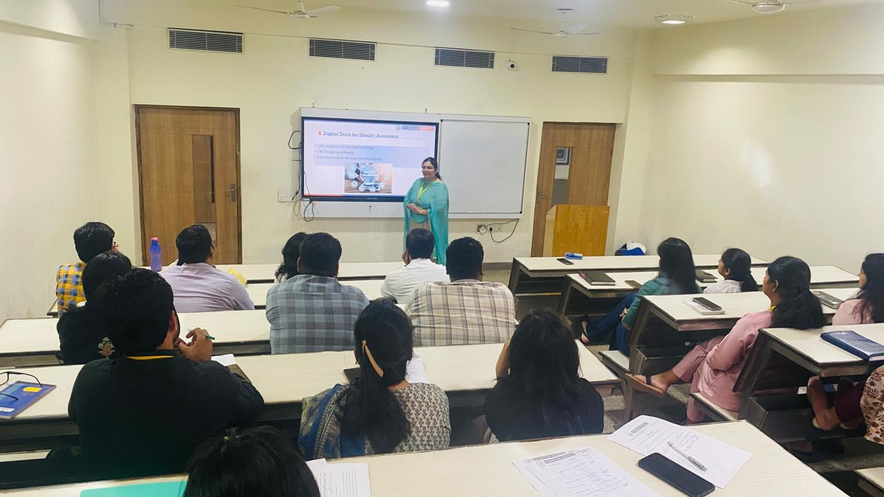

Photo 3: Participants engaged during the session.
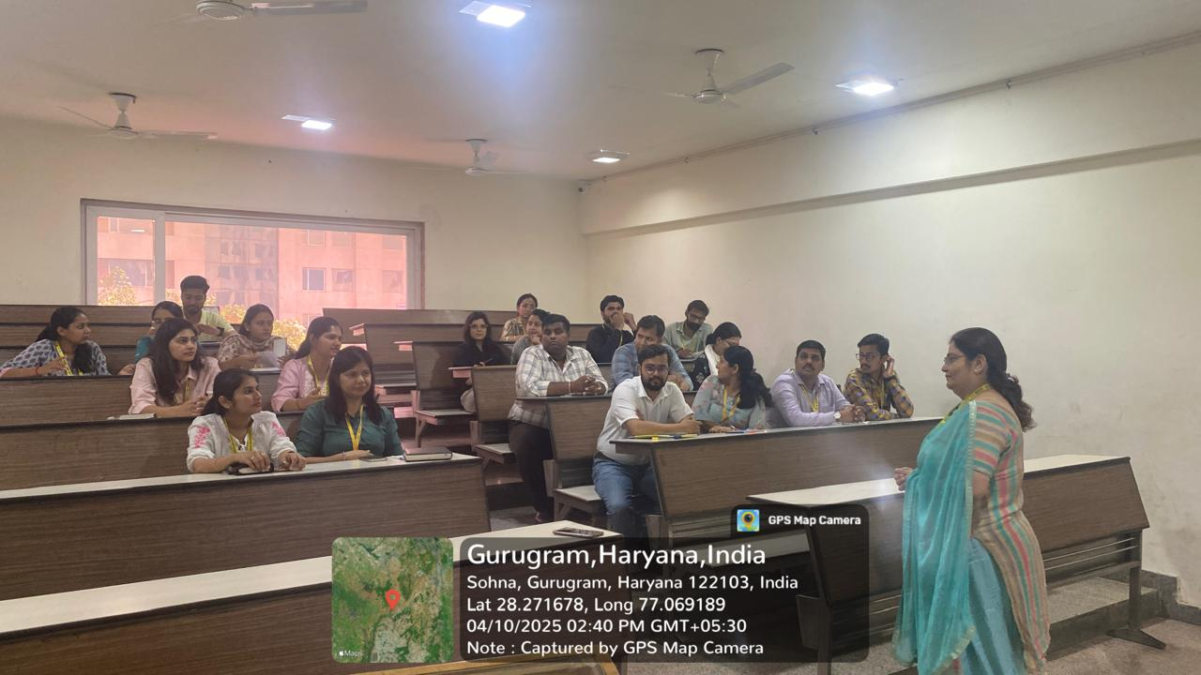

Photo 4: Vote of thanks by Prof. Meena Bhandari, Dean, SBAS.
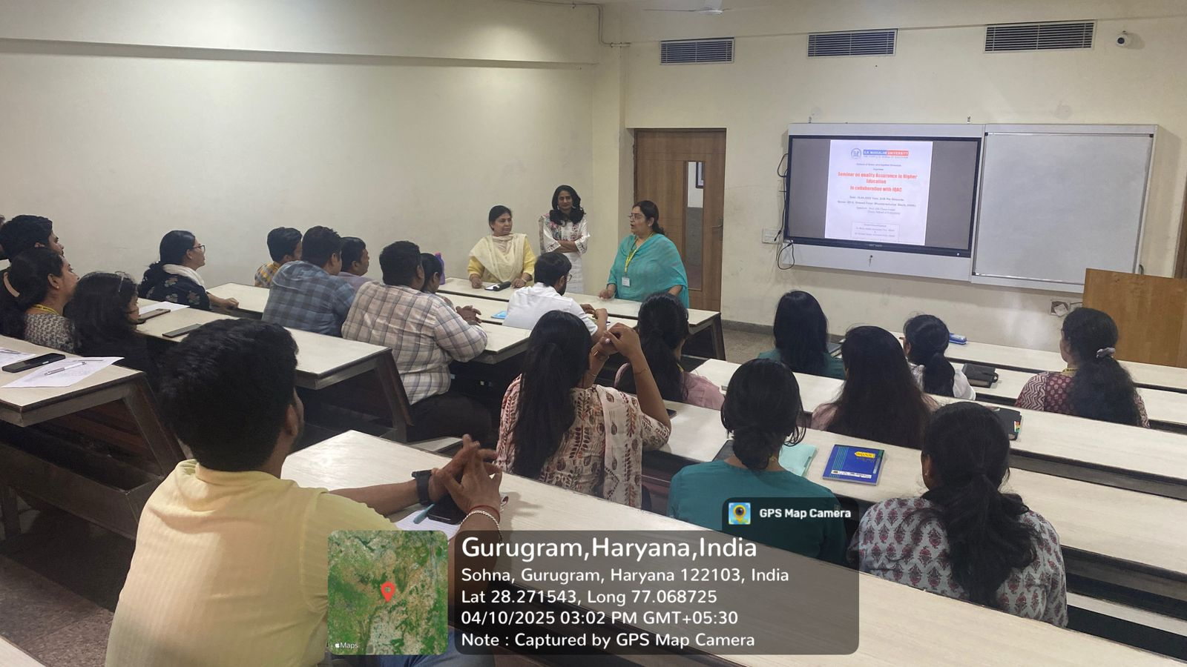

Report Prepared by  Event Coordinator | Dr. Ruby Jindal, Associate Professor, SBAS  Dr. Deepak Yadav, Assistant Professor, SBAS
Report Verified by  Dean, SBAS | Prof. Meena Bhandari
Report Verified by  IQAC Coordinator | Dr. Sikha Dutt Sharma

