K.R. Mangalam University
Environmental Sustainability, Education and Research Report

Introduction
Institutional Framework for Environmental Sustainability
2.1 Climate Action and Sustainability Policy
2.2 Capacity Building and Sustainability Training
2.2.1 Sustainability Trainings, Workshops, Extension Activities and Events for Students
2.2.2 Sustainability Training for Academic and Professional Staff
2.3 Sustainability Literacy Assessment
2.3.1 Assessment of Staff Sustainability Literacy
2.3.2 Assessment of Student Sustainability Literacy
Sustainable Operations and Environmental Performance
3.1 Renewable Energy Adoption
3.2 Carbon Emissions Monitoring and Reporting
3.3 Net-Zero Commitment
Student Engagement and Sustainability Culture
4.1 Student-Led Sustainability Initiatives
Environmental Education
5.1 Sustainability-Focused Academic Courses
Environmental Research and Academic Contribution
6.1 Research Centre for Environmental Sustainability
Conclusion

1. Introduction
K.R. Mangalam University recognises environmental sustainability as a core institutional responsibility and an integral component of its academic, operational, and governance frameworks. The University has adopted a holistic approach that integrates climate action policies, sustainability education, capacity building, assessment mechanisms, renewable energy deployment, and research focused on environmental and climate-related challenges
The University’s sustainability framework is structured around a whole-institution approach, wherein climate action policies, sustainability education, capacity building, extension activities, research, and operational practices function in a mutually reinforcing manner. Environmental considerations are systematically embedded across decision-making processes, academic programming, faculty and staff development, and student engagement, ensuring that sustainability is addressed both as a pedagogical objective and an operational priority.
K.R. Mangalam University places particular emphasis on sustainability literacy and applied engagement, recognising that meaningful environmental impact requires informed participation from students, faculty, professional staff, and surrounding communities. Through structured training programmes, sustainability-focused conferences, extension activities in adopted villages, renewable energy deployment, and institutional monitoring mechanisms, the University actively translates policy commitments into measurable action.
This report presents a consolidated account of the University’s environmental sustainability initiatives across education, operations, research, and outreach. It demonstrates how institutional policies are operationalised through capacity-building programmes, sustainability-mapped conferences, community-oriented extension activities, renewable energy adoption, and assessment frameworks for sustainability literacy. Collectively, these efforts position K.R. Mangalam University as an institution committed to continuous improvement in environmental performance, responsible governance, and long-term climate resilience.
2. Institutional Framework for Environmental Sustainability
2.1 Climate Action and Sustainability Policy
K.R. Mangalam University has formally adopted a Policy on Climate Action, which serves as the primary framework guiding the University’s sustainability agenda. The policy outlines commitments towards climate mitigation, renewable energy adoption, resource efficiency, sustainable procurement, responsible investment practices, and institutional accountability.
The policy is current and is implemented through academic leadership, administrative units, and institutional committees, ensuring that sustainability considerations are embedded across decision-making processes.
Policy on climate action
2.2 Capacity Building and Sustainability Training
2.2.1 Sustainability Trainings, workshops, extension activities and events for Students
K.R. Mangalam University provides structured sustainability awareness and training for students through formal and co-curricular platforms. Student engagement is facilitated primarily through the Environment Club and respective schools, which conduct activities related to climate awareness, environmental responsibility, and the United Nations Sustainable Development Goals.
Environment Club
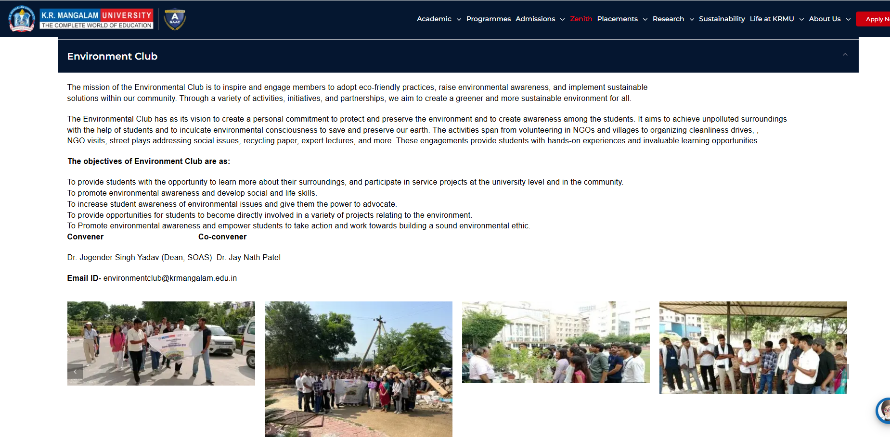
These initiatives ensure that sustainability principles are introduced early and reinforced through experiential learning.
- Training & Workshops for Students
S.No | Name of Event | Type | Date | School | Sustainability Focus | Links
1 | Health and Hygiene Activity of HACCP | Workshop | 07-Nov-24 | SOHMCT | Health, Food Safety, Environment | Link
2 | Breath, Balance, Thrive: Life Skill through Yoga | Training Programme | 04-Feb-25 | SOHS | Preventive Health, Environment | Link
3 | Boosting Immunity: Simple Daily Habits | Training Programme | 23-Jan-25 | SOED | Health Sustainability, Environment | Link
4 | Seminar on Quality & Post-Harvest Food Processing | Seminar | 27-Feb-25 | SOAS | Food Sustainability, Environment | Link
5 | Kisan Gosthi on Natural Farming & Agriculture Diversification | Kisan Gosthi | 19-Feb-25 | SOAS | Sustainable Agriculture | Link
6 | Sensitization on Gender-Sensitive Climate Solutions | Expert Session | 09-Apr-25 | SOHS | Climate & Gender, Environment | Link
 | Expert Session: The Power And Potential Of Solar Cells In Daily Life | Expert Session | 11-04-2025 | NSS | Environmental / Energy | Link

B. Extension Activities for students
S.No | Event Title | Date | Extension Mode | Organising Unit | Location | Sustainability Domain | Links
1 | Drawing Competition – Save the Water | 23-12-2024 | Awareness Competition | Red Cross | Daula | Environmental | Link
2 | Swachhta Hi Seva – Cleanliness Drive & Rally | 25–27-09-2024 | Cleanliness Drive | NSS | Ghanghola | Environmental | Link
3 | Workshop on Recycling Waste & Water Conservation | 22-03-2025 | Workshop | NSS | Ghanghola | Environmental | Link
4 | Reel to Real – Earth’s Challenges (Film & Quiz) | 22-04-2025 | Awareness Programme | NSS | KRMU | Environmental | Link
5 | Expert Session – Solar Cells in Daily Life | 11-04-2025 | Expert Session | NSS | KRMU | Environmental / Energy | Link

2.2.2 Sustainability Training for Staff
Academic and professional staff at K.R. Mangalam University participate in regular capacity-building programmes that incorporate sustainability themes. The trainings are delivered through a structured combination of Faculty Development Programmes (FDPs), institutional seminars, conferences, and capacity-building workshops, all of which include dedicated sessions on environmental sustainability, climate action, energy efficiency, waste management etc.
Participation in these sustainability-focused training programmes forms part of the University’s annual professional development framework and through this approach, the University ensures that environmental sustainability is embedded in staff awareness, decision-making, teaching practices, and campus operations, reinforcing institutional accountability and continuous improvement.Such initiatives ensure continuous professional development and institutional alignment with sustainability goals.
A. Trainings for Staff
Through conferences
Conference
S.No | Conference Title | Date | Organising School | Sustainability Domain | Links
1 | Innovation, Entrepreneurship and Sustainable Solution (IESS 2025) | 24–25 Mar 2025 | SOET | Environmental & Economic Sustainability | Link
2 | International Conference Advanced Materials for Green Chemistry and Sustainable Environment (AMGSE-2025) | 20–21 Mar 2025 | SBAS | Environmental Sustainability | Link
3 | International Conference On Connect 360 Sustainability and Innovation Incorporating Indian Knowledge System | 15–17 Apr 2025 | SJMC | Environmental & Cultural Sustainability | Link
4 | International Multidisciplinary Conference – DESIGN 2030 Developing Efficient and Sustainable Innovations for Global Needs | 21–22 Mar 2025 | SOAD | Environmental & Design Sustainability | Link

2.3 Sustainability Literacy Assessment
2.3.1 Assessment of Staff Sustainability Literacy
K.R. Mangalam University has developed an internal Sustainability Literacy Assessment Tool to evaluate sustainability-related knowledge, policy awareness, and environmentally responsible behaviour among academic and professional staff.
The assessment framework is aligned with internationally recognised sustainability competency models while remaining contextual to K.R. Mangalam University’s institutional policies and operational environment.
Assessment Tool Reference:
https://krmu-echosense.vercel.app/
2.3.2 Assessment of Student Sustainability Literacy
For students, K.R. Mangalam University employs a customised Sustainability Literacy Assessment Tool inspired by global assessment models such as the UN-endorsed Sustainability Literacy Test and other internationally recognised sustainability knowledge frameworks.
This approach ensures international alignment while enabling integration with K.R. Mangalam University’s curriculum, campus initiatives, and sustainability priorities.
Assessment Tool Reference: https://krmu-echosense.vercel.app/
3. Sustainable Operations and Environmental Performance
3.1 Renewable Energy Adoption
K.R. Mangalam University has invested in on-campus renewable energy infrastructure, including a solar photovoltaic system that contributes to reducing dependence on conventional energy sources. Renewable energy generation is monitored through periodic energy audits, supporting informed decision-making and continuous improvement in energy performance.
3.2 Carbon Emissions Monitoring and Reporting
The University monitors activity data related to direct and indirect energy consumption, including electricity usage, fuel consumption, and renewable energy offsets. This monitoring is undertaken through annual energy audits and internal sustainability reporting mechanisms.
While the University is in the process of consolidating carbon emission calculations, the existing monitoring framework provides a robust foundation for future public reporting aligned with internationally recognised standards.
Link for Carbon Emission Report
3.3 Net-Zero Commitment
K.R. Mangalam University has publicly committed to achieving net-zero emissions within a defined institutional timeline. This commitment is articulated within the Climate Action Policy and reflects the University’s strategic intent to progressively reduce its environmental footprint through energy efficiency measures, renewable energy expansion, and responsible resource management.
Policy
4. Student Engagement and Sustainability Culture
4.1 Student-Led Sustainability Initiatives
K.R. Mangalam University actively supports student participation in sustainability initiatives through institutional platforms such as the Centre for Sustainable Development Goals and environment-focused clubs and societies. These platforms facilitate awareness campaigns, community engagement, and sustainability-driven activities that strengthen environmental consciousness across the campus.
Reference:
https://www.krmangalam.edu.in/clubs-and-societies/
5. Environmental Education
5.1 Sustainability-Focused Academic Courses
The University offers academic courses that explicitly address environmental sustainability and climate-related themes as part of officially recognised undergraduate and postgraduate programmes. These courses contribute to developing sustainability literacy, systems thinking, and environmental responsibility among students.
Curricula are periodically reviewed to ensure relevance to contemporary environmental challenges and alignment with global best practices.
Link for Sustainable focused course
Syllbi of sustainable focused course
6. Environmental Research and Academic Contribution
6.1 Research Centre for Environmental Sustainability
K.R. Mangalam University has established a dedicated Research Centre with a specific focus on environmental sustainability. The Centre is supported by dedicated Full-Time Equivalent academic staff and contributes to sustainability-oriented teaching, curriculum development, and research supervision.
The Centre plays a critical role in advancing interdisciplinary research, supporting undergraduate and postgraduate research projects, and strengthening the integration of sustainability within academic programmes.
Scopus Research Analysed Data
10 year Data

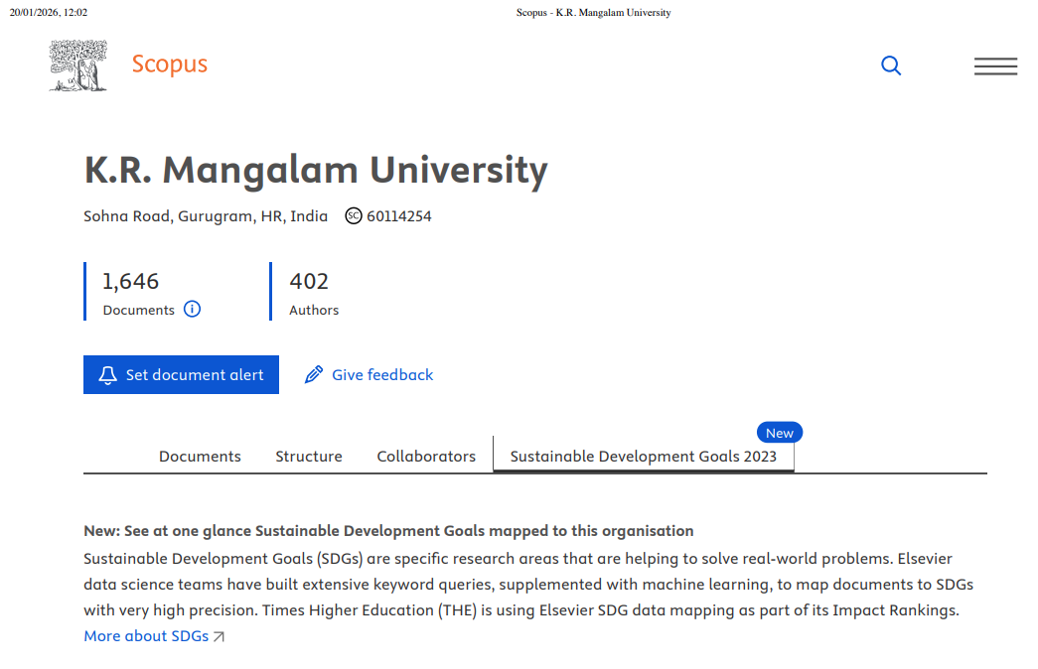
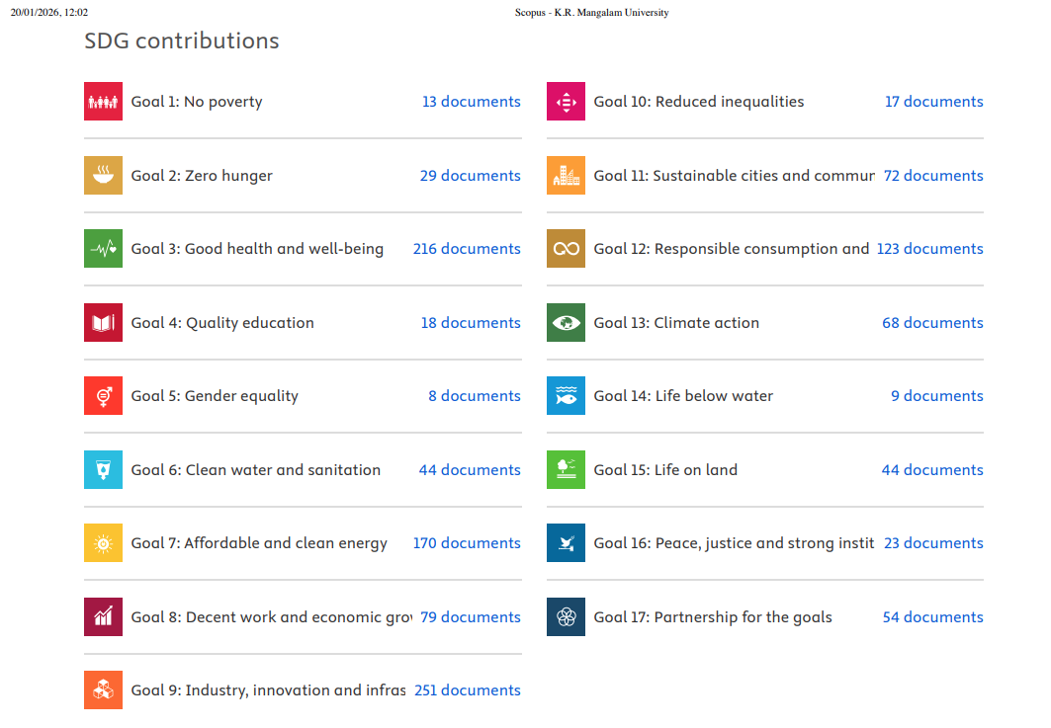
7. Conclusion
K.R. Mangalam University demonstrates a comprehensive and evolving commitment to environmental sustainability through policy frameworks, institutional capacity building, sustainability literacy assessment, renewable energy adoption, student engagement, and focused research initiatives. The University’s integrated approach ensures that sustainability is embedded across academic, operational, and governance domains, positioning K.R. Mangalam University strongly for continued progress in institutional sustainability performance.

