REPORT
ON
TRAINING PROGRAMME ON PROFESSIONAL ETHICS

Date: 28th August, 2024
Venue: C005, C Block, Ground Floor
Event Type: Training Programme
Mode of activity: Offline
Target group: Students of SBAS
Organized by: School of Basic and Applied Sciences, K R Mangalam University, Gurugram
Resource Person: Prof. Pawan Kumar. Professor, School of Basic and Applied Sciences, KRMU
Participants: 60

The Training Program on Professional Ethics for School of Basic and Applied Sciences students was organized on 28th August 2024 led by Prof. Pawan Kumar. The main objective to organize the session was to instil a strong ethical foundation in future science professionals. This insightful session was designed to address the ethical challenges specific to scientific fields, emphasizing the importance of integrity, accountability, and ethical decision-making.
The session was started by Prof. Pawan Kumar where he welcomed all the freshmen and briefed about the session. He explained the motive to conduct the session to student. Prof. Kumar began by discussing the significance of ethical conduct in scientific research and professional practice. Through interactive lectures, he highlighted common ethical dilemmas encountered in various scientific disciplines and provided strategies for navigating these challenges with integrity. Students were introduced to core ethical principles, including responsibility, transparency, and respect for intellectual property.
The program also featured engaging group discussions where students debated real-world case studies. These discussions allowed participants to exchange ideas, confront diverse perspectives, and practice critical
thinking in resolving ethical dilemmas. This training program by Prof. Pawan Kumar was a valuable addition to the curriculum, underscoring the role of ethics in shaping responsible and impactful scientists.
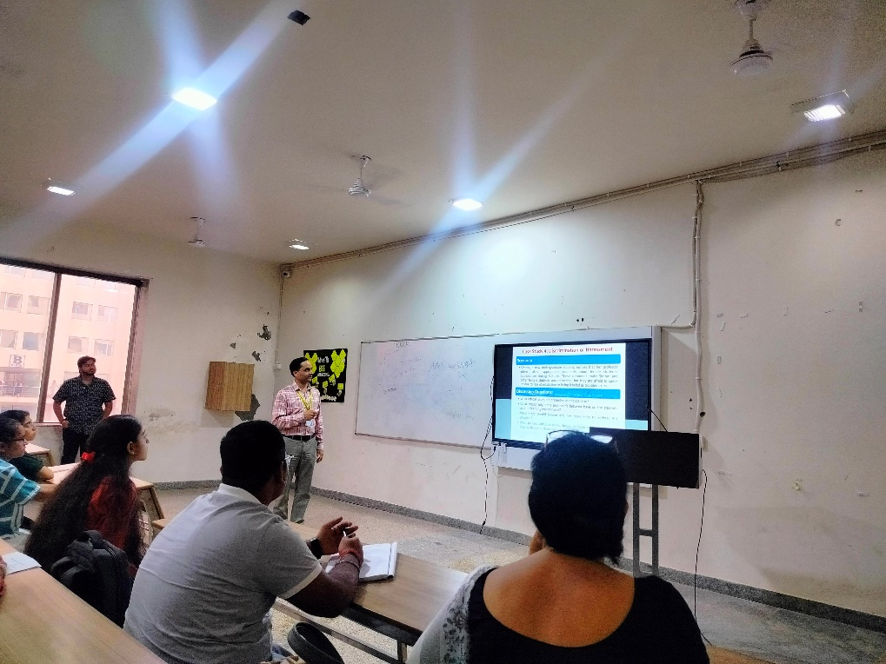

Photo 1: Dr Pawan Kumar briefed about the session
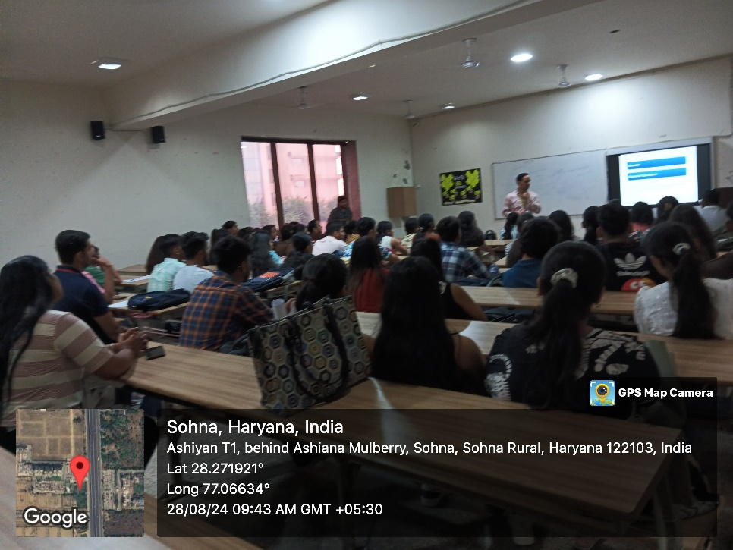

Photo 2: Prof. Pawan Kumar familiarized the students about the importance of ethics for science students

Report prepared by | Dr Pawan Kumar, Associate Professor, SBAS  Dr. Neeraj Kumari, Assistant Professor, SBAS
Report verified by | Prf. Meena Bhandari, Dean, SBAS
Report Verified by IQAC Coordinator | Dr Shikha Dutt Sharma

