REPORT ON

NUKKAD NATAK ON ‘SHAKTI KI UDAAN: BETIYAN BANAYEIN MAHAAN’

Date: 29th November 2024

Venue: Berka Village, Sohna
Event Type: Nukkad Natak (Street Play)
Mode of Activity: Offline
Target Group: Community members, especially village residents
Coordinators: Dr Vicky Kapoor (Assistant Professor, Physics, SBAS)

Organized by: NSS, K R Mangalam University, Gurugram
Participants: 20 NSS volunteers and more than 30 villagers

Introduction:
On 29th November 2024, the National Service Scheme (NSS) K.R. Mangalam University, Gurugram, organized a Nukkad Natak titled "Shakti Ki Udaan: Betiyaa Banayein Mahaaan" in Berka Village, Sohna. The event was aimed at raising awareness about the importance of empowering girls and promoting gender equality. The play conveyed the message of breaking societal stereotypes, encouraging the empowerment of women, and recognizing the role of girls in building a progressive society.

Objectives:
The primary objective of this event was to raise awareness about gender equality, focusing on the empowerment of girls. The performance sought to inspire community members to challenge societal norms and actively work towards creating an environment where girls are treated with equality and respect.

Content:
Event Highlights:
- Nukkad Natak (Street Play):
The central event of the day was the Nukkad Natak, a street play performed by NSS volunteers. The play emphasized the importance of empowering girls and highlighted how their education, freedom, and participation in society are crucial for the progress of any community. The drama depicted real-life scenarios that resonated with the audience and effectively communicated the message of gender equality.
- Audience Engagement:
The Nukkad Natak was designed to engage the local community, particularly the residents of Berka Village, in a discussion about women’s rights and the social challenges faced by girls. The interactive format allowed the villagers to share their views and reflect on their own attitudes toward gender roles.
- Team Effort:
The play was coordinated by Dr. Vicky Kapoor, Assistant Professor at the School of Basic and Applied Sciences (SBAS), along with student coordinators Shubhi and Aditi Gairi. The successful execution of the event was a result of their joint efforts, alongside the participation of 20 NSS volunteers who worked tirelessly to rehearse, set up, and perform the street play.
Conclusion:
The event concluded with a brief speech by the coordinators, Dr. Vicky Kapoor, Shubhi, and Aditi Gairi, who reinforced the importance of empowering girls and promoting gender equality in society. They also encouraged the villagers to continue supporting gender-balanced education and respect for girls. The performance was met with great enthusiasm, and the community expressed their appreciation for the event.
Event Outcomes:
The Nukkad Natak was a resounding success, with an active participation of more than 20 NSS volunteers and a strong turnout of local villagers. The play effectively conveyed its message of empowering girls, and it sparked important conversations about gender equality in the community. The event was a step toward making a positive impact on societal attitudes toward women’s empowerment.

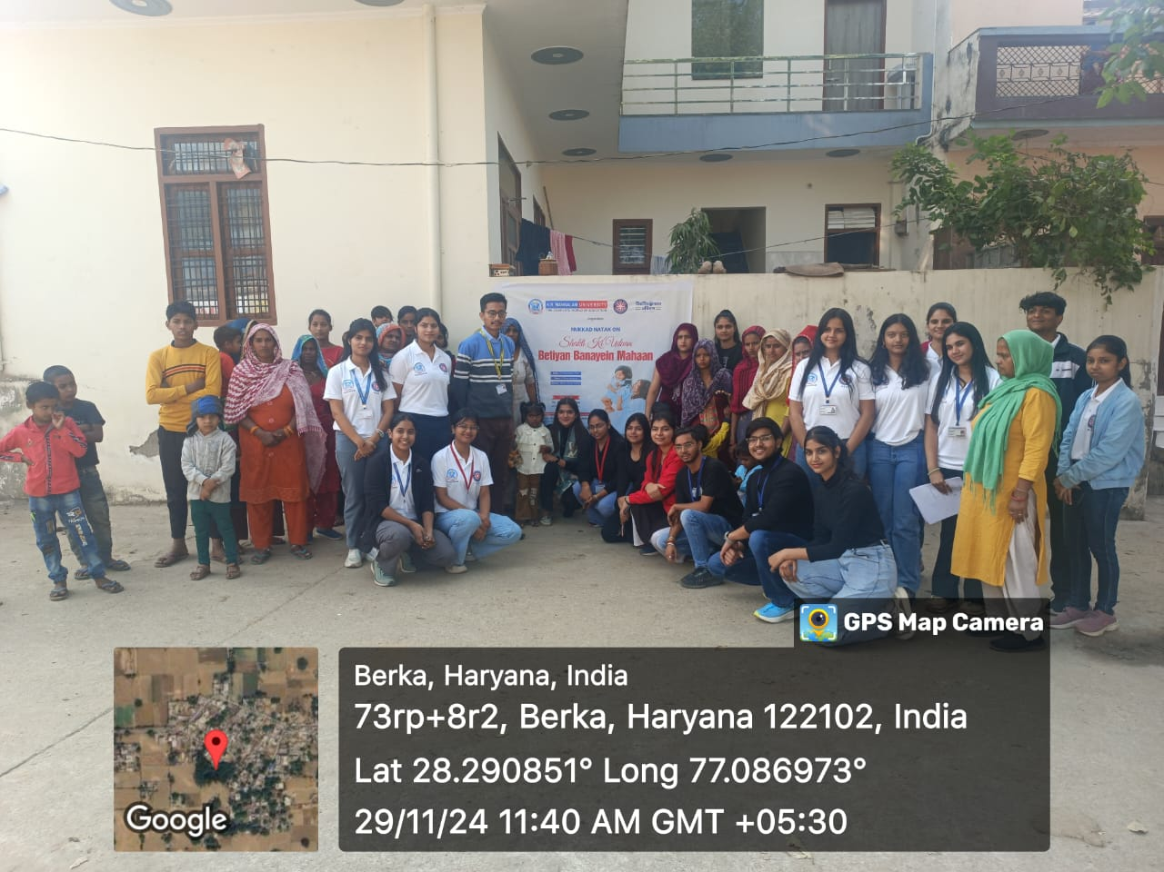

Photo 1: Group photograph of NSS volunteers with villagers
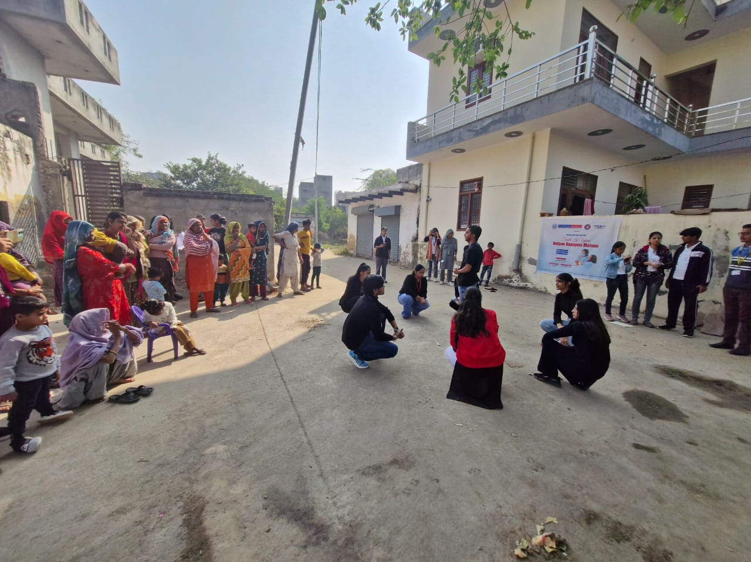

Photo 2: NSS volunteers during nukkad natak.

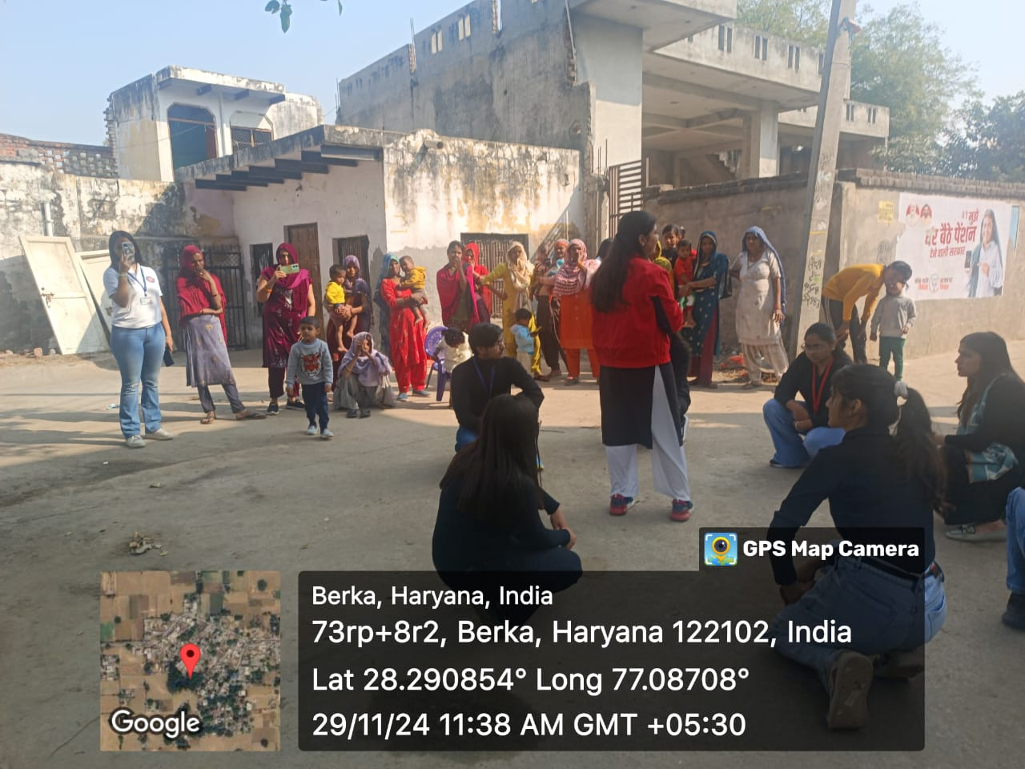

Photo 3: NSS volunteers during their performance.
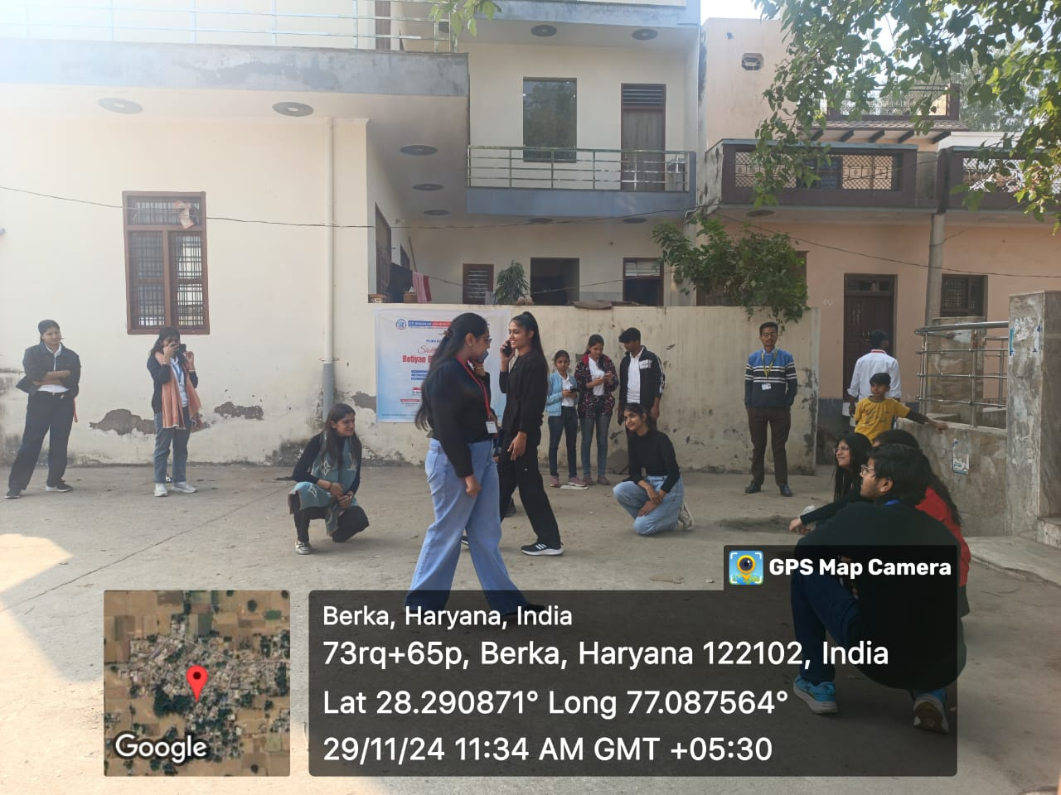

Photo 4: NSS volunteers during their performance.

Report Prepared by | Dr. Vicky Kapoor
Report Verified by | Dr. Neeraj Kumari, NSS Program Coordinator
Report Verified by IQAC Coordinator | Dr Shikha Dutt Sharma

