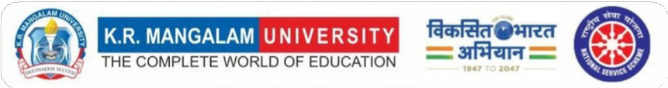

“Legacy of Service”

NSS-KRMU

2024-2025

INDEX
S.No. | Table of Content | Page No.
1 | Words from Chairperson | 2
2 | Words from NSS Program Coordinator | 3
3 | Words from IQAC Coordinator | 4
4 | National Service Scheme (NSS)  Empowering Communities Through Volunteerism | 5
5 | Social Outreach Programs | 7-23
6 | In-House Activities | 24-36
7 | NSS In News | 37-38
8 | Words from Alumni | 39-42
9 | National Integration Camp | 42-43
10 | NSS Adventure Camp | 44
11 | NSS Achievments | 45-46
12 | NSS Metir Certificates | 47
13 | NSS Gallery | 48-53

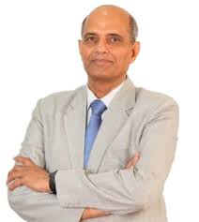
WORDS FROM CHAIRPERSON
Dear NSS Volunteers and Readers,

It gives me immense pride and joy to present this edition of “Legacy
of Service”, a reflection of the unwavering spirit, dedication, and
compassion demonstrated by the NSS Unit of K.R. Mangalam University. Over the past year, our volunteers have truly lived the NSS motto – “Not Me, But You” – by contributing to numerous extension activities aimed at community development and social awareness.
From participating in adventure camps and National Integration Camps (NIC) to organizing impactful seven-day special camps, our volunteers have shown exemplary commitment to serving society. Their efforts in organizing cleanliness drives, awareness rallies, donation campaigns, legal literacy sessions, and health outreach programs have left a lasting impression on the communities they touched.
It is also a moment of honor to acknowledge that our NSS team has been recognized with various awards at district and state levels for their outstanding service and social initiatives. These accolades are a testament to the hard work, integrity, and leadership of our students and the dedicated guidance of our program coordinators.
As we look ahead, I encourage all NSS volunteers to continue this journey of selfless service, nurturing values of empathy, responsibility, and active citizenship. Let this legacy of service continue to inspire change and shape a better tomorrow.

Warm regards,

Prof. Ra g u veer Singh
Chairperson
NSS Advisory Committee
K. R. Mangalam University, Gurugram

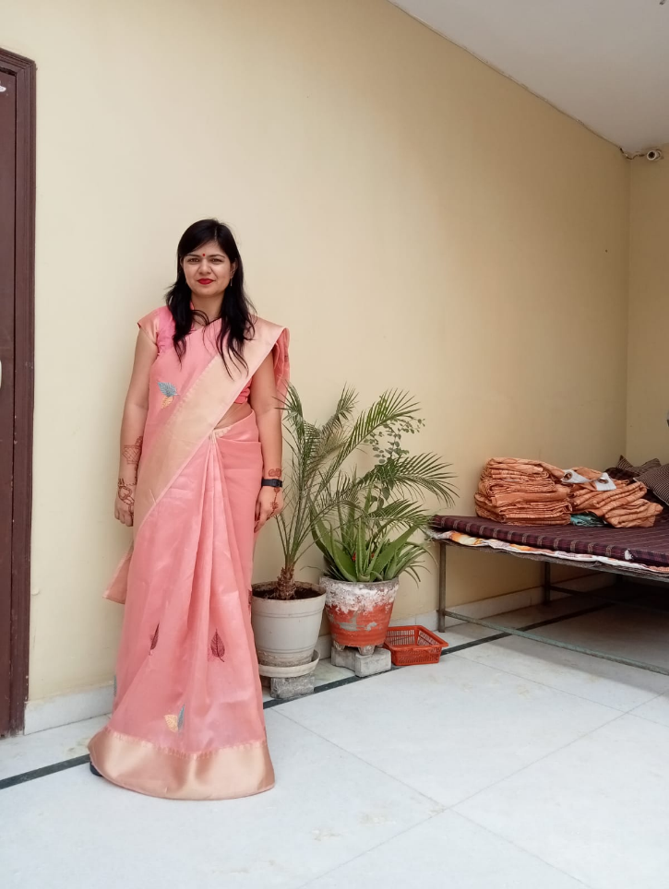
MESSAGE FROM NSS PROGRAM COORDINATOR

"It is not how much we give, but how much love we put into
giving." – Mother Teresa

As the NSS Program Coordinator of K.R. Mangalam University, I take
immense pride in reflecting on the impactful journey of NSS for the academic year 2024–25. This year has been a remarkable chapter in our legacy of service, marked by unwavering dedication, meaningful outreach, and collective efforts toward community welfare.
Our volunteers have gone beyond campus boundaries to serve with compassion—whether through cleanliness drives, health awareness programs, legal literacy camps, or educational support in rural areas. From participating in the National Integration Camp (NIC) to testing their endurance and leadership in Adventure Camps, our students have consistently represented the spirit of NSS on national platforms.
The recognition we received, including prestigious awards for our social initiatives, is a testament to our team's sincerity and sustained commitment to social reform. Each award and activity is not just an achievement, but a reminder of our shared responsibility toward building a just, inclusive, and sustainable society.
As we move forward, I encourage every volunteer to carry this spirit of selfless service in their hearts—because the legacy of NSS is not just in what we do, but in the lives we touch and transform.

Warm regards,
Dr. Neeraj Kumari
NSS Program Coordinator
NSS K. R. Mangalam University Gurugram-122103

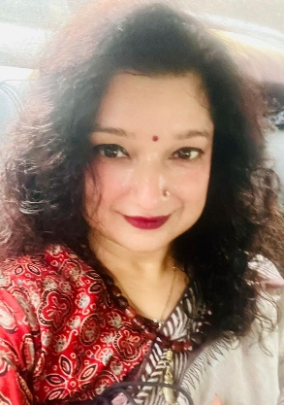
WORDS FROM IQAC COORDINATOR

The National Service Scheme (NSS) at K.R. Mangalam University stands
as a shining example of how academic institutions can nurture socially
responsible citizens. Through its diverse range of outreach programs,
awareness drives, and volunteer engagements, NSS has successfully
integrated the values of empathy, responsibility, and community development into the fabric of our student experience.
From organizing impactful extension activities to receiving accolades for its social initiatives, the NSS unit has continuously raised the bar in promoting the spirit of volunteerism. The participation of our volunteers in national-level platforms like the National Integration Camp (NIC) and Adventure Camps reflects the vibrant leadership and discipline that NSS fosters.
As the IQAC Coordinator, I deeply value the role of NSS in enhancing the quality culture of the university. It bridges classroom learning with real-world understanding, enriching students with practical knowledge and human values. The legacy NSS continues to build each year is not only inspiring but also essential in shaping a more inclusive and conscious society.
Heartfelt congratulations to the NSS team for their unwavering dedication. May your journey of service continue to grow in strength and spirit.

Dr. Shikha Dutt Sharma
IQAC Coordinator
K.R. Mangalam University

NATIONAL SERVICE SCHEME (NSS)
EMPOWERING COMMUNITIES THROUGH VOLUNTEERISM
(EMPOWERING YOUTH, ENRICHING COMMUNITIES)

INTRODUCTION

The National Service Scheme (NSS) is a public service program under the Ministry of Youth Affairs and Sports, Government of India. NSS encourages students to actively participate in social service activities, promoting social responsibility, civic awareness, and personal development. By engaging in various outreach programs such as cleanliness drives, health camps, awareness rallies, and education initiatives, NSS volunteers contribute meaningfully to the betterment of society while enriching their own understanding of real-world challenges.

The motto of NSS is "Not Me, But You" reflects the essence of democratic living and upholds the need for selfless service. It emphasizes the importance of placing the welfare of others above oneself, thereby nurturing the spirit of volunteerism, humility, and national integration among the youth.

The NSS-KRMU team has been recognized for its impactful efforts and was awarded by the District Legal Services Authority (DLSA) of both Delhi and Gurugram for its outstanding contribution to social welfare and community service.
Over the past few years, NSS volunteers have actively participated in a wide range of activities at the national, state, and district levels. These activities reflect the university’s strong commitment to fostering responsible citizenship and holistic student development through community engagement.
OBJECTIVES
- Understand the community in which they work.
- Identify the needs and problems of the community and involve them in problem solving process.
- Utilize their knowledge in finding practical solution to individual and community problems.
- Develop a sense of social and civic responsibility.
- Acquire leadership qualities and a democratic attitude.
- Practice national integration and social harmony.

NSS CORE COMMITTEE
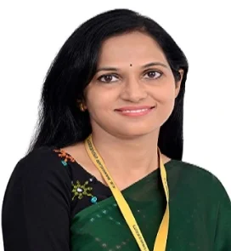
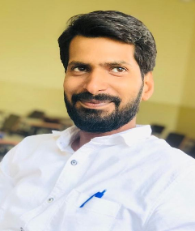
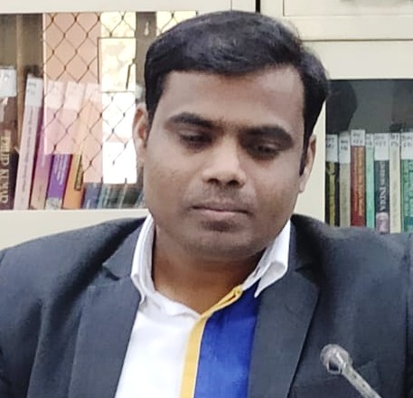
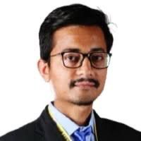
NSS Program Coordinator
NSS Program Officer (SFU)
NSS Member
NSS Program Officer (GIA)
NSS Member

NSS EXTENSION ACTIVITIES

Flag Distribution and Prabhat Pheri

To celebrate the 78th Independence Day, the NSS unit of K.R. Mangalam University organized the "Har Ghar Tiranga" campaign on 13th August 2024 under the Azadi Ka Amrit Mahotsav initiative. Led by Dr. Neeraj Kumari, NSS volunteers conducted a Prabhat Pheri from Lakhuwas village mandir and distributed national flags to households and shops. Patriotic slogans and songs filled the air, inspiring unity and national pride. Volunteers also educated residents about the historical significance of the tricolor and encouraged them to hoist it at their homes. The event fostered patriotism and a strong sense of national identity among community members.

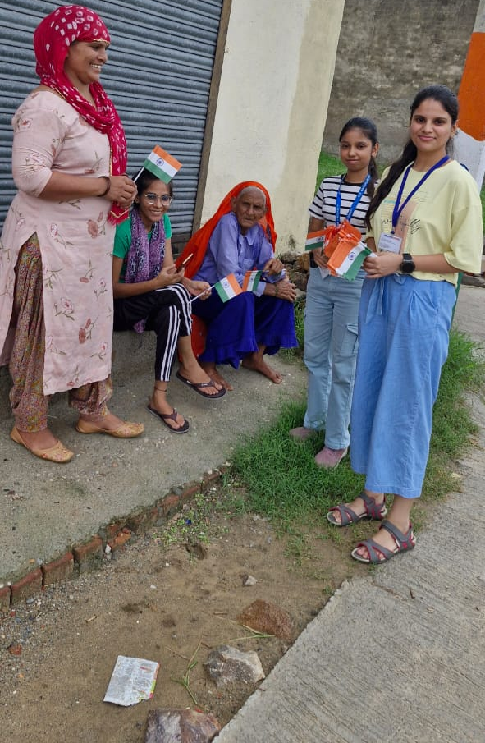
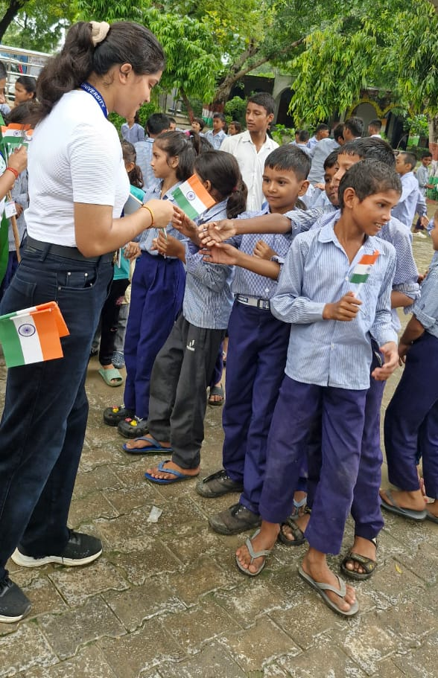

NSS volunteers distributing NSS flags to school students and villagers

An Essay Writing Competition on ‘Hindi Diwas Celebration’

The NSS unit of K.R. Mangalam University, under the guidance of the Ministry of Youth & Sports Affairs, organized a Hindi Diwas celebration on 25th September 2024 at Government Primary School, Abheypur Village. The event featured an essay writing competition, interactive sessions, poetry recitation, and cultural performances aimed at promoting the significance of Hindi. Coordinated by Dr. Sapna Rana and Dr. Vicky Kapoor, the program saw active participation from 33 NSS volunteers and over 40 school students. Volunteers conducted an informative session on the importance of Hindi Diwas, its history, and its role in education and administration. Students wrote essays on “What I Want to Become When I Grow Up,” with the best entries receiving prizes and certificates. Poetry recitations and a dance performance to a patriotic song added cultural vibrance to the event. A short play emphasized the relevance of Hindi in communication and national identity. The event concluded with a closing address by the coordinators and a vote of thanks by the school principal. The celebration successfully instilled pride in the Hindi language and encouraged its use in daily life.
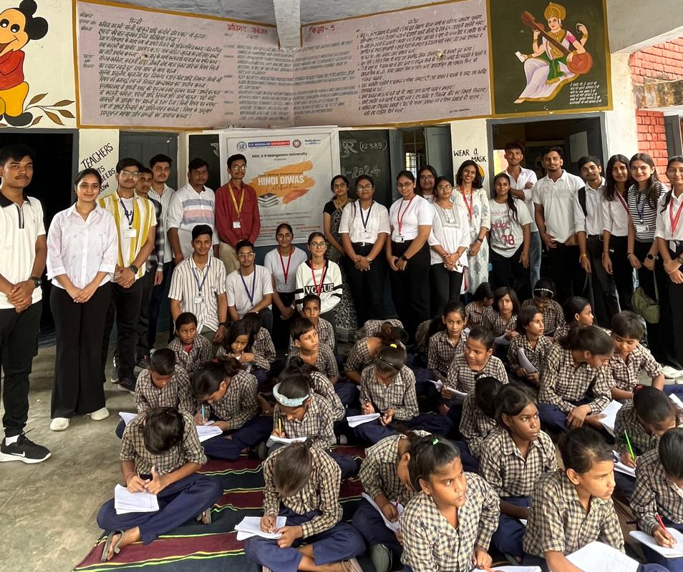

School students during essay writing competition

Cleanliness Drive and Rally under ‘Swachhata Hi Seva’ Campaign
As part of the nationwide ‘Swachhata Hi Seva’ (SHS) campaign, NSS K.R. Mangalam University organized a two-day cleanliness drive and awareness rally at Govt. Sr. Sec. School and Ghanghola village. This campaign, under the Ministry of Youth Affairs and Sports, promotes community participation in maintaining cleanliness and environmental health. The event aimed to encourage hygienic practices among locals and foster civic responsibility.
The initiative began with a briefing by the coordinators, highlighting the significance of cleanliness in improving community well-being. On 25th September, volunteers collected litter, cleaned school premises, and cleared surroundings, visibly transforming the area and promoting hygiene. More than 60 volunteers actively participated that day.
On 27th September, an awareness rally was conducted in Ghanghola village where volunteers marched through the streets chanting slogans like:
- "स्वच्छता ही सेवा है, इसे अपनाएं, जीवन को सुंदर बनाएं।"
- "आओ मिलकर कसम ये खाएं, स्वच्छ भारत हम बनाएंगे।"
- "स्वच्छ रहना, स्वस्थ रहना – यह है हमारा कहना।"
- "स्वच्छ भारत का यही नारा, गंदगी को दूर भगाना हमारा।"
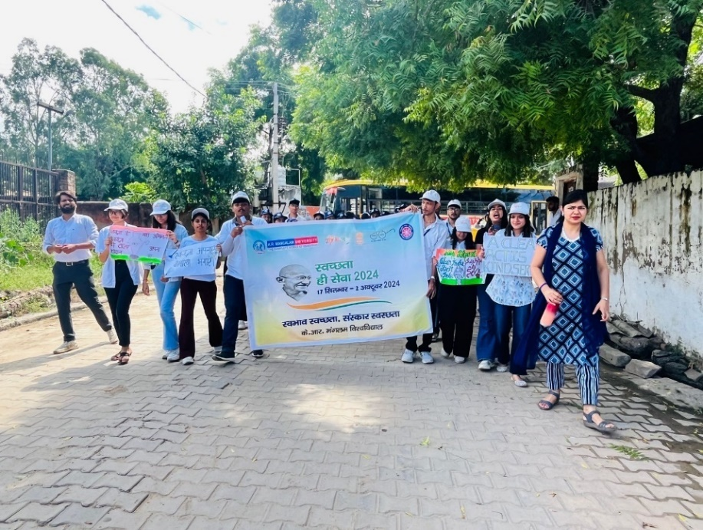
The rally attracted the attention of villagers, promoting awareness on sustainable cleanliness practices. The event concluded with reflections on the importance of collective action for a cleaner India.

NSS volunteers and coordinator during rally
Nukkad Natak: ‘Poshan Bhi, Padhai Bhi’

As part of Rashtriya Poshan Maah under Mission Saksham Anganwadi and Poshan 2.0, NSS K.R. Mangalam University organized a Nukkad Natak on the theme “पोषण भी, पढ़ाई भी” on 30th September 2024 in Lakhuwas village. Coordinated by Dr. Neeraj Kumari and Mr. Thomas Monteiro, the street play was performed by 26 NSS volunteers and witnessed by over 40 villagers. The performance emphasized the vital role of nutrition and education in a child’s development, highlighting government initiatives like Mid-Day Meal and Poshan 2.0. Through engaging storytelling, the volunteers conveyed how a nutritious diet supports better learning and overall growth. The event successfully raised awareness in the community, encouraging parents to prioritize both health and education for their children.

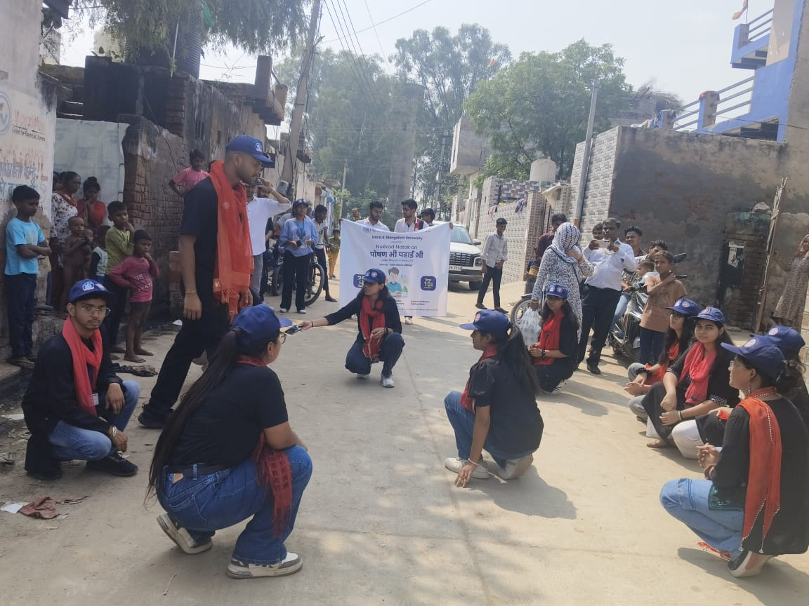

NSS volunteers during their performance

Visit to Ayushman Hospital

On 22nd October 2024, 24 NSS volunteers from K.R. Mangalam University visited Ayushman Hospital, C-2, Palam Vihar, Gurugram, under the guidance of Dr. Neeraj Kumari and Mr. Thomas Monteiro. The visit aimed to provide exposure to traditional systems of medicine under the Ayushman Bharat scheme (PM-JAY). The volunteers were warmly welcomed by experts including Mr. Bhudev (Yoga), Dr. Anupriya (Ayurveda), and Dr. Geetanjli (Panchakarma). They learned about Panchakarma therapy, its detoxification processes, and its benefits in balancing the body and mind. A yoga session introduced them to various asanas and breathing techniques. The interaction offered valuable insights into natural healing, preventive care, and lifestyle management. The session concluded with a discussion on empathy and ethics in healthcare. The visit proved enriching and educational, encouraging volunteers to consider future roles in healthcare and wellness sectors.
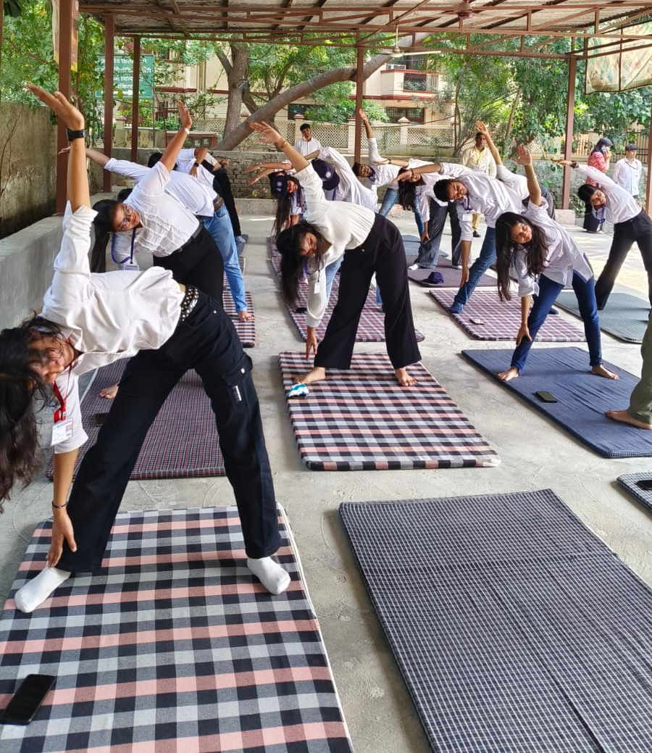

NSS volunteers during their yoga sesson at Ayush Hospital

Session on ‘Constitutional Rights and Duties’

On the occasion of Constitution Day, NSS, K.R. Mangalam University, in collaboration with the Legal Aid Committee, organized a session on ‘Constitutional Rights and Duties’ at Government Senior Secondary School, Abheypur on 26th November 2024. The session aimed to raise awareness about the Indian Constitution, especially the Fundamental Rights and Duties. Dr. Sapna Rana, NSS member, welcomed the gathering and introduced the expert speaker, Dr. Arti Sharma, Assistant Professor, School of Legal Studies, KRMU. Dr. Sharma explained the historical importance of Constitution Day and elaborated on the constitutional provisions that ensure equality, justice, and responsibility. The session saw active participation from students and teachers. An oath-taking ceremony was conducted to pledge allegiance to constitutional values. The program concluded with a vote of thanks by the school principal, who appreciated NSS KRMU's efforts.
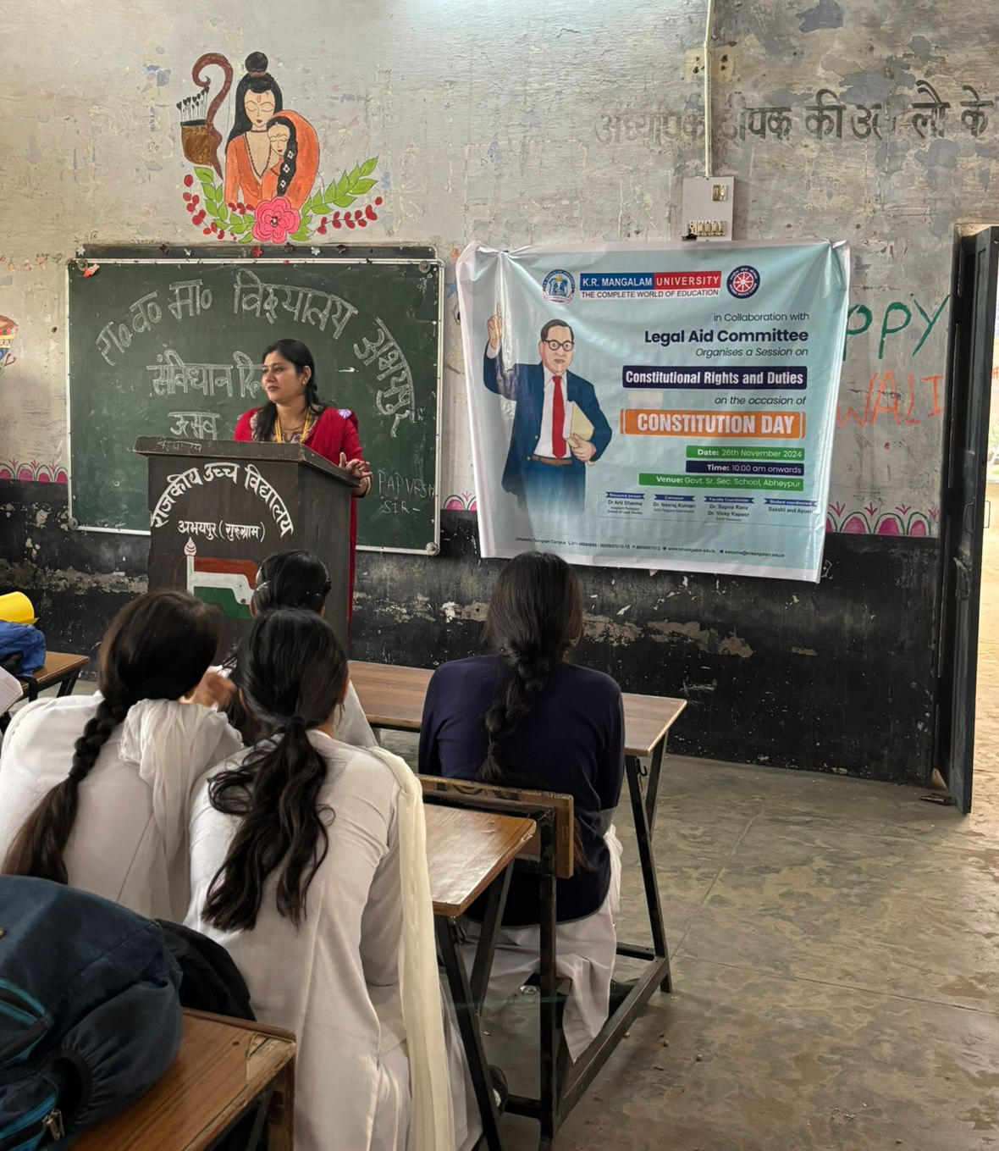

Dr. Arti Sharma explianed about the constitutional rights and duties

Nukkad Natak: ‘Shakti Ki Udaan – Betiyan Banayein Mahaan’

On 29th November 2024, NSS K.R. Mangalam University organized a Nukkad Natak titled "Shakti Ki Udaan: Betiyan Banayein Mahaan" at Berka Village to promote gender equality and girl empowerment. The play, performed by 20 NSS volunteers, depicted real-life situations highlighting the importance of girls’ education, freedom, and societal participation. Coordinated by Dr. Vicky Kapoor along with student leaders Shubhi and Aditi Gairi, the event engaged over 30 villagers in thought-provoking dialogue. The interactive format encouraged reflection on traditional gender roles and the need for change. The community appreciated the performance, and the event successfully inspired awareness and support for women's empowerment at the grassroots level.
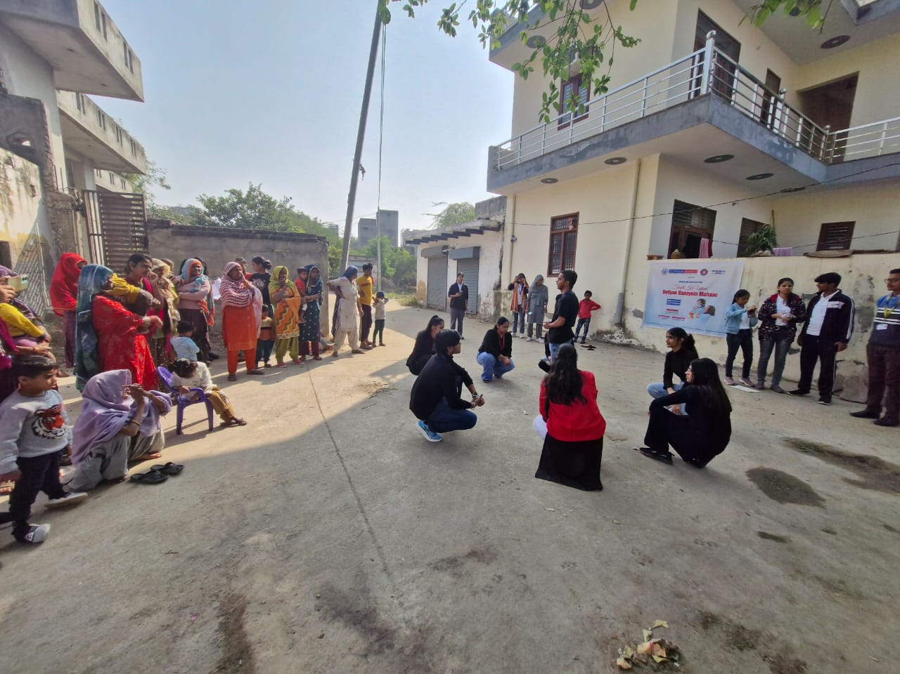

NSS volunteers during their perfromance of nukkad natak

Seven-Day Special Camp under the Theme 'Yuva for My Bharat and Yuva for Digital Literacy'

Under the theme 'Yuva for My Bharat and Yuva for Digital Literacy,' the NSS Unit of K.R. Mangalam University organized a seven-day special camp in Lakhuwas village, Sohna from 2nd to 8th January 2025. The camp was conducted under the guidance of Dr. Neeraj Kumari (NSS Program Coordinator), Mr. Amit Kumar Yadav, Mr. Thomas Monteiro (NSS Program Officers), Dr. Sapna Rana, and Dr. Vicky Kapoor (NSS Members).
The objective of the camp was to spread awareness among youth about digital literacy and community service. Various activities and sessions were conducted to empower the youth and benefit the rural community, including digital literacy training, cyber security awareness, anti-drug awareness, and entrepreneurship development sessions. Additionally, the camp featured a rangoli competition on cleanliness, a speech competition on the importance of Swadeshi, and a poster-making competition on the role of youth, fostering creativity and social responsibility. A health camp and first-aid training were also organized, benefiting over 100 villagers.
NSS volunteers actively participated in nukkad natak (street plays), cultural programs, and sports competitions, promoting community engagement and teamwork. The camp concluded with a valedictory ceremony, where Dr. Rajendra Kumar Yadav, NSS Program Coordinator from Sushant University, distributed prizes to the volunteers and winners. This camp was a remarkable example of youth capacity building and the promotion of digital literacy, significantly contributing to social welfare and nation-building.
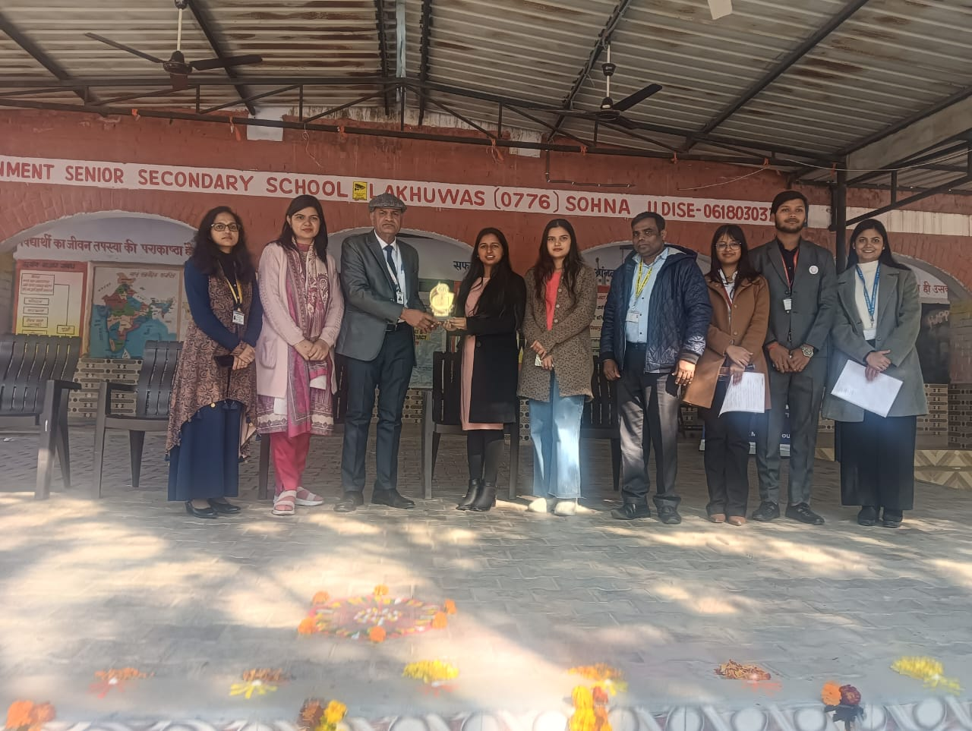

NSS Program Coordinator, Sushant University distributed prizes to NSS volunteers

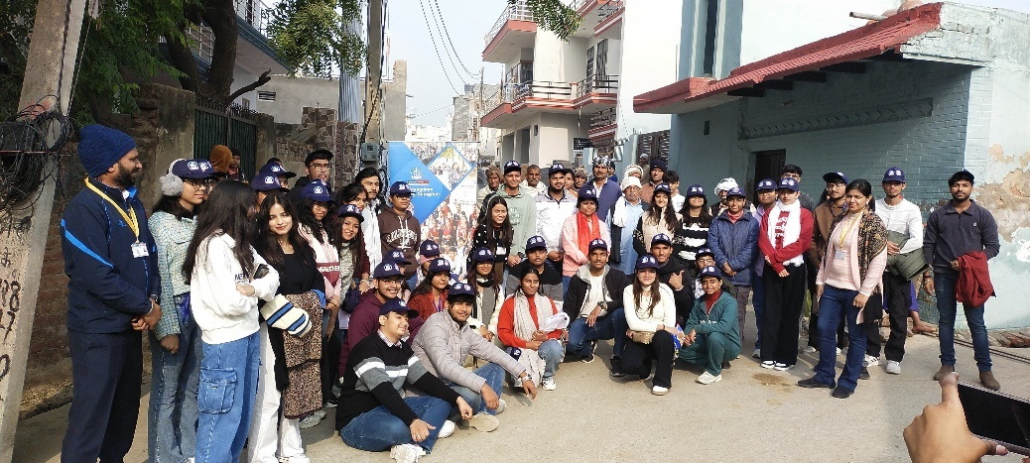

NSS volunteers with villagers after perfroming nukkad natak on drug abuse

Self Defense training workshop

On the occasion of National Girl Child Day, NSS K.R. Mangalam University, in collaboration with the Urban Games Federation of India (UGFI), New Delhi, organized a self-defense training workshop at Govt. Sr. Sec. School, Daulah from 10:30am onwards. The experts of the workshop were Ms. Naveen Choudhary, President of UGFI, and Mr. Harsh Dahiya, General Secretary, UGFI and international coach who imparted essential self-defense techniques to students. The main objective of conducting the workshop was to empower young students by giving them training of some basic self-defense skills to boost their confidence and ensure their safety. The experts demonstrated practical techniques such as blocking, escaping holds using their hands and legs, and remaining vigilant in unfamiliar environments. They also emphasized the importance of awareness, quick reflexes, and maintaining composure in critical situations. The event successfully instilled a sense of self-reliance and courage among the participants. As a token of gratitude, Dr. Neeraj Kumari, NSS Program Coordinator, and Mr Thomas Monteiro, NSS Program Officer presented mementos to Ms. Naveen Choudhary and the Principal of Govt. School, Daulah. The program concluded with a heartfelt vote of thanks extended by Dr. Neeraj Kumari, expressing appreciation for the trainers, school staff, and students for their enthusiastic participation in this meaningful initiative.

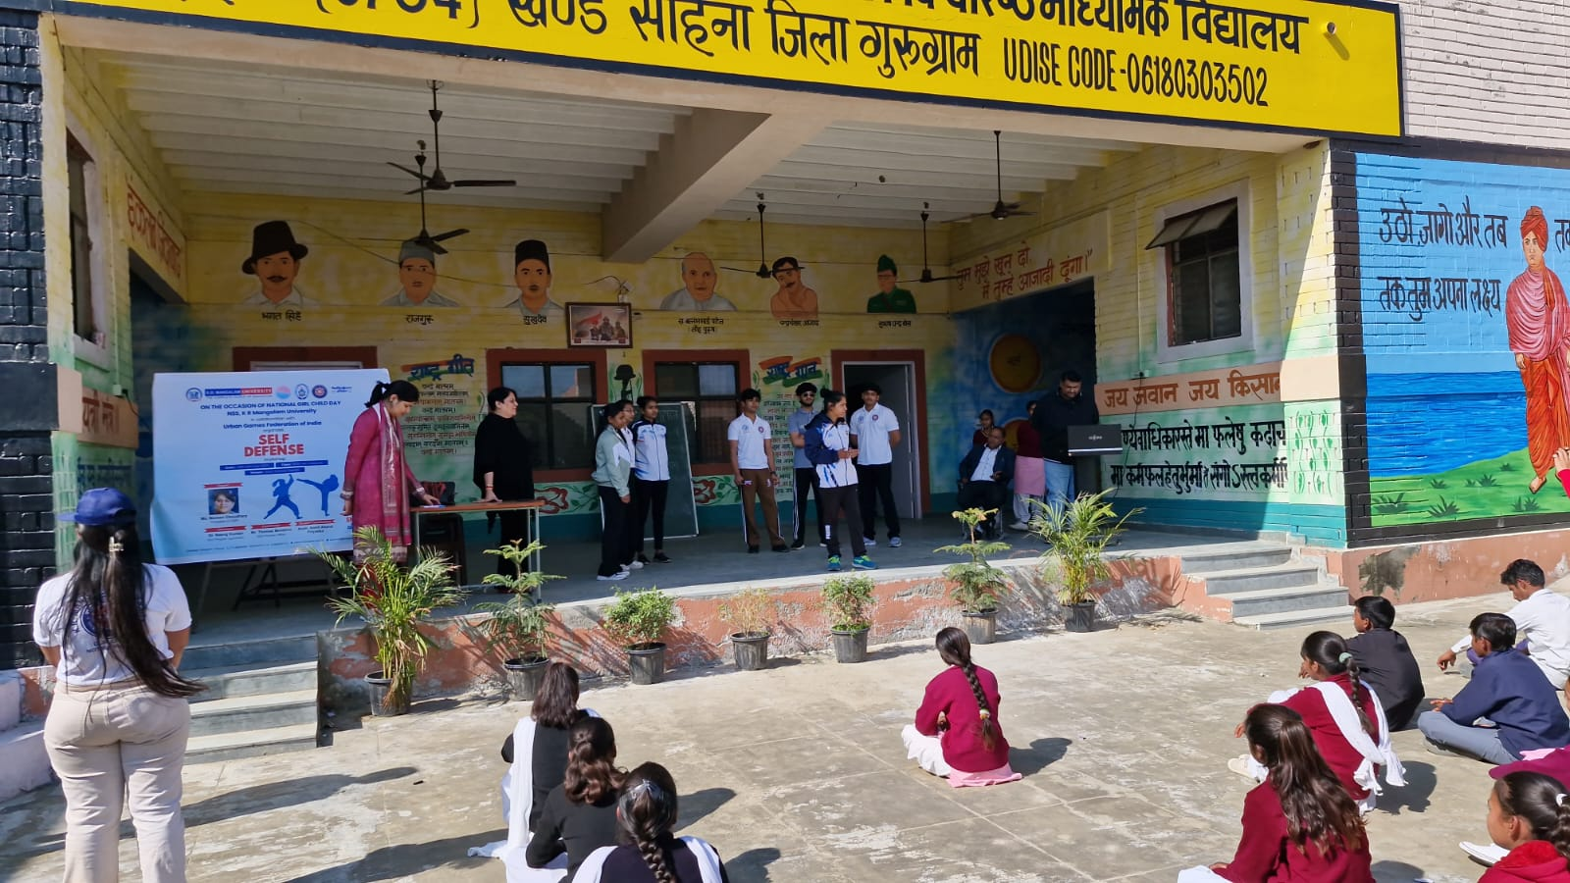

Experts from UGFI explianing some basic steps of the self defence taining to school students

Road Safety Awareness Campaign

On 28th January 2025, NSS K.R. Mangalam University successfully conducted an outreach activity on "Road Safety Awareness" under the National Road Safety Month (NRSM) 2025, an initiative of the Government of India. The event was organized in collaboration with the students of Government Senior Secondary School, Ghangola, Block Sohna, with the aim of spreading awareness about road safety and responsible driving. The activity featured an Awareness Rally through the village, where students and volunteers held placards and chanted slogans to emphasize the importance of traffic rules and safe driving practices. Additionally, a Poster Making Competition and an Essay Writing Competition were conducted among school students to encourage creative expression and critical thinking on road safety issues. The winners were honored with medals and certificates for their outstanding contributions. The event concluded with a felicitation ceremony, where the Principal, Sh. Satish Kumar, appreciated the efforts of NSS Programme Officer Mr. Amit Kumar Yadav, the winners, and all the NSS volunteers for their dedication to this social cause. The initiative successfully engaged the local community, reinforcing the need for responsible road behavior and adherence to traffic regulations to ensure safety for all.

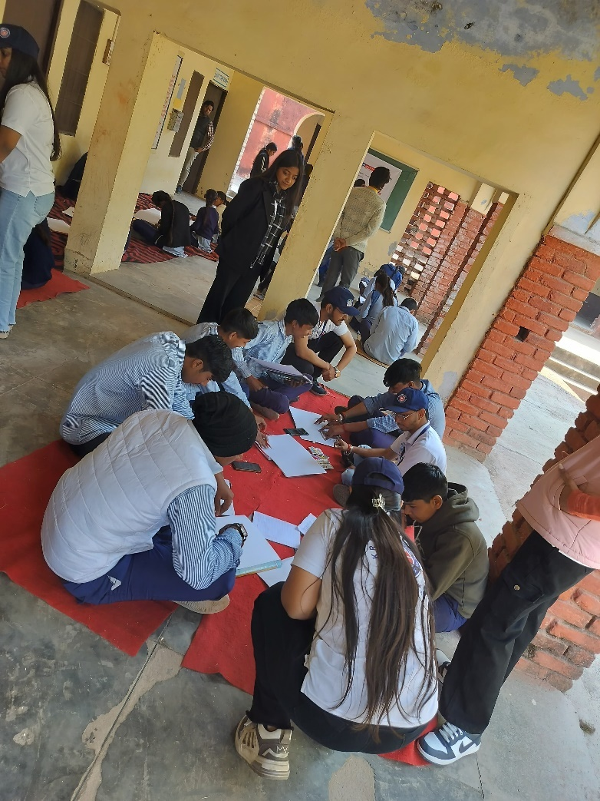

School students preparing their poster on road safety

Donation Drive and Visit to Old Age Home

The NSS Unit of K.R. Mangalam University organized a donation drive and visit to the Earth Saviours Foundation, Bandhwari, on 11th February 2025. Coordinated by Dr. Neeraj Kumari and Dr. Sapna Rana, the initiative aimed to promote compassion, service, and social responsibility among students. Donation boxes were placed across campus to collect clothes, food, and daily essentials, which were later sorted by NSS volunteers. A team of 44 NSS volunteers visited the foundation and distributed the collected items to over 31 residents. Volunteers personally served lunch and engaged in meaningful conversations with the elderly, learning about their lives and challenges. The experience created a warm atmosphere filled with mutual respect and empathy.
The visit not only brought joy to the residents but also deeply impacted the students, reinforcing the value of selfless service. The success of the drive was reflected in the enthusiastic participation of the university community and the heartfelt gratitude expressed by the foundation’s residents.

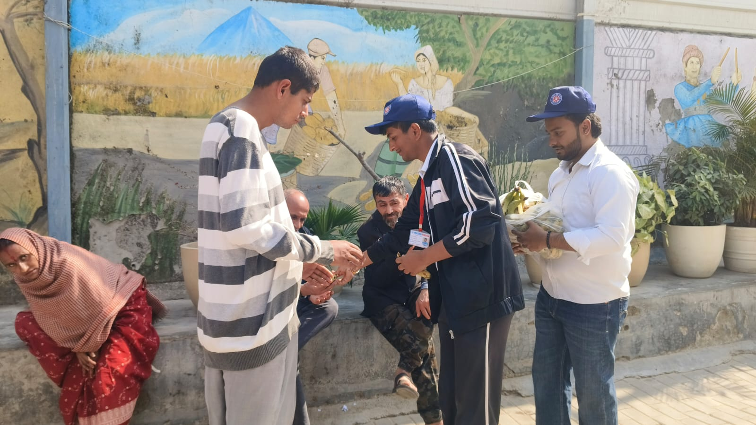

NSS volunteers distributing fruit to the residents of foundation

Shiksha Uday: A One-Day Literacy Camp

NSS Unit of K.R. Mangalam University, Gurugram, organized "Shiksha Uday: A One-Day Literacy Camp" on March 4, 2025, at Dream Girls Foundation, Sector-9, Gurugram, under the guidance of Dr. Neeraj Kumari (NSS Program Coordinator) and Mr. Thomas Monteiro (NSS Program Officer). The camp aimed to educate and inspire underprivileged children (ages 1 to 10) from labor-class backgrounds through engaging activities. NSS volunteers interacted with the children, teaching them basic literacy skills, numbers, and rhymes in a fun and interactive way. Various educational games, storytelling sessions, drawing, and craft activities were conducted to enhance their learning experience. The children also participated in recreational games, songs, and dance activities, making the day lively and joyful. Volunteers distributed stationery, books, and refreshments, ensuring that the children had a memorable and enriching experience. The event successfully created a positive impact, fostering a love for learning among the children while reinforcing the spirit of social responsibility in NSS volunteers.

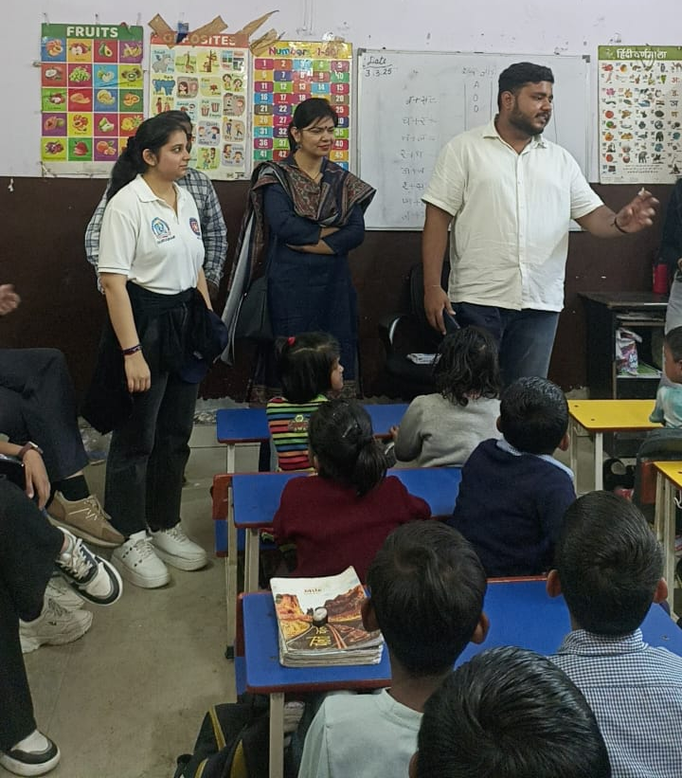

NSS volunteers during teaching

“Empower Her: Celebrating Strength and Spirit through Performance”

On 5th March 2025, the NSS unit of K.R. Mangalam University organized a Nukkad Natak titled “Empower Her: Celebrating Strength and Spirit through Performance” at Abheypur Village to mark International Women’s Day. The event aimed to spread awareness about gender equality and women’s empowerment under SDG 5. Coordinated by Dr. Sapna Rana and Dr. Vicky Kapoor, the program saw the active participation of 30 NSS volunteers and over 30 villagers. The highlight was a compelling street play showcasing women’s struggles and inspiring messages of strength, resilience, and equality. Speeches on women's education and rights further enriched the program. Student coordinators Ansh, Pihu, and Anushri led the event with enthusiasm. The play sparked meaningful discussions among villagers, especially women, who shared their aspirations and challenges. Many young girls expressed interest in further education and skill training. The event successfully fostered awareness, community bonding, and dialogue for positive social change.

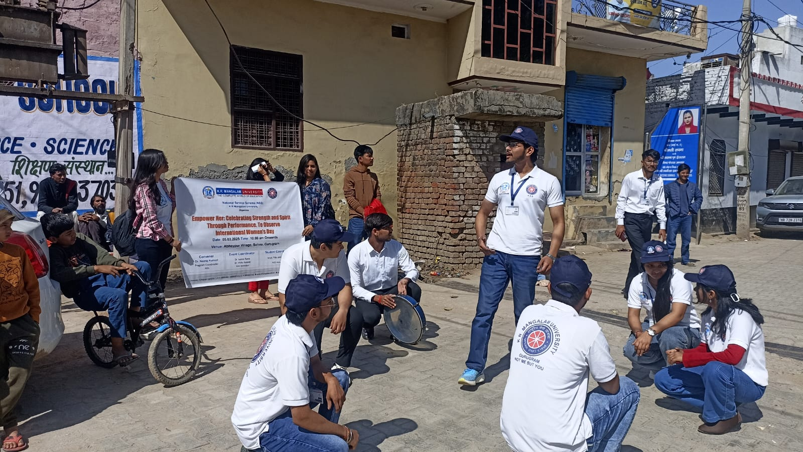

NSS volunteers performing nukkad natak

Awareness about Menstrual Health on the occasion of World Health Day

On the occasion of World Health Day, an awareness session on Menstrual Health was organized by NSS K R Mangalam University on 07th April 2025 in Berka Village, Gurgaon, with the objective of educating rural women about menstrual hygiene and breaking the stigma surrounding it. The event was initiated by Dr. Neeraj Kumari, NSS Program Coordinator, who shared insights into the history of sanitary pads and explained the biological reason behind the monthly menstrual cycle. The session was further led by Ms. Anushri and Ms. Riya, dedicated NSS volunteers, who emphasized the importance of using sanitary pads, the recommended frequency of changing them, managing period pain, and necessary precautions to be taken during menstruation. The event concluded with a heartfelt vote of thanks by Dr. Sapna Rana, event coordiantor followed by the distribution of sanitary pads to women in the village, promoting health, hygiene, and dignity for all.

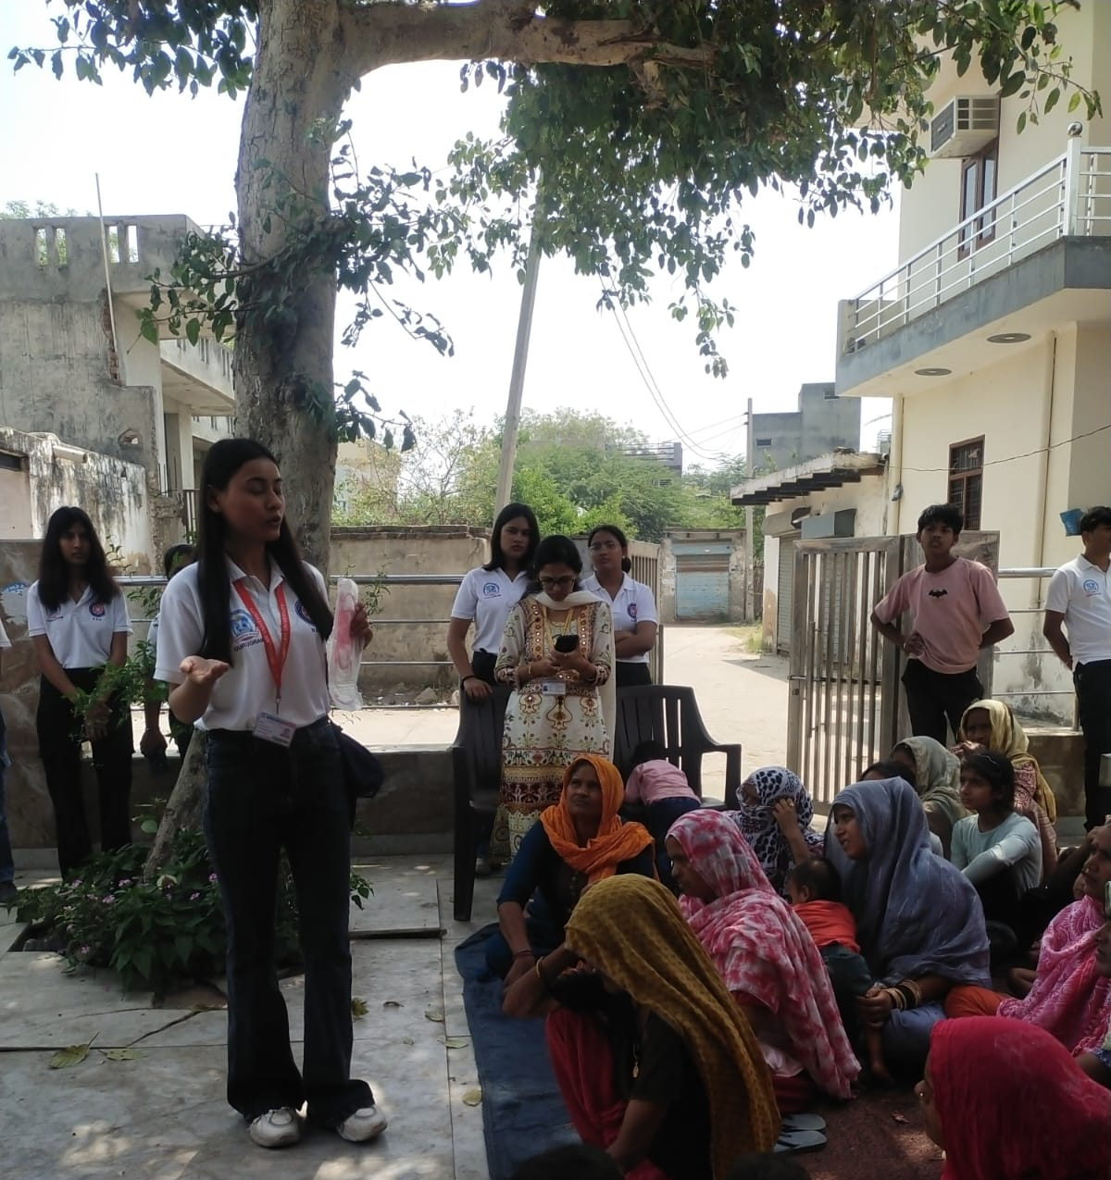

Ms Riya explianed about the use of sanitary pad to rural women

Health Checkup Camp

On 15th April 2025, K.R. Mangalam University’s NSS Unit, in collaboration with the School of Physiotherapy and Rehabilitation Sciences, organized a one-day Health Checkup Camp at Daulah Village, Sohna Block. The camp aimed to provide free physiotherapy and healthcare services to over 34 villagers, addressing common issues like joint pain and mobility problems. Under the guidance of experts Dr. Ankita Samuel and Dr. Hemant Kumar, 31 NSS and SPRS student volunteers conducted check-ups, treatments, and health awareness sessions. The event focused on promoting good health, hygiene, and preventive care in line with SDG 3. Local authorities, including the village Sarpanch, supported the initiative, making it well-received in the community. The camp also provided practical learning opportunities for students, enhancing their clinical skills and social responsibility. It successfully met immediate health needs while educating villagers on healthy lifestyle habits. The collaboration strengthened community ties and inspired plans for future health camps and follow-up care. This outreach reflects the university’s ongoing commitment to nation-building through service.
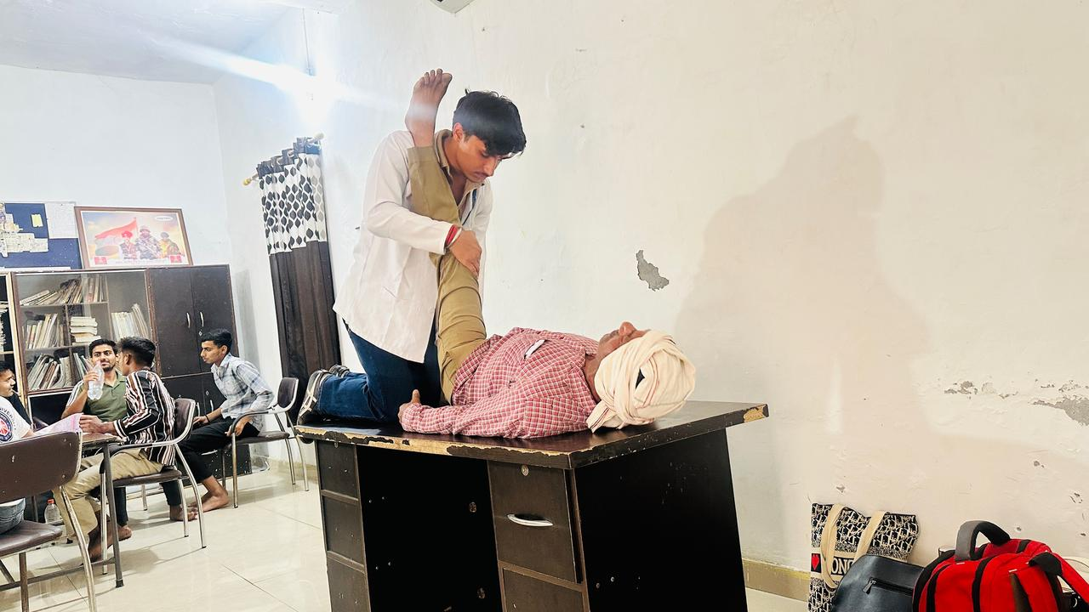

Student from physiotherpy department during the session with villager

‘Eat Right, Move More’- Wellness Workshop for Children

The NSS Unit of K.R. Mangalam University organized a one-day wellness workshop titled "Eat Right, Move More" on 21st April 2025. The event aimed to promote healthy eating habits and physical activity among school students. Coordinated by Dr. Vicky Kapoor, the session engaged 30 school students and 48 NSS volunteers through informative discussions and fun fitness activities.
The workshop included a session on the importance of balanced nutrition, followed by interactive physical games to encourage daily exercise. An open Q&A session allowed students to explore wellness topics further. The event aligned with SDG 3 (Good Health and Well-being), SDG 4 (Quality Education), and SDG 12 (Responsible Consumption and Production).
The workshop successfully raised awareness about the benefits of a healthy lifestyle and inspired students to adopt sustainable wellness habits. Plans are in place to replicate the program in more schools and introduce a student-led “Wellness Challenge” in the future.

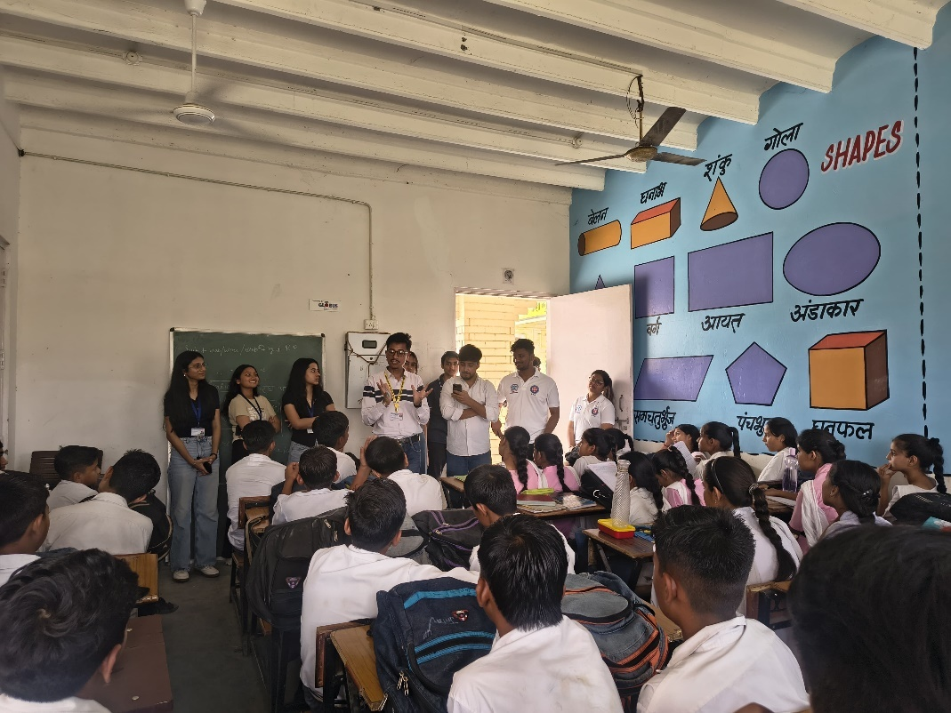

Dr. Vicky Kapoor explianing about the healthy habits

IN-HOUSE ACTIVITIES

'Creative Freedom through Art and Craft Competition' and Independence Day

To celebrate the 78th Independence Day under the "Har Ghar Tiranga" campaign, NSS-KRMU organized a creative Art and Craft competition on 14th August 2024. Nineteen NSS volunteers participated, expressing their thoughts on freedom, patriotism, and India’s heritage through painting, drawing, and craftwork. The event aimed to instill a sense of national pride while offering a platform for creative expression. Volunteers showcased a deep understanding of constitutional rights, duties, and the spirit of independence. Dr. Neeraj Kumari, the coordinator, shared insights on the significance of the Tiranga and the true meaning of freedom. Winners were awarded for their outstanding work, and all participants gained a greater appreciation for India’s cultural and constitutional legacy.
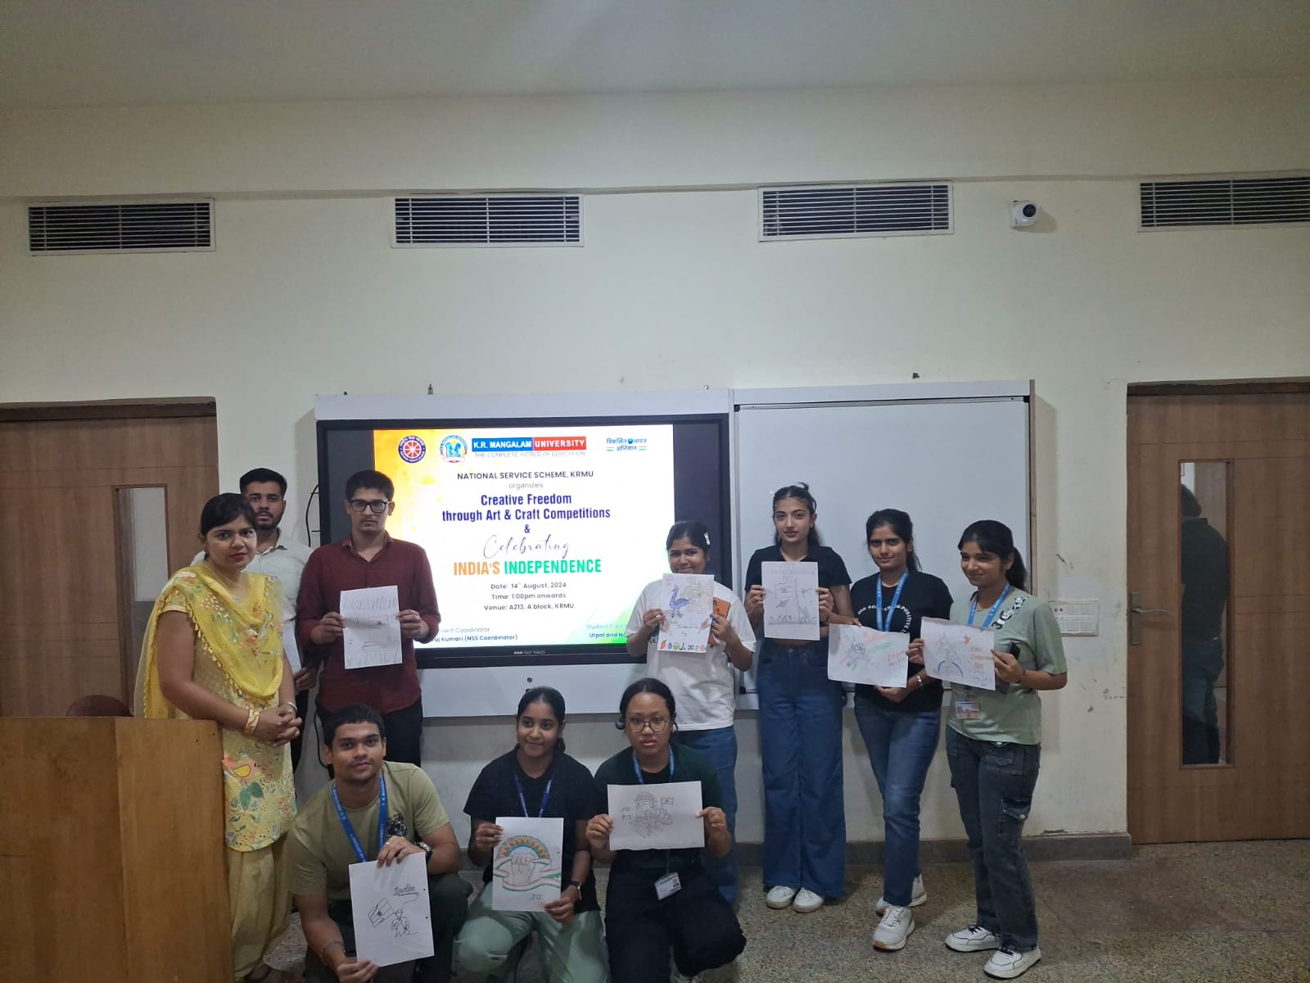

NSS program coordinator with NSS volunteers

NSS Orientation under the theme ‘Empowering the Future: Role of Youth in Nation Building and Development’

On the occasion of NSS Day, September 23, 2024, K.R. Mangalam University organized an NSS Orientation Programme themed "Empowering the Future: Role of Youth in Nation Building and Development" in hybrid mode, in collaboration with Bhagidari Jan Sahyog Samiti and Punjab & Sind Bank. The event was graced by eminent dignitaries including Prof. Raghuveer Singh, Hon’ble Vice-Chancellor, Dr. Dinesh Kumar, State NSS Officer, Sh. Ramesh Chander, Hon’ble Judge and Secretary, DLSA Gurgaon, and Sh. A.N. Singh, DGM, Punjab & Sind Bank. The Vice-Chancellor emphasized the vital role of youth in societal development, while other speakers highlighted legal awareness, cyber security, and community engagement. Special sessions were delivered by Dr. Rakshit Tandon, Cyber Law Expert, and Ms. Naazrin Ansari, Poetess and Social Worker. The program concluded with a felicitation ceremony honoring outstanding NSS volunteers for their exceptional contributions to social initiatives. The event inspired students to take active roles in nation-building through service, leadership, and civic responsibility.
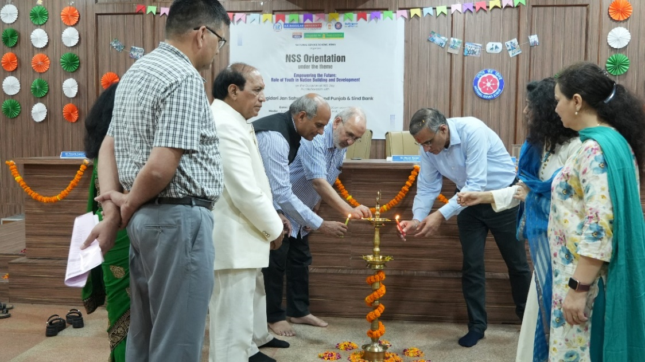

The guest during lamp lightening

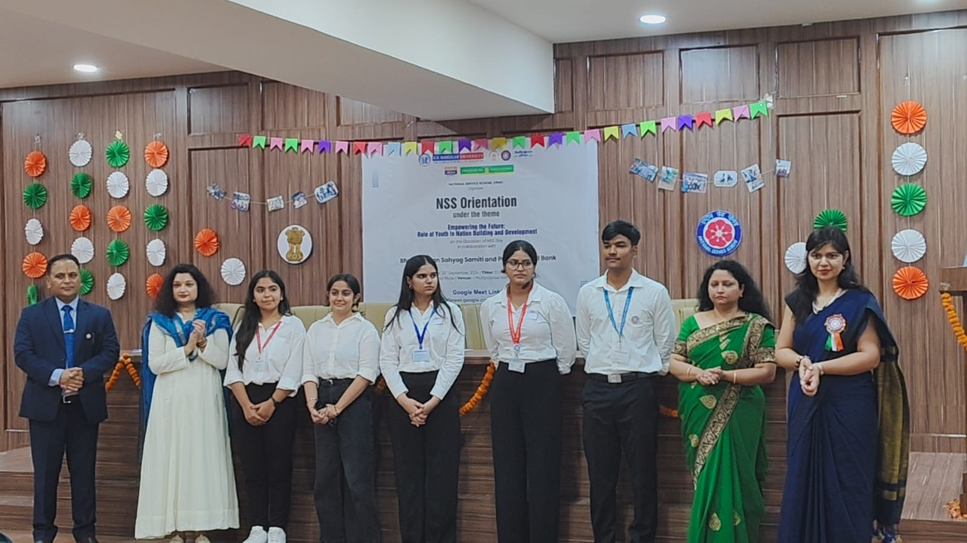

A group photograph of all NSS group leaders
Expert Session on ‘Unlocking Cyber Security’

A Cyber Security Awareness Session titled ‘Unlocking Cyber Security’ was organized by NSS, K.R. Mangalam University on 9th September 2024 in the Multipurpose Hall, targeting NSS volunteers. The session was coordinated by Mr. Thomas Monteiro, with Ms. Ruchika Bhakhar, Assistant Professor, SOET, as the expert speaker. She discussed key cyber threats like phishing, malware, and identity theft, along with preventive measures such as strong passwords, two-factor authentication, and legal frameworks. The session concluded with an engaging Q&A on ethical hacking and cyber security careers. Volunteers gained valuable insights into safeguarding their digital presence.
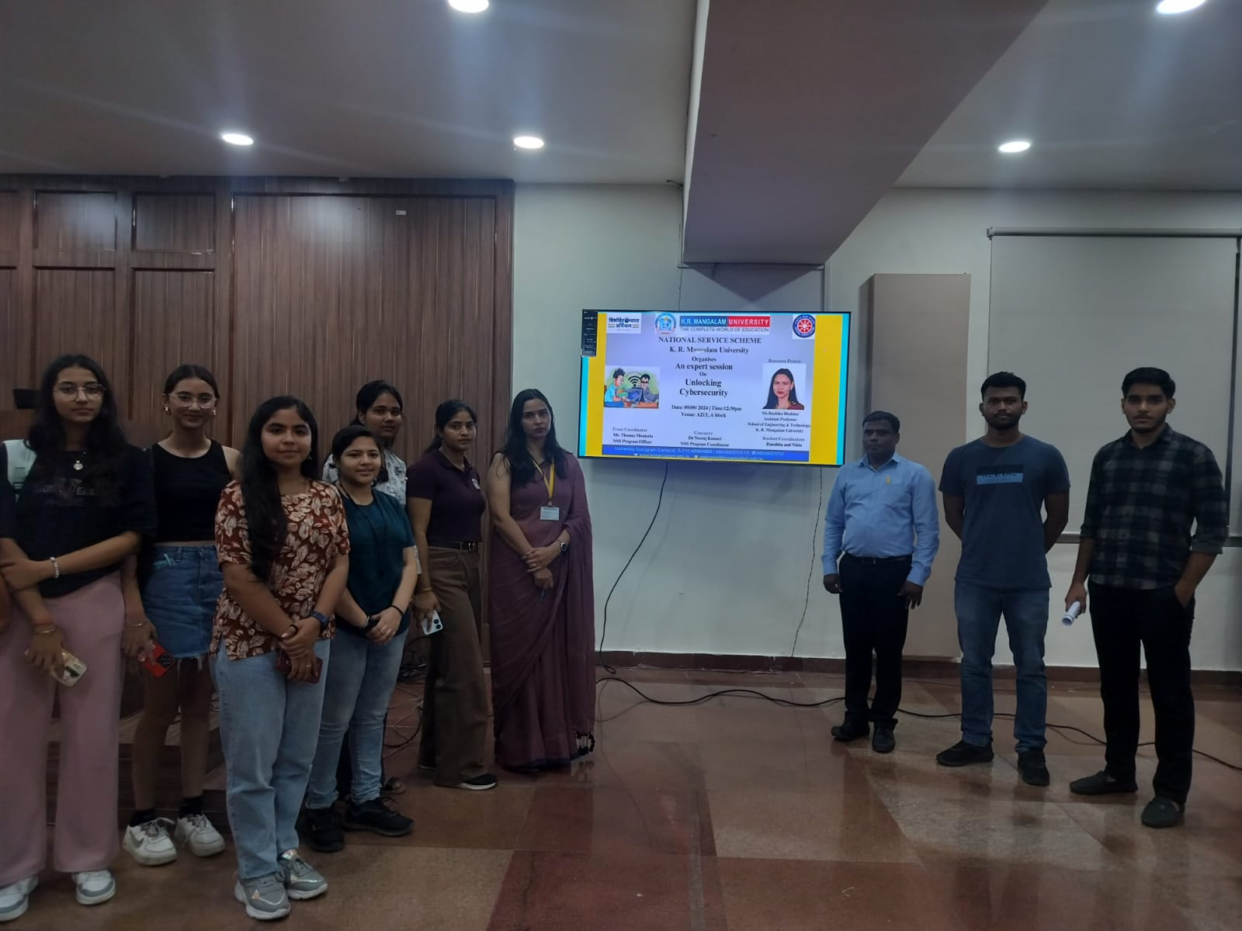

A group photograph of speaker and NSS volunteers

Road Safety Awareness Session

An awareness session on Road Safety was organized by the NSS and Youth Red Cross Society of K.R. Mangalam University in collaboration with the Traffic Police, Sohna, under the coordination of Dr. Neeraj Kumari on 5th November 2025. The session aimed to educate students about traffic rules, causes of road accidents, and the importance of responsible driving. Mr. Mahesh Soni, a traffic officer, discussed key safety practices like obeying traffic signals, wearing helmets and seat belts, and avoiding mobile use while driving. Dr. Rahul Sharma, Registrar, and Dr. Monika Yadav, YRC Coordinator, also addressed the students. The session was interactive and concluded with a strong message on being responsible road users. It successfully raised awareness among 24 NSS volunteers and other students, encouraging them to become ambassadors of road safety in their communities.
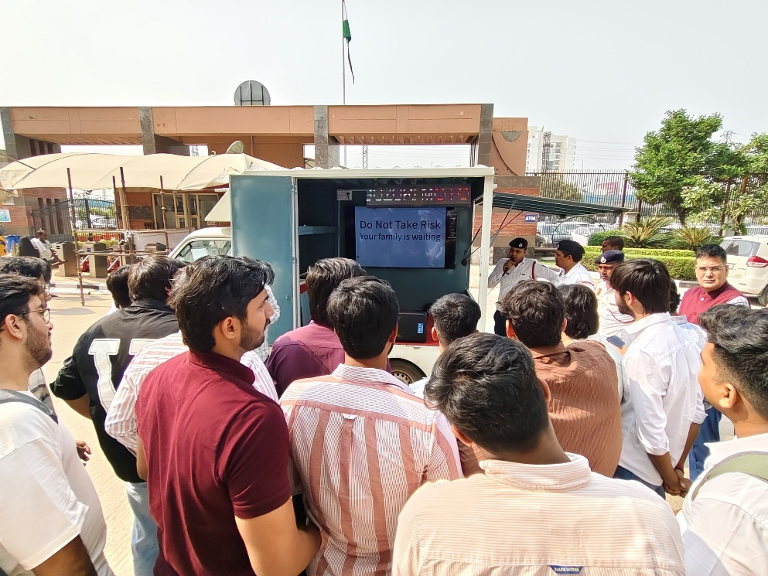

Mr Mahendra Soni expliane about the traffic rules to students

“MY BHARAT: Empowering India’s Youth for a Viksit Bharat”

An online awareness session on "MY Bharat: Empowering India’s Youth for a Viksit Bharat" was organized by NSS-KRMU on 25th October 2024. Over 35 NSS volunteers participated in the event coordinated by Dr. Neeraj Kumari. The session highlighted the MY Bharat portal, launched by Hon’ble PM Narendra Modi, as a dynamic platform to involve youth in national development. Dr. Neeraj guided students on the registration process, volunteering opportunities, and curriculum vitae building through the portal. She also discussed key topics such as One Nation One Election and current electoral challenges. The session concluded with a motivational message encouraging youth to participate in community development initiatives. Volunteers gained valuable insights and expressed a strong commitment to contributing towards Viksit Bharat.

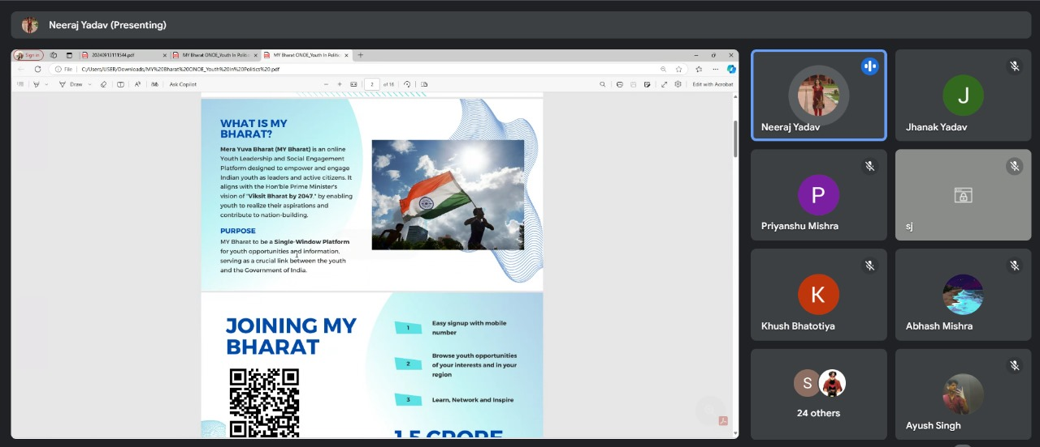

Dr. Neeraj Kumari explained about the enrollement process on My Bharat portal

Visit of School students at K. R. Mangalam University

As part of the Twinning Program, 19 students from Govt. Sr. Sec. School, Abheypur, along with 3 faculty members, visited K.R. Mangalam University. Coordinated by Dr. Neeraj Kumari and Dr. Nudrat Jahan, the visit aimed to introduce school students to university education and infrastructure. The students toured various labs including chemistry, physics, pharmacy, agriculture, mass media, and computer science. They learned about lab techniques, safety protocols, and participated in interactive sessions. In the mass media lab, students experienced live demonstrations of video production and news broadcasting. The visit provided valuable insight into academic and career opportunities, inspiring students to pursue higher education with renewed enthusiasm.

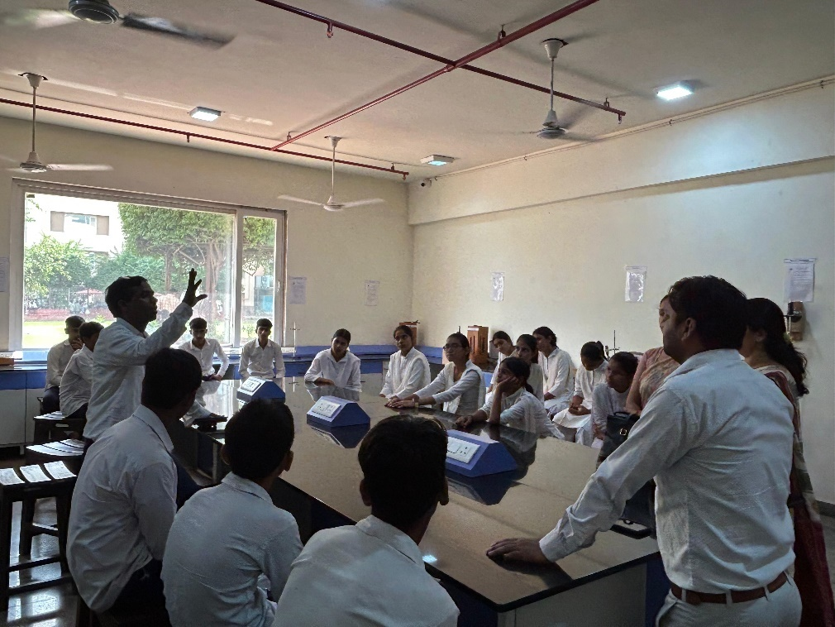

School students exploring physics lab and asking their doubts

Educational Visit under Twinning Program

An educational trip was organized by the NSS Unit of K.R. Mangalam University for 24 students and 10 teachers from Sarvodya Public School, Nuh, under the Twinning Program. The visit aimed to introduce school students to higher education opportunities and inspire them through practical exposure. The students toured various university facilities including the Aryabhata, Bhaskaracharya, and Chanakya Blocks, Forensic Lab, SHOMCT Kitchen, Moot Court, and Psychology Lab. They also participated in interactive sessions and demonstrations. NSS volunteers welcomed the guests and facilitated the visit. Dr. Neeraj Kumari and Dr. Sikha Dutt Sharma extended a vote of thanks and shared university mementos. The visit concluded with appreciation from the school faculty and a commitment to future collaboration.

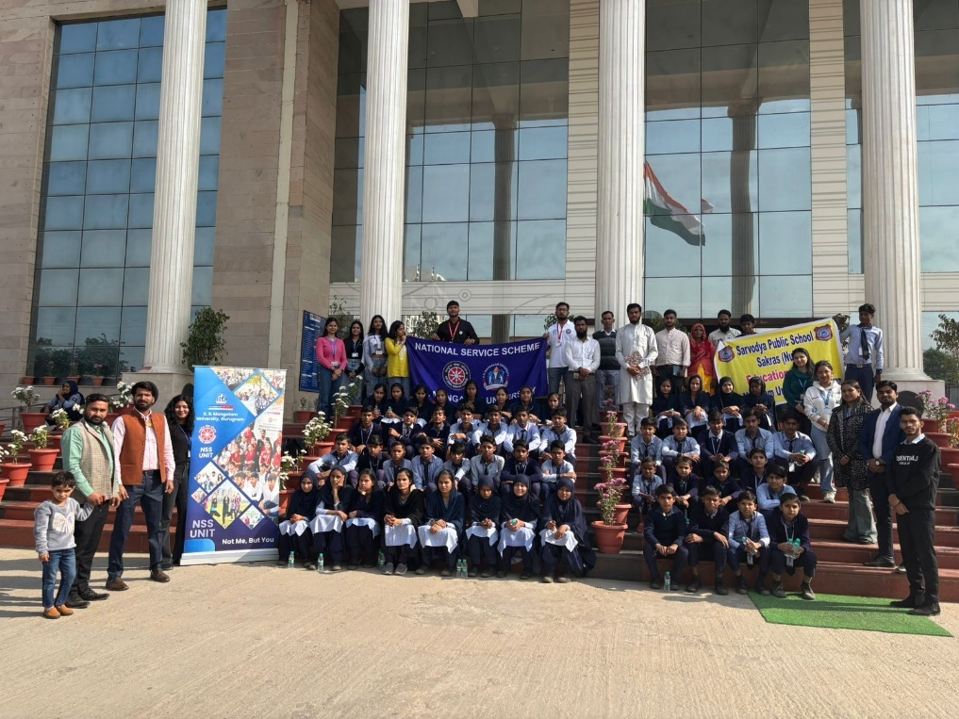

School students at K. R. Mangalam University

Poster Making Competion on ‘Say No To Drugs’

The NSS Unit of K.R. Mangalam University organized an impactful Poster Making Competition on the theme “Say No to Drugs” to raise awareness about the harmful effects of drug abuse. The event witnessed enthusiastic participation from 60 students across various disciplines, who showcased their creativity through powerful and meaningful artwork.
The competition was coordinated by Dr. Thomas Monteiro (NSS Program Officer) and Dr. Sapna Rana, and judged by Dr. Shikha Dutt, IQAC Coordinator. Posters were evaluated on creativity, message clarity, relevance, and visual appeal.
Winners were awarded cash prizes:
1st Prize: Riya Goswami (B.A. Psychology) – ₹1000
2nd Prize: Somiya (B.Des UI & UX) – ₹700
3rd Prize: Nishtha Yadav (B.Sc Chemistry) – ₹300
The event successfully encouraged students to express their views on drug prevention while promoting responsible behavior and community awareness. It was a strong step toward building a healthier, drug-free society.
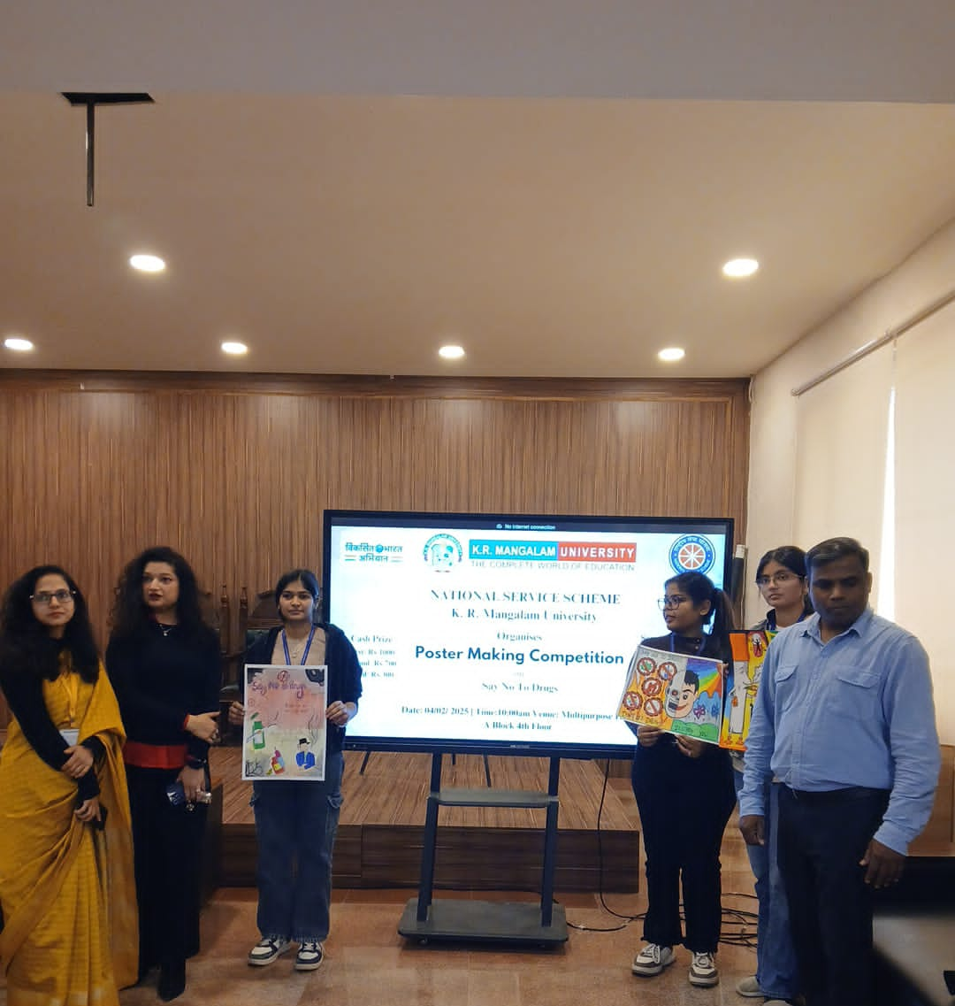

Winner of competition with judge and event coordinators

Visit of School Students at K R Mangalam University

On 17th February 2025, K.R. Mangalam University organized an educational visit for over 44 school students (Classes 9 to 12) from Govt. Sr. Sec. School, Abheypur, Sohna. Coordinated by Dr. Neeraj Kumari, Mr. Amit Kumar Yadav, and Dr. Vicky Kapoor, the visit aimed to introduce students to higher education facilities and scientific learning environments. Students explored the School of Physiotherapy and Rehabilitation Sciences and participated in interactive lab sessions. They visited Chemistry, Physics, and Forensic Science labs, engaging in demonstrations like fingerprint analysis and crime scene techniques. In the Pharmacy and Allied Sciences labs, they learned about medicine formulation in both allopathic and Ayurvedic contexts. The tour ended with a visit to the Central Library, exposing students to academic resources. The NSS team, along with 31 volunteers, ensured smooth coordination. The visit offered hands-on learning and sparked curiosity in scientific fields. Overall, it was a successful initiative to motivate students toward higher education and scientific careers.
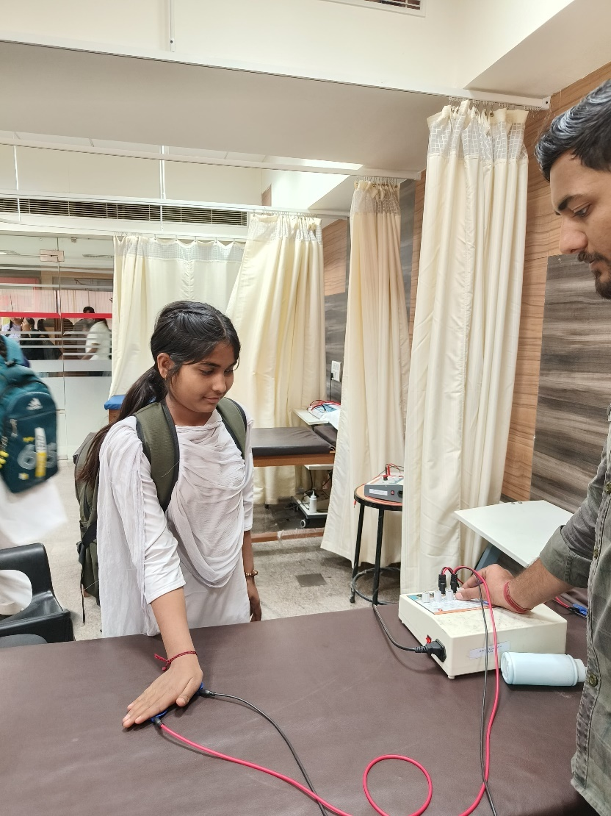

Commemoration of Ambedkar Jayanti: “Relevance of Ambedkar's Vision in the Indian Constitution”
On the occasion of Ambedkar Jayanti, the NSS Unit of K.R. Mangalam University organized a discussion on the topic “Relevance of Ambedkar's Vision in the Indian Constitution.” The session was moderated by Dr. Kriti Singh, Assistant Professor, School of Legal Studies, and attended by 35 students and 4 faculty members. The discussion focused on themes like reservation, “One Nation One Election,” and democratic participation. Students shared innovative ideas for making Ambedkar’s vision more applicable to today’s India. The event concluded with a pledge on the Preamble of the Constitution and a vote of thanks by Mr. Thomas Monteiro, NSS Program Officer.

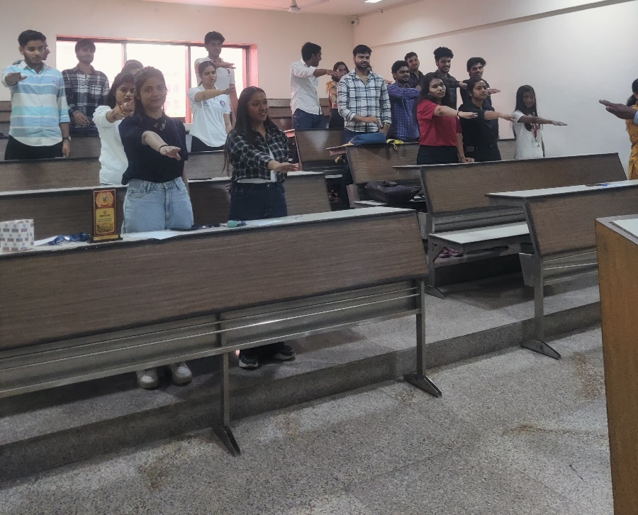

NSS volunteers during pledge ceremony

District Youth Parliament (DYP) Organized by NSS, K.R. Mangalam University

K.R. Mangalam University organized a grand District Youth Parliament on 22-23 March 2025 with the theme "One Nation, One Election: Guiding Towards a Developed India." Participants from Rewari, Faridabad, and Gurugram were selected through screening, with 150 out of 200 registered students taking part enthusiastically. The event was coordinated by NSS officials and volunteers and featured distinguished guests like former state and education officials, jurists, and university dignitaries. On day one, Gurugram students competed, while Rewari and Faridabad students competed on day two. The program also included vibrant cultural performances by NSS students. Ten winners were announced and awarded certificates by the jury. The university and guests praised the youth’s active participation and encouraged their role in nation-building. The event successfully promoted youth engagement and leadership. Overall, it was a well-coordinated, inspiring, and energetic two-day program.

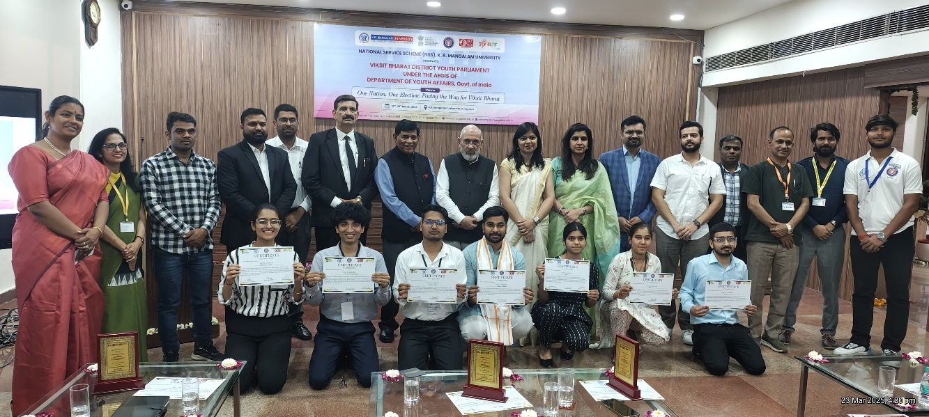

A group photograph with the experts and winners of VBDYP

Expert Session: The Power and Potential of Solar Cells in Daily Life

The NSS Unit of K.R. Mangalam University organized an expert session on “The Power and Potential of Solar Cells in Daily Life” on 11th April 2025 at the Bhaskaracharya Block, Gurugram campus. Dr. Ankit Kumar Rao, Head of R&D at P3C Technology Pvt. Ltd., was the guest speaker, who enlightened NSS and KRMU students on solar technologies, with a focus on advanced perovskite solar cells. The session aimed to raise awareness about renewable energy, demonstrate solar cell functionality, and inspire student engagement in sustainable energy practices. Dr. Rao covered solar fundamentals, emerging trends, real-life applications, and the commercial potential of solar technology. Students actively interacted during the Q&A round, expressing interest in green energy projects. The event highlighted the importance of clean energy and industry-academic collaboration. It successfully deepened students' knowledge of solar innovations and encouraged future research and internships. Plans were discussed to initiate a Green Campus drive and further expert talks. The session strengthened KRMU’s commitment to sustainability and innovation.

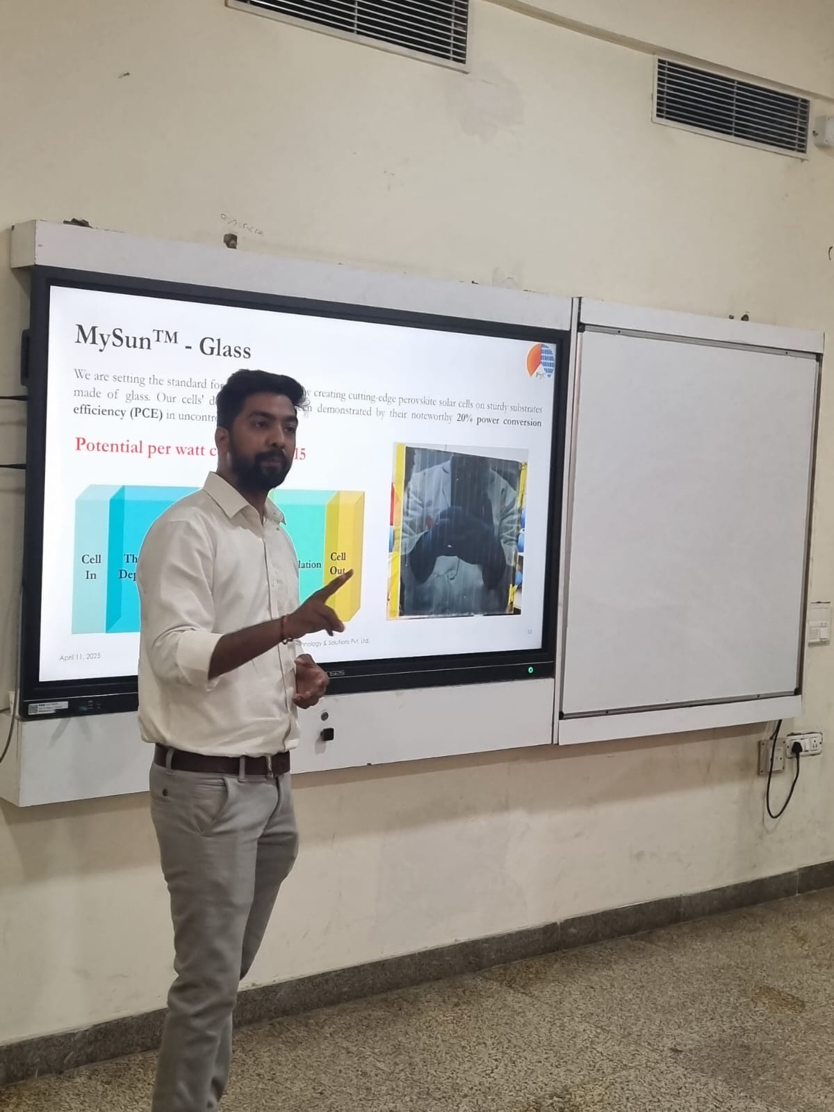

Dr. Ankit Rao explaining about the application of Perovskite Solar Cells

Reel to Real: Exploring Earth’s Challenges through Film and Quiz

On the occasion of World Earth Day (April 22, 2025), the NSS unit of K.R. Mangalam University organized an offline event titled "Reel to Real: Exploring Earth’s Challenges through Film and Quiz" in Room C303. Coordinated by Dr. Sapna Rana with student leads Srishty Singh and Prakhar, the event saw the participation of 40 NSS volunteers. A documentary film highlighting major environmental issues like climate change, plastic pollution, and biodiversity loss was screened. This was followed by an interactive quiz to assess and reinforce students' learning. The program aimed to sensitize students to environmental crises and promote sustainable practices. Through visual storytelling and engagement, the event encouraged critical thinking and environmental responsibility. Dr. Rana appreciated the volunteers' efforts and urged students to adopt eco-friendly habits. The initiative successfully transformed Earth Day from symbolic observance to active learning. NSS reaffirmed its commitment to continue fostering environmental awareness and action among youth.

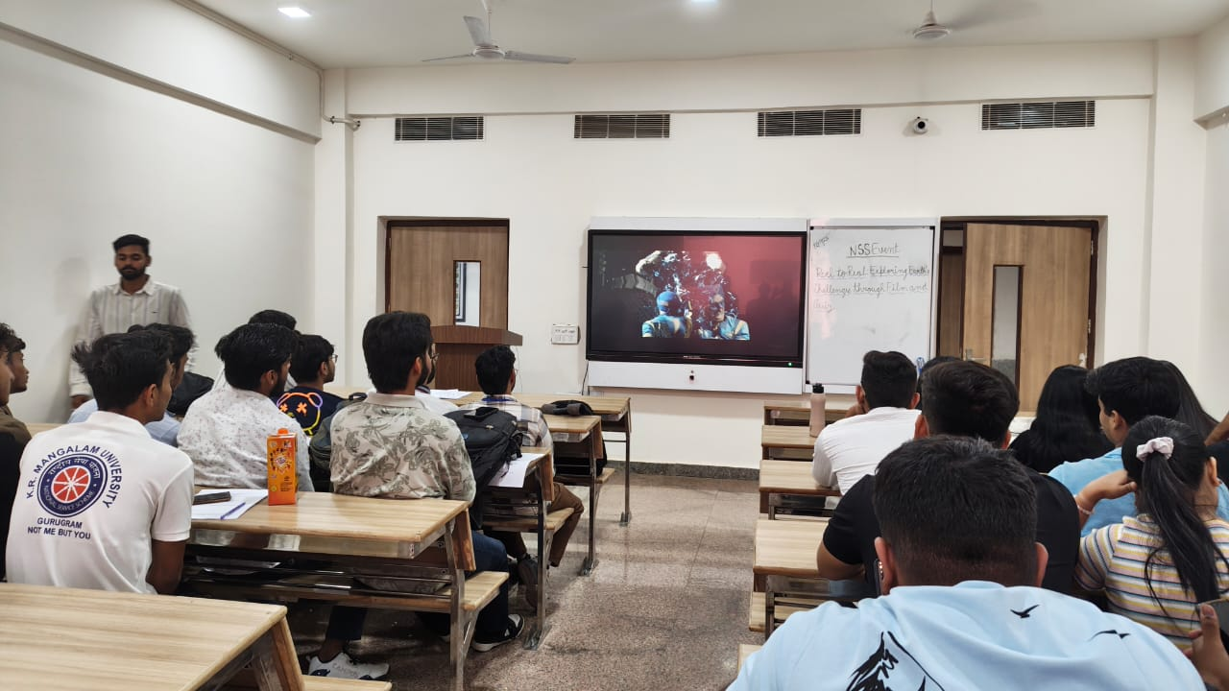

NSS volunteers watching the film

NSS IN NEWS

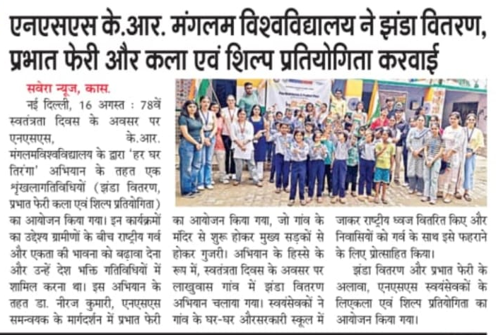

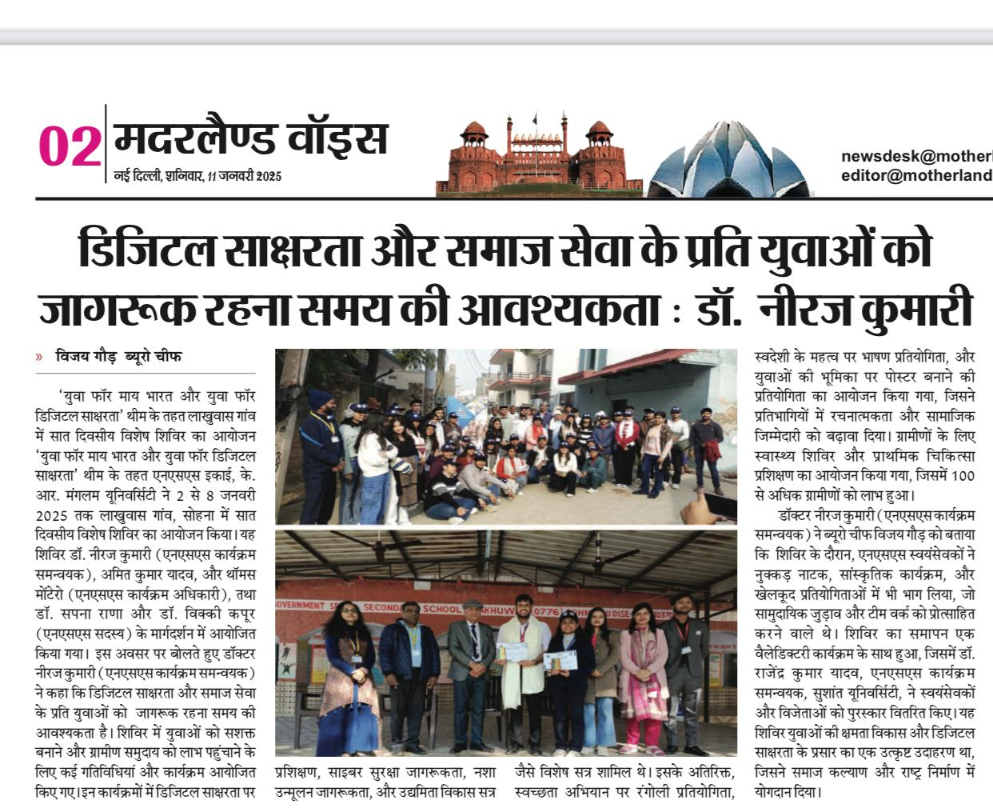
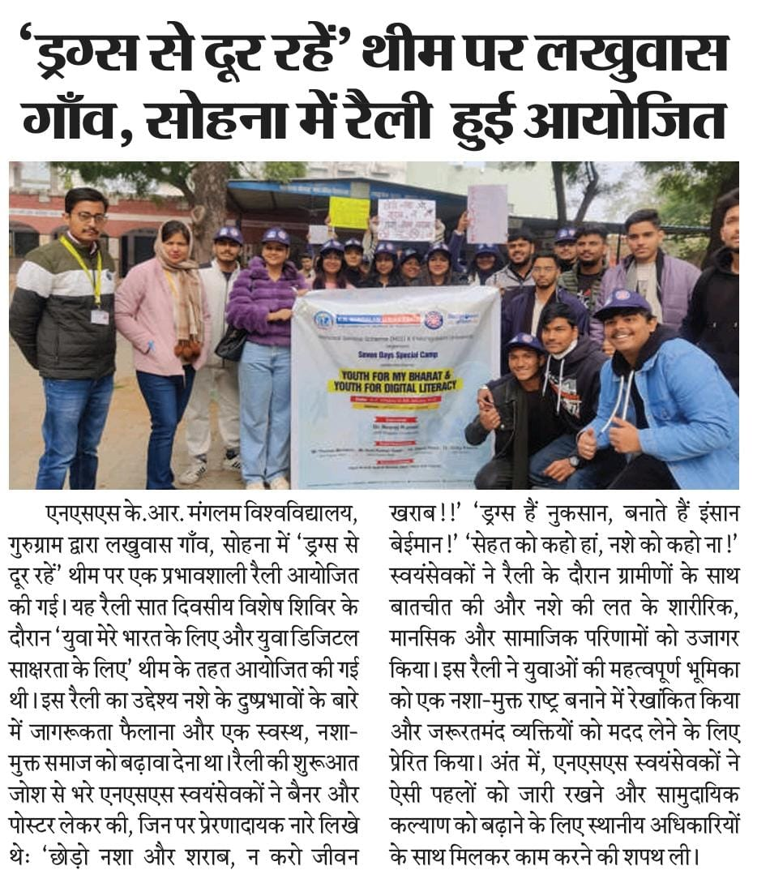

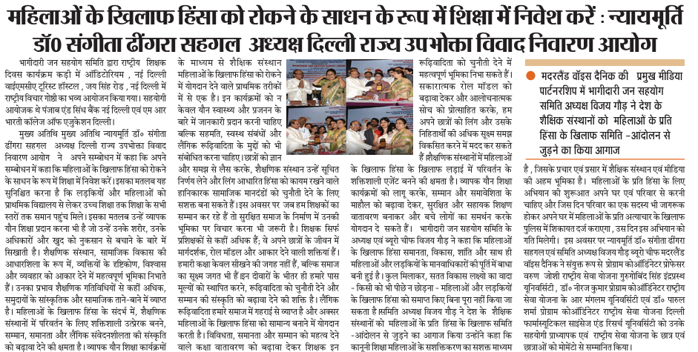

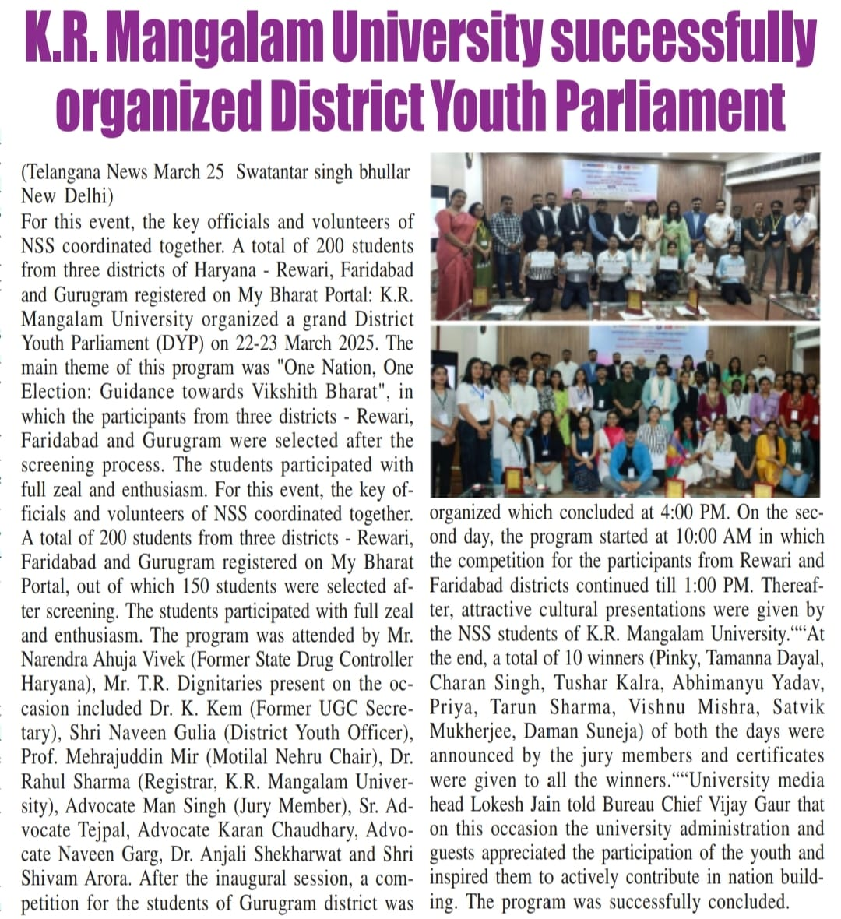

WORDS FROM ALUMNI

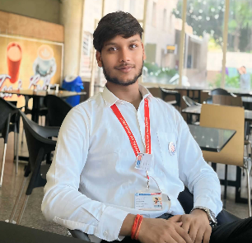
I am Utpal Anand, a B.Tech CSE student, and I have been part of NSS
since my first year of college. It has been a very special and important part
of my college journey. In the first year, I worked as a volunteer and took
part in almost 90% of the events. I learned many new things like
teamwork, helping others, and understanding social responsibility.
In the second year, I got the chance to become the President of NSS.
Leading the team and managing events gave me a lot of confidence.
I learned how to stay calm in difficult situations, how to plan and manage events, and how to lead a group of people with unity.I also attended several camps like the National Integration Camp, Adventure Camp, and the Seven-Day Special Camp. During these camps, I met people from different backgrounds and learned many new things. Each camp gave me new experiences and taught me valuable life lessons like discipline, teamwork, and self-confidence. NSS has helped me grow as a person, These two years with NSS have taught me life skills that I will always carry with me. I feel proud and happy to be a part of NSS.
Utpal Anand
President
NSS-KRMU

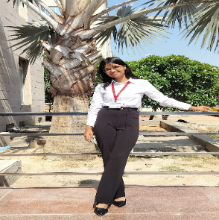
Joining the National Service Scheme (NSS) has been one of the most
transformative decisions of my college life. Over the last two years,
NSS has given me countless opportunities to step beyond academics
and contribute meaningfully to society. I am incredibly grateful for
the experiences, lessons, and memories this journey has gifted me.
From participating in blood donation camps, awareness rallies on women's safety, and plantation drives, to organizing donation campaigns for underprivileged children I’ve witnessed the power of collective effort and the importance of empathy. One of the highlights of my NSS journey was the seven-day special camp in a nearby village, where we conducted hygiene awareness sessions, sanitation drives, and evening teaching programs for children. Those interactions touched my heart and deepened my understanding of grassroots issues.
I’ve grown as a person emotionally, socially, and morally. I’ve learned to communicate better, lead responsibly, and most importantly, listen with compassion. NSS has also helped me build strong friendships, shaped my identity, and shown me how fulfilling it is to serve without expectation. I extend my heartfelt gratitude to my mentors, fellow volunteers, and the NSS unit for making these two years so impactful.

Aakriti Bansal
Vice president
NSS-KRMU

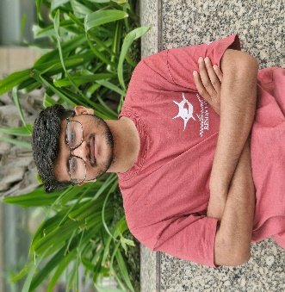
"Completing my two-year journey with the National Service Scheme
(NSS) at K.R. Mangalam University has been a deeply enriching and
transformative experience. During this time, I actively participated in
various community outreach programs, awareness drives, and
social development projects, contributing meaningfully to causes
such as health, education, and environmental sustainability.
These activities helped me grow not just as a responsible citizen, but also as a team leader, planner, and communicator. NSS instilled in me a strong sense of discipline, empathy, and dedication toward societal upliftment. I am proud to have served through this platform and will carry these values forward into every aspect of my personal and professional life."*

Gaurav Pandey
NSS Volunteer
NSS-KRMU

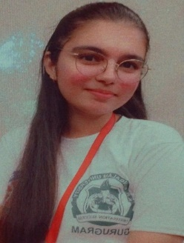
When I first joined the National Service Scheme (NSS), it was
out of encouragement from my seniors and the comfort of beginning
this journey alongside my friends. At the time, I simply thought it
would be easier to learn, grow, and contribute with familiar faces
around. But what began as a step taken for comfort turned into a
transformative chapter of my life.
Over the years, I’ve had the privilege to participate in impactful activities such as village surveys, the annual NSS camp, the National Integration Camp (NIC), and several awareness events that focused on social and community upliftment. Each event was more than just an activity — it was a moment of connection, learning, and contribution. While I never held a formal leadership title, I was always involved in organizing events, supporting our teachers, and helping behind the scenes to ensure everything ran smoothly. I discovered that leadership isn't always about being in the front — it's often about showing up, supporting, and serving with heart.
Through NSS, I developed values that go far beyond textbooks — teamwork, empathy, social responsibility, and the joy of selfless service. I learned that real change often begins with simple actions, and that being present and willing to help can make all the difference.
Some of the most unforgettable moments were during the NSS and NIC camps. Meeting people from different backgrounds, sharing stories, working together, and learning from one another — those experiences taught me the beauty of unity in diversity. They helped me grow more confident, understanding, and aware of the world beyond my own.
This journey has shaped my personality in quiet but powerful ways. NSS has made me more compassionate, responsible, and grounded. It has given me a deeper understanding of community, and the belief that each of us holds the power to uplift others in meaningful ways.
To anyone considering joining NSS, I would say this: step in with an open heart. You won’t just be serving others — you’ll be discovering the best version of yourself.

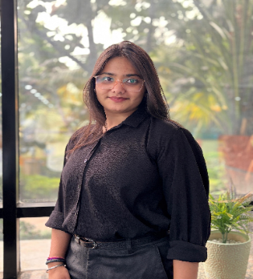
Being an NSS volunteer for the past two years has been one of
the most enriching and transformative experiences of my life. The
National Service Scheme gave me a platform to serve the
community while developing my personality and leadership skills.
Throughout my journey, I actively participated in various social
service activities such as blood donation camps, cleanliness drives
under Swachh Bharat Abhiyan, tree plantation programs, health awareness campaigns, and visits to orphanages and old age homes. Each activity deepened my understanding of social responsibility and taught me the value of selfless service.
One of the highlights of my NSS experience was participating in the special rural camp. Living in a village and working closely with the locals to address their issues not only broadened my perspective but also made me more empathetic and grounded. It showed me that even small actions can make a big difference in someone’s life.

NSS helped me build communication skills, teamwork, discipline, and a strong sense of commitment. It instilled in me a genuine desire to contribute to society and inspired me to continue volunteering beyond college. I am truly grateful to NSS for giving me the opportunity to grow not just as a student, but as a responsible citizen of the country.

Shweta Chaudhary
NSS Volunteer
NSS-KRMU

NATIONAL INTEGRATION CAMP

S N | Name of the NSS volunteer | Course | Name of the Institute | Date
1 | Ayush Singh | B. Tech | Chaudhary Ranbir Singh University Jind, Haryana | 12-18 November 2024
2 | Mr Vaibhav Vaid | B. Tech | Guru Jambheshwar University of Science and Technology, Hisar | 11-17 October 2024
3 | Harshita | B Com (P) | S.D. (PG) college, Panipat | 21-27 October 2024
4 | Nitin Yadav | B. Pharma | S.D. (PG) college, Panipat | 21-27 October 2024
5 | Anuvanshika | B. Sc. (H) Mathematic | BRCM Vidyagram Campus, Bahal | 6-12 November 2024
6 | Amrit Anand | B. Sc. (H) Physics | BRCM Vidyagram Campus, Bahal | 6-12 November 2024
7 | Utpal Anand | B. Tech. | Chaudhary Charan Singh Haryana Agricultural University, Hisar, Haryana | 23-29 October 2024
8 | Aakriti Bansal | B. A. (H) Psychology |  | 23-29 October 2024
9 | Maitali | BPT | Indira Gandhi University, Meerpur, Rewari, Haryana | 21-27 October 2024
10 | Ansh | B. tech | Indira Gandhi University, Meerpur, Rewari, Haryana | 21-27 October 2024

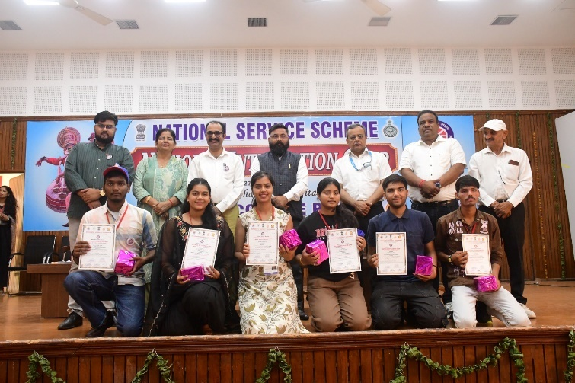
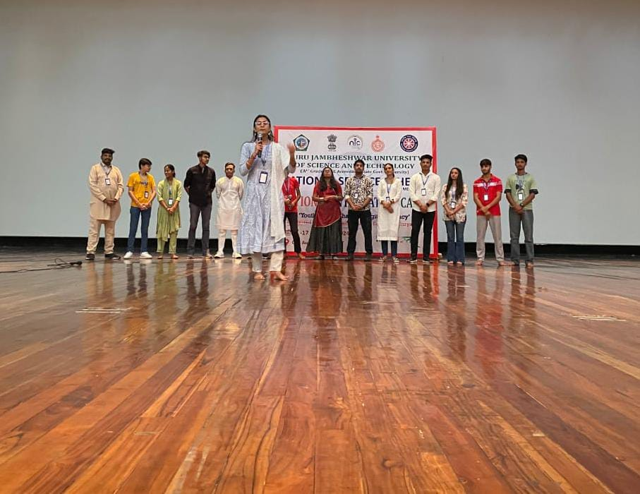

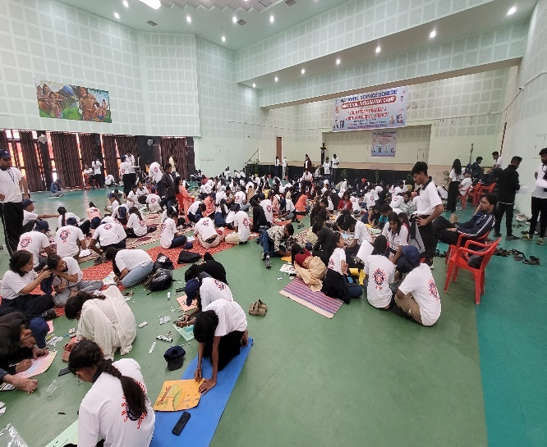
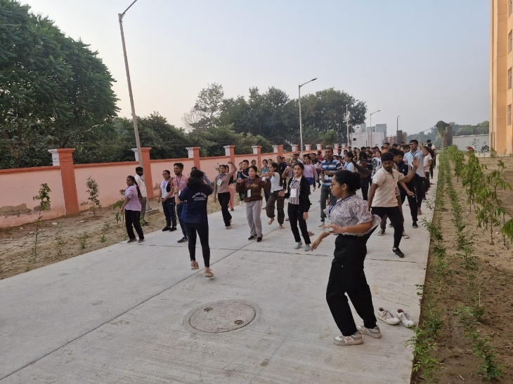

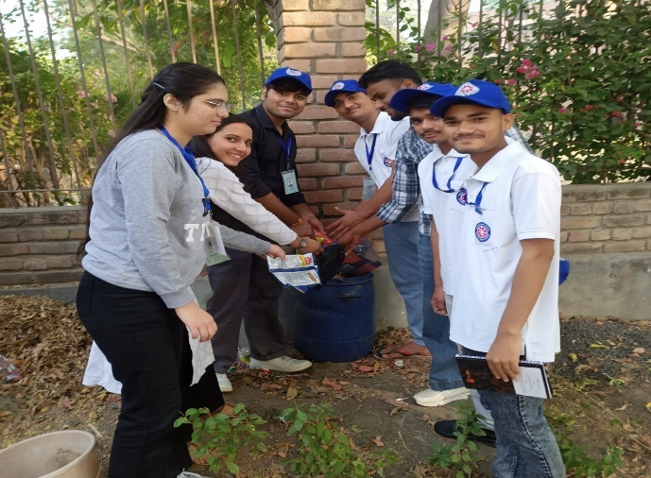
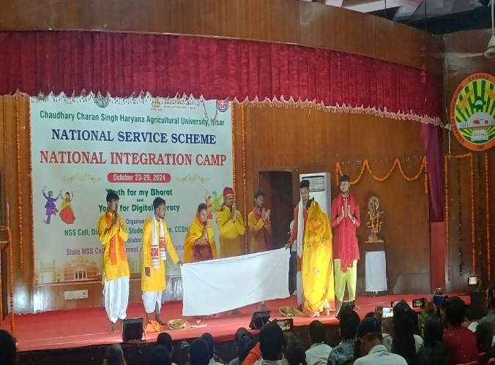

NSS ADVENTURE CAMP

S N | Name of the NSS volunteer | Course | Name of the Institute | Date
1 | Utpal Anand | B. Tech | Jispa in Lahaul and Spiti, Himachal Pradesh | 5-14 November 2024
2 | Chirag Bahal | B. Tech | Jispa in Lahaul and Spiti, Himachal Pradesh | 5-14 November 2024
3 | Harshita | B Com (P) | Jispa in Lahaul and Spiti, Himachal Pradesh | 10-19 October 2024
4 | Priyanshi | B. Tech | Jispa in Lahaul and Spiti, Himachal Pradesh | 10-19 October 2024

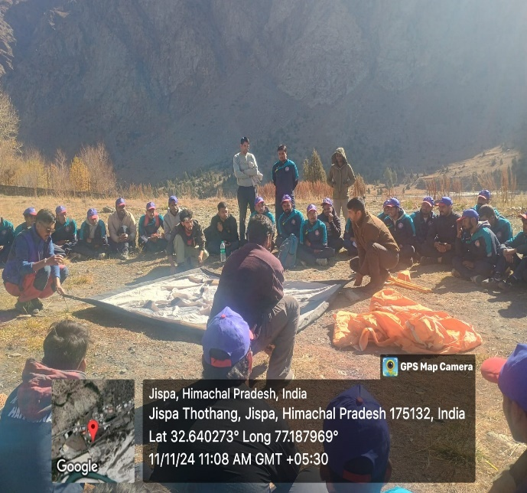
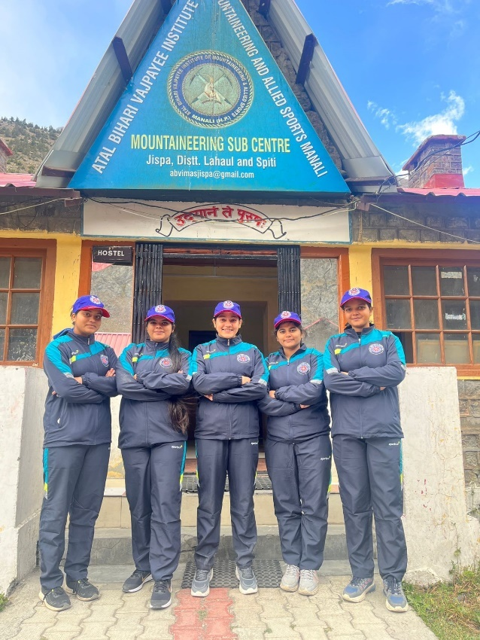

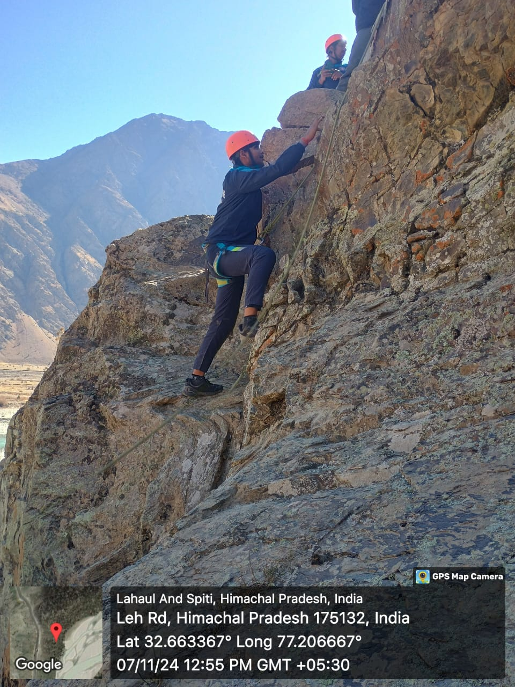

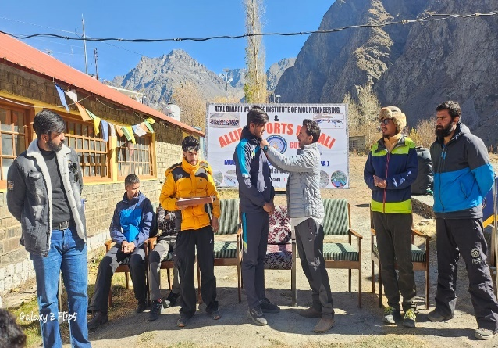

NSS ACHIEVEMENTS

Name of the Award/ recognition | Name of the Awarding agency
National Award for Social Initiatives from Bhagidari Jan Sahyog Samiti | Bhagidari Jan Sahyog Samiti
National Public Awareness Award | Bhagidari Jan Sahyog Samiti
Special Award to Ms. Akriti Winner of Debate Competition | Bhagidari Jan Sahyog Samiti
First Position in Fusion Dance to Mr Ansh | NIC Camp organized by Indira Gandhi University, Meerpur
3rd Position in Musical Fusion to Ms Mitali | NIC Camp organized by Indira Gandhi University, Meerpur
First Position in Drama to Ms Mitali | NIC Camp organized by Indira Gandhi University, Meerpur
Adarsh Rai (B Tech CSE)  1st Position in Valleyball Competition | Mehasrshi Markendshwar University, Mullana, Ambala, Punjab
Anushree Sharma (BA (H) Research)  3rd Position in Skit Competition | Mehasrshi Markendshwar University, Mullana, Ambala, Punjab
Abhas Mishra (B Tech CSE)  1st Position in Treasure Hunt | Mehasrshi Markendshwar University, Mullana, Ambala, Punjab
Abhas Mishra (B Tech CSE)  3rd Position in Tug of War | Mehasrshi Markendshwar University, Mullana, Ambala, Punjab
Yashvi Sahu (BCA Hons)  1st Position in Tug of War | Mehasrshi Markendshwar University, Mullana, Ambala, Punjab
Yashvi Sahu (BCA Hons)  1st Position in Group Singing | Mehasrshi Markendshwar University, Mullana, Ambala, Punjab
Avneet Tanwar (B Tech CSE)  Best Volunteer Award | Mehasrshi Markendshwar University, Mullana, Ambala, Punjab

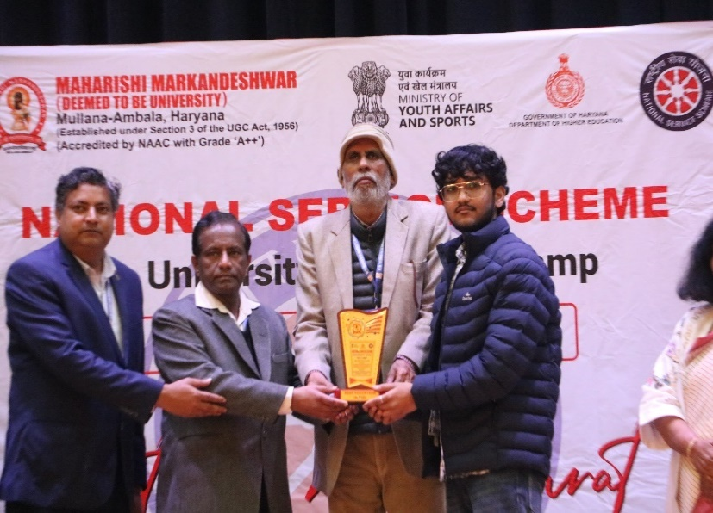
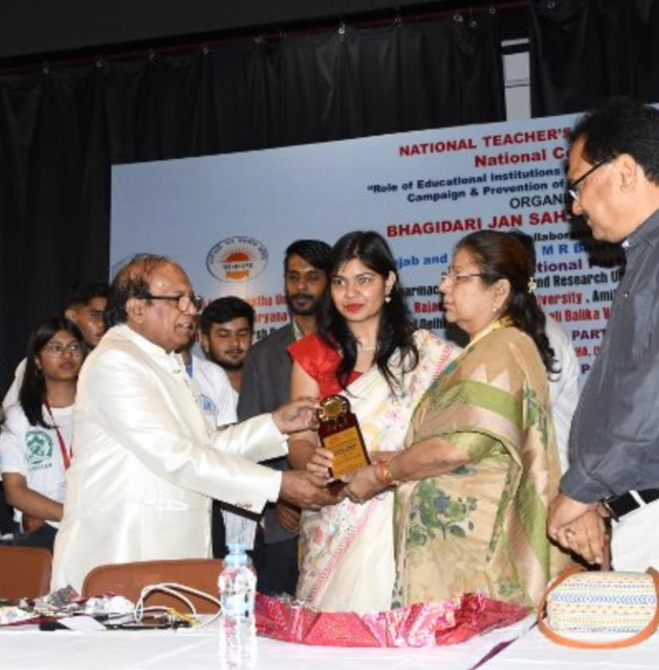

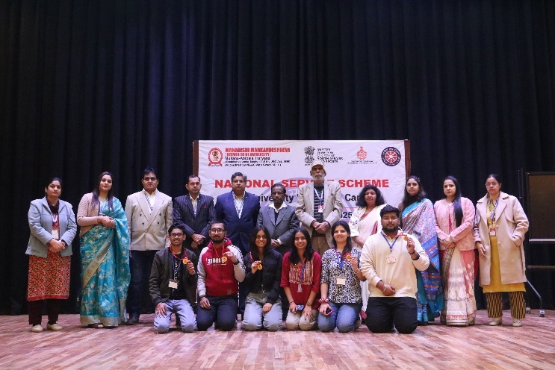
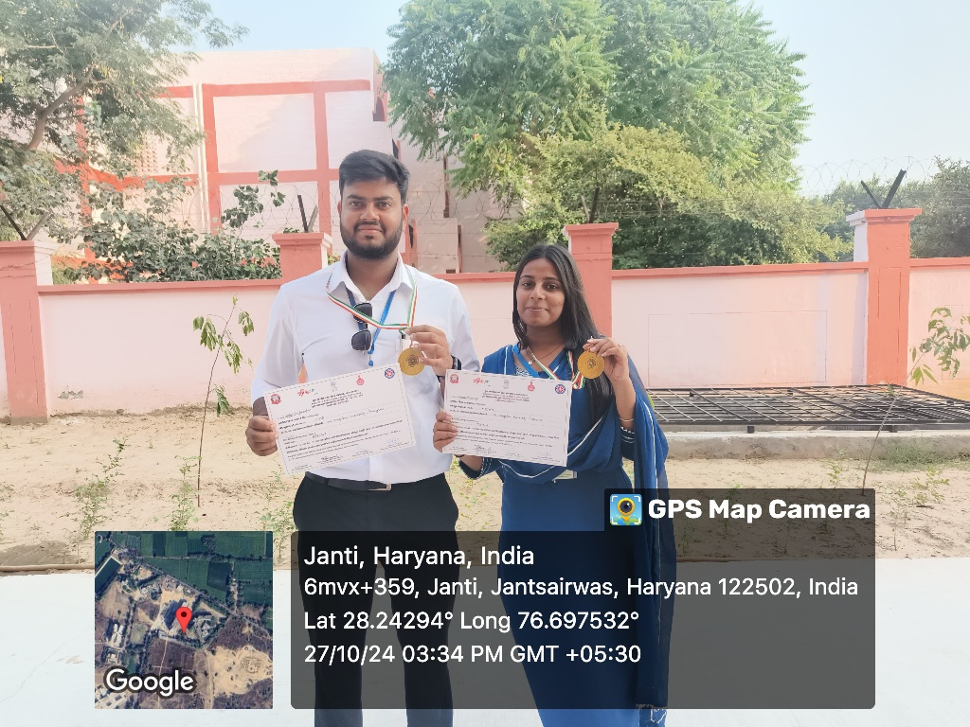

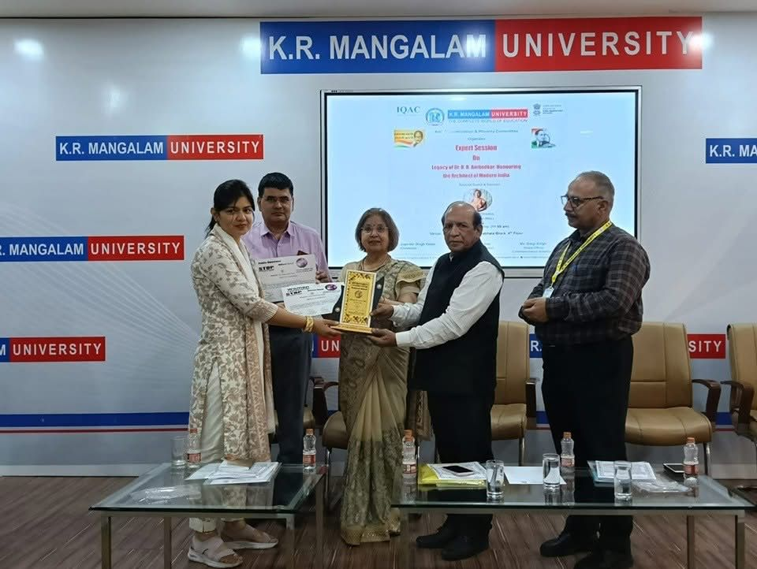
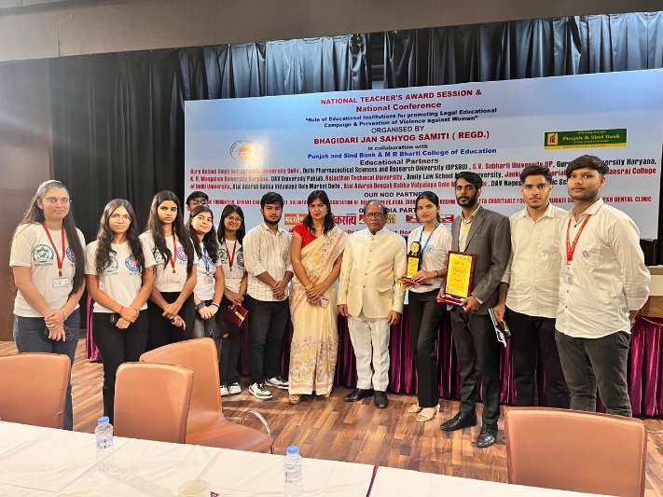

NSS MERIT CERTIFICATES

S N | Name of NSS V olunteers | Course and Semester
01 | Chirag Bahal | B. Tech. CSE (UX/UI)
02 | Riya Goswami | B. A. (H) Psychology
03 | Nitin Yadav | B. Pharma
04 | Anuvsnhika | B. Sc. (H) Mathematics
05 | Shweta Chaudhary | BBA BIA
06 | Amrit Anand | B. Sc. (H) Physics
07 | Mitali | BPT
08 | Aakriti Bansal | B. A. (H) Psychology
09 | Archana | B. Sc. (H) Mathematics
10 | Gaurav Pandey | B. Tech. CSE (FSD)
11 | Bhawana Yadav | B. Sc. (H) Mathematics
12 | Harshita | B. Com. (P)
13 | Utpal Anand | B. Tech. CSE (UX/UI)
14 | Mansi Rustagi | BPT

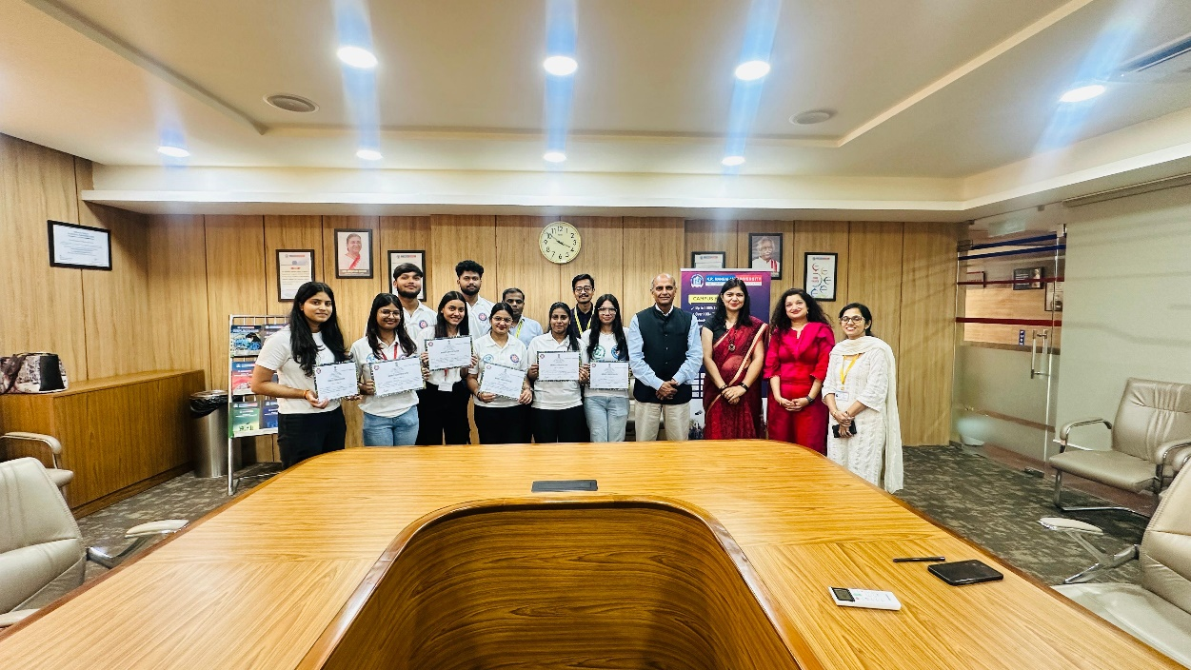

NSS vounteers with Hon’able Vice Chancellor, KRMU
NSS GALLERY

