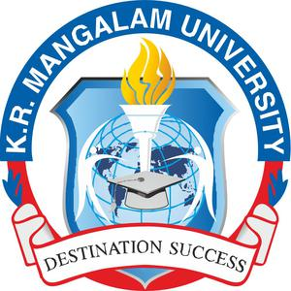
WASTE MANAGEMENT Initiative Report
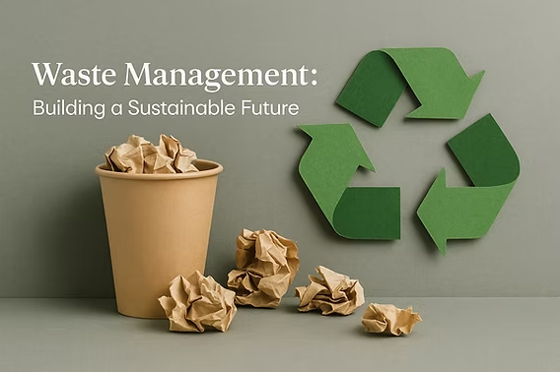

CONTENTS

1. Institutional Context & Sustainability Framework
1.1 Campus Profile
1.2 Sustainability Framework & Policies

2. Waste-Derived Resource Utilisation, Green Cover and Campus Environment
3. Waste Management Systems at K. R. Mangalam University

4. Wastewater Treatment and Reuse Systems

5. Monitoring, Review and Performance Tracking

6. Local Community Outreach for Waste Management and Resource Recovery

7. Plan for Reduction of Waste Generation and Improvement of Resource Recovery

K. R. Mangalam University (KRMU), Gurugram, has established a structured, outcome-oriented framework for solid waste management, organic waste treatment, recycling, and wastewater reuse, integrated within campus operations, community engagement, and institutional planning. The University recognises that increasing academic, residential, and service activities lead to higher waste generation and therefore adopts systematic measures to ensure efficient handling, scientific processing, and responsible disposal of all waste streams while minimising environmental impact.
The waste management framework at KRMU combines infrastructure deployment, operational mechanisms, behavioural interventions, and institutional oversight to achieve measurable improvements in waste reduction, recycling efficiency, and resource recovery. Waste is managed across academic blocks, hostels, canteens, horticulture areas, and service facilities through clearly defined processes for segregation, collection, treatment, and reuse. Continuous monitoring and verification of waste-handling practices ensure compliance with environmental standards and support continuous improvement in waste management performance.
The University’s waste management strategy is built around the following core parameters:
- Comprehensive Solid Waste Segregation and Collection:
KRMU has implemented campus-wide source-level segregation using colour-coded bins for biodegradable, non-biodegradable, and sanitary/biomedical waste. Door-to-door collection systems ensure systematic transfer of segregated waste from academic, residential, and common areas to designated processing and storage points, maintaining hygiene and operational efficiency.
- Recycling and Authorized Disposal Systems:
Dry recyclable waste such as paper, cardboard, plastics, and metals is routed through authorized recycling channels, ensuring safe recovery and reducing landfill dependency. E-waste generated from electronic equipment is collected centrally and disposed of through certified recyclers, while biomedical waste is handled through approved agencies in compliance with regulatory norms.
- Organic Waste Treatment and Resource Recovery:
Organic waste from hostels, canteens, and horticulture activities is processed on campus through composting units and a fully operational biogas plant. Food waste is converted into biogas, which is used as a renewable energy source, while the resulting slurry and compost are utilised for campus landscaping and plantation activities. This closed-loop system supports circular waste management and reduces reliance on external inputs.
- Wastewater Treatment and Reuse:
The University operates a functional sewage treatment plant that enables large-scale reuse of treated wastewater for gardening, green belt maintenance, and other non-potable applications. This significantly reduces freshwater consumption and integrates water reuse into the broader waste and resource management framework.
- Community Engagement and Awareness Initiatives:
Waste management practices are reinforced through cleanliness drives, awareness programmes, workshops, and extension activities conducted by NSS volunteers and the campus community. These initiatives promote behavioural change, environmental responsibility, and community participation both within the campus and in nearby villages.
- Governance, Monitoring, and Compliance:
Waste management activities are implemented through defined operational protocols and supported by regular inspections and data tracking. Authorized vendors, documented procedures, and compliance-based handling of waste streams ensure transparency, accountability, and adherence to environmental norms.
Through this integrated and practice-driven approach, K. R. Mangalam University demonstrates effective management of solid waste, progressive enhancement of recycling and reuse, systematic treatment of organic waste, and efficient wastewater reuse. The University’s initiatives reflect a strong commitment to responsible waste governance, circular resource utilisation, and sustainable campus development, consistent with recognised sustainability performance expectations for higher education institutions.

1. SETTINGS & INFRASTRUCTURE

1.1 Campus Profile
K.R. Mangalam University (KRMU), Gurugram, is a contemporary higher education campus comprising academic, administrative, residential, and recreational facilities planned within a resource-conscious and environmentally responsive framework. The campus has been developed with an emphasis on energy efficiency, optimal land use, and integration of green infrastructure, ensuring that growth in academic and residential functions is balanced with environmental responsibility.
Campus planning prioritises reduced energy demand through efficient building layouts, extensive use of natural lighting and ventilation, and the incorporation of renewable energy systems. Sustainable water management practices, waste minimisation strategies, and green cover are integral to campus development, contributing to improved microclimatic conditions and reduced ecological footprint. Collectively, these measures support long-term operational efficiency while fostering a culture of sustainability among students, faculty, and staff.
Campus Features:
- Location: Gurugram–Sohna Road
- Climate: Composite (hot-dry + warm-humid + cold periods)
- Campus Type: Urban, low-rise academic blocks
- Green Cover: > 8,000 trees; shaded pedestrian zones
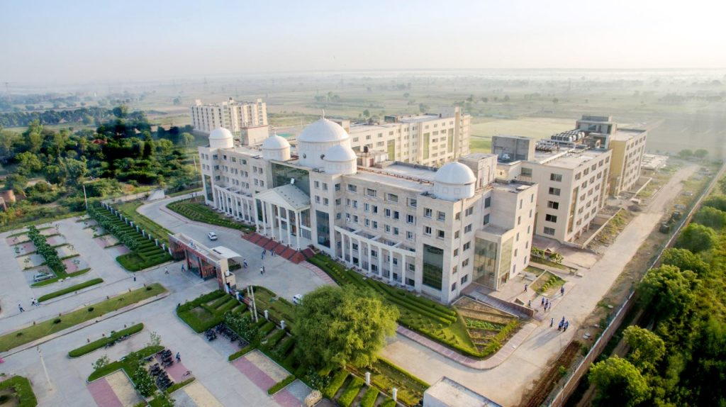
Aerial photograph of campus showing academic blocks and green zones.
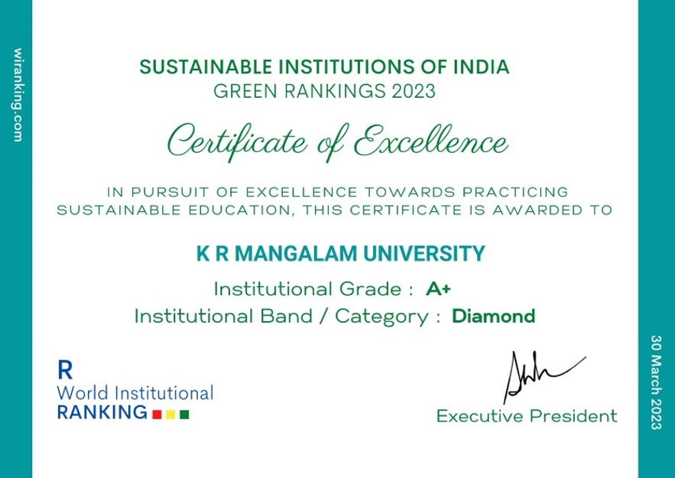
K.R. Mangalam University has been conferred the Certificate of Excellence in the Sustainable Institutions of India – Green Rankings 2023, achieving an A+ Institutional Grade and Diamond Category for its outstanding commitment to sustainable education and campus practices.

1.2 Sustainability Framework & Policies

K. R. Mangalam University (KRMU), Gurugram, has established an institution-wide framework for sustainable waste management and resource recovery, guiding the planning, implementation, and monitoring of solid waste, organic waste, e-waste, biomedical waste, and wastewater management across the campus. The framework reflects the University’s commitment to minimising environmental impact, reducing landfill dependency, promoting recycling and reuse, and adopting circular waste management practices as an integral component of campus operations.
Sustainable Environment & Green Campus Policy

Waste management responsibilities are embedded within institutional governance and operational processes to ensure coordinated implementation, accountability, and regular review. Core practices include source-level segregation, systematic collection, scientific treatment, composting, biogas conversion, recycling through authorised agencies, and wastewater reuse. Emphasis is placed on measurable outcomes such as quantities of waste recycled, organic waste treated, and treated water reused, enabling continuous performance tracking and improvement.
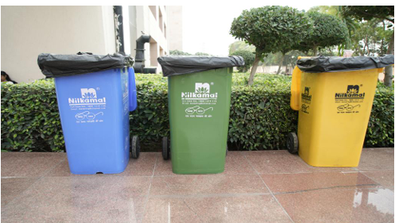

Colour-coded bins across K R Mangalam University promoting source-level waste segregation and responsible recycling

By embedding waste management responsibilities within institutional governance and operational processes, the University ensures coordinated implementation, accountability, and regular review of waste-handling practices. Community engagement through cleanliness drives, awareness programmes, and student participation further strengthens behavioural change and responsible waste practices. Through this integrated and performance-oriented approach, K. R. Mangalam University demonstrates effective stewardship of material resources, advancement of circular waste systems, and sustained progress toward a cleaner, greener, and environmentally responsible campus.

2. Waste-Derived Resource Utilisation, Green Cover and Campus Environment
K. R. Mangalam University (KRMU), Gurugram, integrates waste management practices with campus greening, landscaping, and environmental quality improvement, ensuring that waste-derived resources directly support green cover development and sustainable campus operations. The University adopts a circular approach where organic waste, wastewater, and recyclable materials are systematically processed and reused to enhance campus greenery, reduce environmental burden, and maintain a clean and resource-efficient campus environment.
Organic waste generated from hostels, canteens, and horticultural activities is treated through on-campus composting units and a functional biogas plant, producing organic manure and nutrient-rich slurry. These by-products are utilised extensively for lawns, gardens, plantations, and green belts, reducing the use of chemical fertilizers and supporting soil health. This integration of waste treatment and landscaping demonstrates effective material recovery and sustainable utilisation of campus-generated waste.
Table 1: Resource Recovery and Reuse from Waste Management Practices
Waste Stream | Treatment Method | Recovered Resource | Utilisation on Campus
Food waste | Biogas plant | Biogas energy | Used as a renewable energy source
Biogas slurry | Biogas conversion | Organic manure | Applied to lawns, gardens, and plantations
Horticulture waste | Composting / vermicomposting | Compost | Used for soil enrichment and landscaping
Sewage wastewater | Sewage Treatment Plant (STP) | Treated wastewater | Irrigation, landscaping, green belt maintenance
Dry recyclable waste | Segregation & recycling | Recyclable materials | Sent to authorized recyclers

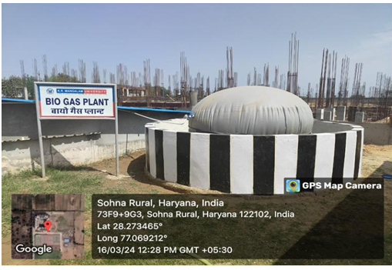

Campus biogas plant converting food waste into clean energy, replacing LPG & generating organic fertiliser
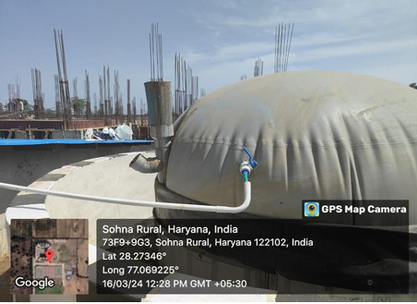

Food waste inlet chamber demonstrating closed-loop waste-to-energy system

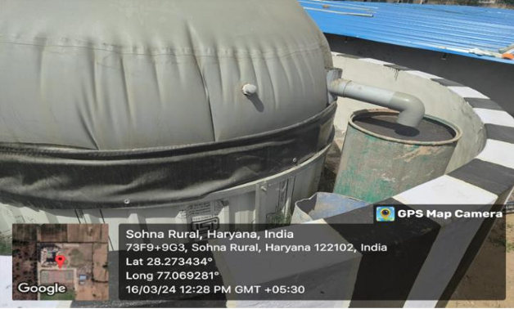

Biogas outlet & slurry discharge used as organic manure for campus horticulture sustainability

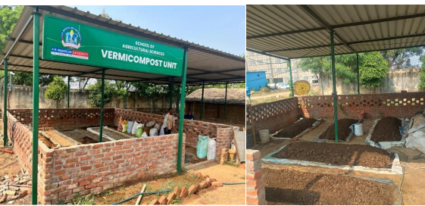

Composting and vermicomposting units

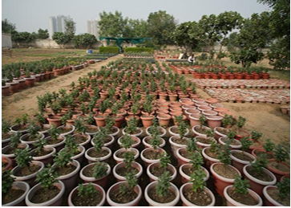

Vermicompost manure used for campus plants and green landscaping at K R Mangalam University, promoting circular waste management

Green Audit

3. Waste Management Systems at K. R. Mangalam University
To minimise environmental impact, reduce landfill dependency, and promote circular resource use, K. R. Mangalam University has systematically integrated waste management considerations into campus planning, daily operations, and institutional practices. With the expansion of academic, residential, and service facilities, the University has adopted structured mechanisms to manage solid waste, organic waste, e-waste, biomedical waste, and wastewater in a scientific and resource-efficient manner. Emphasis is placed on segregation at source, decentralised treatment, recycling, and reuse, ensuring that waste generated on campus is converted into useful resources wherever possible.
Across the campus, operational measures are oriented toward improving hygiene, material recovery, and environmental quality. Colour-coded bins enable segregation at the point of generation, while door-to-door collection ensures systematic handling of waste from academic blocks, hostels, canteens, laboratories, and common areas. Organic waste is diverted from disposal streams and treated through composting and biogas generation, while recyclable and hazardous waste streams are routed through authorised channels. Periodic internal reviews and inspections are used to assess waste quantities, treatment efficiency, and compliance, enabling continuous improvement in waste-handling practices.
Through a combined approach of infrastructure provision, operational controls, monitoring, and community engagement, K. R. Mangalam University continues to strengthen its waste management performance, support circular economy principles, and maintain a clean, safe, and environmentally responsible campus.
Table 2: Details of Installed Waste Management Infrastructure
Component | Capacity / Description
Colour-coded segregation bins | Installed across academic blocks, hostels, corridors, and common areas
Door-to-door waste collection | Daily collection from all campus zones
Composting units | Processing horticulture and biodegradable waste
Biogas plant | Treats ~4,750 kg/year of food waste
Recycling system | Dry waste routed to authorised recyclers
E-waste handling | Dedicated collection and disposal through certified agencies
Biomedical waste system | Disposal through approved service providers
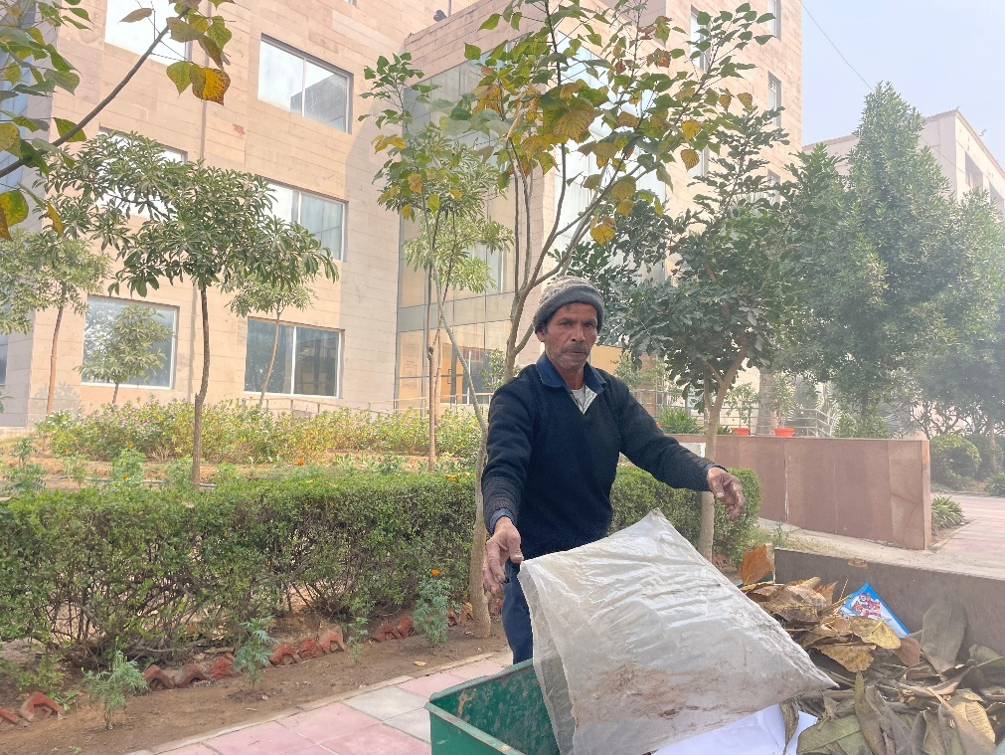

Daily collection of waste from all campus zone

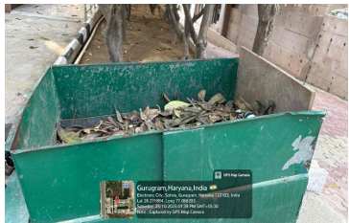

Organic composting of biodegradable waste
4. Wastewater Treatment and Reuse Systems
The University operates a 100 KLD Sewage Treatment Plant, enabling large-scale reuse of treated wastewater. All treated effluent is reused for landscape irrigation, green belt maintenance, and other non-potable applications, significantly reducing freshwater consumption and supporting sustainable campus operations. Water quality parameters such as BOD, COD, and pH remain within prescribed limits, ensuring safe and effective reuse.

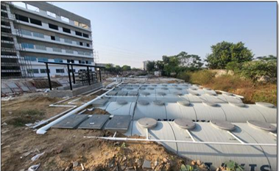

STP near D Block at K R Mangalam University enabling wastewater recycling for irrigation and green landscaping
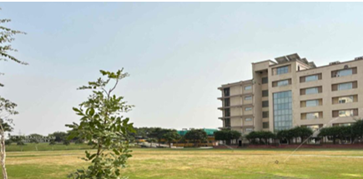

Reused treated water from K R Mangalam University’s STP for plantation and campus landscaping

5. Monitoring, Review and Performance Tracking
K. R. Mangalam University follows a structured approach to track, document, and evaluate waste management performance across academic, residential, and service areas of the campus. The University recognises that effective waste governance depends on reliable data capture, periodic review, and integration of waste indicators into operational decision-making. Accordingly, waste-related parameters are monitored continuously to ensure efficiency, compliance, and progressive reduction of environmental burden.
Quantitative records are maintained for key waste streams, including total solid waste generated, recyclable and reusable materials, food waste processed, biogas output, and treated wastewater reused. These records are compiled annually based on inputs from housekeeping operations, hostel and mess facilities, horticulture units, and authorised waste handlers. Consolidated data is reviewed to assess trends, identify inefficiencies, and support planning for capacity enhancement in composting, biogas generation, and recycling systems.

Table 3: Year-wise Waste Generation, Recycling, and Resource Recovery Performance (2022–25)
Description | 2022–23 | 2023–24 | 2024–25
Total Waste Generated (kg/year) | 77,025 | 92,430 | 1,15,538
Total E-Waste Generated (kg/year) | 3,358 | 4,030 | 5,038
Total Recycled & Reused Waste (kg/year) | 48,369 | 58,043 | 72,554
Total Food Waste Generated (kg/year) | 3,167 | 3,800 | 4,750
Volume of Wastewater Reused (litres/year) | 61,880,000 | 74,256,000 | 92,820,000
Food Waste Converted to Biogas (kg/year) | 3,167 | 3,800 | 4,750
Biogas Generated (kWh/year) | 10,000 | 10,000–14,000 | 15,000

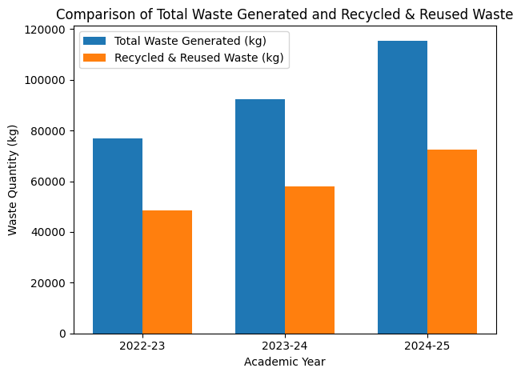

The grouped bar chart shows a consistent increase in total waste generation over the three academic years (2022-25), reflecting expansion in campus activities. Simultaneously, the recycled and reused waste has increased at a comparable rate, indicating strengthened segregation practices, enhanced recycling infrastructure, and improved waste diversion efficiency.
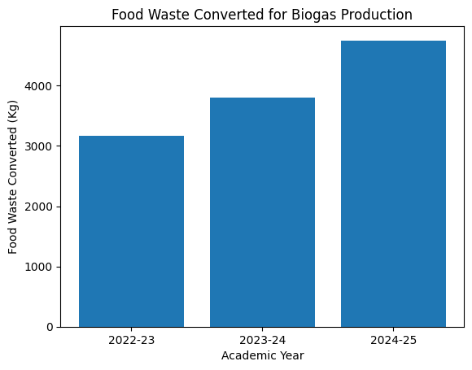

The rising quantity of food waste processed through biogas conversion reflects improved collection and handling of organic waste from hostels and canteens (2022-25). This trend highlights the University’s increasing capacity to channel biodegradable waste into resource-recovery systems.
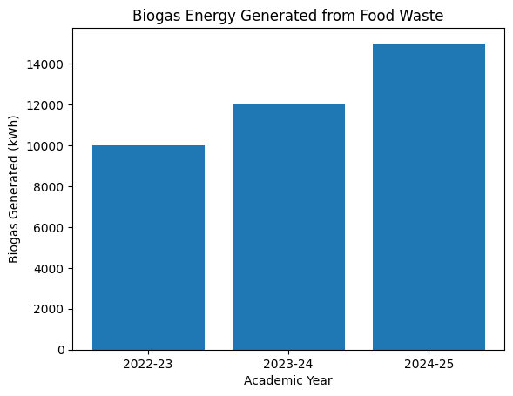

The steady increase in biogas energy generation corresponds with higher organic waste input and improved operational efficiency of the biogas plant through academic year 2022-25. This demonstrates effective conversion of waste into renewable energy, reducing dependence on conventional fuels.
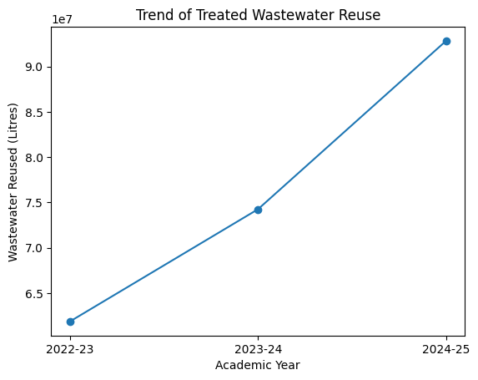

The continuous upward trend in treated wastewater reuse indicates enhanced utilisation of sewage treatment infrastructure and improved water-management practices. Increased reuse for irrigation and landscaping has contributed to reduced freshwater consumption across the campus.
Waste disposal MoU: Hazardous waste & scrap disposal MoU
Audit Reports
Link for green campus initiatives: Green campus initiatives
Sustainable Environment and Green Campus Policy
Biotic Waste Limited -MoU

A particular focus is placed on preventive waste management, where priority is given to segregation at source and decentralised treatment. By ensuring that biodegradable waste is treated on campus and recyclable materials are recovered systematically, the University minimises dependency on external disposal mechanisms and reduces the environmental risks associated with uncontrolled waste handling. Waste streams that require specialised handling, such as e-waste and biomedical waste, are tracked separately to ensure safe transfer through authorised channels.
The environmental implications of waste management practices are reviewed through outcome-based indicators, such as the proportion of waste diverted from landfill, extent of organic waste treated internally, and volume of treated wastewater reused for non-potable purposes. These indicators enable the University to evaluate the indirect environmental benefits of waste management, including improved sanitation, reduced pressure on natural resources, and enhanced campus cleanliness.

Table 4: Waste Management Performance Control Framework
Aspect | Monitoring Approach
Waste quantity tracking | Annual compilation of waste data from campus units
Segregation effectiveness | Visual inspection and waste-stream categorisation
Organic waste handling | Review of composting and biogas processing volumes
Recyclable waste flow | Verification through authorised vendor records
Wastewater reuse | Measurement of treated water applied for landscaping
Review mechanism | Periodic internal assessment and reporting

The following table 5 shows three-year segregated data demonstrates systematic monitoring of waste streams and steady improvement in recycling, organic waste treatment, and wastewater reuse, reflecting controlled and outcome-oriented waste management practices.

Waste Management Indicator | 2022–23 | 2023–24 | 2024–25 | Performance Trend
Total solid waste generated (kg/year) | 77,025 | 92,430 | 1,15,538 | Increasing due to campus expansion
Recycled & reused waste (kg/year) | 48,369 | 58,043 | 72,554 | Consistent improvement
Recycling efficiency (% of total waste) | 62.8% | 62.8% | 62.8% | Maintained efficiency
Food waste processed (kg/year) | 3,167 | 3,800 | 4,750 | Improved segregation & recovery
Organic waste treated on campus (%) | ~100% | ~100% | ~100% | Full internal processing
E-waste safely disposed (kg/year) | 3,358 | 4,030 | 5,038 | Controlled handling
Treated wastewater reused (litres/year) | 61,880,000 | 74,256,000 | 92,820,000 | Strengthened reuse
Biogas energy generated (kWh/year) | 10,000 | 10,000–14,000 | 15,000 | Increasing recover

Periodic inspections, internal reviews, and cross-departmental coordination meetings support corrective actions and continuous improvement. In parallel, awareness initiatives and participatory activities involving students and staff reinforce responsible waste behaviour and strengthen institutional accountability. Through systematic documentation, performance evaluation, and stakeholder engagement, K. R. Mangalam University ensures that waste management functions as a controlled, transparent, and environmentally responsible system within overall campus operations.
green-audit-krmu-23-05-2025.pdf
Biogas plant and compost unit details
Waste segregation policy
environmental audit krmu_Quantity of waste processed
6. Local Community Outreach for Waste Management and Resource Recovery
K. R. Mangalam University adopts a structured and community-oriented approach to promote responsible waste management practices beyond the campus, recognising that environmental sustainability requires active participation from both institutions and local communities. These outreach efforts are guided by the University’s Waste Management and Green Campus Policy, which emphasises waste reduction at source, segregation, resource recovery, and community awareness as core sustainability principles.
Through cleanliness drives, waste awareness campaigns, sanitation programmes, and village-level engagement activities, the University works to build awareness and encourage behavioural change among residents, school students, and youth in nearby rural and peri-urban areas. Outreach initiatives focus on practical waste-handling aspects such as household-level segregation, reduction of single-use plastics, safe disposal of dry and hazardous waste, and management of biodegradable waste through composting and reuse. During the academic year 2023–24, multiple community outreach activities were conducted in nearby villages, engaging local residents and volunteers in hands-on demonstrations and interactive sessions on sustainable waste practices.
In addition to awareness programmes, the University organises workshops, demonstrations, and extension activities to strengthen community capacity in waste management. Faculty members and students collaborate with local stakeholders to demonstrate low-cost composting techniques, cleanliness practices, and environmentally responsible waste disposal methods. These initiatives support the implementation objectives of the institutional policy by translating campus-based waste management practices into replicable community-level solutions.
Waste management outreach is further reinforced through integration with academic activities, NSS programmes, and student-led initiatives, ensuring continuity and accountability in implementation. Policy-aligned monitoring and documentation of outreach activities enable the University to review impact, refine engagement strategies, and strengthen long-term partnerships with local communities. Through this policy-driven yet participatory approach, K. R. Mangalam University ensures that waste management awareness, resource recovery practices, and environmental responsibility extend beyond the campus and contribute to sustainable local development.
Table 6: Details of events and activities
Title of the Activity | Nature of the Activity | Date of Activity | School | Link
International Conference on Advanced Materials for Green Chemistry and Sustainable Environment | Conference | Feb-15-16-2024 | School of Basic & Applied Sciences | Conference Report
The Climate Reality Project | MOU | 2023 | School of Basic & Applied Sciences | MOU- Climate Project
Poster Making Competition on Clean Energy for a Green | Extension Activity | 5-06-2024 | NSS | Report- Poster Making
Plantation and Energy Efficiency Awareness Drive | Extension Activity | 29-06-25 | NSS, in collaboration with KRMU–KEIC STI Hub Foundation | Report Awareness Drive
Awareness on Sustainable Agriculture and Solar Pump Irrigation | Extension Activity | 27-10-2023 | NSS and School of Agricultural Sciences | Report- Sustainable Agriculture
Swachhta and Clean Energy Awareness Camp | Extension Activity | 29-9-2023 | NSS | Report- Swachhta Camp
Cleanliness Drive as a tribute to Mahatma Gandhi on his Birth Anniversary | Extension Activity | 1-10-2023 | NSS | Report- Cleanliness Drive
Hands-on Training for Bio-fertilizers and Biogas as Clean Energy | Workshop | 07–15 May 2024 | School of Agricultural Sciences | Report- Hands on Training
Workshop on Protected Cultivation and Solar-Powered Farming Solutions | Workshop | 21-Sep-23 | School of Agricultural Sciences | Report-Workshop

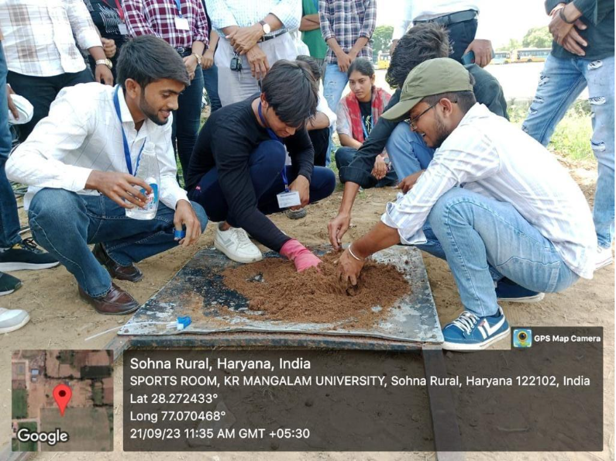
Practical training of students: Students learning energy-efficient and sustainable farming methods through plug tray sowing.
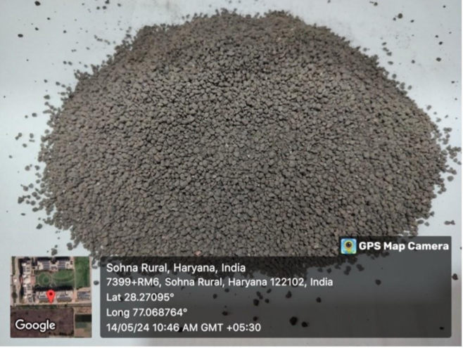
Bio-fertiliser granules prepared during the training session, showcasing practical applications of sustainable agricultural inputs.

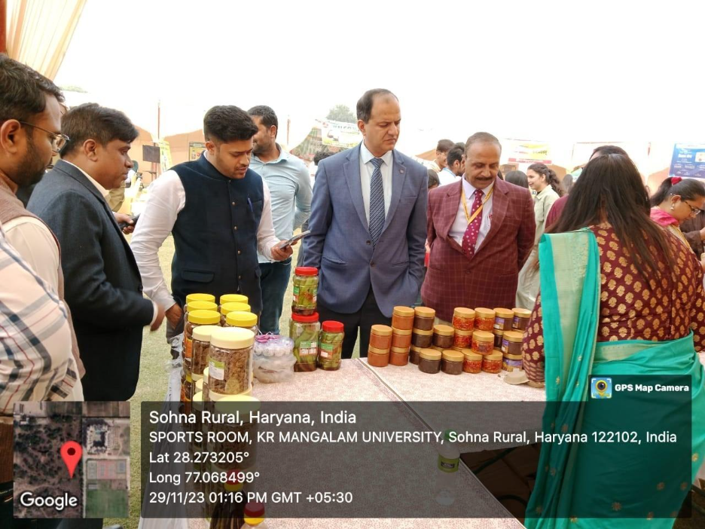
Community outreach in action, Sensitizing farmers to climate-smart and energy-efficient agricultural practices at university
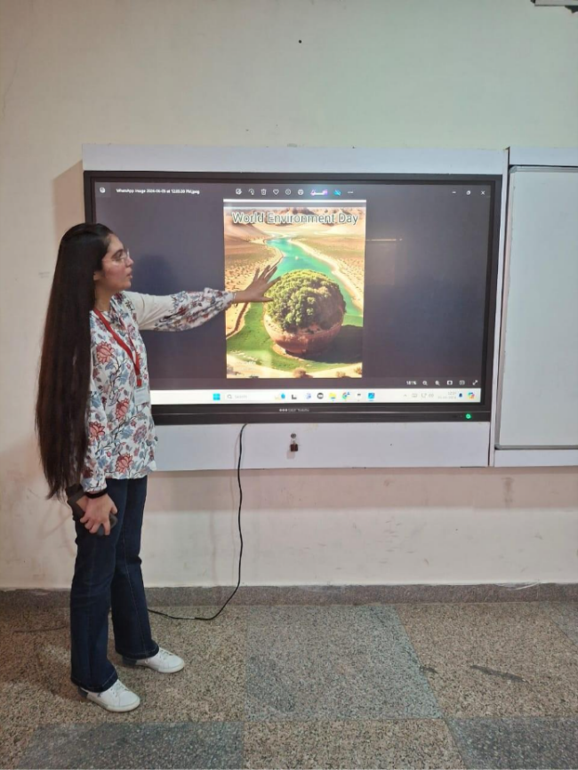
Student participation in a digital poster activity on clean-energy awareness, encouraging behavioural change toward sustainable energy culture.

7. Plan for Reduction of Waste Generation and Improvement of Resource Recovery

K. R. Mangalam University has developed a structured and forward-looking plan to reduce waste generation and enhance resource recovery across academic, residential, and administrative areas of the campus. The plan is guided by year-wise waste generation data and focuses on preventive waste management, segregation efficiency, decentralised treatment, and increased recycling and reuse. By analysing trends in solid waste, food waste, e-waste, and wastewater reuse, the University identifies priority areas for intervention and capacity enhancement.
The University has adopted phased waste reduction and diversion targets, aiming to minimise landfill disposal and strengthen circular waste management practices. Key objectives include improving source-level segregation to maintain recycling efficiency above current levels, increasing on-campus treatment of biodegradable waste through expanded composting and biogas utilisation, and ensuring that a growing proportion of campus waste is processed internally. Special emphasis is placed on reducing mixed waste generation through behavioural change initiatives, promotion of reusable materials, and elimination of single-use plastics in campus operations.
Based on recent data trends, the University plans to scale up organic waste processing capacity in line with increasing food waste generation and to progressively increase the quantity of waste converted into useful outputs such as biogas energy and organic manure. In parallel, systems for tracking recyclable waste and e-waste are being strengthened to ensure safe handling and transfer through authorised channels. Wastewater reuse targets are also aligned with campus growth, with plans to maximise reuse of treated water for landscaping and non-potable applications, thereby reducing freshwater demand.

Implementation of the waste reduction plan is supported through regular monitoring, documentation, and internal review mechanisms. Student engagement, NSS-led activities, and awareness programmes play a key role in reinforcing responsible waste practices and achieving planned outcomes. Through this data-driven and participatory approach, K. R. Mangalam University seeks to progressively reduce its environmental footprint by limiting waste generation, increasing recovery, and promoting sustainable resource use across campus operations.

