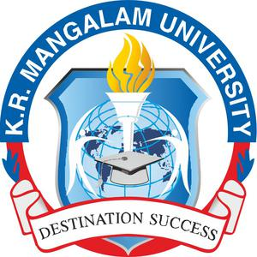
WASTE MANAGEMENT Initiative Report
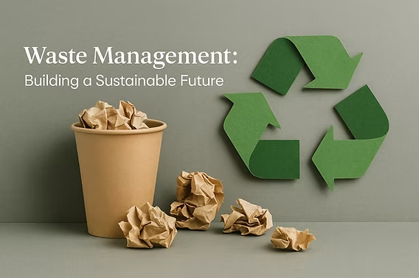

CONTENTS

1. Institutional Context & Sustainability Framework
1.1 Campus Profile
1.2 Sustainability Framework & Policies

2. Waste-Derived Resource Utilisation, Green Cover and Campus Environment
3. Waste Management Systems at K. R. Mangalam University

4. Wastewater Treatment and Reuse Systems

5. Monitoring, Review and Performance Tracking

6. Local Community Outreach for Waste Management and Resource Recovery

7. Plan for Reduction of Waste Generation and Improvement of Resource Recovery

1. Institutional Context & Sustainability Framework
K. R. Mangalam University (KRMU), Gurugram, has established a structured, outcome-oriented framework for solid waste management, organic waste treatment, recycling, and wastewater reuse, integrated within campus operations, community engagement, and institutional planning. The University recognises that increasing academic, residential, and service activities lead to higher waste generation and therefore adopts systematic measures to ensure efficient handling, scientific processing, and responsible disposal of all waste streams while minimising environmental impact.
The institutional waste management framework combines infrastructure deployment, operational mechanisms, behavioural interventions, and institutional governance systems to achieve measurable improvements in waste reduction, recycling efficiency, and resource recovery. Waste generated across academic blocks, hostels, canteens, horticulture areas, and service facilities is managed through clearly defined procedures for segregation, collection, treatment, recycling, and reuse. Continuous monitoring and verification of waste-handling practices ensure compliance with environmental standards and support continuous improvement in waste management performance.
Institutional Waste Governance Structure
Board of Management / Vice Chancellor
↓
Centre for Sustainable Development Goal (SDG)
↓
Estate and Facilities Management Department
↓
Environment and Sustainability Cell
↓
Housekeeping Supervisors and Waste Officers
↓
Operational Waste Handling Staff
↓
Authorised Waste Management Vendors and Recyclers
The institutional governance framework ensures that waste management responsibilities are distributed across strategic, operational, and monitoring levels. While policy direction and sustainability planning are guided by the University's leadership and sustainability committees, operational implementation is managed by facilities and housekeeping teams with oversight from the Environment and Sustainability Cell. This structure ensures accountability, compliance, and systematic coordination in waste management practices.
The University’s waste management strategy is built around several key operational parameters including source-level segregation, decentralised organic waste treatment, recycling through authorised agencies, wastewater reuse, and community awareness initiatives. Through this integrated approach, the University aims to promote circular resource utilisation and sustainable campus management practices.
The University’s waste management strategy is built around the following core parameters:
- Comprehensive Solid Waste Segregation and Collection:
KRMU has implemented campus-wide source-level segregation using colour-coded bins for biodegradable, non-biodegradable, and sanitary/biomedical waste. Door-to-door collection systems ensure systematic transfer of segregated waste from academic, residential, and common areas to designated processing and storage points, maintaining hygiene and operational efficiency.
- Recycling and Authorized Disposal Systems:
Dry recyclable waste such as paper, cardboard, plastics, and metals is routed through authorized recycling channels, ensuring safe recovery and reducing landfill dependency. E-waste generated from electronic equipment is collected centrally and disposed of through certified recyclers, while biomedical waste is handled through approved agencies in compliance with regulatory norms.
- Organic Waste Treatment and Resource Recovery:
Organic waste from hostels, canteens, and horticulture activities is processed on campus through composting units and a fully operational biogas plant. Food waste is converted into biogas, which is used as a renewable energy source, while the resulting slurry and compost are utilised for campus landscaping and plantation activities. This closed-loop system supports circular waste management and reduces reliance on external inputs.
- Wastewater Treatment and Reuse:
The University operates a functional sewage treatment plant that enables large-scale reuse of treated wastewater for gardening, green belt maintenance, and other non-potable applications. This significantly reduces freshwater consumption and integrates water reuse into the broader waste and resource management framework.
- Community Engagement and Awareness Initiatives:
Waste management practices are reinforced through cleanliness drives, awareness programmes, workshops, and extension activities conducted by NSS volunteers and the campus community. These initiatives promote behavioural change, environmental responsibility, and community participation both within the campus and in nearby villages.
- Governance, Monitoring, and Compliance:
Waste management activities are implemented through defined operational protocols and supported by regular inspections and data tracking. Authorized vendors, documented procedures, and compliance-based handling of waste streams ensure transparency, accountability, and adherence to environmental norms.
Through this integrated and practice-driven approach, K. R. Mangalam University demonstrates effective management of solid waste, progressive enhancement of recycling and reuse, systematic treatment of organic waste, and efficient wastewater reuse. The University’s initiatives reflect a strong commitment to responsible waste governance, circular resource utilisation, and sustainable campus development, consistent with recognised sustainability performance expectations for higher education institutions.

1.1 Campus Profile
K.R. Mangalam University (KRMU), Gurugram, is a contemporary higher education campus comprising academic, administrative, residential, and recreational facilities planned within a resource-conscious and environmentally responsive framework. The campus has been developed with an emphasis on energy efficiency, optimal land use, and integration of green infrastructure, ensuring that growth in academic and residential functions is balanced with environmental responsibility.
Campus planning prioritises reduced energy demand through efficient building layouts, extensive use of natural lighting and ventilation, and the incorporation of renewable energy systems. Sustainable water management practices, waste minimisation strategies, and green cover are integral to campus development, contributing to improved microclimatic conditions and reduced ecological footprint. Collectively, these measures support long-term operational efficiency while fostering a culture of sustainability among students, faculty, and staff.
Campus Features:
- Location: Gurugram–Sohna Road
- Climate: Composite (hot-dry + warm-humid + cold periods)
- Campus Type: Urban, low-rise academic blocks
- Green Cover: > 8,000 trees; shaded pedestrian zones
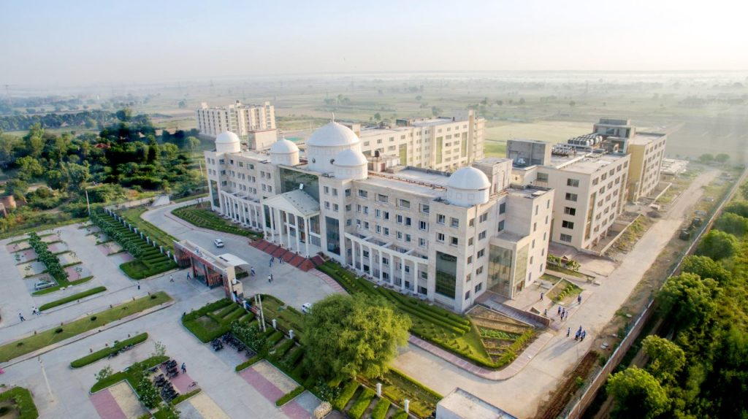
Aerial view of K. R. Mangalam University campus highlighting landscaped green areas, academic infrastructure, and environmentally responsible campus planning that supports sustainable operations and ecological balance.
K.R. Mangalam University has been conferred the Certificate of Excellence in the Sustainable Institutions of India – Green Rankings 2023, achieving an A+ Institutional Grade and Diamond Category for its outstanding commitment to sustainable education and campus practices.

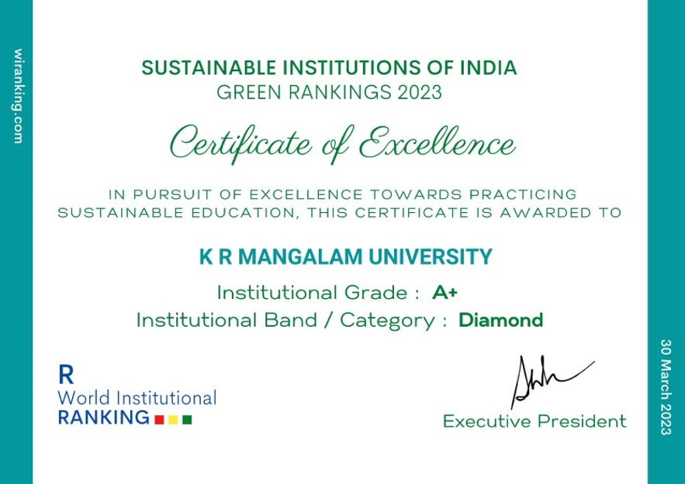

1.2 Sustainability Framework & Policies

K. R. Mangalam University (KRMU), Gurugram, has established an institution-wide framework for sustainable waste management and resource recovery, guiding the planning, implementation, and monitoring of solid waste, organic waste, e-waste, biomedical waste, and wastewater management across the campus. The framework reflects the University’s commitment to minimising environmental impact, reducing landfill dependency, promoting recycling and reuse, and adopting circular waste management practices as an integral component of campus operations. The governance framework links strategic leadership with operational execution and external regulatory compliance.
Sustainable Environment & Green Campus Policy
Sustainable Policy

As part of its sustainability framework, the University has implemented a ban on single-use plastic and other disposable items across the campus to reduce waste generation at source. The policy is supported through official administrative orders and procurement restrictions that discourage the purchase and use of single-use items within university premises. Compliance with this policy is incorporated into vendor and contractor agreements, ensuring that service providers adhere to the University's environmentally responsible procurement standards. In addition, monitoring mechanisms and compliance checks are carried out periodically, and appropriate corrective measures or penalties are applied in cases of non-compliance.
Waste management responsibilities are embedded within institutional governance and operational processes to ensure coordinated implementation, accountability, and regular review. Core practices include source-level segregation, systematic collection, scientific treatment, composting, biogas conversion, recycling through authorised agencies, and wastewater reuse. Emphasis is placed on measurable outcomes such as quantities of waste recycled, organic waste treated, and treated water reused, enabling continuous performance tracking and improvement.
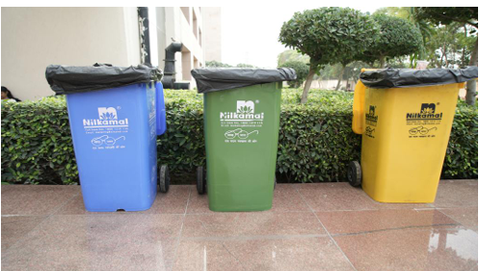

Colour-coded bins across K R Mangalam University promoting source-level waste segregation and responsible recycling
Colour-coded bins across K. R. Mangalam University promote source-level waste segregation and responsible recycling. By embedding waste management responsibilities within institutional governance and operational processes, the University ensures coordinated implementation, accountability, and regular review of waste-handling practices. Community engagement through cleanliness drives, awareness programmes, and student participation further strengthens behavioural change and responsible waste practices. Through this integrated and performance-oriented approach, K. R. Mangalam University demonstrates effective stewardship of material resources, advancement of circular waste systems, and sustained progress toward a cleaner, greener, and environmentally responsible campus.
2. Waste-Derived Resource Utilisation, Green Cover and Campus Environment
K. R. Mangalam University (KRMU), Gurugram, integrates waste management practices with campus greening, landscaping, and environmental quality improvement, ensuring that waste-derived resources directly support green cover development and sustainable campus operations. The University adopts a circular approach where organic waste, wastewater, and recyclable materials are systematically processed and reused to enhance campus greenery, reduce environmental burden, and maintain a clean and resource-efficient campus environment.
Organic waste generated from hostels, canteens, and horticultural activities is treated through on-campus composting units and a functional biogas plant, producing organic manure and nutrient-rich slurry. These by-products are utilised extensively for lawns, gardens, plantations, and green belts, reducing the use of chemical fertilizers and supporting soil health. This integration of waste treatment and landscaping demonstrates effective material recovery and sustainable utilisation of campus-generated waste.
In addition to food and biodegradable waste, horticulture waste generated from landscaping, tree pruning, and garden maintenance is systematically managed within the campus. The University processes horticulture residues such as dry leaves, grass clippings, and plant trimmings through leaf mulching and composting practices, converting them into biomass and organic compost. Leaf mulchers and composting systems help reduce the volume of garden waste while accelerating natural decomposition. The processed material is subsequently used as mulch or compost in landscaped areas, plantations, and green belts, improving soil moisture retention and nutrient availability. Operational records and logs are maintained to track the annual quantity of horticulture waste treated, ensuring transparency and enabling continuous monitoring of resource recovery practices within the campus ecosystem.
Table 1: Resource Recovery and Reuse from Waste Management Practices
Waste Stream | Treatment Method | Recovered Resource | Utilisation on Campus
Food waste | Biogas plant | Biogas energy | Used as a renewable energy source
Biogas slurry | Biogas conversion | Organic manure | Applied to lawns, gardens, and plantations
Horticulture waste | Composting / vermicomposting | Compost | Used for soil enrichment and landscaping
Sewage wastewater | Sewage Treatment Plant (STP) | Treated wastewater | Irrigation, landscaping, green belt maintenance
Dry recyclable waste | Segregation & recycling | Recyclable materials | Sent to authorized recyclers

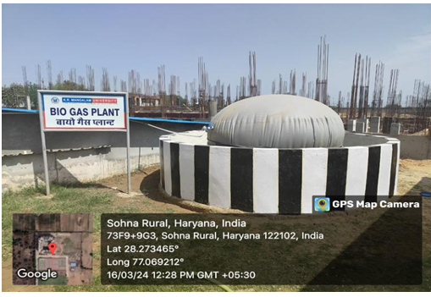

Campus biogas plant converting food waste into clean energy, replacing LPG & generating organic fertiliser

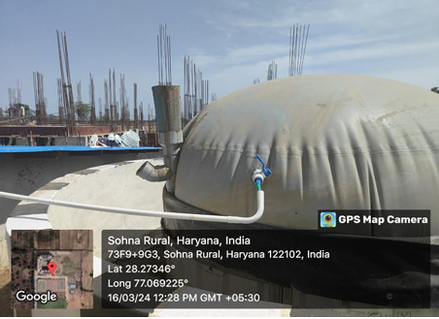

Food waste inlet chamber demonstrating closed-loop waste-to-energy system

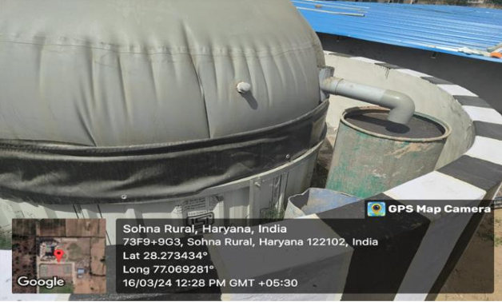

Biogas outlet & slurry discharge used as organic manure for campus horticulture sustainability
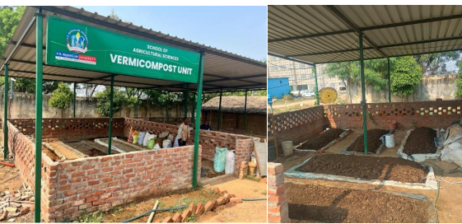

Composting and vermicomposting units

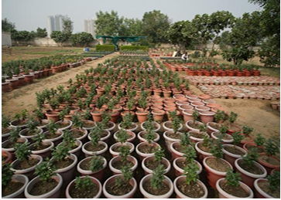

Vermicompost manure used for campus plants and green landscaping at K R Mangalam University, promoting circular waste management

3. Waste Management Systems at K. R. Mangalam University
To minimise environmental impact, reduce landfill dependency, and promote circular resource use, K. R. Mangalam University has systematically integrated waste management considerations into campus planning, daily operations, and institutional practices. With the expansion of academic, residential, and service facilities, the University has adopted structured mechanisms to manage solid waste, organic waste, e-waste, biomedical waste, and wastewater in a scientific and resource-efficient manner. Emphasis is placed on segregation at source, decentralised treatment, recycling, and reuse, ensuring that waste generated on campus is converted into useful resources wherever possible.
Operational Waste Management Flow
Waste Generation at Source
↓
Source Segregation (3-bin system)
↓
Daily Collection and Transfer
↓
On-Campus Processing (Composting / Biogas Plant)
↓
Recycling or Authorised Disposal
↓
Waste Data Recording
↓
Monthly Monitoring and Review
↓
Annual Sustainability Reporting
The operational waste management flow ensures that waste streams are systematically segregated, collected, treated, and recycled. The system minimises landfill disposal and promotes resource recovery through decentralised treatment systems and authorised recycling channels.
Across the campus, operational measures are oriented toward improving hygiene, material recovery, and environmental quality. Colour-coded bins enable segregation at the point of generation, while door-to-door collection ensures systematic handling of waste from academic blocks, hostels, canteens, laboratories, and common areas. Organic waste is diverted from disposal streams and treated through composting and biogas generation, while recyclable and hazardous waste streams are routed through authorised channels. Periodic internal reviews and inspections are used to assess waste quantities, treatment efficiency, and compliance, enabling continuous improvement in waste-handling practices.
Through a combined approach of infrastructure provision, operational controls, monitoring, and community engagement, K. R. Mangalam University continues to strengthen its waste management performance, support circular economy principles, and maintain a clean, safe, and environmentally responsible campus.
3.1 Segregation at Source
Segregation at the point of waste generation forms the foundation of the University’s waste management system. A three-bin segregation system has been implemented across the campus to ensure effective separation of biodegradable waste, recyclable waste, and non-recyclable waste. Colour-coded bins are strategically placed in academic buildings, hostels, cafeterias, laboratories, corridors, and common areas to facilitate easy segregation by students, staff, and visitors.
The University supports this system through clear signage, awareness campaigns, and periodic training programmes aimed at encouraging responsible waste disposal practices. Housekeeping personnel are trained through standard operating procedures (SOPs) to ensure proper handling, collection, and transfer of segregated waste to treatment or recycling facilities. Deployment records of bins and monitoring inspections help ensure compliance and efficiency in source-level segregation practices.
3.2 Processing of Wet Waste within Campus
Biodegradable waste generated from hostels, food courts, and campus landscaping is treated within the University premises through composting units and a functional biogas plant. These decentralised treatment facilities convert food waste and organic residues into organic manure and biogas, reducing the quantity of waste sent for disposal and contributing to sustainable resource utilisation.
The composting units process biodegradable waste to produce nutrient-rich compost that is utilised for maintaining lawns, gardens, and landscaped areas within the campus. The biogas plant processes food waste collected from campus dining facilities, generating biogas and slurry that can be used as organic fertiliser. Operational records and logs are maintained to monitor plant performance and the quantity of biodegradable waste processed annually, enabling effective tracking of resource recovery.
3.3 Dry Waste Recycling Mechanism
Dry waste such as paper, plastic, cardboard, metal, and packaging materials generated across the campus is collected separately and routed for recycling through authorised recycling agencies. The University has established a structured mechanism for the safe handling and transfer of recyclable materials to ensure that valuable resources are recovered and diverted from landfills.
Recycling activities are supported through formal arrangements or Memoranda of Understanding (MoUs) with authorised recyclers, and records such as waste transfer receipts, recycling certificates, and annual quantity reports are maintained for documentation and monitoring purposes. This systematic approach strengthens material recovery while ensuring compliance with environmental regulations.
3.4 E-Waste Management
Electronic waste generated from computers, laboratory equipment, printers, batteries, and other electronic devices is managed through a dedicated e-waste collection and disposal system. Obsolete or non-functional electronic items are periodically identified and collected through the University’s inventory and maintenance departments.
The collected e-waste is transferred to authorised recyclers or Pollution Control Board-certified vendors for safe dismantling, recycling, and disposal in accordance with national e-waste management regulations. Supporting documentation such as authorised recycler certificates, disposal manifests, and transfer records are maintained to ensure transparency, traceability, and regulatory compliance in e-waste handling.
Table 2: Details of Installed Waste Management Infrastructure
Component | Capacity / Description
Colour-coded segregation bins | Installed across academic blocks, hostels, corridors, and common areas
Door-to-door waste collection | Daily collection from all campus zones
Composting units | Processing horticulture and biodegradable waste
Biogas plant | Treats ~4,750 kg/year of food waste
Recycling system | Dry waste routed to authorised recyclers
E-waste handling | Dedicated collection and disposal through certified agencies
Biomedical waste system | Disposal through approved service providers
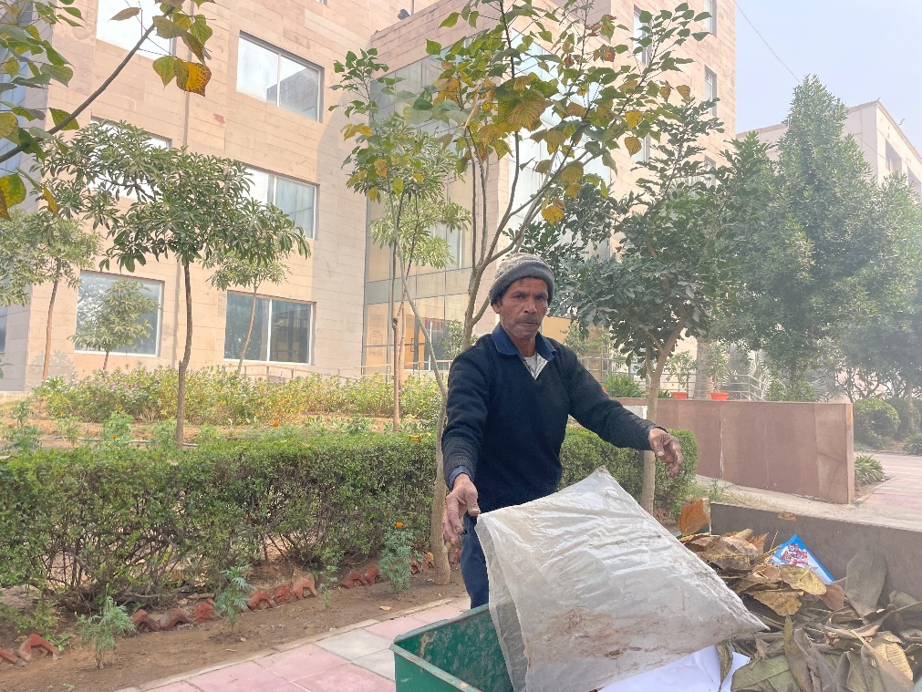

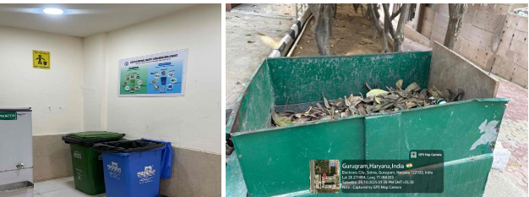

Housekeeping teams conduct systematic daily collection of segregated waste from academic buildings, hostels, and common areas to ensure hygienic campus conditions and efficient waste handling.
4. Wastewater Treatment and Reuse Systems
The University operates a 100 KLD Sewage Treatment Plant, enabling large-scale reuse of treated wastewater. All treated effluent is reused for landscape irrigation, green belt maintenance, and other non-potable applications, significantly reducing freshwater consumption and supporting sustainable campus operations. Water quality parameters such as BOD, COD, and pH remain within prescribed limits, ensuring safe and effective reuse.

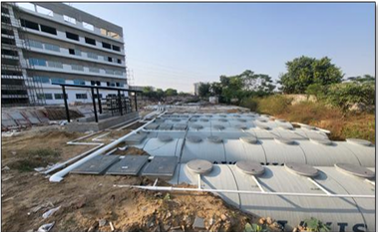

STP near D Block at K R Mangalam University enabling wastewater recycling for irrigation and green landscaping

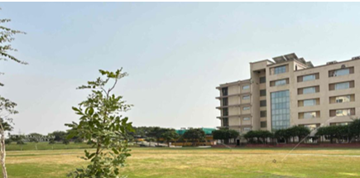

Reused treated water from K R Mangalam University’s STP for plantation and campus landscaping
5. Monitoring, Review and Performance Tracking
K. R. Mangalam University follows a structured approach to track, document, and evaluate waste management performance across academic, residential, and service areas of the campus. The University recognises that effective waste governance depends on reliable data capture, periodic review, and integration of waste indicators into operational decision-making. Accordingly, waste-related parameters are monitored continuously to ensure efficiency, compliance, and progressive reduction of environmental burden.
Quantitative records are maintained for key waste streams, including total solid waste generated, recyclable and reusable materials, food waste processed, biogas output, and treated wastewater reused. These records are compiled annually based on inputs from housekeeping operations, hostel and mess facilities, horticulture units, and authorised waste handlers. Consolidated data is reviewed to assess trends, identify inefficiencies, and support planning for capacity enhancement in composting, biogas generation, and recycling systems.

Table 3: Year-wise Waste Generation, Recycling, and Resource Recovery Performance (2022–25)
Description | 2022–23 (Tons) | 2023–24 (Tons) | 2024–25 (Tons)
Total Waste Generated (Wet + Dry) | 77.03 | 92.43 | 115.54
Dry Waste Recycled / Reused | 48.37 | 58.04 | 72.55
Biodegradable Food Waste Processed | 3.17 | 3.80 | 4.75
E-Waste Generated | 3.36 | 4.03 | 5.04
Food Waste Converted to Biogas | 3.17 | 3.80 | 4.75
Wastewater Reused (Litres/year) | 61,880,000 | 74,256,000 | 92,820,000
Biogas Generated (kWh/year) | 10,000 | 10,000–14,000 | 15,000

5.1 Performance Indicators
To monitor the effectiveness of waste management practices and resource recovery systems, the University tracks key performance indicators annually.
1. Dry Waste Recycling Rate
$$Dry waste recycling rate=\frac{Dry waste recycled }{Total waste generated} ×100$$

Year | Recycling Rate
2022–23 | 62.8%
2023–24 | 62.8%
2024–25 | 62.8%

2. Wet Waste Processing Rate
$$Wet waste processing rate=\frac{Biodegradable Food Waste Processed }{Total waste generated} ×100$$

Year | Processing Rate
2022–23 | 4.1%
2023–24 | 4.1%
2024–25 | 4.1%

3. Total Waste Reduction / Resource Recovery Trend
The data indicates a steady increase in waste recovery and recycling activities, with higher quantities of waste being diverted from disposal through recycling, composting, and biogas generation. The expansion of recycling channels and organic waste processing facilities has contributed to improved material recovery, while increased wastewater reuse supports sustainable water resource management within the campus.

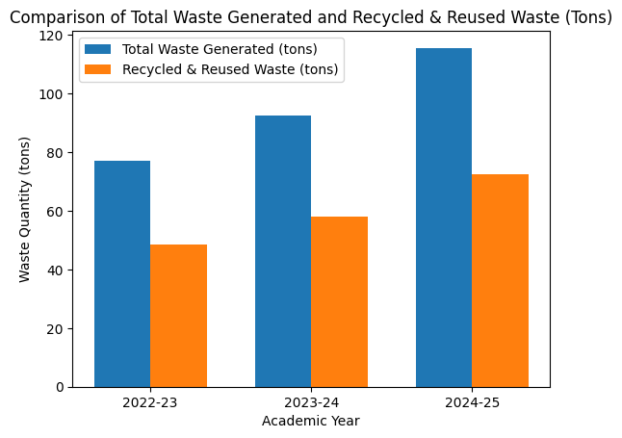

The grouped bar chart shows a consistent increase in total waste generation over the three academic years (2022-25), reflecting expansion in campus activities. Simultaneously, the recycled and reused waste has increased at a comparable rate, indicating strengthened segregation practices, enhanced recycling infrastructure, and improved waste diversion efficiency.
Waste disposal MoU: Hazardous waste & scrap disposal MoU
Link for green campus initiatives: Green campus initiatives
Sustainable Environment and Green Campus Policy
Biotic Waste Limited -MoU

5.2 Waste Management Governance and Compliance Flow Framework
To ensure effective implementation, monitoring, and compliance with environmental regulations, K. R. Mangalam University follows a structured governance framework for waste management. This framework defines institutional responsibilities from strategic decision-making at the University leadership level to operational execution at the campus level. Waste management activities are supervised by the Sustainability and Green Campus Committee and implemented through the Estate and Facilities Management Department with monitoring support from the Environment and Sustainability Cell. Operational handling of waste is carried out by trained housekeeping supervisors, waste officers, and authorised waste management vendors. The governance framework ensures systematic coordination between institutional administration, operational teams, and certified waste recyclers, enabling efficient segregation, treatment, recycling, and documentation of all waste streams.
The operational compliance system follows a step-wise workflow beginning with waste generation and segregation at source, followed by daily collection, on-campus processing through composting and biogas systems, recycling through authorised vendors, and systematic documentation of waste data. Regular inspections, performance reviews, and awareness initiatives help ensure adherence to institutional policies and environmental standards. In cases of non-compliance, corrective measures such as awareness notices, warnings, vendor contract actions, or institutional disciplinary measures are implemented to maintain accountability. The following flow diagrams illustrate the governance structure, operational workflow, and compliance enforcement mechanism adopted by the University for effective waste management.

Institutional Governance Structure for Waste Management
Board of Management / Vice Chancellor
↓
Sustainability & Green Campus Committee
↓
Estate & Facilities Management Department
↓
Environment & Sustainability Cell (Monitoring Authority)
↓
Housekeeping Supervisors & Waste Officers
↓
Housekeeping Staff / Operational Waste Handlers
↓
Authorised Waste Management Vendors & Recyclers

Monitoring and Compliance Operational Flow
Waste Generation at Source
↓
Source Segregation (3-Bin System)
↓
Daily Waste Collection & Transfer
↓
On-Campus Processing (Composting / Biogas / Segregation Yard)
↓
Recycling / Authorised Disposal
↓
Waste Data Recording & Documentation
↓
Monthly Monitoring & Performance Review
↓
Corrective Actions / Awareness / Penalty Enforcement
↓
Annual Sustainability Reporting & NIRF Documentation
Compliance Enforcement Mechanism
Inspection
↓
Non-Compliance Identified
↓
Awareness Notice Issued
↓
Repeat Violation
↓
Written Warning / Penalty
↓
Vendor Deduction / Contract Action
↓
Institutional Disciplinary Measures
Preventive Waste Management Approach
A key focus of the University’s waste management strategy is preventive waste management, where priority is given to segregation at source and decentralised waste treatment. By ensuring that biodegradable waste is treated within the campus and recyclable materials are recovered systematically, the University minimises dependence on external disposal systems and reduces environmental risks associated with uncontrolled waste handling.
Specialised waste streams such as e-waste and biomedical waste are managed separately and transferred through authorised vendors to ensure safe handling, regulatory compliance, and environmentally responsible disposal.

Environmental Impact Assessment
The environmental implications of waste management practices are evaluated through outcome-based indicators, including:
- proportion of waste diverted from landfill
- quantity of organic waste processed internally
- volume of treated wastewater reused for landscaping and non-potable purposes
These indicators help assess the indirect environmental benefits of waste management initiatives, such as improved sanitation, reduced pressure on natural resources, enhanced soil quality, and overall campus cleanliness.

Table 4: Waste Management Performance Control Framework
Aspect | Monitoring Approach
Waste quantity tracking | Annual compilation of waste data from campus units
Segregation effectiveness | Visual inspection and waste-stream categorisation
Organic waste handling | Review of composting and biogas processing volumes
Recyclable waste flow | Verification through authorised vendor records
Wastewater reuse | Measurement of treated water applied for landscaping
Review mechanism | Periodic internal assessment and reporting

The following table 5 shows three-year segregated data demonstrates systematic monitoring of waste streams and steady improvement in recycling, organic waste treatment, and wastewater reuse, reflecting controlled and outcome-oriented waste management practices.

Waste Management Indicator | 2022–23 | 2023–24 | 2024–25 | Performance Trend
Total solid waste generated (T/year) | 77.03 T | 92.43 T | 115.54 T | Increasing due to campus expansion
Recycled & reused waste (T/year) | 48.37 T | 58.04 T | 72.55 T | Consistent improvement
Recycling efficiency (% of total waste) | 62.8% | 62.8% | 62.8% | Maintained efficiency
Food waste processed (T/year) | 3.17 T | 3.80 T | 4.75 T | Improved segregation & recovery
Organic waste treated on campus (%) | ~100% | ~100% | ~100% | Full internal processing
E-waste safely disposed (T/year) | 3.36 T | 4.03 T | 5.04 T | Controlled handling
Treated wastewater reused (T/year) | 61,880 T | 74,256 T | 92,820 T | Strengthened reuse
Biogas energy generated (kWh/year) | 10,000 | 10,000–14,000 | 15,000 | Increasing recovery

Periodic inspections, internal reviews, and cross-departmental coordination meetings support corrective actions and continuous improvement. In parallel, awareness initiatives and participatory activities involving students and staff reinforce responsible waste behaviour and strengthen institutional accountability. Through systematic documentation, performance evaluation, and stakeholder engagement, K. R. Mangalam University ensures that waste management functions as a controlled, transparent, and environmentally responsible system within overall campus operations.
green-audit-krmu-23-05-2025.pdf
Biogas plant and compost unit details
Waste segregation policy
environmental audit krmu_Quantity of waste processed

6. Local Community Outreach for Waste Management and Resource Recovery
K. R. Mangalam University adopts a structured and community-oriented approach to promote responsible waste management practices beyond the campus, recognising that environmental sustainability requires active participation from both institutions and local communities. These outreach efforts are guided by the University’s Waste Management and Green Campus Policy, which emphasises waste reduction at source, segregation, resource recovery, and community awareness as core sustainability principles.
Through cleanliness drives, waste awareness campaigns, sanitation programmes, and village-level engagement activities, the University works to build awareness and encourage behavioural change among residents, school students, and youth in nearby rural and peri-urban areas. Outreach initiatives focus on practical waste-handling aspects such as household-level segregation, reduction of single-use plastics, safe disposal of dry and hazardous waste, and management of biodegradable waste through composting and reuse. During the academic year 2023–24, multiple community outreach activities were conducted in nearby villages, engaging local residents and volunteers in hands-on demonstrations and interactive sessions on sustainable waste practices.
In addition to awareness programmes, the University organises workshops, demonstrations, and extension activities to strengthen community capacity in waste management. Faculty members and students collaborate with local stakeholders to demonstrate low-cost composting techniques, cleanliness practices, and environmentally responsible waste disposal methods. These initiatives support the implementation objectives of the institutional policy by translating campus-based waste management practices into replicable community-level solutions.
Waste management outreach is further reinforced through integration with academic activities, NSS programmes, and student-led initiatives, ensuring continuity and accountability in implementation. Policy-aligned monitoring and documentation of outreach activities enable the University to review impact, refine engagement strategies, and strengthen long-term partnerships with local communities. Through this policy-driven yet participatory approach, K. R. Mangalam University ensures that waste management awareness, resource recovery practices, and environmental responsibility extend beyond the campus and contribute to sustainable local development.
Table 6: Details of events and activities
Title of the Activity | Nature of the Activity | Date of Activity | School | Link
Prayavran Mitra – Plantation Drive | Extension Activity | 21 July 2022 | School of Basic & Applied Sciences | Pryavaran Mitra
Survey on Hygiene Condition and Cleanliness Drive | Extension Activity | 14 October 2022 | NSS & School of Basic & Applied Sciences | Cleanliness Drive
Van Mahotsav Week Under the theme Making a Green World: One Tree at a Time | Extension Activity | 3-7 July 2023 | NSS | Van Mahotsav
Seminar on Water Quality and Sanitation: Impact on Human Health | Seminar | 11 October 2022 | NSS & School of Basic & Applied Sciences | Wash Report
International Conference on Advanced Materials for Green Chemistry and Sustainable Environment | Conference | Feb-15-16-2024 | School of Basic & Applied Sciences | AMGSE-2024
International Conference on Advanced Materials for Green Chemistry and Sustainable Environment | Conference | March 20–21 2025 | School of Basic & Applied Sciences | AMGSE-2025
Tree Plantation | Extension Activity | 23rd Feb 2023 | School of Humanities | Tree Plantation
The Climate Reality Project | MOU | 2023 | School of Basic & Applied Sciences | Climate Project MoU
Poster Making Competition on Clean Energy for a Green | Extension Activity | 5-06-2024 | NSS | Poster Making
Plantation Drive under the theme ‘Green Earth, Clean Earth’ | Extension Activity | 29 June 2024 | NSS | Planation Drive
Awareness on Sustainable Agriculture and Solar Pump Irrigation | Extension Activity | 27-10-2023 | NSS and School of Agricultural Sciences | Sustainable Agriculture
Swachhta and Clean Energy Awareness Camp | Extension Activity | 29-9-2023 | NSS | Swachhata and Clean Energy camp
Cleanliness Drive as a tribute to Mahatma Gandhi on his Birth Anniversary | Extension Activity | 1-10-2023 | NSS | Cleanliness
Swachhata Hi Seva (SHS) campaign | Extension Activity | 27th September 2024 | NSS | Swachhata Hi Seva
Recycling Waste and Conservation of Water | Extension Activity | 22 March 2025 | NSS | Recycling Waste
International Conference on Advanced Materials for Green Chemistry and Sustainable Environment | Conference | Feb-13-14-2024 | School of Basic & Applied Sciences | Report
Awareness regarding Bio and Solar Fuel | Extension Activity | 29th March 2023 | School of Journalism and Mass Communication | Bio and Solar Fuel
Go-Green Drive – Ecosystem Restoration | Extension Activity | 5 June 2023 | School of Education | Go Green Drive
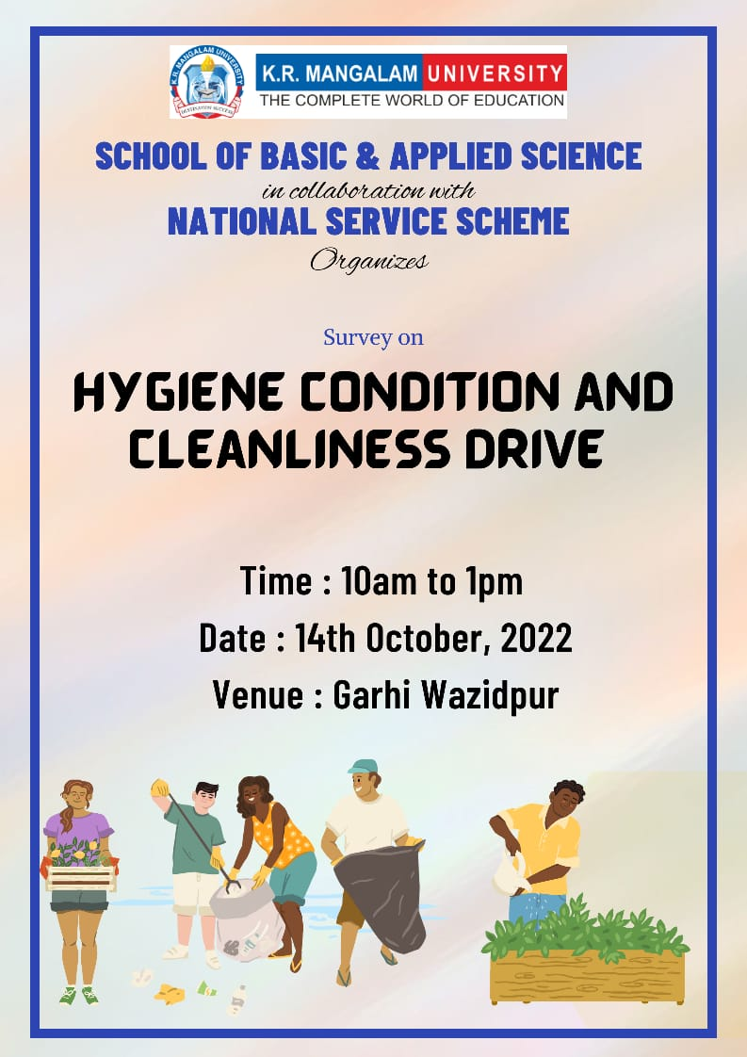
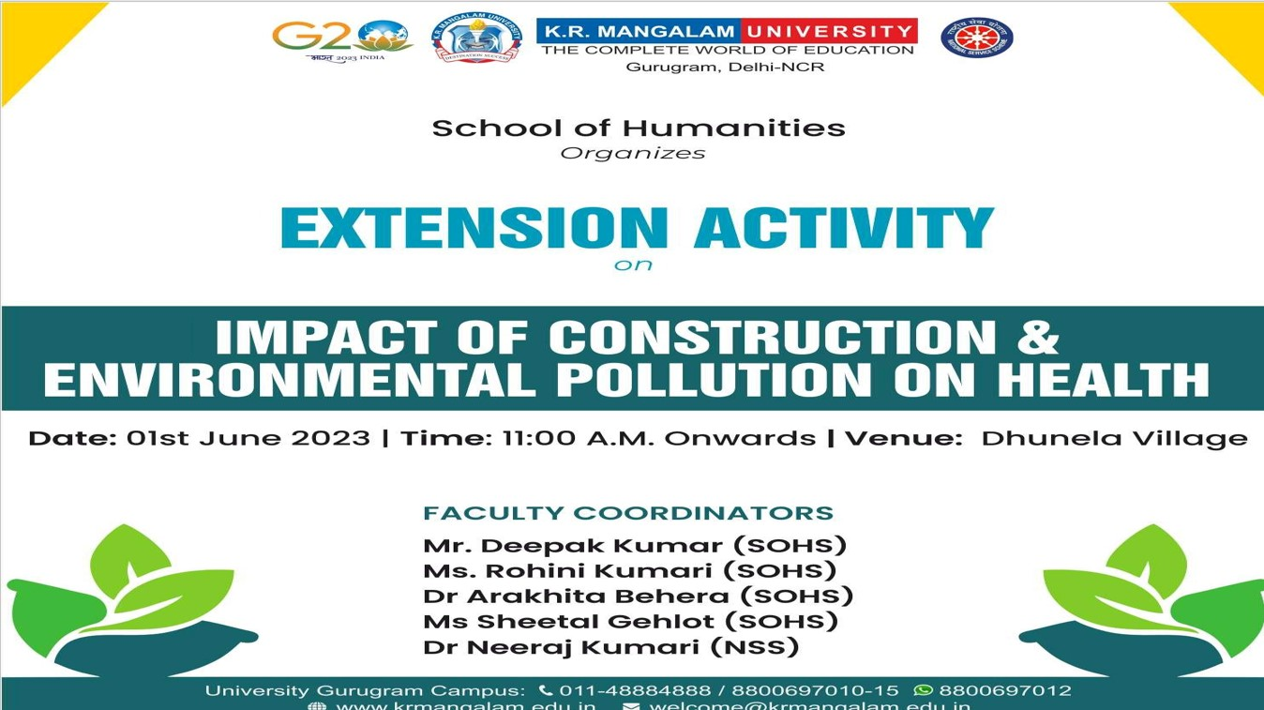
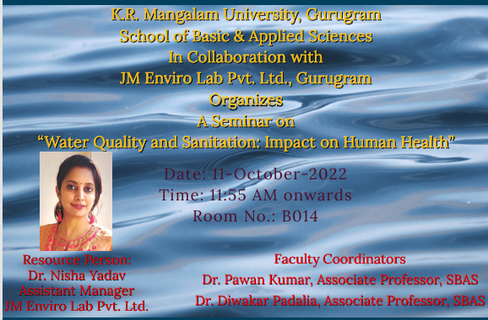

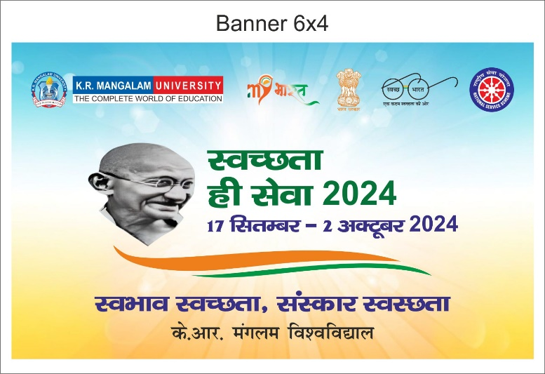
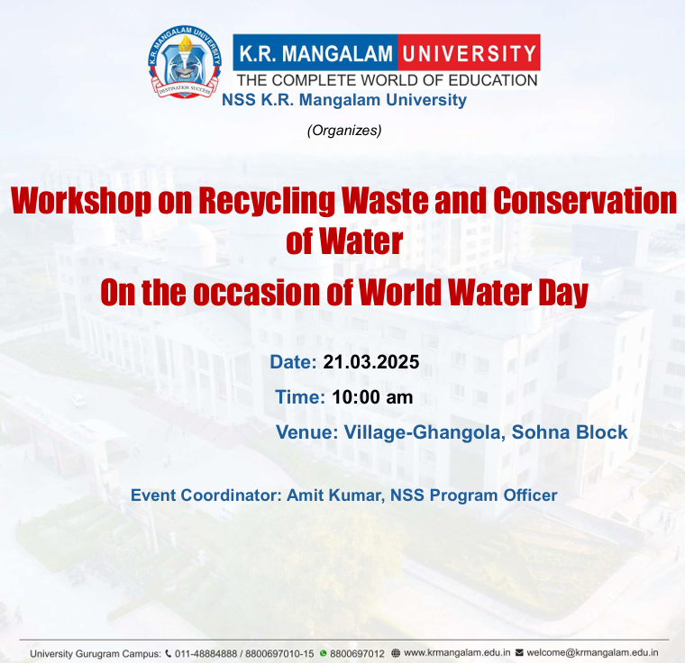

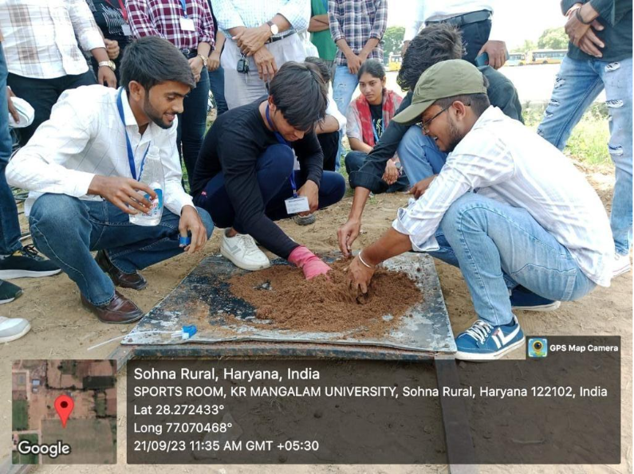
Practical training of students: Students learning energy-efficient and sustainable farming methods through plug tray sowing.
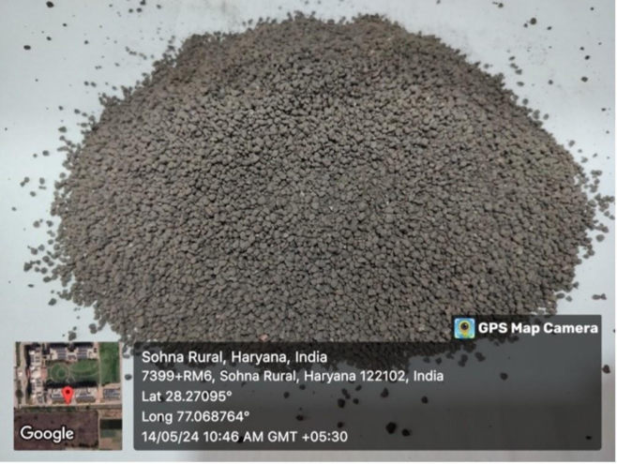
Bio-fertiliser granules prepared during the training session, showcasing practical applications of sustainable agricultural inputs.

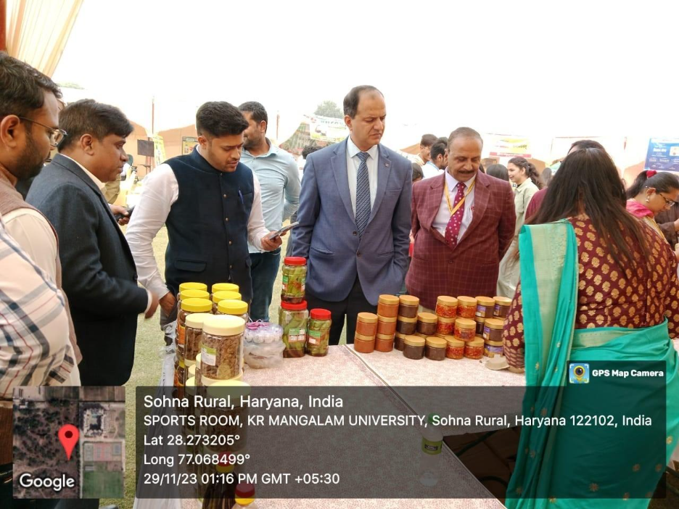
Community outreach in action, Sensitizing farmers to climate-smart and energy-efficient agricultural practices at university
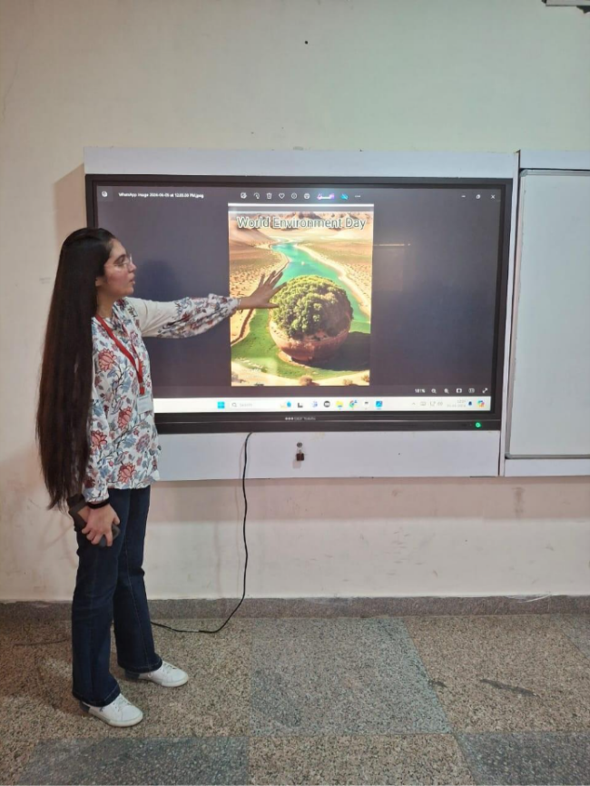
Student participation in a digital poster activity on clean-energy awareness, encouraging behavioural change toward sustainable energy culture.

7. Plan for Reduction of Waste Generation and Improvement of Resource Recovery

K. R. Mangalam University has developed a structured and forward-looking plan to reduce waste generation and enhance resource recovery across academic, residential, and administrative areas of the campus. The plan is guided by year-wise waste generation data and focuses on preventive waste management, segregation efficiency, decentralised treatment, and increased recycling and reuse. By analysing trends in solid waste, food waste, e-waste, and wastewater reuse, the University identifies priority areas for intervention and capacity enhancement.

Waste Generation
↓
Segregation
↓
Treatment (Composting / Biogas)
↓
Resource Recovery (Energy / Compost / Recyclables)
↓
Reuse in Campus Operations
↓
Reduction in Landfill Disposal

The circular waste management model adopted by the University emphasises resource recovery, internal reuse of waste-derived products, and reduction of landfill dependency, supporting long-term environmental sustainability.
The University has adopted phased waste reduction and diversion targets, aiming to minimise landfill disposal and strengthen circular waste management practices. Key objectives include improving source-level segregation to maintain recycling efficiency above current levels, increasing on-campus treatment of biodegradable waste through expanded composting and biogas utilisation, and ensuring that a growing proportion of campus waste is processed internally. Special emphasis is placed on reducing mixed waste generation through behavioural change initiatives, promotion of reusable materials, and elimination of single-use plastics in campus operations.
Based on recent data trends, the University plans to scale up organic waste processing capacity in line with increasing food waste generation and to progressively increase the quantity of waste converted into useful outputs such as biogas energy and organic manure. In parallel, systems for tracking recyclable waste and e-waste are being strengthened to ensure safe handling and transfer through authorised channels. Wastewater reuse targets are also aligned with campus growth, with plans to maximise reuse of treated water for landscaping and non-potable applications, thereby reducing freshwater demand.

Implementation of the waste reduction plan is supported through regular monitoring, documentation, and internal review mechanisms. Student engagement, NSS-led activities, and awareness programmes play a key role in reinforcing responsible waste practices and achieving planned outcomes. Through this data-driven and participatory approach, K. R. Mangalam University seeks to progressively reduce its environmental footprint by limiting waste generation, increasing recovery, and promoting sustainable resource use across campus operations.

