Annual Sustainability Report – 2024-25
KR Mangalam University, Gurugram



April 2025

CONTENTS
1. Introduction and Institutional Overview
1.1 Institutional Profile and Campus Setting
1.2 Campus Area and Infrastructure
1.3 Campus Population
1.4 Sustainability Vision and Governance Framework

2. Energy and Climate Action
2.1 Renewable Energy Installations
2.2 Energy-Efficient Buildings and Infrastructure
2.3 Reduction and Offsetting of Carbon Footprint
2.4 Carbon Footprint Assessment and Monitoring

3. Waste Management and Circular Economy
3.1 Integrated Waste Segregation System
3.2 Energy from Food Waste and Biogas Generation
3.3 Plastic-Free Campus Initiative
3.4 E-Waste, Biomedical and Chemical Waste Management

4. Water Conservation and Management
4.1 Water Conservation Initiatives
4.2 Wastewater Treatment and Reuse
4.3 Rainwater Harvesting and Efficient Irrigation Practices

5. Sustainable Transport and Mobility
5.1 Eco-Friendly Transport Systems
5.2 University Transport Policy and Fleet
5.3 Carpooling and Low-Emission Mobility Initiatives

6. Biodiversity Conservation, Gardens and Afforestation
6.1 Campus Greening and Biodiversity Enhancement
6.2 Herbal, Medicinal and Botanical Gardens
6.3 Green Walkways, Community Gardens and Green Lawns
6.4 Environmental Research Zone and Eco-Friendly Green Belt
6.5 Community and School-Based Plantation Drives

7. Sustainable Horticulture Practices
7.1 Organic Composting and Vermicomposting
7.2 Drip and Sprinkler Irrigation Systems
7.3 Outcomes of Sustainable Landscaping Practices

8. Environmental Education, Awareness and Community Engagement
8.1 Student and Faculty Engagement Programmes
8.2 NSS, YRC and Eco-Club Initiatives
8.3 Community Outreach and Awareness Campaigns
9. Case Study: Environmental Awareness and Sustainable Waste Management
9.1 Alipur Village – Community-Based Intervention Model
10. Sustainable Procurement Practices
10.1 Sustainable Environment and Green Campus Policy
10.2 Ethical Sourcing and Responsible Procurement
10.3 Local and Eco-Friendly Procurement Initiatives

11. Conclusion and Way Forward

1. Settings and Infrastructure
1.1 Campus Setting and Area
K.R. Mangalam University (KRMU) is a multidisciplinary higher education institution located in Gurugram, Haryana. The University operates on a green campus spread across 26.4 acres, designed to support academic excellence while promoting environmental sustainability. The campus layout integrates academic blocks, hostels, administrative buildings, green belts, landscaped areas, and eco-sensitive infrastructure to minimize environmental impact.
1.2 Campus Population
The University hosts a diverse campus population comprising students, faculty members, administrative staff, support staff, and visitors. Residential hostels accommodate students on campus, contributing to daily resource consumption patterns that are systematically monitored under sustainability audits.
1.3 Sustainability Governance
Sustainability initiatives at KRMU are guided by the Sustainable Environment and Green Campus Policy and implemented through institutional mechanisms such as the Centre of Excellence for Sustainable Development Goals (SDGs), NSS, Youth Red Cross (YRC), Eco Clubs, and departmental sustainability committees.
2. Energy and Climate Action
2.1 Renewable Energy Installations
K.R. Mangalam University has made renewable energy adoption a central pillar of its Energy and Climate Action strategy, reflecting its institutional commitment to climate mitigation, energy efficiency, and long-term environmental sustainability. In alignment with national priorities such as the National Action Plan on Climate Change (NAPCC) and global sustainability frameworks including SDG 7 (Affordable and Clean Energy) and SDG 13 (Climate Action), the University has systematically invested in clean energy infrastructure to reduce dependence on fossil-fuel-based grid electricity and lower its overall carbon footprint.
Solar Photovoltaic (Rooftop) Installations
The University has successfully installed a 310 kWp rooftop solar photovoltaic (PV) system across its campus, covering Academic Blocks A, B, and C, along with hostel buildings and utility areas. This large-scale installation represents a significant step towards decentralized renewable energy generation and sustainable campus operations.
The solar infrastructure comprises 984 solar panels distributed across multiple buildings, ensuring optimal utilization of available rooftop space and consistent energy generation throughout the year. The installed system generates approximately 41,850 units of clean electricity per month, which is directly utilized to meet daytime energy requirements for academic, administrative, and residential functions. By substituting conventional grid electricity with solar power, the University has substantially reduced its dependence on fossil fuels and enhanced its energy security.
Environmental and Operational Impact
The deployment of rooftop solar PV systems has led to measurable environmental benefits. The renewable electricity generated contributes to a significant reduction in greenhouse gas emissions, supporting the University’s broader carbon reduction and offsetting initiatives. In addition to lowering the campus carbon footprint, the solar installations have resulted in long-term operational cost savings and improved energy efficiency, strengthening the financial sustainability of campus operations.
Surplus renewable energy generated during peak sunlight hours further supports grid stability and contributes indirectly to emission reduction at the regional level. These efforts collectively reinforce the University’s role in supporting India’s transition towards clean and renewable energy systems.
Academic Integration and Experiential Learning
Beyond infrastructure development, the solar installations serve as a live learning and demonstration model for students across disciplines such as engineering, environmental sciences, sustainability studies, and law. The system provides practical exposure to renewable energy technologies, climate policy implementation, and green infrastructure management. By integrating renewable energy assets into academic and experiential learning frameworks, the University enhances student awareness and capacity building in climate-resilient technologies and sustainable development practices.
Monitoring, Maintenance, and Performance Tracking
The performance of the solar PV system is regularly monitored to ensure efficiency and uninterrupted operation. Maintenance activities are undertaken through authorized vendors, and energy generation is tracked through electricity bills, system logs, and audit mechanisms. This structured monitoring approach ensures transparency, reliability, and continuous optimization of renewable energy performance.
2.2 Energy-Efficient Buildings and Infrastructure
In order to cut overall energy usage and its carbon footprint, K.R. Mangalam University has incorporated energy-efficient design principles into the planning, construction, and operation of all major campus buildings. In order to reduce the need for artificial lighting and energy-intensive cooling systems, the university places a high priority on design elements that optimize natural light and ventilation. Optimal daylight penetration and airflow are ensured by large windows, open corridors, shaded structures, and strategically situated buildings, all of which contribute to significant year-round energy savings.
The University has switched to LED lighting systems and sensor lighting in all academic buildings, administrative spaces, residence halls, labs, and outdoor walkways in an effort to further improve energy efficiency. LEDs require less maintenance and use a lot less electricity because they last longer. Additionally, in order to reduce needless electricity use, a number of buildings have motion-sensor lighting and automated power shutoff systems installed in low-traffic areas like restrooms, stairwells, and storage rooms.
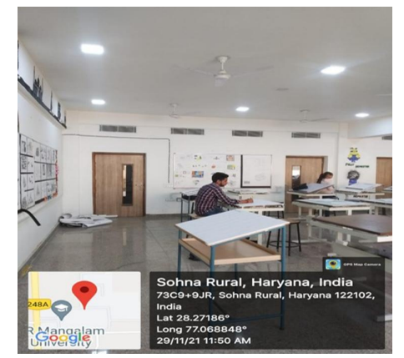
Energy-efficient LED lighting across campus, replacing CFL & tube lights for improved performance & reduced carbon footprint
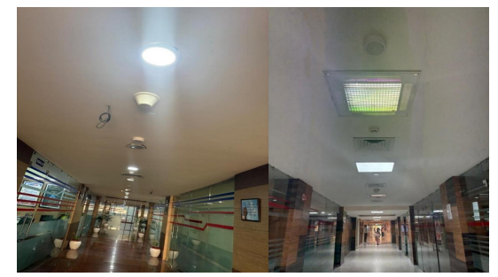
PIR motion-sensor lighting in corridors and common areas — Optimising electricity use by activating LED fixtures only during occupancy
The University also employs energy-efficient HVAC systems, incorporating star-rated appliances and advanced temperature control mechanisms to ensure optimum utilization with minimal energy wastage.
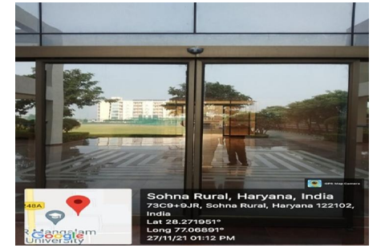
Sensor-operated entry doors across academic buildings, minimising conditioned-air loss and enhancing HVAC efficiency to reduce energy demand
Regular energy audits are conducted to assess consumption patterns, identify inefficiencies, and propose corrective measures. These audits help monitor building performance and ensure compliance with energy standards. Recommendations arising from audits are promptly implemented, such as replacing outdated appliances, optimizing lighting layouts, and improving insulation in older structures.
Energy Audit Report 2024
In addition, some blocks, parking lots, and walkways have solar-powered street lighting, which reduces reliance on grid electricity while improving safety and energy efficiency. The University makes sure that all infrastructure expansions are in line with long-term energy efficiency targets by integrating sustainability into building operations.
K.R. Mangalam University shows a great dedication to lessening its environmental effect and developing sustainable campus infrastructure through its all-encompassing strategy, which includes cutting-edge energy-saving technologies and clever architectural design. These ongoing enhancements serve national initiatives on energy saving and climate action in addition to lowering operating expenses.

Energy Audit Report 2024

2.3 Reduction and Offsetting of Carbon Footprint
K.R. Mangalam University is dedicated to attaining long-term environmental sustainability through the reduction, management, and offsetting of its carbon emissions in accordance with national and international climate targets. The University has implemented a thorough carbon-offset strategy as part of its larger sustainability plan, which supports ongoing initiatives to increase campus biodiversity, expand renewable energy installations, and improve energy efficiency. Unavoidable greenhouse gas (GHG) emissions from campus operations are compensated for by measures that remove or prevent an equivalent quantity of carbon from the atmosphere. This process is known as emission offsetting.
The University’s emission offsetting framework begins with the systematic assessment of carbon-generating activities such as electricity consumption, transportation, waste generation, and academic operations. This baseline estimation enables the institution to identify high-impact sectors and adopt targeted strategies to minimize emissions at the source.
Eco Friendly Transport and other Practices
K. R. Mangalam University integrates sustainability into its core operations by promoting clean mobility, reducing dependence on fossil fuels, and maintaining a low-emission, environmentally responsible campus. Guided by comprehensive environmental, green, and energy audits, the University implements a strict sustainability policy that emphasizes eco-friendly transportation, continuous carbon footprint monitoring, effective pollution control, and the development of a walkable and safe campus environment. With initiatives such as shared mobility systems, expanding CNG and EV fleets, LED and sensor-based energy efficiency measures, and a functional biogas plant that achieves net-zero emissions from food waste, the institution demonstrates a holistic commitment to green campus management. Aligned with national Sustainable Development Goals (SDGs) and recognized under the Sustainable Institutions of India – Green Ranking 2023, K. R. Mangalam University continues to strengthen its leadership in sustainable practices and environmental stewardship.

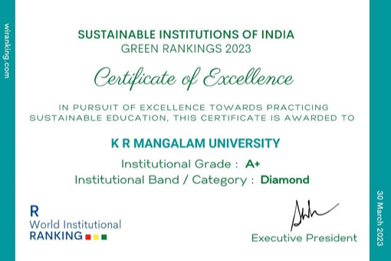

Eco-Friendly Transportation Practices

Zero-Emission and Low-Emission Vehicles
- The University operates CNG buses and CNG cars exclusively for student and staff transportation.
- Electric Vehicle (EV) carts for in-campus movement.
- Only zero-emission vehicles (bicycles, battery-operated vehicles, EV carts) are permitted within the campus premises.
- Strict “No Automobile Policy”:
No private or diesel vehicles are permitted inside.
Vehicles of employees and students are parked in designated external parking areas.
In alignment with national sustainability goals and the University's vision of reducing carbon emissions, the institution has implemented a structured, well-regulated, and inclusive Sustainable Transport System for all stakeholders. This system operates under the officially approved Transport Policy Link.
K. R. Mangalam University’s Transport Policy (2025–26) establishes a centralized, well-regulated, and sustainable mobility system for students and staff. All university transport services, including official trips, are managed by the Transport Department to ensure safety, efficiency, and compliance with institutional and government norms. The University promotes eco-friendly shared mobility through its extensive bus and shuttle network, reducing dependence on private vehicles and lowering the campus carbon footprint. Mandatory registration, bus passes, designated boarding points, and strict discipline protocols ensure safe and responsible commuting. The policy provides transparent fee structures for all categories of students, along with flexible digital and installment-based payment options to enhance accessibility. Clear guidelines for rejoining and refund procedures maintain operational transparency.
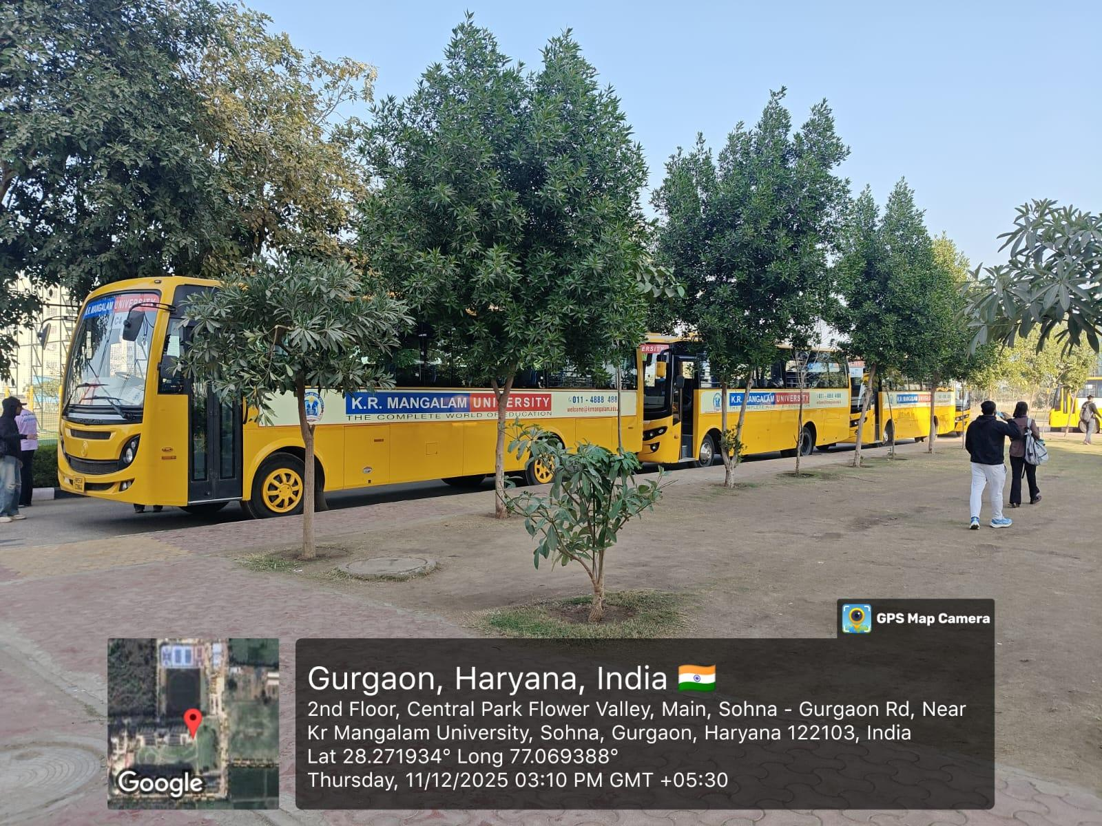
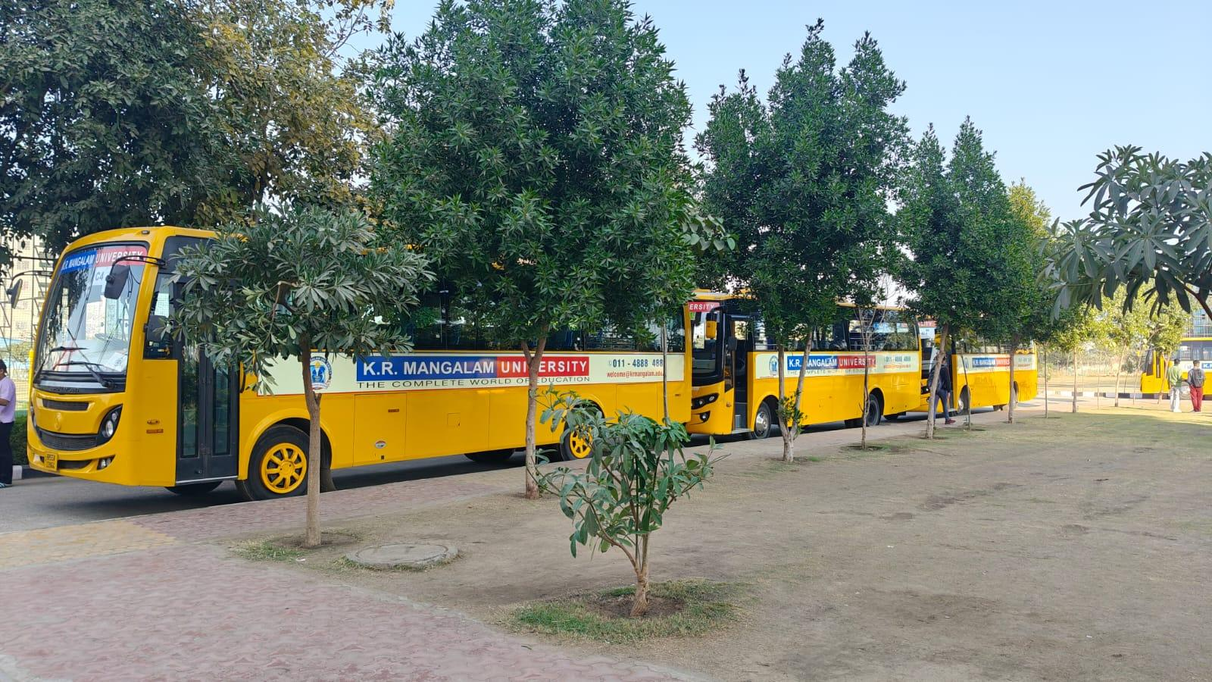

University Transport Fleet Details
Year | No. of CNG Buses | Capacity | Details
2024–25 | 93 | 4,425 | 78 buses – 50-seater, 15 buses – 35-seater
2023–24 | 73 | 3,425 | 58 buses – 50-seater, 15 buses – 35-seater
2022–23 | 53 | 2,425 | 38 buses – 50-seater, 15 buses – 35-seater
These buses reduce congestion, enhance safety, and significantly lower carbon emissions from daily commuting

Sustainable Mobility Options Provided by the University
- Public transportation support
- Bicycle-sharing or cycling promotion programs
- Battery-operated / electric vehicle carts
- Electric rickshaw mobility (for faculty and staff)
- Carpooling incentives
- Walking-friendly campus with pedestrian pathways
- Zero-emission intra-campus movement
Walking & Pedestrian-Friendly Campus
- A network of pedestrian pathways ensures safe and uninterrupted movement across the campus.
- Footpaths are designed with lush green cover, promoting walkability and reducing dependence on motorized mobility.
- University infrastructure includes passive green features, such as sunken areas that help reduce ambient temperatures during summers.
- The campus architecture encourages walking as the primary mode of intra-campus mobility.

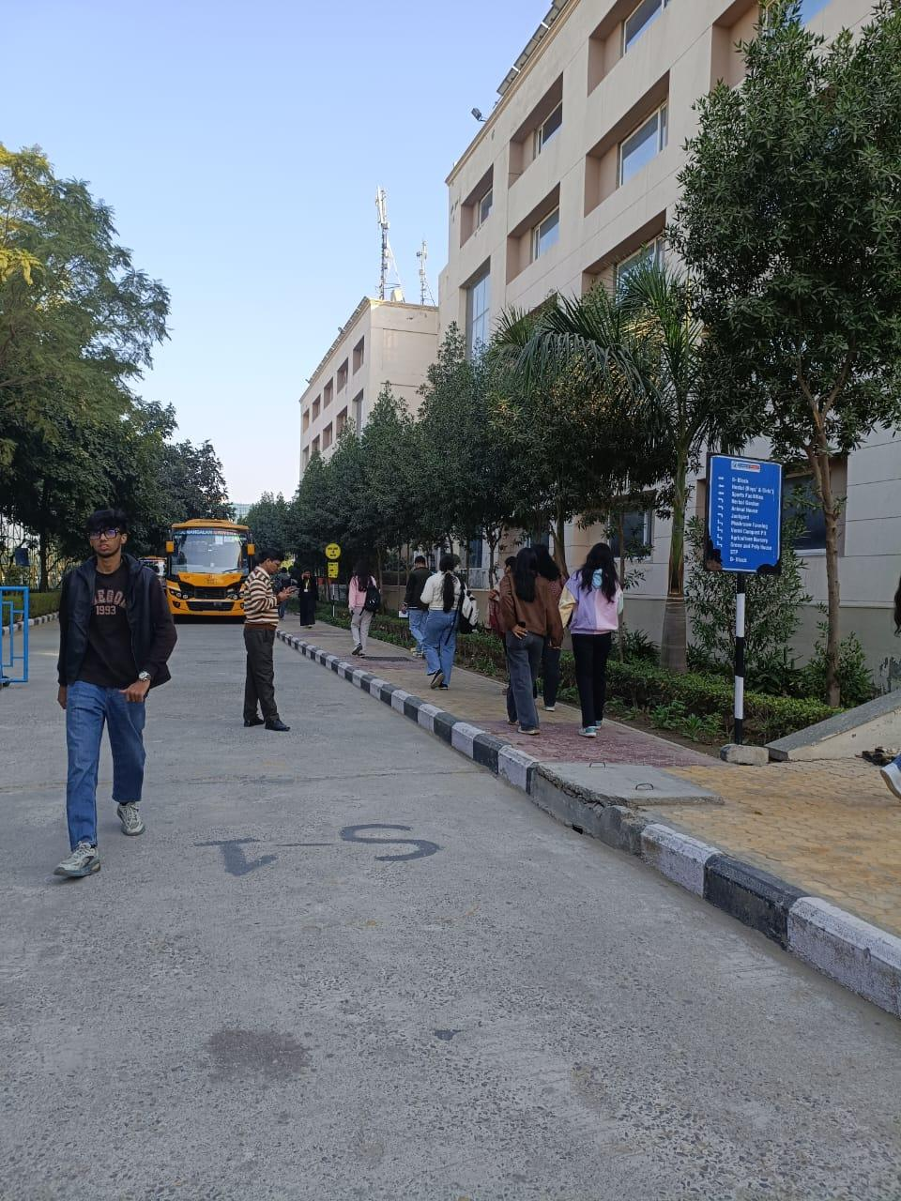

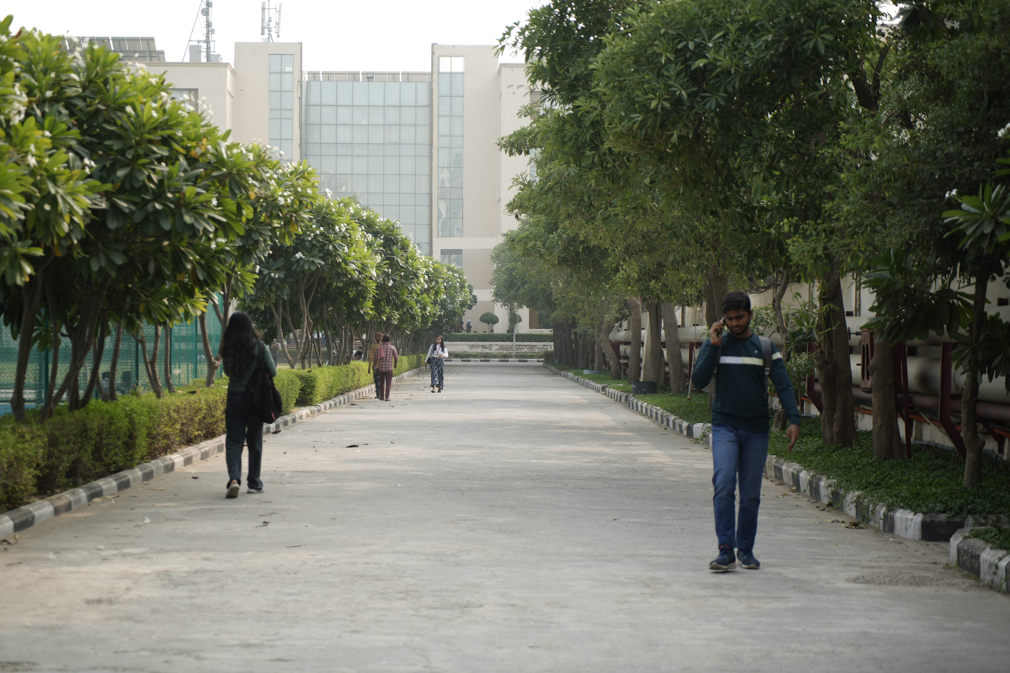
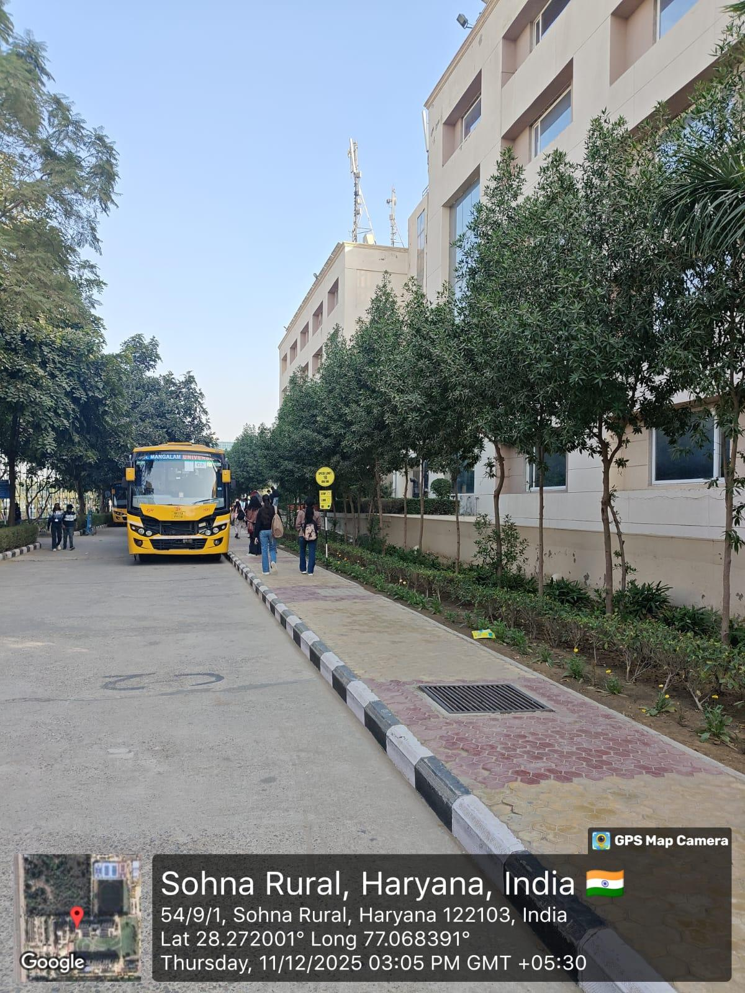

Bicycle & Battery-Operated Vehicle Policy
- Students and staff are encouraged to use bicycles or battery-powered vehicles.
- Strict disciplinary action for unauthorized automobile entry inside campus.
- Verified compliance with environmental standards such as PUC certification (e.g., PUC for HR 55AR 0613 valid till 06/04/2026).

Sustainable Mobility Framework- Carpooling Initiative by Center of Excellence for Sustainable Development Goals:
- The University’s carpooling initiative promotes resource sharing, reduces individual fuel usage, and contributes to lower carbon emissions.
- Shuttle services and on-campus EV carts offer zero-emission mobility, strengthening sustainable internal transport.
As per the survey conducted by the Center of Excellence for sustainable development goals, around 63% of teaching staff and 37% of non-teaching staff participated. Additionally, the survey presented around 27% of the staff who preferred university buses and 30% used carpooling.
Mode | % | Interpretation
University Bus | 27% | Still a major mode; reflects reliance on institutional transport.
Personal Car | 9% | Indicates moderate private vehicle usage and parking demand.
Public Transport (metro/auto/cab) | 14% | Shows continued dependence on public mobility with first/last-mile gaps.
One-way bus + public transport | 8% | Reflects the need for flexible, multi-modal commuting.
Two-wheeler | 8% | Preferred by medium-distance commuters; weather-sensitive.
Carpool with colleagues | 30% | Strong adoption rate; suggests positive response to structured carpooling initiatives.
Walking / Cycling | 2% | Limited due to distance and safety factors.
Electric Vehicle | 2% | EV usage is emerging at an early stage.

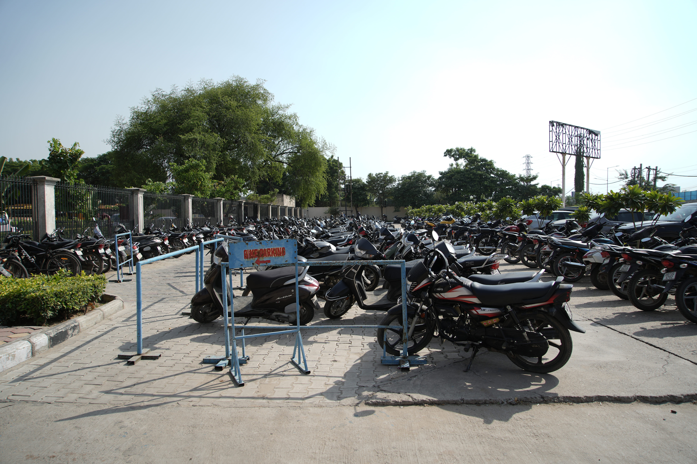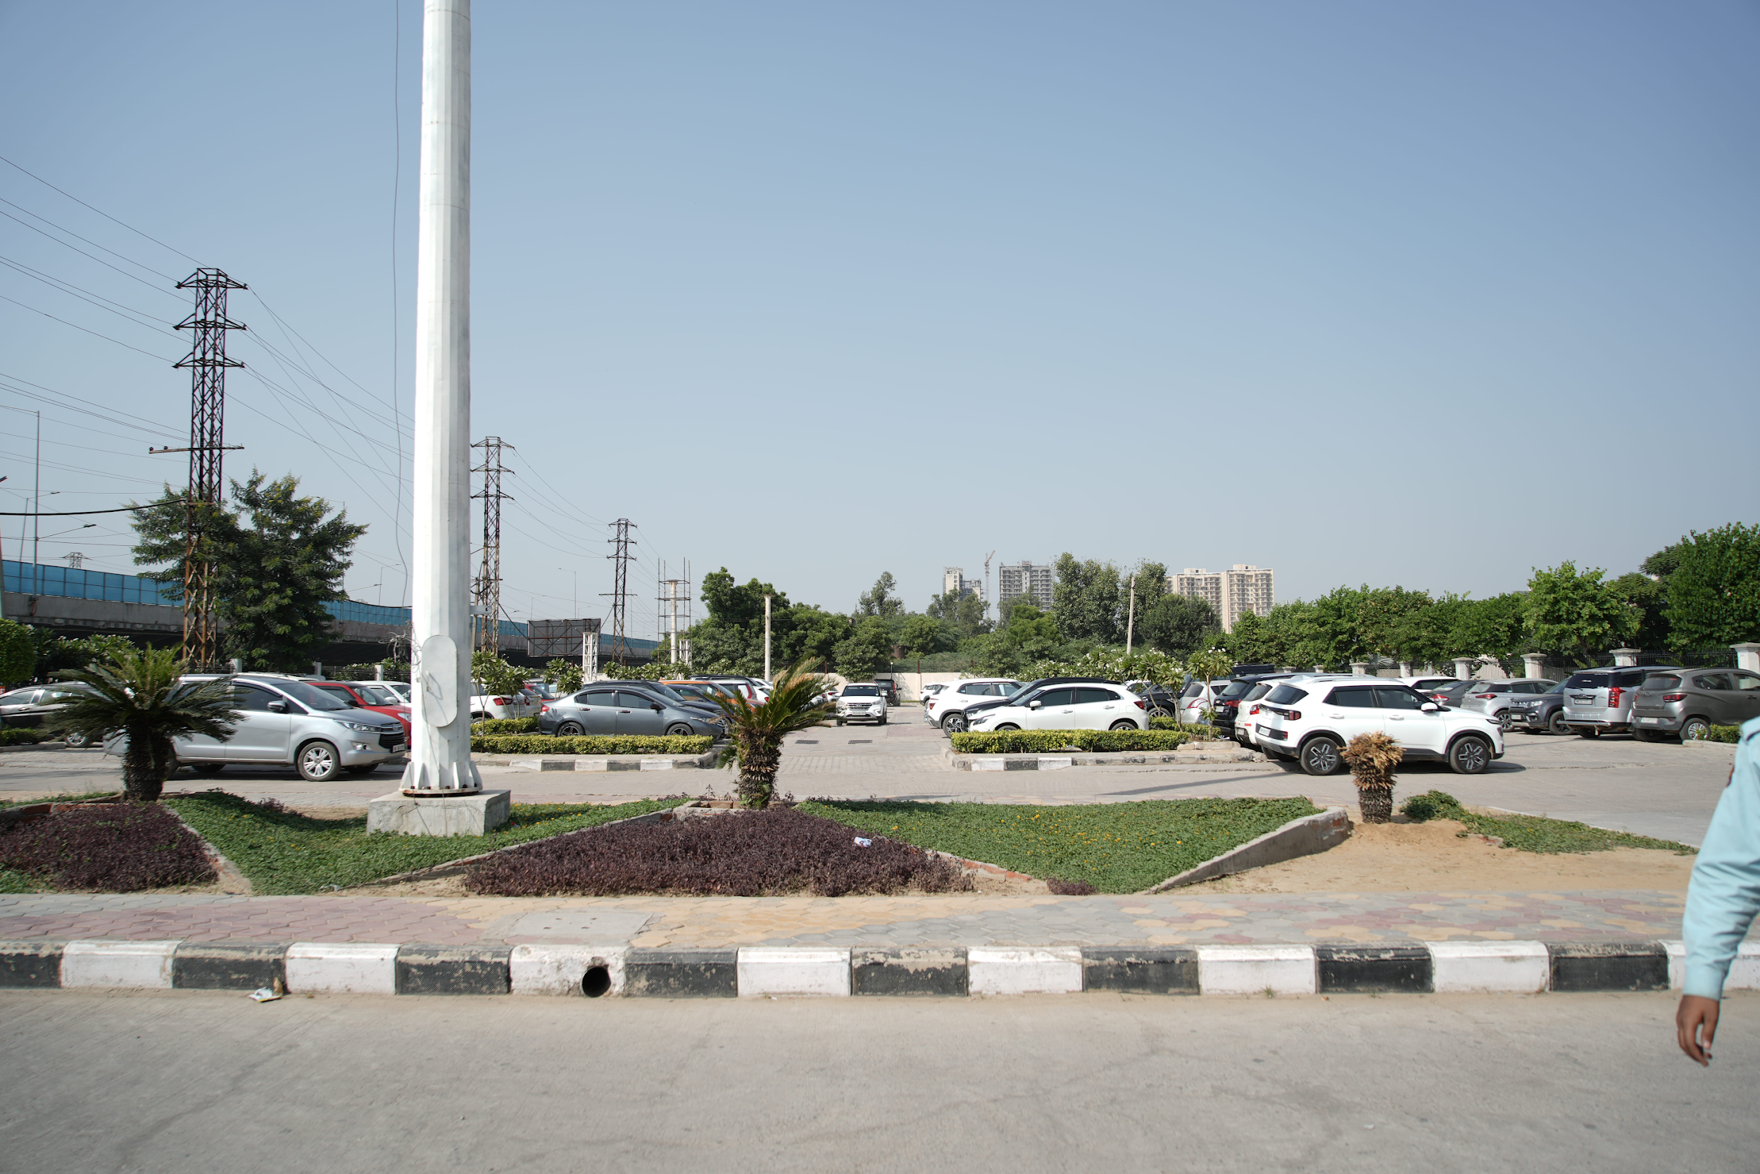
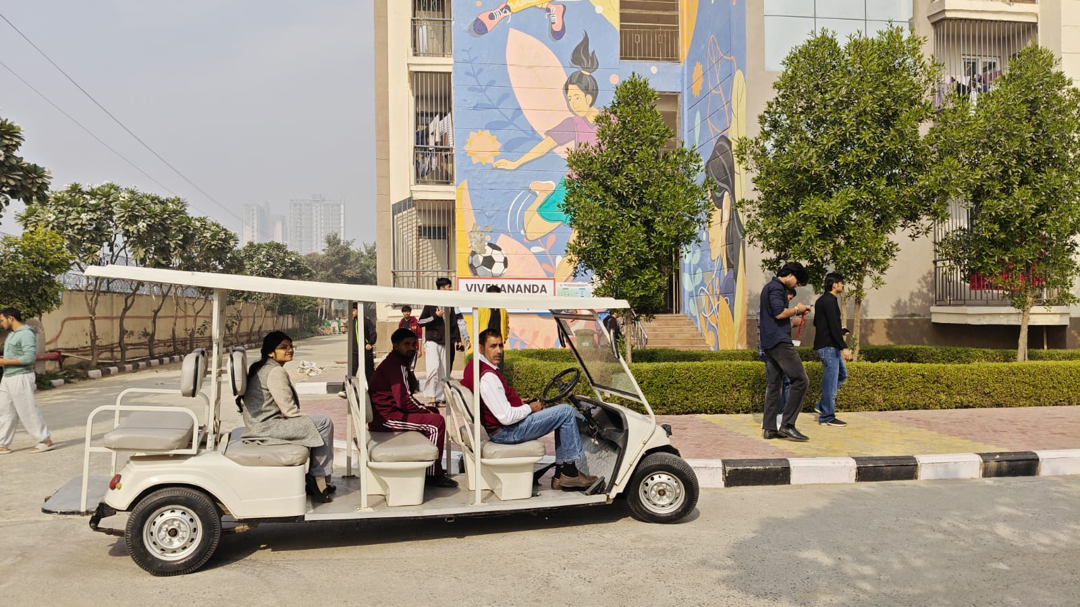
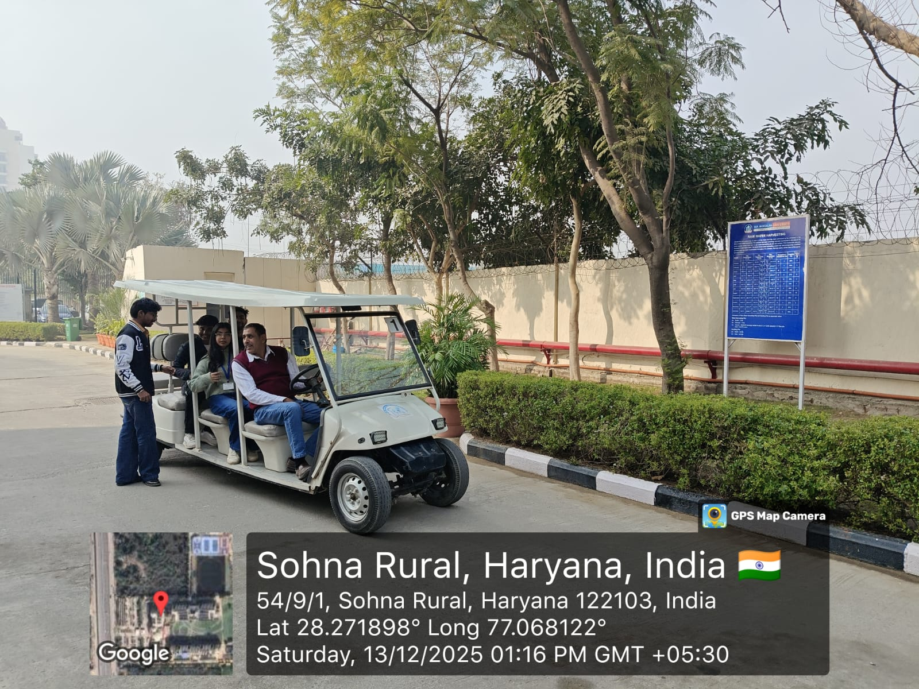
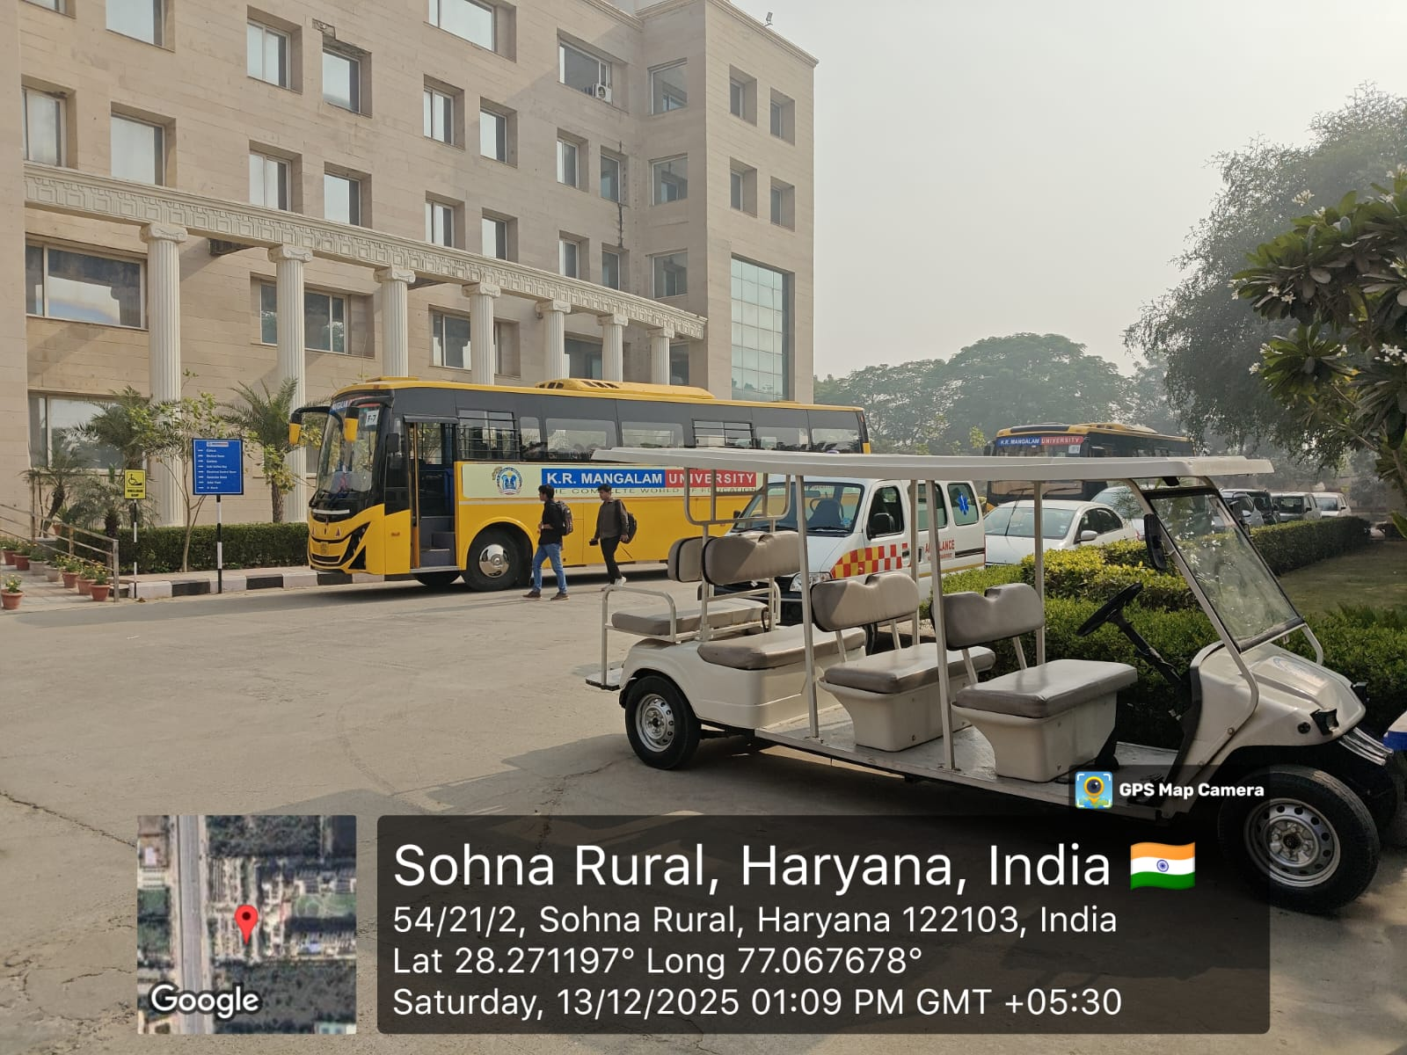
The survey shows that commuting patterns are diverse, but a significant opportunity exists in the K.R. Mangalam University to shift private and car users toward sustainable modes by improving university bus flexibility, comfort, and connectivity.
Air Quality & Pollution Control Measures

Low-Emission Campus
- The University uses CNG buses, CNG cars, and is transitioning to electric mobility.
- Strict control on vehicular entry reduces air and noise pollution.
- Green cover, roadside plantations, and regular plantation drives improve air quality.

Dust & Noise Control
- Well-surfaced internal roads reduce dust emissions.
- Traffic congestion is minimized with structured parking zones.
- Noise levels are controlled through vehicular restrictions.

Pollution Compliance & Monitoring
- All entering vehicles must have a valid Pollution Under Control (PUC) certificate.
- Traffic and movement policies follow NOC guidelines from the Ministry of Road Transport & Highways, Government of India (2014).

Carbon Footprint Monitoring & Emission Assessment
The University conducts annual carbon footprint assessments covering direct and indirect emissions from:
- Diesel generators
- University transport
- Private commuting
- Waste management
- Water treatment
- ICT infrastructure
- Electricity consumption

Annual Emissions (2023–24)
Source | Fuel/Energy Type | Annual Emissions (tCO₂e)
Electricity (Grid) | Grid Electricity | 410
Diesel Generators | Diesel | 65
University Transport | Diesel/CNG | 42
Private & Contracted Transport | Petrol/Diesel/CNG | 190
Waste Disposal | Mixed Waste | 18
Water Treatment & Supply | Electricity for pumping | 25
ICT & Office Equipment | Electricity | 30
Biogas System | Food Waste → Biogas | 0 (Net-zero offset)
The University systematically tracks its annual carbon footprint, identifying grid electricity consumption and private transport as the primary sources of emissions, while university-operated shared mobility contributes comparatively lower emissions due to efficient, high-capacity transportation systems. Sustainable initiatives such as the net-zero biogas plant and the implementation of regulated transport policies play a significant role in reducing pollution and promoting environmentally responsible practices. Overall, the University remains strongly committed to expanding renewable energy adoption, strengthening waste management processes, and minimizing reliance on diesel generators to further enhance its environmental performance.
In addition to monitoring emissions, the University has established a strong framework for Sustainability Governance supported by regular energy, green, and environmental audits that guide policy decisions and operational improvements. Fossil fuel dependence has been significantly reduced through the transition from CFL and tube lights to energy-efficient LED fixtures, the installation of motion sensors across academic and residential blocks, and the gradual introduction of EV-based mobility solutions within the campus. Waste-to-energy innovations, particularly the functional biogas plant, effectively offset LPG usage in hostels and cafeterias, contributing to net-zero emissions from food waste. These measures have led to tangible outcomes, including a substantial reduction in fossil fuel-based transport through the expansion of the CNG fleet and the integration of electric vehicles, along with nearly 30% of university commuters participating in carpooling initiatives that lessen private vehicle dependency. The combined impact of vehicular regulations and continuous greening initiatives has resulted in improved air quality indices within the campus. Overall, these interventions have strengthened institutional safety, environmental stewardship, and alignment with national Sustainable Development Goal (SDG) targets, reflecting the University’s holistic commitment to sustainable campus management.
Solar Panel and Biogas
K.R. Mangalam University has installed a 310-kW rooftop solar power system across Academic Blocks A, B, and C, along with the hostel buildings. This setup ensures a consistent and uninterrupted supply of clean energy during daytime hours throughout the year, substantially reducing the university’s reliance on conventional grid electricity.

Data for Solar Panels
Sr. No. | Academic  Building | No.of  Panels | Total No. of  solar panels | Capacity | Total capacity | Rebate  rate
1 | A | 157 | 984 | 310  Kw/day | 41850  units/month | 0.25
2 | B | 375
3 | C | 204
4 | DG | 120

Between 2018 and 2023, K.R. Mangalam University has shown consistent progress toward achieving Affordable and Clean Energy by steadily increasing the share of solar energy in its overall electricity consumption. From 2018–2020, the University generated a total of 870,125 kWh of solar power, and in 2021–2023, this output increased to 912,489 kWh, marking an improvement of approximately 4.9% in renewable energy generation. This rise reflects more efficient operation and maintenance of the solar photovoltaic system, supported by favorable weather conditions and optimized load management. The University now records an annual average solar generation of around 304,000 kWh, which significantly contributes to its yearly electricity demand of 1.82 million kWh. This stable generation trend highlights the growing share of renewable energy in total power usage and directly advances the University’s low-carbon transition efforts by reducing reliance on conventional grid electricity. Through sustained clean energy initiatives, K.R. Mangalam University continues to strengthen energy efficiency, environmental stewardship, and climate action preparedness across its campus operations.

K.R. Mangalam University (SOLAR PANEL DATA FROM YEAR 2018-2020)
Sr. No | Month | Solar Energy consumption in  KWH (Year 2020) | Solar Energy consumption in  KWH (Year 2019) | Solar Energy consumption in KWH  (Year 2018)
1 | January | 25984 | 30390 | NIL
2 | February | 34484 | 28877 | NIL
3 | March | 32059 | 41233 | NIL
4 | April | 33773 | 41425 | 20013
5 | May | 30546 | 43858 | 37669
6 | June | 21128 | 36766 | 34233
7 | July | 19136 | 25186 | 28081
8 | August | 18119 | 32736 | 28410
9 | September | NIL | 31637 | 28810
10 | October | NIL | 35536 | 30062
11 | November | NIL | 24634 | 28237
12 | December | NIL | 19066 | 28037
 |  | 215229 | 391344 | 263552
Total for 29 months = 215229+391344+263552 =870125 KWH
Note: Sanctioned load for the Institution is 2000 Ampere
Source: Mangalam State Electricity Bills

K.R. Mangalam University (SOLAR PANEL DATA FROM YEAR 2021-23)
Sr. No | Month | Solar Energy consumption in KWH (Year  2021) | Solar Energy consumption in KWH (Year 2022) | Solar Energy consumption in KWH (Year 2023)
1 | January | 7383 | 23992 | 18169
2 | February | 20657 | 35860 | 29464
3 | March | 25815 | 40903 | 33764
4 | April | 33501 | 39729 | 36798
5 | May | 25630 | 34145 | 36308
6 | June | 23627 | 33135 | 31117
7 | July | 18385 | 21836 | 22951
8 | August | 29952 | 23911 | 31238
9 | September | 27302 | 26479 | 27498
10 | October | 40038 | 28519 | 29577
11 | November | 26160 | 27659 | 19158
12 | December | 25997 | 22668 | 22382
 |  | 215229 | 358836 | 338424
Total for 36 months = 912489KWH
Note: Sanctioned load for the Institution is 2000 Ampere
Yearly power Requirement: 1824978KWH
Source: Mangalam State Electricity Bills

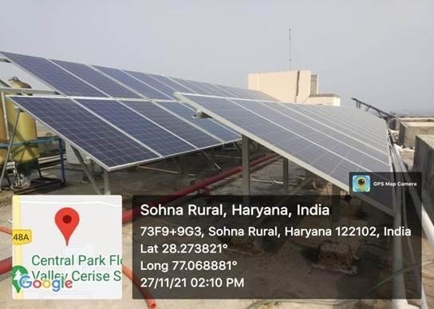
310 kWp rooftop solar PV system across Academic Blocks and hostels, generating clean electricity and reducing dependence on grid power
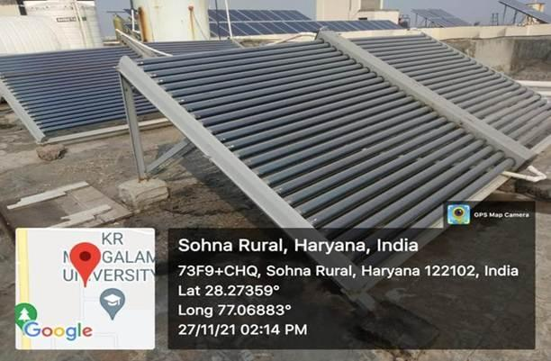
Solar thermal system providing hot water in hostels, reducing LPG and grid energy dependence
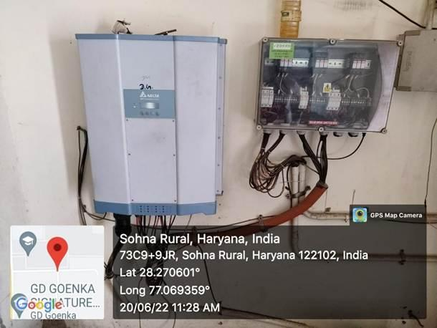
Grid-connected solar system with net metering — Exporting excess renewable power to the grid and supporting regional clean-energy distribution ethical
Biogas
K.R. Mangalam University, committed to sustainable and eco-friendly practices, has taken a major step by installing a biogas plant on its campus. Biogas technology offers an environmentally responsible solution that supports effective waste management while also contributing to energy conservation. This initiative forms an integral part of the University’s larger mission to reduce its carbon footprint and enhance the use of renewable energy sources. The establishment of the biogas plant at KRMU represents meaningful progress toward a greener and more sustainable campus. Beyond generating energy savings, it reflects the University’s dedication to environmental stewardship. This initiative also serves as an inspiring model for other educational institutions and organizations aiming to adopt similar sustainable practices.

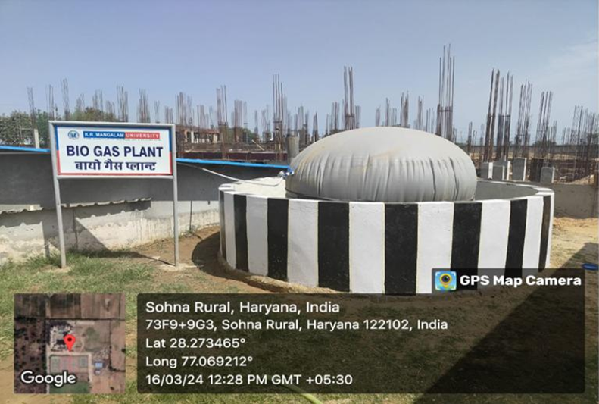
Campus biogas plant converting food waste into clean energy, replacing LPG & generating organic fertiliser
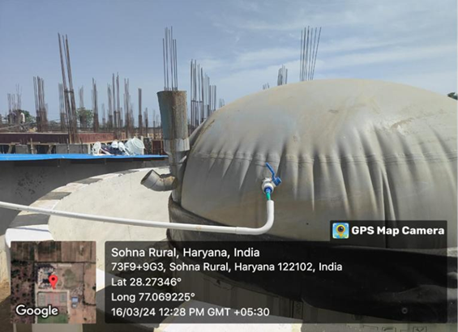
Food waste inlet chamber demonstrating closed-loop waste-to-energy system

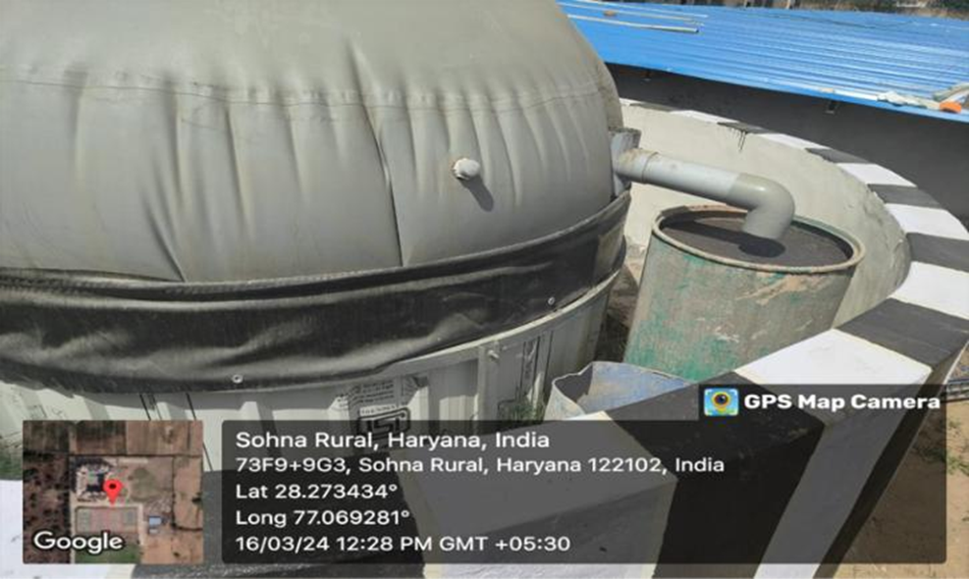
Biogas outlet & slurry discharge used as organic manure for campus horticulture sustainability

Campus Greening & Biodiversity Enhancement
K. R. Mangalam University has demonstrated a strong and sustained commitment to improving campus biodiversity and expanding green cover through systematic plantation drives and ecological conservation initiatives. Over the past three academic years, the University has significantly increased the diversity and quantity of plant species, contributing to improved air quality, enhanced campus aesthetics, and strengthened ecological resilience.
During 2024–25, the University recorded a total of 8,326 plants, comprising 5,860 higher and ornamental plants, 1,286 botanical species, 862 herbal and medicinal plants, and 318 fruit-bearing trees. In 2023–24, the total plantation stood at 4,757 plants, including 2,841 higher and ornamental plants, 983 botanical species, 685 medicinal plants, and 248 fruit plants. The year 2022–23 reflects the foundation of this upward trend, with 2,061 plants, consisting of 1,383 higher and ornamental species, 284 botanical plants, 304 herbal plants, and 90 fruit-bearing varieties.
This progressive increase—from 2,061 plants in 2022–23 to 8,326 in 2024–25—illustrates the University’s proactive approach toward enhancing green cover and promoting biodiversity conservation. These efforts support habitat enrichment, microclimate regulation, carbon sequestration, and overall environmental sustainability on campus. The sustained plantation growth aligns with national environmental priorities and strengthens the University's commitment to the Sustainable Development Goals (SDGs), particularly SDG 11 (Sustainable Cities & Communities), SDG 13 (Climate Action), and SDG 15 (Life on Land).

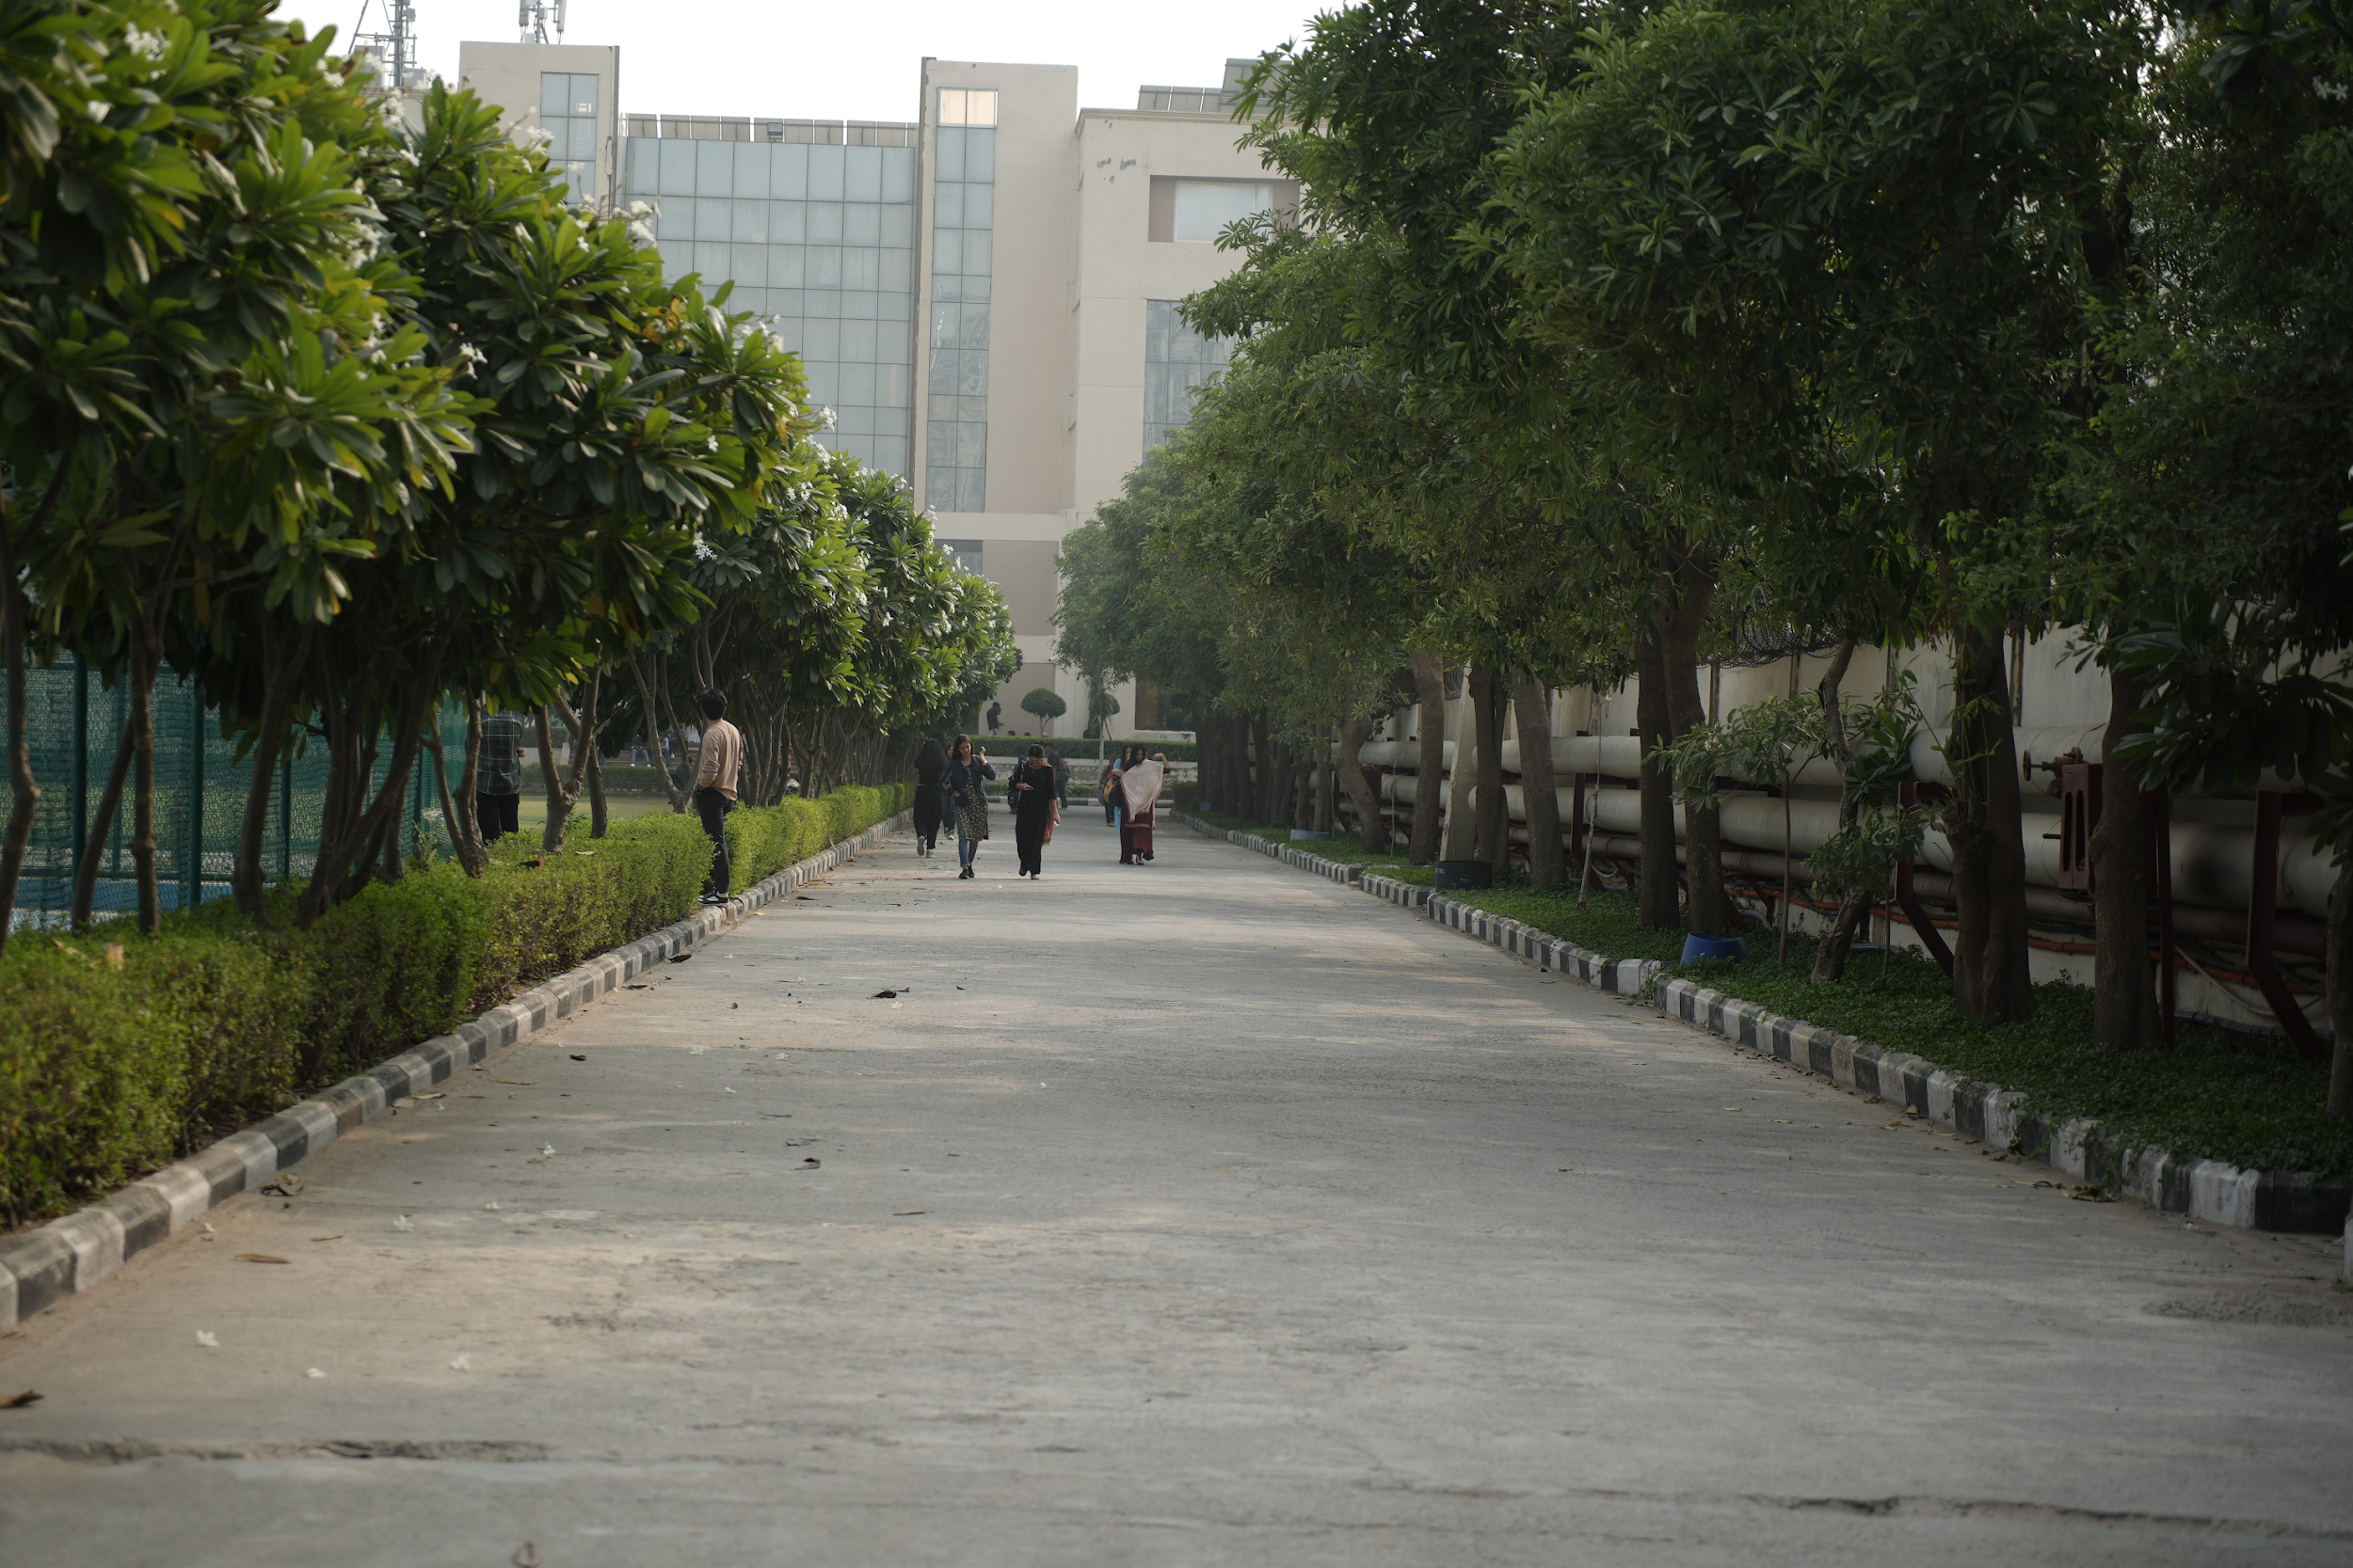
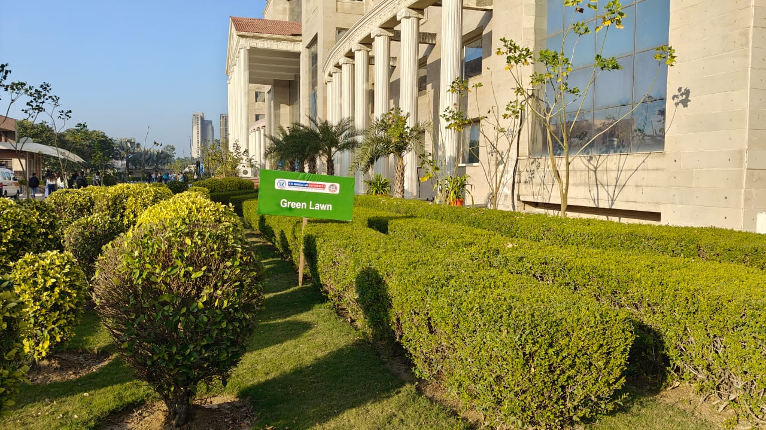
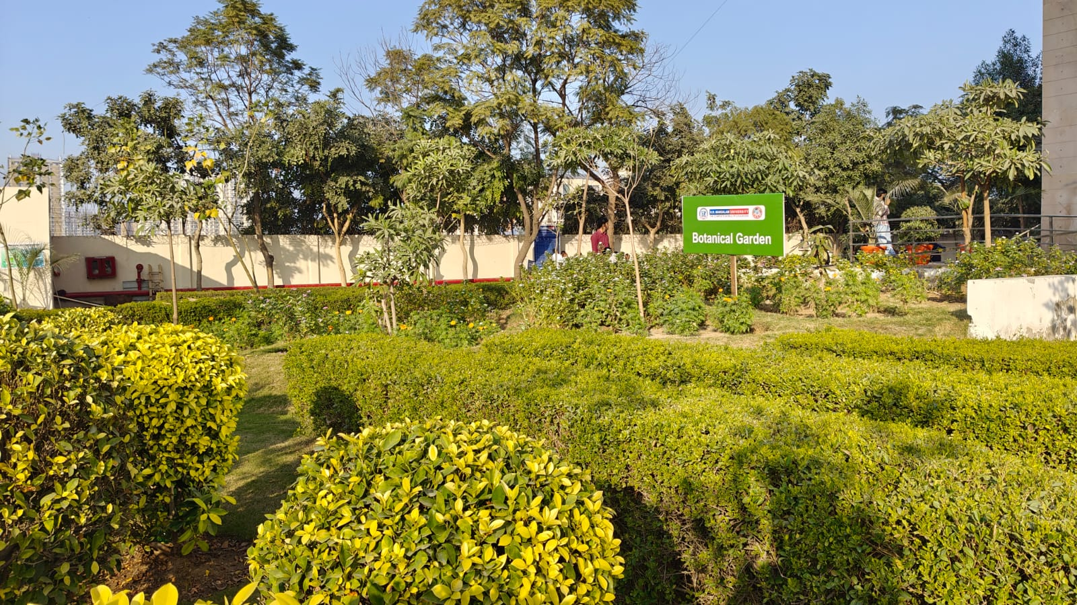

3. Waste Management and Circular Economy
3.1 Integrated Waste Segregation System
The University follows a four-bin segregation system (green, blue, red, black) for biodegradable, recyclable, hazardous, and non-recyclable waste. Regular awareness sessions and housekeeping training ensure compliance.
3.2 Energy from Food Waste and Biogas Generation
Organic waste from hostels and food courts is processed through an on-campus biogas plant and composting/vermicomposting units. Biogas supports cooking and heating needs, while digestate and vermicompost are reused for campus landscaping, closing the resource loop and reducing landfill dependency.
3.3 Plastic-Free Campus Initiative
In accordance with the Plastic Waste Management Rules, 2016 and later amendments, K.R. Mangalam University has implemented extensive programs to turn the campus into a Plastic-Free Zone. Single-use plastics (SUP) are officially prohibited in academic buildings, residence halls, administrative offices, and dining areas at the university. Thermocol disposables, plastic straws, cups, cutlery, plates, stirrers, polythene bags, and thin plastic packaging are all forbidden. Alternative sustainable materials such as steel utensils, paper-based packaging, and reusable bottles were promoted across academic blocks, hostels, and canteens.
The University has adopted a Plastic-Free Campus policy under K.R. Mangalam University Integrated Sustainable Environment and Green Campus Policy (Umbrella Policy) in compliance with the Plastic Waste Management Rules.
Plastic Use Minimization Policy
Purpose: To phase out single-use plastics and promote reusable alternatives.
Provisions
- Ban on single-use plastic bottles, straws, and bags in all departments.
- Canteens and events to use steel, glass, or biodegradable alternatives.
- Students encouraged to carry reusable water bottles.
- Procurement to include “no plastic packaging” clauses.
Impact:
- Reduction of ~500 kg of plastic waste per month.
- Enhanced campus cleanliness and reduced microplastic pollution.
Plastic-free campus Policy https://www.krmangalam.edu.in//pdfs/sdg/sdg-12/sdg-12-policy-K.R-Mangalam-University-Sustainable-Environment-and-Green-Campus-Policy.pdf (Point No. 5.5)
Circulars, notifications, vendor agreements, and staff and student orientation sessions were used to spread awareness of this policy.
To raise awareness about getting rid of single-use plastics, clear and conspicuous plastic-free campus signage has been placed throughout academic buildings, dorms, cafeterias, and common areas. A culture of sustainability and behavioral change is fostered on campus by these boards constant presence. The University promotes a cleaner, greener environment and reaffirms its commitment to the Plastic Waste Management Rules by incorporating educational, bilingual, and eye-catching signage.
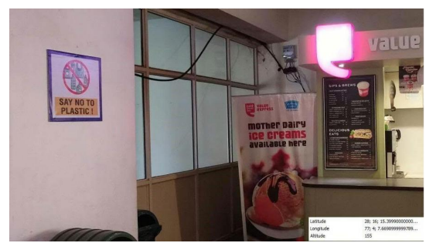 | 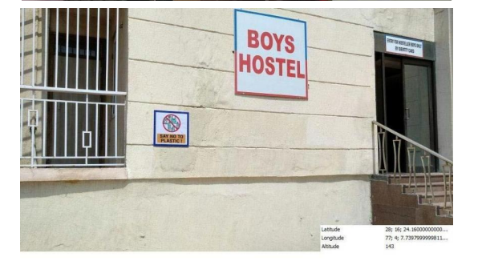
Photographs of plastic-free signage
The University ran awareness campaigns during 2024–2025 to guarantee the success of the plastic-free drive. Steel bottles, jute bags, paper packaging, biodegradable disposables, and reusable tiffins are examples of sustainable substitutes that students were encouraged to use.
On March 4, 2025, the Environment Club of K.R. Mangalam University hosted a pivotal event titled “Green Cleaning Practices” that aimed to revolutionize the way participants think about cleaning and environmental sustainability. In a world overwhelmed by pollution and the harmful effects of chemical products, this event was a wake-up call to rethink our daily habits and embrace healthier, greener alternatives.
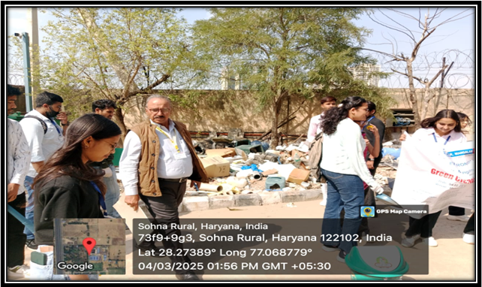
Participants collecting garbage near the hostel on the university campus
For waste segregation and management, all buildings now have separate bins for plastic waste, and authorized recyclers will periodically collect it, strengthening waste segregation mechanisms. To ensure compliance, the Campus Sustainability Committee carried out routine inspectionsaudits.
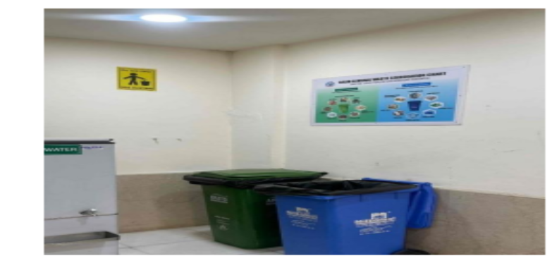 | 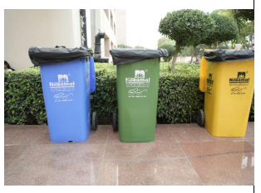
Source-level waste segregation bins across academic blocks
waste Audit

3.4 E-waste, Biomedical and Chemical Waste Management
E-waste is periodically collected and handed over to authorised recyclers. Biomedical waste is managed through certified agencies, while laboratory chemical waste is neutralised and disposed of scientifically.

4. Water Conservation and Management
4.1 Water Conservation Initiatives
The University promotes water conservation through awareness programs, workshops, competitions, and community outreach aligned with World Water Day and SDG 6.
4.2 Wastewater Treatment and Reuse
Treated wastewater from the campus STP is reused for horticulture and flushing, saving substantial freshwater annually.
4.3 Rainwater Harvesting and Efficient Irrigation
Drip and sprinkler irrigation systems, mulching, and soil moisture management are used to optimise water use across gardens and green spaces.

5. Sustainable Transport and Mobility
Offsetting Emissions
K.R. Mangalam University is dedicated to attaining long-term environmental sustainability through the reduction, management, and offsetting of its carbon emissions in accordance with national and international climate targets. The University has implemented a thorough carbon-offset strategy as part of its larger sustainability plan, which supports ongoing initiatives to increase campus biodiversity, expand renewable energy installations, and improve energy efficiency. Unavoidable greenhouse gas (GHG) emissions from campus operations are compensated for by measures that remove or prevent an equivalent quantity of carbon from the atmosphere. This process is known as emission offsetting.
The University’s emission offsetting framework begins with the systematic assessment of carbon-generating activities such as electricity consumption, transportation, waste generation, and academic operations. This baseline estimation enables the institution to identify high-impact sectors and adopt targeted strategies to minimize emissions at the source.
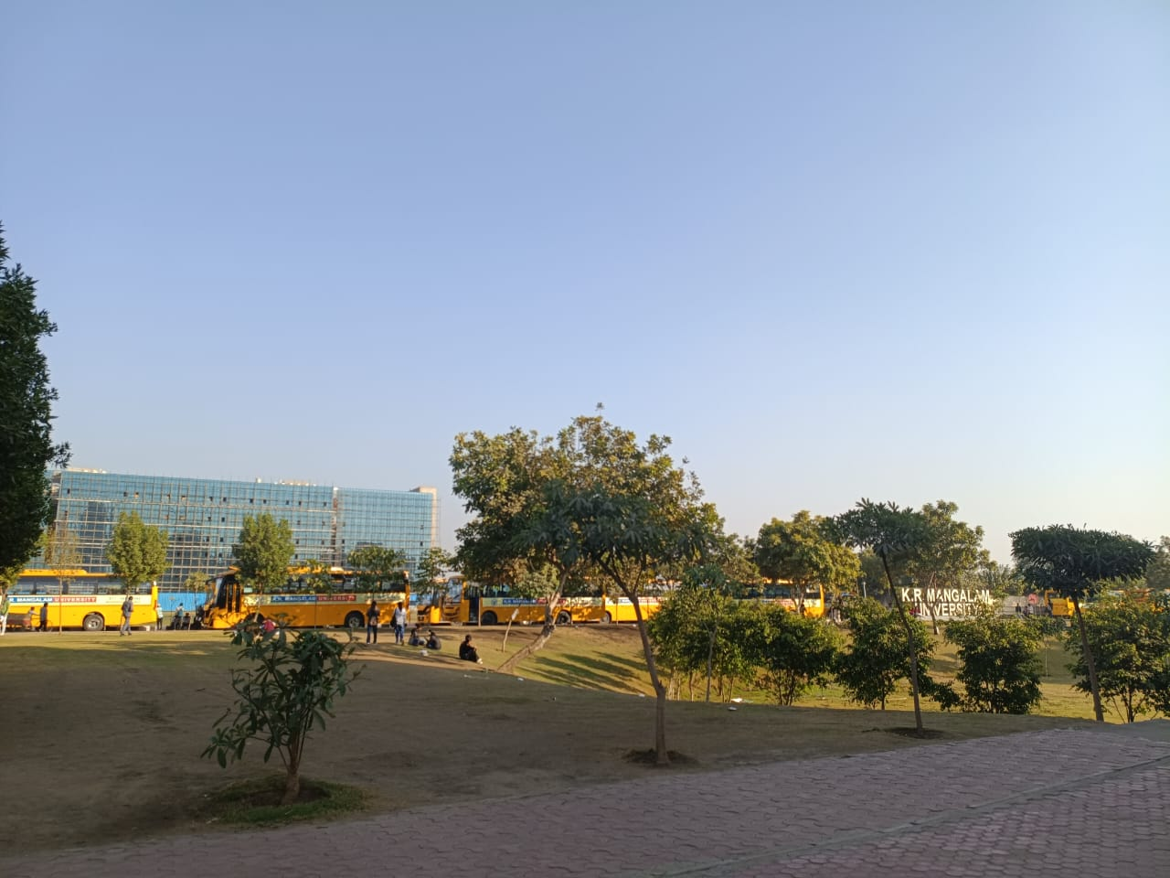
CNG bus transportation at KR Mangalam University
One of the key offsetting strategies includes large-scale afforestation and green-belt development, wherein native and climate-resilient tree species are planted across the campus and surrounding community areas. These plantations contribute significantly to carbon sequestration by absorbing atmospheric CO₂, improving soil health, and supporting local biodiversity. The University also collaborates with government agencies and NGOs to participate in regional plantation drives that extend the impact beyond campus limits.
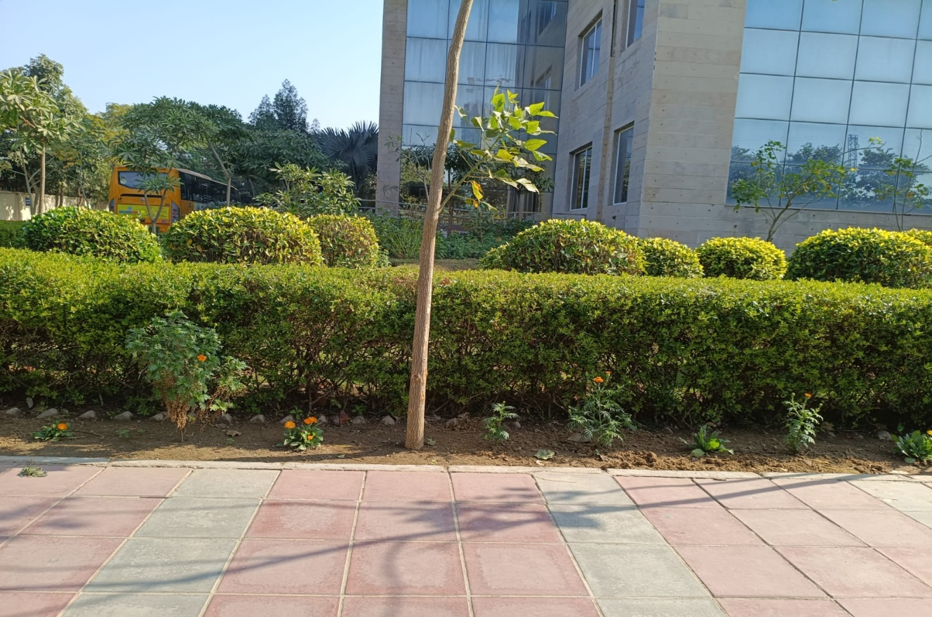
Biodiversity park at K.R. Mangalam University
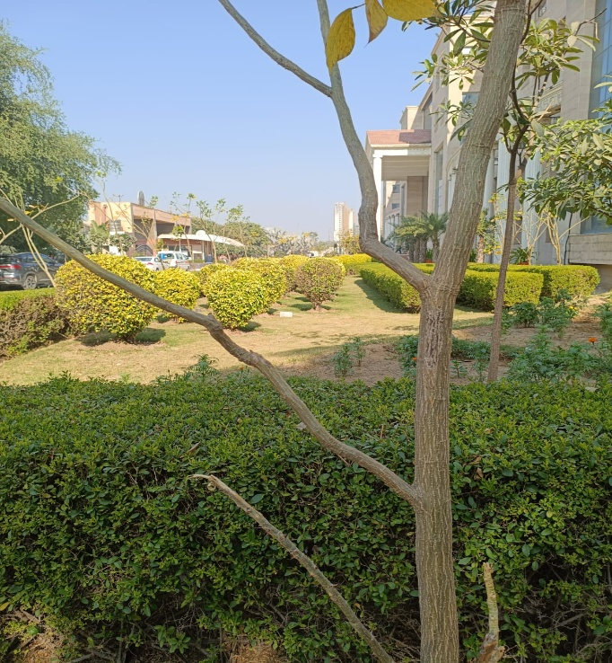 | 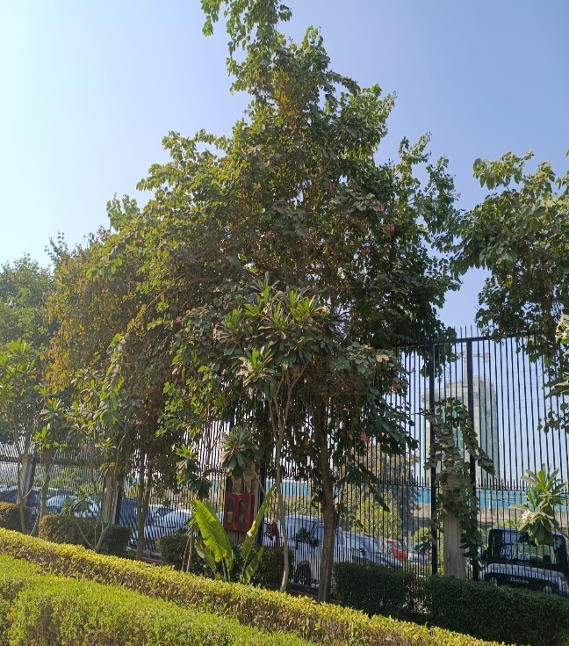
Green Belt at K.R. Mangalam University
Green Cover Expansion

In addition to afforestation, the University promotes renewable energy adoption as an indirect offsetting mechanism. Through the installation of rooftop solar panels and solar-powered utilities, KRMU reduces dependence on grid-based electricity generated from fossil fuels. The surplus renewable energy fed into the system further contributes to emission reduction at the national level. This initiative is aligned with the Government of India’s push toward clean energy and supports SDG 7 (Affordable and Clean Energy) and SDG 13 (Climate Action).
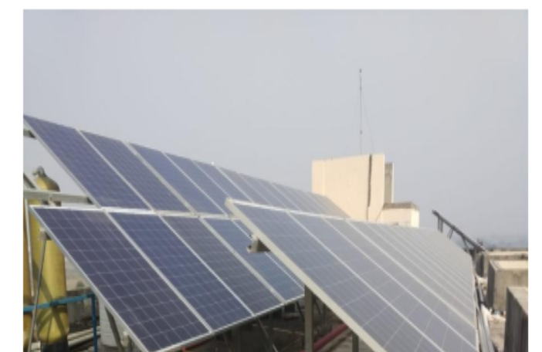
310 kWp rooftop solar PV system across Academic Blocks and hostels, generating clean electricity and reducing dependence on grid power
The University has also undertaken measures such as organic waste conversion into compost, biogas generation, and responsible e-waste disposal, which reduce methane emissions from landfills and minimize environmental pollution. Compost produced on campus is used in the University’s horticulture activities, promoting circular resource use and offsetting emissions associated with chemical fertilizers.
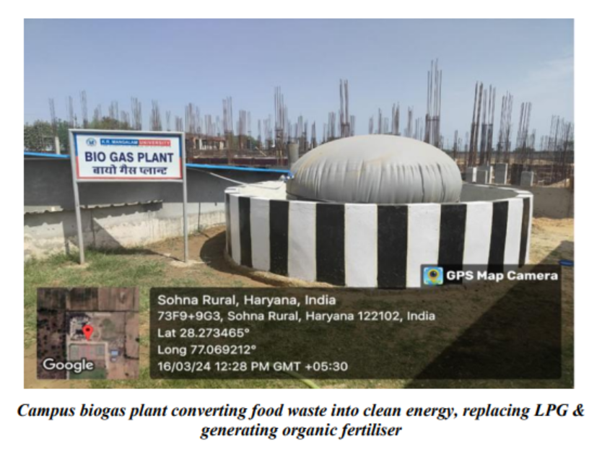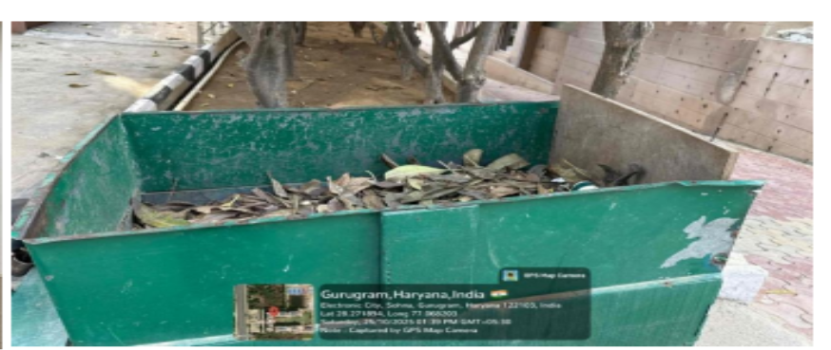
Organic composting of biodegradable waste.
Furthermore, KRMU engages in carbon-positive community initiatives, including awareness campaigns, sustainable lifestyle programs, and capacity-building sessions for students, faculty, and local communities. By encouraging behavioral change and supporting environmentally conscious practices such as carpooling, cycling, and reduced plastic use, the University indirectly reduces overall emissions linked to campus-associated activities.
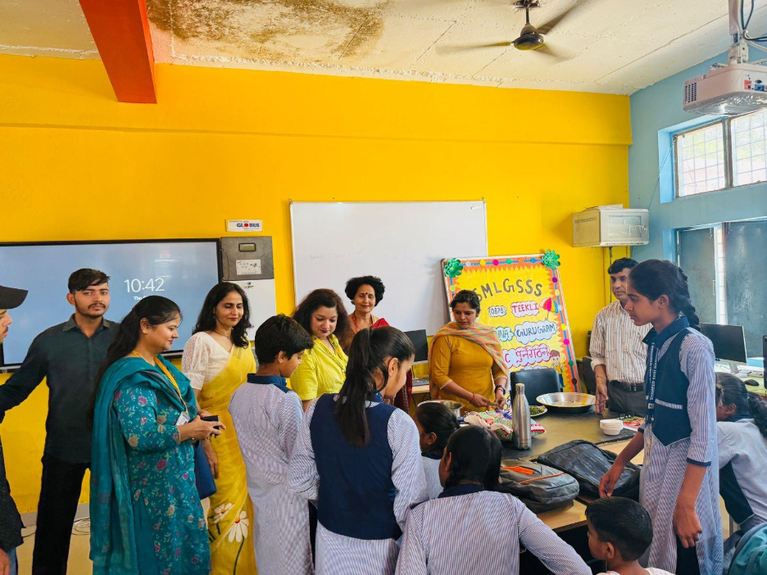
Awareness session on the importance of tree plantation and environmental sustainability
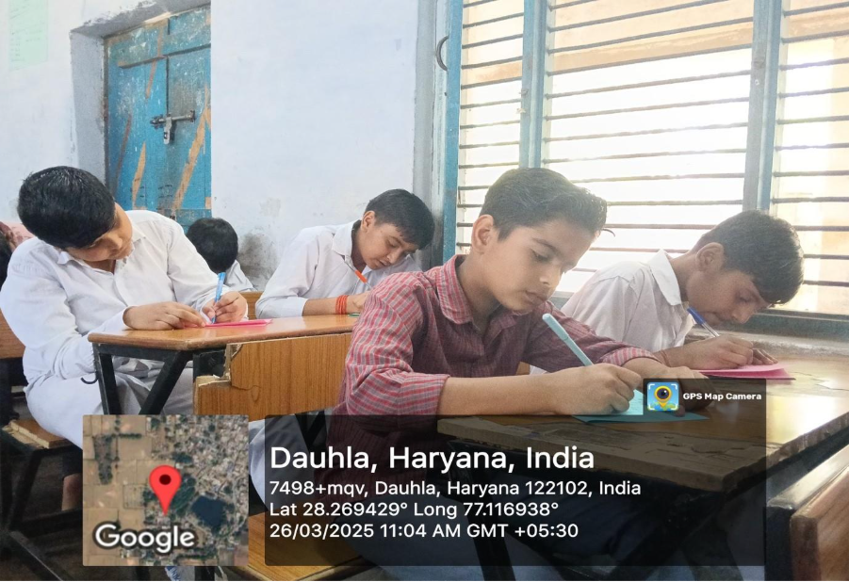
Students actively participating in the essay writing competition held at Dauthla, Haryana, showcasing their creativity and writing skills
Through this multi-dimensional approach, K.R. Mangalam University demonstrates its commitment to responsible environmental stewardship. The emission offsetting initiatives not only help mitigate climate change but also reinforce the University’s role as a sustainability leader in higher education. These efforts collectively contribute to national initiatives like the Swachh Bharat Mission, National Action Plan on Climate Change (NAPCC), and India’s Panchamrit climate targets.

6. Biodiversity Conservation, Gardens and Afforestation
6.1 Biodiversity and Green Cover Enhancement
Biodiversity Garden
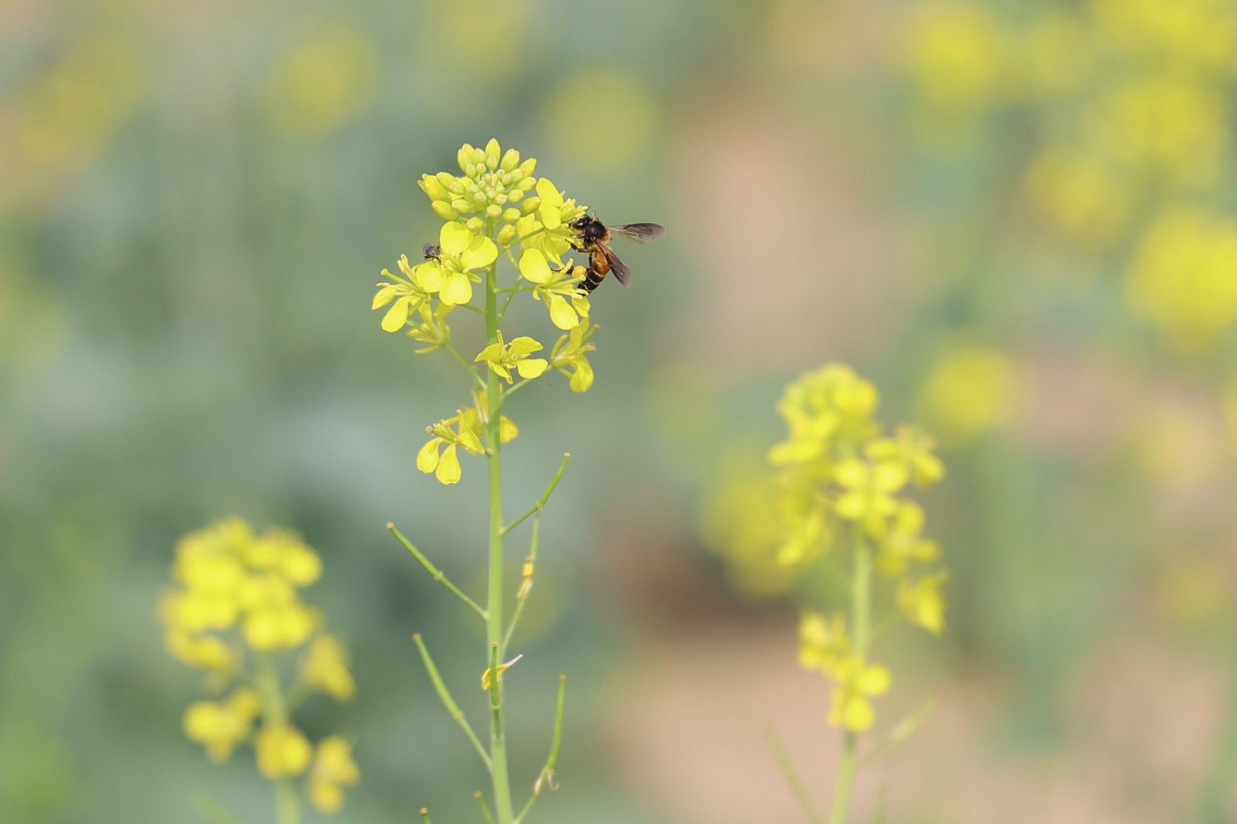
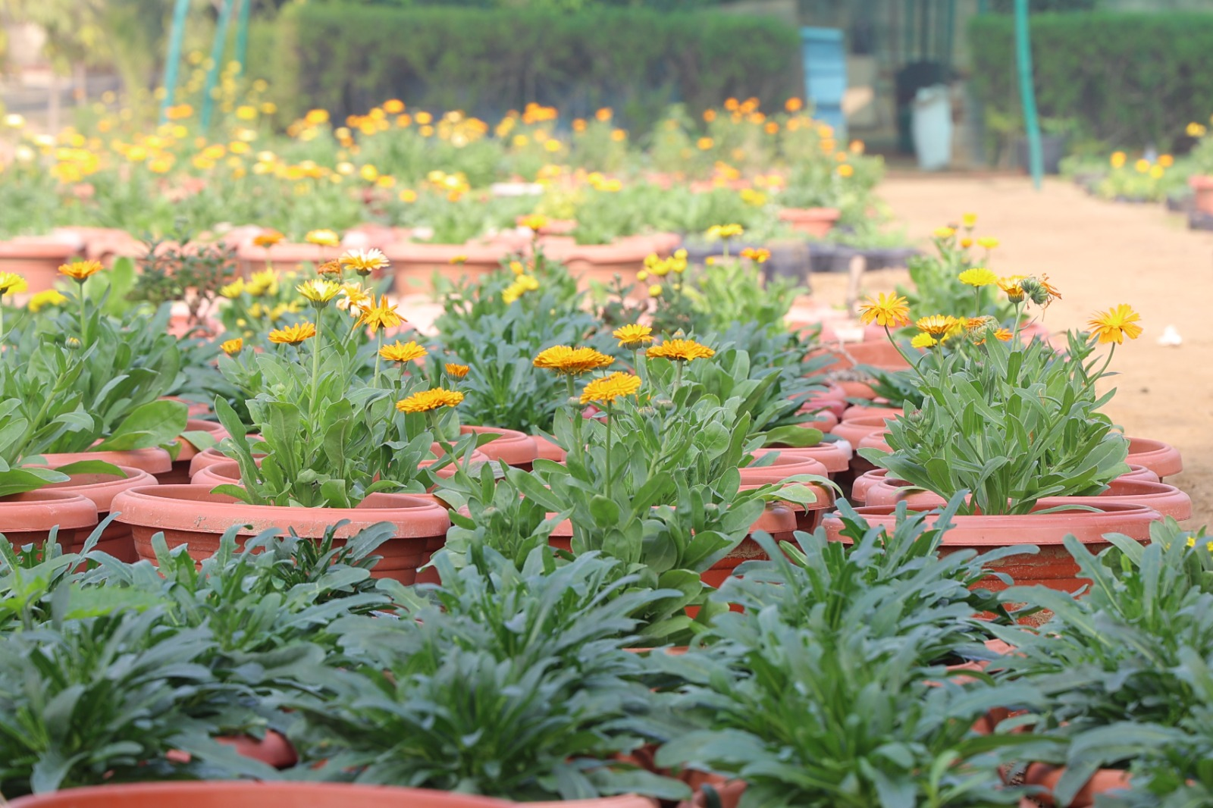
K.R. Mangalam University demonstrates a strong commitment to biodiversity conservation through the systematic development of diverse green spaces across the campus. The university hosts a rich variety of flora, including herbal, medicinal, botanical, ornamental, and native plant species, developed through Herbal Gardens, Medicinal Gardens, Botanical Gardens, Green Walkways, Community Gardens, Green Lawns, Environmental Research Zones, and an Eco-Friendly Green Belt. These initiatives support local flora and fauna, enhance ecological balance, improve air quality, regulate microclimate, and promote groundwater recharge. The biodiversity-rich campus serves as a living laboratory for teaching, research, student projects, and extension activities, fostering environmental awareness, sustainable practices, and experiential learning. Through these integrated efforts, the university contributes effectively to environmental sustainability, biodiversity enhancement, and national priorities aligned with NIRF and sustainable development goals.

Harbal Garden : Area (230 sq. m) , Total plants 289
The Herbal Garden, spread across an area of 230 sq. m, serves as an important resource for promoting botanical awareness and supporting academic and research activities. The garden hosts a diverse collection of 289 herbal plants, representing various species of ecological and botanical importance.
This curated green space provides students and researchers hands-on exposure to plant identification, conservation practices, and the study of plant characteristics, thereby enhancing the institution’s commitment to environmental sustainability and experiential learning.

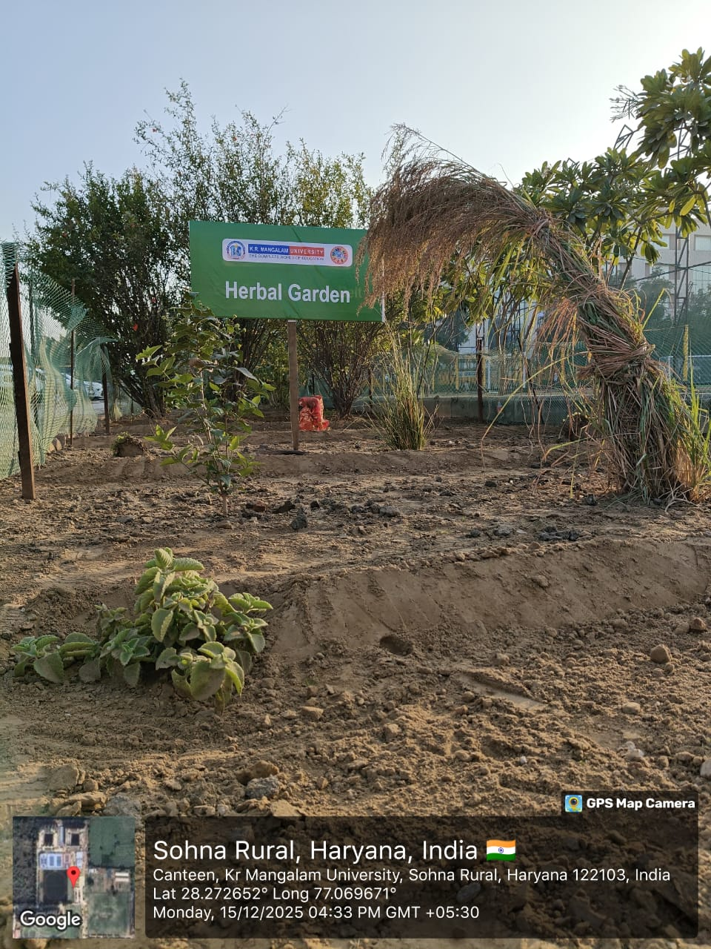

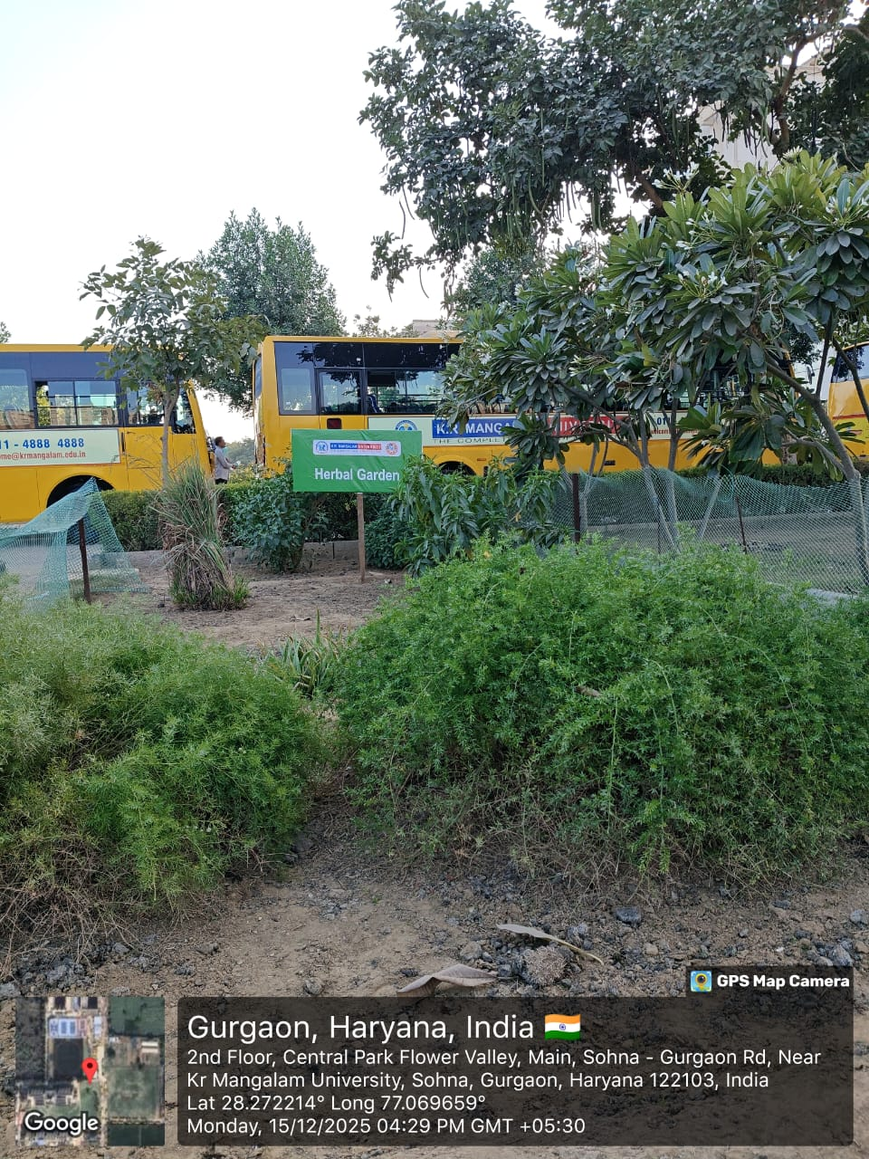
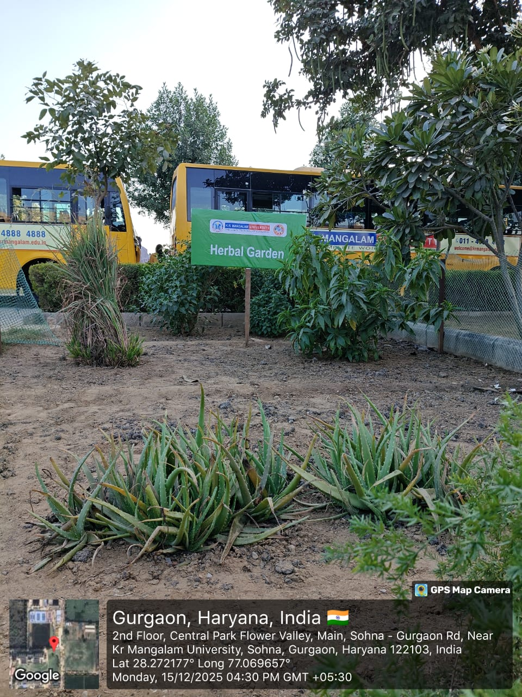

List of Herbal Plants
S. No. | Plant (Common Name) | Botanical Name | Family | Qty. | Benefits
1 | Tulsi | Ocimum sanctum | Lamiaceae | 36 | Boosts immunity, relieves cold & cough, reduces stress
2 | Aloe Vera | Aloe barbadensis | Asphodelaceae | 24 | Heals skin, aids digestion, anti-inflammatory
3 | Neem | Azadirachta indica | Meliaceae | 12 | Blood purifier, anti-bacterial, good for skin & hair
4 | Ashwagandha | Withania somnifera | Solanaceae | 8 | Reduces stress, boosts strength & immunity
5 | Lemongrass | Cymbopogon citratus | Poaceae | 10 | Improves digestion, relieves anxiety, treats cold
6 | Brahmi | Bacopa monnieri | Plantaginaceae | 20 | Enhances memory, reduces stress, improves focus
7 | Giloy | Tinospora cordifolia | Menispermaceae | 10 | Boosts immunity, treats fever, detoxifies body
8 | Pudina (Mint) | Mentha arvensis | Lamiaceae | 25 | Relieves indigestion, nausea, and headaches
9 | Amla | Phyllanthus emblica | Phyllanthaceae | 6 | Rich in Vitamin C, boosts immunity, good for hair
10 | Harshingar (Parijat) | Nyctanthes arbor-tristis | Oleaceae | 4 | Relieves joint pain, improves immunity
11 | Curry Leaves | Murraya koenigii | Rutaceae | 23 | Improves digestion, good for hair & diabetes control
12 | Safed Musli | Chlorophytum borivilianum | Asparagaceae | 5 | Boosts energy, enhances immunity, restorative tonic
13 | Arjuna | Terminalia arjuna | Combretaceae | 18 | Strengthens heart, controls blood pressure
14 | Bael | Aegle marmelos | Rutaceae | 12 | Good for digestion, treats diarrhea & acidity
15 | Shatavari | Asparagus racemosus | Asparagaceae | 3 | Supports women’s health, boosts immunity
16 | Patharchatta | Bryophyllum pinnatum | Crassulaceae | 16 | Treats kidney stones, heals wounds
17 | Stevia | Stevia rebaudiana | Asteraceae | 7 | Natural sweetener, controls diabetes
18 | Ajwain | Trachyspermum ammi | Apiaceae | 2 | Relieves indigestion, gas, and cold
19 | Chamomile | Matricaria chamomilla | Asteraceae | 3 | Calms mind, improves sleep, reduces inflammation
20 | Marigold (Calendula) | Calendula officinalis | Asteraceae | 45 | Heals skin, anti-inflammatory, good for wounds

Total Herbal Plants 289

Medicinal Garden (270 sq. m), Total plants 573
The Medicinal Garden, spread across an area of 270 sq. m, serves as a dedicated space for conserving and showcasing plant species known for their therapeutic and traditional healing properties. The garden accommodates a rich collection of 573 plants, representing a wide range of medicinally significant species.
This facility provides valuable learning opportunities for students and researchers by enabling hands-on exposure to plant identification, cultivation practices, and the study of their traditional uses. The garden also supports the institution’s efforts toward promoting environmental awareness, sustainable practices, and the preservation of ethnobotanical knowledge.
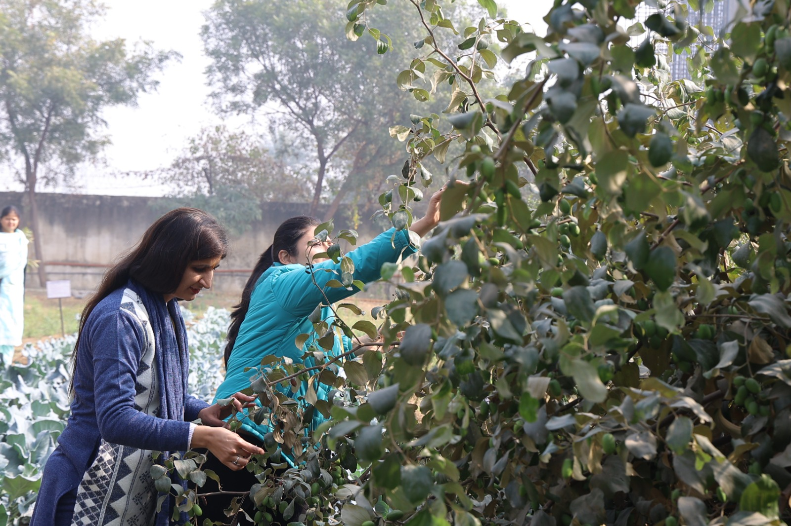
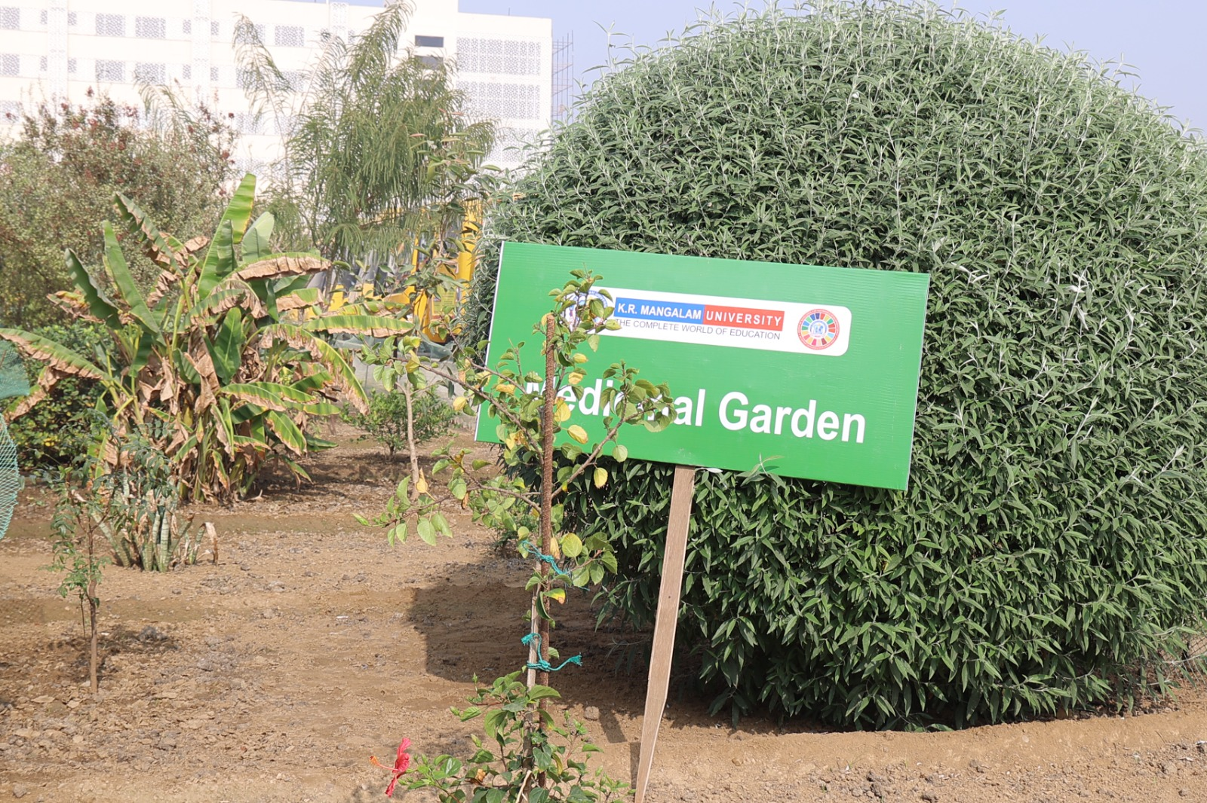
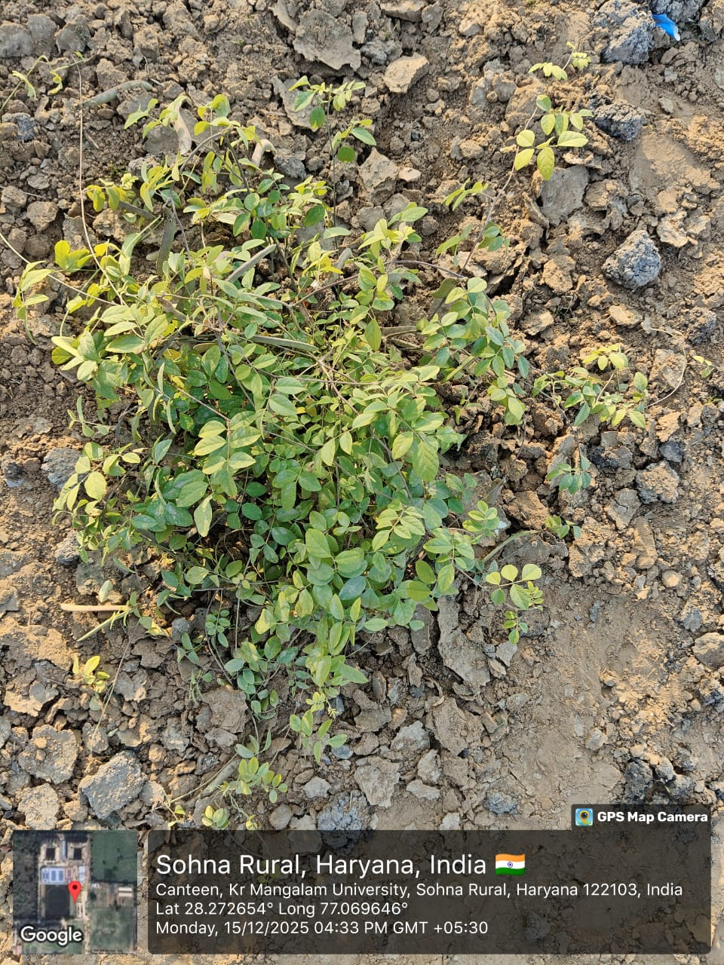
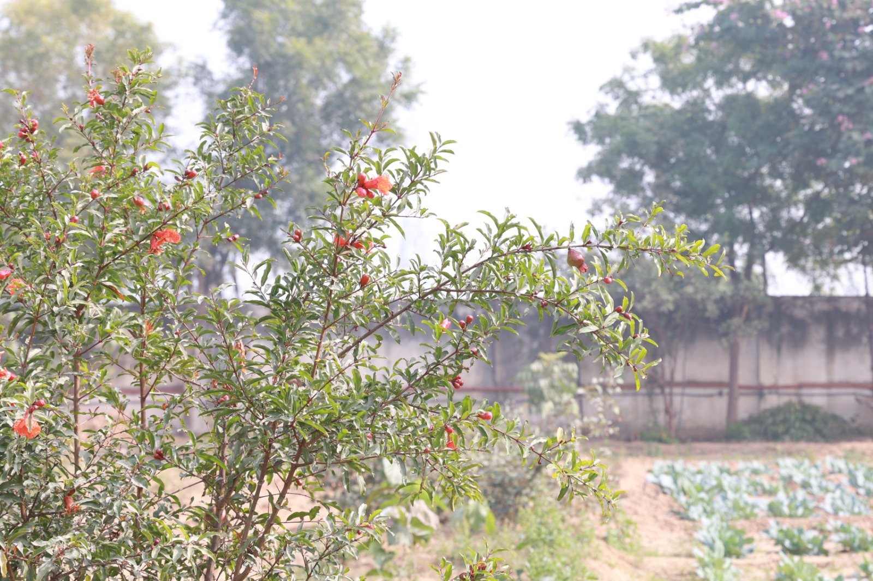

List of Medicinal Plants
S. No. | Plant (Common Name) | Botanical Name | Family | Qty. | Benefits
1 | Ajwain | Trachyspermum ammi | Umbelliferae | 10 | Stimulant, Carminative
2 | Curry-patta | Murraya koenigii | Rutaceae | 25 | Treatment of diarrhoea & gastrointestinal diseases
3 | Ghritkumari | Aloe barbadensis | Liliaceae | 16 | Purgative, Antimicrobial
4 | Datura | Datura metel | Solanaceae | 22 | Antiasthmatic and Anticholinergic
5 | Amla | Emblica officinalis | Phyllanthaceae | 14 | Antiscorbutic, Antioxidant
6 | Ficus | Ficus racemosa | Moraceae | 12 | Antidiabetic, Anti-inflammatory
7 | Ashwagandha | Withania somnifera | Solanaceae | 26 | Glaucoma, Diuretic
8 | Giloe | Tinospora cordifolia | Menispermaceae | 30 | Anti-Diabetic, Antipyretic
9 | Banana | Musa acuminata | Musaceae | 14 | Anti-diarrhoeal, hypokalemia
10 | Harshingar | Nyctanthes arbortristis | Oleaceae | 24 | Anti- rheumatic, laxative
11 | Bel | Aegle mnarmelos | Rutaceae | 10 | Anti-diarrhoeal, Laxative
12 | Jasmine | Jasminum officinale | Oleaceae | 10 | Wound healing, Aniolytic
13 | Kaner | Nerium indicum | Apocynaceae | 6 | Antileprotic, Anti-inflammatory
14 | Ishabgol | Plantago ovata | Plantaginaceae | 10 | Laxative
15 | Brahmi | Bacopa monnieri | Scrophulariaceae | 10 | Memory enhancer, Antipyretic
16 | Pathar-chatta | Bryophyllum pinnatum | Crassulaceae | 10 | Kidney stone, Anticancer
17 | Mandarin Orange | Citrus reticulata | Rutaceae | 10 | Antioxidant
18 | Tulsi | Ocimum sanctum | Lamiaceae | 43 | Immunity Booster, antipyretic Astringent
19 | Karonda | Carrisa carandas | Apocynaceae | 18 | Antiscorbutic, Astringent
20 | Hibiscus | Hibiscus rosasinensis | Malvaceae | 26 | Antimicrobial, Promotes hair growth
21 | Lemon | Citrus limonis | Rutaceae | 18 | Antioxidant, Anticancer
22 | Papaya | Carica papaya | Cariaceae | 14 | Appetizer, digestive
23 | Lemon Grass | Cymbopogon flexuosus | Graminae | 19 | Flavouring agent, Carminative
24 | Pomegranate | Punica granatum | Punicaceae | 15 | Antihypertensive, Anticancer
25 | Mehendi | Lawsonia inermis | Lythraceae | 27 | Hair colorant., Anti-fungal
26 | Rose | Rosa rubiginosa | Rosaceae | 15 | Flavouring Agent
27 | Mirchi | Capsicum annuum | Solanaceae | 14 | Anti-Inflammatory Boosts immunity
28 | Sadabahar | Catharanthus roseus | Apocynacea | 19 | Anti-cancer, anti- diabetic
29 | Satavari | Asparagus racemosus | Liliaceae | 13 | Diuretic, anti-dysentric
30 | Neem | Azadirachta índica | Meliaceae | 18 | Antimalarial, Antimicrobial
31 | Sheesham | Dalbergia sissoo | Leguminosae | 19 | Emollient, Anti-Inflammatory
32 | Tamarind | Tamarindus indica | Fabaceae | 13 | Antipyretic, Laxative
33 | Mirchi | Plumeria rubra | Solanaceae | 23 | Anti-Inflammatory Boosts immunity
 |  |  |  | 573

Botanical Garden (858 sq. m), Total Botanical Plants-1286
The Botanical Garden, spread across an area of 858 sq. m, serves as a vital green resource for enriching academic, research, and ecological learning on campus. The garden houses an extensive collection of 1,286 botanical plants, representing diverse species that contribute to environmental conservation and biodiversity enhancement.
This well-maintained space provides students and researchers with hands-on exposure to plant identification, taxonomy, and cultivation practices. It also supports experiential learning, promotes ecological awareness, and reinforces the institution’s commitment to sustainability and green campus initiatives.
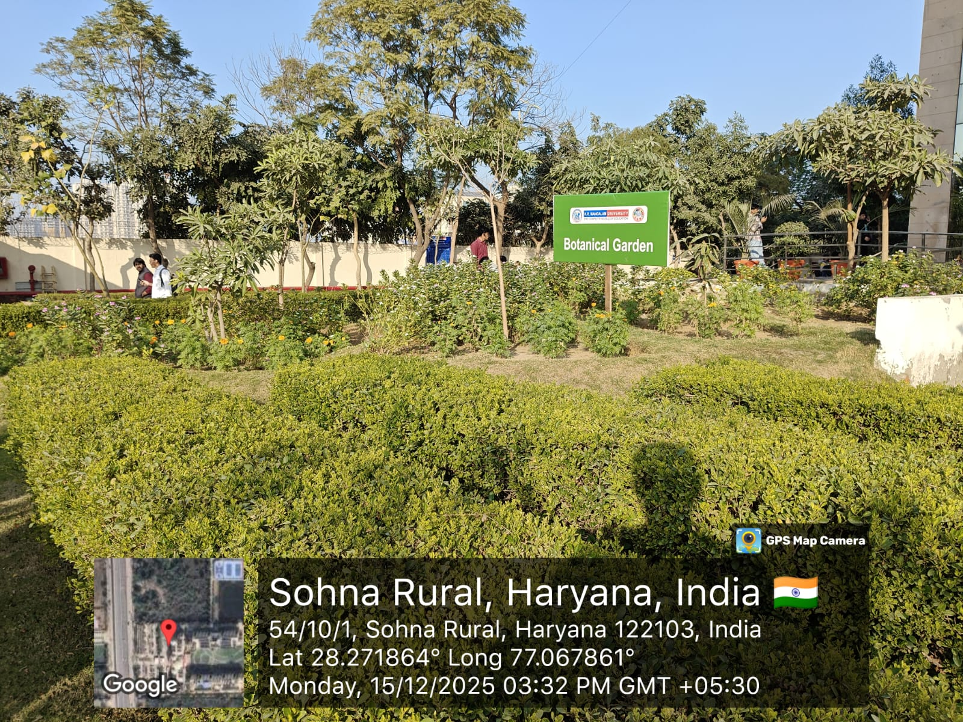
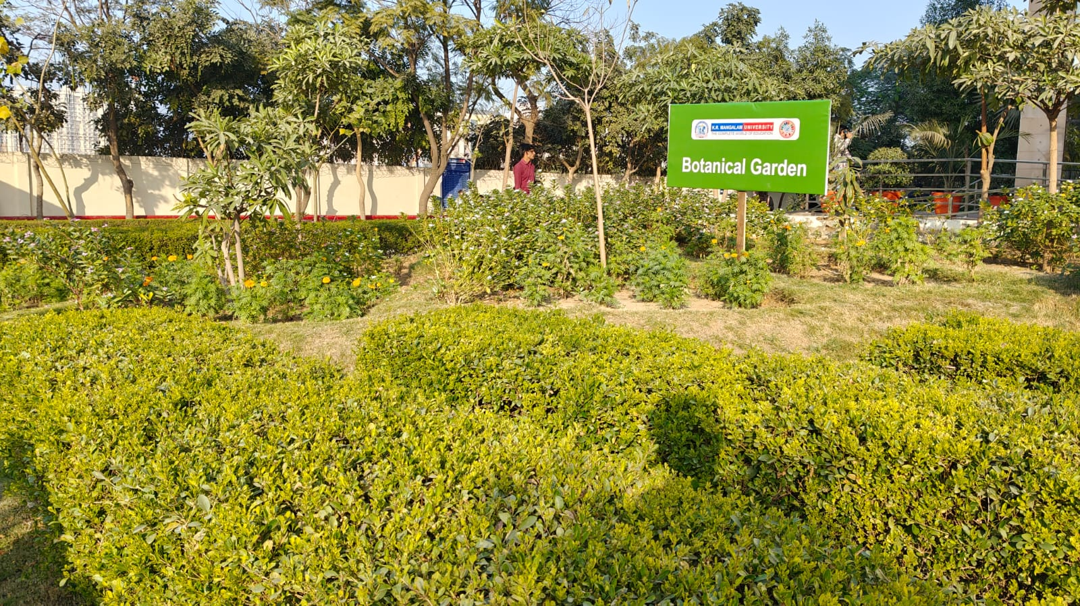
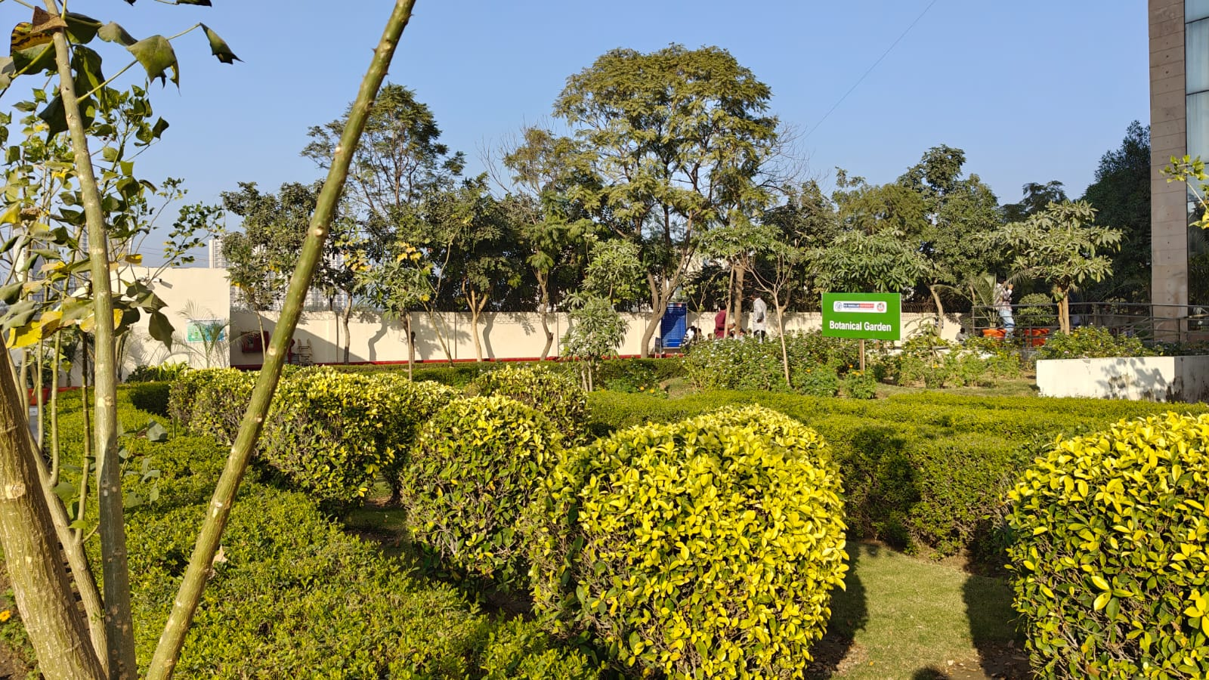
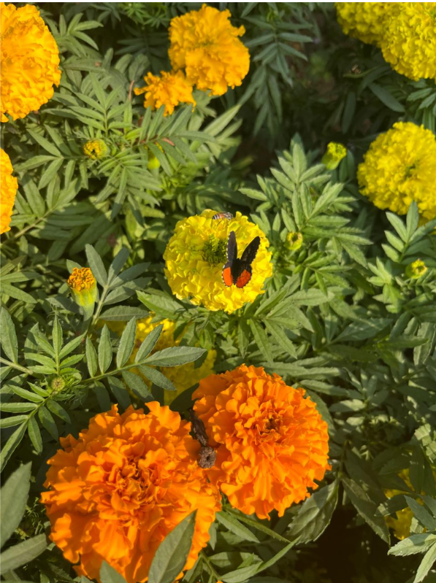
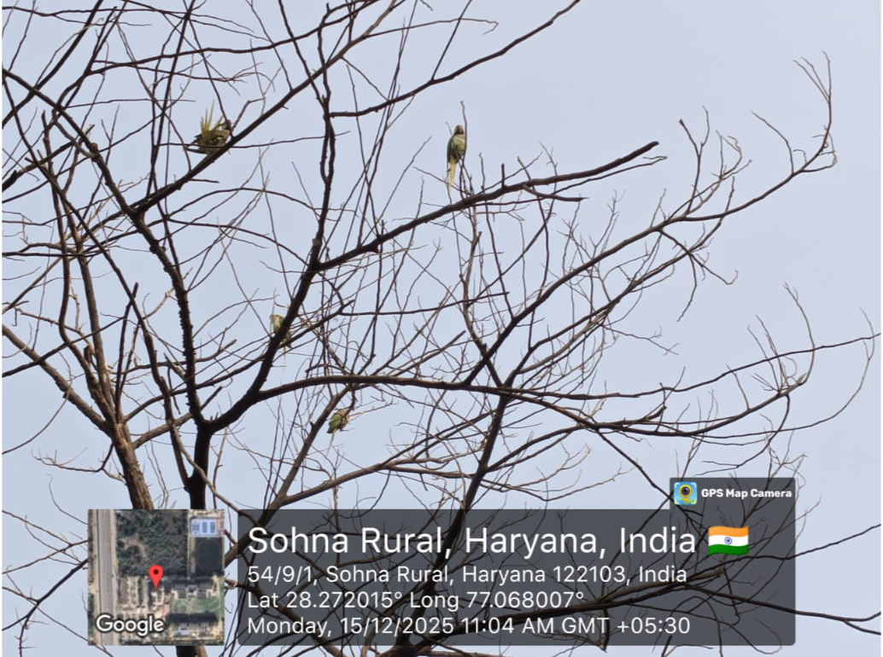

List of Botanical Plants
S. No. | Plant (Common Name) | Botanical Name | Family | Qty. | Benefits of Botanical Garden
1 | Tulsi | Ocimum sanctum | Lamiaceae | 150 | Boosts immunity, purifies air, relieves cold & cough
2 | Aloe Vera | Aloe barbadensis | Asphodelaceae | 80 | Skin healing, anti-inflammatory, drought tolerant
3 | Neem | Azadirachta indica | Meliaceae | 70 | Blood purifier, medicinal, shade tree
4 | Ashwagandha | Withania somnifera | Solanaceae | 50 | Reduces stress, strengthens immunity
5 | Lemongrass | Cymbopogon citratus | Poaceae | 60 | Aromatic, aids digestion, mosquito repellent
6 | Brahmi | Bacopa monnieri | Plantaginaceae | 40 | Enhances memory, reduces stress
7 | Giloy | Tinospora cordifolia | Menispermaceae | 45 | Boosts immunity, detoxifies body
8 | Pudina (Mint) | Mentha arvensis | Lamiaceae | 55 | Relieves indigestion, nausea, headaches
9 | Amla | Phyllanthus emblica | Phyllanthaceae | 35 | Rich in Vitamin C, boosts immunity
10 | Harshingar (Parijat) | Nyctanthes arbor-tristis | Oleaceae | 20 | Ornamental, relieves joint pain
11 | Curry Leaves | Murraya koenigii | Rutaceae | 65 | Culinary, medicinal, improves digestion
12 | Safed Musli | Chlorophytum borivilianum | Asparagaceae | 10 | Boosts energy, restorative tonic
13 | Arjuna | Terminalia arjuna | Combretaceae | 30 | Strengthens heart, controls blood pressure
14 | Bael | Aegle marmelos | Rutaceae | 25 | Treats digestion issues, edible fruit
15 | Shatavari | Asparagus racemosus | Asparagaceae | 15 | Supports women’s health, immunity booster
16 | Patharchatta | Bryophyllum pinnatum | Crassulaceae | 50 | Heals wounds, treats kidney stones
17 | Stevia | Stevia rebaudiana | Asteraceae | 20 | Natural sweetener, diabetes-friendly
18 | Ajwain | Trachyspermum ammi | Apiaceae | 10 | Aids digestion, relieves gas
19 | Chamomile | Matricaria chamomilla | Asteraceae | 15 | Calms mind, improves sleep
20 | Marigold (Calendula) | Calendula officinalis | Asteraceae | 75 | Ornamental skin healing, attracts pollinators
21 | Rose | Rosa indica | Rosaceae | 80 | Ornamental, medicinal
22 | Hibiscus | Hibiscus rosa-sinensis | Malvaceae | 70 | Ornamental, medicinal, edible flowers
23 | Jasmine | Jasminum sambac | Oleaceae | 60 | Fragrant, ornamental
24 | Bougainvillea | Bougainvillea glabra | Nyctaginaceae | 85 | Drought-tolerant ornamental
25 | Lavender | Lavandula angustifolia | Lamiaceae | 50 | Fragrant, calming, ornamental
26 | Neem (Young Saplings) | Azadirachta indica | Meliaceae | 20 | Air purifier, shade, medicinal
27 | Bamboo | Bambusa vulgaris | Poaceae | 30 | Fast-growing, screening, ornamental
28 | Lemon | Citrus limon | Rutaceae | 56 | Fruit-bearing, Vitamin C, ornamental

Green Walkways (705 sq. m), Total Plants-867
The campus features well-developed Green Walkways spread across an area of 705 sq. m, designed to enhance environmental aesthetics and promote a healthy, eco-friendly campus atmosphere. These walkways are lined with a diverse range of ornamental, flowering, and shade-providing plants, with an estimated 867 plants arranged to create continuous greenery along the pedestrian pathways.
The Green Walkways not only improves air quality and microclimatic conditions but also offers students and staff a refreshing, nature-integrated movement space within the campus. This initiative reflects the institution’s strong commitment to sustainability, biodiversity enhancement, and creating a green, serene campus environment.
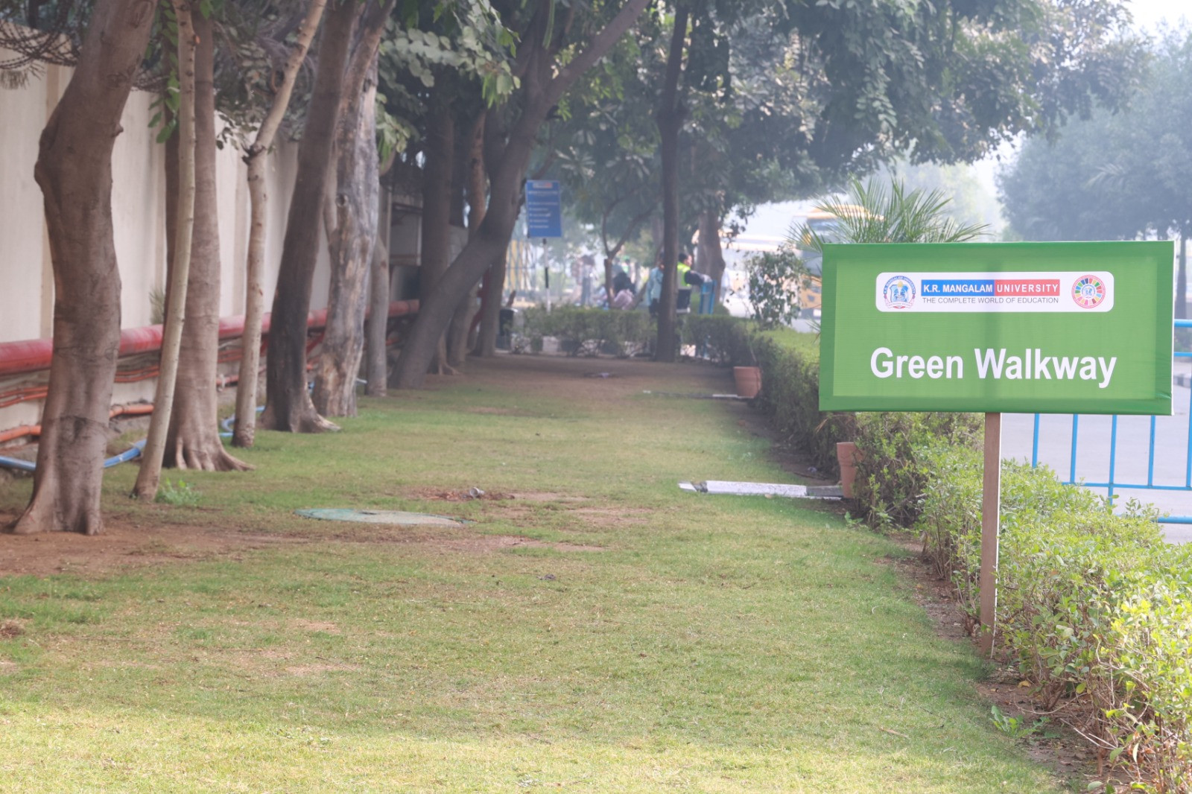

Community Garden (540 sq. m)-Total Plants-686
The Community Garden, developed across 540 sq. m, serves as an interactive green space that encourages student and faculties participation, hands-on learning, and community engagement in sustainable practices. The garden accommodates an estimated 686 plants, consisting of diverse vegetable species, herbs, and seasonal crops cultivated throughout the year.
This garden acts as a practical platform for experiential learning in organic cultivation, composting, soil management, and sustainable agriculture. It also promotes environmental awareness, healthy living, and collaborative stewardship among students and staff. The initiative reflects the institution’s commitment to integrating sustainability and community participation within the academic environment.
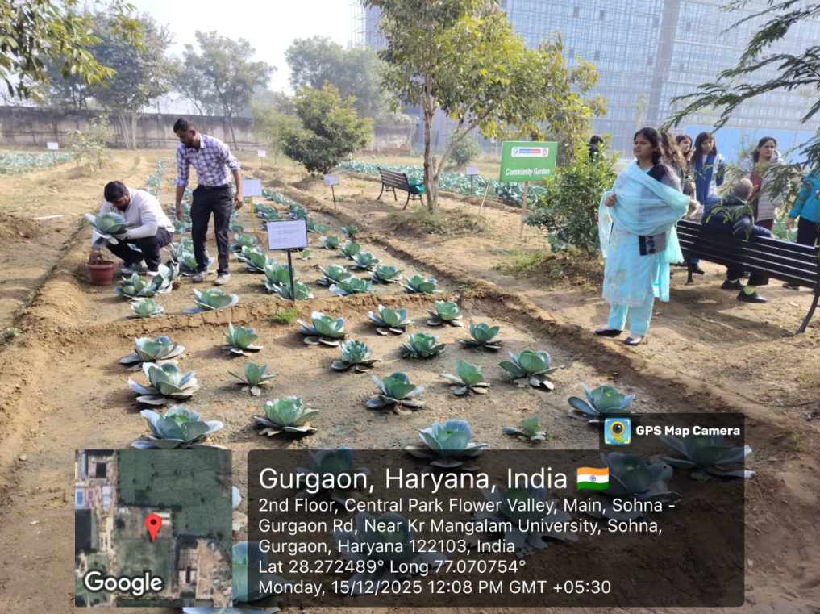
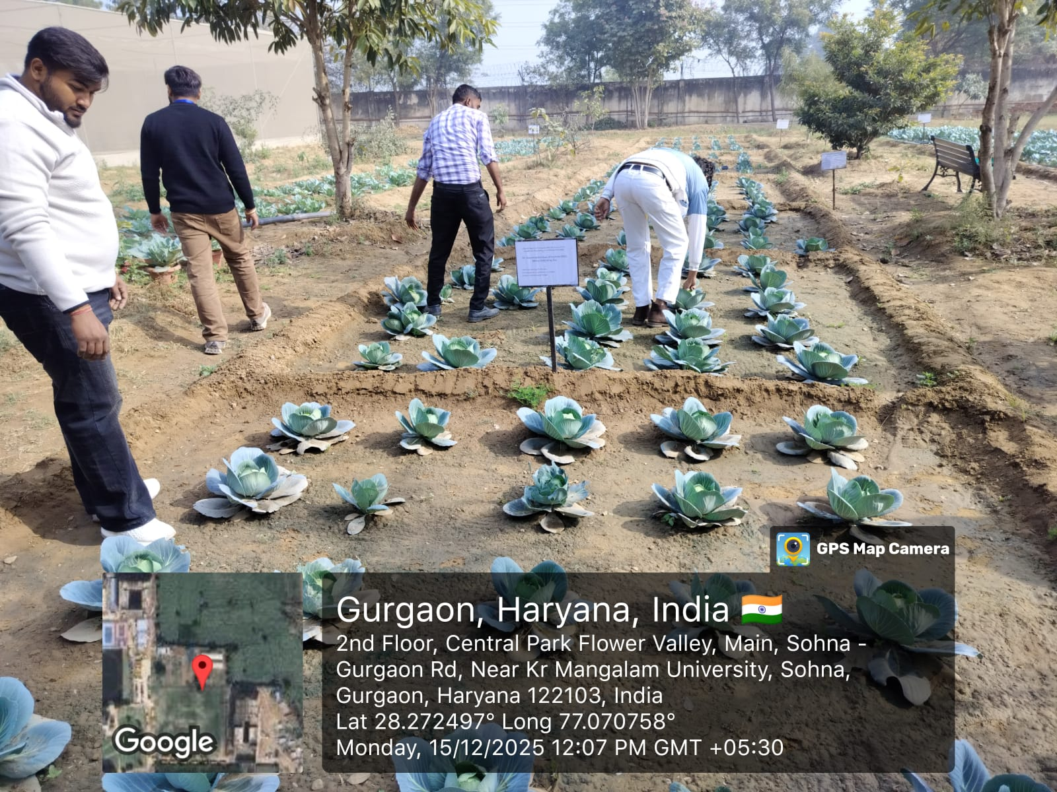
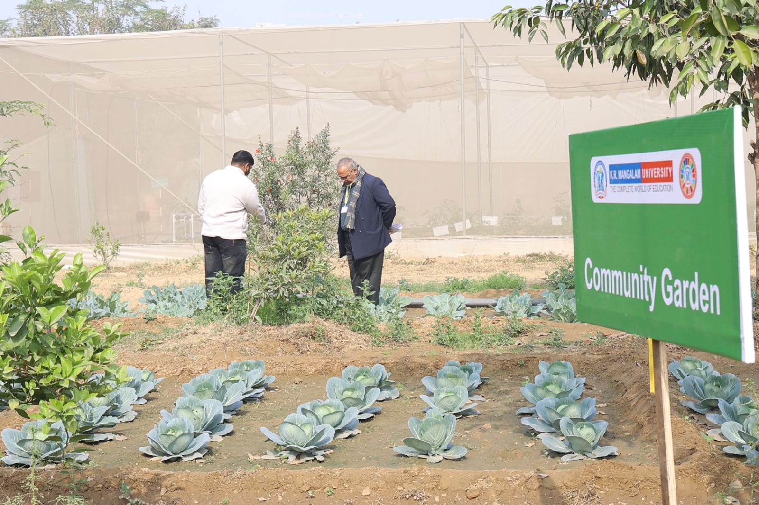
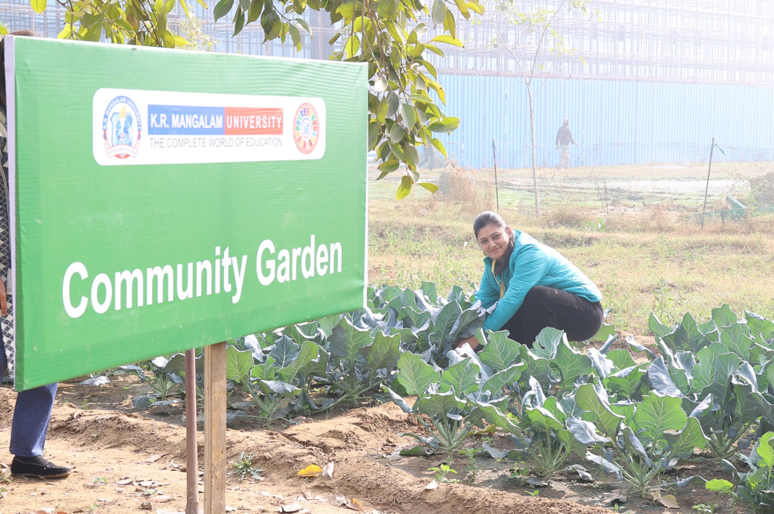
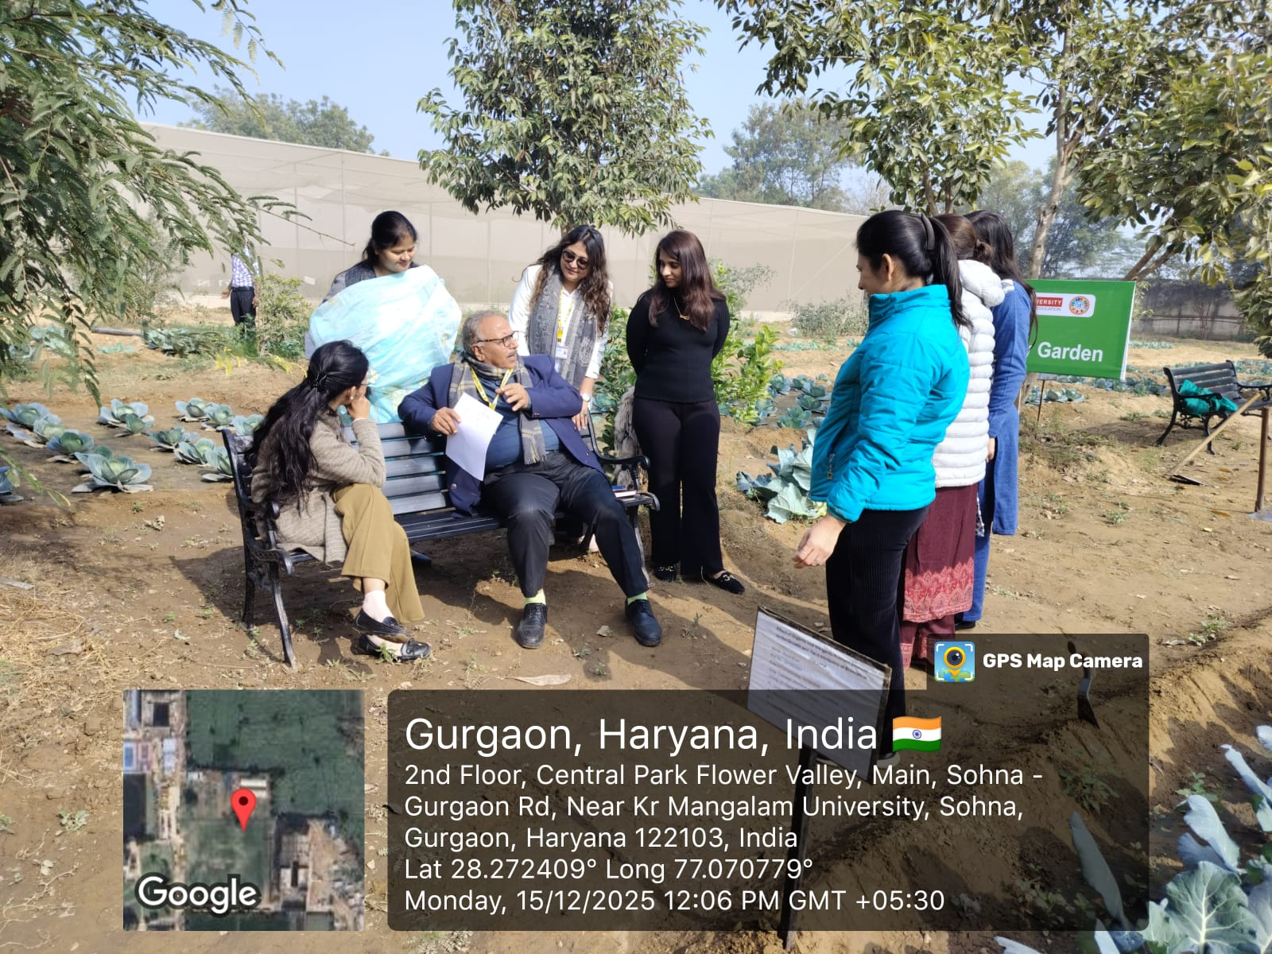
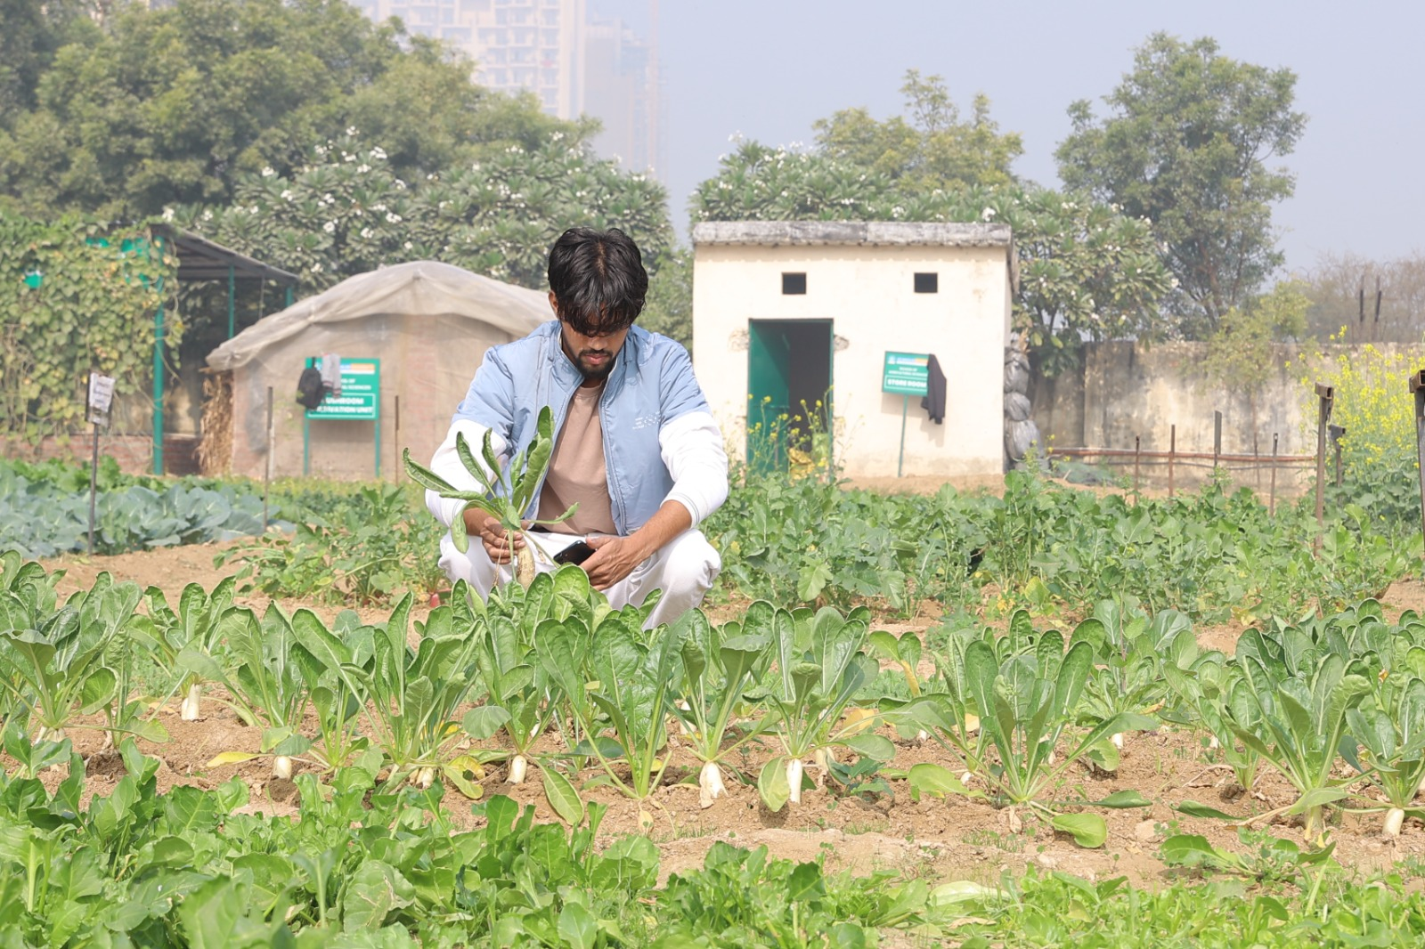

Green Lawns ( 451 sq. m)
The campus maintains extensive Green Lawns spread across 451 sq. m, forming a major component of the institutional green cover. These well-developed lawns enhance the aesthetic appeal of the campus while contributing significantly to environmental sustainability through improved air quality, temperature regulation, and groundwater recharge.
The Green Lawns serve as open recreational and relaxation spaces for students and staff, supporting outdoor activities, academic gatherings, and community events. Regular maintenance practices such as organic lawn care, efficient irrigation, and seasonal turf management ensure healthy and sustainable green cover throughout the year.
This extensive lawn area reflects the institution’s commitment to maintaining a clean, green, and eco-friendly campus environment.

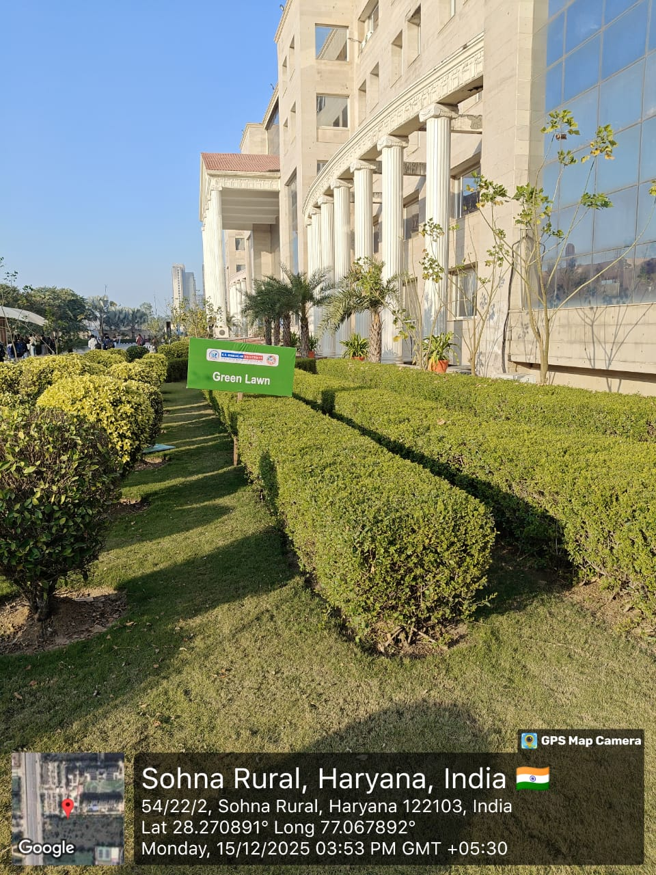

Environmental Research Zone (13563 sq. m), Total Plants –
The Environmental Research Zone spans 278.4 sq. m and is designed as a specialized area for studying native flora, ecological processes, and environmental sustainability practices. The zone contains an estimated 280–550 plants, comprising native species, indicator plants, shrubs, and experimental vegetation plots used for teaching and research activities.
This dedicated space facilitates hands-on learning and research on biodiversity assessment, soil–plant interactions, pollution monitoring, and ecosystem management. It also supports field-based projects, student research, and environmental awareness initiatives. The Environmental Research Zone demonstrates the institution’s commitment to promoting environmental stewardship, experiential learning, and applied ecological studies.
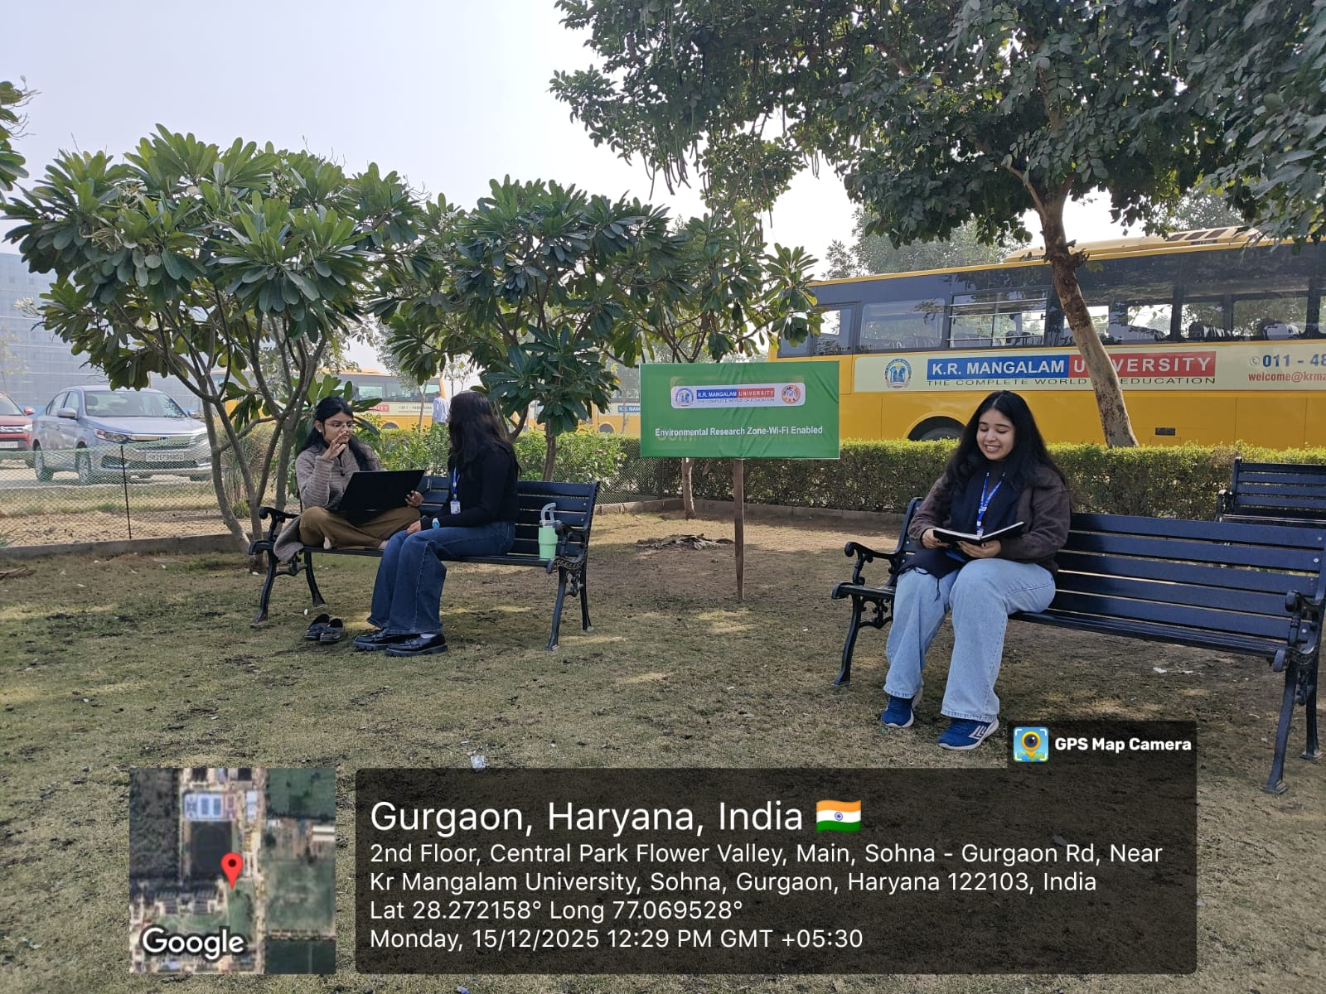
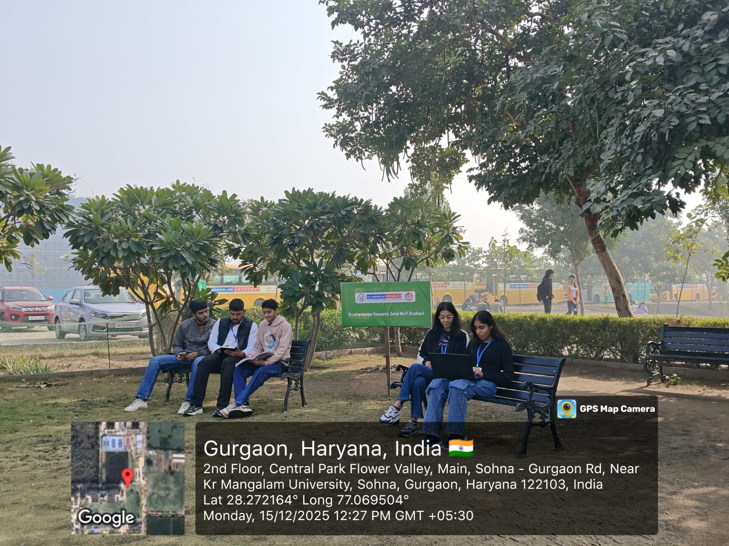
Dr. A.P.J. Abdul Kalam Science Society organized a hands-on workshop titled “Seed to Sapling: A Journey through Plant Growth” on 21 January 2025 at the Agriculture Farm, K.R. Mangalam University. The workshop aimed to educate students on the complete process of plant growth, nursery preparation, and sustainable gardening practices. Students from different schools participated enthusiastically and received practical training on raising nurseries in open fields, polyhouses/net houses, trays, and pots based on crop requirements. They learned techniques for sowing seeds, transplanting saplings, managing raised and sunken nursery beds, and organically growing vegetable crops such as cole crops and cucurbits for kitchen gardens. The session was informative, interactive, and practice-oriented, enhancing awareness about environmental conservation and sustainable gardening
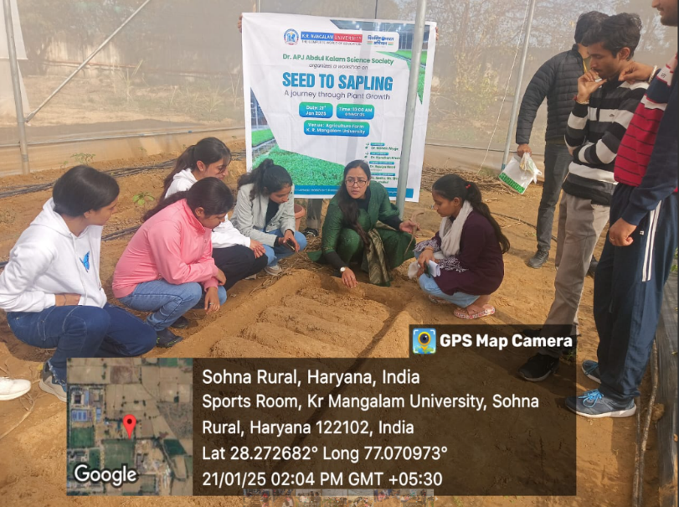
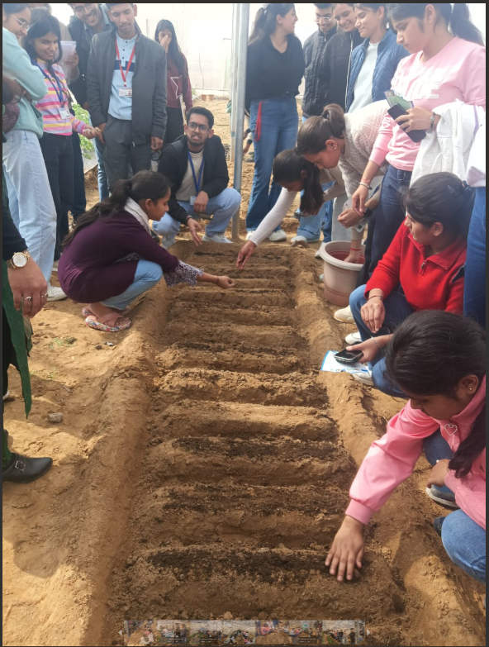
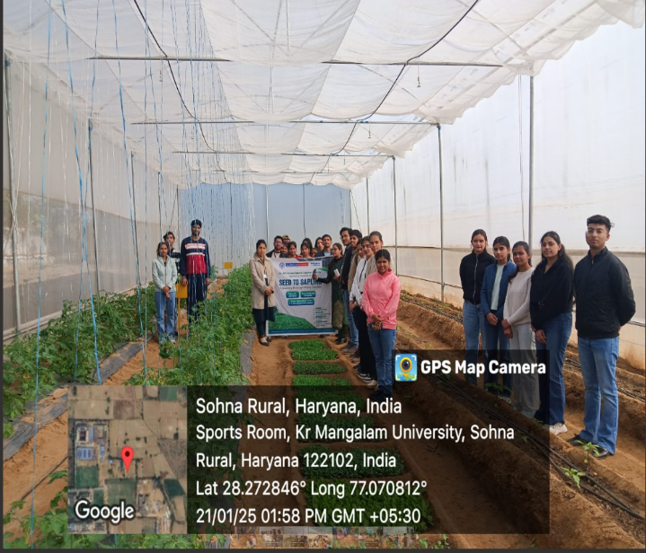
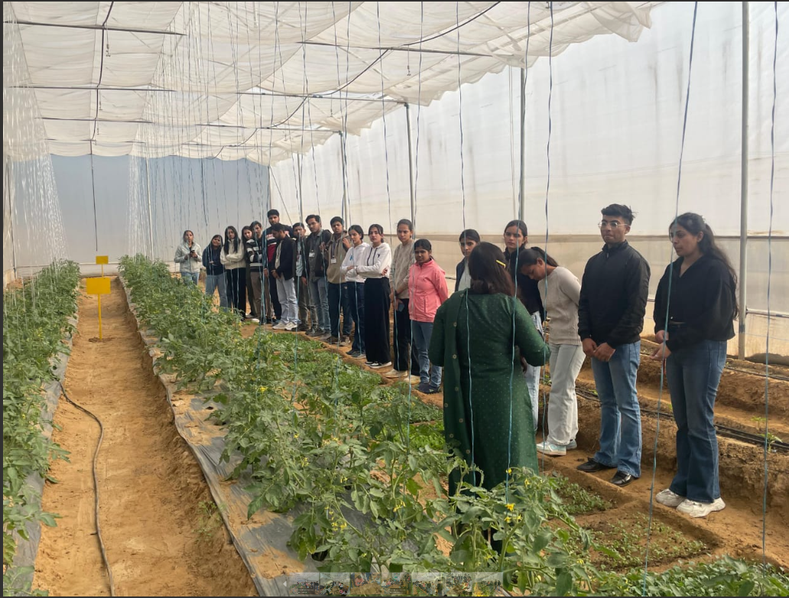

Report of Events
https://drive.google.com/file/d/10qdFXDHv1NHuXaUKSD3clCwGs7IT0RIi/view?usp=sharing
Students Projects
https://drive.google.com/file/d/1dFLcEB_303THtkanLP-n37W8eZI98F7j/view?usp=sharing

Eco-Friendly Green Belt
The eco-friendly green belt of K.R. Mangalam University, spread over 9,242 square meters, is designed to enhance environmental sustainability, biodiversity, and campus well-being. Developed with native and drought-tolerant plants, the green belt helps reduce heat, improve air quality, conserve water through rainwater harvesting and drip irrigation, and support local flora and fauna. It also serves as a green learning space for students, promoting environmental awareness while reflecting the university’s commitment to sustainable development and a healthy campus ecosystem.
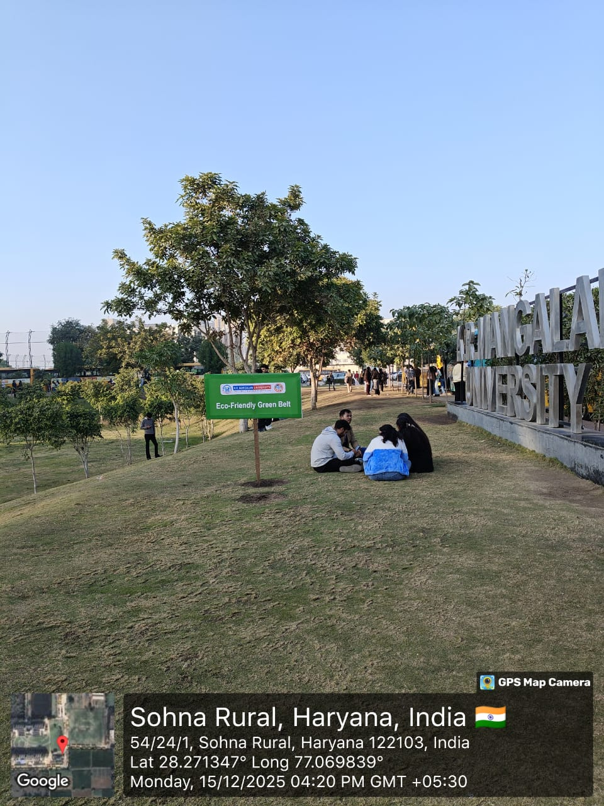
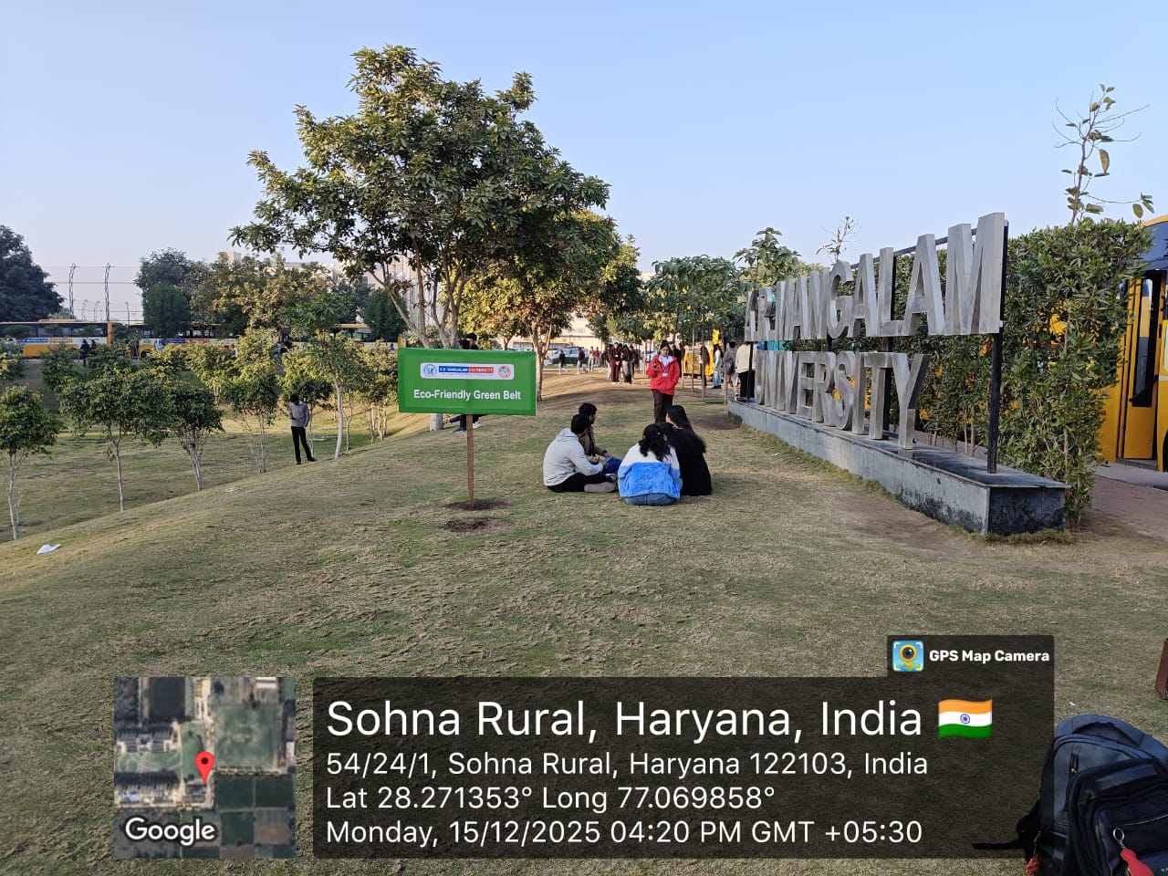

6.3 Community and School-Based Plantation Drives
Plantation and plant donation drives conducted in collaboration with schools, NSS, Legal Aid Committee and community stakeholders extend impact beyond campus. Report Link

7. Sustainable Horticulture Practices
Eco-friendly horticulture practices such as organic composting, mulching, drip irrigation, and use of manure generated from organic waste were adopted. Chemical fertilizers and pesticides were minimized, and sustainable landscaping techniques were promoted to conserve water and soil health.
Outcomes
These practices reduced dependence on chemical inputs and contributed to long-term ecological sustainability of campus landscapes.
✅ Evidence Required
- Records of organic manure usage
- Photographs of compost pits / drip systems
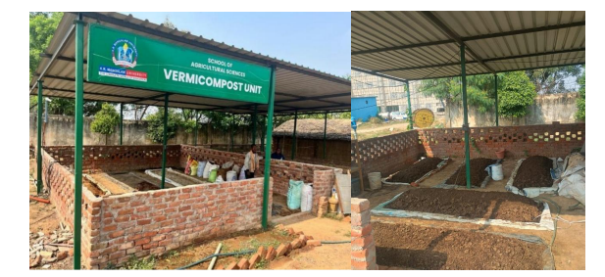
Composting and vermicomposting units
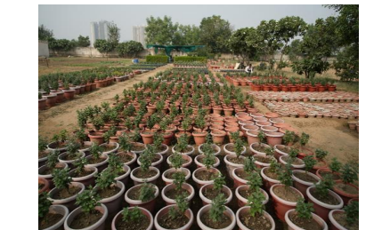
Vermicompost manure used for campus plants and green landscaping at K R Mangalam University, promoting circular waste management.
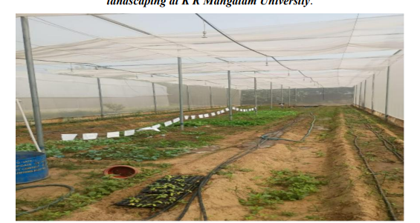
Drip irrigation at K R Mangalam University promoting efficient water use and eco-friendly campus maintenance
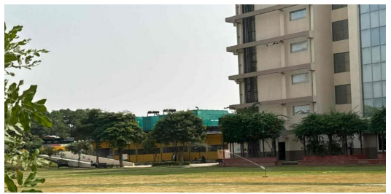
Sprinkler system in Sunken Garden promoting water efficiency and sustainable campus landscaping at K R Mangalam University.

- MoUs: https://www.krmangalam.edu.in/pdfs/sdg/events/sdg-15/MoU-sdg15.pdf

8. Environmental Education, Awareness and Community Engagement
K.R. Mangalam University actively promotes environmental education, awareness, and community engagement through a structured and continuous programme of outreach, experiential learning, and grassroots interventions. Environmental awareness initiatives are implemented through NSS, Youth Red Cross (YRC), Schools, and academic departments, engaging students, faculty, and local communities in issues related to waste management, water conservation, cleanliness, biodiversity protection, and sustainable living. These efforts include school-based awareness programmes, creative competitions such as drawing and poster-making on themes of environmental protection and water conservation, cleanliness drives and rallies under national campaigns, and observance of key environmental days such as World Earth Day and World Water Day . A notable component of community engagement is the University-led intervention in Alipur Village, where structured pre- and post-awareness programmes, street plays (Nukkad Natak), door-to-door sensitisation, and school-centric education resulted in significant improvement in environmental awareness, waste segregation practices, and community participation, demonstrating measurable behavioural change and long-term impact. Cleanliness drives and sanitation awareness activities conducted in collaboration with local schools and villagers further strengthened civic responsibility and environmental stewardship at the community level. Through these integrated initiatives, the University ensures that environmental education extends beyond the classroom, fostering informed citizenship, student leadership, and sustainable community practices aligned with national priorities and sustainability objectives. Link of reports
9. Case Study: Environmental Awareness and Sustainable Waste Management (Alipur Village)
A comprehensive community-based intervention involving pre- and post-assessments, street theatre, school sessions, door-to-door sensitisation, and infrastructure support led to significant improvement in environmental awareness, waste segregation practices, and community participation. The model is scalable and aligned with SDGs 4, 6, 11, 12, 13, and 15. Detailed Report Link

10. Sustainable Procurement Practices
K.R. Mangalam University has institutionalized its commitment to sustainability through the Sustainable Environment and Green Campus Policy which explicitly includes sustainable procurement practices as a key component of responsible operations. This policy reflects the University’s strategic intent to embed environmental considerations into all procurement decisions.
The Green Campus Policy guides procurement choices toward eco-certified products, energy and water efficient items, waste-reducing services, and sustainable vendors who align with environmental and social standards. Such orientation aligns with the NIRF-SDG metric of responsible consumption and production by reducing resource use, waste generation, and environmental impact.
Sustainable-Environment-and-Green-Campus-Policy
Revised-Sustainable-Environment-and-Green-Campus-Policy
K R Mangalam University’s Ethical Sourcing Policy ensures that all procurement practices align with sustainable resource use and responsible production. We source materials and services only from suppliers who follow ethical labour standards, minimise environmental impact, and demonstrate transparency in their operations.
By prioritizing sustainability and accountability across our supply chain, we promote fair trade, reduce resource depletion.
Sustainable-Environment-and-Green-Campus-Policy
Mess-agreement-with-Pawan-Enterprises
The University gives preference to eco-friendly and environmentally certified products in its procurement processes. This includes the purchase of items with recognized eco-labels such as energy-efficient electrical appliances, star-rated equipment, LED lighting, low-water-consumption fixtures, and biodegradable or recycled stationery. Preference is also given to products that comply with national environmental standards and promote reduced carbon emissions, thereby supporting India’s commitments to sustainable development.
University prioritizes purchasing locally sourced food materials, including wheat, rice, and vegetables for the campus mess. Additionally, cow dung is purchased from local farmers for organic fertilizer production. These practices: Support the local economy Promote sustainable procurement Reduce the environmental footprint of university operations.
Procurement actions are supported by broader institutional education and awareness — through the Centre for Sustainable Development Goals, campus events, and curriculum integration — ensuring that stakeholders (students, faculty, and staff) internalize the value of ethical purchasing and sustainability. This cultural embedding reinforces procurement practices by broadening campus acceptance and participation. KRMangalam University

12. Conclusion
The Annual Sustainability Report 2024–25 reflects K.R. Mangalam University’s holistic, evidence-driven, and impact-oriented approach to sustainability. Through integrated governance, infrastructure investments, academic integration, and community engagement, the University demonstrates leadership in advancing sustainable development in alignment with NIRF and national priorities.

