Report on “Say No to Drugs, Yes to Life” Awareness Session
Date: 26th June 2025
Time: 1:00 PM onwards
Venue: A209, 2nd Floor, Aryabhatt Block, K.R. Mangalam University
Organized by: National Service Scheme (NSS), K.R. Mangalam University
Mode of Activity: Offline
Type of Event -Awareness Session
Target Group: Faculties of KRMU
Coordinator: Mr. Amit Kumar, NSS Program Officer and Dr. Neeraj Kumari, NSS Program Coordinator and NSS Student Volunteers
Participants: 34 Faculties 4 NSS Volunteers
Introduction:
In observance of the International Day Against Drug Abuse and Illicit Trafficking, the National Service Scheme (NSS) unit of K.R. Mangalam University organized an awareness session on “Say No to Drugs, Yes to Life” on 26th June 2025. This session aimed to sensitize faculties about the harmful effects of drug abuse and to promote a healthy, drug-free lifestyle which further they will instill in the students and community
Objectives:
- To spread awareness about the detrimental effects of drugs on physical and mental health.
- To encourage positive peer influence and responsible decision-making.
Content:
The session began with a warm welcome by the NSS Program Coordinator, Dr. Neeraj Kumari, who emphasized the significance of observing the International Day Against Drug Abuse. The program focused on educating the participants about the devastating effects of drug abuse on individuals, families, and society. Emphasis was laid on the psychological and physiological consequences of addiction, the social stigma surrounding it, and the long-term impact on career

and relationships. Participants were also engaged in open dialogue, sharing their thoughts and asking pertinent questions, which reflected their curiosity and concern about the growing issue of substance abuse. Some real-life case studies were shared to help the participants to understand the seriousness of drug abuse. A short video documentary was screened, portraying the journey of youth recovering from addiction, which deeply impacted the audience. The event concluded with a strong pledge taken by all participants to abstain from drugs and to serve as ambassadors of a healthy and responsible lifestyle in their communities.
Conclusion:
The awareness session on “Say No to Drugs, Yes to Life” served as a powerful initiative under NSS to engage students in meaningful dialogue about drug prevention. It motivated the youth to adopt a conscious, healthy lifestyle and to actively spread awareness within their communities. The event was a resounding success, marking another impactful step by NSS KRMU in shaping responsible citizens.
Outcomes:
Participants gained valuable insights into the perils of drug abuse and the importance of mental resilience. The session empowered participants to act as ambassadors of a drug-free society. The event reinforced the university’s commitment toward creating a safe, healthy, and drug-free campus.

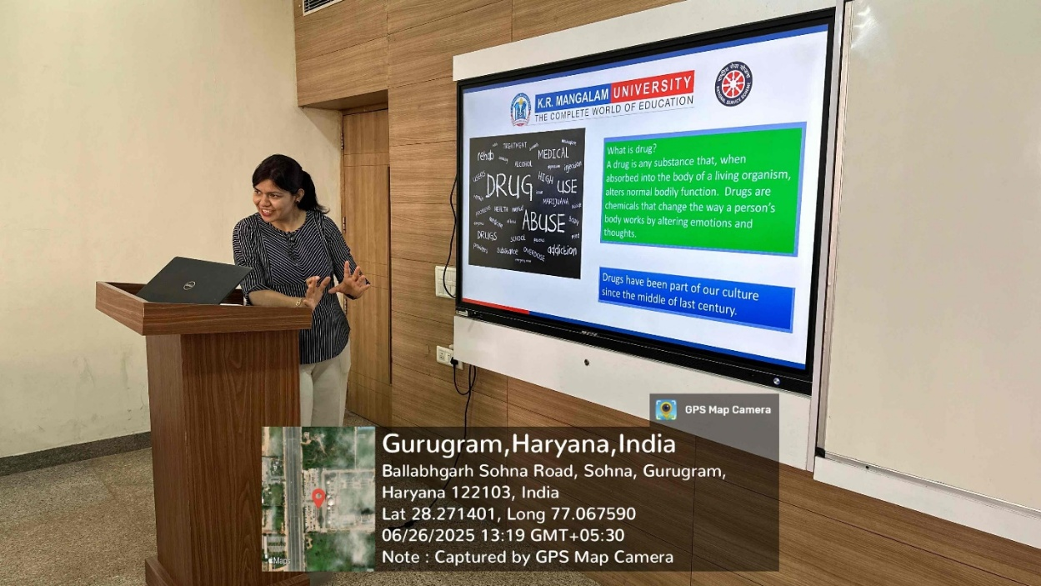

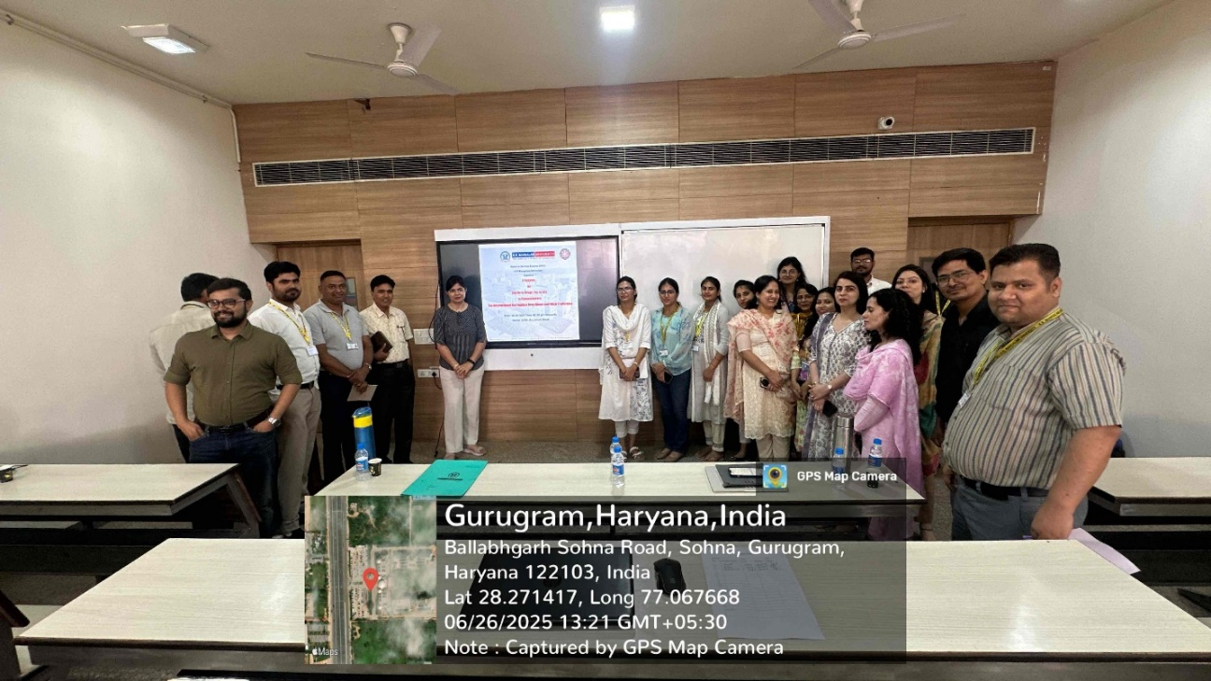
Photo 1: Dr. Neeraj explained about the drugs

Photo 2: A group photograph with participants and event coordinators

Report prepared by Event Coordinator, Mr. Amit Kumar

Report verified by NSS Program Coordinator, Dr. Neeraj Kumari

Report verified by IQAC Coordinator, Dr. Shikha Dutt Sharma

