
Report
"Health and Hygiene Activity of HACCP"
Date: 7th November 2024
Venue: COI 1, SOHMCT
Event Type: Workshop
Mode of Activity: Offline
Target Group: SOHMCT Students (Batch-2024-25)
Coordinator: ChefJaya (Assistant Professor) SOHMCT
Organized by: School of Hotel Management and Catering Technology

Number of Participants: 12
The School ofHotel Management and Catering Technology organized a "Health and Hygiene Activity of HACCP" on 7th November 2024 for the first-year students in room COI 1, event coordinator, Chef Jaya took this workshop and also conducted a hands-on training for the students after the presentation. The students were explained HACCP principles, applicability in the kitchen and other various concepts associated with it like the Catering industry, Food Processing, Types of Hazard, FATTOM,4C's.
The students asked questions on various matters like the existence of these principles, how the hotel continuously monitors the HACCP program in the hotel and its various areas, and whether this is applicable in small restaurants and household kitchens. Additionally, Chef Jaya also gave her advice on how to follow the principles of HACCP while working in the lab practicals of the kitchen.
Objective: This workshop was to make students familiar with the concept of HACCP which is followed in hotels and students can apply the same while working in kitchen operations.

Methodology: The workshop was done offline and started with a presentation which comprised of different modules that gave familiarization with concepts, principles, and usage. Small quizzes labeled as check your understanding were also included after completing each module in the presentation. The session ended with a hands-on training where students surveyed 4 areas in the kitchen where the applicability of HACCP should be done and monitored.
In the hands-on training, the students were provided a list where they had to survey the 4 different areas of the kitchen and mention their observations, critical control points and measures to rectify any hazards which can enter the food items. They thoroughly observed all the areas and noted their points in the provided sheet.
Students were happy to know about various concepts and new knowledge which they gained after this workshop. They were quite attentive and participative throughout the workshop and enjoyed the quizzes in between and the final hands-on training in which they surveyed all the areas of the kitchen. They also expressed their views in having such workshops monthly.
Photo 1 : ChefJaya informing students about the modules that will be covered in workshop.
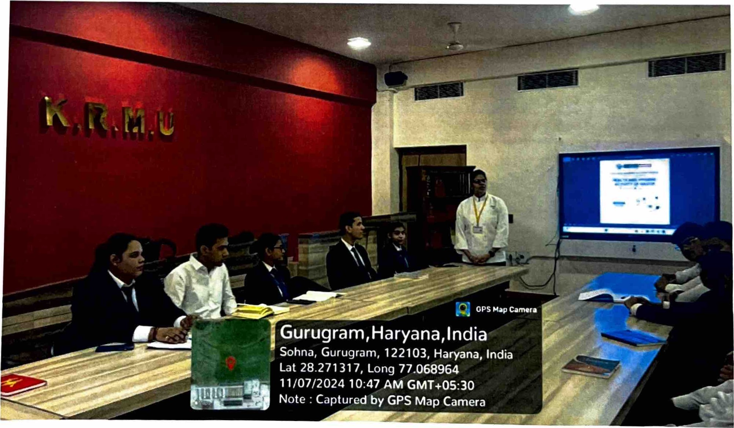

2: asking questions from ChefJaya.
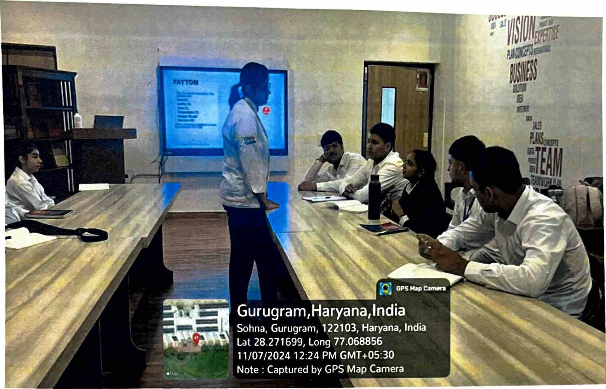
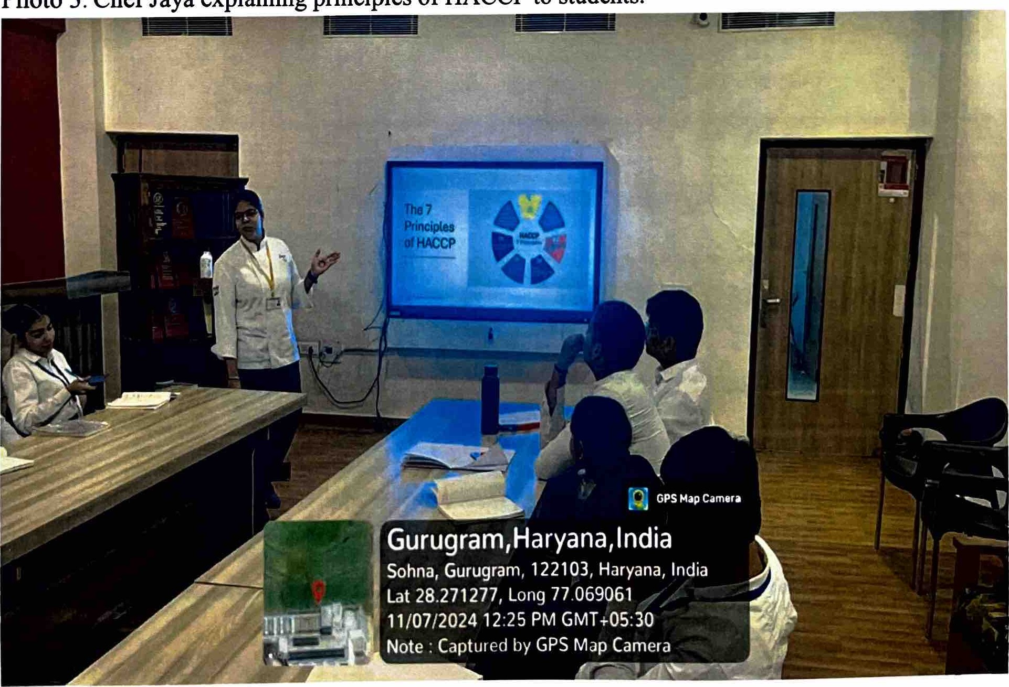
Photo 3: Chef Jaya explaining principles of HACCP to students.

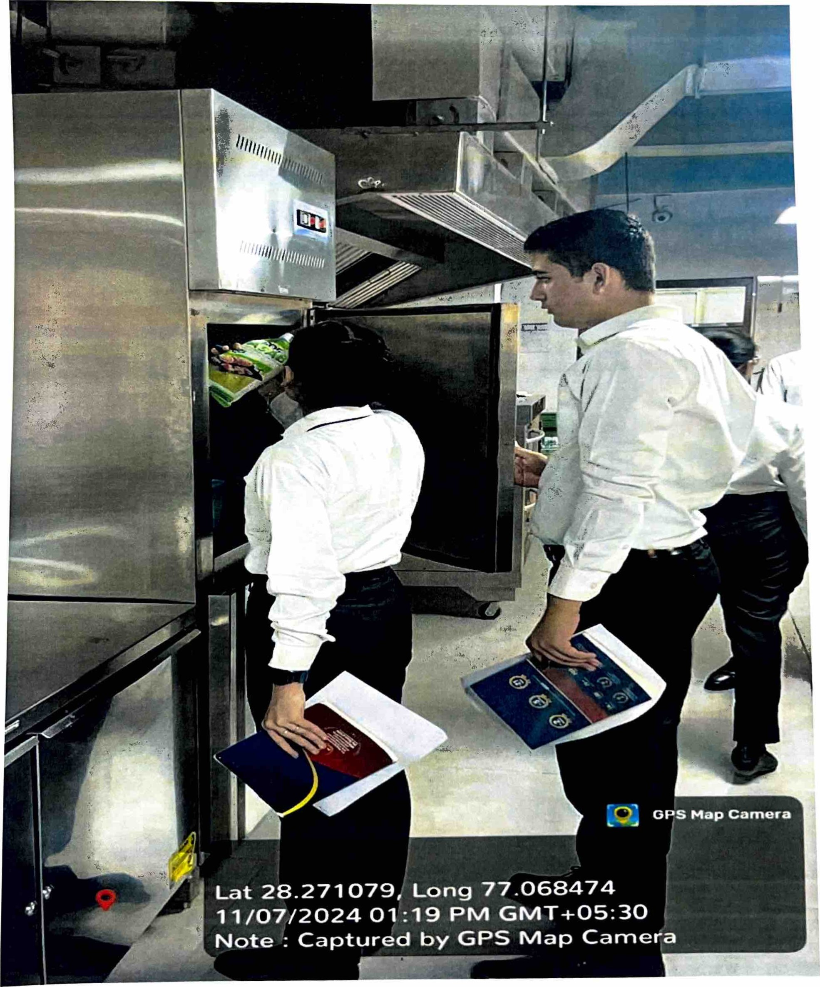

coo

