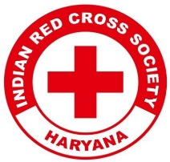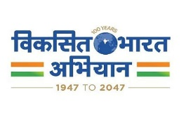
Report on
Green Strokes: Draw to Preserve (Drawing Competition)
Date: 28th May, 2025
Venue: Govt. Primary School, Daula
Total No. of Participants: School students & 14 YRC volunteers, KRMU
Event Type: Drawing Competition
Mode of Activity: Offline
Target Group: School Students, Daula
Organized by: Youth Red Cross Committee, K.R. Mangalam University
Event Coordinator: Dr. Monika Yadav, Program Coordinator, YRC
Student Coordinators: Jatin, Sanjiv, Amar

Introduction:
To commemorate Earth Day and foster environmental awareness among young learners, the Youth Red Cross Committee of K.R. Mangalam University organized a vibrant drawing competition titled “Green Strokes: Draw to Preserve” on 28th May 2025 at Govt. Primary School, Daula. The event focused on inspiring children to visualize the significance of environmental protection through art.

Objectives:
- To raise awareness about environmental preservation among school children.
- To develop creative expression on the theme of Earth Day and sustainability.
- To instill eco-consciousness and responsibility in young minds.
- To promote art-based learning as a tool for environmental education.

Content:
The competition commenced at 11:00 AM with an introduction to the relevance of Earth Day and the need for protecting our natural resources. Participants were given drawing sheets and crayons to depict themes such as Save Trees, Clean Earth, Water Conservation, and Green Planet. Volunteers from YRC guided and supported the children throughout the session.
The drawings were displayed for evaluation, and the top artworks were acknowledged with certificates and appreciation gifts. Informative discussions and slogans on environmental care added to the enriching experience.

Outcome:
- Students gained deeper insights into the importance of a clean and green environment.
- Enhanced awareness and engagement through creative expression.
- Promotion of eco-friendly habits among the young participants.
- Volunteers developed leadership and facilitation skills while conducting the event.

Conclusion:
“Green Strokes: Draw to Preserve” successfully engaged young minds in thinking about the environment through the lens of creativity. The initiative served as an excellent platform to embed sustainable values in children, fostering a future generation that respects and protects nature. The Youth Red Cross Committee remains committed to nurturing social and environmental responsibility through such impactful programs.

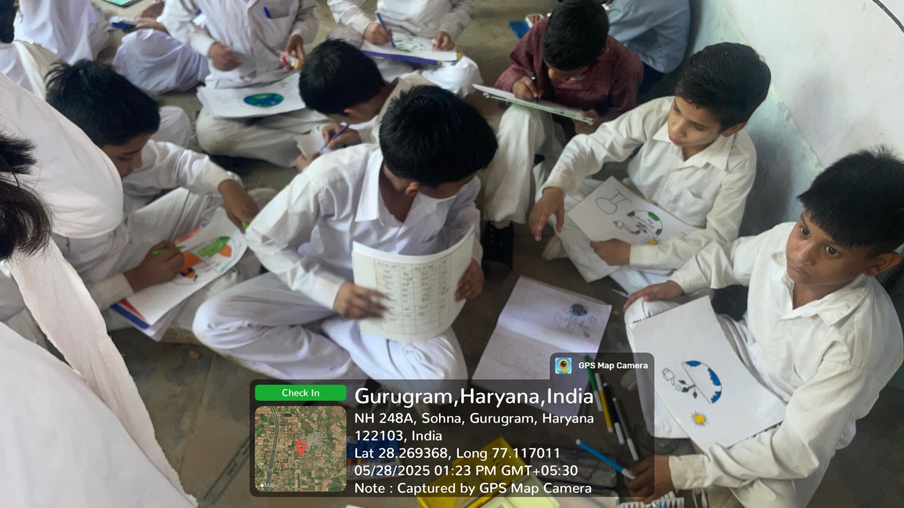

Students enthusiastically express their environmental awareness through art during the "Green Strokes: Draw to Preserve" competition at Govt. Primary School, Daula.

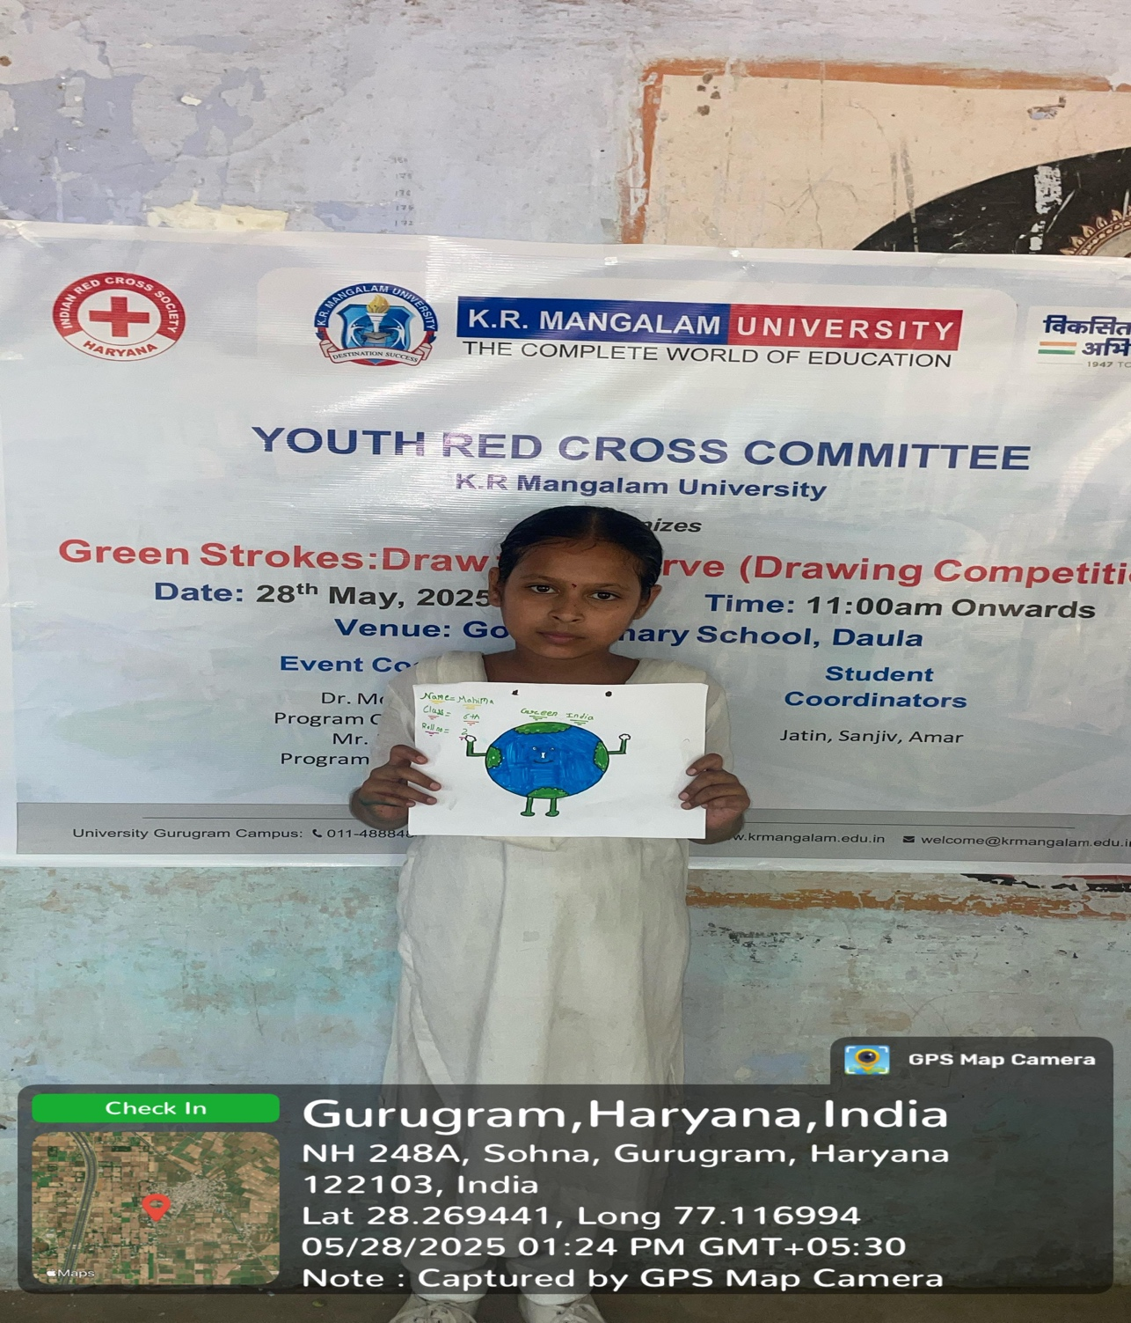

A participant displays her creative artwork promoting environmental conservation during the "Green Strokes: Draw to Preserve" competition at Govt. Primary School, Daula.

Report Seen by Red Cross Coordinator | Dr. Monika Yadav
Report seen by IQAC Coordinator | Dr. Shikha Dutta Sharma

