Good Governance at K.R. Mangalam University

Equality, Diversity and Inclusion (EDI)
1.1 Institutional Framework for Equality, Diversity and Human Rights
1.2 Gender Sensitization & Safety Committee
1.3 Internal Committee (IC) under POSH Act, 2013
1.4 Centre for Human Rights – School of Legal Studies
1.5 Equal Opportunity & Disability Support Initiatives
Existence of Anti-Discrimination and Anti-Harassment Policies
2.1 Anti-Discrimination Policy Framework
2.2 Anti-Sexual Harassment Policy (POSH Compliance)
2.3 Policy Accessibility and Awareness Mechanisms
Anti-Bribery and Anti-Corruption Measures
3.1 Institutional Code of Conduct
3.2 Anti-Bribery and Anti-Corruption Practices
3.3 Financial Transparency, Audits and Compliance Systems
Dedicated Sustainability Staff / Office
4.1 Centre for Excellence for Sustainable Development Goals (SDGs)
4.2 Sustainability Coordination and Governance Structure
4.3 SDG-Aligned Academic, Research and Outreach Initiatives
4.4 Annual Sustainability Reporting
Holistic Ethical Organizational Culture
5.1 Vision, Mission and Core Values
5.2 Ethics in Academic and Administrative Practices
5.3 Ethics Training and Awareness Programmes
5.4 Oversight, Compliance and Monitoring Mechanisms
5.5 Grievance Redressal and Reporting Systems
Student Union and Student Representation
6.1 Existence of Recognized Student Union
6.2 Structure and Functioning of the Student Council
6.3 Student Participation in Governance
Sustainability Committee
7.1 Constitution of the Sustainability Committee
7.2 Composition of Members (Faculty, Students, External Experts)
7.3 Roles and Responsibilities
Transparency and Public Disclosure of Governance Decisions
8.1 Public Sharing of AGM and Statutory Decisions
8.2 Regulatory and Accreditation Disclosures
8.3 Internal Communication of Governance Resolutions
Conclusion: Institutional Governance and Ethical Alignment

1. Equality, Diversity & Inclusion (EDI)
K.R. Mangalam University demonstrates its commitment to equality, diversity and human rights through formal institutional structures and designated committees that advise the administration, conduct sensitisation activities, support grievance mechanisms, and ensure policy compliance in line with national legal frameworks and global benchmarks such as SDG-5 (Gender Equality), SDG-10 (Reduced Inequalities), and SDG-16 (Peace, Justice & Strong Institutions).
The university has constituted the following bodies for promoting a safe, inclusive and equitable campus environment:
- Gender Sensitization & Safety Committee
This committee is responsible for promoting gender sensitization, awareness on gender justice, organising workshops, sensitisation sessions, and ensuring that gender-based concerns are addressed proactively on campus.
Gender Sensitization and Safety Committee
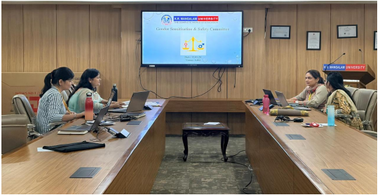
The Gender Sensitization and Safety Committee convene to review and assess the effective implementation of gender equity and safety initiatives at K.R. Mangalam University

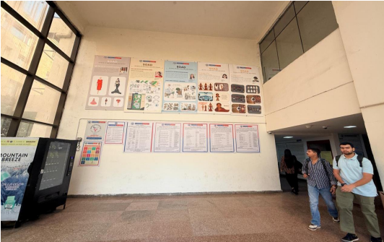
Details to contact the members of the Gender Sensitisation and Safety Committee are displayed in various strategic locations around the University campus
- Internal Committee (IC) under the POSH Act, 2013
The Internal Committee is constituted as per the statutory mandate of the Sexual Harassment of Women at Workplace (Prevention, Prohibition and Redressal) Act, 2013. The IC has administrative authority to receive, inquire into, and redress complaints of sexual harassment in a confidential and legally compliant manner, ensuring protection of complainants and promotion of a safe workplace and academic environment.
Internal Committee
Details of Members of the Internal Complaints Committee (ICC)
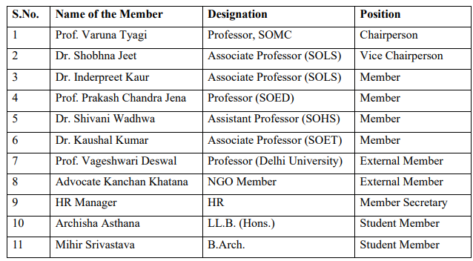
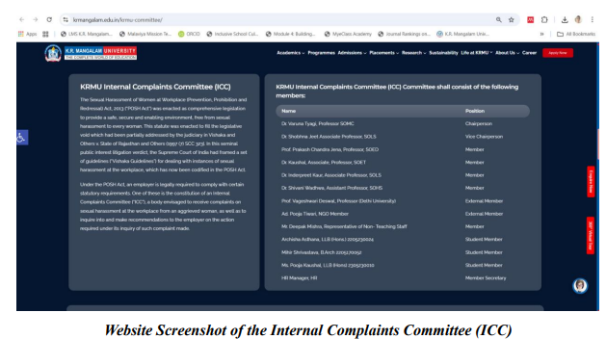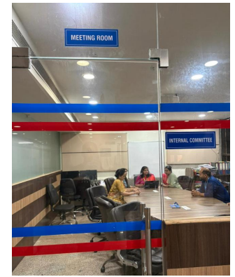
A Dedicated Meeting Room Has Been Provided on Campus for ICC Committee Members to Convene, Deliberate and Address Matters Related to Grievances and Gender Well-being in a Confidential and Professional Environment
- Centre for Human Rights – School of Legal Studies (SOLS)
The Centre for Human Rights at the School of Legal Studies expands the university’s commitment to equality and human dignity through academic, research and advocacy activities. The Centre undertakes:
  - Capacity-building workshops
  - Legal awareness programmes
  - Research publications
  - Training and sensitisation on human rights and constitutional values
In addition, the Centre engages students in experiential learning through fieldwork collaborations with civil society organisations and government bodies, thereby strengthening human rights-related education, compliance and public engagement on campus.
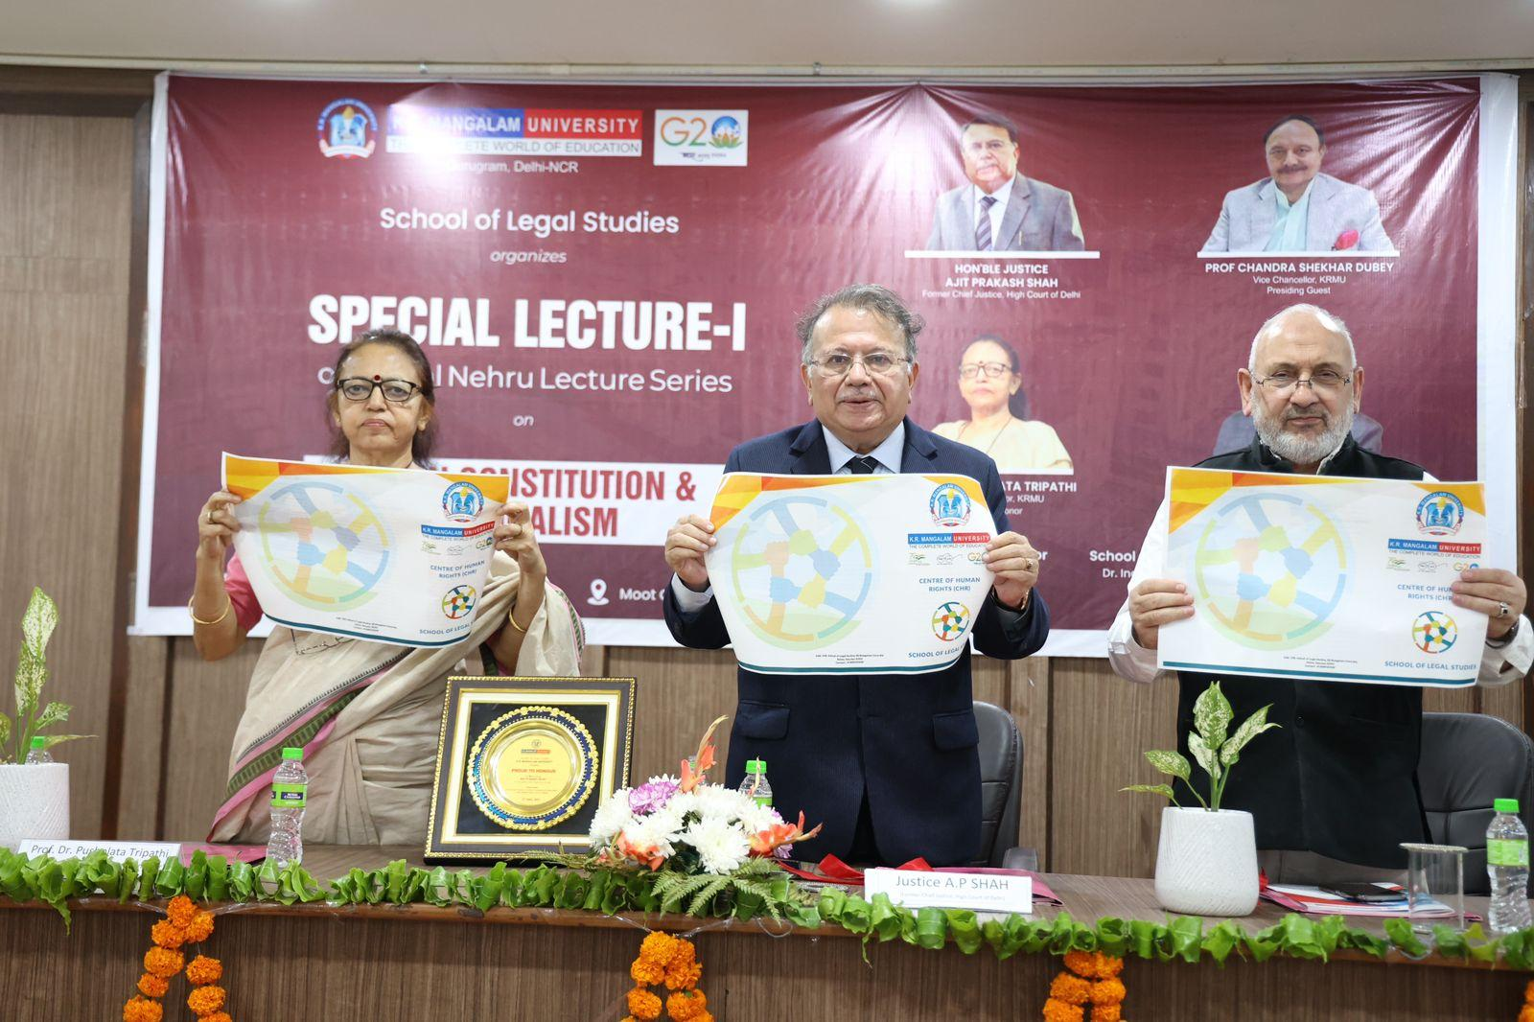
Hon’ble Justice Mr. Ajit Prakash Shah, Former Chief Justice (High court of Delhi), Pro Vice Chancellor Prof. Dr. Pushplata Tripathi and Chair Professor Dr. Mehraj Uddin Mir inaugurating Centre for Human Rights
Centre Composition
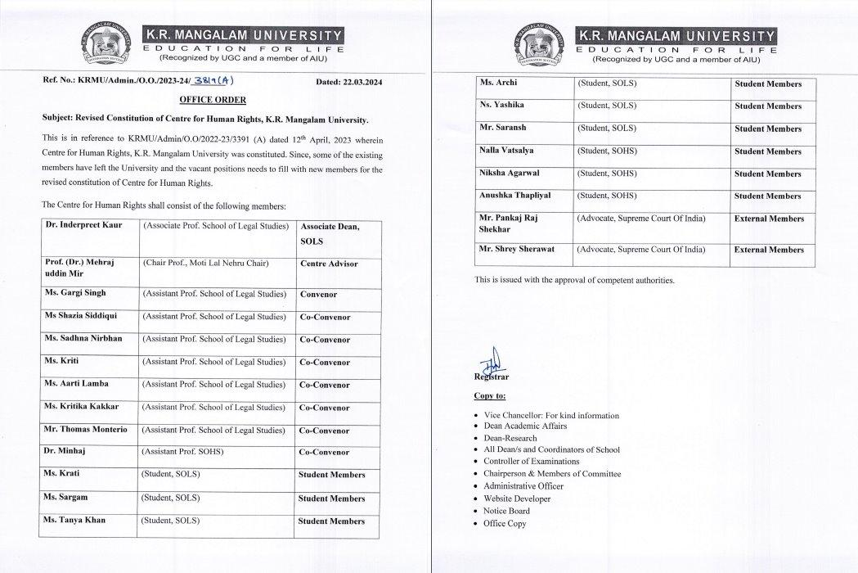
- Equal Opportunity & Disability Support Initiatives
Support for students requiring assistance or accommodations is facilitated through the Dean Student Welfare / Student Support Services, ensuring:
  - Non-discriminatory access to facilities
  - Academic support measures
  - Counselling & wellness services
  - Inclusive campus participation

2. Existence of Anti-Discrimination and Anti-Harassment Policies
K.R. Mangalam University has put in place formal policies and regulatory mechanisms to prevent discrimination and harassment, promote inclusive campus relations, and ensure compliance with statutory mandates and equality-oriented governance norms.
https://www.krmangalam.edu.in/policies-on-gender-equality/
2. Anti-Bribery & Anti-Corruption Policy
K.R. Mangalam University upholds a culture of ethical governance, transparency and integrity in administrative, financial, and academic matters. Its commitment to anti-corruption standards is reflected through:
(a) Institutional Code of Conduct
The University’s Code of Conduct for faculty, administrative staff, students, and officers prohibits:
- bribery and facilitation payments
- misuse of authority for personal gain
- conflicts of interest
- financial irregularities
- fraudulent practices
- academic malpractices
The Code establishes expectations for ethical behavior, accountability and responsible decision-making.
Evidence link : https://www.krmangalam.edu.in/coc/
(b) Anti-Bribery and Anti-Corruption Practices
Anti-bribery norms are embedded in administrative and HR policy frameworks such as:
- procurement and vendor selection procedures
- financial audit and reporting systems
- transparent recruitment processes
- documentation and record-keeping mechanisms
- internal audit and compliance checks
These measures reduce the risk of bribery, undue influence or corruption in operational functions.
Policy Link: https://www.krmangalam.edu.in/policies-on-gender-equality/
Ethical Values
K.R. Mangalam University is a progressive institution committed to nurturing strong ethical values as the foundation of academic excellence and social responsibility. The University upholds principles of integrity, inclusivity, respect, transparency, and fairness through well-defined policies, including its Code of Conduct, Research Ethics Policy, and institutional governance frameworks applicable to faculty, staff, and students.
The University’s vision and mission reflect a deep commitment to holistic education and equitable access to learning opportunities. K.R. Mangalam University strives to empower deserving learners by providing a globally relevant, value-based education that fosters intellectual growth, professional competence, and ethical leadership. Honesty, accountability, and compliance guide all academic and administrative processes, ensuring a culture of trust and openness.
With a strong emphasis on research, innovation, and sustainability, the University encourages critical inquiry and socially responsive solutions to contemporary challenges. By promoting ethical conduct, collaborative engagement, and community well-being, K.R. Mangalam University cultivates a vibrant and inclusive ecosystem of responsible citizens, scholars, and future leaders dedicated to societal transformation.
Code of Conduct for Administration | View
Code of Conduct for Office Staff | View
Code of Conduct for Students | View
Research Policy | View.
Code of Conduct sessions for Faculty and Students
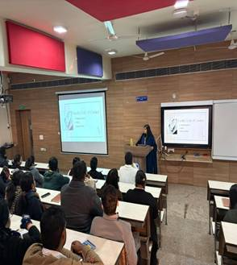 | 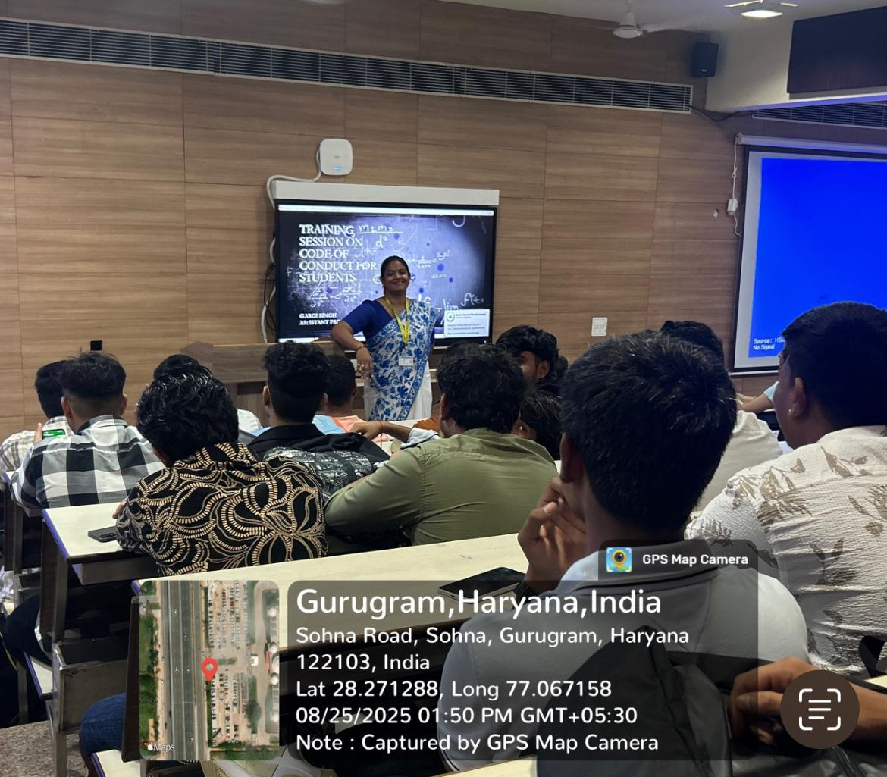

3. Dedicated Sustainability Staff / Office
KRMU has instituted initiatives through the Centre for Excellence for Sustainable Development Goals (SDGs) to promote sustainability on campus, including:
- Awareness campaigns
- Academic collaborations (e.g., UNESCO MGIEP session)
- Student and faculty engagement activities
A designated coordinator/team works to advance sustainability goals.
Centre Composition:
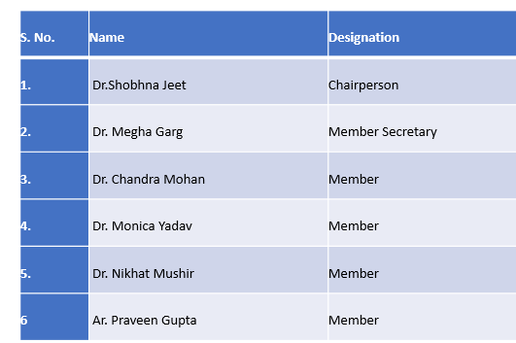
During 2024–25, the University advanced sustainability through a series of SDG-aligned academic, research and community outreach programmes coordinated by the Centre for Excellence for Sustainable Development Goals. Multiple seminars, workshops, student campaigns and collaborative sessions with external bodies such as UNESCO MGIEP strengthened awareness on climate action, gender equality, human rights and responsible consumption. Interdisciplinary engagement across schools enabled integration of SDGs into teaching, experiential learning and institutional culture, contributing to measurable social impact and capacity building on campus.
Link for Annual Report 2024: https://krmangalam.edu.in/pdfs/sdg/annual-report-2024-25.pdf?_gl=1*kksrer*_gcl_au*MTU0MTk3NTQ2NS4xNzY0ODM5MTgw
4. Holistic Ethical Organisational Culture
K.R. Mangalam University fosters a holistic ethical organisational culture anchored in transparency, fairness, and accountability. The institutional commitment to ethical values is formally articulated in strategic public documents, including the Vision, Mission, and Core Values, Code of Conduct, HR policies, and internal Quality Assurance documents. These documents collectively promote values such as diversity and inclusion, honesty and integrity, fairness and respect, and accountability and transparency. These principles guide decision-making, staff conduct, institutional governance, and stakeholder engagement across the university ecosystem.
The university also ensures ethics are operationalised through training and awareness programmes conducted for students, faculty, and administrative staff. Regular sessions are organized on Gender Sensitization, Prevention of Sexual Harassment (POSH), mental health and professional conduct, sustainability practices, and awareness of the Sustainable Development Goals (SDGs). These initiatives contribute to building a culturally aware, respectful, and responsible campus environment in alignment with national and international quality frameworks.
Institutionally, ethical compliance is supported through dedicated oversight bodies and officers. Compliance functions are monitored through statutory and administrative mechanisms such as the Internal Committee for POSH compliance, oversight by the Registrar/Dean Administration, and the Quality Assurance and Accreditation Cell (QAAC). These bodies contribute to policy implementation, monitoring, and periodic review of ethical norms.
To safeguard ethical practices further, the university operates robust grievance redressal and reporting mechanisms ensuring confidentiality and procedural fairness. Reporting systems include online grievance portals, student helpdesks, anti-sexual harassment reporting channels, and student redressal cells functioning under statutory norms. These platforms enable students, faculty, and staff to raise concerns without fear of retaliation and reinforce a culture of trust and accountability across campus.
5. Student Union
Existence of Recognised Student Union
KRMU has a recognised student body functioning through the Student Council under the Directorate of Student Welfare, representing student interests at campus level.
An essential component of a university's operation is the student council. It encourages students to take part in all-around activities and fosters a sense of ownership in them. The council serves as a liaison between the students, faculty, and administration. It gives pupils the chance to develop their organizational, leadership, and planning skills. Students with significant leadership abilities, a history of active involvement in university events, and high academic standing make up the council. After careful consideration and discussion, the dean and faculty members select these students. The selected students then establish the Student Council and choose their own representatives.
The students are elected for the following positions.
President
Vice President
Secretary
Members
Student Union Members as per AY 2024-2025
Name | Roll No. | Post | School
Deepanshi Attree | 2208190024 | President | SOHS
Aastha Jha | 2208190020 | Vice-President | SOHS
Garima | 2209200035 | Secretary Cultural Activities | SJMC
Amrit Anand | 2203090006 | Secretary Extension and Outreach Activities | SBAS
Aryan Singh | 2204120053 | Secretary social media and Marketing | SMAS
Ankit Mahla | 2205170015 | Secretary Sports Activities | SOLS
Payal | 2301360028 | Secretary Hostel Affairs | SOET

https://www.krmangalam.edu.in/student-welfare/
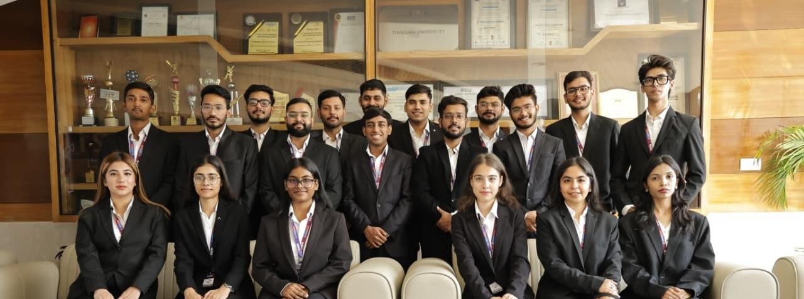
The K.R. Mangalam University Student Council is a representative body that upholds student interests and enriches campus life for all stakeholders. The Council works in close collaboration with the Student Affairs Advisory Body and the University Administration to formulate solutions to issues faced by students, organize meaningful initiatives, and foster leadership, inclusivity, and democratic values on campus.

6. Sustainability Committee
Sustainability Committee Existence
The university has institutional committees for sustainability-related initiatives, supported through the Centre of Excellence and SDG activities.
Details of Members of Sustainable Committee
- Dr. Shobhna Jeet School of Legal Studies (SOLS) – Chairperson

- Prof. Pawan Kumar School of Basic & Applied Sciences (SBAS) – Member
- Dr. Neeraj Kumari School of Basic & Applied Sciences (SBAS)– Member
- Dr. Monica Yadav School of Management & Commerce (SOMC)– Member
- Dr. Mansha Samreen School of Architecture & Design (SOAD) – Member
- Dr. Yogita Raghav School of Engineering & Technology (SOET) – Member
- Dr. Srishti Srivastava School of Liberal Arts (SOLA) – Member
- Dr. Aarti Lamba School of Legal Studies (SOLS) – Member
- Dr. Deepak Kumar School of Agricultural Sciences (SOAS) – Member
- Dr. Deepak Kumar School of Liberal Arts (SOLA) – Member
- Dr. Megha Garg School of Legal Studies (SOLS) – Member Secretary
- Ms. Prerna ((2305170030) BA.LL.B.(H)- Student Member
- Mr. Krishna Sindwani, (2305140045) )B.A.LL.B.(H)- Student Member
- Mr. Anuj (2501940039) MCA (AI & ML)
- Ms. Poornima Palarwal (2405994007) Ph.D. Law-Research Scholar
- Dr. Richa Bansal Project Head, UNESCO MGIEP
Participative Management
K.R. Mangalam University is committed to a participatory management framework that emphasizes collaboration, transparency, and shared accountability among all stakeholders. While the university follows a structured governance model, it actively promotes inclusive and participative decision-making across academic, administrative, and institutional levels. Students, alumni, faculty members, management, and administrative staff are encouraged to contribute meaningfully through various academic bodies, committees, and institutional forums, all of which function under the guidance of statutory and functional authorities.
To institutionalize quality enhancement and stakeholder engagement, K.R. Mangalam University has established the Internal Quality Assurance Cell (IQAC), which plays a pivotal role in planning, monitoring, and strengthening quality benchmarks across the university. The IQAC ensures active student representation and feedback mechanisms, enabling learners to participate in policy formulation and continuous improvement initiatives. This collaborative and inclusive approach underpins KRMU’s commitment to academic excellence, innovation, and holistic institutional development.
Board of Studies | View
IQAC | View
IQAC 18th Meeting October, 2024 | View
IQAC 19th Meeting January 27, 2025 | View
IQAC 20th Meeting May 30, 2025 | View
Public Sharing of AGM Decisions
K.R. Mangalam University follows a transparent and accountable governance model in which major decisions taken during Annual General Meetings (AGMs) and other statutory meetings are recorded, communicated and disclosed through formal mechanisms. While the full proceedings of AGMs or Governing Body meetings may not always be made publicly accessible due to confidentiality norms governing higher education governance, key decisions and action points are reflected through statutory filings, regulatory submissions and accreditation-related documents. These submissions ensure compliance with national statutory requirements and quality assurance frameworks.
Important decisions relating to academic reforms, examinations, student welfare, finance, infrastructure development, faculty recruitment and institutional planning are also captured in accreditation and quality assurance disclosures such as NAAC evaluation documents, Annual Quality Assurance Reports (AQAR), institutional annual reports and academic audit reports. These documents are often uploaded on the university website as a part of mandatory disclosure requirements and enable stakeholders to obtain verified information about the University’s governance performance.
In addition to these external disclosures, minutes and resolutions of statutory bodies such as the Board of management, Academic Council, Finance Committee and Board of Studies are internally circulated among authorised stakeholders including senior leadership, administrative units, faculty members and student representatives (where applicable). This process facilitates implementation of decisions, administrative alignment and compliance with academic regulations. Wherever mandated by regulatory authorities such as the UGC, disclosures are made available to the public through designated web sections including Policy & Governance, IQAC, Reports and Notifications, thereby enhancing the institution’s transparency and public accountability.
Link for Governance and Decisions that are shared publicly:
Annual Reports: https://www.krmangalam.edu.in/pdfs/iqac/annual-report-2023-24.pdf
Advisory Board / Governing Body details: https://www.krmangalam.edu.in/advisory-board/
Notices & Circulars: https://www.krmangalam.edu.in/notice/
Other Disclosures:
https://www.krmangalam.edu.in/disclosure2018-2023/
https://www.krmangalam.edu.in/iqac/

K.R. Mangalam University demonstrates structured governance frameworks, ethical practices, student representation mechanisms, and sustainable development initiatives aligned with contemporary higher education standards and regulatory compliance requirements.

