Report on

Sensitization Program on Gender-Sensitive Climate Solutions for a Sustainable Future

Date: Wednesday, 9th April 2025

Venue: Room No. A 213, Aryabhatta Block, K.R. Mangalam University.
Event Type: Sensitization Program (Expert Session)
Mode of Activity: Offline
Target Group: Students and Faculties

Resource Person: Dr. ShobhnaJeet, Chairperson, Gender Sensitization and Safety Committee.
Coordinators Dr. Kaveri Khound (Assistant Professor, SOHS), Ms. Mansi Jatav (Assistant Professor, SOHS)

Organized by: School of Humanities

Number of Participants: 69

The School of Humanities at K.R. Mangalam University successfully organized a sensitization programme on the theme “Gender-Sensitive Climate Solutions for a Sustainable Future” on 9th April 2025. The initiative aimed at raising awareness and promoting discourse on the intersectionality between gender and climate change, and the need for inclusive strategies in addressing environmental challenges. Gender-sensitive climate solutions are crucial for building a sustainable future because they recognize that climate change impacts women and men differently, and that women's agency and leadership are essential for effective climate action. By integrating a gender perspective into climate policies and solutions, we can ensure that everyone benefits from these efforts and that existing inequalities are not exacerbated. SDG 13
13.3 (Improve education, awareness raising and human and institutional capacity on climate change mitigation, adaptation, impact reduction, and early warning)
Objectives:
- To highlight the disproportionate impact of climate change on different genders.
- To advocate for gender-sensitive approaches in climate policies and sustainability initiatives.
- To empower students and faculty members with knowledge and tools for inclusive climate action
The sensitization programme on “Gender-Sensitive Climate Solutions for a Sustainable Future” held on 9th April 2025 at K.R. Mangalam University featured Dr. ShobhnaJeet, Chairperson of the Gender Sensitization and Safety Committee, as the keynote speaker. In her impactful address, Dr. ShobhnaJeet emphasized the critical need to integrate gender perspectives into climate action frameworks, drawing attention to how environmental challenges disproportionately affect women and marginalized communities.
She shared compelling case studies and real-life examples, highlighting the gaps in existing climate policies and underscoring the importance of inclusive strategies. Dr. ShobhnaJeet advocated for increased representation of women in sustainability leadership roles and encouraged attendees to champion equity in their professional and academic engagements..
It witnessed active participation from students and faculty, fostering an engaging dialogue on sustainable development with a gender-sensitive lens. Participants gained valuable insights and practical knowledge on how to contribute to climate solutions that are equitable and inclusive, making the programme a meaningful and enlightening experience for all.
Glimpses
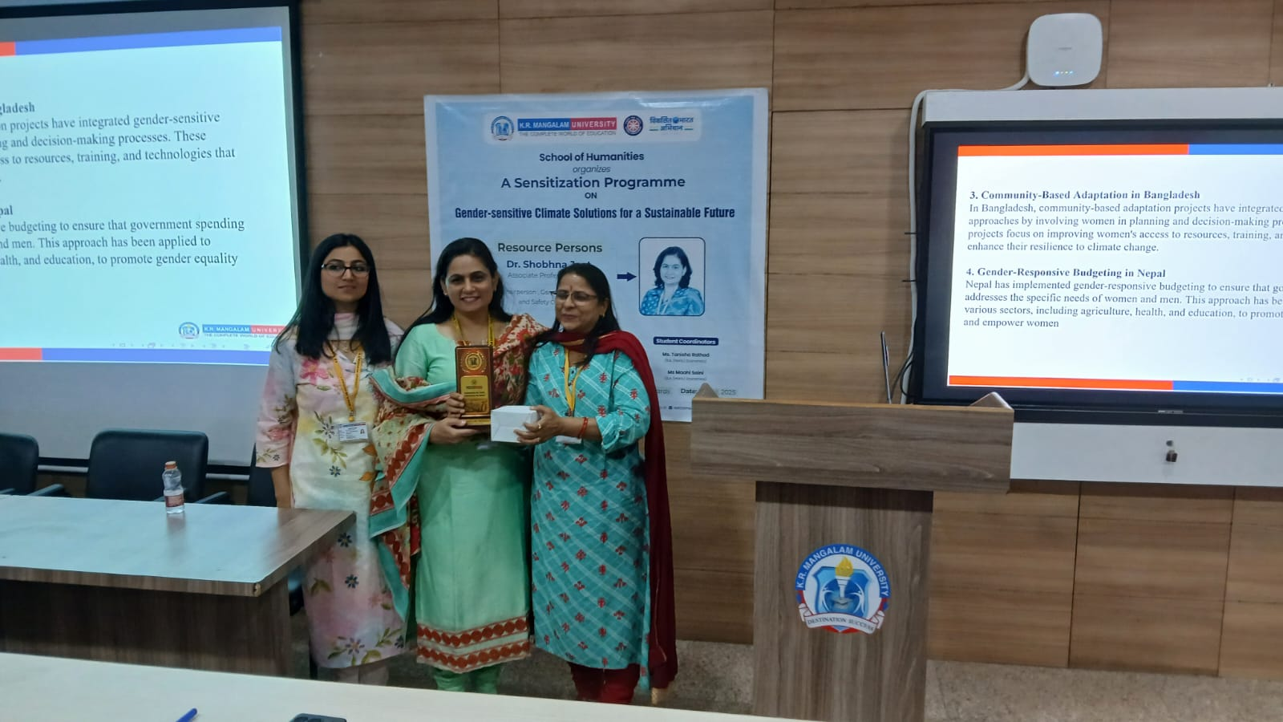
School Coordinator (SOHS) Prof. Renu Verma welcoming our esteemed speaker Dr. ShobhnaJeet, Chairperson, Gender Sensitization and Safety Committee.

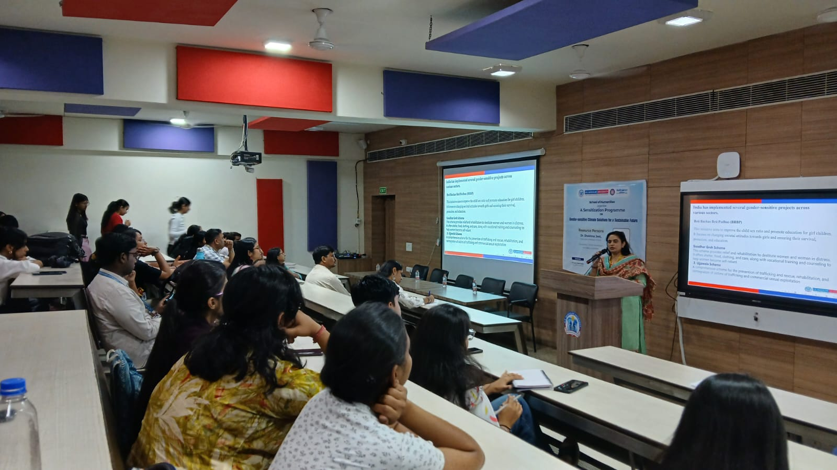

Active participation of the students during the session
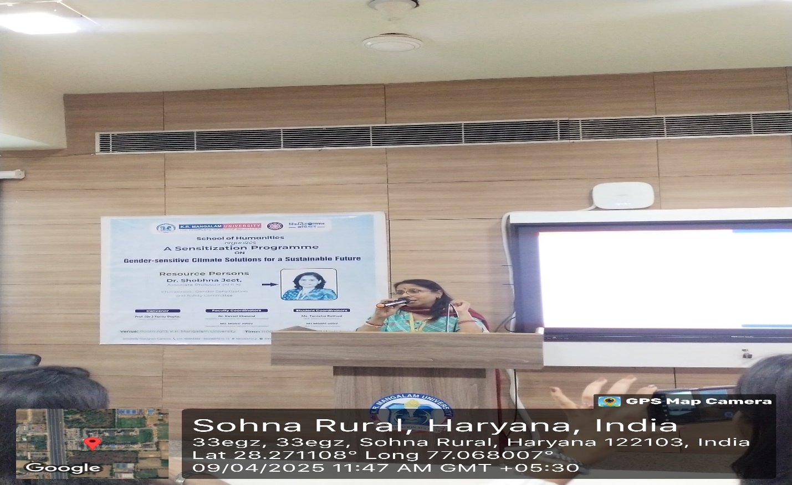
Thank You Speech by our Associate Dean Prof.(Dr.) Renu Verma

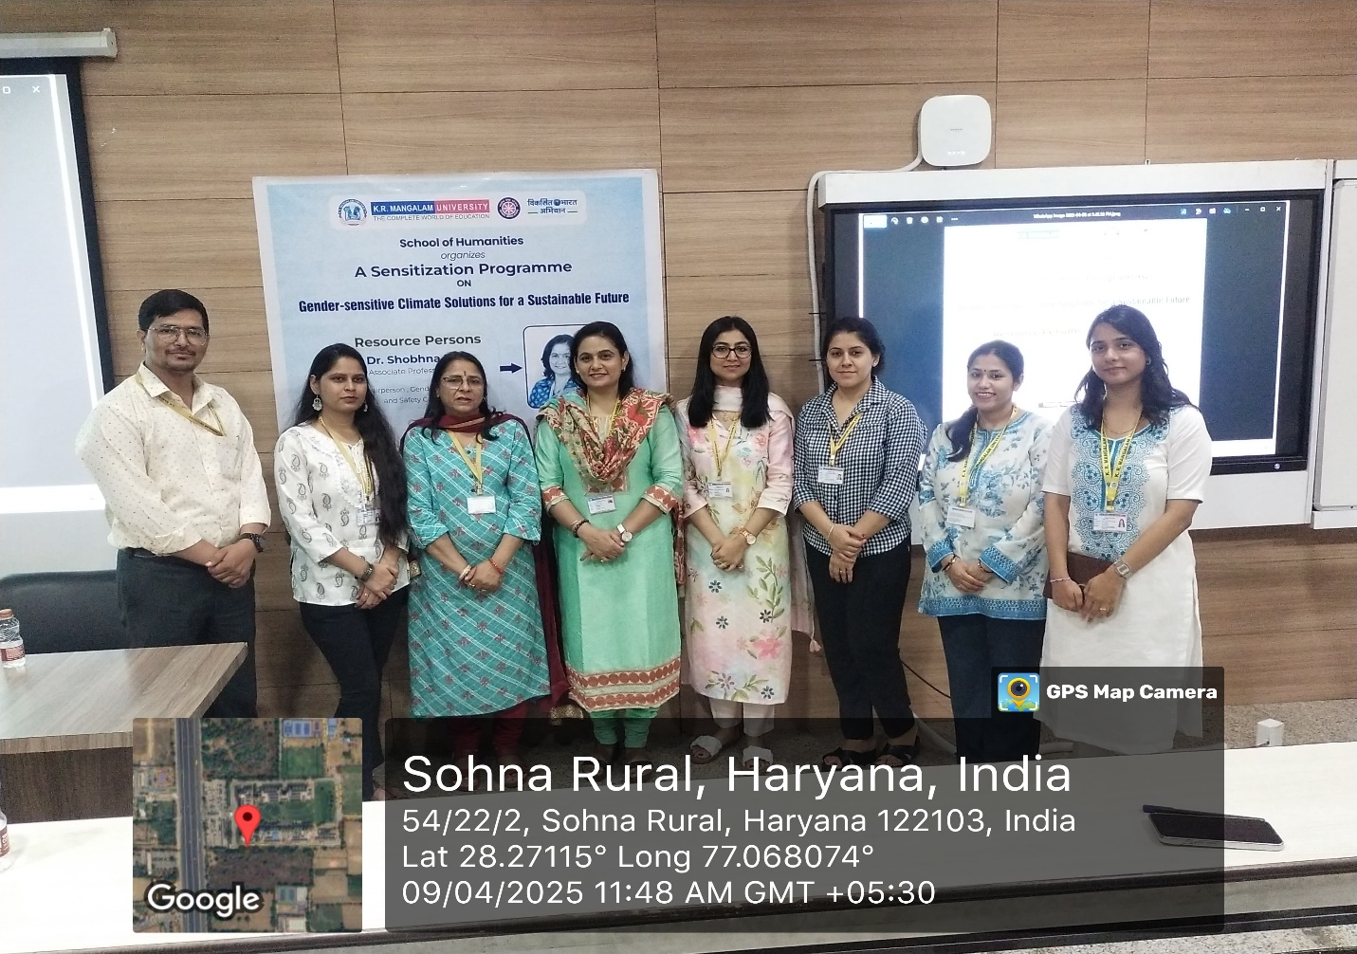

Group Photo of our speaker Dr. Shobhnajeet with Prof. Renu Verma (Associate Dean ,SOHS) and faculty coordinators.

Report prepared by | Ms. Mansi Jatav (Assistant Professor, SOHS)
Report checked and verified by Dean | Professor (Dr.) Tania Gupta (Dean, SOHS)
Report approved by IQAC (IQAC Coordinator) | Dr. Shikha Dutt Sharma (IQAC Coordinator)

