Report on Cleanliness Drive and Rally under ‘Swachhata Hi Seva’ Campaign
Date: 25th and 27th September 2024
Venue: Govt Sr Sec School Ghanghola, Sohna
Event Type: Cleanliness Drive and Rally
Mode of Activity: Offline
Target Group: Villagers
Coordinators: Dr. Neeraj Kumari (NSS Program Coordinator) and Mr Amit Kumar (NSS Program Officer) KRMU

Organized by: NSS, K R Mangalam University, Gurugram
Participants during event: 109 NSS volunteers and More than 50 villagers

Introduction:
The Swachhata Hi Seva (SHS) campaign is a nationwide movement in India focused on promoting cleanliness and sanitation as a way of life. Launched under the broader Swachh Bharat Mission by Government of India, the campaign mobilizes citizens, institutions, and communities to actively participate in cleanliness drives, waste management, and sustainable practices. Through activities such as cleaning public spaces, creating awareness, and encouraging responsible waste disposal, Swachhata Hi Seva aims to achieve a cleaner and healthier environment while instilling a sense of civic duty and environmental stewardship among participants. Therefore, under the direction of Ministry of Youth Affairs and Sports, NSS, K R Mangalam University organized cleanliness drive at Govt. Sr. Sec. School, Ghanghola, and rally at Ghanghola village on 25th and 27th September 2024.
Objectives:
This initiative aimed to promote cleanliness and hygiene in the local community, reinforcing the importance of a clean environment, supporting ‘Swachhata Hi Seva’ campaign.
Content:
The drive began with a brief orientation by Dr. Neeraj Kumari and Mr. Amit Kumar, emphasizing the significance of cleanliness in daily life. During the drive, Volunteers collected waste, swept the grounds, and cleared debris, enhancing the school's environment. The drive successfully engaged over 60 volunteers

fostering a sense of responsibility towards cleanliness. Participants expressed heightened awareness about environmental issues, and the school premises were visibly cleaner and more welcoming. On 27th September, an awareness rally was held in Ghanghola village, where volunteers participated, and chanting following slogans
- स्वच्छता ही सेवा है, इसे अपनाएं, जीवन को सुंदर बनाएं।
- आओ मिलकर कसम ये खाएं, स्वच्छ भारत हम बनाएंगे।
- स्वच्छ रहना, स्वस्थ रहना – यह है हमारा कहना।
- स्वच्छ भारत का यही नारा, गंदगी को दूर भगाना हमारा।
Conclusion:
The cleanliness drive and rally under the Swachhata Hi Seva campaign proved to be a fruitful initiative, instilling the values of cleanliness and environmental stewardship among the youth. NSS volunteers cleaned the premises of the school under the guidance of faculties of the Govt. School.
Event outcomes:
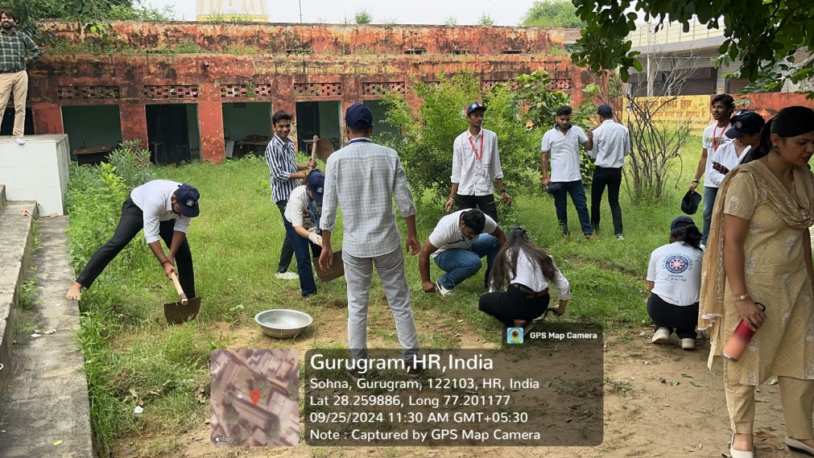
The drive and rally successfully engaged NSS volunteers, increasing awareness about the impact of cleanliness on health and well-being. The enthusiasm of participants led to a cleaner school environment and sparked conversations on sanitation in the village.

Photo 1: NSS volunteers during cleanliness drive

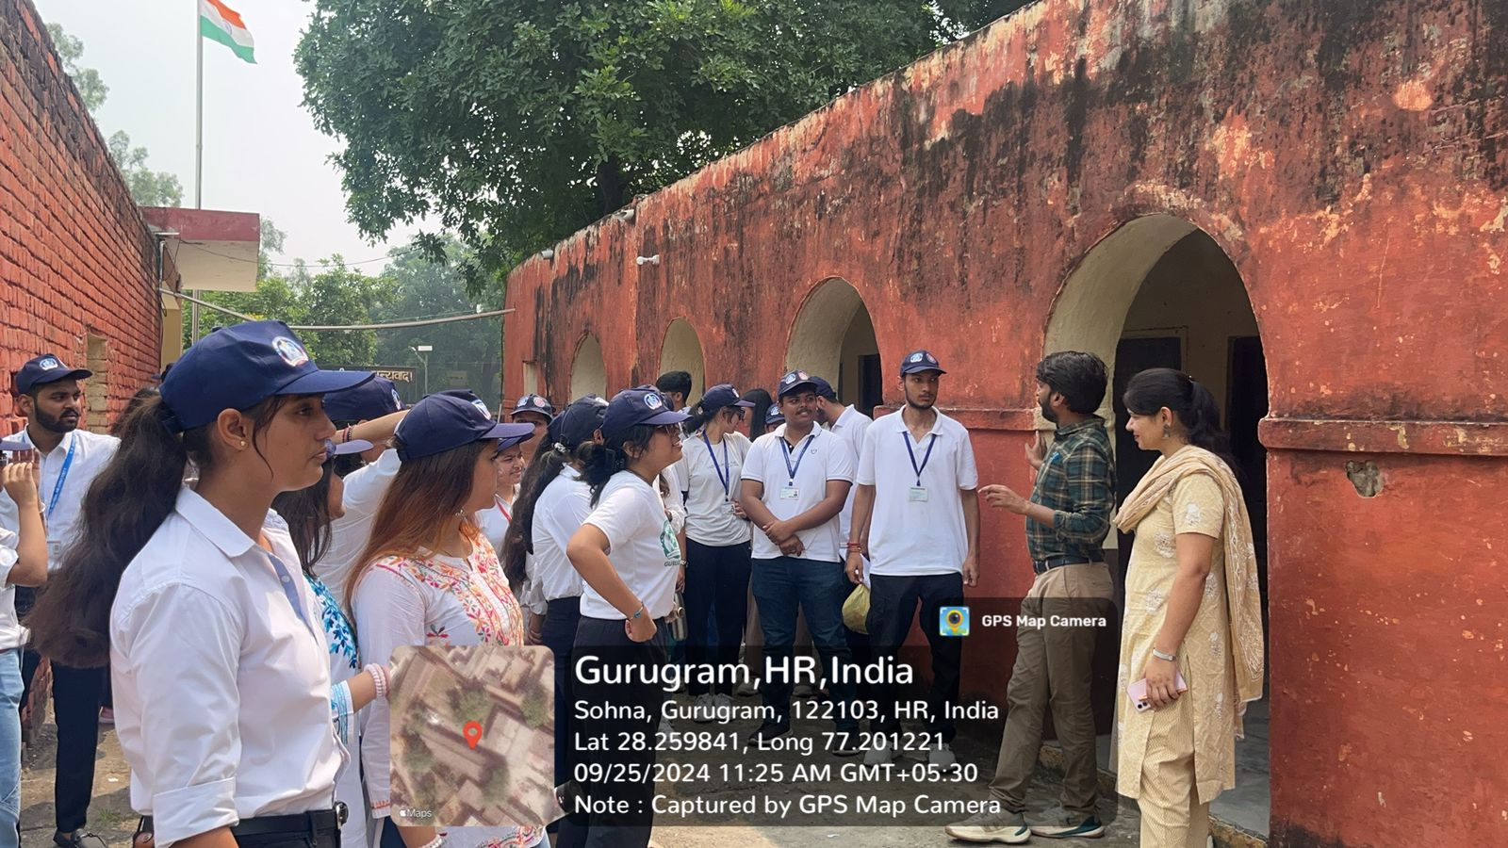

Photo 2: Mr Amit Kumar and Dr Neeraj Kumari briefed NSS volunteers about event
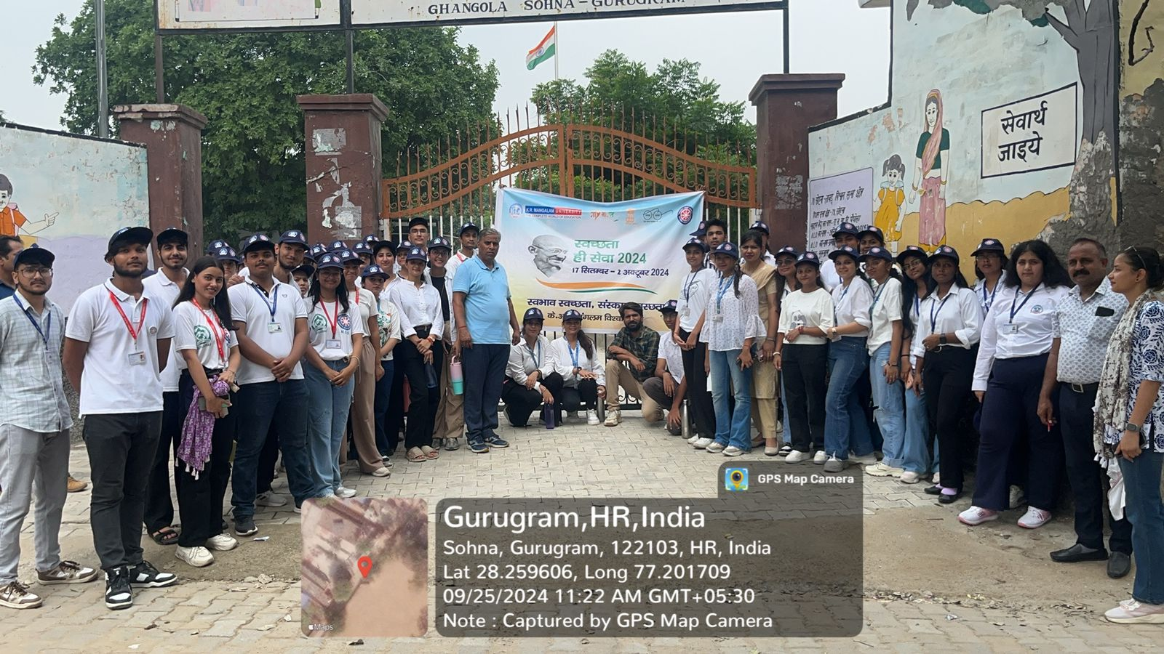

Photo 3: A group photograph of NSS volunteers and school faculties

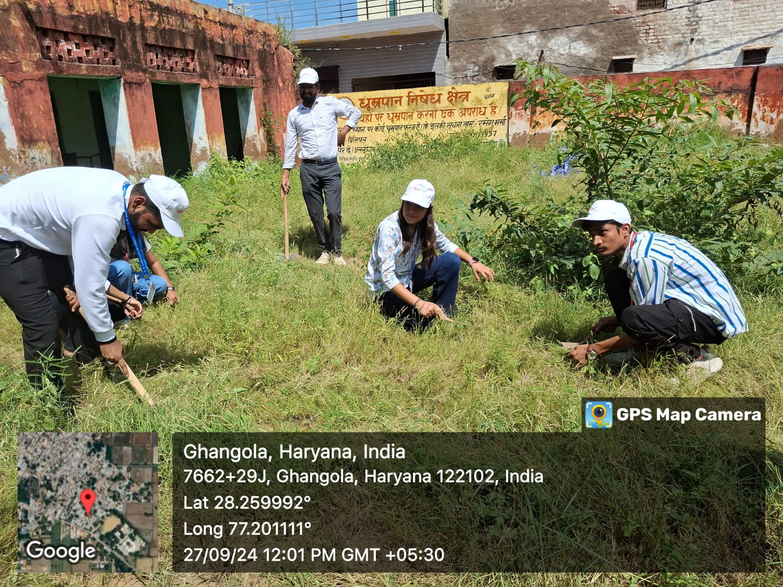

Photo 4: NSS volunteers during cleanliness drive on 27th September 2024
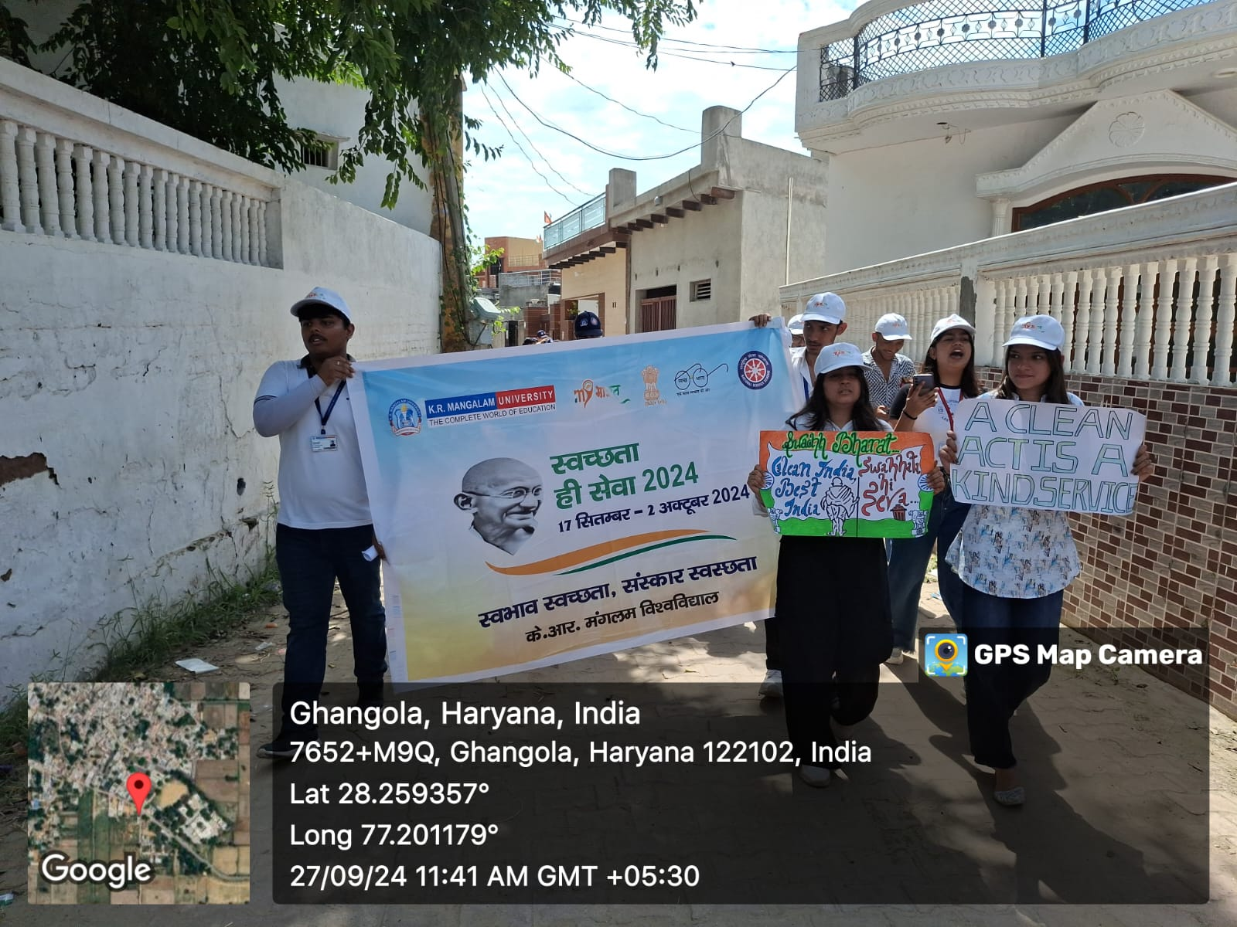

Photo 5: NSS volunteers during rally in village

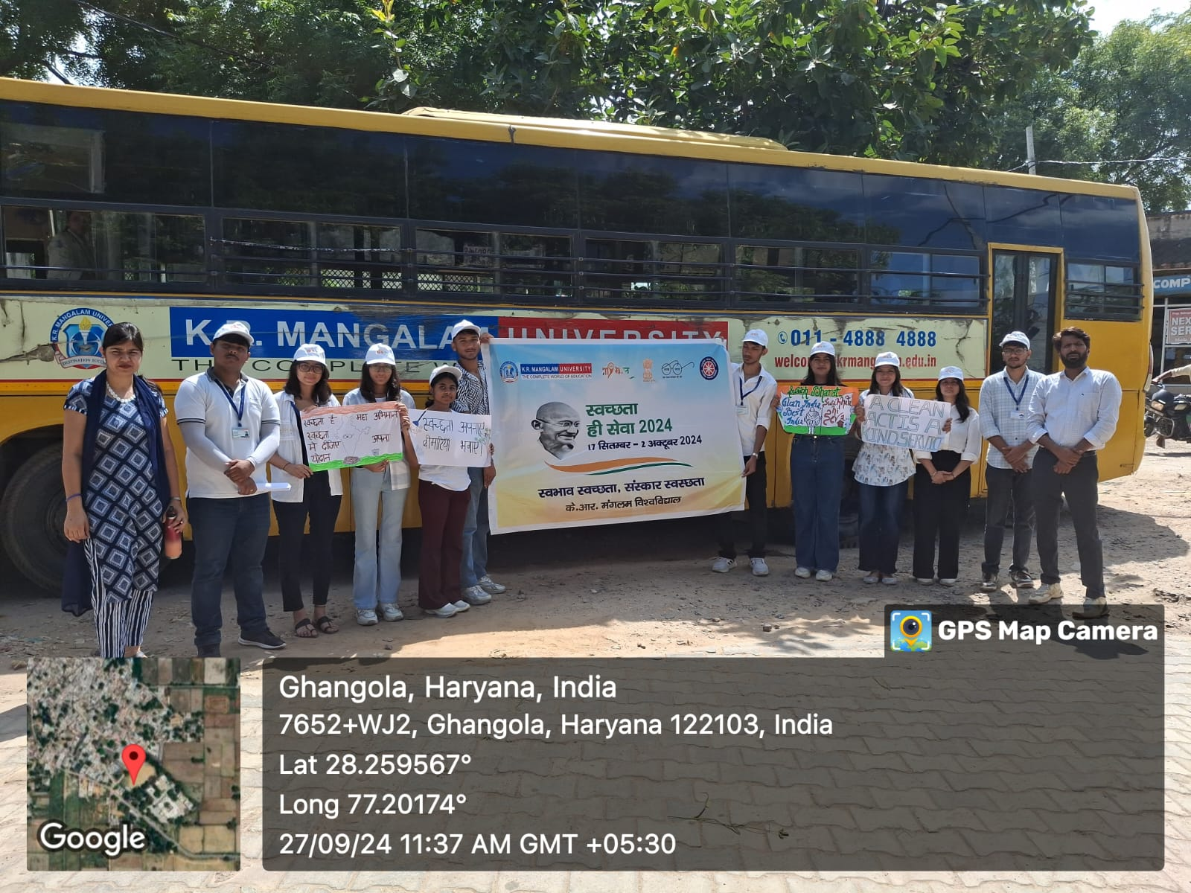

Photo 6: NSS volunteers started the rally from Govt. School, Ghanghola

